**NASA DEVELOP National Program**

Langley Research Center

**Summer 2013**

**South Pacific Oceans**

Predicting the Movement of Pumice Rafts for Enhanced Navigational Warnings

**Team Leads:**

Michael Bender, (Pennsylvania State University),Michael.R.Bender@nasa.gov

Joshua Kelly, (University of Rhode Island),Joshua.T.Kelly@nasa.gov

**Team Members:**

Maureen Kelly, University of Maryland College Park

Corey Walters, St. Louis University

**Advisors & Mentors:**

Dr. Kenton Ross, NASA DEVELOP Science Advisor

Beth Brumbaugh, NASA DEVELOP Langley Center Lead

Lauren Makely, NASA DEVELOP Langley Assistant Center Lead

**Applied Sciences National Applications Addressed:**

Oceans, Disasters, Ecological Forecasting

**Study Area:** South Pacific Ocean (concentrated near the Tonga Trench-Australia region)

**Study Period:** August 2006-December 2012

**Community Concerns**

* Pumice rafts pose a hazard to marine transportation as clasts can block seawater intake valves of ships and damage the hulls of smaller vessels
* Rafts have the potential to block small ports, bringing local water travel to a near standstill
* Rafts threaten fisheries as they can kill off large populations of deep-sea fish as evidenced by the 1984 Home Reef (Tonga) eruption
  + Rafts in shallow water may asphyxiate marine life as large fish jump on the pumice and cannot penetrate back through to the water
* Pumice rafts act as a long range dispersal mechanism for potentially invasive organisms and seeds by delivering them to otherwise pristine and delicate ecosystems
  + The 1883 Krakatoa (Indonesia) pumice raft transported bones >6000 km to East Africa in 10 months and transported trees and seeds 3,500 km to Micronesia

**80-100 Word Blurb**

Pumice rafts are a product of subaerial and submarine explosive volcanism and pose a significant hazard to maritime transportation and island nations in the South Pacific region. Methodologies for predicting the trajectory of newly formed pumice rafts along with imaging them using MODIS data were developed to enhance knowledge and preparedness for these events.

**Abstract**

Pumice rafts are expansive masses of pumice clasts floating on the ocean surface produced by silicic shallow submarine and subaerial explosive volcanic eruptions.  The goal of this project was to enhance knowledge of pumice rafts and develop accessible and practical methodologies for predicting the movement of pumice rafts in the South Pacific region.  Two volcanoes in this region have recently erupted and formed pumice rafts: Home Reef volcano (Tonga) in 2006 and Havre Seamount (Kermadec Islands, New Zealand) in 2012.  These raft events were used as examples to test the trajectory prediction model since they occurred during times at which high spatial and temporal resolution true color imagery were being collected and they have been frequently described in peer reviewed literature, both of which were crucial in providing validation for our models.

Project partners included Dr. Bradley Scott from GNS Science New Zealand and Dr. Greg Vaughan from the U.S. Geological Survey. They are particularly interested in learning how to predict the movement of pumice rafts for enhanced navigational advisement to maritime authorities. Remote sensing data acquired from NASA’s Earth Observing System (EOS) satellites Aqua and Terra were used to image and track the pumice raft produced from the 2012 Havre Seamount eruption.  Additional data acquired from NASA’s EOS satellites Jason-2 and QuikSCAT were used to predict the trajectory of the pumice raft using the General NOAA Operational Modeling Environment (GNOME).  GNOME is a modeling tool used to predict the possible trajectory a pollutant might follow on a body of water using wind and ocean current satellite data.

Learning more about the processes and transport mechanisms of pumice rafts is significant for a number of ecological and economic reasons.  Pumice rafts pose a hazard to marine transportation as individual clasts can block seawater intake valves of large ships and cause hull damage to smaller vessels.  Rafts can also be detrimental to fisheries, a large kill of deep-sea fish followed the arrival of pumice rafts during the 1984 Home Reef eruption.  Additionally, rafts have the potential to introduce harmful invasive species to pristine areas as they drastically increase dispersal distances for otherwise benthic or relatively sedentary organisms. This novel and easily adaptable methodology can be used by island and coastal nations and fishery managers to forecast when and where a pumice raft will be, drastically enhancing maritime navigational warnings and response times to eventual pumice landfall.

**Partners/Collaborators**

Dr. Greg Vaughan, United States Geological Survey

Dr. Bradley Scott, GNS Science, New Zealand

**Current Management Practices & Policies**

Currently, there are no management practices in place for tracking the movement of pumice rafts; however, there is a published MATLAB model that predicted the trajectory of the 2006 Home Reef pumice raft. This model is mathematically complex and requires a steep learning curve so it is not advantageous to a non-scientific user.

**Benefit to End-User:**

* Accessible and practical methodology for predicting the movement of pumice rafts using NOAA’s GNOME particle tracking model
* Designation of major marine shipping lanes susceptible to intercepting pumice rafts based on volcanic hazard map
* Methodology for imaging pumice rafts using moderate resolution (250 m) MODIS true color imagery

**Decision Support Tools**

* Hazard map with locations of potential pumice raft producing submarine volcanoes and marine transportation shipping lanes
* Methodology for predicting the movement of pumice rafts using NOAA’s GNOME particle tracking model

**Earth Observations & Parameters**

Aqua, MODIS – True-Color Imagery  
Terra, MODIS – True-Color Imagery

Aqua, AMSR-E – Sea Surface Temperatures

NOAA-17, AVHRR – Sea Surface Temperature  
Envisat, RA-2 – Sea Surface Height  
ERS-2, RA – Sea Surface Height

Jason-2, Poseidon-3 – Sea Surface Height

Jason-1, Poseidon-2 – Sea Surface Height

QuikSCAT, SeaWinds - Wind Speed and Wind Speed Vectors

**Future Applicable NASA Missions**

Using UAVSAR to collect active microwave data of the South Pacific region to create cloud-free imagery of pumice rafts. Additionally, the Soil Moisture Active Passive (SMAP), scheduled for launch in 2015, will use an advanced radar that could accomplish this task.

**Models Utilized**

General NOAA Operational Modeling Environment (GNOME)

**Software Utilized**

ArcGIS - Raster Manipulation/Analysis, Image Enhancement, and Map Creation of Aqua/Terra MODIS True Color Imagery and GNOME model outputs

SeaDAS 6.4 - Processing and Displaying Aqua/Terra MODIS data

GNOME - Predict how ocean currents and wind might move a pumice raft floating on the sea surface

ENVI - Raster Processing/Conversion, Imagery Manipulation/Analysis

**Imagery & Captions (only to be included in the final draft, not rough draft)**

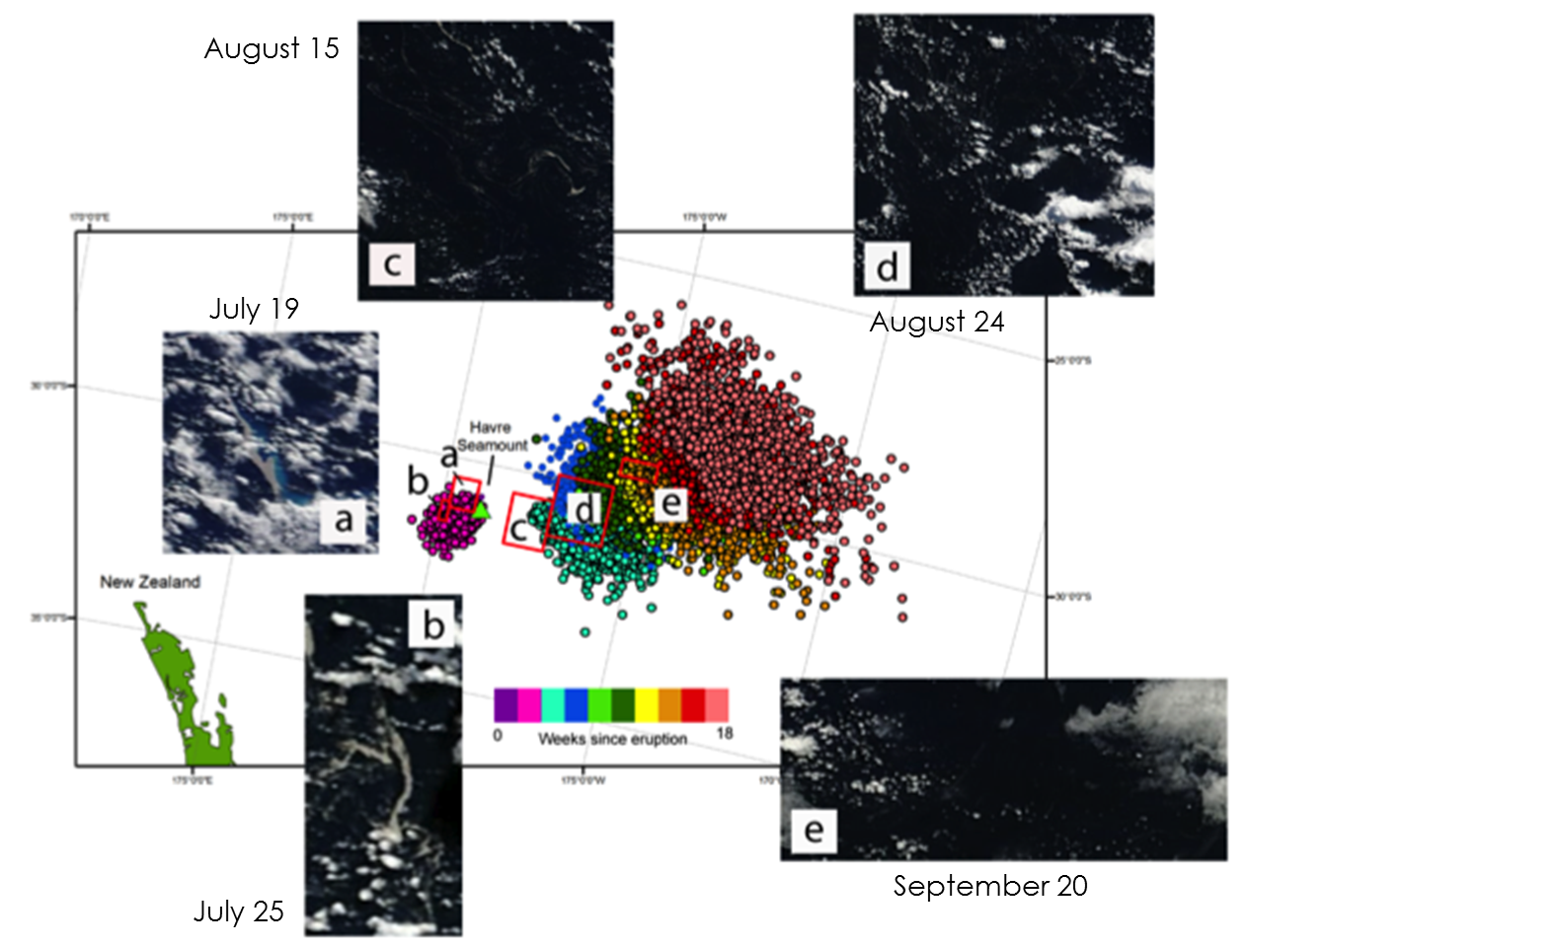

Figure 1: GNOME predicted biweekly movement of the2012 Havre Seamount pumice raft with accompanying MODIS 250 m true color imagery for model validation.

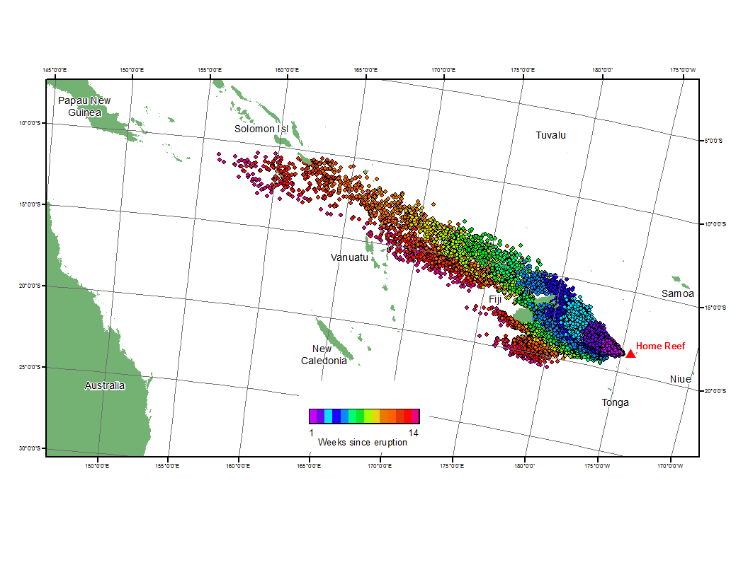

Figure 2: GNOME predicted weekly movement of the 2006 Home Reef pumice raft.

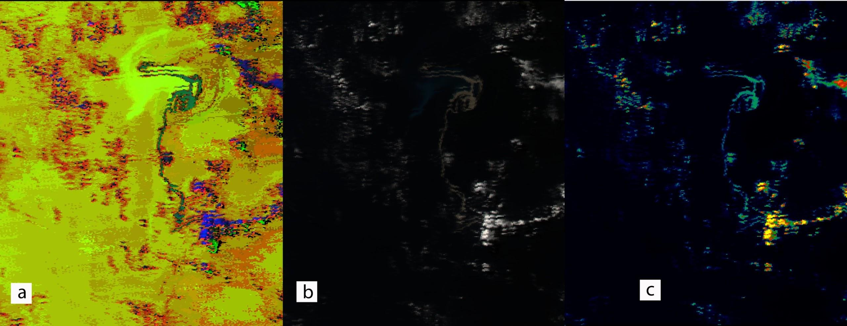

Figure 3: MODIS imagery of the 2006 Home Reef pumice raft. a) Hue, Saturation, and Value enhanced image b) True color image c) ENVI Color Table enhancement image