**NASA DEVELOP National Program**



NOAA National Centers for Environmental Information

*Summer 2017*

US Pacific Islands Oceans

Utilizing the NASA and NOAA Joint Ocean Surface Topography Mission and Modeled Wave Data to Assess Patterns and Trends in Sea-surface Height in the US Affiliated Pacific Islands

**Technical Report**

Final Draft – August 10, 2017

India Young (Project Lead)

Saraneh Fitzgerald

Kaitlin Walker

Alec Courtright

Michael Kruk, NOAA National Centers for Environmental Information (Science Advisor)

# 1. Abstract

Low-lying atoll islands are common features in the tropical Pacific Ocean region and are increasingly vulnerable to extreme sea level variability. Several contributing factors combine to create extreme water-level events. These fluctuations can result in anomalously-high sea levels with occasional, prolonged inundations (high-water stands) or coral reef exposures (low-water stands) over many tidal cycles. Significant wave height, wave direction, sea surface height, and tidal oscillations are system inputs, which when combined at elevated amounts, can have negative socio-economic and environmental impacts on island communities. Coastal infrastructure like groundwater reservoirs, harbor operations, and sewage systems, as well as, coral and beach ecosystems are most vulnerable during inundation events. This project produced a wave climate atlas with significant wave height and direction data illustrated in a series of monthly wave roses in a perimeter around the Republic of the Marshall Islands. Inundation risk percentiles for wave height, sea level anomaly, and tides were also calculated. Lastly, a procedural guide was compiled with methodology for creating an overall risk metric from the aforementioned combined parameters. This tool set will supplement the current University of Hawaii Sea Level Center sea level anomaly forecast. These tools will help coastal managers prepare for high-water events in the Marshall Islands. Furthermore, this information will be disseminated to other U.S. Affiliated Pacific Islands’ (USAPI) decision makers to better inform coastal-management policy and disaster preparedness.

**Keywords**

Wave model, climatology, Marshall Islands, sea level anomaly, sea surface height, sea-level rise, tides, inundation, significant wave height

# 2. Introduction

* 1. ***Background Information***

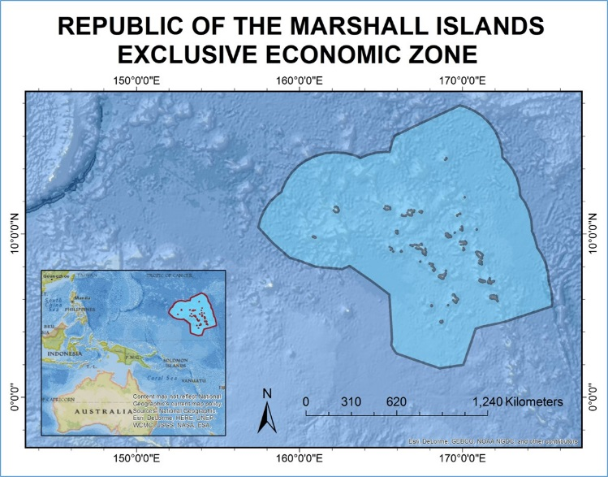

*Figure 1.* Image of the study area, the Exclusive Economic Zone surrounding the Republic of the Marshall Islands.

Low-lying atoll islands are a common feature in the Pacific Ocean region and are increasingly vulnerable to anomalously high sea levels and occasional inundation (Marra et al., 2012; Merrifield et al., 2014; Widlansky et al., 2017). Several contributing factors at various severities combine to create extreme water level events which can manifest as prolonged inundations (high-water stands) and exposures (low-water stands) over many tidal cycles (Widlansky et al., 2017). Tidal oscillations, significant wave height, wave direction, and sea surface height are system inputs, which when combined at elevated amounts, can have negative socio-economic and environmental impacts (Marra et al., 2012; Widlansky et al., 2017). Coastal infrastructure like groundwater reservoirs, harbor operations, and sewage systems as well as coral and beach ecosystems are most vulnerable during inundation events (Marra et al., 2012). Therefore, the causes of sea level extremes must be investigated and their occurrences anticipated in order for coastal managers to mitigate potential hazards and adapt to sea level rise (SLR) (Hoeke et al., 2013).

The particularly low-lying Pacific islands are vulnerable to SLR and extreme sea level anomalies (SLAs) (Marra et al., 2012) which can result in island overwash, the landward movement of water over a coastal bank, and flooding during large wave events (Cheriton et al., 2016). These events are partly driven by the El Niño–Southern Oscillation (ENSO), Pacific decadal oscillation (PDO), and greenhouse gas effect warming (Widlansky et al., 2017). During December 2008, severe flooding occurred in the Republic of the Marshall Islands (RMI) and was attributed strong northeastern winds driving high-amplitude swell waves (Hoeke et al., 2013; Merrifield et al., 2014). More recently in 2014, the RMI were inundated by a combination of 5 meter swells and anomalously high tides for the third time that year (USGS, 2017).

In response to these types of extreme sea surface height (SSH) oscillations, climate scientists utilize wave models to forecast whether inundation hazards to coastal zones are likely. A regional wave model by Hoeke et al. (2013) was created for the US Affiliated Pacific Islands (USAPI), however this model fails to include the influence of both sea and swell waves (SS) and infragravity (IG) waves. With the Merrifield et al. (2014) model there is an improvement as it estimates extreme water levels, but this model lacks the significant wave height and wave direction inputs. Long-term observations of significant wave height (SWH) are based on current buoy data, of which there are only two in the RMI. However, the limited spatial resolution of buoy data cannot be solely relied upon to create an accurate SLA forecast, as they are sparsely located (Reguero et al., 2012). Therefore, project end-users, Dr. John Marra (NOAA Regional Climate Services) and Dr. Matthew Widlansky (University of Hawaii, Sea-Level Center & International Pacific Research Center) are seeking a comprehensive wave climate atlas which includes a series of wave roses that document the historical influence of SWH and wave direction in the Marshall Islands, a calculated percentile risk for waves, tides and SLA, and an overall risk protocol for the combination of these factors in the Marshall Islands. This tool set will help better prepare USAPI nations for future high-water events.

This wave climate atlas will be used by Dr. Widlansky and Dr. Marra to diagnose the extent and severity of coastal inundation in the Marshall Islands. Our partners will then share this atlas with other coastal managers. The study area includes the Republic of the Marshall Islands Exclusive Economic Zones (EEZ) and includes data analysis from the 1979 - 2017 study period. The data analysis generated by using satellite altimetry data provides a more accurate projection of inundation risk at a higher spatial resolution than current *in situ* measurements by incorporating SWH and wave direction. The wave climatology atlas will help coastal managers prepare for anomalously-high sea levels, inundation events, and adapt their management practices to SLR. As soon as August 2017, the island of Majuro in the RMI may experience sea levels at above-normal conditions (10–15 cm) (UH Sea Level Center, 2017). With the potential hazards from elevated SSH, there is an immediate need for an enhanced SLA outlook.

* 1. ***Project Partners & Objectives***

This project will address NASA’s Oceans, Climate, and Disasters national application areas by: (1) partnering with public and private organizations like NOAA and the University of Hawaii, (2) discovering innovative NASA Earth science applications and applying satellite data to SLA forecasting models, (3) supporting environmental decision-making activities by providing an enhanced SLA model to coastal-zone managers, (4) demonstrating practical benefits of NASA Earth science by creating a wave climatology atlas which can be immediately used to help mitigate coastal hazards, and (5) helping to improve the quality of life and strengthen the economy of Pacific Islanders who are being directly affected by SLA and inundation events.

Project end user Dr. John Marra is NOAA’s Regional Climate Services Director in the Pacific Region and works on various coastal research and solutions projects. He will utilize the wave climate atlas and SWH, SLA, and tide risk percentiles, as well as the overall risk protocol to inform policy and mitigation planning for the USAPI. Dr. Marra will then share these tools with other Pacific coastal managers

Project end user Dr. Matthew Widlandsky at the University of Hawaii Sea Level Center researches climate and sea level variability on seasonal, interannual, and longer timescales. Dr. Widlansky uses global climate models of the ocean and atmosphere to assess the limits of predicting coastal impacts from sea level extremes. Dr. Widlansky will use the wave climatology atlas to enhance the current Sea Level Center monthly forecast for SLAs and to better predict possible extreme SSH fluctuations.

Dr. Eric Leuliette is a project partner and collaborator who joined NOAA in 2007 as a research oceanographer. Dr. Leuliette is a member of the Ocean Surface Topography Science Team and the GRACE Science Team.

The project focused on sea level, tidal, and wave dynamics, which are affected by climate events such as the El Niño Southern Oscillation, the Pacific Decadal Oscillation, and changing winds. These events can then lead to disasters such as coastal inundation events in the Pacific Islands. Project objectives include:

* Compare NASA and NOAA Earth observation altimetry data sets
* Enhance current Sea Surface Height outlook by incorporating wave height & direction and tides
* Create RMI wave climatologies at virtual buoy stations
* Create categorical risk assessment protocol to better inform disaster preparedness

# 3. Methodology

The project team produced a daily SWH and wave direction climatology and a daily SWH and wave direction frequency wave roses from 1979-2009 data. The team also created risk percentiles for SWH, SLA, and tides. Lastly, the team created an inundation risk protocol with recommendations about how to create an overall risk metric. These tools will be incorporated alongside the current UHSLC outlook in order to create an enhanced outlook for SSH oscillations in the Marshall Islands.

***3.1 Data Acquisition***

***3.1.1 Sea Level Anomaly Data***

The datasets used in this study come from a variety of sources. Project partners were key to the data acquisition process. To begin, project partner and collaborator Eric Leuliette of the NOAA’s Center for Satellite Applications and Research Oceanography and Climatology Division, directed the team to the NOAA Laboratory for Satellite Altimetry’s (LSA) sea level anomaly dataset, downloaded from the FTP site linked on the NOAA CoastWatch/OceanWatch webpage. This is a level 3 product beginning in January 1, 2017 and is updated daily. This near-real time data was used as an input into our risk metric model. A level 4 sea surface height anomalies dataset (Version 1609) from the NASA Physical Oceanography Distributed Active Archive Center (PODAAC) was utilized for validation of accuracy of the NOAA OceanWatch sea surface height anomaly dataset. The NASA sea level anomaly product ranges from October 1992 to present day and accessed from the FTP server listed on the NASA PODAAC website.

***3.1.2 Wave Model Data***

In addition to SLAs, SWH data were compared form two different wave models: WAM and WW3. Although these measurements are not based on observed or remotely sensed data, the models’ outputs are determined by well-known wind and ocean relationships with inputs such as wind speed. These hindcast measurements were transfered into climatologies. The WW3 climatology was calculated from global data beginning in 1979 and ending in 2009 and was acquired from the FTP server listed on the NOAA Marine Modeling and Analysis Branch site.

***3.1.3 Buoy Data***

Finally, the wave climatology measurements were validated by Hawaii buoy data from the NOAA’s National Buoy Data Center (NBDC). This *in situ* dataset was chosen for validation because it is the peer-reviewed methodology for validating wave models as buoy measurements provide an accurate time series (Reguero et al., 2012). The NBDC data was downloaded from the FTP server listed on the National Centers for Environmental Information (NCEI) website.

***3.1.4 Tidal Data***

Hourly tide gauge data was downloaded from UHSLC for the Majuro and Kwajalein tide gauges, starting in 1993 and continuing until present day.

***3.2 Data Processing***

***3.2.1 NASA-NOAA Blended Data Set Comparisons***

The NASA PODAAC sea level anomaly dataset was resampled to match the spatial resolution of the NOAA OceanWatch/CoastWatch sea level anomaly resolution of 0.25 degrees. The two global datasets were then clipped to the same extent, which is a bounding box around the Marshall Islands as provided by Dr. Philip Thompson at the University of Hawaii. Then a simple difference was found using the “raster_minus” python code, an average difference (MAD) was calculated in excel, and a regression analysis was performed using the “PiCo” code sent by NASA DEVELOP’s Geoinformatics Team.

***3.2.2 Wave Model Data Comparisons***

In order to acquire and analyze the wave data sets, the WW3 and WAM data was transformed from Grib2 file formats into ArcGIS-supported file formats using a script written by the team with assistance from Ryan Smith, of the U.S. Air Force, 14th Weather Squadron, in Python 3. The WW3 and WAM comparisons had the following steps:

1. Compile and average daily wave height and direction data and convert to NetCDF
2. Run NetCDF to geoTIFF code (corrected for orientation)
3. Use ArcGIS model builder to fix pixel sizes and resample WAM raster
4. Compare WAM and WW3 climatology geotiff rasters.

***3.2.3 Wave Climatologies and Wave Roses***

To create the wave climatologies as wave rose the IDL Library Package Coyote was used. Then the Virtual Buoy CSV's, wave height and wave direction tables were input. The file layout was each row as a latitude and longitude and every following column representing a daily value. Next the daily data was inserted into the NetCDF to GeoTIFF R script. ArcMap model was used to extract virtual buoy points from raster data. DailyWave_MergeTables R script, created by the team, was used to merge all the individual buoy tables. CSV data files in the IDL script were used to create wave roses.

***3.2.3 Tidal Predictions***

Tide forecasts were created using the Matlab package "Utide" created by Daniel Codiga, 2011. The first function in this package, ut_solve, performs a harmonic analysis of the input data. The second function, ut_reconstr, uses the harmonic analysis from the first function to create a tidal forecast out several years.

***3.2.4 Percentile Calculations***

The risk percentiles were calculated from daily wave monthly csv files loaded into an R code that calculated percentiles (90, 95, 99). These percentiles were selected to differentiate between varying levels of inundation risk.

***3.3 Data Analysis***

The SLA outlook and modelled wave climatologies were compared to similar past products created by the U.S. Army Corps of Engineers developed by the Wave Information Systems initiative. The SWH and wave direction climatologies were created from WW3 and WAM models and then compared. Using 30-year wave hindcasts, a 30-year monthly climatology was made for each model. Each model hindcast has a unique temporal resolution. For example, the WW3 model dataset contains of 3-hour increments from 1979 to 2009. Based on previous studies, partner input, and comparisons between datasets and SWH products created by the U.S. Army Corps of Engineers, it was determined that the WW3 model data was the best to use for our project.

A tidal forecast was created by analyzing tidal harmonics using the U-Tide Matlab package. Compared to sea level anomalies and wave heights, tides can be easily predicted because they depend on the gravitational pull of the sun and moon; or they are deterministic. For our research, the Matlab package "Utide" was used to forecast tidal heights for future years.

To create risk percentiles for frequency distributions were made for the tidal, SWH, and SLA components. Distributions are categorized by percentile based on the monthly 30-year climatology. “Severe Risk” of inundation is categorized as a significant wave height at or above the 99th percentile, “High Risk” as between the 99th and 95th percentile, “Moderate Risk” as between the 95th and 90th percentile , and “Low Risk” as below the 90th percentile. Similar distributions and risk categorizations was made for SLA and tides, resulting in three categorical risk metrics for these individual components.

# 4. Results & Discussion

***4.1 Analysis of Results***

***4.1.1 SLA Imagery Comparisons***

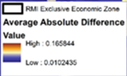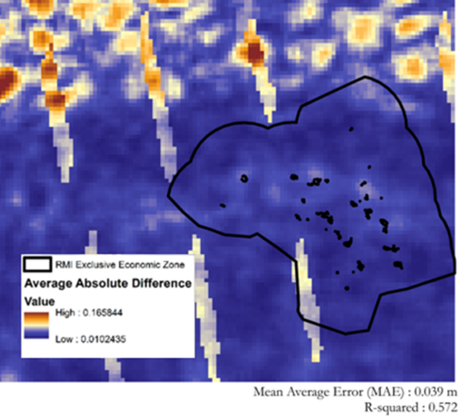

**NOAA OCEAN WATCH**

**UHSLC AVISO**

*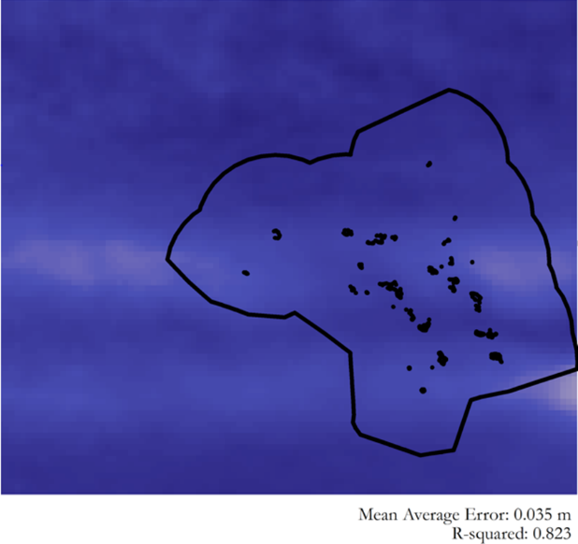Figure 2.* Comparisons of SLA imagery from AVISO and NOAA OCEAN WATCH as they vary from NASA’s OSTM SLA data.

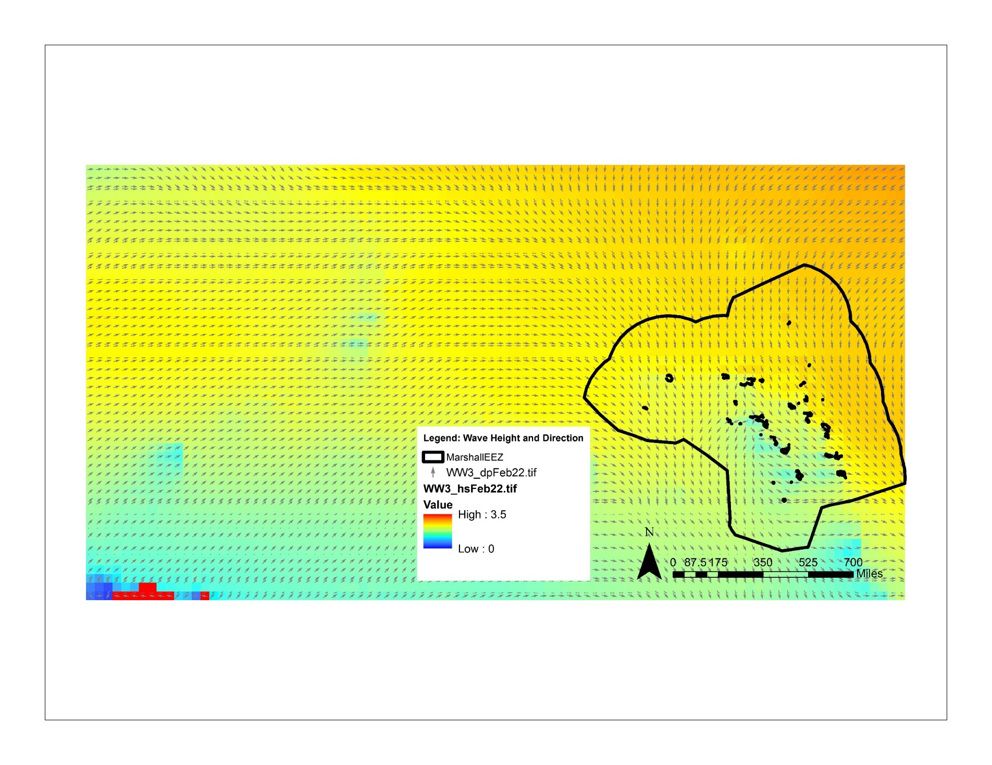 ***4.1.2 Wave Climatology***

*Figure 3.* Average Significant Wave Height & Direction: February 22nd 1979 to 2009.

Monthly wave heights and direction for 41 virtual buoys from 1979 – 2009. Figure 4 shows 41 virtual stations, or buoy points at specific locations in the RMI. Wave roses with SWH and wave direction were created at each station. These stations were retrieved from the US Army Corps Wave Information Studies.

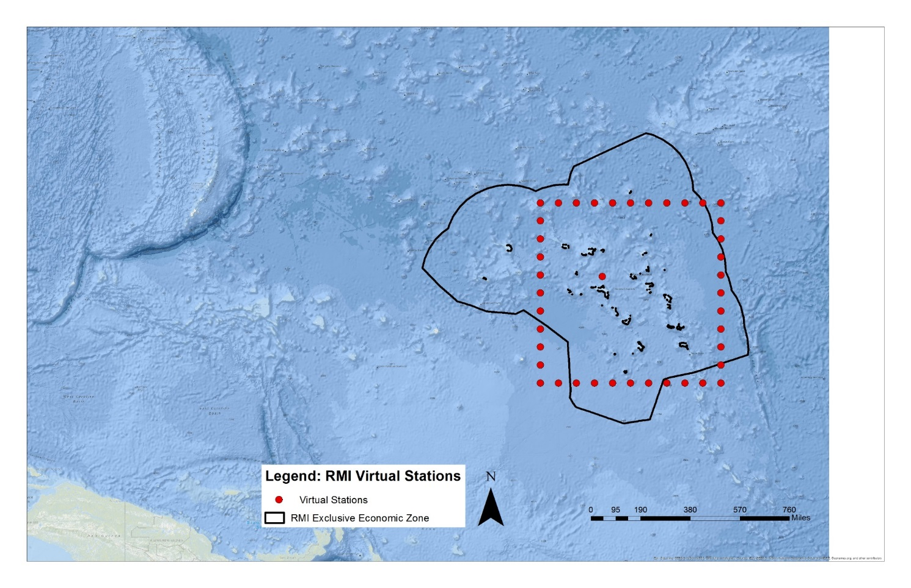

*Figure 4*. Virtual station points in the Republic of the Marshall Islands.

***4.1.2 Wave Rose***

The wave roses below represent NOAA model wave height and direction data from 1979 to 2009, using input wave data extracted from the virtual stations. A wave rose is similar to a wind rose, which shows wind speed and direction, but instead it shows wave height and direction. The rings represent increasing frequency, the blue bars show different wave heights, and the direction of the bars indicates the direction the waves originate from. We also created a wave rose for every month and virtual station to showcase the seasonal variability of waves. Figure 5 is a wave rose for a particular buoy in January while figure 6 is a wave rose for the same buoy in Mar. Wave heights tend to be higher and show a wider variety in wave directions around Pacific Islands in the winter months, as seen in comparing the two wave roses above. The directional component gives interested groups an idea of whether a high wave is a threat based on the direction it originates from.

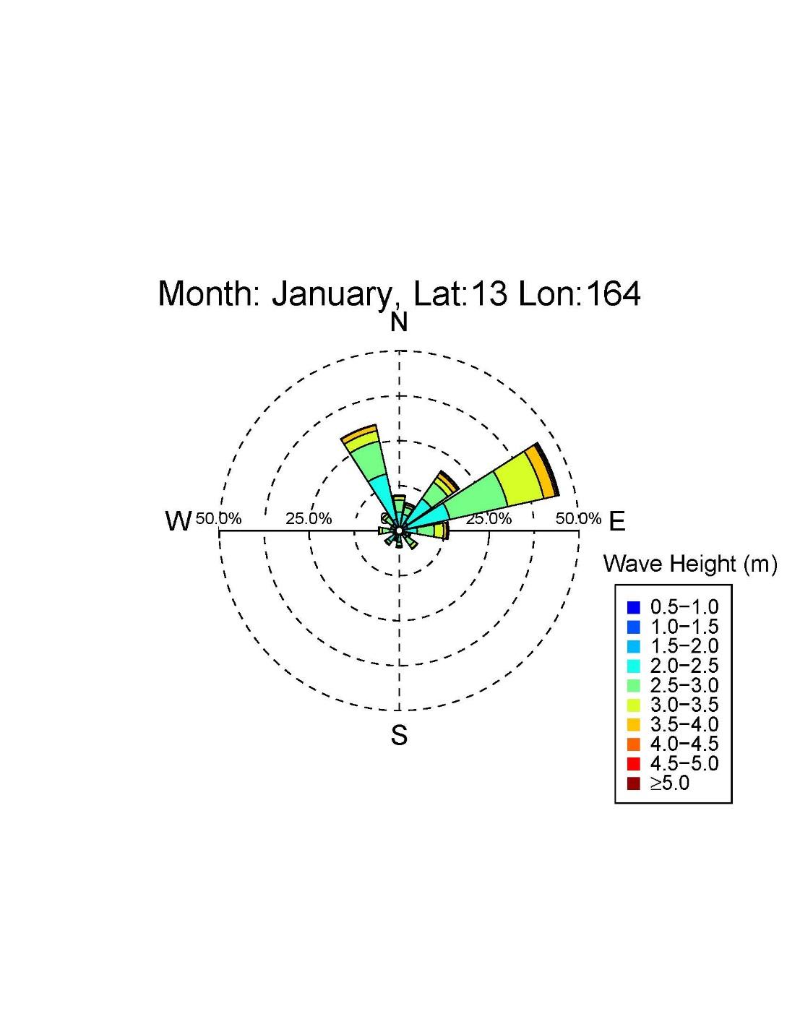

*Figure 5.* Wave rose example for the month of January from 1979-2009 derived from Wavewatch III data.

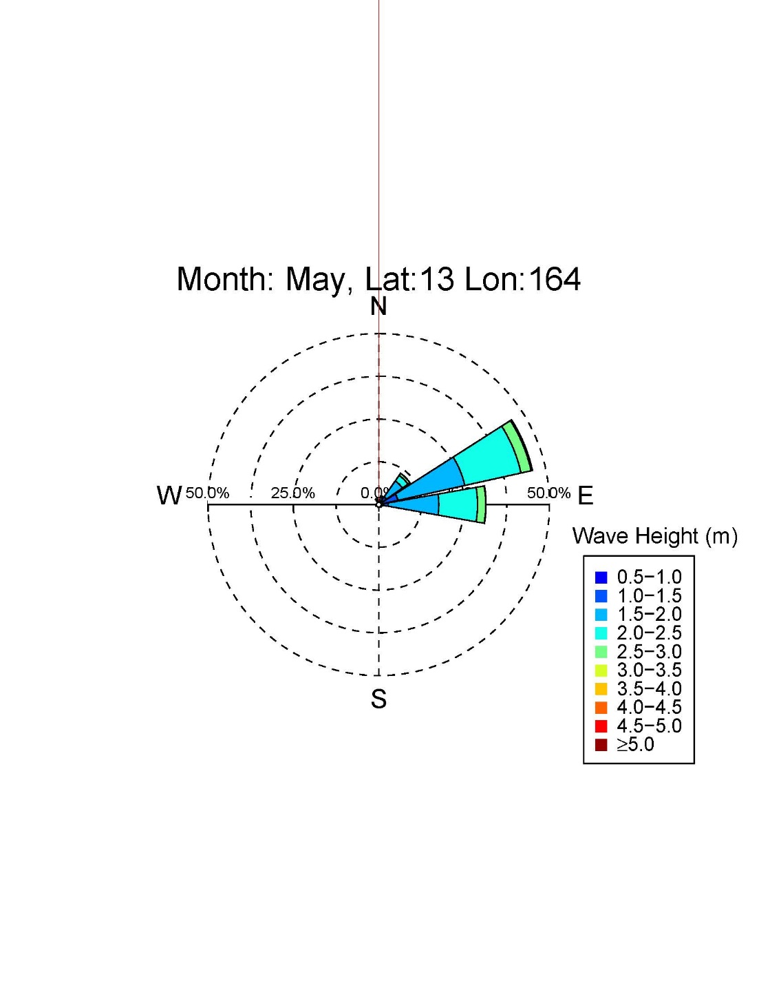

*Figure 6.* Wave rose example for the month of May from 1979-2009 derived from Wavewatch III data.

***4.1.3 Percentile Tables***

Table 1 is an example of the monthly percentile tables provided to the project partners. These tables provide the 90th, 95th, and 99th, percentile values for tides, SLA, and SWH at each virtual buoy station for every month. These tables can be used to analyze risk values for different months or seasons as compared to abnormal tide, SLA, and SWH values.

*Table 1.*

Risk percentiles for tides, sea level anomalies (SLA), and significant wave height (SWH). Values related to each percentile are in meters, latitude and longitude are in degrees.

**January**

|  |  |  |  |  |  |  |  |  |  |  |  |
| --- | --- | --- | --- | --- | --- | --- | --- | --- | --- | --- | --- |
| **Buoy #** | **Lat** | **Lon** | **Tide 90** | **Tide 95** | **Tide 99** | **SLA 90** | **SLA 95** | **SLA 99** | **SWH90** | **SWH95** | **SWH99** |
| 0 | 4 | 164 | 1.603 | 1.619 | 1.640 | 0.065 | 0.090 | 0.112 | 3.037 | 3.275 | 4.070 |
| 5 | 9 | 164 | 1.603 | 1.619 | 1.640 | 0.056 | 0.077 | 0.092 | 3.532 | 3.786 | 4.437 |
| 10 | 14 | 164 | 1.603 | 1.619 | 1.640 | 0.073 | 0.094 | 0.119 | 3.418 | 3.716 | 4.392 |
| 15 | 14 | 169 | 1.603 | 1.619 | 1.640 | 0.066 | 0.090 | 0.119 | 3.514 | 3.840 | 4.253 |
| 20 | 14 | 174 | 1.603 | 1.619 | 1.640 | 0.113 | 0.126 | 0.171 | 2.415 | 2.543 | 2.860 |
| 25 | 9 | 174 | 1.140 | 1.173 | 1.211 | 0.105 | 0.120 | 0.134 | 2.418 | 2.619 | 2.976 |
| 30 | 4 | 174 | 1.140 | 1.173 | 1.211 | 0.122 | 0.143 | 0.164 | 2.510 | 2.655 | 3.018 |
| 35 | 4 | 169 | 1.140 | 1.173 | 1.211 | 0.091 | 0.123 | 0.222 | 3.281 | 3.510 | 4.014 |
| 40 | 9.91 | 167.4 | 1.603 | 1.619 | 1.640 | 0.077 | 0.091 | 0.110 | 3.005 | 3.250 | 4.118 |

* 1. ***Future Work***

Time was a limiting factor in the creation of wave products. The wave direction and significant wave height dynamics have the potential to be analyzed at a greater level of detail or spatial resolution, but the number of islands or coastlines combined with the time constraints prevented the time from diving into wave dynamics at the island level for all of the Marshall Islands. As such, further research may have a more in-depth focus in order to serve high-risk or high-population coastlines in the Marshall Islands. Specifically we suggest these future steps: implementation of the Inundation Risk Assessment Protocol, include wave run-up in outlooks, create an automated tool for Risk Assessment Protocol, and lastly expand methodology to other Pacific islands.

# 5. Conclusions

There were some limitations and uncertainties that were challenges during the project. There were limited available validation data from tide and buoy stations because there are no buoy stations in the Marshall Islands with a sufficient record of wave height and direction data. To address this limitation, we compared our data to representative buoy stations in Hawaii, but even these stations were missing data. Secondly, the wave height data that was used represented offshore wave height. However, inundation due to waves more depends on wave run-up or shoreline water level increases due to wave energy. Wave run-up calculations require field observations of reefs, shoreline topography and these data collections were not possible within the project timeframe. Lastly, the team was unable to create an operational combined risk metric prototype to hand off to project partners that represented overall inundation risk and wave direction.

However, the project tool set and data analysis are useful for coastal mangers and immediately implementable in the Marshall Islands as high tides are expected for August 2017. After our comparison of multiple sea-level anomaly datasets, we determined that NOAA’s OceanWatch, blended satellite altimeter, dataset provided the most accurate, near-real time, SLA imagery for regional sea-level outlooks and warnings. The wave atlas created in this project will provide decision makers in the Marshall Islands with extensive information about climatological and seasonal wave height and direction. The wave atlas includes wave roses for every month at each virtual buoy point and a monthly table of risk values for tides, SLA, and SWH that can be used to determine the 90th, 95th, and 99th percentiles for every buoy station. End users will be able to compare near-real time data and forecasts to the above provided materials to measure their inundation risk. This information can be easily distributed and used to prepare multiple islands or island shorelines for potential inundation events during certain times of the year.

Lastly, the risk assessment protocol provided by the team will help regional decision makers, researchers, and informerscreate more robust inundation risk assessments that include tides, sea-level anomalies, wave height, and wave direction. The protocol or methodology for a categorical risk metric will serve as a guide for project partners, and this research will be used as parameters or inputs. The inundation risk protocol includes: thresholds for high, medium, and low risk categorizations for each component, based on statistical analysis used to define percentiles. These thresholds can be adjusted based on validation from past high-water events, such as the 2014 inundation event in Majuro. The protocol also offers component weighting schemes, a methodology for combining component risk levels, and a suggested tool design or prototype. This protocol will help decision-makers evaluate when to prepare for high-water events.

In conclusion, the project deliverables will help NOAA OceanWatch SLA improves current regional outlooks and warnings. The wave atlas informs RMI decision makers in planning and mitigation efforts, while the Risk Assessment Protocol helps create more robust inundation outlooks and warnings in the region.

# 6. Acknowledgments

* Michael Kruk, Earth Resources Technology
* Dr. Matthew Widlansky, University of Hawaii Sea-Level Center
* Dr. Phil Thompson, University of Hawaii Sea-Level Center
* Dr. John Marra, NOAA NCEI Regional Climate Services – Director, Pacific Region
* Dr. Eric Leuliette, NOAA Satellite Oceanography & Climatology Division
* Eric Freeman, NOAA NCEI
* Katie Johnston, NOAA NCEI
* Ryan Smith, US Air Force 14th Weather Squadron
* Jake Crouch, NOAA NCEI
* Global Science & Technology Inc.

Any opinions, findings, and conclusions or recommendations expressed in this material are those of the author(s) and do not necessarily reflect the views of the National Aeronautics and Space Administration.

This material is based upon work supported by NASA through contract NNL16AA05C and cooperative agreement NNX14AB60A.

# 7. Glossary

**Earth observations** – Satellites and sensors that collect information about the Earth’s physical, chemical, and biological systems over space and time

**Hindcast** – A model retrospective forecast (Widlansky et al 2016)

**NCEI** – National Centers for Environmental Information

**PODAAC** –NASA Physical Oceanography Distributed Active Archive Center

**ICOADS** – NASA International Comprehensive Ocean-Atmosphere Dataset

**NOAA** – National Oceanic and Atmospheric Administration

**Sea Level Anomaly –** The deviation of observed sea level height from the long term trend or climatology

**Significant Wave Height –** A bulk parameter used to describe the overall effect of various wave spectral components

**WAM –** Third-generation wave model which can be run regionally or globally; model outputs include significant wave height and direction, swell height and direction, and other outputs (Guenther 1992)

**Wavewatch III (WW3) –** Third-generation numerical wave model developed by the Marine Modeling and Analysis Branch (MMAB) of the National Centers for Environmental Prediction (NCEP); the model outputs a total of 31 parameters, including significant wave height and direction, in the form of a gridded field (Tolman, 2009)

**Tidal Harmonics** – The mathematical process by which the observed tide or tidal current at any place is separated into basic harmonic constituents

**Wave Rose** – A wave rose is similar to a wind rose, which shows wind speed and direction, but instead it shows wave height and direction. The direction and height shows the frequency of waves coming from particular directions at particular heights.

# 8. References

Cheriton, O. M., Storlazzi, C. D., & Rosenberger, K. J. (2016). Observations of wave transformation over a fringing coral reef and the importance of low‐frequency waves and offshore water levels to runup, overwash, and coastal flooding. *Journal of Geophysical Research: Oceans*, *121*(5), 3121-3140.

Guenther, H., Hasselmann, S., & Janssen, P.A.E.M (1992). The WAM model cycle 4. *No. DKRZ-TR--4(REV.ED). Deutsches Klimarechenzentrum (DKRZ).*

Hoeke, R. K., McInnes, K. L., Kruger, J. C., McNaught, R. J., Hunter, J. R., & Smithers, S. G. (2013). Widespread inundation of Pacific islands triggered by distant-source wind-waves. *Global and Planetary Change*, *108*, 128-138.

Leuliette, E. (2017). Optimal interpolation Level 3 sea level anomalies from multiple altimeter missions. NOAA Laboratory for Satellite Altimetry. Accessed June 12, 2017. ftp://[ftp.star.nesdis.noaa.gov/pub/socd/lsa/rads/sla/daily/nrt](http://ftp.star.nesdis.noaa.gov/pub/socd/lsa/rads/sla/daily/nrt)

Marra, J. J., Merrifield, M. A., & Sweet, W. V. (2012). Sea Level and Coastal Inundation on Pacific Islands. In V. W. Keener, J. J. Marra, M. L. Finucane, D. Spooner, & M. H. Smith (Eds.), Climate Change and Pacific Islands: Indicators and Impacts. Report for the 2012 Pacific Islands Regional Climate Assessment (PIRCA). Washington, DC: Island Press.

Merrifield, M. A., Becker, J. M., Ford, M., & Yao, Y. (2014). Observations and estimates of wave‐driven water level extremes at the Marshall Islands. *Geophysical Research Letters*, *41*(20), 7245-7253.

NOAA National Data Buoy Center. (2017). *National Data Buoy Center.* Retrieved from

URL: <http://www.ndbc.noaa.gov/>.

NOAA NWS NCEP Environmental Modelling Center. (). *WAVEWATCH III® 30-year Hindcast Phase 2* [Phase 2 Data Files]. Retrieved from URL: <http://polar.ncep.noaa.gov/waves/hindcasts/nopp-phase2.php>.

Perez, J., Menendez, M., & Losada, I. J. (2017). GOW2: A global wave hindcast for coastal applications. *Coastal Engineering*, *124*, 1-11.

Reguero, B. G., Menéndez, M., Méndez, F. J., Mínguez, R., & Losada, I. J. (2012). A Global Ocean Wave (GOW) calibrated reanalysis from 1948 onwards. *Coastal Engineering*, *65*, 38-55.

Tolman, H. (2009). User manual and system documentation of WAVEWATCH III ™ version 3.14. *Technical note, MMAB Contribution, 276,* 220.

University of Hawaii Sea Level Center. Accessed June 27, 2017.

URL: http://uhslc.soest.hawaii.edu/sea-level-forecasts/

[U.S. Department of the Interior](http://www.doi.gov/), U.S. Geological Survey (2017). Accessed 06/26/2017.

URL: <https://walrus.wr.usgs.gov/climate-change/lowLat.html>

Widlansky, M. J., Marra, J. J., Chowdhury, M. R., Stephens, S. A., Miles, E. R., Fauchereau, N., ... & Wells, J. (2017). Multimodel Ensemble Sea Level Forecasts for Tropical Pacific Islands. *Journal of Applied Meteorology and Climatology*, *56*(4), 849-862.

Zlotnicki, Victor, Qu, Zheng, & Willis, Joshua. (2016). JPL MEaSUREs Gridded Sea Surface Height AnomaliesInterim Version 1609. NASA Physical Oceanography DAAC. Accessed 12 June 2017. URL: <http://dx.doi.org/10.5067/SLINT-CDRV1>.