**NASA DEVELOP National Program**

****NASA Jet Propulsion Laboratory

**Fall 2016**

**Short Title: Southern Arizona Ecological Forecasting**

**Subtitle:** Detecting and Monitoring Invasive Buffelgrass in the National Parks of Southwestern Arizona

**VPS Title:** Buffelgrass: The Grass that Won’t Quit!

**Project Team & Partners**

**Project Team:**

Molly Spater (Project Lead), Molly.R.Spater@jpl.nasa.gov

Nick Rousseau

Erika Higa

Natalie Queally

**Advisors & Mentors:**

Natasha Stavros (NASA Jet Propulsion Laboratory)

**Partner Organizations:**

|  |  |  |  |
| --- | --- | --- | --- |
| **Organization** | **POC (Name, Position/Title)** | **Partner Type** | **Boundary Org?** |
| National Park Service, Saguaro National Park Rincon Mountain District | Dana Backer, Park Ecologist | Collaborator | Yes |
| USGS Southwest Biological Science Center | Dr. Seth Munson, Research Ecologist | Collaborator | No |
| USGS Southwest Biological Science Center | Cynthia Wallace, Research Scientist | End-User | No |
| Northern Arizona University (NAU) | Dr. Temuulen Sankey, Remote Sensing Scientist | End-User | No |

**Project Details**

**Applied Sciences National Applications Addressed:** Ecological Forecasting

**Study Area:** Organ Pipe Cactus National Monument, AZ

**Study Period:** January 2009 – December 2012

**Earth Observations & Parameters:**

Terra, MODIS – chlorophyll-a, 8-day composite NDVI, Gross Primary Productivity (GPP), Evapotranspiration (ET)

WorldView-2 – land cover

**Ancillary Datasets Utilized:**

* Parameter-elevation Relationships of Independent Slopes Model (PRISM) – rainfall measurements

**Models Utilized:**

* USGS Western Geographic Science Center – Climate-Landscape Response (CLaRe) phenology-based classification model
* Mixture Tuned Matched Filtering (MTMF) spectral based classification model

**Software Utilized:**

* R – CLaRe phenology-based classification model
* Exelis ENVI – image corrections and classification with Mixture Tuned Matched Filtering
* ESRI ArcGIS – image pre-processing and analysis
* ViewSpecPro – used for compiling spectral data
* Python – compiled 8-64 day accumulation precipitation rasters, change in NDVI rasters

**Project Overview**

**80-100 Word Objectives Overview:**

This project expanded the capabilities of the National Park Service to detect, monitor and target non-native buffelgrass (*Pennisetum cilare*) using NASA Earth observations in order to protect local ecosystems across southern Arizona. Buffelgrass is an aggressive invasive species that outcompetes native vegetation and dramatically changes local wildfire regimes. The team investigated Climate Landscape Response (CLaRe) metrics and Mixture Tuned Matched Filtering (MTMF) techniques to formulate an operational methodology for land managers to enhance management of buffelgrass expansion. The team analyzed the effectiveness of CLaRe and MTMF in detecting buffelgrass and produced classification maps for the National Park Service.

**Abstract:**

Organ Pipe Cactus National Monument, located in southern Arizona, is home to both diverse native species and a rich cultural history. It is the only place in the United States where large stands of organ pipe cactus (*Stenocereus thurberi*) can be found. Unfortunately, the Park’s landscape is under threat from invasive buffelgrass (*Pennisetum ciliare*), a non-native species originally brought to the United States from Eurasia and Africa to stabilize soils and improve the productivity of rangelands. Buffelgrass forms dense mats in vacant gaps between native plants that normally serve as fire breaks. Consequentially, these mats become vast fuel loads with high peak fire temperatures that drastically increase the chance of devastating wildfires. The plant also threatens the transformation of native desertscapes to grasslands through an expansive root system that allows the species to outcompete native flora. Currently, park managers rely on costly aerial and ground surveys to monitor this species. To improve the capability of the National Park Service (NPS) to combat the spread of buffelgrass, this project investigated and furthered two methodologies for buffelgrass detection, and mapped predicted locations of buffelgrass presence. Because buffelgrass has a quick phenological response to precipitation events, the Climate-Landscape Response (CLaRe) model was used to study the relationship between remotely sensed Normalized Difference Vegetation Index (NDVI) data derived from the Moderate Resolution Imaging Spectroradiometer (MODIS) and rainfall data from the Parameter-elevation Relationships of Independent Slopes Model (PRISM). The team also tested a spectral-based approach, using the Mixture Tuned Matched Filtering (MTMF) technique on high-spatial-resolution WorldView-2 data.

**Keywords:**

Remote sensing, buffelgrass, invasive species, MODIS, Landsat, WorldView-2, CLaRe Metrics, Mixture Tuned Matched Filtering

**Community Concerns:**

* Buffelgrass presence directly threatens local ecosystems of the Sonoran Desert through competition for nutrients and alteration of habitat
* Buffelgrass increases wildfire severity and frequency of wildfire events, damaging local ecosystems not adapted to this fire regime
* Increased wildfire frequency and severity is a threat to public safety, private property, and the tourist-driven economy of many surrounding cities and parks

**Current Management Practices & Policies**:

Current National Park Service management practices to detect and monitor buffelgrass infestations primarily consist of costly and spatially-limited ground-based and helicopter surveys. Citizen scientist volunteers have also been employed to assist in tracking individual plants and patches. To eradicate buffelgrass from the landscape, NPS and local community groups have focused efforts on manual extraction. More controversially, the NPS has begun herbicidal treatments deployed both from helicopters and by rangers on the ground.

**Decision Support Tools & Benefits:**

|  |  |  |  |
| --- | --- | --- | --- |
| **End-Product** | **Earth Observations Used** | **Benefit & Impact** | **Software**  **Release** |
| Operational Protocol for Buffelgrass Land Management | MODIS, WV-2 | Will incorporate the strengths of modeling buffelgrass presence through the use of the CLaRe metrics and the results from MTMF, and improve opportunity for management of the invasive species | III |
| Classification Maps of Predicted Buffelgrass Locations | MODIS, WV-2 | Will demonstrate the outputs of the methods utilized in this project |  |

**Project VPS/Booklet Imagery**

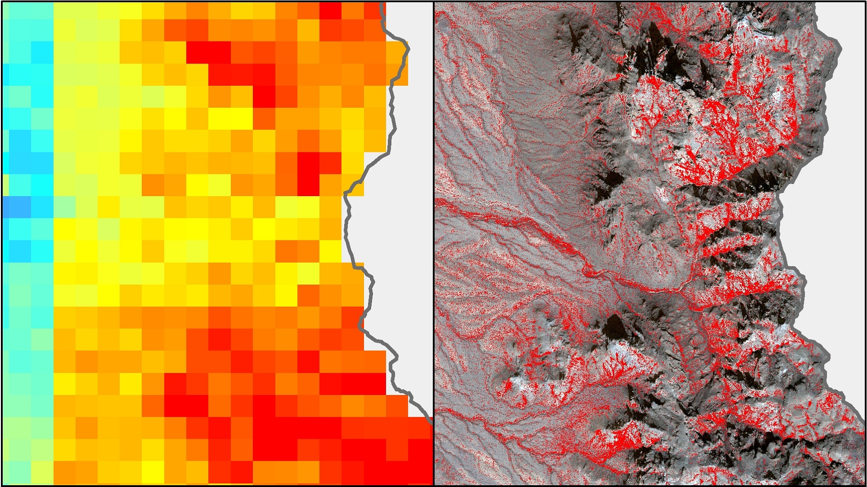

**Caption:** CLaRe correlation image created from MODIS NDVI and PRISM precipitation data(left); MTMF target result image created from WorldView-2 (right). Image Credit: Southern Arizona Ecological Forecasting Team.

**Image:** 2016Fall_JPL_SouthernArizonaEco_VPSImage.jpeg