**NASA DEVELOP National Program**



NASA Ames Research Center

*Fall 2016*

Elkhorn Slough Ecological Forecasting II

Utilizing NASA Earth Observations to Understand the Effects of Sea Level Rise and Climatic Variation on Blue Carbon Sequestration, Marshland Extent, and Vegetation Health in California’s Elkhorn Slough

 **Technical Report**

November 17, 2016

Melanie Feen

Hannah Friedrich

Stephanie Ly

Dr. Juan L. Torres-Pérez, Bay Area Environmental Research Institute (Science Advisor)

Dr. Sherry L. Palacios, Bay Area Environmental Research Institute (Science Advisor)

Previous Contributors:

Irma Caraballo Álvarez

Abigail Childs

Kirsten Jurich

Martha Sayre

Dr. Ken Johnson (Monterey Bay Aquarium Research Institute)

**1. Abstract**

Elkhorn Slough is an ecosystem of high biodiversity found in Monterey Bay, California that protects coastline erosion, naturally filters water, provides critical habitat for unique species, and sequesters carbon. However, Elkhorn Slough is experiencing tremendous loss of its marshland extent and stress to vegetation due to threats of rising sea levels and climatic variation. These changes present an opportunity to identify spatial changes and patterns utilizing remotely sensed imagery and forecast the resilience of the Slough under different climatic scenarios. This study uses Landsat imagery to detect vegetation growth and loss within the Slough from 1997 to present, and map the Slough’s evolution across time and space following large El NiñoSouthern Oscillation (ENSO) years. In addition, this study integrates Sentinel-2/Airborne Visible and Infrared Imaging Spectrometer (AVIRIS) to compare current day marsh extent and health with *in situ* data provided by Elkhorn Slough National Estuarine Research Reserve (ESNERR). The Marsh Equilibrium Model (MEM) also incorporates inputs from *in situ* data to predict Elkhorn Slough’s resilience and adaptation to suspended sediment variations and sea level rise scenarios. These comprehensive historical and present-day analyses, in conjunction with the assessment of future marsh resilience from the model, offer spatial and temporal insights into Elkhorn Slough’s ecological feedbacks. The results from this study will inform ESNERR of Elkhorn Slough’s condition to help future management of this important ecosystem.

**Keywords**

Remote sensing, Landsat, Sentinel-2 MSI, El Niño, vegetation indices, Marsh Equilibrium Model (MEM), sea level rise (SLR)

# 2. Introduction

* 1. *Background Information*

Tidal marshes are among the most highly productive and ecologically important ecosystems on the planet. They provide a multitude of ecosystem services, such as breeding and nursing grounds for endemic species, protecting coastlines and infrastructure from destructive flooding, naturally filtering water, and sequestering carbon (Stralberg et al., 2011). However, tidal marshes are experiencing tremendous stress due to climate change (Parker et al., 2011). While marsh ecosystems cover approximately 140 million hectares of Earth’s surface, they are disappearing at a rate of 1-2% annually with over 50% of global coverage already lost (Crooks et al, 2011). This significant marsh loss is attributed to accelerated sea level rise (SLR), which causes salt water inundation. This inhibits vertical accretionary processes which stabilize marsh elevation and vegetation health (Kearney et al., 2009). If this trend continues, the loss of marshes will result in considerable costs to the environment. Given the significance of this ecosystem and the risks posed by climate change, this project examined the past, present and future of Elkhorn Slough, a salt marsh located on the Central Coast of California.

Researching historical and future adaptability of coastal marine ecosystems is critical to understanding the implications of SLR on marsh vegetation health and extent, soil accretion, and carbon sequestration. Since it is expensive and labor-intensive to complete traditional field surveys of a region, remote sensing is an effective tool to synoptically study the distribution and dynamic changes of an area. Elkhorn Slough National Estuarine Research Reserve (ESNERR) actively measures marsh health in the Slough by collecting field observations and research for estuary restoration. To supplement the research facilitated by ESNERR, the previous DEVELOP Elkhorn Slough Ecological Forecasting project integrated *in situ* data with remote sensing observations to assess eutrophication impacts in the marsh. This study builds upon previous research by using medium to high resolution satellite imagery to analyze historical and present vegetation health in Elkhorn Slough, with particular attention to changes following climatic events like El Niño Southern Oscillation (ENSO). Using historical observations to evaluate marsh health is important given the drastic anthropogenic changes the Slough has undergone, such as draining and diking (Van Dyke & Wasson, 2005). In order to gain a more comprehensive understanding of the Slough’s future responses to climatic variations, the Marsh Equilibrium Model (MEM) was utilized to forecast marsh resilience to sea level rise over the next 100 years. The model takes into account projected SLR scenarios and the role vegetation plays in eco-geomorphic feedbacks to evaluate Elkhorn Slough’s extent over the upcoming century.

By mapping historical changes in Elkhorn Slough and forecasting into the future, both remote sensing and modelling serve as tools for monitoring and managing this important ecosystem. This study provides spatio-temporal information on marsh vegetation health, extent, and its capacity to adapt under threats of sea level rise and global climate change, in the hope of improving existing scientific knowledge of Elkhorn Slough.

* 1. *Study Area*

Situated in Monterey Bay, California, Elkhorn Slough is a seven mile long and 12 km2 wetland, making it the second largest tract of tidal salt marsh in California. This wetland system was selected as a case study for its ecological importance as a State Ecological Reserve and Wildlife Management Area. Elkhorn Slough is a highly productive tidal marsh ecosystem home to diverse aquatic and terrestrial wildlife and vegetation species, predominantly pickleweed (*Sarcocornia pacifica).* Elkhorn Slough provides a number of other vital services as well, including protecting the coastline from erosion and flooding, and sequestering large amounts of carbon each year (ESNERR, 2016).

While Elkhorn Slough serves many important functions, it has undergone significant changes in the past and continues to face both local and global threats. The Slough’s salt marshes have declined at an alarming rate to half of its former marshland extent in the past 150 years due to anthropogenic consequences and environmental effects associated with climate change (ESNERR, 2016). The Slough has had a history dominated by human modifications to its environment with more than half of the marshland lost to dikes, and over two thirds of marshlands converted to other habitat types (Dyke and Wasson, 2005). Diking of tidal marshes restricts the tidal flow and subsequently affects the distribution of marsh vegetation. In addition, El Niño Southern Oscillation (ENSO) and drought climatic anomaly events that occurred throughout the study period have had significant impacts on Elkhorn Slough, like tidal flooding and non-native species invasion (ESNERR, 2016). Furthermore, expected sea level rise and increasing land development to agriculture will affect the ability and capacity of Elkhorn Slough to migrate in the future. These human and environmental impacts are currently the greatest threat to the future existence of this tidal marsh, and thus, are the subject of further investigation to assess the Slough’s vulnerability and potential resilience.

*2.3 Study Period*

The project investigated Elkhorn Slough’s dynamics with a historical time-series spanning between the 1997 to 2016 time range (which includes large El Niño years), a vegetation analysis focusing on the 2016 year using 10m resolution Sentinel-2A imagery, and a future analysis of Elkhorn Slough through the Marsh Equilibrium Model (MEM) projecting forward 100 years.

*2.4 Objectives*

This project addressed the ecological forecasting and climate initiatives applications of NASA’s Applied Science Program. The main objectives of this project included a historical and current day assessment of marshland vegetation health and extent using Landsat and Sentinel-2 observations, as well as a future prediction of marsh health and carbon sequestration capabilities using the MEM. Predicting marsh resilience in the MEM under different scenarios of sea level rise and climatic variations informed ecological forecasting and climate initiatives. Using NASA Earth observations for this project, changes in Elkhorn Slough following ENSO years were identified using vegetation indices as metrics for analyzing marsh vegetation health, further providing information for climate initiatives about past marsh behavior and climatic trends. The results of the study informed end-users of potential marsh restoration sites and offered the MEM as a resource for future decision-making processes in Elkhorn Slough.

*2.5 Project Partners*

This project was conducted in collaboration with Elkhorn Slough National Estuarine Research Reserve (ESNERR). This organization serves as a land trust for the Slough and conducts a variety of research aimed to inform policies regarding restoration practices in preserving the marsh. The outcome of this study aimed to better inform the project partner’s involvement with the Tidal Wetlands Plan (TWP), which is an ongoing five-year plan to restore the marsh through sediment addition, pollution reduction, and increased research efforts (Tidal Wetland Project, 2014). With climate change, outcomes of this study may be used to determine which marsh areas are most susceptible to the impacts of sea level rise, enabling the partners to focus their restoration efforts in that given location. Dr. Kristin Byrd from the United States Geologic Survey (USGS) Western Geographic Science Center is a collaborator in this project. She wrote her dissertation on Elkhorn Slough and also offered expertise working with the MEM.

**3. Methodology**

***3.1 Data Acquisition***

*3.1.1 Landsat Satellite Imagery Acquisition*

Landsat imagery was used to create a time series of Elkhorn Slough because the Landsat collection has an extensive dataset with images consistently captured every 16 days at 30 m resolution. Top-of-Atmosphere (TOA) corrected imagery from Landsat 5 Thematic Mapper (TM) and Landsat 8 Operational Land Imager (OLI) were acquired from Google Earth Engine’s (GEE) public data catalog. The Landsat data is made available in Earth Engine with an Fmask quality band applied to mask cloud and cloud shadows in each image scene. The eight downloaded Landsat scenes cover the entire study area of Elkhorn Slough located along the central California coast, following path 44 and row 34. The images were downloaded and processed through Google Earth Engine to include large ENSO years (Table 1).

**Table 1.** El Niño Dates acquired for Landsat 5 TM and Landsat 8 OLI Images

|  |  |
| --- | --- |
| **Landsat Earth Observation System** | **Date of Image** |
| Landsat 5 Thematic Mapper (TM)  GEE Image Collection ID: LANDSAT/LT5_L1T_TOA_FMASK | 06/23/1997  06/26/1998  06/05/2002  06/24/2003  04/05/2009  04/08/2010 |
| Landsat 8 Operational Land Imager (OLI)  GEE Image Collection ID: LANDSAT/LC8_L1T_TOA_FMASK | 06/25/2015  06/27/2016 |

*3.1.2 Sentinel-2 MSI and AVIRIS Imagery Acquisition*

Imagery for the current day *in situ* data comparison was chosen as close as possible to mid-September, 2016 when the *in situ* data was collected by ESNERR. Acquisition for the Sentinel-2 image was conducted using Image Collection on Google Earth Image to filter all Sentinel-2 imagery over Elkhorn Slough from August 2016 to current day. The Sentinel-2 image with the least cloud cover was collected on August 13, 2016. The spatial resolution for Sentinel 2 imagery ranges from 10 m (visible and two NIR bands), 20 m (four Red Edge and two SWIR bands), and 60 m (aerosols, water vapor, and cirrus bands) [Appendix, Table 1].

The AVIRIS data portal was used to acquire the AVIRIS Classic Image closest to mid-September 2016 taken on June 22, 2016. The spatial resolution was 16 meters for this particular flight path over Elkhorn Slough.

*3.1.3 Ecological Forecasting*

*In situ* data was provided by ESNERR, which included marsh elevations, sediment accretion, peak biomass, and suspended sediment concentrations. ESNERR also provided root:shoot ratios measured by Joanna Nelson, Ph.D. (University of California - Santa Cruz, 2011). The 2009-2011 CA Coastal Conservancy Coastal Lidar Project dataset and the 2013 NOAA Coastal California TopoBathy Merge Project were downloaded on NOAA Digital Coast Data Access Viewer. 2010 and 2014 National Agriculture Imagery Program (NAIP) data were downloaded from USGS Earth Explorer.

*3.1.4 Study Area Boundary*

In order to maintain consistency with tidal variations, a shapefile of unrestricted tidal flow marsh area was provided by Charlie Endris, GIS Specialist at ESNERR, to clip all imagery.

***3.2 Data Processing***

*3.2.1 Landsat Historical Change Series*

The Landsat time series was used to identify patterns and changes in vegetation health within the surrounding unrestricted dikes of Elkhorn Slough. The images were filtered to major El Niño years within the April to June time-frame. Image timestamps were cross-checked to NOAA’s Tides & Currents historical dataset for the Monterey Bay station to ensure tidal level consistency. This was accomplished by taking the average of the daily water level obtained from the NOAA Monterey Station’s historical dataset, and verifying that the Landsat image was captured when the hourly water level was below the mean. The Landsat imagery was clipped to the study area boundary and processed in Google Earth Engine by applying Normalized Difference Water Index (NDWI) to bands 2 and 4 of each Landsat 5 scene, or bands 3 and 5 of each Landsat 8 scene, and then applying a mask to remove known water areas. A Normalized Difference Vegetation Index (NDVI) was applied to the masked imagery to calculate the NDVI difference for two composites from June 1997 and April 2016, as well as for every consecutive El Niño year(s) in the study period. A minimum of -1 and a threshold maximum of 1 were specified and an NDVI palette was added to visualize increases and decreases in vegetation productivity. The resulting image of the NDVI difference was exported to Google Drive and downloaded as a TIFF image into ArcMap to identify trends within Elkhorn Slough for visual comparison between the ENSO years.

*3.2.2 Sentinel-2 Current Day Vegetation Mapping*

After introducing the chosen Sentinel 2 image [Appendix, Figure 1], the Study Area (unrestricted tidal marsh) boundary was imported into Google Earth Engine through a Fusion Table. The image was then clipped to the Study Area boundary. First, a true color (Red, Green, Blue) image was displayed [Appendix, Figure 2]. Supplementary visualizations were created, which include a NIR image (vegetation displays as bright red) [Appendix, Figure 3] and the band combination (SWIR, NIR, Green) [Appendix, Figure 4], which also highlights marsh vegetation. These supplementary visualizations were made to familiarize ourselves with where vegetation dominated as a land cover in Elkhorn Slough. In order to avoid calculating floating or submerged vegetation like algae in the water channel, a Normalized Difference Water Index (NDWI) was applied [Appendix, Figure 5] to mask out any water pixel with a NDWI of greater than 0.1. The number 0.1 was chosen as the threshold as any number greater than 0.1 included all water pixels. The resulting masked image was the image that the vegetation indices would be applied to [Appendix, Figure 6].

The indices chosen were based on a previous marsh vegetation study conducted by Frampton et al. (2013), which analyzed how vegetation indices applied to Sentinel 2 imagery accurately assess marsh productivity. The Sentinel-2A Multispectral Instrument has the capacity to detect “red edge” (705-783 nm) spectral responses. This red edge position (REP) is predominately used to measures leaf area index (LAI) and leaf chlorophyll content (LCC), which can infer the health and productivity of vegetation (Frampton et al., 2013). Therefore, the vegetation indices analyzed with the Sentinel-2A image utilized the two NIR and two of the four red edge bands to highlight vegetation variance across Elkhorn Slough. These indices include NDVI, Normalized Difference Index 45 (NDI45), and the Inverted Red-Edge Chlorophyll Index (IRECI), which has been shown to have the strongest correlation for detection of leaf chlorophyll content (Frampton et al., 2013) (Table 2 below). The resulting images were then exported out of Google Earth Engine and brought into ArcGIS for analysis with the *in situ* point level data.

**Table 2.** Vegetation Indices applied to Sentinel-2 Image

|  |  |  |
| --- | --- | --- |
| Vegetation Index | Formulation | S-2 Bands Used |
| Normalized Difference Vegetation Index (NDVI) | (NIR - R)/(NIR + R) | (B7 - B4)/(B7 + B4) |
| Normalized Difference Index 45 (NDI45) | (NIR - R)/(NIR + R) | (B5 - B4)/(B5 + B4) |
| Inverted Red-Edge Chlorophyll Index (IRECI) | (NIR - R)/(RE1/RE2) | (B7 - B4)/(B5/B6) |

*3.2.3 Ecological Forecasting*

The Marsh Equilibrium Model (MEM) Versions 3.76 and 5.45 were used as a tool to predict marsh resilience to climate change (Morris et al., 2002). Since the model was created for a different marsh ecosystem, the model was calibrated following methods outlined in Schile et al. (2014) using a combination of *in situ* data provided by ESNERR and values from the China Camp State Park, San Francisco Bay Estuary study conducted by Schile et al. (2014). The China Camp location was chosen as a proxy site because of its similarity to Elkhorn Slough, as both are salt marsh ecosystems with Mediterranean climates (Schile et al., 2014; Caffrey, 2002). Model inputs provided by ESNERR included the mean higher high water mark, mean sea level, suspended sediment concentration, marsh elevation, maximum peak biomass, and the elevation at which vegetation grows. Organic matter decay rate, belowground biomass, refractory fraction, and maximum root depth were not measured for Elkhorn Slough, so inputs were obtained from the China Camp study (Schile et al., 2014). Root:shoot ratios measured by Joanna Nelson for Elkhorn Slough in a previous year and for the China Camp State Park by Schile et al. (2014) were both used to inform the corresponding model input. The trapping coefficient and settling velocity were kept at the values set in the model for version 3.76 (Morris et al., 2002). The model was calibrated for Elkhorn Slough ecosystem following Schile et al. (2014) by hindcasting from 1916 to present day with a long term sea level rise rate of 0.14 cm/year determined by the NOAA Tides & Currents Mean Sea Level Trend for the Monterey Bay tide station (2013) [Appendix, Table 2].

***3.3 Data Analysis***

*3.3.1 Landsat Historical Change Series*

As preliminary validation, Landsat imagery downloaded and processed from Google Earth Engine were compared to Charlie Endris’ 2004-2012 National Agricultural Imagery Program (NAIP) data for analysis of Landsat’s capabilities to detect comparable land cover change at 30 m resolution. This was done by creating two land cover classes of polygons within our study area in Google Earth. The two classes included 66 polygons of mudflat and 59 polygons of pickleweed vegetation, which were both saved as KML files, brought into Google Fusion Tables, and imported into Google Earth Engine. Once the training pixels were imported into GEE and the Landsat image was classified, we compared our results to Charlie Endris’ NAIP data and determined that Landsat’s resolution was too coarse to accurately detect land cover change in the marsh. From this conclusion, we decided to forgo analyzing marshland extent and pursue creating a historical time-series of vegetation health using the NDVI index instead.

We gathered NDVI statistics for each El Niño year as well as statistics of the NDVI difference between El Niño years by creating histogram charts in GEE, downloading the histogram data in Excel, and calculating the average annual NDVI values. We plotted the NDVI average by El Niño year with the ENSO Index Average to compare the two variables [Appendix, Figure 7]. This linear regression analysis of the entire study area attempted to identify a relationship between vegetation productivity and El Niño. To gain a more in-depth analysis of this relationship, we split the study area into three polygons based on lower, middle, and upper marsh, and ran the NDVI histograms on each segment [Appendix, Figure 8]. We compared the average annual NDVI values with the average annual ENSO index for lower marsh, middle marsh, and upper marsh to measure their linear correlation and evaluate increases and decreases in vegetation cover by ENSO year.

In addition, a sub-analysis was performed by adding Landsat imagery from years preceding El Niño. The images were acquired from 1996, 2001, 2006, and 2013, and were used as control groups for El Niño years (Table 3). We visually compared maps of vegetation productivity for “normal” years before an El Niño with our maps of vegetation productivity during the subsequent El Niño year (Appendix, Figure 9). The purpose of producing these maps was to provide an additional perspective of Elkhorn Slough’s dynamic past, as well as to comparatively analyze the effects of climatic patterns on vegetation health.

**Table 3.** Dates for “Control Years” Preceding El Niño acquired for Landsat Images

|  |  |
| --- | --- |
| **Landsat Earth Observation System** | **Date of Image** |
| Landsat 5 Thematic Mapper (TM)  GEE Image Collection ID: LANDSAT/LT5_L1T_TOA_FMASK | 05/03/1996  03/30/2001  06/16/2006 |
| Landsat 8 Operational Land Imager (OLI)  GEE Image Collection ID: LANDSAT/LC8_L1T_TOA_FMASK | 04/16/2013 |

*3.3.2 Sentinel-2A Current Day Vegetation Comparison with In Situ Data*

*In situ* data was collected by ESNERR along eight transects across Elkhorn Slough at eight different marshes. Each transect consisted of ten 50 cm squared quadrats that were taken every ten meters along one transect. The *in situ* dataset contained information on elevation, soil moisture, salinity, canopy cover, percent cover of woody and “juicy” pickleweed, and percent cover of other vegetation species [Appendix, Table 3]. ESNERR determined that the Pickleweed Health Index (canopy height + percent pickleweed cover + percent of quadrat that is “juicy” pickleweed) was the most representative variable of pickleweed health within a quadrat. Juicy pickleweed means that the plant is not woody, and the leaf width is plump and succulent. Of the 80 transects, 48 were included in our tidally unrestricted study area and contained some percent cover of pickleweed. Therefore, the quadrats compared with the imagery had a Pickleweed Health Index value greater than zero. Given pickleweed is the dominant vegetation species in Elkhorn Slough, any quadrats with no pickleweed were not included in the *in situ* and imagery comparison [Appendix, Figure 10]. After importing the three vegetation indices into ArcGIS, the *in situ* quadrat data was then added as points to ArcGIS.

For each of the 48 points, raster values from the three vegetation indices were extracted to the *in situ* point level data and populated in new fields of the *in situ* attribute table. This attribute table was then exported as a text file and opened in Excel. Regression analyses were performed in Excel to analyze how Pickleweed Health Index at different elevations and marshes (transect sites) in Elkhorn Slough linearly correlated with each of the three vegetation indices. The different elevation thresholds were broken down into high elevation marsh (>156 cm) and low elevation marsh (< 156cm). The threshold of 156 cm was chosen as it was the average elevation for pickleweed distribution based on data collected by ESNERR prior to the mid-September 2016 *in situ* data collection.

*3.3.3 Ecological Forecasting*

Once the MEM was calibrated to forecast the marsh’s resilience to sea level rise, the model was run under a variety of sea level rise scenarios and suspended sediment concentrations. Version 5.45 was used to assess future marsh health with sea level rise [Appendix, Table 4]. Since the MEM does not have a spatial component, the output was visualized on the 2013 NOAA Coastal California TopoBathy Merge Project. The DEM was linearly corrected using real time kinematic (RTK) elevation data collected by ESNERR, and NDVI calculations from 2010 National Agriculture Imagery Program (NAIP) imagery. DEM corrections were completed in R with code provided by Buffington et al. (2016). The 2010 NAIP imagery was used instead of the 2014 imagery to maintain consistency with the timing of the elevation data collection (Kevin Buffington, personal communication). The 2013 LIDAR project was used instead of the 2009-2011 because the model was designed for 1 m resolution NAIP and LIDAR data. The 2013 DEM project uses the 2009-2011 data but was available to download at the resolution required to run the LEAN model. The output from the MEM model was overlaid onto the corrected DEM using Excel and ArcMap Model Builder provided by Kristin Byrd (USGS) and developed by Lisa Schile (Schile et al., 2014).

# 4. Results & Discussion

*4.1 Analysis of Results*

*4.1.1 Landsat Historical Change Series*

The time series of vegetation health in Elkhorn Slough provided spatial and temporal insight of changes in pickleweed coverage due to climatic variations, like El Niño. An NDVI change average of 0.55 indicated increased vegetation productivity during El Niño years from 1997 to 2016, but with each El Niño year varying in degrees of vegetation density (pickleweed) and varying by region.

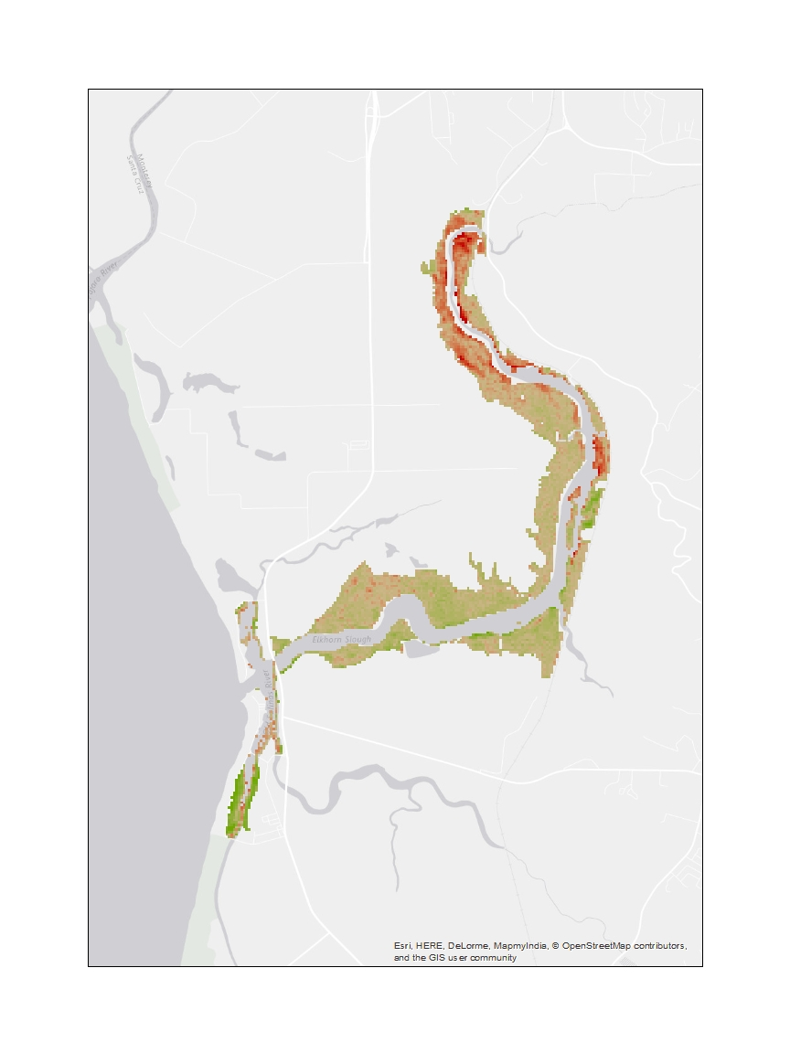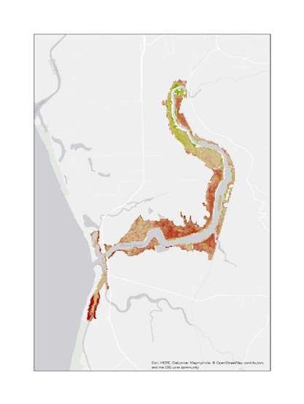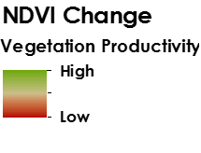While we expected to see greater effects during extreme events and generally better vegetation health during “normal” years before or after El Niño, we found that vegetation productivity decreased during control years without the presence of El Niño. This phenomenon was observed throughout the years preceding El Niño when compared with vegetation changes during ENSO events (Figure 1).

**1997 to 1998**

**1996 to 1997**

**Figure 1.** Comparative analysis of NDVI change from 1996 to 1997 and 1997 to 1998.

Based on the imagery analysis alone, it is unclear why vegetation health is worse in years without El Niño. We postulate the plants could be affected by changing soil characteristics and nutrient availability, or that there could be a lag effect for vegetation following El Niño. It would be highly beneficial to further research the effects of other climatic variables and identify the possibility of a lag effect on vegetation health.

In addition, the linear regression analyses of the NDVI average taken from the entire study area and the three delineated regions for each El Niño year yielded random correlation [Appendix, Figures 7 and 8]. This lack of a correlation could be attributed to Landsat’s lower spatial resolution of 30 m as well as the unpredictable nature of El Niño patterns. These confounding results open future research opportunities for our partners at ESNERR to continue exploring the relationship of other indices with NDVI.

*4.1.2 Sentinel-2A Current Day Vegetation Comparison with In Situ Data*

We attempted to validate the remotely sensed vegetation indices (Figure 2 below) with *in situ* data to provide insight into Elkhorn Slough’s vegetation health. In addition, we identified which elevation of the *in situ* data best correlated with Sentinel 2A. The regression analysis determined that remotely sensed imagery provides limited insight into study area dynamics of pickleweed health.

Our hypothesis was that the Pickleweed Health Index and the various vegetation indices would correlate strongly based on previous studies looking at the relationship between Sentinel 2 imagery and vegetation health measures like LAI and LCC. However, our results indicated weak, positive correlations with low R-squared values, confirming that these relationships are not statistically significant (Table 4 below). Nevertheless, we can deduce that in higher elevations, the Pickleweed Health Index correlates better than in lower elevations. This is especially evident with the IRECI index (see Figure 3). We can conclude that further analysis must be conducted to better understand how field data from Elkhorn Slough can validate the use of remotely sensed imagery.

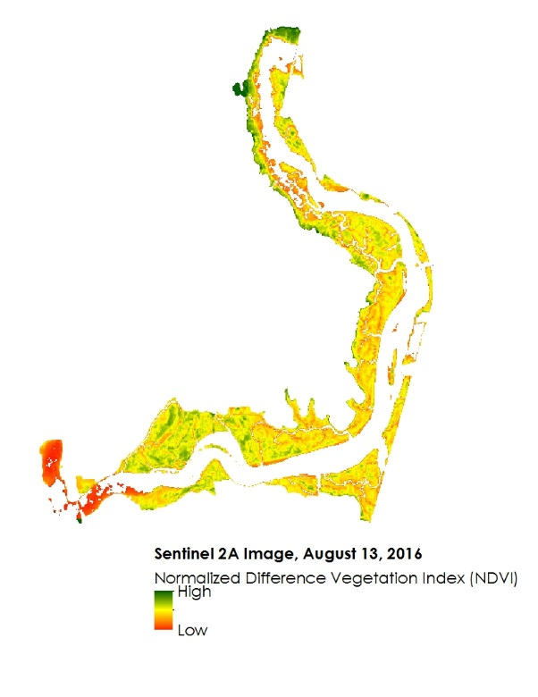 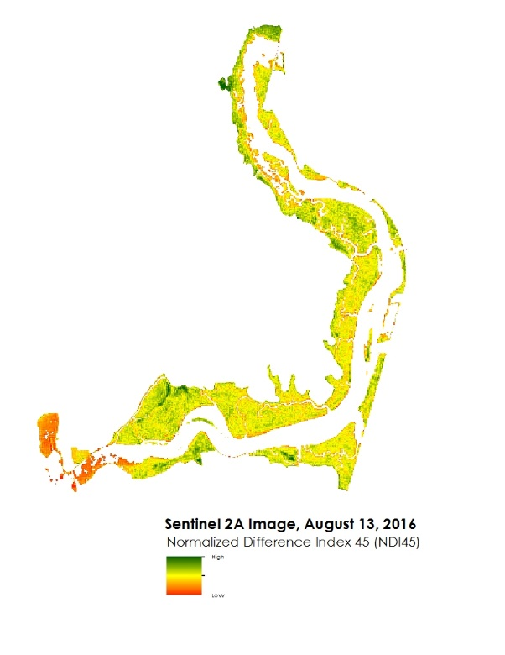 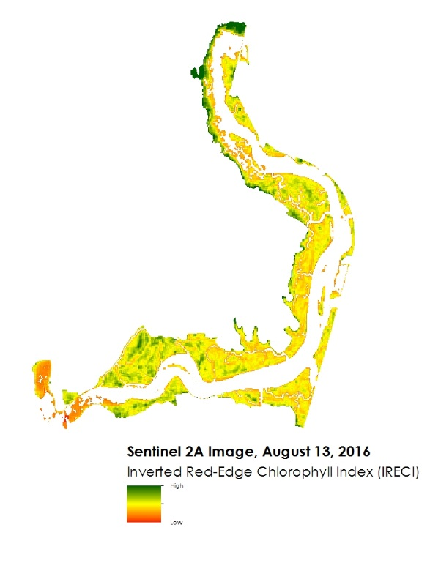

**Figure 2.** Visualization of Vegetation Indices shown with red representing lower index values and green representing higher index values. NDVI Image (left), NDI45 (center), IRECI (right). Legend (bottom center).

**Table 4**. Regressions run with calculated R-squared value

|  |  |
| --- | --- |
| **Regression** | **R-squared Value** |
| NDVI vs Pickleweed Health Index for High Elevations | 0.177 |
| NDI45 vs Pickleweed Health Index for High Elevations | 0.155 |
| IRECI vs Pickleweed Health Index for High Elevations | 0.34 |
| NDVI vs Pickleweed Health Index for Low Elevations | 0.067 |
| NDI45 vs Pickleweed Health Index for Low Elevations | 0.148 |
| IRECI vs Pickleweed Health Index for Low Elevations | 0.083 |
| NDVI vs Pickleweed Health Index for All Elevations | 0.219 |
| NDI45 vs Pickleweed Health Index for All Elevations | 0.271 |
| IRECI vs Pickleweed Health Index for All Elevations | 0.218 |

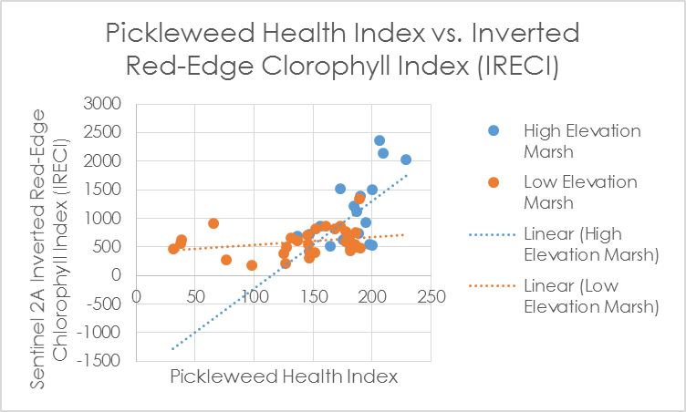

**Figure 3.** Scatterplot of IRECI and Pickleweed Health Index.

In summary, our results show insignificant R-squared values with subtle positive correlations between increased Pickleweed Health Index values and higher vegetation index values [See Appendix, Figure 11]. The weak relationships and low R-squared values can be attributed to the fact that the quadrats are only 50 cm by 50 cm, whereas a Sentinel 2 pixel in all three vegetation indices is 10 m. Comparing a point representing a 50 cm by 50 cm plot to a 10 meter pixel is likely to yield minimal correlations because a Sentinel 2 pixel can contain multiple land covers such as mud, water, or vegetation. Larger sample size of each elevation with larger quadrants may reveal stronger correlations in future analyses.

In regards to the AVIRIS Classic image, supervised classification was attempted using classification results given to us by Charlie Endris. The results, however, were not conclusive for identifying pickleweed without the spectral characteristics of pickleweed. Since no *in situ* spectral information was gathered from Elkhorn Slough for pickleweed, it would not be useful to incorporate the AVIRIS image given the time constraints of the project.

*4.1.3 Ecological Forecasting*

*Calibrating*

Hindcasting was found to be an unsuccessful calibration method of the MEM for Elkhorn Slough given the dynamic nature of the Slough in the past 150 years (Van Dyke, E. & Wasson, K., 2005). Present day accretion rates in the Slough are different from accretion over the past, making it challenging to discern which accretion rates the model outputs could best be compared with to assess how well the model is calibrated to Elkhorn Slough. However, it was observed that when running the MEM v3.76 model with the inputs outlined in Appendix Table 2, the model derived accretion rates were statistically the same as values observed in cores over the past 50 years (Table 5). The starting elevation for this model run was 181 cm NAVD, which was the average marsh elevation. However, this may not be representative of an accurate calibration because the marsh elevation input should be close to the elevation that the cores were collected at (Lisa Schile, personal communication) and changing the starting elevation will change the accretion and carbon sequestration rate. Additionally, the outputs of sediment accretion from the model were compared with sediment accumulation data collected in the field and this simulation does not account for any marsh subsidence.

**Table 5.** Results from hindcasting using the MEM 3.76.

|  |  |  |
| --- | --- | --- |
| Variable | Model | *In situ* |
| Sediment Accretion/Accumulation (cm yr-1) | 0.67 | 0.54 ± 0.2 |
| Carbon Accretion (g C m-2 yr-1) | 222 | 201 ± 47 |

In the newer model of MEM (5.41), we were advised not to use the self-calibrating to the accretion rate (Jim Morris, personal communication) because that was currently still in the updating/improvement process. We are currently uncertain about the status of this function for the 5.45 version of the model.

Given the assumptions made in being able to hindcast the marsh, it remains unclear whether the model is well calibrated to use for Elkhorn Slough. Despite the lack of evidence for how well the model is able to capture the dynamic and stressed state of the Slough, simulations were still completed to forecast marsh resilience to predict the future of Elkhorn Slough with climate change.

*DEM Correction*

The LIDAR Elevation Adjustment with NDVI (LEAN) model created by Buffington et al. (2016) corrected the LIDAR elevations using the RTK data provided by ESNERR with model computed NDVI from 2010 NAIP imagery. Correcting the DEM using the code provided by Buffington et al. improved the RMSE from 0.2 to 0.07. All corrected data is provided in the Appendix, Figure 13. Converting the elevation values from meters NAVD to elevation relative to mean sea level, and classifying the DEM based on present day cutoffs of vegetation growth based on elevation represents present day marsh features. Elevations below zero would be indicative of the water and channels. Elevations between 0 and 0.49 relative to mean sea level are consistent with present day pans and mudflats, between 0.49 and 0.74 would be consistent with low marsh elevation, and 0.74 to 1.59 with high marshes. Classifying vegetation based on elevation passed a visual inspection given what is known about where vegetation persists in Elkhorn Slough today (Figure 4).

*Model Output*

The MEM results showed that under mild sea level rise scenarios the marsh would improve (Figure 4). Mild sea level rise scenarios have been found to promote vegetation growth in field studies conducted by Morris et al. (2013). Similarly, Kirwan et al. (2016) proposed that not all marshes are vulnerable to sea level rise. However, whether or not these theories apply to Elkhorn Slough is still of question because there are many fundamental differences between the marshes the model was designed for and Elkhorn. Elkhorn Slough is dominated by pickleweed, which has been found to follow a wedge-shaped growth curve unlike the parabolic growth curve of *Spartina alterniflora* (Janousek et al., 2016; Morris et al., 2013). In order to run the 5.45 version without the model overflowing, the average biomass value and corresponding elevation for the entire marsh was used. This in effect, made the biomass-elevation curve more similar to that of *S. alterniflora*, which may explain these results. When running the model with the average high marsh biomass and elevation value, the model would overflow.

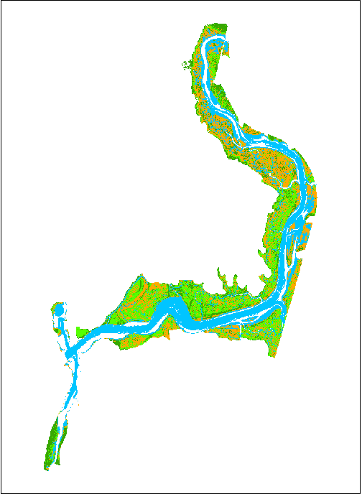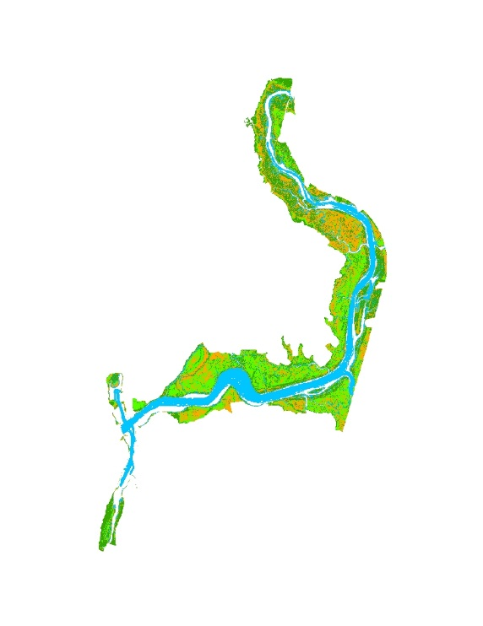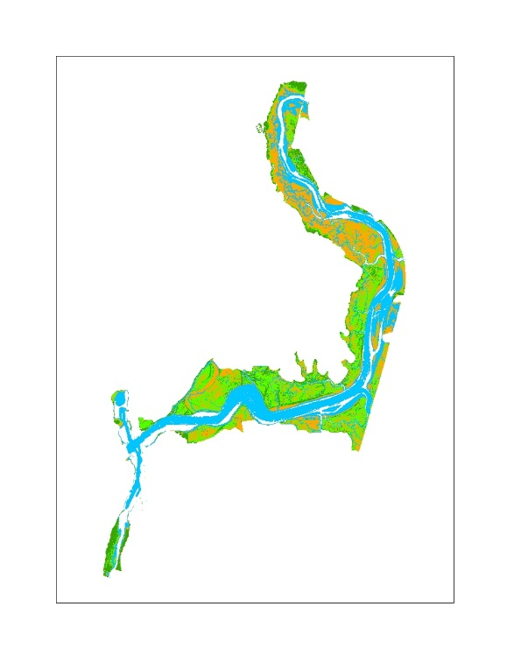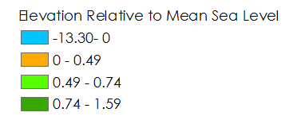

14 cm

100 cm

Corrected DEM

**Figure 4.** Using the MEM version 5.45 with conditions outlined in Table 4 in the Appendix, the marsh appeared to improve the marsh with low sea level rise conditions.

Since Elkhorn Slough is already showing signs of decline where the channels have widened and there are many mud-filled places within the marsh, it is possible that the marsh is still recovering from its past dynamic state and that the current version of the MEM is not capable of capturing this disequilibrium.

*4.2 Future Work*

As for future efforts to further analyze how remotely sensed imagery and forecast modeling can be used to analyze marsh health, we recommend analyzing the effects of other climatic variables like precipitation, drought, and water quality (drawing on NASA DEVELOP Elkhorn Slough Ecological Forecasting I Summer 2016 research).

Taking these results into account, we offer a few suggestions for future work comparing *in situ* data with imagery. Our first suggestion is to gather *in situ* data on a scale similar to that of the imagery pixel. If Sentinel 2A is used in the future, the plots should be 10 by 10 m rather than 50 cm by 50 cm. This may lead to a more positive trend between the Pickleweed Health Index and various vegetation indices. Secondly, it may be beneficial to gather an Elkhorn Slough-specific spectral signature for pickleweed and apply this to hyperspectral imagery like AVIRIS.

In terms of further work with the MEM, it would be beneficial to collect specific parameters for Elkhorn Slough and further investigate the relationship between peak biomass and the elevation relative to mean sea level. Ideally, this analysis would incorporate a sensitivity analysis of the model to peak biomass and to the elevation of peak biomass. It would also be helpful to compare the predictions of the MEM to additional models. This could be assessed by determining the present day carbon sequestration capabilities of the marsh using the Ecosystem Services Modeler (ESM) within the TerrSet Geospatial Monitoring and Modeling Software. Applying the Climate Change Adaption Modeler in combination with the ESM feature may be able to discern changes in carbon sequestration due to sea level rise.

# 5. Conclusions

Our study mapped Elkhorn Slough’s vegetation health across time and space utilizing remotely sensed imagery, as well as modeled the Slough’s resilience and adaptation to climatic variables in the future. Contrary to our initial expectations, we found worse vegetation health during years without the presence of El Niño when compared to vegetation productivity during historically climatic events like ENSO. In addition, our present day analysis found a statistically insignificant relationship between the Pickleweed Health Index and the three vegetation indices, despite former studies that found strong positive relationships. There were also discrepancies between current field observations of Elkhorn Slough’s condition with the projected future of the Slough using the Marsh Equilibrium Model. Therefore, in order to use this model for Elkhorn Slough, more research is necessary to understand how the biophysical inputs into the model can best capture Elkhorn Slough’s complex and dynamic nature.

By providing historical, present-day, and future perspectives, this project sought to identify innovative methods of detecting and forecasting change in Elkhorn Slough. Given the historical decline of marshland extent in the Elkhorn Slough, we employed remote sensing and modeling to offer spatio-temporal insight into the Slough’s ecological feedbacks in the hope of supporting future monitoring and management of this important ecosystem. The results of this study can inform our partners at Elkhorn Slough National Estuarine Research Reserve and their stakeholders of marsh restoration sites, and offer the MEM as a potential resource for evaluating future marsh survival.

# 6. Acknowledgments

We would like to thank Brittany Zajic and Jenna Williams for their continued support and guidance. We would also like to thank our science advisors, Dr. Juan L. Torres-Pérez and Dr. Sherry L. Palacios in addition to Dr. Kerstin Wasson, Andrea Woolfolk, Monique Fountain, and Charlie Endris of ESNERR and Dr. Kristin Byrd of the USGS.

Any opinions, findings, and conclusions or recommendations expressed in this material are those of the author(s) and do not necessarily reflect the views of the National Aeronautics and Space Administration.

This material is based upon work supported by NASA through contract NNL11AA00B and cooperative agreement NNX14AB60A.

# 7. References

Buffington, K.J., Dugger, B.D., Thorne, K.M., & Takekawa, J.Y. (2016). Statistical correction of lidar-derived digital elevation models with multispectral airborne imagery in tidal marshes. *Remote Sensing of Environment, (186),* 616-625.

Caffrey, J.M., Harrington, N., & Ward, B. (2002). Biogeochemical processes in a small California estuary. 1. Benthic fluxes and pore water constituents reflect high nutrient freshwater inputs.*Marsh Ecology Progress Series, (233)*, 39-53.

Crooks, S., Herr, D., Laffoley, D., Tamelander, J., & Vandever, J. (2011). Regulating Climate Change Through Restoration and Management of Coastal Wetlands and Near-shore Marine Ecosystems: Mitigation Potential and Policy Opportunities. *World Bank, IUCN, ESA PWA, Washington, Gland, San Francisco*.

Department of Commerce (DOC), National Oceanic and Atmospheric Administration (NOAA), National Ocean Service (NOS), Office for Coastal Management (OCM). (2012). 2009 - 2011 CA Coastal Conservancy Coastal Lidar Project<https://coast.noaa.gov/dataviewer/#/lidar/search/ where:ID=1124>.

Elkkorn Slough Tidal Wetland Project: About TWP. (n.d.). Retrieved October 03, 2016, from <http://www.elkhornslough.org/tidalwetland/description.htm>

Elkhorn Slough: Conservation. (n.d.). Retrieved September 29, 2016, from [http://www.elkhornslough.org/ conservation/index.htm](http://www.elkhornslough.org/%20conservation/index.htm)

Frampton, W. J., Dash, J., Watmough, G., & Milton, E. J. (2013). Evaluating the capabilities of Sentinel-2 for quantitative estimation of biophysical variables in vegetation. *ISPRS Journal of Photogrammetry and Remote Sensing*, *82*, 83-92.

Janousek, C. N., Buffington, K. J., Thorne, K. M., Guntenspergen, G. R., Takekawa, J. Y., & Dugger, B. D. (2016). Potential effects of sea-level rise on plant productivity: species-specific responses in northeast Pacific tidal marshes. *Marine Ecology Progress Series*, *548*, 111-125.

Kearney, M. S., Stutzer, D., Turpie, K., & Stevenson, J. C. (2009). The effects of tidal inundation on the reflectance characteristics of coastal marsh vegetation. *Journal of Coastal Research*, 1177-1186.

Kirwan, M.L., Temmerman, S., Skeehan, E.E., Guntenspergen, G.R. & Faherazzi, S. (2016). Overestimation

of marsh vulnerability to sea level rise. *Nature Climate Change, 6,* 253-260.

Morris, J.T., Sundareshwar, P.V., Nietch, C.T., Kjerfve, B., & Cahoon, D.R. (2002). Responses of coastal

wetlands to rising sea level. *Ecology*, *83*(10), 2869-2877.

Morris, J.T., Sundberg, K., Hopkinson, C.S. (2013). Salt marsh primary production and its responses to

relative sea level and nutrients in estuaries at Plum Island, Massachusetts, and North Inlet, South

Carolina, USA. *Oceanography, 26 (3),* 78-84.

National Oceanic and Atmospheric Administration (NOAA), National Ocean Service (NOS). (2013). NOAA

Tides & Currents. [https://tidesandcurrents.noaa.gov/sltrends/ sltrends_update.htm;jsessionid=C960D442D358770D7A0BB9CD27F2BD69?stnid=9413450](https://tidesandcurrents.noaa.gov/sltrends/%20sltrends_update.htm;jsessionid=C960D442D358770D7A0BB9CD27F2BD69?stnid=9413450)

Parker, V. T., Callaway, J. C., Schile, L. M., Vasey, M. C., & Herbert, E. R. (2011). Climate change and San Francisco bay-delta tidal wetlands. *San Francisco Estuary and Watershed Science*, *9*(3).

Tidal Wetland Project. (2014). Elkhorn Slough National Estuarine Research Reserve tidal wetland project 5 year plan.

Schile, L. M., Callaway, J. C., Morris, J. T., Stralberg, D., Parker, V. T., & Kelly, M. (2014). Modeling tidal marsh distribution with sea-level rise: Evaluating the role of vegetation, sediment, and upland habitat in marsh resiliency. *PloS one*, *9*(2), e88760.

Stralberg, D., Brennan, M., Callaway, J. C., Wood, J. K., Schile, L. M., Jongsomjit, D., Kelley, M., Parker, Thomas, P., & Crooks, S. (2011). Evaluating tidal marsh sustainability in the face of sea-level rise: a hybrid modeling approach applied to San Francisco Bay. *PloS one*, *6*(11), e27388.

Van Dyke, E., & Wasson, K. (2005). Historical ecology of a central California estuary: 150 years of habitat change. *Estuaries*, *28*(2), 173-189.

# 8. Content Innovation

**Content Innovation #1**

Audio Slides

Shared with Tiffani Miller through Google Drive

**Content Innovation #2**

VPS Video

**Content Innovation #3**

Inline Supplementary Material

* Table 1
* Table 2
* Table 3
* Table 4
* Table 5
* Figure 1
* Figure 2
* Figure 3
* Figure 4

**9. Appendices**

**Table 1.** Sentinel-2 MSI Spectral Bands

|  |  |  |  |  |
| --- | --- | --- | --- | --- |
| **S-2 Band** | **Use** | **Central Wavelength (nm)** | **Bandwidth (nm)** | **Spatial Resolution (m)** |
| 1 | Aerosols | 443 | 20 | 60 |
| 2 | Blue | 490 | 65 | 10 |
| 3 | Green | 560 | 35 | 10 |
| 4 | Red | 665 | 30 | 10 |
| 5 | Red Edge 1 | 705 | 15 | 20 |
| 6 | Red Edge 2 | 740 | 15 | 20 |
| 7 | Red Ege 3 | 783 | 20 | 20 |
| 8 | NIR | 842 | 115 | 10 |
| 8a | Red Edge 4 | 865 | 20 | 20 |
| 9 | Water Vapor | 945 | 20 | 60 |
| 10 | Cirrus | 1375 | 30 | 60 |
| 11 | SWIR 1 | 1610 | 90 | 20 |
| 12 | SWIR 2 | 2190 | 180 | 20 |

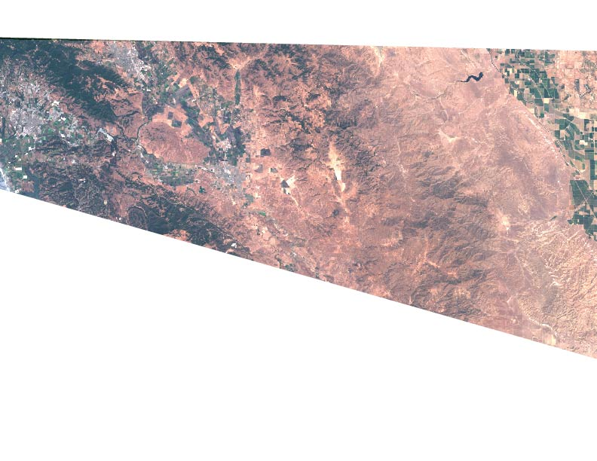

**Figure 1**. Unclipped, full scene Sentinel 2 True Color Image.

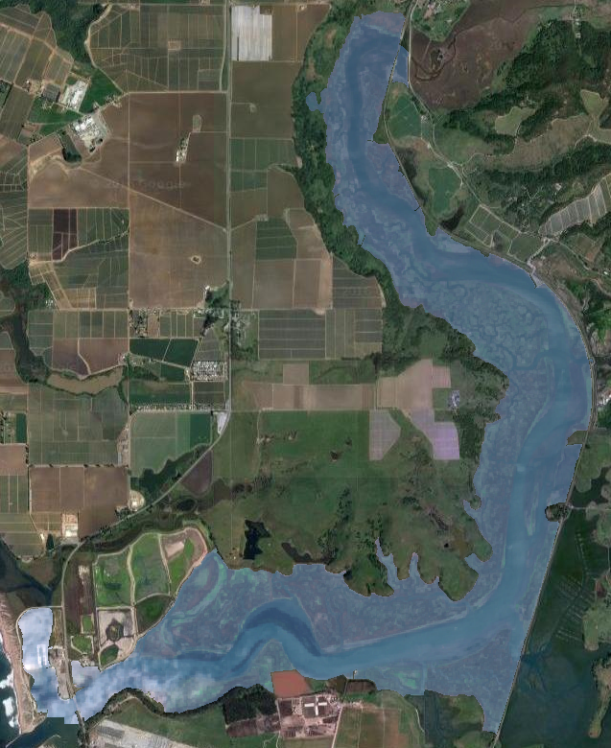

**Figure 2**. Clipped Sentinel 2 True Color Image.

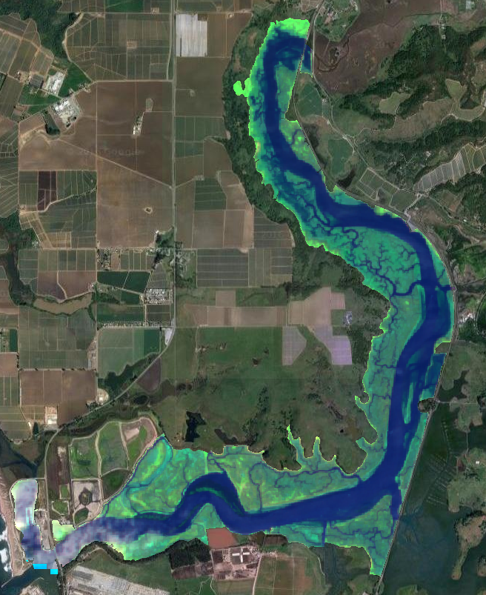

**Figure 3**. Sentinel 2 Image with band combination to highlight marsh vegetation (SWIR, NIR, Green)

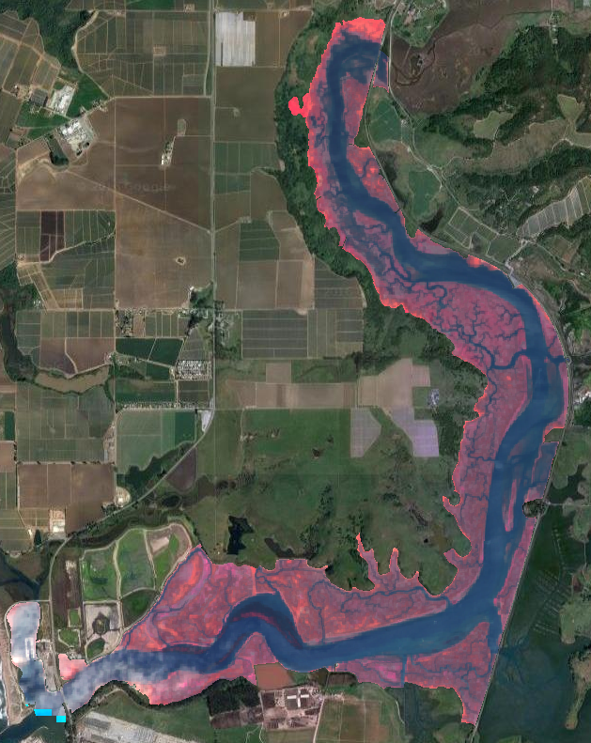

**Figure 4**. Sentinel 2 Image with band combination to highlight vegetation (NIR, Red, Green)

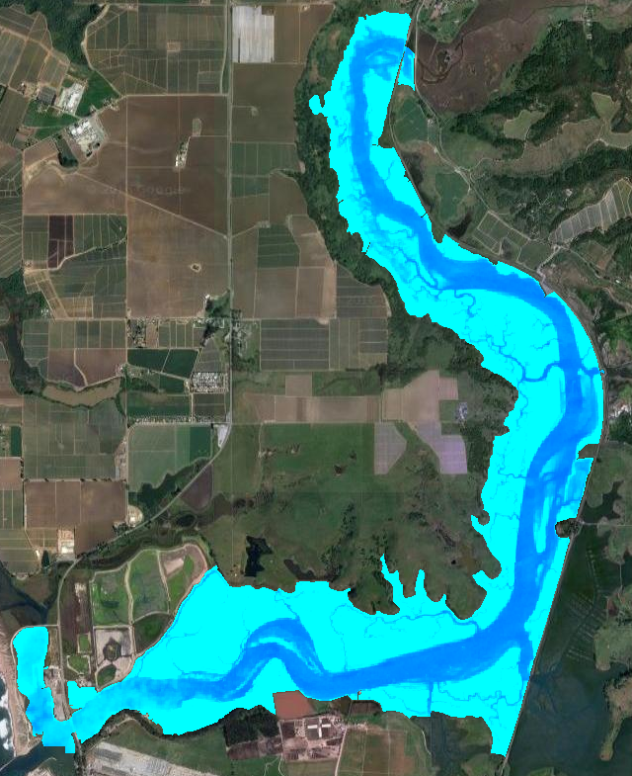

**Figure 5.** NDWI of study area (light blue = no water, dark blue = water)

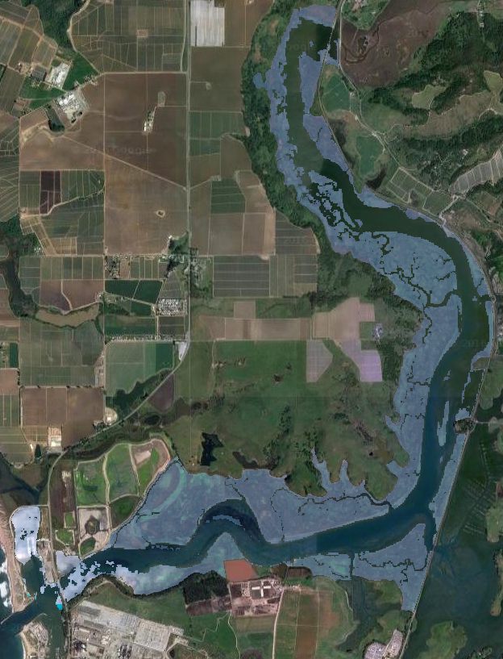

**Figure 6.** Clipped, water masked out true color image

**Table 2.** Marsh equilibrium model inputs for the calibration using version 3.76.

|  |  |  |
| --- | --- | --- |
| **Input** | **Input** | **Notes/Source** |
| Start (yr) | 1916 - calibration  2016 - forecasting | The model works by predicting a based on a century of sea level rise, so 100 years from present day was the start date for calibrating and present to forecast to 2116. |
| Century Sea Level Rise (cm) | 14 | NOAA Tides & Currents, Monterey Bay tides  (2013) |
| Mean High Water (cm NAVD) | 177 | Value provided by ESNERR. This is actually the mean higher high water to be consistent with Schile et al. inputs for China Camp (2014) |
| Mean Sea Level (cm NAVD) | 95 | ESNERR |
| Initial Rate SLR (cm/yr) | 0.14 | NOAA Tides & Currents, Monterey Bay tides (2013) |
| Suspended Se. Conc. (mg/liter) | 20 | ESNERR |
| Marsh Elevation (cm NAVD) | 181 | This was the average marsh elevation. Ideally it would be the elevation of the core site (Lisa Schile, personal communication) |
| Max Veg Elev (cm NAVD) | 225 | This is the maximum elevation that vegetation grows and was provided by ESNERR |
| Min Veg Elev (cm NAVD) | 135 | This is the minimum elevation that vegetation grows and was provided by ESNERR |
| Max Peak Biomass (g/m^2) | 3284.8 | This is supposed to be the peak biomass value, however to avoid using anomalous values the average biomass of the high marsh was used instead and was provided by ESNERR |
| Elev of Peak Biom (cm NAVD) | 201 | This is supposed to be the elevation corresponding to the peak biomass value, however to avoid using anomalous values the average elevation of the high marsh sites at which biomass data were collected was used instead and was provided by ESNERR |
| OM Decay Rate (1/time) | -0.3 | Value from the China Camp study by Schile et al (2014) |
| Root&Rhizome:Shoot Ratio | 2.5 | Value from the China Camp study by Schile et al (2014 |
| BG turnover rate | 1 | Value from the China Camp study by Schile et al (2014) |
| refractory fraction (kr) (g/g) | 0.1 | Value from the China Camp study by Schile et al (2014 |
| Max (95%) Root depth (cm) | 20 | Value from the China Camp study by Schile et al (2014) |

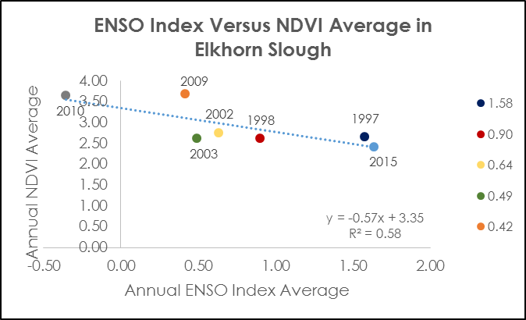

**Figure 7.** A regression analysis of the entire study area comparing Average Annual ENSO Index with Average Annual NDVI.

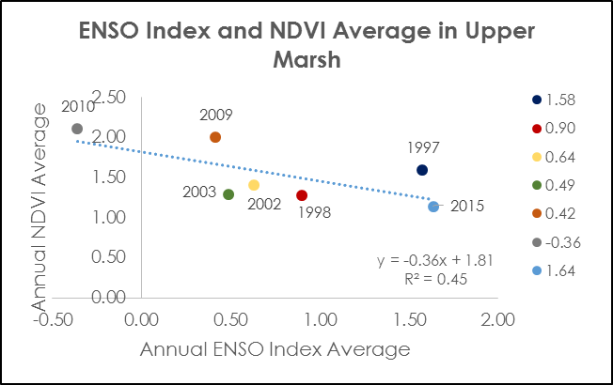

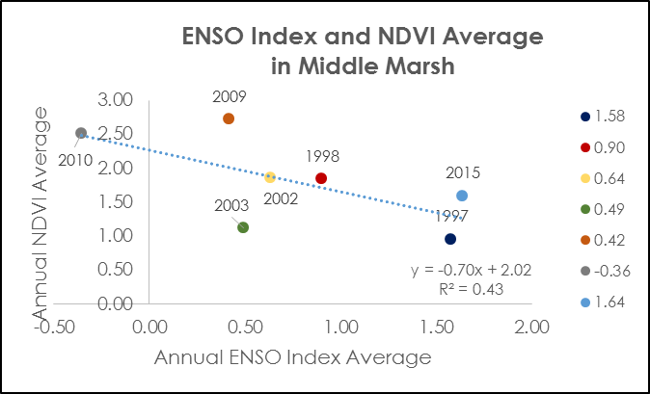

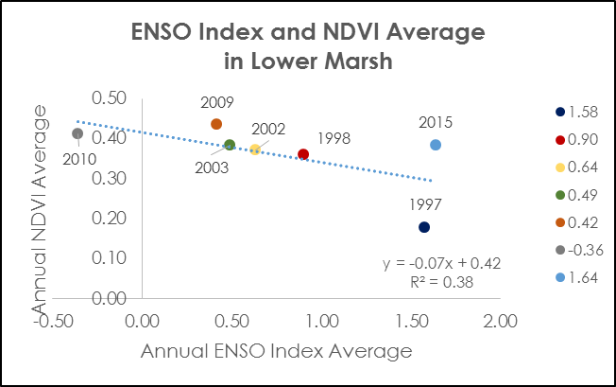

**Figure 8.** A series of regression analyses comparing ENSO Index and NDVI average for each El Niñoyear by region: upper marsh, middle marsh, and lower marsh.

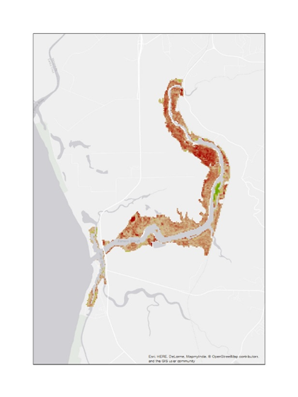



**1996 to 1997**

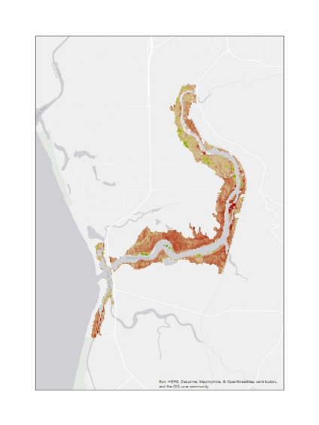

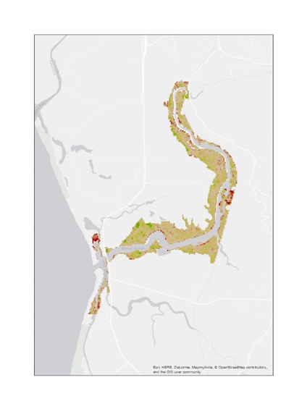

**2006 to 2009**

**Figure 9.** Maps indicating decreased vegetation productivity for years preceding El Niño.

**Table 3.** *In situ* data collected by ESNERR mid-September, 2016.

|  |  |
| --- | --- |
| **In Situ Variable** | **Description** |
| Date |  |
| Site ID | 8 transects total |
| Quadrat | 1 is at upload boundary, 10 at channel boundary |
| Distance | Meters from upland boundary |
| Latitude | Decimal Degrees |
| Longitude | Decimal Degrees |
| Elevation | Cm |
| Pickleweed only plant in quadrat? | Yes or No |
| Pickleweed Health Index | Canopy Height + Percent Cover + % Juicy (only plots with no other vegetation than Pickleweed) |
| NDVI | Calculated by Charlie Endris from NAIP Imagery |
| Canopy Height of Pickleweed | Cm |
| Pickleweed Health Category | High: Index > 150, Low: Index < 150 |
| % Pickleweed |  |
| % Juicy Pickleweed |  |
| % Woody Pickleweed |  |
| % of Pickleweed that is Juicy |  |
| % No live vegetation |  |
| % Dead annual grass |  |
| % Distichlis |  |
| % Frankenia |  |
| % Jaumea |  |
| % Atriplex prostrata |  |
| % Rabbitsfoot grass |  |
| Succulent width of Pickleweed (mm) | Average |
| Ground Firmness | F = firm, BS = bit squishy, S = very squishy |
| Crabs | 0 = no, 1 = yes |
| Groundwater | 0=no, 1=yes for whether groundwater was sufficient to sample |
| Salinity | at 15 cm; note "dry" if no pore water here |
| Pickleweed Description | Verbal description |

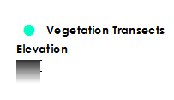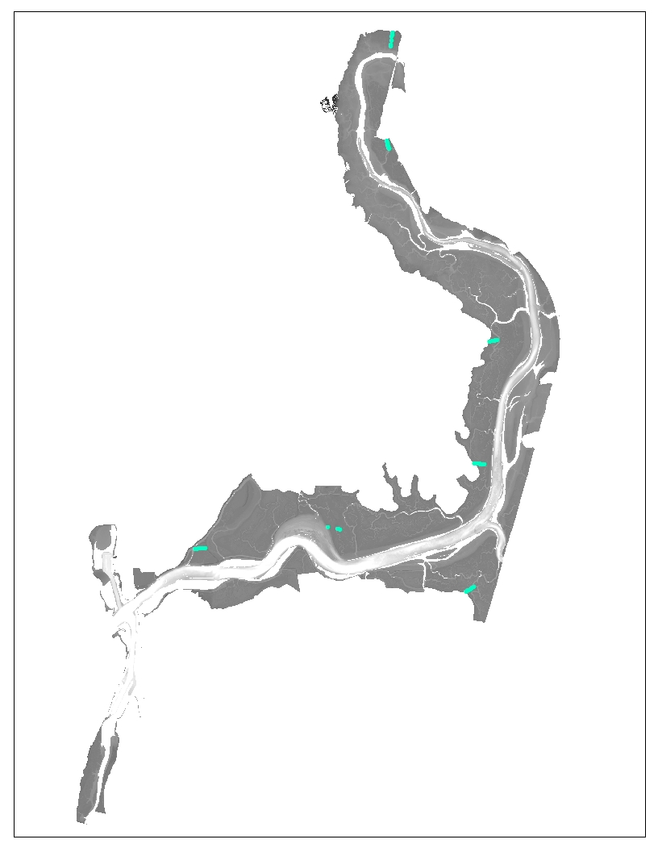

**Figure 10.** Map showing distribution of 48 quadrats used in *in situ* data and vegetation index analysis.

**Table 4.** Marsh equilibrium model inputs for forecasting using version 5.45.

|  |  |  |
| --- | --- | --- |
| **Input** | **Input** | **Notes/Source** |
| Sea Level Forecast (cm/100y) | 41 or 126 | NOAA Tides & Currents, Monterey Bay tides long term sea level rise of 14 cm plus the subsidence recorded by ESNERR of 27 cm  (2013) or a long term relative sea level rise of 126 cm (including subsidence and sea level rise) |
| Sea Level at Start (cm NAVD) | 95 | ESNERR |
| 20th Cent Sea Level Rate (cm/yr) | 0.4 or 1.26 | The Sea level rise divided by 100 years |
| Marsh Elevation @ t0 | Varied | The model was run at 10 cm increments of marsh elevation to get a range over the entire marsh |
| Suspended Min. Se. Conc. (mg/liter) | 20 | ESNERR |
| Suspended Org. Se. Conc. (mg/liter) | 5 | No *in situ* data was provided. |
| Accretion Rate (cm/yr) | 0.3 | This value was provided by ESNERR, although the calibrate to accretion rate function was not used, so this should not affect the model runs. |
| Max Growth Limit (cm rel msl) | 130 | This is the maximum elevation that vegetation grows and was provided by ESNERR |
| Min Growth Limit (cm rel msl) | 35 | This is the minimum elevation that vegetation grows and was provided by ESNERR |
| Max Peak Biomass (g/m^2) | 2067 | This is supposed to be the peak biomass value, however to avoid using anomalous values the average biomass of the high marsh was used instead and was provided by ESNERR |
| Elev of Peak Biom (cm NAVD) | 86 | This is supposed to be the elevation corresponding to the peak biomass value, however to avoid using anomalous values the average elevation of the high marsh sites at which biomass data were collected was used instead and was provided by ESNERR |
| %OM below root zone | 17.6 or 88 | It is unclear what the function of this value does to us. The model adjusts this value automatically. |
| OM Decay Rate (1/time) | -0.3 | Value from the China Camp study by Schile et al (2014) |
| Root&Rhizome:Shoot Ratio | 2 | Value from the China Camp study by Schile et al (2014 |
| BG turnover rate | 1 | Value from the China Camp study by Schile et al (2014) |
| Max (95%) Root depth (cm) | 20 | Value from the China Camp study by Schile et al (2014) |

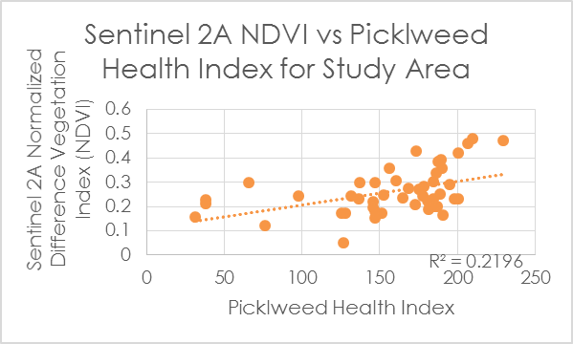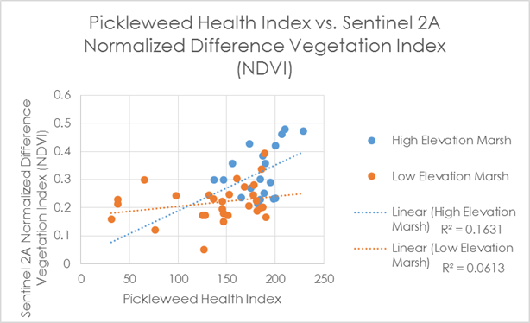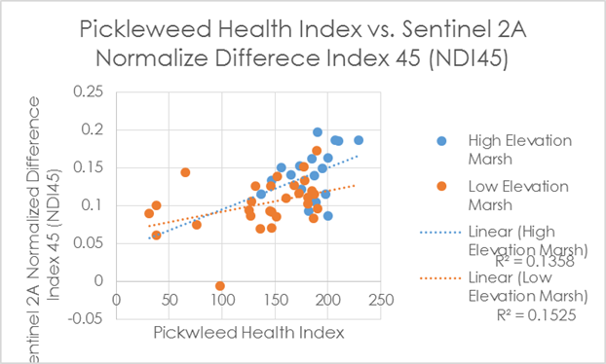

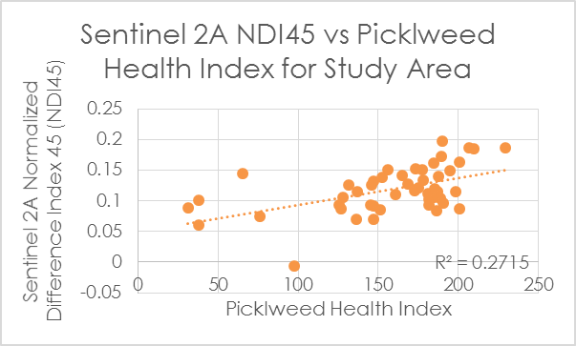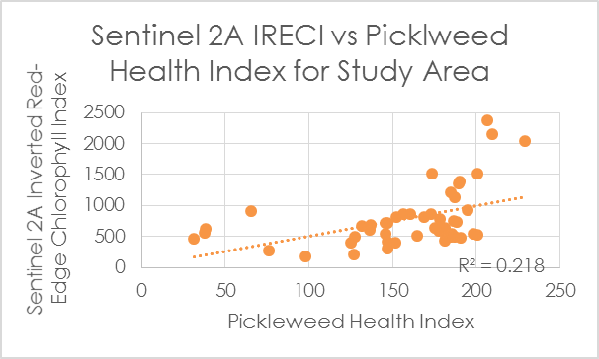

**Figure 11.** Graphs of *in situ* data and vegetation index regressions

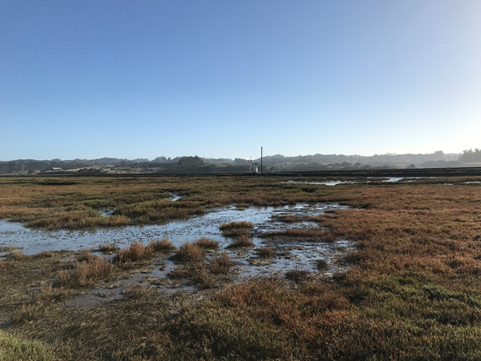

**Figure 12.** Image of mixed land covers in Yampah Marsh

**Figure 13.** Elevation data corrected using code provided by Buffington et al. (2016).