Unalakleet Climate

Analyzing Permafrost Degradation and Drainage Networks in Unalakleet, Alaska

 **Technical Report**

August 11th, 2023

Ian Lee (Project Lead)

M. Jaweed Nazary

Clara Maxwell

Daniel J. Marsden

***Advisors:***

Dr. Marguerite Madden, University of Georgia, Center for Geospatial Research (Science Advisor)

Dr. Franz Meyer, University of Alaska Fairbanks (Science Advisor)

Dr. Simon Zwieback, University of Alaska Fairbanks (Science Advisor)  
Dr. Anna Liljedahl, Woodwell Climate Research Center (Science Advisor)  
Dr. Chandi Witharana, University of Connecticut (Science Advisor)

***Fellow:***  
Sarah Payne (Georgia – Athens)

# 1. Abstract

The coastal community of Unalakleet is currently the 8th most at-risk community in Alaska due to the adverse effects of climate change that include permafrost degradation, severe coastal erosion, and sea-level rise-induced flood inundation caused by increasingly frequent storm surges. In response, the community has started a managed relocation with support from the Native Village of Unalakleet (NVU) and the National Renewable Energy Lab (NREL)’s Alaska campus in Fairbanks. The Unalakleet Climate NASA DEVELOP team partnered with NREL to provide remote sensing support and analysis for resilience planning in Unalakleet, supporting their ongoing relocation efforts and guiding future expansion. The team utilized Sentinel-1 C-Synthetic Aperture Radar (SAR), WorldView-2, and WorldView-3 datasets from 2017 – 2023 to analyze seasonal summer subsidence and utilized a 2014 Ancillary USGS 5 m Alaska DEM to conduct drainage network analyses that included watershed delineation and Height Above Nearest Drainage (HAND) analysis. The team also used high-resolution WorldView images to locate stable reference points that served as quality control for the team’s analyses. The team’s end products included maps containing subsidence and drainage zones information at and surrounding the relocation site. The team’s products provide NREL with valuable data that enables them to better assist Unalakleet’s managed relocation and assists Unalakleet with adapting to the catastrophic effects of climate change and build resilience in a community on the front lines of climate change.

**Key Terms**

Alaska, subsidence, InSAR, drainage networks, HAND, remote sensing, resilience planning, permafrost degradation

# 2. Introduction

***2.1 Background Information***

Climate change poses unique challenges to remote coastal communities, such as the Native Village of Unalakleet (NVU). NVU is situated in Western Alaska, bordered by Norton Sound to the west, and the Unalakleet river to the southeast. Due to its location, the village is experiencing increasingly frequent and intense impacts of climate change, including permafrost degradation, melting-induced flooding, coastal erosion, and sea level rise (USACE, 2019). The city is located on a 4-mile-long gravel spit, situated approximately 14 ft above sea level. However, the rate of erosion of ~2 feet per year from the Unalakleet River poses a significant threat to the longevity of NVU’s existing infrastructure (USACE, 2019). This has forced the community to plan and conduct a relocation ~1.5 miles northeast to a location at the base of the Nulato Hills (Figure 1).

The ecosystems surrounding Unalakleet have been vital to the community's 800 residents for centuries, offering abundant opportunities for hunting, fishing, and gathering. The area is known for its abundant salmon species and thriving wildlife that support hunting for both recreation and survival (USGS, 2004). However, permafrost degradation and severe coastal erosion have damaged these habitats, thereby affecting resource availability and access to hunting grounds. Furthermore, the indigenous people heavily rely on existing infrastructure like roads and the airport runway for transportation, and these are also impacted by the unstable ground due to the melting permafrost and erosion. Alaska’s surface terrain is ~85% permafrost, consisting primarily of rock, soil, and sediments that have been continuously frozen for at least two or more years (Alaska Department of Natural Resources, 2023). The uppermost layer of permafrost, known as the active layer, experiences seasonal freezing and thawing. As this layer freezes in winter, it expands and moves upward. Conversely, it moves downward as it thaws during the summer (Streletskiy et al., 2017). This process can lead to infrastructure damage. In this report, we refer to the upward movement of the ground as 'uplift,' and the downward movement as 'subsidence'. Quantifying the subsidence and uplift are vital for addressing the challenges posed to both the community and infrastructure in Unalakleet, and we conduct investigations into these changes from 2017 – 2023. It is imperative to note that while we are observing subsidence in a region with significant permafrost degradation, there is still much work to be done to confidently quantify how much of that subsidence can be attributed to permafrost degradation along with other environmental factors. Thus, throughout this paper we used the term subsidence instead of permafrost degradation when referring to the observed vertical displacement.

One method to quantify subsidence is utilizing space-borne radar remote sensing technologies, such as Synthetic Aperture Radar (SAR). A SAR instrument sends signals to the Earth's surface in radar waveforms and receives the returning waves. These radar waves oscillate between peaks and troughs, and the phase of the radar signal refers to the location on the oscillating waveform when radar is received by the satellite. Depending on whether they were at their peak, troughs, or somewhere in between, the radar phase will be different. The phase is measured in radians from - $π$ to $π$. The satellite also receives information on the radar strength. The received signals are then processed to create a high-resolution image called an interferogram, formatted in a way to store both the signal-phase and strength. The signal phase is useful to estimate ground displacement down to sub-centimetric levels while signal strength is useful to verify the quality of the radar data.

In addition to subsidence, extreme erosion impacting the banks of the Unalakleet River compounds the urgency of the community’s planned relocation. Prior studies analyzed surface hydrology, including river characteristics like flow accumulation, direction, stream networks and watershed extent using high resolution Digital Elevation Models (DEMs) (Tarboton, 1997). The DEMs are vital inputs for hydrological modeling, such as Height Above Nearest Drainage (HAND); HAND uses the relative vertical distance to the drainage lines to display an accurate representation of soil water environments and soil draining potential derived from the local topography (Nobre et al., 2011, Rennó et al., 2008). The HAND visualizations and localized drainage information are important for the community to identify infrastructure that is vulnerable to flooding and runoff and inform decision making for future construction. The drainage network information can also be analyzed along with subsidence data.

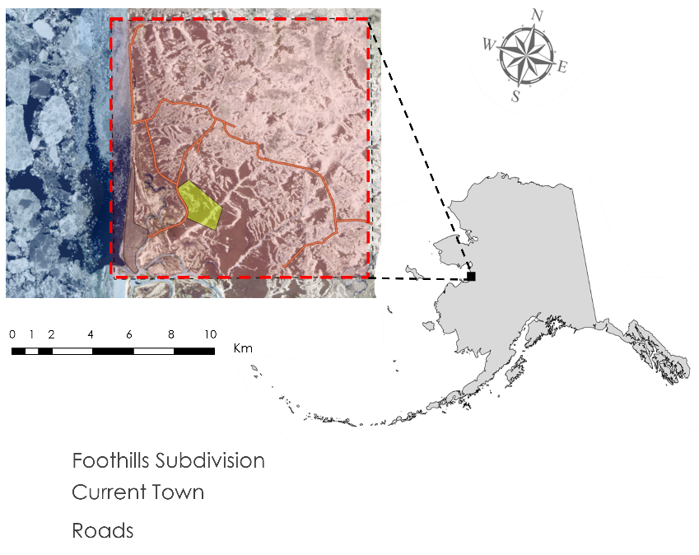

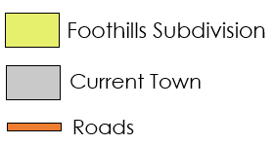

*Figure 1.* Location of the Unalakleet community in western Alaska. The study area is highlighted in the dashed red box overlain over the modified image derived from PlanetScope Image, May 10, 2023.

***2.2 Project Partners & Objectives***

This project collaborated with the National Renewable Energy Lab (NREL) to support the relocation of the village of Unalakleet. NVU has been exploring relocation since 2003, and the first phase began in 2020 at the selected site at the base of the Nulato Hills (or also known as the Foothills Subdivision). NREL’s objectives are to assist with this relocation and proactively respond to the negative impacts of climate change. To support our partner’s objectives, the team’s project has two primary objectives: 1) Analyze summer subsidence and drainage networks at and surrounding the Foothills Subdivision and the current town, 2) create static & interactive maps that highlight subsidence and drainage zones in the aforementioned locations. In their work, NREL strives to remain accountable, establish effective communication, respect the Indigenous knowledge and cultures, build and sustain relationships, and pursue responsible environmental stewardship. The end products provided by the NASA DEVELOP Unalakleet Climate team will aid NREL in determining stable locations for building new infrastructure, such as houses and roads. The partnership between NREL and NVU will enable the community to make well-informed decisions as they address the ongoing challenges of relocation, ensuring that long-term health and community resilience remain central to the project.

# 3. Methodology

The study area (Figure 1) was an 8 km x 8 km square area that encompassed the Foothills Subdivision, current town, and surrounding landscape. The area of focus is located on the north side of the Unalakleet River delta, beginning along the coast and moving in a northeast direction. This wide coverage (relative to the towns) ensures the drainage network and summer subsidence analyses the surrounding watershed, including highlands and lowlands, and represent the conditions in Unalakleet.

***3.1 Data Acquisition***

The data for the drainage network analysis was extracted from the Alaska 5 m mid-accuracy Digital Elevation Model (DEM) obtained from the United States Geological Survey (USGS) 3D Elevation data portal (USGS, 2014). SAR images from Sentinel-1 deployed by the European Space Agency (ESA) are used to derive the summer subsidence. Sentinel-1 operates in C-band, with radar waves of ~5.5 cm. Sentinel-1 provides SAR data with a spatial resolution of about 10 m, and temporal resolution of 12 days. The team used a specific format of SAR called Single Look Complex (SLC) that stores both signal strength and signal phase. For two SAR images, the changes in signal phase can be obtained through an analytical process known as Interferometric SAR or InSAR. An image that shows the phase change between two SAR images is called interferogram. The team acquired 142 interferograms through the Alaska Satellite Facility (ASF) Vertex portal, which included imagery from 2017 – 2023, covering the summer thaw season from the middle of May to the middle of September. Additionally, there were some buffer days before and after the end of summer extending into May and October, respectively.

The team corroborated the observations made in their drainage network and summer subsidence analyses with high-resolution (~40 cm) optical imagery from WorldView-2 and WorldView-3. These data were obtained through the NASA Commercial Small Sat Data Acquisition Program. WorldView images from 2022 and 2019 were used to identify key ground features such as prominent vegetation, drainage networks, topography, and existing infrastructure. The team also used WorldView images to identify reference points, such as rock outcrops and other long-stable features, that are necessary to create a summer subsidence analysis time series. Furthermore, the WorldView images were used to create shapefiles for Unalakleet’s roads, current community location, and the Foothills Subdivision. A list of the team’s Earth observations used is shown in Table 1.

Table 1

Earth observations and datasets used for the drainage networks and summer subsidence analysis

|  |  |  |
| --- | --- | --- |
| **Platform & Sensor** | **Parameter(s)** | **Use** |
| **USGS 5 m Alaska Digital Elevation Model (DEM)** | Relative elevation and slope | Served as inputs to perform watershed delineation and HAND analysis |
| **Sentinel-1 C-SAR** | Radar strength, radar phase | Phase change is used to assess vertical displacement in land surface, which can show ground subsidence |
| **Maxar WorldView-2** | Surface reflectance | This dataset provided high-resolution imagery that was used to locate reference points and infrastructure, such as roads, to compare with drainage networks and summer ground subsidence. |
| **Maxar WorldView-3** | Surface reflectance | This dataset provided high-resolution imagery that was used to locate reference points and infrastructure, such as roads, to compare with drainage networks and summer ground subsidence. |

***3.2 Data Processing***  
**3.2.1 Drainage Networks**

Drainage network maps help visualize and reproduce hydrological features based on the local topography. The team utilized the Hydrology toolset in ArcGIS Pro 3.1.1 to extract hydrologic information from the study area watershed and then calculated HAND (Figure A1). To preprocess the data, the team obtained multiple DEM tiles covering the study area, mosaiced and clipped them to the estimated watershed extent, and then projected them in ArcGIS Pro 3.1.1. With the preprocessed DEM, the first step was creating a hydrologically conditioned, or filled, DEM. A filled DEM is essential for accurate water analyses since it addresses sinks and depressions in the original data and ensures a continuous flow path; this continuity is vital for precise estimates of flow direction (Grimaldi et. al., 2007). The team calculated flow direction, indicating the direction of runoff, using the D8 flow algorithm. The D8 method was designed to model the flow direction from each cell to the closest neighboring cell in the eight cardinal directions (O'Callaghan & Mark, 1984). Using the flow direction raster, flow accumulation was also calculated to highlight areas with higher concentrated flow. The filled DEM, flow direction, and flow accumulation acted as major inputs for the drainage network analysis.

**3.2.2 Summer Subsidence Analysis**

For the summer subsidence analysis, the team processed InSAR data collected in ASF’s OpenSARlab. SAR processing is computationally intensive, complicated, and thus prohibitively expensive. In response, ASF provided OpenSARlab, a cloud-based and customizable computing service which runs Alaska Satellite Facility's Hybrid Pluggable Processing Pipeline (HyP3) and subsequent processing software (MintPy). HyP3 is a SAR processing service that addresses common issues with preprocessing of raw SAR data. InSAR data were ordered from the ASF Vertex portal and then directly extracted, unzipped, and stacked on HyP3 (Hogenson et al., 2020). The workflow for HyP3 involved 1) loading the data stack into the notebook, 2) filtering for date range (2017 – 2023), flight path (44), and orbit direction (descending and ascending), 3) downloading and unzipping the data, and 4) confirming the presence of a DEM, azimuth angle map, and incidence angle map for subsequent analysis. All interferograms that overlapped with our study area were included. Following HyP3 processing, the team proceeded to the MintPy Time-Series Notebook for Short Baseline Subset (SBAS) InSAR analysis. In this notebook, the team used the prepared ASF HyP3 InSAR data stack to create multiple time series. The generated time series enabled the team to map the summer subsidence and assess the quality of the results. The MintPy processing workflow was derived from the methods of Yunjun et al., (2019) as shown in Figure 2, and runs in OpenSARlab.

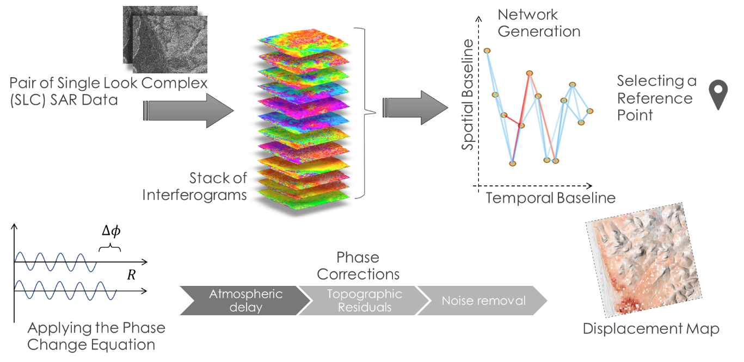

*Figure 2.* The MintPy processing workflow the team used to derive summer subsidence from a stack of interferograms. It applies atmospheric delay correction, topographic effect correction, and noise removal.

To begin the MintPy processing workflow, the team created a network from a stack of interferograms. The network generation process utilized is shown in Figure 2. In this network, the nodes represent the SAR images acquired, and the links represent their interferograms. The horizontal distance between nodes, known as the temporal baseline, represents the number of days between the first SAR image and the secondary SAR image. The vertical distance between nodes, known as the spatial baseline, represents the distance between the location difference of the satellite that takes those images. Refer to Figure B2 in the appendix for more information on the networks. Interferograms with poor quality were removed during this step. Additionally, interferograms with temporal baselines >24 days and spatial baselines >300 m were also removed from the network. To remove these “bad” interferograms, proper measure of interferogram quality is needed. In InSAR analysis, there are two measures to quantify interferogram quality, spatial coherency, and temporal coherency. Spatial coherency refers to the similarity between neighboring pixels or areas within an image. This parameter can be calculated for each pair if interferogram using equation 1 based on Prati et al. (1994).

|  |  |  |
| --- | --- | --- |
|  | $$γ_{spatial}=\frac{〈s_{1}s_{2}^{*}〉}{\sqrt{〈s_{1}s_{1}^{*}〉〈s_{2}s_{2}^{*}〉}}$$ | (1) |

where $γ_{spatial}$ is the spatial coherency in complex number format. A complex number has two parts: a real part and an imaginary part. To visualize these components, please refer to Figure B14 in Appendix B. Parameter $s$ in Equation 1 represents the SAR signal value stored in SLC in complex number format. The parameter $s^{*}$ is the same number as $s$ except the sign for the imaginary part is opposite. The subscripts 1 and 2 denote the first and secondary SAR images respectively.

Temporal coherence refers to the consistency of the timeseries with the network of interferograms and similar to spatial coherency varies from 0 to 1 for each individual pixel (a higher value indicates better reliability for timeseries analysis). A temporal coherence value above 0.7 is considered significantly appropriate (Yunjun et al., 2019). Temporal coherence was calculated using Equation 2 based on Pepe & Lanari (2006)

|  |  |  |
| --- | --- | --- |
|  |  | (2) |

where *j* is the imaginary unit, *M* is the number of interferogram used in the network, *H* is an $M×1$ matrix filled with ones. $Δφ$ is the interferometric phase change for each interferogram. $A$ is an $M×\left(N-1\right)$ 2-D matrix indicating acquisition pairs used for interferometric analysis. The matrix is filled with -1, 1, and 0 for each row, with -1 if the scene is a reference sense, 1 if the scene is a secondary scene and 0 if none.

The average spatial coherency was calculated over all pairs within the study area and is shown in Figure B1, with a pixel value that was closer to 1 being more reliable for use in time series analysis. Thresholds of 0.4 for spatial coherency and 0.7 for temporal coherency were applied to filter out pairs with too low or unreliable coherencies. Pairs with image-wise average coherencies above these thresholds were kept and used for analysis. It is important to note that to ensure reliable coherency, the team utilized an averaging technique called multi-looking which, in a trade-off, reduced the spatial resolution to 80 m. Next, the team also set a reference point to which all vertical displacement within the analysis region was relative. The team chose the Unalakleet airport runway (latitude: 63.883°, longitude: -160.797°), which has been relatively stable for decades and is situated next to the original site.

Following along in Figure 2, the next step is “Inverting Network to Raw Phase Delay”, which was described in Equation (3) by calculating the phase change $Δϕ$. The phase change for each image pair is simply the difference between wave phase of the received signal for the first and secondary scene. The phase change is as described by Ferretti et al. (2001) and results from land deformation, atmospheric delay, topographic errors, orbit error, and random noise. Orbit error can be ignored for well-engineered satellite systems such as Sentinel-1.

|  |  |  |
| --- | --- | --- |
|  | $$Δϕ=W\left\{\frac{4π}{λ}v×Δt+\frac{4π}{λ}\frac{B_{⊥}}{R ×sin⁡(θ)}h_{err}+ϕ_{atmo}+ϕ_{orbit}+ϕ_{noise}\right\}$$ | (3) |

$Δϕ$ is the change in phase of the radar signals from reference scene to the secondary scene wrapped from $-π$ to $π$. Wrapped means the values are in terms of wave phase instead of wavelength. $v$ is the velocity of earth surface deformation in line of sight of the radar readings, and for the team’s purpose represents the rate of land subsidence. Vertical displacement velocities can be calculated assuming horizontal displacements are negligible. $Δt$ is the temporal baseline or the time between the first pass and second pass. $R$ is the range distance calculated based on travel time. $θ$ is the incident angle. $λ$ is the radar signal wavelength. $B_{⊥}$ is the perpendicular baseline: the distance between location of the satellite for first and second pass. $h_{err}$ is the residual topographic height error caused because of the imperfection of the DEM used and the fact the topography seen by radar might not be the same as the one defined by DEM. The DEM might refer to the land surface, but radar can see the top of the vegetation or snow, or even a few centimeters into the ground. $ϕ_{atmo}$ is the atmospheric delay of the radar phase. $ϕ_{orbit}$ is the phase change caused by satellite orbit error though for Sentinel satellite, this error is negligible. $ϕ_{noise}$ is the random noise in phase change inherent to SAR imaging.

The phase change equation is used to solve for $v$ or the velocity of earth surface deformation, which for the team’s purpose represents the rate of land subsidence. Before solving for $v$, it is necessary to quantify the other variables in this equation. Starting from the right-hand side for the noise error $ϕ_{noise}$, since the noise is random in both time and in space, it can thus be removed with a smoothing filter. Orbit error $ϕ_{orbit}$ can be assumed to be negligible and is a fair assumption for precise satellites systems like Sentinel-1. Errors in phase change due to atmospheric delay error $ϕ_{atmo}$ are primarily caused by inhomogeneities in temperature, pressure, and water content in the troposphere and variations of electron density in the ionosphere (Mayer & Nicoll, 2008). For this study, electron density variations were neglected. For the remaining factors, (temperature, water vapor, and pressure) the effects of their variations were simulated using ERA5 climate reanalysis pressure data in the MintPy Jupyter notebook based on Global Atmospheric Models (GAMs) data (Jolivet et al., 2011; 2014). Other options to correct for these three factors include height correlation models such as in Doin et al. (2009), and iterative tropospheric decomposition model described in Yu et al. (2018), but these were not used for this study. Finally, there are also errors in phase change due to topographic errors. These errors can be corrected using a DEM. However, DEMs have topographical residue errors, $h_{err}$, that remain unknown in the equation. As a result, for each interferometric pair there are two unknowns, the topographic error $h_{err}$ and velocity of displacement $v$. The redundant number of interferograms allows us to solve for these unknowns and create our final displacement maps.

***3.3 Data Analysis***

**3.3.1 Drainage Networks**

To begin the drainage network analysis, the filled DEM, flow direction, and flow accumulation served as inputs to create the stream networks, watershed, and outlets for prominent rivers in the area. The team started by extracting stream network values from the flow accumulation layer. Flow accumulation thresholds are highly sensitive to the local topography, and it can be difficult to determine an appropriate value that will accurately represent the input for the drainage network (McMaster, 2002). To determine the appropriate threshold for the stream network, the team explored various thresholds, including 500, 1,000, 10,000 and 100,000 (Figure A2). Based on the derived stream networks, the team was able to locate and place outlet points at the mouth of the Unalakleet River Creek and Power Watershed Creek, a smaller creek ~8 km north of the Unalakleet River. To delineate the watershed, the team snapped the outlet points to the raster grid of the flow accumulation layer and utilized the watershed tool in ArcGIS Pro 3.1.1 to calculate the upslope area that contributed water flowing into the two outlets (Figure A3). To validate the location of the streams, outlet points, and drainage basins, a visual inspection of the landscape was conducted by comparing various WorldView-2 and WorldView-3 images. After visually inspecting the topography, HAND was calculated utilizing the following inputs: 1) 500, 1,000, 10,000, and 100,000 flow accumulation threshold variations, 2) the conditioned DEM, and 3) the flow direction raster. The team calculated HAND by determining vertical flow distance from the lowest point in the drainage utilizing these four different thresholds for comparison with each other and the surrounding terrain.

**3.3.2 Summer Subsidence Analysis**

To evaluate the quality of the MintPy outputs which included the coherence, velocity, and surface displacement, the team inspected the results for the 2019 summer for both spatial coherence and temporal coherence. The team began by looking at the average spatial coherence of image scenes. Upon inspecting the interferogram network in Figure B2, it was found that the scenes had perpendicular baselines all within ~100 m of each other and an average spatial coherence of ~0.6. This represents the reliability of the method because spatial coherence value ≥ 0.4 are considered reliable, as suggested in Jian & Lohman (2021). The spatial coherence map in Figure B1 revealed pixel-wise coherence, demonstrating strong phase similarity and signals between corresponding pixels in a scene pair. The team also identified coherence 'hot spots' with values near 1.0, which served as indicators of bare ground. Furthermore, the stretch of area to the west, with values close to zero, was associated with water bodies, including the Norton Sound where SAR signals cannot penetrate. These highs and lows were interspersed by a range of values that corresponded to vegetation and bare ground close in proximity – the short wavelengths used by the InSAR satellites have difficulty penetrating dense vegetation and can lead to the observed incoherence. The team compared these data with high-resolution WorldView-2 and 3 images.

The subsidence values for each summer were compared to their corresponding average temporal coherency and spatial coherency (Figure B7 and B8). A dot represents an individual pixel within the study area, and these figures showed that most of our pixels exhibited coherency. Pixels with zero (0) coherency represented water bodies. Furthermore, we also compare the seasonal subsidence with height above sea level, shown in figure B9 and shows a slight correlation between elevation and subsidence. This might be due to local stratification of the atmosphere and though the team used global atmospheric correction to count for atmospheric error, a local models might be more appropriate and address this correlation.

Finally, spatial coherency for 2 types of interferogram, 2-day temporal baseline and one-year temporal baseline, were calculated. The team generated box plots to show the maximum, minimum and median of coherency for each interferogram. The results are shown in Figure B10, and the box plot shows the coherency for longer baselines reduces the quality of the results.

# 4. Results & Discussion

***4.1 Analysis of Results***

**4.1.1 Drainage Networks**

Flow accumulation thresholds of 500, 1,000, 10,000 and 100,000 yielded varying results due to the highly sensitive nature of stream density. The smallest threshold of 1000 displayed dense stream networks reflecting the local topography and indentations of the drainage basins in contrast to the larger thresholds. As the team increased the threshold, both stream density and extent decreased; however, the inclusion of larger streams proved beneficial in identifying larger drainage basins (Figure A2). Stream networks were a vital parameter in HAND calculations, serving as the lowest point in the drainage. The team used various thresholds in an exploratory study to characterize the landscape. The lowest thresholds in the HAND calculation output a rough surface raster due to a larger number of pixels being input as “drainage” which rendered them too fine for the analysis. Similarly, the largest threshold of 100,000 failed to calculate the height from the undetected smaller drainages, generating results that did not reflect the gradient shifts seen in the local topography. Consequently, these HAND calculations derived from too low or too high thresholds were dismissed in the analysis. After tuning and visual inspection, the 10,000-threshold HAND calculation presented a shaded relief of the study area that most accurately represented visual changes in the environment and is the result we present here. In reference to Rennó et. al., 2008, the 10,000 HAND calculation highlighted local relative variations in height and pronounced drainages relative to the original USGS 3DEP DEM (Figure A4).

The stream network with a 1,000-threshold was excluded from the HAND calculation. Although this network offered the community valuable insights into minor stream inputs within the drainage, it resulted in HAND calculations that were overly sensitive to local variations in the DEM. This sensitivity resulted in numerous flow paths contributed minimally to the overall drainage patterns. When utilizing the 10,000 threshold for HAND calculations, the team observed that several large drainages in the center of the study area intersected with local roads, while other roads were located at the highest elevations above the drainage (Figure A5). Overlapping the data and identifying roads that interacted with large and small drainage networks provided valuable information about viability of current and future infrastructure for our partners. Infrastructure located within the drainages is at risk of damage from flooding and erosion due to the runoff and flooding events. Moving away from the drainage, the potential for flooding and erosional damage decreases. This would make the area more stable for roads and future building construction because they would not be directly impacted by mass runoff and inputs into the major drainages.

**4.1.2 Summer Subsidence Analysis**

The team examined the displacement patterns that emerged from subsidence (negative displacement) and uplift (positive displacement) during summer seasons. The displacement maps shown in Appendix Figures B3 and B4 depict subsidence fluctuations across the study area. Particularly, higher subsidence rates were detected near the relocation site, while inland areas exhibited lower levels of subsidence. These figures illustrate the average seasonal subsidence, with red pixels indicating subsidence and the blue pixels representing uplift. The color intensity corresponds to the displacement magnitude, with more intense pixels denoting larger values. The observed displacements reflect a consistent seasonal pattern of thawing and freezing. This thaw-freeze cycle (Figure B5) was observed across almost all locations within the study area, excluding densely vegetated regions and water bodies. When examining the displacement patterns from 2017 – 2019, a generally S-shaped curve is discernible. However, subsequent years show a transition to a more degraded shape that may be attributed to significant climatic impacts caused by the exceptionally warm summer of 2019 (Zwieback & Meyer, 2021).

Moreover, the displacement time series analysis reveals diverse patterns across different areas within the study. Aside from permafrost degradation, these variations may be attributed to other factors like specific geological conditions which influence the observed displacements. Among the dominant distinct patterns observed in the study area is an S-shaped curve that shifts slightly downward each year. This specific trend suggests a long-term permanent subsidence, indicating a slow and gradual thawing of the permafrost. However, as previously noted, this S-shaped curve began degrading toward the second half of our study period following the exceptionally warm summer of 2019. Geological field data are necessary to better understand the relationship between subsidence, permafrost thaw, and other factors. The forthcoming geotechnical investigation, planned by our NREL partners, will be instrumental in advancing our interpretation and understanding of these patterns, thereby aiding in the development of effective strategies to mitigate the adverse effects associated with permafrost degradation.

**4.1.3 Drainage Network and Summer Subsidence**

To improve our understanding of the risks the community is facing, the team also explored summer subsidence and the corresponding HAND values together. K-means analysis, an unsupervised machine learning technique, was applied to find patterns or groupings of vertical displacement in relation to HAND. The k-means analysis groups data into *k* clusters and provides valuable information on data relationships. To determine the optimal number of clusters, the team utilized the “elbow” method to calculate Within-Cluster Sum of Squares (WCSS). With this method, the team identified that 5 clusters would be the most accurate for the dataset (Figure B11). HAND values which were less than 5-m were excluded in the analysis because of the incoherency of subsidence data attributed to water bodies. The team observed that lower HAND values had higher average displacement than higher hand values, as seen in Figure B12 and B13. However, more area-specific research is needed to understand the dynamic environmental factors influencing subsidence closer to the drainage basins. According to literature, drainage lines are more prone to experience subsidence due to permafrost degradation (Gibson et al., 2015), which could be an indication of the processes occurring here.

***4.2 Feasibility Assessment***

**4.2.1 Drainage Networks**

Our drainage network analysis has yielded crucial insights for the community of Unalakleet, highlighting areas that present varying degrees of risk. One critical component of this analysis is the HAND values, which represent the vertical distance above drainage lines. The HAND values are of particular importance to the community, as they directly correlate to the risk factors facing both community residents and infrastructure. Smaller HAND values signify higher risk, encompassing not only the dangers of erosion and flooding but also an increased potential for permafrost degradation and collapse (Gibson et al., 2015). It is important to recognize that the team did not specify the height threshold for flood risk for HAND as that determination is subjective and should be based on the regional context and domain knowledge of our partners and NVU. A general approach is to emphasize caution in areas with lower values, but determining appropriate thresholds based on the HAND values remains a responsibility for our partners.

Our analysis is not without its limitations, and the community must be aware of multiple sources of uncertainty. First, the DEM used to derive the drainage network and HAND values were collected in 2014, thus present-day topography may differ from the DEM utilized and influence our HAND results. Nonetheless, our methodology can be applied to newer and more accurate DEMs as they become available to derive updated drainage network and HAND values. Second, the DEM possesses a vertical accuracy < 1 m and horizontal accuracy < 3 m. The 3 m horizontal accuracy indicates if a pixel is highlighted as a drainage line, this pixel is not necessarily within a drainage line but within 3-m proximity of it; some there is a minor location uncertainty. It is also notable to mention that the pixel size for the DEM data is 5 m; as a result, very small drainage lines smaller than the pixel size may not be reflected in our results. The outcome of this analysis is thus best suited for mapping and locating more relatively substantial drainage lines. Specifically, any drainage line receiving water from an area larger than 25,000 square meters would be well-represented in our findings. Despite the inherent limitations, the insights gleaned from this analysis provided a valuable tool for the Unalakleet community. These findings offer a pathway to more strategic planning to enable the community to identify and mitigate risks related to drainage, and to foster a more resilient and adaptive response to the complex challenges posed by the changing landscape in the face of climate change.

**4.2.2 Summer Subsidence Analysis**

The analysis of subsidence time series has yielded both insightful and actionable findings. Seasonal displacement maps have played a crucial role in highlighting areas with higher fluctuations of subsidence, thereby signaling zones that warrant specific attention for future foundation and structural design. These maps depict the overall displacement for each summer season, comprising 98 x 98 pixels. It’s important to note that each pixel value represents an average within an 80 x 80-m area. It’s essential for the community to recognize that within these pixels, local displacements might deviate from the indicated average in our results. Understanding these nuances is vital to developing robust and resilient infrastructure within a pixel as well as the relocation areas. Furthermore, our analysis has identified regions with a low range of seasonal fluctuation. Such areas may indicate zones of greater stability, that are likely to be favorable sites for future relocation and migration planning. Geotechnical data will be required to validate the general stability of these sites and could subsequently inform and guide the community in their long-term strategies. Areas exhibiting less fluctuation in displacement are likely to have a reduced impact on infrastructure, presenting opportunities for the community to economize on structural design without compromising integrity. More economical foundation solutions can be explored that align with the areas' demonstrated stability.

While our seasonal displacement observations have demonstrated good accuracy, we must acknowledge certain limitations in our analysis. Interpretation of long-term displacement remains difficult and problematic, and stems from unwrapping errors due to the large temporal baselines. Unwrapping errors refer to the inaccuracies made during the process of transforming the interferogram from a phase value into distance values. These errors can be caused by noise, interference, or inconsistencies in the data. The presence of discontinuities in the true phase, artefacts, or low-quality data can therefore result in incorrect unwrapping. The unwrapping error can be estimated from spatial coherency of the interferograms, and we show an example for the first 40 interferograms in Figure B11. When building the networks for 2017 – 2023, we used annual and 12 days connections which are shown in Figure B2. The annual connections had considerable unwrapping errors and very poor spatial coherency, while the 12 day connections had much higher coherency. The intra-year results were therefore far more reliable than any inter-year and this was what we focused on in this study. Refer to Figure B10 for a comparison of a typical 12 days interferogram with a year-long interferogram. This is an issue associated with the nature of Synthetic Aperture Radar (SAR) imaging, where coherency decays with time between two SAR images. Long-term displacement is very important for understanding and tracking thawing permafrost, yet the inherent errors within year-to-year pairs restrict the reliability of these measurements.

For now, we have chosen not to report the inaccurate results of the long-term displacement within this paper, but it is vital to recognize that the long-term thawing of permafrost represents a highly destructive force with the potential to create significant disturbances in the terrain. Summer subsidence by itself would not be directly related to permafrost degradation, and a breakdown of the factors that influence the subsidence can be better derived from having long-term displacement results and field data. There is still much work to be done beyond the scope of this 10-week project. Nevertheless, the findings presented here have contributed valuable insights for the Unalakleet community's relocation efforts. While we have more scientific questions arising from the subsidence, the community’s primary concern is the amount and activity level of subsidence in their proposed relocation site in the Foothills Subdivision which we have managed to provide from 2017 – 2023. Our results will help NREL and NVU with their targeted assessment of sites for development, fine-tuning of construction approaches, and the thoughtful planning for future community resilience in this region.

***4.3 Future Work***

The team’s analysis of displacement time series has unveiled a rich diversity of patterns across various locations within the study area. These patterns appear to be connected to the specific geological conditions, which can exert a considerable influence on the observed displacements. Future work can achieve a more comprehensive understanding of what causes the displacements by incorporating geotechnical field data to help break down the contributing factors to subsidence. The National Renewable Energy Lab (NREL) is planning an extensive geotechnical testing within the study area, and these investigative tests will probe the geological conditions which may be affecting the observed displacement patterns. Once these results are available, they will not only validate our results but also provide a refined and nuanced interpretation of the displacement dynamics. Additionally, there is also an opportunity to enhance the hydrological understanding of the site by utilizing the displacement maps to produce updated Digital Elevation Models (DEMs) that can reflect the drainage networks to be more closely aligned with the actual topography. The current resolution of the team’s Synthetic Aperture Radar (SAR) analysis is 80 x 80 meters, a scale that is not optimal for detailed drainage network analysis. Future technological advancements, such as the forthcoming NASA NISAR satellite in 2024, have the ability to deliver much higher resolution SAR data that can significantly improve coherency. This refined data could be instrumental in understanding the Unalakleet site's dynamic nature and hydrological intricacies. As the SAR displacement measurements are taken every 12 days, having continual updates to the DEM and an enriched understanding of the actual topography will be very useful. Such enhancements will enable more robust analysis and allow more accurate insights into the complex interactions between seasonal summer subsidence, geological conditions, permafrost degradation, and changing drainage patterns. These directions present several promising avenues for future long-term monitoring of thawing permafrost and mapping of the changing drainage network. Implementing this future work will further inform NVU in their relocation and future expansion efforts as they prepare for ongoing seasonal subsidence, flooding, and permafrost degradation within their community.

# 5. Conclusions

This work is an important step toward both understanding and managing the challenges facing coastal Alaskan communities such as Unalakleet. Through the collaborative efforts of our team and the NREL, the study used advanced Earth observation tools to generate and share tangible insights into seasonal subsidence and drainage network analyses with the Unalakleet community.

For drainage networks, the 1,000-threshold HAND calculation was found to best represent the landscape and provide localized drainage information vital for the community's infrastructure planning. Our HAND analysis offered insights into areas at higher risk for flooding, increased erosion, and potential permafrost thaw and provided a useful guide for the community’s relocation efforts. Our investigation of summer subsidence utilized displacement time series obtained from InSAR analysis and shed light on seasonal patterns, long-term trends, and the multifaceted relationship between displacement and factors such as local geology. While year-to-year displacement analysis had inherent limitations due to their lower coherency, the summer displacements within each year were found to hold reliable accuracy. This information played a critical role in highlighting potential risk zones and areas of stability. Our intra-year subsidence results can guide important decisions about relocation, foundation design, and long-term community resilience. The work done demonstrates an exemplary application for SAR for understanding summer subsidence and sets up key future follows-up that include decreasing the unwrapping errors, utilizing geotechnical data to assess the displacement timeseries patterns, and assessing how much of the long-term subsidence is attributed to permafrost degradation. Collaborative efforts with institutions like NREL and NVU, continuous monitoring of the region, production of more data, and tapping into the new upcoming methodologies will assist the community of Unalakleet as they strive to adapt and thrive amidst the complex challenges posed by the changing landscape.

# 6. Acknowledgements

We would like to extend our gratitude to:

* Georgina Davis – National Renewable Energy Laboratory
* Aaron Cooke – National Renewable Energy Laboratory
* Dr. Marguerite Madden – University of Georgia
* Dr. Franz Meyer – University of Alaska Fairbanks
* Dr. Simon Zwiebeck – University of Alaska Fairbanks
* Dr. Anna Liljedahl – Woodwell Climate Research Center
* Dr. Chandi Witharana – University of Connecticut
* Sarah Payne – NASA GA Node Fellow

This material contains modified Copernicus Sentinel data (2017 – 2023), processed by ESA.

This work utilized data made available through the NASA Commercial Smallsat Data Acquisition (CSDA) program.

DigitalGlobe/Maxar data were provided by NASA’s Commercial Archive Data for NASA investigators (cad4nasa.gsfc.nasa.gov) under the National Geospatial-Intelligence Agency’s NextView license agreement.

Any opinions, findings, and conclusions or recommendations expressed in this material are those of the author(s) and do not necessarily reflect the views of the National Aeronautics and Space Administration.

This material is based upon work supported by NASA through contract NNL16AA05C.

# 7. Glossary

**ASF –** Alaska Satellite Facility, a NASA Distributed Active Archive Center (DAAC) that specializes in handling synthetic aperture radar (SAR) technology.

**Coastal Erosion** – The gradual wearing of material from a coastal profile, an example would be the removal of beach sand dunes or sediment by wave action, tidal currents, or drainage.

**DEM** – Digital Elevation Model, a raster file representing the bare ground (bare earth) topographic surface or elevation of the Earth.

**Earth Observations** – Data gathered about the planet’s physical, chemical, and biological systems using remote sensing technologies.

**ESA** – European Space Agency

**Flow Accumulation** – A hydrologic modeling measurement that helps to identify stream channels.

**Foothills Subdivision** – The relocation site for the Unalakleet community, located at the bottom of the Nulato Hills.

**GIS** – Geographic Information Systems

**Gravel Spit** – A narrow and elongated coastal landform created by the deposition of sediment.

**HAND** – Height Above Nearest Drainage, an analysis method to understand how high a location is above the nearest drainage system – this information is helpful for flood modeling.

**InSAR** – Interferometric Synthetic Aperture Radar, a radar technique that utilizes interferometry to map ground deformations and is capable of detecting fine centimeter-scale changes.

**Interferometry** – The study of the phases of electromagnetic waves, used in InSAR imagery analysis.

**Melt-Induced Flooding** – Flooding that is caused by the melting of ice such as permafrost.

**NREL** – The National Renewable Energy Laboratory, a national laboratory of the U.S. Department of Energy (DOE) that is providing support for the resilience planning efforts in Unalakleet, Alaska.

**Nulato Hills** – The prospective relocation site for the community of Unalakleet.

**NVU** – Native Village of Unalakleet, the organization that aids the tribal membership of Unalakleet in Alaska through self-governance.

**Permafrost** – Ground that remains frozen for two or more consecutive years.

**Permafrost Degradation** – Thaw of perennially frozen permafrost, leading to ground instability.

**Radar Phase** – The location on the oscillating waveform of the radar signal when the radar is received by the sensor.

**Radar Strength** – The amplitude of the radar signal when the radar is received by the sensor.

**Remote Sensing** – A method of observing and studying objects/areas from a distance, usually from an aircraft or satellite.

**Riverine Erosion** – Erosion by a river or stream, which can impact banks and nearby landscapes.

**SAR** – Synthetic Aperture Radar

**Shapefiles** – Common geospatial vector data format for geographic information system (GIS) software, used to store the location, shape, and attributes of geographic features.

**SLC** – Single Look Complex, a data product in radar imaging that retains both amplitude and phase information that can be used in interferometric analysis.

**USACE** – United States Army Corps of Engineers

**USGS** – United States Geological Survey

# 8. References

Alaska Department of Natural Resources. (2023). *Permafrost and Periglacial Hazards*.

<https://dggs.alaska.gov/hazards/permafrost.html#:~:text=Permafrost%20and%20periglacial%20hazards%20are,into%20permafrost%20near%20Fairbanks%2C%20Alaska>

Doin, M. P., C. Lasserre, G. Peltzer, O. Cavalié, & C. Doubre (2009). Corrections of stratified tropospheric

delays in SAR interferometry: Validation with global atmospheric models, *Journal of Applied Geophysics*, *69*(1), 35-50. <https://doi.org/10.1016/j.jappgeo.2009.03.010>

Ferretti, A., Prati, C., & Rocca, F. (2001). Permanent scatterers in SAR interferometry. *IEEE Transactions on Geoscience and Remote Sensing,* *39*(1), 8–20.

<https://doi.org/10.1109/36.898661>

Grimaldi, S., Nardi, F., Di Benedetto, F., Istanbulluoglu, E., & Bras, R. L. (2007). A physically-based method

for removing pits in digital elevation models. *Advances in Water Resources*, *30*(10), 215-2158. <https://doi.org/10.1016/j.advwatres.2006.11.016>

Hogenson, K., Kristenson, H., Kennedy, J., Johnston, A., Rine, J., Logan, T., Zhu, J., Williams, F., Herrmann,

J., Smale, J., & Meyer, F. (2020). Hybrid Pluggable Processing Pipeline (HyP3): A cloud-native infrastructure for generic processing of SAR data (v0.3.74). *Zenodo*.

<https://doi.org/10.5281/zenodo.4646138>

Jolivet, R., P. S. Agram, N. Y. Lin, M. Simons, M. P. Doin, G. Peltzer, & Li, Z. (2014). Improving InSAR

geodesy using global atmospheric models. *Journal of Geophysical Research: Solid Earth*, *119*(3), 2324-2341. <https://doi.org/10.1002/2013JB010588>

Jolivet, R., R. Grandin, C. Lasserre, M. P. Doin, and G. Peltzer (2011), Systematic InSAR tropospheric phase

delay corrections from global meteorological reanalysis data. *Geophysical Research Letter*s, *38*(17), L17311. <https://doi.org/10.1029/2011GL048757>

McMaster, K. J. (2002). Effects of digital elevation model resolution on derived stream network positions.

*Water Resources Research*, *38*(4), 13-1. doi: <https://doi.org/10.1029/2000WR000150>

Nobre, A. D., Cuartas, L. A., Hodnett, M., Rennó, C. D., Rodrigues, G., Silveira, A., & Saleska, S. (2011).

Height Above the Nearest Drainage–a hydrologically relevant new terrain model. *Journal of Hydrology*, 404(1-2), 15. <https://doi.org/10.1016/j.jhydrol.2011.03.051>

O'Callaghan, J. F., & Mark, D. M. (1984). The extraction of drainage networks from digital elevation data.

*Computer vision, graphics, and image processing*, *28*(3), 323-344.

<http://dx.doi.org/10.1016/S0734-189X(84)80011-0>

Pepe, A., & Lanari, R. (2006). On the extension of the minimum cost flow algorithm for phase unwrapping

of multitemporal differential SAR interferograms. *IEEE Transactions on Geoscience and Remote Sensing*, 44(9), 2374-2383. <https://doi.org/10.1109/TGRS.2006.873207>

Rennó, C. D., Nobre, A. D., Cuartas, L. A., Soares, J. V., Hodnett, M. G., & Tomasella, J. (2008). HAND, a

new terrain descriptor using SRTM-DEM: Mapping terra-firme rainforest environments in Amazonia. *Remote Sensing of Environment*, 112(9), 12.

<https://doi.org/10.1016/j.rse.2008.03.018>

Streletskiy, D.A., Shiklomanov, N.I., Little, J.D., Nelson, F.E., Brown, J., Nyland, K.E., & Klene, A.E. (2017).

Thaw subsidence in undisturbed tundra landscapes, Barrow, Alaska, 1962-2015. *Permafrost and Periglacial Processes*, 28(3), 566-572.

<https://doi.org/10.1002/ppp.1918>

Tarboton, D. G. (1997). A new method for the determination of flow directions and upslope areas in grid

digital elevation models. *Water Resources Research*, 33(2), 309-319.

<https://doi.org/10.1029/96WR03137>

U.S. Geological Survey, 2014, USGS Alaska 5 Meter Alaska_Mid_Accuracy_DEM_6 6, accessed June 25,

2023. <https://data.usgs.gov/datacatalog/data/USGS:e250fffe-ed32-4627-a3e6-9474b6dc6f0b>

U.S. Geological Survey, 2004, Area Use Map of U.S.G.S. Quadrangle “Unalakleet D–4” Alaska.

Yu, C., Z. Li, & N. T. Penna. (2018). Interferometric synthetic aperture radar atmospheric correction using a

GPS-based iterative tropospheric decomposition model, *Remote Sensing of Environment*, 204, 109-121. <https://doi.org/10.1016/j.rse.2017.10.038>

Yunjun, Z., Fattahi, H., & Amelung, F. (2019). Small baseline InSAR time series analysis: Unwrapping error

correction and noise reduction, *Computers & Geosciences*, 133, 104331. <https://doi.org/10.1016/j.cageo.2019.104331>

Zwieback, S., & Meyer, F. J. (2021). Top-of-permafrost ground ice indicated by remotely sensed late-season

subsidence. *The Cryosphere, 15*(4), 2041-2055. <https://doi.org/10.5194/tc-15-2041-2021>

# 9. Appendices

**Appendix A: Drainage Networks**

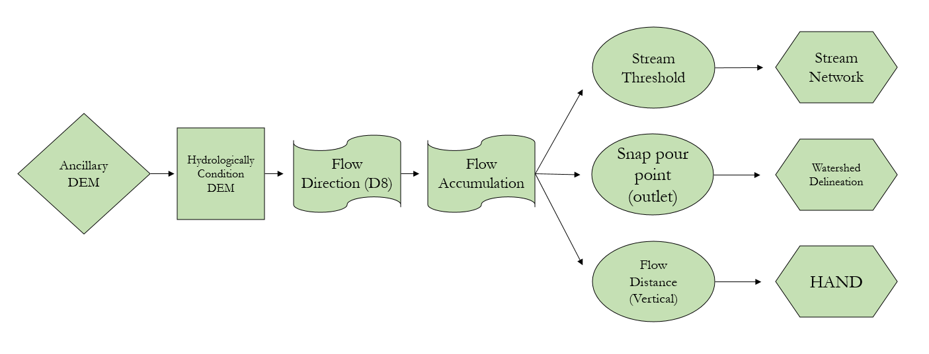

*Figure A1.* Workflow for watershed delineation and HAND. The diamond and square on the left display the first procedures of the analysis, where the team filled depressions in the original DEM to create the conditioned DEM. The flags represent original raster layers derived from the conditioned DEM. The ovals represent the measurements derived from the flow direction and flow accumulation raster layers and acted as inputs. The creation of the final products is visualized in the polygons.

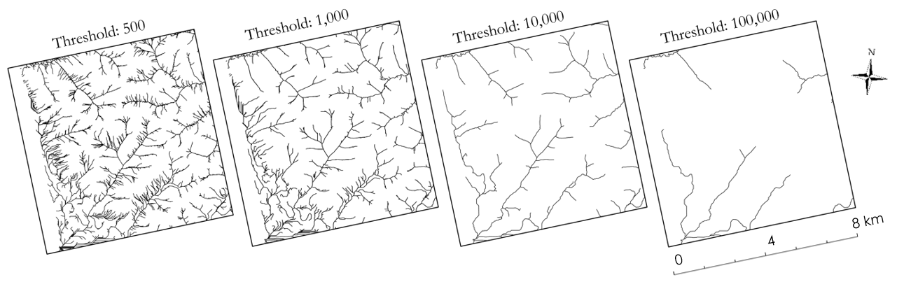

*Figure A2.* To calculate the stream networks, thresholds of 500, 1,000, 10,000, and 100,000 were applied to the flow accumulation layer and compared to high resolution imagery to locate and verify the location of small streams and larger drainage networks throughout the study area.

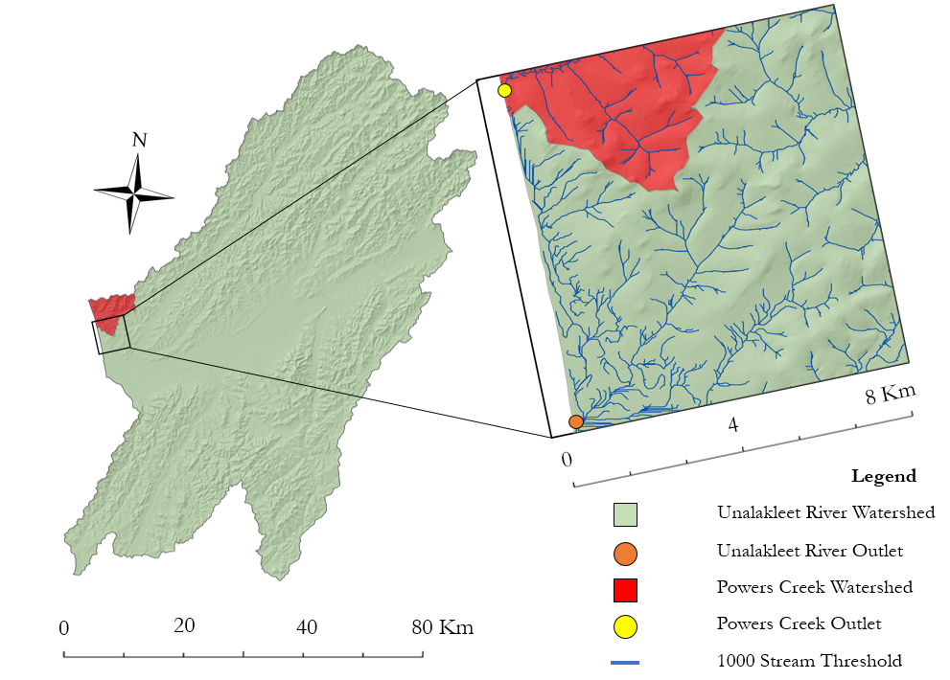

*Figure A3.* Map displaying watershed delineation for the Unalakleet River and Powers Creek watersheds, their corresponding outlets, and stream networks surrounding the community. Stream networks with a threshold of 1,000 were chosen for this study because it highlighted small drainage inputs and accurately corresponded to drainage networks identified through visual inspection.

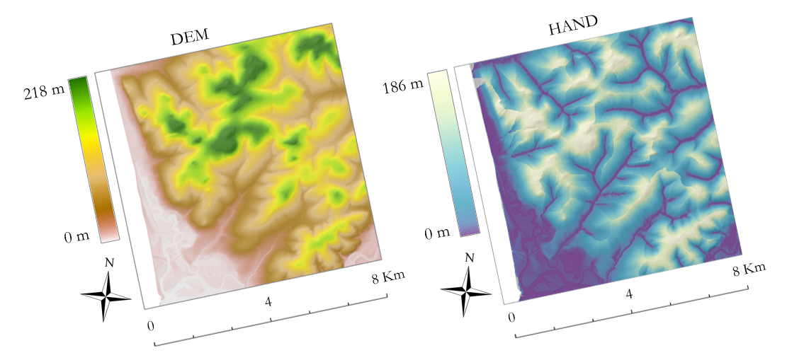

*Figure A4.*The ancillary DEM is shown with the HAND results.

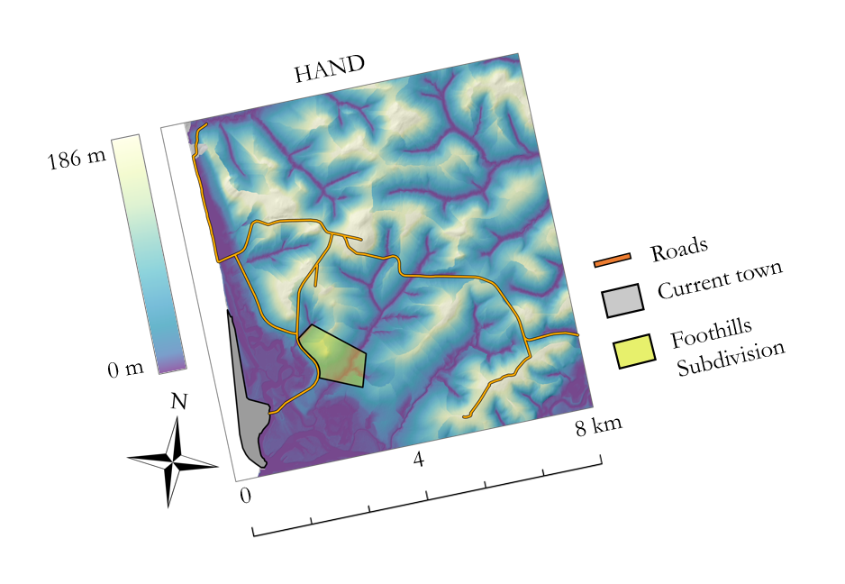

*Figure A5.* The HAND results are overlayed with key infrastructure including roads, the current town of Unalakleet, and the Foothills Subdivision relocation site. The darkest colors on the map represent the lowest points of the drainage at 0 meters.

**Appendix B: Summer Subsidence**

*Figure B1.* Investigating spatial coherency for the study area.The map on the right shows unsupervised land cover classification derived from a Maxar image of the same area. The map on the left shows the average spatial coherence map. Lower values are less coherent and reliable while values close to 1 are more coherent and reliable. The coherent “hot spots” in red correspond to bare ground on the Maxar image, and areas with green and yellow spatial coherence values correspond to closely interspersed vegetation and bare ground with more incoherence. Dark blues correspond to water from the Norton Sound, which is close to 0 and not coherent because SAR cannot penetrate water.

©2019, Maxar, USG Plus

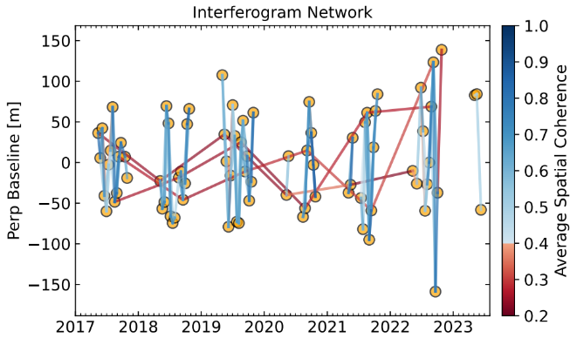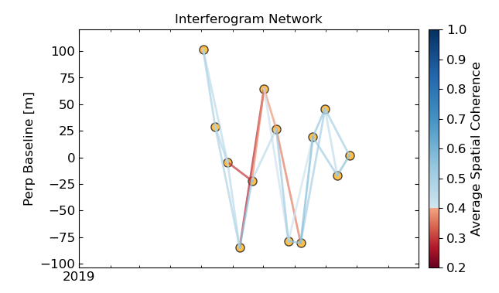

*Figure B2.* Interferogram network for summer 2019 (left) and 2017-2023 (right) for the study area. Each circle point refers to a SAR scene and each line refers to an interferometric pair. Blue connections are pairs that have higher spatial coherency and red connections are pairs with low spatial coherency.

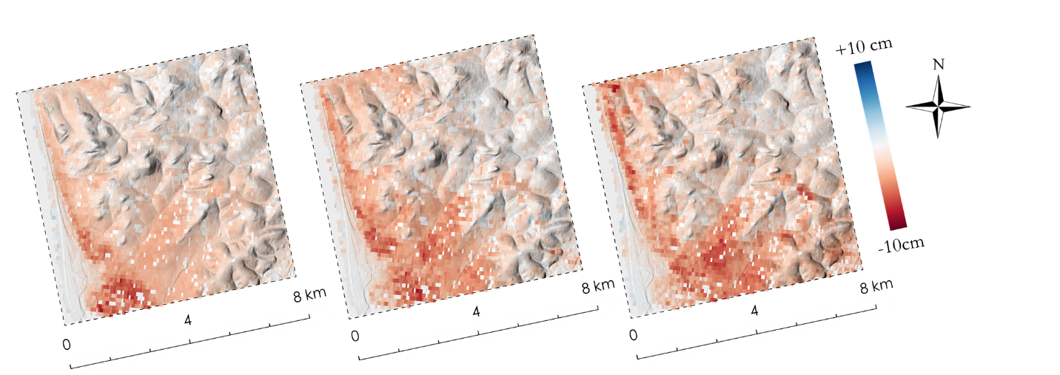

*Figure B3.* Summer displacement maps for 2017, 2018 and 2019 from left to right.

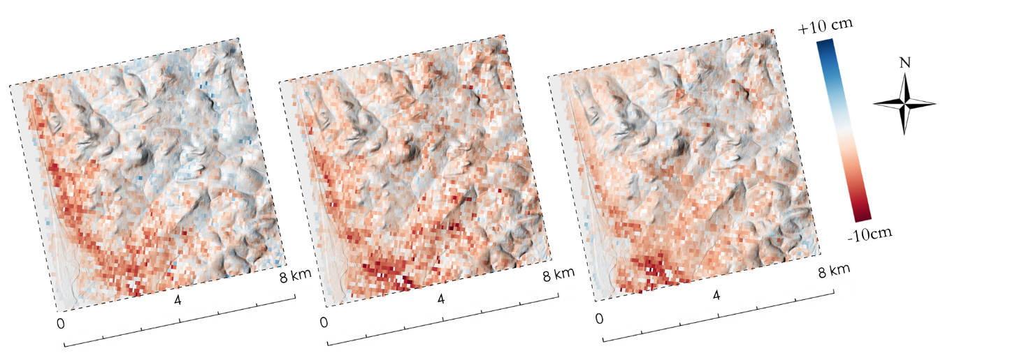

*Figure B4.* Summer displacement maps for 2020, 2021 and 2022 from left to right.

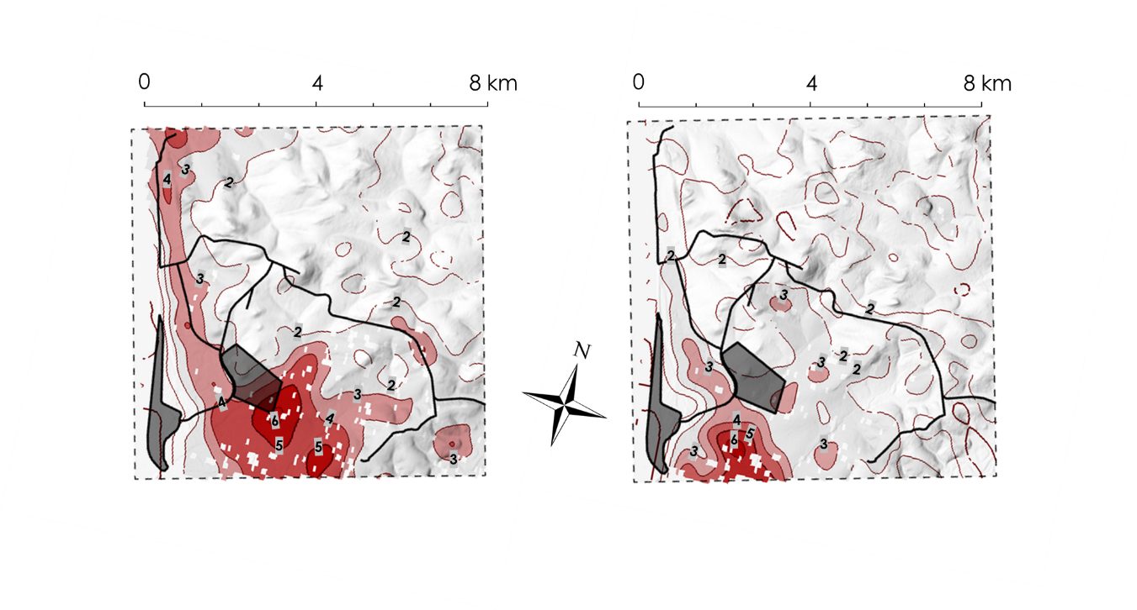

*Figure B5.* Summer displacement contour maps for 2019 (left) and 2022 (right). The black polylines and dark gray polygons represent the roads, current town, and the Foothill subdivision. For the contours, darker reds show higher subsidence. The average value of subsidence along a contour line is labeled in centimeters.

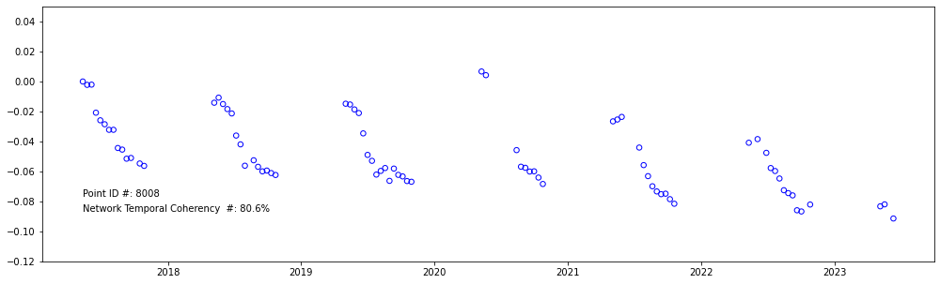

Vertical displacement

*Figure B6.* Time series of displacement for an arbitrary pixel within the study area. The displacements in a year show a rough reverse sigmoid or s-shaped pattern, impacted by the seasonal thawing and freezing patterns – it is more prominent from 2017 – 2019, and this shape gradually degrades in the second half of the study period.

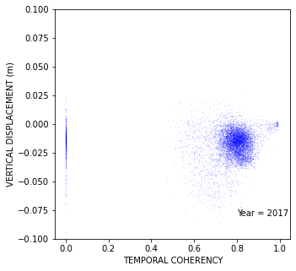 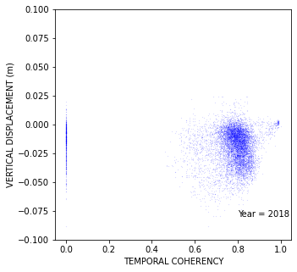 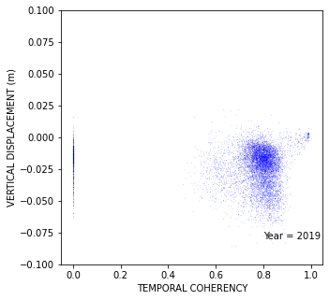 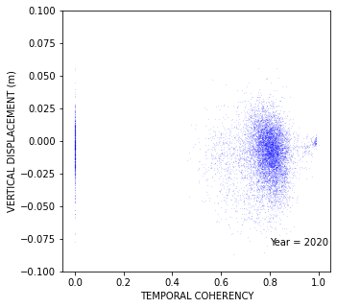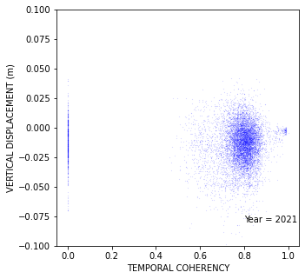 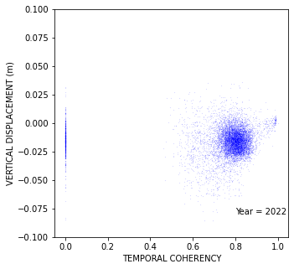

*Figure B7.* Scatter plot of average network temporal coherency v. vertical displacement for 2017 – 2022. Each data point represents a pixel within the study area. Most pixels hold high temporal coherency. The vertical line with zero temporal coherency on the left represents water bodies and are removed from the analysis. The small cluster on the far right represents urban areas, airport runway and areas.

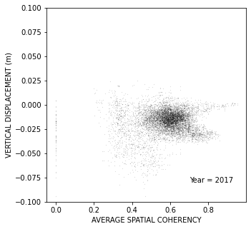 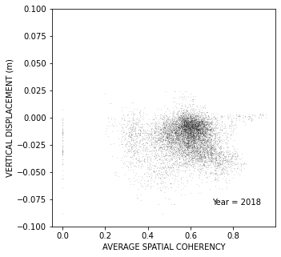 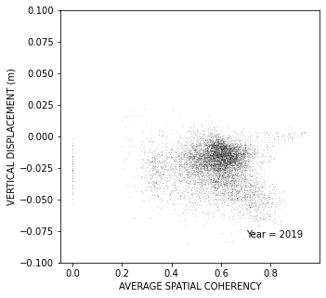 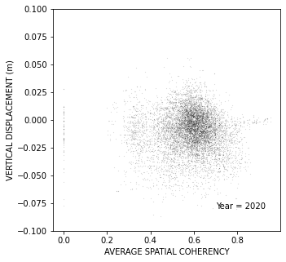 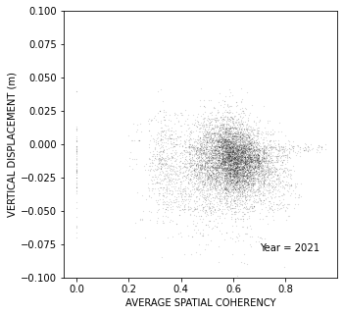 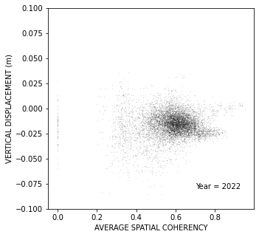

*Figure B8.* Scatter plot of average spatial coherency v. vertical displacement for 2017 – 2022. Each data point represents a pixel within the study area. This plot shows most of our pixels have an acceptable spatial coherency (> 0.4). The vertical line with zero values on the left represents water bodies and is removed from the analysis.

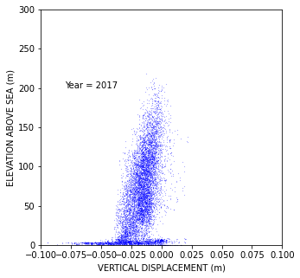 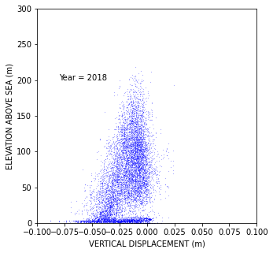 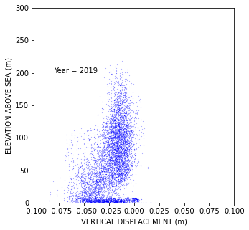 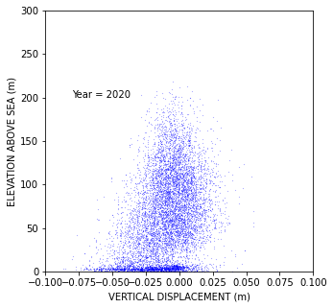 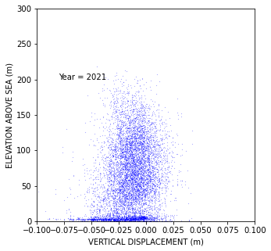 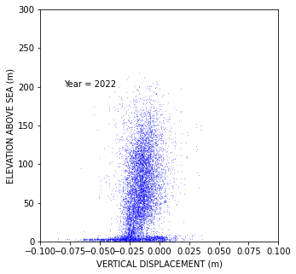

*Figure B9.* Scatter plot of elevation above sea level and vertical displacement for 2017 – 2022. We observe a slight correlation between elevation and derived displacement, with the higher elevation pixels exhibiting less displacement. This can be due to stratification of the atmosphere and its effect on radar phase change. Utilizing local atmospheric models rather that current global models might help to remove this error.

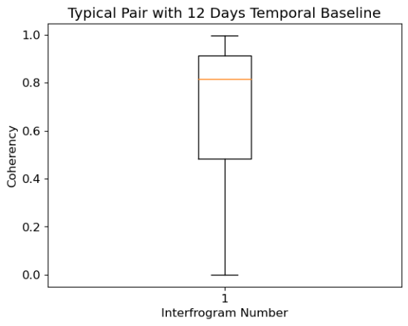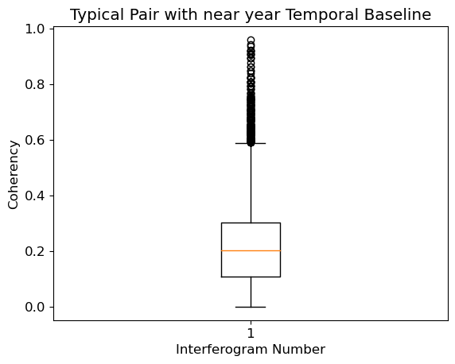

*Figure B10.* Box plot of the spatial coherency for two types of interferogram used in the network. The upper and lower limits of the box represent the maximum and minimum coherency for each interferogram, and the orange line represents the median. The left shows the box plot for a shorter temporal baseline interferogram, here 12 days apart (2017-05-13 – 2017-05-25). This type of interferogram generally holds good coherency, thus providing a reliable connection within the interferogram network.The right conversely shows the box plot for a longer temporal baseline interferogram, here almost a year apart (2017-05-13 – 2018-05-08. These links have much lower coherency, thus providing a less reliable connection within the interferogram network. The right plot includes spatial coherence data points for the 12-day interferogram (from the left) for comparison.

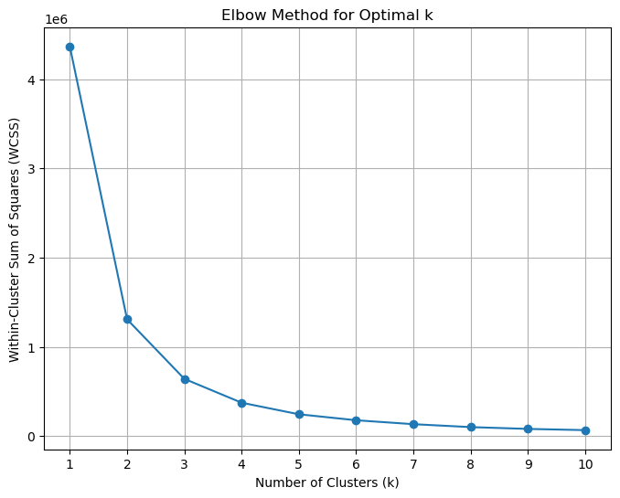

*Figure B11.*To compare the HAND values with summer subsidence values, Within-Cluster Sum of Squares (WCSS) was used in the elbow method for Optimal k analysis for k-means cluster number determination. The point where the curve starts to flatten is considered the optimal value for k and based on this elbow plot the team clustered the data into 5 different clusters.

|  |  |
| --- | --- |
| **Cluster** | **Average Displacement (m)** |
| 1 | -0.0186 |
| 2 | -0.0150 |
| 3 | -0.0158 |
| 4 | -0.0139 |
| 5 | -0.0123 |

*Figure B12***.** Average maximum and minimum HAND values corresponding to the clusters identified in the k-means clustering analysis. These values can be used to inform the areas above the drainage that are most at risk for seasonal subsidence in the area surrounding the community.

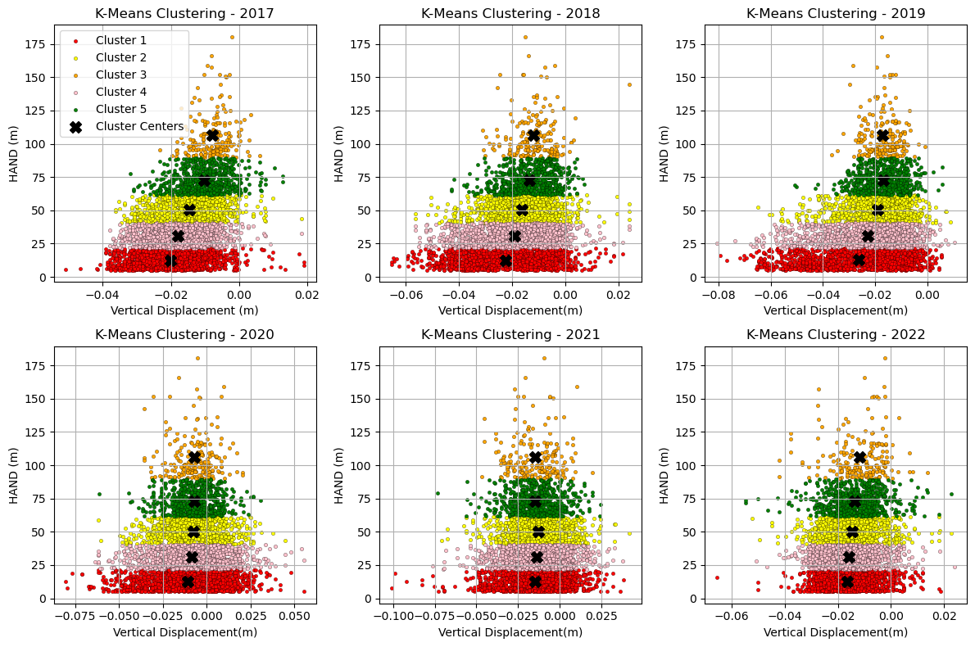

*Figure B13.*These graphs are displaying the grouping patterns after performing a k-means clustering analysis and reference the clusters in Figure B12. The team grouped vertical displacement (or summer subsidence) and HAND values. Patterns observed include a greater spread of higher displacement values with higher HAND values, particularly in exceptionally warm years such 2019. The data suggests that there is a relationship between displacement and HAND, however, more future work is necessary to interpret these results.

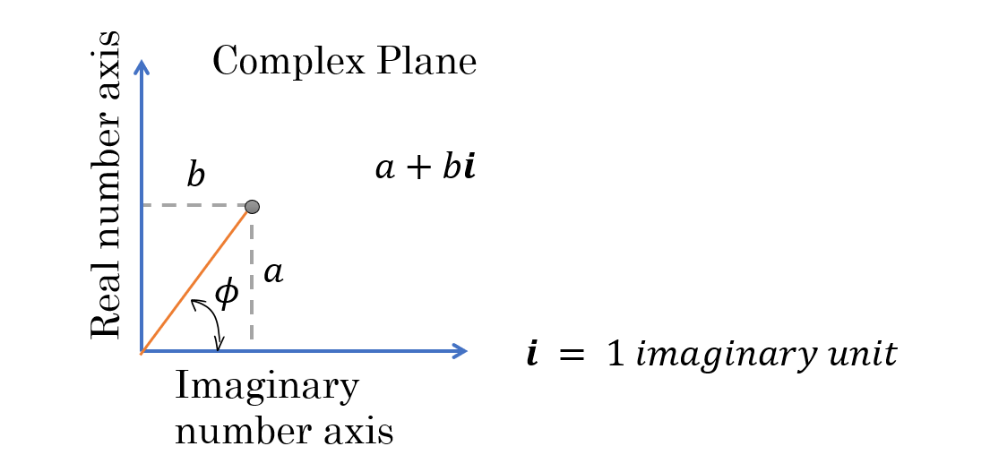

*Figure B14.*An illustration of the real and imaginary components of complex numbers, which is a format used in SAR SLC products. The magnitude of the radar signal $σ$ can be obtained by $\sqrt{a^{2}+b^{2}}$, and the phase of the radar, $ϕ$, can be calculated using $\tan^{-1}{(\frac{a}{b}})$. This characteristic of complex numbers makes SLC the only format capable of storing radar phase and strength values.