New Mexico Energy

Identifying Optimal Site Locations for Wind Energy Farms Considering Ecological and Social Impacts

 **Technical Report**

Kara Cassano (Project Lead)

Joy Marich

Franny Senkowsky

Dr. Jeffrey Luvall, NASA Marshall Space Flight Center (Science Advisor)

Dr. Robert Griffin, University of Alabama in Huntsville (Science Advisor)

# 1. Abstract

With the increasing cost and declining availability of fossil fuels, renewable energy, specifically wind power, has become one of the fastest growing sources of energy in New Mexico. To assist with the goals set by the state’s Renewables Standard Portfolio established in 2004, the NASA DEVELOP team created three Optimal Wind Farm Suitability maps that consider social impact, ecological impact, and power production efficiency. Along with the National Renewable Energy Laboratory (NREL), project partners included the New Mexico Energy, Minerals & Natural Resources Department’s Energy Conservation & Management Division (ECMD), and New Mexico Department of Game and Fish (NMDGF). The team utilized datasets from February 2013 – May 2018 including NASA Earth observations from the Shuttle Radar Topography Mission (SRTM) and Suomi National Polar-orbiting Partnership (NPP) to take into account vulnerable species, average wind patterns, and US Air Force Base locations. These three maps were combined into a final suitability map for optimal wind farm placement. Fuzzy Logic modeling was implemented to identify areas of low social and ecological impact and of high wind power productivity. The Land-Use Conflict Identification Strategy (LUCIS) combined the Fuzzy Logic model outputs to predict regions that may be overall suitable for wind farms.

**Keywords**

Renewable energy, site suitability, fuzzy logic, LUCIS, SRTM, Suomi NPP

# 2. Introduction

* 1. 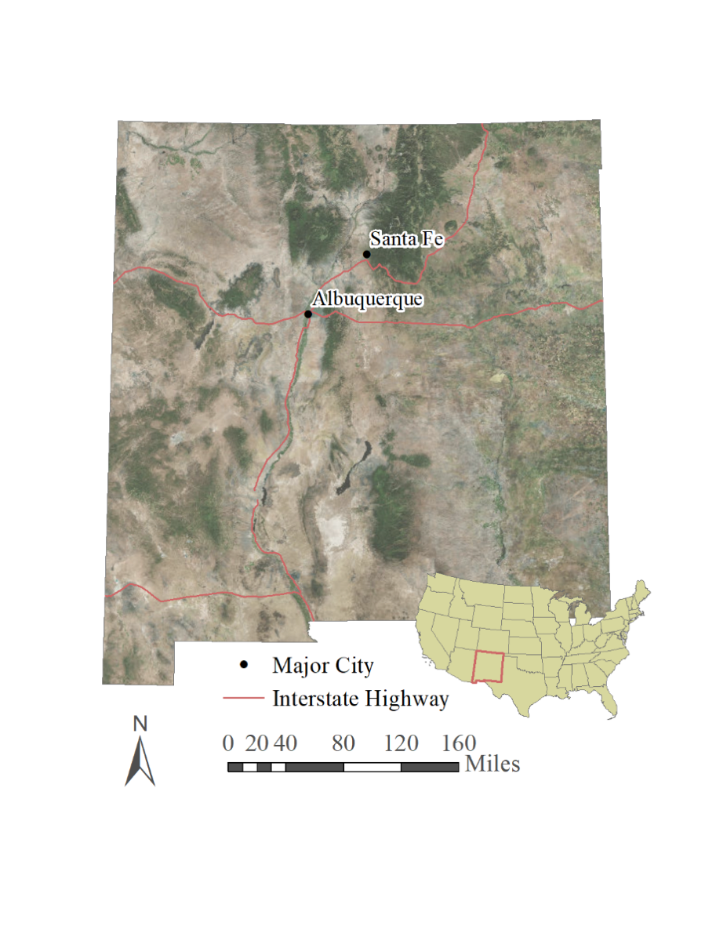***Background Information***

As of 2017, wind energy has become the largest source of renewable electric capacity in the United States (American Wind Energy Association, 2018). This development comes as a result of increasing fuel prices and declining availability of these fossil fuels (Shafiee & Topal, 2010). However, as this rapid growth continues, there are specific concerns that must be taken into consideration over the societal and ecological impact wind energy development would have as more states pursue this renewable resource.

In the state of New Mexico (Figure 1), wind energy generates more than 11% of the state’s energy production and, as of December 2017, the state is home to 1,682 MW of installed wind capacity (American Wind Energy Association, 2018; Oteri, Baranowski, Baring-Gould, & Tegen, 2018). Wind development has generated $2 billion of total capital investment and has supported between 1,000 and 2,000 direct and indirect jobs (American Wind Energy Association, 2017a). The industry continues to grow throughout the state, and approximately 1,028 MW of wind capacity were under production as of September 2017 (American Wind Energy Association, 2017c).

*Figure 1.*  Map of the study area, New Mexico.

Wind sector growth also causes concern for particular communities that may be impacted by rapid development. In New Mexico, the presence of Air Force bases can create barriers to production and competition for air space (Auld, McHenry, & Whale, 2013). Bird populations, such as the golden eagle and lesser-prairie chicken, are an ecological concern due to turbines disrupting their habitats and flight patterns (Pruett, Patten, & Wolfe, 2009). Disturbance of areas of high population density and protected lands pose other concerns, affecting public attitudes towards wind farm development near their communities (Swofford & Slattery, 2010). All of these important social and ecological factors are integral to our study which determines optimal locations for wind farm development using data from February 2013 to May 2018 to accurately characterize the study area. Models, such as the Land-Use Conflict Identification Strategy (LUCIS) and fuzzy logic, were used to overlay data and conduct site suitability analysis.

* 1. ***Project Partners & Objectives***

The Energy Conservation and Management Division (ECMD) located within New Mexico Energy’s Minerals & Natural Resources Department, is primarily concerned with developing reliable supplies of renewable and non-renewable energy for the state. It plans to utilize the end products to both achieve the goals outlined in the state’s Renewables Portfolio Standard and to assess the social impacts of wind farm development on Air Force bases and areas of high population development. The National Renewable Energy Lab (NREL) is primarily concerned with finding creative approaches to energy production and plans to replicate our methodologies in other regions or states with wind development potential. The New Mexico Department of Game & Fish (NMDGF) is primarily concerned with conservation of wildlife within the state and will utilize the end products to outline potential development areas with the least ecological impact, especially on the golden eagle, the bald eagle, and the lesser prairie-chicken, and to follow the goals outlined in the State Wildlife Action Plan (SWAP). All partners have expressed an interest in sharing the information from the end products with other interested parties, especially without the need for GIS software. The partners also emphasized that this information could be used to inform the public and other organizations.

Through this project, we aimed to showcase NASA Earth observations from Shuttle Radar Topography Mission (SRTM) and Suomi National Polar-orbiting Partnership (NPP) through site suitability analysis of possible locations for wind farm development. We also assessed the social impact of wind farms, specifically on Air Force bases, Protected Lands, and densely populated areas, as well as the ecological impact of wind farms on the golden eagle, bald eagle, and lesser prairie-chicken. We used factors, such as wind speed, to determine areas with the greatest wind power potential. Finally, we produced four end product maps for decision makers to visualize optimal locations using fuzzy logic and the Land-Use Conflict Identification Strategy (LUCIS) for wind farms in the state of New Mexico.

# 3. Methodology

***3.1 Data Acquisition***

The team used elevation data from the NASA Earth observing satellites SRTM and light intensity data from Suomi NPP to assess potential sites for wind farms (Table 3). The team downloaded data from Suomi NPP Visible Infrared Imaging Radiometer Suuite (VIIRS), throughout the state of New Mexico based on nighttime lights, to assess population density. The team downloaded the Suomi NPP data in GeoTIFF format from the National Oceanic and Atmospheric Administration’s website. The “vcmsl” (VIIRS Cloud Mask – Stray Light Corrected) version of Tile 1 includes stray-light corrected imagery of the United States, and the data was downloaded from each month in 2017. The “vcmsl” format was chosen because it includes two GeoTIFF files. The team downloaded the NASA Surface Meteorology and Solar Energy (SSE) dataset in CSV format from NASA Prediction of Worldwide Energy Resources (POWER) website (Table 4).

The team obtained data containing the geographic distribution of the golden eagle and lesser prairie chicken in New Mexico from the National Heritage New Mexico database (Table 4). The dataset included a polygon shapefile of sightings of the two species on public and private lands. These data aid in identifying areas of potential wind farm development that could negatively impact these vulnerable species.

The team acquired population density data from NASA’s Socioeconomic Data and Applications Center (SEDAC) to supplement the Suomi NPP dataset and determine areas with low population densities, in order to identify areas suitable for wind farm development (Table 4). The team downloaded data from 2015 in GeoTIFF format into ArcMap with a resolution of approximately 110 km. The team created a shapefile of Air Force bases, Special Use Airspaces, and Military Training Routes based on data from the Department of Defense Flight Information Publication (FLIP) Planning Books AP/1A and AP/1B (Table 4).

Table 3*.*

*NASA Earth Observations utilized for suitability mapping of wind farms in New Mexico.*

|  |  |  |  |
| --- | --- | --- | --- |
| **NASA Earth Observations** | | | |
| **Platform/Sensor** | **Parameters** | **Dates Available** | **Source** |
| SRTM v4 | Elevation | 2000 | NASA JPL |
| Suomi PP VIIRS | Population Density | 2011 – Present | NASA GSFC |

Table 4.

*Ancillary datasets to supplement optimal suitability analysis of wind farms with NASA Earth observations.*

|  |  |  |  |
| --- | --- | --- | --- |
| **Ancillary Datasets** | | | |
| **Dataset Name** | **Parameters** | **Dates Available** | **Source** |
| NASA Surface Meteorology  and Solar  Energy (SSE) | Wind speed | February 2013 -  May 2018 | NASA Prediction  Of Worldwide  Energy Resources  (POWER) |
| National  Land Cover Dataset | Land  Classification | 2011 | United States Geological Survey (USGS) |
| Natural Heritage  New Mexico  Database | Golden Eagle and Lesser Prairie Chicken populations | 2018 | Natural Heritage  New Mexico  (NHNM) |
| Gridded Population  Of the World  (GPW), v4.10 | Population Distribution | 2015 | NASA  Socioeconomic  Data and  Applications  Center (SEDAC) |
| Department of Defense  Flight Information  Publication (FLIP)  Planning Books AP/1A &  AP/1B | Air Force Bases,  Special Use Airspaces (SUAS), & Military Training Routes (MTR) | 2018 | National  Geospatial-  Intelligence  Agency (NGA) |

* 1. ***Data Processing***

*3.2.1 Wind Power Potential*

The team calculated the Wind Power Density at 100 meters over the state of New Mexico using SSE data. The team used 50 mmean wind speed data from SSE to estimate the wind speed at 100 mbecause this represents the speed at the height of a typical wind turbine. Inserting the 50 m wind speed into the Log Wind Profile equation (Equation 1) gives an estimate of wind at 100 m,

${\text{V}}_{\text{h}}\text{=}{\text{V}}_{\text{hr}}\text{* }\frac{\text{ln}\text{⁡}\text{(}\frac{\text{h}}{{\text{z}}_{\text{o}}}\text{)}}{\text{ln}\text{⁡}\text{(}\frac{\text{hr}}{{\text{z}}_{\text{o}}}\text{)}}$ (1)

where *Vh*is the velocity at the desired height (m/s), *Vhr* is the velocity at the reference height (m/s), *h* is the desired height (m), *hr* is the reference height (m), and *zo* is the roughness length (Appendix A).

Roughness length is the height at which wind can blow freely without any impediment from friction or obstructions (World Meteorological Organization, 2008). After obtaining a mean wind speed for each point at 100 m, the team used the velocity to calculate the Wind Power Density (Equation 2):

$P= \frac{\left(\frac{1}{2}\right)*ρ*V^{3}}{A}$ (2)

where *P* is the Wind Power Density (W/m2), is the density of air at 15°C SLP (kg/m3), *V* is the velocity at 100 m (m/s), and *A* is the windswept area of the rotor blades (m2) (Robichaud, 2018). The resulting estimates of wind power density at 100 m were imported into ArcMap using Excel to Table and analyzed from there.

For elevation parameters used in the Wind Power Potential map, the team combined several Digital Elevation Models from the SRTM data and normalized their values (Equation 3) in Raster Calculator in ArcMap to create an elevation layer for the study area.

$\text{(}\frac{\text{raster-raster.minimum}}{\text{raster.maximum-raster.minimum}}\text{)*100}$ (3)

The team utilized the 2011 version of the National Land Cover Dataset to obtain an accurate land type classification of New Mexico and reclassified into eight classes: water, urban, barren land, forest, shrub land, grassland, agriculture, and wetland. After discussion with the project partners, grassland and barren land were determined to be more suitable due to less effort to construct wind turbines compared to land cover such as forest, where trees would have to be cut down. The land cover types were ranked based on suitability when reclassified with the more suitable land covers having higher values.

*3.2.2 Low Ecological Impact*

In order to assess impacts of wind turbines on golden eagles and lesser prairie-chickens, the team used population distribution data provided by Natural Heritage New Mexico. As suggested by the NMDGF, a three-mile buffer around distribution on public and private land was created to serve as the minimum distance turbines should be from golden eagle and lesser-prairie chicken habitats in order to not disturb them. The team masked out lands owned by the National Park Service, National Forestry Service, and Fish & Wildlife Services since those are ecologically protected and would be highly impacted by wind farms.

*3.2.3 Low Social Impact*

The team created a model in ArcMap to clip rasters for all 12 months of light intensity data and project into a UTM Zone 13N. These data helped to determine population centers within the state of New Mexico. Each pixel within each month of Suomi NPP data did not contain the same number of observations due to variations in cloud cover throughout the month.  Because of this, the team used the raster calculator to create a weighted average for the year (Equation 4).

$\frac{{(Jan}_{cvg}+{Jan}_{avg_rade9}{)*(Feb}_{cvg}+ {Feb}_{avg_rade9})+…({Dec}_{cvg}*{Dec}_{avg_rade9})}{{Jan}_{cvg}+{Feb}_{cvg}+… {Dec}_{cvg}}$ (4)

Attribute tables for both datasets were combined in ArcMap by Object Identification (OID). The team generated random points and extracted values to compare data at each random point between both datasets. The team then exported data to an Excel spreadsheet to perform simple linear regression. The team used simple linear regression and the graphing function in Excel to investigate if the data were normally distributed.

***3.3 Data Analysis***

*3.3.1 Wind Power Potential Suitability*

The team used the Excel to Table tool in ArcMap to import the final mean wind speeds and convert the latitude and longitude into projected points and display the points in the Geographic Coordinate System WGS 1984. The team clipped the outline of New Mexico to fit the project’s region of interest. To estimate the values between the points, the team utilized the Inverse Distance Weighted tool, creating a layer that illustrates wind density across the state.

Utilizing elevation, wind density, and land cover data, the team applied the fuzzy membership linear function resulting in three layers combined with the fuzzy overlay tool in ArcMap. A linear function assigns high fuzzy membership values to large values. The team chose the linear function due to more suitable land cover having higher values after reclassification. The team applied the linear membership to the elevation layer as well. This membership assigned lower suitability to higher elevation, based off project partner expertise.

*3.3.2 Suitability Considering Low Ecological Impact*

The team used the Euclidean distance tool to produce three rasters which the team then applied fuzzy membership to with a linear function. Areas were considered more suitable when the distance from bird populations and ecologically protected areas increase. The team combined three fuzzy membership layers using fuzzy overlay to create a map displaying suitability considering low ecological impact.

*3.3.3 Suitability Considering Low Social Impact*

Nighttime light imagery was previously utilized to assess population density and acts as a reliable supplement to improve human population datasets (Sutton, Robersts, Elvidge, & Meij, 1997). The team used simple linear regression to investigate the distribution of the combined Suomi NPP and SEDAC data, extracted from the random points in ArcMap. Analysis of this data indicated that the distribution was not normal, as was to be expected due to the much higher rates of both average radiances from nighttime lights and number of people per square kilometer in larger cities compared to rural areas.

Similar to the Wind Power Potential Suitability Map and the Suitability Considering Low Ecological Impact map, the team applied fuzzy membership to Euclidean distance layers of major roads, Air Force Bases, and Special Use Airspaces and the population density layer to create the Suitability Considering Low Social Impact Map. The team used a linear function because suitability increases as the distance from bases and airspaces increases. The minimum and maximum values for the population density layer were flipped because lower populations were determined as more suitable.

*3.3.4 Optimal Wind Farm Suitability*

The team used the Land Use Conflict Identification Strategy (LUCIS) model to create a final Optimal Wind Farm Suitability Map, which combined the three Wind Farm Site Suitability Maps. The three fuzzy model outputs were reclassified into three classes or categories, divided by natural breaks to accurately represent the three classes (low, medium, and high). The team used raster calculator to multiply the suitability values of each fuzzy output by the following values: the social suitability values were multiplied by 100, the ecological suitability values were multiplied by 10, and the wind power suitability values were multiplied by 1. The team added these three new rasters together. The resulting three-digit output values correspond to a different suitability ranking. The first digit of each three-digit value corresponds to the social suitability of a location, the second digit refers to the ecological suitability of a location, and the third digit refers to the wind power potential of a location. The locations corresponding to the value “333” would be considered of the highest suitability in each category.

# 4. Results & Discussion

***4.1 Analysis of Results***

*4.1.1 Suitability of Sites Considering Wind Power Potential Analysis*

Wind power potential is an extremely important factor when considering potential sites for wind farm development. The team utilized three different datasets that were combined using Fuzzy Logic to create the suitability map describing the wind power potential across the state of New Mexico. The first dataset shows the calculated Wind Power Density, based on mean wind speed at 100 meters. The highest values for wind power density appear in the northeast corner of the state, with values maxing at 348 W/m2 and values ranging in the mid 200’s to 300’s area. Layering this data with land classifications that were ranked depending on their suitability to wind farm development, and with data from SRTM elevation datasets, the wind power potential is painted clearly across the state. This map shows the areas with the highest suitability according to wind power potential to be mostly on the eastern side of the state, with maxes near the northeastern corner and southeast of Albuquerque (Figure 2).

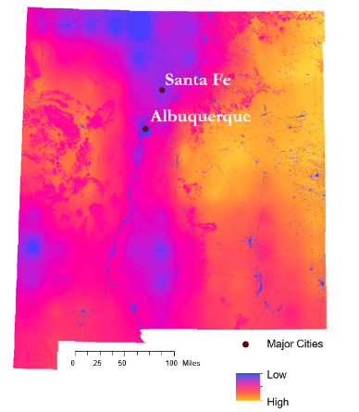

*Figure 2.* Suitability of Sites Considering Wind Power Potential, New Mexico.

*4.1.2 Suitability of Sites Considering Ecological Impact Analysis*

The presence of lesser-prairie chicken and golden eagle populations, as well as the presence of protected natural lands, greatly impacted the suitability of sites for wind farm development. The team utilized data from Natural Heritage New Mexico, which included sightings of each bird species on both public and private lands. The team then created a buffer around these polygons to outline the appropriate distance between bird populations and potential wind farm development. A shapefile of protected natural lands was also included in the map to outline these locations not suitable for wind farm development. Considering these factors and utilizing Fuzzy Logic, the map depicts areas suitable for wind farm development in the state considering these ecological factors (Figure 3). The most suitable areas appear to be to the east of Santa Fe and Albuquerque and along the southern border of the state, as well as other, smaller areas that appear to be highly suitable.

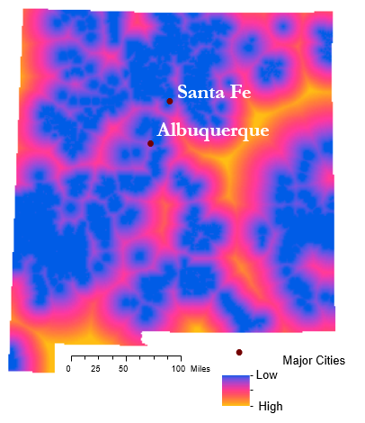

*Figure 3.* Suitability of Sites Considering Ecological Impacts, New Mexico.

*4.1.3 Suitability of Sites Considering Social Impact Analysis*

Locations of Air Force bases and Special Use Airspaces greatly impacted the suitability of wind farm development. Based on the social factors chosen, the top left corner of the state is more suitable. Overall, the northern portion of New Mexico would have a lower social impact of wind farm development. This is due to the higher concentration for military activity, specifically Air Force, in southern New Mexico (Figure 4).

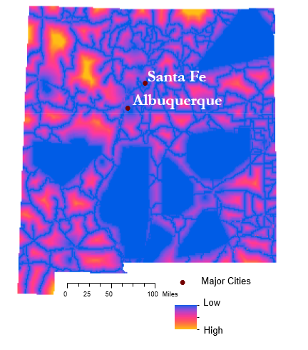

*Figure 4.* Suitability of Sites Considering Social Impacts, New Mexico.

*4.1.4 Optimal Wind Farm Suitability Analysis*

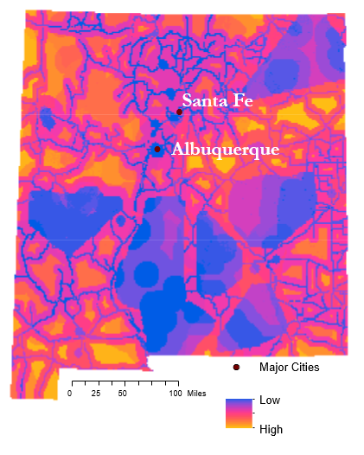The team combined the three suitability maps to create a fourth overall suitability of sites map using LUCIS. This map outlines locations throughout the state with areas of low to high suitability for wind farm development, or high to low land-use conflict, respectively. Considering social factors, ecological factors, and wind power production potential, the Optimal Wind Farm Suitability Map (Figure 5)

*Figure 5.* Optimal Wind Farm Site Suitability, New Mexico.

demonstrates the highly suitable areas, depicted in bright yellow, such as those to the east of Santa Fe and Albuquerque and in the boot heel area in the south of the state. These highly suitable locations are also locations where these three factors were in the least conflict with each other. Because of this, these areas are considered most suitable for wind farm development.

***4.2 Future Work***

Considering the many ecological impacts wind farm development can have, important future work would involve assessing the impact of wind farms on other species, such as bats and the sand dune lizard. Additionally, continued validation of *in situ* wind data to validate wind power density would ensure the accuracy of wind calculations. Another next step would be incorporating other factors deemed important by the project partners into further suitability analysis, such as transmission line location and accessibility and land ownership throughout the state. Other wind-related factors could be included when assessing wind power potential, including wind shear and diurnal wind variation. Finally, a more detailed suitability analysis should be run on smaller areas with additional datasets to conduct a more in-depth analysis.

# 5. Conclusions

This project successfully utilized NASA Earth observations to identify and address potential land use conflicts when conducting wind farm site suitability. Not unexpectedly, site suitability varies greatly throughout the state of New Mexico, and tools such as Fuzzy Logic and LUCIS were integral in identifying these suitable locations. There are many factors to consider when conducting site suitability analysis, and the team relied on guidance from the project partners to choose specific factors to include in the suitability analysis. Chosen factors such as Air Force Base locations, wind power density, and lesser prairie-chicken and golden eagle distribution greatly impact an area’s suitability for potential wind farm development. The four end product maps created during the term will facilitate conversation between various stakeholders and organizations regarding policy making and wind farm development.

# 6. Acknowledgments

The DEVELOP New Mexico Energy team would like to acknowledge the following people for guidance and support on this project:

* Dr. Jeffrey Luvall, NASA Marshall Space Flight Center (Science Advisor)
* Dr. Robert Griffin, University of Alabama in Huntsville (Science Advisor)
* Leigh Sinclair, University of Alabama in Huntsville/Information Technology and Systems Center (Mentor)
* Maggi Klug, University of Alabama in Huntsville (Mentor)
* Helen Baldwin, NASA DEVELOP
* Mercedes Bartkovich, NASA DEVELOP
* Robi Robichaud, National Renewable Energy Lab
* Jeremy Lewis, New Mexico Energy Minerals and Natural Resources Department
* Ronald Kellermueller, New Mexico Department of Game & Fish

Any opinions, findings, and conclusions or recommendations expressed in this material are those of the author(s) and do not necessarily reflect the views of the National Aeronautics and Space Administration.

This material is based upon work supported by NASA through contract NNL16AA05C and cooperative agreement NNX14AB60A.

# 7. Glossary

**LUCIS** – Land Use Conflict Identification Strategy, which is a model to identify where future conflicts over competing land uses may arise

**NASA Earth observations** – Satellites and sensors that collect information about the Earth’s physical, chemical, and biological systems over space and time

**NASA GSFC** – NASA Goddard Space Flight Center, located in Greenbelt Maryland

**NASA JPL** – NASA Jet Propulsion Laboratory located in Pasadena, California

**SRTM** – Shuttle Radar Topography Mission

**Suomi NPP** – Suomi National Polar-orbiting Partnership

# 8. References

American Wind Energy Association. (2017a). U.S. wind energy state facts. Retrieved from http://www.awea.org/resources/statefactsheets.aspx?itemnumber=890&navItemNumber=5067

American Wind Energy Association. (2017b). U.S. wind industry third quarter 2017 market report. Retrieved from https://www.awea.org/About/content.aspx?ItemNumber=11147

American Wind Energy Association. (2018). U.S. wind industry fourth quarter 2017 market report.” Retrieved from http://awea.files.cmsplus.com/FileDownloads/pdfs/4Q%202017%20AWEA%20Market%20Report%20Public%20Ve rsion.pdf.

Auld, T., McHenry, M. P., & Whale, J. (2013). US military, airspace, and meteorological radar system impacts from utility class wind turbines: Implications for renewable energy targets and the wind industry. *Renewable Energy*, *55*, 24-30.

Azizi, A., Malekmohammadi, B., Jafari, H. R., Nasiri, H., & Parsa, V. A. (2014). Land suitability assessment for wind power plant site selection using ANP-DEMATEL in a GIS environment: Case study of Ardabil province, Iran. *Environmental Monitoring and Assessment*, *186*(10), 6695-6709.

Center for International Earth Science Information Network - CIESIN - Columbia University. (2017). Gridded Population of the World, Version 4 (GPWv4): Population Density, Revision 10. Palisades, NY: NASA Socioeconomic Data and Applications Center (SEDAC), accessed 26 June 2018. doi: https://doi.org/10.7927/H4DZ068D

Jarvis A., H.I. Reuter, A.  Nelson, E. Guevara, 2008, Hole-filled seamless SRTM data V4, International Centre for Tropical Agriculture (CIAT), available from http://srtm.csi.cgiar.org

NOAA National Centers for Environmental Information, Earth Observations Group (2017). Version 1 VIIRS Day/Night Band Nighttime Lights. Retrieved June 26, 2018 from [https://www.ngdc.noaa.gov/eog/viirs/download_dnb_composites.html](https://slack-redir.net/link?url=https%3A%2F%2Fwww.ngdc.noaa.gov%2Feog%2Fviirs%2Fdownload_dnb_composites.html&v=3)

Oteri, Frank, Ruth Baranowski, Ian Baring-Gould, and Suzanne Tegen. (2018). 2017 state of wind development in the United States by region. Golden, CO: *National Renewable Energy Laboratory.* Retrieved from https://www.nrel.gov/docs/fy18osti/70738.pdf.

Pruett, C. L., Patten, M. A., & Wolfe, D. H. (2009). It's not easy being green: Wind energy and a declining grassland bird. *BioScience*, *59*(3), 257-262.

Robichaud, R. (2018). *NASA - New Mexico Wind Project Wind Energy Overview.* [PowerPoint Slides].

Shafiee, S., & Topal, E. (2010). A long-term view of worldwide fossil fuel prices. *Applied Energy*, *87*(3), 988-1000.

Sutton, P., Roberts, D., Elvidge, C., & Meij, H. (1997). A comparison of nighttime satellite imagery and population density for the continental United States. *Photogrammetric Engineering and Remote Sensing*, *63*(11), 1303-1313.

Swift, A. (2015). Wind energy essentials: Societal, economic, and environmental impacts. *John Wiley & Sons* (pp. 145-159).

Swofford, J., & Slattery, M. (2010). Public attitudes of wind energy in Texas: Local communities in close proximity to wind farms and their effect on decision-making. *Energy Policy*, 38(5), 2508-2519.

World Meteorological Organization. (2008). Guide to meteorological instruments and methods of observation*.* Retrieved from https://www.weather.gov/media/epz/mesonet/CWOP-WMO8.pdf

# 9. Appendices

Appendix A.

Terrain classification from Davenport (1960)

adapted by Wleringa (1980*b*)

in terms of aerodynamic roughness length zo

*Table A1.* World Meteorological Organization Roughness Lengths

|  |  |  |
| --- | --- | --- |
| **Terrain classification from Davenport (1960)**  **adapted by Wleringa (1980*b*)**  **in terms of aerodynamic roughness length zo** | | |
| ***Class*** | ***Short terrain description*** | ***zo(m)*** |
| 1 | Open sea, fetch at least 5 km | 0.0002 |
| 2 | Mud flats, snow; no vegetation, no obstacles | 0.005 |
| 3 | Open flat terrain; grass, few isolated obstacles | 0.03 |
| 4 | Low crops; occasional large obstacles, *x/H* > 20 | 0.10 |
| 5 | High crops; scattered obstacles, 15 < *x/H* < 20 | 0.25 |
| 6 | Parkland, bushes; numerous obstacles, *x/H* = 10 | 0.5 |
| 7 | Regular large obstacle coverage (suburb, forest) | 1.0 |
| 8 | City centre with high- and low-rise buildings | ≥2 |