**NASA DEVELOP National Program**



NASA John C. Stennis Space Center

*Fall 2015*

Texas Disasters II

Utilizing NASA Earth Observations to Assist the Texas Forest Service in Mapping and Analyzing Fuel Loads and Phenology in Texas Grasslands

 **Technical Report**

Rough Draft – October 8, 2015

J. Michael Brooke (Project Lead)

Meredith Williams

Teresa Fenn

Joseph Spruce, NASA Stennis Space Center (Science Advisor)

James “Doc” Smoot, NASA Stennis Space Center (Science Advisor)

Previous Contributors:

Benjamin Beasley

Alex Holland

Kristen Kelehan

# I. Abstract

[Placeholder - do not put anything here until the final draft submission. The abstract in the project summary is where the working draft of the abstract should “live”]

**Keywords**

Remote Sensing, Fuel Load, Wildfire, Landsat, MODIS, Disasters

# II. Introduction

**Background Information:**

Wildfires in Texas have increased due to several contributing components. The main component is human influences on the environment such as recent urbanization and climate change. In 2011, Texas suffered one of the worst wildfire seasons and droughts ever recorded in the history of the state. According to Texas emerging communities, 80 percent of wildfires are occurring within two miles of communities. With the recent development into these wildfire areas the risk of property loss and loss of life has increased. In 2011, 31,453 wildfires burned 4 million acres and destroyed 2,947 homes (Texas Forest Service 2011). According to the Texas Forest Service, in April 2011, the state of Texas documented six of the 10 largest wildfires in the history of the state. With Bear Creek Fire recorded as the largest wildfire ever to burn in East Texas at 41,050 acres and the most acres burned in a single wildfire season at 4,011,709 acres (Texas Forest Service 2011). According to Texas state climatologist John Nielsen-Gammon, October 2010 through September 2011 was the driest twelve month period in Texas history.

The historical 2011 wildfire season and drought was preceded by an abnormally wet year in 2010. According to the National Oceanic Atmospheric Administration (NOAA), the winter of 2010 had low humidity and precipitation variations as a result of La Niña. La Niña refers to the periodic cooling of the ocean surface temperatures in central and east-central equatorial Pacific that occurs every three to five years (NOAA 2012). La Niña in the winter of 2010 brought drier than normal weather conditions across the Southeastern portion of the United States. The abnormally wet year in 2010 allowed for an increase in vegetation growth therefore an increase in fuel load. These factors followed by a drought contributed to the most severe wildfire season the state of Texas has ever recorded.

**Project Objectives:**

The project objective was to map vegetation type specific phenology as it related to wildfire fuel loads by acquiring mapped wildfire fuel types and fuel loads from the Stennis Space Center Texas Disasters project and the Langley Research Center Texas Water Resources project to provide a more synergistic analysis of wildfire risk in Texas.

**Study Area:**

The focus of the project was the entire state of Texas. The Texas is the second largest state in the Unites States. The state varies climatically and topographically. The northern part of Texas known as the panhandle is dry, barren and consists of mostly grasslands. The central part of the state known as the hill country is a transition from flat woods to grassland areas. The eastern part of Texas is the wettest region in Texas and is made up of pinewoods. The southern region of the state is dry and mountainous with interspersed desert regions. The western region of Texas is known for dry, hot weather and vegetation consisting of grasslands and shrubs. Due to the large size of Texas a smaller study area within Texas was selected. The Possum Kingdom Complex wildfire which consisted of six counties: Palo Pinto, Young, Stevens, Wise, Jack and Parker County was selected. The Possum Kingdom Complex wildfires burned 126,000 acres and destroyed 168 homes in this area during the historic 2011 wildfire season.

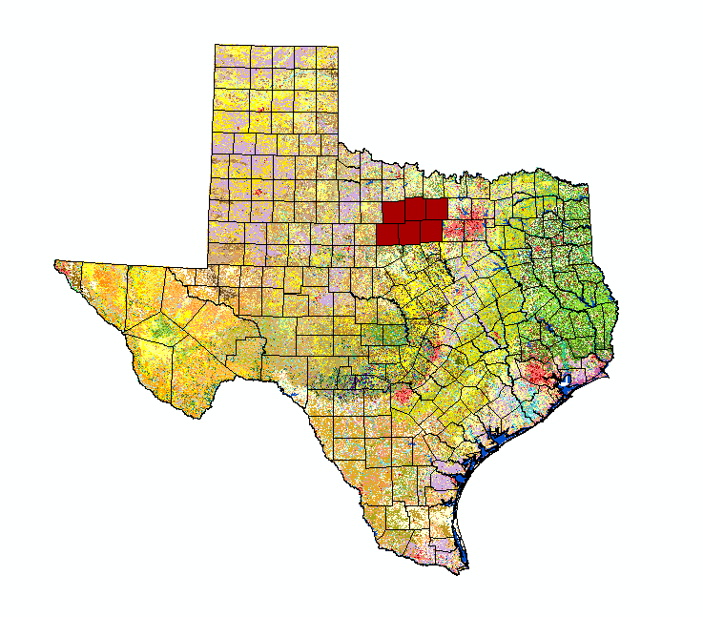

Figure 1: Study Area

**Study Period:**

This project will utilize NASA Earth observations and ancillary data collected from 2001 until present. The study period includes data from the years 2010-2011 in which 2010 was an abnormally wet year followed by the historical 2011 wildfire season.

**National Application(s) Addressed:**

This project applies to the application areas of disasters, ecological forecasting, agriculture and water resources. Two previous projects from the Stennis Space Center (SSC) Texas Disasters team and the Langley Research Center (LaRC) Texas Water Resources II team were used to provide a more synergistic analysis of wildfire risk in Texas.

**Project Partners:**

Our partners for this project are the Texas Forest Service (TFS) and the United States Department of Agriculture (USDA) Forest Service. The TFS is tasked with estimating and evaluating potential fire risk in order to manage and allocate resources for the prevention and containment of potential wildfires across Texas. The TFS currently utilizes data derived from the United States Geological Survey (USGS) LANDFIRE program which predicts and monitors wildfires. The project methodologies and results will provide supplemental information from two previous projects at SSC and LaRC along with this project to the TFS to help aid, monitor and prevent future wildfires.

# III. Methodology

Data Acquisition:

Land Cover

Texas Parks and Wildfire Department data were acquired for the state of Texas at 30 meter ground resolution. The data sets were clipped to the six counties that surround the Possum Kingdom Complex wildfire area.

Forwarn MODIS Phenology

USDA Forest Service Forwarn Early Warning System…. This data set was for the entire contiguous United States and was clipped to cover the study area for this project; first for Texas and then for the six counties that surround the Possum Kingdom Complex wildfire area.

What data did you get, what level products are they, for what dates did you get images, where did you get the images from, etc.

Data Processing:

What did you do to the data? Were there conversions needed to be able to analyze it? Did you have to mosaic images? Did you have to normalize anything to fit other datasets? Did you run an NDVI, change detection, etc?

Data Analysis:

How did you analyze the data? What methods did you use?

# IV. Results & Discussion

Insert images, graphs, maps, charts, etc. here. Choose the most important results to highlight here. No word cap, but two to six pages is a good range.

Things to discuss:

* Analysis of Results: What can you tell from your graphs, images, etc? What does this mean for your project?
* Errors & Uncertainty: What factors could you not account for, what things didn’t work out like you expected they would, etc.
* Future Work: If this project was to be selected for another term, what would be the focus? What other areas would be of interest?

# V. Conclusions

Final conclusions. Word count: 200-600 (~a page).

# VI. Acknowledgments

Insert here. Keep to a concise paragraph or bullets of names. End with the following sentence.

Any opinions, findings, and conclusions or recommendations expressed in this material are those of the author(s) and do not necessarily reflect the views of the National Aeronautics and Space Administration.

This material is based upon work supported by NASA through contract NNL11AA00B and cooperative agreement NNX14AB60A.

# VII. References

Insert references here. Only include articles/content cited in the body of text above. It’s great if you read many other articles, but they should not all be listed here unless they are being cited in this report.

Use whatever style you want - here are some options:

<http://texasforestservice.tamu.edu/uploadedFiles/FRP/New_-_Mitigation/Safety_Tips/2011%20Texas%20Wildfires.pdf>

<http://www.cpc.ncep.noaa.gov/products/analysis_monitoring/ensostuff/ensofaq.shtml#NINA>

# VIII. Content Innovation

In preparation for DEVELOP’s coming microjournal, please select three content innovation features to support your paper. For each item, please list the name of the feature, and include the tool itself if possible (eg. glossary terms and definitions). If the tool does not work in Microsoft Word (eg. Interactive MATLAB Figure Viewer), please list the file name and upload the related file to the DEVELOP Exchange. If you choose to use Inline Supplementary Material, please also include where the material should appear in the text.

**Some options include:**

AudioSlides

Database Linking Tool

Data Profile

Executable Papers

Featured Author Videos

Featured Multimedia for this Article (video and podcast options)

Glossary Viewer

Inline Supplementary Material (figures, tables, computer code)

Interactive Map Viewer

Interactive MATLAB Figure Viewer

Interactive Plot Viewer

Nomenclature Viewer

# IV. Appendices

Insert here