**NASA DEVELOP National Program**

Marshall Space Flight Center

**Spring 2014**

**Cumberland Plateau Ecological Forecasting II**

*Using NASA Earth Observations to Model a Representative Species’ Future Geographic Distribution in the Cumberland Plateau to Aide in Conservation Efforts*

**Team Lead:** Amanda Weigel (University of Alabama in Huntsville), amw0039@uah.edu

**Team Members:**

Jean Baptiste Kayitare (California Baptist University)

Robert Rossell (University of Alabama in Huntsville)

**Advisors & Mentors:**

Dr. Jeffrey Luvall (NASA Global Hydrology and Climatology Center)

**Past or Other Contributors:**

Dr. Robert Lawton (University of Alabama in Huntsville)

**Applied Sciences National Applications Addressed:**

Ecological Forecasting

Climate

**Study Area:** Cumberland Plateau: Alabama, Tennessee, Kentucky

**Study Period:** May 2010 - December 2040

**Community Concerns**

* The Cumberland Plateau has the highest concentration of endangered species on the continent and is in need of preservation.
* An increase in homes and tourism has led to the fragmentation and degradation of the area’s rich forests and streams.
* Increasing recreational uses has added new pressures to the area.
* Federal government agencies and other non-profit organizations need assistance prioritizing suitable land to purchase for preservation.
* Maps of future species distributions are needed to aid organizations in considering land purchases for preservation.

**80-100 Word Blurb**

The Cumberland Plateau is considered a biodiversity hotspot in North America, rivaling others around the globe. Areas within the Cumberland Plateau are currently being protected by private and government agencies. This study employs a methodology to map the optimal species distribution for White Oak based on future climatic conditions and physical environmental parameters. Using environmental parameters weighted by their corresponding percent contribution output by the Maximum Entropy Species Distribution Model (MaxEnt), the White Oak’s optimal future distribution was mapped using a fuzzy logic model created in ArcGIS. The results from this study are used by agencies to prioritize areas for preservation.

**Abstract**

This study examines the spatial distribution of White Oak, a representative species for the Cumberland Plateau area, using future climatic and physical environmental parameters. The Cumberland Plateau is one of the most biodiverse regions in North America. Government and private agencies are interested in purchasing land for conservation efforts in the region to support biodiversity for years to come. Consequently, these lands are purchased without knowledge as to how the climate will affect the forests in the future. Using Global Digital Elevation Models (GDEM), current climate and hydrography data acquired and compiled from Earth observing satellites, the White Oak’s environmental parameters were weighted using the Maximum Entropy Species Distribution Model (MaxEnt). Using the model outputs of percent contribution, a fuzzy logic model created in ArcGIS was used to map the White Oak’s optimal distribution and habitable range based on future climate projections. The results are used to provide the Nature Conservancy and the US Fish and Wildlife Services areas in the Cumberland Plateau that are worth purchasing.

**Partners/Collaborators**

The Nature Conservancy: Steve Northcutt (Director of Protection)

U.S. Fish and Wildlife Service: Oliver van den Ende (Refuge Planner)

U.S. Forest Service: Dr. Callie Schweitzer (Research Forester)

**Current Management Practices & Policies**

The Nature Conservancy and other organizations purchase land and set up forest preserves based on endangered species habitats and land availability. The method used for land purchases and preservation is based on preserving endangered species in habitats that are economically beneficial. The Nature Conservancy does not implement remote sensing to aide in the decision making process.

**Benefit to End-User:**

* Identifying areas that can be used as corridors to connect isolated regions of White Oak based on climatic changes
* Aid in land conservation efforts to preserve the biodiversity of the Cumberland Plateau by purchasing critical areas of land

**Decision Support Tools**

* A map of the most suitable areas to conserve
* Methodology used to aid in future projections of optimal land purchasing using future climatic conditions
* Optimal locations to purchase for preservation

**Earth Observations & Parameters**

Landsat 8, OLI - Current land cover

Terra, ASTER - Global Digital Elevation Model (GDEM)

**Future Applicable NASA Missions**

Global Precipitation Measurement (GPM) - Future Precipitation

Soil Moisture Active Passive (SMAP) - Soil Moisture

**Models Utilized**

Princeton University, Maximum Entropy Species Habitat Model (MaxEnt)

**Ancillary Datasets Utilized**

Forest Preserve/Land Purchased data provided by The Nature Conservancy

National Center for Atmospheric Research (NCAR) Community Climate System Model (CCSM), future air temperature and precipitation

U.S. Forest Service tree plot data, model training data

USGS National Hydrography Dataset

**Software Utilized**

ArcGIS 10.1 - Raster Manipulations/ Analysis, fuzzy logic model, Map Generation

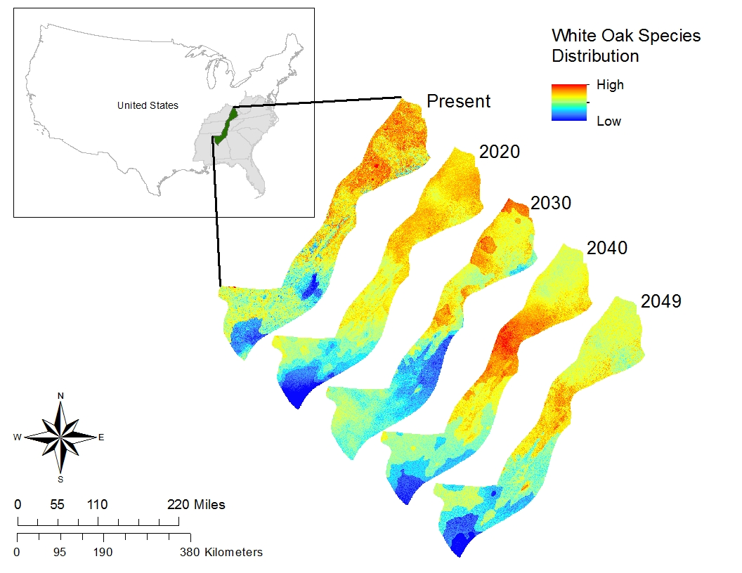ENVI 5.0 - Raster Processing