Marin County Wildland Fires

Examining Fuel Load and Land Cover Change to Inform Fire Prevention and Suppression Decisions in Marin County, CA

**Technical Report**

Final – March 30th, 2023

Suhani Dalal (Project Lead)

Katera Lee

Gabriel Rosenstein

Chandler Ross

***Advisors:***

Dr. Juan Torres-Pérez, NASA Ames Research Center (Science Advisor)

Dr. John (Jake) Dialesandro, Santa Clara University (Science Advisor)

Britnay Beaudry, NASA Ames Research Center (Science Advisor)

***Fellow:***  
Lisa Tanh (ARC)

# 1. Abstract

Heightened occurrence of severe wildfires in the Western United States is increasing the need to better understand regions of high potential wildfire severity and develop methodologies for identifying the best locations for fuels reduction and active wildfire suppression, especially in populated regions such as Marin County, California. Marin County, located in the San Francisco Bay Area, has had significant development in the wildland-urban interface and periods of highly wildfire-prone conditions. The NASA DEVELOP team collaborated with Fire Foundry (a Marin-based fire service workforce development program) and the Marin County Fire Department to develop models to assist with fire management. Using data from Sentinel-2A, PlanetScope, ECOSTRESS, a county-wide LiDAR mapping effort, Landsat 7 Enhanced Thematic Mapper (ETM+), and Landsat 8 Operational Land Imager (OLI), our team developed a number of input data layers for three different models to evaluate wildfire severity. One model performed a suitability analysis with weights based on scientific literature; another model utilized a U-Net Convolutional Neural Network trained on previous fires in Marin and neighboring Sonoma County to predict the difference normalized burn severity; and the third inputted data layers into the FlamMap tool that outputs risk categories. We compared model outputs and performed a weighted overlay analysis to identify specific locations where a fireline could be constructed to interrupt the progress of an active fire. These tools will assist partners in preparing for and managing active wildfire situations.

**Key Terms**

Remote sensing, Sentinel-2, machine learning, fireline, fire severity, Landsat, FlamMap

# 2. Introduction

***2.1 Background Information***

California has experienced a sharp increase in large-scale, destructive wildfire in recent years due to a variety of factors. Historic exclusion of fire from fire-adapted ecosystems, encroachment of human development into the wildland-urban interface (WUI), and climactic changes have led to longer, hotter, and drier autumns that coincide with strong offshore winds to create high wildfire risk conditions (Gross et al., 2020). Situated between the Pacific Ocean and the San Francisco Bay, Marin County has a typically moist climate that leads to rapid growth of vegetation in many forested regions (Figure 1). This effect is concentrated on the windward side of Mount Tamalpais, while the leeward side experiences the long summer dry season more acutely. Fire has been historically excluded for upward of one hundred years in these forests and it faces many of these same wildfire risks (G. Groneman, personal communication, January 31, 2023). While the moisture results in relatively few days of high fire risk, extreme heat and wind increasingly coincide across the area and create the potential for an explosive wildfire with substantial intermixed development at risk. The main vegetation, or fire fuels, in the study area comprises grasses and forested areas (Table 1). Fires in Marin County occur from the months of May to October. A higher quantity of fires occurs in mid-summer (the months of July and August), but the area burned is greatest in late summer and early fall (CalFire FRAP GIS Data, 2023). This trend is in alignment with other areas of California, where fuel-driven fires are more common and wind-driven fires are fewer but burn more area (Jin et al., 2015). Marin County has Foehn Wind events in the early fall that can propagate these large fires (Forrestel et al., 2011).

Researchers across the American West and other fire-prone regions around the world have increasingly turned to remote sensing to evaluate wildfire risk and address wildfires when they do ignite. Topography is key as it affects the climactic factors that drive vegetation growth and fuel wildfire, with slope in particular contributing to the rate of spread as fire moves quickly uphill (Maniatis et al., 2022). Satellites can also provide information across large areas about wildfire fuel loads such as the landcover type, vegetation density, and water availability, all of which determine how quickly and severely a fire may spread through an area (Mitsopoulos et al., 2017; Maniatis et al., 2022). Wildfires also require an ignition source and research shows that wildfire in developed parts of California will be overwhelmingly sparked by human ignition (Chen & Jun, 2022). Proximity to infrastructure, also provided by remote sensing, is another key component in determining wildfire risk at a given location.

Table 1

*Land cover percentages for Marin County*

|  |  |  |
| --- | --- | --- |
| **Land Cover** | **Land Cover (km2)** | **Percent of Land (excluding water)** |
| Forest | 651 | 48.6% |
| Grassland | 574 | 42.8% |
| Built Up | 59 | 4.4% |
| Barren/Sparse Veg | 25 | 1.9% |
| Cropland | 14 | 1% |
| Herbaceous Wetland | 11 | 0.8% |
| Shrubland | 5 | 0.4% |

Source: 2020 Sentinel-2 derived landcover map.

Fires require heat, fuel, and oxygen to burn and propagate. Wildland firefighters typically attempt to remove fuel (e.g., downed branches, shrubbery, and trees) to extinguish fires, as cooling or snuffing an active fire is difficult. Fire suppression techniques in Marin County primarily include hand-cut firelines, bulldozer lines, and prescribed burns. These activities are implemented based on factors such as fuel moisture, topography, and weather patterns, with consideration of historic suppression activities to inform the most ideal locations for active fire management. Remote sensing technology that is developed into a robust model could improve Marin County’s effectiveness in battling wildfires. This model would attribute fire risk to various areas based on the different fuel, vegetation, and topography parameters and identify ideal areas for fire suppression intervention. As fire regimes in the region are shifting due to climate change and other factors, historic data may not reflect contemporary fuel and fire dynamics. As such, a study period looking at 2013 to 2022 will allow for fire risk and suppression models to focus on the most up-to-date data and incorporate newer remote sensing products with superior spatial and spectral resolutions that may be relevant to understanding fuel conditions.

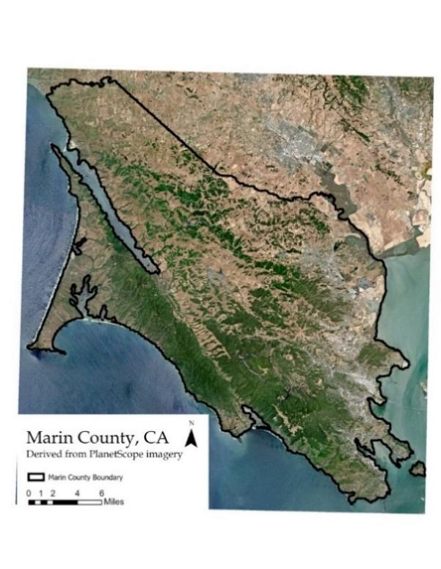

*Figure 1.* 3-meter ground sample resolution Marin County study area map derived from PlanetScope data (2023). Includes copyrighted material of Planet Labs PBC. All rights reserved.

***2.2 Project Partners & Objectives***

We partnered with FIRE Foundry, a workforce development program based in Marin County that aims to bolster the next generation of individuals in the fire service through training and certifications. The program is a consortium of many organizations including the Marin County Fire Department (MCFD) and the University of California, Berkeley’s Disaster Lab. The MCFD is a local government agency that is interested in using Earth observations (EO) to aid their understanding of risk and future suppression sites in Marin County. Currently, the MCFD utilizes both hands-on and remotely sensed data observations to aid in fire management and suppression activities. While the MCDF is able to locate and stop ongoing fires, they currently lack a robust system for locating the best regions for suppression tactics that incorporate historical data on dozer lines and fire breaks, as well as vegetation and climate indices. With the use of NASA EO, in conjunction with other types of satellite data products, the county can be better equipped in monitoring and controlling high severity fires that may transpire in the summer season.

The MCFD has been using hand-drawn maps, in conjunction with Avenza and InciWeb, to mark dozer lines, fire breaks, and locate areas for targeted fire suppression activity during active fires. For future fire modeling, however, they are seeking a real-time model that is optimized with soil, land, and vegetation parameters in addition to historical information on fire suppression indents. We wanted to make a final product that was easy to use with little technical experience. Using Google Earth Engine (GEE), the final product classified fire risk and severity, overlayed with suggestions on where to focus fire suppression efforts. Data fusion and resizing was necessary because the data inputs for this model have unique temporal and spatial resolutions, and separate processing methods.

This project created a coding tutorial and presentation on remote sensing applications in wildfire management to support FIRE Foundry’s goal to equip early-career fire service individuals with knowledge of the latest technology in fire management.

# 3. Methodology

***3.1 Data Acquisition***

*3.1.1 Vegetation and Fuels*

Our team acquired 10-meter Sentinel-2A imagery from the GEE satellite repository for Normalized Difference Vegetation Index (NDVI) calculations and land cover classifications. For one of our models, the U-NET, we used 30-meter Landsat 7 EMT+ and Landsat 8 OLI imagery. We also acquired Dynamic World V1 (DW) data from GEE to help establish land cover classes (Brown et al, 2022). DW is a land use land cover (LULC) probability dataset that utilizes Sentinel-2 imagery for its nine-class LULC predictions.

Figure A-1 illustrates key fuel parameters for predicting wildfire severity. Our team acquired products for Canopy Height, Canopy Cover, Canopy Bulk Density, and Canopy Base Height from the LANDFIRE program (LANDFIRE, 2022). All LANDFIRE data products are derived from a combination of 30-meter Landsat 7 Enhanced Thematic Mapper (ETM+) and Landsat 8 Operational Land Imager (OLI) imagery, LiDAR data, and field datapoints. The LANDFIRE base map is based on 2016 data and fuels which were updated to expected 2022 levels based on disturbances from 2016-2020. While other products may be more recent or of a finer scale, LANDFIRE is widely used and has the most established commitment to regularly updating their data product (Ryan & Opperman, 2013).

Marin County Parks, in association with several other local, state, and national organizations, conducted a LiDAR mapping effort between December 2018 and March 2019 and generated a data product of ladder fuel density that we acquired from their dedicated online portal (Table 2). The product expresses the density of ladder fuels as the number of returns, between 1 and 4 meters, over the number of returns below 1 meter in each region (Marin County, 2019). The ladder fuel spatial resolution is ~19.5 meters, or 64 feet.

Fuel loads do not change significantly on an annual basis outside of a meaningful disturbance, but a large fire would greatly alter fuel conditions. Only one major fire, the Woodward Fire, burned in our study area since the oldest data product, the 2018-2019 LiDAR-derived ladder fuels. To update this layer, we acquired a 30-meter raster of the fire parameter and severity from Monitoring Trends in Burn Severity (MTBS, 2022).

*3.1.2 Moisture*

To analyze the stress level of vegetation in Marin County, as well as determine the drought-susceptibility of the region, our team downloaded ECOSTRESS data using NASA’s Application for Extracting and Exploring Analysis Ready Samples (AppEEARS) (Table 2). ECOSTRESS, launched in June 2018, is a thermal instrument on the International Space Station that measures plant temperature in order to analyze plant stress and has a resolution of 70 meters. Our team downloaded Level-4 Water Use Efficiency (WUE) and Level-4 Evaporative Stress Index (ESI_PT-JPL) products as they can be helpful drought indicators alongside Level-2 Cloud Masks to remove clouds from the imagery. We collected all usable images for the fire season, from May to October, for every year starting in 2018.

*3.1.3 Ancillary Datasets*

To incorporate topography data, our team downloaded countywide digital elevation model (DEM) tiles, in raster format, from the County of Marin’s GIS website. The data was based off a 2019 LiDAR dataset. To determine the location of areas with low vegetation, such as roads and hiking trails, our team used a combination of vector and raster data from Planet. High ground sample resolution (3-meter) PlanetScope imagery was acquired for September 2022 (recent fire season) and January 2022 (green season). Our team downloaded hiking trail data from the National Park Service and the California State Parks (Table 2). Lastly, we downloaded road, bikeway, and waterbody locations from Marin County’s geospatial portal.

Table 2

*List of data products used in the project*

|  |  |  |  |  |
| --- | --- | --- | --- | --- |
| **Data Product** | **Derived Source** | **Years** | **Acquisition Source** | **Original Spatial Resolution (m)** |
| WUE | ECOSTRESS | 2018-2022 | AppEEARS | 70 |
| ESI | ECOSTRESS | 2018-2022 | AppEEARS | 70 |
| Dynamic World Land Cover | Sentinel-2 | 2018-2022 | GEE | 10 |
| Sentinel –2 Level 2A Surface Reflectance | Sentinel-2 | 2018-2022 | GEE | 10, 20 |
| Elevation | LiDAR | 2019 | Marin County Landscape Database | 0.5 |
| Aspect | LiDAR | 2019 | Marin County Landscape Database | 0.5 |
| Slope | LiDAR | 2019 | Marin County Landscape Database | 0.5 |
| Ladder Fuels | LiDAR | 2019 | Marin County Landscape Database | ~19.5 |
| Canopy Bulk Density | Landsat 7 ETM + and Landsat 8 OLI | 2020 | LANDFIRE | 30 |
| Canopy Cover | Landsat 7 ETM + and Landsat 8 OLI | 2020 | LANDFIRE | 30 |
| Canopy Height | Landsat 7 ETM + and Landsat 8 OLI | 2020 | LANDFIRE | 30 |
| Canopy Base Height | Landsat 7 ETM + and Landsat 8 OLI | 2020 | LANDFIRE | 30 |
| Planet Daily Scenes | PlanetScope | 2022 | Planet Labs | 3 |
| Roads | N/A | 2019 | Marin County Landscape Database | Vector Data |
| Trails | N/A | 2018 | California State Parks | Vector Data |
| Marin County Boundary Shapefile | N/A | 2022 | U.S. Census Bureau TIGERLINE | Vector Data |

***3.2 Data Processing***

*3.2.1 Fuels*

Some of our fuel data products that were sourced from satellites required additional processing. To start, we created an annual composite of the Dynamic World land cover data for each year of the study period with the “Introduction to Dynamic World” tutorial from GEE which provides steps to visualize DW land cover (Gandhi, 2022). Next, we generated NDVI products in GEE using Sentinel-2A imagery (Equation 1; Mitsopoulos et al., 2017). We incorporated a simple cloud mask using the Sentinel-2 QA band, and computed NDVI values for each pixel of each masked image. We generated median NDVI values for each dry season (May 16 - November 15) and wet season (November 16 - May 15) in our study period. To calculate the NDVI differential, we subtracted the dry season NDVI values from the preceding wet season. This NDVI differential values provided an estimate of where dense winter/spring herbaceous vegetation dried out and then converted to highly combustible fuels (Li et al., 2020). The formula for the NDVI calculation is below, where NIR is the near-infrared band and red is the red band.

$NDVI = \frac{NIR - Red}{NIR + Red}$ (Eq. 1)

To update ladder fuels from earlier dates in our study period to current conditions, we resized and snapped a raster image of wildfire severity from the Woodward Fire in 2020 to the ladder fuel data. Using the raster calculator in ArcGIS Pro 2.4.2, we updated ladder fuel values to 0 in areas with high severity burns, to one third of original values in areas with medium severity burns, and to two-thirds of original values in areas with light severity burns. We determined these values by comparing pre and post fire raster images from LANDFIRE of the burned area and from literature regarding the effects of wildfire on surface and ladder fuels (Warner et al., 2020; Vaillant et al., 2009). Although other fuel layers dated from 2020 did not need post-fire updating, we developed similar formulas in order to reduce various canopy fuel values following disturbance in the future.

*3.2.2 Moisture & Topography*

Our team processed WUE and ESI data with a script in Python Version 3.9.12 that masked out “no data” values and applied a cloud mask. We then computed composites of each input for the summer fire season. Our team ensured final processed images retained only values consistent with each input range and removed negative values and cloud covered pixels. For visualizations, we applied a consistent color ramp and standardized the coordinate system.

We mosaicked DEM raster images in ArcGIS Pro with the “Mosaic to New Raster” tool. We resampled the elevation mosaic from 1.5 ft to 10 m to match the resolution of the other inputs of our team’s fire model. To derive slope and aspect from the DEM, we used the “Slope” and “Aspect” tools in ArcGIS Pro.

*3.2.3 Additional data*

Our team downloaded PlanetScope data in separate tiles within our study area for the data collected from January and September 2022. To make the data a single image, we used the “Mosaic to New Raster” tool in ArcGIS Pro, creating daily mosaics to reduce bidirectional reflectance issues. We clipped the imagery to the Marin County Boundary shapefile that was downloaded from the US Census Bureau to fit our study area. Lastly, we input each fire severity factor dataset into ArcGIS ModelBuilder, which reprojected the raster, resampled it to a 10- meter resolution, and clipped the output to the Marin County boundary.

***3.3 Data Analysis***

We chose to create three models: the FlamMap based severity model to represent current mapping practices, a Suitability model as an easy way for fire managers to manipulate the model that is also transparent, and a machine learning model, which was supposed to be the most accurate model. A fireline suitability model was made from these fire severity outputs.

*3.3.1 FlamMap Analysis for Fire Severity*

The FlamMap based analysis for fire severity uses the topography, canopy, and landcover inputs depicted in Figure B-3. The inputs were inserted to the FlamMap 6.2 software package. The outputs include flame length, rate of spread, heat per unit area, and fireline intensity metrics (Figure B-1). Due to the relationship between flame length, fireline intensity, heat per unit area, and rate of spread, we broke flame length into four severity classes (Andrews and Rothermel, 1982). The classes are "one” for fires 0-4 ft, “two” for fires 4-8 ft, “three” for fires 8-11 ft, and “four” for fire lengths above 11 feet. Fires in class one can be reduced using hand tools, while fires in class two can be mitigated with dozers. Fires in class three are extremely hard to mitigate, and fires in class four are near impossible to stop. The workflow can be found in Figure B-3.

*3.3.2 Suitability Analysis Fire Severity Model*

Our team’s suitability analysis fire severity model uses the topography, canopy, and fuel inputs shown in Figure B-2. We derived each of the inputs from the most recent data sources and reclassified them with ArcGIS Pro’s “Reclassify” tool from a scale of 1 to 5 (lowest impact value to greatest impact value). We determined reclassification values for these inputs based on literature and distribution of values (Table B-1). After each input was reclassified to the same scale, we used ArcGIS Pro’s “Weighted Sum” tool to assign a percent decimal weight to each input based on its influence and contribution to fire severity, resulting in a range of values between 1 and 5 (Table B-2). Finally, we reclassified these values into 5 distinct fire severity bins based on Jenks natural breaks.

*3.3.3 U-Net Convolutional Neural Network Fire Severity Model*

A U-Net Convolutional Neural Network (CNN) that utilizes semantic segmentation, or pixel-based classification, was the machine learning model used to predict fire severity. U-Net was first developed for biomedical image segmentation and contains a symmetric “U” shaped architecture consisting of a contracting path, or the encoder, and expansive path, the decoder. As it performs classification on each pixel, it can localize and distinguish borders with inputs and outputs of the same size. The U-Net model used topography, moisture, 7-band Landsat imagery, and fires in Marin County and Sonoma County from 2013 to 2022 as inputs. The inputs were first reprojected and rescaled uniformly to 30-meter resolution. To boost efficiency of the training process, the images were split into 600 by 500 sections, calculated from their original size of 4247 by 6515 pixels. A cloud mask was applied using the QA_PIXEL band in the Landsat imagery to extract good quality pixel data. The input layers were then normalized using the standard deviation and mean, calculated per band and input data set.

As a metric of fire severity, the difference normalized burn ratio (dNBR) was calculated by generating the normalized burn ratio of pre-fire and post-fire dates (Equation 4; Park & Office, 2008). The formula takes the difference of the near-infrared and shortwave-infrared bands divided by their sum (Equation 3; Landsat Missions, n.d. ). A custom PyTorch DataLoader was scripted with functions written to normalize images and remove any nan values, calculate dNBR, and appropriately sample the images based on slices for more efficient training. A batch size of four was chosen, which specifies how many groups the samples were partitioned into. Loss functions measure a dataset’s performance on a model and the batch loss is tracked during the training process. The goal of the learning process during training is to reduce errors computed by the loss function after each iteration. In this model, the Smooth L1 Loss function from PyTorch was used which is most effective for features with a large range of values and to prevent exploding gradients that can be typical of solely mean square error loss functions.

NBR= $\frac{\left(NIR-SWIR2\right)}{\left(NIR+SWIR2\right)}$ (Eq. 3)

dNBR = (PreFire NBR) − (PostFire NBR) (Eq. 4)

*3.3.4 Model Comparison*

The FlamMap, machine learning, and suitability models each used a collection of related inputs for their respective processing and methodologies for the output fire severity tiff. Our team compared outputs for each pixel from the FlamMap and suitability models against each other using the Raster Calculator tool in ArcGIS Pro to discern how the models varied in their evaluation of fire severity in the county, as well as performing a visual comparison of these outputs to various inputs to discern how different inputs contributed to the variations in output.

*3.3.5 Fireline Location Model*

To better provide Marin County with actionable data to inform fire suppression efforts, our team incorporated the fire severity outputs into an additional model to generate potential fireline locations. Based on information from the County regarding how steep of a slope they can build a fireline into, we reclassified the slope raster into “flat” (0-30 degrees), mild (30-60 degrees), and severe (60-90 degrees). The model uses raster calculator to multiply slope values by fire severity model values to generate a new raster highlighting flatter and less severe burn areas as potential fireline locations, with anything on a slope steeper than 60 degrees or occurring in severe fire locations as infeasible for a fireline. Table B-3 lists out how final fireline model values were generated based on initial slope and fire severity values.

# 4. Results & Discussion

***4.1 Analysis of Results***

*4.1.1 FlamMap Model*

The FlamMap model is a representation of what traditional fire modelers use to assess fire severity. The output consists of 4 classes based on what tools are needed to control a fire: hand lines, dozer lines, near impossible to control, and impossible to control (Figure 2). Class 3, which represents fires that are controllable by dozers, covered 48% of the area, which is the biggest class. Almost a quarter of the area is uncontrollable by fire crews. The uncontrollable areas are in small patches along ridgelines.

This is a traditional method to map burned areas that fire agencies have used in the past. The benefit of this model is that it outputs helpful metrics, such as flame length. Flame lengths of a certain height correspond to what methods can be used to create firelines, which is helpful information for firefighters.

Despite its potential usefulness, there are clear limitations to this model as well. The underlying model for the FlamMap software is the Rothermel fire spread equation which works well for small fires but does not scale well to real life high severity fire events. Further, the FlamMap model runs on a per pixel bases, which means it does not take into effect objects and their spatial relation to one another. The model also has a consistent fuel moisture for all the different classes without relation to spatial effects, where Marin County has vastly different fuel moistures given specific microclimates. Along with the fuel moisture, the wind speed is also set to a constant 15 mph in the onshore direction. Finally, the fuel model is generalized and assumes that urban areas cannot burn, but the county contains numerous urban structures in the wildland-urban interface (WUI) that could burn if a fire passes through the area.

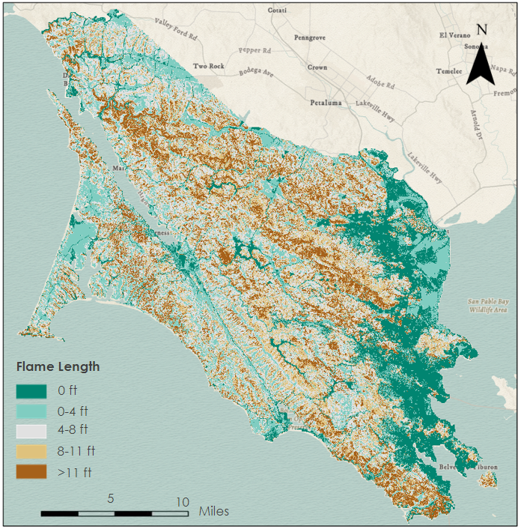

*Figure 2*: Fire severity for the FlamMap based model. The values range from 0 ft to over 11 ft in flame length.

*4.1.2 Suitability Model*

We examined the output suitability raster which contained information of the fire severity levels across Marin County. Table 3 shows the percentage of the study area of each fire severity level. Class 4, which represents high fire severity, was the most dominant class, covering 30% of the study area, followed by Class 5, which represents extreme fire severity, covering 27% of Marin County. Low and moderate fire severity areas make up 6% and 12% of the county, respectively. Figure 3 displays the distribution of fire severity classes. Class 4 and 5 have a large coverage in more mountainous regions which are areas of greater elevation and slope. The most potentially fire-severe areas as classified as a “5” which means that it would be extremely difficult, if not impossible, to prevent or control a fire according to the suitability model (Table-B1).

Table 3.

*Area for each class of the FlamMap Severity model.*

|  |  |  |  |
| --- | --- | --- | --- |
| Class | Meaning | Area (Km2) | Percent of Area |
| 1 | Not Burnable | 200 | 15% |
| 2 | Controllable with Hand Lines | 195 | 14% |
| 3 | Controllable with Dozers and Air Drops | 648 | 48% |
| 4 | Incredibly Hard to Control | 181 | 14% |
| 5 | Impossible to Control | 124 | 9% |

The suitability model offers probable insight into the impact of these inputs in relation to fire severity. The basis of our inputs and assigned percent weights in the weighted sum was predicated on a different literature, which varies from each publication in terms of the types of categories of inputs and weighting for each input. In addition, the inputs for the suitability model were sourced from different datasets from different years- some of which contained missing data in the study area. In comparison to the FlamMap model, the final classes of the suitability model output do not reflect practical differences in fire severity, but rather were separated out solely based on the distribution of the data, which tended to clump towards median values after initial processing (Table-B2). There is a general left-skew distribution of the suitability model in comparison to the FlamMap model output which has a more normal standard distribution of the fire severity classes (Table 4). The definition of what the suitability model classifies as a “3” may differ from what other models classify as a 3 and additionally simplifies what reflects higher severity fire than 2 and lower than 4. Subsequent natural breaks classification helps identify where inherent groupings exist in the data and how fire severity varies across the landscape. Inland Marin County showed the suitability fireline map as more severe whereas the FlamMap fireline map showed the coasts as more severe.

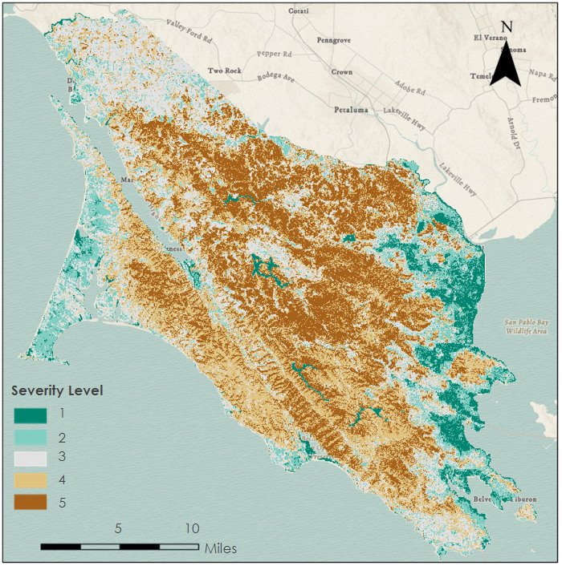

*Figure 3*: Fire severity for the Suitability based model. 5 is high fire severity and 1 is low fire severity.

Table 4.

*Area for each class of the Suitability Severity model.*

|  |  |  |  |
| --- | --- | --- | --- |
| Class | Meaning | Area (in Km2) | Percent of Area |
| 1 | Low Severity Fire | 74 | 6% |
| 2 | Moderate Severity Fire | 166 | 12% |
| 3 | Medium Severity Fire | 337 | 25% |
| 4 | High Severity Fire | 410 | 30% |
| 5 | Extreme Severity Fire | 361 | 27% |

*4.1.3 U-Net Convolutional Neural Network*

The U-Net CNN outputted a tiff of dNBR for a selected date based on fire training data in Marin County and Sonoma County from 2013 to 2022. During the model training process, however, the loss function consistently produced a range of spikes in the loss which is not typical of the shape of this loss function or indicative that the learning process was improving in each iteration. An issue with the raw data inputs may have caused this error with the machine learning model, though it is still unclear why the loss function exhibited multiple spikes. The workflow can be found in Appendix Figure B-4.

The machine learning model has inherent limitations as typical CNNs input hundreds or thousands of images for the training dataset. With a limited number of fires to train on, the model had less than 22 date ranges to observe. Additionally, the extension to Sonoma County for data imposed natural limitations with the accuracy of the fire model as the environment may have some differences to Marin County.

*4.1.4 Model Comparisons*

Figure 4 shows values of comparison between the outputs of the FlamMap and suitability models, where increasingly negative values show pixels where the suitability model predicts increasingly severe fire compared to FlamMap, and increasingly positive values show higher severity predictions by FlamMap. Pixel values of 0 show areas where the two models agree. The suitability model predicts higher fire severity for 56% of the county compared to the FlamMap model, the models agree on fire severity for 27% of the county, and the FlamMap model predicts higher fire severity for only 16% of land. Based on visual comparisons of the model output comparison and various input layers, many of the pixels of increased fire severity in the suitability model occur in forested areas where the various canopy fuel metrics likely contributed to increased model outputs. While additional validation is required to determine which model’s handling of forests better reflects real-world fire severity, increased severity rankings in dense forest will subsequently deprioritize these areas in the fireline model compared to shrubland and grass. Shrub and grass are indeed easier to build firelines through, suggesting the suitability model may better suit the county’s ultimate purpose. The regions where the suitability model underpredicted fire severity compared to FlamMap occur primarily along moister coastal regions where moisture inputs, particularly WUE, may have lowered the score. The County also sought to better incorporate local differences in climate and moisture to fire predictions and the suitability model seems to accomplish this end to some extent as well.

*Figure 4:* Model comparison generated by subtracting suitability model values from FlamMap model values. The negative values show where the Suitability severity model depicts more severe fire, and the positive values show where the FlamMap severity model depicts more severe fire.

*4.1.5 Fireline Location Model*

With a maximum feasible fireline slope of 60 degrees, the fireline model using the FlamMap input predicts that firelines can easily be cut on 27% of land and are feasible but more difficult on another 49% of land. The fireline model using the suitability input ranks 17% of land in the easiest fireline class and 46% of land as feasible for firelines. Both models show less feasible firelines in mountainous regions of the county, with ridges highlighted as possible fireline locations. A single pixel, with a resolution of 10 meters, is large enough to contain a fireline. By zooming into an area of the county threatened by a wildfire, firefighters can identify corridors that can accommodate a fireline and connect to other unburnable features to stop the spread of wildfire.

*Figure 5*: Fireline model outputs with fire severity input from the FlamMap model (top) and suitability model (bottom). Easy, medium, and hard refer to where it is easy to create a fireline that will be successful during an active fire situation.

***4.2 Future Work***

Future work ould expand this past Marin County to the surrounding counties with similar ecosystems, namely Sonoma and Napa Counties. Further, the suitability and machine learning models could be improved. The suitability model could be further refined with field validation where the Marin County Fire Department goes out and states whether they agree with the assessment or not. Plus, their practical knowledge could be used to refine the weights further. The machine learning model could benefit from further training and testing in order to achieve a more meaningful result. Lastly, input parameters are scaled temporally to the fire season, but further refinement, especially of fuels and fuel moisture would greatly improve the model. The MCFD would like to see an hourly fuel moisture and wind update that can automatically create an updated map for firelines. This would greatly improve the precision of the final model. Further mapping of unburnable areas for the fireline model, such as rock outcrops and hiking trails should also be pursued.

# 

# 5. Conclusions

This feasibility project utilized multiple Earth observations and ancillary datasets to examine current fuel loads in Marin County to assess the best places to create a fireline in support of Marin County’s fire suppression efforts. Our team created three different fire severity models: the FlamMap-based model to represent current practices for mapping fire severity, a suitability model to allow firefighters to easily change values in the field and to have transparency in the model, and a U-Net CNN to achieve the most accurate results.

The suitability model output reveals that most of the county is susceptible to a moderate to high fire severity burn. The largest class is high fire severity at 30%, which can be due to the high weight placed on the fuels and canopy metrics. The fire weather inputs that were run on the FlamMap based model were based on the peak fire season, which is a red flag day during fire season. The FlamMap based fire severity model determined that a large percentage of the area of Marin County (48%) could be controlled by equipment such as dozers and aircraft retardant drops. 15% of the area is considered unburnable, 14% of the area can be controlled with hand tools, and an additional 14% can be incredibly difficult to contain due to the probability of crowning and spotting. The smallest percentage of the area, 9%, is impossible to control. Lastly, the ML model created outputs that were very different from the other two models. Unfortunately, due to issues in the loss function of the training process and time to create and troubleshoot the model, we determined the output for the machine learning model to not be sufficient to continue with analysis. More time and data are needed to create a more robust model.

The FlamMap based and suitability-based fire severity models both showed a difference in the fire severity for the different fuel types. The suitability model predicts higher fire severity in many of the forested areas but predicts lower fire severity in some moist coastal regions compared to the FlamMap based severity model. The Suitability fire severity model depicts more areas as high severity than the FlamMap based model.

The fireline maps from Figure 5 can be useful to show where a fireline should be placed during an active wildfire. The FlamMap based map showed more locations to place firelines than the suitability based firelines map did. This is due to the FlamMap fire severity map having lower severities than the suitability map did. Both models need field validation to be completed to assess the usefulness of the maps, but they could be useful in providing a visual source to general areas in the county where fire suppression efforts can be made.

# 6. Acknowledgments

Our team would like to thank everyone involved in this project for their support and guidance, especially our science advisors Dr. John (Jake) Dialesandro at Santa Clara University and Dr. Juan Torres-Pérez and Britnay Beaudry at NASA Ames Research Center. We thank our project partners, Josh Dimon (FIRE Foundry) and Graham Groneman (Marin County Fire Department) for their support and guidance, and lastly our NASA DEVELOP ARC Fellow, Lisa Tanh.

This material contains modified Copernicus Sentinel data (2018-2022), processed by ESA.

This work utilized data made available through the NASA Commercial Smallsat Data Acquisition (CSDA) program.

Includes copyrighted material of Planet Labs PBC. All rights reserved

Any opinions, findings, and conclusions or recommendations expressed in this material are those of the author(s) and do not necessarily reflect the views of the National Aeronautics and Space Administration.

This material is based upon work supported by NASA through contract NNL16AA05C.

# 

# 7. Glossary

**Avenza** – Mapping software used in the field by fire fighters to mark location of various fire suppression interventions during an active fire

**Bulldozer line** – A Fire break cut by a bulldozer. It is also referred to as a ‘dozer line

**Canopy Base Height (CBH)** – The distance between the bottom of the canopy and the forest floor. If base height is smaller, a fire is more likely to spread into the canopy where it will do maximum damage while a large base height suggests a crown fire is less likely.

**Canopy Bulk Density (CBD)** –A measure of the weight of the canopy per unit of ground, which tracks how much fine fuel would likely burn in a canopy fire.

**Canopy Cover (CC)** – The percent of horizontal land covered by tree canopy. Complete canopy could lead to more rapid spread of a damaging tree crown fire.

**Canopy Height (CH)** – The distance from the forest floor to the top of the canopy. Used to understand the total aboveground biomass that may be converted into wildfire fuel.

**Difference Normalized Burn Severity (dNBR)** – The difference between pre-fire and post-fire burn severity that indicated high damage areas by fires. The normalized burn ratio is calculated with the near-infrared and shortwave-infrared bands.

**Earth observations** – Satellites and sensors that collect information about the Earth’s physical, chemical, and biological systems over space and time

**Fire break** – A gap in vegetation that impedes the spread of wildfire

**Foehn wind** – Dry, warm winds moving downslope on the leeward side of a mountain range.

**Hand-cut fireline** – Fire break cut by fire fighters using hand tools

**InciWeb** – An incident information management system used by various agencies across different levels of government to track information related to wildfires and subsequent response and suppression activity

**Ladder fuels** – Ladder fuels provide a connection for fire to travel from a mild surface fire into the tree canopy, creating a much more severe and uncontrollable fire. Ladder fuel density measures how much of this dangerous fuel is present per unit of ground. Satellite products alone cannot measure ladder fuel as it is typically obscured by the tree canopy, but LiDAR can measure these fuels.

**LiDAR** – Short for Light Detection and Ranging, LiDAR is an active remote sensing technique that uses a pulsed laser to measure the distance to the Earth and other objects on its surface.

**Monitoring Trends in Burn Severity (MTBS)** – An interagency program of the US Department of Agriculture, the US Forest Service, the Department of the Interior, and the US Geological Survey. MTBS uses Landsat scenes pre and post fires sized at 1000 acres or larger to generate data including a normalized burn ratio (NBR) and other related calculations from the reflectance imagery. MTBS analysts use these indices to delineate the fire ratio and to differentiate between areas of various burn severities within the overall fire perimeter, creating a data product that includes not only the overall fire perimeter but a raster that shows the burn severity for each pixel within the perimeter (MTBS, 2022).

**Prescribed burn** – A fire set under specific circumstances in order to accomplish a specific task in a controlled region, typically reduction of fuels in order to reduce the potential intensity or spread of future fires. The fire prescription refers to the specific desired fire characteristics and the conditions required to achieve them, such as a low intensity fire over several acres to burn off dry grasses that is set on a cool, humid day with a gentle wind in the desired direction

**WUI** – Wildland Urban Interface, a term for urban and residential development that extends into natural areas, putting the infrastructure at fire risk and complicating efforts to fight fire that otherwise could burn naturally without threatening human life or property.

**U-Net** – A convolutional neural network for pixel-by-pixel image segmentation that utilizes a series of convolutions, pooling operations, and upsampling and downsampling.

# 8. References

Brown, C., Brumby, S., Guzder-Williams, B., Birch, T., Hyde, S., Mazzariello, J., Czerwinski, W., Pasquarella, V., Haertel, R., Ilyushchenko, S., Schwehr, K., Weisse, M., Stolle, F., Hanson, C., Guinan, O., Moore, R., & Tait, A. (2022). Dynamic World, Near real-time global 10 m land use land cover mapping. *Scientific Data.* 9. 251. <https://doi.org/10.1038/s41597-022-01307-4>.

CalFire FRAP GIS Data. (2023). <https://frap.fire.ca.gov/mapping/gis-data/>

Copernicus Sentinel data. (2022). Retrieved from Google Earth Engine [15 Feb 2023], processed by ESA. <https://doi.org/10.5270/S2_-742ikth>

Chen, B. & Jin Y. F. (2022). Spatial patterns and drivers for wildfire ignitions in California*. Environmental Research Letters, 17*(5), <https://doi.org/10.1088/1748-9326/ac60da>

Fernández-Alonso, J. M., Alberdi, I., Álvarez-González, J. G., Vega, J. A., Cañellas, I., & Ruiz-González, A. D. (2013). Canopy fuel characteristics in relation to crown fire potential in pine stands: analysis, modelling and classification. *European Journal of Forest Research,* 132, 363-377. <https://doi.org/10.1007/s10342-012-0680-z>

Gandhi, Ujaval (2022). Introduction to Dynamic World (Part 1) - Visualization and Creating Composites. [Source Code] <https://developers.google.com/earth-engine/tutorials/community/introduction-to-dynamic-world-pt-1>

Goss, M., Swain, D. L., Abatzoglou, J. T., Sarhadi, A., Kolden, C. A., Williams, A. P., & Diffenbaugh, N. S. (2020). Climate change is increasing the likelihood of extreme autumn wildfire conditions across California. *Environmental Research Letters*, *15*(9). <https://doi.org/10.1088/1748-9326/ab83a7>

Jin, Y., Goulden, M. L., Faivre, N., Veraverbeke, S., Sun, F., Hall, A., Hand, M. S., Hook, S., & Randerson, J. T. (2015). Identification of two distinct fire regimes in Southern California: Implications for economic impact and future change. *Environmental Research Letters, 10*(9), 094005. <https://doi.org/10.1088/1748-9326/10/9/094005>

Kramer, H. A., Collins, B. M., Kelly, M., & Stephens, S. L. (2014). Quantifying ladder fuels: a new approach using LiDAR. *Forests, 5*(6), 1432-1454. <https://doi.org/10.3390/f5061432>

LANDFIRE 2.2.0. (2022). U.S. Department of Agriculture, Forest Service, U.S. Department of Interior. <http://www.landfire.gov/index.php>

# Landsat Missions*.* Landsat Normalized Burn Ratio. *USGS*. [https://www.usgs.gov/landsat-missions/landsat-normalized-burnratio#:~:text=NBR%20is%20used%20to%20identify,SWIR%20values%20in%20traditional%20fashion.&text=In%20Landsat%204%2D7%2C%20NBR,Band%204%20%2B%20Band%207)](https://www.usgs.gov/landsat-missions/landsat-normalized-burn-ratio#:~:text=NBR%20is%20used%20to%20identify,SWIR%20values%20in%20traditional%20fashion.&text=In%20Landsat%204%2D7%2C%20NBR,Band%204%20%2B%20Band%207).).

Li, Z., Shi, H., Vogelmann, J. E., Hawbaker, T. J., & Peterson, B. (2020). Assessment of fire fuel load dynamics in shrubland ecosystems in the western United States using MODIS products. *Remote Sensing, 12*(12). <https://doi.org/10.3390/rs12121911>

Maniatis, Y., Doganis, A., & Chatzigeorgiadis, M. (2022). Fire risk probability mapping using machine learning tools and multi-criteria decision analysis in the GIS environment: a case study in the national park Forest Dadia-Lefkimi-Soufli, Greece. *Applied Sciences, 12*(2938). <https://doi.org/10.3390/app12062938>

Marin County Vegetation and Land Cover Data (2019). Marin County Parks, One Tam. <https://vegmap.marincounty.org/>

Mitsopoulos, I., Mallinis, G. , Zibtsev, S., Yavuz, M., Saglam, B., Kucuk, O., Bogomolov, V., Borsuk, A., & Zaimes, G. (2017). An integrated approach for mapping fire suppression difficulty in three different ecosystems of Eastern Europe. *Journal of Spatial Science, 62*(1)*,* 139–155. <http://dx.doi.org/10.1080/14498596.2016.1169952>

Monitoring Trends in Burn Severity (MTBS). (2022). *Woodward* Fire. US Department of the Interior, US Forest Service, US Geological Survey. <https://www.mtbs.gov/>

Park, B.A., & Office, F.A. (2008). Assessing the difference Normalized Burn Ratio’s ability to map burn severity in the boreal forest and tundra ecosystems of Alaska’s national parks. *Semantic Scholar: Environmental Science.* <https://www.semanticscholar.org/paper/Assessing-the-differenced-Normalized-Burn-Ratio-%E2%80%99-s-Park-Office/d1e4d2d5fed8ad4ccfdc9af8c738a9e699ad80f2>

Planet Team (2022). Planet Application Program Interface: In Space for Life on Earth. San Francisco, CA. [https://www.api.planet.com](https://www.api.planet.com/).

Ryan, K. C. & Opperman, T. S. (2013). LANDFIRE – A national vegetation/fuels data base for use in fuels treatment, restoration, and suppression planning. *Forest Ecology and Management*, 294, 208-216. <https://doi.org/10.1016/j.foreco.2012.11.003>

Warner, T. A., Skowronski, N.S., & Puma, I. L. (2020). The influence of prescribed burning and wildfire on lidar-estimated forest structure of the New Jersey Pinelands National Reserve. *International Journal of Wildland Fire, 29*(12). <https://doi.org/10.1071/WF20037>

# 9. Appendices

Appendix A – Inputs

*Figure A-1.* Descriptions of the characteristics of Canopy. Moving clockwise from top left: Canopy bulk density is the amount of biomass in the canopy of the tree; canopy cover is the width of the canopy; canopy base height is the height of the canopy from the ground; canopy height is the height of the tallest part of the canopy from the ground; ladder fuel density is the density of the fuels below the canopy.

Appendix B – Models

Table B-1

*Model layer reclassification details (Bin 1 is lowest fire severity, Bin 5 is highest)*

|  |  |  |  |  |  |
| --- | --- | --- | --- | --- | --- |
| **Layer** | **Bin 1** | **Bin 2** | **Bin 3** | **Bin 4** | **Bin 5** |
| Ladder Fuel Density 1 | 0-3% | 3-8% | 8-13% | 13-20% | 20-100% |
| Canopy Base Height 2 | Unforested (0) | 70+ meters | 50-69 meters | 1-29 meters | 30-49 meters |
| Canopy Bulk Density 3 | Unforested (0) | 0.01-0.05 kg/m3 | 0.06-0.1 kg/m3 | 0.11-0.21 kg/m3 | 0.22-0.34 kg/m3 |
| Canopy Cover | Unforested (0) | 15-25% | 35-45% | 55-65% | 75-85% |
| Landcover | Water, snow, ice | Flooded vegetation, bare, built, crops | Grass | Trees | Shrub and scrub |
| WUE4 | 0-0.2 | 0.2-0.5 | 0.5-1 | 1-2 | 2-6.6 |
| ESI 4 | 0.7-1 | 0.5-0.7 | 0.3-0.5 | 0.2-0.3 | 0-0.2 |
| NDVI Differential | -1-0 | 0-.1 | .1-.2 | .2-.3 | .3+ |
| Slope | 0-13 | 13-28 | 28-43 | 43-56 | 56-84 |
| Aspect | N/Flat | NE | E | W/SE | S/SW |
| Elevation | 2000+ | 1500-2000 | 1000-15000 | 500-1000 | <500 |

1 Majority of land is unforested with less than 3% ladder fuels; binning taken from literature that suggests effective fuel treatment in Mediterranean forests reduces ladder fuels to 8% or less (Kramer et al., 2014).

2 CBH does not relate linearly to fire risk – very low CBH signifies there is little canopy to catch fire while very tall crowns are also unlikely to catch (Fernández-Alonso et al., 2013). Values of 0 are non-forested while values of 10 include canopies 10+ meters.

3 Values of 0 are non-forested; binned according to natural breaks.

4 WUE and ESI are correlated. A higher WUE would result in a lower ESI, and an ESI closer to 1 would represent low activity of plant transpiration and indicates a lack of water (Pascolini-Campbell et al., 2022).

Table B-2

*Suitability model weights*

|  |  |  |
| --- | --- | --- |
| **Data Input** | **Category** | **Percent Weight** |
| Aspect | Topography | 7% |
| Elevation | Topography | 6% |
| Slope | Topography | 7% |
| WUE | Moisture | 15% |
| ESI | Moisture | 15% |
| NDVI Differential | Fuels | 10% |
| Canopy Bulk Density | Fuels | 6% |
| Ladder Fuel Density | Fuels | 8% |
| Canopy Base Height | Fuels | 4% |
| Canopy Cover | Fuels | 2% |
| Landcover | Fuels | 20% |

Table B-3

*Fireline model process showing results of raster calculator and subsequent reclassification.*

|  |  |  |  |
| --- | --- | --- | --- |
| **Slope Value** | **Fire Severity Value** | **Raster Calculator Output** | **Final Fireline Value** |
| 1 (flat) | 1 | 1 | 1 (Easy) |
| 1 (flat) | 2 | 2 | 1 (Easy) |
| 2 (mild) | 1 | 2 | 1 (Easy) |
| 1 (flat) | 3 | 3 | 2 (Medium) |
| 1 (flat) | 4 | 4 | 2 (Medium) |
| 2 (mild) | 2 | 4 | 2 (Medium) |
| 1 (flat) | 5 | 5 | 3 (Difficult/Infeasible) |
| 2 (mild) | 3 | 6 | 3 (Difficult/Infeasible) |
| 2 (mild) | 4 | 8 | 4 (Difficult/Infeasible) |
| 2 (mild) | 5 | 10 | 4 (Difficult/Infeasible) |
| 0 (steep) | 1 | 0 | 5 (Difficult/Infeasible) |
| 0 (steep) | 2 | 0 | 5 (Difficult/Infeasible) |
| 0 (steep) | 3 | 0 | 5 (Difficult/Infeasible) |
| 0 (steep) | 4 | 0 | 5 (Difficult/Infeasible) |
| 0 (steep) | 5 | 0 | 5 (Difficult/Infeasible) |

*Figure B-1.* Fuel categories used for the models. Acronyms used: CBD = canopy bulk density, NDVI = normalized difference vegetation index, WUE = water use efficiency, ESI = evaporative stress index

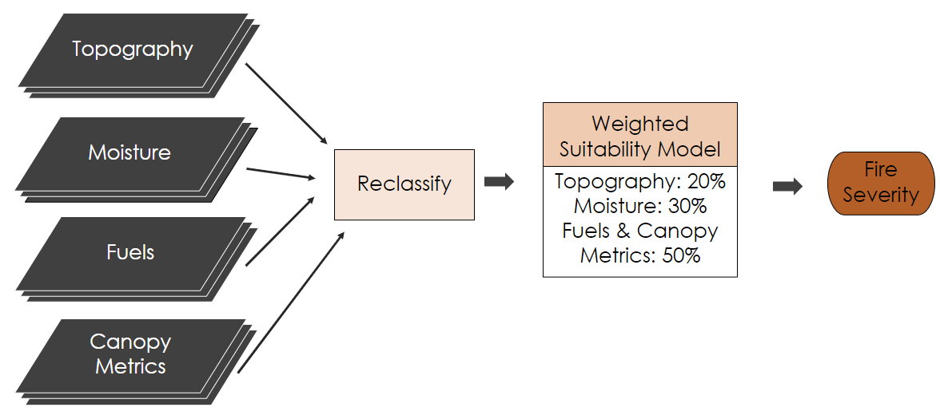

*Figure B-2*. Suitability analysis workflow.

*Figure B-3*. FlamMap model workflow.

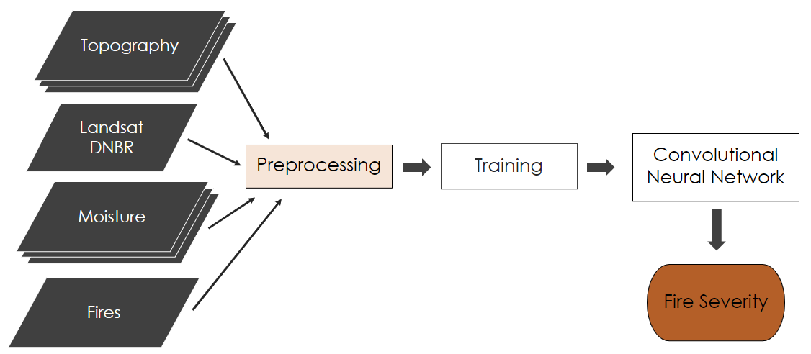

*Figure B-4*. Machine learning model workflow.