Tempe Urban Development
Utilizing NASA Earth Observations to Assess Thermal Landscapes and Prioritize Greening Initiatives in Tempe, Arizona


Technical Report
Final Draft – November 15th, 2018

Hannah Bonestroo (Project Lead)
Roger Alvarez
Elizabeth Swanson
Taylor Quinn

Dr. David Hondula, Arizona State University (Science Advisor)
Dr. Ariane Middel, Arizona State University (Science Advisor)

1. Abstract
Located in the northern Sonoran Desert, Tempe, Arizona, regularly experiences extreme heat, with summer daily maximum temperatures reaching over 37°C. The rapid urbanization of the region in the last 50 years has caused a steady increase in the mean daily air temperature due to the urban heat island (UHI) effect. Recognizing that urban forestry has been documented to mitigate the effects of UHIs through the processes of evapotranspiration and shading, the City of Tempe created an Urban Forestry Master Plan (UFMP) in 2017 in an effort to improve the thermal environment of its parks and green spaces. In partnership with the City of Tempe and the Arizona State University (ASU) Urban Climate Research Center (UCRC), the fall 2018 Tempe Urban Development DEVELOP team used Landsat 5 Thematic Mapper (TM) and Landsat 8 Operational Land Imager (OLI) and Thermal Infrared Sensor (TIRS) satellite imagery to identify changes in the normalized difference vegetation index (NDVI) and land surface temperature (LST) from 1998 to 2018. Combined with United States Geological Survey (USGS) lidar tree point data and Central Arizona-Phoenix Long-Term Ecological Research (CAP LTER) Land Cover Classification data using National Agriculture Imagery Program (NAIP) imagery, the team examined the correlation between tree clustering, land cover, and LST in city parks. The City of Tempe can use these results to inform residents and developers about how investment in deliberate urban forestry improves the city’s thermal environment and helps mitigate extreme heat.

Keywords
Outdoor thermal comfort, urban forestry, optimal tree placement, remote sensing, Landsat, urban heat island, land surface temperature (LST), Normalized Difference Vegetation Index (NDVI)

2. Introduction
  - Background Information
The development of air conditioning and the influx of new industries in the late 1940s led the Phoenix metropolitan area to grow from an agriculture settlement of under 330,000 people into an urban center of over 4.5 million people today (Baker et al., 2002). Tempe, Arizona, the focus area of this study, is an inner ring suburb of Phoenix positioned in the East Valley section of the metropolitan region that is home to the main campus of Arizona State University (ASU) (Figure 1). Located in the northern Sonoran desert, Tempe, with just over 185,000 people, experiences a semi-arid climate with summer daily maximum temperatures regularly exceeding 37.8°C. The rapid urbanization of the region has exacerbated its extreme heat due to the urban heat island (UHI) effect, in which impervious surfaces in urban areas absorb a greater share of the sun’s radiant energy than surrounding rural areas (Brazel et al., 2007; Guhathakurta & Gober, 2007). Between 1948 and 2000, the average daily minimum air temperature recorded at Sky Harbor Airport (located just west of Tempe) increased by 5.0°C and the average daily average temperature rose by 1.7°C (Buyantuyev & Wu, 2009). During the same time period, the number of hours with air temperature over 37.8°C per day during the hottest months of the year, July and August, doubled (Baker et al., 2002). Rising temperatures are of great concern to the city because exposure to extreme heat not only reduces the comfort and well-being of residents, but it can also pose serious health risks and aggravate pre-existing chronic conditions (Fraser & Chester, 2017; Luber & McGeehin, 2008). Beyond health impacts, higher temperatures can increase water and energy use and hinder year-round tourism to the region (Brazel et al., 2007).

In 2017, Tempe created an Urban Forestry Master Plan (UFMP) to address the increasing risk of urban heat and improve the thermal environment of its parks and green spaces. Increasing vegetation cover in public spaces is a well-documented strategy for UHI mitigation (Harlan, Brazel, Prashad, Stefanov, & Larsen, 2006; Kong, Yin, Wang, Cavan, & James, 2014). Vegetation increases thermal comfort by enhancing positive latent heat flux through the processes of evapotranspiration (Brazel, Selover, Vose, & Heisler, 2000; Dimoudi, & Nikolopoulou, 2003) and blocking incoming solar radiation (Middel, Selover, Hagen, & Chhetri, 2016). In a study conducted in Athens, Greece, Dimoudi, and Nikolopoulou (2003) found an average temperature reduction of 1.0° C for every 100 m² of vegetation added to sample urban park locations. Additionally, natural shade offers significant aesthetic benefits (Klemm, Heusinkveld, Lenzholzer, & Hove, 2015), as well as providing stormwater retention and wildlife habitat. While excessive water can be a concern when caring for the urban forest, the UFMP outlines six drought tolerant tree species that thrive in desert conditions (“City of Tempe”).

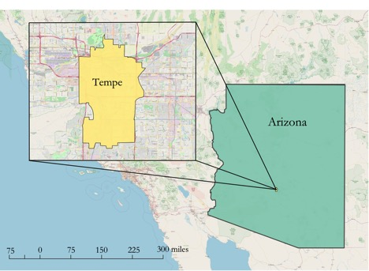
Figure 1. The study area of the project was the city of Tempe located in central Arizona.

  - Project Partners & Objectives
The Tempe Urban Development team partnered with the City of Tempe to support their Urban Forestry Master Plan (UFMP). This plan, released in 2017, highlights how crucial urban forestry is to its public health and infrastructure and outlines strategies for achieving 25% urban tree canopy (UTC) cover and becoming a 20-minute walkable city by 2040. The city defined this goal in the UFMP as supporting development and land use where residents can comfortably walk or bike to urban hubs and major amenities within 20 minutes of their homes. Besides analyses conducted for the UFMP, the city only has access to regularly updated information about trees on public lands.

The objectives of this project were to assess the change in Normalized Difference Vegetation Index (NDVI) and Land Surface Temperature (LST) in Tempe during the project study period from 1998 to 2018 and to investigate the effects tree clustering and land cover class have on the thermal environment. LST is a measurement of how hot the ground surface of the Earth feels to the touch, while NDVI is an index that ranges from -1 to +1 that measures the difference between near infrared and red visible light in order to assess “greenness.” The outcomes of this study will supplement the UFMP and inform residents and developers about the importance of deliberate urban forestry in improving the city’s thermal environment. Ultimately, the main goal of this project was to provide the City of Tempe with information on how urban forests can contribute to heat mitigation strategies, including data on where to focus tree-planting initiatives. The provided analyses using NASA Earth observations will enable the City of Tempe to identify steps needed to improve the thermal environment of its parks and green spaces and help ensure its goal of 25% UTC cover by 2040.

3. Methodology
3.1 Data Acquisition
The team extracted Level 2 Tier 1 Landsat 5 Thematic Mapper (TM) Surface Reflectance imagery from 1998, 2008, and 2010 and Level 2 Tier 1 Landsat 8 Operational Land Imager (OLI) and Thermal Infrared Sensor (TIRS) imagery from 2018 in Google Earth Engine (GEE) by setting the parameters to select all images in the month of July. The month of July, during which temperatures are greatest, was selected in order to be able to better assess spatiotemporal changes in temperature extremes. The team’s partners at the Arizona State University (ASU) Urban Climate Research Center (UCRC) provided United States Geological Survey (USGS) 3D Elevation Program (3DEP) lidar 2015 tree point data and Central Arizona-Phoenix Long-Term Ecological (CAP LTER) Land Cover Classification using 2010 National Agriculture Imagery Program (NAIP) Imagery.

3.2 Data Processing
3.2.1 Study Area Shapefile Creation
Using ArcMap, the team extracted the City of Tempe shapefile from the 2018 TIGER/Line shapefile of US Census Places. The team then created a local parks shapefile by extracting parks downloaded from the Esri ArcGIS Online USA Parks layer within the newly created Tempe shapefile (Figure C1). Parks absent from these data were digitized in ArcMap. Both new layers were then re-projected to the WGS 1984 UTM Zone 12N coordinate system.

3.2.2 Normalized Difference Vegetation Index
The team uploaded the acquired Landsat Google Earth Engine (GEE) imagery and study area shapefiles to a Google Fusion Table. By calling upon the fusion table as a feature collection, the team clipped the images to the shapefile. The team calculated NDVI with the normalized difference function in GEE, which performs Equation 1, where R is the red band (band 4) and NIR is the near-infrared band (band 5).
$\text{NDVI=}\frac{\text{NIR - R}}{\text{NIR + R}}$ (1)

The team used the resulting maps to identify areas in Tempe with high vegetation density and areas with little to no vegetation, as well as to calculate the change in mean NDVI from 1998 to 2018.

3.2.3 LST
Utilizing methods described by Giannini, Belfiore, Perente, and Santamaria (2015), the team calculated LST using the acquired Landsat GEE imagery. First, the team found the Top of Atmosphere Radiance (TOA), Brightness Temperature (BT), Vegetation Proportion, and Emissivity using Equations 2 through 5 in Table 1.

Table 1
Preliminary equations used to calculate LST
Number | Name | Equation | Variables
(2) | TOA | $${\text{L}}_{\text{λ}}\text{=}{\text{G}}_{\text{rescale}}\text{* }{\text{Q}}_{\text{cal}}\text{+ }{\text{B}}_{\text{rescale}}$$ | ${\text{L}}_{\text{λ}}$ = Spectral radiance in units of [W/(m² * sr * $μm$)]  ${\text{G}}_{\text{rescale}}=$ Rescaling gain factor for each band  ${\text{Q}}_{\text{cal}}$ = Quantized calibrated pixel value (Pixel values)  ${\text{B}}_{\text{rescale}}$ = Rescaling bias factor for each band
(3) | BT | $${\text{T}}_{\text{B}}\text{=}\frac{{\text{K}}_{\text{2}}}{\text{ln(}\frac{{\text{K}}_{\text{1}}}{{\text{L}}_{\text{λ} }}\text{+1)}}\text{-273.5}$$ | ${\text{T}}_{\text{B}}=$ Value of brightness temperature in units of Celsius  ${\text{K}}_{\text{1}}\text{, }{\text{K}}_{\text{2}}=$ Thermal conversion constants  ${\text{L}}_{\text{λ} }=$ TOA Radiance
(4) | Vegetation Proportion | $${\text{P}}_{\text{v}}\text{=}{\left[\frac{\text{NDVI-}{\text{NDVI}}_{\text{min}}}{{\text{NDVI}}_{\text{max}}\text{-}{\text{NDVI}}_{\text{min}}}\right]}^{\text{2}}$$ | ${\text{P}}_{\text{v}}=$ Proportion of vegetation  ${\text{NDVI}}_{\text{max}}=$ 0.5  ${\text{NDVI}}_{\text{min}}=$ 0.2
(5) | Emissivity | $$\text{ϵ}\text{=0.004* }{\text{P}}_{\text{v}}\text{+0.986}$$ | $ϵ$ = Emissivity  ${\text{P}}_{\text{v}}=$ Proportion of vegetation

Using the results from Equations 2–5, the team calculated LST with Equation 6, where T_{B} is temperature brightness, $λ$ is the central wavelength of the thermal band in meters, and $ϱ$ is equal to 1.438*10⁻² m*K. The value of $ϱ$ was calculated using the equation, $ϱ$ = h*c/σ, where σ is the Boltzmann constant (1.38*10⁻²³ J/K), c is the velocity of light (2.998*10⁸ m/s) and h is Planck’s constant (6.626*10⁻³⁴ J*s).

$\text{LST= }\frac{{\text{T}}_{\text{B}}}{\text{1+}\left(\frac{\text{λ}\text{*}{\text{T}}_{\text{B}}}{\text{ϱ}}\right)\text{*ln(}\text{ε}\text{)}}$ (6)

With the resulting maps, the team calculated the relative change in LST from 1998 to 2018 by identifying pixels that shifted and became either hotter or cooler than the median LST of Tempe. Relative LST change was calculated rather than the absolute change in LST because LST is more readily influenced by potential weather anomalies on the days of the selected images. The analysis focused on the difference between 1998 and 2018 because July 2008 received 1.16 more inches of precipitation than on average (“Climate Phoenix”), which heavily influenced the LST values of that year.
3.2.4 Tree Density and Land Cover
For each LST pixel and city park, the team found the number of trees per acre by using the “Spatial Join” tool in ArcMap. Utilizing the “Tabulate Intersection” tool in ArcMap, the team calculated the percentage of each of the thirteen land cover classes (building, road, soil, tree, grass, shrub, cropland, fallow, orchard, lake, canal, pool, and seasonal river) in each of the LST pixels and city parks. The team also created a new “impervious” land cover class, which included road and building classes (Figure 2).
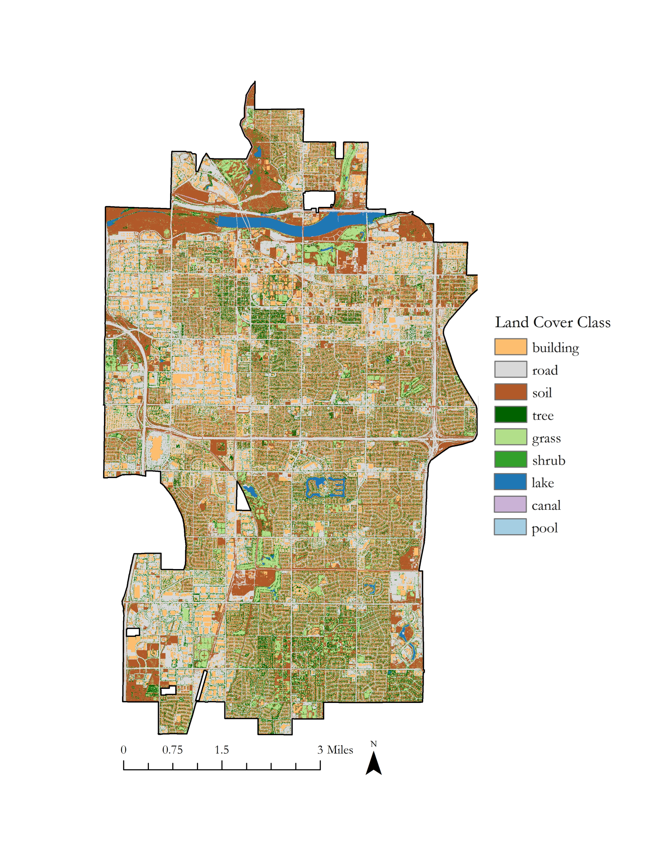
Figure 2. Tempe, AZ CAP LTER Land Cover Classification data using National Agriculture Imagery Program (NAIP) imagery.

3.3 Data Analysis
3.3.1 NDVI and LST
The team performed a linear regression analysis between change in NDVI and LST from 1998 to 2018 and statistical correlation analysis between NDVI and LST in 2018.
3.3.2 Tree Density, Land Cover, and LST
The team created a statistical correlation matrix to examine the relationship between LST; the percentage impervious, lake, grass, and tree land cover types; and trees per acre at the citywide level. To investigate the mean and median LSTs of different land cover types with trees and without trees, these data were visualized with a box plot and analyzed with several Welch Two Sample t-tests. Pixels were classified as a land cover type if they had over 85% of that specific land cover type. Pixels were classified as having trees if they had over 5% tree land cover and were classified as having no trees if they had less than 1% tree cover. The team excluded all pixels containing lake, pool, and canal land cover types, due to the potential cooling factor of these land features.
3.3.3 Parks Analysis
The team analyzed the Tempe parks by calculating the mean LST, number of trees, and tree density of each park. To more closely investigate the effects of land cover on the mean LST of the parks, the team conducted linear regression analyses between LST and the percentage of grass, soil, building, road, and tree land cover at the citywide level.

4. Results & Discussions
4.1 Discussion of Results
4.1.1 NDVI and LST Assessment
The average NDVI of Tempe was higher in 2018 (0.17) than in 1998 (0.14) (Figures A1 and A2). From 1998 to 2018, areas with LST above the median in Tempe increased by 11.7%, while areas with LST below the median in Tempe decreased by 9.7% (Table A1). The greatest increases in NDVI and decreases in relative LST were concentrated in southern Tempe near the Tally Ho North and the Sunburst Farms neighborhoods. Areas that experienced the largest positive shift in relative LST from 1998 to 2018 were concentrated west of the AZ-101 Loop and north of US Route 60 (Figures A3-A5).

The linear regression analysis between change in NDVI and change in LST revealed that for every NDVI value increase of one, the LST decreases by 9.4 degrees Celsius (Table A2). The correlation test showed that there was a strong negative correlation between NDVI and LST in 2018, with a correlation coefficient of -0.4.

4.1.2 Tree Density, Land Cover, and LST
The correlation matrix indicated a strong positive correlation between LST and the percentage of impervious land cover, with a correlation coefficient of 0.38 (Figure 3). There was a strong negative correlation between LST and the percentage of grassland cover, with a correlation coefficient of -0.27.

LST was negatively correlated with the percentage tree canopy cover (correlation coefficient = -0.13). LST and tree density were likewise negatively correlated (correlation coefficient = -0.03), and the weaker correlation between LST and tree density than between LST and tree canopy cover is insightful when considering species of trees to plant. Tree density, which was calculated using the USGS 3D Elevation Program (3DEP) lidar 2015 tree point data, counts every type of tree, while the percentage of tree canopy cover, calculated using 2010 National Agriculture Imagery Program (NAIP) imagery, only includes identifiable tree canopy cover. The stronger correlation between LST and the percentage tree land cover over tree density could indicate that the size of a tree’s canopy and, thus, shade coverage, is important to consider for heat mitigation strategies.

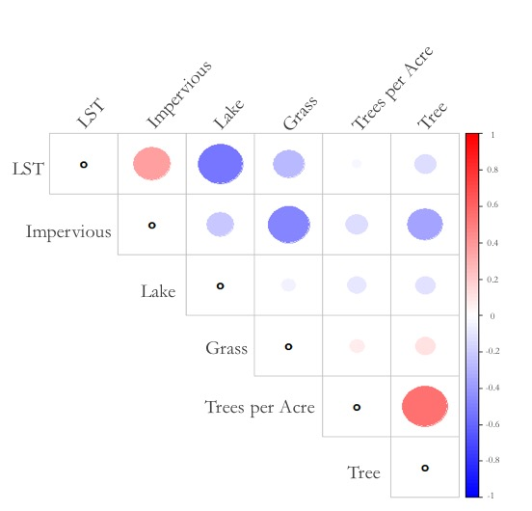
Figure 3. Matrix displaying the correlations between LST, various land cover classes, and tree density, where large red circles indicate a strong positive correlation and large blue circles indicate a strong negative correlation.
The Welch Two-Sample t-tests revealed statistically significant differences between the mean LSTs of grass, building, and road land cover classes (Table B1). A large number of outliers in the field of building land cover with no trees are explained by the unusually low LST of the rooftop of Oceanside Ice Arena, and the unusually high LST of the rooftop and parking lot of Arizona Mills Mall (Figure 4). While the mean LST of both grass and building land cover with trees were lower than the mean LST of same land cover type without trees, building was the only land cover class that indicated a statistically significant difference between the mean LST with trees and without trees, with a p-value less than 0.001 (Tables B2 and B3).

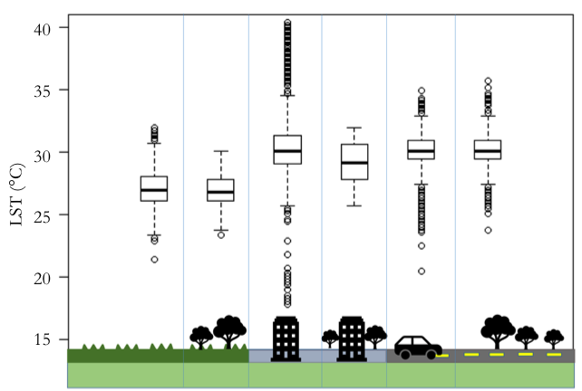
Figure 4. Boxplot displaying LST of grass, building, and road land cover classes both with and without trees
4.1.3 Parks Analysis
The five parks identified as having the highest LSTs were Papago Park, Victory Park, Moeur Park, Rotary Park, Esquer Park (Table C1). The different linear regression analyses between LST and the percentage of each land cover class, indicated that a 10% increase in grass coverage decreases LST by 0.32°C and a 10% increase in tree coverage decreases LST by 0.19°C. Further, a 10% increase in road area increases LST by 0.17°C, a 10% increase in building land coverage increases LST by 0.13°C, and a 10% increase in soil land coverage increases the LST by 0.006°C (Tables C2-C6). These results support the fact that several of the parks with the highest surface temperatures, such as Papago Park and Moeur Park, are natural parks with a higher percentage of soil land cover or parks with a high percentage building land cover, such as Rotary Park, with 17.9% building land cover.
4.2 Future Work
There are many strategies to improve and expand the scope of this project. First, acquiring higher resolution satellite data with a thermal band would allow for a higher resolution analysis of the thermal environment of Tempe and allow for the quantification of LST near individual trees, buildings, and sidewalks. In order to better analyze the influence of trees on urban LST, acquiring an updated land cover classification that excludes trees would allow for the land cover classes trees are on to be determined and expand possible statistical analyses. The parks’ LSTs, tree densities, and land cover classifications could be further explored and used to create a “Heat Score,” which would rank the city’s most vulnerable parks with regard to extreme heat. A similar ranking could also be applied to major arterials in the city to be able to identify those that heat mitigation efforts should be focused on. Additionally, a localized heat vulnerability index could be created using the acquired LST data, along with socio-economic indicators such age, race/ethnicity, and household income, in order to identify heat mitigation priority neighborhoods. Additional fieldwork could be conducted in order to better assess air temperature and to determine which species of trees provide the best shade at the lowest cost.

5. Conclusions
Several conclusions can be drawn from this research and used by the City of Tempe to enhance its heat mitigation strategies. This research confirmed that there is a strong negative correlation between NDVI and LST, a strong positive correlation between the percentage of impervious land cover and LST, and a strong negative correlation between the percentage tree land cover and LST. Decreasing the percentage of building and soil land cover by increasing the percentage grass and tree land cover, as well as planting more trees on areas with building land cover, could improve the thermal comfort of the city’s parks while supporting the goal of becoming a 20-minute walkable city. The City of Tempe could focus its heat mitigation efforts on the area west of the AZ-101 Loop and north of US Route 60, which shifted to be above the median LST in 2018. While there are many areas in this project that could be expanded on or improved, the team hopes that the given results will provide the City of Tempe with the data and tools needed to support its UFMP and inspire further exploration of strategies to improve Tempe’s thermal environment.

6. Acknowledgments
- Bonnie Richardson – City of Tempe
- Braden Kay – City of Tempe
- Ariane Middel – Assistant Professor, ASU School of Arts, Media and Engineering
- David Hondula – Assistant Professor, ASU School of Geographical Sciences and Urban Planning

Any opinions, findings, and conclusions or recommendations expressed in this material are those of the author(s) and do not necessarily reflect the views of the National Aeronautics and Space Administration.

This material is based upon work supported by NASA through contract NNL16AA05C.

7. Glossary
Earth observations – Satellites and sensors that collect information about the Earth’s physical, chemical, and biological systems over space and time
Evapotranspiration – The process by which water is transferred to the atmosphere by evaporation from various surfaces including when plants give off water vapor emitted through pores in their leaves
Google Earth Engine (GEE) – A cloud-based platform for geospatial analysis
Land surface temperature (LST) – The radiative skin temperature of land surface derived from solar radiation
Normalized Difference Vegetation Index (NDVI) – An index that quantifies the density of plant growth by using visible and near-infrared light reflection: NDVI = (NIR-VIS)/ (NIR + VIS)
Top of Atmosphere reflectance (TOA) – Value that corrects for factors that hider an accurate reflectance reading including radiation from neighboring pixels and the radiation reflected from clouds
Urban Forestry Master Plan (UFMP) – A Master Plan developed by the City of Tempe with the consultation of arborists, city staff, community members, data analysts, and other experts in the urban
forestry field in order to optimize the City’s urban forest tree canopy
Urban heat island (UHI) – An urban area that is significantly warmer than surrounding rural regions due to anthropogenic activities and infrastructure
Urban tree canopy (UTC) – The layer of leaves, branches, and stems of trees that cover the ground in urban settings

8. References
Baker, L. A., Brazel, A. J., Selover, N., Martin, C., McIntyre, N., Steiner, F. R., . . . Musacchio, L. (2002). Urbanization and warming of Phoenix (Arizona, USA): Impacts, feedbacks and mitigation. Urban Ecosystems, 6, 183-203. https://doi.org/10.1023/A:1026101528700

Brazel, A., Gober, P., Lee, S., Grossman-Clarke, S., Zehnder, J., Hedquist, B., & Comparri, E. (2007). Determinants of changes in the regional urban heat island in metropolitan Phoenix (Arizona, USA) between 1990 and 2004. Climate Research, 33, 171-182. doi:10.3354/cr033171

Brazel, A., Selover, N., Vose, R., & Heisler, G. (2000). The tale of two climates-Baltimore and Phoenix urban LTER sites. Climate Research, 15, 123-135. doi:10.3354/cr015123

Buyantuyev, A., & Wu, J. (2009). Urban heat islands and landscape heterogeneity: Linking spatiotemporal variations in surface temperatures to land-cover and socioeconomic patterns. Landscape Ecology, 25(1), 17-33. doi:10.1007/s10980-009-9402-4

City of Tempe, Arizona. (2017). City of Tempe Urban Forestry Master Plan. Retrieved from City of Tempe
Website: https://www.tempe.gov/city-hall/community-services/parks/urban-forest

Climate Phoenix – Arizona [Weather report]. (n.d.). Retrieved from https://www.usclimatedata.com/climate/phoenix/arizona/united-states/usaz0166

Dimoudi, A., & Nikolopoulou, M. (2003). Vegetation in the urban environment: Microclimatic analysis and benefits. Energy and Buildings, 35(1), 69-76. doi:10.1016/s0378-7788(02)00081-6

Fraser, A. M., & Chester, M. V. (2017). Transit system design and vulnerability of riders to heat. Journal of Transport & Health, 4, 216-225. doi:10.1016/j.jth.2016.07.005

Giannini, M. B., Belfiore, O. R., Perente, C., & Santamaria, R. (2015). Land Surface Temperature from Landsat 5 TM images: Comparison of different methods using airborne thermal data. Journal of Engineering Science and Technology Review, 8(3), 83-90. doi:10.25103/jestr.083.12

Guhathakurta, S., & Gober, P. (2007). The impact of the Phoenix urban heat island on residential water use. Journal of the American Planning Association, 73(3), 317-329. doi:10.1080/01944360708977980

Harlan, S. L., Brazel, A. J., Prashad, L., Stefanov, W. L., & Larsen, L. (2006). Neighborhood microclimates and vulnerability to heat stress. Social Science & Medicine, 63(11), 2847-2863. doi:10.1016/j.socscimed.2006.07.030

Klemm, W., Heusinkveld, B. G., Lenzholzer, S., & Hove, B. V. (2015). Street greenery and its physical and psychological impact on thermal comfort. Landscape and Urban Planning, 138, 87-98. doi:10.1016/j.landurbplan.2015.02.009

Kong, F., Yin, H., Wang, C., Cavan, G., & James, P. (2014). A satellite image-based analysis of factors contributing to the green-space cool island intensity on a city scale. Urban Forestry & Urban Greening, 13(4), 846-853. doi:10.1016/j.ufug.2014.09.009

Luber, G., & McGeehin, M. (2008). Climate change and extreme heat events. American Journal of Preventive Medicine, 35(5), 429-435. https://doi.org/10.1016/j.amepre.2008.08.021

Middel, A., Selover, N., Hagen, B., & Chhetri, N. (2016). Impact of shade on outdoor thermal comfort—a seasonal field study in Tempe, Arizona. International Journal of Biometeorology, 60(12), 1849-1861. doi:10.1007/s00484-016-1172-5

US Geological Survey Earth Resources Observation and Science Center. (2016-2018). Landsat 8 OLI/TIRS Level-2 Data Products - Surface Reflectance. [Image collection]. US Geological Survey, accessed 10/02/2018. https://doi.org/10.5066/F78S4MZJ

US Geological Survey Earth Resources Observation and Science Center. (2008-2018). Landsat 7 Enhanced Thematic Mapper Plus (ETM+) Level-2 Data Products - Surface Reflectance. [Image collection]. US Geological Survey, accessed 10/02/2018. https://doi.org/10.5066/F7Q52MNK

US Geological Survey Earth Resources Observation and Science Center. (2008-2012). Landsat 4-5 Thematic Mapper (TM) Level-1 Data Products. [Image collection]. US Geological Survey, accessed 10/02/2018. https://doi.org/10.5066/F7N015TQ

9. Appendices

Appendix A
Supplementary Figures and Tables for NDVI and LST Assessment

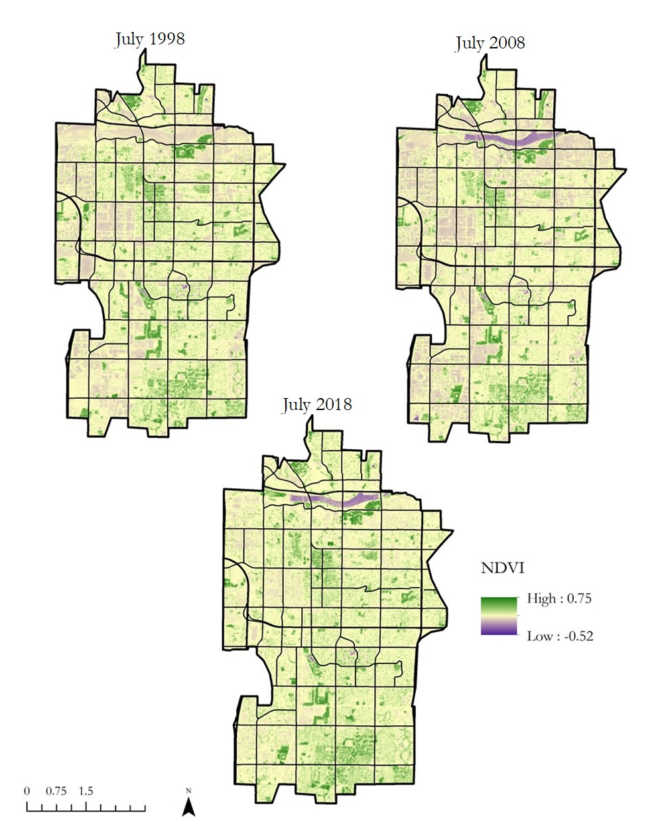
Figure A1. Tempe, AZ NDVI time series derived from Landsat imagery.
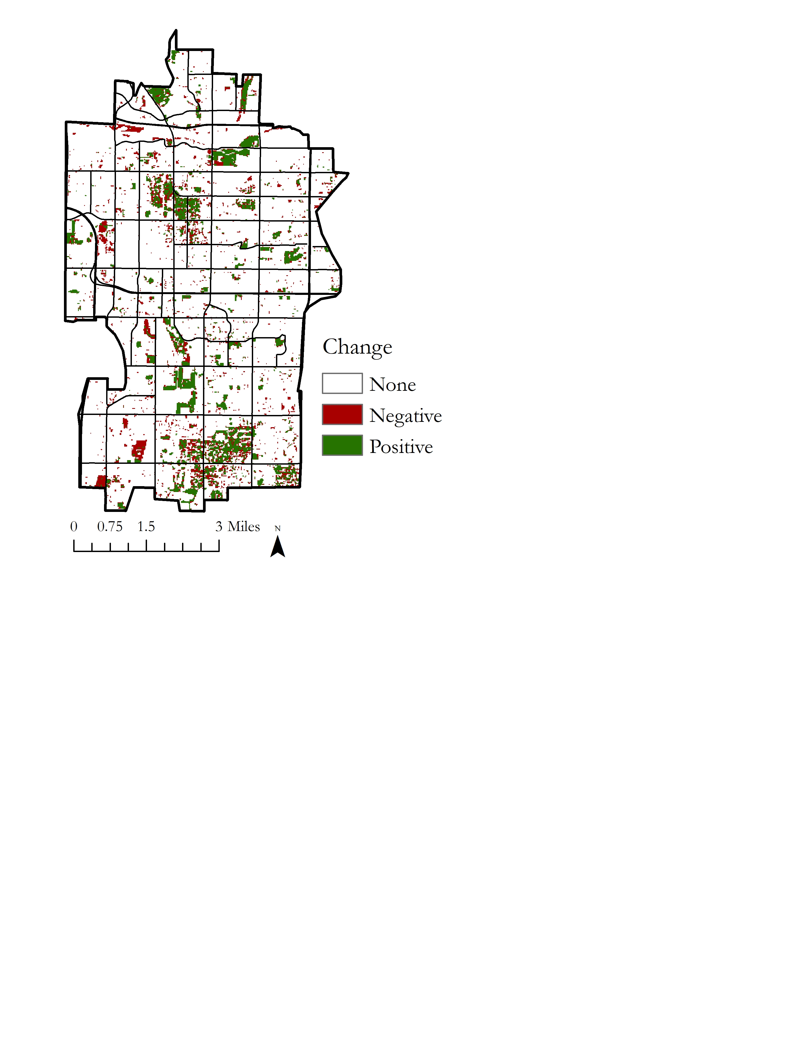
Figure A2. Tempe, AZ Change in NDVI (1998 to 2018).

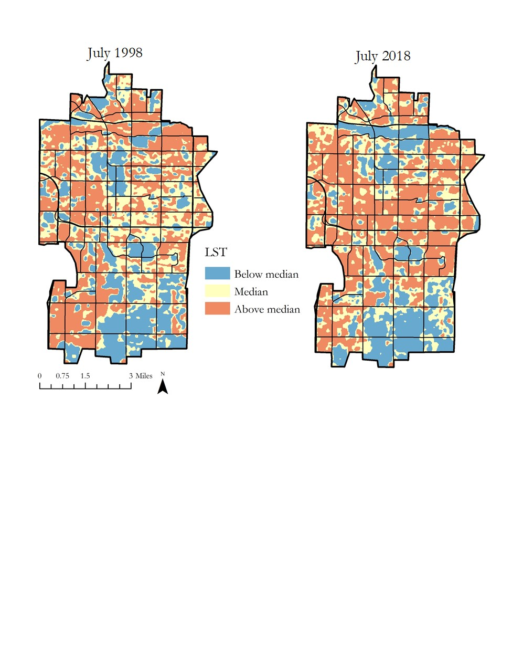
Figure A3. Tempe, AZ relative LST time series derived from Landsat imagery.

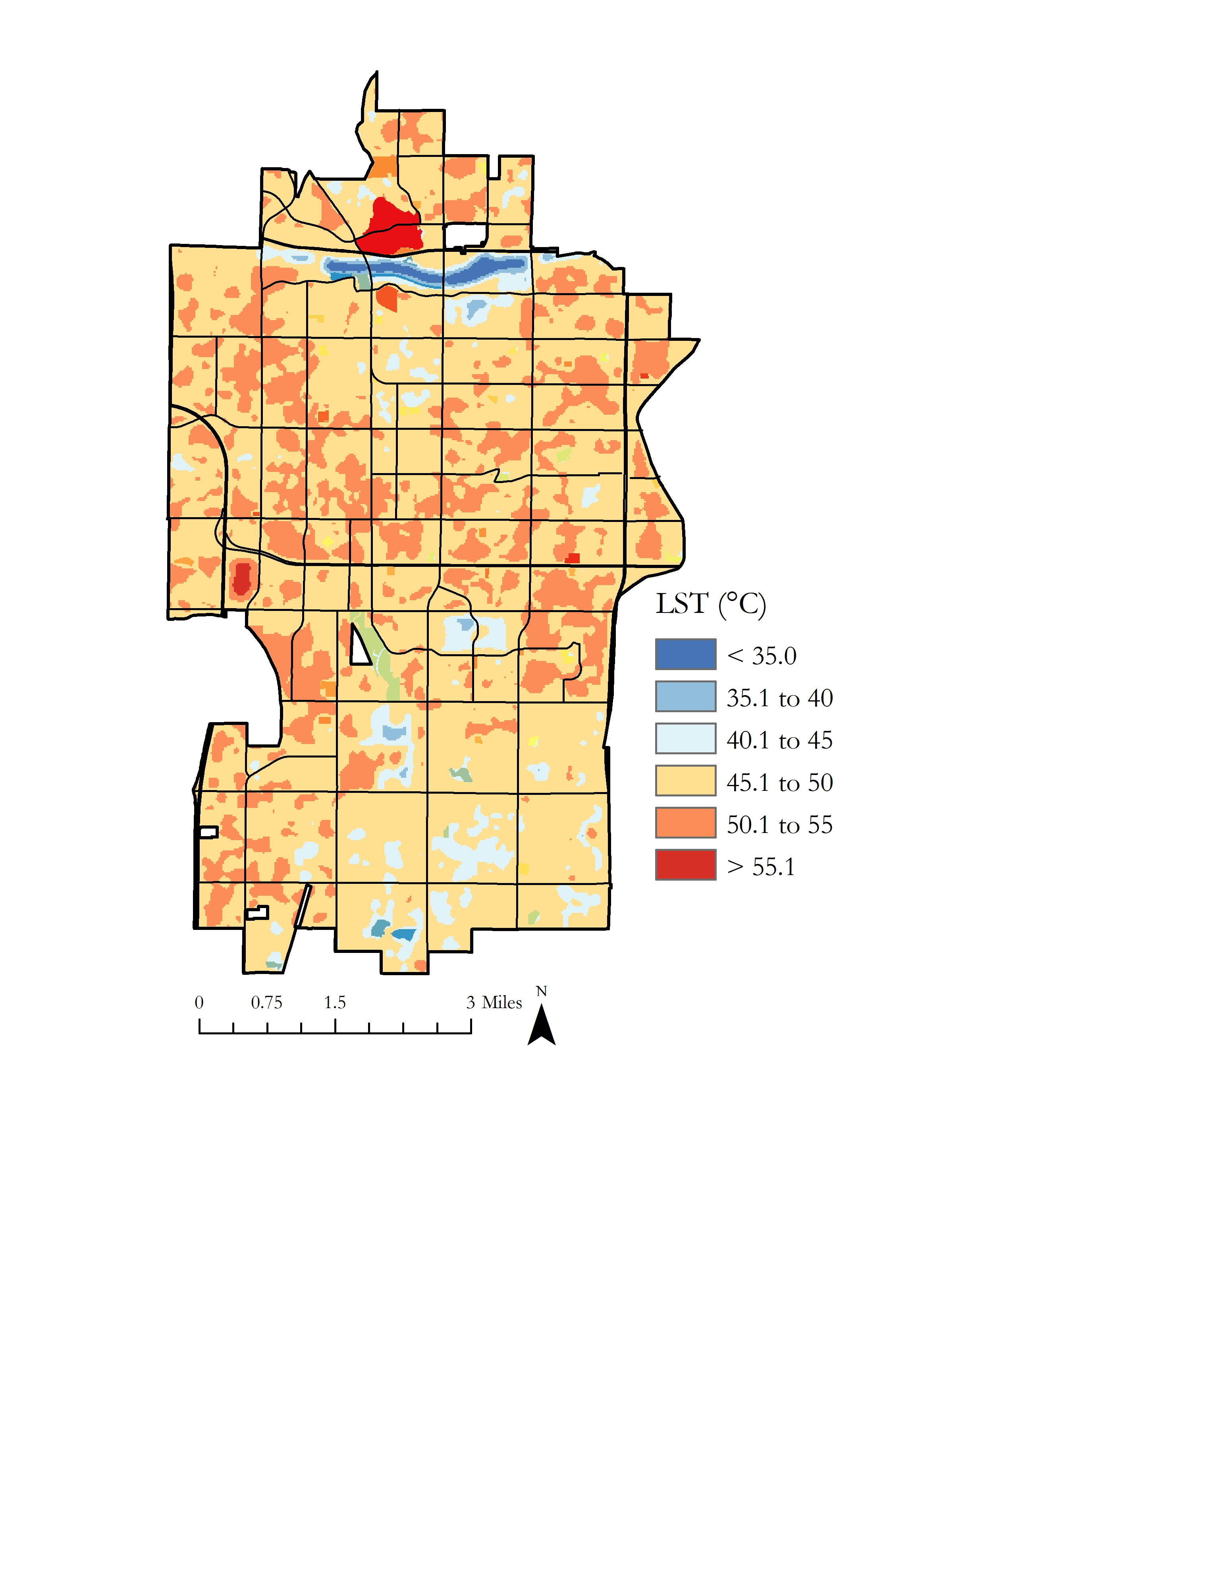
Figure A4. Tempe, AZ LST July 2018.

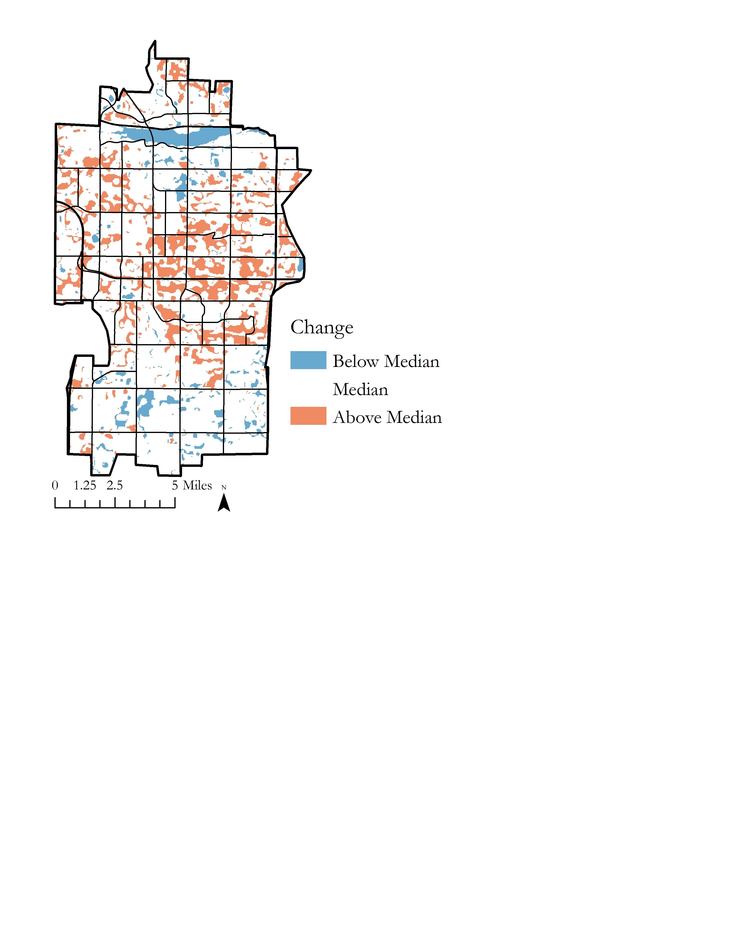
Figure A5. Tempe, AZ relative change in LST (1998 to 2018).

Table A1
Tempe, AZ relative change in LST (1998 to 2018) summary table
 | Below median LST |  | Above median LST
Year | Square Kilometers | Percent of Total Area | Square Kilometers | Percent of Total Area
1998 | 26.7 | 25.5 | 42.8 | 40.9
2018 | 24.1 | 23.0 | 47.8 | 45.7

Table A2
Statistical summary of linear regression analysis with LST change as a function of NDVI change from 1998 to 2018
Residuals:
Min | 1Q | Median | 3Q | Max
-9.9839 | -0.6384 | 0.0502 | 0.6693 | 17.1513
Coefficients: | Estimate | Std. Error | t-value | Pr(>/t/)
(Intercept) | 12.0490 | 0.004249 | 2835.9 | < 2*10⁻¹⁶
NDVI Change | -9.377265 | 0.052221 | -179.6 | < 2*10⁻¹⁶
Residual standard error: | 1.465 on 169,593 degrees of freedom
Multiple R-squared: | 0.1598 | Adjusted R-squared: |  | 0.1598
F-statistic: | 3.225*10⁴ on 1 and 169,593 DF, p-value: < 2*10⁻¹⁶

Appendix B
Supplementary Figures and Tables for Tree Density, Land Cover, and LST

Table B1
Statistical summary of Welch Two-Sample t-tests between mean LST of different land cover types (with and without trees)
Population 1 | Population 2 | t-value | df | p-value
Grass land cover | Building land cover | -37.30 | 2,317.2 | < 2.2*10⁻¹⁶
Grass land cover | Road land cover | -56.61 | 963.14 | < 2.2*10⁻¹⁶
Building land cover | Road land cover | 3.69 | 1,705.6 | 0.0002334

Table B2
Statistical summary of Welch Two-Sample t-tests between mean LST of different land cover types
Population 1 | Population 2 | t-value | df | p-value
Mean LST of grassland cover with trees | Mean LST of grassland cover with no trees | 1.69 | 231.59 | 0.09
Mean LST of building land cover with trees | Mean LST of building land cover with no trees | 4.11 | 25.50 | 0.36*10⁻⁴
Mean LST of road land cover with trees | Mean LST of road land cover with no trees | -1.38 | 1,515.9 | 0.17

Table B3
Mean and median LST of different land cover types (with and without trees)
Land Cover Type | Mean LST (°C) | Median  LST(°C) | Number of Pixels Sampled
Grass with trees | 26.94 | 26.75 | 130
Grass without trees | 27.17 | 26.96 | 454
Building with trees | 30.19 | 29.15 | 24
Building without trees | 30.48 | 30.08 | 1,392
Road with trees | 30.15 | 30.08 | 924
Road without trees | 30.08 | 30.08 | 3,624

Appendix C
Supplementary Figures and Tables for Parks Analysis

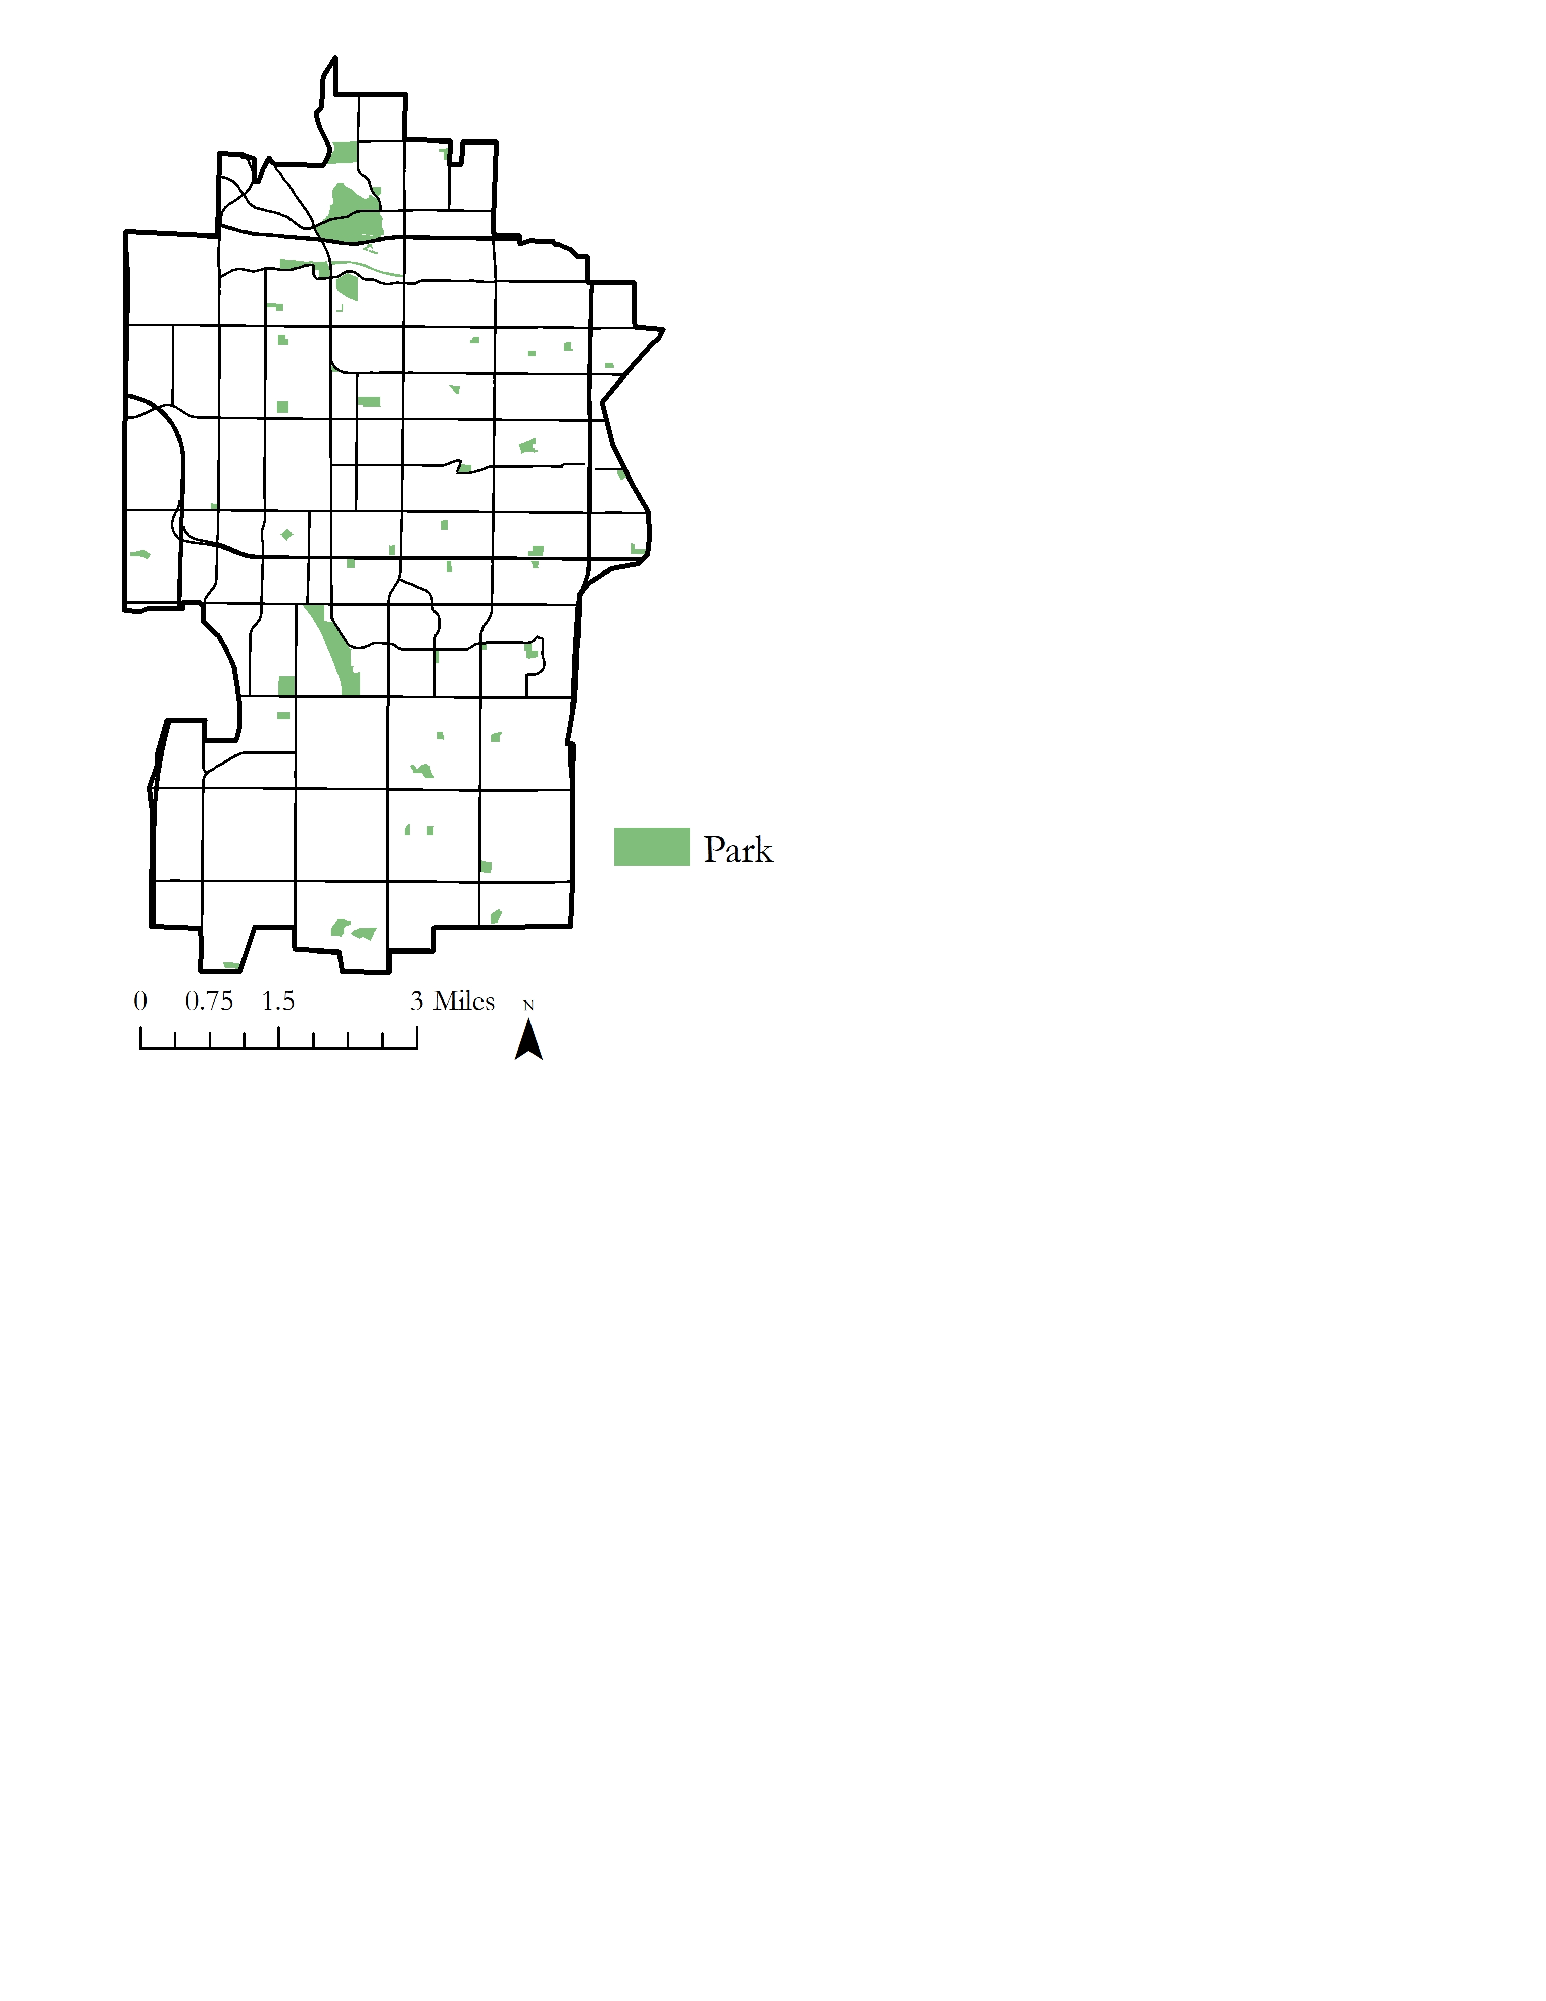
Figure C1. Parks in Tempe, AZ.

Table C1
Tempe parks including mean LST, tree density, and land cover percentages
Land Cover Class Key: 1 = Building, 2 = Road, 3 = Soil, 4 = Tree, 5 = Grass, 6 = Shrub, 7 = Lake, 8 = Canal, 9 = Pool
 |  |  |  |  |  |  | Percent Land Cover Class
 | Name | Mean LST (°C) | Min LST (°C) | Max LST (°C) | Range LST (°C) | STD LST (°C) | 1 | 2 | 3 | 4 | 5 | 6 | 7 | 8 | 9 | Trees | Acres | Trees per Acre
1 | Papago Park | 49.7 | 45.3 | 51.5 | 6.2 | 1.1 | 0.2 | 9.4 | 68.6 | 2.9 | 8.7 | 10.3 | 0.0 | 0.0 | 0.0 | 173 | 79.2 | 2.2
2 | Victory Park | 49.5 | 49.3 | 49.7 | 0.4 | 0.2 | 0.0 | 30.0 | 24.7 | 28.8 | 15.0 | 0.0 | 0.0 | 1.5 | 0.0 | 7 | 0.2 | 40.8
3 | Moeur Park | 49.5 | 44.0 | 51.5 | 7.5 | 1.5 | 0.0 | 10.9 | 69.5 | 7.1 | 12.3 | 0.0 | 0.1 | 0.0 | 0.0 | 487 | 112.0 | 4.3
4 | Rotary Park | 49.2 | 47.2 | 50.8 | 3.5 | 1.0 | 17.9 | 12.6 | 15.4 | 17.4 | 36.7 | 0.0 | 0.0 | 0.0 | 0.0 | 82 | 9.7 | 8.4
5 | Esquer Park | 49.0 | 47.5 | 50.7 | 3.2 | 0.8 | 1.6 | 2.3 | 44.5 | 12.5 | 39.0 | 0.0 | 0.0 | 0.0 | 0.0 | 45 | 3.1 | 14.3
6 | Petersen Park | 48.8 | 47.6 | 50.1 | 2.5 | 0.7 | 1.8 | 30.7 | 19.7 | 21.7 | 26.1 | 0.0 | 0.0 | 0.0 | 0.0 | 41 | 2.2 | 18.7
7 | Hayden Butte Preserve Park | 48.5 | 47.3 | 50.1 | 2.8 | 0.4 | 0.9 | 52.0 | 38.2 | 2.1 | 6.8 | 0.0 | 0.0 | 0.0 | 0.0 | 31 | 33.4 | 0.9
8 | Clark Park | 48.3 | 47.3 | 50.1 | 2.8 | 0.6 | 2.0 | 7.8 | 39.9 | 15.3 | 33.8 | 0.0 | 0.0 | 0.0 | 1.2 | 180 | 9.4 | 19.2
9 | Benedict Park | 48.1 | 44.2 | 51.1 | 7.0 | 1.7 | 0.6 | 28.6 | 14.0 | 10.1 | 46.7 | 0.0 | 0.0 | 0.0 | 0.0 | 168 | 16.6 | 10.1
10 | Arredondo Park | 47.9 | 46.7 | 49.4 | 2.7 | 0.7 | 0.1 | 11.1 | 19.1 | 17.9 | 51.8 | 0.0 | 0.0 | 0.0 | 0.0 | 32 | 3.6 | 9.0
11 | Lo Piano Mesquite Bosque | 47.8 | 45.8 | 49.2 | 3.4 | 0.8 | 0.0 | 6.7 | 35.5 | 45.6 | 12.1 | 0.0 | 0.1 | 0.0 | 0.0 | 186 | 7.1 | 26.3
12 | Scudder Park | 47.7 | 46.7 | 49.6 | 2.9 | 0.7 | 0.0 | 21.6 | 13.1 | 14.6 | 50.6 | 0.0 | 0.0 | 0.0 | 0.0 | 52 | 4.5 | 11.7
13 | Celaya Park | 47.6 | 46.0 | 49.3 | 3.3 | 0.9 | 0.0 | 11.6 | 8.9 | 11.9 | 67.6 | 0.0 | 0.0 | 0.0 | 0.0 | 104 | 6.2 | 16.7
14 | Alegre Park | 47.6 | 46.7 | 48.9 | 2.1 | 0.6 | 1.1 | 3.2 | 28.2 | 14.1 | 53.4 | 0.0 | 0.0 | 0.0 | 0.0 | 32 | 3.2 | 10.0
15 | Evelyn Hallman Park | 47.5 | 42.8 | 50.8 | 8.0 | 1.8 | 0.0 | 3.4 | 64.2 | 5.2 | 8.0 | 2.8 | 16.0 | 0.4 | 0.0 | 240 | 40.9 | 5.9
16 | Cyprus Park | 47.5 | 46.6 | 49.8 | 3.2 | 0.7 | 0.0 | 13.0 | 21.7 | 47.5 | 17.9 | 0.0 | 0.0 | 0.0 | 0.0 | 81 | 4.7 | 17.3
17 | Gaicki Park | 47.3 | 46.5 | 48.7 | 2.2 | 0.6 | 0.4 | 20.3 | 10.0 | 14.4 | 54.8 | 0.0 | 0.0 | 0.0 | 0.2 | 18 | 2.8 | 6.4
18 | Svob Park | 47.1 | 45.7 | 49.3 | 3.6 | 0.9 | 0.0 | 11.9 | 9.3 | 28.1 | 50.8 | 0.0 | 0.0 | 0.0 | 0.0 | 105 | 8.5 | 12.4
19 | Tempe Women's Club Park | 47.1 | 45.9 | 48.7 | 2.8 | 0.8 | 0.0 | 1.7 | 46.9 | 22.4 | 29.0 | 0.0 | 0.0 | 0.0 | 0.0 | 90 | 4.5 | 19.8
20 | Cole Park | 47.0 | 45.9 | 49.0 | 3.1 | 0.8 | 0.0 | 5.2 | 49.1 | 30.1 | 15.5 | 0.0 | 0.0 | 0.0 | 0.0 | 74 | 3.5 | 21.1
21 | Palmer Park | 46.9 | 45.6 | 48.6 | 2.9 | 0.8 | 0.1 | 4.9 | 34.4 | 35.8 | 23.1 | 0.0 | 0.0 | 1.6 | 0.0 | 52 | 5.1 | 10.2
22 | Redden Park | 46.9 | 46.1 | 48.9 | 2.8 | 0.6 | 0.0 | 5.4 | 28.9 | 10.9 | 54.8 | 0.0 | 0.0 | 0.0 | 0.0 | 36 | 3.7 | 9.8
23 | Daumler Park | 46.5 | 43.7 | 48.8 | 5.1 | 1.3 | 0.0 | 14.2 | 13.2 | 14.6 | 50.6 | 0.0 | 0.0 | 0.0 | 0.0 | 46 | 5.4 | 8.4
24 | Hudson Park | 46.4 | 45.8 | 47.5 | 1.7 | 0.4 | 0.6 | 8.8 | 45.3 | 16.4 | 28.9 | 0.0 | 0.0 | 0.0 | 0.0 | 38 | 4.2 | 9.1
25 | Jaycee Park | 46.3 | 45.3 | 47.9 | 2.5 | 0.7 | 7.4 | 13.7 | 21.2 | 23.4 | 34.3 | 0.0 | 0.0 | 0.0 | 0.0 | 172 | 6.8 | 25.2
26 | 6th Street Park | 46.1 | 45.3 | 46.5 | 1.2 | 0.4 | 0.0 | 19.9 | 28.0 | 17.5 | 34.6 | 0.0 | 0.0 | 0.0 | 0.0 | 84 | 4.0 | 20.9
27 | Birchett Park | 46.1 | 45.8 | 46.7 | 0.9 | 0.3 | 0.0 | 31.3 | 9.4 | 39.0 | 20.4 | 0.0 | 0.0 | 0.0 | 0.0 | 39 | 2.5 | 15.6
28 | Estrada Park | 46.1 | 45.1 | 48.1 | 3.0 | 0.7 | 0.1 | 16.5 | 5.5 | 12.0 | 66.0 | 0.0 | 0.0 | 0.0 | 0.0 | 73 | 10.0 | 7.3
29 | Mitchell Park | 46.0 | 44.4 | 48.4 | 4.0 | 1.2 | 0.0 | 5.8 | 27.1 | 17.8 | 49.4 | 0.0 | 0.0 | 0.0 | 0.0 | 202 | 7.0 | 29.0
30 | Creamery Park | 46.0 | 44.5 | 48.8 | 4.3 | 1.2 | 5.1 | 4.5 | 39.6 | 7.5 | 43.3 | 0.0 | 0.0 | 0.0 | 0.0 | 28 | 3.7 | 7.7
31 | Daley Park | 46.0 | 44.3 | 47.5 | 3.2 | 0.5 | 0.0 | 11.4 | 33.3 | 16.6 | 38.7 | 0.0 | 0.0 | 0.0 | 0.0 | 106 | 13.0 | 8.2
32 | Optimist Park | 45.9 | 44.2 | 48.9 | 4.7 | 1.1 | 0.1 | 6.0 | 31.6 | 7.6 | 54.7 | 0.0 | 0.0 | 0.0 | 0.0 | 63 | 11.2 | 5.6
33 | Indian Bend Park | 45.8 | 43.4 | 48.4 | 5.0 | 1.4 | 2.0 | 5.1 | 24.0 | 15.2 | 53.8 | 0.0 | 0.0 | 0.0 | 0.0 | 65 | 6.8 | 9.5
34 | Dwight Park | 45.7 | 44.0 | 48.1 | 4.1 | 1.0 | 0.0 | 12.5 | 33.1 | 9.0 | 45.4 | 0.0 | 0.0 | 0.0 | 0.0 | 126 | 5.8 | 21.6
35 | Stroud Park | 45.6 | 44.4 | 47.1 | 2.7 | 0.7 | 0.3 | 6.6 | 26.2 | 8.2 | 58.6 | 0.0 | 0.0 | 0.0 | 0.0 | 49 | 6.2 | 7.9
36 | Escalante Park | 45.4 | 43.6 | 48.7 | 5.1 | 1.2 | 7.4 | 1.7 | 20.8 | 21.3 | 48.8 | 0.0 | 0.0 | 0.0 | 0.0 | 60 | 5.0 | 12.1
37 | Ehrhardt Park | 45.4 | 44.3 | 48.5 | 4.2 | 1.0 | 1.0 | 4.4 | 13.9 | 16.5 | 64.0 | 0.0 | 0.0 | 0.2 | 0.0 | 51 | 7.4 | 6.9
38 | Selleh Park | 45.3 | 42.3 | 49.2 | 6.9 | 1.9 | 2.6 | 16.3 | 16.9 | 28.5 | 30.2 | 0.0 | 4.7 | 0.8 | 0.0 | 117 | 11.5 | 10.2
39 | Joyce Park | 45.1 | 43.9 | 47.4 | 3.5 | 0.9 | 1.1 | 5.8 | 29.2 | 57.0 | 6.8 | 0.0 | 0.0 | 0.0 | 0.0 | 75 | 4.5 | 16.5
40 | Meyer Park | 45.0 | 41.6 | 49.7 | 8.1 | 2.5 | 0.0 | 11.8 | 11.6 | 25.8 | 50.7 | 0.0 | 0.0 | 0.0 | 0.0 | 84 | 8.2 | 10.2
41 | Kiwanis Park | 44.9 | 36.9 | 50.0 | 13.1 | 2.6 | 1.9 | 7.6 | 32.1 | 14.8 | 35.6 | 0.0 | 7.9 | 0.0 | 0.0 | 1199 | 107.8 | 11.1
42 | Waggoner Park | 44.6 | 42.7 | 46.7 | 4.0 | 0.9 | 0.9 | 12.0 | 15.2 | 22.8 | 49.1 | 0.0 | 0.0 | 0.0 | 0.0 | 104 | 8.9 | 11.7
43 | Goodwin Park | 44.5 | 42.7 | 46.8 | 4.1 | 1.0 | 1.0 | 10.0 | 6.4 | 12.4 | 70.1 | 0.0 | 0.0 | 0.0 | 0.2 | 43 | 8.6 | 5.0
44 | Rio Salado Park | 43.7 | 36.5 | 49.4 | 12.9 | 3.6 | 5.3 | 12.2 | 44.2 | 4.9 | 31.3 | 0.0 | 2.1 | 0.0 | 0.0 | 161 | 8.9 | 18.1
45 | Corbell Park | 43.6 | 41.4 | 46.2 | 4.8 | 1.1 | 0.0 | 7.8 | 10.9 | 6.8 | 74.5 | 0.0 | 0.0 | 0.0 | 0.0 | 103 | 14.5 | 7.1
46 | Tempe Beach Park | 43.6 | 37.7 | 47.5 | 9.7 | 2.3 | 0.9 | 18.5 | 32.2 | 13.0 | 35.4 | 0.0 | 0.1 | 0.0 | 0.0 | 138 | 15.2 | 9.1
47 | Campbell Park | 43.3 | 41.6 | 46.4 | 4.8 | 1.4 | 0.1 | 6.8 | 18.7 | 17.9 | 56.5 | 0.0 | 0.0 | 0.0 | 0.0 | 70 | 6.3 | 11.1
48 | Harleson Park | 42.5 | 40.4 | 45.0 | 4.6 | 1.0 | 0.4 | 13.1 | 22.6 | 12.9 | 51.0 | 0.0 | 0.0 | 0.0 | 0.0 | 156 | 17.2 | 9.1
49 | Town Lake Marina | 42.4 | 38.5 | 46.0 | 7.5 | 2.2 | 0.8 | 1.9 | 52.2 | 4.8 | 38.4 | 0.0 | 0.0 | 0.1 | 1.8 | 13 | 3.7 | 3.5
50 | Hanger Park | 41.9 | 39.1 | 46.8 | 7.7 | 1.7 | 0.0 | 7.2 | 11.1 | 15.5 | 66.2 | 0.0 | 0.0 | 0.0 | 0.0 | 137 | 16.1 | 8.5
51 | Neil G. Giuliano Park | 39.7 | 36.4 | 44.3 | 7.9 | 1.6 | 1.5 | 0.9 | 49.5 | 4.8 | 36.6 | 0.0 | 4.2 | 2.5 | 0.0 | 86 | 13.5 | 6.4

Table C2
Statistical summary of linear regression analysis with LST change as a function of the percentage of building land cover
Residuals:
Min | 1Q | Median | 3Q | Max
-13.2197 | -13.2197 | -0.8141 | 0.2804 | 10.1301
Coefficients: | Estimate | Std. Error | t-value | Pr(>/t/)
(Intercept) | 28.897 | 7.482*10⁻³ | 3,872 | < 2*10⁻¹⁶
Percentage building land cover | 1.252*10⁻² | 2.559*10⁻⁴ | 48.92 | < 2*10⁻¹⁶
Residual standard error: | 1.888 on 10,5661 degrees of freedom
Multiple R-squared: | 0.02215 | Adjusted R-squared: |  | 0.02214
F-statistic: | 2,393 on 1 and 105,661 DF, p-value: < 2*10⁻¹⁶

Table C3
Statistical summary of linear regression analysis with LST change as a function of the percentage of soil land cover
Residuals:
Min | 1Q | Median | 3Q | Max
-13.4357 | -0.7790 | 0.2655 | 1.0933 | 11.1660
Coefficients: | Estimate | Std. Error | t-value | Pr(>/t/)
(Intercept) | 29.19 | 8.136*10⁻³ | 3,587.578 | < 2*10⁻¹⁶
Percentage soil land cover | 6.145*10⁻⁴ | 2.338*10⁻⁴ | 2.628 | 0.00858
Residual standard error: | 1.909 on 10,5661 degrees of freedom
Multiple R-squared: | 6.538*10⁻⁵ | Adjusted R-squared: |  | 5.592*10⁻⁵
F-statistic: | 6.909 on 1 and 105,661 DF, p-value: 0.00858

Table C4
Statistical summary of linear regression analysis with LST change as a function of the percentage of grassland cover
Residuals:
Min | 1Q | Median | 3Q | Max
-13.7224 | -0.7362 | 0.2291 | 1.0621 | 10.8793
Coefficients: | Estimate | Std. Error | t-value | Pr(>/t/)
(Intercept) | 29.4770387 | 0.0064177 | 4,593.07 | < 2*10⁻¹⁶
Percentage grass land cover | -0.0317116 | 0.0003528 | -89.88 | < 2*10⁻¹⁶
Residual standard error: | 1.84 on 10,5661 degrees of freedom
Multiple R-squared: | 0.07102 | Adjusted R-squared: |  | 0.07101
F-statistic: | 8,078 on 1 and 105,661 DF, p-value: < 2*10⁻¹⁶

Table C5
Statistical summary of linear regression analysis with LST change as a function of the percentage of tree land cover
Residuals:
Min | 1Q | Median | 3Q | Max
-13.6990 | -0.7469 | 0.2683 | 1.1274 | 10.9027
Coefficients: | Estimate | Std. Error | t-value | Pr(>/t/)
(Intercept) | 29.4453635 | 0.0081504 | 3,613.78 | < 2*10⁻¹⁶
Percentage tree land cover | -0.0190166 | 0.0004366 | -43.56 | < 2*10⁻¹⁶
Residual standard error: | 1.892 on 10,5661 degrees of freedom
Multiple R-squared: | 0.01764 | Adjusted R-squared: |  | 0.01763
F-statistic: | 1,897 on 1 and 105,661 DF, p-value: < 2*10⁻¹⁶

Table C6
Statistical summary of linear regression analysis with LST change as a function of the percentage of road land cover
Residuals:
Min | 1Q | Median | 3Q | Max
-12.8726 | -0.8253 | 0.1987 | 1.1123 | 11.7291
Coefficients: | Estimate | Std. Error | t-value | Pr(>/t/)
(Intercept) | 28.63 | 8.314*10⁻³ | 3,443.34 | < 2*10⁻¹⁶
Percentage road land cover | 1.71*10⁻² | 1.814*10⁻⁴ | 94.58 | < 2*10⁻¹⁶
Residual standard error: | 1.833 on 10,5661 degrees of freedom
Multiple R-squared: | 0.07806 | Adjusted R-squared: |  | 0.07805
F-statistic: | 8,946 on 1 and 105,661 DF, p-value: < 2 * 10⁻¹⁶

