**NASA DEVELOP National Program**



Wise County Clerk of Court’s Office

*Spring 2015*

Peru Water Disasters

Utilizing NASA Earth Observations to Develop a Comprehensive Water Budget for the Asuncion district in Peru

 **Technical Report**

Rough Draft - Feb 19, 2015

Sarah Medley, (Project Lead)

Kieran Blakemore

Jordan Bates

Grant Bloomer

Scott Arnette

Michael Mullins

Azeb Shewago

Dr. Kenton Ross, NASA DEVELOP National Program (Science Advisor)

Dr. DeWayne Cecil, Global Science and Technology Inc. (Science Advisor)

Dr. Ryan Stewart (Virginia Tech)

Previous Contributors:

Steve Padgett-Vasquez

Catherine Steentofte

Abigail Holbrook

Manzi Roger Dusabimana

Rohini Swaminathan

# I. Abstract

In rural regions of Peru access to adequate water and sanitation systems is limited, and large percentages of the population remain below the poverty line. In addition, major flooding in 2008, 2013, and 2014 devastated the region. In a partnership with Water For People, a non-profit organization, this project aimed to create datasets and tools necessary for water resource management projects in the Gran Chimú province and Asunción district of Peru. An additional partnership with the *Instituto Nacional de Defensa Civil del Peru* (INDECI) will aim to support flood mitigation. NASA Earth observations were used in this project to provide alternative datasets for Water For People’s projects in Peru. Earth observations systems such as Landsat 8’s Operational Land Imager (OLI) data, Digital Elevation Model (DEM) data from the Advanced Spaceborne Thermal Emission and Reflection Radiometer (ASTER), climatic data from the Tropical Rainfall Measuring Mission (TRMM), and land use data from the Moderate-resolution Imaging Spectroradiometer (MODIS) were used in this project. The Soil and Water Assessment Tool (SWAT) was used to build a model that will enable the end-user to study the hydrological processes and to develop a water resources inventory for the study area. Necessary models and data to estimate the flood risk assessment were also identified. The final maps, models, datasets and tutorials developed in this project will enable Water For People and the Peruvian government to improve water management programs.

**Keywords**

Remote Sensing, Water Resources, Flood Risk, Water For People, Asunción District, SWAT Modeling, Land cover, Classification

# II. Introduction

Many developing countries struggle to provide water security and sanitation services to communities. Although Peru has a rapidly growing economy propelled by mining, agriculture, textiles, and manufacturing exports, it still struggles to provide adequate water resources and sanitation systems, particularly to people in rural areas. Recent studies show that in rural areas of Peru only about 65% of residents have access to satisfactory water sources and only 37% of residents have access to satisfactory sanitation facilities (Water For People, 2013). Inadequate flood risk management plans further convolute efforts to provide water resource management systems. Water For People, is a non-profit organization dedicated to assisting countries with water sanitation through creative and collaborative solutions that allow people to build and maintain their own reliable safe water systems (Water For People, 2013). The organization is currently working in the Gran Chimú province of the La Libertad Region of northern Peru, and the Asunción district in the Cajamarca province in the Cajamarca Region of Peru. Water For People is actively working with the Peruvian government to create water budgets for those districts in order to improve water resources management plans and assist in flood risk management. Water For People lacks sufficient in-situ data and wishes to incorporate remotely sensed data from NASA Earth Observing Systems to augment current resources. Previous DEVELOP projects have mapped evapotranspiration using the Mapping Evapotranspiration at high Resolution with Internalized Calibration (METRIC) model and set up a Soil and Water Assessment Tool (SWAT) model to study the hydrological processes and develop a water resource inventory for the study area for the Gran Chimú province.

The goal of the project was to provide Water For People with datasets and tools derived from NASA Earth observations that would assist them in water resources management projects in Asunción and Gran Chimú. A complete SWAT model will enable the end-user to study the hydrological processes and well to develop a water resource inventory for the study area. Additional tutorials and training will allow the end-users to share the information with other organizations in Peru and apply the model to other projects. The identification of preliminary models and data to estimate the flood risk assessment will expand the study to aid in flood risk management in the future.

The Gran Chimú province is located in the La Libertad Region of Peru. The Chicama River and its tributaries serve as the main source of water throughout the region with the watershed encompassing roughly five thousand square kilometers (ISSUU, 2003, pg. 49). This project has focused its water budget analysis on the Ochape sub-basin of the Rio Chicama watershed. The Ochape sub-basin politically covers the provinces of Contumaza and Gran Chimú. The Gran Chimú province, where Cascas is located, is primarily agricultural with 68% of the population living in rural areas (Water For People, 2014). The Ochape sub-basin’s area is approximately two-hundred and seventeen square kilometers. The Ochape sub-basin consists of 67 springs, 52 irrigation canals, and 29 reservoirs (Water For People, 2013). There are 34 communities within the sub-basin, and the demographics of the region are 68% rural, and 32% urban (Water For People, 2013). The sub-basin has a warm, dry climate year round and has an average temperature of 18.9°C (Water For People, 2013). The Ochape sub-basin encompasses a mountainous terrain with rolling hills. The maximum altitude reaches four-thousand two-hundred meters (ISSUU- 2003, pg. 53). The main industry of the sub-basin is agriculture with a staple-crop of beets, with the industry of livestock closely following. Groundwater withdrawals and irrigation which are necessary for agriculture development change the natural flow patterns. Water resource monitoring and a management plan are crucial to ensure there is adequate water distribution for agricultural and individual use in the region. The Asunción district is located in the mountainous Cajamarca Region of Peru. The district has a population of 11,757 people living in 33 communities over an area of 214.7 km2 (Water For People, 2013). The majority of the Asunción district falls within the Rio Jequetepeque watershed. The total basin covers an area of 3,564.8 km2 and has an average elevation of around 400-800 m above sea level, with the mountainous regions reaching up to 4000 m. It has an arid, semi-warm coastal desert climate with the average annual temperature varying from 23°C in the coastal desert to 3°C in the mountainous parameters (Offer Water Management in Watersheds Project INADE Water Erosion in Middle and Upper Basin River, n.d.). Rainfall varies from 50 to 1217 mm annually (Offer Water Management in Watersheds Project INADE Water Erosion in Middle and Upper Basin River, n.d.).

The study period for the project term is from January 2011 to July 2014. This study period was set as such to produce enough hydrological trends and conduct simulations to forecast future mechanisms. Flood risk analysis is from January 2007 to December 2014 to reflect the time period when major flood disasters occurred.

The project addressed the “Water Resources” and the “Disasters” NASA application area and contributed to supporting the goal of broadening NASA Earth observation users and data. Under the Water Resources and Disasters programs, data will be derived and analyzed to assist in water management and flood risk analysis within the Ochape sub-basin and the Rio Jequetepeque benefiting Water For People’s and regional management plans (Farmer, 2012).

The research was completed for and in collaboration with the nonprofit organization, Water for People. Water for People’s ultimate goal is to achieve universal clean drinking water and sanitation services for global citizens. They are currently partnered with the regional governments of Peru to find solutions to improve water and sanitation services for the region. To do so, they seek to create a comprehensive water management plan that contains a water resource inventory. Before this project, NASA Earth observation data was not being incorporated into this management plan. Water For People wished to incorporate remotely sensed data from NASA EOS into their plan to help bridge the gaps in currently-available data.

# III. Methodology

SWAT Model

The Soil and Water Assessment Tool (SWAT) was chosen to help study the hydrological processes in the Asuncion district in Cajamarca Province, Peru. SWAT is a watershed-scale model that functions on a daily time step; and it is primarily applied to predict and evaluate long-term land cover and land management practices on the quantity and quality of water that is exported from watersheds with agricultural land use.

The model is physically-based and relies on environmental parameters and plant growth to estimate the amount of water available in the landscape to contribute to stream flow and delivery of sediment, nutrients, and pesticides to the watershed outlet. In this project, SWAT was ran via ArcSWAT, an ArcGIS based platform to model hydrological processes in the study area using NASA Earth Observation data in conjunction with other databases. SWAT has been successfully applied in many medium and large-scale basins in different regions of the world with various weather and topographic conditions to simulate flow and sediment transport.

**Data Acquisition**

To operate the SWAT model the following data was acquired. These data inputs were converted into a projected coordinate system of WGS 1984 UTM 17 S. The input data consists of spatial layers and time series data.

Digital Elevation Model

The elevation data used in this project was collected from the The Advanced Spaceborne Thermal Emission and Reflection Radiometer (ASTER) Global Digital Elevation Model (GDEM), a joint project by NASA and the Japan’s Ministry of Economy, Trade and Industry. ASTER is capable of collecting in-track stereo using nadir- and aft-looking near infrared cameras. Since 2001, these stereo pairs have been used to produce single-scene (60- x 60-kilomenter (km)) digital elevation models (DEM) having vertical (root-mean-squared-error) accuracies generally between 10- and 25-meters (m). In this project, DEM’s Geographic Tagged Image File Format (GeoTIFF) files for the area surrounding the Asuncion district were downloaded through the United States Geological Survey’s data portals. In this project, a 30-meter DEM was used for the SWAT model setup. The ArcSWAT interface uses the DEM to determine the physical characteristics of reaches, sub-basins, river networks, and hydrologic response units (HRUs)

Soils map showing soil types and locations

The soil inputs for the SWAT model were downloaded from the Food and Agriculture Organization of the UN’s Digital Soil Map of the World. These soil inputs provide information to populate the model with. These parameters include soil depth, particle size distribution, bulk density, hydraulic conductivity, and available water capacity. Soil input is an important factor for developing an accurate model since hydrological mechanisms in the watershed basin have a strong correlation with soil properties.

Land use and land cover

Land use is an important part of the hydrological response definition for the SWAT model. This data will help determine how various types of land cover react to changes in hydrology. Parcels represented by different types of land cover will respond independently to precipitation levels and climate forcing based on the soil type and slope. Land use/cover used in this project was derived from NASA’s Moderate Resolution Imaging Spectroradiometer (MODIS) an instrument aboard the TERRA and AQUA satellites. If this resolution fails to accurately represent our area of interest because of low spatial resolution Landsat 8 imagery has been downloaded from USGS’s Earth Explorer to create our very own classification system.

[Link to SWAT ‘s Land Cover Look up Table](http://www.placer.ca.gov/Departments/CommunityDevelopment/Planning/PCCP/WatershedPlanning/~/media/cdr/Planning/PGCC/AppendixB%20pdf.pdf)

The meteorological time series data for this SWAT model consists of historical precipitation data, temperatures, relative humidity, solar radiation, and wind speed data. This data was derived from the Climate Forecast System Analysis from the National Centers for Environmental prediction. Further historical time series data will be recorded from *in – situ* ground teams from Water for People.

*Diagram Summarizing the Inputs files for SWAT*

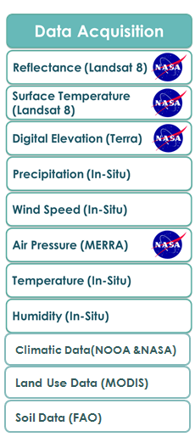

**Data Processing and Analysis**

SWAT functions as a process based, computationally efficient, and capable of continuous simulation over long periods of time. In Arc SWAT, a watershed is divided into multiple sub-watersheds, which are then further subdivided into hydrologic response units (HRUs) that consist of homogeneous land use, management, topographical, and soil characteristics as detailed in Arnold et al (1998). Simulation of watershed hydrology is separated into the land phase, which controls the amount of water and sediments loadings to the main channel in each sub-basin, and the in-stream or routing phase, which is the water movement of water, sediments, etc., through the channel network of the watershed to the outlet. As described in the SWAT theoretical documentation (<http://swat.tamu.edu/>), the hydrologic cycle is climate driven and provides moisture and energy inputs described above. SWAT can read these observed data directly from observed monthly statistics. Snow is computed when temperatures are below freezing, and soil moisture is computed because it impacts water movement and the decay rate of residue in the soil.

Once the SWAT model is created, the final process to ensure its correctness and accuracy is calibration and validation. This technique begins by analyzing what parameters in the model are most sensitive and how much they affect the model when changed. Through this sensitivity analysis, the parameters that most affect the model’s output are determined and can be manipulated through the calibration process (Arnold et al., 2012). Calibration allows for the model to improve its accuracy by introducing a previously derived local set of data to the model. Finally, validation occurs by comparing the output of the model to a set of real data not used during calibration. The validation process ensures the model’s ability to produce an accurate solution. One tool used for calibration and validation is SWAT-CUP, a public domain program offered on the Neprash Technology website ([http://http://www.neprashtechnology.ca/](http://http/www.neprashtechnology.ca/)). With this program, several algorithms and procedures such as SUFI-2, GLUE, and ParaSol can be applied to the model to apply calibration techniques using locally gathered data. Once calibration is performed for one dataset, SWAT-CUP can be run again and its results compared to a separate gathered dataset to validate the model’s accu

racy. Additionally, SWAT-CUP provides graphical modules to model data such as visualization of watersheds and simulation results.

# IV. Results & Discussion

Preliminary Results

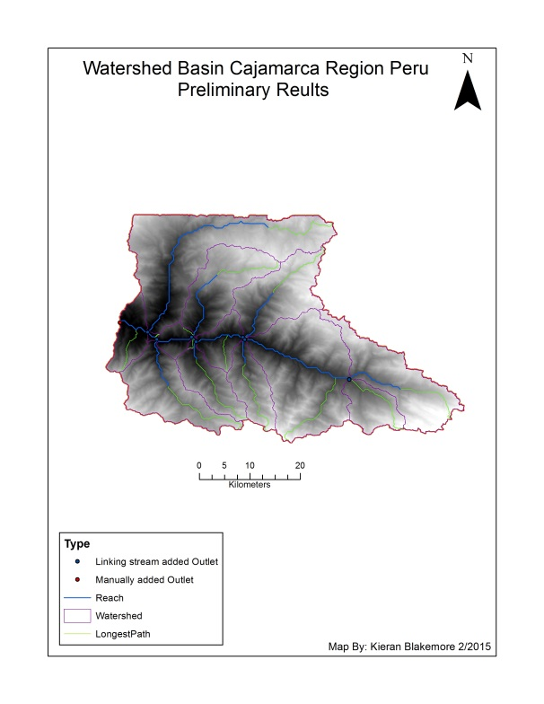

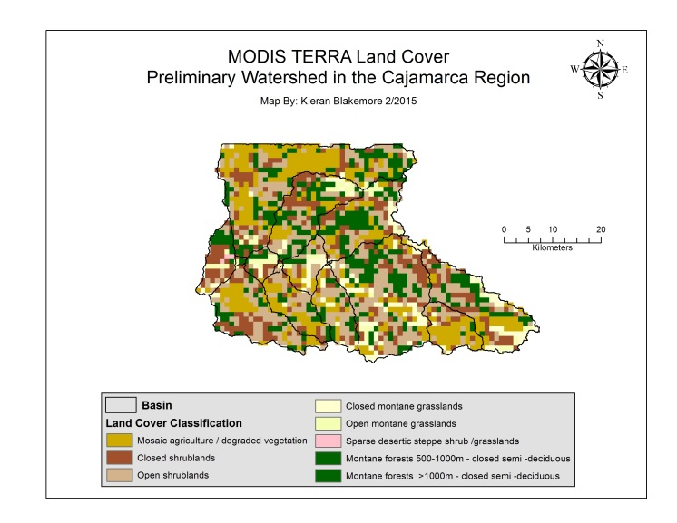

# V. Conclusions

Work in Progress

# VI. Acknowledgments

The team would like to acknowledge Dr. Kenton Ross, the NASA DEVELOP National Science Advisor and Dr. DeWayne Cecil from Global Science and Technology Inc., and Dr. Ryan Stewart from Virginia Polytechnic Institute and State University for their guidance and support throughout the term. We would also like to extend our special appreciation to Hon. Jack Kennedy, Wise County/ City of Norton Clerk of Court and Ms. Melanie Salyer, NASA DEVELOP Wise Principal Investigator for their support throughout the duration of this project. This material is based upon work supported by NASA through contract NNL11AA00B and cooperative agreement NNX14AB60A.

# VII. References

Arnold, J. G., Moriasi, D. N., Gassman, P. W., Abbaspour, K. C., White, M. J., Srinivasan, R., … Jha, M. K. (2012). SWAT: Model Use, Calibration, and Validation. American Society of Agricultural and Biological Engineers, 55. Retrieved from http://swat.tamu.edu/media/99051/azdezasp.pdf

Arnold, J. G., Srinivasan, R., Muttiah, R. S., and Williams, J. R., 1998. Large areahydrologic modeling and assessment part I: Model development. Journal of American Water Resources Association., 34(1), 73–89.

ISSUU: Evaluación y Ordenamiento de los Recursos Hídricos en la Cuenca del Río

Chicama. Ministerio de Agricultura Administración Técnica del Distruito de Reigo

Chicama, Uno, 49-55. Retrieved June 26, 2014, from <http://issuu.com/redlibre/docs/named815f4>

Farmer, J. (2012, August 7). NASA DEVELOP Projects. Retrieved February 20, 2014, from

<http://develop.larc.nasa.gov/projects.html>

Offer Water Management in Watersheds Project INADE Water Erosion in Middle and Upper Basin River Jequetepeque. (n.d.). Retrieved February 20, 2015, from <http://www.condesan.org/apc-aa-files/c6924e7390318016d869182e0da9470c/PSanchez_INADE_1_.pdf>

Water For People. (2013, October 28). Retrieved February 20, 2015, from

https://www.waterforpeople.org/

# VIII. Appendices

Insert here