Chile Water Resources

Monitoring the Extent and Distribution of Saline Systems in Chile’s Atacama Desert Utilizing NASA Earth Observations

Genevieve Clow1,2

Catherine Breen1

Gina Cova1

Monica Zhang1

1 Earth Sciences Division, DEVELOP National Program, NASA Ames Research Center, Moffett Field, CA 94345

2 Corresponding author; email: [genna796@gmail.com](mailto:genna796@gmail.com)

# Highlights

* Using several spectral indices can accelerate the ability to develop land classifications for the Atacama Desert without adding training points for each year.
* Vegetation and water levels in the Atacama Desert fluctuate through time.
* The Saline Analysis Tool developed in this project will enable future monitoring of the Atacama Desert by the Servicio Nacional de Geología y Minería, Chile.

# Abstract

Saline systems, consisting of salt flats, ponds, and marshes, provide vital water resources to northern Chile’s Atacama Desert, one of the driest regions in the world. Mining is extensive in the Atacama, which contains 30% of the world’s lithium reserves and is abundant in potassium and boron. The groundwater that feeds into salt marshes and ponds is extracted in large volumes for mining operations, limiting the availability of water for local indigenous communities and ecosystems. The Chile Water Resources team at NASA Ames Research Center, in collaboration with la Universidad de La Serena, partnered with Servicio Nacional de Geología y Minería (SERNAGEOMIN), a Chilean national agency, to create a Saline Analysis Tool (SalT) in Google Earth Engine (GEE) to monitor the extent and distribution of these remote saline systems. The tool incorporates Earth observations from Landsat 5 Thematic Mapper (TM), Landsat 8 Operational Land Imager (OLI), Landsat 8 Thermal Infrared Sensor (TIRS), and Shuttle Radar Topography Mission (SRTM). SalT outputs include a land classification map for each year and charts displaying how Normalized Difference Vegetation Index (NDVI) and Normalized Difference Water Index (NDWI) have changed over the study period. The tool was used to analyze changes in the Atacama from 1986 to 2018, and outputs were compared to precipitation and temperature data for the final analysis. The ability to visualize how these saline systems have changed over time will help SERNAGEOMIN understand the regional impacts of mining operations and changes in climate.

**Keywords**

Google Earth Engine, remote sensing, saline systems, Atacama Desert, Normalized Difference Vegetation Index, Normalized Difference Water Index

# 1. Introduction

* 1. ***Background Information***

The Atacama Desert in northern Chile is one of the driest places on earth as precipitation varies across the region between 0.15 mm to 155 mm per year (Houston, 2006). In the Atacama, surface water and groundwater derived from rare precipitation events are a vital resource that supports indigenous communities and fragile ecosystems throughout the desert (de la Fuente & Niño, 2010; Romero, Méndez, & Smith, 2012; Valdés-Pineda et al., 2014). The continual dry conditions and high rate of evaporation contribute to the formation of saline systems, which include salt flats, salt marshes, ephemeral pools, and permanent lakes high in salinity (Risacher, Alonso, & Salazar, 2003).

Saline pools contain crusts and brine with significant amounts of lithium, magnesium, potassium, boron, and other minerals of economic importance to Chile. Chile’s saline systems are estimated to hold 28 to 60 million metric tons of lithium, which makes up 20 to 30 percent of the world’s lithium reserves (Comisión Chilena del Cobre, 2013; Agusdinata, Liu, Eakin, & Romero, 2018). Because of the relative ease of extracting lithium from brine, Chile has become one of the world’s top producers of lithium (Comisión Chilena del Cobre, 2013). The growing interest in lithium-ion batteries to power electric cars is projected to increase global demand for lithium by 150% in 2020 from 2012 levels (Gajardo Cubillos, 2014; Goonan, 2012).

Although mining has brought Chile economic prosperity, it can have negative impacts on local communities and ecosystems. Mineral extraction and processing rely heavily on the same groundwater that feeds into saline systems (Risacher et al., 2003; Romero et al., 2012). One ton of lithium produced is estimated to require the removal of 500,000 gallons of brine from saline systems (Agusdinata et al., 2018). Brine removal can have profound effects on the surrounding ecosystems—one study found that between 1988 and 2013, vegetation density in the winter decreased by 19% in Pampa del Tamarugal, which corresponded to groundwater decline (Chávez, Clevers, Herold, Ortiz, & Acevedo, 2013). The saline systems are home to unique ecosystems filled with microbiological diversity (Bull, Asenjo, Goodfellow, & Gomez-Silva, 2016) and provide habitat to the rare Andean Flamingo. Groundwater availability is also threatened by the changing climate, which may bring higher temperatures and less precipitation to the region, thus causing negative impacts on the surrounding ecosystems (Souvignet, Gaese, Ribbe, Kretschmer, & Oyarzún, 2010; Valdés-Pineda et al., 2014; Zhao et al., 2016).

Prudent management of water resources is of critical concern to Chile (Romero et al., 2012; Valdés-Pineda et al., 2014). While saline systems have been studied for their physical processes and chemical composition (de la Fuente & Niño, 2010; Risacher, Alonso, & Salazar, 1999; Troncoso, Ercilla, Carrasco, & Vivallo, 2013), long-term and large-scale environmental monitoring of Chile’s saline systems has not yet been accomplished. There is a lack of research examining the impacts of lithium production on local communities and ecosystems, and more information about water consumption is needed (Agusdinata et al., 2018). However, the number, size, and location of Chile’s saline systems make *in situ* monitoring challenging. There are 58 salt flats (Troncoso et al., 2013) spread throughout an area of about 250,000 km2 (Gajardo Cubillos, 2014). The Atacama Desert is also surrounded by mountain ranges, with the Coastal Cordilleras to the west and Andean Cordilleras to the east, making access difficult.

* 1. ***Project Partners & Objectives***

The objectives of this project were to classify land types throughout the Atacama Desert using multiple spectral indices, analyze how water and vegetation associated with the saline systems have changed since 1986, and create a Saline Analysis Tool (SalT) in Google Earth Engine (GEE) that can be used for future monitoring. SalT incorporates NASA Earth observations from Landsat 5 Thematic Mapper (TM), Landsat 8 Operational Land Imager (OLI), and Landsat 8 Thermal Infrared Sensor (TIRS) along with elevation data from Shuttle Topography Radar Mission (STRM). The primary end user of SalT is Servicio Nacional de Geología y Minería (SERNAGEOMIN), a Chilean national agency whose responsibilities include conducting and disseminating geological research and monitoring mining activities in the country. Agency officials provide input on legal decisions regarding mining activities and contribute to environmental impact assessments. They are interested in assessing the future economic outlook of mining in the Atacama as well as the effects of current operations on vegetation and water levels. SalT was created to improve SERNAGEOMIN’s evaluation capabilities of saline systems throughout the Atacama Desert. The study area was identified by the partners to include the region of the Atacama that contains salt marshes and several wetlands of international importance between 18*°*S and 27*°*S latitude (*Figure 1).*

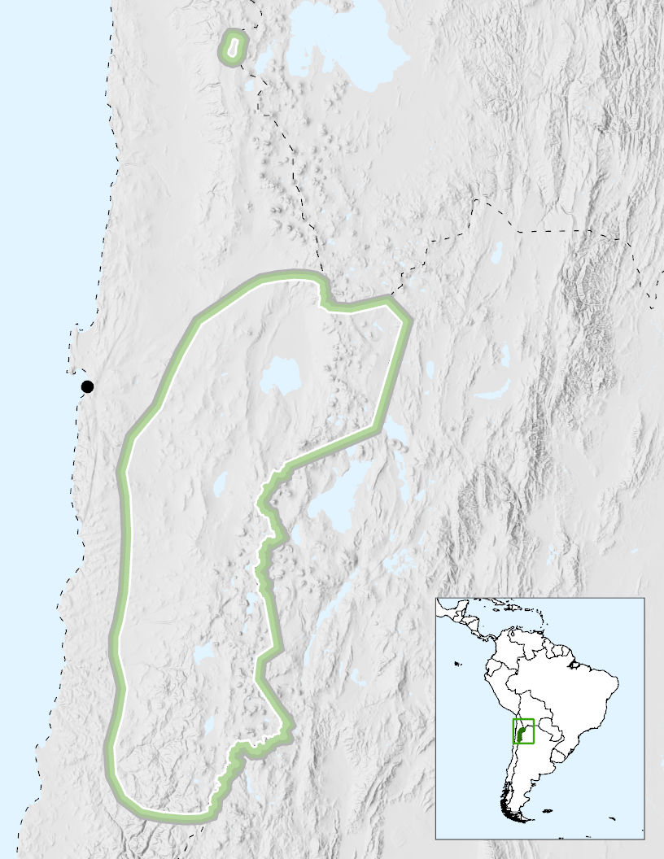

Study Area

Antofagasta

N

140 km

*Figure 1*. The study area encompasses the region of the Atacama Desert that includes salt flats of interests as identified by the partner (map made in ArcGIS Pro, ESRI).

* 1. ***Scientific Basis***

Landsat was chosen for its high spatial resolution of 30 meters and the ability to provide data throughout the entire study period. Landsat 8 has demonstrated success in detecting salt marshes in the past, particularly in the Atacama Desert (Oyola Lepe, 2009; Ozesmi & Bauer, 2002). Landsat 5 Thematic Mapper has also been used to distinguish land cover types for several wetland studies (Klemas, 2011).

There have been several previous efforts to classify land cover type throughout Chile (Centro de Información de Recursos Naturales, 2017; Giri & Long, 2014; Ozesmi & Bauer, 2002; Zhao et al., 2016). Zhao et al. (2016) produced a 30 m resolution classification of Chile for 2014 using Landsat 8, which was also supplemented with MODIS Enhanced Vegetation Index data, high-resolution Google Earth imagery, and SRTM DEM data. Their work developed more detailed land classifications for Chile, and the classifications for the Atacama Desert included the classes water bodies, barren, wetlands, withered vegetation, snow/ice, and salt flats (Zhao et al., 2016). Additionally, the United States Geological Survey produced a 2010 land classification dataset of Chile using 30 m resolution Landsat data with water, forest, barren, other, and snow/ice classifications. However, this dataset is limited by its temporal availability and inability to demonstrate the diversity of unique landscapes throughout the Atacama (Giri & Long, 2014).

While the majority of previous land classification efforts have either focused on a single year or a short time range, the goal of this study was to analyze data over a 30-year time period to examine how the landscape may have fluctuated over time. The Normalized Difference Vegetation Index (NDVI) is a widely used spectral index in time series analyses (Klemas, 2011), and several studies have used NDVI to classify salt marsh land cover types (Zhang, Lu, Yang, Sun, & Sun, 2011). The use of cloud computing through GEE enables rapid processing of spatial data for analyses spanning longer time periods (Gorelick et al., 2017). GEE has successfully analyzed Landsat 5 and 8 scenes for NDVI time series changes in previous studies (Schmid, 2018).

# 2. Methodology

***2.1 Data Acquisition***

*2.1.1 Earth Observation Data*

GEE was used to access and analyze image collections from Landsat 5 TM and Landsat 8 OLI/TIRS (Table 1). Elevation data from the SRTM were also acquired directly through GEE. Temperature trends were acquired using the thermal band in Landsat 5 and Landsat 8. Spatial resolution for Band 6 (thermal infrared) is 120 meters. Thermal bands detect surface temperatures collected at 100 meters. Landsat 5 and 8 images were acquired as Tier 1 atmospherically corrected surface reflectance data. Images were acquired for each year in the period from 1986 through 2018. Landsat 5 TM images were used from 1986 to 2012, and Landsat 8 OLI/TIRS images were used from 2013 to 2018. The southern hemisphere meteorological spring season, September 1 to November 30, was chosen as the study period because it is the greenest season and has the most distinguishable NDVI values within the study site. 1986 was chosen as the initial study year because it is the first full year that Landsat 5 data are available for this study site.

Table 1

*Earth observations used in the land cover analysis for Northern Chile’s Atacama Desert*

|  |  |
| --- | --- |
| **Product Title** | **Image Dates** |
| Landsat 8 Combined OLI TIRS Tier 1 Surface Reflectance | 2013 to 2018 |
| Landsat 5 TM Tier 1 Surface Reflectance | 1986 to 2012 |
| Shuttle Radar Topography Mission | 2000 |

*2.1.2 Ancillary Data*

The partner provided a .kmz file of existing salt marsh names and coordinates that was used to locate regions of interest (Appendix A). Names of these regions of interest were confirmed using a dataset from the Chilean Ministerio de Obras Públicas (Risacher, Alonso, & Salazar, 1999). The partner also provided a list of salt marshes and salt flats of particular interest to the government of Chile. These salt marshes have a history of mining operations or are currently under review for future mining activity. Precipitation was incorporated from the Climate Hazards Group Infrared Precipitation with Station Data (CHIRPS) dataset, with each asset spanning a pentad. CHIRPS is available in GEE and is a 30+ year quasi-global rainfall dataset with 0.05° resolution satellite imagery (Funk et al., 2015). Table 2 summarizes the ancillary data used in this project.

Table 2

*Ancillary datasets used in the land cover analysis for Northern Chile’s Atacama Desert*

|  |  |  |
| --- | --- | --- |
| **Data Type** | **Specifications** | **Source** |
| Saline System location data | .kmz file | Provided by collaborator |
| Active mines dataset | Instituto Geográfico Militar de Chile database | Provided by collaborator and literature |
| Precipitation (1986 to 2018) | CHIRPS Pentad: Climate Hazards Group InfraRed Precipitation with Station Data | Google Earth Engine |

***2.2 Data Processing***

*2.2.1 Composite Images*

Image processing was performed in Google Earth Engine. An image collection was created using images from September through November for each year to capture a seasonal average. A cloud score, which incorporates brightness, temperature, and the Normalized Difference Snow Index (NDSI snow), was used as an indicator of cloudiness and calculated for every pixel in the images. Finally, a composite image representing that year was created using the least cloudy pixels from the image collection. This process was repeated for each study year.

*2.2.2 Spectral Indices*

Spectral indices were calculated, using Equations 1 through 5, and added as bands to the composite images. NDVI, Normalized Difference Water Index (NDWI), NDSI snow, Normalized Difference Salinity Index (NDSI salinity), and Normalized Difference Soil Index (NDSI soil) were each incorporated into the initial analysis. Several spectral index values were assessed and compared with one another in order to determine the most effective indices for differentiating between land classes. *Figure 2* shows examples of some of the processing results.

$\text{NDVI =} \frac{\text{Near Infrared – Red}}{\text{Near Infrared + Red}}$ (1)

$\text{NDWI = }\frac{\text{Green – Near Infrared}}{\text{Green + Near Infrared}}$ (2)

$\text{NDSI }\left(\text{snow}\right) \text{= }\frac{\text{Green – Shortwave Infrared 1}}{\text{Green + Shortwave Infrared 1}}$ (3)

$\text{NDSI }\left(\text{salinity}\right)\text{ = }\frac{\left(\text{Red - Near Infrared}\right)}{\text{(Red + Near Infrared)}}$ (4)

$\text{NDSI }\left(\text{soil}\right) \text{=} \frac{\left(\text{Shortwave Infrared 2 - Green}\right)}{\text{(Shortwave Infrared 2} \text{+} \text{Green)}}$ (5)

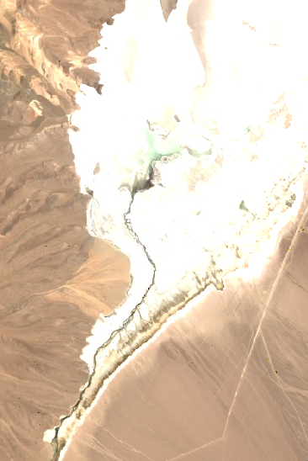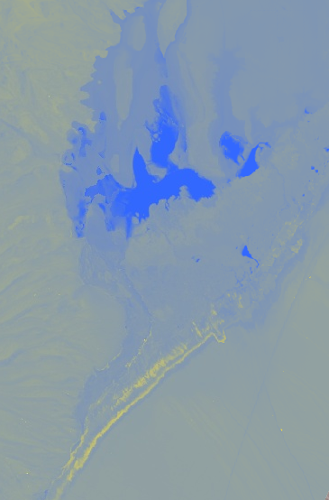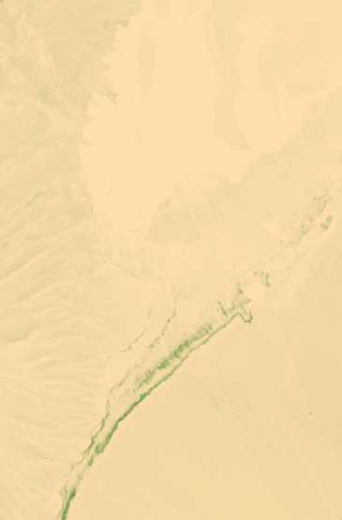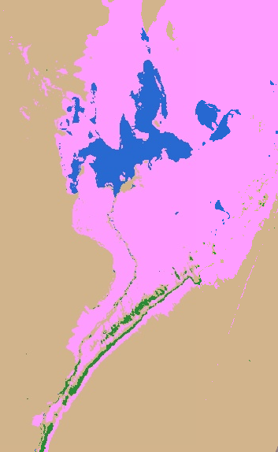

**N**

D)

C)

B)

A)

2 km

*Figure 2.* A) Cloud-free Landsat 8 composite image. B) Normalized Difference Water Index image. Water is shown in blue. C) Normalized Difference Vegetation Index image. Vegetation is shown in green. D) Final land classification image created using thresholds of multiple spectral indices.

*2.2.3 Land Classification*

The land classification process was performed in GEE for each composite image using thresholds of spectral indices (*Figure 3*). Classification by thresholding was chosen over supervised classification to ensure more convenient classification of images in future years. Five land types were identified: water, snow, salt flats, barren, and vegetation. The thresholds were determined by creating 75 training points in each land class for three years: 1986, 1997, and 2017. The points were created by inspecting Landsat imagery in GEE and using NDWI and NDVI as reference data when Landsat imagery resolution was too coarse to visually differentiate classes. The spectral indices were calculated for each training point. Histograms of index values were then created for each land class (*Figure 4*). Statistics were pulled from these histograms to determine the threshold values that would most accurately separate the land classes. This process was repeated for 1986, 1997, and 2017, and thresholds were adjusted to ensure consistency over time.

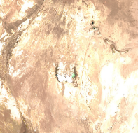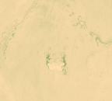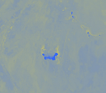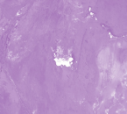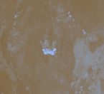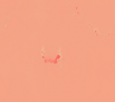

Calculate Thresholds for Land Cover Types

**Landsat 5 and Landsat 8 Imagery**

**NDVI**

**NDWI**

**NDSI**

**(snow)**

**NDSI**

**(soil)**

**NDSI**

**(salinity)**

**Spectral Indices**

**Land Classification**

Google Earth Engine – Saline Analysis Tool (SalT)

Charts of NDVI and NDWI Over Time

Time Series Maps

**Outputs**

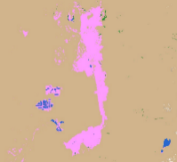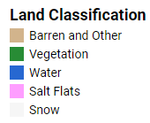

Barren/Other

Vegetation

Water

Salt

Snow

*Figure 3.* Summary of the image analysis process.

*Figure 4.* Example of how thresholds were determined using histograms of data.

The indices that most successfully differentiated between classes were NDVI and NDWI. NDSI (snow) and NDSI (salinity) were not used in the final classification thresholds because they did not aid in distinguishing classes. Due to the difficulty of discerning snow, salt flats, and barren, other parameters were incorporated into the thresholding. A DEM was used to parse snow from salt flats, as salt flats tend to be below the normal snow level. Using the thermal band to differentiate between snow and salt flats was also attempted, but a clear threshold value could not be determined. Surface reflectance of the blue band was used to eliminate snow from water classifications and salt flats from barren classifications because snow and salt are both highly reflective in visible wavelengths. Elevation and blue band reflectance thresholds were determined using the same method as the other indices. Literature values were also considered when thresholding. For example, the final NDVI thresholds used in the analysis are consistent with Sobrino, Jiménez-Muñoz, & Paolini (2004), which characterized NDVI less than 0.2 as bare soil, NDVI between 0.2 and 0.5 as less-dense vegetation, and NDVI above 0.5 as fully vegetated. Because desert vegetation tends to be sparse relative to other ecosystems, the less-dense vegetation range was classified as regular vegetation. The final thresholds used are listed in Table 3.

Table 3

*Parameters used to determine land cover classifications, ordered by highest to lowest priority in classification*

|  |  |
| --- | --- |
| **Land Cover Type** | **Threshold** |
| Snow | DEM > 4550 m, NDWI >0, NDWI < 0.4, and BLUE > 1,500 |
| Salt Flats | DEM < 4550 m, NDWI < 0.1, NDSI (soil) < 0.1, and BLUE > 2000 |
| Water | NDWI > 0 |
| Vegetation | NDVI > 0.2 |
| Barren or other | NDVI < 0.2 |

Using the thresholds shown above, a binary layer for each class was created in GEE. The individual binary layers were then mosaicked together and reclassified from 1 to 5 to create the final land classification images. Because of known overlaps in the threshold values, the binary layers were not mutually exclusive. The layers were mosaicked in a predetermined “stacked” order (*Figure 5*) to account for these known overlaps where some pixels were assigned more than one land class across the individual binary layers. The stacked mosaic order was as follows: vegetation was first mosaicked over barren/other; water was then mosaicked over that resulting layer, followed by salt and finally snow. This mosaic order yielded the most accurate land classification based on visual inspection of Landsat imagery. The final land classification layer was used to create maps for the years 1986, 2000, and 2018 to visualize changes in the Atacama over time.

snow

salt

water

vegetation

barren/other

*Figure 5.* Illustration of how land classes were stacked for the final land classification image.

*2.2.4 Precipitation*

Precipitation data were incorporated into the analysis to contextualize fluctuations in NDVI and NDWI values over time. Data were accessed via the Climate Hazards Group InfraRed Precipitation with Station Data (version 2.0 final) dataset at the pentad scale for the entire study region. Yearly composite images were created for each individual study site by first applying a sum reducer across all images within the year (73 images per year) for each pixel. After each summed image was generated, a mean reducer was applied to calculate the average total precipitation value within each study site. These values were then exported into a spreadsheet format and normalized on a scale from 0 to 1 using Equation 6. While normalizing the data eliminates the ability to review actual precipitation values, normalized data can easily be plotted on charts against NDVI and NDWI values for comparison.

${\text{x}}_{\text{normalized}}\text{ = }\frac{\text{(x - }{\text{x}}_{\text{min}}\text{)}}{\text{(}{\text{x}}_{\text{max}}\text{ -}\text{ x)}}$ (6)

*2.2.5 Temperature*

Temperature data were incorporated using the thermal band of Landsat 5 and Landsat 8, bands 6 and 10, respectively. Mean temperature was calculated using a mean reducer across the entire study area. The resulting values were multiplied by a scale factor of 0.1 to report the values in Kelvin for both Landsat 5 and 8. The temperature values used do not represent land surface temperature, which must be calculated from this band using a complex series of equations. For this study, visualizing overall trends in temperature was more important. Following the same process as precipitation, temperature data were exported into a spreadsheet format and normalized on a scale from 0 to 1 using Equation 6.

***2.3 Data Analysis***

*2.3.1 Study Site Identification*

The study area was broken up into smaller study sites (*Figure 6*) to make data analysis of images easier and exclude high-elevation areas where snow and topography shadows resulted in erroneous land classifications. These sites were determined by cross-referencing the saline system location dataset provided by our partners and examining satellite imagery to ensure study sites completely captured saline systems. The study sites include multiple Wetlands of International Importance, as determined by the Ramsar Convention: Salar de Huasco (Ramsar, 1996) in the Huasco site; Salar de Tara (Ramsar, 2010a) and Salar de Pujsa (Ramsar 2009b) in the Northeast Region site; Sistema Hidrológico de Soncor del Salar de Atacama (Ramsar, 2010b) in the Atacama site; and Salar de Aguas Calientes IV (Ramsar 2009a) in the Mountains East site.

100 km

**N**

**Salar de Huasco**

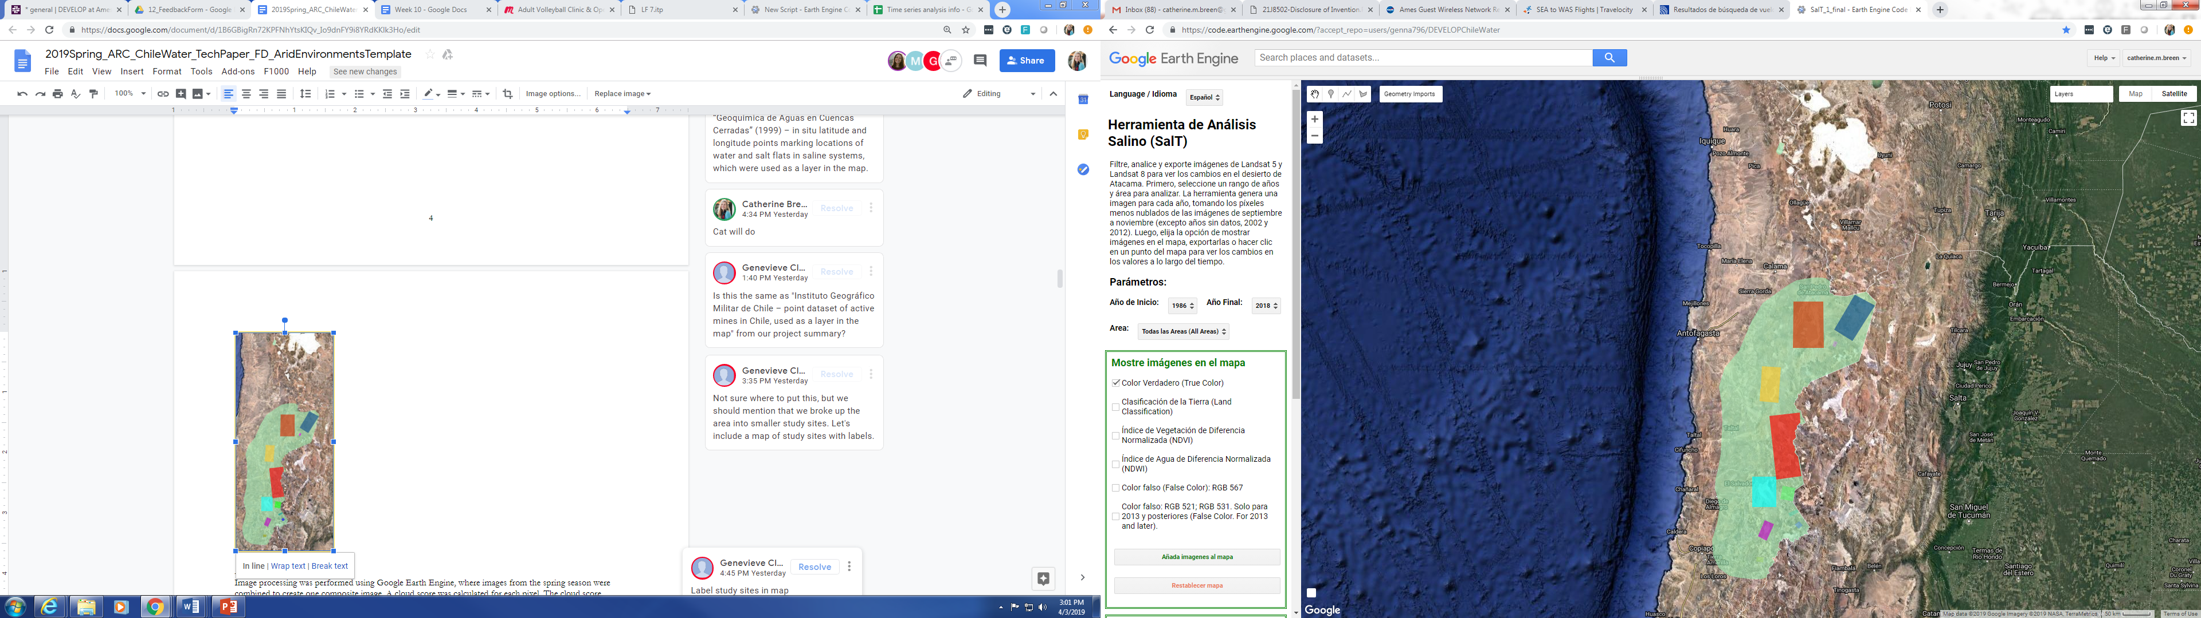

Entire study region (including Salar de Huasco)

Atacama

Northeast

Punta Negra

Maricunga

Pedernales

Mountains East

Bravas Jilguero

Laguna Verde

Negro Francisco

Eulogio Escondida

Laguna Miscanti

*Figure 6.* Map of the study area with regions of interest highlighted.

*2.3.2 Analysis of Vegetation and Water*

Both water and vegetation change were measured using percent land cover and average index values. These two measurements were used together to assess trends in place of *in situ* data. Percent values were calculated by taking the total number of pixels classified as either vegetation or water and dividing by the total number of pixels in the entire study site. Pixels with low amounts of water or vegetation are grouped into this value, presenting a more inclusive measure of water and vegetation. NDVI and NDWI values were standardized to be consistent across sensors since it was noticed that values for Landsat 8 were typically higher than those from Landsat 5. To account for this, NDVI and NDWI values from a reference pixel was determined for each sensor, and all values were divided by these numbers. Standardizing NDWI and NDVI does not allow for the analysis of actual normalized values, but it still demonstrates overall trends.

*2.3.3 Temperature and Precipitation Data*

Temperature and precipitation data were charted against NDWI and NDVI. To explore trends, coefficients of determination were calculated using an R-squared value. The R-squared analyzes how differences in one variable can be explained by the other variable. The R-squared was calculated using the formula in Microsoft Excel.

# 3. Results & Discussion

***3.1 Case Study Results***

*3.1.1 Salar de Atacama*

Analysis of vegetation changes in Salar de Atacama shows no overall trend (*Figure* 7). NDVI and NDWI values frequently fluctuate across the study period, but the fluctuation is between very small numbers. The chart of water percentage in Salar de Atacama shows a slight positive trend, which is expected due to the increasing presence of artificial mining pools (*Figure 8*). However, average NDWI shows no significant trend over time. This may indicate an equalizing effect on NDWI as artificial mining pools draw out water from the surrounding natural areas. The conflicting trends for each index demonstrate the difficulty of assessing water and vegetation in the arid environment. 1999, 2015, and 2016 reveal that water and vegetation can have strong inverse relationships with one another. This suggests that reduction in water could leave soil with high moisture content, increasing vegetation growth. Similarly, water recession could leave behind algae that are then detected in satellite imagery and classified as vegetation.

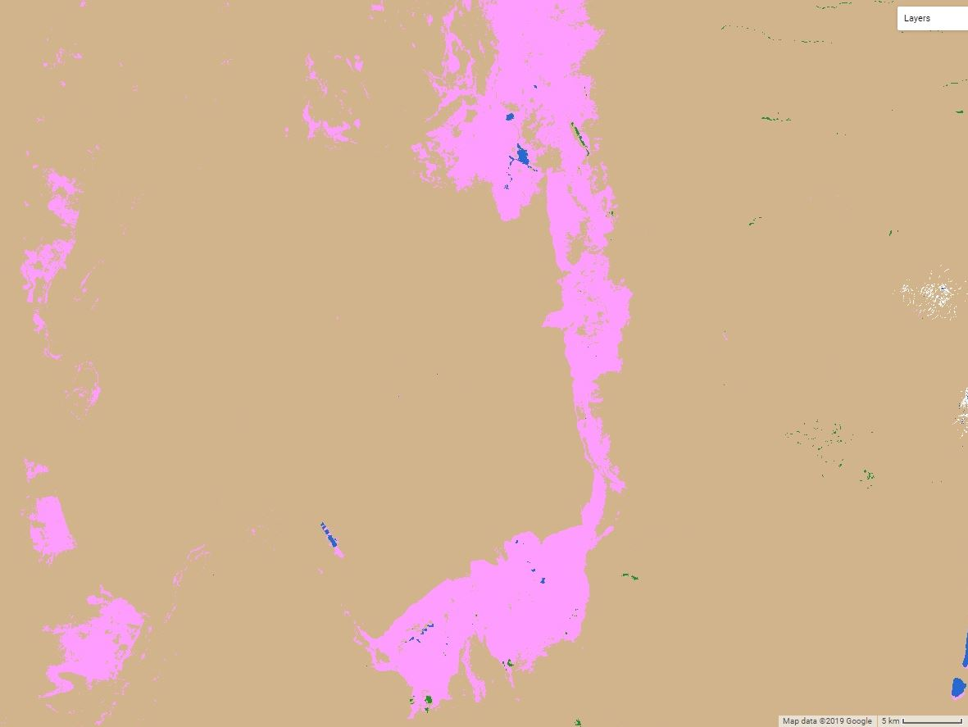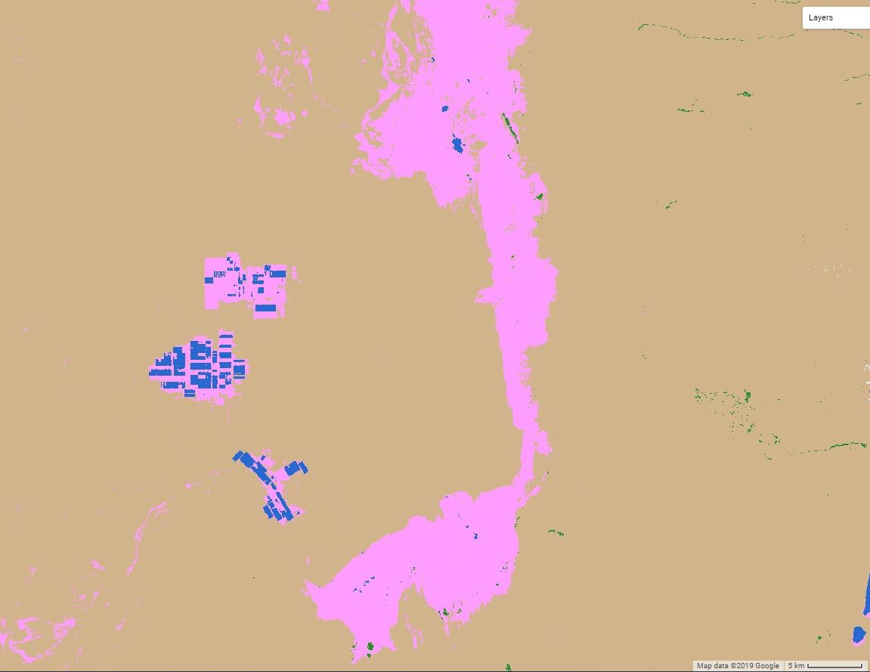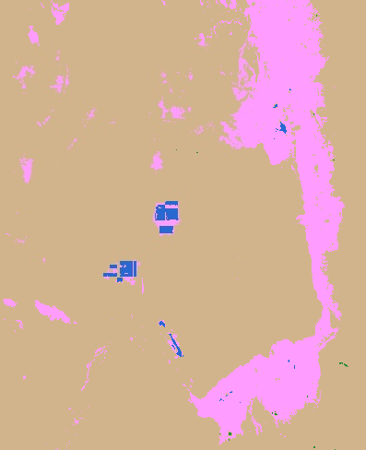

5 km

**N**

Land Classification

Barren and other

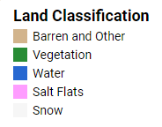

Vegetation

Water

Salt

Snow

1986

2000

2018

*Figure 7.* This time series shows the rapid growth of mining in Salar de Atacama.

Years shown: 1986 (left), 2000 (center), 2018 (right).

*Figure 8.* Charts showing changes in water and vegetation over time (1986 to 2018) using two measurements: pixel count divided by total pixel number and average index value.

*3.1.2 Salar de Huasco*

Visual examination of the Salar de Huasco land classification time series maps (*Figure* *9*) suggests a minimal change in this saline system during the study period. The chart of water percentage and NDWI shows no overall significant trend (*Figure 10*), although percent water may indicate a slight increase. Percent vegetation and average NDVI fluctuate significantly but show no overall trend.

**N**

Land Classification



Barren and other

Vegetation

Water

Salt

Snow

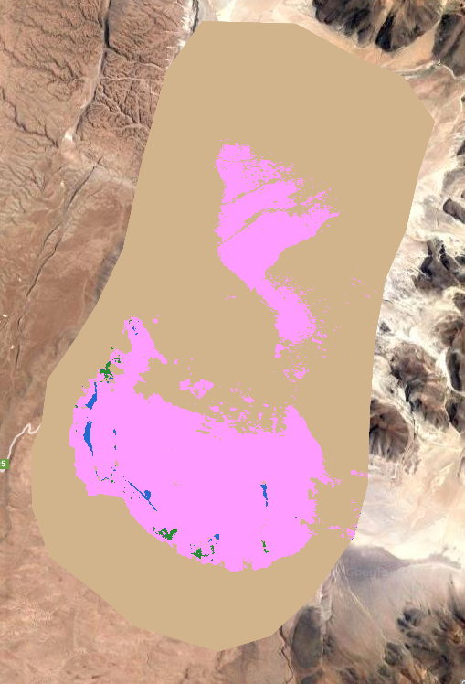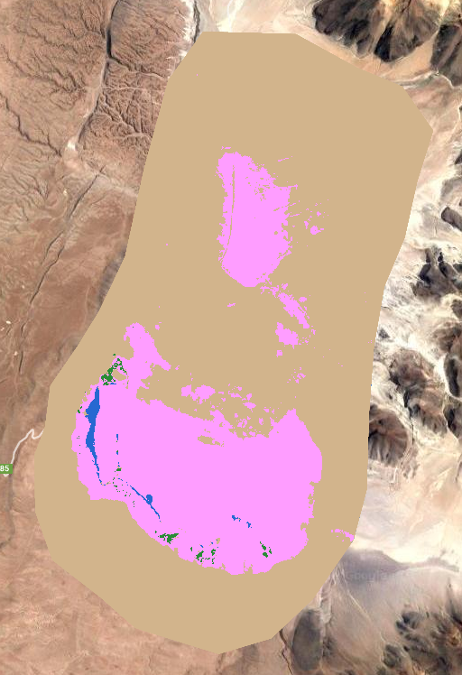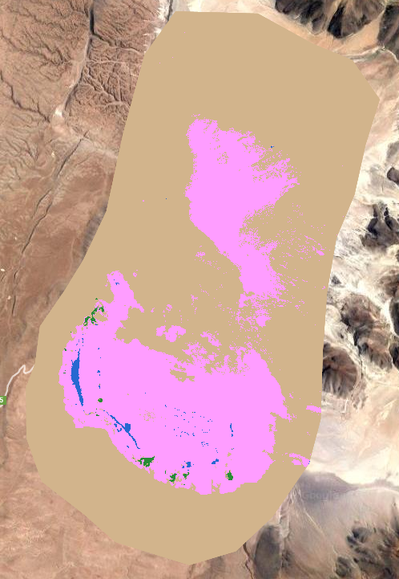

**N**

2 km

1986

2000

2018

**N**

*Figure 9.* Time series maps of Salar de Huasco. Years shown: 1986 (left), 2000 (center), 2018 (right).

*Figure 10.* Charts showing changes in water and vegetation over time (1986 to 2018) using two measurements: pixel count divided by total pixel number and average index value.

*3.1.3 Los Flamencos National Reserve*

Large fluctuations in water are observed in two wetlands of national importance: Salar de Tara (*Figure 11*) and Salar de Pujsa (*Figure 12*). These wetlands provide sanctuaries to the rare Andean Flamingo. The year 2000 shows the smallest amount of water, which may indicate that this year experienced drier conditions than normal. Visual inspection of both sites suggests that water levels may be decreasing, but further analysis is needed to quantify this change. Future monitoring of these sites is recommended.

Land Classification

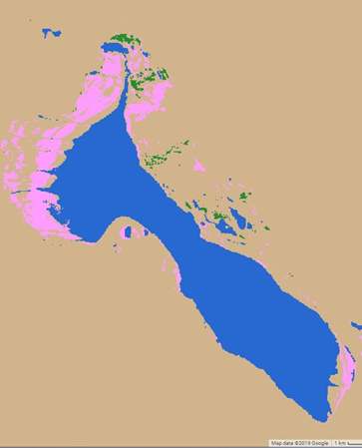

1 km

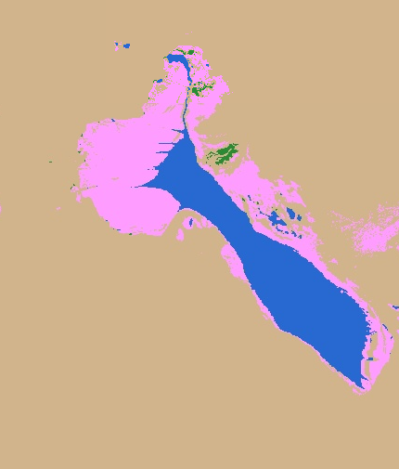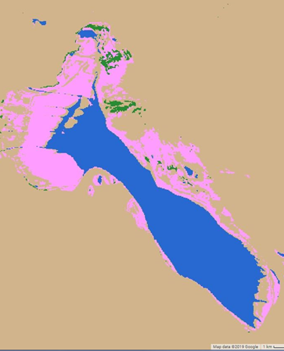

Barren and other

Vegetation

Water

Salt

Snow

1986

2000

2018

**N**

*Figure 11*. Time series maps of Salar de Tara. Years shown: 1986 (left), 2000 (center), 2018 (right).

Land Classification



Barren and other

Vegetation

Water

Salt

Snow

1986

2018

2000

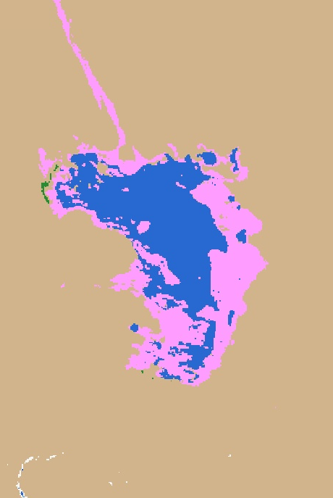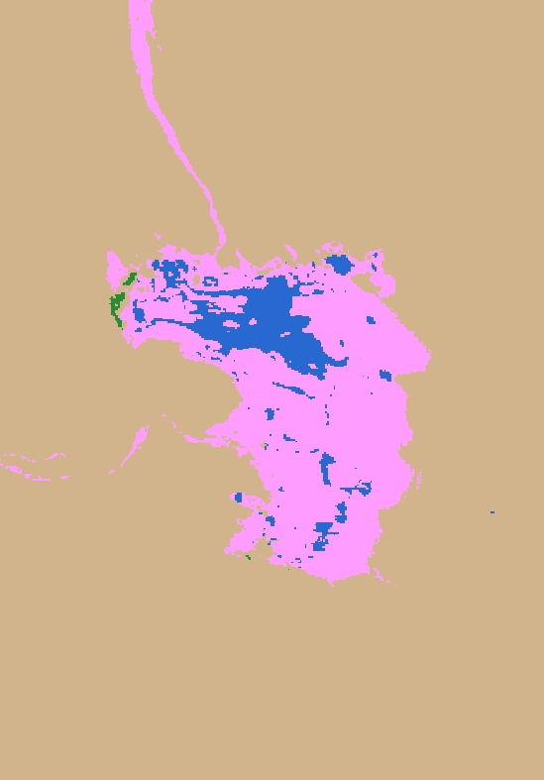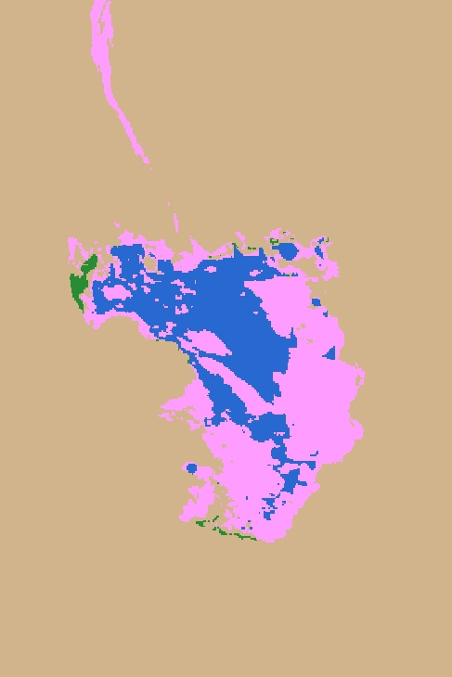

**N**

1 km

*Figure 12*. Time series maps of Salar de Pujsa. Years shown: 1986 (left), 2000 (center), 2018 (right).

***3.2 Impacts of Temperature and Precipitation***

Neither NDVI nor NDWI showed overall relationships with temperature or precipitation (*Figure 13*). R-squared values were low: 0.0058 for NDVI and precipitation; 0.00023 for NDVI and temperature; 0.037 for NDWI and precipitation; and -0.096 for NDWI and temperature. Because the water in natural pools is derived primarily from groundwater, there may not be a strong correlation between precipitation and water. Groundwater is formed slowly from both precipitation and melting glaciers. Due to the time required for groundwater recharge to occur, there may not be an immediate effect of precipitation on overall water levels. Additionally, mining operations extract groundwater, so a year with high precipitation may show low water levels because the water is simultaneously being extracted. Higher temperatures increase evaporation rates, so it was expected that years with high temperatures would show a slight decrease in water levels. However, no significant trend was found. These results demonstrate the complexity of the saline systems. There are many variables that affect the vegetation and water levels in the Atacama. While it is difficult to visualize the impact of temperature and precipitation, this does not necessarily mean that there is no relationship. More robust analysis is needed to gain further understanding as to which factors have the greatest influence on the overall health of these ecosystems.

*Figure 13.* Charts showing NDVI and NDWI compared with temperature and precipitation.

***3.3 Uncertainties***

*3.3.1 Artifacts and Missing Data*

Landsat 5 contained artifacts as a result of combining multiple scenes in GEE (*Figure* *14A*). Artifacts in the data were present in all years from 2001 to 2011, with 2001 having the worst quality. These “tracks” appeared as vegetation or water when classified using thresholds. The study area was separated into individual subregions of interest to avoid conflation of vegetation trends. When looking at the entire study area, however, these values are included. There was no imagery for 2002 or 2012 from Landsat 5, so these years were excluded from the data processing and analysis.

*3.3.2 Uncertainties in Land Classification*

The number of training points to build the land classification thresholding histograms was limited by the timeline of the project. While 75 points informed threshold values that produced compelling land classifications, additional points could improve the ability to determine more accurate thresholds. When analyzing the histograms, thresholds were estimated, and further work is needed to explore whether more precise thresholds can be determined. It is recommended that the partner explore fine-tuning these thresholds by analyzing the histograms and using *in situ* data.

At high elevations, snow and salt are difficult to differentiate in their reflectance alone (*Figure 14B*). A DEM was implemented to identify snow at high altitudes. Since there are salt flats also at high altitudes, this DEM threshold was conservative to ensure that no salt flat was identified as snow. In order to more accurately classify high snow years, it is recommended that SalT users modify the DEM threshold by following the procedure listed in the methodology to calculate an appropriate elevation. In addition to the difficulty of accurately classifying snow and salt, accuracy in the mountains may also be decreased due to topography shadows. It is recommended that land classification in the mountains is referenced with true color images for each year to identify where accuracy is poor. The timeline of this project did not allow for robust error analysis.

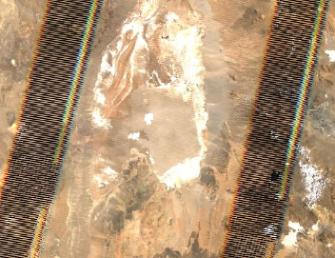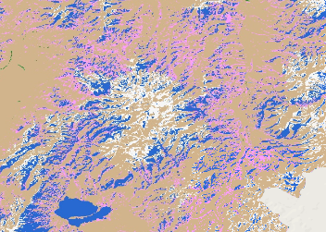

**(B)**

**(A)**

*Figure 14. A*) Example of “tracks” in Landsat 5 data from 2001. *B)* Landsat 5 imagery from 1987 showing the error in classification when snow falls below the DEM threshold.

*3.3.3 Land Classification Histogram errors in GEE*

While calculating the percent vegetation and water within a study site, it was discovered that there was an error in generating land classification histograms through GEE. Each land cover type should have been in its own histogram bin, which would result in bins of integers numbering 1 through 5, each containing the number of pixels for the corresponding land class (1 indicating barren, 2 indicating vegetation, 3 indicating water, 4 indicating salt flats, and 5 indicating snow). However, for some sites, the bins produced in GEE were not whole numbers. Due to the time constraints of the project, we did not troubleshoot the error and excluded sites where this happened from the analysis of land class percentage values. Future work will examine the cause of this error and expand the analysis to include all study sites.

***3.4 Future Work***

Future work is necessary to further assess the validity of the land classifications and resolve changes in the Atacama Desert ecosystem. Ground truth data can confirm the accuracy of land classifications and conducting fieldwork is the best method to measure water and vegetation. Error analysis is needed in order to assess confidence in the land classification approach used for this study. The data presented here could be compared to previously generated land classifications of Chile, such as the dataset created by Zhao et al. (2016). Additional land classes could also be incorporated into the study. For example, Zhao et al. (2016) incorporated multiple vegetation classes to distinguish between wetlands, grasslands, and shrublands. It is possible that higher resolution imagery could further distinguish among land classifications and more accurately capture the complexity of saline system landscapes. Therefore, future work could incorporate European Space Agency data from the Sentinel-2 MultiSpectral Instrument, a sensor with a finer spatial resolution of 10 m.

Our results show that there are frequent fluctuations in vegetation and water pixel counts, but correlation coefficients were low. Further work could continue to run statistical tests to determine if there are any statistically significant relationships between average NDVI, average NDWI, temperature, and precipitation.

In some study sites, water pools appear to shrink in size, but further work is needed to assess the trends for local areas. Creation of change detection maps could also enhance the visualization of changes in land classification. The tool incorporated a layer of active mining sites, but no statistical analysis was run to determine if proximity to these mines correlated to changes in vegetation and water. Some mines drain from the same groundwater that feeds into the saline systems, and further work is recommended to explore if saline ponds that share the same water source as mining sites experience larger fluctuations or reductions in size.

To gain an understanding of fluctuations in the Atacama landscape, a seasonal analysis is needed. The data presented here were generated only from the months of September through November. However, Zhao et al. (2016) demonstrate that there are significant differences between seasons in wetlands of the Atacama. Studying different seasons can easily be accomplished using SalT. Although the graphical user interface does not allow for this specification, instructions are written into the code to help the user change the months of interest.

***3.5 SalT End Product***

A Saline Analysis Tool (SalT) was created in GEE to further assist SERNAGEOMIN in analyzing NASA Earth observations of the Atacama Desert. SalT was designed for future monitoring of saline systems as well. The tool obtains images for years after 2013 from GEE’s USGS Landsat 8 Surface Reflectance Tier 1 dataset, which is continually updated, giving the partners the ability to analyze imagery of the Atacama Desert in the years to come. The tool incorporates a graphical user interface that allows users to choose analysis parameters (start year, end year, and area of interest) and outputs through a selection menu rather than directly editing the code. The user interface has text in both Spanish and English so it is more accessible to a wide range of users.

Given the user-selected time range and area of interest, the tool filters the Landsat collections to only include images from the months of interest and then creates the least cloudy composite for each year in the time range. NDVI, NDWI, NDSI (snow), NDSI (salinity), and NDSI (soil) are calculated for each composite and finally, a land classification is performed using the thresholds described previously. Users have three options for visualizing the processed image collection: viewing the image for each year on a map, exporting images individually as GeoTIFFs or as a video, or clicking a point to view a graph showing analysis values over time. In displaying images, users have the option to add any of the following as layers to the map: true color, false color (RGB 567, RGB 521, RGB 531), NDVI, NDWI, and land classification. SalT can also export an image for each year with either NDVI, NDWI, or land classification band values, or an image with every Landsat band (blue, green, red, near infrared, shortwave infrared 1, shortwave infrared 2, brightness temperature). RGB 567, RGB 521, and RGB 531 were requested by the partner to identify mineral-rich areas (Muñoz et al. 2018). Users have the option to export time series videos, which are created from the processed image collection and show NDVI, NDWI, land classification, or true color images through the selected years of analysis. Lastly, with the Point Change Inspector option, clicking anywhere in the area of analysis will generate a graph (*Figure 15*) illustrating NDVI, NDWI, or land classification values for the selected pixel over the chosen time period.

*Figure 15*. Example of data generated by the Point Change Inspector in SalT, showing NDVI values for the pixel at -68.27999, -23.31689in the Salar de Atacama study area from 1986 to 2018. This chart was made in Microsoft Excel using data exported from the chart generated by SalT.

# 4. Conclusions

Thresholding of multiple spectral indices accelerated the ability to classify land through a 30-year time period without necessitating training points for each year. The thresholds captured five land classes of interest to the partner: barren/other, salt flat, snow, water, and vegetation. A training point collection of 75 points for each land classification was sufficient to determine thresholds for land classes and matched visual inspection of land type and data from partners.

Overall NDWI and NDVI values showed no significant trends over time, although some study sites indicated that water levels are changing. For example, in Los Flamencos National Reserve, large pools fluctuated in area. Measuring vegetation and water using land cover percent and average index values did not confirm any overall trend. Moving forward, ground truth data will help determine precise measurements of vegetation.

Google Earth Engine allows for the rapid generation of land classification, NDVI, and NDWI maps over a 30-year time period. A monitoring tool was successfully created to easily display this information and allow future monitoring by SERNAGEOMIN. The raw code for the tool will be available with comments and descriptions embedded, so it can be modified. The code will automatically incorporate Landsat 8 imagery for future years as it becomes available. SalT allows for continuous monitoring of saline systems and provides SERNAGEOMIN with the ability to incorporate this information into future water management decisions.

# 5. Acknowledgments

* Paula Olea Encina, Servicio Nacional de Geología y Minería
* Dr. Ricardo Cabezas, Universidad de La Serena
* Dr. Juan Torres-Pérez, Bay Area Environmental Research Institute, NASA Ames Research Center
* Dr. Kenton Ross, NASA Langley Research Center
* John Dilger, Spatial Informatics Group, LLC
* Farnaz Bayat, DEVELOP National Program, California – Ames Node Center Lead
* Jerrold Acdan, DEVELOP National Program, California – Ames Node Assistant Center Lead

Any opinions, findings, and conclusions or recommendations expressed in this material are those of the author(s) and do not necessarily reflect the views of the National Aeronautics and Space Administration.

This material is based upon work supported by NASA through contract NNL16AA05C.

# 

# 6. Glossary

**DEM** – Digital elevation model, source of elevation data

**Earth observations** – Satellites and sensors that collect information about the Earth’s physical, chemical, and biological systems over space and time

**GEE** **–** Google Earth Engine, a publicly available cloud-computing platform

**SERNAGEOMIN** – Servicio Nacional de Geología y Minería (National Geology and Mining Service), a Chilean national agency

# 7. References

Agusdinata, D.B., Liu, W., Eakin, H., & Romero, H. (2018). Socio-environmental impacts of lithium mineral extraction: Towards a research agenda. *Environmental Research Letters, 13*(12).

https://doi.org/10.1088/1748-9326/aae9b1

Bull, A. T., Asenjo, J. A., Goodfellow, M., & Gomez-Silva, B. (2016). The Atacama Desert: Technical

resources and the growing importance of novel microbial diversity. *Annual Review of Microbiology, 70*, 215-234. https://doi.org/10.1146/annurev-micro-102215-095236

Centro de Información de Recursos Naturales. (2017). Entrega de imágenes satelitales de alta resolución de

19 salares, en el marco del estudio: “Provisión de imágenes satelitales y ejecución de un estudio de

geoprocesamiento para caracterización de salares.” *Centro de Información de Recursos Naturales.*

Chávez, R. O., Clevers, J. G. P. W., Herold, M., Ortiz, M., & Acevedo, E. (2013). Modelling the spectral response of the desert tree Prosopis tamarugo to water stress. *International Journal of Applied Earth Observation and Geoinformation,* *21*, 53–65. <https://doi.org/10.1016/j.jag.2012.08.013>

Comisión Chilena del Cobre. (2013). *Mercado internacional del litio* (N° 238.164). Santiago, Chile. Retrieved from http://www.sernageomin.cl/wp-content/uploads/2017/09/Mercado

Internacional_Potencial-del-Litio-en-salares-del-norte-de-chile.pdf, pp. 6-67

de la Fuente, A., & Niño, Y. (2010). Temporal and spatial features of the thermodynamics of shallow salty

lagoons in northern Chile. *Limnology and Oceanography, 55*(1), 279-288.

<https://doi.org/10.4319/lo.2010.55.1.0279>

Farr, T. G., Rosen, P. A., Caro, E., Crippen, R., Duren, R., Hensley, S., … Alsdorf, D. E. (2007). The shuttle radar topography mission. *Reviews of Geophysics*, *45*(2), RG2004. https://doi.org/10.1029/2005RG000183

Funk, C., Peterson, P., Landsfeld, M., Pedreros, D., Verdin, J., Shukla, S., Husak, G., … Michaelsen, J. (2015). The climate hazards infrared precipitation with stations—A new environmental record for monitoring extremes. *Scientific Data*, *2*, 150066. doi:10.1038/sdata.2015.66.

Gajardo Cubillos, A. (2014). *Potencial de litio en salares del norte.* Santiago, Chile: Servicio Nacional de Geología y Minería. Retrieved from http://www.sernageomin.cl/wp-content/uploads/2017/12/Potencial_de_Litio_en_Salares_de_ChileAnibalGajardo.pdf

Giri, C, & Long, J. (2014). Land cover characterization and mapping of South America for the year 2010 using Landsat 30 m satellite data. *Remote Sensing*, 6, 9494-9510. https://doi.org/10.3390/rs6109494

Goonan, T. G. (2012). *Lithium Use in Batteries* (US Geological Survey Circular 1371). Reston, Virginia: US

Geological Survey. Retrieved from <https://pubs.usgs.gov/circ/1371/pdf/circ1371_508.pdf>

Gorelick, N., Hancher, M., Dixon, M., Ilyushchenko, S., Thau, D., & Moore, R. (2017). Google Earth Engine: Planetary-scale geospatial analysis for everyone. *Remote Sensing of Environment,* *202*, 18-27. https://doi.org/10.1016/j.rse.2017.06.031.

Houston, J. (2006). Variability of precipitation in the Atacama Desert: Its causes and hydrological impact. *International Journal of Climatology, 26*, 2181-2198. https://doi.org/10.1002/joc.1359

Kautz, S. (2018). Landsat 8 OLI (Operational Land Imager) and TIRS (Thermal Infrared Sensor) [Dataset].

US Geological Survey, accessed 14 February 2019. https://doi.org/10.5066/f71835s6

Klemas, V. (2011). Coastal wetlands and sea level rise: A remote sensing perspective. *Journal of Coastal Research*. *27*(3), 418-427. https://doi.org/10.2112/JCOASTRES-D-10-00174.1

Muñoz, P., Gallaud, A., Flores, J. P., Sáez, H., Delsouc, A., Herrara, A., … Retamal, M. (2018). Report 3: Provisión de imágenes satelitales y ejecución de un studio de geoprocesamiento para caracterización de salares. Centro de Información de Recursos Naturales.

Oyola Lepe, N. (2009). Identificación de humedales del norte grande de Chile utilizando técnicas geomáticas   
 en imágenes satelitales Landsat. (Unpublished master’s thesis). Universidad de Chile, Santiago, Chile.   
 <http://bibliotecadigital.ciren.cl/handle/123456789/26028>

Ozesmi, S. L., & Bauer, M. E. (2002). Satellite remote sensing of wetlands. *Wetlands Ecology and Management, 10*(5), 381-402. https://doi.org/10.1023/A:1020908432489

Pérez Guerra, A. (2006, April 1). La destrucción del altiplano. *La Insignia*. Retrieved from

https://www.lainsignia.org/2006/abril/ibe_002.htm

Ramsar. (1996). *Ramsar sites information service, Salar de Huasco*. Retrieved from https://rsis.ramsar.org/ris/874

Ramsar. (2009a). *Ramsar sites information service, Salar de aguas Calientes IV.* Retrieved from https://rsis.ramsar.org/ris/1870

Ramsar. (2009b). *Ramsar sites information service, Salar de Pujsa.* Retrieved from https://rsis.ramsar.org/ris/1871

Ramsar. (2010a). *Ramsar sites information service, Salar de Tara.* Retrieved from https://rsis.ramsar.org/ris/875

Ramsar. (2010b). *Ramsar sites information service, Sistema Hidrológico de Soncor del Salar de Atacama.* Retrieved from https://rsis.ramsar.org/ris/876

Risacher, F., Alonso, H., & Salazar, C. (1999). Geoquimica de Aguas en Cuencas Cerradas. Ministerio de Obras Públicas, Dirección General de Aguas; Universidad Católica del Norte; and Instituto de Investigación para el Desarrollo. http://documentos.dga.cl/CQA1921v3.pdf

Risacher, F., Alonso, H., & Salazar, C. (2003). The origins of brines and salts in Chilean salars: A hydrochemical review. *Earth-Science Reviews, 63*(3-4), 249-293. <https://doi.org/10.1016/S0012-8252(03)00037-0>

Romero, H., Mendez, M., & Smith, P. (2012). Mining development and environmental injustice in the Atacama Desert of Northern Chile. *Environmental Injustice, 5*(2), 70-76.

https://doi.org/10.1089/env.2011.0017

Schmid, J. N. (2018). Using Google Earth Engine for Landsat NDVI time series analysis to indicate the present status of forest stands. (Unpublished bachelor’s thesis). Georg-August-Universität Göttingen, Basel, Switzerland. https://doi.org/10.13140/RG.2.2.34134.14402/5

Sobrino, J.A., Jiménez-Muñoz, J.C., & Paolini, L. (2004). Land surface temperature retrieval from LANDSAT TM 5. *Remote Sensing of Environment,* *90*(4), 434-440. https://doi.org/10.1016/j.rse.2004.02.003

Souvignet, M., Gaese, H., Ribbe, L., Kretschmer, N. & Oyarzún, R. (2010). Statistical downscaling of precipitation and temperature in north-central Chile: An assessment of possible climate change impacts in an arid Andean watershed. *Hydrological Sciences Journal, 55*(1), 41-57. <https://doi.org/10.1080/02626660903526045>

Troncoso, R., Ercilla, O., Carrasco, R., & Vivallo, W. (2013). *Estudio del potencial de litio en salares del norte de Chile* (pp. 68-319). Santiago, Chile: Servicio Nacional de Geología y Minería. Retrieved from <http://www.sernageomin.cl/wp-content/uploads/2017/09/Mercado-Internacional_Potencial-del>Litio-en-salares-del-norte-de-chile.pdf

Valdés-Pineda, R., Pizarro, R., Garcia-Chevesich, P., Valdés, J. B., Olivares, C., Vera, M., … Helwig, B.

(2014). Water governance in Chile: Availability, management and climate change. *Journal of Hydrology, 519(C)*, 2538-2567. <https://doi.org/10.1016/j.jhydrol.2014.04.016>

US Geological Survey Earth Resources Observation and Science Center. (2012). Landsat 5 TM Tier 1 Surface Reflectance (SR) Science Product [Dataset]. US Geological Survey. https://doi.org/10.5066/f7kd1vz9

Zhang, Y., Lu, D., Yang, B., Sun, C., & Sun, M., (2011) Coastal wetland vegetation classification with a Landsat Thematic Mapper image. *International Journal of Remote Sensing*, *32*(2), 545-561. https://doi.org/10.1080/01431160903475241

Zhao, Y., Feng, D., Yu, L., Wang, X., Chen, Y., Bai, Y., … Gong, P. (2016). Detailed dynamic land cover mapping of Chile: Accuracy improvement by integrating multi-temporal data. *Remote Sensing of Environment*, 183, 170-185. https://doi.org/10.1016/j.rse.2016.05.016

# 8. Appendices

***Appendix A***. List of critical salt marshes as identified by the partner or literature, by region. These salt marshes were used for change in salt marsh extent case studies.

|  |  |  |
| --- | --- | --- |
| Saline System | Source | Type of current water extraction |
| **Salar de Huasco** | Identified by partner | Copper mining |
| **Salar de Atacama** | Identified by partner | Surface water for copper mining, groundwater extraction for non-metallic mining |
| **Salar de Antofagasta** | Identified by partner | - |
| **Salar de Punta Negra** | Identified by partner | Copper mining |
| **Salar de Surire** | Identified by literature (Pérez Guerra, 2006) | Deuxlexite extraction |
| **Salar de Tara y Pujsa** | Identified by literature (Pérez Guerra, 2006) | Non-metallic mining |
| **Salar de Maricunga** | Identified by literature (Pérez Guerra, 2006) | Copper mining |
| **Salar de Ascotán** | Identified by partner | Copper mining, non-mineral mining |
| **Laguna Cotacotani** | Identified by literature (Pérez Guerra, 2006) | Hydroelectric water extraction |
| **Lagunillas y Huantija** | Identified by literature (Pérez Guerra, 2006) | Copper mining |
| **Salar de Coposa y Michincha** | Identified by literature (Pérez Guerra, 2006) | Copper mining |