**NASA DEVELOP National Program**

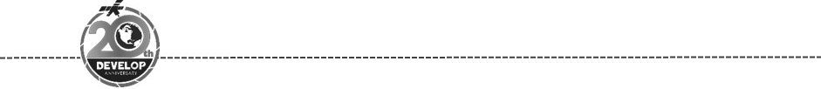Alabama – Marshall

*Spring 2018*

Puget Sound Water Resources

Evaluating Methods for Identification and Monitoring of Factors in the Puget Sound that Indicate Eutrophication and Hypoxia

 **Technical Report**

Final Draft – March 29, 2018

Emily Kinkle (Project Lead)

Helen Baldwin

Christine Evans

Yu Han

Dr. Jeffrey Luvall, NASA Marshall Space Flight Center (Science Advisor)

Dr. Juan L. Torres-Pérez, Bay Area Environmental Research Institute, NASA Ames Research Center (Science Advisor)

Dr. Robert Griffin, University of Alabama in Huntsville (Science Advisor)

Leigh Sinclair, University of Alabama in Huntsville/Information Technology and Systems Center (Mentor)

Maggi Klug, University of Alabama in Huntsville (Mentor)

# 1. Abstract

Dissolved oxygen levels have been declining in the Puget Sound since 2000 due to eutrophication, resulting in

Harmful Algal Bloom (HAB) events which negatively impact water quality and wildlife in the area. Therefore, analyzing and identifying eutrophication and hypoxic events is integral to water quality control and watershed

management. The Puget Sound Water Resources team partnered with the Pacific States Marine Fisheries

Commission (PSMFC) Habitat Program to test methods for monitoring water quality using remote sensing.

The team tested multiple algorithms utilizing Landsat 8 Operational Land Imager (OLI) and Sentinel-2 Multispectral Imager (MSI) data to detect turbidity and chlorophyll concentrations. Results will assist the PSMFC Habitat Program to fill geographic and temporal data gaps and to enhance local decision-making practices and management of water resources.

**Keywords**

Eutrophication, Puget Sound, Sentinel-2 MSI, Landsat 8 OLI, water resources, ACOLITE, chlorophyll, turbidity

# 2. Introduction

* 1. ***Background Information***

The Puget Sound estuary, located in northwestern Washington, stretches 161 km from the Admiralty Inlet to Olympia (Figure 1). Approximately two-thirds of Washington’s population resides along the 2,143 km long coastline alongside a wide variety of aquatic and terrestrial organisms. Puget Sound’s depth reaches 0.28 km at its peak, making it the second highest volume coastal plain estuary in the United States. The sound is approximately 83% seawater, which travels to Puget Sound from the Pacific Ocean through the Strait of Juan de Fuca, and 17% fresh water, which primarily comes from the Skagit River, entering the sound through the Whidbey Basin (MacCready, 2017). The estuarine circulation throughout the sound has a substantial influence on water quality with an average residence time of one month. This high residence time allows for biogeochemical processes to take place and cause severe hypoxia problems (Babson, Kawase, & MacCready, 2006).

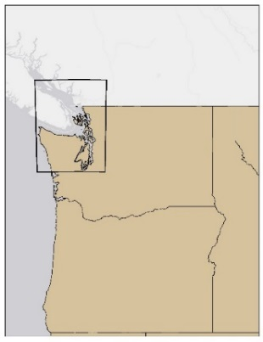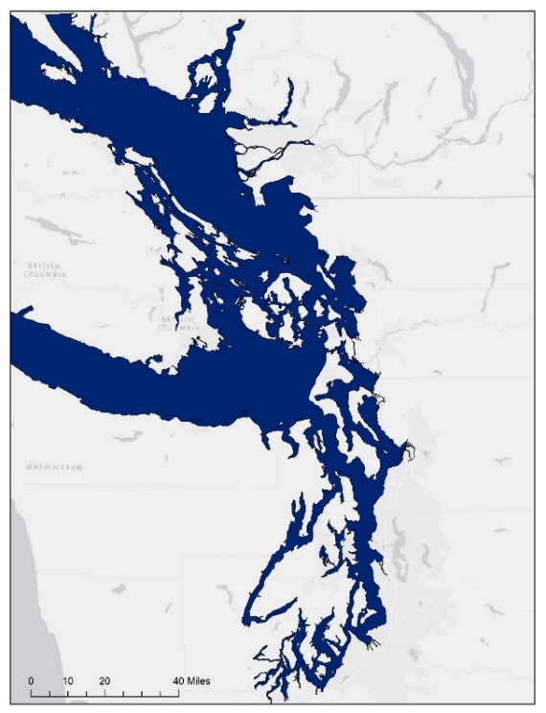

Puget Sound

Bellingham

Mt Vernon

Seattle



Canada

WA

ID

OR

*Figure 1.* Study area map displaying the Puget Sound water basin located in Washington.

Hypoxia and eutrophication have become more prevalent in the Puget Sound since 2000, which has led to negative impacts on water quality and wildlife (Environmental Protection Agency, 2017). Harmful algal blooms (HABs) rapidly develop in response to the eutrophication of the water. When the algal blooms begin to decay, their decomposition consumes the dissolved oxygen needed by aquatic organisms to breathe. This leads to an increase in fish kill events and a decrease in healthy sessile organisms, both of which negatively impact the area’s marine economy (Sellner, Doucette, & Kirkpatrick, 2003). Another major concern with HABs is that some species produce domoic acid, which is harmful to humans if consumed through contaminated shellfish (Washington Department of Fish and Wildlife, n.d.).

This study used *in situ* buoy data along with NASA Earth observations to evaluate changes in water quality from 2013 through 2017 for the typical bloom season of May to October. The team used images from Sentinel-2 MultiSpectral Imager (S2MSI) and Landsat 8 Operational Land Imager (L8OLI) to identify chlorophyll concentrations and turbidity.

* 1. ***Project Partners & Objectives***

The Pacific States Marine Fisheries Commission (PSMFC) aims to protect and manage fisheries in over five states, including those within the Puget Sound. The PSMFC’s Habitat Program has a non-voting seat with the Pacific Fishery Management Council and works to protect essential fish habitats and provide water quality management advice to communities and organizations. The Habitat Program also assists fishermen and communities with recycling fishing nets, gear, and other marine debris in order to support fish habitat conservation and restoration. They act as the grant coordinator for the Oregon Watershed Enhancement Board and serve on the boards of the Oregon Central Coast Estuarine Collaborative, Mid Coast Watersheds Council, and the Salmon Drift Creek Watersheds Council. The PSMFC Habitat Program partners with communities and organizations to maintain water quality in watersheds and estuaries along the West Coast. They also monitor eutrophication and hypoxia, and offer advice to the Pacific Fishery Management Council on the protection of essential fish habitats. They currently use seaplanes, ferries, and moored instruments to monitor water quality in the Puget Sound.

The objectives for this project were to identify factors indicative of HABs in the Puget Sound. We assessed the suitability of utilizing S2MSI and L8OLI data processed through ACOLITE, a program developed at the Royal Belgian Institute of Natural Sciences (n.d.), to identify areas that are historically prone to development of HABs. ACOLITE is used to process images of marine and inland water captured by L8OLI and S2MSI to obtain output parameters such as chlorophyll concentration and turbidity. The results of this project will provide the partner with a resource to bridge spatial gaps in *in situ* data and further aid in water quality management.

# 3. Methodology

***3.1 Data Acquisition***

This project contains modified Copernicus Sentinel data processed and analyzed by the team. L8OLI Level 1 data were downloaded for May 2013 - October 2017, and S2MSI data were downloaded for May 2016 - October 2017. The images were acquired from the United States Geological Survey (USGS) EarthExplorer portal with restrictions applied to acquire images with less than 10% cloud cover for the study area. This yielded L8OLI imagery for 24 dates and S2MSI imagery for seven dates (Table A1). Remotely sensed images have a timestamp for the start and stop time of each row/path area. L8OLI has a time interval of less than one minute and S2MSI has a time interval of less than ten minutes.

*In situ* data were obtained from King County’s Puget Sound Marine Mooring Home Data Download, the National Oceanic and Atmospheric Administration (NOAA) National Data Buoy Center, and the State of Washington Department of Ecology Marine Water Monitoring (Figure 2) websites. Data were collected from a total of 52 stationary platforms within the Puget Sound, providing measurements of chlorophyll concentration and turbidity levels. All 52 buoy locations measured chlorophyll concentration, however only 15 buoy locations measured turbidity levels. The remaining 37 buoys recorded light-transmission percentage; therefore, these were not included in the data analysis. King County buoy data, specifically water depth, chlorophyll fluorescence, and turbidity, were downloaded from 6 locations within the sound from May 01, 2013 through October 31, 2017. Within NOAA’s National Data Buoy Center, we determined the buoys located within our study area using their interactive mapper. We used the Historical Data Downloader to determine which buoys within the area contained oceanographic data measurements within the study period; this provided 9 buoys with valuable information. Using the State of Washington Department of Ecology Marine Water Monitoring website, we downloaded 37 buoy locations containing long-term marine water quality data.

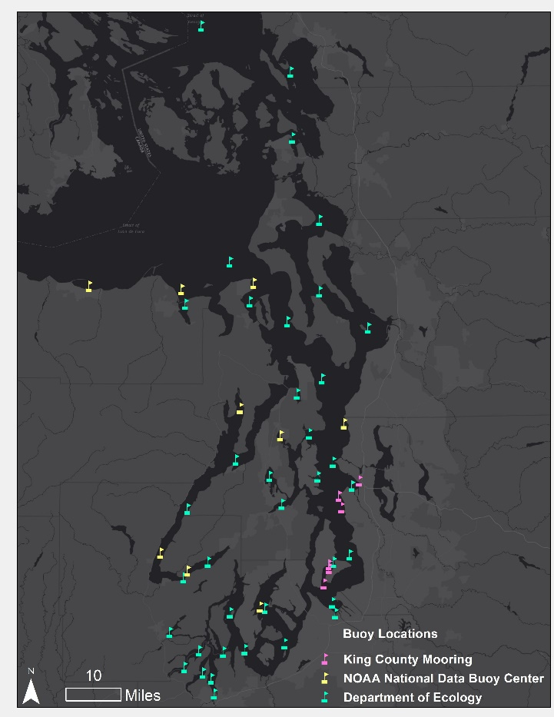

*Figure 2.* Buoy locations from King County Mooring, NOAA National Data Buoy Center, State of Washington Department of Ecology

***3.2 Data Processing***

The S2MSI and L8OLI data were processed using ACOLITE to obtain turbidity and chlorophyll concentration. Royal Belgian Institute of Natural Sciences (2017a) describes multiple algorithms for processing these data in ACOLITE. We tested four algorithms to detect chlorophyll concentration and five algorithms to detect turbidity. The L8OLI data were processed using two algorithms to detect chlorophyll concentration and five algorithms to detect turbidity. The S2MSI data were processed using four algorithms to detect chlorophyll concentrations and five algorithms to detect turbidity (Table 1).

Table 1

*ACOLITE Algorithms Used*

|  |  |  |  |
| --- | --- | --- | --- |
| **Parameter** | **Algorithm** | **Wavelength (Band)** | **Satellite/Sensor** |
| Chlorophyll | CHL_OC2 (CH2) | 483/561nm (Blue/Green) | Landsat 8 OLI, Sentinel-2 MSI |
| Chlorophyll | CHL_OC3 (CH3) | 443/483/561nm  (Ultra Blue/Blue/Green) | Landsat 8 OLI, Sentinel-2 MSI |
| Chlorophyll | CHL_RE_GONS (GON) | Red | Sentinel-2 MSI |
| Chlorophyll | CHL_RE_MOSES3B (MO) | Red | Sentinel-2 MSI |
| Turbidity | T_DOGLIOTTI (T) | 645/859 nm (Red/NIR) | Landsat 8 OLI, Sentinel-2 MSI |
| Turbidity | T_DOGLIOTTI_RED (TRED) | 645nm (Red) | Landsat 8 OLI, Sentinel-2 MSI |
| Turbidity | T_DOGLIOTTI_NIR (TNIR) | 859nm (NIR) | Landsat 8 OLI, Sentinel-2 MSI |
| Turbidity | T_GARABA_645_LIN (TGAR) | 645nm (Red) | Landsat 8 OLI, Sentinel-2 MSI |
| Turbidity | T_NECHAD_645 (TNEC) | 645nm (Red) | Landsat 8 OLI, Sentinel-2 MSI |

After the images were processed through ACOLITE, they were projected to North American Datum (NAD) 83 Universal Transverse Mercator (UTM) zone 10N. The projected imagery was clipped to the Puget Sound Water Basins shapefile in ArcMap 10.4.1 before processing. Some of the outputted tiff files contained NoData pixels within the study area. We used the focal statistics tool to fill the NoData pixels for each image with a mean calculated from a seven by seven pixel neighborhood. NoData pixels remained for certain images, but using a larger neighborhood to calculate the pixel statistics would have introduced additional error.

Within the *in situ* data, we searched for specific parameters such as chlorophyll concentration, turbidity level, water depth, and time of collection. The King County chlorophyll concentration and turbidity measurements were collected every 15 minutes and at a depth of three meters. NOAA’s National Data Buoy Center measurements were collected randomly throughout each month and did not have a set water depth. The State of Washington Department of Ecology buoy data measurements were recorded once a month, on random days, with no time stamp, and at depths ranging from one meter to 200 meters. Instead of turbidity, these buoys measured light-transmission percentage, which is related to turbidity, but not easily converted.

In order to compare the greatest number of matching *in situ* data points with the remotely sensed data, we determined the average chlorophyll concentration and turbidity levels for each date at each buoy. However, some buoy measurements were not averages because there was only one measurement for that day. This could introduce error, as the satellite overpass occurred within a ten-minute interval. To obtain corresponding chlorophyll concentration and turbidity from the satellite data for each buoy location, we used the “extract values to points” tool.

We processed all 24 L8OLI images through ACOLITE using the CHL_OC2 algorithm as these outputs had the fewest NoData pixels. This produced 24 ACOLITE analysis maps to provide the project partner with an assessment of the utility of algorithms. A time series was created by combining the L8OLI images from May 2013 through October 2017 into a GIF to display change in chlorophyll concentration levels over time. Two buoy interpolation maps were created using empirical bayesian kriging interpolation. The dates August 20, 2013 and July 09, 2015 were chosen, as there must be at least 10 buoy locations that provide the specified parameter measurements. No dates available had sufficient points measuring turbidity levels for interpolation.

***3.3 Data Analysis***

Based on studies in areas other than Puget Sound, we hypothesized that there should be a high correlation between chlorophyll concentration and turbidity (Babin et al., 2005). This relationship would show that both parameters are useful for identifying HABs. Using RStudio, we plotted the *in situ* chlorophyll concentration against turbidity to determine their relationship.

Three statistical measures within RStudio were used to compare the algorithms to one another and to the *in situ* data. Analysis of variance (ANOVA) was used to examine whether there was a significant difference between algorithms for each parameter and the Tukey’s honest significant difference (HSD) test was used to find out which of the algorithms were different. We used Pearson correlation analysis to determine which of the algorithms correlated the most with the *in situ* data to validate the chlorophyll concentration and turbidity outputs from ACOLITE. After assessing the correlation, we tested the significance of the correlation by graphing the *in situ* data, chlorophyll and turbidity, against the satellite data to examine the linear relationship between them (Figure D1- Figure D4).

# 4. Results & Discussion

***4.1 Analysis of Results***

The relationship between chlorophyll concentration and turbidity in the *in situ* data was low with an r-value ranging from -0.01 to 0.35 (Table B1). This could be due to limitations in the collection methods of *in situ* data. Although all 52 buoys provided chlorophyll concentration measurements, only 15 buoys provided turbidity level measurements. Further research could reveal a relationship between chlorophyll concentration and turbidity in the Puget Sound.

A Pearson correlation analysis results showed that there was no significant correlation between the *in situ* chlorophyll concentrations and chlorophyll concentrations obtained through each of the algorithms derived from ACOLITE (all P-values>0.05, at α = 0.05 level) for S2MSI and L8OLI data (Table 2). Similarly, the turbidity values from *in situ* data were not significantly correlated with the turbidity values obtained through each of the algorithms using S2MSI and L8OLI (all P-values>0.05) (Table 2). To visualize this low correlation, the chlorophyll concentration and turbidity values from *in situ* data and satellite data were graphed (Figure D1 – Figure D4).

Table 2.

*Pearson Correlation Analysis between in situ and satellite data.*

|  |  |  |  |  |
| --- | --- | --- | --- | --- |
| Parameter | Algorithm | r | P-value | N |
| Chlorophyll | CH2 | 0.25 | 0.362 | 15 |
| Chlorophyll | CH3 | 0.19 | 0.508 | 14 |
| Chlorophyll | GON | -0.26 | 0.377 | 14 |
| Chlorophyll | MO | -0.25 | 0.392 | 14 |
| Turbidity | T | 0.25 | 0.631 | 6 |
| Turbidity | TNIR | -0.47 | 0.350 | 6 |
| Turbidity | TRED | -0.03 | 0.958 | 6 |
| Turbidity | TGAR | 0.26 | 0.620 | 6 |
| Turbidity | TNEC | 0.25 | 0.631 | 6 |

These algorithms measure the same parameters; therefore, we compared them to see if the outputs were similar. The comparison of algorithms produced different results for chlorophyll and turbidity. For both S2MSI data and L8OLI data, the ANOVA results showed that there was no significant difference between algorithms of chlorophyll (P>0.05) (Table 3). However, a significant difference was evident among certain algorithms of turbidity (P<0.05). The result of Tukey’s HSD’s analysis specifically explained which of algorithms were different from each other (Table C1 and Table C2). The algorithm TNIR was significantly different from T, TGAR, TNEC and TRED.

Table 3.

*ANOVA analysis among algorithms of chlorophyll concentration and turbidity.*

|  |  |  |  |
| --- | --- | --- | --- |
| Parameter | Algorithm | F-value | P-value |
| Chlorophyll | CH2 | 2.269 | 0.082 |
| Chlorophyll | CH3 |
| Chlorophyll | GON |
| Chlorophyll | MO |
| Turbidity | T | 75.400 | 0.000 |
| Turbidity | TNIR |
| Turbidity | TRED |
| Turbidity | TGAR |
| Turbidity | TNEC |

The ACOLITE analysis map of chlorophyll concentration, Figure 3(a), was created using L8OLI imagery processed through ACOLITE using the algorithm CHL_OC2. For visual comparison, the scale was adjusted to 0-6 /L. The buoy interpolation of chlorophyll concentration, Figure 3(b), was created using the empirical bayesian kriging interpolation tool in ArcMap. Interpolation is inherently biased towards areas with higher density of point data; therefore, it has limitations when being used in decision making processes. The interpolation map scale was set to 0.80-24.5 µg/L. Relative to the scale, areas of high chlorophyll concentration were spatially similar in both maps, specifically in areas such as the Tacoma Inlet and Skagit Bay. These results were also apparent in our time series analysis which identified Tacoma Inlet and Skagit Bay as two areas that had consistent high indicators of HABs, Figure 3(a).

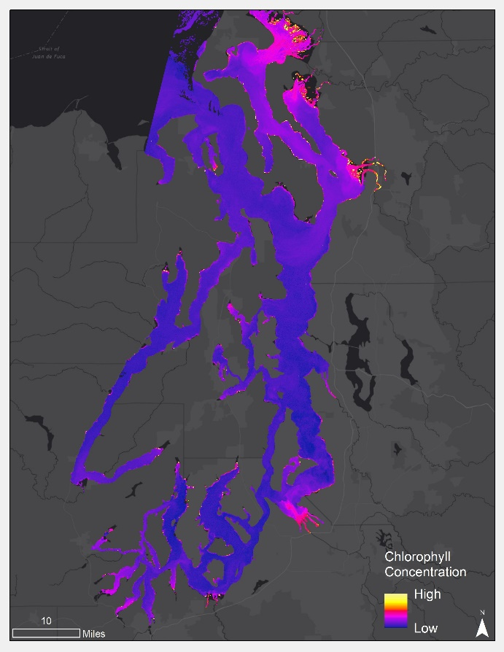

Tacoma

Skagit Bay

*(a)*

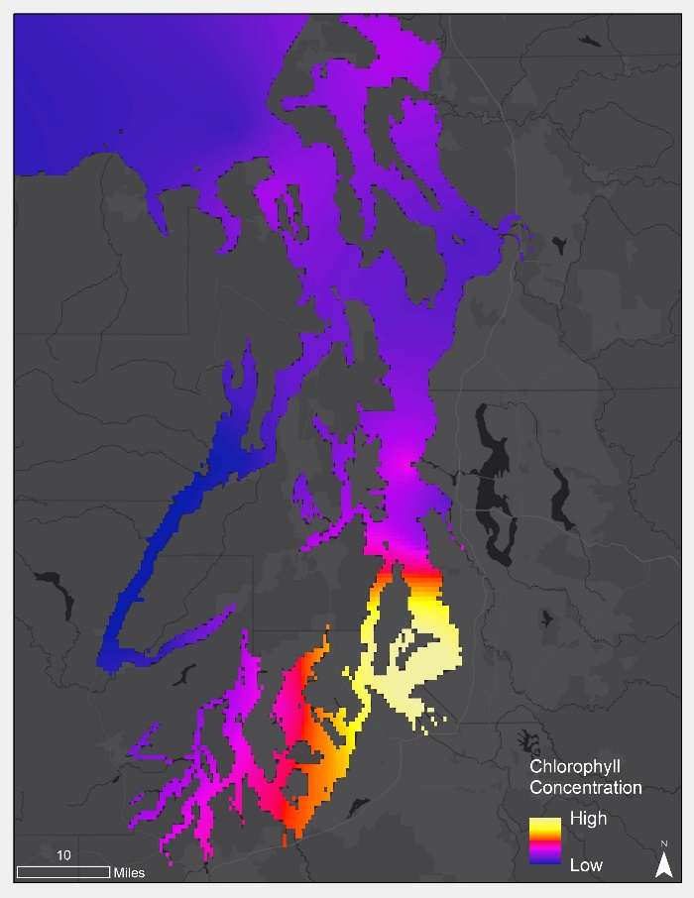

*(b)*

Tacoma

Skagit Bay

*(a)*

*Figure 3. (a)* The ACOLITE analysis map, on the right, was created using the August 20, 2013 L8OLI image that was processed through ACOLITE to show chlorophyll concentration. For visual comparison, the scale was adjusted to 0-6 µg/L *(b)* The Buoy Interpolation of Chlorophyll Concentration was created using the Empirical Bayesian Kriging Interpolation method. The scale was left at 0.80 – 24.5 µg/L.

***4.2 Future Work***

For future work, we suggest a thorough investigation of the advanced settings within ACOLITE, testing alternative algorithms, and including more indicators of HABs. As explained by the Royal Belgian Institute of Nature Sciences (2017b), the advanced settings within ACOLITE include options for atmospheric corrections and adjustments for specified atmospheric pressures. While pressure would not have a large impact on results within the near-sea level Puget Sound, utilizing an atmospheric correction for a study period spanning years is appropriate and could impact the algorithm output (Song, Woodcock, Seto, Lenney, & Macomber, 2001). We studied the results of four algorithms identifying chlorophyll concentrations and five algorithms identifying turbidity. Other algorithms that identify chlorophyll concentrations without being processed in ACOLITE exist and may produce more accurate results for the Puget Sound area. For example, the floating algal index (Hu, 2009) and the normalized difference chlorophyll index (Mishra & Mishra, 2012) were designed for MODIS and incorporate improvements to atmospheric corrections designed specifically for inland waters (Page & Mishra, in progress) which all utilize bandwidths contained by the high spatial resolution S2MSI and L8OLI sensors. We identified turbidity and chlorophyll concentration as indicators of HABs, however the inclusion of more parameters could provide improved results. Sea surface temperature could improve HAB identification as algae thrives in warmer water (Singh & Singh, 2015). With further study, spatial and temporal gaps in *in situ* data collection in the Puget Sound could be filled, enhancing water quality management in the region.

# 5. Conclusions

The method used in this study showed no correlation between satellite data processed through ACOLITE and *in situ* data; therefore, this particular method should not be used for monitoring eutrophication and HABs in the Puget Sound. However, incorporating atmospheric corrections, additional parameters, and/or additional algorithms could potentially yield useful results. Because there were no significant differences between the chlorophyll algorithms tested, we theorize that if one algorithm can be validated then the others can be as well. There were significant differences in certain turbidity algorithms due to the fact that TNIR is the only algorithm to rely solely on the 859 nm wavelength band. Although the values of turbidity and chlorophyll concentration have very low correlation with the *in situ* data, after interpolating the *in situ* data and visually comparing it with the ACOLITE processed data, the areas of high chlorophyll concentration, relative to scale, were spatially similar. These areas also spatially align with the areas that continuously show high chlorophyll concentrations over the time series analysis. These areas are primarily within and along inlets, particularly Skagit Bay and Tacoma Inlet. Skagit Bay and is surrounded by agricultural lands and the Tacoma Inlet is surrounded by an industrialized community. Both receives large amounts of nutrient rich runoff increasing algal growth and thus causing those areas to have relatively high chlorophyll concentrations.

# 6. Acknowledgments

Dr. Jeffrey Luvall (NASA Marshall Space Flight Center)

Dr. Robert Griffin (University of Alabama in Huntsville)

Dr. Juan L. Torres-Pérez (Bay Area Environmental Research Institute, NASA Ames Research Center)

Leigh Sinclair (University of Alabama in Huntsville/Information Technology and Systems Center)

Maggi Klug (University of Alabama in Huntsville)

Mercedes Bartkovich (NASA DEVELOP)

Benjamin Page (NASA SERVIR)

This material contains modified Copernicus Sentinel data (2015-2017), processed by ESA.

Any opinions, findings, and conclusions or recommendations expressed in this material are those of the author(s) and do not necessarily reflect the views of the National Aeronautics and Space Administration.

This material is based upon work supported by NASA through contract NNL16AA05C and cooperative agreement NNX14AB60A.

# 7. Glossary

**Eutrophication** – excess of nutrients in a body of water

**Hypoxia** – low oxygen levels

**HAB** – harmful algal bloom; increase in the population of algae

**Domoic Acid** – neurotoxin produced by algae that causes amnesic shellfish poisoning

**ACOLITE** - an atmospheric correction and processor for the Landsat 8 Operational Land Imager and Sentinel-2 Multispectral Imager developed at Royal Belgian Institute of Natural Sciences

**ANOVA** – Analysis of Variance, a test of hypothesis that is appropriate to compare means of a continuous variable in two or more independent comparison groups

**Pearson Correlation Analysis** - measures the strength and direction of linear relationships between pairs of continuous variables

**Tukey’s HSD Analysis** - Tukey’s Honest Significant Difference test, a test that compares all possible pairs of means after ANOVA is conducted

**UTM -** Universal Transverse Mercator

**NAD –** North American Datum

# 8. References

Babin, M., Cullen, J. J., Roesler, C. S., Donaghay, P. L., Doucette, G. J., Kahru, M., . . . Sosik, H. M. (2005). New approaches and technologies for observing harmful algal blooms. *The Oceanography Society, 18*(2), 220. doi: <https://doi.org/10.5670/oceanog.2005.55>

Babson, A.L., Kawase, M. & MacCready, P. (2006) Seasonal and interannual variability in the circulation of Puget Sound, Washington: a box model study, *Atmosphere-Ocean*, *44*(1), 29-45, doi: 10.3137/ao.440103

Dogliotti, A. I., Ruddick, K. G., Nechad, B., Doxaran, D., & Knaeps, E. (2015). A single algorithm to retrieve turbidity from remotely-sensed data in all coastal and estuarine waters. *Remote Sensing of Environment,* 156, 157-168. doi: 10.1016/j.rse.2014.09.020

Environmental Protection Agency (2017). Marine water quality. Salish Sea Report. Retrieved September 18,

2017 from www.epa.gov/salish-sea/marine- water-quality.

Garaba, S., Badewien, T., Braun, A., Schulz, A.-C., & Zielinski, O. (2014). Using ocean colour remote sensing products to estimate turbidity at the Wadden Sea time series station Spiekeroog. *Journal of the European Optical Society Rapid Publications, 9*, 14020*.* doi: 10.2971/jeos.2014.14020

Hu, C. (2009). A novel ocean color index to detect floating algae in the global oceans. *Remote Sensing of the Environment, 113*(10), 2118-2129. <https://doi.org/10.1016/j.rse.2009.05.012>

Kautz, S. (2017). Sentinel. [Data set]. U.S. Geological Survey doi: 10.5066/f76w992g

MacCready, P. (2017). Puget Sound’s physical environment. Retrieved from: <https://www.eopugetsound.org/articles/puget-sounds-physical-environment>

Mishra, S. & Mishra, D. (2012). Normalized difference chlorophyll index: A novel model for remote estimation of chlorophyll-a concentration in turbid productive waters. *Remote Sensing of Environment, 117*(2), 394-406. https:doi/10.1016/j.rse.2011.10.016

NASA Goddard Space Flight Center, Ocean Ecology Laboratory, Ocean Biology Processing Group (2018). *Moderate-resolution Imaging Spectroradiometer (MODIS) Aqua downwelling diffuse attenuation coefficient data; 2018 reprocessing I* [data set]. doi: 10.5067/AQUA/MODIS/L3M/KD/2018

Page, B. & Mishra, D. In progress. A modified atmospheric correction when coupling Sentinel-2A and Landsat-8 for inland water quality monitoring. *Journal of Photogrammetry and Remote Sensing.*

Royal Belgian Institute of Natural Sciences. (n.d.). ACOLITE. Retrieved from https://odnature.naturalsciences.be/remsem/software-and-data/acolite

Royal Belgian Institute of Natural Sciences. (2017a). *ACOLITE Manual*. Retrieved from https://odnature.naturalsciences.be/downloads/remsem/acolite/acolite_manual_20180327.0.pdf

Royal Belgian Institute of Natural Sciences. (2017b). *Overview of ACOLITE settings*. Retrieved from <https://odnature.naturalsciences.be/downloads/remsem/acolite/ACOLITE_processing_options_20170718.0.pdf>

Sellner, K. G., Doucette, G. J., & Kirkpatrick, G. J. (2003). Harmful algal blooms: Causes, impacts and detection. *Journal of Industrial Microbiology and Biotechnology,* *30*(7), 383-406. doi:10.1007/s10295-003-0074-9

Singh, S. & Singh, P. (2015). Effect of temperature and light on the growth of algae species: A review. *Renewable and Sustainable Energy Reviews, 50*(10), 431-444. <https://doi.org/10.1016/j.rser.2015.05.024>

Song, C., Woodcock, W., Seto, K., Lenney, M., & Macomber, S. (2001). Classification and change detection using Landsat TM data: When and how to correct atmospheric effects? *Remote Sensing of Environment, 75*(2), 230-244. <https://doi.org/10.1016/S0034-4257(00)00169-3>

U.S. Geological Survey Earth Resources Observation and Science Center. (2014). Provisional Landsat OLI Surface Reflectance [Data set]. doi: 10.5066/f78s4mzj

Washington Department of Fish and Wildlife. (n.d.). Domoic Acid – A major concern to Washington State’s shellfish lovers. Retrieved from <https://wdfw.wa.gov/fishing/shellfish/razorclams/domoic_acid.html>

# 9. Appendices

Appendix A. Dates of remotely sensed data

Table A1

*Dates of satellite data downloaded from USGS EarthExplorer.*

|  |  |  |
| --- | --- | --- |
|  | **S2MSI** | **L8OLI** |
| **2013** | N/A | 07/03, 07/19, 07/26, 08/20 |
| **2014** | N/A | 08/07, 08/23, 09/15 |
| **2015** | N/A | 06/07, 06/14, 06/23, 07/09, 08/17, 09/11, 09/27, 10/04 |
| **2016** | 08/29, 09/18 | 05/31, 07/27, 08/09, 08/12, 09/13 |
| **2017** | 06/05, 08/04, 08/24, 09/13, 10/03 | 05/27, 07/05, 07/14, 10/09 |

Appendix B. Comparison of *in situ* chlorophyll concentration and turbidity

Table B1

*Correlation coefficient between in situ chlorophyll concentration and in situ turbidity.*

|  |  |
| --- | --- |
| Buoy location | Correlation Coefficient  (r) |
| Alki Buoy | -0.01 |
| Dockton | 0.03 |
| Point Williams | 0.06 |
| Quarter Master Yacht Blub Buoy | 0.12 |
| Quarter Master Buoy | 0.35 |
| Seattle Aquarium | 0.13 |
| Yacht Club | 0.27 |

Appendix C. Tukey comparison of ACOLITE algorithms

Table C1

*Tukey multiple comparisons of means 95% family-wise confidence level for algorithms for S2MSI data processed through ACOLITE.*

|  |  |  |  |  |
| --- | --- | --- | --- | --- |
| Algorithms | Mean difference | 95% Confidence Interval | | P-value |
| Lower Bound | Upper Bound |
| CH3-CH2 | -0.013 | -339.60 | 339.57 | 1.000 |
| GON-CH2 | 18.893 | -320.69 | 358.48 | 0.999 |
| MO-CH2 | -272.232 | -611.82 | 67.35 | 0.164 |
| GON-CH3 | 18.906 | -320.68 | 358.49 | 0.999 |
| MO-CH3 | -272.219 | -611.81 | 67.37 | 0.164 |
| MO-GON | -291.125 | -630.71 | 48.46 | 0.121 |
| TGAR-T | -0.579 | -1.99 | 0.84 | 0.794 |
| TNEC-T | 0.026 | -1.39 | 1.44 | 1.000 |
| TNIR-T | 6.771 | 5.36 | 8.19 | 0.000* |
| TRED-T | -0.474 | -1.89 | 0.94 | 0.888 |
| TNEC-TGAR | 0.605 | -0.81 | 2.02 | 0.766 |
| TNIR-TGAR | 7.350 | 5.93 | 8.77 | 0.000* |
| TRED-TGAR | 0.104 | -1.31 | 1.52 | 1.000 |
| TNIR-TNEC | 6.745 | 5.33 | 8.16 | 0.000* |
| TRED-TNEC | -0.501 | -1.31 | 0.92 | 0.867 |
| TRED-TNIR | -7.246 | -8.66 | -5.83 | 0.000* |

* The mean difference is significant at the 0.05 level.

Table C2

*Tukey multiple comparisons of means 95% family-wise confidence level for algorithms for Landsat 8 data OLI through ACOLITE.*

|  |  |  |  |  |
| --- | --- | --- | --- | --- |
| Algorithms | Mean difference | 95% Confidence Interval | | P-value |
| Lower Bound | Upper Bound |
| CH3-CH2 | -0.001 | -0.27 | 0.26 | 0.995 |
| TGAR-T | -2.556 | -10.12 | 5.00 | 0.884 |
| TNEC-T | -1.575 | -9.14 | 5.99 | 0.979 |
| TNIR-T | 4.27 | 35.14 | 50.26 | 0.000* |
| TRED-T | -1.575 | -9.14 | 5.99 | 0.979 |
| TNEC-TGAR | 9.812 | -6.58 | 8.52 | 0.996 |
| TNIR-TGAR | 4.526 | 37.70 | 52.82 | 0.000* |
| TRED-TGAR | 9.812 | -6.58 | 8.54 | 0.996 |
| TNIR-TNEC | 4.428 | 36.72 | 51.84 | 0.000* |
| TRED-TNEC | -1.332 | -7.56 | 7.56 | 1.000 |
| TRED-TNIR | -4.428 | -51.84 | -36.72 | 0.000* |

*Mean difference is significant at the 0.05 level.

Appendix D. Correlation of chlorophyll concentration between *in situ* and remotely sensed data

*Figure D1*. Correlations between *in situ* chlorophyll concentration and chlorophyll concentration obtained through 4 different algorithms for S2MSI data through ACOLITE.

*Figure D2.* Correlations between *in situ* chlorophyll concentration and chlorophyll concentration obtained through 2 different algorithms for L8OLI data through ACOLITE.

*Figure D3.* Correlations between *in situ* turbidity and turbidity obtained through 5 different algorithms for S2MSI data through ACOLITE.

*Figure D4.* Correlations between *in situ* turbidity and turbidity obtained through 5 different algorithms for L8OLI data through ACOLITE.