NASA DEVELOP National Program
California – Ames
Fall 2017

Lassen Volcanic National Park Disasters II
Evaluating Fuel Loading at a Landscape Scale in High Elevation Alpine Forests of Lassen Volcanic National Park


Technical Report
Final Draft – November 16, 2017

Anna McGarrigle (Project Lead)
Andrea Ferrer
Heather Myers
Peter Norton

Juan Torres-Perez, Bay Area Environmental Research Institute, NASA Ames Research Center (Science Advisor)

Previous Contributors:
Jenna Williams
John Dilger
Joshua Verkerke

1. Abstract
The disruption of natural fire regimes caused by fire suppression policies, coupled with drought and changing climate conditions, allow fuel loads to grow in the absence of naturally ignited, low intensity surface fires. Within the mixed conifer forests of the Cascades, catastrophic wildfires challenge forest resilience in Lassen Volcanic National Park and Lassen National Forest. Land managers within these forested areas can benefit from integrating landscape-scale fuel load density and ecosystem recovery assessments derived from high-resolution, remotely sensed data into their wildfire mitigation and management projects. To provide a landscape-scale assessment, we calculated density estimates of stems per acre and canopy understory fuel loads for the Badger Planning Area with LiDAR, studied ecosystem recovery from the 2012 Reading Fire by calculating pre- and post-fire land cover using high spatial resolution imagery from the USDA National Agriculture Imagery Program (NAIP), and provided land managers an integrated web tool for spatiotemporal analysis of historical tree mortality and regional fire history using multispectral data from the Landsat series (TM, ETM+, OLI) accessed in Google Earth Engine API. Examining fuels with this methodology for present conditions, future planning, and historic mortality trends will improve wildfire management strategies across administrative boundaries in the Lassen area.

Keywords
Google Earth Engine, Lassen, fuel load, LiDAR, Reading Fire, ecosystem recovery, interagency collaboration

2. Introduction
  - Site Background
Lassen Volcanic National Park (LVNP) lies at the southern extent of the Cascade Range in Northern California, and is surrounded by the Lassen National Forest (LNF). In these combined 4,400 square kilometers of conifer-dominant forests, the disruption of natural fire regimes caused by fire suppression policies, coupled with drought and changing climate conditions, allow fuel loads to grow in the absence of naturally-occurring, low intensity surface fires. Heightened fuel loads and the aftermath of the 2012 Reading Fire have invited an interagency collaboration to assess fuel loads at a landscape scale across administrative boundaries.
In August 2012, the Reading Fire burned 28,079 acres in LVNP and LNF, costing over $17 million (Hendricks, 2012). The natural ignition appeared on July 23rd, 2012 in a location with low fuel loading, and was monitored for resource benefits. Fourteen days after ignition, wind gusts increased, relative humidity decreased, and fuel moistures diminished, causing the fire to rapidly spread north into heavier fuel loads (Hendricks, 2012). Post-fire reports stated that managers were unprepared for the expansion and intensity of the fire line and could have benefited from high resolution fire behavior modelling (Hendricks, 2012). Successful fuels treatment in LVNP began in the early 1990s to restore the natural fire regime (Hendricks, 2012). Since then, the technique of Wildland Fire Use (WFU) has been utilized to reduce fuel loads caused by antecedent suppression policy by managing natural ignitions for resource benefit (Collins, 2007).

Extensive wildland fire science research exists on post-fire recovery and the effect of burn patterns on ecosystem recovery in the region. In LNF, ecologists studying post-fire vegetation regeneration after the 2000 Storrie Fire concluded that the forest recovered more diversely, implying that higher burn severity correlated to greater shrub coverage (Crotteau, 2013). In another study, fire return interval explained burn severity more so than fire history or spatial patterns, demonstrating how fuel loading is a function of fire frequency (Collins, 2007).

Multiple early studies in LVNP used GIS methods to map vegetation type and perform an unsupervised classification of Landsat to identify genus, but few utilized remotely-sensed imagery to calculate tree mortality (Pinder, 1997; White, 1995; Parker, 1991). Studies of vegetation health elsewhere use the Normalized Difference Vegetation Index (NDVI) to interpret greenness (Casady et al., 2010). In similar conditions in California, concentrations of drought-induced tree mortality increase the risk of high intensity wildfires (Potter, 2016). Combining multispectral imagery and Light Detection and Ranging (LiDAR) data successfully estimated biomass within a similar conifer-dominant forest (Pflumacher et al., 2017). With the need to identify high priority fuel loading sites, processing remotely sensed data into discrete objects enables advances in landscape scale assessments where objects are the minimum mapping unit of analysis (Blaschke, 2010).

NASA DEVELOP previously worked with partners at LVNP during summer 2017. This research studied historic and present-day tree mortality, and conducted a feasibility study of LiDAR to measure fuel loads. To map historic tree mortality, a tool was built in Google Earth Engine to calculate trends in vegetation health from Landsat imagery called, Simple Analysis of Vegetative Trends in Earth Engine (SAVeTrEE).
  - Project Partners & Objectives
Several catastrophic, large-scale fires in the last decade demonstrated the immediate need for inter-agency landscape-scale restoration to mitigate fire hazards with fuels treatment (Hendricks, 2012). Ultimately, the park and forest would like to use WFU practices to allow low-intensity surface fires to burn for resource management (S. Buckley, personal communication; Kilgore & Taylor, 1979). To implement landscape restoration, the interagency Burney-Hat Creek Collaborative Forest Landscape Restoration (CFLR) project brings together stakeholders from LVNP and LNF, as well as science, community, timber, and environmental groups. As members of this collaborative, our partners expressed interest in creating data that would be useful, not only to their respective forests, but also to the overarching goals of the CFLR. These agencies have limited resources to manage increasing fuel loads while the threat of catastrophic fire increases. Partners need high-resolution metrics on fuel loads, forest structures, post-fire regrowth, and horizontal and vertical fuels in the restoration area to perform a landscape-scale assessment before implementing treatments.

In partnership with ecologists and GIS analysts at LVNP and LNF, this project addresses the Disasters category of NASA’s National Application Area. To address partner needs, project objectives include analyzing LiDAR data in the Badger Planning area to identify priority fuels treatment locations, quantifying recovery from the 2012 Reading Fire, and continuing the analysis of historical mortality events. This research will help ecologists and land managers plan for resilience.

3. Methodology
3.1 Data Acquisition
Shapefiles of the LVNP and LNF administrative boundaries were provided by the project partners. Extent of the LiDAR coverage was derived from these data. The total study area covers LVNP and the extent of LiDAR in the Badger Creek Planning Unit (Figure 1). Partners provided ancillary datasets, including planting activity shapefiles from LNF from 2012 to 2017. Detailed documentation of fuel treatments and fire history for LVNP were provided in both geodatabase and written format.

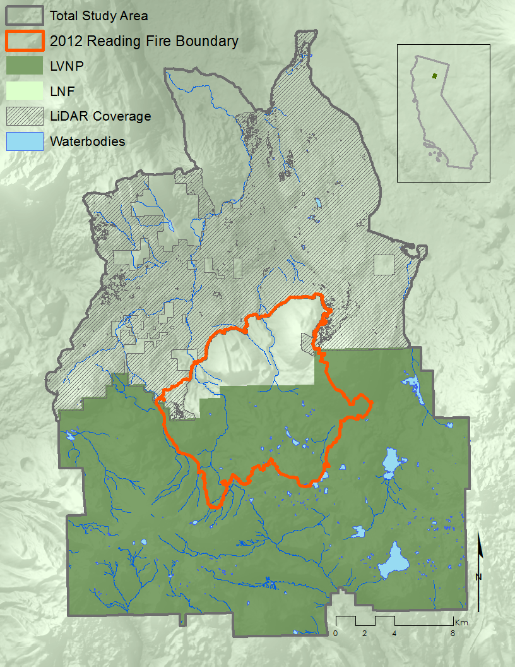

Figure 1. Study area of Lassen Volcanic National Park and LiDAR extent in the Badger Planning Area.

Lassen National Forest flew LiDAR over the Badger Creek unit of the Burney-Hat Creek CFLR area on October 2015. These data were acquired from USFS Region 5 as a Level 1 product, with aggregate nominal pulse spacing (ANPS) of 8 points/m². USDA National Agriculture Imagery Program (NAIP) Orthoimagery quadrangles captured between June and August of 2012, 2014, and 2016 were downloaded from Google Earth Engine. The imagery contains 4 bands (R, G, B, NIR) at 1 m spatial resolution. Surface Reflectance data from Landsat 5 Thematic Mapper (TM), Landsat 7 (ETM+) and Landsat 8 Operational Land Imager (OLI) satellites were accessed through Google Earth Engine from 1984 to 2016. Both are Level 2 products at 30 m spatial resolution.

3.2 Data Processing and Analysis
3.2.1 LiDAR
Our team created high spatial resolution elevation products from the LiDAR point cloud data using 1m x 1m binning cells. This is an appropriate minimum cell size due to the high point density of the dataset. Products derived from this dataset include a Digital Elevation Model (DEM), a Digital Surface Model (DSM), a Canopy Height Model (CHM), and a Canopy Cover Model (CCM). ArcGIS and ArcPy programs were used to process the data.

A 1 m DSM and DEM were created using a simple bilinear interpolation of the classified non-ground and ground points, respectively (Figure 2). Simple bilinear interpolation performs well on estimating continuous data with minor smoothing, and is ideal for creating surface models.

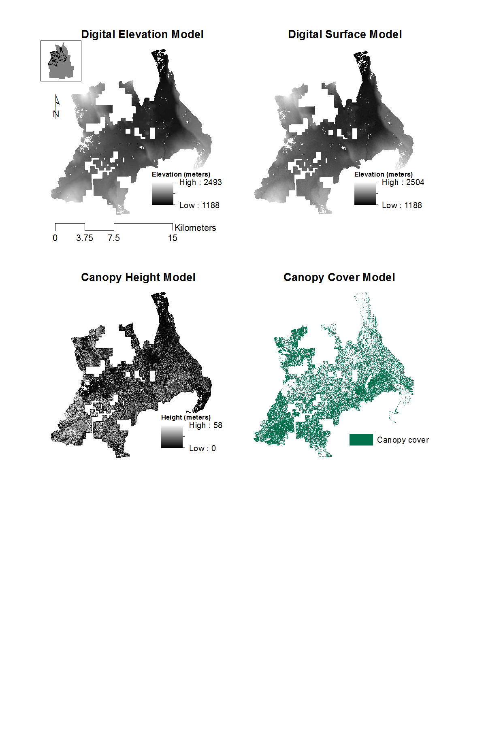
Figure 2. Digital Elevation Model (DEM), Digital Surface Model (DSM), Canopy Height Model (CHM), and Canopy Cover Model (CCM). All surfaces were created using a 1m x 1m grid.

A 1 m resolution height model captured the horizontal spatial variation of individual trees across the entire 300 square mile study area. This calculation is the difference between the DSM and the DEM. The height model was segmented into ground and canopy cover surfaces. Canopy cover was determined as a collection of all height pixels greater than 1.83 m (6 ft), where 1.8288 m represents the minimum height for a tree. This segmented canopy cover became the boundary for all trees, such that it masks all non-trees and creates a Canopy Height Model (CHM). Our team created and algorithm to identify the relative maximum heights of canopies as a proxy for identifying individual canopies from the CHM. This is a recursive process that slices the CHM by 1 m vertical increments and separates new canopies tops from existing canopies.

From the point dataset of canopy centers, we created Thiessen polygons to estimate the natural boundaries between neighboring points as a means to segment canopies (Figure 3). The Thiessen polygons were then clipped by the canopy cover boundary to fit the segmentation to individual canopies. This is an object-based image analysis approach, where the minimum mapping unit is the tree object (Blaschke, 2010). This method does not solve the overlapping canopy problem and assumes canopies are able to be horizontally segmented.

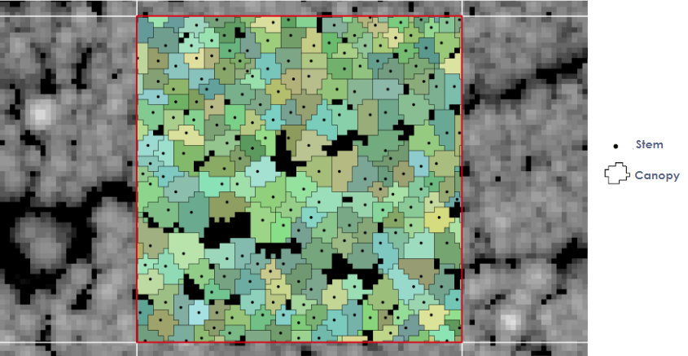

Figure 3. Diagram of horizontal canopy segmentation for 1 acre.

Our team estimated the canopy base heights for each tree by calculating the zonal minimum height for each segmented canopy (Figure 4). The canopy base height measures the distance from the ground to a tree’s lowest branch. While this minimum height may not be observed in the CHM for a tree that does not grow in a conical shape, the algorithm provides a successful diagram in non-overlapping canopy, conifer forests.

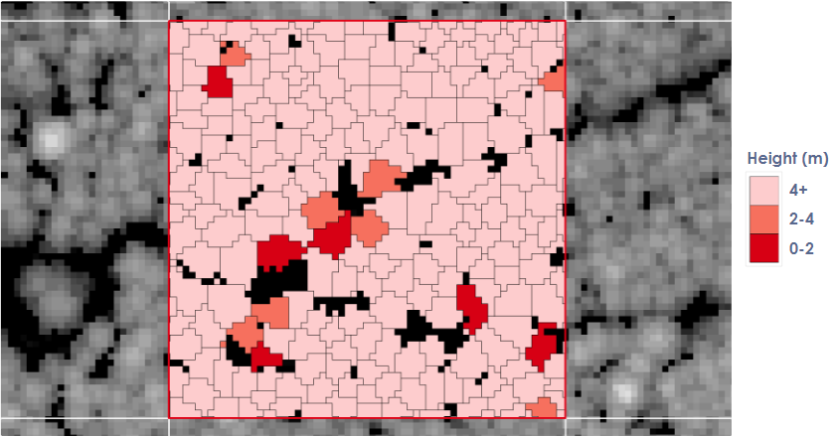

Figure 4. Diagram of canopy base heights.

3.2.2 Reading Recovery Map
Our team used two methods to analyze recovery in the Reading Fire area: 1) supervised land cover classification of the area before and after the fire, and 2) evaluation of NDVI and planting activity on the LNF side of the fire perimeter, compared to random points on the LVNP side. The NAIP quadrangles from 2012, 2014 and 2016 were mosaicked and clipped to the area of interest in ArcMap 10.5. The lakes in the area were masked out before running the classifications because the study included only bare earth and vegetation.

To examine ecosystem recovery, our team created land cover classification for each image using a Support Vector Machine (SVM) classification (Singh et al., 2013). Our team used NAIP imagery to create 30 training samples for each of the following classes: bare earth, grass, and tree. The SVM tool was used to train and classify the image. To test the accuracy of the classification method, 50 validation points for each class derived from NAIP imagery were spatially joined with the classified image. Our team used ArcMap’s field calculator to calculate sums of correctly identified pixels, and the results were plugged into a table to calculate the accuracy of the classification method. This method was repeated for the imagery of each year. Raster Calculator was then used to calculate changes in land cover type on a pixel by pixel basis determining areas of recovery.

To assess how different management practices impact ecosystem recovery, planting activity on the LNF side was compared to random points on the LVNP using the same NAIP imagery. The forest actively plants stems for timber harvesting to encourage vegetation growth due to a federal mandate within the USDA. LVNP’s Wilderness designation under the Wilderness Act of 1964, however, inhibits this type of active management. To quantify anthropogenic-induced vegetation growth on the LNF side, a set of randomly distributed points within the LVNP side of the fire was created for comparison. Google Earth Engine calculated NDVI values for each image, reduced NDVI at each point, and aggregated data outputs into columns based on point geometry. We calculated NDVI for each image, using the calculation:
$\text{NDVI}\text{=}\frac{\text{NIR-RED}}{\text{NIR+RED}}$ (1)

The output produced a table for every side of the fire, with each side’s 9,000 points. The NDVI value at that point in each image provides descriptive statistics on the dataset (Appendix, Table 1).

3.2.3 Isolating Historic Tree Mortality Events
Previous work by NASA DEVELOP created the SAVeTrEE tool in Google Earth Engine to map historic tree mortality. To expand options for analysis, our team added additional areas of interest and historic fire perimeters. In addition to the original LVNP boundary, we acquired options for LNF, the Badger Planning area, and the total study area and ingested them into Earth Engine, along with the addition to the selection options. We also built the option to specify a different area of interest shapefile. Furthermore, our team downloaded fire perimeter data from the Fire and Resource Assessment Program’s (FRAP) and ingested into Google Earth Engine. This data includes historic perimeters from 1878 to 2016 for wildfires, prescription fires and other treatments in the state of California. We added a dropdown to select the type of fire history (wildfire, fuels treatment, or prescription burn) and input boxes for the start and end year to the user interface to filter and access the data. We used the FRAP data to demarcate those areas for which tree mortality or regrowth shown in the simple linear analysis could be explained by wildfires, prescription treatments and other treatments that are on record.

4. Results & Discussion
4.1 Analysis of Results
4.1.1 Badger Planning Area Fuel Loading
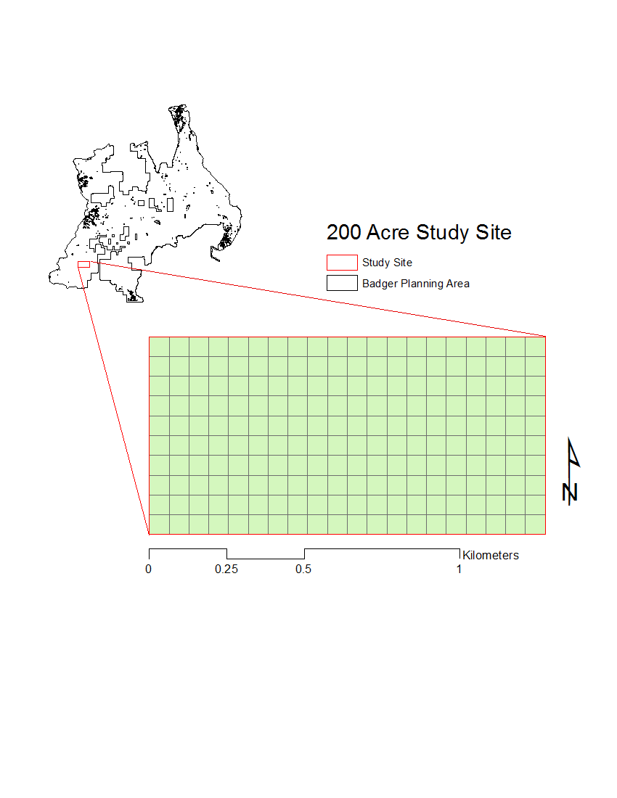
Figure 5. Due to the size of Badger Planning Area, a 200 acre study site was created to demonstrate the scale of the high resolution results. This site is a mix of new- and old-growth, planted lodgepole pine trees.

4.1.1.1 Per Acre Stem Density
A high resolution map of per acre stem densities for the Badger Planning Area is important to assessing the fuel loads from timber and 1000 hour fuels. These fuel burn at extreme intensities and are extremely difficult to contain. Fuel managers should treat acres identified with high densities to reduce the overall risk of to the remaining forest (Figures 6-8).

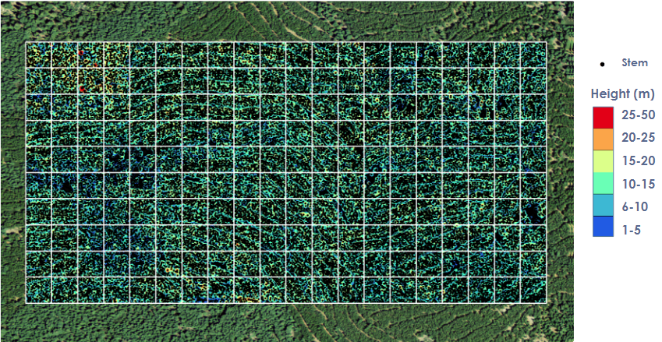

Figure 6. Diagram of per acre stem densities for the Badger Planning Area.

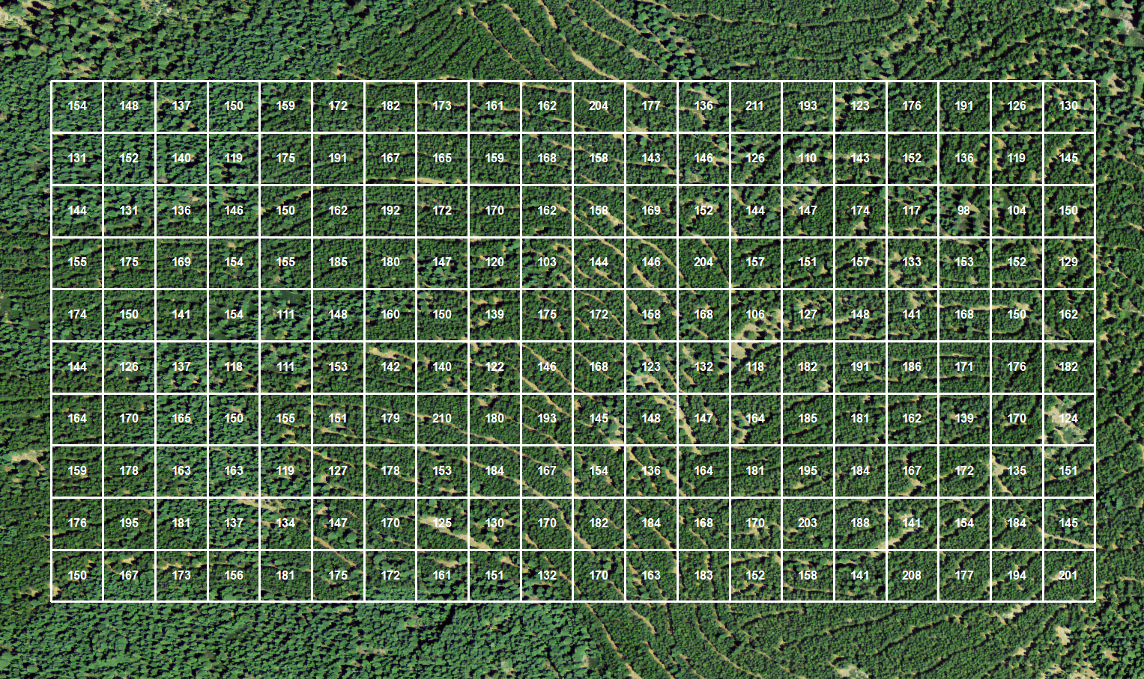

Figure 7. Diagram of per acre stem densities for the Badger Planning Area.

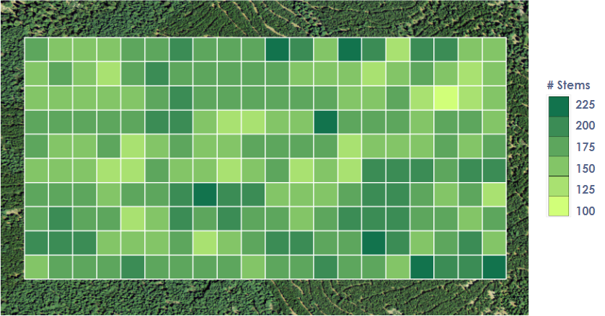

Figure 8. Diagram of per acre stem densities for the Badger Planning Area.

4.1.1.2 Canopy Base Height Model
Grasslands are the primary carrier of surface fires. At the forest-grassland interface, surface fires spread through grass fuels can spread easily into canopies with low canopy base heights. The edge effects of these forest and grassland patch dynamics produce habitats that are more suitable for diverse grasses and shrubs and present a high priority location for fuel treatments to reduce the risks of surface fires becoming canopy fires. The canopies in dark red have low base heights. These areas within the forest-grassland interface should have fuel breaks and canopy understories removed (Figures 9-11).

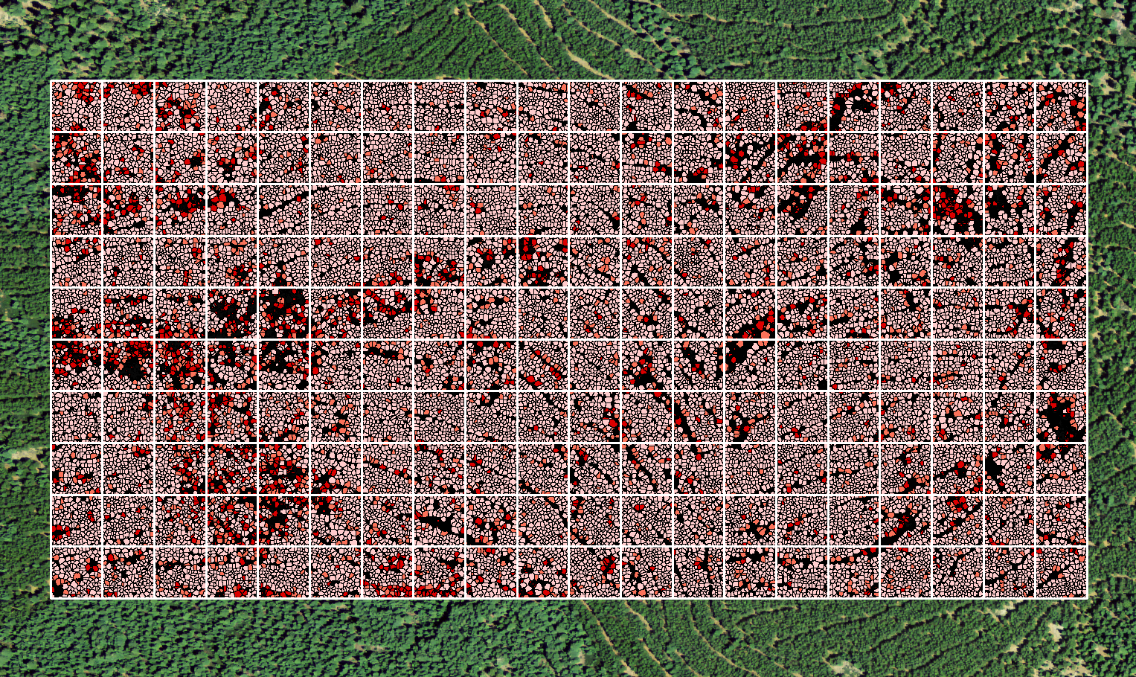

Figure 9. Diagram of median Canopy Base Heights per acre for the Badger Planning Area.

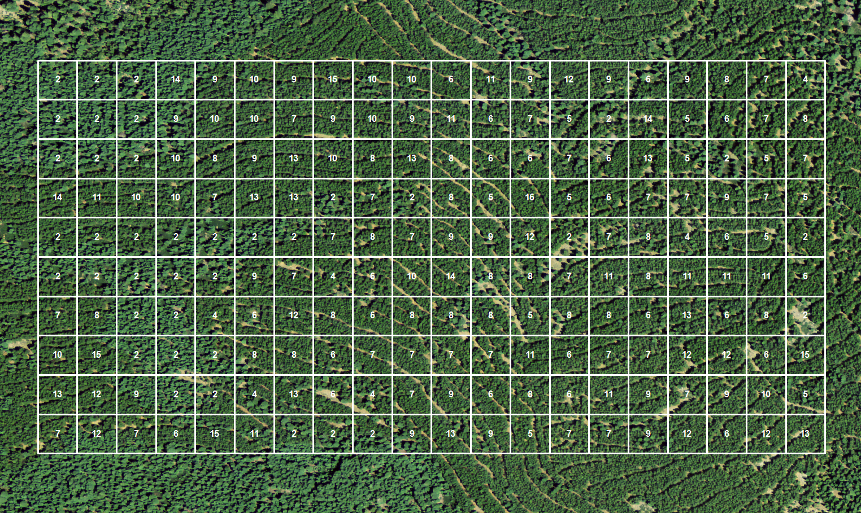

Figure 10. Diagram of median Canopy Base Heights per acre for the Badger Planning Area.

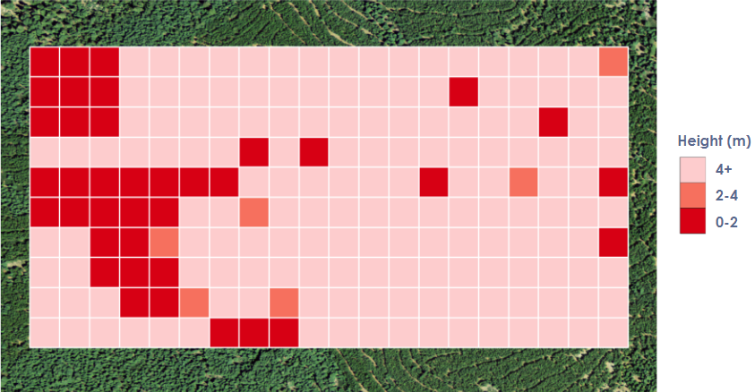

Figure 11. Diagram of median Canopy Base Heights per acre for the Badger Planning Area.

4.1.2 Reading Fire Ecosystem Recovery
The SVM supervised classification method was 86%, 80%, and 82% accurate for 2012, 2014, and 2016, respectively (Appendix B, Table 2). While NAIP offers high-resolution aerial imagery, its spectral resolution prohibits a species-level land classification, which is why only bare earth, grass, and tree were classified.

The computed area of bare earth doubled after the fire, covering 63% of the area in 2014, then decreased to around 45% in 2016 (Appendix B, Table 3). Of the classified 27,939 acres burned by the 2012 Reading Fire, 16,309 acres (58%) were not adversely affected by the fire. This includes areas of vegetation as well as bare earth. Of the vegetation that experienced mortality from the fire, 6,844 acres (25%) have not begun to recover by returning to their pre-fire land cover class, while 2,460 acres (9%) have recovered. A total of 1,374 acres (5%) of vegetation recovered from the fire as a new vegetation cover i.e. it was classified as grass in 2012 and tree in 2016. Additionally, 952 acres (3%) of vegetation are in a state of transition to their pre-fire state i.e. it was classified as tree in 2012 and grass in 2016 (Figure 12).

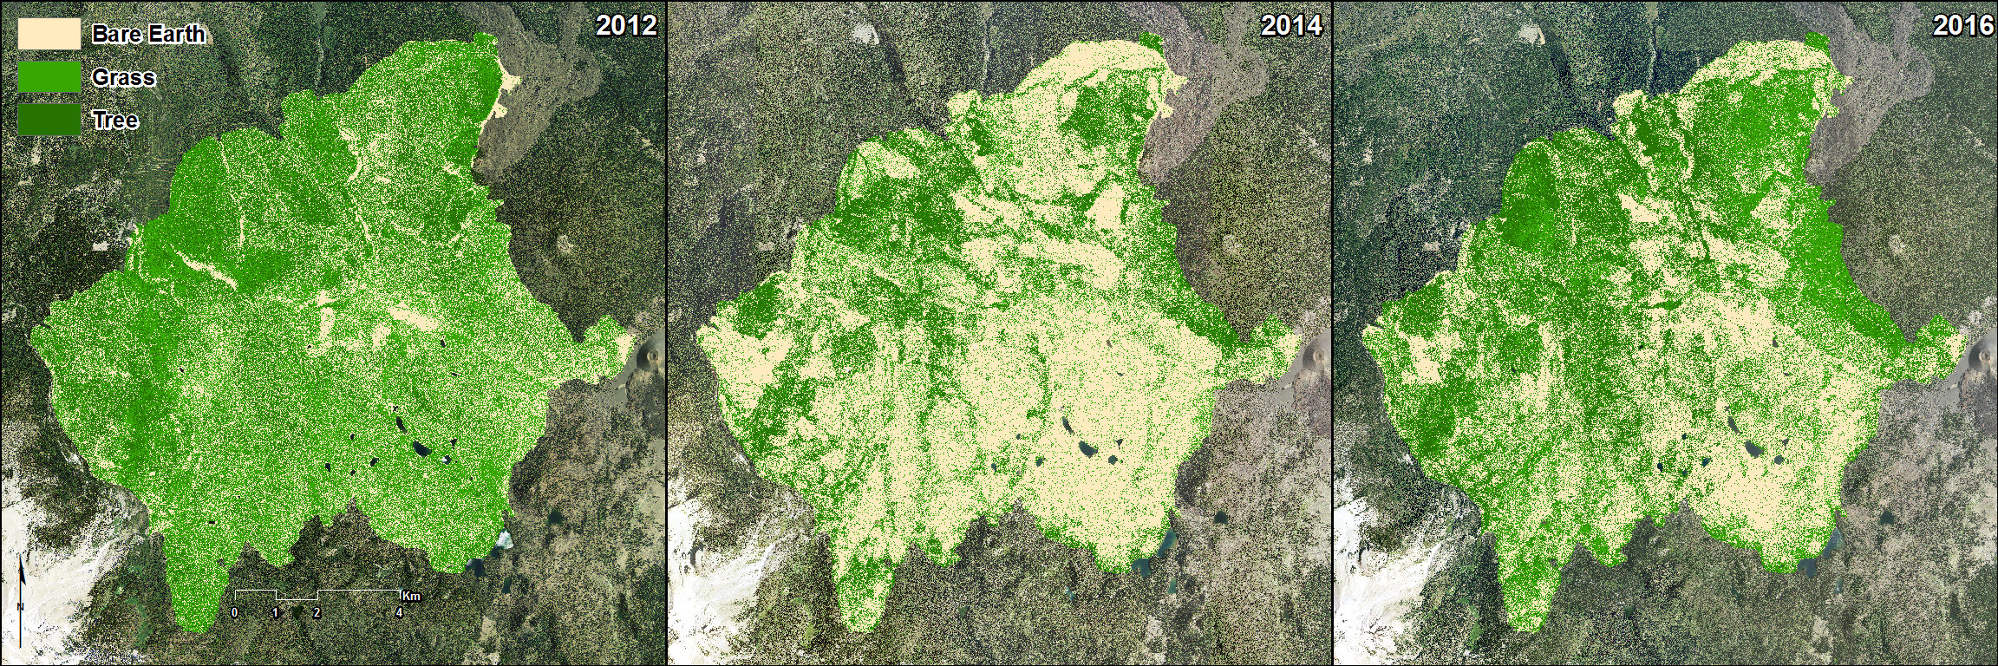

Figure 12. Land cover classification maps of the Reading Fire area in 2012, 2014, and 2016.

Examining planting activity on the LNF side of the fire, points were binned as either healthy or unhealthy based on their NDVI value (Figure 13). Points between 0.2 and 0.8 fall into the healthy range, while points below and above those values are considered unhealthy. The frequency of healthy points on both sides of the boundary before the fire are platykurtic in the healthy range. After the fire in 2014, the distribution of both datasets moves lower to the unhealthy range in a leptokurtic distribution centered around -0.15. Two years later in 2016, both distributions remain leptokurtic but are positively skewed, centered around 0.15. The histograms of these datasets are significant because the distribution of post-fire unhealthy pixels took new form from pre-fire healthy pixels, and points sampled on both sides of the boundary demonstrate very similar distributions at each point in time.

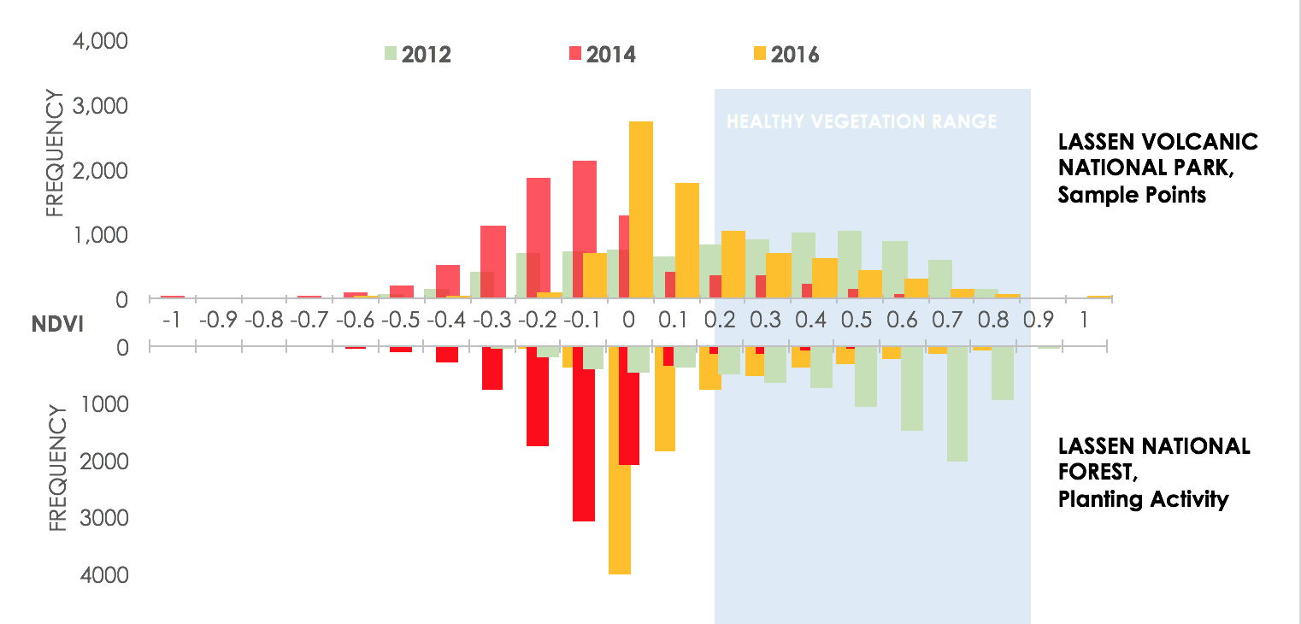

Figure 13: Histogram of NDVI values from 2012, 2014, and 2016 NAIP imagery within the Reading Fire perimeter, separated by the Lassen Volcanic National Park and Lassen National Forest boundary.
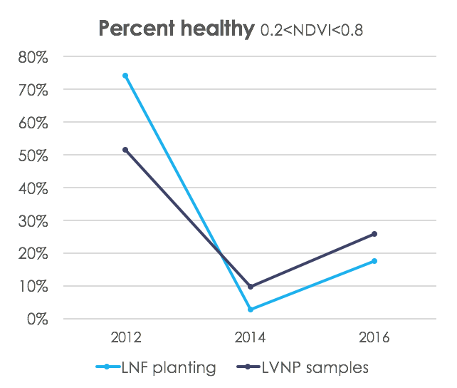

Figure 14: Both sample datasets were less than 10% healthy post-fire, and increased with similar rate of change.

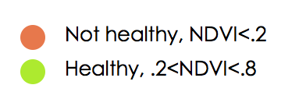
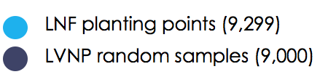
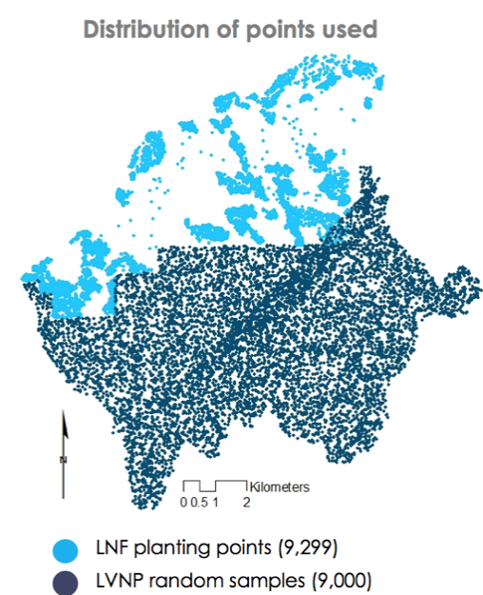
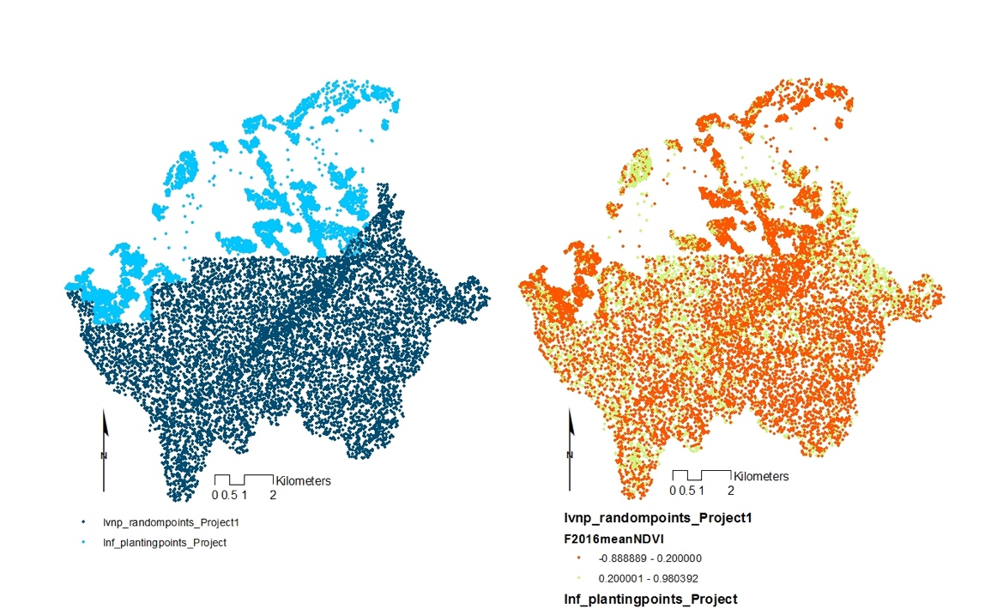
Before the fire, 75% of points in LNF were healthy, with a NDVI value in the range (0.2 – 0.8) and in LVNP about 50% points were healthy (Figure 14). In 2014, both dropped to below 10% after the fire, as reflected in the change in land cover classes. The mean change in NDVI from 2014 to 2016 was +0.216 for the LNF planting points and +0.249 for the LVNP random points. This shift of approximately two-tenths in both datasets can be seen in on the histogram (Figure 13) and in the slope of the percent healthy change between 2014 and 2016 (Figure 14). Therefore, throughout the perimeter of the Reading Fire, vegetation health improved from below 10% to between 19% and 27%. The planting activity did not improve vegetation growth compared to the untouched land (Figure 15).

Figure 15: Results of planting points analysis. Left, distribution of planted points vs. random samples, and right, indiscernible results of healthy vs. unhealthy points.

4.1.3 Historic Tree Mortality SAVeTrEE
The additional development of the SAVeTrEE user interface expanded its capabilities for landscape scale analysis of tree mortality (Figure 16). First, updates to the area of interest options broadened the scope of analysis. With the new options in the area of interest dropdown menu, users can compute trends in tree mortality on more areas in the region, as well as their own shapefile, without modifying the source code. This increases the amount of potential users from one National Park, to the surrounding lands managed by different federal agencies.
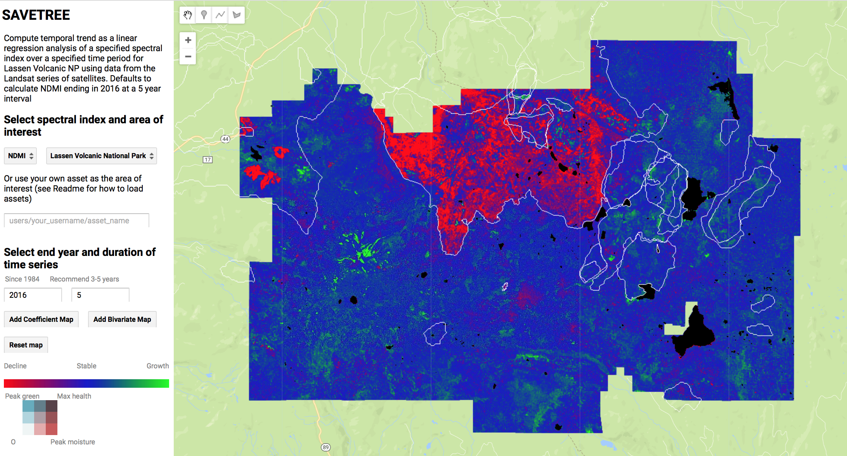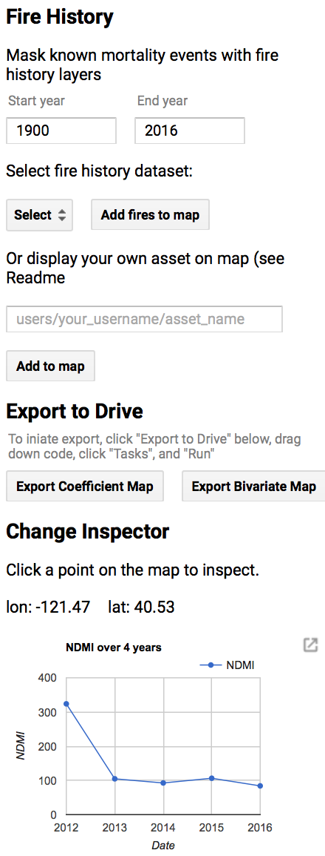

Figure 16: The SAVeTrEE user interface with the coefficient map to show a time series trend analysis of tree mortality. Historic fire perimeters are shown as white outlines.

Second, the addition of fire history data adds another dimension of analysis. With historic events masked, unexplained mortality events can be identified. The addition of a user-inputted fire history option further tailors the output to users’ needs as new datasets become available. The FRAP dataset is updated annually with uniform database structure, so future users may easily download updated data, ingest it, and add it as a layer in SAVeTrEE. The result of these additions is more flexibility in computing landscape scale analysis of historic tree mortality.

4.2 Sources of Error
4.2.1 LiDAR
The field data used to validate the LiDAR data included GPS and stem location omission errors. An accuracy assessment could not be produced since we were unable to acquire the protocol used to produce this field dataset, which would have been used to resolve errors and explain omissions. The GPS error was significant such that multiple stems were located within a few centimeters of one tree. There were instances where the field data counted no trees where the LiDAR captured a tree.

In regard to the errors from the canopy segmentation process, the algorithm was poor at differentiating between multiple trees in close proximity that do not have a clear and separable boundary or are hidden beneath dominant and codominant trees. If canopies overlap, there was a higher probability of under segmentation. Errors in segmentation were also present where a single tree has multiple relative maximums, which led to over segmentation of a single tree.

4.2.2 Reading Fire Recovery
The tradeoff for using high spatial resolution NAIP data is its low temporal resolution. The biannual flights during peak greenup offer 1 m spatial resolution but leave 2-year gaps in data streams. Although imagery was captured weeks before the fire, the post-fire analysis used imagery taken two years after the fire. This introduced an error in mapping land cover classification because the immediate post-fire conditions are not captured.

With the planting points evaluation, the points created on the LVNP side of the fire were randomly distributed whereas the points on the LNF side were captured at places with known vegetation. Error arises since LVNP points are random; points might be placed over bare earth, rocks, or other vegetation types other than tree. The incongruous temporal resolution between planting activity and imagery also introduces uncertainty when the addition of stems or growth from added stems appears on remotely sensed imagery.

4.2.3 SAVeTrEE
SAVEeTrEE uses a simple linear regression to calculate the coefficient trend map which shows positive change as vegetation growth or negative change as decline. This can normalize extreme events, depending on the duration being evaluated. Variable growing seasons introduce uncertainty in the greenest pixel composites because peak green-up in recent drought years is shorter while changing climate conditions shift seasons and temperature patterns. A major uncertainty with SAVeTrEE is that the tool is still in the software release process so the project partners have not been able to use it to provide feedback.

5. Conclusions
5.1 Badger Planning Area LiDAR
Within the Badger Planning Area, each square acre has a mean of 157 stems. Mean density does not capture the degree of fuel loading within the Badger Planning Area, but may be useful when comparing individual stem densities to this mean to assess relative densities. Fuel managers should prioritize areas with higher than average densities in order to reduce overall risks.

Canopies with low base heights were identified along the forest-grassland interface as high priority locations for fuel treatments. The median canopy base heights for each acre present one method for approaching fuel treatments for the Badger Planning Area. A fuel manager might consider treating areas with low canopy base heights first, or forest patches with low canopy heights along large grassland areas.

5.2 Reading Fire Recovery
Within the Reading Fire perimeter, 9% of pixels show recovery to their pre-fire land cover while 25% show no signs of recovery and are still classified as bare earth. The classification shows a higher percentage of pixels classified as tree in 2016 than in 2012, increasing by 2%. This can be compared with the planting activity data, which showed no significant vegetation growth. More analysis needs to be done with fire severity data to see if severity impacted regrowth.

There is no significant difference in vegetation growth (∆NDVI) between LNF planting points and LVNP sampled points according to satellite imagery. Within the Reading Fire perimeter, the mean vegetation growth from 2012 to 2014 was approximately 0.2 on the NDVI index (Appendix B, Table 1). The potential error in temporal resolution and sampling strategy inhibits detailed analysis, and further analysis at a higher temporal resolution could render significant results.

5.3 SAVeTrEE
Additional areas of interest enable broader study of relationships between tree mortality events in the larger landscape of the Lassen area. Historical fire perimeters added to SAVeTrEE aid interpretation of past and present tree mortality trends. Mortality trends can be corroborated with previous fire perimeters, while undocumented mortalities from drought, disease, or insect kill can be identified. These features build upon previous work by providing more tools for partners to understand where and when tree mortality events occur.

6. Acknowledgments
We would like to thank our project partners at Lassen Volcanic National Park, Steve Buckley and Elizabeth Hale. Contributions by Jenna Williams at NASA DEVELOP were instrumental to the project’s success, as was the support of our science advisor, Juan Torres-Pérez. We would like to acknowledge previous work on this project by the summer 2017 team: Joshua Verkerke and John Dilger.

Any opinions, findings, and conclusions or recommendations expressed in this material are those of the author(s) and do not necessarily reflect the views of the National Aeronautics and Space Administration.
This material is based upon work supported by NASA through contract NNL16AA05C and cooperative agreement NNX14AB60A.

7. Glossary
Earth observations – Satellites and sensors that collect information about the Earth’s physical, chemical, and biological systems over space and time
Ecosystem recovery – The ability of an ecosystem to return to its normal state following a anthropogenic or natural disturbance event
CFLR – Community Forest Landscape Restoration, interagency planning group to design landscape scale forest restoration and meet varied stakeholders’ needs
Fire exclusion – Policies which require immediately extinguishing naturally occurring fires, the status quo in the first half of the 20th century
Fire regime – The combination of fire frequency, predictability, intensity, seasonality, and size characteristics of fire in a unique ecosystem, disturbance regimes are used to characterize the spatial scale and temporal patterns of disturbance and subsequent response and recovery of ecosystems (Averill et al., 1995)
Fire severity – A qualitative measure of the immediate effects of fire on the ecosystem, relates to the extent of mortality and survival of plant and animal life both aboveground and belowground and to loss of organic matter, an intense fire may not necessarily be severe
Fire suppression – The act of extinguishing a naturally occurring wildland fire as rapidly as possible
Fuel loading – The weight per unit area of fuel often expressed in tons per acre or tons per hectare
Fuel moisture content – This is expressed as a percent or fraction of oven dry weight of fuel, the most important fuel property controlling flammability
Google Earth Engine – A cloud-computing platform with an extensive archive of remotely sensed data and the ability to process, analyze and download it freely through an API
Landscape scale – An assessment examining the relationships between multiple factors over a large extent, as opposed to studying solely one factor in a locale
LiDAR – Light Detection and Ranging, a remote sensing method that uses lasers to measure distance from the sensor to the target surface in an airborne or terrestrial system
Prescribed fire – A planned fire ignited by fire managers in a targeted region to reduce fuel loads with a controlled plan
Restoration – Returning landscape to pre-settlement conditions, which is characterized by natural fire regimes and absence of anthropogenic impacts such as fire suppression.
Wildfire use (WFU) – The fire management strategy of letting naturally ignited fires burn under if conditions are deemed safe

8. References
Blaschke, T. (2010). Object based image analysis for remote sensing. ISPRS journal of photogrammetry and remote
sensing, 65(1), 2-16.

Calkin, D. E., Gebert, K. M., Jones, J. G., & Neilson, R. P. (2005). Forest Service Large Fire Area Burned and
Suppression Expenditure Trends, 1970–2002. Journal of Forestry, 103(4), 179–183.

Diller, J. S. (1916). The Volcanic History of Lassen Peak. Science, 43(1117), 727–733.
Hendricks, K., Exline, J., Neill, C., Wuchner, G., Woffinden, B., Wade, J., … Keller, P. (2012). Reading Fire
Review. Lassen Volcanic National Park: Lassen Volcanic National Park. Retrieved from https://www.nps.gov/lavo/learn/management/reading-fire.htm

Parker, A. J. (1991). Forest/Environment Relationships in Lassen Volcanic National Park, California, U.S.A.
Journal of Biogeography, 18(5), 543–552. https://doi.org/10.2307/2845690

Pflugmacher, D., Cohen, W. B., Kennedy, R. E., & Yang, Z. (2014). Using Landsat-derived disturbance and
recovery history and lidar to map forest biomass dynamics. Remote Sensing of Environment, 151(Supplement C), 124–137. https://doi.org/10.1016/j.rse.2013.05.033

S Potter, C. (2016). Landsat Image Analysis of Tree Mortality in the Southern Sierra Nevada Region of
California during the 2013-2015 Drought. Journal of Earth Science & Climatic Change, 07(03).
https://doi.org/10.4172/2157-7617.1000342

Singh, S., Srivastava, P., Gupta, M., Thakur, J. K., & Mukherjee, S. (2013). Appraisal of land use/land cover
of mangrove forest ecosystem using support vector machine (Vol. 71). https://doi.org/10.1007/s12665-013-2628-0

Stimson, H. C., Breshears, D. D., Ustin, S. L., & Kefauver, S. C. (2005). Spectral sensing of foliar water
conditions in two co-occurring conifer species: Pinus edulis and Juniperus monosperma. Remote Sensing of Environment, 96(1), 108–118. https://doi.org/10.1016/j.rse.2004.12.007

Taylor, A. H. (2000). Fire regimes and forest changes in mid and upper montane forests of the southern
Cascades, Lassen Volcanic National Park, California, USA. Journal of Biogeography, 27(1), 87–104.

US Geological Survey Earth Resources Observation And Science Center. (2014). Provisional Landsat OLI
Surface Reflectance. US Geological Survey. https://doi.org/10.5066/f78s4mzj

US Geological Survey Earth Resources Observation And Science Center. (2012). Provisional Landsat ETM+
Surface Reflectance. US Geological Survey. https://doi.org/10.5066/f7q52mnk

US Geological Survey Earth Resources Observation And Science Center. (2012). Provisional Landsat TM
Surface Reflectance. US Geological Survey. https://doi.org/10.5066/f7kd1vz9

Westerling, A. L., Hidalgo, H. G., Cayan, D. R., & Swetnam, T. W. (2006). Warming and Earlier Spring
Increase Western U.S. Forest Wildfire Activity. Science, 313(5789), 940–943. https://doi.org/10.1126/science.1128834

White, J. D., Kroh, G. C., & Pinder lll, J. E. (1995). Forest Mapping at Lassen Volcanic National Park,
California, Using Landsat TM Data and a Geographical Information System. Photogrammetric Engineering & Remote Sensing, 61(3), 299–305.

9. Appendix

Appendix A

Flowchart diagram of canopy segmentation algorithm.
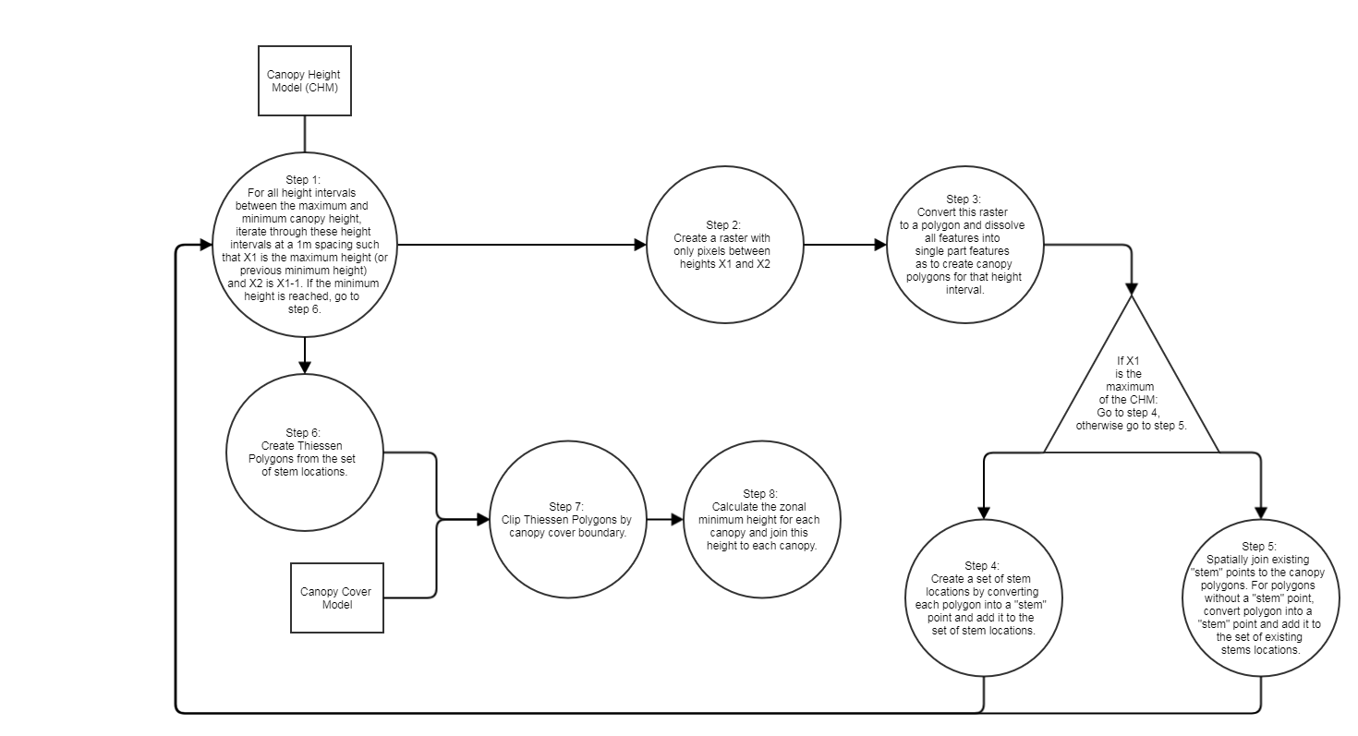

Appendix B

Table 1: Descriptive statistics results from planting points analysis of Reading Fire area

LASSEN NATIONAL FOREST
 | 2012 | 2014 | 2016
Mean | 0.416 | -0.154 | 0.063
StDev | 0.278 | 0.165 | 0.210
N observed | 9,256 | 9,256 | 9,256
Median | 0.507 | -0.146 | 0.000
LASSEN VOLCANIC NATIONAL PARK
 | 2012 | 2014 | 2016
Mean | 0.179 | -0.153 | 0.096
StDev | 0.318 | 0.242 | 0.238
N observed | 9,000 | 9,000 | 9,000
Median | 0.216 | -0.172 | 0.035

Table 2. Accuracy assessment for the SVM supervised classification.

2012
 | Bare | Grass | Tree | Overall accuracy (%)
Bare Earth | 50 | 0 | 0
Grass | 0 | 34 | 5
Tree | 0 | 16 | 45
Producer’s accuracy (%) | 100 | 68 | 90 | 86
Kappa Statistic | 0.79
2014
 | Bare | Grass | Tree | Overall accuracy (%)
Bare Earth | 47 | 2 | 1
Grass | 3 | 38 | 14
Tree | 0 | 10 | 35
Producer’s accuracy (%) | 94 | 76 | 70 | 80
Kappa Statistic | 0.7
2016
 | Bare | Grass | Tree | Overall accuracy (%)
Bare Earth | 45 | 0 | 0
Grass | 0 | 45 | 20
Tree | 2 | 5 | 30
Producer’s accuracy (%) | 96 | 90 | 60 | 82
Kappa Statistic | 0.73

Table 3. Results of land cover classification of 2012, 2014 and 2016 images, as percentage of computed area.

LAND COVER
 | 2012 | 2014 | 2016
Bare Earth | 30.5% | 63.0% | 45.2%
Grass | 42.1% | 17.4% | 25.5%
Tree | 27.4% | 19.5% | 29.3%

