NASA DEVELOP National Program
University of Georgia
Summer 2015

Southeast U.S. Ecological Forecasting
Utilizing NASA Earth Observations and Proximal Remote Sensing to Map the Spatio-temporal Distribution of Hydrilla verticillata


Technical Report
Final Draft – August 6, 2015

Shuvankar Ghosh (Project Lead)
Peter Hawman (Co-Project Lead)
Wuyang Cai
Elizabeth Dyer
Pradeep Kumar Ragu Chanthar

Dr. Deepak Mishra, University of Georgia (Science Advisor)
Dr. Susan Wilde, University of Georgia (Science Advisor)

I. Abstract
Hydrilla verticillata is an invasive aquatic plant that has become a serious problem in Southeastern United States, especially impacting vegetation and water quality. Traditionally, hydrilla infestation has been tackled using a combination of field-based physical, chemical and biological methods which are often costly. Rapid and accurate spatio-temporal estimates of hydrilla density and distribution are needed for better monitoring and management of this invasive plant. This project demonstrated an innovative approach using Landsat 8 OLI data to study the spread of this invasive aquatic plant in inland waters. NASA Landsat 8 Operational Land Imager (OLI) imagery in combination with in situ data was used to map hydrilla density and distribution in four lakes across Georgia and Florida. Performances of Visible Atmospherically Resistant Index (VARI) and Green Normalized Difference Vegetation Index (GNDVI) were analyzed for indications of hydrilla density and distribution, using a combination of statistical techniques, such as coefficient of determination (R2), percent normalized root mean square error (%RMSE), and residual trends. The resulting detection tool for monitoring hydrilla distribution was delivered to Georgia Power, the J. W. Jones Ecological Research Center, and the Henry County Water Authority for use in water quality restoration decision-making. This tool will be an efficient alternative to otherwise costly measures, and facilitate adaptive plant management.

Keywords
Remote Sensing, Landsat 8 OLI, Hydrilla, Macrophyte, Aquatic Plants, Invasive Species

II. Introduction
Background Information
Hydrilla verticillata, known commonly as hydrilla, is an invasive aquatic plant that can negatively impact native vegetation and water quality. It outcompetes native plants by growing rapidly and forming a surface canopy that blocks light passing through the water column. It intensifies stratification, creates anoxic conditions in deeper areas, and changes the amounts of many other important nutrients. This submersed aquatic plant is on the state and federal noxious weed lists and has been nicknamed ‘‘the perfect aquatic weed’’ due to its aggressive growth habit and adaptive morphological characteristics (Langeland 1996). Hydrilla has become one of the most serious aquatic weed problems for the southeastern United States. It affects the food chain, as aquatic wildlife can die from consuming hydrilla with associated toxic epiphytic cyanobacteria (Wilde et al., 2005). Hydrilla is also a concern for the recreation industry, clogging boat motors and becoming a swimming hazard. It can be economically costly as it obstructs water withdrawal for drinking, irrigation or power generation.

The native range of Hydrilla verticillata is believed to be Asia, Australia and possibly Africa (Cook & Luond 1982). The freshwater aquarium trade introduced hydrilla to Florida in the 1950s, and hydrilla spread throughout the southeast in the subsequent years (McCann et al., 1996). Today, according to the USDA’s Plants Database, hydrilla spans the southern United States, up the east coast into New England and west into California and Washington State as seen in Figure 1 (USDA Plants Database, 2015).
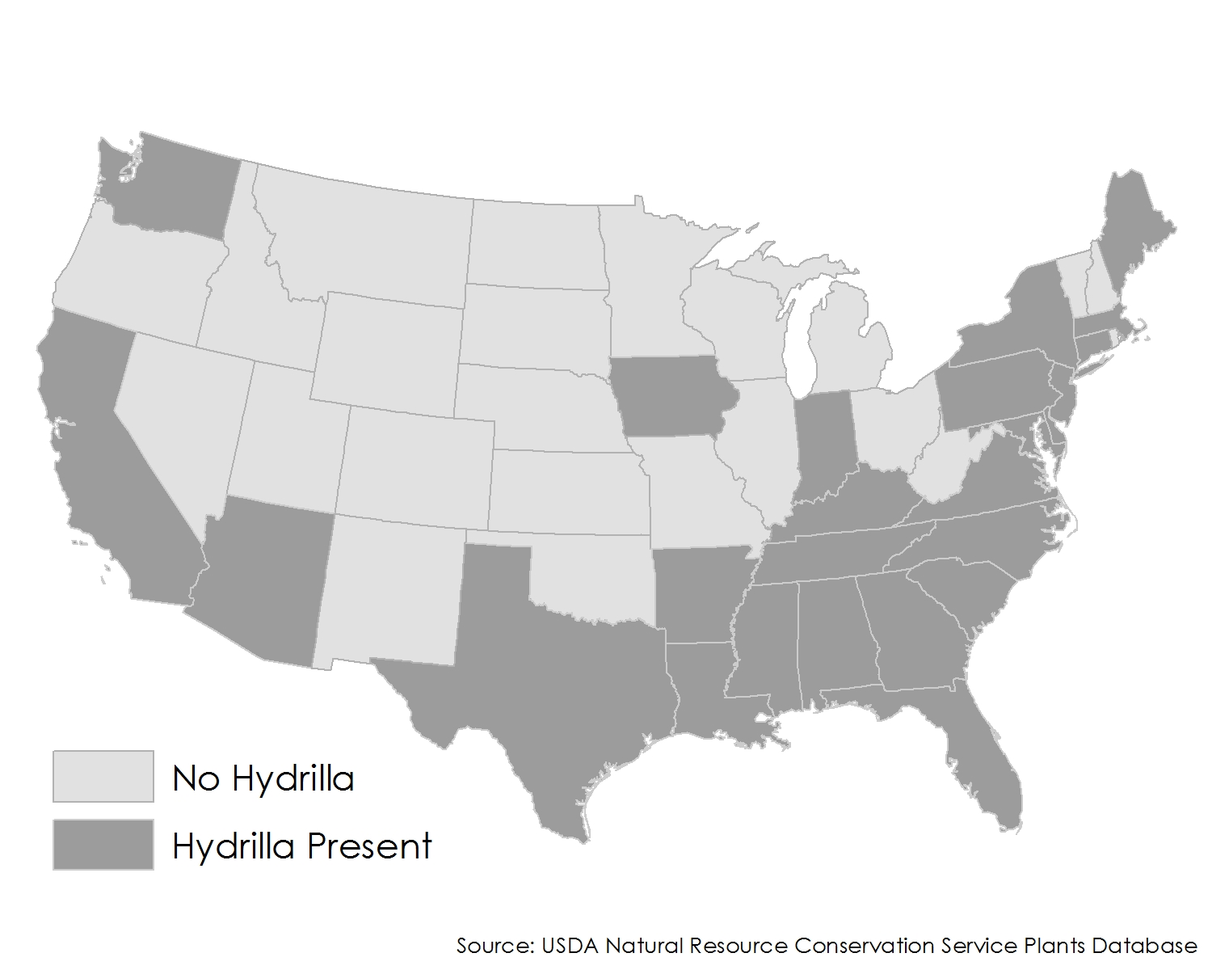
Figure 1: Hydrilla distribution across the United States

Study Area
This study focused on five reservoirs located in Georgia and bordering Alabama, Florida, and South Carolina (Fig. 2). Two of the lakes are managed by the United States Army Corps of Engineers (USACE), Lake Seminole and Lake Thurmond. Georgia Power manages the other three study lakes: Lake Harding, Lake Oliver, and Goat Rock Reservoir.

Located in the southwest corner of Georgia along its border with Florida, Lake Seminole is a USACE reservoir where there have been attempts to control hydrilla for almost 50 years using a combination of chemical, physical and biological controls. Hydrilla in Lake Seminole has interfered with navigation, degraded water quality, fish and wildlife habitat, diminished recreation area use, increased mosquito populations, blocked hydropower intakes, and decreased adjacent property values. Lake Strom Thurmond is a large reservoir (288 Km²) on the border between Georgia and South Carolina just north of Augusta, GA. This reservoir is the third of three reservoirs along the Savannah River. The USACE struggles to produce rapid accurate estimates of invasive plant density to determine which techniques provide the most cost-effective control throughout these reservoirs.

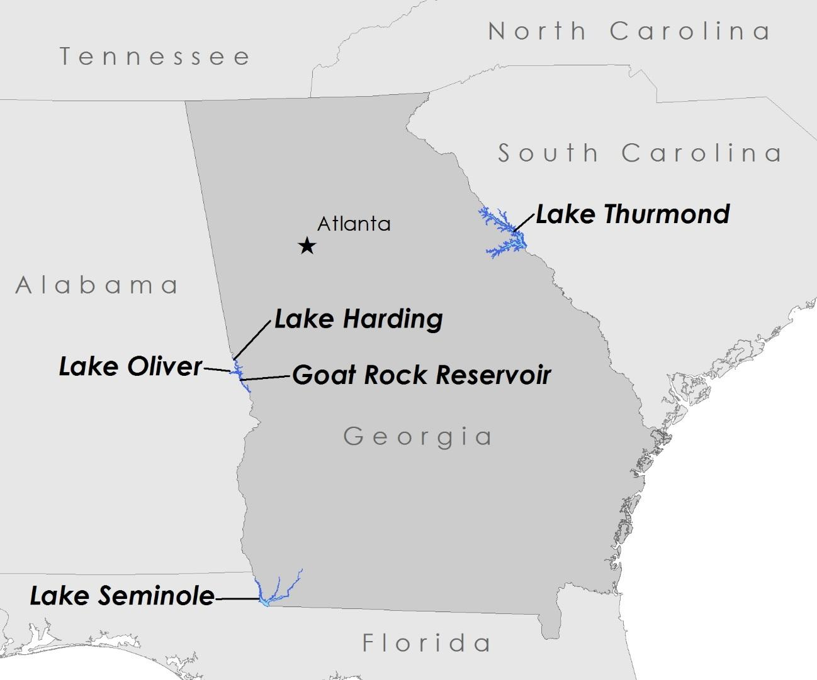
Figure 2: The five reservoirs studied: Lake Thurmond, Lake Harding, Lake Oliver, Goat Rock Reservoir, and Lake Seminole

In 2013, Georgia Power experienced a rapid hydrilla invasion throughout two large reservoirs on the Chattahoochee River: Lake Harding (24 Km²) and Lake Oliver (9 Km²). During the fall of 2014, Georgia Power discovered hydrilla expanding into the next reservoir down in the series, Goat Rock Reservoir. According to Anthony Dodd, Environmental Specialist from Georgia Power, they have received countless complaints from their stakeholder user groups, including dock owners who are overrun with hydrilla and fisherman who can’t motor through the thick mats.

Study Period
This project focused on mapping hydrilla distribution in the southeast for the years 2013 through 2015. These years were chosen because the project focused on utilizing NASA’s Landsat 8 satellite, which began collecting data in 2013. The Landsat 8 mission provides timely, high quality, visible and infrared images of all landmass and near-coastal areas on the Earth, which was necessary for the project goal of determining the distribution pattern of hydrilla in the study area.

National Application Areas
This project addressed two NASA Applied Science national application areas: Ecological Forecasting and Water Resources. This project focused on the formation of a benthic model allowing the forecasting of areas susceptible to hydrilla infestation. Because hydrilla impacts nutrient and oxygen levels in lakes and reservoirs, this project also addressed water quality issues and the results will aid lake managers in focusing mitigation efforts to control hydrilla expansion.

Project Partners
This project partnered with the Joseph W. Jones Ecological Research Center, the Georgia Power Company, and Henry County Water Authority.

The Joseph W. Jones Ecological Research Center is a research facility located in southern Georgia outside the town of Newton along the Flint River. The research facility is located just north of Lake Seminole. Dr. Stephen W. Golladay, Associate
Scientist, is a lead investigator on Lake Seminole Studies. For 10 years he and his team have been conducting studies on water quality in the lower Flint River and Lake Seminole, focusing on invasive species such as Hydrilla verticillata. Dr. Golladay and his colleagues are very interested in incorporating remote sensing to better understand phenological characteristics and seasonal distributions of hydrilla.

The Georgia Power Company is responsible for protecting and restoring 17 reservoirs in Georgia. As the owner and steward of these reservoir resources, the Georgia Power Company is concerned with the spread of Hydrilla verticillata and the negative impacts this species has on the health of Georgia reservoirs. Georgia Power requires a comprehensive assessment of hydrilla expansion to optimize their chemical control efforts. The production of accurate, timely biomass maps will allow for adaptive plant management.

University of Georgia science advisors, Dr. Deepak Mishra and Dr. Susan Wilde, have been assisting the Henry County Water Authority since 2010 when a hydrilla infestation was discovered in two of their newly constructed drinking water reservoirs. Hydrilla is creating recreation concerns for fisherman and waterfowl hunters. Bird deaths from Avian Vacuolar Myelinopathy, an emerging wildlife neurological disease linked to hydrilla have been documented at both two Henry County reservoirs.

III. Methodology

Data Acquisition:
The team used NASA's Landsat 8 Operational Land Imager (OLI) data to estimate hydrilla density and distribution in the five selected sites. Four scenes were needed to cover the five reservoirs (Table 1). All scenes were acquired from the data portal USGS Global Visualization Viewer as Level 1 GeoTIFF Data products. Images were selected based on cloud-free conditions in the vicinity of the study sites through visual interpretation. Images were collected from 2013 to present.

Table 1: Landsat 8 path and row for study lakes
Lake | Path | Row
Lake Harding | 19 | 37
Lake Oliver | 19 | 37
Goat Rock Reservoir | 19 | 37
Lake Thurmond | 18 | 36
Lake Thurmond | 18 | 37
Lake Seminole | 19 | 39

Reservoir Digital Boundaries:
Lake boundaries were acquired from several sources including the National Hydrographic Dataset and the Georgia GIS Clearinghouse. Individual lake boundary shapefiles from these two sources were compared and adjusted to reflect changes in shorelines based on the Landsat data and Google Earth imagery.

Field Data
The team collected extensive field data from the two reservoirs, Lake Thurmond and Lake Seminole. Multiple sites across these reservoirs were sampled for hydrilla presence, distribution and density. For each location several measurements were recorded including a GPS point location. In situ spectral data for the hydrilla present was measured using the SVC HR-1024i spectroradiometer for estimation of remote sensing reflectance (Rrs). The SVC HR-1024i spectroradiometer also captured a digital image for estimation of vegetation fraction. Plant depth below the surface was measured to estimate the attenuation of light through the water column. Hydrilla biomass samples were also collected over a 1 square foot area, oven dried and dry weight was estimated.

Data Processing
Prior to quantitative analysis and estimation of biophysical parameters, it was imperative to reduce the atmospheric effect on the surface reflectance values and increase the signal to noise ratio. Two atmospheric correction methods were compared, ACOLITE (Vanhellemont & Ruddick 2014) and the atmospheric correction suggested by Dash et al. (2012). The method created by Vanhellemont & Ruddick (2012) incorporates values of solar radiance, water absorption, Rayleigh optical thickness and ozone optical thickness into an intuitive graphic user interface for processing Landsat data. The results of each method were compared using spectral signatures and field measurements.
Atmospherically corrected scenes were mosaicked if required, and reservoir subsets were created using the digital lake boundaries. These subsets were used for model development, and creation of hydrilla distribution and density maps.
Data Analysis
Hydrilla biomass, height and vegetation fraction were calibrated using both Landsat-derived as well as in-situ-derived vegetation indices. The model was validated using Visible Atmospherically Resistant Index (VARI) (Gitelson et al., 2002) and the Normalized Difference Vegetation Index (NDVI) (Rouse et al., 1974) values calculated from field data, as shown in the equations (1) and (2) below.
VARI = (R_{Green} – R_{Red})/(R_{Green} + R_{Red}) (1)
NDVI = (R_{NIR} – R_{Red})/(R_{NIR} + R_{Red}) (2)
NDVI was used to identify vegetation floating on the water’s surface as well as along the shorelines of the lakes. Once identified, this vegetation was masked out and VARI was performed to locate and quantify the submerged vegetation. Using both these indices, the team was able to map vegetation both above and below the water’s surface.
Once the time series composites were prepared using NDVI and VARI, visual validation was done using Google Earth images. Threshold values of VARI and NDVI were adjusted accordingly, until we achieved a reasonably good match between our composites and Google Earth image.

IV. Results & Discussion

In Situ Results:
Through in situ data collection at two of the study lakes, Lake Thurmond and Lake Seminole, reflectance measurements of hydrilla were taken with the SVC HR-1024i spectroradiometer. These spectral measurements allowed the team to understand the reflectance patterns of hydrilla at different depths within the water column. Figure 3 illustrates the reflectance patterns at four different depths. Because water absorbs in the NIR region, reflectance values are lower when vegetation is deeper in the water column. There is still a peak in the green region around 560nm with obvious absorption in the blue and red regions. As hydrilla grows closer to the surface the red edge becomes more prominent. The red edge is the area between 680 and 690nm where there is a sharp upward trend in reflectance from red to NIR. Figure 3a shows the reflectance of hydrilla at greater than 7ft where there is little NIR reflectance do the absorption by water. Once the vegetation grows to 1.5ft below the surface the reflectance values around 700nm increase as seen in Fig. 3c. At the surface, floating hydrilla has similar reflectance profiles as terrestrial vegetation (Figure 3d).

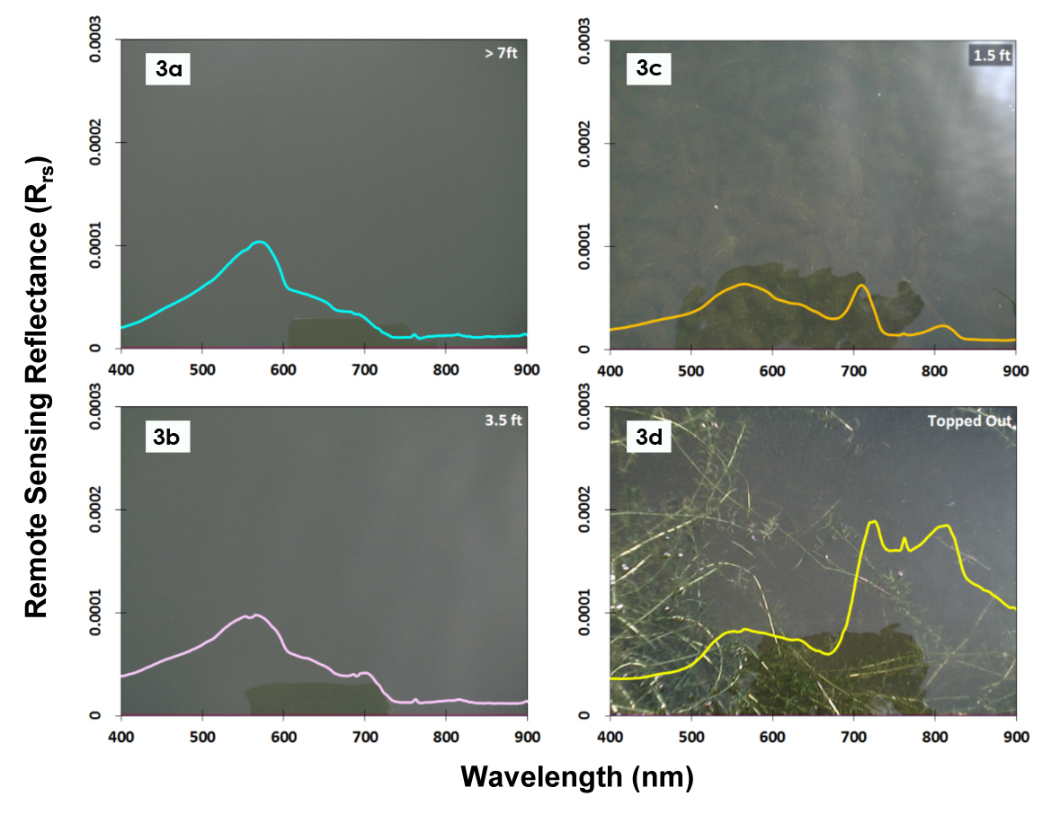
Figure 3: Spectral signature of submerged hydrilla across different water depths; reflectance at NIR becomes more prominent with decreasing depth

Lake Seminole:
The time series composites prepared were able to capture the spatio-temporal distribution of hydrilla in our study area. The composites showed the phenological characteristics of hydrilla in lake seminole; plant growth beginning in early spring and peaking in late summer and early fall before dying back in winter. The densest areas of hydrilla were located predominantly in the Spring Creek portion of the lake with several large patches also present in the Flint River section. There was also a large patch along the dam in the southern portion of the lake (Appendix A).
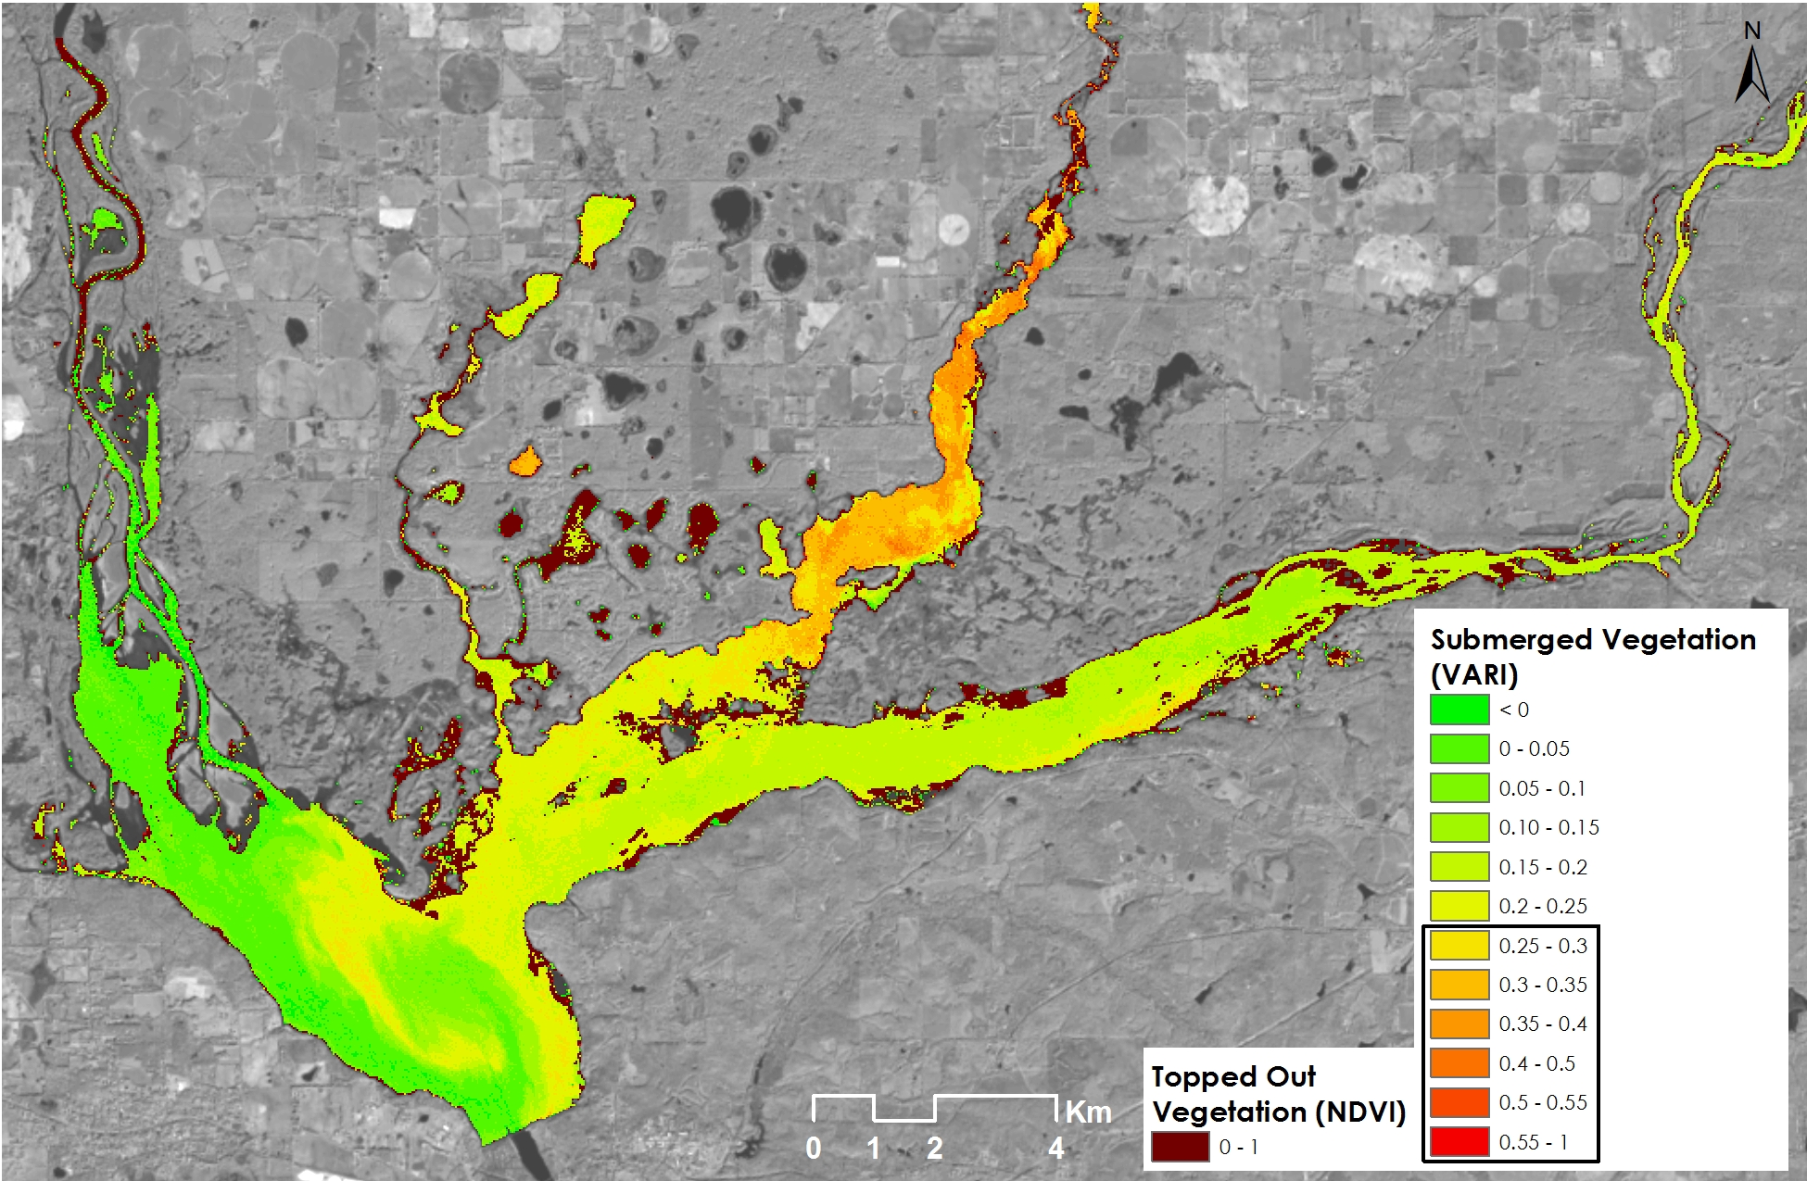
Figure 4: Hydrilla distribution in Lake Seminole for May 22, 2014

The composite from May 22, 2014 (Fig. 4) clearly shows the growth of hydrilla in the northern branch of the lake, Spring Creek. The abundance of submerged vegetation is represented in green in the map. Along the edges of Flint River topped out vegetation is seen along the northern and southern shorelines, shown in dark red. Later in the growing season the amount of both submerged and topped out vegetation can be seen to increase.

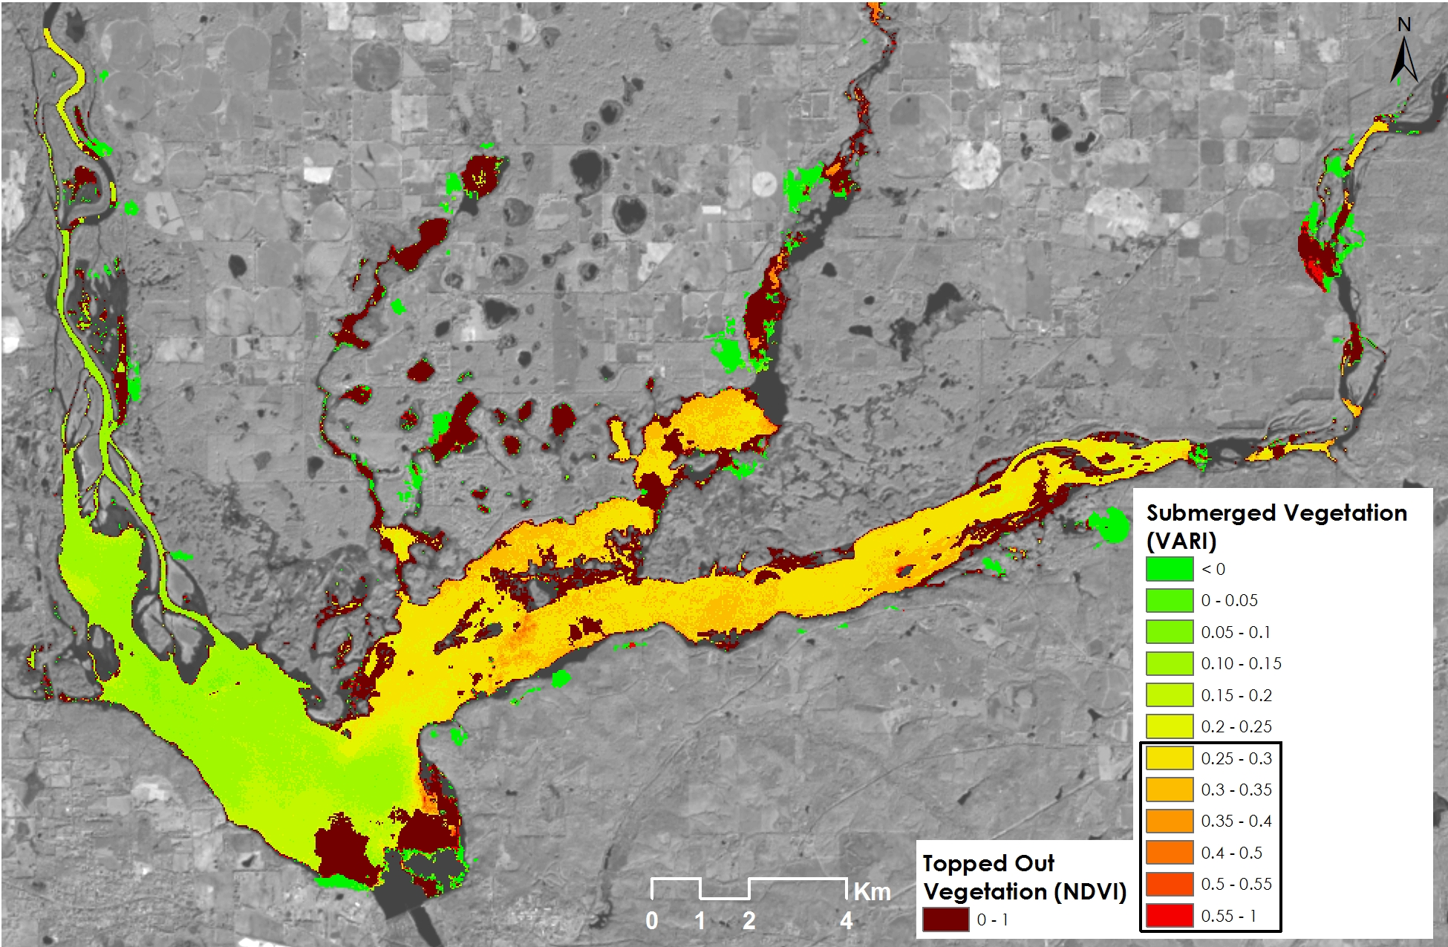
Figure 5: Hydrilla distribution in Lake Seminole for September 11, 2014

The composite for September 11, 2014 (Fig. 5) demonstrates this. Submerged vegetation is abundant in both Spring Creek and the Flint River sections of the lake. As temperatures start to decrease in autumn, the plants senesce and sink down in the water column reducing the amount of topped out vegetation.
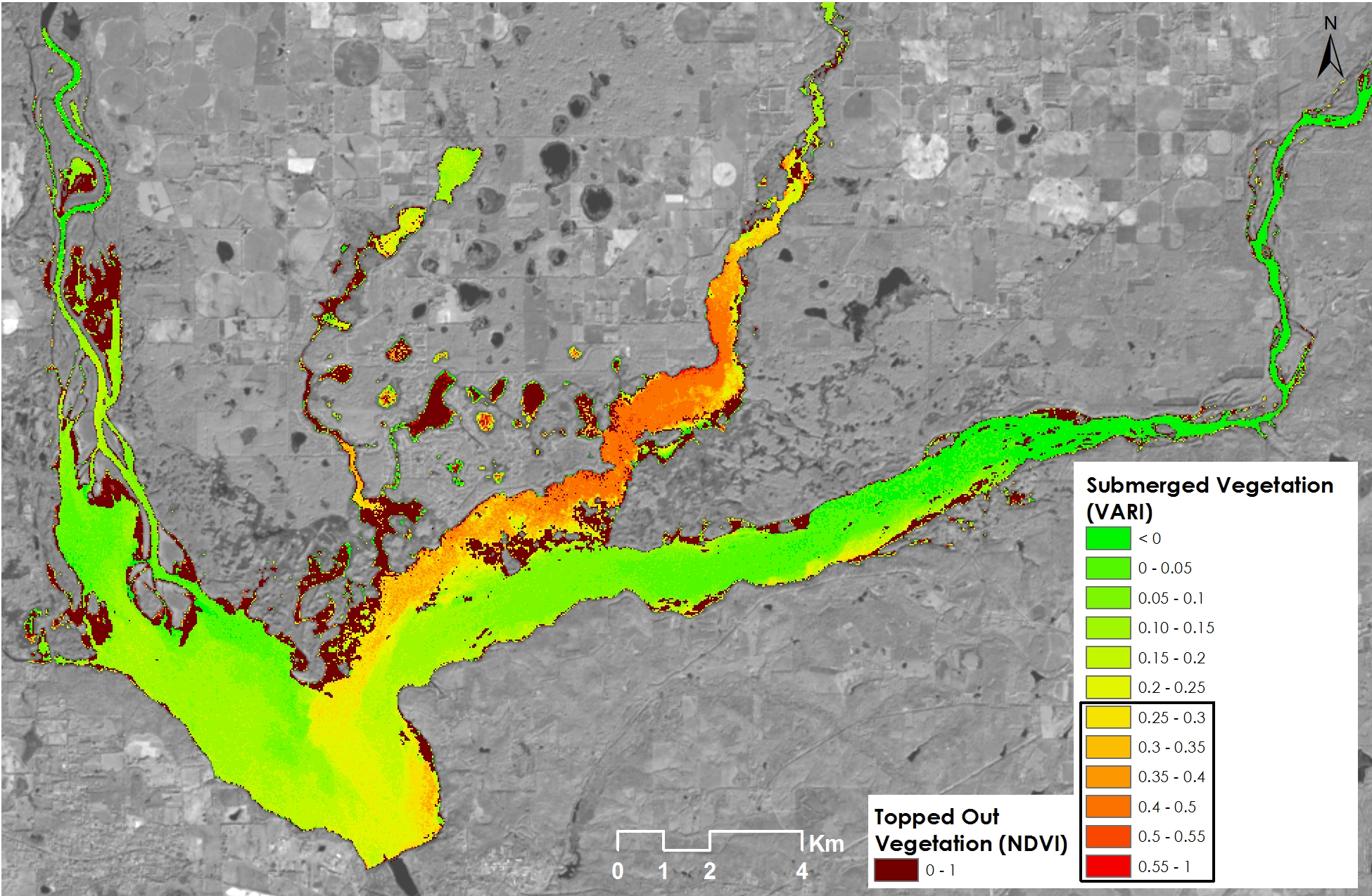
Figure 6: Hydrilla distribution in Lake Seminole for November 30, 2014

Submerged vegetation is still present and is seen in the composite for November 30, 2014 (Fig. 6). Note the topped out areas in the western side of the lake in the Chattahoochee River branch. These areas were identified by the project partners at the Joseph W. Jones Ecological Research center as floating lily pads with few areas of hydrilla.
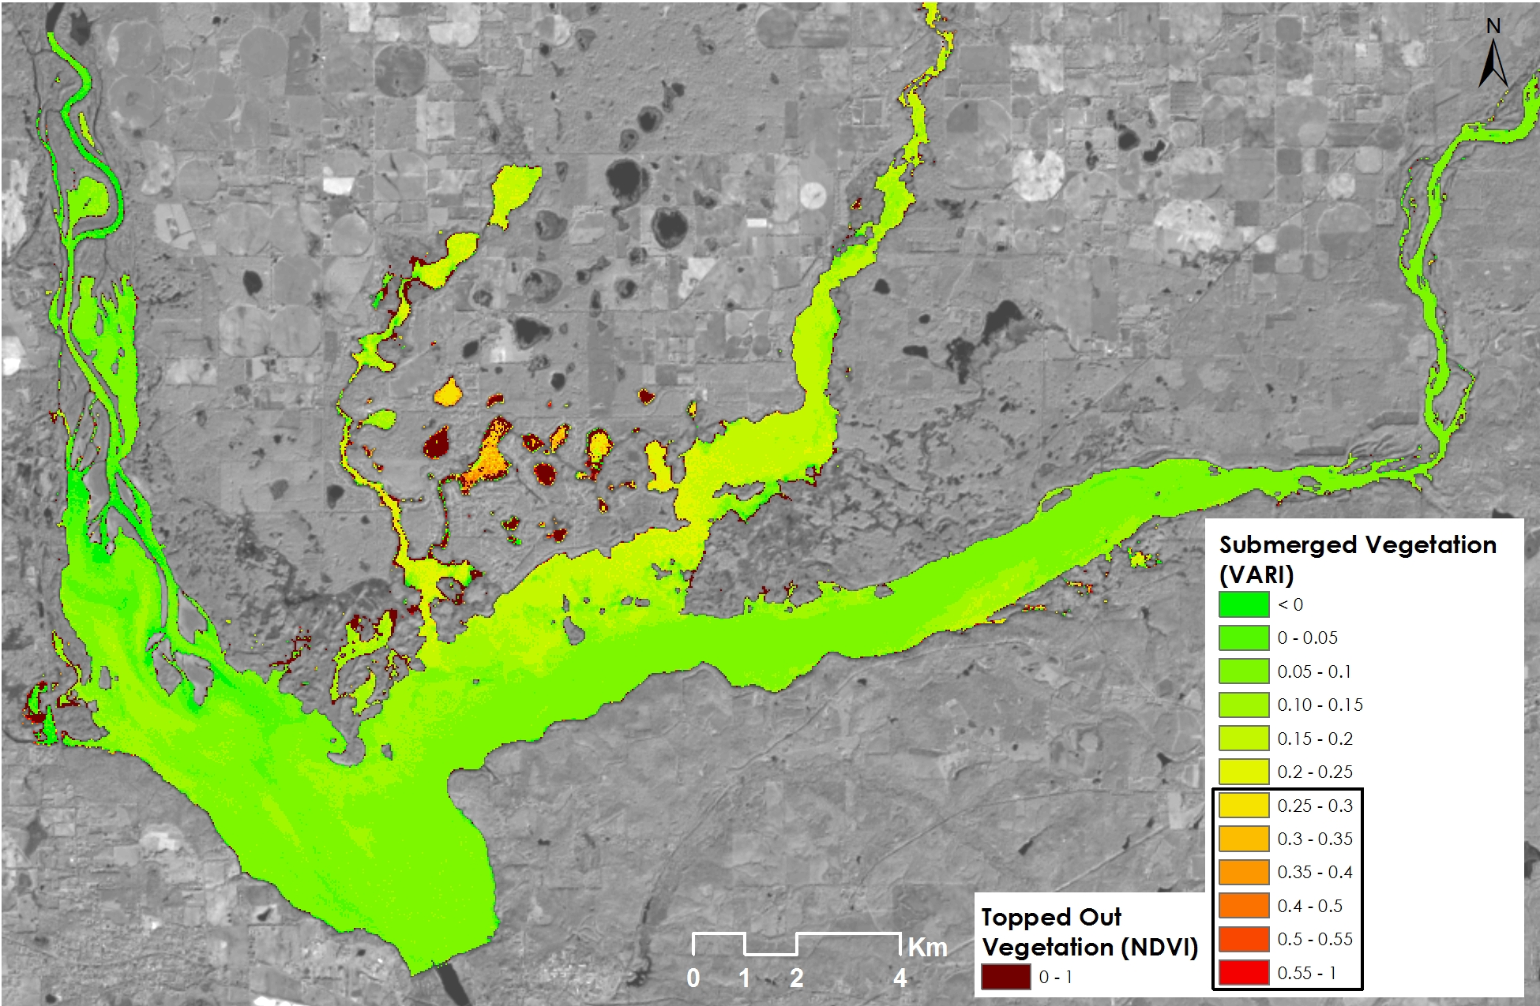
Figure 7: Hydrilla distribution in Lake Seminole for February 18, 2015

By the middle of February, there is very little vegetation present in our composites (Fig. 7). The areas in dark yellow are the remains of hydrilla from the previous year.

Lake Harding, Oliver and Goat Rock Reservoir:
Similar to our findings with Lake Seminole, the chain of lakes consisting of Lake Harding, Lake Oliver and Goat Rock Reservoir show the seasonal variation of hydrilla (Appendix B - E). Goat Rock Reservoir appears to have the highest amount of hydrilla located on the western portion of the lake. This area and the surrounding coves are shallower and more suitable for hydrilla growth. Topped out hydrilla is seen clearly in Lake Oliver in August of 2013 (Appendix B).

Errors & Uncertainty:
The hydrilla detection models developed so far need robust validation, using more in situ data. When comparing our results to those from our partners at the Joseph W. Jones Ecological Research Center, we saw a potential overestimation by our methods. Their distribution maps were created through visual observation at ground level. This limits their ability to observe deeper submerged vegetation however several of our composites identified hydrilla in areas that it may not actually be present. Likewise, there are some sections in the Chattahoochee River area where hydrilla was present in 2013 but our methods could not identify it. Several factors could result from this overestimation. One is the inability to distinguish different species through our methods. Though hydrilla is the predominate macrophyte in the lake, other vegetation is present. Additionally, increases in sedimentation after rain events causes the reflectance values of the lake to increase which made it difficult to accurately map the submerged vegetation. To correct for over-sedimentation, careful selection of images for processing is needed to avoid this issue.

Additional testing of atmospheric correction may also yield improved results. Correcting for atmospheric effects over inland waters can be difficult. The methods used in this project were originally designed for coastal waters. Comparing several methods and incorporating in situ reflectance values taken from a spectroradiometer would allow for fine tuning the atmospheric correction procedures.

Future Work:
To improve the results and create a modeling tool, future work is needed. To improve results more field data needs to be collected. During this term the team was only able to visit two of the five study lakes. Visiting each lake and conducting repeated data collection trips throughout the growing season would allow the team to more accurately verify our results. Once the accuracy of our results has increased, a model or tool can be built to allow partners to continue mapping the distribution of hydrilla.

V. Conclusions

The results demonstrated the feasibility of mapping macrophytes using Earth observing satellites. NASA’s Landsat 8 OLI has the potential to identify the presence of submerged aquatic vegetation allowing the team to map the spatial-temporal variation of hydrilla within the study lakes. Additional in situ data collection is required for refinement and validation of the hydrilla density distribution models developed so far. Mapping accuracy depends on the depth of the submerged vegetation and further analysis is needed to correlate reflectance values with hydrilla depth below the surface. Ultimately, this methodology can help the project partners to detect the presence of hydrilla using low cost methods that provide up to date distribution maps.

VI. Acknowledgments

The NASA DEVELOP Southeast U.S. Ecological Forecasting team would like to thank the project partners, the Joseph W. Jones Ecological Research Center, the Georgia Power Company, and the Henry County Water Authority. Their support through field data and access to study sites was necessary for the success of this project. We would also like to thank our science advisors, Dr. Deepak Mishra and Dr. Susan Wilde. Their expertise and guidance helped drive this project and their continued support for the DEVELOP program has benefited the University of Georgia node greatly. Finally, a special thanks to the DEVELOP National Program Office for their support of this project.

This material is based upon work supported by NASA through contract NNL11AA00B and cooperative agreement NNX14AB60A.

VII. References

Cook, C.D.K. and Luond, R. (1982). A revision of the genus Hydrilla (Hydrocharitaceae). Aquatic Botany 13:485-504.

Dash, P., Walker, N., Mishra, D., D’Sa, E., & Ladner, S. (2012). Atmospheric Correction and Vicarious Calibration of Oceansat-1 Ocean Color Monitor (OCM) Data in Coastal Case 2 Waters. Remote Sensing, 4(6): 1716-1740.

Georgia GIS Clearinghouse. (2015). Available from https://data.georgiaspatial.org

Gitelson, A. A., Kaufman, Y., & Merzlyak, M. N. (1996). Use of green channel in remote sensing of global vegetation from EOS-MODIS, Remote Sensing of Environment, 58: 289 – 298.

Gitelson, A. A., Stark, R., Grits, U., Rundquist, D., Kaufman, Y., & Derry, D. (2002). Vegetation and soil lines in visible spectral space: a concept and technique for remote estimation of vegetation fraction, International Journal of Remote Sensing, 23(13): 2537−2562

“Hydrilla verticillata (L. f.) Royle waterthyme.” USDA Natural Resource Conservation
Service: Plants Database. n.p. Web. 18 June 2015

Langeland, K. A. (1996). Hydrilla verticillata (LF) Royle (Hydrocharitaceae)," The Perfect Aquatic Weed". Castanea, 293-304.

United States Geologic Survey Global Visualization Viewer. (2015). Available from http://glovis.usgs.gov/

United States Geologic Survey National Hydrography Dataset. (2015). Available from http://nhd.usgs.gov/index.html

Vanhellemont, Q., & Ruddick, K. (2014). Turbid wakes associated with offshore wind turbines observed with Landsat 8. Remote Sensing of Environment 145: 105-115.

Wilde, S. B., Murphy, T. M., Hope, C. P., Habrun, S. K., Kempton, J., Birrenkott, A., Wiley, F., Bowerman, W. W., Lewitus, A. J. (2005). Avian Vacuolar Myelinopathy Linked to Exotic Aquatic Plants and a Novel Cyanobacterial Species. Environmental Toxicology, 20(3), 348-353.

McCann, A.J., Arkin, L.N., Williams, J.D. (1996). Nonindigenous Aquatic and Selected Terrestrial Species of Florida. Southeastern Biological Science Center, 256 p.

VIII. Content Innovation

Interactive Map Viewer: Map of hyrilla distribution in Lake Seminole

Interactive Plot Viewer: Spectra of hydrilla at varying depths below the water’s surface

IV. Appendices
Appendix A
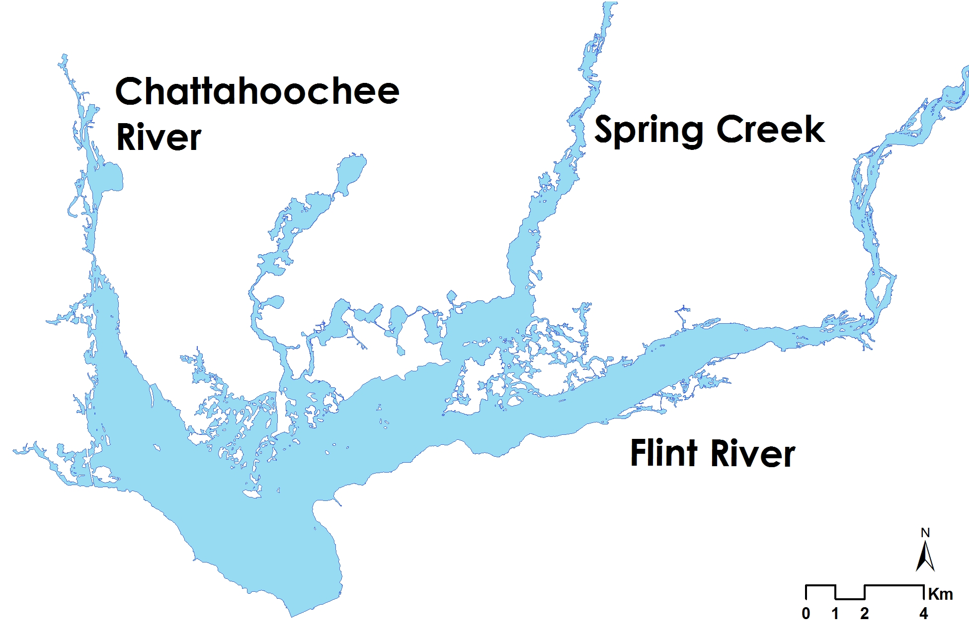
The three branches of Lake Seminole: Chattahoochee River, Spring Creek and Flint River.

Appendix B

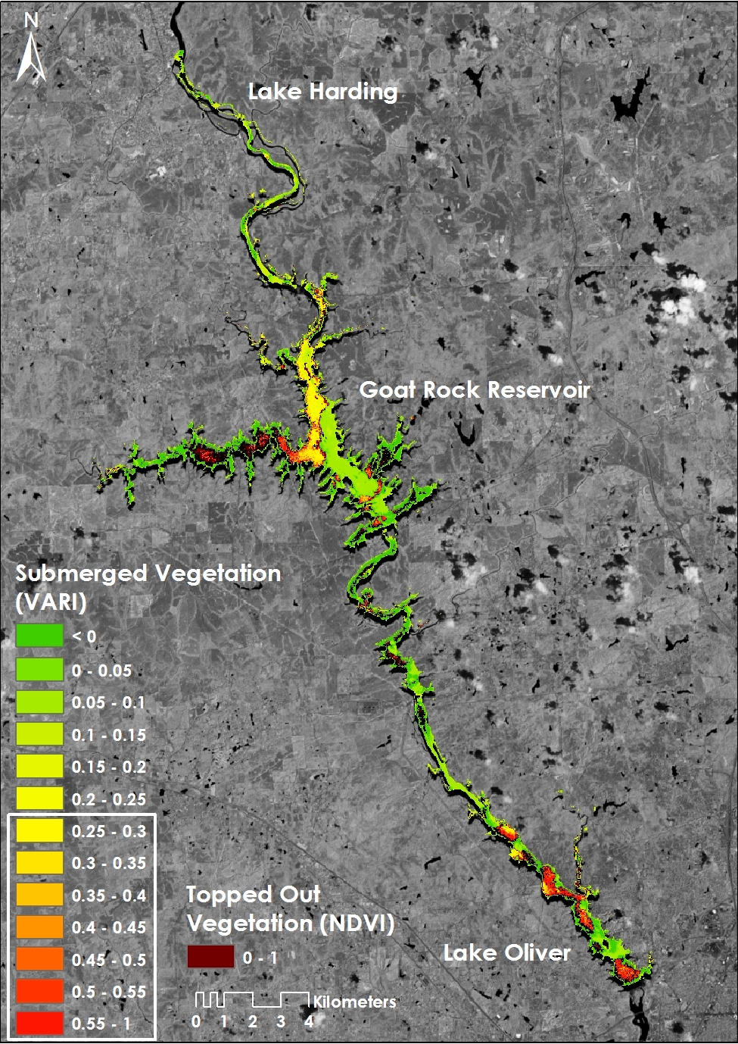
Hydrilla distribution in Lake Harding, Oliver and Goat Rock Reservoir for August 23, 2013
Appendix C

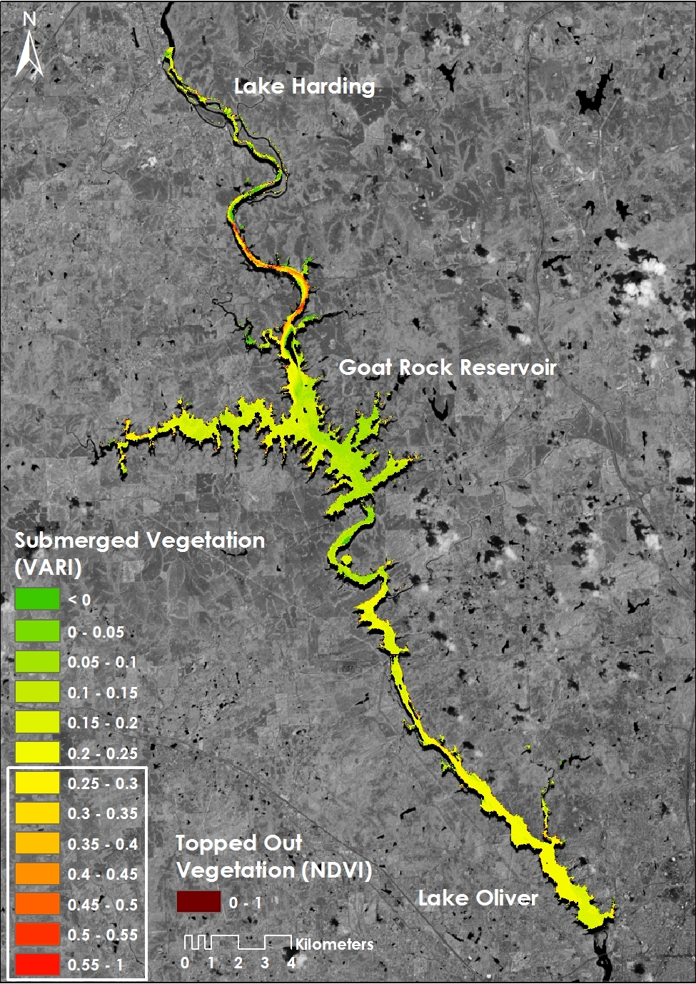
Hydrilla distribution in Lake Harding, Oliver and Goat Rock Reservoir for November 11, 2013
Appendix D

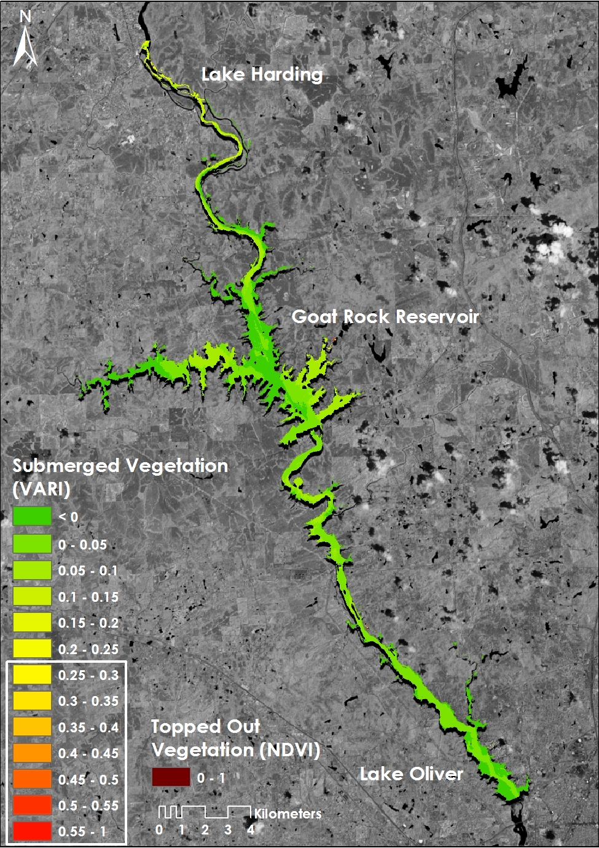
Hydrilla distribution in Lake Harding, Oliver and Goat Rock Reservoir for February 15, 2014
Appendix E

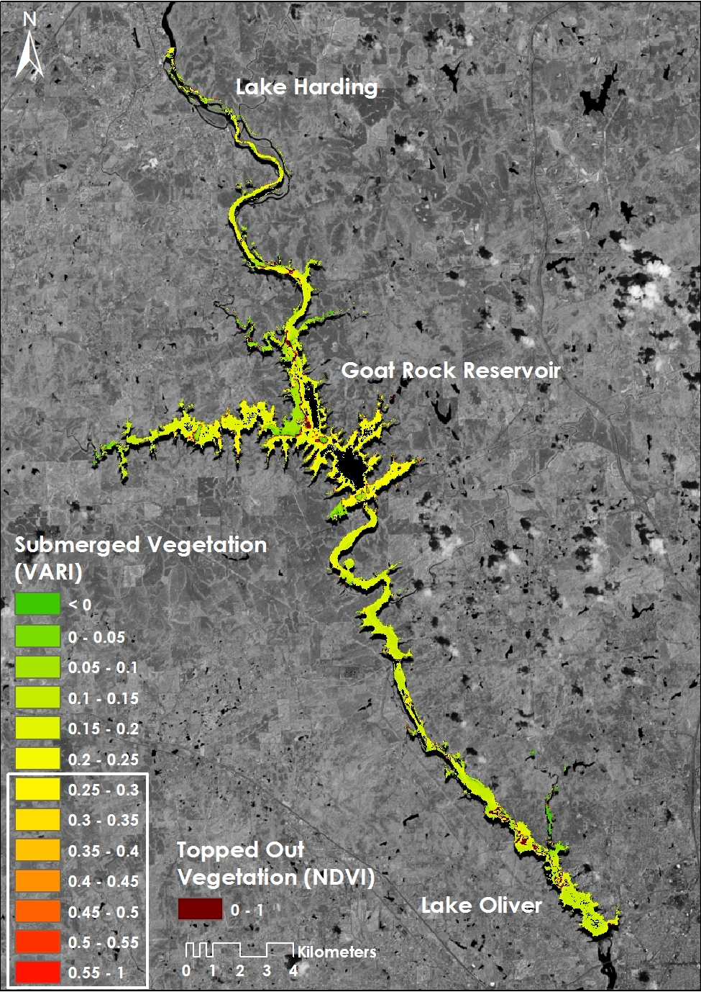
Hydrilla distribution in Lake Harding, Oliver and Goat Rock Reservoir for May 6, 2014

