**NASA DEVELOP National Program**

****NASA Marshall Space Flight Center

**Summer 2015**

**Short Title: Texas and Arizona Ecological Forecasting**

**Subtitle:** Utilizing NASA Earth Observations to Monitor and Manage Ocelot Habitat Loss

**VPS Title:** There’s Not a Lot of Ocelots: The Search for an Endangered Feline

**Project Team & Partners**

**Project Team:**

Daryl Ann Winstead (Project Lead), daw0005@uah.edu

Kaushik Narasimhan

Christ**i**na Fischer

Amberle Keith

**Advisors & Mentors:**

Dr. Jeffrey Luvall (NASA at the National Space Science Technology Center)

Dr. Robert Griffin (University of Alabama in Huntsville)

**Partner Organizations**

Pittsburg Zoo & PPG Aquarium, Collaborator/Boundary Organization, POC: Ken Kaemmerer

Pittsburg Zoo & PPG Aquarium, Collaborator/Boundary Organization, POC: Dr. Joseph Gaspard

Caesar Kleberg Wildlife Research Institute at Texas A&M University–Kingsville, End-User/Boundary Organization, POC: Michael Tewes and Humberto Perotto

The Denver Zoo, End-User, POC: Nanette Bragin

South Texas Refuge Complex, End-User, POC: Mitch Sternberg

Texas Department of Transportation, End-User, POC: Dr. John Young, Jr.

Secretaria de Medio Ambiente y Rescusos Naturales (SEMARNAT), Boundary Organization/End-User, POC: Dr. Arturo Caso

East Wildlife Foundation, End-User, POC: Dr. Tyler Campbell

**Project Details**

**Applied Sciences National Applications Addressed:**

Ecological Forecasting

**Study Area:** TX and AZ

**Study Period:** Jan - Mar, 1996 - 2014

**Earth Observations & Parameters**

Landsat 8, Operational Land Imager (OLI) - Land Cover

Landsat 5, Thematic Mapper (TM) - Land Cover

Terra, MODIS - Surface Reflectance

Terra ASTER - Global Digital Elevation Model

**Ancillary Datasets Utilized**

* USFWS U.S. Counties for Ocelot Species - Believed occurrences of ocelots
* Texas A&M University Current Ocelot Habitat Data - Ocelot habitat locations
* U.S. Census Bureau Census Data - Current population and road network data

**Models Utilized**

* Princeton University Maximum Entropy Distribution Model (Maxent)

**Software Utilized**

ArcGIS 10.2.1 - Raster Manipulation/Analysis, land cover classification of Landsat imagery, Normalized Difference in Vegetation Index (NDVI) of Landsat, Terra, and Aqua MODIS imagery

ENVI Classic - Data processing of Landsat, geo-referencing of Terra and Aqua MODIS imagery, land cover classification of Landsat imagery

R - Execution of Maxent

Soil Data Viewer 6.2 - Access to soil databases

**Project Overview**

**80-100 Word Objectives Overview**

The goal of this project was to use remote sensing technologies to study ocelot habitats in southern portions of Texas and Arizona. In recent years, urban and agricultural growth has reduced the ocelot habitat in the United States. Additionally, road development has had a significant impact on ocelot populations by isolating ocelot territory and increasing risk for vehicular collisions. This project contributed to a further understanding of these trends, empowering decision makers to find ways to reduce their impacts on ocelot habitat and prevent further habitat loss, as well as find ways to minimize conflicts between humans and ocelots.

**Abstract**

Although ocelot (*Leopardus pardalis*) habitat is found throughout Central America, portions of South America, and the United States, the species is currently listed as endangered with less than 100 remaining in the United States. This cat requires a minimum home range of 6.5 square kilometers, which aids in deadly interactions with humans on roadways. Many conservation efforts have been attempted, from ocelot translocation to habitat restoration. In this project, a remote sensing approach was developed, using NASA Earth-observing sensors. Landsat 8 Operational Land Imager (OLI) and Landsat 5 Thematic Mapper (TM) imagery were used to create supervised land cover classifications for 1996, 2005, and 2014 during January through March to assess land use and cover over time. Surface reflectance imagery from Terra and Aqua Moderate Resolution Imaging Spectroradiometer (MODIS) were then used to derive Normalized Difference Vegetation Index (NDVI values) to verify the results from the land cover classification layer. The verified land cover classification was then used with *in situ* data in the Princeton Maximum Entropy model to identify suitable ocelot habitat. A proximity risk map to roads and urban areas was created using multiband buffer zones over this habitat. The products were delivered to the Pittsburgh Zoo & PPG Aquarium, Caesar Kleberg Wildlife Research Institute, Denver Zoo, Texas Department of Transportation, South Texas Refuge Complex, and Secretaria de Medio Ambiente y Rescusos Naturales. The use of GIS and remote sensing will greatly aid the project partner’s decision-making process in directing conservation efforts for this endangered species.

**Community Concerns**

* Congress listed the ocelot (*Leopardus pardalis*) on the Endangered Species List in 1981, as fewer than a hundred individuals remain in the closed canopy dense thornscrub of south of Texas and in the Sky Islands region of Arizona.
* According to Simpson et al. (2010), 95% of ocelot habitat has been destroyed as a result of human encroachment and land alteration of the ocelot historical range. Combined with poaching, isolation as a result of highways and urban sprawl, and conversion to farmland, remaining ocelot populations face severe population pressures.
* Grigioni & Mrykalo (2004) stated that 16 counties in southern Texas that represent the majority of ocelot habitat are among the fastest growing counties in Texas. The Texas Office of the State Demographer projects Cameron and Hidalgo counties, which contain the majority of the remaining ocelots in the U.S., will grow in population by 83% and 130% by 2050 respectively.
* Remaining populations remain small and isolated. These ocelots face inbreeding depression, reduced reproductive success, and increasing competition from other mesopredators.
* Large populations of ocelots live on privately-owned lands, and partnerships with stakeholders are vital to preserving remaining populations.

**Current Management Practices & Policies**

Currently, conservation efforts by researchers at Caesar Kleberg Wildlife Institute at Texas A&M University - Kingsville and South Texas Refuge Complex include a variety of practices, such as the use of camera trappings, radiotelemetry, translocation of Mexican ocelots, and the restoration of native vegetation in the area. These management practices can be costly and time-consuming for the project’s partners and each technique has its limitations. Trapping and collaring ocelots is an invasive method which causes the animal undue stress. Additionally, previously trapped ocelots avoid traps in the future, further increasing the difficulty of future research. While camera trapping is a non-invasive practice, accurate assessments of population density for ocelots is difficult via this method, as trap placement bias, small sample size, and repeated captures of the same individuals contribute to skewing the data.

**Decision Support Tools & Benefits**

|  |  |  |
| --- | --- | --- |
| **End-Product** | **Earth Observations Used** | **Benefit & Impact** |
| Habitat Percent Cover Map | Landsat 8 OLI, Landsat 5 TM | This product will narrow the focus of the decision making process to specific locations for vegetation restoration. |
| Habitat Probability Map | Landsat 8 OLI, Terra MODIS | This product will aid the decision making process for future translocation of ocelots. |
| Proximity Risk Map | Landsat 8 OLI, Terra MODIS, Terra ASTER | This product may help the decision making process for current and future road networks in order to minimize human/ocelot conflicts. |

**Project Imagery**

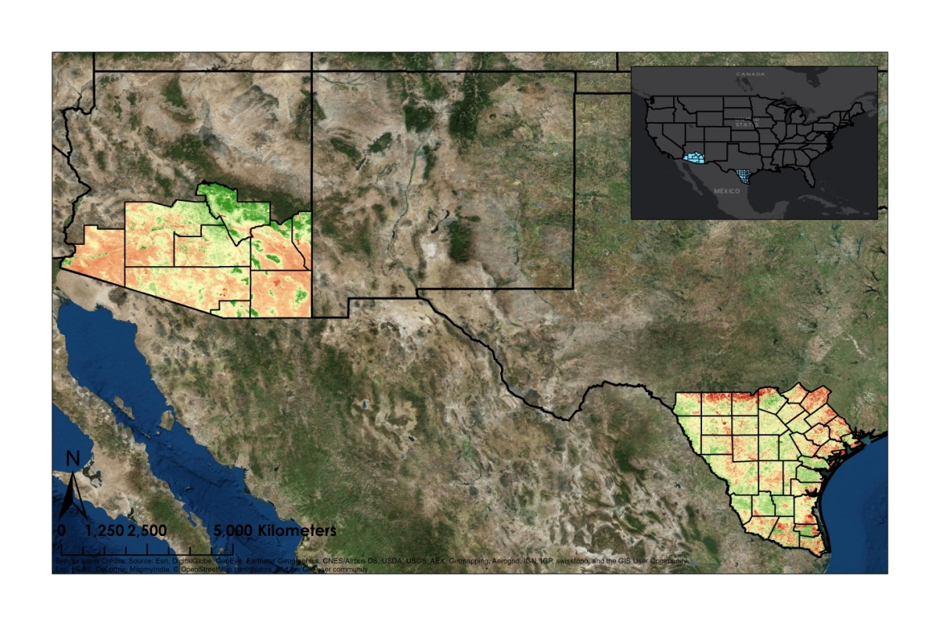

Study Area

**NDVI**

High : 0.9

Low : -0.8

**Caption:** The Normalized Difference in Vegetation Index (NDVI), which indicates varietals in vegetation, aided in the finding of suitable ocelot habitat. Image Credit: Texas and Arizona Ecological Forecasting Team.

**Image:** 2015Sum_MSFC_TXAZEcoForecasting_VPSImage.jpg