NASA DEVELOP National Program
NASA Langley Research Center
Fall 2015

El Salvador Ecological Forecasting
Utilizing NASA Earth Observations to Develop a Historically Based
Trajectory of Deforestation and Degradation in El Salvador


Technical Report
Final Draft – November 19, 2015

Jordan Ped (Project Lead)
Stephen Zimmerman
Courtney Duquette
Susannah Miller
Clarence Kimbrell

Dr. Kenton Ross, DEVELOP National Program (National Science Advisor)

I. Abstract
Tropical rainforests have been recognized as a major contributor to maintaining the global carbon budget and contain a significant portion of the world's biodiversity. However, these ecosystems are threatened by deforestation and forest degradation and require careful management to retain their ecosystem services. La Mancomunidad La Montañona in Chalatenango, El Salvador is home to the critical Rio Lempa watershed where small scale farmers and pastoralists commonly practice slash-and-burn agriculture. Using NASA Earth observations in collaboration with Ministerio de Medio Ambiente y Recursos Naturales (MARN) and the Earth Institute of Columbia University, Agroforestry for Biodiversity and Ecosystem Services (ABES) Project, a methodology was developed for stakeholders and policy makers to monitor long-term changes in forest cover and identify indicators of forest degradation. A baseline time series showing forest cover, land use, and land cover from December 1986 to January 2015 was used to forecast forest cover change. These predictions and tools will help assess priority areas for conservation and development of sustainable agricultural practices.

Keywords
Remote Sensing, Land Use/Land Cover, Classification, Earth Observing Systems, Landsat, Forecast

II. Introduction
Forests of Mesoamerica are critical to global ecological stability. These forests support highly biodiverse ecosystems, remove carbon dioxide (CO₂) from the atmosphere, and act as a carbon sink in the form of biomass accumulation (Houghton, Skole, & Lefkowitz,1991). In addition, in mountainous regions they purify the small streams and rivers which are critical sources of water for isolated rural communities (Rosa et al. 2003). These important forest ecosystems currently face many threats such as frequent exploitation for timber, agriculture, and pastoralism, which have led to deforestation and forest degradation (Herold, et. al 2011). Subsistence farmers throughout Mesoamerica commonly practice “slash-and-burn” agriculture, which is the process of cutting down trees and burning remaining vegetation to clear lands for agriculture (Wilken, 1990, p. 56). In lightly populated regions, this method can be a sustainable practice, but intense agricultural activity make slash-and-burn methods unsustainable. El Salvador has the least forest cover (121,000 ha) and the highest population density (295 people/km²) of the seven countries in Central America (World Bank, 2014; Billings et al. 2004/2). In La Mancomunidad La Montañona, a mountainous region in Northern El Salvador, the forests are being threatened by traditional slash-and-burn agricultural practices.

The primary objectives of this project were to create a regional land use and land cover (LULC) classification with a nationally applicable methodology and a forecast model based on historical imagery. The LULC classification for the years 1986, 1996, 2000, and 2014 used regionally specific classes; lakes or rivers, forested areas, agricultural or crop land, pastoral plots or pasture, and urban development or roads. The forecast model predicted the extent of future land cover change based on the data derived from the classifications for the year 2030. The project period was based on the longest time series available, 1986 - 2015. Landsat imagery from the dry season (November to April) was selected to coincide with ancillary datasets provided by project collaborators and end-users.

In collaboration with the NASA DEVELOP El Salvador Ecological Forecasting team, the Agroforestry for Biodiversity and Ecosystem Services (ABES) Project through the Earth Institute at Columbia University provided field surveys and additional satellite imagery to use as ground truth and satellite calibration data. The end-users of the project include La Mancomunidad La Montañona, Chalatenango, El Salvador, and the Ministerio de Medio Ambiente y Recursos Naturales (MARN). MARN is in the process of developing strategic policies specially focused on reducing deforestation and degradation at the national scale by implementing Reducing Emission from Deforestation and Degradation (REDD+) guidelines set forth by the United Nations at the United Nations Framework Convention on Climate Change (UNFCCC). The ABES Project worked as an intermediary to incorporate the end products of this research into tangible results that address the concerns of the local community. The classification of the images from the Landsat archives created a thorough understanding of past land use and land cover practices as well as an overview of regional trends. The model recognized these trends and highlighted high risk areas to inform La Mancomunidad La Montañona’s decisions in addressing water quality, forest degradation, and deforestation. In addition to addressing regional concerns, the project served to develop an extensible methodology for national forest monitoring.

The NASA National Science Application area addressed in this project was Ecological Forecasting. The project used time series images from the study area to examine historic forest change over four epochs. This information was used to determine regional forest dynamics, including which areas face the greatest risk of deforestation and forest degradation, through a forecast model.

III. Methodology
Data Acquisition
Landsat 4/5 TM and 8 OLI imagery for path 19, row 50, were downloaded from United States Geological Survey (USGS) for the years of 1986-2015 during the dry season, which runs from November to April. An image was downloaded for each season as close to the month of December as possible based on availability, while maintaining minimal cloud cover. This was determined by manually choosing each scene from the USGS Global Visualization (GLOVIS). The ABES Project and MARN provided survey data from 2012 and 2014 and RapidEye from 2012 of the La Mancomunidad La Montañona region. QuickBird imagery of the region from a 100 km² area in December 2012, and LULC classifications created from both high resolution satellites (Table 1).

Table 1. Earth Observing Systems and High Resolution Satellite Imagery
Table 1. Shows the details on each type of imagery used in classification.
Satellite | Source | Resolution | Research Use | Year Acquired
Landsat 4/5 TM | USGS GLOVIS | 30 m | Land Use/Land Cover | 1986 1996, 2000
Landsat 8 OLI | USGS GLOVIS | 30 m | Land Use/Land Cover | 2014
RapidEye | Project Collaborators (ABES) | 5 m | Ground Truth for Land Use Land Cover | 2012 (Region)
QuickBird | Project Collaborators (ABES) | 2.4 m | Global Forest Cover (GFC) validation, | December, 2012
Additional data were acquired from various open sources. The terrain and elevation layers used as inputs for the forecasting model were acquired from SRTM-1 (SRTM, 2000). The municipalities and country outlines were downloaded from the Global Administrative Areas Database. A 30 m resolution global forest cover (GFC) data set for 2014 was obtained from a study conducted by Matt Hansen working in the Department of Geographical Sciences at the University of Maryland (Hansen et al. 2013).

Land Use/Land Cover Classification – Data Processing
The data were processed to streamline the production of the two end products through a three-step standardization method. First, the imagery and additional data were cropped to the extent of the RapidEye imagery, a slightly larger scope than the study area, to ensure that influential regions were not excluded. Second, the data were projected to UTM-16N. Finally, duplicates of all images were filtered and resampled to match the Landsat 30 m resolution, creating more robust statistical comparisons for assessing accuracy.

Land Use/Land Cover Classification – Data Analysis
The most accurate LULC was created based on the available ground truth data and its concurrent Landsat imagery by testing several classification methods and software platforms. In order to build the base for the forecast model, four epochs (1986, 1996, 2000, and 2014) were selected based on the availability of quality imagery and evenly spaced dates. In ArcGIS a minimum of 20 training sites were drawn in each epoch for water, urban or bare land, forest, crop, and pasture. These classes were identified on the Landsat images using a combination of high-resolution imagery, ABES plot classes, band composites, and knowledge of the region (Appendix Table A1-A2).

The first round of training sites were used for the 1986, 1996, and 2000 classifications, but an additional analysis was performed to refine the 2014 classes. The classes were refined based on both logical and statistical methods. The training sites that introduced error through placement in ambiguous land cover areas were redrawn in easily identifiable areas. A statistical analysis was then conducted by compiling average and individual training site reflectance values for the entire scene and by class. This helped identify the differences between the spectral responses in all bands; therefore, maximizing the use of all available information. Training sites that fell outside of a standard deviation from the average were reevaluated and removed if there was an indication that the land class was not correct. This method also allowed us to identify a critical difference between the two most closely related classes, pasture and crop. The difference between Short Wave Infrared (SWIR) band and Near Infrared (NIR) band was greater on average for pasture than it is for crop, therefore an extra band ratio was created subtracting SWIR from NIR to help identify this difference. Once the training sites were refined the classifications were run on the same Landsat scene.

Accuracy Assessment – Percent Similar
Percent similarity was calculated between four methods of Landsat LULC classification and a LULC classification created from RapidEye 5 m resolution imagery. Calculating percent similar statistics on pre-existing LULC classifications reinforces claims made by resulting LULC classifications. Four different classification methods were compared to the RapidEye classification: maximum likelihood and unsupervised in ArcGIS, and maximum entropy and random forests in Google Earth Engine. The statistics were calculated for individual classes forest, water, urban, crop, and pasture. Before each calculation the rasters were reclassified into Boolean “Forest” and “Non-Forest” classes with pixels values of “1” and “0”, respectively. Raster addition was then performed on the newly reclassified rasters, producing a new raster with values “0”, “1”, and “2”. Resulting pixels with a value of “0” and “2” indicate the pixel values from the two rasters agree. Resulting pixels with a value of “1” mean the pixel values do not agree. For each class the total number of correct pixels divided by the total number of pixels in the study area gave the percent similarity.

Accuracy Assessment – Percent Accurate
An accuracy assessment on the Landsat LULC classifications was performed using ABES field surveys, which consisted of ground observations conducted on forest sites ranging from 0.1 ha to 1 ha. The first step in calculating accuracy was to convert the ABES field surveys from polygon vector data into point vector data, this allowed the use of a tool in ArcGIS called “Extract Values to Points”. This tool pulled the pixel value of a raster (in this case the Landsat LULC is the raster) and associated it with the point data (ABES field surveys) within the attribute table. It was necessary to identify and remove any “No Data” pixels using a query. Next, the “Frequency” tool in ArcGIS created a summary table detailing which pixels from the raster layer were correctly classified and which were incorrectly classified. The summary table was put into an ArcGIS tool called “Pivot Table”. This tool rearranged the information from the summary table to a confusion matrix.

Forecast Model
The LULC classifications, SRTM, and Open Street Map data were processed to become four separate driver variables for the forecast model. Theoretically, urban areas and water sources should exert significant influence on each class so the 2014 LULC map was used to create nearness rasters in ArcGIS for urban and water land cover classes. In order to account for the slope in predicting changes in land use the SRTM data were converted to percent slope. Finally, a layer of primary, secondary, and tertiary roads, downloaded from Open Source Map, was converted to a raster, which allowed the identification of minor roads in the region.

The forecast model was produced using Clark Labs TerrSet Land Change Modeler, which also is available as an ArcGIS extension. The program was setup to model the land use land cover changes between the earliest image from 1986 and the latest image from 2014. The overall change in land use and land cover was examined for each classification. The ArcGIS maximum likelihood classification was used in the forecast model because the changes observed over this time period aligned most closely with the changes that would have been predicted: forest area was lost, urban area increased, water remained nearly the same, and crop and pasture showed less predictable fluctuations. Each potential land use land cover transition was then modeled using the aforementioned variables determined to be drivers of change. Following this, the model was set to forecast change to the year 2030.

Global Forest Cover Validation – Data Processing
Two rasters, the GFC and the QuickBird LULC classification rasters, were used in this method. The extent of the QuickBird image was smaller than the GFC extent and the study area defined by RapidEye. Therefore, the GFC was clipped to the extent of the QuickBird LULC classification to remove as many “No Data” values as possible. Since the QuickBird imagery had a higher resolution (2.4 m) the raster was resampled to match the resolution of Landsat at 30 m. These two steps ensured the pixels lined up to create a smooth analysis. Finally, the QuickBird image was resampled into “Forest” and “Non-Forest” classes.

Global Forest Cover Validation – Data Analysis
Using a Python script in ArcGIS, the 2014 GFC raster was replicated and reclassified ninety-nine times. For each iteration a threshold pixel value ranging from 1 to 100 was set, all values above the threshold were considered Forest and assigned a value of “1”. The threshold value and all those below were considered Non-Forest and assigned a value of “0”. Percent similarity was then calculated by performing raster math to determine which percent threshold forest cover from the GFC associates best with the “Forest” class from the Quickbird LULC classification. The first step overlaid the Quickbird raster with the different GFC rasters ensuring the pixel cells aligned properly. It then added the individual pixel values from the GFC data to the corresponding pixel value from the Quickbird raster, resulting in a raster containing three different pixel values: “0”, “1”, and “2”. A value of “0” implied that both the GFC and the QuickBird rasters classified their pixel as Non-Forest. A pixel value of “1” meant the rasters did not agree. A value of “2” indicated both rasters classified their pixels as Forest.

The number of pixels whose values are either “0” or “2” in the result raster were added together and divided by the total number of pixels in the image. The percent similarities produced from the script were exported to an excel document and then graphed. It was determined that a threshold at 28% tree cover was closest to the QuickBird image being 72.475% similar.

IV. Results & Discussion
It was determined that a threshold at 28% canopy cover was closest to the QuickBird image being 72.475% similar. Therefore, the GFC can be reliably applied as an additional source of ground truth data for 2000 and 2014 in the region at 28% canopy cover. The results also indicate that the GFC is useful for predicting forest cover at low percentage of canopy cover and losses its accuracy with a higher threshold. This is likely a result of a high GFC threshold being a stricter definition of forest than the QuickBird image classification (Figure 1).

Figure 1. Regional Validity of Global Forest Cover Dataset
Figure 1. The percentage of similar pixels between the high resolution QuickBird classification and the boolean representation of percent canopy cover at each value (1-100) of the global forest cover

The map produced by each LULC classification method had slightly different results, which initially appear to be more or less correct at a qualitative level. The unsupervised classification was the least accurate and over identified forest extent and failed to clearly outline any urban areas. The maximum entropy and the random forests classifications were similar and appear to identify higher forest cover and higher variance in land use than the maximum likelihood classification (Appendix Figure A1-A2).

Results from the percent similar statistic indicated the classification methods in Google Earth Engine provided similar results to existing LULC classifications produced from high resolution imagery (Table 2). Water and Urban classes are the easiest to correctly classify, while Forests are moderately easy, leaving Crop and Pasture as the two most difficult classes to differentiate.

Table 2. Percent Similar Statistic Between Landsat LULC and RapidEye LULC
Table 2. Percent similar statistics of four LULC classification methods. Statistics are for individual classes within the LULC forest, water, urban, crop, and pasture.
Software | Method | Forest | Water | Urban | Crop | Pasture
Earth Engine | Maximum Entropy | 81.7 | 98.5 | 95.7 | 73.6 | 73.1
 | Random Forest | 81.7 | 98.5 | 95.7 | 73.6 | 73.1
ArcGIS | Maximum Likelihood | 82.0 | 99.5 | 96.0 | 68.2 | 69.7
 | Unsupervised | 69.4 | 99.5 | 86.8 | 70.4 | 66.9
The percent similar statistic is not the most robust measure of the LULC classification accuracy, because it relies entirely on the accuracy of another LULC map. Although this statistic can give an indication of how well a classification method performs in contrast to other classification methods, an accuracy assessment using ground truth data is a more valid measure. Percent accuracy statistics were calculated based on plot surveys (Table 3).

Table 3. Percent Similar Statistic Between Landsat LULC and RapidEye LULC
Table 3. A confusion matrix showing errors of omission and commission for the accuracy assessment of the 2014 maximum likelihood classification
Truth (Field Survey) |  | Tree | Crop | Pasture | Urban | Water | Total
Predicted  (Raster) | Tree | 65 | 11 | 11 | 0 | 0 | 87
 | Crop | 20 | 21 | 11 | 0 | 0 | 52
 | Pasture | 25 | 24 | 45 | 0 | 0 | 94
 | Urban | 2 | 4 | 6 | 16 | 2 | 30
 | Water | 1 | 0 | 0 | 0 | 29 | 30
Total |  | 113 | 60 | 73 | 16 | 31 | 293
The overall accuracy was measured at 60.1% for the 2014 maximum likelihood classification. This is lower than the percent similar statistic, but is also an indicator of variations in the land use patterns are in the region. The confusion matrix indicated from where the misclassifications arose both from omission and commission. It seems that the most common commission error was an over identification of trees as crops or as pasture whereas the most common omission errors were in the same classes. This indicates that not only was it difficult to distinguish between crop and pasture as the percent similar statistic showed, but also that it was difficult to differentiate between forest, crop, and pasture. The smallholder agriculture is always likely to result in some misclassification given that the land use changes frequently, but there is undoubtedly room for improvement in the identification of forest cover and the errors between the three most inaccurate classes. One possible approach observes crop phenology through 2014 to identify that class more accurately another is improved ground truth data.

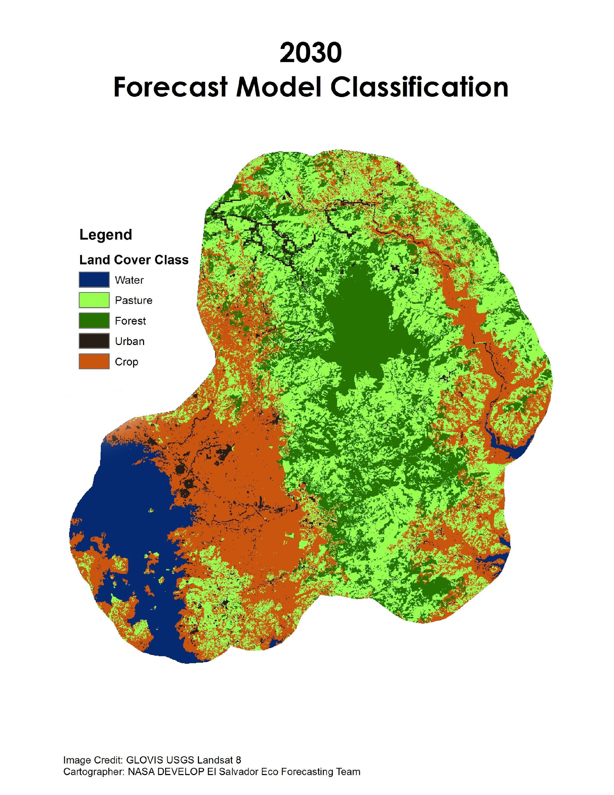
Figure 2. 2030 Forecast Model Classification
Figure 2. La Mancomunidad La Montañona region in 2030 based on Maximum Likelihood Classifications input for the Terrset Land Change Modeler Forecast

The forecast model predicting land use and land cover change to the year 2030 (Figure 2.) shows the forests in the region have increased around the primary forest in the northwest of the image while crop land around the urban areas and along the river banks appears to have consolidated. Additionally some urban areas have expanded, but others are predicted to return to forest and pasture land. These predicted trends, especially the last transition from urban to forest, seem unlikely to take place given current practices and observations. Therefore, our results indicate that the forecast model is unlikely to be accurate. This inaccuracy could be due either to the inputs or the definition of the model and should be a focus of future work.

A likely source of error was introduced to the model through its inputs. The original LULC map for 2014 was only 60.1% accurate, which introduced inherent error to the forecast. As the LULC classifications undergo the aforementioned refinement, it is possible that the forecast model would begin to show a more accurate prediction. Specification errors, which occur from defining the model in different variations, are also possible sources of error. The first is the choice of transition driver variables. As shown in Appendix A1 each transition was modeled from the same set of 5 different variables, which were included based on their theoretical influence. Additional variables could be unaccounted for or the existing variables could be refined to only include those that had a statistically significant effect. The second is the end of the Salvadoran Civil War in 1992, which falls in between the model’s base years. This could be a major confounding event because it had significant implications for land use trends (Hecht and Saatchi, 2007). If the earlier year in the model was changed to years following the end of the civil war it might gain accuracy.

V. Conclusions
The results presented in this paper have sources of error that can be reduced or corrected with more time. Following the conclusion of the fall 2015 term this project will be continued by the spring 2016 El Salvador Ecological Forecasting team. A bulk of the work conducted during this term was geared toward being a precursor for the research to be done in the spring 2016 term. Further refinement of training sites used in the LULC classification will help increase the overall accuracy of the classification. Inputs with greater accuracy for the forecasting model, including LULC classifications and other ancillary variables listed previously, will also increase the predicting capabilities of this software. Incorporating the Hansen GFC data set can broaden the scope of applicability for this methodology. Validating the accuracy of the global dataset at a regional scale allows for regional end-users such as MARN to apply the methods used in this paper to other regions that may lack the ground truth data necessary for a proper accuracy assessment of the resulting LULC classification.

VI. Acknowledgments
Dr. Kenton Ross - National Science Advisor, NASA DEVELOP National Program
Dr. Sean Smukler & Sean Kearney - The Earth Institute, Columbia University (ABES Project)
Arnulfo Alberto - La Mancomunidad La Montanona, Chalatenango
Giovanni Molina - Ministerio de Medio Ambiente y Recursos Naturales (MARN)

Any opinions, findings, and conclusions or recommendations expressed in this material are those of the author(s) and do not necessarily reflect the views of the National Aeronautics and Space Administration.

This material is based upon work supported by NASA through contract NNL11AA00B and cooperative agreement NNX14AB60A.

VII. References
Billings R.F., S.R. Clarke, V. Espino Mendoza, P. Cordón Cabrera, B. Meléndez Figueroa, J. Ramón Campos and G. Baeza. 2004/2. Bark beetle outbreaks and fire: a devastating combination for Central America’s pine forests. An international journal of forestry and forest industries, 55: 16-21.
Garcia and Gonzalez. 2004. Change in oak to pine dominance in secondary forests may reduce shifting agriculture yields: experimental evidence from Chiapas, Mexico. Agriculture, Ecosystems and Environment, 102:389-401.
Global Forest Change (GFC) 2000-2014 Data Download Version 1.2 Hansen M., et al.
Hansen M.C., P.V. Potapov, R. Moore, M. Hancher, S. A. Turubanova, A. Tyukavina, D. Thau, S. V. Stehman, S. J. Goetz, T. R. Loveland, A. Kommareddy, A. Egorov, L. Chini, C. O. Justice, J. R. G Townshend. 2013 "High-Resolution Global Maps of 21st Century Forest Cover Change." Science. 342: 850-853.
Hecht S.B. and S.S. Saatchi. 2007. Globalization and Forest Resurgence: Changes in Forest Cover in El Salvador. BioScience Magazine, 57, 8: 663-672.
Herold M., R.M. Roman-Cuesta, D. Mollicone, Y. Hirata, P. Van Laake, G.P. Asner, C. Souza, M. Skutsch, V. Avitabile, and K. MacDicken. 2011. Options for monitoring and estimating historical carbon emissions from forest degradation in the context of REDD+. Carbon Balance and Management, 6:13.
Houghton R.A., D.L. Skole, and D.S. Lefkowitz. 1991. Changes in the landscape of Latin America between 1850 and 1985: II a net release of CO2 into the atmosphere. Journal of Forest Ecology and Management, 38:133-199.
Paula M.D., J. Groeneveld, and A. Huth. 2015. Tropical forest degradation and recovery in fragmented landscapes -- Simulating changes in tree community, forest hydrology and carbon balance. Global Ecology and Conservation, 3: 664-677.
Rosa H., I. Gomez, S. Kandel. 2003. Gestión territorial rural: Enfoque, experiencias y lecciones de Centroamérica. PRISMA.
SRTM Digital Elevation Data 30m, 2000 USGS Data Pool accessed via Google Earth Engine
Wilken, G. C. 1990. Good farmers: Traditional agricultural resource management in mexico and central america. Oakland, CA: University of California Press.

VIII. Content Innovation
- Virtual Poster Session
- Interactive Map Viewer
- Interactive Glossary

IV. Appendices
Figure A1. ArcGIS Results of Maximum Likelihood Classification Method
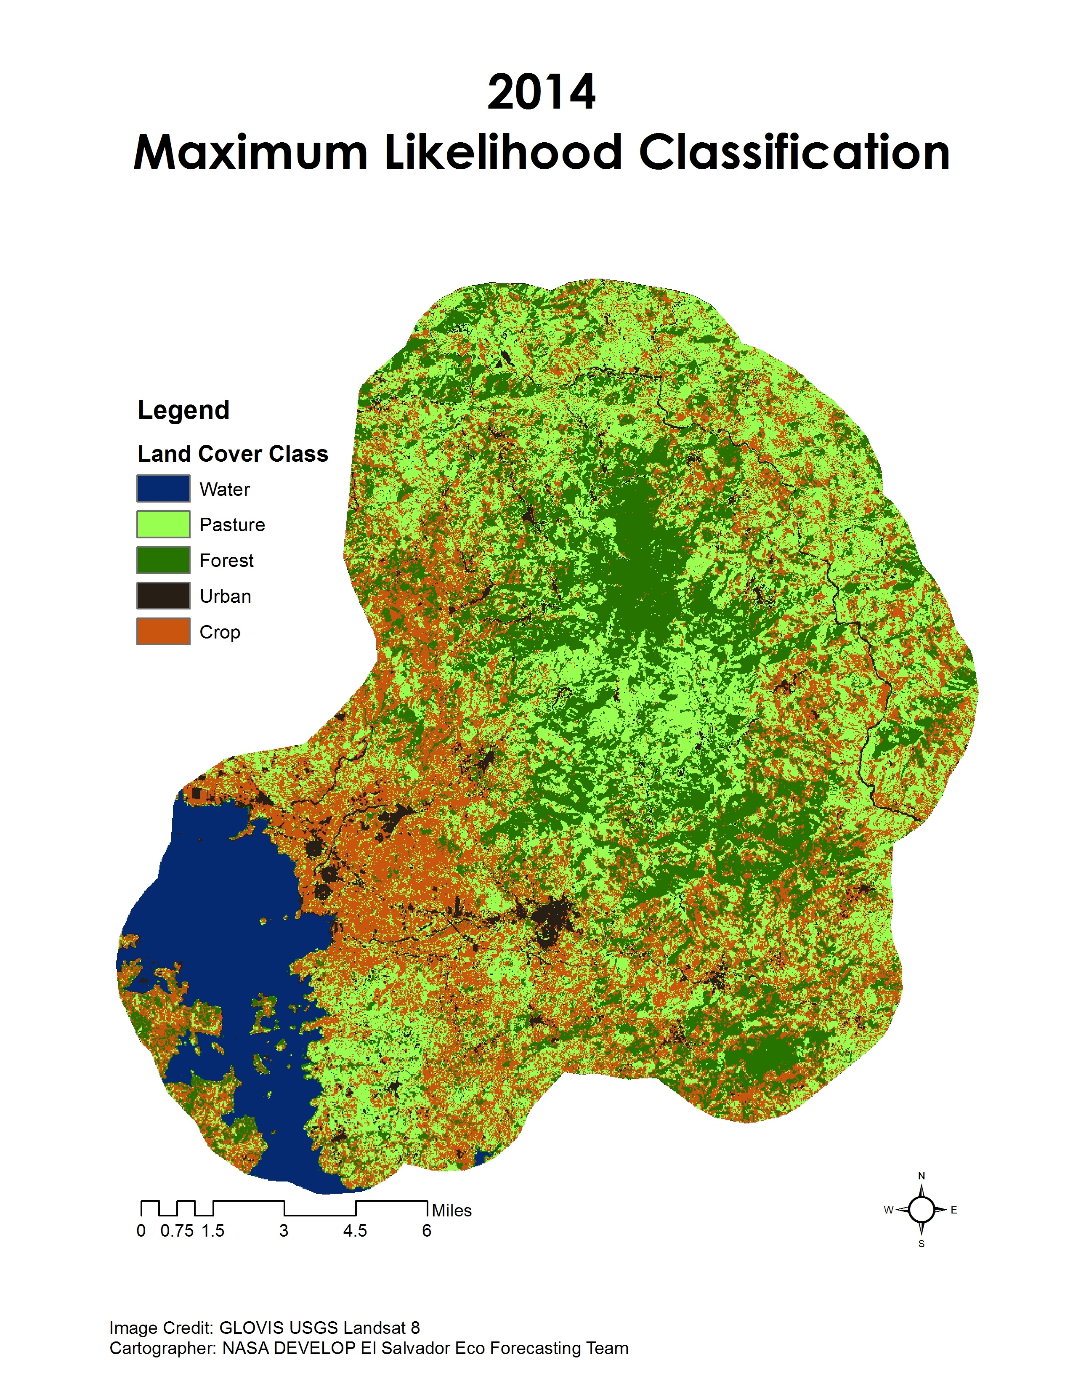
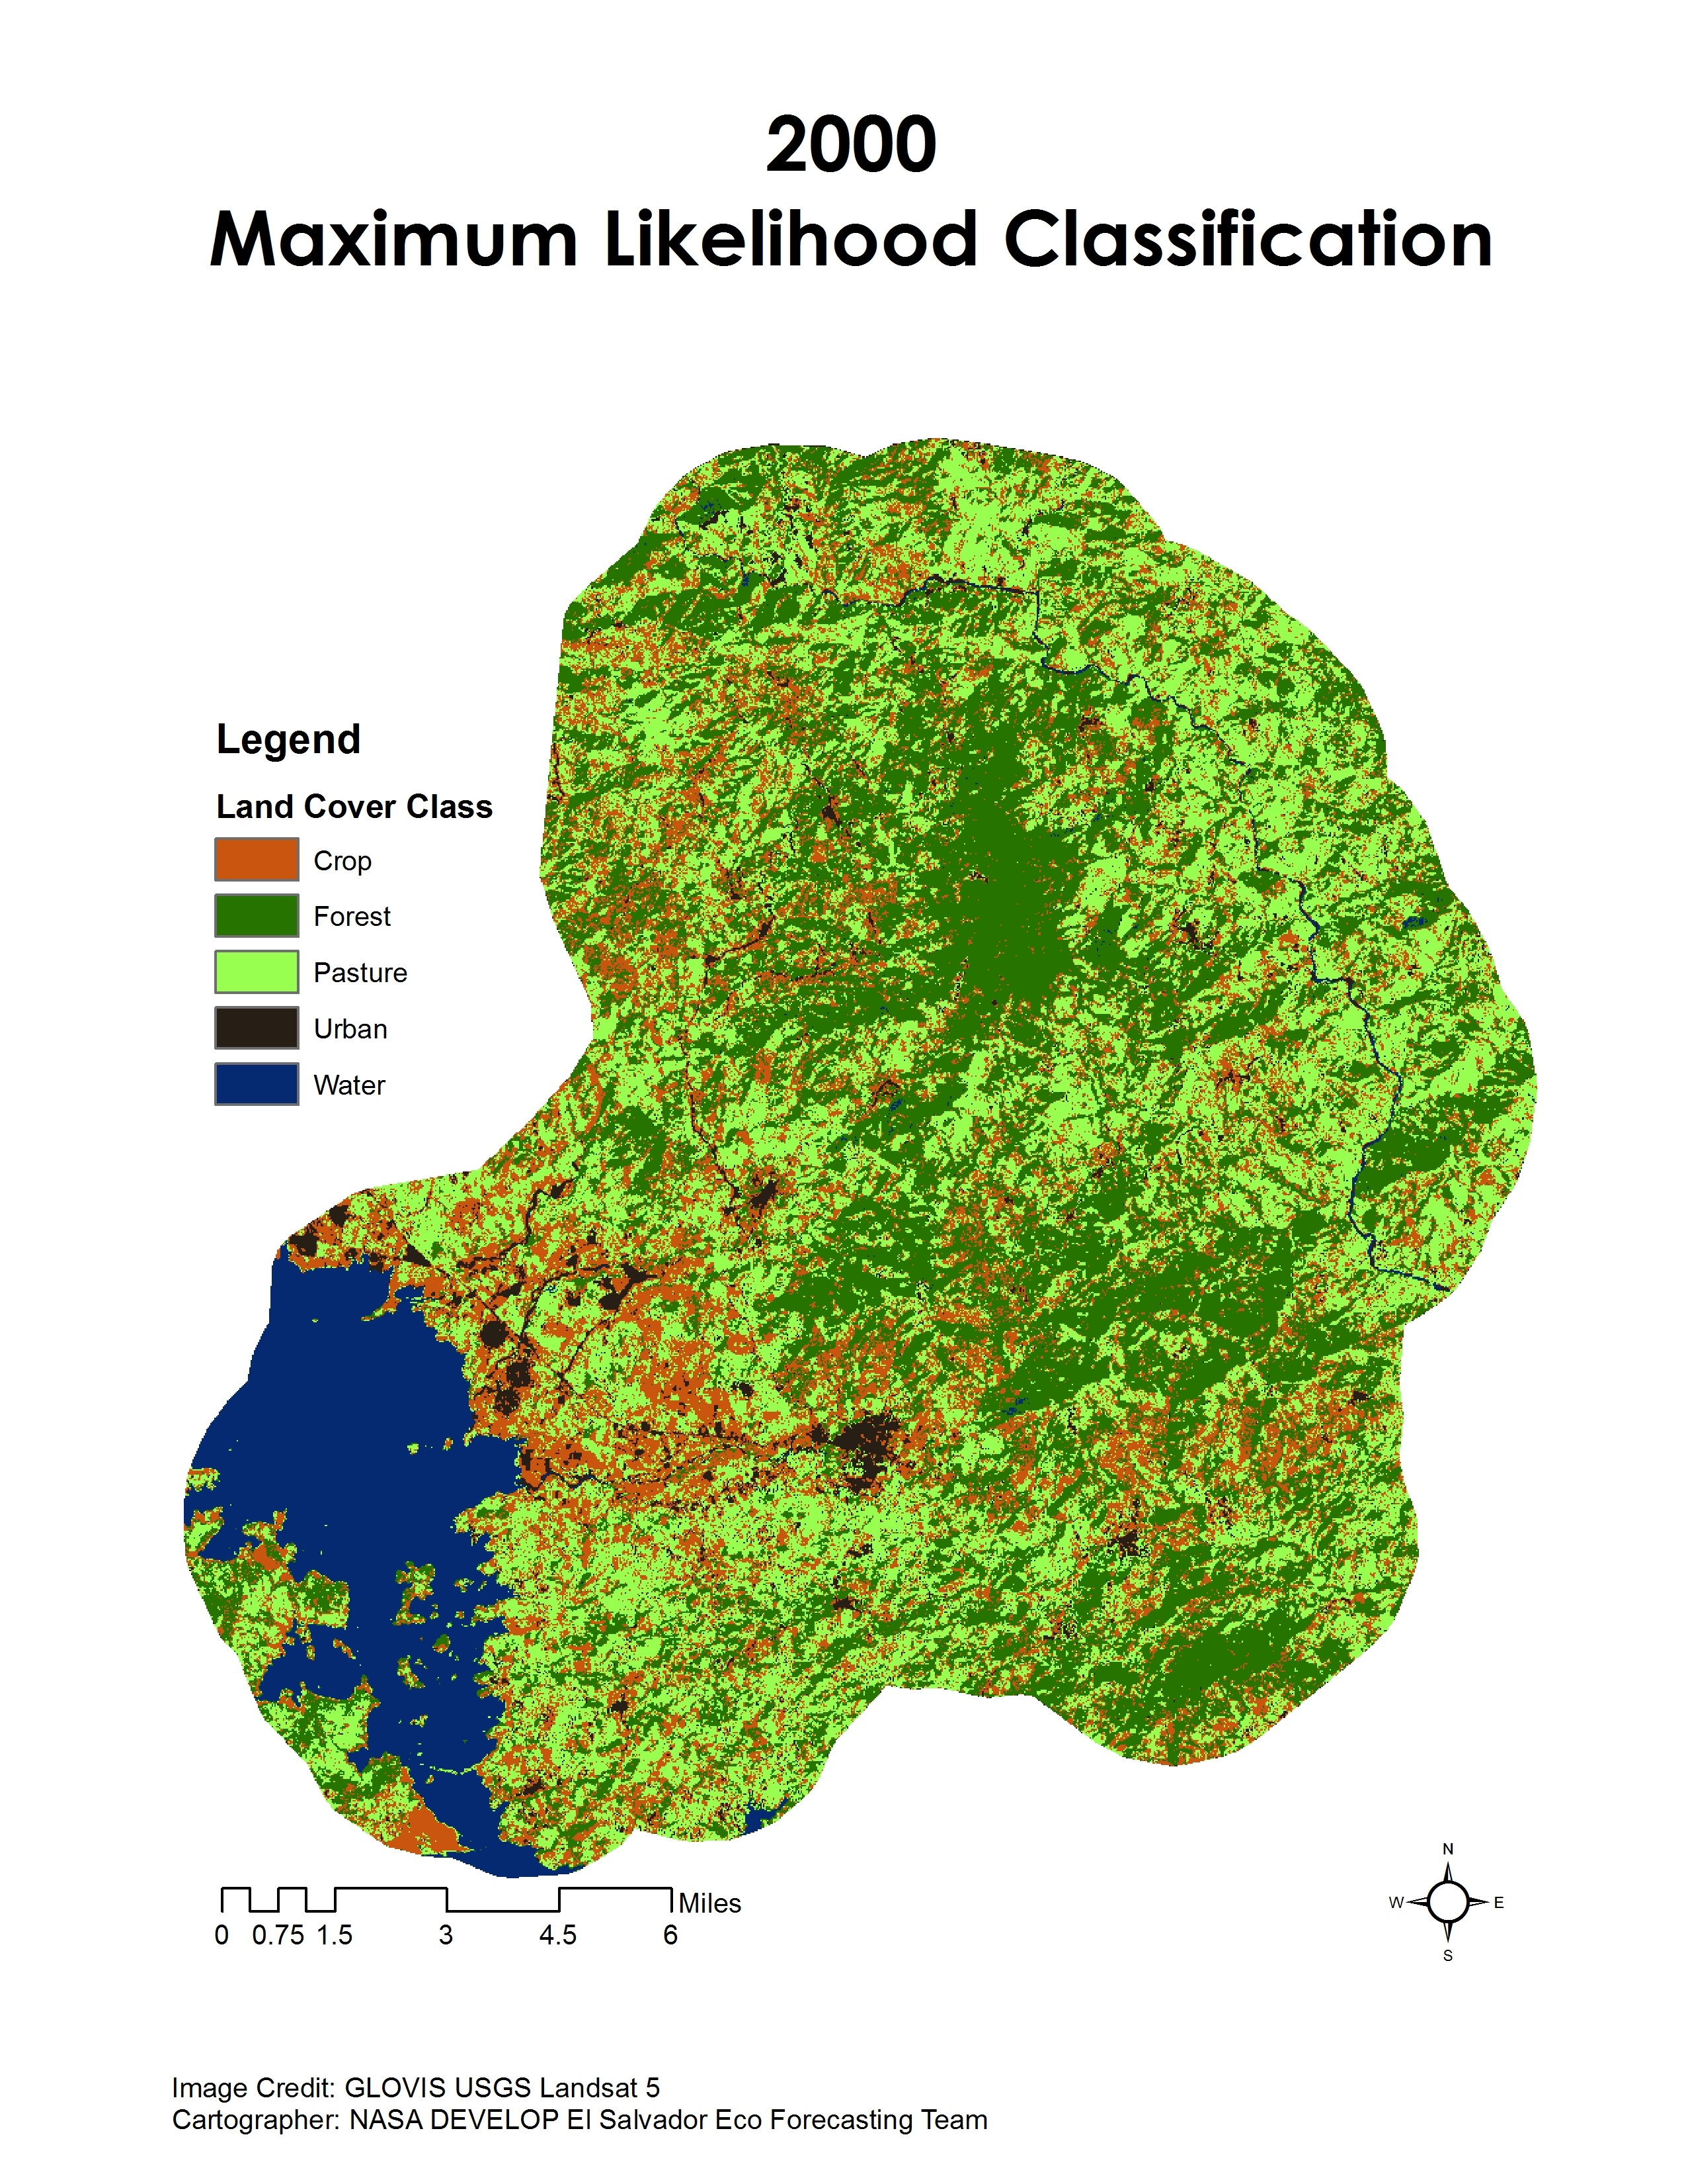
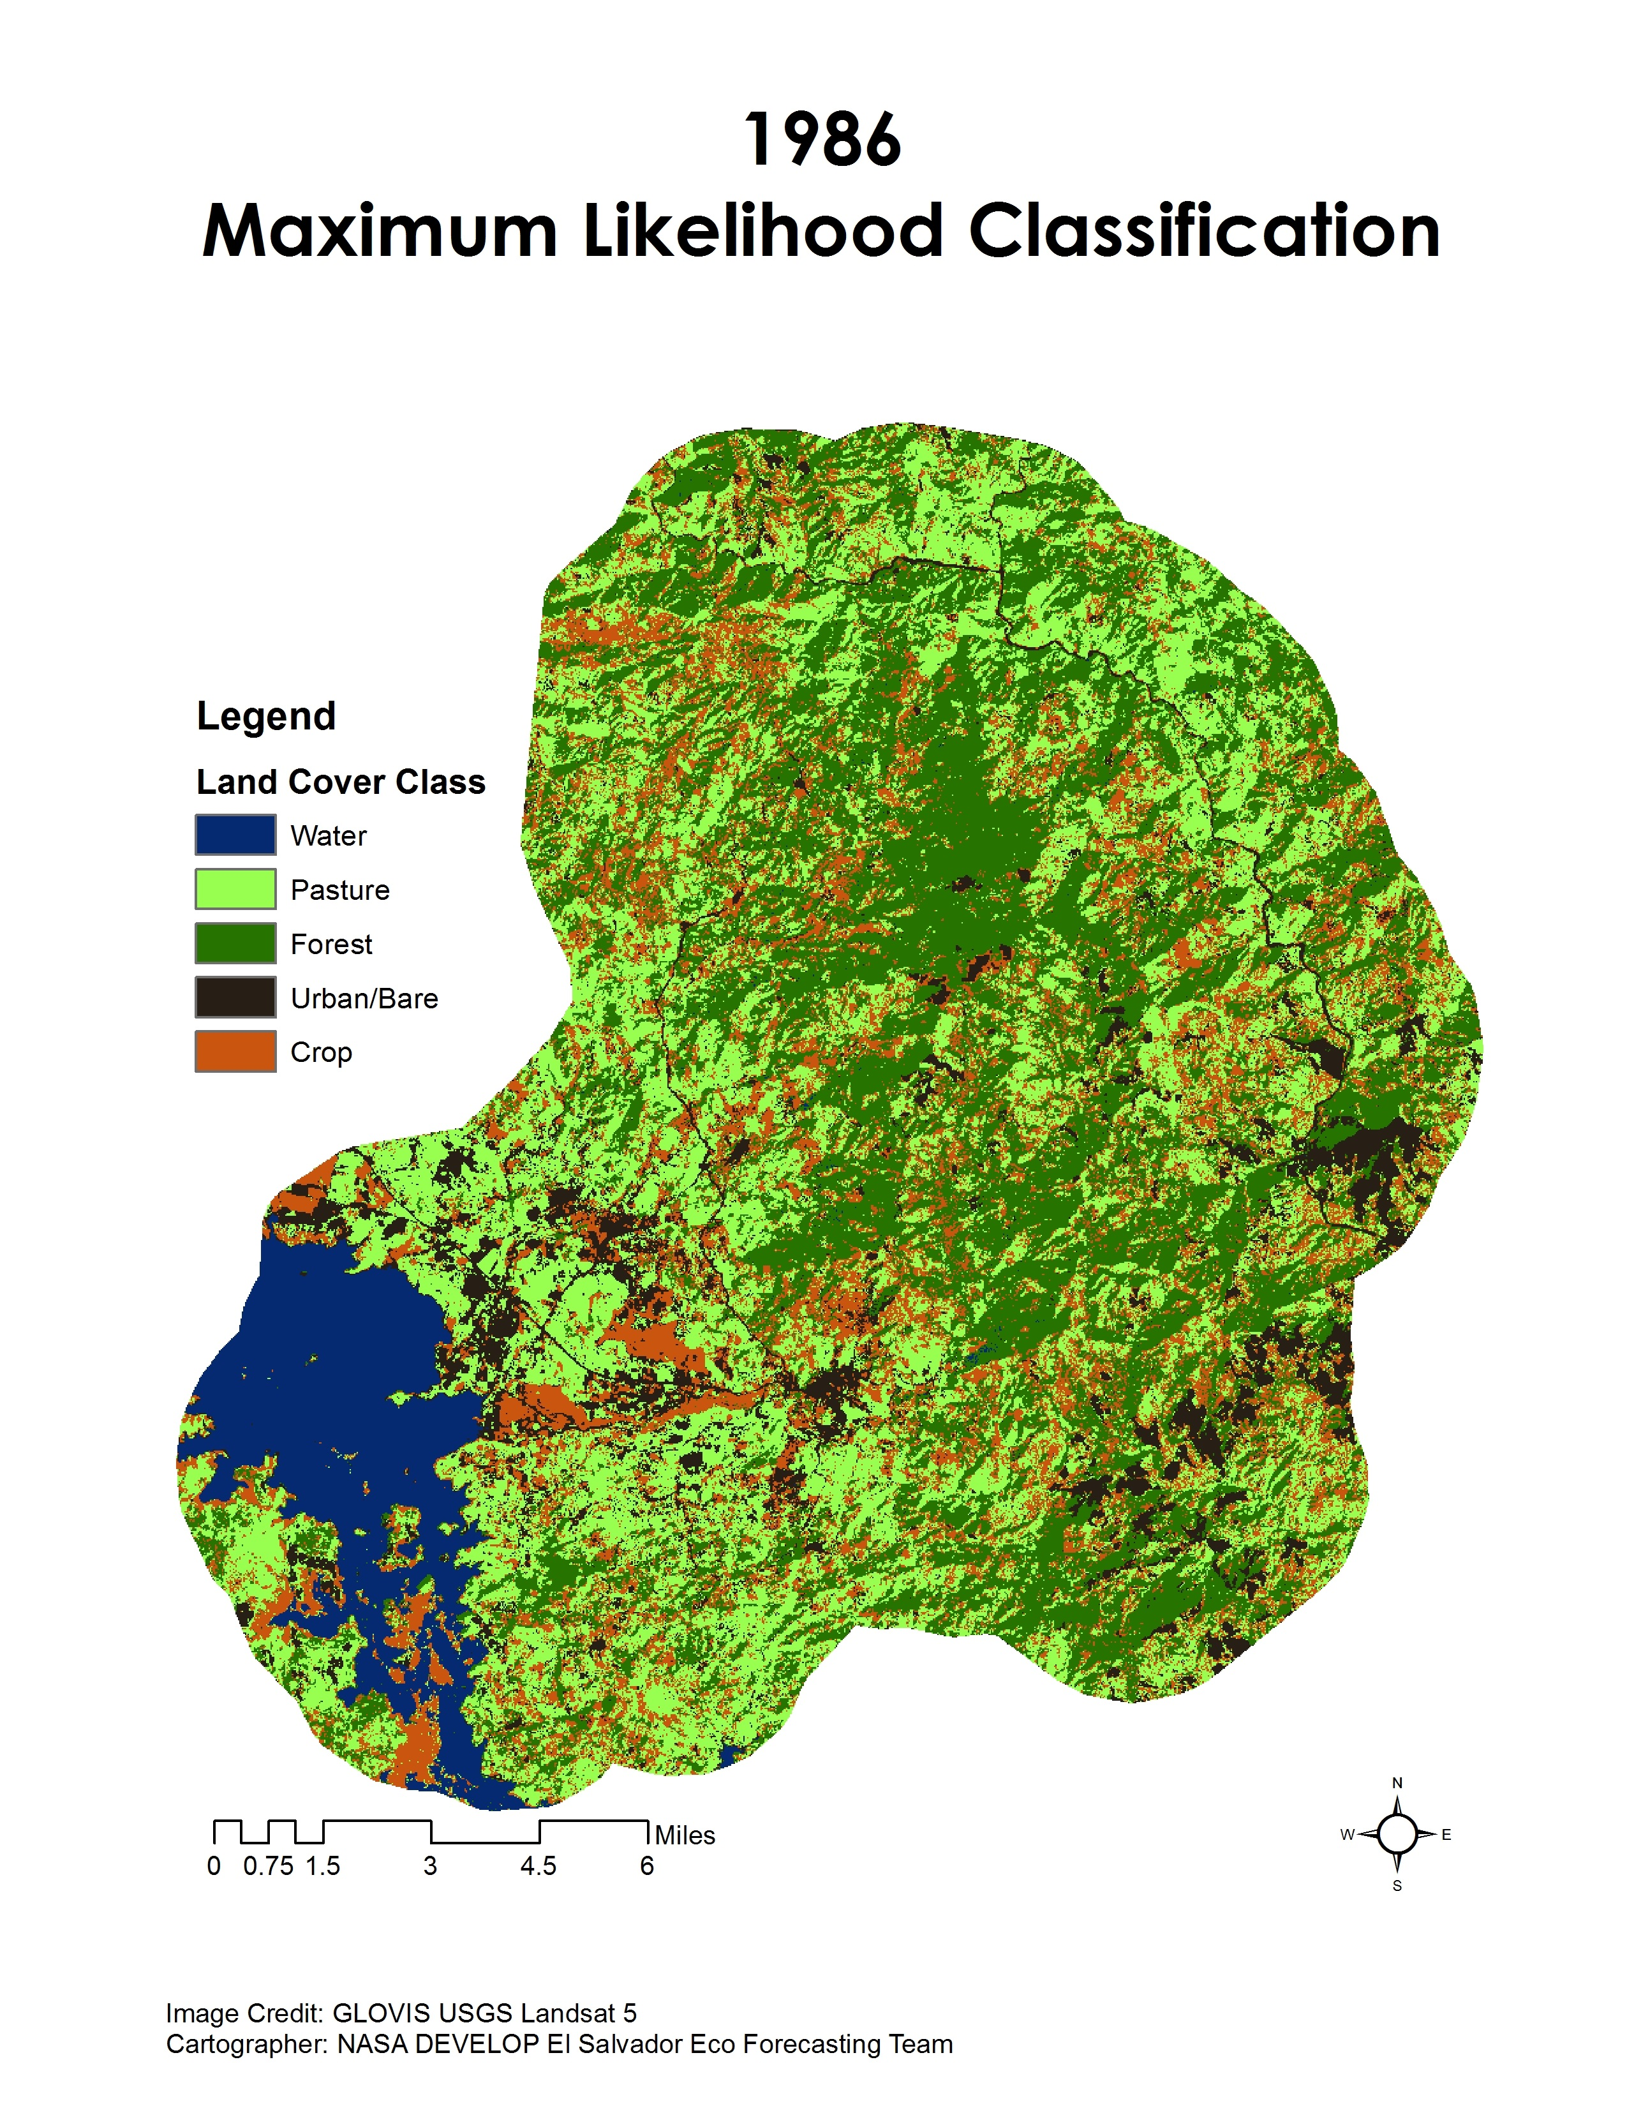
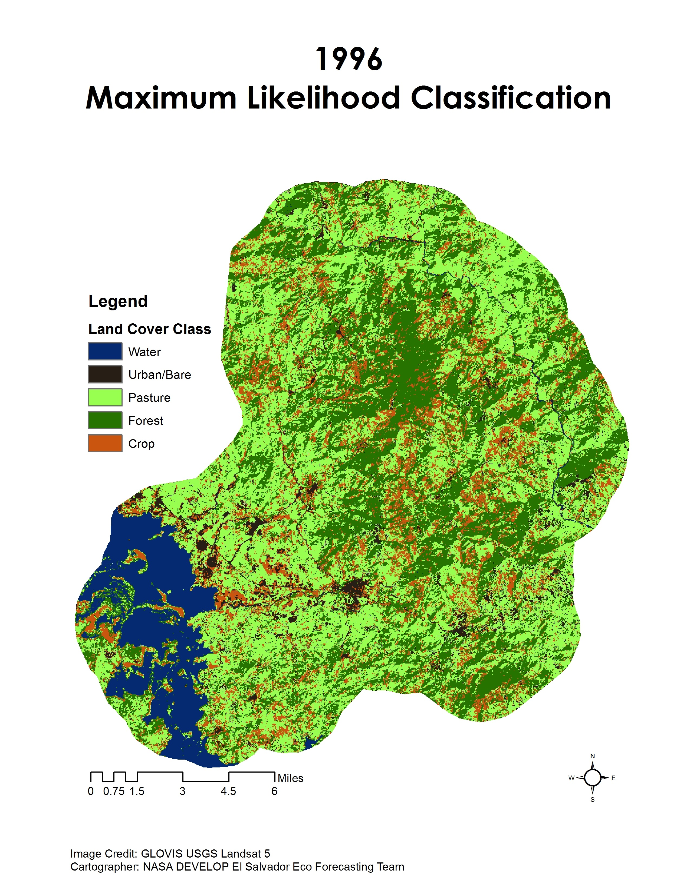
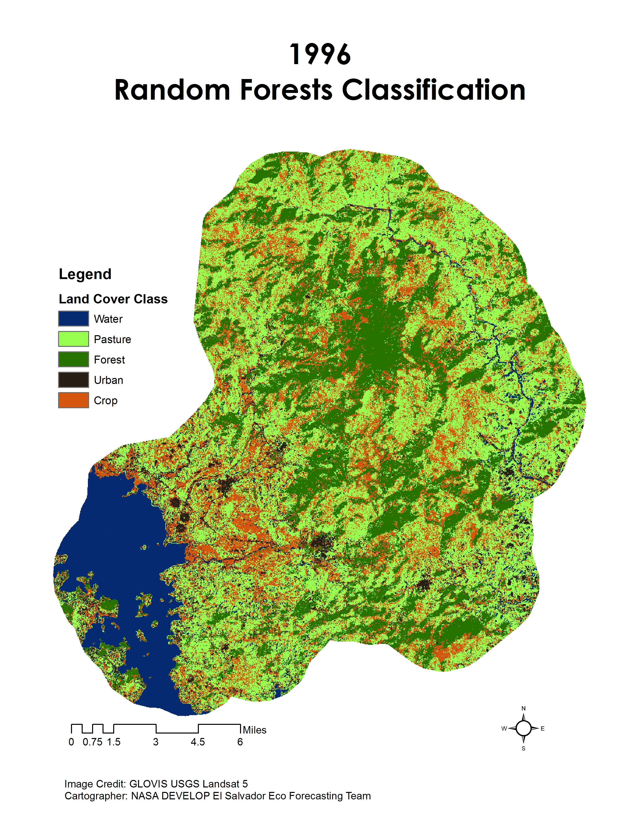
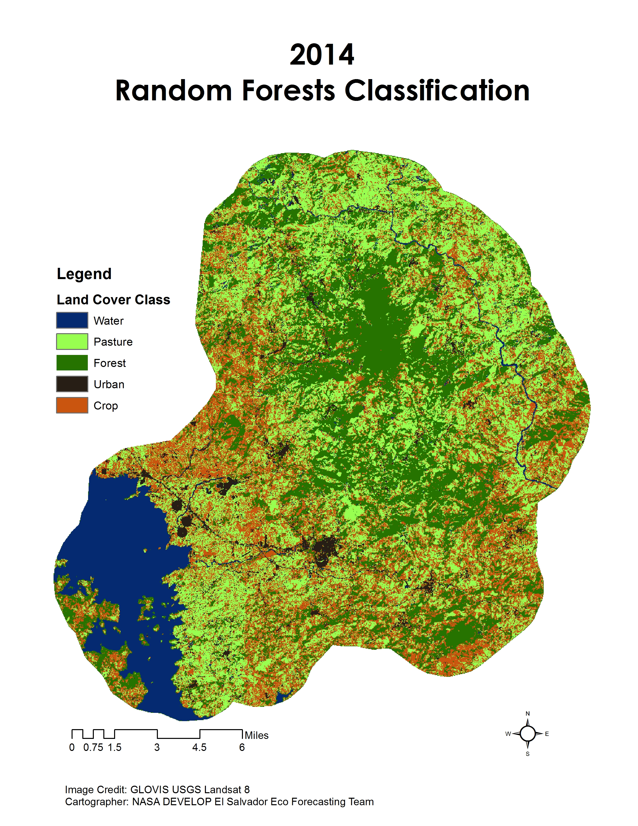
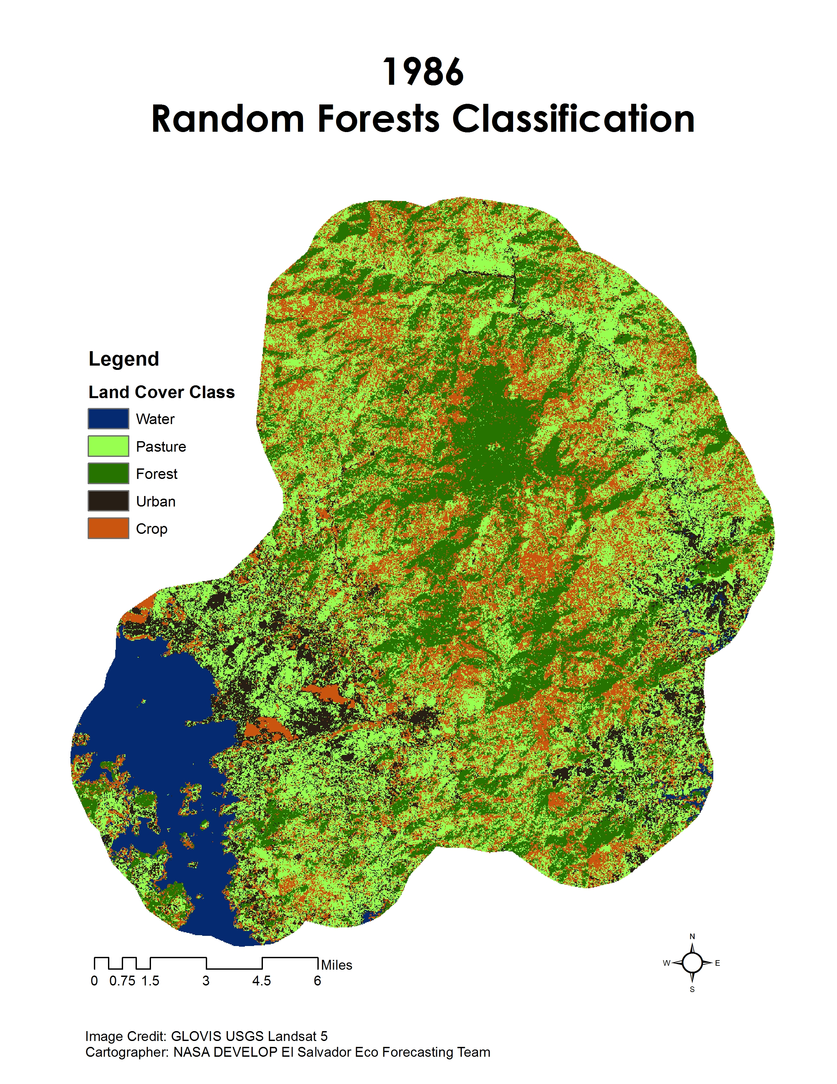
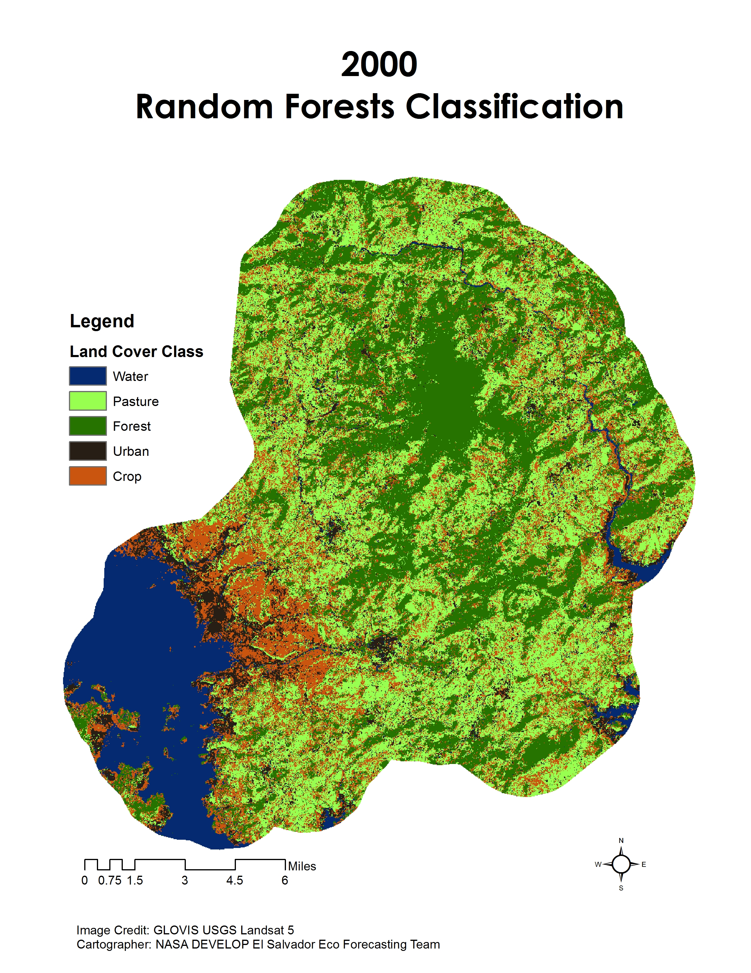
Figure A2. Google Earth Engine Results of Random Forests Classification Method

Table A1. Landsat 4/5 TM Band Composites and Ratios Used to Identify Land Cover and Land Use Class
 | Land Use/Land Cover Class
Composite/Ratio | Water | Pasture | Forest | Urban | Crop
TM 3/4 |  |  |  | x
TM 4/3 |  |  | x
TM 3/2 |  |  | x |  | x
TM 7/2 |  |  | x |  | x
TM 5 - 4 |  | x |  |  | x
7,4,2 |  | x | x |  | x
5,4,3 |  |  | x
‘True Color’ 3,2,1 | x | x | x | x | x
‘False Color’ 4,3,2 |  |  |  | x | x
NDVI |  |  | x |  | x

Table A2. Landsat 8 OLI Band Composites and Ratios Used to Identify Land Cover and Land Use Class
 | Land Use/Land Cover Class
Composite/Ratio | Water | Pasture | Forest | Urban | Crop
TM 4/5 |  |  |  | x
TM 5/4 |  |  | x
TM 4/3 |  |  | x |  | x
TM 8/3 |  |  | x |  | x
TM 6 - 5 |  | x |  |  | x
7,5,2 |  | x | x |  | x
6,5,3 |  |  | x
‘True Color’ 4,3,2 | x | x | x | x | x
‘False Color’ 7,6,4 |  |  |  | x | x
NDVI |  |  | x |  | x

