Pacific Northwest Health & Air Quality

Monitoring Trends in Air Quality During a Drought Case Study to Improve Public Health Response to Drought Threats

 **Technical Report**

August 11th, 2023

Abby Sgan (Project Lead)

Greta Bolinger

Tallis Monteiro

Cristina Villalobos-Heredia

Taylor West

***Advisors:***

Molly Woloszyn, NOAA National Integrated Drought Information System (Science Advisor)

Dr. Jesse Berman, University of Minnesota, School of Public Health (Science Advisor)

Dr. Babak Fard, University of Nebraska Medical Center’s Water, Climate, and Health Program (Science Advisor)

Ronald Leeper, NOAA National Centers for Environmental Information, North Carolina Institute for Climate Studies (Science Advisor)

Jared Rennie, NOAA National Centers for Environmental Information (Science Advisor)

***Fellow:***  
Katie Caruso (North Carolina – NCEI)

# 1. Abstract

Recent studies have documented a correlation between air quality and drought in the United States, which has been linked with increased aerosols including airborne particulate matter (PM) during drought conditions. This study partnered with local health departments to evaluate trends in air quality in the Pacific Northwest during the evolution of drought conditions using aerosol optical depth (AOD) observations collected by NASA’s Moderate Resolution Imaging Spectroradiometer (MODIS) sensor aboard the Terra and Aqua satellites. These satellite data were analyzed in conjunction with ground-based PM2.5 and PM10 data sourced from the Environmental Protection Agency (EPA)’s network of ground-based monitors and the Standardized Precipitation Evapotranspiration Index (SPEI) drought index. Based on recommendations by local health departments, this study examined air quality trends between 2015 and 2022 in 12 counties within Oregon and Washington that reflected diversity in population density, drought exposure, rural and urban status, and data availability from EPA monitors. Overall, results indicated variation in relationships among drought, satellite, and ground-based air quality data across the study area. This study did not control for the impact of wildfire events on air quality and also did not investigate shorter SPEI aggregation periods, both of which are avenues for future research. This project supplemented research into links between drought and human health and provided health departments with an objective foundation from which they can communicate public health risks to local communities.

**Key Terms**

Air quality, aerosol optical depth, drought, MODIS, Pacific Northwest, particulate matter, SPEI

# 2. Introduction

***2.1 Background Information***

Drought is characterized by prolonged periods of precipitation and soil moisture deficit in combination with high temperatures (Trenberth et al., 2014). Due to the observed and projected increase in Pacific Northwest (PNW) drought under a changing climate (Dai, 2013), extreme drought is an area of distinct concern (Ebi et al., 2022). By the end of 2015, both Oregon and Washington were experiencing drought or abnormally dry conditions (National Integrated Drought Information System, n.d.). Dry conditions persisted for seven years, leaving nearly 58 percent of the region in drought in 2022 (US Drought Monitor, n.d.), which led to concerns about compounding issues associated with the intensification of drought.

Prolonged drought exacerbates dry soil, which has been shown to increase the amount of particulate matter (PM) pollutants released into the air during drought conditions (Wang et al. 2017). Our team was specifically interested in particulate air pollutants because of their complex relationship with drought (Wang et al. 2015). Several studies have shown elevated particulate matter to be correlated with drought (Wang et al. 2017; McClure & Jaffe, 2018; Liu et al. 2021), while another study has indicated that there are correlations between drought and elevated ozone concentrations (Lin et al. 2020).

Certain populations, including communities of color, individuals of low socioeconomic status, the elderly, and individuals with pre-existing health conditions, are particularly vulnerable to the damaging effects of substandard air quality caused by particulate air pollutants (Puvvula et al., 2023). Further, drought and wildfire events have been shown to exacerbate cases of respiratory illness and mortality rates by contributing to heightened concentrations of airborne PM (McClure & Jaffe, 2018; Liu et al., 2021). Above-normal concentrations of atmospheric PM have been shown to directly impact the physical health of the study area’s population of over 12 million people, creating the impetus for this study (Kramer et al. 2020; U.S. Census Bureau, 2022).

Atmospheric pollutants can be monitored both remotely and using *in situ,* or ground-based, methods*.* Remote monitoring of atmospheric particulate matter is achievable via NASA satellite observations of aerosol optical depth (AOD). AOD is not a direct measurement of atmospheric PM but is rather a reflection of the extent to which electromagnetic radiation is blocked by airborne aerosols in the atmosphere (Rogozovsky et al., 2021). To ground truth remotely sensed air quality observations, our study used *in situ* data collected by the EPA’s Air Quality System (AQS) ground monitors. To indicate drought conditions, the we used data from the Standardized Precipitation Evapotranspiration Index (SPEI) to evaluate trends in air quality conditions during the evolution of drought conditions (Figure 1) in Oregon and Washington across the study period (Jan. 1, 2015-Dec. 31, 2022).

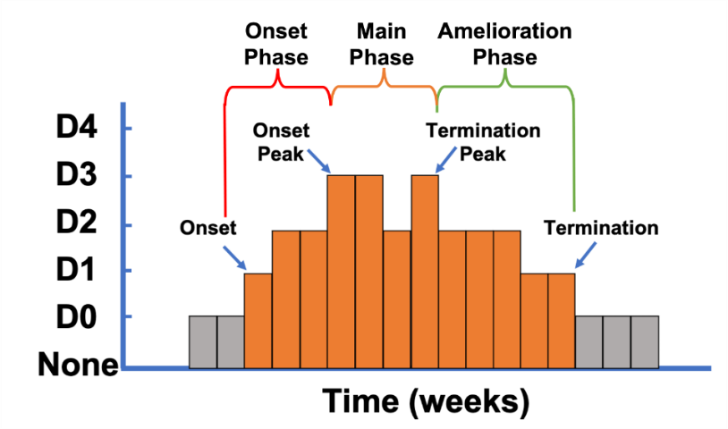

*Figure 1.* Overview of drought evolution, courtesy of Ronald Leeper.

For our project, the study area of Oregon and Washington was further narrowed to a select number of counties recommended by partners (Figure 2). These counties varied in topography, population, urban or rural status, and presence of vulnerable populations (Washington Department of Ecology Air Quality Program, 2023).

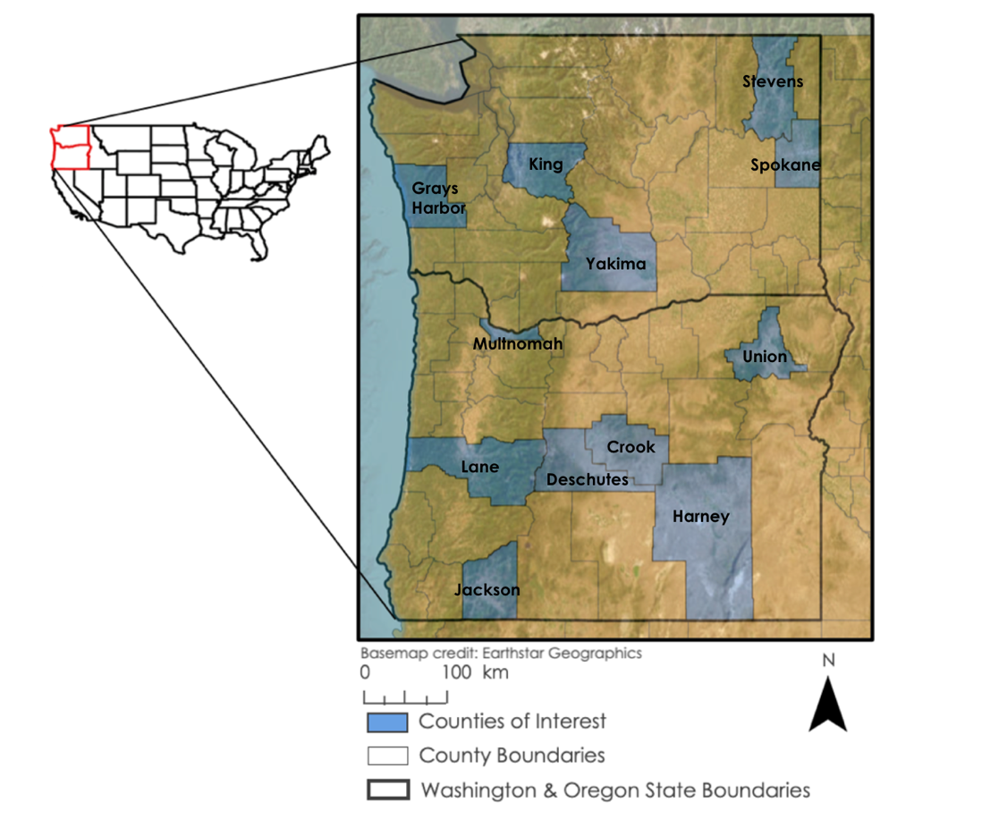

*Figure 2*. Study area indicating the states of Washington and Oregon and the twelve counties selected to conduct analysis. Washington counties included Gray’s Harbor, King, Spokane, Stevens, and Yakima. Oregon counties included Crook, Deschutes, Harney, Jackson, Lane, Multnomah, and Union.

***2.2 Project Partners & Objectives***

The partners for this project were the University of Nebraska Medical Center (UNMC)’s Water, Climate, and Health Program, NOAA National Integrated Drought Information System (NIDIS), the Oregon Health Authority (OHA), and the Washington State Department of Health (DOH). As end users, the DOH and the OHA were interested in exploring drought as a factor that influences air quality and subsequently the health of the communities that they serve. They will use the end products and conclusions provided by this study to supplement future research examining regional vulnerabilities to drought-related reductions in air quality to guide policy decisions and improve public health. The OHA is interested in incorporating satellite assessments of drought impacts on air quality into their real-time reports, which currently focus on wildfire smoke conditions. Representatives from the Crook County Health Department, a county level health department within the OHA in Crook County, Oregon, were specifically seeking informational resources describing county-level trends in air quality and drought to provide for the well-being of their constituents.

Two of the primary objectives of this study were to measure remotely sensed air quality trends in Oregon and Washington and compare them with ground-based air quality trends. Representatives from the study’s collaborator partners, UNMC’s Water, Climate, and Health Program and NIDIS, were interested in monitoring this project’s analysis of correlations between drought and air quality to inform further research within their respective organizations. As part of its mission to engage in case studies of drought and air quality with local health authorities, UNMC’s Water, Climate, and Health Program also facilitated collaboration between NASA DEVELOP, NIDIS, and project end users, the Washington State DOH and OHA. NIDIS collaborated on this study to expand its efforts to address public health risks posed by drought and support other end-user organizations who aim to mitigate health impacts caused by regional drought.

# 3. Methodology

***3.1 Data Acquisition***

*3.1.1 AOD*

This study used three datasets: satellite Earth observations of aerosol optical depth (AOD), ground-based detection of atmospheric particulate matter (EPA AQS PM2.5 & PM10), and a calculated index to indicate drought conditions (SPEI) (Table 1).

Terra and Aqua MODIS AOD and Water Vapor from Multi-Angle Implementation of Atmospheric Correction (MAIAC) Daily L3 Global 0.05Deg CMG V061 data, equipped with the MAIAC algorithm used to visualize and quantify AOD, were obtained through a JavaScript Application Programming Interface (API) in Google Earth Engine (GEE). This dataset allowed our team to visualize atmospheric aerosols through a remote proxy measurement of total aerosols over the study area. AOD measurements were taken by MODIS every one to two days and were averaged to the county level.

*3.1.2 EPA AQS PM2.5 & PM10*

We acquired PM data from the EPA’s ground network of air quality monitoring stations, equipped with air quality sensors across the study region and period. In the United States, the EPA sets standards for acceptable pollutant concentrations to protect public health in accordance with the Clean Air Act by creating a set of criteria pollutants. EPA criteria pollutants include sulfur dioxide, nitrogen dioxide, carbon monoxide, lead, and ground-level variations of PM, characterized by size. The two most common classifications of air pollutant PM are PM2.5 and PM10. Measured in micrometers, these two variants of airborne PM are inhaled deep into the respiratory system, causing exacerbated respiratory illness and posing a major threat to public health (Rau et al., 2022).

For this project, we were specifically interested in daily mean concentrations (µg/m3) of aerosol particulates sized less than 2.5 or 10 microns in diameter (PM2.5 and 10). PM2.5 pollutants have been shown to consist of primarily combustion-related aerosols, including wildfire smoke particulates (Maykut et al. 2003). While PM10 includes these smaller, combustion-sourced aerosols, PM10 is also inclusive of drought-specific aerosols, like dust particles, which tend to be larger than combustion-sourced aerosols. We specifically chose these sizes to maximize spatiotemporal data availability and inclusivity of drought-sourced aerosols. The PM datasets were collected by a total of 326 monitoring stations (243 PM2.5, 83 PM10) located throughout the Pacific Northwest. We used code written in R programming languages to manipulate and spatially aggregate the datasets to the county level from 2015–2022.

*3.1.3 SPEI*

SPEI drought index data, derived from the Gridded Surface Meteorological (gridMET) dataset at 4km spatial resolution, were also obtained through the JavaScript API in GEE, visualized through written code, and clipped to the study area. SPEI is a multiscale drought index that accounts for the climatic water balance between precipitation and evapotranspiration. SPEI was used in this study as a proxy measurement for detecting, monitoring, and analyzing drought to explore how air quality changes throughout drought intensity and duration (Vicente-Serrano et al., 2010). SPEI was supplied on a 270-day time scale corresponding to the temporal aggregation of precipitation, reference evapotranspiration, and precipitation minus reference evapotranspiration rates to indicate drought severity (Abatzoglou, 2012).

Table 1

*Datasets used in the project and their resolution, timeframe, source, and GEE Image Collection ID*

|  |  |  |  |
| --- | --- | --- | --- |
| **Dataset** | **Spatial and Temporal Resolution** | **Data Source** | **GEE Image Collection ID** |
| MODIS MAIAC Aerosol Optical Depth (AOD) | 1 km / 2015 – 2022 | [MCD19A2.061:](https://developers.google.com/earth-engine/datasets/catalog/MODIS_061_MCD19A2_GRANULES) Terra & Aqua MAIAC Land Aerosol Optical Depth Daily 1 km | MODIS/061/MCD19A2_GRANULES |
| SPEI drought index | 4 km / 2015 – 2022 | [GRIDMET Drought: CONUS Drought Indices](https://developers.google.com/earth-engine/datasets/catalog/GRIDMET_DROUGHT?hl=en) 4 km 270-day SPEI | GRIDMET/DROUGHT |
| EPA AQS PM 2.5 & 10* | 2015 – 2022 | [EPA Air Quality System (AQS) Database](https://www.epa.gov/outdoor-air-quality-data/download-daily-data) | N/A |

*Indicates *in situ* dataset

***3.2 Data Processing***

*3.2.1 AOD*

We processed MODIS MAIAC Aerosol Optical Depth data in GEE. We first uploaded the Washington and Oregon study area shapefile to GEE to clip the MODIS dataset to the study region. Next, we extracted data from two spectral bands: ‘Optical_Depth_055’ and ‘AOD_QA’. The ‘Optical_Depth_055’ band extracted AOD values from the MODIS green band at 55 µm. The ‘AOD_QA’ band extracted only quality assured, or QA, imagery in which images with cloudy or obscured skies were excluded from final images (Christian et. al., 2023). The cloud-masked, quality assured MODIS AOD data and imagery were further clipped to a select number of counties in order to prevent computation errors and limit the data to the same spatial area as other datasets. The code also included a bit masking function that further isolated and extracted cloud-containing pixels from the images generated by MODIS. Finally, we generated a time series with mean daily AOD concentration values exported from GEE.

*3.2.2 EPA AQS PM2.5 & PM10*

We processed EPA AQS data differently than AOD and SPEI, as the EPA AQS dataset was a point dataset rather than a spatial raster. To do so, we collected EPA AQS PM2.5 and PM10 datasets from Oregon and Washington across the study period. We then filtered the data to only include counties with available PM concentration data. We calculated daily averages for PM2.5 and PM10 measurements in each county and created data visualizations to observe spatial trends in particulate matter over the study period.

*3.2.3 SPEI*

We processed the gridMET SPEI dataset in GEE using a similar method to our Earth observation data. After clipping the gridMET dataset to the identified counties in Washington and Oregon, we filtered the gridMET dataset by date to our study period. We also filtered the dataset by the ‘spei270d’ band to select only SPEI drought index values that aggregated for 270 days (about nine months). The SPEI values were then extracted and visualized in a time series for each county.

***3.3 Data Analysis***

We compiled all of the major datasets described above into data visualizations reflecting changes in air quality and drought indicators over the course of our study period and region. Time series were created for each county of interest to allow for higher resolution spatial comparisons of drought indices and air quality across the study period, and box plots and maps were drawn to highlight changes in air quality parameters between periods of drought and normal, or wetter, conditions.

A linear correlation analysis was used to assess the relationship between datasets across our study region and period. We fitted our data to a linear regression model and calculated the R2 value, which described the degree of correlation between datasets. We re-ran this correlation analysis multiple times to ensure validity. Finally, we mapped our PM and AOD datasets, in both drought and non-drought conditions (as specified by SPEI values), across the study region and period.

# 4. Results & Discussion

***4.1 Analysis of Results***

We expected to see consistent spatiotemporal correlation between drought and poor air quality in the Pacific Northwest (Wang et al. 2017; McClure & Jaffe, 2018; Liu et al. 2021). Instead, we observed that, within the study area, drought does not appear to have a strong relationship with poor air quality. Atmospheric aerosols increased and decreased episodically throughout our study period and region, while drought, in contrast, was observed to last for months or years (Figure 3). In many counties, atmospheric aerosols were high in mid-late 2017, which was an above-normal precipitation year for much of the Pacific Northwest, making it increasingly unlikely that the observed poor air quality events were due to long-term drought in the region.

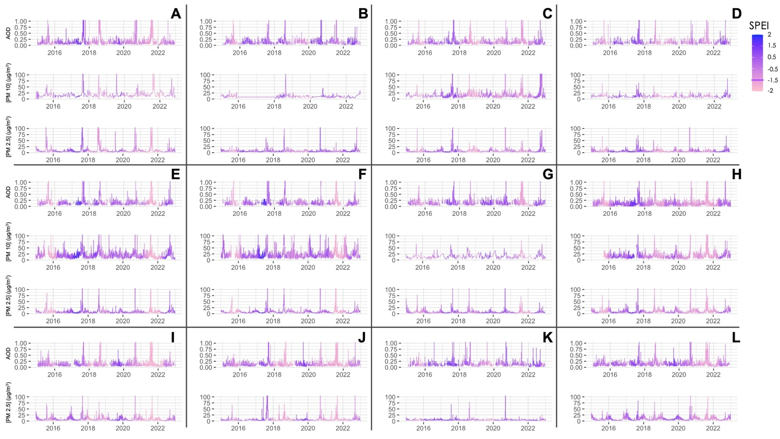

*Figure 3.* Air quality (as measured by Aerosol Optical Depth (AOD), PM10, and PM2.5) in Pacific Northwest counties did not appear to be linked to drought conditions (indicated by the Standardized Precipitation and Evapotranspiration Index) in the study region and period (Jan. 1, 2015- Dec. 31, 2022). Shaded values show a gradient in SPEI conditions. Light pink shades correspond with extreme drought conditions, while dark purple shades signify normal or above-normal precipitation. Counties included were **A.** Jackson, OR, **B.** King, WA, **C.** Lane, OR, **D.** Multnomah, OR, **E.** Spokane, WA, **F.** Stevens, WA, **G.** Union, OR, **H.** Yakima, WA, **I.** Crook, OR, **J.** Deschutes, OR, **K.** Gray’s Harbor, WA, and **L.** Harney, OR.

Our study additionally found that drought events were variable throughout the region. 2020–2022 was a dry period for Yakima, Crook, Deschutes, and Harney counties (Figure 3: H, I, J, L), all of which are located east of the coastal range and Cascade Mountains (Figure 1). While 2018 was an above-normal precipitation year for most counties, parts of the Oregon coast and coastal range were experiencing extreme drought conditions (Figure 3: A, C, D). Given the expected correlation between air quality and drought, we expected air quality to vary similarly across the study period and region (Wang et al. 2017; McClure & Jaffe, 2018; Liu et al. 2021).

However, we did not observe similar variability in air quality. Across all counties, we consistently observed four major “spikes” in air quality, which occurred in the late summer and fall of 2017, 2018, 2020, and 2021. These poor air quality events temporally coincided with active wildfire seasons in both nearby British Columbia (2017–2018) and the Pacific Northwest (2020–2021) (Government of British Columbia, n.d.; Johnson, 2021). Several counties also showed poor air quality towards the end of 2015, as well as in late 2022, which may have been attributed to localized wildfires.

Poor air quality events, however episodic, were prevalent throughout the study region and across the study period, raising public health concerns and prompting further analysis. Results from a linear regression correlation analysis indicated variation in relationships among drought, satellite, and ground-based air quality data across the study area (Table 2). Linear regression correlation analysis yielded R2 values describing the degree of correlation between AOD, PM, and SPEI datasets in all counties of interest. Degrees of correlation between air quality datasets were calculated for both extreme drought (SPEI <-1.5) and above-normal precipitation (SPEI >0.5) conditions, in addition to all SPEI conditions

Table 2

*Correlation values between air quality and drought datasets. Strong positive correlations were defined as R2 values being greater than 0.7 and are shown in green. Positive correlations are shown in light green, negative correlations are shown in gray, and null correlations are shown in white.*

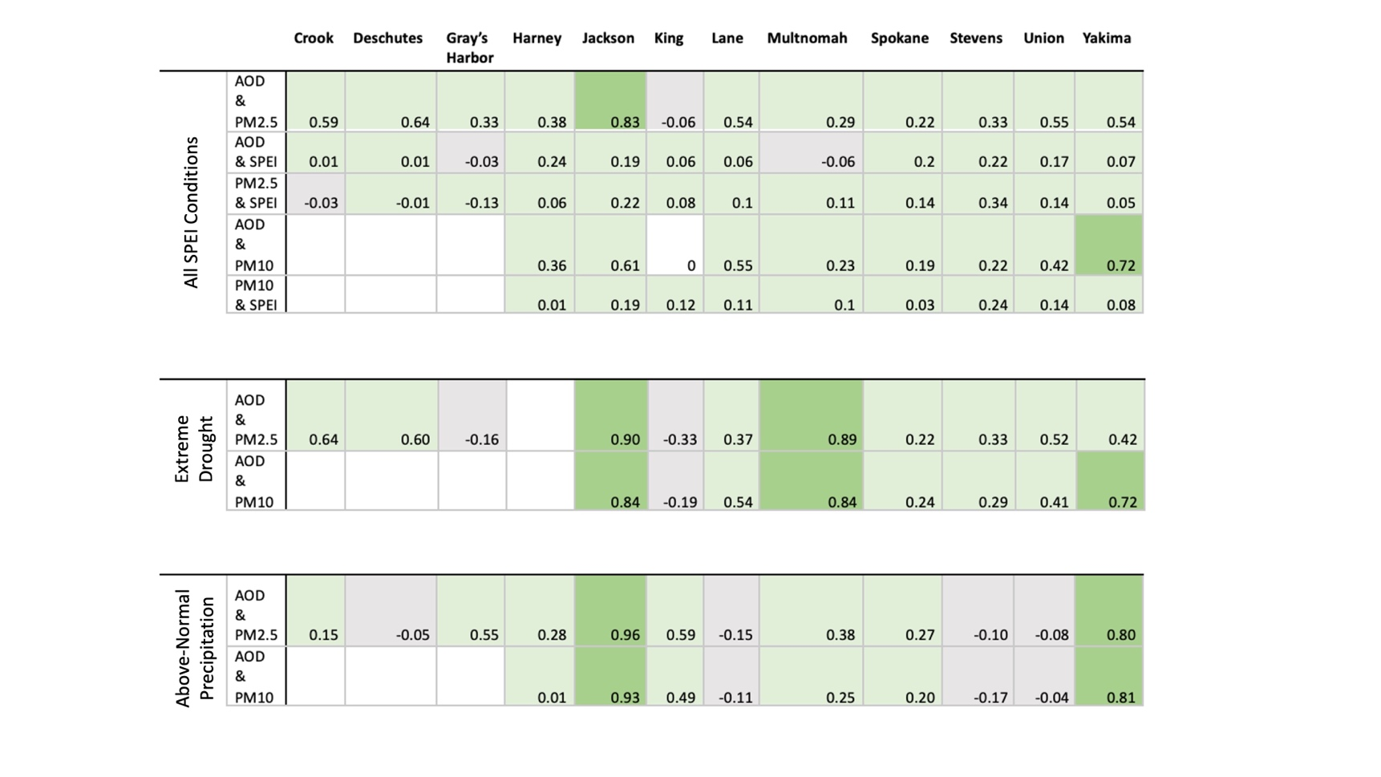

Several counties showed high correlation between air quality parameters, including between AOD and PM10 datasets in Jackson, Multnomah, and Yakima counties during extreme drought (SPEI values <-1.5). AOD & PM were also correlated in above-normal precipitation conditions in several counties. Strong correlations between AOD and PM reassure that satellite observations of aerosols are indicative of ground conditions.

Most surprising, however, was the lack of significant correlation between SPEI and air quality parameters across the study region and period (Figure 4). Even in Jackson (Figure 4A) and Spokane (Figure 4B) counties, both of which had high correlations between AOD and PM, air quality parameter medians did not significantly shift between above-normal precipitation conditions and drought conditions, as specified by SPEI (Figure 4).

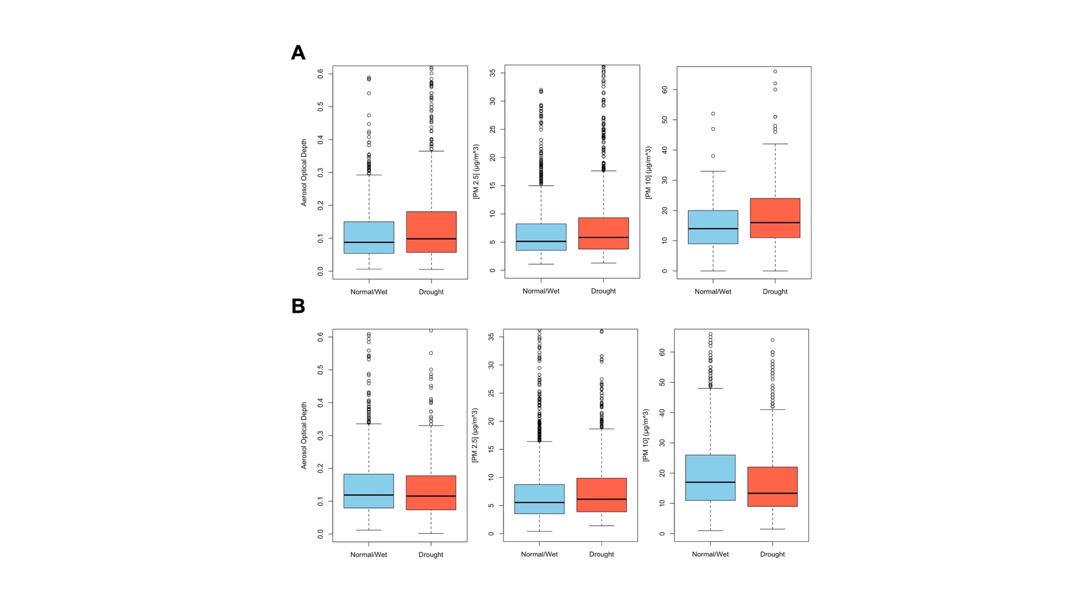

*Figure 4.*Aerosol optical depth, PM2.5 (µg/m3) concentrations, and PM10 (µg/m3) concentrations did not significantly vary between above-normal precipitation (blue) and drought (orange) conditions, as indicated by SPEI, in **A.** Jackson County, OR, and **B.** Spokane County, WA across the study period. Calculated medians were indicated by black lines bisecting each box.

SPEI’s insignificant correlation with air quality was also evident in our spatial analysis, with counties behaving opposite to what we would expect (Figure 5). AOD and PM10 concentrations were selected based on whether they occurred in drought or above-normal/wet conditions (as indicated by SPEI) and were averaged across the study period (2015–2022). Several counties, including King, Lane, Multnomah, Spokane, and Union, all showed lower AOD and PM10 concentrations in drought conditions than in above-normal precipitation conditions. Jackson and Harney counties, however, both exhibited higher concentrations of PM10 in drought conditions than in above-normal precipitation conditions, which aligned well with our expectations. Yakima and Stevens counties showed no change between drought and above-normal precipitation conditions.

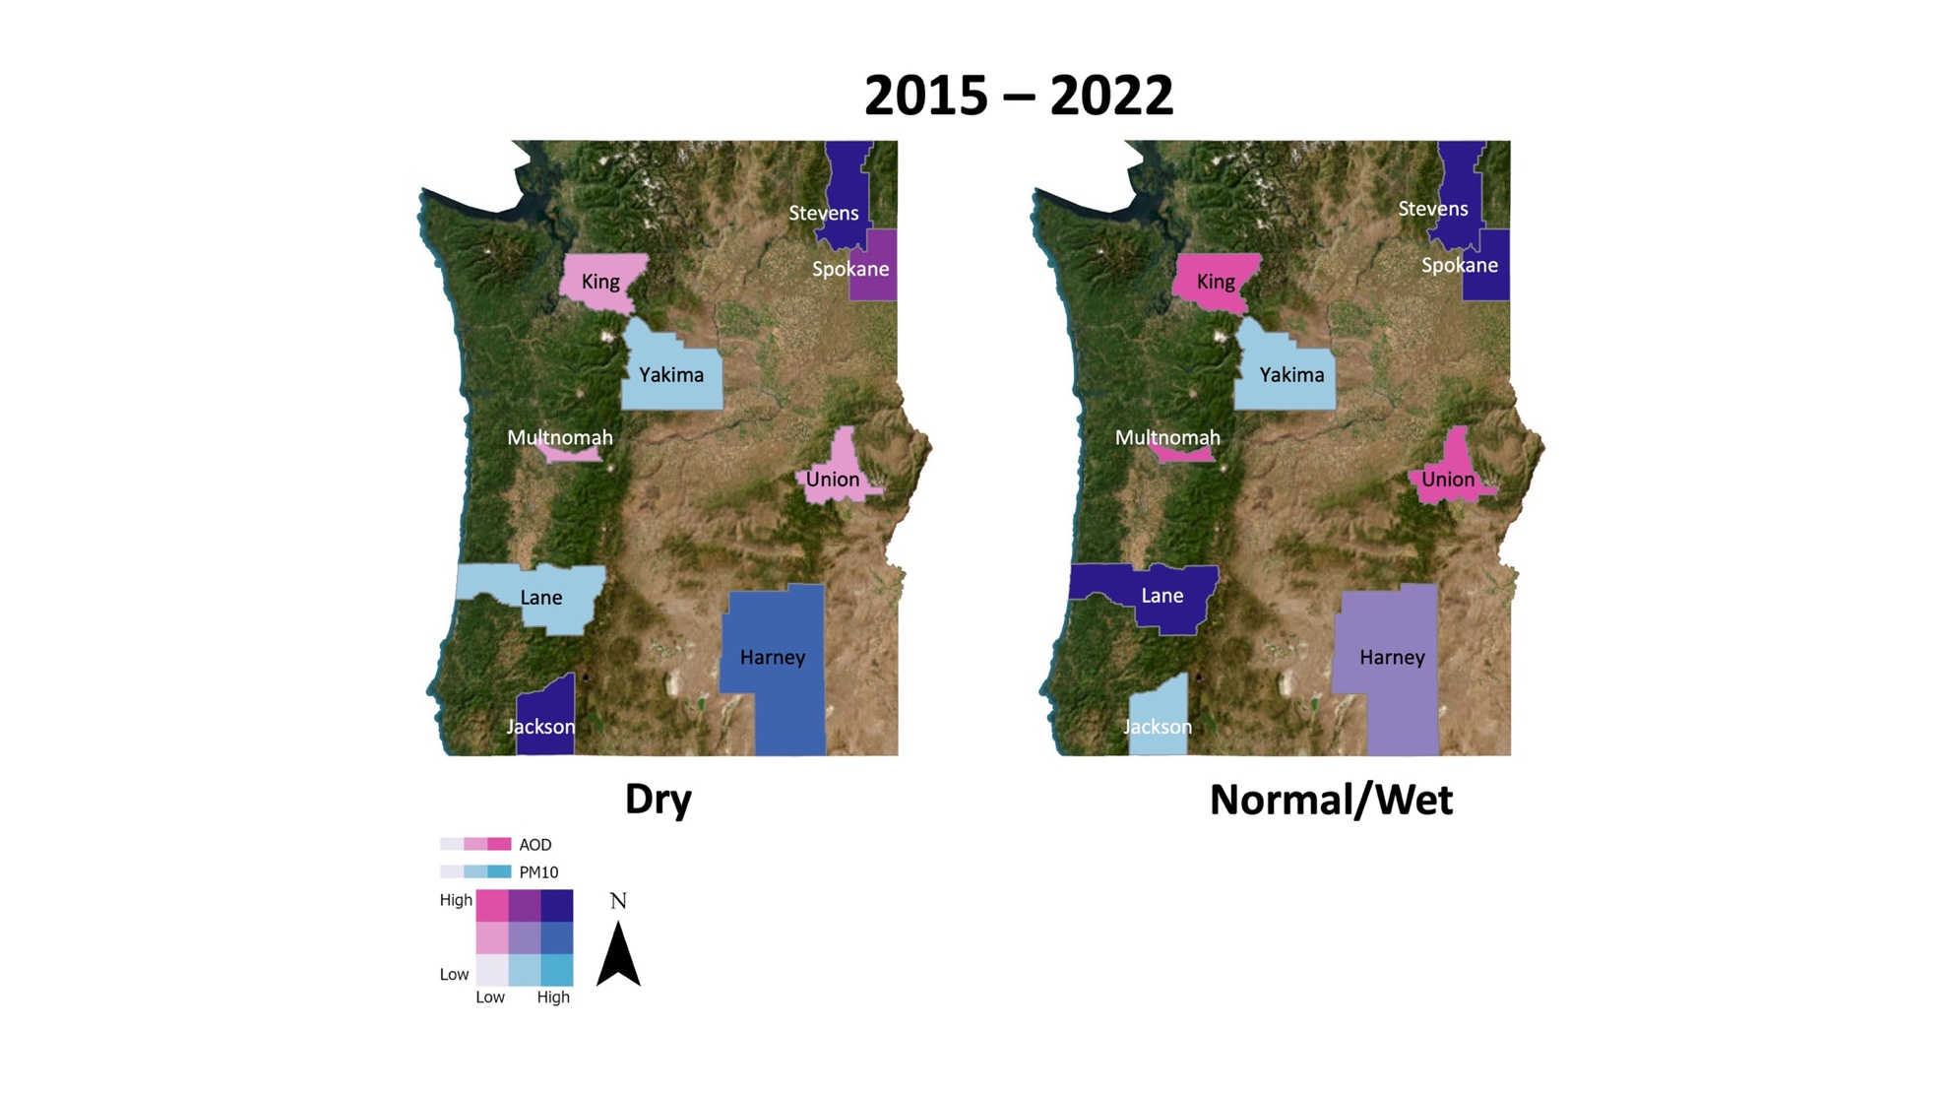

*Figure 5.* This image shows *r*elative concentrations of air quality parameters (AOD and PM10) and their variability across the study area, filtered to selected counties of interest. Dark purple indicates counties where both AOD and PM10 concentrations are high, while light lavender indicates low concentrations of both air quality parameters. Bright teal blue values indicate counties where PM10 concentrations are high while AOD is low, and bright pink values indicate counties where AOD is high and PM10 concentrations are low. Middle values are represented by in-between colors in the bivariate gradient.

*4.1.1 Uncertainty*

Overall, SPEI was negatively or only loosely correlated with AOD, PM10, and PM2.5, suggesting other factors may be affecting analysis. In all air quality parameters considered, we observed frequent and strong wildfire signals, which are known to be secondary impacts of drought (NIDIS, n.d.). It is possible, however, that wildfires may not be significantly correlated with SPEI conditions, which could have introduced outliers into our correlation analysis. Further, SPEI was calculated based on a 270 day, or nine-month, aggregation period, meaning that shorter, more episodic drought events would have been smoothed out of the SPEI calculation, escaping representation in our analysis.

***4.2 Feasibility Assessment***

Project partners can gain an understanding of utilizing remote Earth observations to sense atmospheric air pollutants and aerosols through this project. The use of AOD as a remote dataset allowed the partners to understand the availability, limitations, and capabilities of this proxy measurement of aerosols. Our methodology also allowed end users to observe ways in which remote data can be used in conjunction with ground-based data to study air quality through a wider lens.

***4.3 Future Work***

We suggest using a shorter SPEI aggregation period to allow for detection of shorter-lived droughts, which may be impacting air quality in the region. Atmospheric advection of poor air quality from locations outside our study region, as well as differences in population density between counties, could have also resulted in discrepancies between localized SPEI conditions and air quality (Samson, 1988; Borck & Schrauth, 2021). In addition to their interest in understanding trends in the region’s air quality history, project partners also expressed interest in differentiating between wildfire and drought influences on air quality. Due to limitations on the scope of this project, we exclusively examined the impact of drought on air quality in Oregon and Washington. Future NASA DEVELOP terms may explore the combined impact of various point-sources of air pollution (including wildfires, topography, and population density) on regional air quality.

# 5. Conclusions

Drought did not appear to be the cause of poor air quality in the Pacific Northwest during this study period. We did not observe a significant correlation between SPEI, our indicator of drought, and air quality parameters across our study period and region. For the most part, our results did not show air quality worsening in periods of drought, with several exceptions in Jackson and Harney counties. We found, however, a high degree of correlation between remotely sensed air quality parameters (AOD) and ground-based measurements of air quality (PM10 and PM2.5), which encourages future use of satellite observations to measure air quality. AOD was highly correlated with both PM datasets (PM2.5 and 10), however, identifying a gap in our ability to isolate specific aerosols from satellite observations. Further, we found a nine-month SPEI aggregation period to be unsuitable for research into the effect of drought on air quality. Future studies should shorten the SPEI aggregation period to include shorter, episodic drought events. Additionally, future studies should expand analyses to all counties in the Pacific Northwest, include the state of Idaho to incorporate varied topography, and investigate other sources of poor air quality, such as wildfires, population density and emissions, all while considering the possibility of atmospheric advection of poor air quality.

The partners received map layer packages, results from correlation analyses, time series, and written materials (in both scientific and creative science communication formats) upon completion of this project. In summary, our study supplemented research into links between drought and human health and provided health departments with an objective foundation from which they can communicate public health risks to local communities.

# 6. Acknowledgements

Our team would like to acknowledge all those who provided support, guidance, and partnership for this project. First, we would like to thank our partners: Amber Blanchard, Victoria Clemmons, Curtis Cude, Dr. Carol Trenga, Sarah Worthington, Marnie Boardman, Dr. Anne Doubleday, Dr. Julie Fox, Britt Parker, Dr. Jesse E. Bell, and Rachel Lookadoo. We would also like to thank our science advisors: Molly Woloszyn, Dr. Jesse Berman, Dr. Babak Fard, Ronald Leeper, and Jared Rennie.

We would also like to extend a special thanks to all other individuals who provided assistance including Ryan Healey, Britnay Beaudry, Annie Britton, Kristen O’Shea, Steve Ansari, NCICS IT (Scott Wilkins and Stephen Marcus), and Dr. Kenton Ross. Finally, we would like to thank the North Carolina – NCEI fellow, Kathryn Caruso, for all of her guidance and help throughout the term.

Any opinions, findings, and conclusions or recommendations expressed in this material are those of the author(s) and do not necessarily reflect the views of the National Aeronautics and Space Administration.

This material is based upon work supported by NASA through contract NNL16AA05C.

# 7. Glossary

**Aerosols** – A collection of particles suspended in air or gas.

**AOD** – Aerosol Optical Depth. A remote proxy measurement of atmospheric aerosols that measures the amount of electromagnetic radiation blocked by aerosols in a column of air.

**Bivariate Choropleth Map** – A type of spatial mapping that represents a relationship between two variables using a color grid to express the extent to which the variables are related.

**Earth observations** – Satellites and sensors that collect information about the Earth’s physical, chemical, and biological systems over space and time.

**EPA** – Environmental Protection Agency.

**Evapotranspiration** – Process by which soil moisture is lost from the soil, via evaporation, and water is lost from plants, via transpiration.

**GEE** – Google Earth Engine. A geospatial mapping and processing platform that allows users to access remote Earth observations using code.

**GridMET** – Gridded Meteorological Data. A high-resolution spatial dataset of surface meteorological variables covering the continental United States at 4km resolution.

**MAIAC** – Multi-Angle Implementation of Atmospheric Correction. An algorithm that processes surface reflectance and atmospheric aerosol data from MODIS using time series analysis and consolidates MODIS data into a fixed grid at 1 km resolution.

**MODIS** – Moderate Resolution Imaging Spectroradiometer. A sensor aboard NASA’s Terra and Aqua satellites that collect Earth observation data using 36 spectral bands.

**Particulate Matter** – PM. A type of atmospheric pollutant consisting of small particles of airborne solids or liquids.

**SPEI** – Standardized Precipitation Evapotranspiration Index. A climatological index that expresses variances in precipitation-evapotranspiration balances to indicate drought conditions.

**Spatiotemporal** – Correlations occurring across space and time.

# 8. References

*2022 Drought Resources for the Pacific Northwest*. Drought.gov. (n.d.). <https://www.drought.gov/2021-drought-resources-pacific-northwest#:~:text=Most%20of%20the%20Pacific%20Northwest,the%20region%20is%20in%20drought>

Abatzoglou, J. T. (2011). Development of gridded surface meteorological data for ecological applications and modelling. *International Journal of Climatology*, *33*(1), 121–131. <https://doi.org/10.1002/joc.3413>

*About OHA*. Oregon Health Authority : About OHA : State of Oregon. (n.d.). <https://www.oregon.gov/oha/Pages/Portal-About-OHA.aspx>

*About Us*. UNMC. (n.d.). <https://www.unmc.edu/publichealth/wch/about/index.html>

AirNow.gov, U.S. EPA. (n.d.). *AQI Basics*. AQI Basics | AirNow.gov. <https://www.airnow.gov/aqi/aqi-basics/>

Dai, A. (2013). Increasing drought under global warming in observations and models. *Nature Climate Change*, *3*(1), 52–58. <https://doi.org/10.1038/nclimate1633>

*DROUGHT EARLY WARNING SYSTEM Pacific Northwest*. Drought.gov. (n.d.-b). <https://www.drought.gov/dews/pacific-northwest>

Ebi, K. L. (2022). Methods for quantifying, projecting, and managing the health risks of climate change. *NEJM Evidence*, *1*(8). <https://doi.org/10.1056/evidra2200002>

Environmental Protection Agency. (n.d.). *Managing Air Quality - Air Pollutant Types*. EPA. <https://www.epa.gov/air-quality-management-process/managing-air-quality-air-pollutant-types>

Environmental Protection Agency. (n.d.-b). *Outdoor Air Quality Data Download Daily Data*. EPA. <https://www.epa.gov/outdoor-air-quality-data/download-daily-data>

Johnson, D. (2021, August 1). *At the end of July, Oregon’s 2021 fire season was greatly outpacing the 2020 season*. KGW8. <https://www.kgw.com/article/news/local/oregon-2021-wildfire-season-outpacing-2020/283-ef36e233-c924-4490-a267-919b6f29196f>

Kramer, A. L., Campbell, L., Donatuto, J., Heidt, M., Kile, M., & Massey Simonich, S. L. (2020). Impact of local and regional sources of PAHs on tribal reservation air quality in the U.S. Pacific Northwest. *Science of The Total Environment*, *710*, 136412. <https://doi.org/10.1016/j.scitotenv.2019.136412>

Liu, Y., Austin, E., Xiang, J., Gould, T., Larson, T., & Seto, E. (2021). Health Impact Assessment of the 2020 Washington State Wildfire Smoke Episode: Excess Health Burden Attributable to Increased PM2.5 Exposures and Potential Exposure Reductions. *GeoHealth*, *5*(5). <https://doi.org/10.1029/2020gh000359>

LP DAAC - MCD19A2 - USGS. (n.d.). <https://lpdaac.usgs.gov/products/mcd19a2v061/>

LP DAAC - MCD19A2CMG. (n.d.-b). <https://lpdaac.usgs.gov/products/mcd19a2cmgv061/>

Lyapustin, A. *MODIS/Terra+Aqua AOD and Water Vapor from MAIAC, Daily L3 Global 0.05Deg CMG V061*. 2023, distributed by NASA EOSDIS Land Processes DAAC, <https://doi.org/10.5067/MODIS/MCD19A2CMG.06>. Accessed 2023-06-13.

Lyapustin, A. (n.d.) *Multi-Angle Implementation of Atmospheric Correction (MAIAC) (MCD19)*. National Aeronautics and Space Administration – Goddard Space Flight Center. <https://modis-land.gsfc.nasa.gov/MAIAC.html>

U.S. EPA. (n.d.). *Managing Air Quality – Air Pollutant Types*. EPA.gov. <https://www.epa.gov/air-quality-management-process/managing-air-quality-air-pollutant-types>

McClure, C. D., & Jaffe, D. A. (2018). US particulate matter air quality improves except in wildfire-prone areas. *Proceedings of the National Academy of Sciences*, *115*(31), 7901–7906. <https://doi.org/10.1073/pnas.1804353115>

NASA. (n.d.). *NLDAS-2 forcing dataset information | LDAS - NASA*. LDAS Land Data Assimilation System. <https://ldas.gsfc.nasa.gov/nldas/v2/forcing>

National Drought Mitigation Center University of Nebraska-Lincoln. (n.d.). *What is the USDM?*. What is the USDM? | U.S. Drought Monitor. <https://droughtmonitor.unl.edu/About/WhatistheUSDM.aspx#:~:text=The%20map%20uses%20six%20classifications,)%20and%20exceptional%20(D4>)

NIDIS (n.d.). *Wildfire Management*. Drought.gov. <https://www.drought.gov/sectors/wildfire-management#:~:text=Drought%2C%20combined%20with%20warming%20temperatures,increased%20potential%20for%20large%20wildfires>.

NOAA. (n.d.). *What is NIDIS?*. Drought.gov. <https://www.drought.gov/about>

*Particle pollution in Washington’s air*. Particle pollution - Washington State Department of Ecology. (n.d.). <https://ecology.wa.gov/Air-Climate/Air-quality/Air-quality-targets/Air-quality-standards/Particle-pollution>

Puvvula, J., Poole, J. A., Gwon, Y., Rogan, E. G., & Bell, J. E. (2023). Role of social determinants of health in differential respiratory exposure and health outcomes among children. *BMC Public Health*, *23*(1). <https://doi.org/10.1186/s12889-022-14964-2>

Samson, P. J. (1988). Atmospheric Transport and Dispersion of Air Pollutants Associated with Vehicular Emissions. *Air Pollution, the Automobile, and Public Health*. <https://www.ncbi.nlm.nih.gov/books/NBK218142/>

Thome, K. (n.d.). *Terra: Modis*. NASA. <https://terra.nasa.gov/about/terra-instruments/modis#:~:text=With%20its%20sweeping%202%2C330%2Dkm,than%20any%20other%20Terra%20sensor>

U.S. Census Bureau (2022). *Encyclopedia of Big Data*, 155–158. <https://doi.org/10.1007/978-3-319-32010-6_257>

Vicente-Serrano, S. M. (2022, September 9). *Standardized Precipitation Evapotranspiration Index (SPEI)*. The Climate Data Guide. <https://climatedataguide.ucar.edu/climate-data/standardized-precipitation-evapotranspiration-index-spei#:~:text=The%20average%20value%20of%20SPEI,to%20a%20Log%2Dlogistic%20distribution>

Vicente-Serrano, S. M., Beguería, S., & López-Moreno, J. I. (2010). A multiscalar drought index sensitive to global warming: The standardized precipitation Evapotranspiration index. *Journal of Climate*, *23*(7), 1696–1718. <https://doi.org/10.1175/2009jcli2909.1>

Wang, Y., Xie, Y., Cai, L., Dong, W., Zhang, Q., & Zhang, L. (2015). Impact of the 2011 Southern U.S. Drought on Ground-Level Fine Aerosol Concentration in Summertime*. *Journal of the Atmospheric*  *Sciences*, *72*(3), 1075–1093. <https://doi.org/10.1175/JAS-D-14-0197.1>

Wang, Y., Xie, Y., Dong, W., Ming, Y., Wang, J., & Shen, L. (2017). Adverse effects of increasing drought on air quality via natural processes. *Atmospheric Chemistry and Physics*, *17*(20), 12827–12843. <https://doi.org/10.5194/acp-17-12827-2017>

Washington State Department of Health. (n.d.). <https://doh.wa.gov/>

*What is gridMET?* (n.d.). Climatologylab.org. <https://www.climatologylab.org/gridmet.html>

*What is NIDIS?*. Drought.gov. (n.d.-b). <https://www.drought.gov/about#:~:text=NIDIS’s%20mission%20is%20to%20improve,to%20the%20effects%20of%20drought>.

*What is* *the USDM?* (n.d.) U.S. Drought Monitor. <https://droughtmonitor.unl.edu/About/WhatistheUSDM.aspx#:~:text=The%20map%20uses%20six%20classifications,)%20and%20exceptional%20(D4>)