Alaska Disasters

Evaluating the Atmosphere-Land Exchange Inverse Evaporative Stress Index for the Alaskan Environment to Determine Wildfire Likelihood

 **Technical Report**

Final Draft – April 4th, 2019

Christine Evans (Project Lead)

Ryan Marshman

Brianna Santallana

Dr. Jeffrey Luvall, NASA Marshall Space Flight Center (Science Advisor)

Dr. Robert Griffin, University of Alabama in Huntsville (Science Advisor)

# 1. Abstract

Alaska’s wildfire season has progressively increased in duration and intensity over the last decade, leaving forested areas subject to devastating destruction. These increases in wildfire occurrence are due to gradual rises in land surface temperature, decreases in precipitation levels, and lack of soil moisture throughout the state. This causes concerns for air pollution as well as the destruction of homes and wildlife habitats within or around forests. The Alaska Disasters project team used remotely sensed data obtained from Aqua Moderate Resolution Imaging Spectroradiometer (MODIS), Terra MODIS, Suomi National Polar-orbiting Partnership (NPP) Visible Infrared Imaging Radiometer Suite (VIIRS), and National Oceanic and Atmospheric Administration-20 (NOAA-20) VIIRS from April through September of 2004, 2005, 2015, and 2018 to observe vegetation and moisture changes in affected areas before and after wildfires. Using the Atmosphere-Land Exchange Inverse (ALEXI) Evaporative Stress Index (ESI) generated by the NASA Short-term Prediction Research and Transition Center (SPoRT), the team determined if ALEXI ESI provided lead time on the evaluation of vegetation stress. Team members completed this analysis by using Pearson’s correlation coefficient to determine the correlation between the ALEXI ESI output and various vegetation monitoring indices. The team then compared the utility of the ALEXI ESI to the Canadian Fire Weather Index (FWI) to evaluate the benefit of using ALEXI ESI in conjunction with current decision-making processes in Alaska. With these results, the Alaska Interagency Coordination Center (AICC) and Alaska Fire Science Consortium (AFSC) are able to make better-informed decisions when determining fire management techniques and assessing the risk of future wildfire outbreaks.

**Keywords**

Terra MODIS, Aqua MODIS, Suomi NPP VIIRS, NOAA-20 VIIRS, remote sensing, vegetation,

water stress

# 2. Introduction

* 1. ***Background Information***

The state of Alaska, depicted in *Figure 1*, has been experiencing climatic changes at a rate twice that of the contiguous United States. Temperatures since the 1970s have been the warmest of the past 200 years, causing winters to be shorter and summers to be longer. Over the past century, mean temperatures in Fairbanks, Alaska, located in the central part of the state, have increased by 1.4 °C (Calef, Varvak, & Mcguire, 2017). With increased temperatures, Alaska experiences earlier snowmelt, thawing permafrost, and drier landscapes, which in turn causes water stress in vegetation. These environmental changes have a major impact on the state’s burn season, causing the fires to increase in duration and intensity (Chapin et al., 2014). On average over the last 55 years, 3,775 square kilometers of land burn every year, and this number continues to increase (Wendler, Conner, Moore, Shulski, & Stuefer, 2011). The Burn Belt, a region through central Alaska, has experienced a higher concentration of wildfires. The Burn Belt lies between the Brooks Range to the north and the Alaska Range to the south. The mountain ranges block moisture from reaching the interior of this area, contributing to the area’s semi-arid climate. Tree growth in the Burn Belt is only possible due to low evapotranspiration rates and low summer temperatures (Calef et al., 2017).

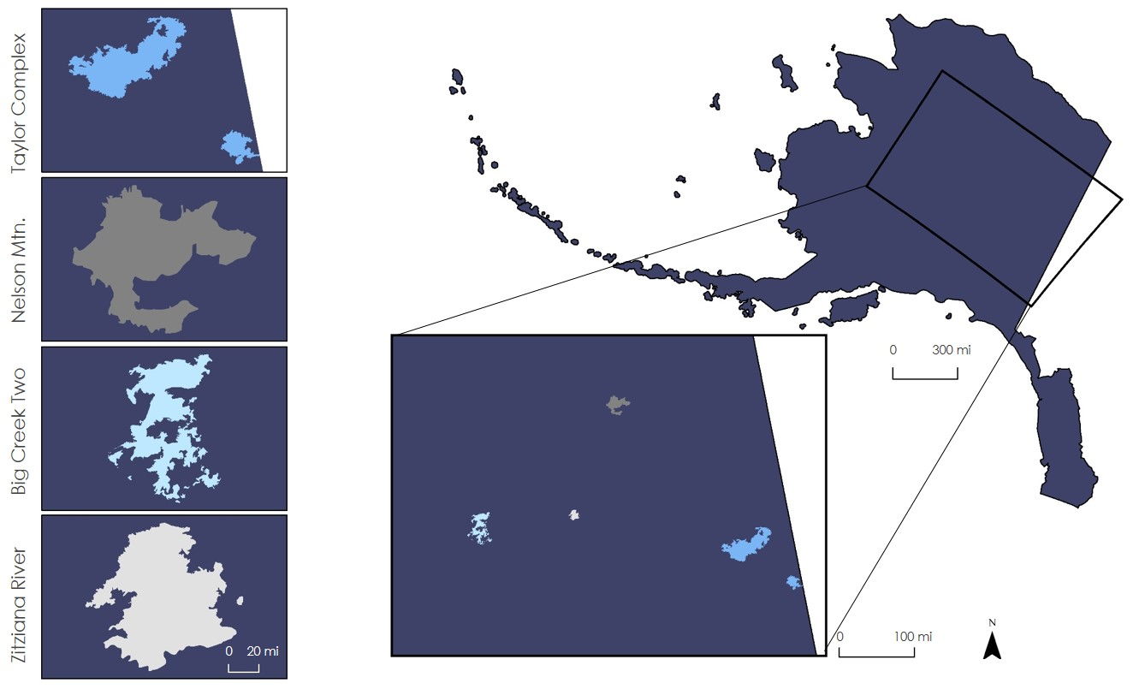

Figure 1. The project study area covers the state of Alaska, specifically focusing on the four largest fires during 2004, 2005, 2015 and 2018.

The increase in fire potential has prompted scientists to investigate where wildfires start and how long they last, especially in the Burn Belt where wildfires are detected but not easily monitored. To do this, the team utilized data from the Alaskan fire seasons (April to September) of 2004, 2005, 2015, and 2018 to analyze current methods used for determining the presence of wildfires and to assess the potential for wildfire management practices supported by remotely sensed data.

The Atmosphere-Land Exchange Inverse (ALEXI) Evaporative Stress Index (ESI) may enhance forecasting wildfires as it can detect vegetation water stress before the vegetation health approaches a critical level. ALEXI ESI is a thermal infrared-based, surface-energy balance model that provides the mean moisture condition (Mishra, Cruise, Hain, Mecikalski, & Anderson, 2018). The land surface temperature (LST) signal shows signs of vegetation stress prior to vegetation showing any indications of stress through the Normalized Difference Vegetation Index (NDVI). Due to this, ESI can potentially provide an early warning system for vegetation health as water stress occurs prior to vegetation health degradation (Case, Hain, Blankenship, & Schultz, 2017). Using the ALEXI ESI may help the Alaska Interagency Coordination Center (AICC) with predicting wildfires earlier.

* 1. ***Project Partners & Objectives***

The NASA DEVELOP team partnered with the AICC, the Alaska Fire Science Consortium (AFSC), and NASA Short-term Prediction Research and Transition (SPoRT). The AICC provides logistics support, tactical resource coordination, and predictive services to help combat wildfires in Alaska by means of fire management and suppression (Alaska Interagency Coordination Center, 2018). The four wildland fire management options (critical, full, modified, and limited) work to prioritize populated areas for initial response to ensure human safety, protect community land, and manage wildlife habitats in the most cost-effective way. By utilizing satellite data, the AICC also provides informational maps of Alaska, such as historical fire and lightning maps, which assist with assessing fire risk and management. The AFSC acts as a link between fire science research and fieldwork application by facilitating communication between fire or land managers and research scientists (Alaska Fire Science Consortium, n.d.). NASA SPoRT utilizes Earth observations from NASA, the National Oceanic and Atmospheric Administration, and commercial land remote sensing images to improve regional land surface and atmospheric models. Recently, SPoRT has developed a global ESI product using the ALEXI model, allowing for detection of the current surface moisture state without using precipitation data (Hain et al., 2017).  Our partner, the AICC, currently uses the Canadian Fire Weather Index (CFWI) System for analyzing the potential for a wildfire to occur. The CFWI System is completely weather-based and utilizes noontime measurements of precipitation, relative humidity, temperature, and wind speed. However, the CFWI does not account for varied fuel types and drying conditions (Bourgeau-Chavez et al., 2007).

The objectives of this project included improving the detection of vegetation stress through NASA Earth observations, evaluating the ALEXI ESI product, identifying drought-prone areas, and displaying these results in an ArcGIS Story Map. Determining the ALEXI ESI product to be useful allows for more lead-time on identifying vegetation degradation. To do this, the team compared the ALEXI ESI to indices our partners currently use. As stressed vegetation acts as fuel for fire, being able to identify areas of soil moisture stress through ESI prior to the vegetation actually showing stress allows our partners to monitor these potential fire risk areas that do not appear through other indices. The team also provided an ArcGIS Online Story Map for use as an outreach tool highlighting the benefits of utilizing NASA Earth observations. By comparing the ESI product to the CFWI, NDVI, and the United States Drought Monitor (USDM), the AICC can evaluate the benefits of using the ALEXI model.

# 3. Methodology

***3.1 Data Acquisition***

The team first acquired a shapefile of the state of Alaska from the United States Census Bureau. The team then acquired ALEXI ESI data through the NASA SERVIR ESI product catalogue, obtaining 20 files of weekly vegetation stress data. Each file contains composite data for the previous four weeks of ALEXI ESI anomaly data in GeoTIFF format. For 2004, dates for the files downloaded are May 13, June 17, July 15, August 19, and September 16. For 2005 the dates are May 14, June 18, July 16, August 20, and September 17. Lastly, for both 2015 and 2018, the dates are May 9, June 18, July 12, August 21, and September 14. The team used these data for comparison with NDVI. NASA SPoRT also provided additional ESI percentage data in 4-week composites of the fire seasons for comparison with United States Department of Agriculture (USDA) United States Drought Monitor (USDM) data. The team downloaded 1-week composites of the USDM. The team then made 4-week composites of the data. For 2004, the team used the 4-week composites of May 18, June 15, July 20, August 17, and September 14. For 2015, the team used the 4-week composites of May 19, June 16, July 21, August 18, and September 15. For 2018, the team used the 4-week composites of May 22, June 19, July 24, August 21, and September 18. There are no data for 2005 because there was no drought during the study period. The team then acquired Moderate Resolution Imaging Spectroradiometer (MODIS) Vegetation Index products to determine vegetation conditions throughout the study area. The MODIS product, MOD13, provides a 16-day composite of NDVI values at a spatial resolution of 250 meters (Table 1). The NDVI files were acquired through the EarthExplorer portal in the form of GeoTIFFs. The team utilized these three datasets to create the ALEXI ESI Comparative Analysis end product.

The team acquired the CFWI data from the Alaska Fire and Fuels Website. The team downloaded data from 5 stations that surrounded each fire case study area. The time range was different for each year due to the fire cases occurring at different times. The team downloaded a 4-week composite of data that corresponded as close as possible to the time that led up to the fire for each fire case study and the ESI percentage data since the CFWI was compared to the ESI. The team downloaded 2004 CFWI data from May 21 to June 18 and included the stations of TKFA2, CKNA2, TEEA2, ALHA2, and PAOR. The team also downloaded 2005 CFWI from May 21 to June 18 and included the stations of SMIA2, LSTA2, WBQA2, VNKA2, and HOZA2. The team downloaded 2005 data from May 28 to June 25 and included data from the stations of KAI2, COTA2, RNDA2, PAMC, and PMNA2. Lastly, the team downloaded the 2018 data from May 7 to June 4 and included data from the stations of MDTA2, PATA, WNLA2, PANN, and CHTA2 (MesoWest & SynopticLabs, n.d.).

The team downloaded the USDM data from the USDA USDM website. The team downloaded the drought shapefiles of Alaska for the entire years of 2004, 2005, 2015, and 2018. The USDA compiled the USDM data into 1-week composites. After downloading and unzipping the data, the team only used the months of April to September for the study period and deleted the irrelevant data. Data levels, date ranges, parameters, and resolutions are included in Table 1.

Table 1

*Data products utilized*

|  |  |  |  |  |  |  |
| --- | --- | --- | --- | --- | --- | --- |
| **Sensor & Platform** | **Product**  **Level** | **Date Range** | **Database** | **Parameters** | **Temporal Resolution** | **Spatial Resolution** |
| Aqua MODIS | MYD13Q1 | April to September (2000 to 2003/2006 to 2014/2016) | EarthExplorer | Green vegetation cover | 16-day composite | 250 m |
| Terra MODIS | MOD13Q1 | April to September (2001 to 2005/2015/ 2018) | EarthExplorer | Green vegetation cover | 16-day composite | 250 m |
| ALEXI ESI (Anomalies) | N/A | April to September (2004 to 2005/2015 / 2018) | SERVIR Global ESI | Thermal-based LST, TIR-ESI, Thermal +Microwave- based LST, TIR+MW ESI | 4-week composite | 5 km |
| ALEXI ESI (Percentages) | N/A | April to September (2004 to 2005/2015/ 2018) | NASA SPoRT | Thermal-based LST, TIR-ESI, Thermal +Microwave- based LST, TIR+MW ESI | 4-week composite | 5 km |
| USDA Drought Monitor | N/A | April to September (2004 to 2005/2015/ 2018) | USDA Drought Monitor | Drought classification | 1-week composite | N/A |
| Canadian Fire Weather Indices (CFWI) | N/A | April to September (2004 to 2005/2015/ 2018) | Alaska Fire and Fuels | Fire intensity | 4-week composite | N/A |

***3.2 Data Processing***

For the 2004 and 2005 ALEXI ESI anomaly fire season data, the team used the raster calculator in ArcMap to remove null values from the data. This was not necessary for the 2015 and 2018 data as the null values were already removed. The team projected data from all years into the Alaska Albers Equal Area Conic coordinate system. Next, the team clipped all data files to the shapefile of the study area and resampled the data files to a spatial resolution of 250 m.

The team uploaded the CFWI data into a Microsoft Excel file, averaged the CFWI value for each station from the specified time period, and made a new table in Excel that included the station ID, latitude and longitude of each station, and the FWI average for the station. There were a total of 4 tables made in Excel for each year in the study period. The team uploaded the Excel tables into ArcMap and created points from the latitude and longitude of the stations. The team then created a shapefile of all the points for each year and projected the shapefiles to the Alaska Albers Equal Area Conic coordinate system.

In order to analyze the USDM and ALEXI ESI percentage data, the team had to adjust the data in ArcMap. The team projected both datasets to the Alaska Albers Equal Area Conic coordinate system. Next, the team clipped the USDM data and ALEXI ESI percentage data to only the state of Alaska. The team converted the USDM data into a raster file for the ALEXI ESI comparison. The team then resampled both the ALEXI ESI and USDM data to a spatial resolution of 250 m. Next, the team reclassified the ALEXI ESI and USDM data. For the ALEXI ESI, the team reclassified values from -1 to 0 equal to 1 and reclassified values from 0 to 1 equal to 0. Values of 1 indicated stressed vegetation and values of 0 indicated unstressed vegetation. The team also removed values with no data. For the USDM, the team reclassified the values from D1 to D4 equal to 1 and reclassified values of D0 equal to 0. Values of 1 indicated drought and values that were 0 or not identified with a value were considered not to be drought. Finally, the team made 4-week composites of the USDM data to better compare with the ALEXI ESI data

Using MODIS-derived NDVI, the team formatted the data into anomalies to provide a more accurate comparison to the ALEXI ESI. First, the team used the raster calculator to adjust the scale of the data values by multiplying the raster by 0.001. Once the NDVI values were in the correct format, the team utilized all eighteen years of data composites to compute anomalies. An anomaly highlights where the vegetation was abnormally unhealthy in comparison to the mean and standard deviation of the data. The team calculated the mean NDVI value, standard deviation of the data, and anomaly for each 4-week range of data. The team calculated this using Equation 1, where (v(w, y, i, j)) is the composite for week w, year y, and i-, j-grid locations, the second term in the numerator is the normal field averaged over all years (ny), and the denominator is the standard deviation computed overall years (Anderson et al., 2012).

(1)

***3.3 Data Analysis***

The team performed a spatial correlation statistical analysis with the CFWI and ALEXI ESI. This helped in comparing the two models and evaluating the ALEXI ESI model to see the benefits of using it throughout Alaska and use for predicting wildfires. The team performed an accuracy assessment of the ALEXI ESI model in order to quantify how well it classifies drought and fire risk compared to the USDM and CFWI. In order to assess the accuracy, the team computed a confusion matrix of the ALEXI ESI model against both the USDM and the CFWI. The confusion matrix allowed the team to evaluate the error of the ALEXI ESI model when compared to the USDM and the CFWI.  From the confusion matrix, the team calculated overall accuracy, producer’s accuracy, and user’s accuracy. Overall accuracy evaluated if the ALEXI ESI model under or over-predicts stressed vegetation. Producer’s accuracy showed the accuracy from the point of view of the ALEXI ESI model, while the user’s accuracy showed the accuracy from the point of view of the USDM and the CFWI. When the team computed the confusion matrix for the CFWI, the team identified values of 21 or higher (values considered to be high fire risk or greater according to the CFWI) to be stressed for the comparison to the ALEXI ESI.

To compare the ALEXI ESI model and the USDM, the team created random points for the Alaska shapefile and extracted those values to points for each file for both the ALEXI ESI and USDM. The team exported the tables from the newly created shapefiles to Excel. In Excel, the team computed a confusion matrix for each year in study period to calculate the overall accuracy, producer’s accuracy, and user’s accuracy. The team repeated the same process for the CFWI and ALEXI ESI comparison except the team did not create random points because the team used the latitude and longitude of the stations for the fire case studies as the points.

To compare the ALEXI ESI data to the NDVI data, the team created a layer of 24,000 random points within the shapefile of the state of Alaska. The team extracted values for both the ESI and NDVI data raster layers at these point locations and exported those values to Excel. As the data raster layers all had different areas of data gaps, the team removed any point data from the comparisons that represented null values. Using Excel, the team calculated Pearson’s correlation coefficient (R) using Equation 2 and arranged the data into scatter plots with lines of best fit displaying the R2 values.

(2)

# 4. Results & Discussion

***4.1 Analysis of Results***

*4.1.1 ALEXI ESI Comparative Analysis*

The team produced visual map comparisons of ESI anomalies to NDVI anomalies and of ESI percentages to the USDM drought classifications. To do this, the team separated the data into mid-month to mid-month increments. For the ESI to USDM comparison, ESI percentage values from 0 to 1 indicated no drought while values from -1 to 0 indicated drought. For the USDM, categories D1 through D4 were classified as drought while categories of none and D0 were classified no drought. Both the NDVI and the ESI show high values in purple and low values in gold. The high values for NDVI represent areas of above average green vegetation while low values represent areas with below average green vegetation cover. High-value areas for ESI represent above-average vegetation health and soil moisture while low-value areas represent below average vegetation stress and soil moisture content. The USDM shows only areas of droughts, represented in gold. Visually, these indices do not show much correlation, as low values for the NDVI do not necessarily correlate with low values for ESI, nor do they often correlate with areas of drought in the USDM (*Figure 2* and *Appendix Figures A1 through A3*).

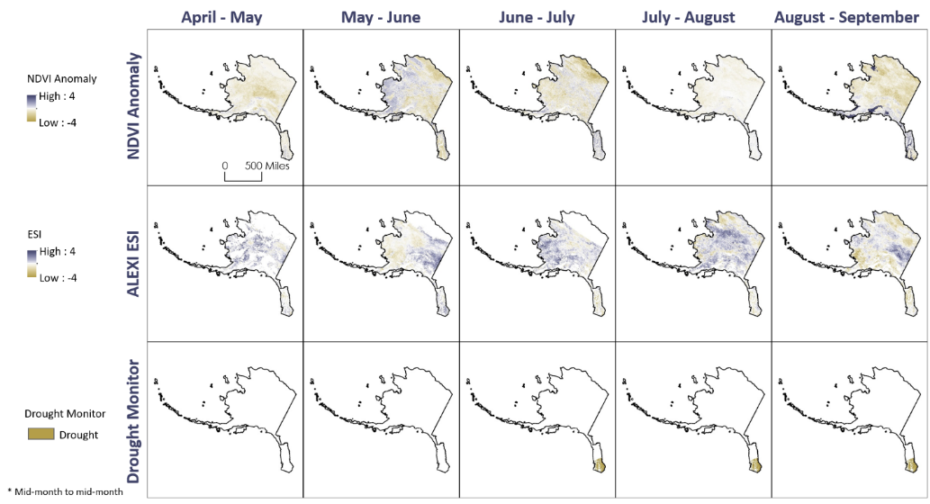

*Figure 2.* Visual comparison maps between the NDVI anomalies, ALEXI ESI, and drought monitor classifications during the fire season in 2018.Areas of healthy, green vegetation are displayed in purple while areas of unhealthy, less green vegetation are shown in gold. The drought classification areas are also in gold.

To quantitatively compare our data, the team created scatter plots displaying R2 values along with lines of best fit for each period of the NDVI to ESI comparison (*Appendix Figures B1 through B20*). The team also calculated the R values for each pair, as displayed in Table 2. R values for this analysis range from 1 to -1, with 1 meaning positive correlation, -1 meaning negative correlation, and 0 meaning no correlation. R2 values range from 0 to 1, with 0 representing no correlation to the line of best fit while 1 indicates perfect correlation. As you can see from our computations, there was little correlation between the data as both R and R2 values are low. These numbers are expected as the visual analysis showed little correlation.

Table 2

*Pearson’s correlation coefficient between ALEXI ESI and MODIS-derived NDVI*

|  |  |  |  |  |
| --- | --- | --- | --- | --- |
|  | **2004** | **2005** | **2015** | **2018** |
| April to May | - 0.163 | - 0.327 | - 0.109 | - 0.099 |
| May to June | - 0.123 | - 0.072 | - 0.143 | - 0.360 |
| June to July | - 0.130 | - 0.100 | 0.036 | - 0.153 |
| July to August | - 0.104 | - 0.129 | - 0.179 | - 0.031 |
| August to September | - 0.026 | - 0.256 | - 0.038 | - 0.267 |

The team statistically analyzed the comparison between the ALEXI ESI and USDM by computing a confusion matrix to assess the accuracy of the ALEXI ESI against the USDM. In Appendix Table C3, the team created a confusion matrix for the ALEXI ESI and USDM for the fire season of 2018; similar confusion matrices for 2004 and 2015 are found in Appendix Tables C1 and C2. Looking at the June to July time frame of 2018 as an example, the box that intersected the not stressed ALEXI ESI and the not stressed USDM were true negatives (TN). The box that intersected stressed ALEXI ESI and not stressed USDM were false positives (FP). The box that intersected not stressed ALEXI ESI and stressed USDM were false negatives (FN). Lastly, the box that intersected stressed ALEXI ESI and stressed USDM were true positives (TP). The team used the values from the confusion matrix to calculate different accuracy assessment parameters. Table 3 below shows the results of the accuracy assessment from June to July for the study period. In 2018, the overall accuracy was 61.2%, the producer’s accuracy was 61.3%, and the user’s accuracy was 99.8%. In 2004, the accuracy was the highest out of the study period with an overall accuracy of 95.4%. The accuracy of the correctly classified area of both the ALEXI ESI and USDM in 2004 demonstrated a high correlation between the two products while the other years did not show a very high correlation between the two products. There was no drought in 2005 during the study period, so the team did not have any results. The accuracy assessment between the ALEXI ESI and USDM generally showed that the ALEXI ESI classified areas of stressed vegetation differently than the UDSM.

Table 3

*Accuracy Assessment between ALEXI ESI and USDA USDM drought classifications for June to July*

|  |  |  |  |
| --- | --- | --- | --- |
|  | **Overall**  **Accuracy** | **Producer’s Accuracy** | **User’s Accuracy** |
| 2004 | 0.954 | 0.954 | 1 |
| 2005 | N/A | N/A | N/A |
| 2015 | 0.752 | 0.753 | 0.999 |
| 2018 | 0.612 | 0.613 | 0.998 |

*4.1.2 Canadian Fire Weather Index Comparative Analysis*

The team also computed a confusion matrix to statistically analyze the comparison between the ALEXI ESI and CFWI. The team used the values produced from the confusion matrix to calculate the accuracies using the same equations from the ALEXI ESI and USDM accuracy assessment. Table 4 below shows the results of the accuracies for the June to July ALEXI ESI and CFWI comparison. As the table shows below, the accuracies were high for most of the years indicating that the ALEXI ESI and CFWI had a high correlation. The high correlation between the two products was not necessarily ideal because the accuracy assessment did not show any differences between the ALEXI ESI and CFWI.

Table 4

*Accuracy Assessment between ALEXI ESI and Canadian Fire Weather Indices for June to July*

|  |  |  |  |
| --- | --- | --- | --- |
|  | **Overall**  **Accuracy** | **Producer’s Accuracy** | **User’s Accuracy** |
| 2004 | 1 | 1 | 1 |
| 2005 | 0.7143 | 0.6667 | 1 |
| 2015 | 0.7143 | 0.6000 | 1 |
| 2018 | 1 | 1 | 1 |

***4.2 Future Work***

# Future projects in this region should consider incorporating different classification types from the USDM, including the abnormally dry regions that show dryness in vegetation but not enough to be considered drought. These areas may have a higher correlation with the ALEXI ESI product since the plants may be stressed even if not dry enough to be classified as drought. As the majority of the wildfires that have occurred in Alaska were started by lightning, further analysis could also incorporate lightning point data as a parameter for lightning risk. Areas that have high vegetation stress combined with increased activity in lightning could be at a higher risk for wildfire occurrence. Knowing where these locations are, decision-makers can adjust their mitigation strategies to better monitor these areas. Finally, to continue analyzing and validating the ALEXI ESI product, the product could be compared to different vegetation monitoring indices such as the MODIS Evapotranspiration MOD16 product. This product calculates a water and energy balance to monitor soil water status. This may provide a better correlation over the comparison between the MODIS-derived NDVI and the ALEXI ESI.

# 5. Conclusions

ALEXI ESI senses changes in soil moisture before changes in vegetation health occur. This may explain the lack of correlation between ESI and NDVI as the ESI is detecting the change in the soil moisture before vegetation becomes stressed or less green as sensed by NDVI. This also holds true for the ESI comparison to the USDM as the ESI can sense changes in soil moisture prior to an area becoming dry enough to be classified as drought. One major limitation to the project was the NDVI and USDM composites were not the same as the ALEXI ESI. For example, the ALEXI ESI was a 4-week composite while the USDM was a 1-week composite. In order to analyze the ALEXI ESI with the NDVI and USDM, the team made a 4-week composite of both the NDVI and USDM data for all years in the study period. The composites did not overlap exactly which caused an error in the ALEXI ESI comparative analysis. Another limitation with the project was the classification of stress for the CFWI. The CFWI had 5 different classifications of fire risk. The team had difficulty distinguishing between stressed and unstressed values for the comparison to the ALEXI ESI. The issues of classification most likely contributed to the high accuracy for the CFWI and ALEXI ESI, thus not making this a good comparison. The high accuracy was not ideal because this showed no differences between the two products. The team wanted to evaluate the differences with each product to see the benefits of using the ALEXI ESI. Overall, the ALEXI ESI product detected stress in areas the NDVI and USDM did not, which could provide increase lead time in wildfire detection in Alaska.  

# 6. Acknowledgments

* Heidi Strader, Alaska Interagency Coordination Center (End User)
* Alison York, Alaska Fire Science Consortium (Collaborator)
* Chris Schultz, NASA Short-term Prediction Research and Transition Center (Collaborator)
* Chris Hain, NASA Short-term Prediction Research and Transition Center (Collaborator)
* Dr. Jeffrey Luvall, NASA Marshall Space Flight Center (Science Advisor)
* Dr. Robert Griffin, University of Alabama Huntsville (Science Advisor)
* Maggi Klug, University of Alabama Huntsville (Mentor)
* Leigh Sinclair, University of Alabama in Huntsville/Information Technology and Systems Center
* (Mentor)
* Helen Baldwin, University of Alabama in Huntsville (Mentor)
* Madison Murphy, NASA DEVELOP (Center Lead)
* Kathrene Garcia, NASA DEVELOP (Communications Fellow)

Any opinions, findings, and conclusions or recommendations expressed in this material are those of the author(s) and do not necessarily reflect the views of the National Aeronautics and Space Administration.

This material is based upon work supported by NASA through contract NNL16AA05C.

# 

# 7. Glossary

**AICC** – Alaska Interagency Coordination Center

**AFSC** –Alaska Fire Science Consortium

**ALEXI** – Atmosphere-Land EXchange Inverse

**CFWI** – Canadian Fire Weather Index

**Earth observations** – Satellites and sensors that collect information about the Earth’s physical, chemical, and biological systems over space and time

**ESI** –Evaporative Stress Index

**LST** – Land surface temperature

**MODIS** – MODerate resolution Imaging Spectroradiometer

**NASA SPoRT** – NASA Short-term Prediction Research and Transition Center

# VIIRS – Visible Infrared Imaging Radiometer Suite

# 8. References

Alaska Fire Science Consortium. (n.d.). *About AFSC*. Retrieved February 2019 from <https://www.frames.gov/afsc/about>

Alaska Interagency Coordination Center. (2018). *Alaska Interagency Mobilization Guide.* Retrieved February 2019 from https://fire.ak.blm.gov/content/aicc/aimg/Alaska%20Mobilization%20Guide%20 (full%20version).pdf

Anderson, M. C., Hain, C. R.., Wardlow, B. D., Pimstein, A., Mecikalski, J. R., & Kustas, W. P. (2012) Thermal-based evaporative stress index for monitoring surface moisture depletion. *Drought Mitigation Center Faculty Publications,* 106. Retrieved from https://digitalcommons.unl.edu/droughtfacpub/106

Bourgeau-Chavez, L. L., Garwood, G., Riordan, K., Cella, B., Alden, S., Kwart, M., & Murphy, K. (2007). Improving the prediction of wildfire potential in boreal Alaska with satellite imaging radar. *Polar Record*, *43*(4), 321-330. http://doi.org/10.1017/S0032247407006535

Calef, M. P., Varvak, A., & Mcguire, A. D. (2017). Differences in human versus lightning fires between urban and rural areas of the boreal forest in interior Alaska. *Forests,* *8*(11), 422. https://doi.org/10.3390/f8110422

Case, J. L., Hain, C. R., Blankenship, C. B., & Schultz, C. J. (2017). *Land surface modeling and evaporative stress products for increased situational awareness.* Retrieved from https://ntrs.nasa.gov/archive/nasa/casi.ntrs.nasa.gov/20170010722.pdf

Chapin, F. S., III, Trainor, S. F., Cochran, P., Huntington, H., Markon, C., McCammon, M., … Serreze, M. (2014). Alaska. In J. M. Melillo, T.C. Richmond, & G. W. Yohe (Eds.), *Climate change impacts in the United States: The third national climate assessment* (pp. 514-536). https://doi.org/10.7930/J00Z7150

Hain, C., & Anderson, M. (n.d.). Evaporative Stress Index [dataset]. SERVIR Global Product Catalogue, accessed February 2019. Retrieved from http://catalogue.servirglobal.net/Product?product_id=198

Hain, C., Anderson, M. C., Gao, F., Otkin, J., Holmes, T., Wardlow, B., … Tetrault, R. (2017). *Development of a global evaporative stress index based on TIR and MW LST.* Retrieved from https://ntrs.nasa.gov/archive/nasa/casi.ntrs.nasa.gov/20180008809.pdf

MesoWest & SynopticLabs. (n.d.). *Alaska fire and fuels*. Retrieved March 2019 from https://akff.mesowest.org/

Mishra, V., Cruise, J. F., Hain, C. R., Mecikalski, J. R., & Anderson, M. C. (2018). Development of soil moisture profiles through coupled microwave–thermal infrared observations in the southeastern United States. *Hydrology and Earth System Sciences*, *22*(9), 4935-4957. http://doi.org/10.5194/hess-22-4935-2018

Vermote, E. (2015). MYD09A1 MODIS/Aqua Surface Reflectance 8-Day L3 Global 500m SIN Grid V006. NASA Land Processes Distributed Active Archive Center, accessed February 2019. http://doi.org/10.5067/MODIS/MYD09A1.006

Vermote, E. (2015). MOD09A1 MODIS/Terra Surface Reflectance 8-Day L3 Global 500m SIN Grid V006. NASA Land Processes Distributed Active Archive Center, accessed February 2019. https://doi.org/10.5067/MODIS/MOD09A1.006

Wendler, G., Conner, J., Moore, B., Shulski, M., & Stuefer, M. (2011). Climatology of Alaskan wildfires with special emphasis on the extreme year of 2004. *Theoretical and Applied Climatology*, *104*(3-4), 459-472. https://doi.org/10.1007/s00704-010-0357-9

# 9. Appendices

**Appendix A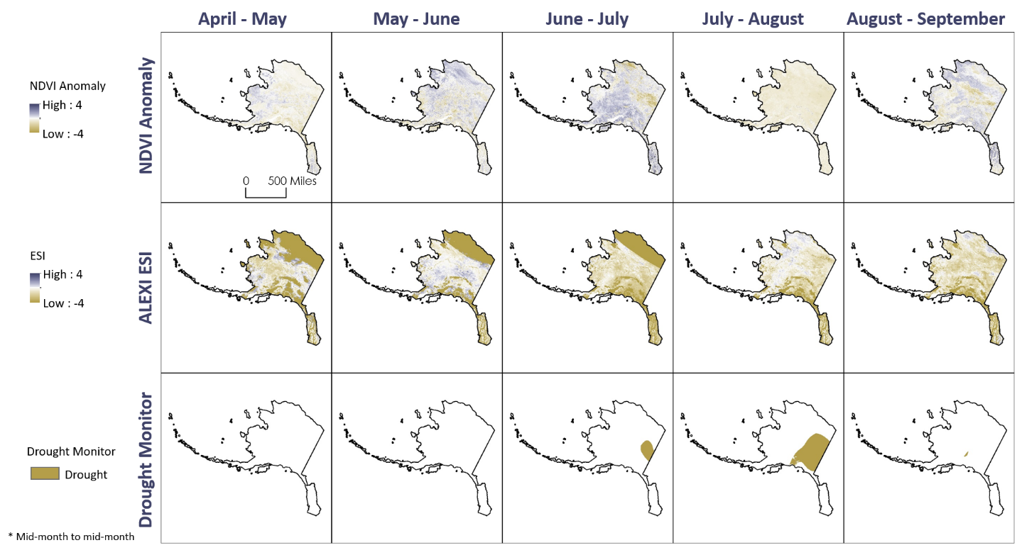.** Visual comparison of NDVI, ALEXI ESI, and USDA USDM classification areas

*Figure A1.* Visual comparison maps between the NDVI anomalies, ALEXI ESI, and drought monitor classifications during the fire season in 2004. Areas of healthy, green vegetation are displayed in purple while areas of unhealthy, less green vegetation are shown in gold. The drought classification areas are also in gold.

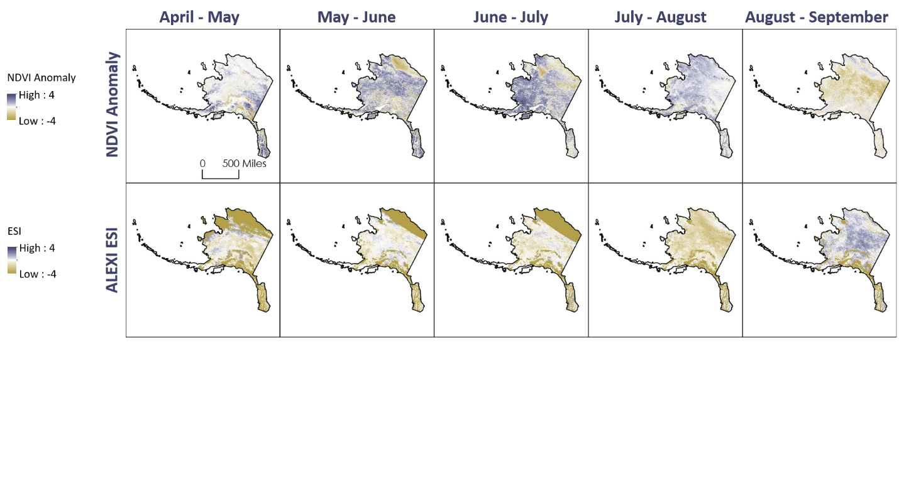

*Figure A2.* Visual comparison maps between the NDVI anomalies and ALEXI ESI during the fire season in 2005. Areas of healthy, green vegetation are displayed in purple, while areas of unhealthy, less green vegetation are shown in gold. There are no drought classification areas during our study period in 2005.

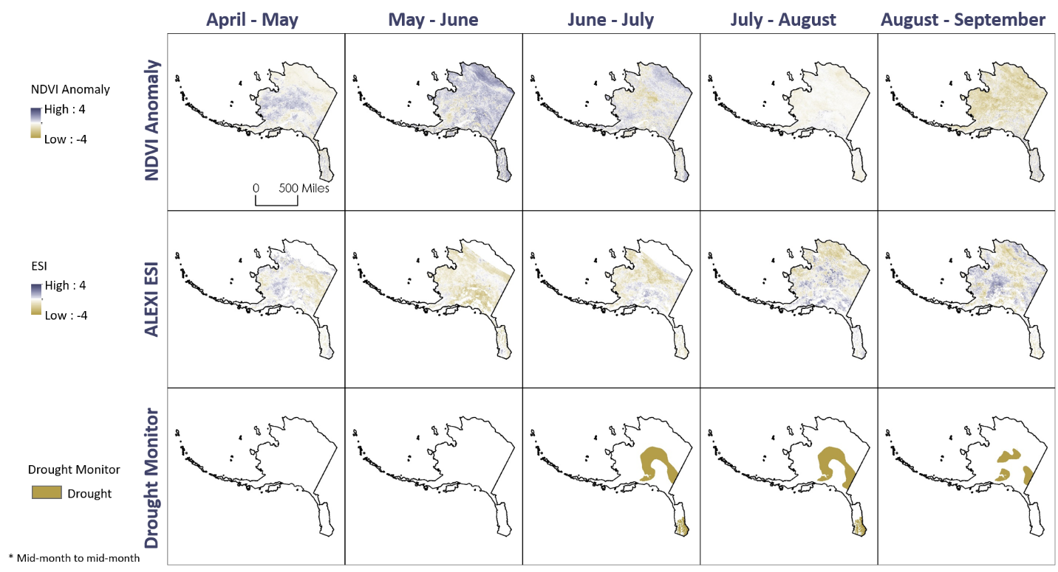

*Figure A3.* Visual comparison maps between the NDVI anomalies, ALEXI ESI, and drought monitor classifications during the fire season in 2015. Areas of healthy, green vegetation are displayed in purple while areas of unhealthy, less green vegetation are shown in gold. The drought classification areas are also in gold.

**Appendix B.** Statistics to quantitatively compare the NDVI anomalies and ALEXI ESI

Figure B2. Statistical analysis between MODIS-derived NDVI and ALEXI ESI, providing an R2 value of 0.015.

Figure B1. Statistical analysis between MODIS-derived NDVI and ALEXI ESI providing an R2 value of 0.0267.

Figure B4. Statistical analysis between MODIS-derived NDVI and ALEXI ESI, providing an R2 value of 0.0109.

Figure B3. Statistical analysis between MODIS-derived NDVI and ALEXI ESI, providing an R2 value of 0.0168.

Figure B7. Statistical analysis between MODIS-derived NDVI and ALEXI ESI, providing an R2 value of 0.0051.

Figure B8. Statistical analysis between MODIS-derived NDVI and ALEXI ESI, providing an R2 value of 0.01.

Figure B6. Statistical analysis between MODIS-derived NDVI and ALEXI ESI, providing an R2 value of 0.1069.

Figure B5. Statistical analysis between MODIS-derived NDVI and ALEXI ESI, providing an R2 value of 0.0007.

Figure B9. Statistical analysis between MODIS-derived NDVI and ALEXI ESI, providing an R2 value of 0.0166.

Figure B10. Statistical analysis between MODIS-derived NDVI and ALEXI ESI, providing an R2 value of 0.0655.

Figure B12. Statistical analysis between MODIS-derived NDVI and ALEXI ESI, providing an R2 value of 0.0203.

Figure B11. Statistical analysis between MODIS-derived NDVI and ALEXI ESI, providing an R2 value of 0.0119.

Figure B15. Statistical analysis between MODIS-derived NDVI and ALEXI ESI, providing an R2 value of 0.0014.

Figure B16. Statistical analysis between MODIS-derived NDVI and ALEXI ESI, providing an R2 value of 0.0097.

Figure B13. Statistical analysis between MODIS-derived NDVI and ALEXI ESI, providing an R2 value of 0.0013.

Figure B14. Statistical analysis between MODIS-derived NDVI and ALEXI ESI, providing an R2 value of 0.032.

Figure B20. Statistical analysis between MODIS-derived NDVI and ALEXI ESI, providing an R2 value of 0.0881.

Figure B19. Statistical analysis between MODIS-derived NDVI and ALEXI ESI, providing an R2 value of 0.001.

Figure B18. Statistical analysis between MODIS-derived NDVI and ALEXI ESI, providing an R2 value of 0.0235.

Figure B17. Statistical analysis between MODIS-derived NDVI and ALEXI ESI, providing an R2 value of 0.1298.

**Appendix C.** Statistics to quantitatively compare the ALEXI ESI & USDA USDM classification areas

Table C1

*Confusion Matrix displaying the data comparison between ALEXI ESI and USDA USDM classification areas for 2004*

|  |  |  |
| --- | --- | --- |
| 2004 Confusion Matrix | ALEXI ESI  (not stressed) | ALEXI ESI (stressed) |
| April to May Drought Monitor (not stressed) | 3575 | 16 |
| April to May Drought Monitor (stressed) | 0 | 0 |
| May to June Drought Monitor (not stressed) | 7768 | 69 |
| May to June Drought Monitor (stressed) | 0 | 0 |
| June to July Drought Monitor (not stressed) | 6407 | 0 |
| June to July Drought Monitor (stressed) | 309 | 0 |
| July to August Drought Monitor (not stressed) | 10146 | 2 |
| July to August Drought Monitor (stressed) | 4838 | 0 |
| August to September (not stressed) | 11254 | 0 |
| August to September (stressed) | 75 | 0 |

Table C2

*Confusion Matrix displaying the data comparison between ALEXI ESI and USDA USDM classification areas for 2015*

|  |  |  |
| --- | --- | --- |
| 2015 Confusion Matrix | ALEXI ESI  (not stressed) | ALEXI ESI (stressed) |
| April to May Drought Monitor (not stressed) | 4275 | 11 |
| April to May Drought Monitor (stressed) | 0 | 0 |
| May to June Drought Monitor (not stressed) | 9827 | 17 |
| May to June Drought Monitor (stressed) | 0 | 0 |
| June to July Drought Monitor (not stressed) | 9182 | 7 |
| June to July Drought Monitor (stressed) | 3015 | 0 |
| July to August Drought Monitor (not stressed) | 13071 | 44 |
| July to August Drought Monitor (stressed) | 3558 | 0 |
| August to September (not stressed) | 13212 | 88 |
| August to September (stressed) | 1537 | 36 |

Table C3

*Confusion Matrix displaying the data comparison between ALEXI ESI and USDA USDM classification areas for 2018*

|  |  |  |
| --- | --- | --- |
| 2018 Confusion Matrix | ALEXI ESI  (not stressed) | ALEXI ESI (stressed) |
| April to May Drought Monitor (not stressed) | 1464 | 62 |
| April to May Drought Monitor (stressed) | 0 | 0 |
| May to June Drought Monitor (not stressed) | 3160 | 22 |
| May to June Drought Monitor (stressed) | 0 | 0 |
| June to July Drought Monitor (not stressed) | 1054 | 2 |
| June to July Drought Monitor (stressed) | 666 | 1 |
| July to August Drought Monitor (not stressed) | 846 | 12 |
| July to August Drought Monitor (stressed) | 661 | 0 |
| August to September (not stressed) | 947 | 3 |
| August to September (stressed) | 669 | 9 |