Glen Canyon Ecological Forecasting
Using NASA Earth Observations to Prioritize Locations for the Further Monitoring and Management of Cultural Resources in Glen Canyon National Recreation Area


Technical Report
Final Draft – August 10th, 2018

William Patrick Frier (Project Lead)
Robert Cecil Byles
Robert Maxwell Stewart

Dr. Kenton Ross, NASA Langley Research Center (Science Advisor)

1. Abstract
Glen Canyon National Recreation Area (NRA) contains a diverse suite of culturally and historically significant archeological sites that are threatened by erosion and changing land cover dynamics. The National Park Service (NPS) is tasked with monitoring, studying, and preserving these archeological sites, many of which reside in extremely remote locations. At Glen Canyon NRA, perennial vegetation helps stabilize soils and mitigate erosion. The loss of such soil stabilizers is indicative of high erosion potential. This project calculated vegetation indices and generated a time series of vegetation maps across the entire extent of Glen Canyon NRA using Landsat 5 Thematic Mapper (TM), Landsat 7 Enhanced Thematic Mapper Plus (ETM+), and Landsat 8 Operational Land Imager (OLI) data for the years 1995 to 2017. The project team then used multiple vegetation analyses from across the study period to provide an assessment of year-to-year change in the abundance and distribution of soil-stabilizing vegetation. This approach allowed for a comprehensive assessment of vegetation and soil stabilization across a broad region that could not feasibly be assessed by traditional ground-based means. Finally, the team used these vegetation analyses to assess the rate of change of vegetation cover and to predict future vegetation distribution. Land managers and archeologists at the NPS can use the results of this work to prioritize the monitoring and management of important archeological sites that could otherwise be lost to erosion.

Keywords
Landsat, remote sensing, National Park Service, MSAVI, NDVI, vegetation change, vegetation index

2. Introduction
  - Background Information
Glen Canyon National Recreation Area is a 1.25 million acre expanse of the American Southwest (Figure 1) that attracts over 4 million visitors a year (NPS, 2018). It contains some of the region’s most dramatic landscapes, unique examples of desert vegetation, and the continent’s second largest man-made lake - Lake Powell. Glen Canyon NRA also contains highly significant archeological sites and artifacts that cover over 13,000 years of human habitation in North America. These archeological sites range in origin from 11,500 years BCE (Before Common Era) to the recent past (NPS, 2018; Parezo, 2014) and preserve evidence of both ancient native populations (e.g. the Clovis, Folsom, and Anasazi peoples) and more recent Spanish and Mormon settlers (NPS, 2018). The monitoring, preservation, and study of these archeological sites across vast landscapes provides a unique challenge to land managers from the National Park Service (NPS) at Glen Canyon NRA.

The semi-arid to arid climate of the American Southwest can help preserve these archeological sites, but some are threatened by erosion and changing land cover dynamics. Vegetation and naturally occurring cryptobiotic soil crusts, colonies of cyanobacteria and lichen, help stabilize the topsoil and prevent the erosion and degradation of such artifacts (Belnap and Gardner, 1993; Ravi et al., 2010). The loss of such soil stabilizers can be extremely detrimental. As such, monitoring changes in the distribution of vegetation and cryptobiotic soil crusts is an important aspect of preserving and managing these archeological resources. Glen Canyon NRA’s vast extent and remote location makes monitoring by traditional ground-based means costly and impractical.

This study applied comprehensive vegetation data derived from NASA Earth observations to Glen Canyon NRA’s vast landscape to help address one aspect of erosion susceptibility – vegetation change. Mapping vegetation via remotely sensed satellite data has become increasingly common over the past several decades (Huete, 1988; Qi et al., 1994; Ustin et al., 2009), but this can be difficult in arid regions with relatively sparse vegetation (Ustin et al., 2009). A complex mix of vegetation health, soil brightness, shadow, soil color, and moisture content all affect the spectral response of vegetated desert landscapes. Bare rock/soil and desiccated desert vegetation can have spectral similarities that further complicate the detection of vegetation with remote sensing in such regions (Ustin et al., 2009).
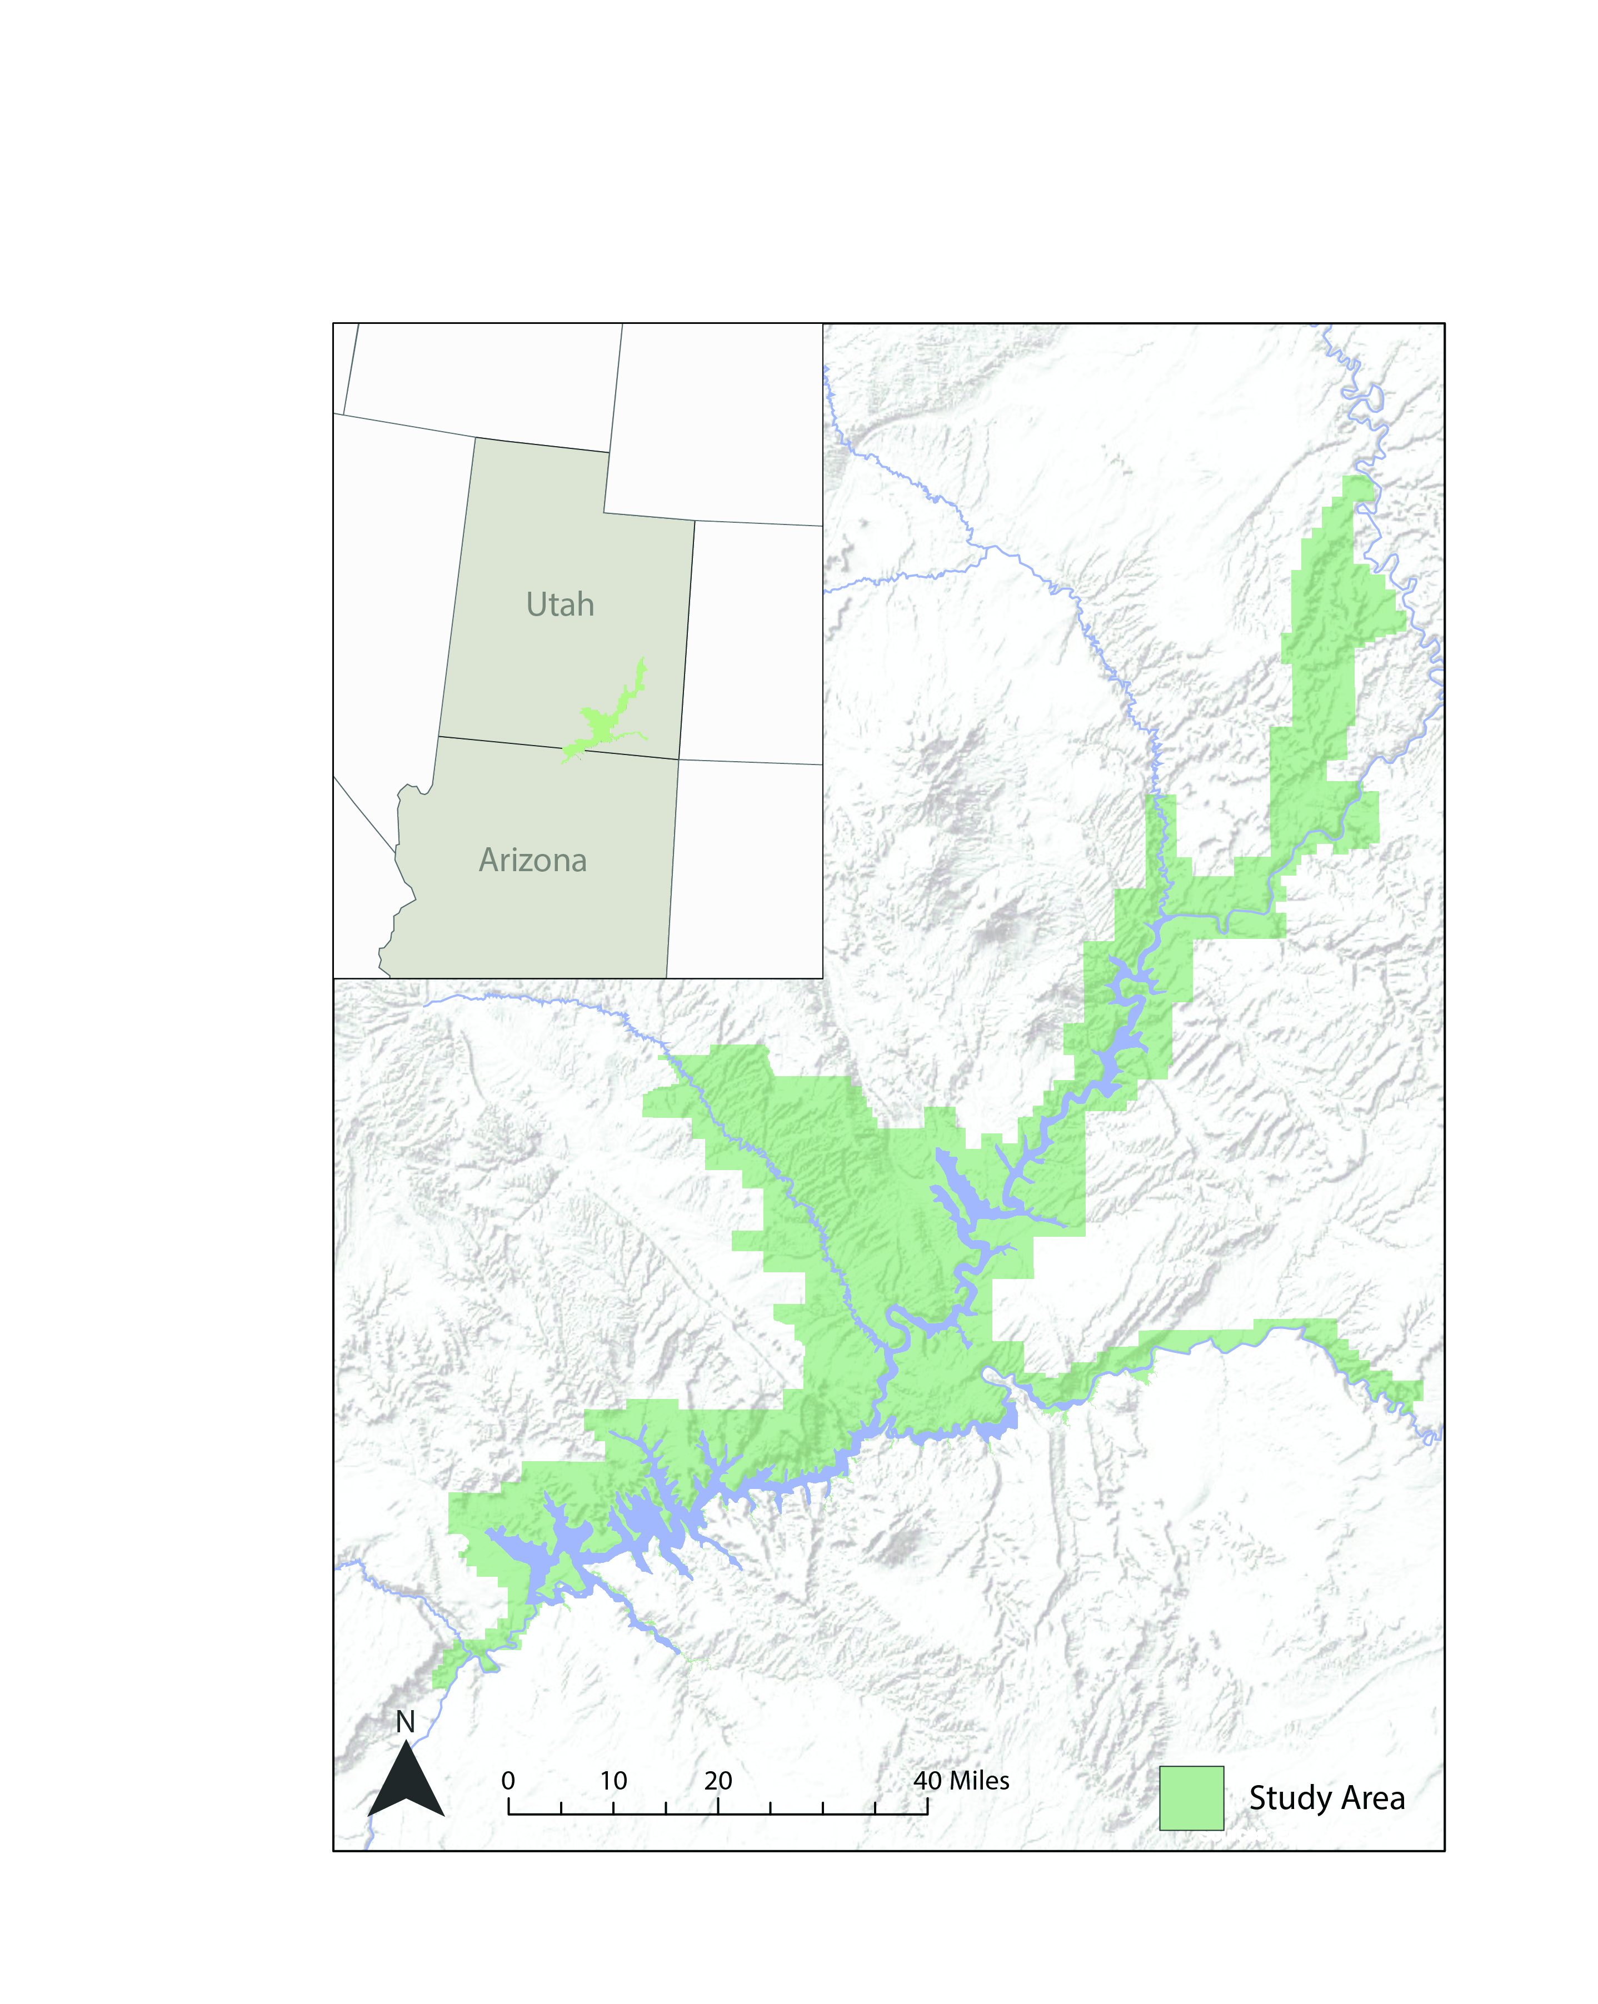
Figure 1. Extent of the study area, Glen Canyon National Recreation Area, and its location within Utah and Arizona.
One method of assessing vegetation cover from remote satellite data is the use of vegetation indices (VIs), which are equations and ratios that incorporate multiple spectral bands into quantitative measurements that relate to the distribution and characteristics of vegetation on the ground. Spectral VIs that incorporate red and infrared bands capitalize on the physical properties of plants on the surface because chlorophyll in photosynthesizing vegetation absorbs red (630 – 690 nm) radiation and the cellular structure of such plants reflects radiation in the infrared (760 – 900 nm). The Normalized Difference Vegetation Index (NDVI) is a common means of assessing vegetation vigor (the aggregate of overall health and prevalence of vegetation) that capitalizes on this relationship and correlates well with measurable vegetation parameters like green leaf area, biomass, and photosynthetic activity (Tucker, 1979; Colwell, 1974; Hatfield et al., 1984; Asrar et al., 1984; Sellers, 1985); however, NDVI is a simple ratio of the difference between the near infrared and red bands and the sum between the near infrared and red bands. It fails to account for or adjust for interference from soil reflectance.

Because soil reflectance can affect spectral values, some VIs are tailored for use in landscapes that contain sparsely distributed vegetation (Huete, 1988; Qi et al., 1994), such as the deserts of the American Southwest around Glen Canyon NRA. The Modified Soil Adjusted Vegetation Index (MSAVI) correlates well with measurable vegetation parameters and incorporates a scalable adjustment factor that minimizes soil noise when gaps in vegetation cover lead to exposed surfaces and a non-uniform canopy structure (Qi et al., 1994).

2.2 Project Partners & Objectives
The Glen Canyon Ecological Forecasting team partnered with NPS archeologists and ecologists from Glen Canyon NRA. The park provides opportunities for superb recreation and preserves some of America’s most amazing natural and cultural resources. The NPS is tasked with the preservation of this landscape and its unique character. As such, park archeologists aim to thoroughly monitor, catalog, and preserve archeological sites within the park. Changes in vegetation and cryptobiotic soil crust can lead to changes in erosion patterns, which can in turn threaten the park’s archeological resources. This project was born out of a desire to better prioritize the management, monitoring, and safekeeping of archaeological sites. To accomplish this the team sought to understand vegetation change dynamics across the entire extent of Glen Canyon NRA in the context of erosion and threats to these resources.

In support of the NPS and officials at Glen Canyon NRA, the principle objectives of this project were to: (1) create reliable maps of vegetation distribution across Glen Canyon NRA for the years 1995 - 2017, (2) analyze spatial and temporal trends in gains and losses of vegetation over the study period, (3) provide a reproducible project methodology that can be utilized by park officials in the future, and (4) provide information to help anticipate future vegetation distribution within the park.

3. Methodology
3.1 Data Acquisition
The Glen Canyon Ecological Forecasting team utilized atmospherically corrected (Collection 1 – Level-2) Landsat 5 Thematic Mapper (TM), Landsat 7 Enhanced Thematic Mapper Plus (ETM+), and Landsat 8 Operational Land Imager (OLI) surface reflectance data for the years 1995 – 2017. These data were ordered and obtained from the United States Geological Survey (USGS) Earth Explorer platform. These data were atmospherically corrected by the USGS using standard procedures as outlined by Masek et al (2006). Images were collected from July, August, and September of each year, during and immediately following the region’s monsoon season. At this time of year, most vegetation is at its seasonal growth peak providing robust vegetation cover. Within this time period, preference was given to images with the least cloud cover (less than 10-20% of the scene when possible and not exceeding 50% of the scene). The park covers portions of three different Landsat scenes. The team acquired July, August, and September images of each of these Landsat scenes. Additional in situ vegetation data were also provided by the NPS as a supplement to the remotely sensed satellite data and were used for basic validation/analysis purposes.

3.2 Data Processing
After acquisition and downloading, all Landsat datasets underwent four initial pre-processing steps: masking, compositing, mosaicking, and clipping. All appropriate bands (Table 1; see appendix) were amalgamated to produce composite datasets at 30 m spatial resolution. Each raster was then clipped to the bounds of the study area and mosaicked to generate a final analysis-ready raster dataset of the entire study area. A variation of this preprocessing procedure was applied to all Landsat 5 TM, Landsat 7 ETM +, and Landsat 8 OLI imagery. Each raster was also masked to exclude any pixels that were fully saturated in the red or near infrared bands. This saturation occurs in highly reflective portions of the image, generally around clouds, and can inaccurately skew vegetation index (VI) calculations. These processes were performed using a Python script based primarily on Python’s Geospatial Data Abstraction Library (GDAL). The script was used to apply these pre-processing functions to the satellite imagery for all 22 years of the study period. Each raster dataset underwent the same initial preprocessing steps.

3.3 Data Analysis
Characterizing vegetation with remotely sensed data often incorporates combining multiple spectral bands because a single band is insufficient to categorize land cover or vegetation (Huete, 1988; Qi et al., 1994). Such vegetation indices capitalize on the physical characteristics of vegetation and how those characteristics manifest themselves spectrally. The most common of these is the Normalized Difference Vegetation Index (NDVI), which is given by:

NDVI = p_{NIR} - pred / p_{NIR} + pred (1)

where p is the spectral reflectance of a particular band, in this case near-infrared (NIR) and red. This index capitalizes on the fact that chlorophyll in photosynthetic plants has distinctive responses in the red and NIR portions of the spectrum. Various other vegetation indices are tailored to address specific conditions that complicate vegetation remote sensing in areas like Glen Canyon, such as sparse canopy cover and abundant exposed soil (Huete, 1988; Baret et al., 1989). The Modified Soil Adjusted Vegetation Index (MSAVI) developed a variable adjustment factor that decreases with increasing vegetation cover and is derived from the NDVI and weighted difference between the reflectance of the red and NIR bands. This adjusted vegetation index is given by:

MSAVI = 2p_{NIR} + 1 - √ ((2p_{NIR} + 1)² - 8(p_{NIR} - pred)) (2)
2

where p is the spectral reflectance of a particular band. The MSAVI technique is particularly useful in regions with variable vegetation cover because its soil adjustment factor scales with the abundance of soil on the ground and minimizes complications from exposed soil, even if the amount of exposed soil changes across the image. The success of the MSAVI technique in other vegetation studies in arid settings with sparse vegetation cover lends credence to its efficacy as a viable method in this study, which deals with sparsely vegetated desert landscapes.

The team applied MSAVI and NDVI equations to each preprocessed Landsat dataset using a Python script. This resulted in an MSAVI and NDVI array for July, August, and September of each year of the study, which were then aggregated to generate a cumulative raster for each year. Because the goal was to gain the most comprehensive view of vegetation distribution possible, the team chose to output a raster of maximum VI values for each year based on the highest pixel value between the July, August, and September images. This resulted in two finalized rasters for each year – the maximum MSAVI and maximum NDVI. This method had the benefit of accounting for annual inconsistencies in vegetation phenology and senescence. The timing of peak vegetation might be somewhat different each year based on weather and local variables, but in this manner, the team output the maximum late growing season VI for each year and accounted for this variability. The maximum MSAVI and NDVI datasets serve as annual vegetation distribution maps for the entire extent of Glen Canyon NRA for the years 1995–2017.

4. Results & Discussion
4.1 Analysis of Results
The team sought to analyze spatial and temporal trends in vegetation distribution, as expressed in maximum annual MSAVI and NDVI values. Figure 2 shows a comparison of the maximum MSAVI and NDVI rasters for the same year (2017) and portion of the study area (Navajo Point). Green pixels represent high VI values, while those in red are low VI values. Mild differences can be seen between the MSAVI and NDVI-derived images, but little effective visual difference is available when the images are shown with the same visualization and stretch. This lends credence to the idea that either VI could be used to access vegetation distribution; however, because MSAVI is specifically tailored for sparse vegetation in desert landscapes and typically performs better in such settings (Section 3.3) all subsequent images will focus on MSAVI. That said, all analyses were conducted in tandem and applied to both MSAVI and NDVI so that each product can be compared to its equivalent in the other VI. Two basic types of temporal variation in vegetation can be teased apart from the data discussed herein – annual change and cumulative change across the entire study period. The following sections outline an analysis of the results based on these annual and cumulative means of comparison.

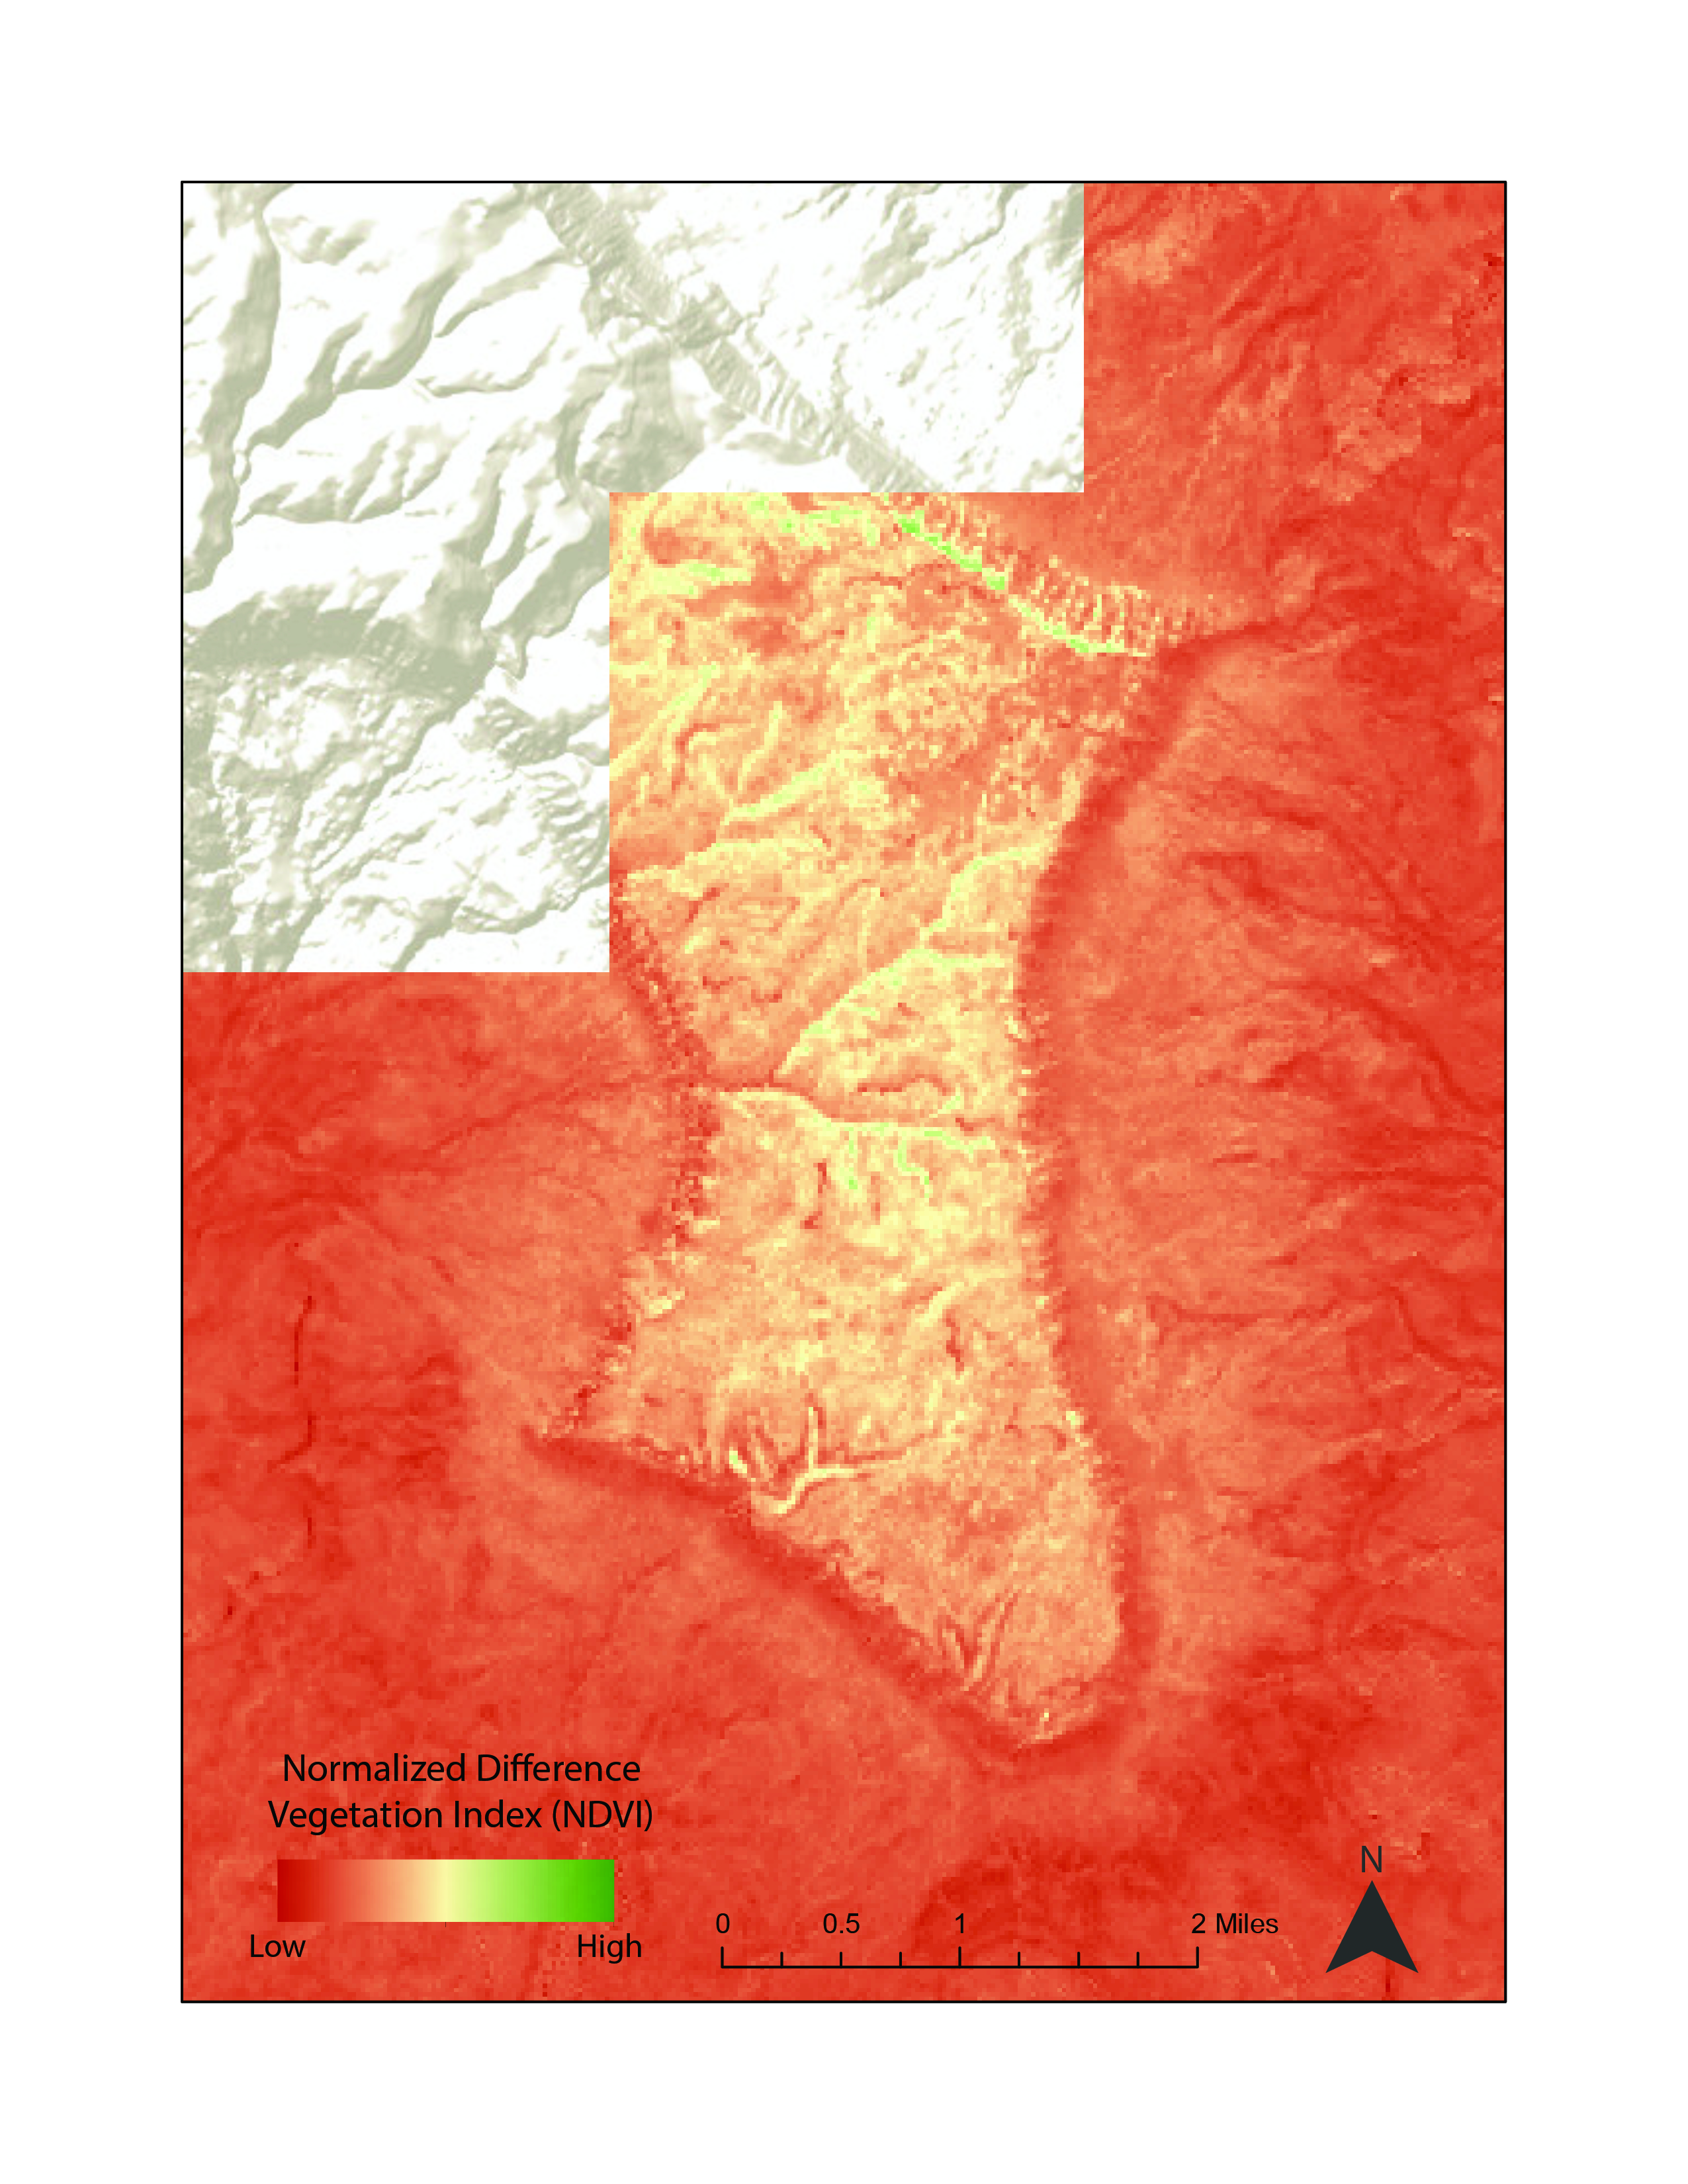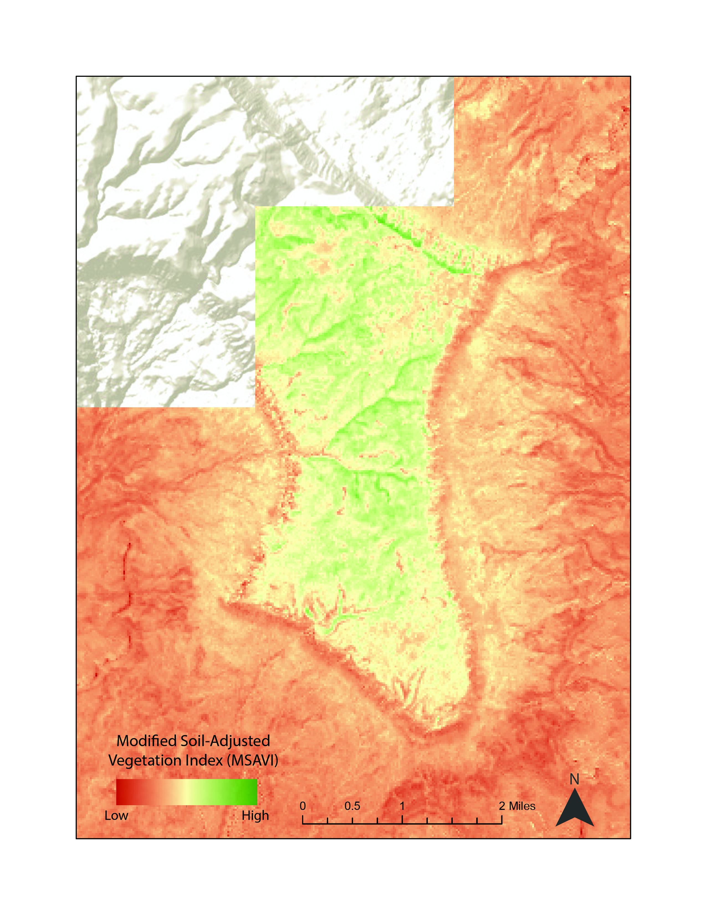
Figure 2. A comparison of two different vegetation indices: NDVI and MSAVI (from Landsat 8 OLI, 2017).

4.2 Analysis of Annual Results
The team analyzed year-over-year variations in vegetation based on deviation from two threshold values, the mean and 90th percentile VI values for the entire study period for each pixel. The team assessed each annual maximum MSAVI (and NDVI) dataset based on its anomaly from the mean and its relative pixel value as compared to a threshold set as the 90th percentile. To accomplish this, the team first utilized a Python script that considered each maximum annual VI raster and calculated the mean and 90th percentile value for each pixel across the image and output those to two new raster datasets. The anomaly from the mean was then calculated by subtracting the study period mean MSAVI raster from any given annual MSAVI raster. This is given more generally by:

Aμ = VI_{Year} - VIμ (3)

where Aμ is the anomaly from the mean, VI_{Year} is the vegetation index of a given year, and VIμ is the mean vegetation index. The 90th percentile comparison was calculated as any given annual MSAVI raster divided by the 90th percentile for the entire study period. This is given more generally by:

A_{P90} = VI_{Year} / VI_{P90} (4)

where A_{P90} is variation from the 90th percentile, VI_{Year} is the vegetation index of a given year, and VI_{P90} is the 90th percentile vegetation index. These calculations were applied to each annual raster and provide a simple means by which to compare annual values to the study period average for each pixel (Equation 3) and a threshold value for healthy, vigorous vegetation (Equation 4).

Figure 3 shows the anomaly from the mean for 2013 and 2014 in the vicinity of Navajo Point within Glen Canyon NRA. In these images, green pixels represent positive variations from the mean, those that are more vigorous in a given image than their mean value for the study period. Likewise, red pixels represent negative variations from the mean, those that are less vigorous in a given image than their mean value for the study period. Tan pixels are those at or near their mean value for the study period, indicating little variation from the mean in the given image.
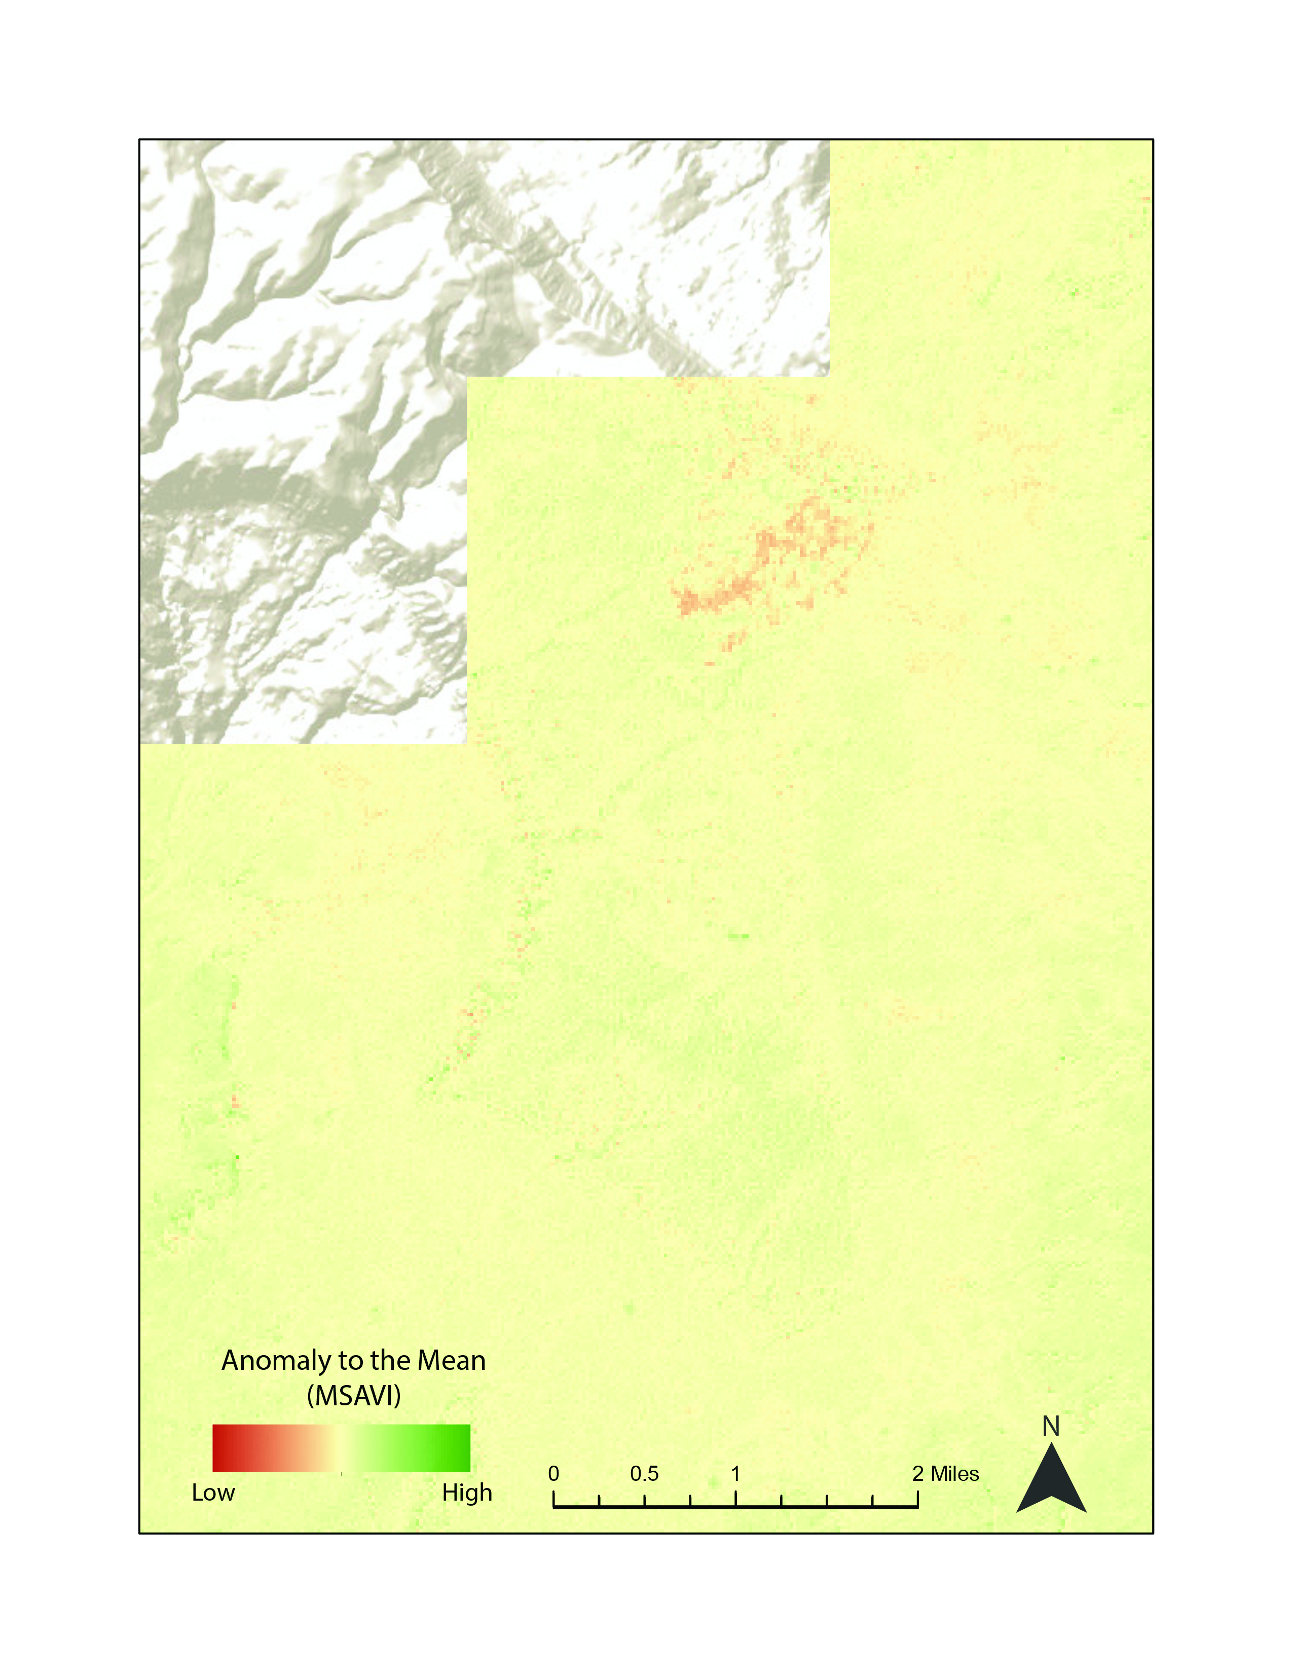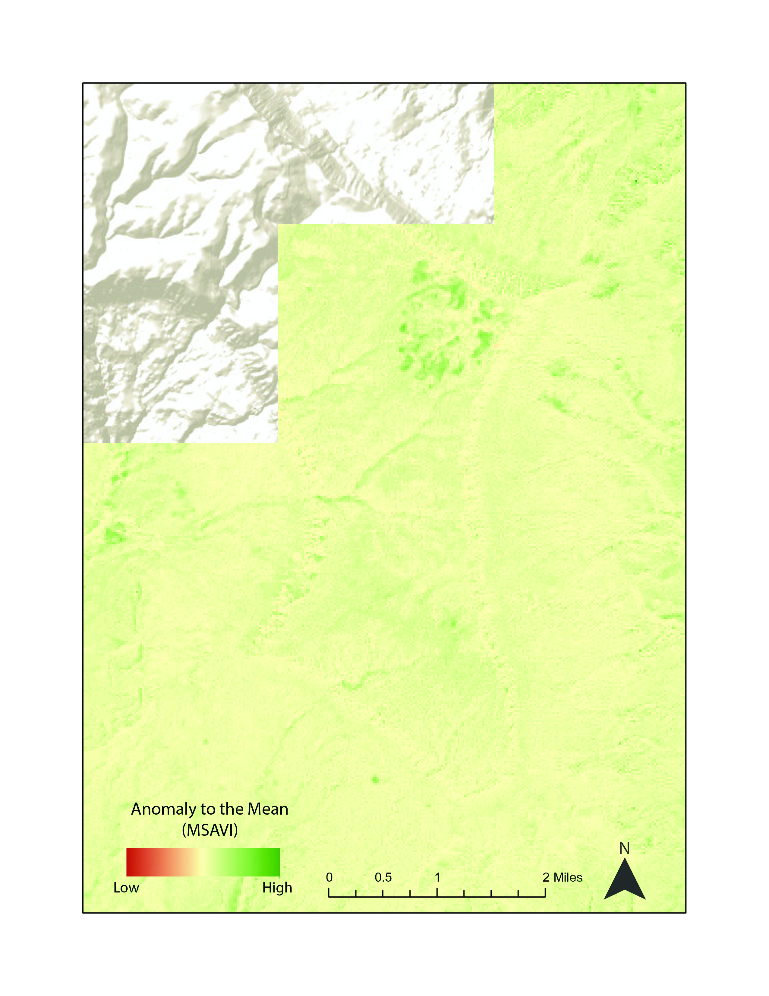
2014
2013

Figure 3. A map showing anomaly from mean MSAVI values in the vicinity of Navajo Point (Landsat 8 OLI, 2013-2014)

Figure 4 shows variation from the 90th percentile for 2013 and 2014 in the vicinity of Navajo Point, the same region shown in Figure 3. In these images, bright, saturated pixels are those that represent healthy vigorous vegetation as compared to the 90th percentile VI value for the entire study period. A pixel value of 1 or greater represents a pixel value that was at or exceeded the 90th percentile in VI for a given year. Dull, less saturated pixels are those where the pixel value of the given year was significantly less than the 90th percentile for the study period. Visualization of these images provides a representation of the relative magnitude of VI in a given year and compares it against an arbitrary threshold for healthy, vigorous vegetation.

4.3 Analysis of Cumulative Results
The team assessed cumulative results across the entire study period by means of a linear regression applied to each pixel. This was primarily done to assess the rate of change of each pixel through the study period (i.e. the slope of the linear regression curve). The team did this by applying a Python script to a three-dimensional array (x, y, and z being latitude, longitude, and time) of all the annual maximum MSAVI images. The script iterated through each pixel of the array and calculated the slope, intercept, p-value, correlation, and standard error of each regression while outputting those to separate raster datasets. The script was also used to output a standard deviation raster, which was then used to calculate the coefficient of variation (ratio of the standard deviation to the mean) for each pixel. Each of these statistics was output to a separate raster file.

Figure 5 is the rate-of-change raster based on all annual MSAVI values from across the study period and displays two small subsets of the study area. Pixels in green are those with a positive slope, indicating a general increase in MSAVI values through time. Pixels in red are those with a negative slope, indicating a general decrease in MSAVI values through time. The stretch and visualization of this image is centered on
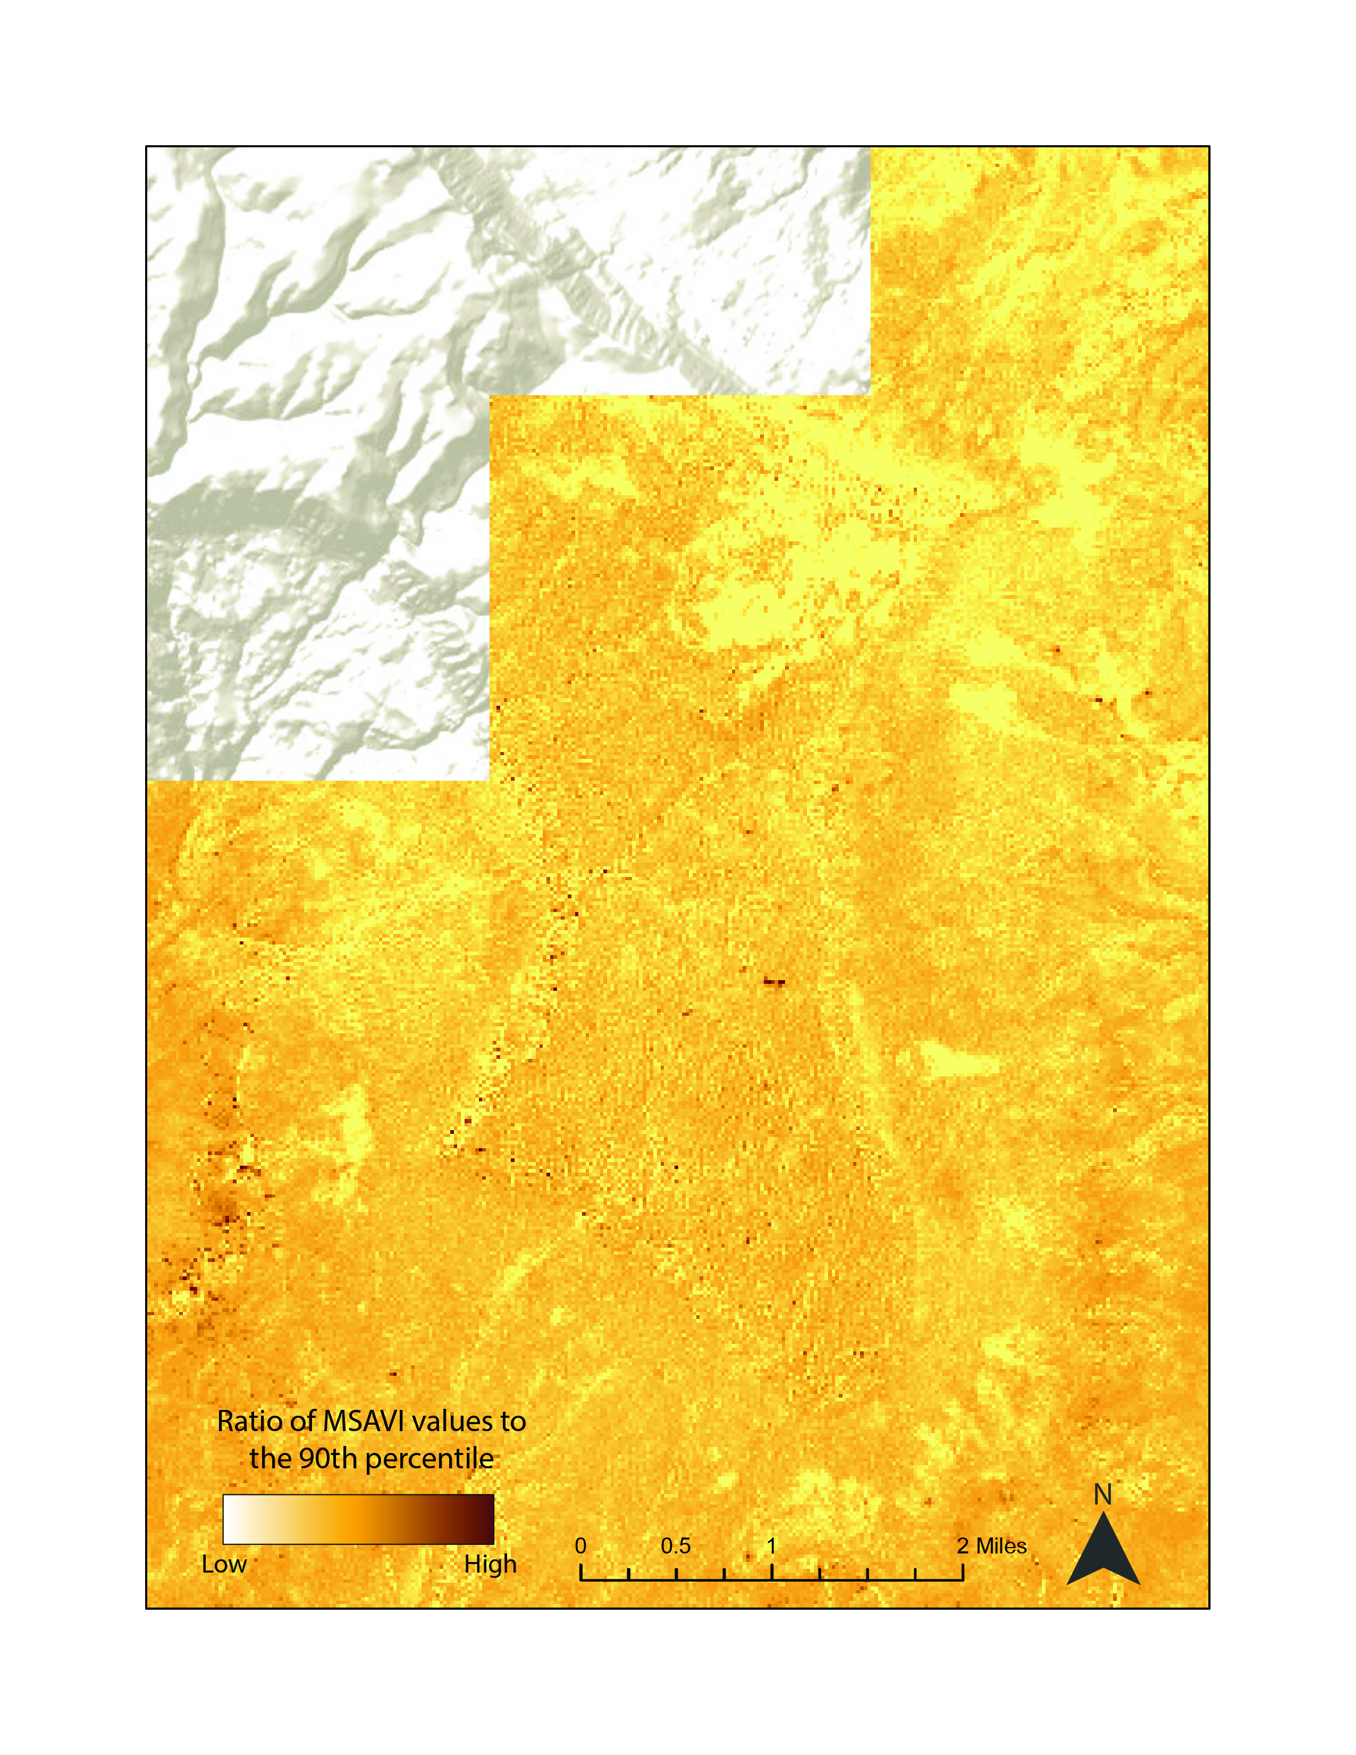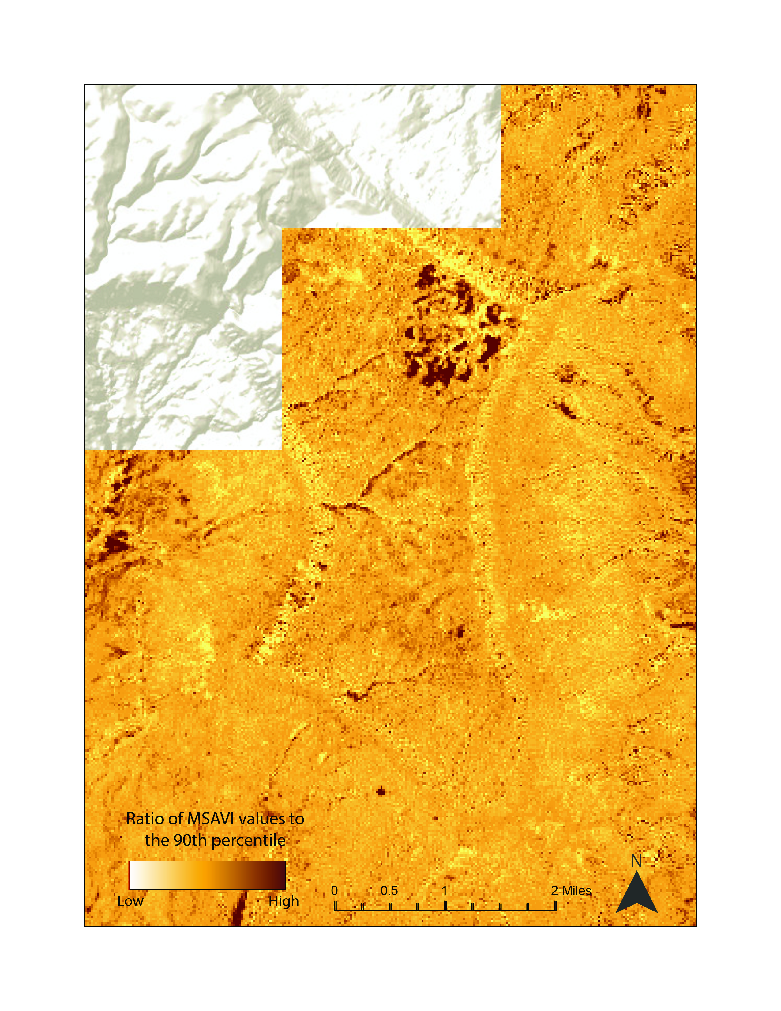
2013
2014
Figure 4. A map showing variation from the 90th percentile MSAVI values in the vicinity of Navajo Point (from Landsat 8 OLI, 2013-2015)
zero, so pixels in tan are those with a slope (i.e. rate of change) that is at or near zero for the entire study period. Presented this way, these data give a sense of the spatial distribution of regions experiencing the most extreme rates of increase and decrease in MSAVI throughout the study period. Assessing the rate of change raster in Figure 5 in terms of its importance on the ground showcases portions of the park on Navajo Point that cumulatively have experienced a negative rate of change across the study period; however, the vast majority of the park has experienced either a slightly positive rate of change or a nearly flat rate of change through time, indicated by the abundance of the tan and green pixels. This finding that most of the park has experienced modest increases in MSAVI through time and therefore has likely experienced a modest increase in vegetation on the ground was unexpected. When compared against the Park Service’s own ground-truthed dataset from 2014, the areas of negative rates-of-change coincide with the distribution of grassland ecological communities suggesting that the variety of vegetation/ecological community affects the rate at which vegetation changes.

This work sought to identify regions of the park experiencing vegetation loss, which can be seen in some areas (i.e. Navajo Point), but the park-wide trend is one of slightly increasing MSAVI values across the study period. Assessing the driver behind this requires further study, but the mildly increasing VI values could potentially be explained by certain natural phenomena, like grassification. Elsewhere in North American desert landscapes, ecologists have identified the progressive expansion of grasses (Pierson et al., 2011) that can change ecological communities sometimes after environmental disturbances, like fire. Land managers from these regions have identified the need to understand ecological adaptations to stressors like climate change, invasive species, and fire (Friggens et al., 2012) in the context of these changes in vegetation.

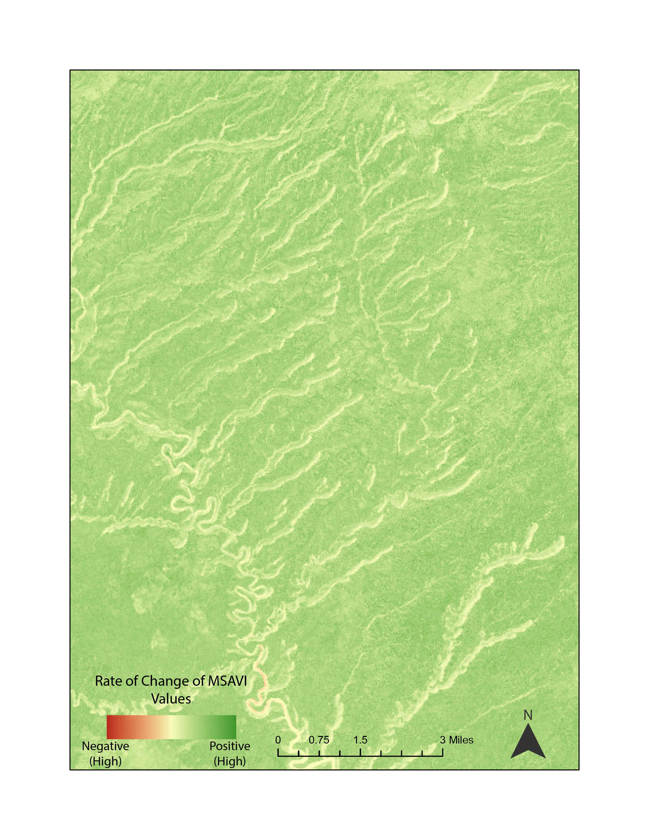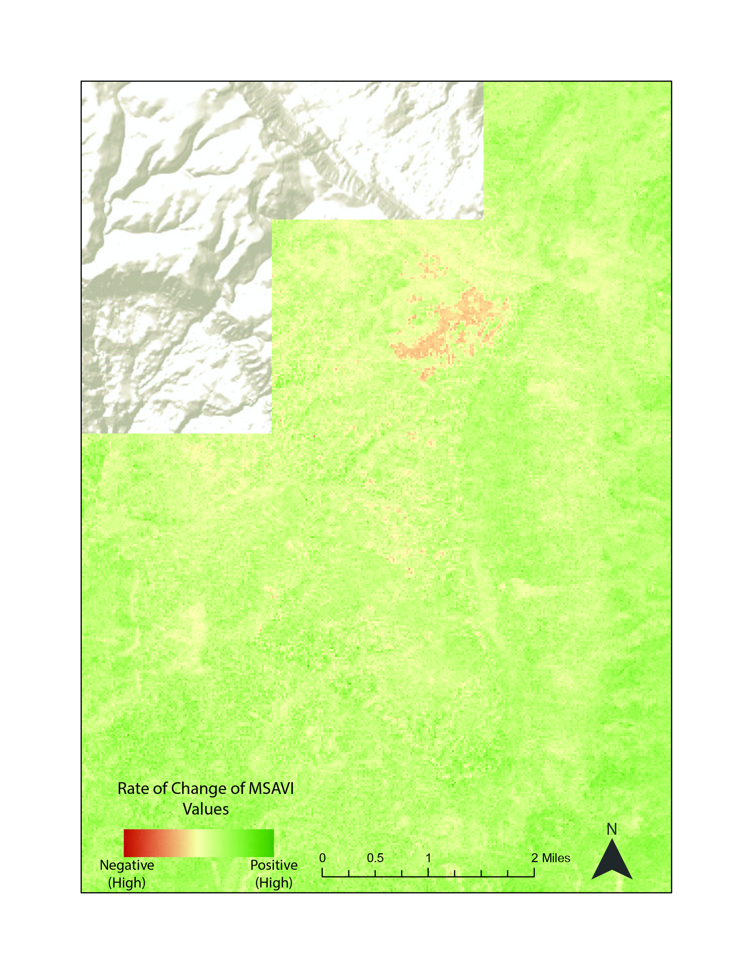
Figure 5. Rate of change raster based on MSAVI values in the vicinity of Navajo Point (from Landsat 5 TM, Landsat 7 ETM+, and Landsat 8 OLI, 1995-2017)

While wildfires are difficult to predict accurately, changes in vegetation variety can affect the types of fuels available and therefore change the likelihood of wildfire itself. Certain grasses, especially invasive cheatgrass (Bromus tectorum), are capable of altering fire dynamics. Floyd et al (2008) determined that the recurrence interval of wildfire in Glen Canyon NRA’s Pinon-juniper woodlands was inherently infrequent, but acknowledged that changing vegetation dynamics have the potential to change that regime and could alter ecosystem dynamics as a result. A better understanding of vegetation change through time will aid in assessing potential vulnerabilities to the park’s archeological and ecological resources in the future.

4.2 Potential Future Work
Cryptobiotic soil crusts are another soil stabilizer that could potentially be assessed by remote means. Belnap and Gillette (1996) found the presence of cryptobiotic soil crusts to have a significant effect on soil stabilization in southeastern Utah. Similar to the time series of vegetation analysis presented herein, a time series of cryptobiotic soil crust distribution would provide information about what portions of the park might have the most unstable soils. Previous studies have utilized a combination of hyperspectral and multispectral remote sensing to detect cryptobiotic soil crust distributions (Ustin et al., 2009; Weber et al., 2008; Karnieli et al., 2001). The methods of that work would differ from those of this project, but such analysis could be used in tandem with the vegetation analysis herein to give a much more comprehensive view of soil stabilizers within the park.

Additionally, the results of this work generated a suite of statistical rasters that could be applied in various ways to tease out more information about vegetation within the park. For example, with the slope of the linear regression curve (i.e. the rate of change raster) and the intercept (another raster output from the regression), park officials could forward model future VI values for the park and attempt to predict future vegetation loss/gain in the park.

5. Conclusions
This suite of annual change and cumulative change analysis rasters provides Glen Canyon NRA the opportunity for enhanced data-driven decision making. Several basic conclusions can be drawn from the results herein: (1) the distribution of vegetation in Glen Canyon NRA has increased slightly over the past few decades, evidenced by marginally increasing MSAVI values and a positive rate of change raster across most of the park, (2) vegetation in the park is subject to dynamic annual changes/drivers, evidenced by changes in the mean anomaly rasters year-to-year, and (3) cumulative rates of vegetation loss, as evidenced by negative values in the rate-of-change raster, are nonuniform across the park and may be related to ecological variables like the particular variety of vegetation in question or physiographic variables like elevation, slope, and aspect.

These findings will allow NPS land managers at Glen Canyon NRA to incorporate their other datasets in light of these vegetation change findings. They will be able to visualize where important archeological sites lay in relation to these changes in vegetation and prioritize their work with insight from park-wide annual vegetation data. Beyond the primary objective of understanding vegetation in relation to these archeological sites, they will also be able to assess how the vegetation trends discussed herein might related to ecosystem health and their other management practices.

6. Acknowledgments
- Dr. Kenton Ross (NASA Langley Research Center)
- Jonathan O’Brien (NASA Langley Research Center)
- Brian Harmon (NPS, Glen Canyon National Recreation Area)
- John Spence (NPS, Glen Canyon National Recreation Area)
- Alahna Moore (NPS, Glen Canyon National Recreation Area)
- Vanessa Glynn-Linaris (NPS, Glen Canyon National Recreation Area)

Any opinions, findings, and conclusions or recommendations expressed in this material are those of the author(s) and do not necessarily reflect the views of the National Aeronautics and Space Administration.

This material is based upon work supported by NASA through contract NNL16AA05C and cooperative agreement NNX14AB60A.

7. Glossary
Acronyms
ETM+ – Enhanced Thematic Mapper Plus
MSAVI – Modified Soil Adjusted Vegetation Index
MSI – Multispectral Instrument
NDVI – Normalized Difference Vegetation Index
NIR – Near Infrared
NPS – National Park Service
NRA – National Recreation Area
OLI – Optical Land Imager
TM – Thematic Mapper
USGS – United States Geologic Survey

8. References
Asrar, G., Fuchs, M., Kanemasu, E. T., Hatfield, J. L. (1984). Estimating absorbed photosynthetic radiation and leaf area index from spectral reflectance in wheat. Agronomy Journal, 76, 300-306.
Belnap, J., & Gardner, J. S. (1993). Soil microstructures in soils of the Colorado Plateau: the role of the cyanobacterium Microcoleus vaginatus. The Great Basin Naturalist, 53(1), 40-47.
Belnap, J., & Gillette, D. A. (1997). Disturbance of biological soil crusts: impacts on potential wind erodibility of sandy desert soils in southeastern Utah. Land Degradation & Development, 8(4), 355-362.
Colwell, R. K. (1974). Predictability, constancy, and contingency of periodic phenomena. Ecology, 55(5), 1148-1153
Floyd, M. L., Romme, W. H., Hanna, D. D., Winterowd, M., Hanna, D., & Spence, J. (2008). Fire history of piñon-juniper woodlands on Navajo point, glen canyon national recreation area. Natural Areas Journal, 28(1), 26-36.
Friggens, M. M., Warwell, M. V., Chambers, J. C., Kitchen S.G. (2012). Modeling and predicting vegetation response of western USA grasslands, shrublands, and deserts to climate change. In D. M. Finch (Ed.), Climate Change in Grasslands, Shrublands, and Deserts of the Interior American West: A Review and Needs Assessment (pp. 1-20) Fort Collins, Colorado: U.S. Department of Agriculture, Forest Service, Rocky Mountain Research Station.
Hatfield, J. L., Asrar, G., Kanemasu, E. T. (1984). Intercepted photosynthetically active radiation estimated by spectral reflectance. Remote Sensing of Environment, 14, 65-75.
Huete, A. R. (1988). A soil-adjusted vegetation index (SAVI). Remote Sensing of Environment, 25, 295-309.
Karnieli, A., Kokaly, R. F., West, N. E., & Clark, R. N. (2001). Remote sensing of biological soil crusts. In J. Belnap and O. Lange (Eds.), Biological soil crusts: structure, function, and management. (pp. 431-455). Springer, Berlin, Heidelberg. DOI: 10.1007/978-3-642-56475-8_31
Masek, J. G., Vermote, E. F., Saleous, N. E., Wolfe, R., Hall, F. G., Huemmrich, K. F., Gao, F., Kutler, J., Lim, T-K. (2006). A Landsat surface reflectance dataset for North America, 1990-2000. IEEE Geoscience and Remote Sensing Letters 3(1),68-72.
National Park Service Glen Canyon NRA Statistics. Accessed June 26, 2018
https://irma.nps.gov/Stats/SSRSReports/Park%20Specific%20Reports/Annual%20Park%20Recreation%20Visitation%20(1904%20-%20Last%20Calendar%20Year)?Park=GLCA.

Parezo, N. J., & Janetski, J. C. (Eds.). (2014). Archaeology in the Great Basin and Southwest: papers in honor of Don D. Fowler. University of Utah. (pp. 17-35)
Pierson F.B., Williams, C. J., Hardegree, S. P., Weltz, M. A., Stone, J. J., Clark, P. E. (2011). Fire, plant invasions, and erosion events on western rangelands. Rangeland Ecology & Management 64(5), 439–440.
Qi, J., Chenbouni, A., Huete, A. R., Kerr, Y. H., Sorooshian, S. (1994). A modified soil adjusted vegetation index. Remote Sensing of Environment, 48,119-126
Ravi, S., Breshears, D. D., Huxman, T. E., D’Odorico, P. (2010). Land degradation in drylands: Interactions among hydrologic-aeolian erosion and vegetation dynamics. Geomorphology, 116, 236-245.

Sellers, P. J. (1985) Canopy reflectance, photosynthesis and transpiration, International Journal of Remote Sensing, 6(8), 1335 – 1372

Tucker, C. J. (1979). Red and photographic infrared linear combinations for monitoring vegetation. Remote Sensing of Environment, 8, 127-150.

U.S. Geological Survey Earth Resources Observation and Science Center. (2012). Provisional Landsat TM Surface Reflectance. US Geological Survey. https://doi.org/10.5066/F7KD1VZ9

U.S. Geological Survey Earth Resources Observation and Science Center. (2012). Provisional Landsat ETM+ Surface Reflectance [Data set]. US Geological Survey. https://doi.org/10.5066/f7q52mnk

U.S. Geological Survey Earth Resources Observation and Science Center. (2014). Provisional Landsat OLI Surface Reflectance. US Geological Survey. https://doi.org/10.5066/F7KD1VZ9

Ustin, S. L., Valko, P. G., Kefauver, S. C., Santos, M. J., Zimpfer, J. F., & Smith, S. D. (2009). Remote sensing of biological soil crust under simulated climate change manipulations in the Mojave Desert. Remote Sensing of Environment, 113(2),317-328.

Ustin, S., Jacquemoud, S., Palacios-Orueta, A., li, L., & Whiting, M. (2009). Remote sensing based assessment of biophysical indicators for land degradation and desertification. In A. Röder and J. Hill (Eds.), Recent Advances in Remote Sensing and Geoinformation Processing for Land Degradation Assessment (pp. 15-43). United States: CRC Press. https://doi.org/10.1201/9780203875445.ch2
Weber, B., Olehowski, C., Knerr, T., Hill, J., Deutschewitz, K., Wessels, D. C. J., Eitel, B., & Büdel, B. (2008). A new approach for mapping of biological soil crusts in semidesert areas with hyperspectral imagery. Remote Sensing of Environment, 112(5), 2187-2201.

9. Appendix
Table 1:
A listing of sensor bands, descriptions, and wavelengths used in this project. Dark grayed out rows depict bands not included in raster composites from this project.
Satellite & Sensor | Bands | Satellite Band Numbers | Resolution (m) | Wavelength (µm)
Landsat 5 TM  Years used:  1995-1999, 2003-2012 | Blue | 1 | 30 | 0.45 - 0.52
 | Green | 2 | 30 | 0.52 - 0.60
 | Red | 3 | 30 | 0.63 - 0.69
 | NIR | 4 | 30 | 0.76 - 0.90
 | SWIR 1 | 5 | 30 | 1.55 - 1.75
 | Thermal | 6 | 30 | 10.40 -12.50
 | SWIR 2 | 7 | 30 | 2.08 - 2.35
Landsat 7 ETM+  Years used:  2000-2002 | Blue | 1 | 30 | 0.45 - 0.52
 | Green | 2 | 30 | 0.52 - 0.60
 | Red | 3 | 30 | 0.63 - 0.69
 | NIR | 4 | 30 | 0.77 - 0.90
 | SWIR 1 | 5 | 30 | 1.55 - 1.75
 | Thermal | 6 | 60 * (30) | 10.40 - 12.50
 | SWIR 2 | 7 | 30 | 2.09 – 2.35
 | Panchromatic | 8 | 30 | 0.52 – 0.90
Landsat 8 OLI  Years used:  2013-2018 | Ultra Blue (coastal/aerosol) | 1 | 30 | 0.435 - 0.451
 | Blue | 2 | 30 | 0.452 - 0.512
 | Green | 3 | 30 | 0.533 - 0.590
 | Red | 4 | 30 | 0.636 - 0.673
 | NIR | 5 | 30 | 0.851 - 0.879
 | SWIR 1 | 6 | 30 | 1.566 - 1.651
 | SWIR 2 | 7 | 30 | 2.107 – 2.294
 | Panchromatic | 8 | 15 | 0.503 - 0.676
 | Cirrus | 9 | 30 | 1.363 - 1.384
 | Thermal IR 1 | 10 | 100 * (30) | 10.60 – 11.19
 | Thermal IR 2 | 11 | 100 * (30) | 11.50 – 12.51

