**NASA DEVELOP National Program**

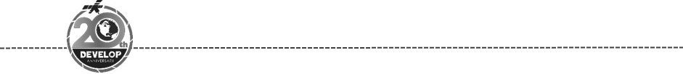Georgia – Athens

*Spring 2018*

Osa Peninsula Water Resources

Assessing Threats to River Water Quality and Mangrove Health Based on Watershed Land Use on the Osa Peninsula, Costa Rica

 **Technical Report**

Final Draft – March 29th, 2018

Suravi Shrestha (Project Lead)

Marie Bouffard

John Langstaff

Candice Lee

Emily Pauline

Sam Tingle

Dr. Marguerite Madden, University of Georgia (Science Advisor)

# 1. Abstract

The Osa Peninsula, located in the southern region of Costa Rica’s Pacific Coast, is one of the most biologically-diverse places on Earth and is a popular ecotourism destination. However, the area faces watershed degradation and loss of biodiversity due to deforestation, pollution from agriculture, and human settlement. NASA DEVELOP worked with Osa Conservation to analyze land use and land cover change in the Osa Peninsula to better understand threats to river water quality and mangrove health. This project used Landsat 5 Thematic Mapper (TM), Landsat 8 Operational Land Imager (OLI), and Terra Advanced Spaceborne Thermal Emission and Reflection Radiometer (ASTER) to create a land cover time series map from 1987 to 2017. These time series data were used to compare land use over time, as well as patterns in water quality, mangrove health, erosion, and deforestation. The time series also helped to identify the impact of the creation of protected areas and the 1996 Forest Law 7575, which aimed to support reforestation and riparian health. Osa Conservation will use and distribute results to the National System of Conservation Areas (SINAC), Ministry of Environment and Energy (MINAE), and local communities to inform land management decisions, policy enforcement, education and outreach initiatives, and watershed restoration and monitoring.

**Keywords**

Biodiversity, land use change, habitat degradation, watershed health, restoration, Landsat, time series analysis

# 2. Introduction

* 1. ***Background Information***

Costa Rica is one of the world’s frontrunners in biodiversity and conservation efforts. In particular, its Osa Peninsula is a hotspot for diverse and critical ecosystems. Located in the southern portion of the country’s Pacific coast, the Osa Peninsula is home to an estimated 2.5% of the planet’s biodiversity and has been called, “The most biologically intense place on Earth” by National Geographic (“About the Osa”, 2017). However, the ecological health of the Osa Peninsula faces increasing threats from deforestation, land use change, and watershed degradation.

Deforestation causes habitat loss and habitat fragmentation, leading to inbreeding among various plant species, reducing plant diversity in the region (Zahawi, Duran, & Kormann, 2015). Historically, deforestation in Costa Rica has been driven by growing populations and the massive conversion from forests to agricultural lands, especially beef cattle pastures and palm oil, teak, and coffee monocultures (Rodrick, 2010). In 1943, about 77% of Costa Rica was covered in forest, but by 1987 forest cover had been reduced to 21% (Ding et al., 2017). In the 1940s, a government initiative encouraged deforestation as a response to immigration that resulted from World War II (Zahawi et al., 2015). To support this growing population, deforestation for agriculture and settlements continued, and from 1960-1980 Costa Rica had one of the highest rates of deforestation in the world at 3.86% per year (Zahawi et al., 2015). .

Land use change alters the natural hydrology of the region, impacting water quality, flow dynamics, and nutrient levels, which can negatively impact ecological health in the watershed (Allan & Flecker, 1993). Deforestation for agricultural use can lead to the degradation of water quality due to runoff of pesticides and fertilizers (de Mello, Randhir, Valente, & Vettorazzi, 2017). Changing river flow regimes have led to a decrease in the natural absorption and filtration of nutrients and pollutants (Palmer et al., 2009). Without these essential processes, excess nitrogen and phosphorus buildup in water, making it unsuitable for both native species and human use (Palmer et al., 2009). If no action is taken to change the situation, these impacts on water quality and biodiversity will ultimately come back to negatively impact human health.

Amid a growing international recognition of the importance of healthy natural ecosystems, Costa Rica has established itself as a leader in environmental conservation. In recent decades, Costa Rica has become very involved in implementing environmental policies like the Forest Law 7575, which aims to curb deforestation and promote reforestation (Algeet-Abarquero, Sañchez-Azofeifa, Bonatti, & Marchamalo, 2015). One of the significant policies of the 1996 Forest Law was that it designated riparian zones as protected lands. This regulation is supported by studies that have shown that forest cover in riparian buffers can mitigate the negative impacts deforestation has on water quality (Lorian & Kennedy, 2009). Riparian forests are critical to protecting water quality because they provide filtration of pollutants and excess nutrient runoff, protection against bank erosion, and regulation of water temperature (de Mello et al., 2017). The restoration of these ecosystems is particularly important for the Osa Peninsula, which is experiencing the effects of watershed degradation (de Mello et al., 2017).

Costa Rica is also considered a pioneer in market-based conservation initiatives and was an early adopter of Payments for Environmental Services (PES) programs. The current PES system was introduced in 1996 by the Forest Law 7575 and aims to support conservation by directly compensating landholders for protecting and restoring ecosystem services on their private lands (Sierra & Russman, 2005). The program recognizes four types of ecosystem services: greenhouse gas mitigation, hydrological services, biodiversity conservation, and preservation of scenic beauty for recreation and ecotourism.

While it is unclear how effective the PES program has been in decreasing deforestation, forest cover has increased. In the 1990s, reforestation rates started to overtake deforestation, resulting in a net gain in forest cover (Algeet-Abarquero et al., 2015). Between 1991 and 2015, Costa Rica’s forest cover increased from 29% to 54% (Ding et al., 2017). A 2014 land cover study of the Osa Peninsula in Costa Rica identified conservation policies, socioeconomic changes, ecotourism, and a growing international focus on environmental conservation as the main drivers behind forest recovery in the region (Algeet-Abarquero et al., 2015). Ecotourism provides an economic incentive for conservation. With its impressive biodiversity and two popular national parks, ecotourism is the main driver of the local economy in the Osa Peninsula (Hunt Durham, Driscoll, & Honey, 2014).

NASA DEVELOP partnered with Osa Conservation to better understand the threats to biodiversity and ecosystem health in the Osa Peninsula (Figure 1) and how effective Forest Law 7575 policies have been in addressing them. This project used NASA Earth observations to analyze regional land use and land cover change between January 17, 1987 and December 31, 2017 to identify patterns between land use and watershed health. Osa Conservation will use results of this project to inform land management decisions, legislation, and watershed restoration and monitoring in the Osa Peninsula.

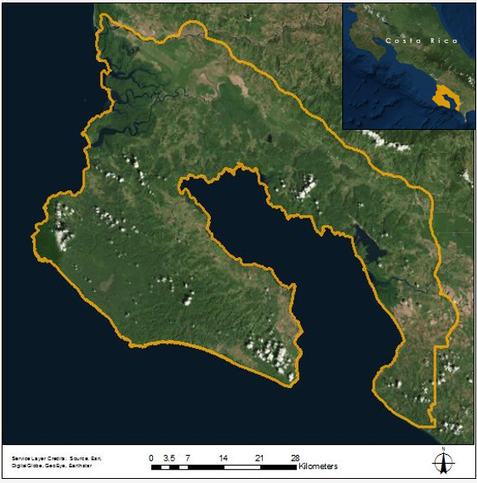

*Figure* 1. The study area for this project is the Osa Peninsula, located in the southern portion of Costa Rica

* 1. ***Project Partners & Objectives***

Osa Conservation is a nonprofit organization dedicated to protecting the globally significant biodiversity of Costa Rica’s Osa Peninsula through environmental monitoring, wildlife conservation, educational outreach, and habitat restoration. One of their programs, the Watershed Health program (*Rios Saludables*), utilizes biological and chemical testing to monitor the river water quality across the peninsula. Using the test results to assess the effects of human activity on river health, Osa Conservation is able to better target long-term water quality monitoring and community education efforts. Osa Conservation is currently responsible for the conservation and restoration of multiple sites across the Osa Peninsula and is interested in focusing its future restoration efforts on riparian corridors.

Osa Conservation needs data on land use and land cover change to better understand the connections between these changes and local watershed health. The temporal and spatial analysis on land use patterns will help evaluate the effectiveness of Forest Law 7575. Further analysis will focus specifically on riparian zone health, investigating the impact that land use change has had on this important habitat. In addition to looking at the entire peninsula, our land cover analysis also focused on a smaller stream area in the south of the peninsula where Osa Conservation is conducting a restoration project (Figure 2). The two scales of our analysis, the peninsula as a whole and the case study area, will provide the necessary broad understanding of land cover change, as well as a more tailored insight into the local effects of land cover within the context of a specific stream restoration project.

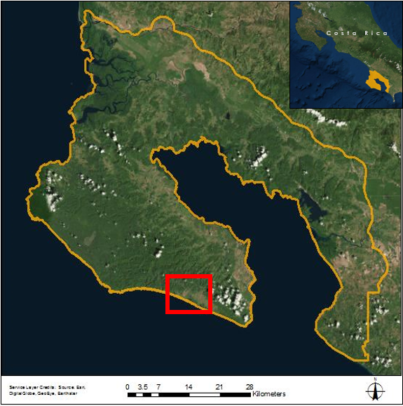

*Figure 2.* In addition to looking at the entire peninsula (outlined in orange), the study will also conduct analysis on a smaller case study area (shown in red) where Osa Conservation is currently conducting a restoration project.

Finally, to ensure that our findings contribute to the larger efforts for conservation, our project partners will create accessible public outreach materials to educate the local community on how to implement sustainable practices. This greater understanding of the current and past conditions of watersheds in the region will help to inform land management strategies, policy decisions, and more effective watershed restoration efforts.

# 3. Methodology

***3.1 Data Acquisition***

During this project we conducted a land cover change analysis using Landsat Surface Reflectance Level-2 products from 1987-2017. Our methodology is summarized in Figure 3. The team used three Landsat images ordered and downloaded from USGS Earth Explorer. We acquired images for January 17, 1987 and March 7, 1999 from Landsat 5 Thematic Mapper (TM) and an image from December 21, 2017 from Landsat 8 Operational Land Imager (OLI). The Landsat scenes were acquired for Worldwide Reference System (WRS)-2 Path 14, Row 54, which encompasses the study area. Frequent cloud cover in the region obscures the visibility of the ground, so we chose three images with minimal cloud cover that spanned the time period of this study. To account for seasonal differences in vegetation, each image was taken during Costa Rica’s dry season. We also downloaded the Global Digital Elevation Model Version 2 (GDEM V2) from the Advanced Spaceborne Thermal Emission and Reflection Radiometer (ASTER) to further assist in land cover analysis.

Osa Conservation provided additional data, including shapefiles of roads, rivers, protected lands, and a land cover map created by the Osa and Golfito Initiative (INOGO) program of the Stanford Woods Institute for the Environment in partnership with the University of Florida. The INOGO map used 5-meter RapidEye imagery from 2012 to create a detailed land cover map of the study area (Broadbent et al., 2012). The INOGO map, along with Google Earth Imagery, were used as references during our own classification.

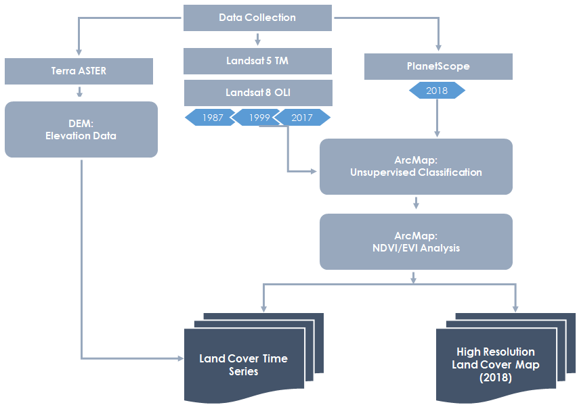

*Figure* 3. Summary of overall project methodology

***3.2 Data Processing***

Surface reflectance data from Landsat 5 TM were atmospherically corrected using the Landsat Ecosystem Disturbance Adaptive Processing System (LEDAPS) algorithm, while products from Landsat 8 OLI were generated with the Landsat Surface Reflectance Code (LaSRC) algorithm. We loaded the data into ArcMap 10.5 and created composites of bands 1-5 and 7 for the Landsat 5 TM images (example of infrared imagery of 1999 shown in Figure 4), and bands 2-7 for the Landsat 8 OLI images. The composites were then clipped to the study area provided by Osa Conservation.

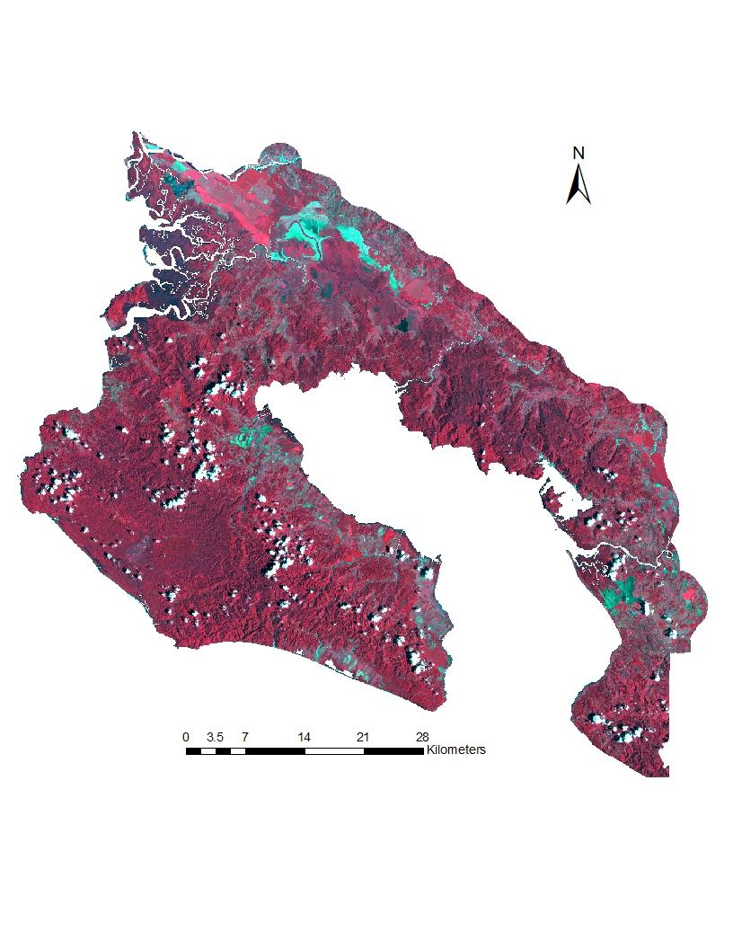

*Figure* 4: Near-infrared composite of 1999 Landsat 5 TM imagery

***3.3 Data Analysis***

We established land cover classes that were of interest to our partners and practical for our team to identify. We performed an unsupervised classification on each image, beginning with 35 classes to help separate the different types of land cover in our study area. After the initial classification, clouds and cloud shadow pixels were converted to “NoData” and were not included in the rest of the classification process. Since ground truth data were unavailable, we used the INOGO land cover map and high-resolution Google Earth imagery to help us identify and categorize clusters. The remaining clusters were reclassified into seven final classes: forest, water, palm, bare/urban, grassland, negra forra, and wetland.

To help characterize the vegetation in our study area, we calculated Normalized Difference Vegetation Index (NDVI) values for each image using the near infrared (NIR) and visible red bands (Equation 1). NDVI provides valuable information on the type and abundance of vegetation represented in a pixel. The results are expressed on a scale ranging from -1 to 1, where values closer to 1 indicate denser, healthier vegetation; Bare/urban environments display NDVI values closer to -1. We used this index in our classification process to differentiate between the signatures of different vegetation types.

$NDVI=\frac{NIR-Red }{NIR+Red}$ (1)

The high relief of our study area created some drastic differences in illumination, leading to the misclassification of some forest slopes. Shaded slopes were classified differently than sunlit slopes even if they appeared to be of the same forest type. Sunlit slopes were heavily confused with palm plantations. We used our ASTER GDEM to circumvent the issue by only assigning palm pixels below 100 meters, as all palm plantations are found in the lowlands of our study area. After our classes were finalized, we calculated the area of each land cover and examined how it changed over our study period.

the area of each land cover and examined how it changed over our study period.

***3.4 Case Study Methodology***

In addition to the land cover analysis of the entire peninsula, our partners were also interested in a case study of a stream in the southern tip of the peninsula. This required the use of a dataset of higher resolution so that smaller scale features could be identified.  To achieve this greater level of detail, we used PlanetScope imagery. Employing a collection of small satellites, PlanetScope collects daily 3 meter imagery of the entire Earth, producing high resolution, temporally relevant data that we could use to conduct our analysis (Planet Team, 2017). Our team had access to PlanetScope imagery through Planet’s Education and Research Program, from which we downloaded an image of our study area from March 15, 2018.  Like the methodology described above, we performed an unsupervised classification and then merged the classes into the categories that were used for the rest of our study: forest, water, palm, bare/urban, grassland, negra forra, and wetland. We also calculated NDVI values for the image to display vegetation health in our case study area.

# 4. Results & Discussion

***4.1 Analysis of Results***

Our land classification and NDVI analysis yielded a variety of results with important implications for the Osa Peninsula. The NDVI analysis of the study area provided information on vegetation density and health for each year (Figure 5). This analysis also helped our classifications by allowing us to distinguish between vegetation types based on NDVI. Forest cover pixels had the highest NDVI values. By selecting and reclassifying pixels with an NDVI value higher than 0.81, we were able to differentiate between forest and other vegetation classes. This was also useful for separating palm plantations and grassland because palm displayed higher values.

Image result for north arrow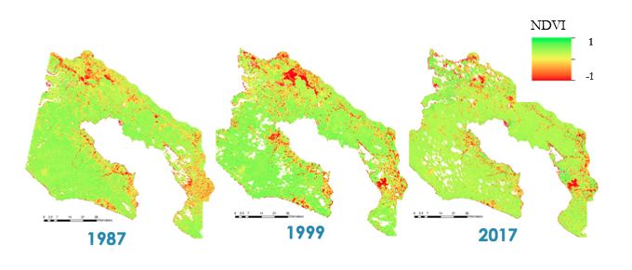

*Figure* 5: Normalized Difference Vegetation Index (NDVI) Analysis

The comparison between the NDVI values in 1987 and 2017 revealed changes over the thirty year period and highlighted areas that saw increases or decreases in vegetation density (Figure 6). A majority of the study area saw little to no change in NDVI between 1987 and 2017, but there were small, concentrated areas that saw net gains or losses in NDVI values.

Image result for north arrow 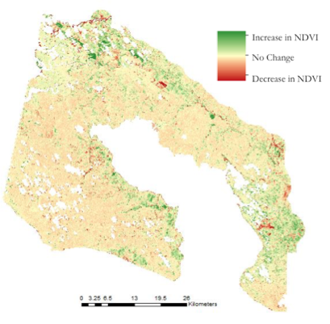

*Figure* 6: Change in NDVI between 1987 and 2017

After completing our land classification, we created a time series of the maps to see how land use has changed over time (Figure 7). There are three areas with the most pronounced changes over our study period: the north, the east, and the central part of the peninsula. In the northern edge of the peninsula, areas that were grassland in 1987 have largely become palm plantations and forests. This can be seen from the transition from light green to yellow and dark green. In the east, the areas that were grasslands in 1987 have also become forests and palm plantations. In the central part of the peninsula, land change over time has also changed from grasslands to forests and palm plantations.

Image result for north arrow

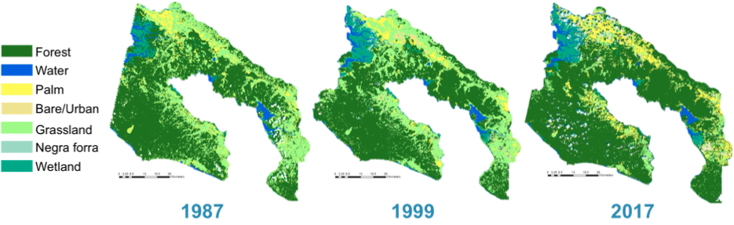

*Figure* 7: Osa Peninsula Land Cover Classification

In general, vegetation has increased in the Osa Peninsula during our study period from 1987-2017. This can also be seen when looking at the percentage change of different land cover types (Figure 8). In these graphs, forest, palm plantation, and grassland are highlighted because these classes showed the greatest changes over the study period. We calculated that from 1987 to 2017, forest cover saw a 10.69% increase, palm a slight decrease of 6.66% and grassland had the biggest decrease of 48.58%.

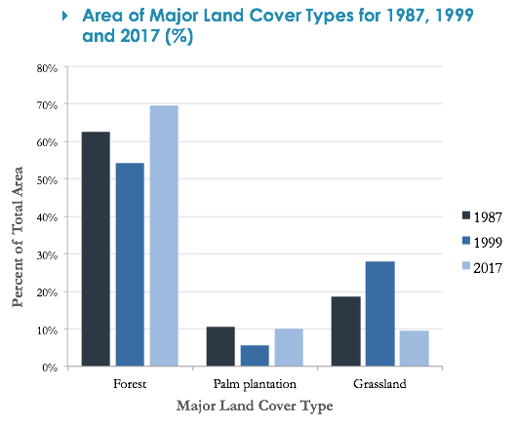

*Figure* 8: Area of Major Land Cover Types for 1987, 1999, and 2017 in Osa Peninsula (%)

This land use change can also be described using a land cover change matrix, which describes how different land cover classes have changed over time by giving the percent of a particular land class that has changed to another type or remained the same from one period to the next (Table 1). This can be directly applied to the land cover analysis of the Osa Peninsula. Table 1 is interpreted by choosing one row and reading it from left to right. The numbers in each box represent the percent of land cover class that has changed from the class listed in the row header to each land cover class in the columns between 1987 and 2017. As an example, the forest row (the top row) will be highlighted. The first box represents the percent of land that began as forest in 1987 and remained as forest in 2017, i.e. 89.14%. The second box in that row represents the percent of forest that began as forest in 1987 and had become palm by 2017; in this case it is a little more than 4%. By using this table, two other important results become evident: 36% of the land that was used for palm plantations in 1987 had become forest in 2017, and 48.63% of the land that was grassland had also become forest by 2017. This table also reveals that 79.34% of the areas that were wetlands in 1987 were still wetlands in 2017, and 17.52% had converted to forest. These changes can have important implications for health of local ecosystems and water quality as these natural habitats are restored.

*Table 1*. Land cover change matrix of Osa Peninsula (1987 and 2017) in percentage

|  |  |  |  |  |  |  |  |  |
| --- | --- | --- | --- | --- | --- | --- | --- | --- |
| 2017 | | | | | | | | |
| 1987 |  | Forest | Palm | Grassland | Water | Negra Forra | Wetlands | Urban/Bare |
| Forest | 89.14 | 4.06 | 2.83 | 0.27 | 0.60 | 2.95 | 0.16 |
| Palm | 36.89 | 31.47 | 28.53 | 0.36 | 0.05 | 0.11 | 2.58 |
| Grassland | 48.63 | 21.23 | 25.43 | 0.64 | 0.07 | 0.24 | 3.75 |
| Water | 4.48 | 1.13 | 0.66 | 89.64 | 0.11 | 3.41 | 0.56 |
| Negra Forra | 3.86 | n/a | 0.01 | 1.58 | 26.38 | 68.17 | n/a |
| Wetlands | 17.52 | 0.31 | 0.32 | 2.06 | 0.41 | 79.34 | 0.04 |
| Urban/Bare | 31.48 | 26.29 | 18.53 | 11.70 | 0.31 | 3.65 | 8.03 |

***4.2 Case Study Area***

In addition to our study of the entire Osa Peninsula, our partner expressed interest in a stream study site where they are planning a riparian zone restoration project. PlanetScope imagery was ideal for analysis of this area due to its higher resolution (3 meter) and recent dates of collection. The analysis of PlanetScope imagery provided more detailed spatial analysis of the different land covers. Although not differentiated in Figure 9, the analysis yielded delineations between different types of forest vegetation that were not distinguishable in the Landsat imagery.

The findings of the land cover classification of the Planet Imagery are preliminary (Figure 9). Moving into the second term of this project, this detailed imagery partnered with *in situ* data can be used to create a much nuanced land cover classification map. This map can be used to understand the stream area’s current land cover to better inform restoration efforts and can be updated to monitor the ongoing impact of those efforts.

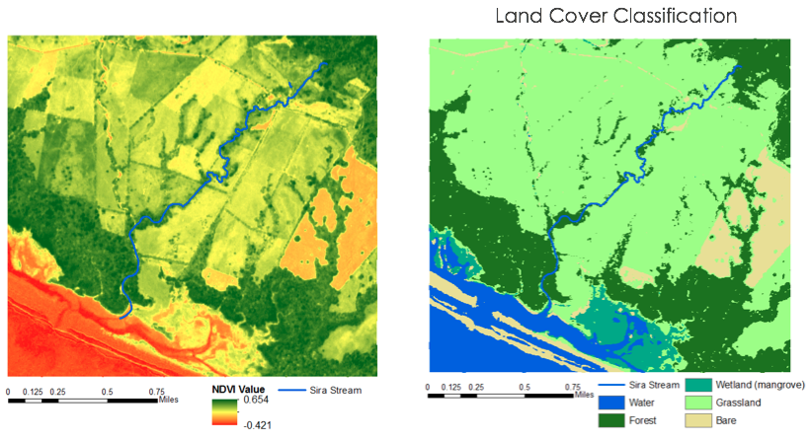

*Figure* 9: The NDVI and land cover analysis of the 3 meter high-resolution imagery of our case study area.

***4.3 Future Work***

Based on partner feedback from the first term, the team will continue the project to define and integrate environmental and social factors to produce data on watershed health and water quality risks. In addition, the team will identify areas of mangrove deforestation and those at risk for deforestation, produce mangrove health maps, and combine local water quality data to assess impacts of watershed land use and river water quality on mangrove health.

As mentioned previously, the high resolution of Planet data can provide a more detailed land cover classification of a smaller area. The use of this imagery to analyze a case study area can be replicated for other areas around the peninsula related to watershed health. As the second term of this project further investigates watershed and mangrove health, Planet imagery can be used to supplement Landsat analysis with a more contextual classification of specific areas.

# 5. Conclusions

The results of our analysis show an overall increase in vegetation cover over the study period. A comparison between the land cover classifications for 1987 and 2017 indicate that palm plantation, urban/bare area, and grassland decreased while negra forra, water, forest, and wetlands increased. Additionally, the Osa Peninsula saw a 10.7% increase in forest cover between 1987 and 2017, as indicated by our land cover classification and NDVI analysis. These results demonstrate historical land cover change trends and provide insights for evaluating policies and conservation strategies. While these findings indicate a positive trend in reforestation, this alone is not enough information to categorically confirm the success of the 1996 Forest Law. According to the literature, it is difficult to determine how much of the reforestation has been because of Forest Law policies and how much was due to unrelated socio-economic events like the abandonment of cattle pastures after the economic value of beef fell in the 1990s. However, further research could shed more light on the effectiveness of the 1996 Forest Law because one of its major components was to designate buffers around streams and rivers as protected lands and promote reforestation in riparian zones.

# 6. Acknowledgments

We would like to acknowledge our project partners, Hilary Brumberg and Andy Whitworth at Osa Conservation for their continuous involvement and communication throughout the term. The team would also like to thank our science advisor, Dr. Marguerite Madden at the University of Georgia’s Center for Geospatial Research for her support and guidance. Additionally, we would also like to thank our Center Lead, Caren Remillard, and the Communications Fellow, Austin Stone, for their timely feedback throughout the term.

Any opinions, findings, and conclusions or recommendations expressed in this material are those of the author(s) and do not necessarily reflect the views of the National Aeronautics and Space Administration.

This material is based upon work supported by NASA through contract NNL16AA05C and cooperative agreement NNX14AB60A.

# 7. Glossary

**Atmospheric Correction** – The process used to remove atmospheric distortion from satellite imagery

**Biodiversity** – The variety of species in an area

**Earth observations** – Satellites and sensors that collect information about the Earth’s physical, chemical, and biological systems over space and time

**Ground Truth Data**– data that is collected on location and allows image data to be compared to real features and verify image analysis

**Habitat fragmentation** – the division of large, continuous habitats into a greater number of smaller patches of lower total area isolated from each other by a matrix of dissimilar habitats

**Mangrove** – Trees or shrubs that grow in the coastal intertidal zone and stabilize the coastline by reducing erosion from storm surges, currents, and tides. The intricate root system of mangroves provides essential habitats for fish and other organisms seeking food and shelter from predators.

**Monoculture** – The cultivation of a single crop in a given area

**Normalized Difference Vegetation Index (NDVI)** –Indicator of green vegetation abundance derived from visual and near infrared spectral bands

**Orthorectified** – The process of removing image distortions (tilt and terrain effects) for the purpose of creating a planimetrically correct image   
**Riparian Zones** – Interface area between land and a river or stream

**Worldwide Reference System (WRS)** – Coordinate system used to describe Landsat image locations on Earth

# 8. References

About the Osa. (2017). Retrieved from http://osaconservation.org/about-the-osa-peninsula/

Algeet-Abarquero, N., Sañchez-Azofeifa, A., Bonatti, J., & Marchamalo, M. (2015). Land cover dynamics in Osa Region, Costa Rica: Secondary forest is here to stay. *Regional Environmental Change, 15*(7), 1461–1472. https://doi.org/10.1007/s10113-014-0714-9

Allan, J. D., & Flecker, A. S. (1993). Biodiversity conservation in running waters. *Bioscience, 43*(1), 32-43. https://doi.org/10.2307/1312104

Broadbent, E.N., Almeyda Zambrano, A.M., Almeyda Zambrano, S.L., Quispe Gil, C.A., Morales Barquero, L., Villalobos M.,… Menke, C. (2012). INOGO Mapas 2012: A high resolution map of land cover in the Osa and Golfito region of Costa Rica.

de Mello, K., Randhir, T.O., Valente, R.A., & Vettorazzi, C.A. (2017). Riparian restoration for protecting water quality in tropical agricultural watersheds. *Ecological Engineering, 108,* 514-524. https://doi.org/10.1016/j.ecoleng.2017.06.049

Ding, H., Faruqi, S., Wu, A., Altamirano, J.C., Anchondo Ortega, A., Verdone, M.,… Vergara, W. (2017). Roots of prosperity: The economics and finance of restoring land. World Resources Institute.

Hunt, C.A., Durham, W.H., Driscoll, L., & Honey, M. (2014). Can ecotourism deliver real economic, social, and environmental benefits? A study of the Osa Peninsula, Costa Rica. *Journal of Sustainable Tourism, 23*(3), 339-357. https://doi.org/10.1080/09669582.2014.965176

Lorian, C.M., & Kennedy, B.P. (2009). Relationships between deforestation, riparian forest buffers and benthic macroinvertebrates in neotropical headwater streams. *Freshwater Biology, 54*, 165-180. https://doi.org/10.1111/j.1365-2427.2008.02092.x

Palmer, M., Lettenmaier, D.P., Poff, N.L., Postel, S.L., Richter, B., & Warner, R. (2009). Climate change and river ecosystems: Protection and adaptation options. *Environmental Management, 44*, 1053-1068. https://doi.org/10.1007/s00267-009-9329-1

Planet Team (2017). Planet application program interface: In space for life on Earth. Retrieved from https://api.planet.com.

Rodricks, S. (2010). Enabling the legal framework for PES, Costa Rica. Retrieved from http://www.TEEBweb.org/

Sierra, R. & Russman, E. (2005). On the efficiency of environmental service payments: A forest conservation assessment in the Osa Peninsula, Costa Rica. *Ecological Economics,* *59*(1), 131-141. https://doi.org/10.1016/j.ecolecon.2005.10.010

US Geological Survey Earth Resources Observation and Science Center. (2014). Provisional Landsat OLI Surface Reflectance [Landsat 5 TM and 8 OLI]. US Geological Survey. https://dx.doi.org/10.5066/F78S4MZJ

# U.S./Japan ASTER Science Team. (2014). ASTER Global Digital Elevation Model V002.

https://dx.doi.org/10.5067/ASTER/ASTGTM.002

Zahawi, R.A., Duran, G., & Kormann, U. (2015). Sixty-seven years of land-use change in southern

Costa Rica. *PLOS ONE, 10*(11). https://doi:10.1371/journal.pone.0143554

# 9. Appendices

Table A1.

*Area of land cover conversion for each land cover class from 1987 to 2017 in the Osa Peninsula, Costa Rica*

|  |  |  |  |  |
| --- | --- | --- | --- | --- |
| **Forest to Other Land Cover** | | | | |
| **1987** | **2017** | **Area (km2)** | **% of Total Area** | **% of Total Change** |
| Forest | Grassland | 44.52 | 1.77 | 5.77 |
| Forest | Palm | 63.81 | 2.54 | 8.27 |
| Forest | Water | 4.19 | 0.17 | 0.54 |
| Forest | Urban/Bare | 2.51 | 0.10 | 0.32 |
| Forest | Wetlands | 46.46 | 1.85 | 6.02 |
| Forest | Negra Forra | 9.396 | 0.37 | 1.22 |
| **Palm to Other Land Cover** | | | | |
| **1987** | **2017** | **Area (km2)** | **% of Total Area** | **% of Total Change** |
| Palm | Forest | 96.55 | 3.84 | 12.51 |
| Palm | Grassland | 74.67 | 2.97 | 9.68 |
| Palm | Water | 0.95 | 0.04 | 0.12 |
| Palm | Urban/Bare | 6.75 | 0.27 | 0.87 |
| Palm | Negra Forra | 0.13 | 0.01 | 0.02 |
| Palm | Wetlands | 0.29 | 0.01 | 0.04 |
| **Grassland to Other Land Cover** | | | | |
| **1987** | **2017** | **Area (km2)** | **% of Total Area** | **% of Total Change** |
| Grassland | Forest | 226.61 | 9.01 | 29.36 |
| Grassland | Palm | 98.91 | 3.93 | 12.82 |
| Grassland | Water | 3.00 | 0.12 | 0.39 |
| Grassland | Urban/Bare | 17.46 | 0.69 | 2.26 |
| Grassland | Wetlands | 1.13 | 0.05 | 0.15 |
| Grassland | Negra Forra | 0.34 | 0.01 | 0.04 |
| **Negra Forra to Other Land Cover** | | | | |
| **1987** | **2017** | **Area (km2)** | **% of Total Area** | **% of Total Change** |
| Negra Forra | Wetlands | 8.45 | 0.34 | 1.09 |
| Negra Forra | Water | 0.20 | 0.01 | 0.03 |
| Negra Forra | Forest | 0.48 | 0.02 | 0.06 |
| Negra Forra | Grassland | 0.00 | 0.00 | 0.00 |
| **Urban/Bare to Other Land Cover** | | | | |
| **1987** | **2017** | **Area (km2)** | **% of Total Area** | **% of Total Change** |
| Urban/Bare | Forest | 14.22 | 0.57 | 1.84 |
| Urban/Bare | Grassland | 8.37 | 0.33 | 1.08 |
| Urban/Bare | Water | 5.28 | 0.21 | 0.68 |
| Urban/Bare | Palm | 11.88 | 0.47 | 1.54 |
| Urban/Bare | Wetlands | 1.65 | 0.07 | 0.21 |
| Urban/Bare | Negra Forra | 0.14 | 0.01 | 0.02 |
| **Water to Other Land Cover** | | | | |
| **1987** | **2017** | **Area (km2)** | **% of Total Area** | **% of Total Change** |
| Water | Palm | 0.96 | 0.04 | 0.12 |
| Water | Urban/Bare | 0.48 | 0.02 | 0.06 |
| Water | Grassland | 0.57 | 0.02 | 0.07 |
| Water | Forest | 3.84 | 0.15 | 0.50 |
| Water | Negra Forra | 0.10 | 0.00 | 0.01 |
| Water | Wetlands | 2.92 | 0.12 | 0.38 |
| **Wetlands to Other Land Cover** | | | | |
| **1987** | **2017** | **Area (km2)** | **% of Total Area** | **% of Total Change** |
| Wetlands | Forest | 12.31 | 0.49 | 1.60 |
| Wetlands | Water | 1.44 | 0.06 | 0.19 |
| Wetlands | Palm | 0.22 | 0.01 | 0.03 |
| Wetlands | Grassland | 0.22 | 0.01 | 0.03 |
| Wetlands | Urban/Bare | 0.03 | 0.00 | 0.00 |
| Wetlands | Negra Forra | 0.29 | 0.01 | 0.04 |

Table A2.

*Area of land cover that remain unchanged from 1987 to 2017 in the Osa Peninsula, Costa Rica*

|  |  |  |
| --- | --- | --- |
| **Land cover** | **Area (km2)** | **% of total area** |
| Negra forra | 3.27 | 0.13 |
| Water | 76.68 | 3.05 |
| Palm Plantation | 82.35 | 3.27 |
| Forest | 1402.60 | 55.78 |
| Urban/Bare | 3.63 | 0.14 |
| Wetlands | 55.76 | 2.22 |
| Grassland | 118.51 | 4.71 |

Table A3.

*Percent change in major land cover type in the Osa Peninsula, Costa Rica*

|  |  |  |  |
| --- | --- | --- | --- |
| **Land cover** | **1987 and 2017** | **1987 and 1999** | **1999 and 2017** |
| Forest | 10.69 | -10.93 | 24.28 |
| Palm | -6.66 | -46.34 | 73.95 |
| Grassland | -48.58 | 54.55 | -66.73 |