**NASA DEVELOP National Program**

NOAA National Centers for Environmental Information

**Spring 2016**

**Short Title: Cascade & Sierra Nevada Mountains Water Resources**

**Subtitle:** A Comparison of Remotely-Sensed Climate Data Records over the Cascade and Sierra Nevada Mountains for Improved Climate Monitoring

**VPS Title:** Rain or Snow: Precipitation Estimation in the Mountainous West

**Project Team & Partners**

**Project Team:**

Sam Swanson (Project lead), sam.swanson@noaa.gov

Kevin Rapa

Jessica Sutton

**Advisors & Mentors:**

Mike Kruk (Earth Resources Technology, Inc.)

**Partner Organizations:**

Western Regional Climate Center (End-User), POC: Nina Oakley

National Weather Service Western Region, Climate Services Division (Collaborator), POC: Andrea Bair; Boundary Organization

**Project Details**

**Applied Sciences National Applications Addressed:** Water Resources, Climate, and Weather

**Study Area:** The Cascade mountain range in Washington (WA), Oregon (OR) and California (CA), and the Sierra Nevada mountain range in California (CA) and Nevada (NV)

**Study Period:** January 1998 – December 2015

**Earth Observations & Parameters:**

CMORPH-CDR – microwave precipitation estimate

GPM – merged precipitation estimate

SNODAS – merged snow water equivalent (SWE) estimate

**Ancillary Datasets Utilized:**

* NOAA Global Historical Climate Network (GHCN - ) SWE and precipitation measurements
* PRISM - Precipitation measurements

**Software Utilized:**

R Statistical Program - data mitigation, statistical analysis

ArcGIS - raster manipulation/analysis, image enhancement & map creation

**Project Overview**

**Objectives Overview:**

An increasing problem in the western United States is the exacerbation of wet-season drought, resulting in decreasing snowpack and an earlier spring snowmelt. This project facilitates a comparison and analysis of remotely-sensed and *in situ* precipitation data in the Sierra Nevada and Cascade mountain ranges to gauge the usefulness of satellite data in mountainous regions. To this end, we hope to enhance the understanding of water availability in mountainous snowpack and inform climate monitoring and water resource management efforts across the western United States.

**Abstract:**

Shifting hydrologic processes have become a significant problem in California, Oregon, and Washington. In recent years, the average winter temperatures have risen, spring snowmelt has occurred earlier, and a greater portion of precipitation has fallen as rain rather than snow in the Sierra Nevada and Cascade mountain ranges. The natural reservoir of water stored in mountain snowpack has drastically declined, limiting water availability in the summer and forcing water managers to reassess their water management regimes. Current methods of understanding orographic precipitation in the West are limited to ground-station and volunteer-based observations, which are spatially limited in such areas. Considering the needs of the Western Regional Climate Center and the National Weather Service (NWS) Western Region, this project enhanced the understanding of precipitation in the Sierra Nevada and Cascade mountain ranges, using the National Oceanic and Atmospheric Administration (NOAA) Climate Precitcion Center (CPC) Morphing technique (CMORPH), the Global Precipitation Model (GPM), and the NOAA NWS SNOw Data Assimilation System (SNODAS) satellite data records. A comparison between satellite and *in situ* datasets revealed information about the usefulness of remotely-sensed data in estimating orographic precipitation. Ultimately, this project created several output products for the end-user: maps comparing *in situ* and satellite data, detailing precipitation variability, showing anomalies in precipitation, and identifying regions that lack *in situ* data while performing well at the remotely-sensed level.

**Community Concerns:**

* Climate change is rapidly changing the water cycle in the West, with earlier onset of snowmelt in the spring and higher occurrences of rain than snow during the winter, creating low summertime water availability. During the summer of 2015, reservoirs around California hit record lows, reaching levels unseen since the placement of their dams.
* *In situ* monitoring stations of precipitation are spatially limited in the Sierra Nevada and Cascade mountains, creating uncertainty when assessing available water resources for agriculture, recreation, and other human and ecological uses during the normally dry summer months.

**Current Management Practices & Policies**:

According to the end-users, remotely-sensed data are not utilized in their mission to “disseminate high quality climate data and information pertaining to the western United States.” In assessing their region’s current water status, the WRCC primarily uses PRISM, a gridded network derived from ground-station data; and the Global Historical Climate Network (GHCN), a ground-station dataset of which PRISM is partially based. PRISM’s climate data is interpolated into areas of similar geography in the mountain ranges of the West using bias-corrected station-based measurements. In our study area, the GHCN is comprised of data from the Cooperative Observer Program Network (COOP), Snow Telemetry (SNOTEL), and the Automated Surface Observation System (ASOS). When assessing snowpack, the California Snow Survey and the 8- and 5-Station Indices are used in addition to SNOTEL, albeit infrequently.

**Decision Support Tools & Benefits:**

|  |  |  |
| --- | --- | --- |
| **End-Product** | **Earth Observations Used** | **Benefit & Impact** |
| Estimation Comparison Graphs | CMORPH, GPM | CMORPH, GPM, and PRISM precipitation estimates are visually compared to GHCN station data for validation |
| Estimation Comparison Maps | CMORPH, GPM | Considering that the NWS and WRCC do not use satellite data, these maps will show where satellite data will be useful in decision-making and forecasting efforts |
| Monthly Normals Maps | CMORPH | This will further enhance understanding of precipitation variability by showing which months receive more or less precipitation during the winter (wet) season |
| Snow Water Equivalent Analysis | SNODAS | As time allows, similar analysis and end-products will be produced comparing SNODAS satellite-derived and SNOTEL station-based data detailing snow water equivalents |

**Project Imagery**

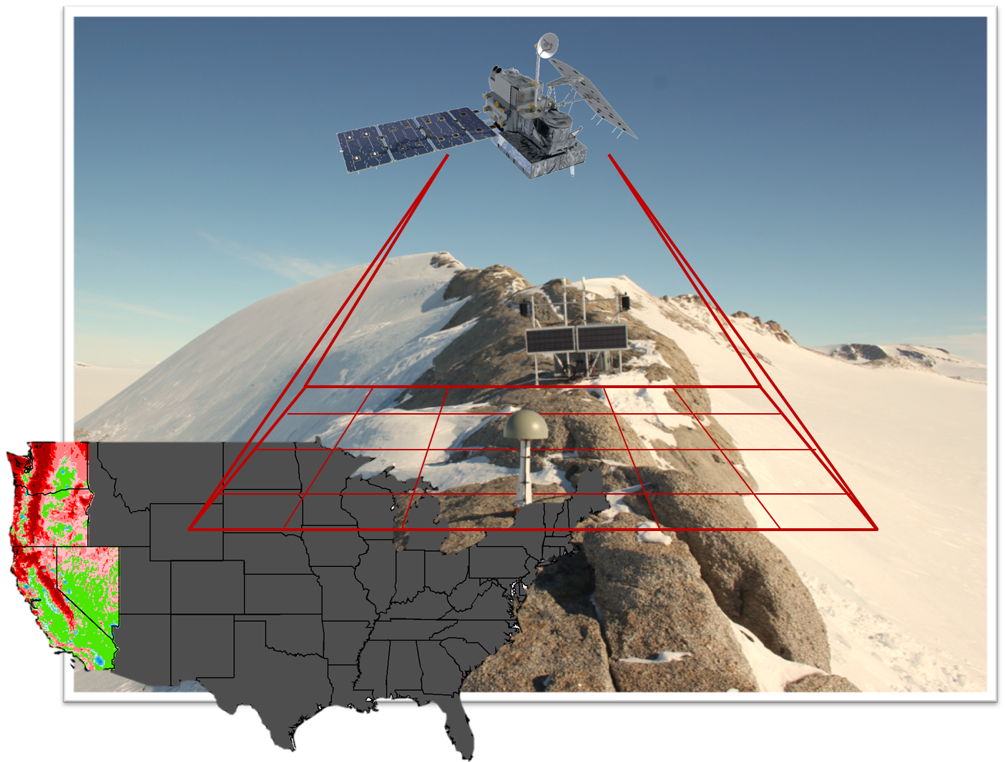

**Caption:** By comparing satellite- and station-derived precipitation estimates, the Cascade Sierra Water Team improved water resources monitoring in the western U.S. Image Credit: Cascade Sierra Water Team.

**Image:** 2016Spring_NCEI_CascadeSierraWater_VPSImage_RD_V1.jpeg

**Software Release Requirements**

Category I - no software release required