Rocky Mountain Disasters

Using Earth Observations to Quantify Postfire Vegetation Recovery on the Colorado Front Range

 **Technical Report**

Rough Draft – July 13th, 2020

Eric Jensen (Project Lead)

Audrey Colley

Lauren Kremer

Zackary Werner

Dr. Paul Evangelista, Colorado State University, Natural Resource Ecology Laboratory (Science Advisor)

Dr. Catherine Jarnevich, Colorado State University, Natural Resource Ecology Laboratory (Science Advisor)

Dr. Tony Vorster, Colorado State University, Natural Resource Ecology Laboratory (Science Advisor)

Peder Engelstad, Colorado State University, Natural Resource Ecology Laboratory (Science Advisor)

Nicholas Young, Colorado State University, Natural Resource Ecology Laboratory (Science Advisor)

**1. Abstract**

Forest composition and structure in the Colorado Front Range has been altered by changed to wildfire regimes, especially increased fire severity. Subsequently, reduced post-fire tree canopy regrowth often results in chronic impacts to upland ecological function and water quality. This project partnered with the U.S. Forest Service to estimate long-term tree canopy recovery in four Colorado Front Range fires between 1996–2002—Bobcat, Buffalo Creek, Hayman, and High Meadows—using Landsat 5 Thematic Mapper (TM), Landsat 7 Enhanced Thematic Mapper (ETM+), and Landsat 8 Operational Land Imager (OLI). We established relationships between spectral recovery slopes of multiple remote sensing vegetation health indices and field-collected counts of post-fire tree seedling regeneration. Using maps of post-fire spectral recovery slopes, we evaluated ecological drivers (topography, climate, soils, landscape metrics, and fire severity patches) of recovery using the Random Forest algorithm. In addition, we identified spectral characteristics that detect sites that may have transitioned to shrub or grassland vegetation communities. Understanding variables that influence vegetative recovery, and vegetation type conversion, and watershed characteristics will aid forest restoration efforts and water quality management.

***Keywords:***

remote sensing, Landsat 8 OLI, Landsat 7 ETM+, Landsat 5 TM, synthetic aperture radar, wildfire, vegetation recovery, random forest

**2. Introduction**

***2.1 Background Information***

Historically, relatively frequent mixed-severity fires have been an important driver in Southern Rockies montane forests (Brown et al., 2014). These fires reduce forest ground fuels and contribute to a heterogeneous forest structure by reducing density and burning patches of the forest canopy (Brown et al., 2014; Dickinson, 2014; Malone et al., 2018). However, policies of fire suppression resulted in higher densities of trees in many montane forests with estimates that 190 million acres of federal public lands in the United States are unnaturally dense (Goodlatte, 2003). High fuel loads are one factor that has contributed to larger patches of high-severity fire in Colorado Front Range than within the natural range of variability (Covington and Moore, 1994). Importantly, these moderate- and high-severity fire patches often show diminished post-fire tree regeneration, reducing ecological and hydrological function more than a decade following fire (Chambers et al., 2016).

Vegetation within forested water catchments regulates water quality through retention and release of nutrients. However, vegetation mortality due to wildfire instantaneously reduces plant demand of nutrients (Rhoades et al., 2019) and in combination with hydrophobic soils (Reale et al., 2015), results in high post-fire erosional sediment and nutrient inputs to headwater streams. Persistent nitrogen increases in burned stream catchments exceed reference conditions for healthy stream ecosystems (Rhoades et al., 2019). More than a decade after the Hayman Fire, stream nitrate demonstrated a positive relationship with high severity burn extent at the catchment scale, underscoring the importance of post-fire forest regeneration for water quality. Understanding the impacts of severe fire on forest regeneration and water quality is critically important for communities across the western U.S. whose water originates in fire-prone, forested watersheds.

In recent years, a variety of research approaches have been applied to analyze post-fire forest regeneration for fires in the Colorado Front Range. Bright et al. (2019) conducted remote sensing time-series analysis of post-fire pixel recovery using Landsat, while Chambers et al. (2016) and Malone et al. (2018) each used field plot-based approaches. Specifically, Bright et al. analyzed fitted recovery trends of the normalized burn ratio (NBR) for the Hayman Fire, in addition to two other fires in ponderosa pine-dominated (*Pinus ponderosa)* forests across the western United States. Chambers et al. (2016) analyzed counts of post-fire regeneration of coniferous and deciduous tree seedlings across fire severity gradients more than a decade following five Colorado Front Range fires. Similarly, Malone et al. (2018) collected a spatially explicit census of tree seedlings in mixed fire severity patches during the period 12-14 years after the Hayman Fire. Collectively, these additive approaches represent the state of the science for post-fire forest regeneration in the Colorado Front Range.

Post-fire forest regeneration is driven by factors such as topography, climate, fire severity, and forest patch characteristics. Elevation has consistently been demonstrated to be related to tree recruitment which, as Bright et al. (2019) helpfully points out, covaries with climate variables including temperature and precipitation (Chambers et al., 2016). Unsurprisingly then, climate variables such as post-fire precipitation and temperature anomalies have been demonstrated to be important for pixel recovery in ponderosa pine forests (Bright et al., 2019). Of a suite of topographic variables related to aspect, slope, and topographic position and complexity, the topographic wetness index (a slope and catchment-derived estimation of water availability) has had demonstrated predictive power.

Notably, the relationship of fire severity to tree regeneration is complex. In the Hayman fire, tree regeneration densities were much lower in sites burned at high severity then those burned at low severity 17 years after the fire. However, the distance from the nearest residual trees was an important predictor of regeneration across severity classes (Chambers et al., 2016). And one study even found that regeneration densities were highest in high severity sites, provided that those sites were near a masting tree (Malone et al., 2018). All of suggests that fire severity-based distance metrics may be more important than categorical fire severity metrics. One confounding variable can be forest-type. Bright, et al (2019) considered the entire Hayman fire as ponderosa pine-dominated, but in reality, the composition is more complex. In particular, aspen (*Populus tremuloides*) patches are important communities that can be stimulated following fire (Porter, 2019).

In this project, our primary objectives are to 1) evaluate the applicability of Landsat time-series analysis of vegetation health indices as a measure of post-fire forest recovery 2) determine whether it is possible to accurately predict post-fire vegetation recovery using remotely sensed data and ancillary datasets

***2.2 Study Area***

This study investigates long-term vegetation recovery trends in four fires that occurred in the Colorado Rocky Mountains between 1996–2002 (attributes of these fires are listed in Table 1). The burn areas were selected from a project that collected post-fire conifer regeneration data within several wildfires to determine abiotic and biotic factors affected regeneration density (Chambers et al. 2016). These burn areas are located in a montane forest zone on the eastern slope of the Front Range with the northernmost fire (Bobcat Gulch) near Drake, CO and the southernmost (Hayman) near Woodland Park, CO. The forested landscapes within the elevation ranges of these fires are characterized by complex topography with vegetative communities that change with elevational gradient and slope aspect. At high elevations (~2200 – 2800m), tree communities are comprised of ponderosa pine (*Pinus ponderosa*), Douglas-fir (*Pseudotsuga menziesii*), blue spruce (*Picea pungens*), trembling aspen (*Populus tremuloides*), and lodgepole pine (*Pinus contorta*). The density of blue spruce, aspen and lodgepole pine diminish with elevation until forests include only ponderosa pine, Douglas-fir, and Rocky Mountain juniper (*Juniperus scopulorum*) at lower elevations (~1600-2200m). Southern slopes at these elevations are more likely to contain only ponderosa with less dense stands than northern slopes (Chambers et al. 2016). Narrow-leaf cottonwood (*Populus angustifolia*) is also present at lower elevations along riparian areas (Kaufmann et al. 2000). Temperature ranges and precipitation averages are similar among burn areas (Table 2) though temperature and moisture patterns may be highly localized and therefore variable within a burn area due to topographic and spatial complexity of the study area.

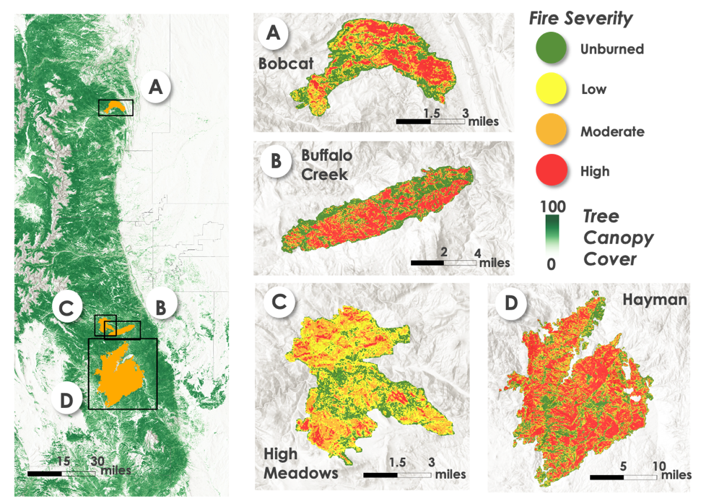

***Figure 1:*** *Locations of four selected wildfires along the Colorado Front Range, USA. Tree canopy cover data was retrieved from the National Land Cover Database (2016). Fire severity data was taken from MTBS (2014).*

Table 1. Attributes of the studied fires. Table adapted from Chambers et al. 2016. Burn severity percentages and thresholds are from MTBS (Eidenshrink et al., 2007)

|  |  |  |  |  |  |  |  |
| --- | --- | --- | --- | --- | --- | --- | --- |
| Fire | Fire year | Area  burned (ha) | Elevation range (m) | Low severity (% burned) | Moderate severity (% burned) | High severity (% burned) | Severity thresholds  (dNBR) |
| Hayman | 2002 | 55,751 | 2000-3230 | 34 | 22 | 43 | Low: .140  Mod: .211 Hi: .350 |
| Buffalo Creek | 1996 | 4,816 | 1900-2360 | 42 | 21 | 37 | Low: .330  Mod: .363  Hi: .500 |
| High Meadows | 2000 | 4,371 | 2090-2630 | 60 | 31 | 8 | Low: .077  Mod: .269  Hi: .500 |
| Bobcat Gulch | 2000 | 4,289 | 1690-2550 | 48 | 22 | 30 | Low: .200 Mod: .342; Hi: .550 |

Table 2. Mean annual temperature metrics and precipitation from climate stations maintained by the Colorado Climate Center that are within or in close proximity of each burn area (Colorado Climate Center, Colorado State University, Ft. Collins, Colorado, unpublished data).

|  |  |  |  |  |  |
| --- | --- | --- | --- | --- | --- |
| Fire | Station site | Elevation (m) | Mean annual minimum (◦C) | Mean annual maximum (◦C) | Mean annual precipitation (cm) |
| Hayman | Cheeseman | 2100 | 63 | 33 | 15 |
| Buffalo Creek | Bailey | 2350 | 57 | 26 | 17 |
| High Meadows | Bailey | 2350 | 57 | 26 | 17 |
| Bobcat Gulch | Buckhorn | 2250 | 58 | 36 | 21 |

***2.3 Project Partners***   
Researchers from the U.S. Forest Service, Rocky Mountain Research Station in Fort Collins, Colorado have completed several studies measuring burn severity, forest recovery, and watershed response. This study is intended to contribute to their understanding of the impacts and recovery trajectories of Front Range forests at landscape scales. Remote sensing analysis could aid decision makers in identifying areas where restoration efforts of these and other fires would have the greatest impact.

# 3. Methodology

***3.1 Data Acquisition***

We utilized USGS Landsat 5 TM, Landsat 7 ETM+ and Landsat 8 OLI tier 1 surface reflectance products in Google Earth Engine (GEE) to calculate various vegetation health indices and burn severity metrics (i.e. NDVI, normalized burn ratio, and others) relevant to vegetation recovery for the Hayman, High Meadows, Bobcat, and Buffalo Creek fires. These indices were used to characterize pre-fire vegetation health and track post-fire vegetation recovery for 15 years following each fire analyzed in this study. Additionally, synthetic aperture radar (SAR) products from ALOS PALSAR and Sentinel-1 were included in the analysis for assessing vegetation structure. The PALSAR data are SAR L-band data, whereas the Sentinel-1 are C-band data, corresponding to different wavelengths used by the sensors. A summary of the data utilized is presented in Table 3.

Table 3. Sensors and Data Products utilized for this project.

|  |  |  |  |
| --- | --- | --- | --- |
| Platform and Sensor | Data Product | Dates | Acquisition Method |
| USGS/NASA  Landsat 5 (TM) | Surface Reflectance Tier 1 | January 1990 – December 2012 | Google Earth Engine |
| USGS/NASA  Landsat 7 (ETM) | Surface Reflectance Tier 1 | January 2000 – December 2017 | Google Earth Engine |
| USGS/NASA  Landsat 8 (OLI) | Surface Reflectance Tier 1 | January 2014 – December 2017 | Google Earth Engine |
|  |
| JAXA/JAROS  ALOS PALSAR | Yearly Mosaic | January 2015 – December 2019 | Google Earth Engine |  |
|  |
| Copernicus Sentinel-1A and –1B C – band SAR | Ground Range Detected, log scaling | April 2016 – October 2019 | Google Earth Engine |  |
|  |
|  |

We downloaded fire severity datasets from Monitoring Trends in Burn Severity (MTBS) for the four Colorado Front Range fires between 1996 and 2002. The MTBS dataset served as a basis for spatial and statistical analysis surrounding fire severity and was used to track differences in vegetation recovery over time between the severity thresholds.

Topographic predictor variables were generated in GEE from data acquired through various means (Table 4). Outputs from the digital elevation model National Elevation Dataset (NED) provided elevation data and were later used to derive other topographic variables. Additionally, topographic diversity and Continuous Heat Isolation Load Index (CHILI) data were directly obtained from Science Conservation Partners through GEE.

Table 4. List of datasets utilized as ecological predictor variables for this project.

|  |  |  |  |
| --- | --- | --- | --- |
| Data Type | Source | Variable(s) | Acquisition Method |
| Climate | DayMet V3 | Precipitation, temperature | Google Earth Engine |
| Soils | POLARIS Soil Properties | Fractional sand, silt, and clay; bulk density, pH, soil moisture capacity | POLARIS website |
| Topography | USGS National Elevation Dataset (NED) | DEM, slope, aspect, topographic position | Google Earth Engine |
| Fire | Monitoring Trends in Burn Severity (MTBS) | NBR, dNBR, RdNBR,  classified burn severity | MTBS website |
| Vegetation | LANDFIRE | Type, cover fraction, leaf-area index | LANDFIRE website |

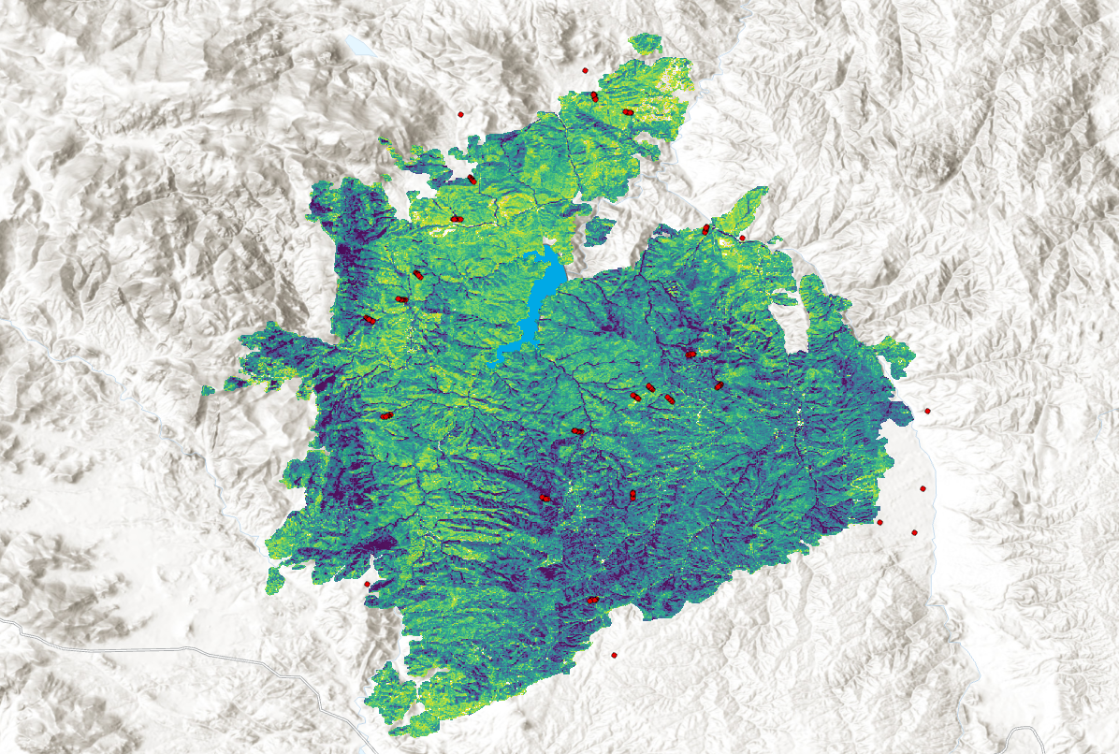***3.2 Data Processing***

**Figure 2:** Map of linear regression slopes of NDVI median composites for the 15-year period following the Hayman Fire. Points (red) are training data locations for which values were extracted from each Landsat variable and used as Random Forest training data, as described in section 3.3

*3.2.1 Landsat Data*

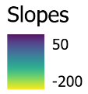The Landsat mission satellites 5, 7, and 8 were each included in the analysis to satisfy the temporal requirements (1994 – 2017) for investigating pre-fire and post-fire condition for the four fires. We first applied a mask using the Quality Assessment band to remove pixels that were likely to be clouds, water, or snow from each image. To overcome differences between the three satellites’ sensors, all three Landsat surface reflectance products were harmonized using methodology described in Roy et al. (2016), allowing the three sensors to be combined for time-series analysis. Preliminary exploratory analysis suggested that vegetation health including the normalized difference vegetation index (NDVI), tasseled cap greenness (TCG), and the enhanced vegetation index (EVI) and the fire index normalized burn ratio (NBR) were related to post-fire vegetation recovery (Table 5). We calculated raster bands for each of these indices for each Landsat image and then created mean, median, and maximum annual composite images corresponding to the September 1 – October 15; the date range corresponds to guidance from project partners and is related to the period following seasonal senescence of herbaceous vegetation in the region. For each of the four fires, the pre-fire period was considered as the two years prior to the year of fire and the post-fire period was considered as the 15 years following the fire. Using those specifications, we generated raster layers for each vegetation health index for the 15th year following the fire (post-fire raster), the post-fire raster minus the pre-fire median raster (differenced raster), the differenced raster divided by the pre-fire raster, and the linear regression slope fit through each image for the 15 years following the fire (figure 2).

Table 5. List of Landsat vegetation indices and corresponding formulas used for long temporal scale spectral analysis.

|  |  |
| --- | --- |
| Index | Formula |
| Normalized Difference Vegetation Index (NDVI) |  |
| Tasseled Cap Greenness (TCG) |  |
| Enhanced Vegetation Index (EVI) | ** |
| Normalized Burn Ratio (NBR) |  |

*\*\** *G, L, C1, and C2 are atmospheric correction coefficients*

*3.2.2 Synthetic Aperture Radar (SAR) Data*

Synthetic aperture radar data were derived from two satellite missions Sentinel-1 and PALSAR. The PALSAR are served out on GEE as annual mosaics composited based on visual inspection and including bands of HH and HV polarizations. The data are available for years 2007, 2008, 2009, 2010, 2015, 2016, and 2017. We selected HV polarization for analysis because the signal most closely corresponds to dense vegetation cover. The Sentinel-1 data are comprised of individual images from which we created annual growing season median composites between May 1–September 30. The data includes VV and VH bands, from which we selected the VH for the same reasons as described for PALSAR and we selected images with “ascending” orbit because more images were available for our region. We then applied a 50-meter radius smoothing filter to the PALSAR and Sentinel-1 data to reduce the effect of speckling that is common for SAR data. For both sensors, we derived rasters for the most recent year’s data collection (2017 for PALSAR and 2019 for Sentinel-1) and for the difference between the most recent year’s collection and the first year’s collection (2007 for PALSAR and 2016 for Sentinel-1)

*3.2.3 Topographic Data*

Formulas were applied to NED digital elevation model to produce rasters of aspect, northness, eastness, and slope percentage variables (Table 6). See Roberts & Cooper et al. for the mathematical algorithm utilized to obtain TRASP values. All topographic variables, as listed in sections 3.1 and 3.2.3, were clipped to each fire. Subsequently, the topographic variables were extracted as training data for random forest modeling.

Table 6. *Mathematical functions applied to variables derived f*ro*m DEM data.*

*Aspect* = 

*Northness* = 

*Eastness* = 

*Slope percentage* = 

*Note: a is aspect in degrees; b is slope in degrees*

***3.3 Data Analysis***

Using the calculated metrics and collected variables as predictors, we reviewed random forest models to determine relative the relative influence of each of the predictors on response variables in R statistical software (R Core Team 2015; version 3.2.2). Several metrics indicative of vegetation recovery were tested in the models as response variables, which were provided by field data collected by Chambers et al. (2016) determining total tree count, deciduous tree count and coniferous tree count along with classifications of total tree counts. Before developing each model, we first removed redundant predictors in two ways: multicollinear predictors were removed using the *multi.collinear* function of the *rfUtilities* package (Evans and Murphy 2019), then predictors were selected from the remaining variables using the *rf.modelSel* function.

The random forest algorithm estimates the importance of variables using decision trees. It is a non-parametric technique that does not make any assumptions about the residuals of the model. The algorithm selects bootstrapped datasets from the original data and generates decision trees for each of the bootstrapped samples where for each branch of the regression tree, predictors are randomly sampled. The “out-of-bag” (*oob*), or un-bootstrapped portion of the original dataset is then used to measure the accuracy of the forest using the proportion of the *oob* samples that were correctly predicted by the forest. Incorrectly classified *oob* is classified as *oob* error. Variable importance is estimated by the prediction error increase when *oob* data for a given variable is permuted while all other variables are left unchanged (Liaw and Wiener 2002). We modeled datasets using selected variables by executing the *randomForest* function of the *randomForest* package (Liaw and Wiener 2002). For each model, we reviewed selected variables and random forest validation statistics including the *oob* error and the percentage of variation explained by the model. Models with the last oob error and the greatest variation explained were applied across the landscape of each of the four burn areas using the predict function of the *randomForest* package.

**References:**

Allen, C. D., Macalady, A. K., Chenchouni, H., Bachelet, D., McDowell, N., Vennetier, M., . . . Cobb, N. (2010). A global overview of drought and heat-induced tree mortality reveals emerging climate change risks for forests. *Forest Ecology and Management, 259*(4), 660-684. doi:10.1016/j.foreco.2009.09.001

Bond-Lamberty, B., Wang, C. K., & Gower, S. T. (2004). Net primary production and net ecosystem production of a boreal black spruce wildfire chronosequence. *Global Change Biology, 10*(4), 473-487. doi:10.1111/j.1529-8817.2003.0742

Bright, B. C., Hudak, A. T., Kennedy, R. E., Braaten, J. D., & Khalyani, A. H. (2019). Examining post-fire vegetation recovery with Landsat time series analysis in three western North American forest types. *Fire Ecology, 15*. doi:10.1186/s42408-018-0021-9

Casady, G. M., van Leeuwen, W. J. D., & Marsh, S. E. (2010). Evaluating Post-wildfire Vegetation Regeneration as a Response to Multiple Environmental Determinants. *Environmental Modeling & Assessment, 15*(5), 295-307. doi:10.1007/s10666-009-9210

Chambers, M. E., Fornwalt, P. J., Malone, S. L., & Battaglia, M. A. (2016). Patterns of conifer regeneration following high severity wildfire in ponderosa pine – dominated forests of the Colorado Front Range. *Forest Ecology and Management, 378*, 57-67. doi:10.1016/j.foreco.2016.07.001

Covington, W. W., Moore, M.M. (1994). Post settlement changes in natural fire regimes and forest structure: ecological restoration of old-growth ponderosa pine forests. *Journal of Sustainable Forestry*. 2, 153-181, doi:10.1300/J091v02n01_07

Dickinson, Y. (2014). Landscape restoration of a forest with a historically mixed-severity fire regime: What was the historical landscape pattern of forest and openings?. *Forest Ecology and Management*, 331, 264-271. doi:10.1016/j.foreco.2014.08.018

Eidenshink, J., Schwind, B., Brewer, K., Zhu, Z., Quayle, B., Howard, S. (2007). A Project for Monitoring Trends in Burn Severity. *Fire Ecology*, *3*, 3–21. doi:10.4996/fireecology.0301003

Evans JS, Murphy MA (2018). *rfUtilities*. R package version 2.1-3, https://cran.r-project.org/package=rfUtilities.

Goodlatte, B. (2003). Healthy Forests Restoration Act of 2003: Report together with minority views (to accompany H.R. 1904). Washington, D.C.: U.S. G.P.O.

Lentile, L. B., Holden, Z. A., Smith, A. M. S., Falkowski, M. J., Hudak, A. T., Morgan, P., . . . Benson, N. C. (2006). Remote sensing techniques to assess active fire characteristics and post-fire effects. *International Journal of Wildland Fire, 15*(3), 319-345. doi:10.1071/wf05097

Liaw, A., Wiener, M. (2002). Classification and Regression by randomForest. *R news.* 2, 18-22.

Malone, S. L., Fornwalt, P. J., Battaglia, M. A., Chambers, M. E., Iniguez, J. M., & Sieg, C. H. (2018). Mixed-Severity Fire Fosters Heterogeneous Spatial Patterns of Conifer Regeneration in a Dry Conifer Forest. *Forests, 9*(1). doi:10.3390/f9010045

Porter, A. (2019). The Role of Wildfire and Topography in Shaping Aspen Regeneration after the Hayman Fire, CO, USA. *Colorado State University*. [Thesis].

R Core Team. 2015. R: A language and environment for statistical computing, 3.2.2 edn. R Foundation for Statistical Computing, Vienna

Reale, J. K., Van Horn, D. J., Condon, K. E., & Dahm, C. N. (2015). The effects of catastrophic wildfire on water quality along a river continuum. *Freshwater Science, 34*(4), 1426-1442. doi:10.1086/684001

Rhoades, C. C., Chow, A. T., Covino, T. P., Fegel, T. S., Pierson, D. N., & Rhea, A. E. (2018). The Legacy of a Severe Wildfire on Stream Nitrogen and Carbon in Headwater Catchments. *Ecosystems, 22*(3), 643-657. doi:10.1007/s10021-018-0293-6

Sherriff, R. L., Platt, R. V., Veblen, T. T., Schoennagel, T. L., & Gartner, M. H. (2014). Historical, Observed, and Modeled Wildfire Severity in Montane Forests of the Colorado Front Range. *PloS one, 9*(9). doi:10.1371/journal.pone.0106971

Walker, R. B., Coop, J. D., Parks, S. A., & Trader, L. (2018). Fire regimes approaching historic norms and reduce wildfire-facilitated conversion form forest to non-forest. *Ecosphere, 9(4).* doi:10.1002/ecs2.2182

Westerling, A. L., Hidalgo, H. G., Cayan, D. R., & Swetnam, T. W. (2006). Warming and earlier spring increase western US forest wildfire activity. *Science, 313*(5789), 940-943. doi:10.1126/science.1128834