NASA DEVELOP National Program
NASA Langley Research Center
Summer 2017

Mississippi Sound Water Resources II
Analyzing the Impact of Environmental Disturbances on Oyster Reef Health in the Mississippi Sound Using NASA Earth Observations


Technical Report
Final Draft – August 10, 2017

Carter Grimm (Project Lead)
Rachael Green
Hannah Russ

Dr. Kent Ross (Science Advisor)
Benjamin Holt (Science Advisor)
Dr. Severine Fournier (Science Advisor)

Previous Contributors:
Emily Gotschalk (Project Co-Lead Spring 2017)
Brigitte Moneymaker (Project Co-Lead Spring 2017)
Katherine Cavanaugh
Catherine Stolfi
Erika Higa
Jessica Gregory

1. Abstract
Oysters are vital to the environmental health of the Mississippi Sound and a critical part of Mississippi’s economy. Environmental disturbances, such as Hurricane Katrina, major flooding events, and the Bonnet Carré spillway openings, have caused oyster populations to decline and have has negatively affected the water quality and economy of the Sound. Oysters purify water via filter feeding and a decline in their population could lead to increased levels of dissolved solids in the waterways. In collaboration with the Mississippi Department of Marine Resources (MDMR), the team focused on specific case studies of significant disturbances by combining data gathered in the Spring 2017 Term with data on the degradation of marshlands in the area. The team investigated the relationships between extreme weather events, salinity, freshwater discharge and diversion, chlorophyll-a, and oyster reef health. These case studies will help inform MDMR about how these factors are interdependent and impact the overall health of the Sound. This information will assist the MDMR in making better-informed decisions in preparing for and managing ecological stressors.

Keywords
Mississippi Sound, Water Quality, Water Resources, Remote Sensing, Oyster Reefs, Hurricanes, Flooding, NASA Earth Observations

2. Introduction

2.1 Background Information
Oyster reefs are a vital component of healthy estuarine systems. In addition to serving as a habitat for multiple species of fish and invertebrates, reef systems improve water quality via filter feeding; an adult oyster can filter up to 50 gallons of water per day (Mississippi, 2013). In the Gulf of Mexico, oysters hold not only a high environmental value, but also a high economic value. In 2009 alone, the commercial fishing industry landed 1.4 billion pounds of finfish and shellfish, earning $629 million in revenue, of which $72 million of the earnings were explicitly from oysters (National, 2011). Despite the overall high percentage of oyster landings in the Gulf, some states in the region have experienced a sharp decrease in landings. Since 2002, oyster landings have declined by over 90% in the western region of the Mississippi Sound, an area where 97% of the state’s oysters are harvested (Appendix A1) (Impacts, 2007).
The Mississippi Sound, located in the Gulf of Mexico, is an estuarine habitat bordered by several barrier islands, the Biloxi marsh of Louisiana, as well as coastal Mississippi and Alabama (Appendix A2). Freshwater from rivers and streams flows into Lakes Maurepass, Lake Pontchartrain, and Lake Borgne before continuing into the Sound. The marshland to the south of Lake Borgne, in addition to the barrier islands to the east, keep the freshwater close to the coast. The freshwater mixes with saltwater from the Gulf and creates a brackish environment that is ideal for oyster reefs. Environmental disturbances, namely hurricanes and flooding, impact water quality parameters such as turbidity, chlorophyll-a, total suspended matter (TSM), and salinity (Appendix A3). Oysters thrive in salinities between 15 and 30 practical salinity units (psu). Salinity concentrations below 15 psu impedes the oysters’ growth and concentrations beyond 30 psu increases predation from halophiles, such as the oyster drill snail (Turner, 2006).
High freshwater discharge events from surrounding rivers and the Bonnet Carré Spillway also affect oyster health. In March of 2016, heavy rainfall led to high discharge rates from the Mississippi, Amite, and Pearl Rivers; large plumes of freshwater, sediments and organic material from these rivers can be seen in Lake Maurepas, Lake Pontchartrain, and Lake Borgne (Appendix A4 & A5). The Pearl River alone had a peak discharge rate of 11,600 ft³/sec and a gage height of nearly 13 feet before the monitoring station was no longer able to continue taking measurements (USGS). When significant flooding occurs, the Bonnet Carré Spillway, located between the Mississippi River and the southwestern corner of Lake Pontchartrain, is opened to prevent flooding in New Orleans. According to Turner (2006), the average duration of diversion opening is one to three months, and each spillway opening can triple nitrogen levels in Lake Pontchartrain.
Compounding effects can be felt far into the Sound as nitrogen flows out of Lake Borgne and into the marshes and reefs. Blooms of bacteria, cyanobacteria, and algae thrive on high levels of nitrogen and other nutrients (Dale et. al, 2010). As the organic matter dies, it descends to the benthic zone where the decomposition process expends more oxygen than is readily available in the water column (Diaz & Rosenburg, 2008). This leads to hypoxic zones, also called dead zones, which move along with the ocean currents and have critically low absorbed oxygen. Free moving animals can flee from these areas, but plants and sessile animals are incapable of doing so, and as a result, suffocate in mass die-offs.
The team hypothesized that marshland and barrier island degradation in conjunction with high salinity and turbidity have negatively impacted oyster reefs in the Mississippi Sound. Deliverables produced from this project could possibly assist the Mississippi Department of Marine Resources (MDMR) in tracking these changes and managing future environmental threats.

2.2 Project Partners & Objectives
The Mississippi Department of Marine Resources was established in 1994 to “enhance, protect and conserve marine interests of the state” (Goodwin Group, 2015). Upon observing a decline in oyster populations, MDMR began working with the Oyster Restoration and Resiliency Council in 2015. In conjunction with MDMR, the Mississippi Sound Water Resources II NASA DEVELOP team examined water quality parameters for the Biloxi Marsh and barrier islands. The team analyzed changes in these parameters caused by specific environmental disturbances in the Sound spanning from 2002 to 2017. The project study area encompasses the Mississippi Sound, the Biloxi Marsh area, and Lakes Maurepas, Pontchartrain, and Borgne in Louisiana.

The project partners may apply the data produced from the marsh climatology to supplement similar climatologies developed in the Sound from term I of the project. The case studies produced may be used to illustrate both the short and long term effects of environmental disturbances on oyster reefs. This project addresses the NASA Applied Sciences’ Water Resources National Application Area by supporting the use of Earth observations for water resources management.

3. Methodology

3.1 Data Acquisition
USGS EarthExplorer provided level 1T 30 m resolution images from Landsat 5 Thematic Mapper, Landsat 7 Enhanced Thematic Mapper Plus, and Landsat 8 Operational Land Imager/Thermal Infrared Sensor (TIRS). In most cases, images with cloud cover exceeding 90% were excluded. Remaining cloud cover present in the scene was masked with ACOLITE.

The Land Processes Distributed Active Archive Center (LP.DAAC) provided surface reflectance at 250 m resolution from Aqua and Terra MODIS using the Application for Extracting and Exploring Analysis Ready Samples (AppEARS), courtesy of the NASA EOSDIS LP DAAC USGS/Earth Resources Observation and Science (EROS) Center.

The Physical Oceanography Distributed Active Archive Center (PO.DAAC) provided salinity data from the Soil Moisture Active Passive (SMAP) satellite spanning from April 1st, 2015 to June, 2015. The version 2.0 SMAP-SSS level 3 monthly gridded product has a resolution of 0.25x0.25 degrees and is pre-processed and distributed by JPL.

USGS Real_Time Hydrological Monitoring Stations provided in situ salinity, water discharge, and gage height & turbidity data from January 2002 through June 2017.

3.2 Data Processing

Turbidity
USGS water monitoring stations located throughout the Mississippi Sound were limited in available water quality parameters and parameter sampling periods. Monitoring station 301527088521500 Mississippi Sound at USGS East Ship Island Light contained the most complete data set in the study area and thus was chosen for turbidity analysis. It is positioned between the eastern and western sound study area boxes, slightly to the northeast of Ship Island. Data obtained from the station was comprised of continuous fifteen minute sampling intervals spanning from November, 2009 to December, 2016.

On the USGS website, turbidity was selected from the list of available parameters, output was set to table format, and the sampling period was selected for the first year that data was available - 2009. The resulting dates and times with corresponding turbidity measurements were copied into an excel file where turbidity measurements were averaged annually by month. This step was repeated for each subsequent year up to, and including, 2016. A line graph containing all annual averages was then created to display the fluctuations in turbidity during the study period.

Landsat 5 provided imagery for 2002-2011, Landsat 7 provided imagery for 2012, and Landsat 8 provided imagery for 2013-2017. The images were then run through ACOLITE using the semi-empirical single band turbidity retrieval algorithm (Appendix B4). Within the semi-empirical single band turbidity retrieval algorithm, A^{λ}_{T} and C^{λ} are calibration coefficients that are dependent on wavelength and ρw is water reflectance (Nechadi et al., 2009). ACOLITE derived turbidity using the 655 nm setting used within Dogliotti et al. (2015) and produced the processed images as GeoTIFFS. The desired values were then extracted from these images and used to create both the time series and case studies.

Chlorophyll-a (Chl-a)
Daily chlorophyll-a 1 km resolution data from 2003 – 2014 was provided by Dr. Chuanmin Hu during term one of the project. Dr. Chuanmin Hu, in conjunction with his colleagues, devised an algorithm to estimate chlorophyll-a concentrations utilizing near-concurrent Aqua MODIS data. This data was then calibrated and validated using field observations in the Louisiana coast.

During term one, the team converted Dr. Chuanmin Hu’s chlorophyll-a data to GeoTiffs by employing a Python code that incorporated gdal_translate. ModelBuilder was used to batch convert all pixel values that were above 100 and below 0 as No Data values. Chlorophyll-a data was categorized yearly by month, as well as into each of the five study area boxes that make up the Sound, by creating a monthly mean of the data with ArcMap’s Cell Statistics. The term II team averaged the five zones together for each year by month in order to obtain turbidity measurements for the entire Mississippi Sound. Measurements for the Mississippi Sound, as well as the Western Sound were arranged chronologically and then graphed using excel.

Landsat 5 provided imagery for 2002 - 2011, Landsat 7 provided imagery for 2012, and Landsat 8 provided imagery for 2013-2017. The images were then run through ACOLITE using the OC2 algorithm (Appendix B4). Each variable within the OC2 algorithm represents a different numeric constant (Appendix B5). ACOLITE produced the processed images as GeoTIFFS.

Total Suspended Matter
Term one obtained TSM data from the MODIS Aqua 8-day Surface Reflectance product using band 1 (red portion) 250 m data. Clouds in each product were masked with Quality Assurance (QA) data files and extraneous values were removed. The reflectance value range was converted to % Reflectance and the scale factor provided with the MODIS product [Reflectance Value (0.001)] was applied. An equation, outlined by Miller and McKee (2004), was applied to the % Reflectance value in order to convert to the TSM mg/L unit (Appendix B8). In order to facilitate comparisons, the 8-day products were categorized into approximately monthly averages (Appendix B7). An R script, created in R Studio, was used to generate zonal averages for each time series.

The term II team averaged the zonal averages for each of the study area boxes to obtain average monthly TSM measurements for the Mississippi Sound spanning from July, 2002 through December, 2016. Both the Mississippi and Western Sound data were deseasonalized in order to ascertain an accurate data trend and then graphed using excel.

Landings
Oyster landings data was found on the National Oceanic and Atmospheric Administration’s (NOAA) Office of Science and Technology webpage for commercial fisheries statistics. During 2005, oysters were only harvested from January to April - oysters are not harvested during the summer months and therefore it is common to be missing data from May through July or August. Unfortunately, the severe impacts of Hurricane Katrina delayed further oyster harvest until March of 2007 and resulted in an absence of oyster landings data for the state of Mississippi from May, 2005 to February, 2007.

On the commercial fisheries statistics’ webpage, oyster data was selected from 2002 to 2015, the timeframe was set to year by month, geographical area was selected for Mississippi, and the final output was in table form. The resulting data was copied into an excel file and graphed. Data was also averaged on an annual scale to serve as a comparison.

Salinity
Salinity data post-2005 is limited in the Sound due to the impacts of Hurricane Katrina. The Hurricane destroyed many of the in-situ hydrological monitoring sites and a majority have yet to be replaced. Salinity for the Western Sound was recorded at monitoring station 301527088521500 Mississippi Sound at USGS East Ship Island Light and was available from October, 2011 through December, 2016. Output format was set to table and measurements were produced in continuous fifteen minute intervals. The data was then copied into an excel file and averaged annually by month.

In order to track the movement of freshwater through Lakes Pontchartrain and Borgne, salinity measurements were also gathered in eastern Lake Pontchartrain at monitoring station 301001089442600 Rigolets at Hwy 90 near Slidell, LA; western Lake Pontchartrain at station 300602090375100 CRMS5373-H01-RT; and the northeastern Biloxi Marsh at station 300722089150100 Mississippi Sound near Grand Pass. Measurements at all three of these sites were only needed for 2016 and the data was copied into an excel file and averaged by month.

Gage Height
Gage height data was taken at the Biloxi Marsh from USGS station 300722089150100 Mississippi Sound near Grand Pass and from the Pearl River at USGS station 02492620 Pearl River at NSTL Station, MS. Only measurements from 2016 were used and data was copied into an excel file and calculated into monthly aggregates.

3.3 Data Analysis
For all imagery, each parameter was put in ArcMap and the desired values were extracted. For T Dogliotti red turbidity, the query used was “Value >0 AND Value <=100.” For Ocean Colour 2 chlorophyll, the query “Value >0 AND Value <=10” was used. It is important to note that in both queries, the value had to be written as greater than zero, as opposed to greater than or equal to, because all null values in the GeoTIFF files produced by ACOLITE were given a value of “0.” The extracted values were then used to create both the time series and case studies (Appendix C1).

4. Results & Discussion

4.1 Analysis of Results

Turbidity
Turbidity in the Western Sound has been steadily decreasing since January, 2010 (Appendix D1). This trend is further amplified when high turbidity anomalies are excluded (Appendix D2). The team hypothesized that these high spikes in turbidity were related to tropical storm Cindy in June of 2014 and the flooding event that took place in March of 2016. Although it is worth noting that turbidity during other disasters, namely Hurricane Katrina, did not register as anomalies on the yearly average. These data points were excluded from our analysis, however, because data prior to 2010 were not reliable.

The Landsat imagery appears to show this trend (Appendix D3 and D4). Images from September and October from 2005, 2008, 2011, and 2015 were used because these months generally had atmospheric conditions that were more conducive to clear views. While there were not enough data points to perform thorough analyses, the imagery does show an overall decline in turbidity; this is most apparent in the open water, but it is also visible just north of the Biloxi Marsh.

Chlorophyll-a
In both the Western Sound and Mississippi Sound, chlorophyll-a has been increasing since January, 2003 (Appendix D5 & D6). The standard deviations of data preceding January 2010 and post-January 2010 were calculated in order to establish whether the data sets were also increasing in variability. January 2010 was chosen as the point of comparison because the data suggests that chlorophyll-a concentrations become increasingly varied after this date. For the Mississippi Sound, the standard deviation of chlorophyll-a increased by 57.003% (pre-January 2010 ơ=1.9527, post-January 2010 ơ=3.0658), while standard deviation increased by 96.89% in the Western Sound (pre-January 2010 ơ=2.3892, post-January 2010 ơ=4.7042).

Landsat imagery further corroborates this trend (Appendix D7 and D8). Imagery was gathered during the months of September and October for the following years: 2005, 2008, 20011, and 2015. While there were not enough data points to do analysis, the images in D7 and D8, including other images in our time series (Available in a link in Appendix A6) did not appear to show an increase or decrease. Instead, they appeared varied from year to year during the same month, thus further corroborating the in situ data that suggests an increase in variability.

Total Suspended Matter
TSM data was deseasonalized for the Western Sound and Mississippi Sound data sets on the monthly scale (Appendix D9 & D10). This allowed the team to accurately establish a trend for the data. Since 2010, TSM in the Western Sound has increased marginally from an approximate average of 22 mg/L to 27 mg/L. A difference that is too slight to verify an increase of TSM in the Western Sound. The concentration of TSM in the Mississippi Sound as a whole has increased from roughly 19 mg/L to 25 mg/L . This increase is also negligible, and the team concluded that TSM has remained relatively constant throughout the Sound within the study area and study period.

Landings
Oyster landings in Mississippi have decreased dramatically since 2002 (Appendix D11). Landings data was collected annually by month, but large gaps in the data made correlations difficult (Appendix D12). The team then averaged the monthly date into annual data in order to assess trends and in comparison with other water quality parameters.

Salinity
According to the data, salinity in the Western Sound decreased from an approximate average of 28 PPT in 2002 to 22 ppt in 2016. Though this decrease is not significant, the data implies that variability increased substantially following October of 2013 (Appendix D13). Preceding October, 2013 the dataset had a standard deviation of ơ=3.0956; post October, 2013 the dataset had a standard deviation of ơ=5.3474 - an increase of 72.79%. The team hypothesizes that degradation of barrier islands and marshland due to extreme weather events, as well as increased precipitation, may be behind this variability of salinity in the Western Sound. However, these mechanisms would need further investigation in order to assess their relationship with salinity.

During the Bonnet Carré opening and flooding event in 2016, salt concentrations in western and eastern Lake Pontchartrain declined before re-stabilizing (Appendix D14 & D15). Yet, the water monitoring station positioned in the Biloxi marsh did not experience a decrease in salinity during the spillway opening, but did have lower salt concentrations following the flooding event (Appendix D16). This would suggest that water released from the Bonnet Carré spillway travelled out of Lake Borgne and was diverted through three-mile pass instead of flowing into the Sound. The team hypothesized that flood water from the Pearl River influenced the Biloxi Marsh monitoring station during the flooding event - leading to the decline in salinity.

Gage Height
Gage Height increased in conjunction with the high water discharge from the Pearl River in March, 2016 (Appendix D17). This further corroborates the severity of the flooding that took place.

Correlations
Average monthly Pearl River water discharge and Western Sound TSM were compared in order to determine their relationship (Appendix D18). Both parameters were graphed in a scatter plot and demonstrated a promising positive linear relationship for a complex natural system (R² = 0.4345). A two-tailed Pearson correlation coefficient analysis was performed to measure the strength of the linear relationship between the variables. In the analysis, there were 28 degrees of freedom, α = 0.01, critical value = 0.479, and r = 0.6529. These results propose that there is a less than 1% probability that the relationship between the data is due to random chance.

Salinity of the Western Sound and average monthly Pearl River water discharge were compared and an inverse linear relationship was observed (R² = 0.5015; Appendix D19). A Pearson correlation coefficient analysis was performed to check the validity of this relationship. There were 26 degrees of freedom, α = 0.01, critical value = 0.496, and r = 0.7082. This implies that there is a less than 1% probability that the relationship between Western Sound salinity and Pearl River water discharge is due to random chance.

The team used turbidity and chlorophyll-a as indicators of salinity - with low turbidity illustrating high salinity and high chl-a indicating low salinity. In the Western Sound, turbidity (Appendix D2) and chl-a (Appendix D6) did not show the same pattern of variability as seen in the aforementioned in situ salinity data. According to the in situ data, turbidity in the Western Sound decreased overall, implying an increase in salinity; while chlorophyll-a in the Western Sound increased overall, indicating a decrease in salinity. The team investigated this contradiction and discovered that high inorganic turbidity can decrease light potential and affect the productivity of chlorophyll-a and photosynthetic phytoplankton (Dokulil, 1994; Figueroa-nieves et al., 2006). In An Empirical Analysis of Phosphorus, Nitrogen, and Turbidity Effects on Reservoir Chlorophyll-a Levels, water samples were taken from 480 U.S. Army Corps of Engineers stations located throughout the United States in order to observe the relationship between chl-a and water quality parameters. The study revealed that turbidity significantly limited chlorophyll-a productivity in 69% of the data (Walker, 2013). According to Figueroa-nieves et al. (2006), chlorophyll-a decreased greatly in turbid concentrations greater than 4 to 39 nephelometric turbidity units (NTU). The team measured turbidity of the Western Sound from 13 formazin nephelometric units (FNU) in 2010 to 1 FNU in 2016. In this study, the team uses NTU and FNU interchangeably and as comparable measurements on a 1:1 ratio. However, Dokulil (1994) states in Environmental Control of Phytoplankton Productivity in Turbulent Turbid Systems, that an increase in the concentration of suspended solids above 75mg/L is “severely limiting” to chlorophyll-a. In the Western Sound and Mississippi Sound, TSM never exceeded a concentration of 45 mg/L and the effects of TSM on chlorophyll-a productivity were ruled out. In conclusion, the team theorized that high turbidity during 2010 was limiting the light energy and, ultimately, the productivity of chlorophyll-a in the Sound. As turbidity decreased over time, light potential increased and caused the rise in chlorophyll-a. This would account for the increase of chl-a in the Sound in absence of an influx of freshwater. It is worth noting that while the team has chl-a data beginning in January 2003, the earliest in situ turbidity data only dates back to January of 2010. Although highly improbable, it is possible that the decreasing trend for turbidity in the Western Sound would not be as severe had more data been available to the team.

Case Studies
Only chlorophyll-a, oyster landings, and TSM were available during Hurricane Katrina. The hurricane seemed to have no effect on chl-a and TSM. Oyster landings were severely affected, although the team proposes that this decline is due more to the brunt physical force of the storm rather than the storm’s effect on the Sound’s water quality.

Following the Deepwater Horizon BP oil spill there were no abnormal changes in turbidity in the Mississippi Sound. A small chl-a spike was recorded in the Western Sound, though this likely erroneous. There were no other increases in chl-a throughout the study area boxes and oil from the spill never travelled far enough west to impact the Western Sound. There are no evident changes in oyster landings, TSM, nor turbidity and no salinity data was available for the Western Sound during this time. Additionally, a study done on the effects of the DWH spill “compared the carbon and nitrogen stable isotopes of the growing edge of an oyster shell with local suspended particulate matter to study whether oysters incorporated oil into their diets” (Carmichael et al. 2012; Rabalais et al. 2016). The oysters were collected at three periods in the spill: before oil was present off the coast of Mississippi and Alabama, once oil was present in that location, and three months later. The study, through these comparisons, showed that “although oil-derived elements were present in surface and bottom waters where oysters were growing … they did not appear to significantly influence the [carbon] and [nitrogen] stable isotope composition in oysters” (Carmichael et al. 2012).

There is a strong correlation between the 2011 Bonnet Carré spillway opening and an increase in chl-a with a decrease in TSM throughout the Mississippi Sound. The 2016 spillway opening resulted in a sharp spike in TSM and chl-a in the Western Sound and the Mississippi Sound. Salinity decreased noticeably in the Western Sound and eastern Lake Pontchartrain. Turbidity data, at USGS water monitoring station East Ship Island Light, was unavailable from February to May 2016 - during the time of the spillway opening. Therefore, the team was unable to establish a relationship between the Bonnet Carré spillway and turbidity.

The major flooding that took place in March of 2016 lead to a spike in TSM, turbidity, chl-a, as well as a noticeable decrease in salinity. It is likely that the combined effects of both the 2016 spillway opening and flooding event are what contributed to the dramatic spikes in water quality parameter, as seen in Appendices D1, D5, & D6.

4.2 Future Work
Future work on this project could include in situ measurements of oyster reef health. This project compared water quality parameters against oyster landings data. Many anthropological restrictions, such as prohibiting or limiting harvesting during certain times of year and/or in certain areas (Appendix A1), cause irregular landings and are not necessarily indicative of the actual health of oysters. In order to determine correlations between the examined parameters and oyster health, data that more accurately reflects health would need to be gathered and analyzed.

Further research could also focus on land changes in the barrier islands surrounding the Sound. MDMR has expressed concern over environmental events degrading the surrounding barrier islands. Losses in land area, specifically on Ship Island (Appendix E1), may decrease the islands’ ability to retain freshwater flowing in from Lake Borgne and coastal rivers. This may raise salt concentrations in the areas closest to the coast and affect species that are vulnerable to large fluctuations in salinity. This project could continue to focus on oysters by investigating the correlation between high salinity and oyster mortality due to predation from oyster drills. Oyster drills thrive in salinities above 30 psu, thus the aforementioned degradation of the barrier islands would affect the oysters indirectly (Turner 2006). In this project, salinity was measured in both practical salinity units and parts per thousand. The team used these measurements with the intent that they are meant to be closely relatable, but are not precisely equivalent.

Additionally, precipitation and water currents, in conjunction with the aforementioned physical changes to marshlands and barrier islands, could be further investigated in relation to water quality parameters. The data show an increase in variability of water quality parameters in the Sound. The team hypothesized this could be a result of an increase in large precipitation events combined with degradation of the surrounding marshland and barrier islands. Land change has been shown in both areas, but the exact relationship between it and water currents requires future examination.

Future work could also include extending the timeframe of the study periods. The team did not feel confident drawing conclusions from some of the data despite apparent trends due to insufficient data points. By extending the timeframe of the study period or finding more data within the study period, enough data points could be found to make concrete conclusions about trends of the water quality parameters.

5. Conclusions
Similarly, our analysis of environmental events over the duration of our study period did not indicate concrete correlations with changes in water quality directly affecting oyster reef health.

This project brought to light a number of limitations associated with remotely sensed data near coastlines and marshlands. While a number of sensors provided suitable remotely sensed data to accompany the in situ data, there were simply not enough data points from Landsat imagery alone to analyze trends and draw concrete conclusions. This was in part due to the length of time between images taken over the same path-row as well as cloud cover that obscured many of the scenes. Additionally, there are many aspects of oyster health that neither satellite imagery nor in situ data from the USGS stations can measure. For example, an increase in salinity is indicative of higher oyster mortality rates as well as higher predation, but without directly measuring mortality and predation, there is no way to definitively say that a relationship is in effect in this instance through satellite imagery alone.

The results of this project also illustrate the need for future scientific work to be done within the study area. Supplementary studies on the degradation of marshlands and barrier islands, as well as a focus on trends in precipitation patterns in the area could further develop the data and results found by our team. Additionally, in order to confidently compare oyster landings data with available water quality data in the Sound, further research must be done on public policy and management decisions made by policy makers that could have potentially made an impact on oyster harvests and productivity.

6. Acknowledgments
The Mississippi Sound Water Resources II Team would like to thank our partners from MDMR: Scott Gordon, George Ramseur, Charlie Robertson, Karen Clark, and Robert Gruba, as well as our science advisors: Dr. Kenton Ross, NASA Langley Research Center; Benjamin Holt, NASA Jet Propulsion Laboratory; and Dr. Severine Fournier, NASA Jet Propulsion Laboratory. We would also like to thank our Center Lead, Emily Gotschalk, for her hard work and continued commitment to our success.

7. Glossary
a_{DG} – absorption coefficient due to gelbstoff and detrital material; water quality parameter
ETM+ – Enhanced Thematic Mapper Plus; Landsat 7 sensor
Earth observations – satellites and sensors that collect information about the Earth’s physical, chemical, and biological systems over space and time
MDMR – Mississippi Department of Marine Resources; a state agency of Mississippi dedicated to enhancing, protecting and conserving the marine interests of Mississippi for present and future generations
MODIS – Moderate resolution Imaging Spectroradiometer
MUR – Multi-scale Ultra-high Resolution Sea Surface Temperature
OLI – Operational Land Imager; Landsat 8 sensor
PSU – Practical Salinity Unit
SMAP – Soil Moisture Active-Passive; satellite mission that measures and maps Earth's soil moisture and freeze/thaw state
SSS – Sea Surface Salinity; water quality parameter in practical salinity unit (psu)
SST – Sea Surface Temperature; water quality parameter
TSM – Total Suspended Matter; a mg/L unit water quality parameter

8. References

Carmichael, R.H., A.L. Jones, H.K. Patterson, W.C. Walton, A. Pérez-Huerta, E.B. Overton, M. Dailey, and K.L. Willett. 2012. Assimilation of oil-derived elements by oysters due to the Deepwater Horizon oil spill. Environmental Science & Technology 46:12,787–12,795. http://dx.doi.org/10.1021/ es302369h.

Dale, V. H., Boynton, W., Kling, C. L., Conley, D. J., Meyer, J. L., Crumpton, W., … Wright, D. (2010). Introduction. In V. H. Dale, D. Wright, C. L. Kling, W. Boynton, J. L. Meyer, K. Mankin, … C. S. Snyder (Eds.), Hypoxia in the Northern Gulf of Mexico, 1–8. https://doi.org/10.1007/978-0-387-89686-1_1

Diaz, J.R., Rosenburg, R. (2008). Spreading dead zones and consequences for marine ecosystems. Science, 321(5891), 926-929. https://doi.org/10.1126/science.1156401

Dogliotti, A., Ruddick, K., Nechad, B., Doxaran, D., & Knaeps, E. (2015). A single algorithm to retrieve turbidity from remotely-sensed data in all coastal and estuarine waters. Remote Sensing of Environment, 156, 157–168. https://doi.org/10.1007/978-94-017-2670-2_6

Dokulil, M. T., (1994). Environmental control of phytoplankton productivity in turbulent turbid systems. Developments in Hydrobiology, 100, 65-72. https://doi.org/10.1007/978-94-017-2670-2_6

Figueroa-nieves, D., Royer, T. V., & David, M. B. (2006). Controls on chlorophyll-a in nutrient-rich agricultural streams in illinois, USA. Hydrobiologia, 568(1), 287-298. http://dx.doi.org.ezproxylocal.library.nova.edu/10.1007/s10750-006-0114-3

GoodwinGroup. (2015). Agency Information. Retrieved from http://www.dmr.state.ms.us/index.php/dmr-information

Landsat data distributed by the Land Processes Distributed Active Archive Center (LP DAAC), located at USGS/EROS, Sioux Falls, SD. Accessed at http://lpdaac.usgs.gov

Le, C., Lehrter, J.C., Hu, C., Murrell, M.C., Qi, L. (2014). Spatiotemporal chlorophyll-a dynamics on the Louisiana continental shelf derived from a dual satellite imagery algorithm. Journal of Geophysical Research: Oceans, 119(11), 7449-7462. https://doi.org/10.1002/2014JC010084.

Miller, R. L., and McKee. (2004), Using MODIS Terra 250 m imagery to map concentrations of suspended matter in coastal waters, Remote Sensing of Environment, 93, 259-266.
Mississippi Department of Marine Resources. (2013). Oystermen’s Guide to Mississippi Gulf Coast Oyster
Reefs. Retrieved from http://www.dmr.state.ms.us/joomla16/images/publications/2013 oystermens-guide.pdf

NASA Jet Propulsion Laboratory, Remote Sensing Systems (RSS). 2016. RSS SMAP Level 3 Sea Surface Salinity Standard Mapped Image Monthly V 2.0 Validated Dataset. Reprocessing. NASA PO.DAAC, Santa Rosa, CA, USA. Accessed on 28 June 2017.
https://doi.org/10.5067/SMP20-3SMCS.

National Oceanic and Atmospheric Administration. (2011). Fisheries Economics of the United States 2009: Economics and Sociocultural Status and Trends Series. Retrieved from https://www.st.nmfs.noaa.gov/st5/publication/econ/2009/FEUS%202009%20ALL.pdf

Nechad, B., Ruddick, K., & Neukermans, G. (2009). Calibration and validation of a generic multisensor algorithm for mapping of turbidity in coastal waters. In: SPIE Europe Remote Sensing. p. 74730H–74730H.

Nechad, B., Ruddick, K., & Park, Y. (2010). Calibration and validation of a generic multisensor algorithm for mapping of total suspended matter in turbid waters. Remote Sensing of Environment, 114, 854–866.

Rabalais, N.N., and R.E. Turner. 2016. Effects of the Deepwater Horizon oil spill on coastal marshes and associated organisms. Oceanography 29(3):150–159. http://dx.doi.org/10.5670/oceanog.2016.79.
Sheikh, A., Pervaze. (2007, October 18). The Impact of Hurricane Katrina on Biological Resources. Retrieved
from https://digital.library.unt.edu/ark:/67531/metacrs8477/m1/1/high_res_d/RL33117_2006
Feb22.pdf
Turner, R. E. (2006). Will Lowering Estuarine Salinity Increase Gulf of Mexico Oyster Landings? June 2006,
29 (3), 1–8. Retrieved from https://link.springer.com/content/pdf/10.1007/BF02784984.pdf

U.S. Geologic Survey. (2016). National water information available on the world wide web. Water Data for the Nation. Retrieved from https://waterdata.usgs.gov/ms/nwis/uv?site_no=02492620

U.S. Geological Survey. (2012). Provisional Landsat TM Surface Reflectance. U.S. Geological Survey Earth Resources Observation And Science Center. https://doi.org/10.5066/f7kd1vz9

U.S. Geological Survey. (2012). Provisional Landsat ETM+ Surface Reflectance. U.S. Geological Survey Earth Resources Observation and Science Center. https://doi.org/10.5066/f7q52mnk

U.S. Geological Survey. (2014). Provisional Landsat OLI Surface Reflectance. U.S. Geological Survey Earth Resources Observation And Science Center. https://dx.doi.org/10.5066/F78S4MZJ

Walker, W. W. (2013). An Empirical Analysis of Phosphorus, Nitrogen, and Turbidity Effects on Reservoir Chlorophyll-a Levels. Canadian Water Resources Journal., January 2013, 88-107. http://dx.doi.org/ 10.4296/cwrj0701088

9. Appendices

Appendix A: Introduction and Reference Maps
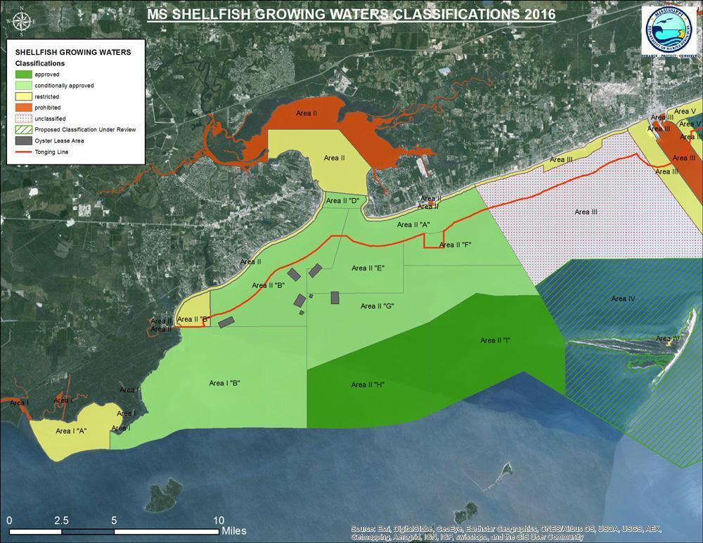

Figure A1. Shellfish Growing Areas in the Western Mississippi Sound (MDMR, 2016).

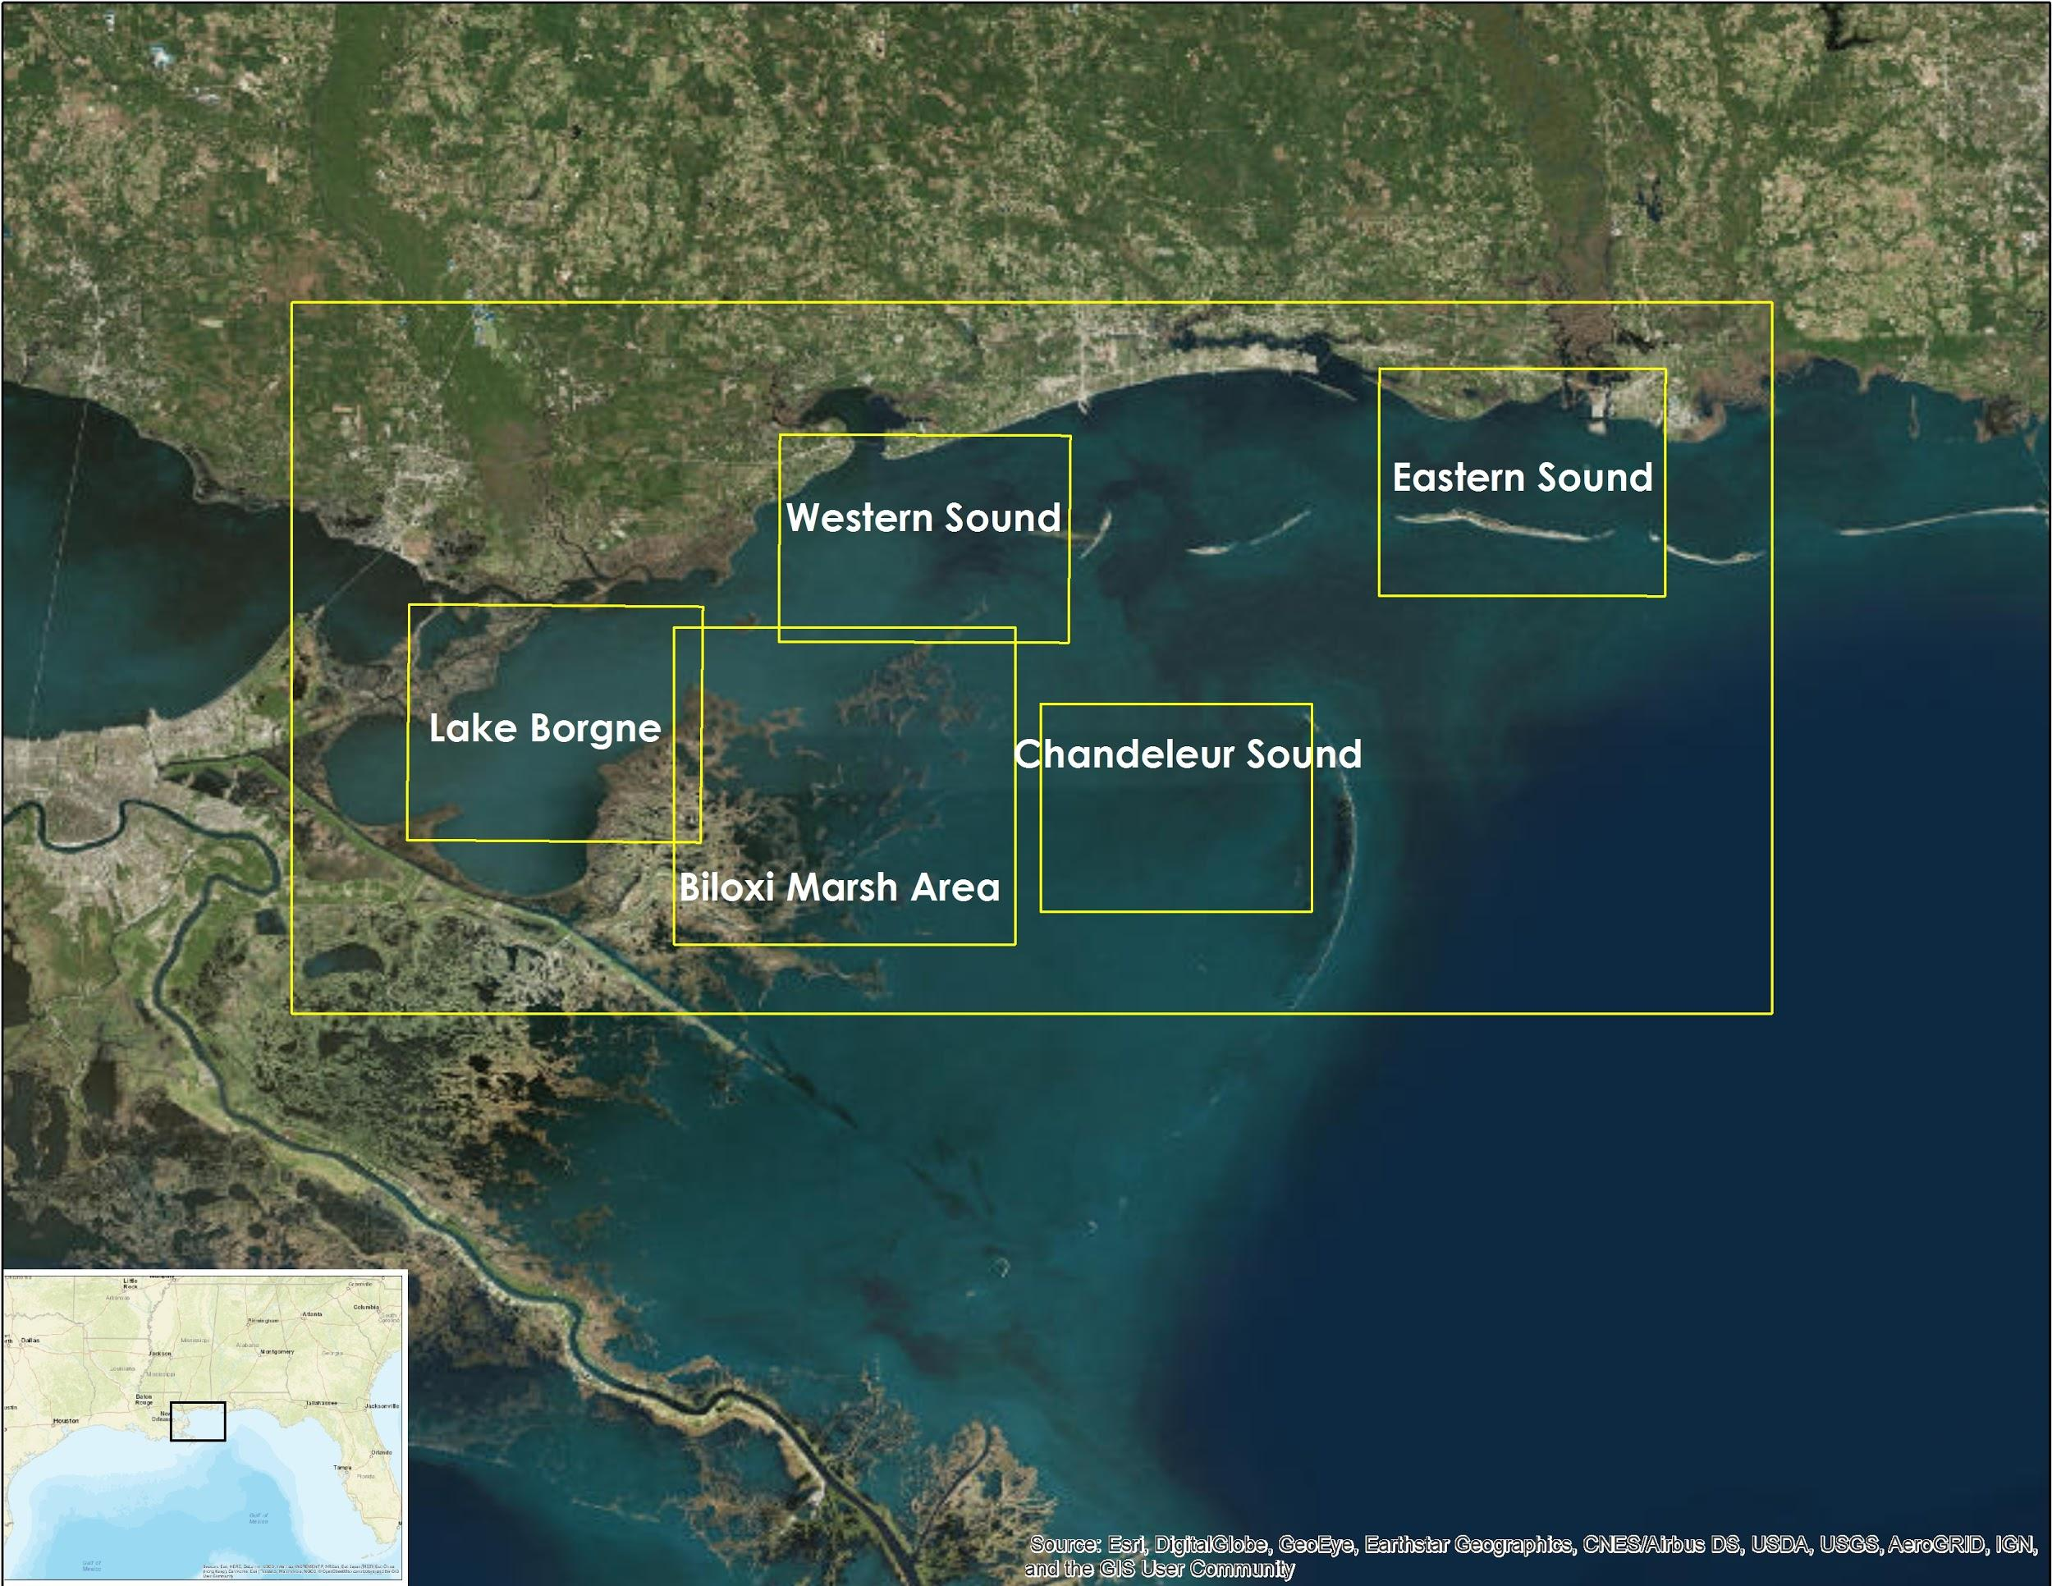

Figure A2. Complete study area with zonal focus regions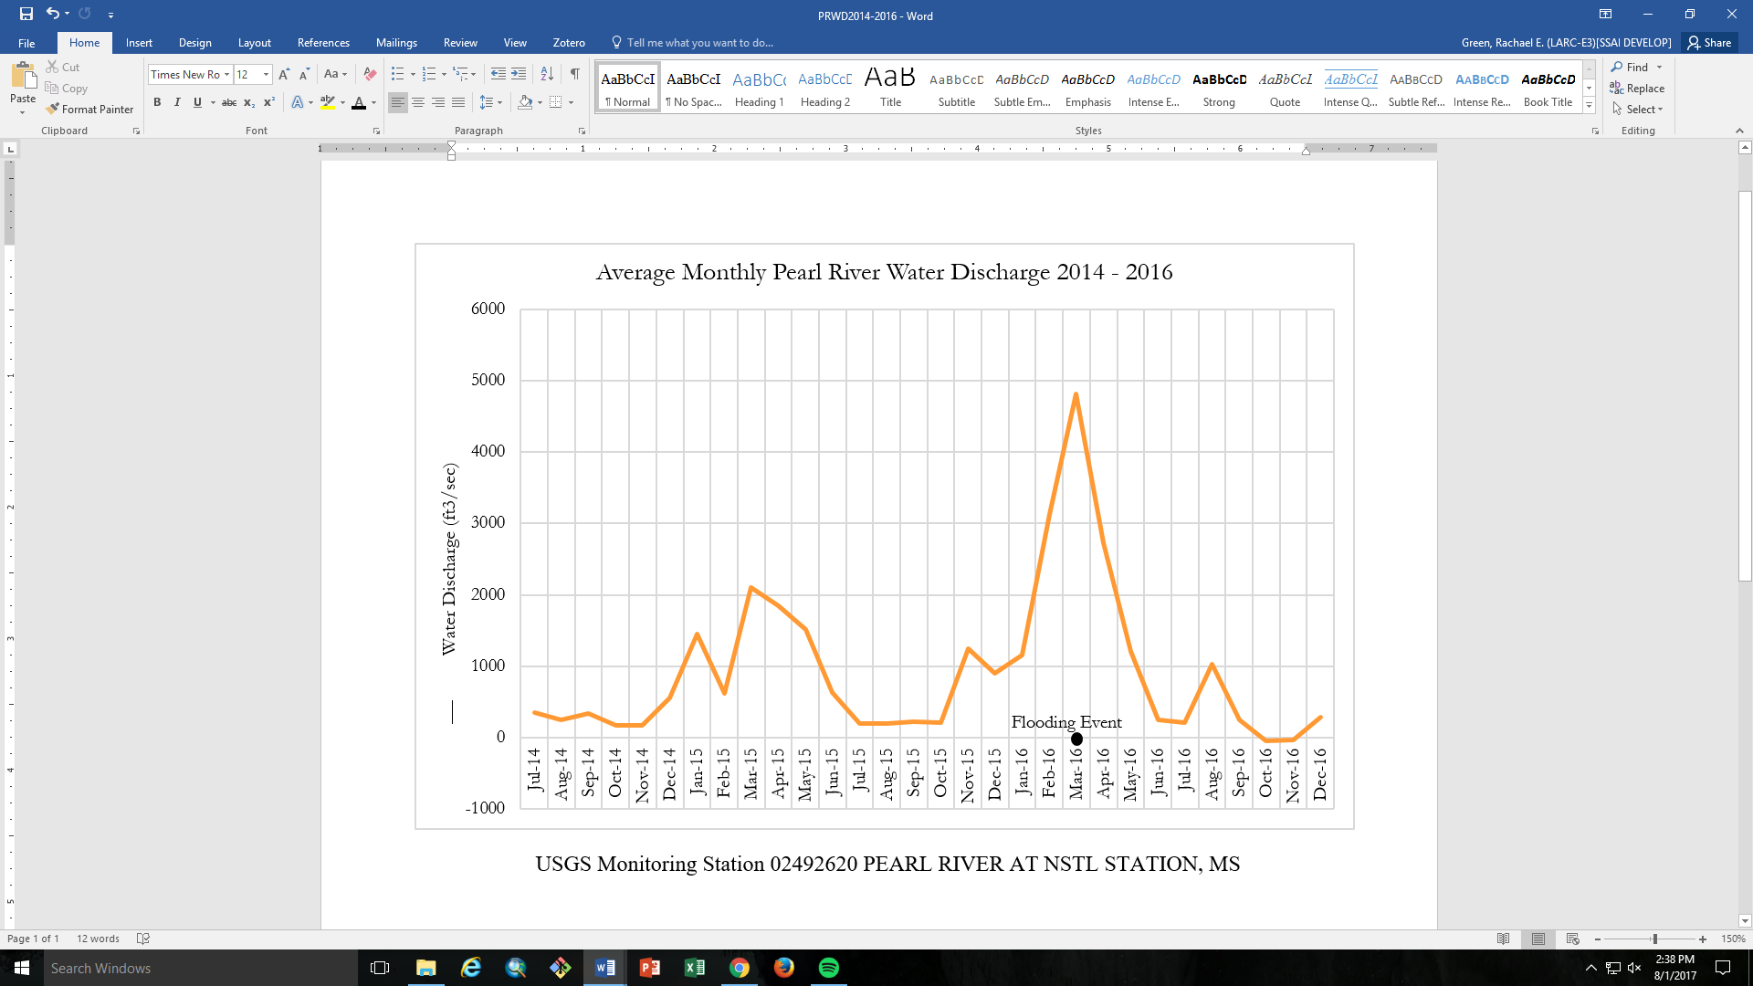

Figure A3. Pearl River Water Discharge in response to the Flooding Event of March 14th, 2016

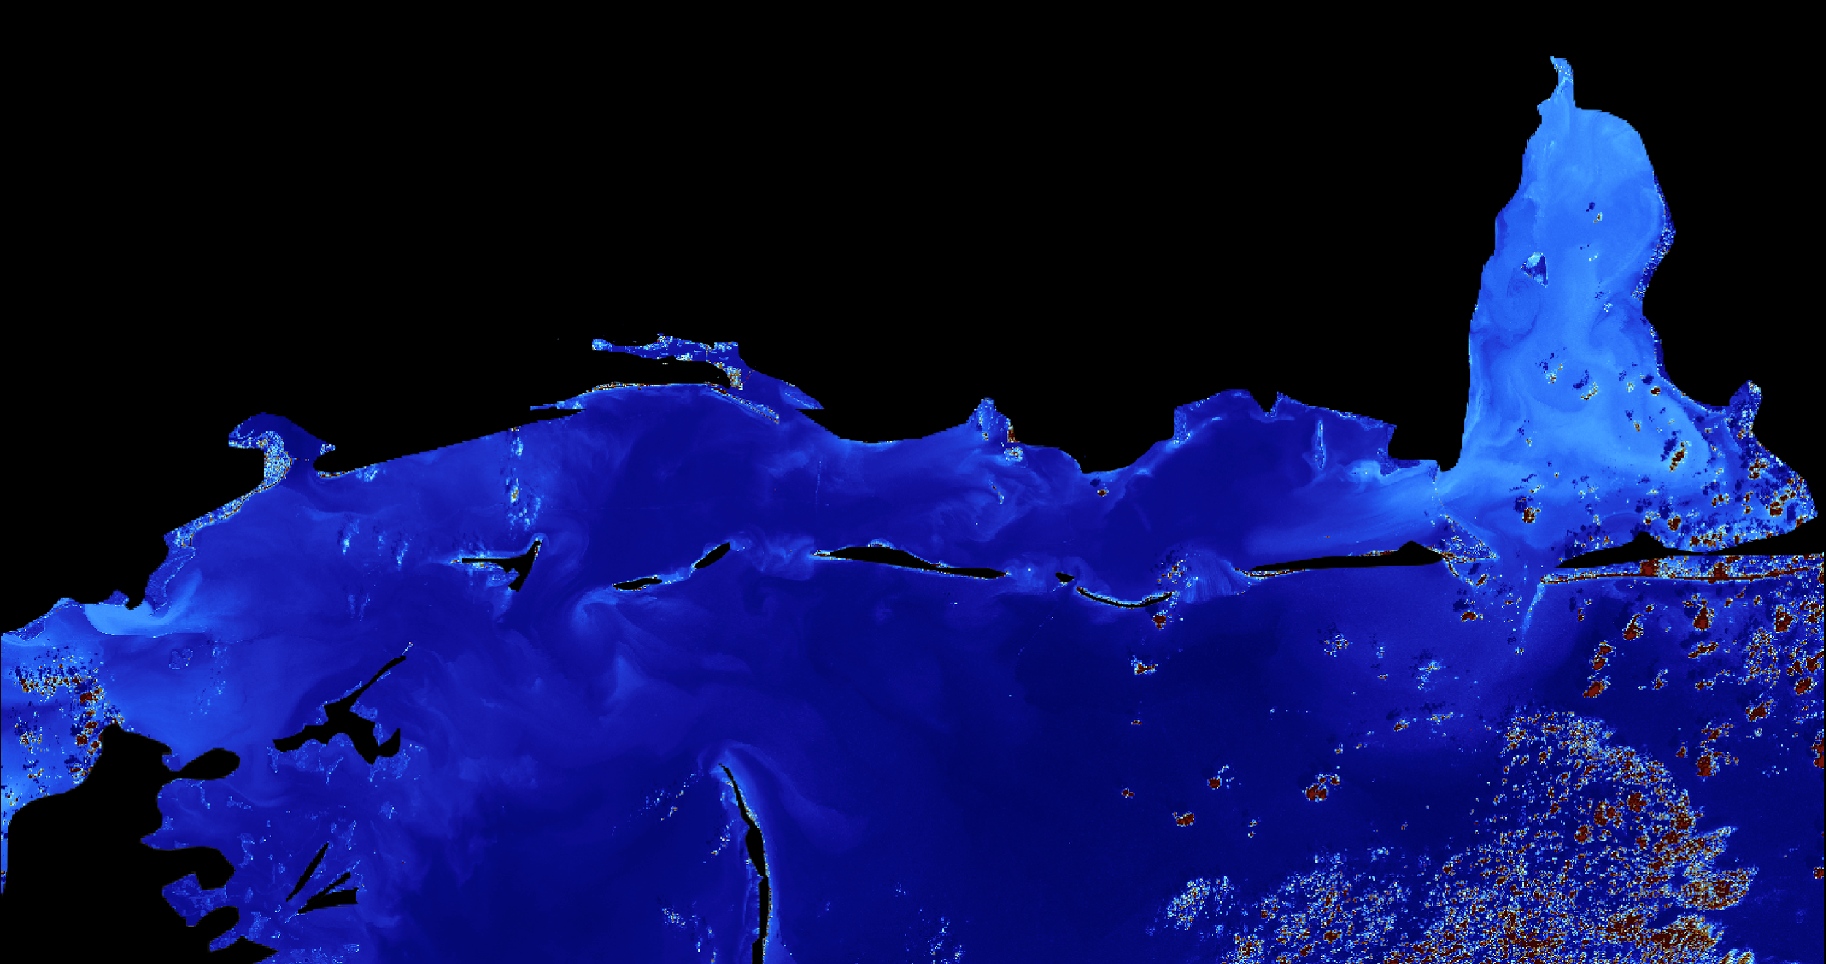Figure A4. River plumes on February 19, 2016 with no significant discharge event
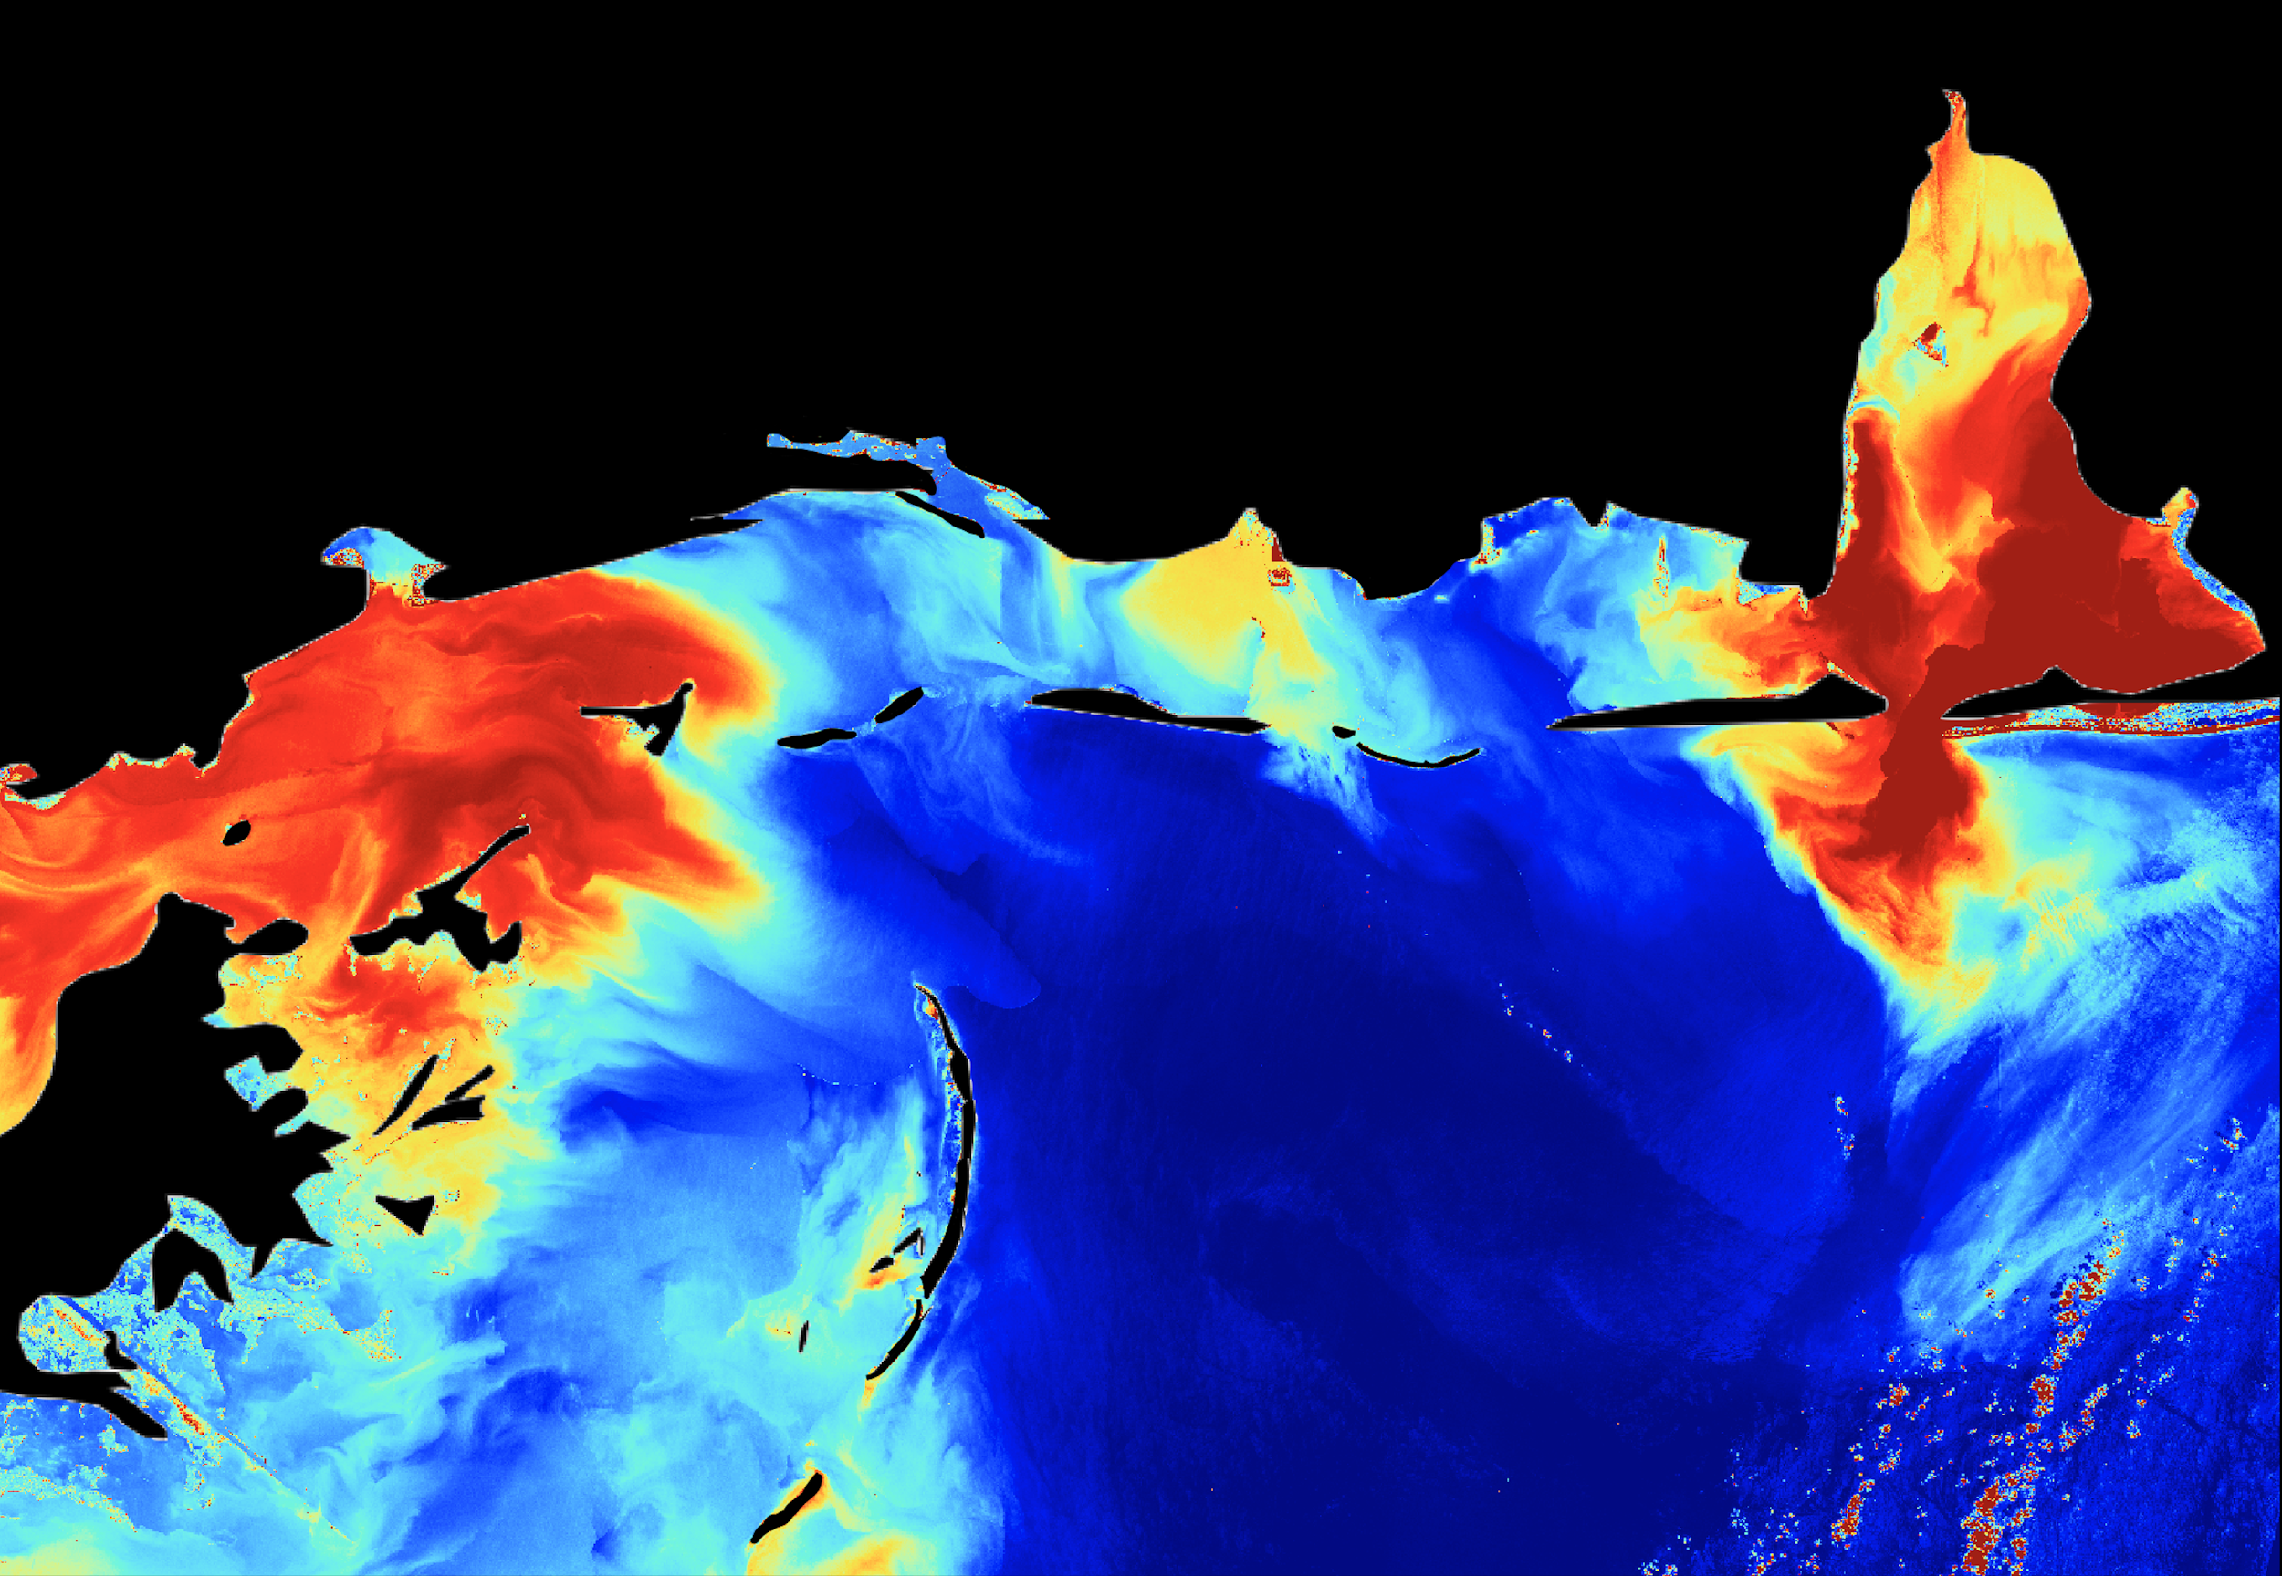

Figure A5. River plumes on March 22, 2016 after a high discharge event.

https://drive.google.com/open?id=0BzUo3fOXQbTGU1RDWjdPcHpYSzQ

Figure A6. Link to time series of chlorophyll and turbidity in the Sound and Lake Pontchartrain

Appendix B: Data Processing

Table B1. NASA and ESA Sensors, including products utilized and parameters produced.

Sensor | Parameter | Products
Aqua MODIS | Surface Reflectance | MYD09Q1 MODIS/Aqua Surface Reflectance 8-Day L3 Global 250m SIN Grid V006
 | chlorophyll-a | MODIS-Aqua Level 3 Mapped chlorophyll-a Data Version 2014
Landsat 5, 7, 8 | chlorophyll-a Concentration | Landsat 5 TM C1 Level-1
 | Turbidity | Landsat 8 OLI/TIRS C1 Level-1

Table B2. Landsat dates and path-rows.

Sensor | Dates | Path-row
Landsat 5 TM | January 2002 - November 2011 | 21-39  22-39
Landsat 7 ETM+ | November 2011 - March 2013 | 21-39  22-39
Landsat 8 OLI | April 2013 - December 2016 | 21-39  22-39

Table B3. In situ data parameters and station locations supplied by the USGS Current Water Data for the Nation.

Parameter | Station Location | Station Numbers
Discharge | Pearl River at NSTL Station | 02492620
Salinity
Gauge Height | Pearl River at NSTL Station | 02492620

Table B4. The algorithms used by ACOLITE to derive chlorophyll-a concentration, suspended sediment concentration, and turbidity from Landsat 5, 7, and 8 imagery.
Parameter | Algorithm Name | Algorithm Equation
chlorophyll-a Concentration | OC2 (NASA Ocean Biology Processing Group) | 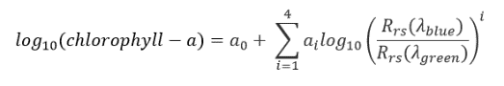
Turbidity | Semi-empirical single band turbidity retrieval algorithm (Nechad et al. 2009, Dogliotti et al. 2015 ) | 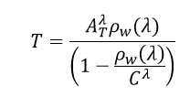

Table B5. Constants and associated values used within the OC2 algorithm for Landsat 5, 7, and 8

Constant | Landsat Value
a₀ | 0.1977
a₁ | -1.8117
a₂ | 1.9743
a₃ | -2.5635
a₄ | -0.7218
λ_{blue} | 482 nm
λ_{green} | 561 nm

Table B6. The equation used to derive total suspended matter (TSM) from % reflectance
Parameter | Reference | Equation
Total Suspended Matter | Miller and McKee (2004) | TSM = 1140.25(MODIS Band 1) -1.91  % Reflectance = MODIS Band 1

Table B7: 8-day MODIS Aqua surface reflectance monthly separation
Month | 8-day File # | 8-day Julian Filename | Monthly Range
1 | 4 | 1, 9, 17, 25 | January 1st - February 1st
2 | 4 | 33, 41, 49, 57 | February 2nd - March 5th
3 | 4 | 65, 73, 81, 89 | March 6th - April 6th
4 | 3 | 97, 105, 113 | April 7th – April 30th
5 | 4 | 121, 129, 137, 145 | May 1st – June 1st
6 | 4 | 153, 161, 169, 177 | June 2nd – July 3rd
7 | 4 | 185, 193, 201, 209 | July 4th – August 4th
8 | 4 | 217, 225, 233, 241 | August 5th – September 5th
9 | 3 | 249, 257, 265 | September 6th – September 29th
10 | 4 | 273, 281, 289, 297 | September 30th – October 31st
11 | 4 | 305, 313, 321, 329 | November 1st – December 2nd
12 | 4 | 337, 345, 353, 361 | December 3rd – December 31st

Appendix C: Data Analysis

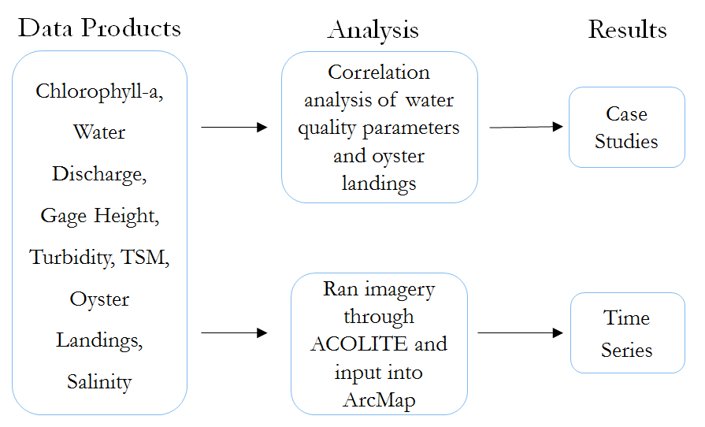

Figure C1. Abbreviated visualization of methodology used in this project

Appendix D: Analysis of Results
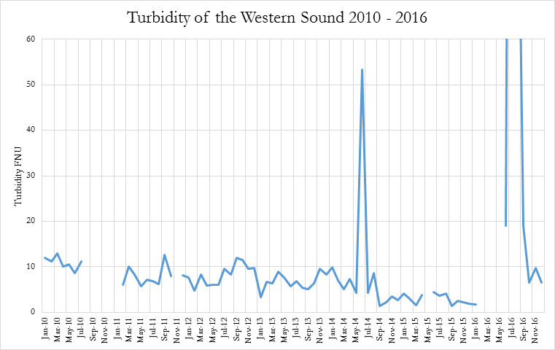

Figure D1. Average monthly turbidity of the Western Sound with anomalies included

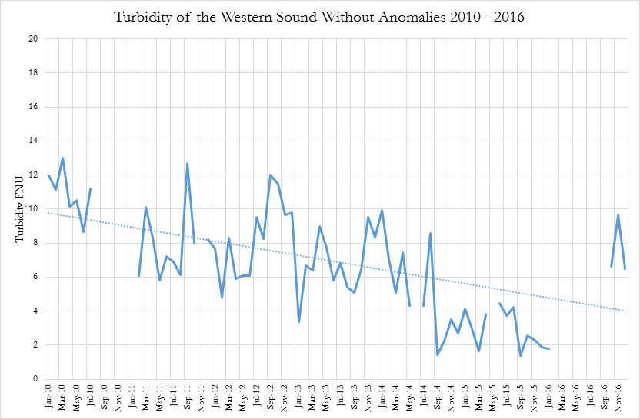
Figure D2. Average monthly turbidity of the Western Sound with anomalies excluded

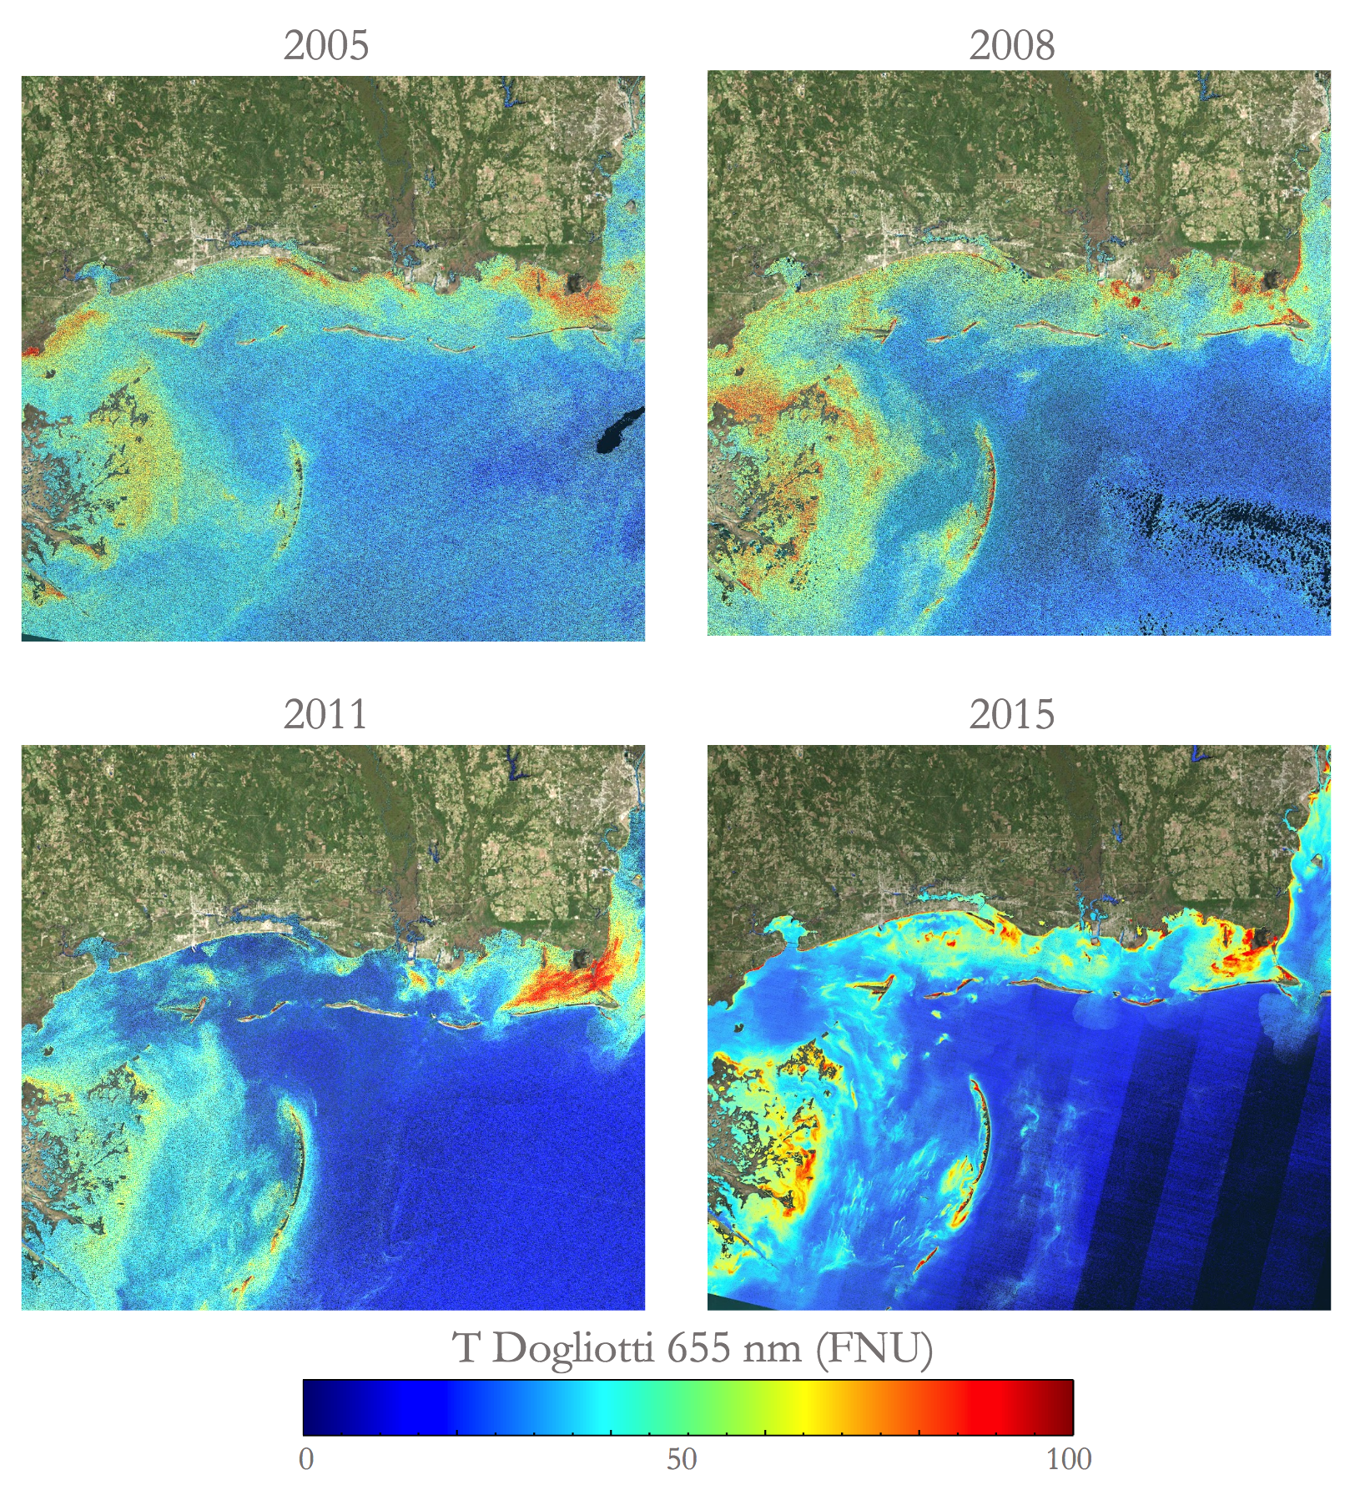Figure D3. Turbidity in the Barrier Islands from 2005, 2008, 2011, 2015 (Basemap Source: Esri, Digital Globe, GeoEye, Earthstar, Geographics, CNES/Airbus DS, USDA, USGS, AeroGRID, IGN, and the GIS User Community)

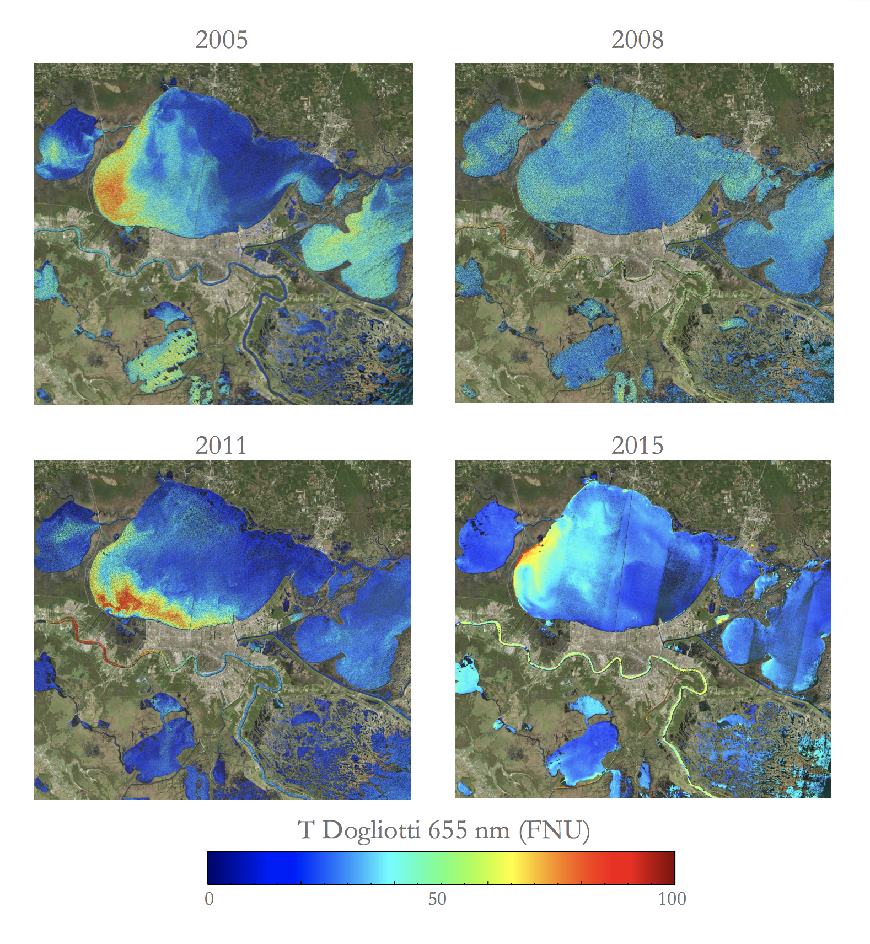Figure D4. Turbidity in Lake Pontchartrain from 2005, 2008, 2011, 2015 (Basemap Source: Esri, Digital Globe, GeoEye, Earthstar, Geographics, CNES/Airbus DS, USDA, USGS, AeroGRID, IGN, and the GIS User Community)

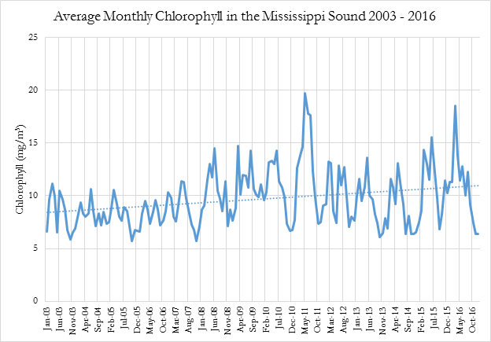
Figure D5. Average Monthly Chlorophyll in the Mississippi Sound

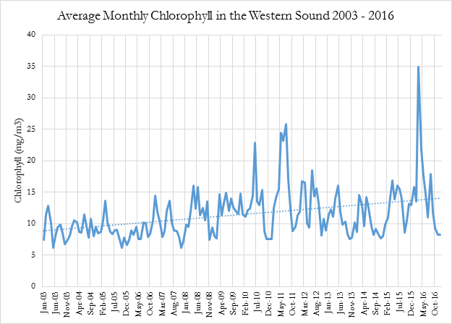
Figure D6. Average Monthly Chlorophyll in the Western Sound

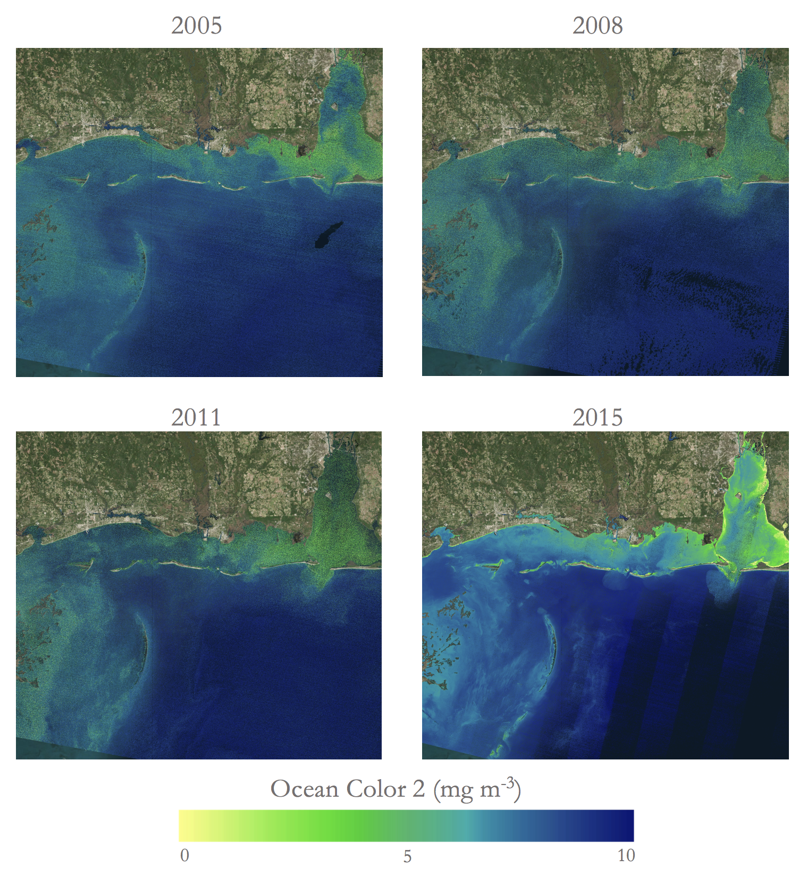Figure D7. Chlorophyll in the Barrier Islands from 2005, 2008, 2011, 2015 (Basemap Source: Esri, Digital Globe, GeoEye, Earthstar, Geographics, CNES/Airbus DS, USDA, USGS, AeroGRID, IGN, and the GIS User Community)

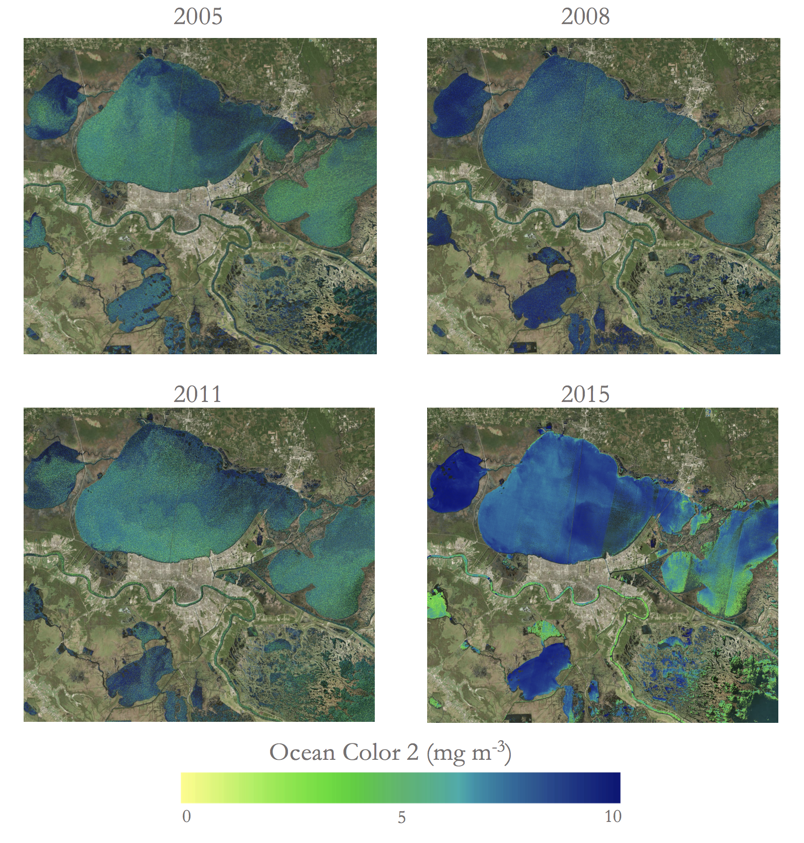Figure D8. Chlorophyll in the Marsh area from 2005, 2008, 2011, 2015 (Basemap Source: Esri, Digital Globe, GeoEye, Earthstar, Geographics, CNES/Airbus DS, USDA, USGS, AeroGRID, IGN, and the GIS User Community)

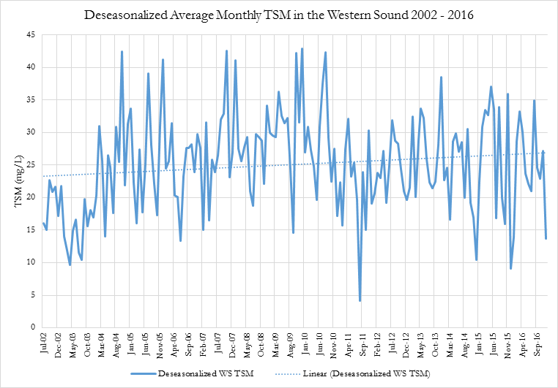

Figure D9. Deseasonalized Monthly TSM in the Western Sound

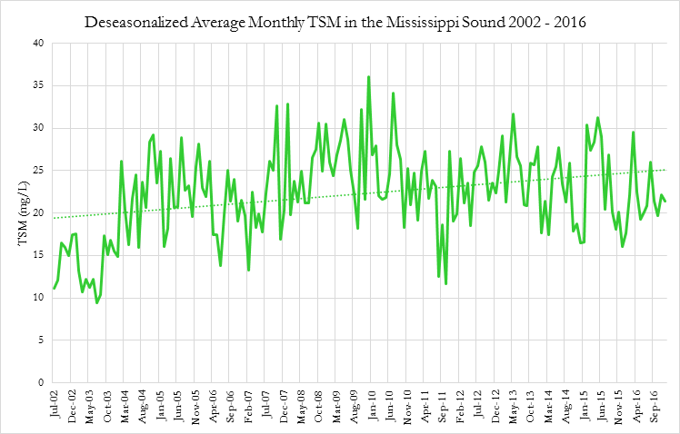
Figure D10. Deseasonalized Monthly TSM in the Mississippi Sound

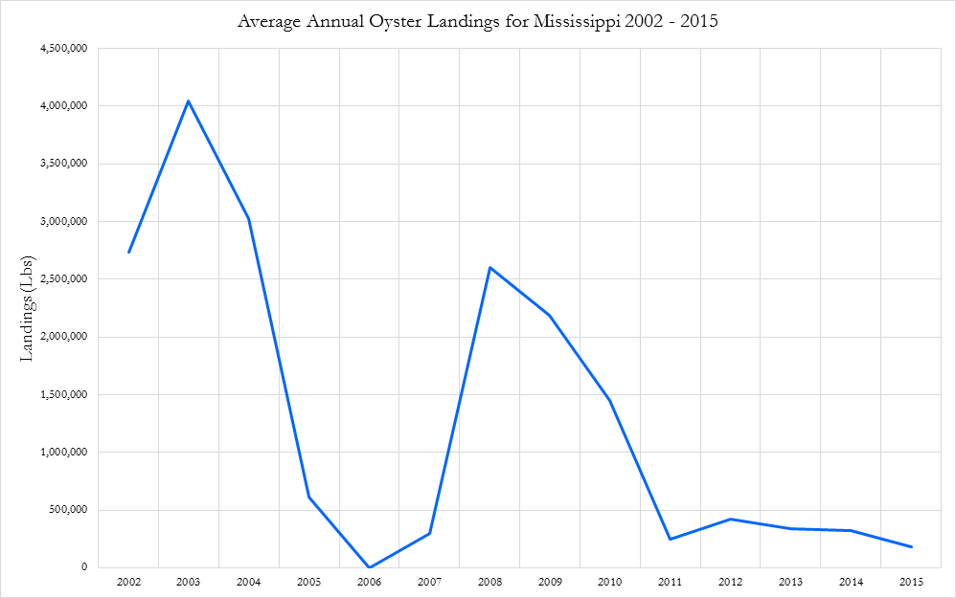
Figure D11. Annual Oyster Landings in the state of Mississippi

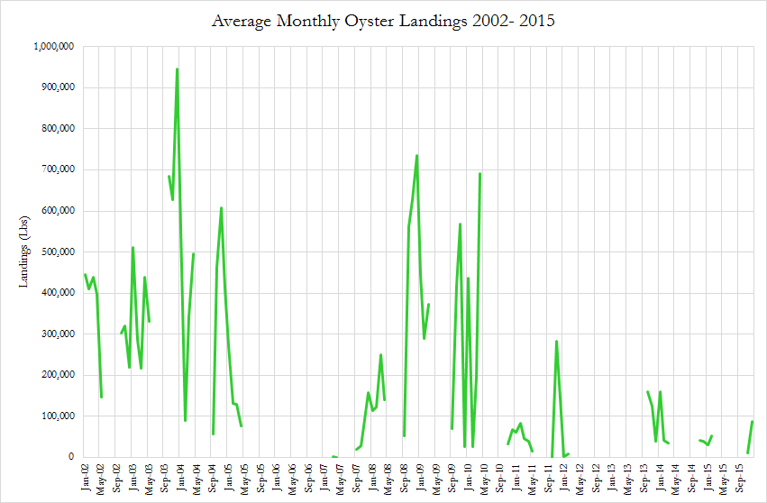
Figure D12. Monthly Oyster Landings in the state of Mississippi

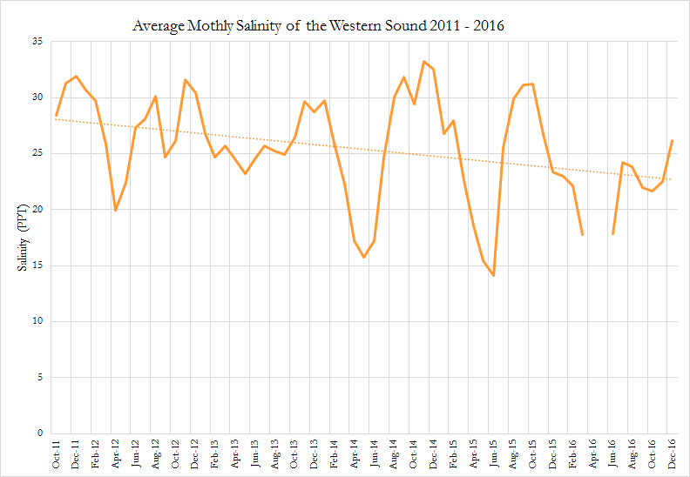
Figure D13. Average Monthly Salinity of the Western Sound
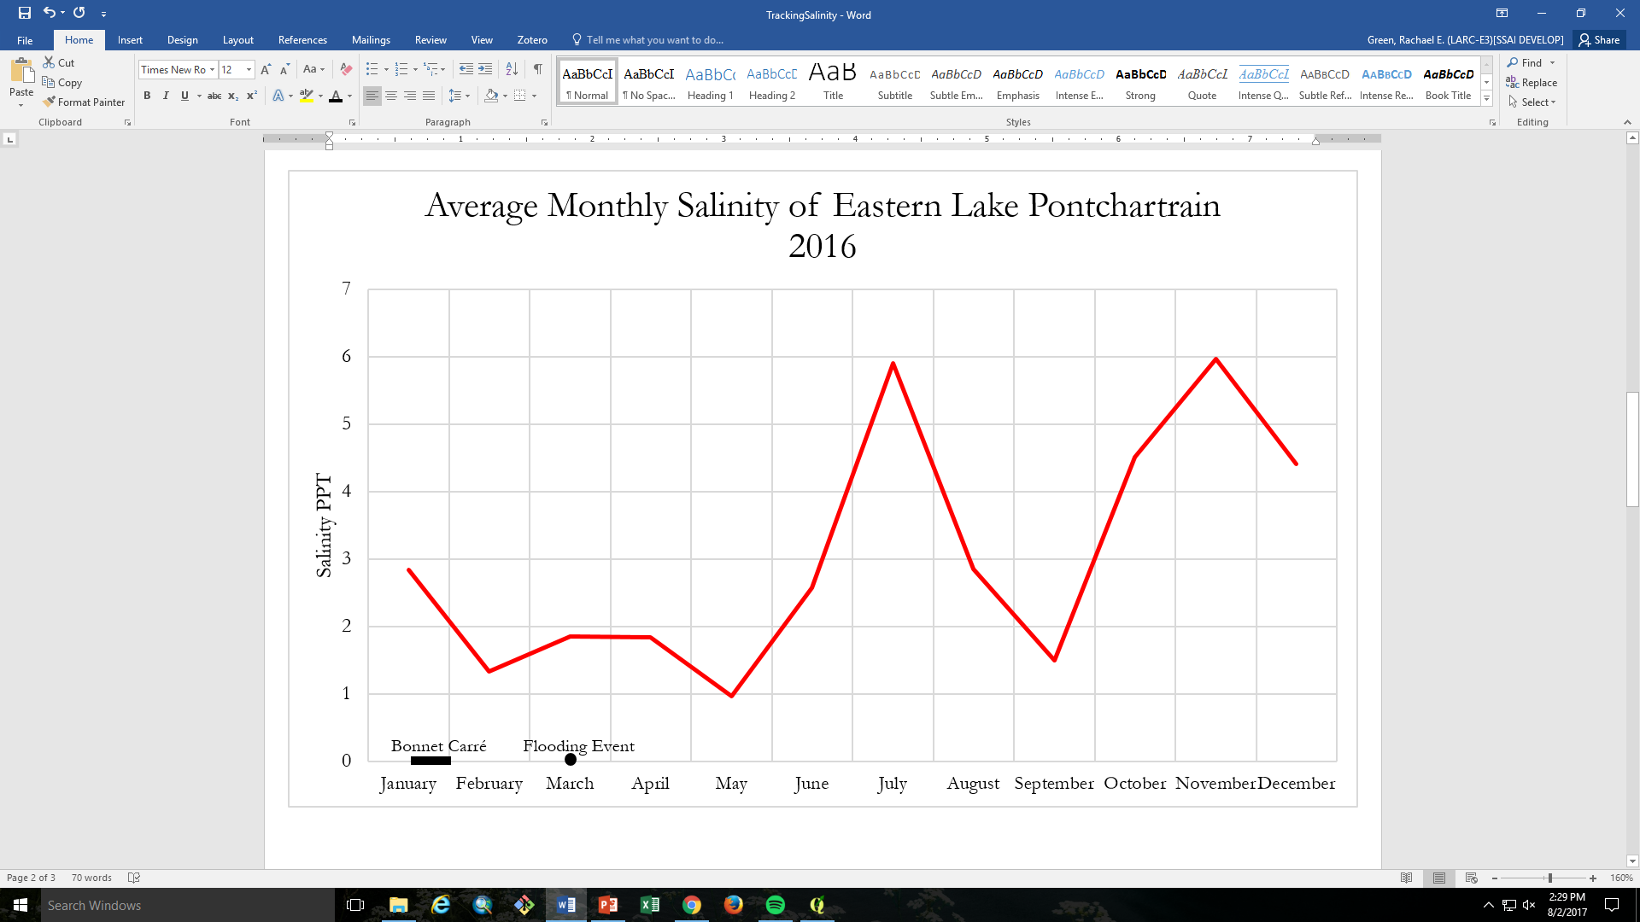

Figure D14. Salinity of eastern Lake Pontchartrain following the Bonnet Carré opening and flooding event

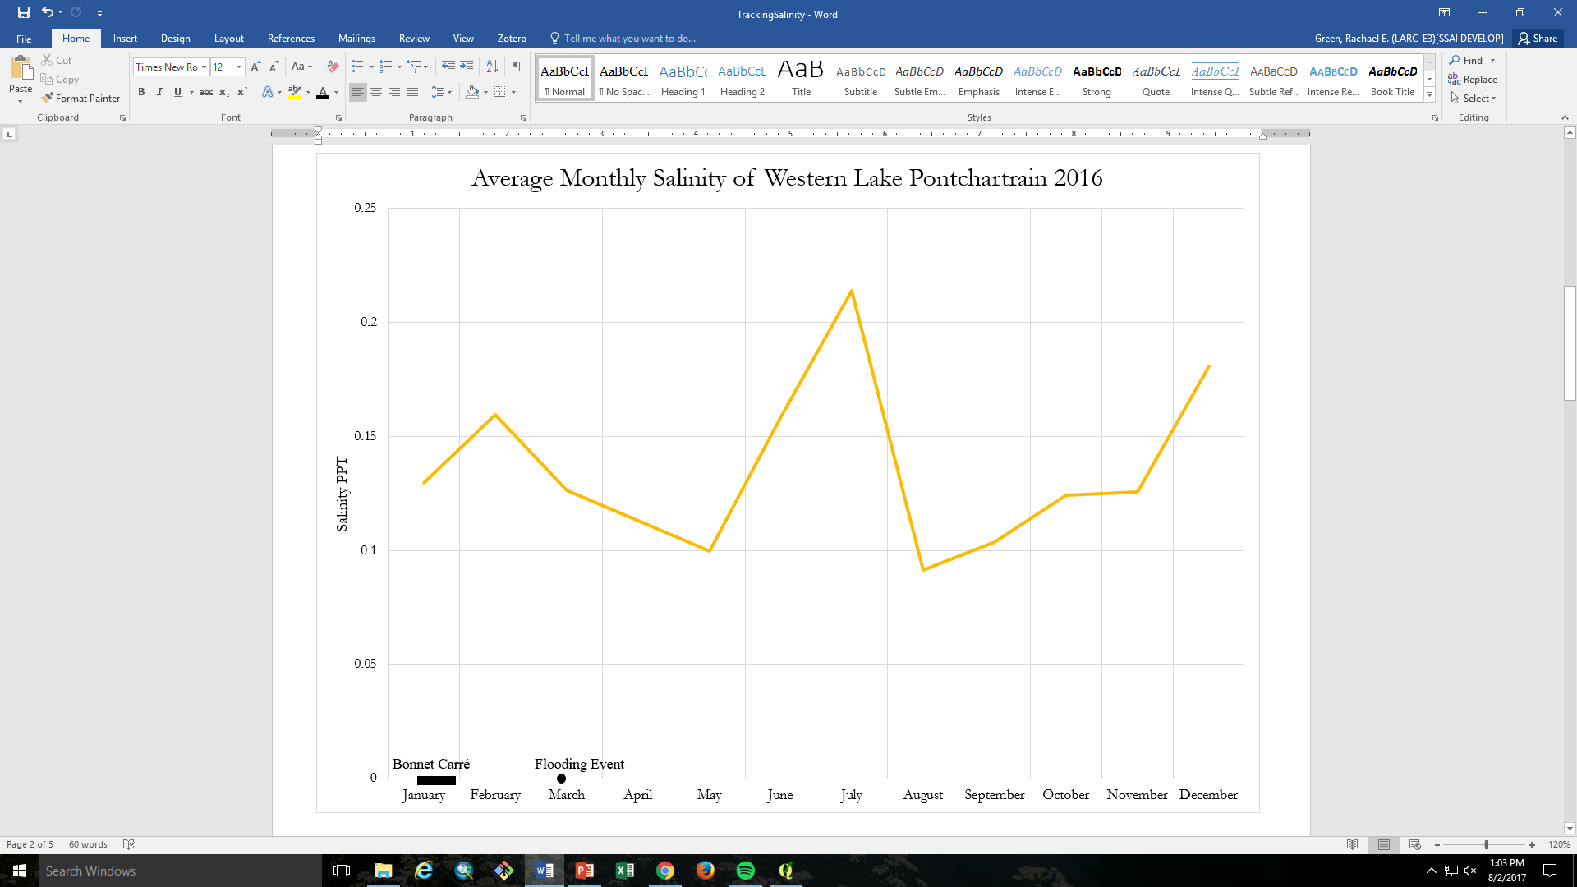
Figure D15. Salinity of western Lake Pontchartrain in response to the spillway opening and flooding event

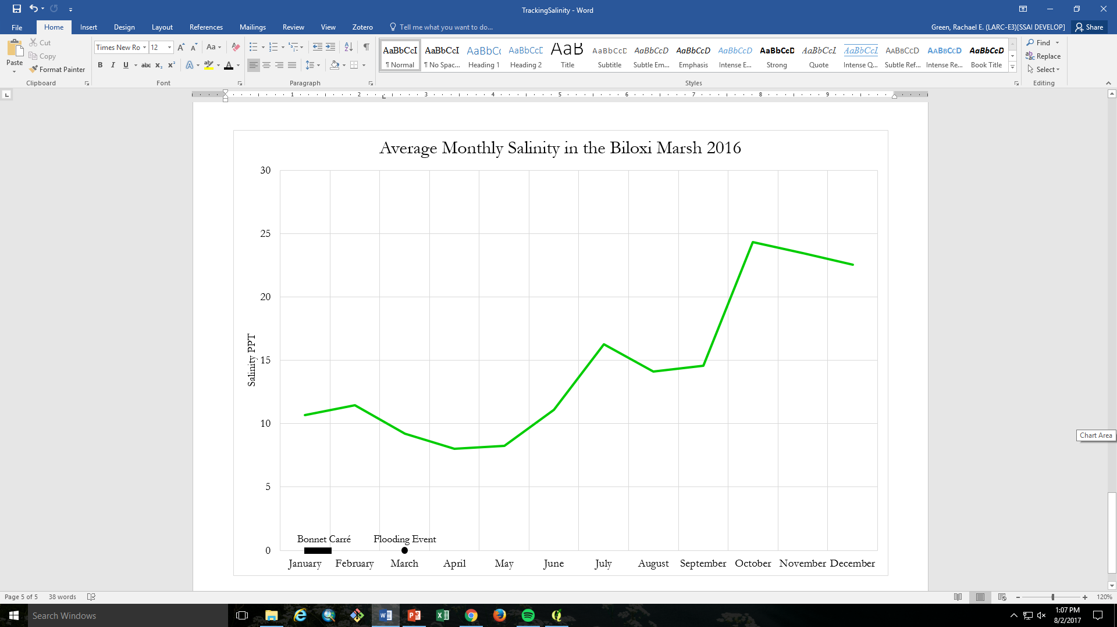
Figure D16. Salinity of the Biloxi Marsh after the spillway opening and flooding event

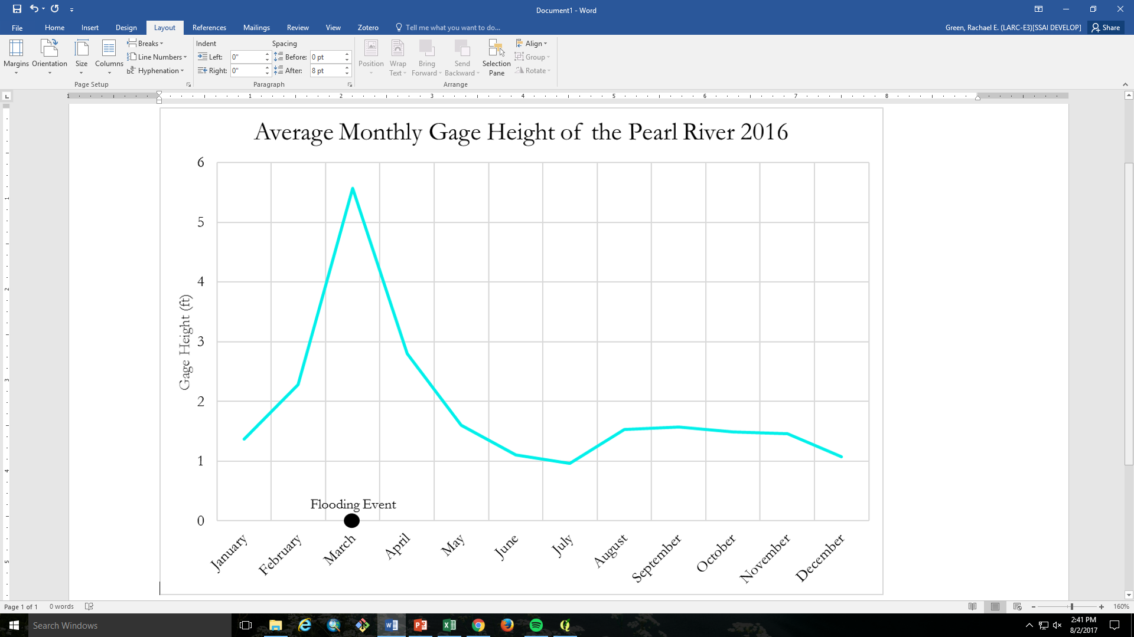
Figure D17. Gage height of the Pearl River during the March, 2016 flooding
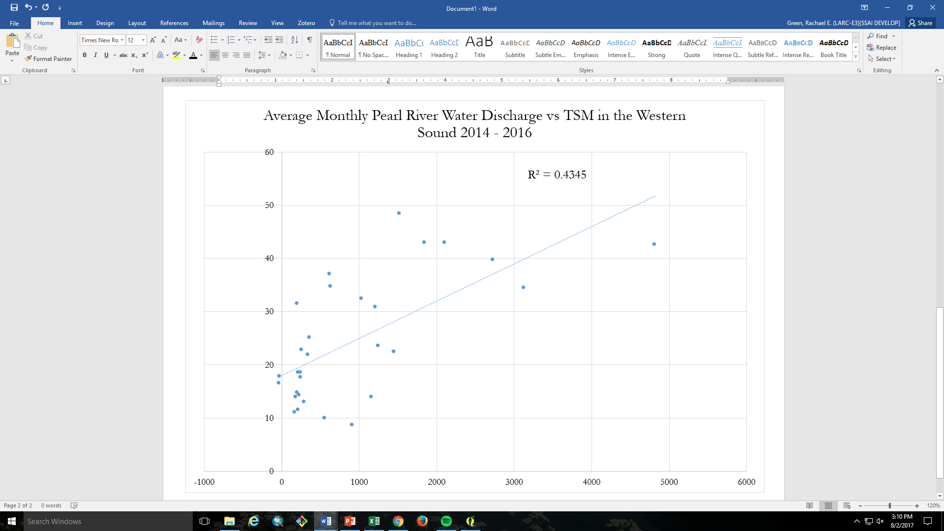

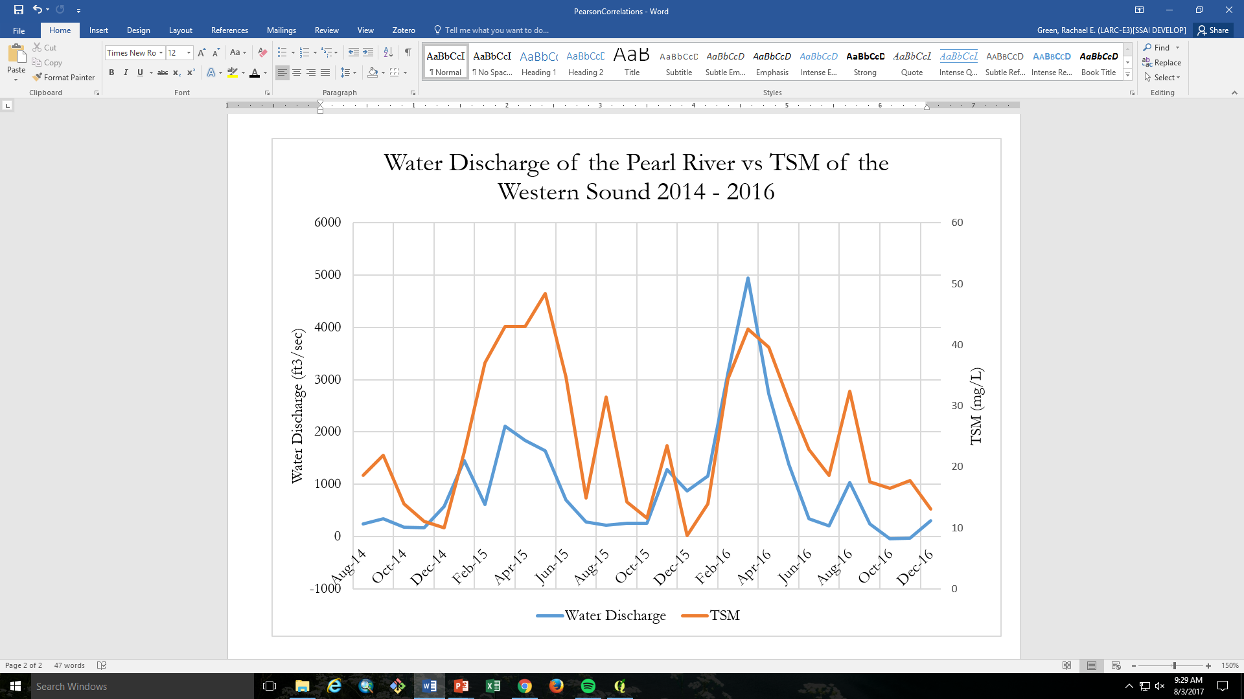

Figure D18. Relationship between Pearl River water discharge and Western Sound TSM

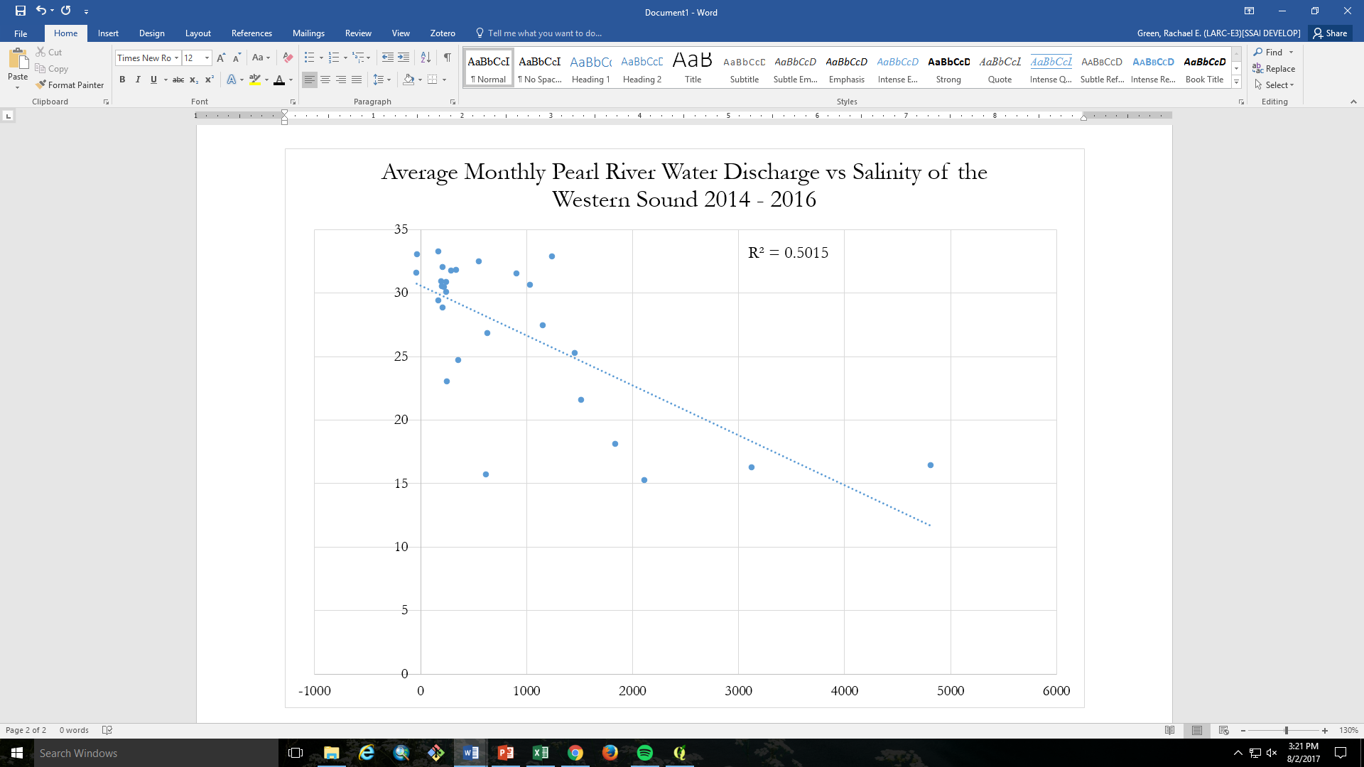
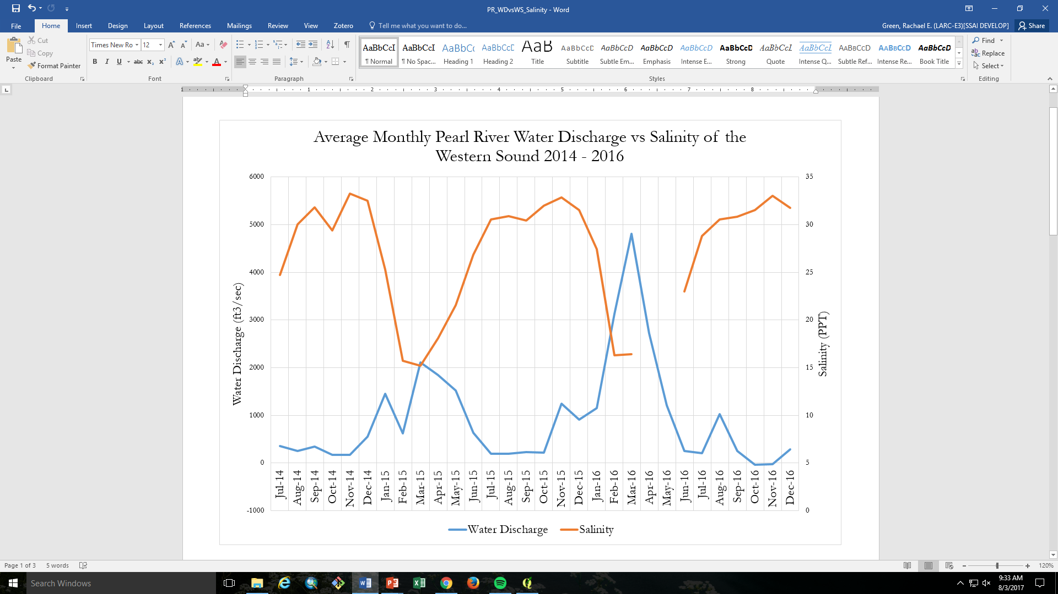

Figure D19. Relationship between Pearl River water discharge and Western Sound salinity

Appendix E: Future Work

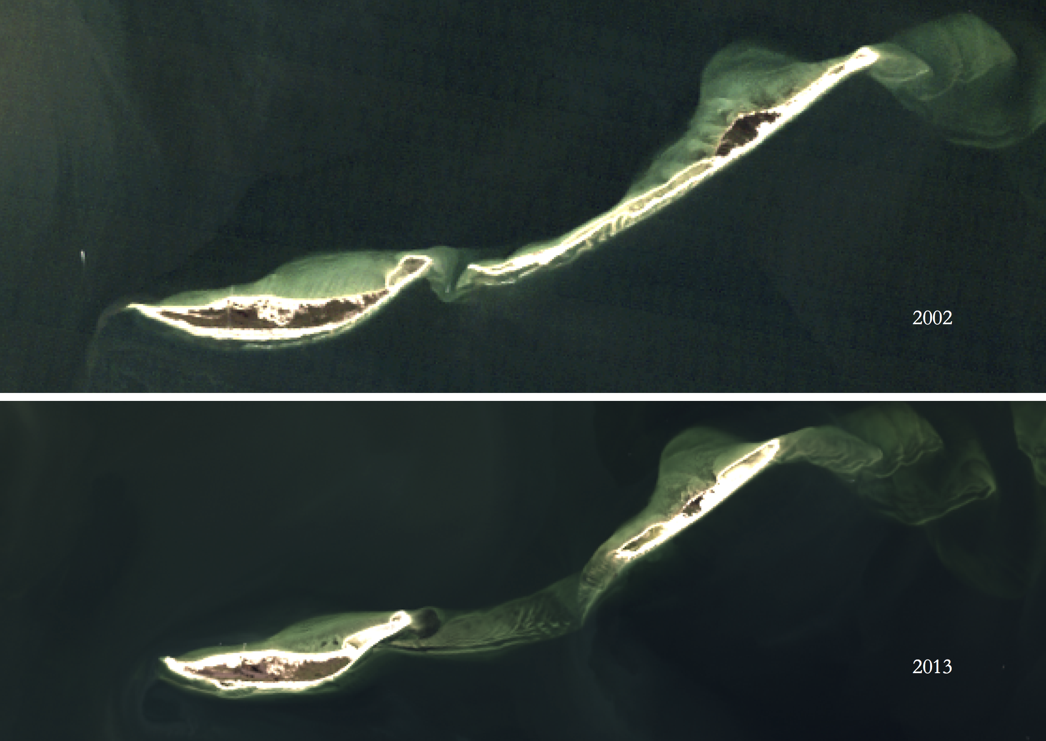

Figure E1: Ship Island land change shown by false colour images from Landsat 5 (2002) and Landsat 8 (2013)

