**NASA DEVELOP National Program**

****NASA Jet Propulsion Laboratory

**Summer 2016**

**Short Title: California Water Resources**

**Subtitle:** Quantifying the Impact of the 2015-2016 El Niño Event on California’s Historic Drought to Improve Water Resource Management

**VPS Title:** State in Denial: A Deeper Look into California’s Water Resources

**Project Team & Partners**

**Project Team:**

Justin Lawrence (Project Lead), jlawrence@gatech.edu

Lauryn Gutowski

Nick Rousseau

Brittany Zajic

**Advisors & Mentors:**

Dr. John T. Reager (NASA Jet Propulsion Laboratory)

**Partner Organizations:**

|  |  |  |  |
| --- | --- | --- | --- |
| **Organization** | **POC (Name, Position/Title)** | **Partner Type** | **Boundary Org?** |
| NOAA, National Weather Service, Los Angeles/Oxnard Weather Forecast Office | Mark Jackson, Meteorologist in Charge, Oxnard, CA | End-User | No* |

**Project Details**

**Applied Sciences National Application Addressed:** Water Resources

**Study Area:** CA

**Study Period:** Jan 2002 – Mar 2016

**Earth Observations & Parameters:**

Tropical Rainfall Measuring Mission (TRMM), Precipitation Radar (PR) – precipitation

Global Precipitation Measurement (GPM), Dual-frequency Precipitation Radar (DPR) – precipitation

Gravity Recovery and Climate Experiment (GRACE), Terrestrial Water Storage (TWS) – Surface Soil Moisture

Soil Moisture Active Passive (SMAP), Radiometer – Surface Soil Moisture

**Ancillary Dataset Utilized:**

* NOAA NCEI Climate Data – historical temperature and precipitation
* California Department of Water Resources – historical reservoir storage levels

**Software Utilized:**

* Matlab – GRACE datasets provided by science advisor
* Python – Time series analysis, statistical computation, linear regression analysis
* ArcGIS – Raster manipulation/analysis, image enhancement & map creation

**Project Overview**

**80-100 Word Objectives Overview:**

The goal of this project is to quantify the impacts of the 2015-2016 El Niño weather event on California’s exceptional five-year drought by using terrestrial water storage (TWS) (i.e. groundwater, soil moisture, surface water, snow and ice, and wet biomass). We use these parameters as a means to gain a more precise measurement of drought recovery the state experienced during the 2015-2016 wet season. With the aim of understanding drought recovery with future ENSO events, this project also seeks to assess the precipitation, temperature, and surface reservoir storage trends from the previous century.

**Abstract:**

2015 marked the arrival of the strongest El Niño ever recorded, surpassing the 1997-1998 event that brought significant rainfall to the southwestern United States. As sea surface temperatures in the Central Pacific increased, it was forecasted that this event may have similar effects and alleviate what the U.S. Drought Monitor classifies as “exceptional” drought across California. However, the effects from the drought, now in its fifth year, continue to strain both municipal and agricultural water supplies throughout the state. Our team utilized data from NASA’s Gravity Recovery and Climate Experiment (GRACE), Global Precipitation Measurement (GPM), Tropical Rainfall Measuring Mission (TRMM), and Soil Moisture Active Passive (SMAP) Earth observations, as well as meteorological surface observations from the National Oceanic and Atmospheric Administration (NOAA), and historical reservoir levels from the California Department of Water Resources to gain a more complete understanding of water resources in California. Together with our partners at the NOAA/ National Weather Service (NWS) regional office in Oxnard, CA, our study employs NASA Earth observations to better quantify impacts of the 2015-16 El Niño event and determine how much drought recovery occurred throughout the state over the course of the wet season. Specifically, monthly GRACE measurements of terrestrial water storage allow for a better understanding of subsurface resources, a parameter often omitted from drought assessments. We also analyzed monthly precipitation and temperature trends in relation to droughts and ENSO patterns with climatological history from NOAA dating back to 1895.

**Keywords:**

U.S. Drought Monitor, ENSO, GRACE, TRMM, GPM, SMAP, TWS, reservoirs

**Community Concerns:**

* California agriculture supplies nearly half of all produce grown in the US, generating $45 billion/ year
* Lack of rainfall limits reservoir allotments, forcing farmers to rely on groundwater, which is causing land subsidence and infrastructure damage
* California’s population growth and distribution is compounding water shortages that are predicted to worsen in the future

**Current Management Practices & Policies**:

The current decision making process is outlined by the U.S. Drought Monitor Classification Scheme. The Drought Monitor summary map identifies general drought areas, labeling the drought intensity by 5 qualitative classes: D0, D1, D2, D3, and D4, ranging from abnormally dry to exceptional drought, respectively. National weekly assimilated GRACE data, complied by Matt Rodell at the NASA Goddard Space Flight Center, is incorporated into U.S. Monitor Drought Measurements.

**Decision Support Tools & Benefits:**

|  |  |  |  |
| --- | --- | --- | --- |
| **End-Product** | **Earth Observations Used** | **Benefit & Impact** | **Software**  **Release** |
| Historical Climate and Precipitation Maps/Time Series Plots | NOAA Monthly Climate Data (1895-Present), GRACE | Comparative graphs of dry vs. wet years. In depth analysis of over 100 years of California’s water balance. Studying past trends allow for a more accurate fit of projected future patterns. | 1 |
| Quantitative Analysis of Drought Recovery from the 2015-1016 El Niño rain season | GRACE, SMAP, TRMM, and GPM | A new methodology to supplement the existing qualitative drought classification scheme for the U.S. Drought Monitor. The end product will be in the form of an automated, algorithm that uses the weighted datasets to determine drought recovery within the state of California with 2 major updates from existing tools:   1. Numerically based system (quantitative) 2. With better spatial resolution for more accurate measurements (currently by county) | 3 |
| ArcGIS Online Story Map | GRACE, SMAP, TRMM, and GPM | Request from project partners to showcase more information about drought using NASA Earth Observations | 1 |

**Project VPS/Booklet Imagery**

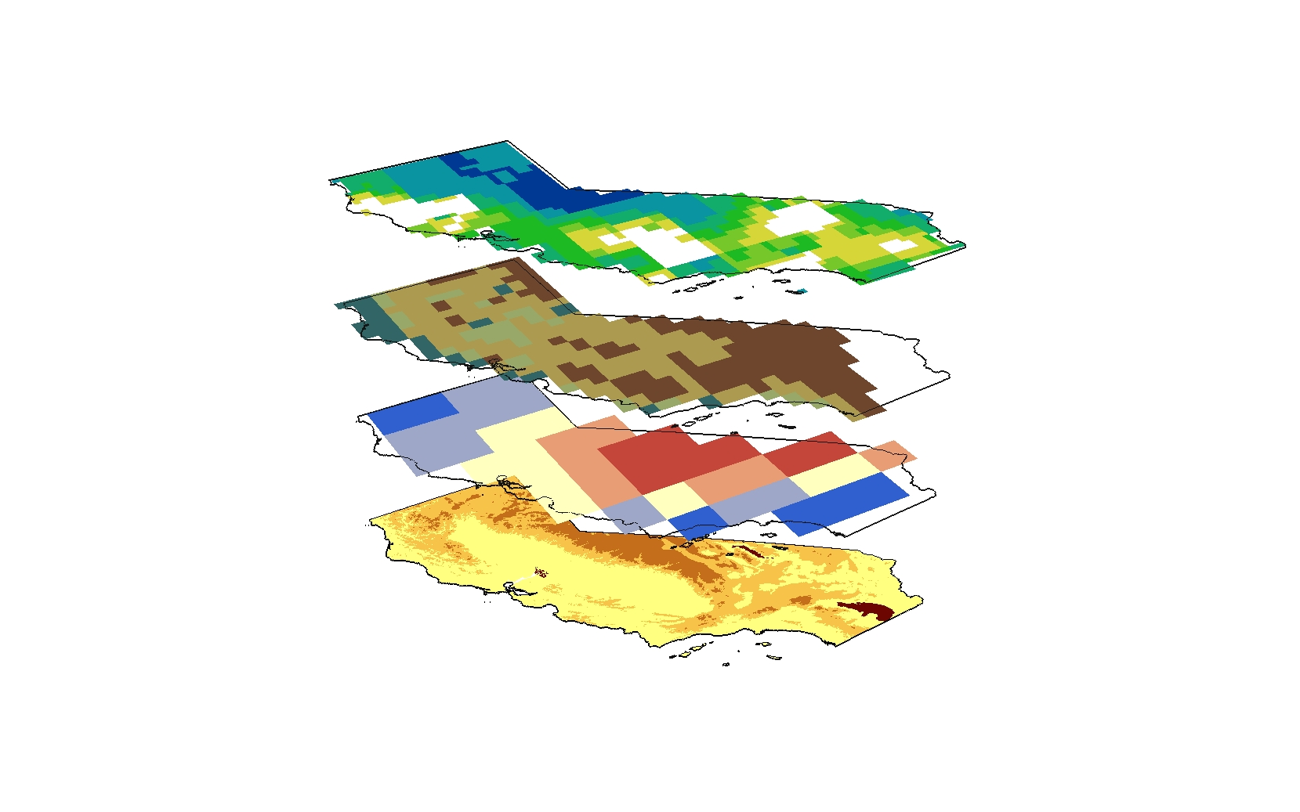

**Caption:** Average TRMM Precipitation (top), SMAP Soil Moisture, and GRACE Water Storage data from June 2015 over a DEM of California (bottom). Image Credit: California Water Resources Team.

**Image:** 2016Sum_JPL_CaliforniaWater_FinalImagery.jpg