Douglas County Energy
Identifying Areas with High Solar Power Potential in Kansas via NASA Earth Observations and LiDAR


Technical Report
Final Draft – August 8th, 2019

Robert Cecil Byles (Project Lead)
Thomas Crimmel
Erica O’Connor
Charlotte Stanley

Qing Yue, NASA Jet Propulsion Laboratory, California Institute of Technology (Science Advisor)

1. Abstract
The City of Lawrence and Douglas County, Kansas, are working to reduce greenhouse gas emissions and achieve 100 percent renewable energy. The NASA DEVELOP team used Shuttle Radar Topography Mission (SRTM) and LiDAR elevation data along with Landsat 8 Operational Land Imager (OLI) surface reflectance data and National Agriculture Imagery Program (NAIP) aerial imagery in order to create a solar insolation map, which identifies areas of high solar energy potential in both the City of Lawrence and Douglas County. Using this solar insolation product, the team created a solar panel site suitability map that takes into account additional factors such as land cover/use, building footprints, parcel ownership, floodplain extent, and protected land areas. This product both identifies solar potential and determines the most feasible and effective properties for the installation of rooftop solar panels and ground-mounted solar farms. We found that Douglas County, Kansas, receives an average solar insolation of 1,982 kilowatt-hours per square meter annually and building rooftops in Lawrence receive an average of 950 kilowatt-hours per square meter annually. Additionally, we found that Douglas County and Lawrence have a great capacity for solar power, with 30% of Douglas County’s land area and 52% of Lawrence’s building rooftop area being highly suitable for solar panel installation. The results of this project will be utilized by Douglas County to better understand the factors that dictate solar potential and suitability, enabling personnel to make informed decisions about the ideal placement of solar panels.

Keywords
Landsat 8 OLI, LiDAR, NAIP, SRTM, photovoltaic potential, solar insolation, solar radiation, solar panels

2. Introduction
  - Background Information
Greenhouse gases emitted by fossil fuel combustion are the primary driver behind increasing global temperatures. Transitioning to renewable energy will help mitigate these changes in climate conditions and improve air quality. Solar photovoltaic (PV) panels are one example of a renewable, local source of energy that reduces reliance on fossil fuels, stabilizes energy costs, and decreases building operational energy costs (Kouhestani et al., 2018). Their proven benefits have led to a surge in solar development. Solar energy is now one of the most rapidly growing sectors in the United States, having experienced an average annual growth rate of 50% in the last decade (SEIA, 2019). The swift growth of the solar sector is partly due to the drop in price: the average cost of a solar electric system has decreased by 50% since 2010 (US DOE, 2019).

Consequently, the huge tracts of underutilized land in the United States offer enormous potential for solar energy. Rooftop PV panels could supply up to 40% of US electricity consumption (Gagnon, Margolis, Melius, Phillips, & Elmore, 2016), and filling just 0.6% of the land in the US with solar farms would produce enough electricity to power the entire county (US DOE, 2019). In Kansas, coal currently provides one-third of electricity production, while solar accounts for less than 1% (US EIA, 2019). While solar capacity has doubled in Kansas over the past two years, the state still falls in the bottom five states for solar energy generation (SEIA, 2018). The state government does not have ambitious plans to increase renewable energy, as they downgraded their Renewable Energy Standard, which aims for 20% renewable energy generation by 2020, from mandatory to voluntary, in 2015 (Kansas Corporation Commission, 2019; US DOE, 2019). County and local governments are now stepping in to take direct action to reduce greenhouse gases.

This project examined two main study areas: Douglas County and its major metropolitan area, the City of Lawrence. Douglas County lies in the midwestern United States in northeast Kansas between Topeka and Kansas City (Figure 1). 475 square miles in size, Douglas County borders the Kansas River and contains mostly agricultural land, woodlands, prairies, and Clinton Lake (Lawrence/Douglas County Planning Office, 2018). Lawrence lies in the north of this primarily rural county and is 34 square miles in area (Lawrence/Douglas County Planning Office, 2018). Project analyses focused on data from January 2018 to December 2018.

The methodology for this project is modeled after a number of similar scientific studies that use Earth observations and LiDAR to calculate rooftop solar panel potential at local scales. For the solar insolation analysis, the majority of similar projects used the Esri ArcGIS Solar Radiation toolset to calculate solar energy potential and then validated the tool’s results with other datasets (Kodysh, Omitaomu, Bhaduri, & Neish, 2013; Santos et al., 2014; Wong et al., 2016). Several studies used multi-criteria analysis to determine site suitability, a common methodology used in the environmental field. Combining various data layers, each with a unique weight representing its significance, creates a composite suitability layer that environmental stakeholders can use in decision-making (Janke, 2010; Charabi & Gastli, 2011; Watson & Hudon, 2015).

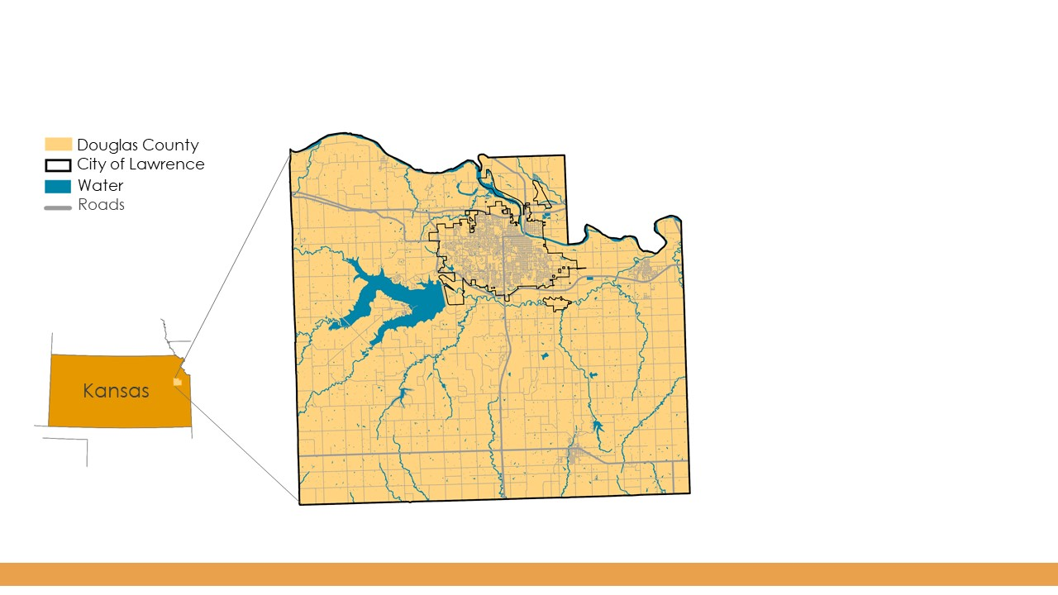
Figure 1. This map depicts the study area: Douglas County, Kansas, and Lawrence, Kansas.

  - Project Partners & Objectives
The NASA DEVELOP Douglas County Energy team worked with Douglas County’s Department of Sustainability. This department includes The Climate Protection Task Force (CPTF), which has a citywide climate mitigation goal of reducing greenhouse gas emissions 80 percent by 2050, as measured in carbon dioxide equivalents (CPTF, 2009).

The goals of this project were to create both static and interactive online maps detailing the solar power potential and solar panel site suitability for the City of Lawrence and Douglas County. The solar potential maps include average daily solar insolation values throughout the County as well as each individual rooftop in the City. In addition to the solar potential maps, site suitability maps were created incorporating land ownership and local environmental factors that partners can use to determine the most feasible locations for the installation of solar farms.

As regional leaders in sustainability initiatives, Douglas County and the City of Lawrence want to use NASA Earth observations to better understand solar opportunities throughout the County. They currently do not utilize remotely sensed data in their decision making. The project results will offer information on the most effective locations to site rooftop and ground-mounted solar PV panels, helping our partners increase their solar energy capacity and meet their long-term renewable energy goals. Douglas County aims to incentivize solar panel installation for homeowners by reducing permitting fees and has led by example through two PV panel installations on publicly owned buildings (Douglas County Kansas, 2019). Through this project, The Sustainability Department can share solar siting best practices with nearby municipalities, ultimately expanding solar energy generation throughout the Midwest.

3. Methodology
3.1 Data Acquisition
Data acquisition included downloading 30-meter resolution Shuttle Radar Topography Mission (SRTM) digital elevation model (DEM) from the United States Geological Survey (USGS) Earth Explorer website; the most recent elevation data available for Douglas County were from 2014. Additionally, we acquired a LiDAR-derived digital surface model (DSM) from 2015 with 1-meter spatial resolution from our project partner in order to create a more detailed product for the analysis of the City of Lawrence. The DSM has a finer spatial resolution and was necessary to identify key features, such as rooftops and tree canopy, which a DEM cannot provide. Optical data was downloaded from two sensors: Landsat 8 Operational Land Imager (OLI) and USDA National Agriculture Imagery Program (NAIP). This included 30-meter resolution Landsat 8 OLI Collection 1 Level-1 spectral reflectance data from the USGS Earth Explorer website from April 26th, 2019 and June 13, 2019 as well as 1-meter resolution NAIP aerial imagery from the EarthExplorer website for the date August 19, 2017. Table 1 below describes all Earth observations used in this study. We also received additional ancillary data (listed in Appendix Table A1) from our partners and from the State of Kansas GIS website, including building footprints, property ownership attributes, floodplain extent boundaries, protected land areas, and proximity to power stations.

Table 1
Description of Earth observations used
Platform | Product Level | Image Dates | Image Source | Parameter | Use
SRTM C-band | Void Filled | 2014 | NASA | Elevation | Created a hillshade product used in calculating solar insolation that was also used as an input into the Esri ArcGIS Area Solar Radiation tool
Landsat 8 OLI | Level 1 | 4/26/2019,  6/13/2019 | NASA | Spectral reflectance | Created a Modified Normalized Difference Water Index (MNDWI) used to mask out water areas in Douglas County

3.2 Data Processing
The solar potential (i.e. average daily or total received insolation on a given surface throughout the year) is one of the more reliable metrics for finding the most suitable surfaces for PV system installation (Lukac, Seme, Zlaus, Stumberger, & Zalik, 2012). In order to estimate the yearly average solar potential for our study area, we utilized the Esri ArcGIS Area Solar Radiation tool to determine insolation. The Area Solar Radiation tool enables the mapping and analysis of solar insolation over a geographic area for a specific period of time. It accounts for atmospheric effects, site latitude, slope, aspect, daily and seasonal shifts of the sun angle, and the effects of shadows cast by surrounding buildings and topography (Santos et al., 2014). The tool calculations are carried out using the following four steps: (1) an upward-looking hemispherical viewshed is calculated based on topography, (2) the viewshed is overlaid on a direct sunmap to estimate direct radiation, (3) the viewshed is overlaid on a diffuse skymap to estimate diffuse radiation, and (4) the process is repeated for every location of interest to produce an insolation map (Huang & Fu, 2009). The tool takes an elevation raster as input and outputs another raster with values of watt-hours per square meter (Wh/m²). In our case, we used the SRTM-derived DEM as input to calculate the solar potential of open spaces in Douglas County and the LiDAR-derived DSM as input to calculate the solar potential of rooftops in the City of Lawrence.

In the Area Solar Radiation tool, we adjusted two parameters unique to the study site; after acquiring the regional values from NASA POWER, we assigned a transmissivity of 0.5 and diffuse proportion of 0.25 to acquire more precise, accurate results. For the time configuration, we set the tool to calculate solar insolation for “special days,” corresponding to the summer and winter solstices and the spring and fall equinoxes. The special days were averaged and extrapolated out to acquire annual average solar insolation.

Within the county, we masked out water areas by calculating a MNDWI from the Landsat 8 OLI data, shown in Figure 2. MNDWI uses a ratio of green and middle-infrared bands to determine water bodies, as shown in Equation 1. Water bodies would be unsuitable for solar panel installation and were therefore not included in our analysis. Within the city, we clipped the output insolation raster to the boundaries of all city buildings in the aforementioned building footprint shapefile.

$\text{MNDWI = }\frac{\text{Green - MIR}}{\text{Green + MIR}}$ (1)

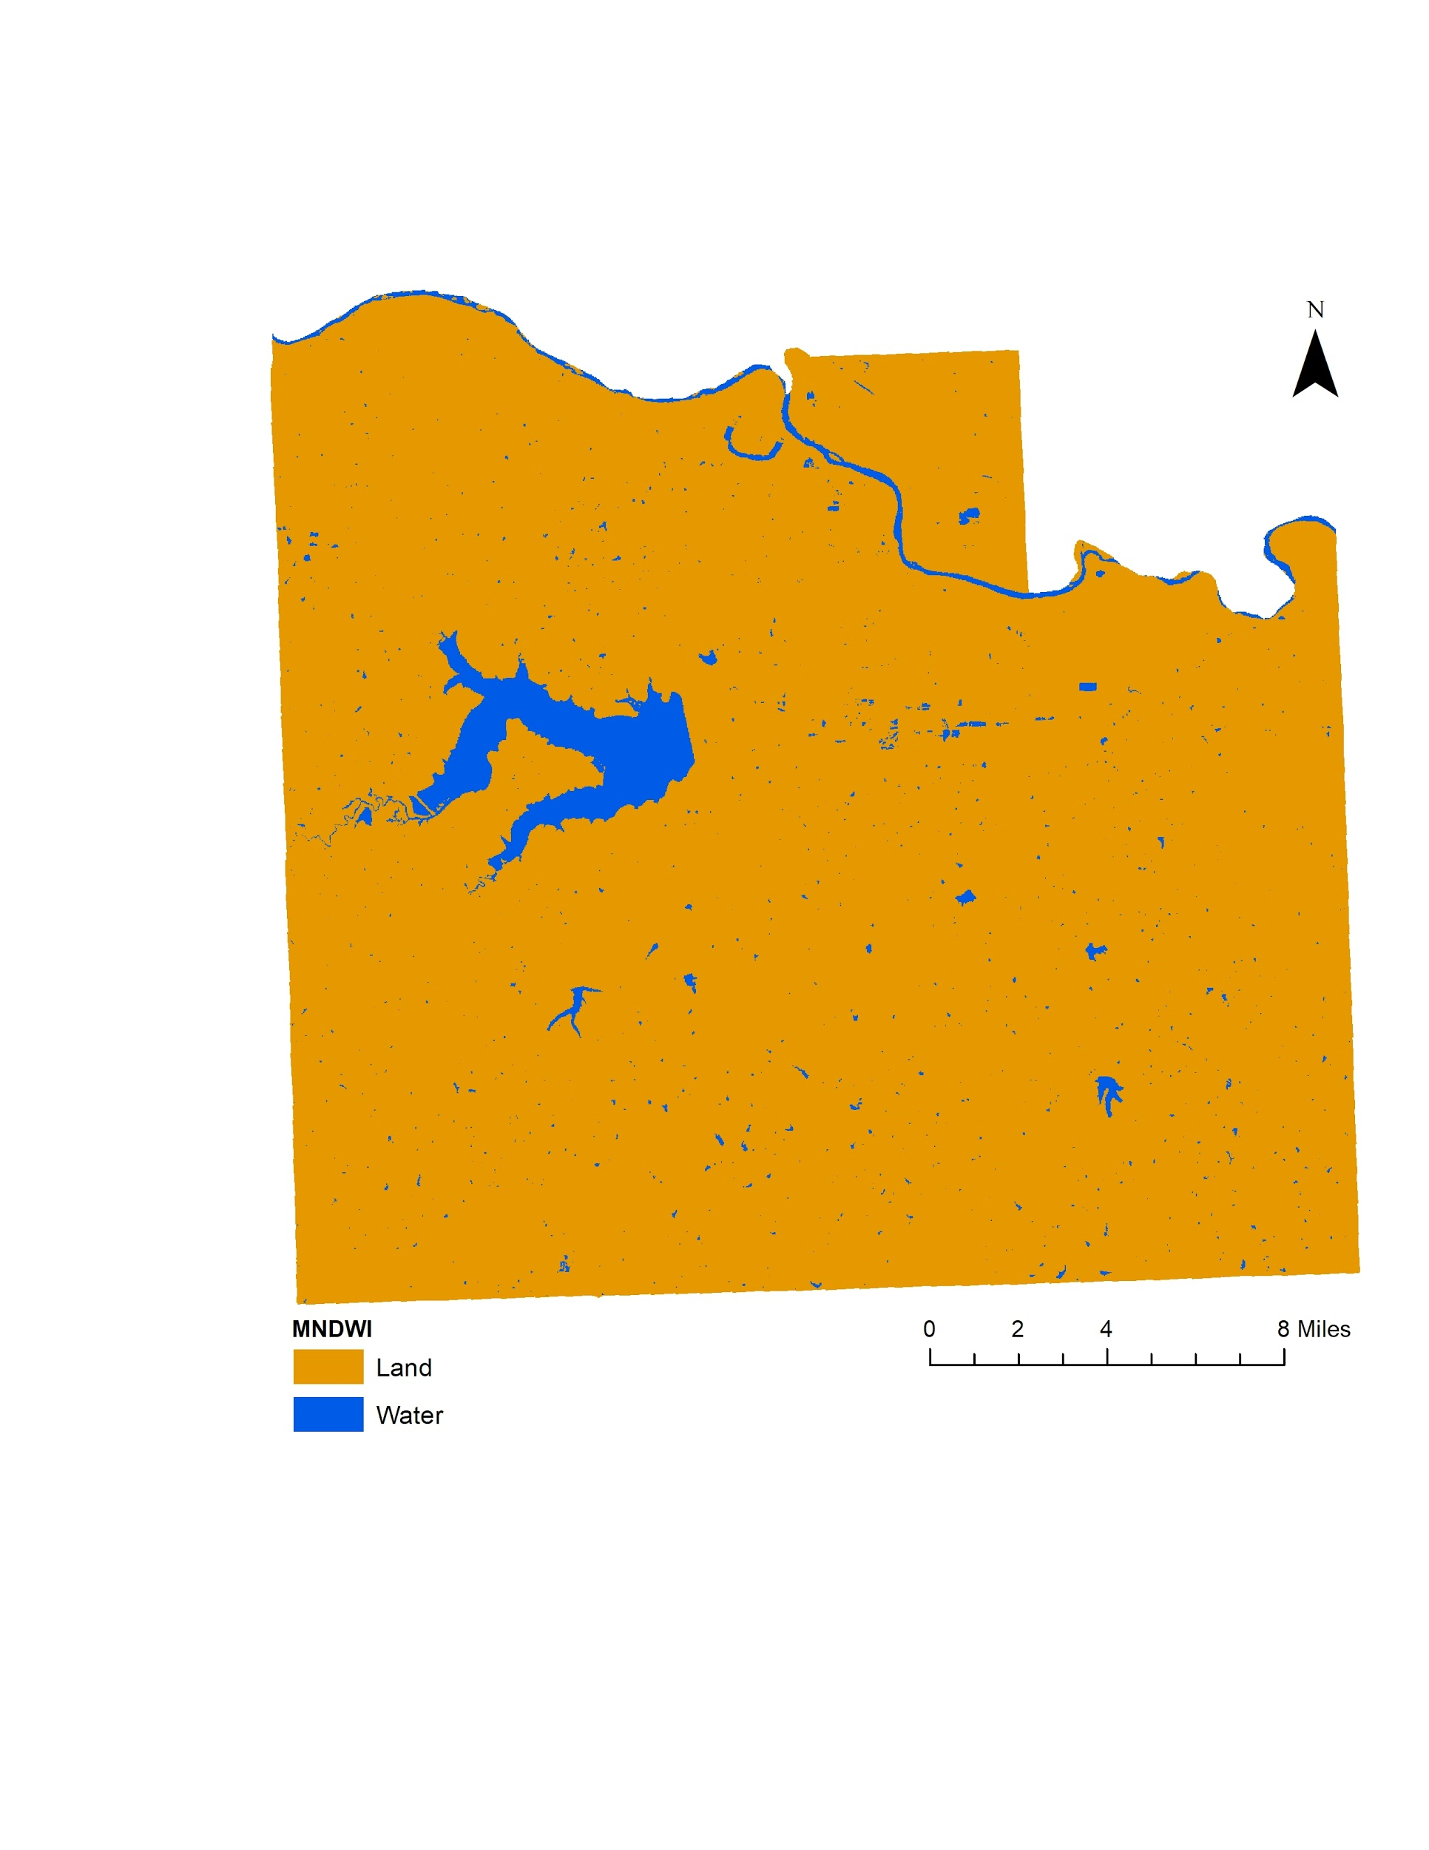
Figure 2. The MNDWI image identifies water bodies in Douglas County (from Landsat 8 OLI, 2019).

Next, using NAIP imagery, we calculated a Normalized Difference Vegetation Index (NDVI) raster to identify tree cover within the city (Figure 3). NDVI uses a ratio of red and near-infrared bands to determine vegetation vigor and is given as follows in Equation 2 (Huete, 1988). We used the NDVI raster to differentiate between rooftops and trees covering roofs, masking out trees to remove portions of rooftops with an obstructed solar view. Once the trees were masked out, a new building shapefile feature set was created without the obstructing trees. Finally, we calculated the average solar radiation per rooftop, summarizing the pixel values within each building footprint polygon.

$\text{NDVI= }\frac{\text{NIR-Red}}{\text{NIR+Red}}$ (2)

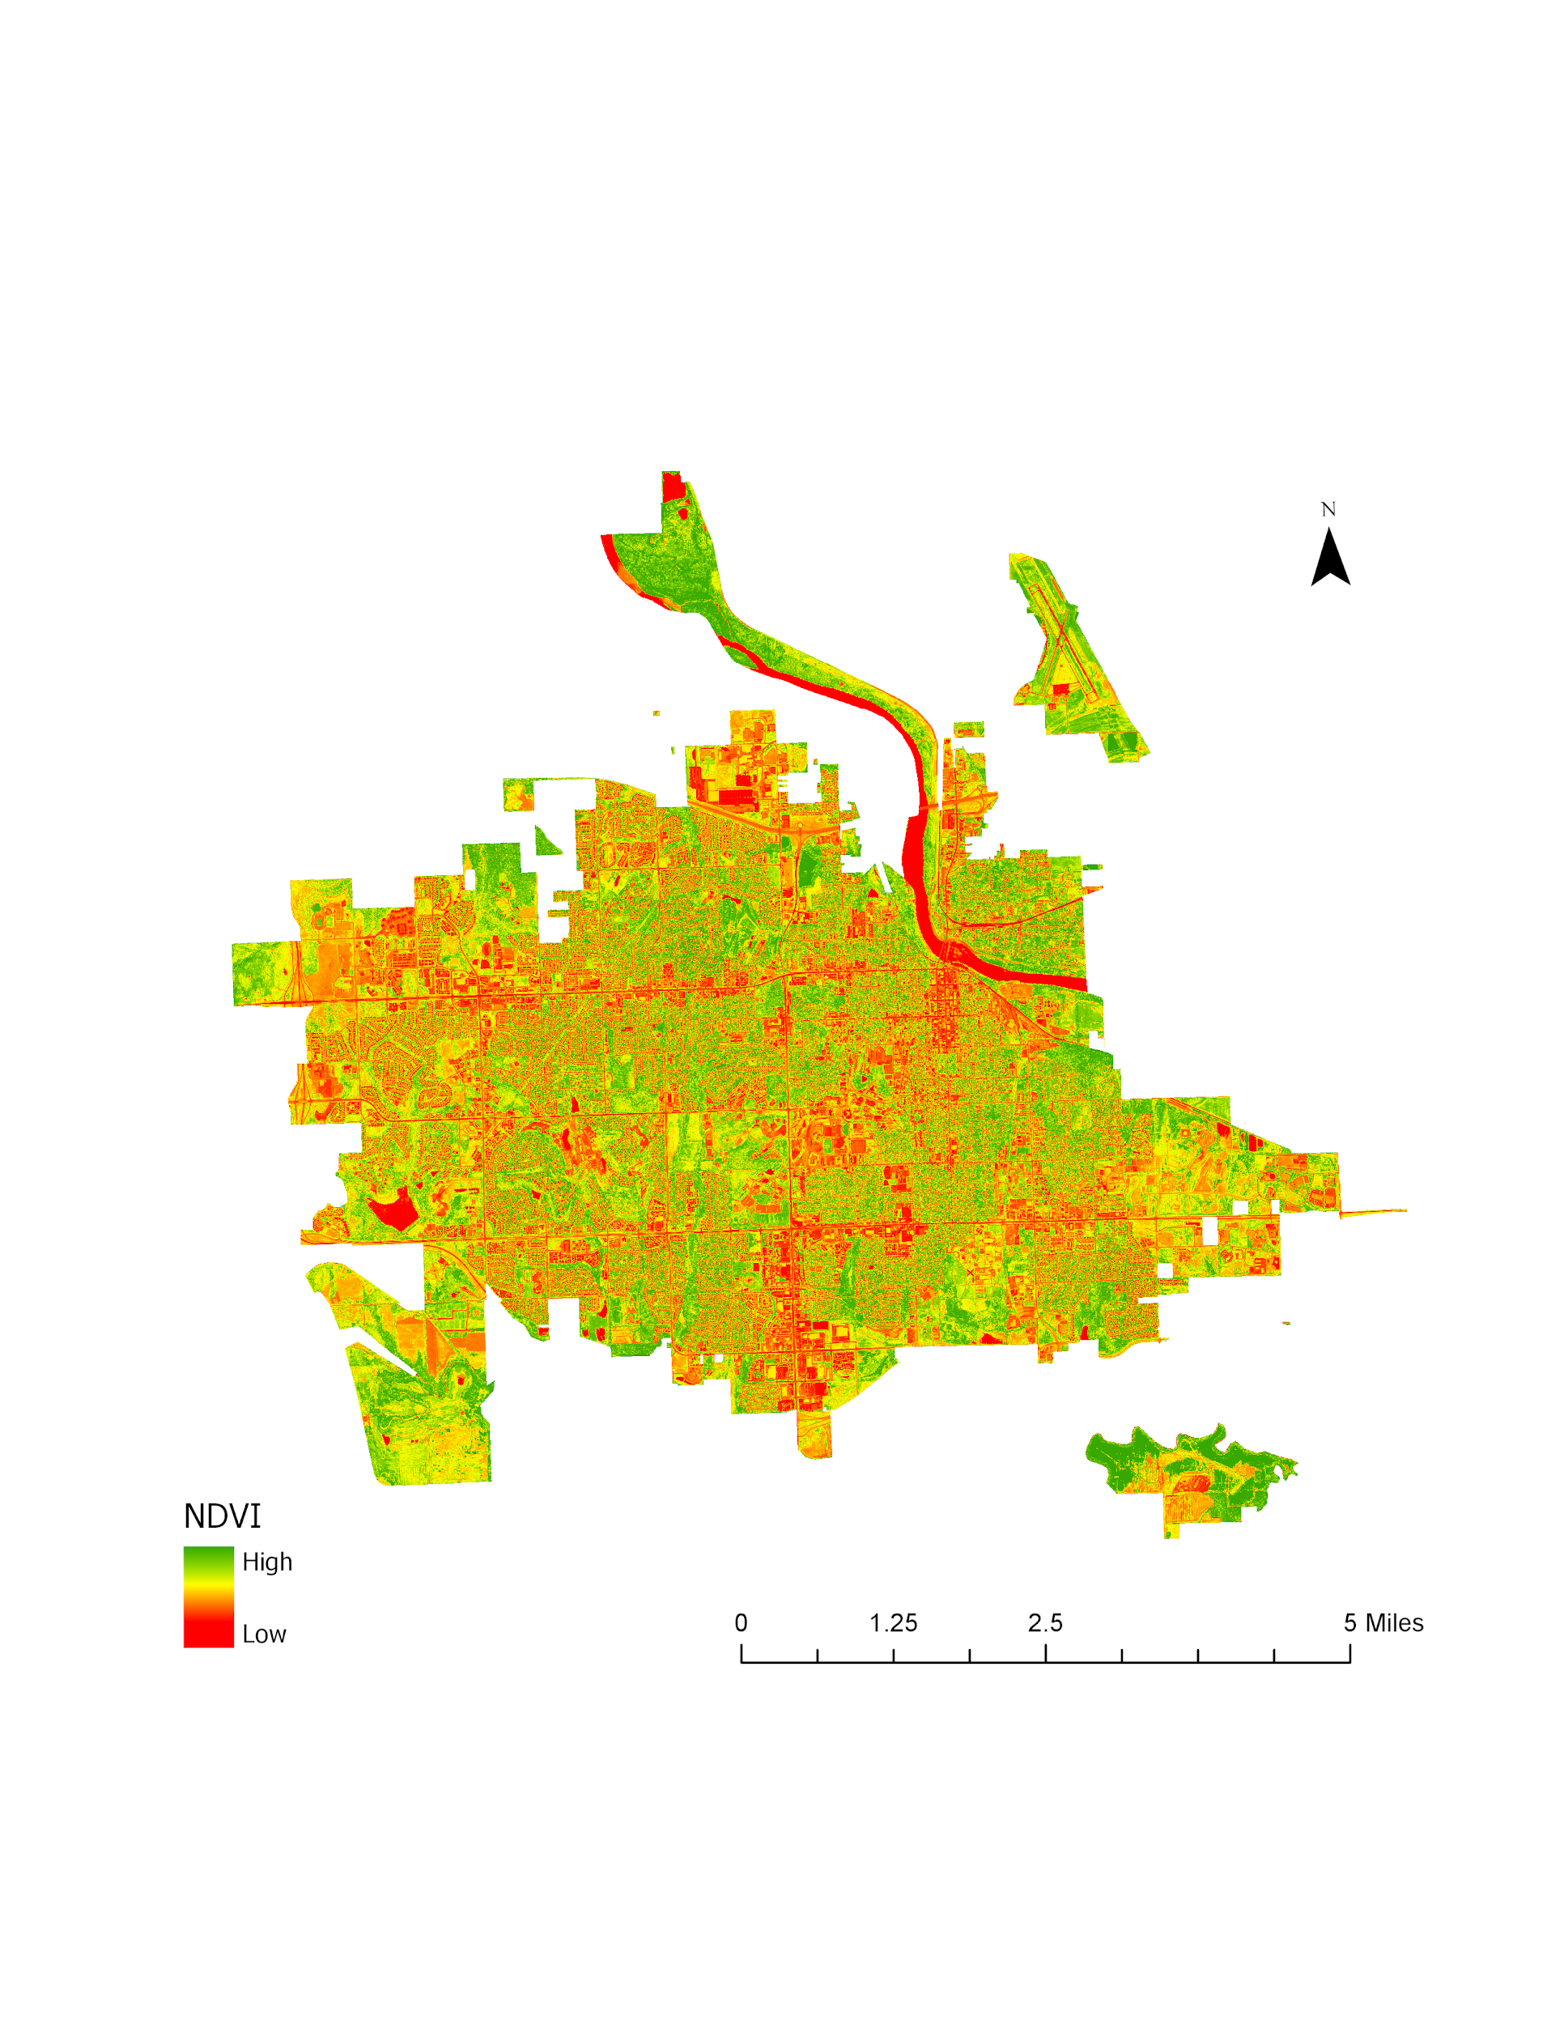
Figure 3. NDVI image clipped to the City of Lawrence (from NAIP, 2017).

For our two distinct areas of interest – the County and the City – we also created site suitability maps. Our variable inputs include the amount of solar insolation and other relevant environmental and community factors. In order to combine these various spatial data into our model, they had to be transformed into a common preference scale. The categorical inputs were reclassified and the continuous inputs were rescaled by function. Factors included in the final analysis were processed based on their relative suitability for solar panel development, and rescaled to a range from 0 to 1. Table 2 below describes the specific processing methods and factor weights for each layer. The final suitability score (normalized between 0 and 1) was calculated as the sum of all normalized variables, according to Equation 3. The final insolation and suitability maps for the City and County were averaged based on representative polygons: building footprints for the City and parcels for the County. The suitability values were then split into relative ranges corresponding to high, medium, and low suitability.

Table 2
Description of site suitability factors
Factor | Description and Processing | Scale of Analysis | Boolean/  Normalized | Weight
Insolation | Includes slope, aspect, hillshade, and shadows | City and County | Normalized | High
Protected Areas and Water | Mask out federal/state parks, cemeteries, water bodies, and waterways | City and County | Boolean | High
Slopes | Masks out unsuitable slopes greater than 45 degrees | City | Boolean | Mid
Parcel and Building Ownership | High weight for city and county owned; medium weight for universities, schools, hospitals; low weight for state and federal; lowest weight for privately owned | City and County | Normalized | Mid
Land Cover/Land Use | High weight for grassland and open space; medium weight for agricultural land; low weight for forests; lowest weight for wetlands | County | Normalized | Mid
Installation | Suitability based on proximity to power lines, power stations, and roads | County | Normalized | Low
Flood Plain | Removes areas within flood zone from analysis, and remaining suitability based on elevation extending beyond the floodplain | County | Normalized | High

$\text{Solar Panel Suitability =}\left[\frac{\left[\text{0.5}\left(\text{a}\right)\text{+0.1}\left(\text{b}\right)\text{+0.2}\left(\text{c}\right)\text{+0.05}\left(\text{d}\right)\text{+0.15}\left(\text{e}\right)\right]}{\text{n}}\right]\text{*f}$ (3)

Where: a = Solar insolation, b = Ownership, c = Floodplain extent, d =Proximity to power stations/ transmission lines, e = Land use, f = Protected/water areas, n = Number of variables, with appropriate weights applied to each input. In order to establish the weights for each variable, a multi-criteria decision analysis was performed. We worked in conjunction with our project partners at the Douglas County Office of Sustainability in order to determine which factors were the most important for their community needs. The factors needed to be weighted relative to each other, therefore the values all add up to 1. Insolation was given a weight of 0.5 because its impact on the site suitability was deemed the most important and needed to weigh as much as the other inputs combined. Floodplain extent was the next most impactful factor as decided by our project partner, and was given a value of 0.2. Ownership and land use were the next most important and they needed to have corresponding weights, however, ownership was weighted slightly lower than land use. Installation factors such as proximity to power stations and transmission lines needed to be included for our partners, but were the least impactful. Finally, if an area was in a protected area or water body, then it was determined to be not suitable at all, and given a weight of 0.

3.3 Data Analysis
We validated our solar insolation results by comparing our outputs to the US Department of Energy’s National Renewable Energy Laboratory (NREL) solar maps. According to their data, Kansas state receives between 4.6 and 6.6 kWh/m² /day. Our average solar radiation outputs for Douglas County were 5.4 kWh/m² /day, within the NREL range, indicating a reasonable accuracy. We further validated our insolation results at a smaller spatial scale by comparing our outputs with the US NREL Solar Radiation Research Laboratory (Irradiance Inc. RSP v2) Daily Plots and Raw Data Files. These ground truth measurements are taken at their research facility in Denver, Colorado. Denver’s location is 39.7392° N, 104.9903° W and Douglas County’s location is 38.9265° N, 119.6499° W; with their latitude’s being only about 1 degree apart, we concluded that their ground truth measurements would be a sufficient baseline to compare. We used their Global Horizontal Irradiance measurements for each day of the 2018 year and calculated monthly averages. These measured monthly averages were plotted against our estimated monthly averages, calculated from the ArcGIS Area Solar Radiation Tool, and the results can be found in Appendix Figure B1. Both insolation values follow a very similar normal curve throughout the year, but our estimated outputs were lower overall compared to the measured ground truths. This discrepancy could possibly be explained by the elevation differences between the two areas of Denver and Douglas County – Denver’s elevation is 5280 feet and Lawrence Kansas’ elevation is 866 feet. Generally, higher elevations receive more insolation than lower elevations. This results both because higher elevation have more open viewsheds and because the solar beam travels through less air mass (Fu, Pinde & Rich, Paul, 1999). Based on these validation assessments, we concluded that the estimated solar insolation values from the Esri Area Solar Radiation tool were reasonably accurate.

4. Results & Discussion
4.1 Analysis of Results
Results for insolation and suitability were divided up into five classes, using the quantile classification method to distribute an equal number of features across each class. Prior to classification, small parcels within the City of Lawrence (less than 100,000 square feet), and unsuitable land (protected areas and water) were removed from the county analysis. Using this classification scheme, 5.01% of Douglas County contains very highly suitable land for solar installation, 15.94% of land high suitability, and 21.88% moderate suitability. Highly suitable land includes large parcels within Lawrence, southwest of the county, and northwest of the county. Land on the north side and northeast of Douglas County have low suitability, likely due to the proximity to flood zones. These areas are inadequate locations for ground-mounted solar panels, due to the high frequency of recent flooding in Douglas. Out of all the parcels that are owned by the City of Lawrence, 9.36% of city-owned land area has very high suitability, and 31.52% has high suitability. For parcels owned by the County government, 22.37% of land area is very highly suitable, and 45.90% is highly suitable. Government-owned land generally has high suitability levels, with a higher percentage of suitable land than all parcels combined, corresponding to a good opportunity for solar farm development on public lands.

For our results at the city scale, the overall site suitability includes 47.4% very high suitability, 17.55% high suitability, 14.56% moderate suitability, 12.47% low suitability, and 8.02% very low suitability. Our variable inputs for the city scale were the solar insolation and the building owner type. The rooftops with the highest suitability were clustered around the downtown area, which makes sense due to the larger building sizes and public ownership, as compared to the suburban areas in the west and northwest areas of the city. Out of all the buildings in the city that are owned by the City of Lawrence, 76.7% had very high suitability, 8.7% high suitability, 9.19% moderate suitability, 3.7% low suitability, and 1.74% very low suitability. Additionally, out of the buildings in the city that are owned by Douglas County, 88.4% have very high suitability, 1.8% have high suitability, 6.11% have moderate suitability, 2.89% have low suitability, and 0.78% have very low suitability, indicating a sufficient capacity for the government to adopt solar panels on the buildings they own. A suitability map for both Douglas County and Lawrence can be found in Figure 5.

The average solar insolation by land parcel for the county was 1,982 kilowatt-hours per square meter annually and the average solar insolation by building rooftop for the city was 950 kilowatt-hours per square meter annually. The overall average insolation results are shown in the maps in Figure 4. This energy potential, in addition to the site suitability results, indicate that Douglas County and its largest metropolitan area, Lawrence, have the capacity to implement solar panels on a large proportion of the county and city’s assets. Most of the rooftops in the City if Lawrence are highly suitable for solar panel installation, and with our partner’s climate mitigation goals including converting to renewable energy sources, PV panels are a possible solution for them.

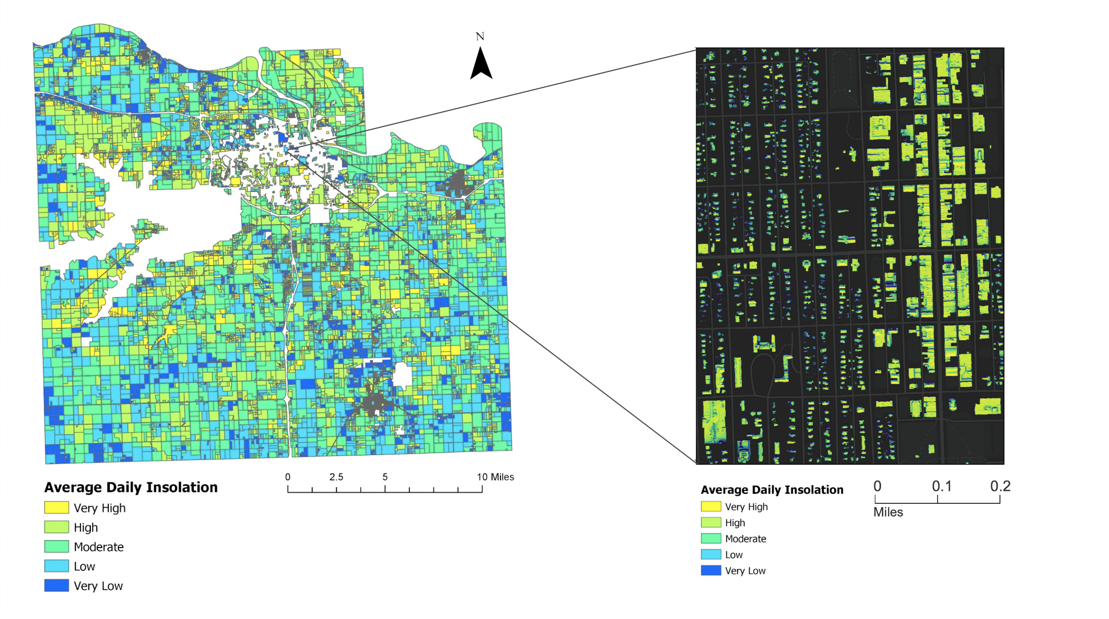
Figure 4. Average insolation values per parcel for Douglas County, and per rooftop in downtown Lawrence, Kansas. Map excludes parcels in the city of Lawrence under 100,000 square feet, and parcels that are not suitable for solar installation.

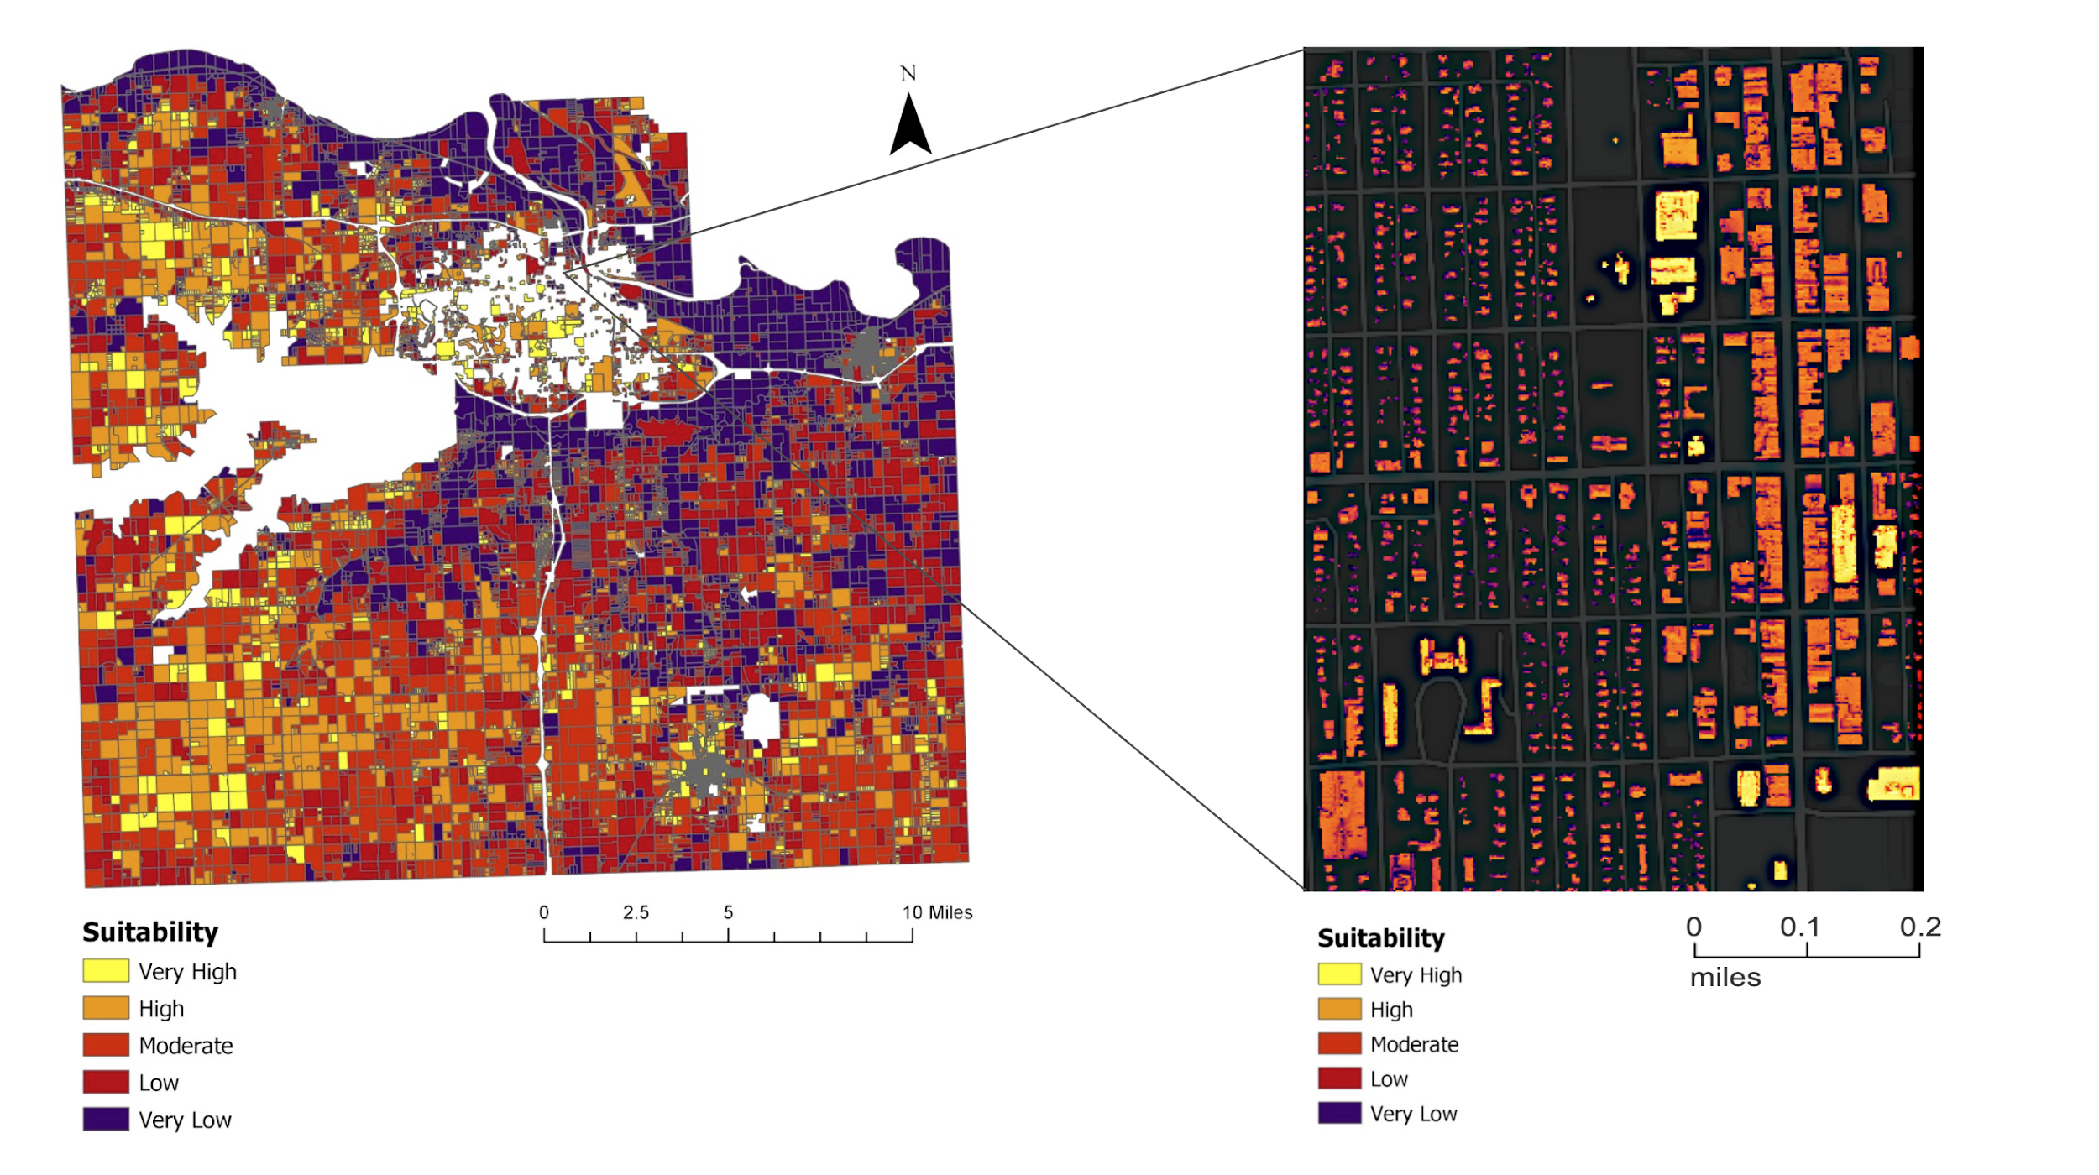
Figure 5. Suitability per parcel for Douglas County and per rooftop for downtown Lawrence, Kansas. Map excludes city parcels under 100,000 square feet, and parcels that are not suitable for solar installation.

4.2 Error Analysis
These results for both solar insolation and site suitability are estimates. The primary source of insolation error in this study comes from the estimated calculations from the Esri Area Solar Radiation Tool. This tool includes multiple input options for time configurations of the study. For our study, we used the “special days” time configuration, which calculates solar insolation for the summer and winter solstices, and the fall and spring equinoxes. This particular time configuration interpolates the amount of solar insolation between these special days, which will inherently contain some error. We used this option, instead of a whole year time configuration, due to the ten week time constraint of the DEVELOP Program term; running this tool for the “whole year” was too time-consuming to run at the high spatial resolution of one meter. Our solar insolation outputs for the city scale were measured using the entire area of the rooftop. This study doesn’t account for rooftop edges, chimneys, AC units, and other things on the rooftop that limit flat surfaces. Solar panels are typically only installed on south facing roofs, which we did not require as an installation input. Additionally, the values included in this study measure for horizontal solar insolation, and do not account for the tilt in actual solar panel installation to optimize solar energy generation.

Elevation and surface feature measurements were the primary variables in our solar insolation calculations from the Esri Area Solar Radiation Tool. These measurements were obtained from DEMs and DSMs given to us by our partner. These digital surface models were from 2014 and are outdated. When compared with more recent optical imagery from spring 2019, some new buildings/features have been constructed, while others have been demolished. The solar insolation raster does not account for changes in surface features or elevation since 2014.

4.3 Future Work
The analysis for this project was completed within the one DEVELOP term. For future work, the partner could pursue a more detailed analysis of solar panels on specific building rooftops, taking into account rooftop obstructions, such as air conditioning units and chimneys. This analysis would require a DSM with higher spatial resolution, or ground truthing to confirm layout of rooftops. With more detailed data, the partner could calculate more accurate numbers of solar panels per rooftop, and calculate more exact energy outputs for panels on each rooftop. Early in the term, the partner also mentioned that they are currently undergoing an analysis of threatened species habitats within Douglas County. We recommends overlaying these future data layers with the suitability map, to ensure installation of solar panels on sites that do not encroach upon critical habitats.

5. Conclusions
Our partner at the Douglas County Office of Sustainability are pursuing renewable energy initiatives in their community in order to help reduce greenhouse gas emissions. Currently, they do not utilize any satellite data or earth observations in their decision making. We successfully produced end products that our partners can make use of. The suitability model results - 5.01% very high suitability and 15.94% high suitability in Douglas County, and 47.4% very high suitability and 17.55% high suitability in Lawrence - indicate high area of land suitable for solar panel installation. The partners in Kansas have a large opportunity to expand solar panels throughout the region, and can use these maps to identify parcels to target. These percentages correspond to 99.4 square miles within the County and 1.9 square miles of rooftops. Furthermore, by focusing on the 3.5 square miles of highly suitable city-owned and county-owned land, our partners can avoid barriers to installation on private land. While the implementation process can be time consuming, the eventual solar panel development throughout the County will help mitigate greenhouse gas emissions, achieving community and partner goals of transitioning to renewable energy.

The static maps demonstrate the solar insolation potential and solar panel suitability at both the county and city scales. These maps can be used by our partner to identify larger spatial patterns across the county parcels or across the city’s rooftops. The online tool’s interactive maps will allow our partners to closely study solar potential at a building scale, and will help residents of Douglas County learn more information about the solar potential of their property. The online tool also has the potential to be shared with the general public and allow residents to explore the solar insolation and site suitability of every rooftop and parcel in the study area, with infographics displayed at their convenience. Douglas County residents interested in installing solar panels to reduce their carbon footprint can use the ArcGIS Online map and discover their rooftop suitability, ultimately reducing greenhouse gas emissions from Kansas.

6. Acknowledgments
We would like to thank Sustainability Director Jasmin Moore and GIS Coordinator Bryce Hirschman at Douglas County for their contributions to this project. We would also like to thank and acknowledge Qing Yue, Erika Higa, and Ben Holt from NASA Jet Propulsion Laboratory, Paul Stackhouse, Brian Tisdale, and Jason Barnett at NASA Langley Research Center for their support with NASA POWER, and finally, Daniel Hedges, Brian Sims, and Gert Van Maran at Esri for their support with the ArcGIS Area Solar Radiation Tool. We would also like to thank the team members on the DEVELOP Arizona Ohio Energy Project, Hannah Besso, Sinhang Chen, Yiyi He, and Crystal Wespestad, for their collaboration and support.

Any opinions, findings, and conclusions or recommendations expressed in this material are those of the authors and do not necessarily reflect the views of the National Aeronautics and Space Administration.

This material is based upon work supported by NASA through contract NNL16AA05C.

7. Glossary
DEM – Digital elevation model is a 3D computer generated bare-earth raster grid representation of a terrain's bare surface created from a terrain's elevation data
DSM – Digital surface model is a 3D computer generated representation of a terrain's natural and built features/ surfaces
Insolation – The amount of solar radiation reaching a given area, in units of power per unit area
Landsat 8 OLI –Global satellite that consists of optical instruments. The Operational Land Imager (OLI) provides seasonal coverage of the global landmass at a spatial resolution of 30 meters

LiDAR – Light Detection and Ranging is a remote sensing method that uses light in the form of a pulsed laser to measure ranges to the Earth; these light pulses, combined with other data recorded by the airborne system, generate precise, three-dimensional information about the shape of the Earth and its surface characteristics
NAIP – National Agriculture Imagery Project acquires aerial imagery during the agricultural growing seasons in the continental United States. It is administered by the USDA's Farm Service Agency through the Aerial Photography Field Office
SRTM – Shuttle Radar Topography Mission is mounted on a Space Shuttle and obtains Earth surface data by remote sensing technology utilizing a synthetic aperture radar

8. References
Charabi, Y., & Gastli, A. (2011). PV site suitability analysis using GIS-based spatial fuzzy multi-criteria evaluation. Renewable Energy, 36(9), 2554-2561. doi:10.1016/j.renene.2010.10.037

Climate Protection Task Force, Douglas County Sustainability Advisory Board. (2009). Climate Protection Plan: Climate Protection Task Force Report to Lawrence City Commission, Final Draft [PDF]. Retrievedfrom https://cdn.lawrenceks.org/wp-content/uploads/2019/01/Lawrence-Climate-Protection-Plan-3-31-2009.pdf

Douglas County Kansas. (n.d.). Renewable energy. Retrieved June 24, 2019, from https://www.douglascountyks.org/depts/sustainability/renewable-energy

Fu, Pinde & Rich, Paul. (1999). Design and implementation of the Solar Analyst: an ArcView extension for modeling solar radiation at landscape scales. Proceedings of the 19th Annual ESRI User Conference. Retrieved from https://www.researchgate.net/publication/266576778_Design_and_ implementation_of_the_Solar_Analyst_an_ArcView_extension_for_modeling_solar_ radiation_ at_landscape_scales

Gagnon, P., Margolis, R., Melius, J., Phillips, C., & Elmore, R. (2016). Rooftop solar photovoltaic technical potential in the United States: A detailed assessment (Technical Report NREL/TP-6A20-65298). Golden, CO: National Renewable Energy Laboratory. doi:10.2172/1236153

Huang, S., & Fu, P. (2009). Modeling small areas is a big challenge: using the solar radiation analysis tools in
ArcGIS Spatial Analyst. ArcUser, 12(2), 28-31. Retrieved from
https://www.esri.com/news/arcuser/0309/files/solar.pdf

Huete, A. R. (1988). A soil-adjusted vegetation index (SAVI). Remote Sensing of Environment, 25, 295-309.
doi:10.1016/0034-4257(88)90106-X

Janke, J. R. (2010). Multicriteria GIS modeling of wind and solar farms in Colorado. Renewable Energy, 35(10), 2228-2234. doi:10.1016/j.renene.2010.03.014

Kansas Corporation Commission. (n.d.). Kansas Renewable Energy Standard (RES). Retrieved June 24, 2019,
from http://kcc.ks.gov/electric/renewable-energy-standard

Kansas Data Access and Support Center (DASC). (2019). State of Kansas GIS. Retrieved from https://www.kansasgis.org/

Kodysh, J. B., Omitaomu, O. A., Bhaduri, B. L., & Neish, B. S. (2013). Methodology for estimating solar potential on multiple building rooftops for photovoltaic systems. Sustainable Cities and Society, 8, 31-41. doi:10.1016/j.scs.2013.01.002

Kouhestani, F. M., Byrne, J., Johnson, D., Spencer, L., Hazendonk, P., & Brown, B. (2018). Evaluating solar energy technical and economic potential on rooftops in an urban setting: The city of Lethbridge, Canada. International Journal of Energy and Environmental Engineering, 10(1), 13-32. doi:10.1007/s40095-018-0289-1

Lawrence / Douglas County Planning Office. (2018). Plan 2040, a comprehensive plan for unincorporated Douglas County & The City of Lawrence, draft [PDF]. Retrieved from https://assets.lawrenceks.org/assets/ pds/planning/h2020/AugustDraft/Comp-Plan-Update-Guide.pdf

Lukac, N., Seme, S., Zlaus, D., Stumberger, G., & Zalik, B. (2012). Building roofs photovoltaic potential
assessment based on LiDAR data. Energy, 102, 803-812. doi:10.1016/j.energy.2013.12.066

NASA JPL (2013). NASA Shuttle Radar Topography Mission Global 1 arc second [Data set]. NASA EOSDIS Land Processes DAAC. Accessed 2019-06-24 from https://doi.org/10.5067/MEaSUREs/SRTM/SRTMGL1.003

NASA Langley Research Center (LaRC) (2018). NASA Langley Research Center (LaRC) POWER Project funded
through the NASA Earth Science/Applied Science Program [Data set]. Accessed 2019-06-24 from
https://power.larc.nasa.gov/data-access-viewer/

Santos, T., Gomes, N., Freire, S., Brito, M., Santos, L., & Tenedório, J. (2014). Applications of solar mapping
in the urban environment. Applied Geography, 51, 48-57. doi:10.1016/j.apgeog.2014.03.008

Solar Energy Industries Association (SEIA). (2018). Kansas solar. Retrieved June 24, 2019, from
https://www.seia.org/state-solar-policy/kansas-solar

Solar Energy Industries Association (SEIA) (2019). Solar industry research data. Retrieved June 24, 2019, from https://www.seia.org/solar-industry-research-data

US Department of Energy (US DOE). (n.d.). Renewable energy goal. Retrieved June 24, 2019, from
https://www.energy.gov/savings/renewable-energy-goal

US Department of Energy (US DOE). (n.d.). Solar energy in the United States. Retrieved June 24, 2019, from
https://energy.gov/eere/solarpoweringamerica/solar-energy-united-states

US Department of Energy (US DOE) National Renewable Energy Laboratory. (n.d.). Solar Maps. Retrieved July 22, 2019, from https://www.nrel.gov/gis/solar.html.

US Department of Energy (US DOE) National Renewable Energy Laboratory, Solar Radiation Research Laboratory (Irradiance Inc. RSP v2). (n.d.). Daily Plots and Raw Data Files. Retrieved July 22, 2019, from https://midcdmz.nrel.gov/apps/plot.pl?site=IRRSP&start=20070619&edy=21&emo=7 &eyr=2019&zenloc=12&amsloc=15&year=2018&month=1&day=1&endyear=2018& endmonth=12&endday=31&time=1&inst=3&type=day&first=3&math=0&second=-1 &value=0.0&global=-1&direct=-1&diffuse=-1&user=0&axis=1

US Energy Information Administration (US EIA) - Independent Statistics and Analysis. (2019). Kansas,
State profile and energy estimates. Retrieved June 24, 2019, from https://www.eia.gov/state/?sid=KS#tabs-3

US Geological Survey. (2019). Landsat OLI/TIRS Level-2 Data Products - Surface Reflectance [Data set]. US Geological Survey Earth Resources Observation and Science (EROS) Center, accessed June 24, 2019. https://dx.doi.org/10.5066/F78S4MZJ

Watson, J. J., & Hudson, M. D. (2015). Regional scale wind farm and solar farm suitability assessment using GIS-assisted multi-criteria evaluation. Landscape and Urban Planning, 138, 20-31. doi:10.1016/j.landurbplan.2015.02.001

Wong, M. S., Zhu, R., Liu, Z., Lu, L., Peng, J., Tang, Z., . . . Chan, W. K. (2016). Estimation of Hong Kong’s solar energy potential using GIS and remote sensing technologies. Renewable Energy, 99, 325-335. doi:10.1016/j.renene.2016.07.003

9. Appendices

Appendix A
Table A1
Description of ancillary datasets used
Data | Dates | Data Source | Parameter | Use
NAIP | 2017 | USDA | Land cover | Used to calculate NDVI in the City of Lawrence to create a tree mask
LiDAR | 2015 | Douglas County | Digital surface model | Created a DSM of the City of Lawrence used to estimate the amount of solar radiation each building receives
CropScape | 2018 | United States Department of Agriculture | Land cover & land use | Used to identify agricultural areas in Douglas County
Building Footprint Area | 2014 | Douglas County | Building area | Used in site suitability model as a weighted variable input
Parcel Ownership | 2018 | Douglas County | Building & parcel ownership attributes | Used in site suitability model as a weighted variable input
Flood Zone | 2015 | FEMA | Floodplain extent | Used in site suitability model as a weighted variable input
Protected Land Areas | 2018 | USGS | Land area attributes | Used in site suitability model as a weighted variable input
NASA POWER | 2018 | NASA | Cloud masking, atmospheric correction | Used in Area Solar Radiation tool as transmissivity and diffuse proportion parameter
Substations | N.d. | Douglas County | Installation | Used in site suitability model as a component of the installation variable
Transmission Lines | 2017 | Kansas Corporation Commission | Installation | Used in site suitability model as a component of the installation variable
Roads | 2012 | Kansas Department of Transportation | Installation | Used in site suitability model as a component of the installation variable
Cemeteries | N.d. | Douglas County | Land area attributes | Used in site suitability model as a component of the protected areas variable
Water Bodies | 2013 | Douglas County | Land area attributes | Used in site suitability model as a component of the protected areas variable
Waterways | N.d. | Douglas County | Land area attributes | Used in site suitability model as a component of the protected areas variable

Appendix B
Figure B1
Ground truth insolation values compared to estimated insolation values
