Argentina Water Resources

Evaluating Evapotranspiration in Humid Subtropical and Semi-Arid Climates with NASA Earth Observations to Understand Water Balance in Paraná and the Patagonian Steppe of Argentina

 **Technical Report**

Final Draft – April 4th, 2019

Carl Jurkowski (Project Lead)

Ahmed Baqai

Jose I. Ochoa

A. R. Williams

Keith T. Weber, Idaho State University, GIS TReC (Science Advisor)

Previous Contributors:

Ian Lauer

Carolyn Macek

Francis Zurek

# 1. Abstract

Evapotranspiration (ET) is a key indicator of hydrological balance across different ecosystems. Water availability is a vital ecosystem service for biota and communities. The transpiration and evaporation of water from vegetation and soil can be estimated through *in situ* ET measurements. However, *in situ* ET data sampling represents an expensive and challenging task, especially in geographically remote areas. Models used in this study utilized data from sensors aboard multiple NASA satellites including, Landsat 8, Aqua, and Terra. Two models, Operational Simplified Surface Energy Balance (SSEBop) and Moderate Resolution Imaging Spectroradiometer (MODIS) Global ET Project (MOD16) were validated by the Fall 2018 NASA DEVELOP Idaho Water Resources II team. The Global Land Data Assimilation Noah evapotranspiration (GLDAS-2-Noah) was validated in Reynolds Creek Experimental Watershed (RCEW) by our Argentina Water Resources team. SSEBop, MOD16, and GLDAS-2-Noah were applied in two study areas: Paraná, province Entre Ríos, Argentina, a humid subtropical (Pampean) bioregion, and the Patagonian Steppe in Argentina, a semi-arid region, climatically similar to the validation site at RCEW. Validation and implementation of the models applied in this study will allow our partners at Consejo Nacional de Investigaciones Científicas y Técnicas (CONICET) and land managers in Argentina to use the model that best suits their needs while also making empirically based decisions regarding water resources.

**Keywords**

evapotranspiration, remote sensing, Landsat, climate, vegetation, energy balance model, water balance

# 2. Introduction

* 1. ***Background Information***

The primary focus of hydrologic studies has been on the supply side of water and not the demand side that includes evapotranspiration (ET) (Fisher et al., 2017). ET is the transport of water from different land surfaces to the atmosphere (United States Geological Survey, n.d.). The water is converted to water vapor through the processes of evaporation, the physical process, and transpiration, the biological process (Stancalie & Nertan, 2012). Within the hydrological cycle, ET is an important flux responsible for an estimated 60 percent of all terrestrial precipitation returned to the atmosphere (Zeng et al., 2012). ET measurements often give an indication of water balance and are an essential component of the hydrological cycle (Gavilán, Pastore, Quignard, Marasco, & Aceñolaza, *in review*). Obtaining empirical data from remote locations such as the semi-arid landscape of the Patagonian Steppe, which comprises 15 percent of Argentina, approximately 119 million acres (Fernández & Busso, 1999), provides a challenge to land managers. Land managers rely on remotely sensed datasets during their decision-making processes due to the expenses and time associated with *in situ* data collection in remote locations. To improve the ability of land managers to make empirically based management decisions, high spatial and temporal resolution datasets are needed to understand the hydrologic cycle and annual water availability across remote and expansive landscapes.

In the fall of 2018, the Idaho Water Resources II team investigated remotely sensed ET models derived from NASA Earth observation data for the semi-arid sagebrush steppe of Idaho. The team used *in situ* data from eddy covariance towers at the Reynolds Creek Experimental Watershed (RCEW)in southwest Idaho to validate four ET models: Google Earth Engine Evapotranspiration Flux (EEFLUX), Operational Simplified Surface Energy Balance (SSEBop), Moderate Resolution Imaging Spectroradiometer (MODIS) Global Evapotranspiration Project (MOD16), and the North American Land Data Assimilation Systems 2 Noah (NLDAS-2-Noah). A simple regression analysis between the ET models and *in situ* data showed the highest correlations between NLDAS-2-Noah (R2 of 0.70 to 0.87) and EEFLUX (R2 of 0.32 to 0.83). The lowest correlations were found with SSEBop (R2 of 0.21 to 0.85) and MOD16 (R2 of 0.04 to 0.61). The work completed by the Idaho Water Resources II team demonstrated the potential application of various ET models in semi-arid landscapes.

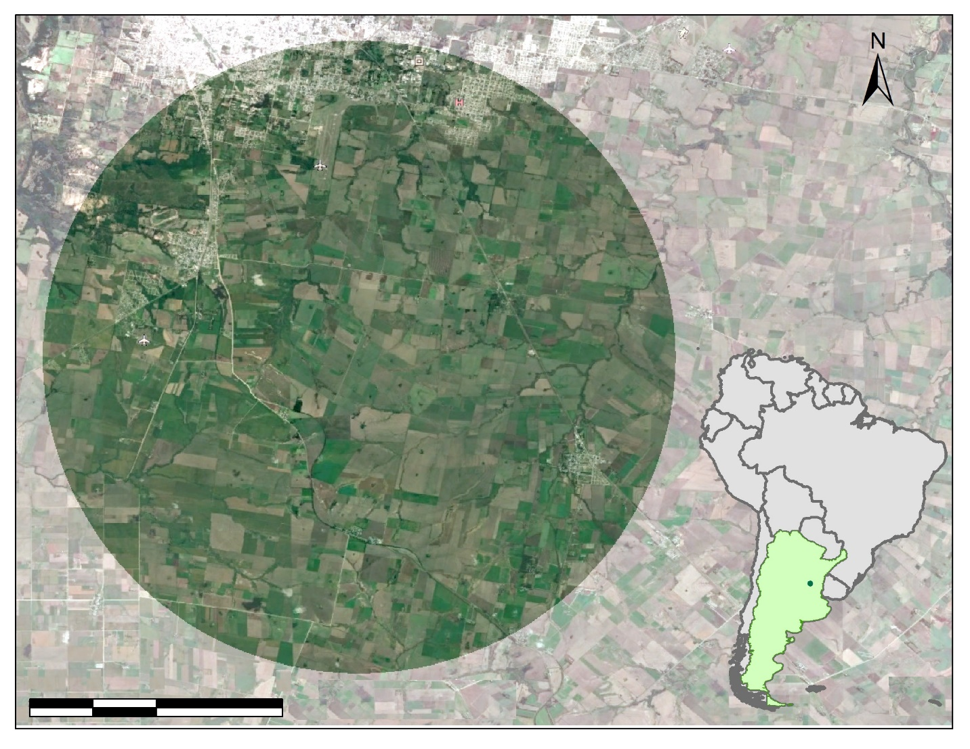

km

4

8

2

0

*Figure 1.* The first study area encompasses a 10 km radius circle in the Paraná region, Entre Ríos province, Argentina, South America. The green zone corresponds to the country of Argentina. The green dot indicates the location of Paraná. (Image Source: Google Earth Pro, Digital Globe 2019. Coordinate System: GCS WGS 1984, Datum WGS 1984, Units: Degree).

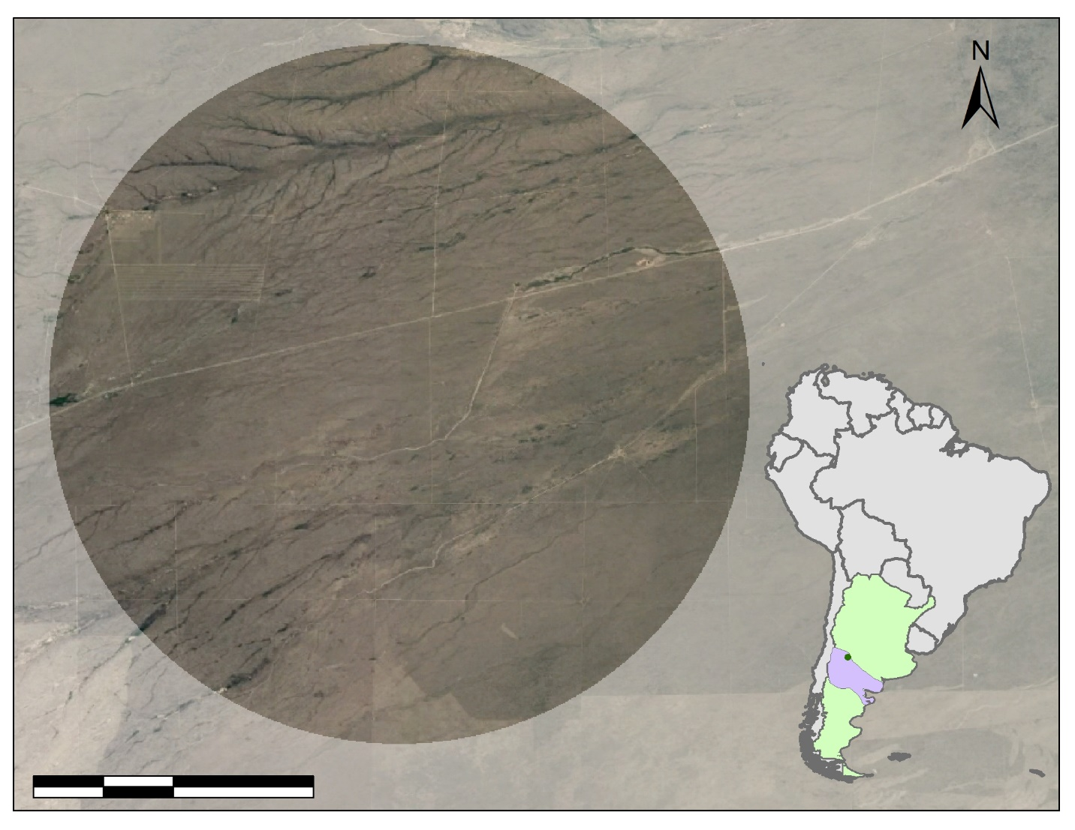

km

8

4

2

0

*Figure 2.* The second study area encompasses a 10 km radius circle in the Patagonian Steppe region, Argentina, South America. The green zone corresponds to the country of Argentina. The purple area represents the entire semi-arid steppe region. The green dot indicates the Patagonian Steppe location.

(Image Source: Google Earth Pro, Digital Globe 2019. Coordinate System: GCS WGS 1984, Datum WGS 1984, Units: Degree).

Our Paraná, Argentina, study area (*Figure 1*) is within an extensive agricultural region primarily consisting of corn and soy. With global temperatures predicted to increase (Diffenbaugh & Giorgi, 2012) and shifts in precipitation regimes expected to occur in a response to climate change (Trenberth, 2011), understanding ET, a vital constituent in the water cycle, is important when implementing water management strategies in agricultural regions. It is predicted that climate change will negatively affect water availability for vegetation by reducing precipitation and the subsequent infiltration of water and by increasing temperature and atmospheric CO2 fertilization that will increase reference evapotranspiration and vegetation growing capabilities (Pereira, 2011; Saadi et al., 2014). Research presented in this study can help land managers monitor shifts in hydrologic regimes and ET by implementing various validated ET models used in this study in the humid subtropical agricultural bioregion of Paraná, Argentina.

Both our Patagonian Steppe, Argentina, study area (*Figure 2*) and our validation site, RCEW, are semi-arid regions. A land cover description for RCEW is presented in detail in Lauer, Jurkowski, Macek & Zurek (2018). Higher elevations in RCEW consist of various sagebrush species and lower elevations consist of shrub species. The vegetation of the Patagonian Steppe is characterized by a semi-arid Monte rangeland, which constitutes a majority of arid rangeland in the country. The climate is dry and warm and becomes cooler towards the south. Monte vegetation consists of steppe scrub dominated by microphyllous xerophytic shrubs 1 to 3 m in height. Some plant species are short-lived summer or winter species whose abundance are strictly dependent on seasonal rainfall (Fernández & Busso, 1999).

* 1. ***Project Partners & Objectives***

Consejo Nacional de Investigaciones Científicas y Técnicas (CONICET), our partner for this project, is tasked with the promotion of science and technology within Argentina. Currently, models exist to measure ET for homogeneous agricultural lands, but many are generally untested for use in natural spatially heterogeneous land cover. In addition, some models tend to overestimate ET flux values, especially across heterogeneous natural systems. Penman and Bartholic-Namken-Wiegand models in semi-arid environments (DehghaniSanij, Yamamoto, & Rasiah., 2004; Hatfield, Reginato, & Idso, 1984) and Penman-Monteith in arid regions (Zhang, Kang, Li, & Zhang, 2008) are examples of models that tend to overestimate ET flux values. Dr. Pablo G. Aceñolaza and Sebastián Anibal Gavilán, current researchers for CONICET, were interested in using methods developed for the Snake River Plane, a semi-arid sagebrush steppe environment of western Idaho, to better understand water availability and transport in Argentina’s Patagonian Steppe. Specifically, Dr. Aceñolaza is aiming to compare the ET models validated by the Idaho Water Resources II team and the model validated in this study, with his existing regional model. The collaboration between the NASA DEVELOP Idaho – Pocatello Node and CONICET provided a critical next step in the validation of these ET products and will allow CONICET to determine which models correlate best for use in areas that have limited *in situ* measurements. Providing researchers and land and resource managers with a calibrated methodology for effectively modeling ET rates and soil moisture utilizing NASA Earth observations will allow for the development of more targeted and effective water conservation strategies.

# 3. Methodology

***3.1 Data Acquisition***

The team analyzed data from three ET models: two from the Idaho Water Resources II project, and one new model (Appendix Table A1). The study period for this project was from 2015 to 2017. Spatial and temporal resolutions varied between the ET models. Resolutions ranged from 500 m (MOD16) to ~28 km (Global Land Data Assimilation Noah evapotranspiration otherwise known as GLDAS-2-Noah), as shown in *Figure 3*. Temporal resolutions ranged from 3 hours (GLDAS-2-Noah) to 10 days (SSEBop). Operational Simplified Surface Energy Balance (SSEBop) ET estimates were collected from the United States Geological Survey via the Google Earth Engine (GEE) Application, Climate Engine. SSEBop has a temporal resolution of 10 days, with data reported in 10-day cumulative values and a spatial resolution of 1 km. This product is derived from Aqua and Terra Moderate Resolution Imaging Spectroradiometer (MODIS) data (MYD16A2: MODIS/Aqua Net Evapotranspiration 8-Day L4 Global 500 m SIN Grid V006; Mu, Zhao, & Running, 2011). MOD16 ET data were collected from GEE (MOD16A2: MODIS/Terra Net Evapotranspiration 8-Day L4 Global 500 m SIN Grid V006; Running, Mu, Zhao, 2017). MOD16 data are derived with a temporal resolution of eight days and a spatial resolution of 500 m. ET values are reported in eight-day cumulative ET. GLDAS-2-Noah actual ET data were collected from NASA Giovanni (Global Land Surface Model L4 three Hourly 0.25 x 0.25 degree V002; Wang, Cui, Wang, & Chen, 2016).

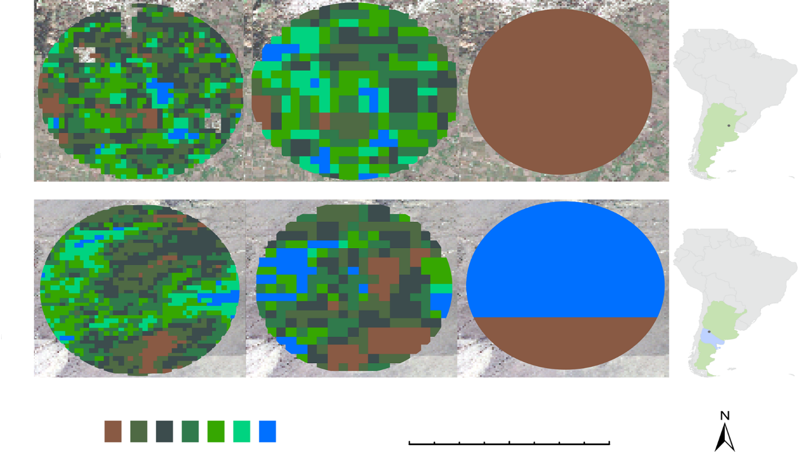

km

20

10

0

GLDAS-2-Noah

SSEBop

MOD16

High

Low

Paraná

Patagonia

[Grab your reader’s attention with a great quote from the document or use this space to emphasize a key point. To place this text box anywhere on the page, just drag it.]

*Figure 3.* Comparison of the spatial resolution of the three ET models in both study locations. Resolutions from left to right: MOD16 500 m, SSEBop 1 km, GLDAS-2-Noah ~28 km. The ET scale bar is relative and reported ET value ranges differ between study area. Numerical ET values are shown in the time series data.

The Patagonian Steppe study area was determined by analyzing the Köppen-Geiger climate classification map of Argentina (Beck et al., 2018), a climate classification map from an Argentinean science education resource (García, 2019), and using climatological analysis of precipitation data over RCEW and the semi-arid Patagonian Steppe region. Climate classification maps were visually analyzed to investigate exactly what regions were semi-arid and what regions were considered steppe environments in Argentina. After identifying an optimum region to select a location, we used precipitation to narrow our selection further. An ancillary dataset was used to identify a Patagonia Steppe location, specifically standard monthly mean precipitation rate from the National Oceanic and Atmospheric Administration (NOAA) Oceanic and Atmospheric Research(OAR)/Earth System Research Laboratory(ESRL)/Physical Sciences Division(PSD) CPC Merged Analysis of Precipitation (CMAP). CMAP precipitation values are estimated based on satellite data and gauge data at a spatial resolution of 2.5 x 2.5 degree and units of measurement mm/day (NOAA, 2019; *Figure 4*). This then allowed us to pick a location in the Patagonian Steppe with a similar average monthly precipitation rate to our RCEW validation site for the peak month of each locations’ respective water year high point. A list of all of the ancillary datasets used in this study is found in Appendix Table A2.

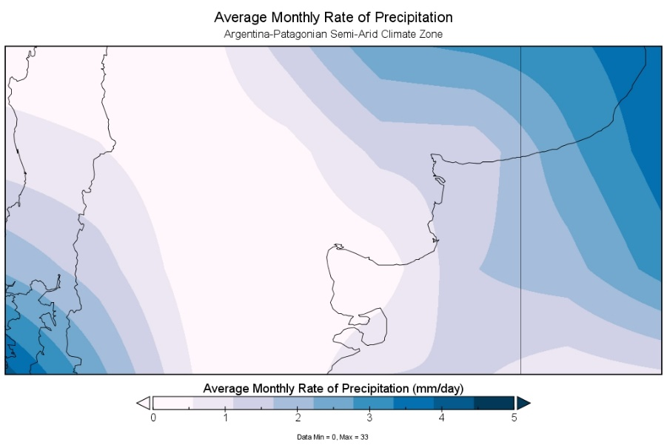

0 1 2 3 4 5

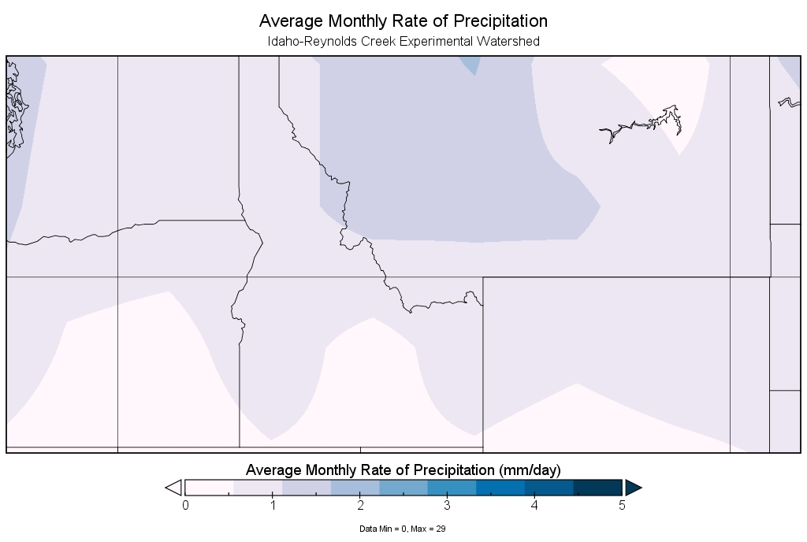

Average Monthly Precipitation Rate (mm/day)

Figure 4. Maps of monthly precipitation rate (mm/day) over the semi-arid Patagonian Steppe in January 2017 (top), and RCEW for June 2017 (bottom). Note: Area is not to geographical scale.

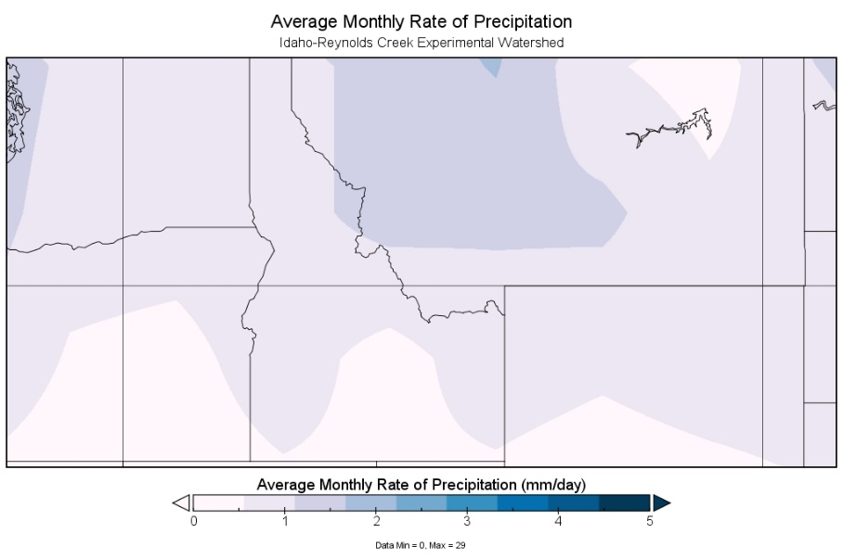

***3.2 Data Processing***

The team used Esri ArcMap 10.6.1, ArcGIS Pro, and Microsoft Office Excel for spatial analysis of vector and raster data as well as complementary processing of satellite-derived data, *in situ* data, and model outputs. ArcMap and ArcGIS Pro were also utilized to spatially process model output data layers, including delimitation (clipping) and georeferencing (orthorectification) of study areas. Panoply 4.10.4 was used to visualize precipitation data to determine the Patagonian Steppe extent.

In order to have a standard time metric for the posterior systematic comparison, we calculated cumulative monthly ET values for all three models. We applied corresponding mathematical operations for the different temporal features: 8-day (MODIS), 10-day (SSEBop), and 3-hour (GLDAS-2-Noah). Using the R platform, we aggregated the data into a monthly basis and exported them into CSV files. After the monthly values were sorted into corresponding water years for humid subtropical and semi-arid climates (corresponding to Paraná and Patagonian regions), we then generated annual time series to analyze seasonal and monthly patterns of ET. Because the study sites were in a different hemisphere than the validation site, time series were reported in a water year timeframe. The water year for Argentina is from July to June and the water year for the RCEW is from October to September. Detailed analysis and discussion about the validation done by the Idaho Water Resources II team can be found in Lauer et al. (2018). These time series were used for the final statistical analysis.

***3.3 Data Analysis***

Since each ET model has varying temporal resolutions (Appendix Table A3), we calculated the monthly average (mean) ET. Statistical correlation analysis was performed using linear regression and ANOVA (ANalysis Of VAriance). Coefficient of determination (r2) and standard deviation (*s*) were extracted from the regression analyses and the ANOVA table and compared to determine the most accurate models. We evaluated the accuracy of GLDAS-2-Noah using *in situ* data from RCEW through three categories: weak (r2<=0.3), moderate (0.3 < r2 <= 0.7), and strong (r2>0.7).

Next, a Kruskal-Wallis test and a Student’s t post hoc test were applied to the time series data to understand the relationship between the three models and their ability to predict ET in relation to each other. The Kruskal-Wallis test assumes a null hypothesis that all model medians are equal. The result provides a p-value, which is considered significant if that number is below 0.05. The Student’s t post hoc test determines the difference between the models by providing the p-value between each pair of models (see section 4.4).

# 4. Results & Discussions

***4.1 GLDAS-2-Noah***

The North American Land Data Assimilation System (NLDAS) ET output had strong correlations with *in suit* eddy covariance data evidenced by an r2 of 0.7 to 0.87 (Lauer et al. 2018). However, this dataset is not available in our Argentina study regions. Instead, GLDAS-2-Noah ET data were validated in RCEW with the same methodologies used by the Idaho Water Resources II team and then applied to our study areas in Argentina. GLDAS-2-Noah has the lowest spatial resolution of the models in the study at ~28 km, but it has the highest temporal resolution at 3 hours. Monthly summed ET regression coefficients for the study period ranged from 0.26 to 0.84 and for the 2017 water year ranged from 0.43 to 0.84 (*Figure 5*). The time series analysis displays a similar trend between the two study areas where ET is low at the beginning of the water year, increases during the growing season, and decreases after January until the start of the new water year. Peak ET values were reached at different months during both study years in both study areas. Paraná ET reached its maximum monthly sum in December and November of 2016 and 2017, respectively. Patagonian Steppe ET reached its maximum ET values in January and October of 2016 and 2017 respectively. As expected, ET values in Paraná were higher than the Patagonian Steppe, at times doubling total monthly cumulative ET in November (*Figure 6*). Similar to the NLDAS dataset, the GLDAS-2-Noah ET product assimilates meteorological datasets from across the earth. Therefore, high regression coefficients may be a product of these datasets and may not produce accurate results in regions that lack meteorological stations. Lower correlations may be the result of the lower spatial resolution of the data. A single pixel of the GLDAS-2-Noah ET output covered the entire RCEW validation site. Averaging ET over an area covered by GLDAS-2-Noah may artificially increase or decrease resulting ET outputs depending on the dominant land cover in each respective pixel.

*Figure 5*. GLDAS-2-Noah modeled ET vs. RCEW ET regression analysis for the 2017 water year.

B)

A)

Month

ET (mm)

*Figure 6.* A) GLDAS-2-Noah time series for the water years 2016 (purple) and 2017 (blue) in Paraná. B) GLDAS-2-Noah time series for the water years 2016 (purple) and 2017 (blue) in the Patagonian Steppe.

***4.2 SSEBop***

*Figure 7*A time series shows an increase of ET to the peak of the growing season (January) in Paraná and a decrease in ET following the growing season. Patagonian Steppe 2016 ET increased greatly after September until November. ET decreased following November but has a secondary spike in January. A substantial decrease in ET is seen following January until a third spike in April. 2017 ET data from the Patagonian Steppe increase rapidly in September and decreases for the remainder of the year with small ET spikes in February, April, and June (*Figure 7B*).

*Figure 7*. A) SSEBop time series for the water years 2016 (purple) and 2017 (blue) in Paraná. B) SSEBop time series for the water years 2016 (purple) and 2017 (blue) in the Patagonian Steppe.

Month

B)

A)

ET (mm)

***4.3 MOD16***

ET values in Paraná display a trend with an increase in ET and peaks during the growing season followed by a decrease in ET. ET does not drop below 55 mm during either year of our study period (*Figure 8A)*. ET in the Patagonian Steppe shows no definite trend in monthly values. A distinct increase in ET occurs in February and a distinct decrease in ET occurs in March of 2016 and 2017 respectively. Patagonian ET values do not drop below 40 mm during either year of our study (*Figure 8B*).

Month

B)

A)

ET (mm)

*Figure 8.* A) MOD16 time series for the water years 2016 (purple) and 2017 (blue) in Paraná. B) MOD16 time series for the water years 2016 (purple) and 2017 (blue) in the Patagonian Steppe.

***4.4 Kruskal-Wallis Analysis of ET Models***

A Kruskal-Wallis test was run to determine whether the medians of the models were similar in each study area. The data met all assumptions of the Kruskal-Wallis test except the assumption of homogenous variance. To test the relationship of the two models, we ran a Student’s t-test, which individually compared the models to one another for Paraná and the Patagonian Steppe. *Figures 9* and *10* show how MOD16 is different from SSEBop and GLDAS-2-Noah at both Paraná and Patagonia, respectively. Table 1 shows that the Kruskal-Wallis test in Paraná for two water years resulted in a p-value of 0.009, which gives 99 percent certainty that the models are statistically different and the same test in the Patagonian Steppe had a p-value of 0.0011, a 99 percent significant level, again showing that the models are statistically different. For both study areas, the null hypothesis was rejected, which states the medians of all groups are the same. The results for the Student’s t-test for Paraná (Table 1) showed that MOD16, when compared to SSEBop for two water years, had a p-value of 0.0001. When MOD16 was compared to GLDAS-2-Noah, the p-value was 0.0035, a 99 percent significant level. Thus we can say MOD16 is significantly different from SSEBop and GLDAS-2-Noah. SSEBop and GLDAS-2-Noah in Paraná had a p-value of 0.2927, which is not statistically different. The Student’s t-test results are similar in Patagonia with MOD16 once again being significantly different with p values of 0.0078 and 0.0018 from SSEBop and GLDAS-2-Noah, giving once again a 99 percent significant level.

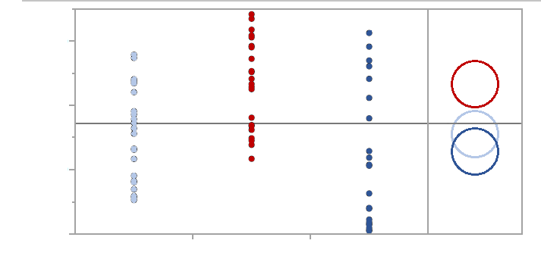

**Paraná**

GLDAS-2-Noah

MOD16

SSEBop

Group A

Group B



MOD16

SSEBop

GLDAS-2-Noah

0

50

100

150

Monthly ET (mm)

*Figure 9.*Kruskal-Wallis and Student’s t-tests for the Paraná study area.

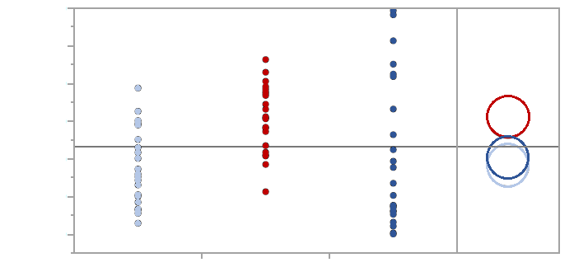

**Patagonian Steppe**

GLDAS-2-Noah

SSEBop

MOD16

Group A

Group B



MOD16

SSEBop

GLDAS-2-Noah

Monthly ET (mm)

*Figure 10.*Kruskal-Wallis and Student’s t-tests for the Patagonian Steppe study area.

Table 1

*Results from the Kruskal-Wallis and Student’s t-tests for Paraná on the left and the Patagonian Steppe on the right*

**Paraná Patagonian Steppe**

|  |  |  |  |  |  |  |  |  |  |  |
| --- | --- | --- | --- | --- | --- | --- | --- | --- | --- | --- |
| **Water Years** | **Kruskal- Wallis** | **Student’s t** | | |  | **Water Years** | **Kruskal-Wallis** | **Student’s t** | | |
|  | All Models | MOD16 vs. SSEBop | MOD16 vs. GLDAS-2-Noah | GLDAS-2-Noah vs. SSEBop |  | All Models | MOD16 vs. SSEBop | MOD16 vs. GLDAS-2-Noah | GLDAS- 2-Noah vs. SEEBop |
| Two Water Years | 0.0009** | 0.0001** | 0.0035** | 0.2927 | Two Water Years | 0.0011** | 0.0079** | 0.0018** | 0.6163 |
| 2016 | 0.0144* | 0.0032** | 0.0181* | 0.4939 | 2016 | 0.0418* | 0.0615 | 0.0229* | 0.6553 |
| 2017 | 0.0523 | 0.0169* | 0.0920 | 0.4400 | 2017 | 0.0139* | 0.0540 | 0.0301* | 0.7906 |
| * Significant Level at 95% | | | | | | | | | | |
| ** Significant Level at 99% | | | | | | | | | | |

***4.5 Future work***

The ET models used in this study have been previously validated in RCEW. However, our study areas and validation site for this project are in different hemispheres. Validating various ET models using *in situ* equipment (eddy covariance tower) from a semi-arid region in the southern hemisphere may help land managers explore the applicability of ET models in geographically different but biophysically similar regions. There is also continued interest in using the ECOsystem Spaceborne Thermal Radiometer Experiment on Space Station (ECOSTRESS) to determine ET across different environments. Currently, the time series from the modified Surface Energy Balance Algorithm for Land (SEBAL) model developed by our partners at CONICET, are not available. Developing a method to automate the process of image downloading and raster processing would allow our partners to apply their model across larger spatial extents and temporal timescales. Furthermore, because the changing climate is expected to influence global temperatures and precipitation regimes (Diffenbaugh & Giorgi, 2012; Pereira, 2011; Saadi et al., 2014; Trenberth, 2011), analyzing long-term time series can help land managers understand shifts in hydrologic regimes as a response to shifting climates. Long-term data analysis in both Argentina and RCEW can make clear the differences in water availability in response to climate variations.

# 5. Conclusions

In our investigation of ET models, we came to four main conclusions. The first being that MOD16 is significantly different from other models across both study areas. This could indicate that MOD16 uses a different equation or different variables when measuring ET. Secondly, GLDAS-2-Noah and SSEBop have no statistically significant difference for either study area. The third conclusion is that GLDAS-2-Noah and SSEBop have the potential to be applied to a semi-arid region like the Patagonian Steppe. Lastly, we would propose the development of a hybrid model for GLDAS-2-Noah and SSEBop.

MOD16 was found to be statistically and significantly different from both GLDAS-2-Noah and SSEBop in the Paraná and the Patagonian Steppe with a 99 percent significant level according to the Student’s t post hoc test for two water years (2016, 2017). This could indicate that MOD16 either uses different variables than the other models, or it could be a factor of the MOD16 base equation, the Penman-Monteith equation. There is an inherent error with MOD16 as it tends to overestimate ET values, which is to be expected because the Penman-Monteith equation overestimates ET values in heterogeneous environments (DehghaniSanij et al., 2004).

GLDAS-2-Noah and SSEBop showed no statistically significant difference in ET values for either study area. Due to their statistical similarity, GLDAS-2-Noah and SSEBop have the potential to be applied in a semi-arid study region like the Patagonian Steppe. Furthermore, a model could be developed that utilizes the important aspects of the two. GLDAS-2-Noah and SSEBop performed well over the semi-arid study region for this project. We would propose developing a model that combines the temporal resolution of GLDAS-2-Noah and the spatial resolution of SSEBop. This model would be optimal for regional or global investigations of ET and could be an effective way to measure ET more accurately. This hybrid model would likely be applicable in semi-arid study regions based on the individual model performances in the Patagonian Steppe and in RCEW. We must keep in mind there could be errors due to a large difference in spatial resolution, 1 km and 28 km respectively. But this model would be a good combination of an energy balance model and estimated and observed ET measurements.

Throughout this project, we have investigated the applicability of three different models in our study areas. With our analysis, we discovered that GLDAS-2-Noah and SSEBop are statistically similar and therefore have the highest confidence for use in a semi-arid region. GLDAS-2-Noah has a better temporal resolution but poorer spatial resolution compared to that of SSEBop. SSEBop could allow for a more detailed spatial investigation for utilization by land managers. Both models can be applied in these kinds of locations to aid in decision-making processes surrounding water availability. Use of either model would be beneficial in the advancement of studying ET across the globe.

In general, monthly ET values during the study period in Paraná are more consistent compared to monthly ET values in the Patagonian Steppe. This might be the result of agricultural irrigation providing a standard annual water use regime. Varying ET values during the study period in the Patagonian Steppe may be more closely related to water availability and variability of precipitation. In this region, there are a few vegetation species that are summer or winter ephemerals which are strictly dependent on seasonal rainfalls. For example, the peak in ET seen in February 2017 in the SSEBop time series might be the result of a summer ephemeral bloom.

# 6. Acknowledgments

The Argentina Water Resources team would like to thank advisors and project partners who dedicated their time, resources, and assistance to the project:

Consejo Nacional de Investigaciones Científicas y Técnicas (CONICET):

* Dr. Pablo G. Aceñolaza, Researcher
* Sebastián Anibal Gavilán, Researcher

Special thank you to our DEVELOP Idaho – Pocatello Node Science Advisor:

* Keith T. Weber, GIS Director at Idaho State University, GIS TReC

Thank you to all previous DEVELOP contributors, the Idaho Water Resources I and II team members:

* Ian Lauer, Carolyn Macek, Francis Zurek, Madison Broddle, Dane Coats, Leah Kucera, Zach Sforzo

Thank you to the DEVELOP Colorado – Fort Collins and Idaho – Pocatello Node leadership for help writing the proposal for this project and technical editing:

* Kristen Dennis, Center Lead
* Tim Mayer, Former Center Lead
* Dane Coats, Assistant Center Lead and Geoinformatics Fellow

Any opinions, findings, and conclusions or recommendations expressed in this material are those of the author(s) and do not necessarily reflect the views of the National Aeronautics and Space Administration.

This material is based upon work supported by NASA through contract NNL16AA05C.

# 7. Glossary

**CONICET –** National Scientific and Technical Research Council of Argentina

**ET –** Evapotranspiration, which is the transport of water from different land surfaces and vegetation to the atmosphere

**GEE –** Google Earth Engine

**GLDAS-2-Noah** –Global Land Data Assimilation System-2-Noah

**Microphyllous xerophytic** – A plant found in relatively dry habitats with one single, unbranched leaf vein

**MODIS** – MODerate resolution Imaging Spectroradiometer

**MOD16** – MODerate resolution Imaging Spectroradiometer Global Evapotranspiration Project

**Reference evapotranspiration –** Evapotranspiration from a standardized vegetated surface

**SSEBop –** Operational Simplified Surface Energy Balance

# 8. References

Beaudoing, H., & Rodell, M. NASA/GSFC/HSL. (2016). GLDAS Noah Land Surface Model L4 3 hourly 0.25 x 0.25 degree V2.1, Greenbelt, Maryland, USA, Goddard Earth Sciences Data and Information Services Center (GES DISC). doi: 10.5067/E7TYRXPJKWOQ

Beck, H.E., Zimmerman, N.E., McVicar, T.R., Vergopolan, N., Berg A., & Wood, E.F. (2018). Present and future Köppen-Geiger climate classification maps at 1-km resolution. *Scientific Data, 5(180214).* doi: 10.1038/sdata.2018.214

DehghaniSanij, H., Yamamoto, T., & Rasiah, V. (2004). Assessment of evapotranspiration estimation models for use in semi-arid environments. *Agricultural Water Management, 64*(2), 91-106. <https://doi.org/10.1016/S0378-3774(03)00200-2>

Diffenbaugh, N. S., & Giorgi, F. (2012). Climate change hotspots in the CMIP5 global climate model ensemble. *Climatic Change*, *114*(3-4), 813–822. doi: 10.1007/s10584-012-0570-x

Falge, E., Aubinet, M., Bakwin, P.S., Baldocchi, D., Berbigier, P., Bernhofer, C.,…Wofsy, S.C. (2017). FLUXNET Research Network Site Characteristics, Investigators, and Bibliography, 2016. ORNL DAAC, Oak Ridge, Tennessee, USA. doi: 10.3334/ORNLDAAC/1530

Fernández, O. A., & Busso, C. A. (1999). Arid and semi-arid rangelands: two thirds of Argentina. *Arid and semi-arid rangelands of Argentina* (41-60). Reykjavíc (Iceland: Agricultural Research Institute). Received from <http://citeseerx.ist.psu.edu/viewdoc/download?doi=10.1.1.550.86&rep=rep1&type=pdf>

Fisher, J.B., Melton, F., Middleton, E., Hain, C., Anderson, M., Allen, R.,…Wood, E.F. (2017). The future of evapotranspiration: Global requirements for ecosystem functioning, carbon and climate feedbacks, agricultural management, and water resources. *Water Resources Research, 53*(4), 2618-2626. <https://doi.org/10.1002/2016WR020175>

Gavilán, S., Pastore, J.I., Quignard, I., Marasco, N.D., & Aceñolaza, P.G. (*in review*). Energy balance model to estimate real evapotranspiration from satellite and Meteorological data.

García, C. (2019). Climas del territorio argentino. Retrieved on March 28, 2019 from https://www.educ.ar/recursos/14651/climas-del-territorio-argentino

Hatfield, J. L., Reginato, R. J., & Idso, S. B. (1984). Evaluation of canopy temperature—evapotranspiration models over various crops. *Agricultural and Forest Meteorology, 32*(1), 41-53. <https://doi.org/10.1016/0168-1923(84)90027-3>

Lauer, I., Jurkowski, C., Macek, C., & Zurek, F. (2018) Idaho Water Resources II: Evaluating Evapotranspiration and Water Budget Components in Semi-Arid Sagebrush Steppe*. Technical Report*. *NASA DEVELOP National Program: Idaho Node, Pocatello, ID*.

Mu, Q., Zhao, M., & Running, S. W. (2011). Improvements to a MODIS global terrestrial evapotranspiration algorithm. *Remote Sensing of Environment*, *115*(8), 1781-1800. <https://doi.org/10.1016/j.rse.2011.02.019>

NOAA/OAR/ESRL PSD (2019). CPC Merged Analysis of Precipitation (CMAP) [Mean (Standard Monthly)]. Retrieved from https://www.esrl.noaa.gov/psd/data/gridded/data.cmap.html#detail

Pereira, L. S. (2011). Challenges on Water Resources Management when Searching for Sustainable Adaptation to Climate Change focusing Agriculture. *European Water*, *34*. 41-54. Retrieved from <https://www.ewra.net/ew/pdf/EW_2011_34_04.pdf>

Saadi, S., Todorovic, M., Tanasijevic, L., Pereira, L. S., Pizzigalli, C., & Lionello, P. (2014). Climate change and Mediterranean agriculture : Impacts on winter wheat and tomato crop evapotranspiration, irrigation requirements and yield. *Agricultural Water Management*, *147*, 103-115. doi: 10.1016/j.agwat.2014.05.008

Stancalie, G., & Nertan, A. (2012). Possibilities of deriving crop evapotranspiration from satellite data with the integration with other sources of information. In Ayse Irmak (Eds.), *Evapotranspiration – remote sensing and modeling* (437-466). IntechOpen. doi: 10.5772/23635

Running, S., Mu, Q., Zhao, M. (2017). MOD16A2 MODIS/Terra Net Evapotranspiration 8-day L4 Global 500m SIN Grid V006. NASA EODIS LP DAAC. doi: 10.5067/MODIS/MOD16A2.006

Trenberth, K. E. (2011). Changes in precipitation with climate change. *Climate Research*, *47*, 123-138. doi: 10.3354/cr00953

United States Geological Survey. (n.d.). Evapotranspiration and the water cycle. Retrieved on March 28, 2019, from https://water.usgs.gov/edu/watercycleevapotranspiration.html

Wang, W., Cui, W., Wang, X., & Chen, X. (2016). Evaluation of GLDAS-1 and GLDAS-2 forcing data and Noah Model simulations over China at the monthly scale. *Journal of Hydrometeorology*, *17*, 2815–2833. https://doi.org/10.1175/JHM-D-15-0191.1

Zeng, Z., Piao, S., Lin, X., Yin, G., Peng, S., Ciais, P., & Myneni, R. B. (2012). Global evapotranspiration over the past three decades: estimation based on the water balance equation combined with empirical models. *Environmental Research Letters*, *7*(1). doi: 10.1088/1748-9326/7/1/014026

Zhang, B., Kang, S., Li, F., & Zhang, L. (2008). Comparison of three evapotranspiration models to Bowen ratio-energy balance method for a vineyard in an arid desert region of northwest China. *Agricultural and Forest Meteorology, 148*(10), 1629-1640. <https://doi.org/10.1016/j.agrformet.2008.05.016>

# 9. Appendices

**Appendix A.** Dataset information.

Table A1

*Primary datasets used in this study*

|  |  |  |  |  |
| --- | --- | --- | --- | --- |
| **ET Model** | **Model Type** | **Date** | **Source** | **Satellite** |
| Operational Simplified Surface Energy Balance (SSEBop) | Surface Energy Balance | 2015 to 2017 | <https://cida.usgs.gov/gdp/> | PRISM, TERRA MODIS, SRTM |
| Global Land Data Assimilation System (GLDAS-2) Noah | Land Surface Model | 2015 to 2017 | <https://giovanni.gsfc.nasa.gov/giovanni/> | AQUA AMSR-E,  TRMM TMI,  DMSP,  NOAA-18, GOES |
| Penman-Montieth MOD 16 | Penman-Montieth | 2015 to 2017 | <https://lpdaac.usgs.gov/node/1191> | TERRA MODIS |

Table A2

*Ancillary datasets used in this study*

|  |  |  |  |  |
| --- | --- | --- | --- | --- |
| **Dataset** | **Date** | **Use** | **Acquired From** | **DOI** |
| FLUXNET | 2015 to 2017 | CO2, water vapor, energy measurements | https://daac.ornl.gov/cgi-bin/dataset_lister.pl?p=9 | 10.3334/ORNLDAAC/1530 |
| RCEW Soil Moisture | 2015 to 2018 | Soil moisture | USDA-ARS | N/A |
| RCEW Precipitation | 2017 | Precipitation | USDA-ARS | N/A |
| Reynolds Creek - Soils, Vegetation, and Geology | 1960 to 1970 | Vegetation | Critical Zone Observatory - Reynolds Creek Experimental Watershed | http://criticalzone.org/reynolds/data/dataset/3722/#policy |
| Reynolds Creek - Instrumentation, Regions, and Boundaries | 2014 | Boundaries and instrument locations | Critical Zone Observatory - Reynolds Creek Experimental Watershed | http://criticalzone.org/reynolds/data/dataset/3934/#citation |
| Joint Research Centre Global Surface Water Mapping Layers, v1.0 | 2015 to 2017 | Surface water for model validation of ET models | Google Earth Engine | https://global-surface-water.appspot.com/download |
| USGS NED n44w117 1/3 arc-second 2013 1 x 1 degree | 2013 | Elevation | U.S. G US Geological Survey | https://catalog.data.gov/dataset/national-elevation-dataset-ned-1-3-arc-second-downloadable-data-collection-national-geospatial |

Table A3

*ET model resolutions*

|  |  |  |
| --- | --- | --- |
| **ET Model** | **Spatial Resolution** | **Temporal Resolution** |
| Moderate Resolution Imaging Spectroradiometer (MODIS) Global Evapotranspiration Project (MOD16) | 500 m | 8 days |
| Operational Simplified Surface Energy Balance (SSEBop) | 1 km | 10 days |
| Global Land Data Assimilation Noah evapotranspiration (GLDAS-2-Noah) | ~28 km | 3 hours |