**NASA DEVELOP National Program**



NASA Jet Propulsion Laboratory

*Summer 2017*

Southern California Oceans

Analyzing NASA Earth Observation Data to Evaluate Grunion Response to Ecosystem Changes Forced by Recent Environmental Conditions in California’s Oceans

 **Technical Report**

Final Draft – August 10, 2017

Lael Wakamatsu (Project Lead)

Sol Kim

Ariana Nickmeyer

Benjamin Holt, NASA Jet Propulsion Laboratory, California Institute of Technology (Science Advisor)

# 1. Abstract

The California grunion is an endemic fish species vital to the California coast, acting as a versatile food source for many species such as seabirds, large mammals, and other fish in the food web. This species, known primarily for the unique way in which they spawn, have two specialized regions. Historically, they only occur in Southern California and northern Baja California and are vulnerable to air and ocean temperature changes. In the last 16 years, scientists recorded grunion spawning further north to the San Francisco Bay area. In response to air and ocean temperature increases, the fish migrate to cooler waters they are more adapted to. This is an issue due to the fact that the grunion found here are much smaller in size, indicating the north coast may not be as suitable for the species. Increased beach activity, beach cleaning practices, and coastal erosion significantly contribute to the decrease in population and the significant shift of spawning areas. This project, in collaboration with the Grunion Greeters Project, used Aqua MODIS satellite data for sea surface temperature (SST) and chlorophyll-a concentration to create a time series of the California coast from 2003 to 2017. Analyzing this product will help predict grunion spawning areas and can be used to develop beneficial management practices as well as establish new protective areas to keep the species thriving and safe.

**Keywords**

California grunion, species migration, sea surface temperature rise, remote sensing, Aqua MODIS, chlorophyll-a, coastal erosion

# 2. Introduction

* 1. ***Background Information***

The California grunion (*Leuresthes tenuis*) is a silverside fish endemic to the coast of California, USA and northern Baja California, Mexico (Martin, 2015). The fish are known for their unusual spawning behavior during the summer months, which involves “running” en masse onto sandy beaches after the full or new moon, when the height of the high tide is greatest (Martin, Moravek, Martin, & Martin, 2011). During these runs, which can involve thousands of grunion, the females bury themselves in the sand, laying up to 3,000 eggs at a time in their nest (Martin, Moravek, & Carlson, 2011). Several males then fertilize the eggs, wrapping themselves around a female and releasing their milt, or fish sperm, to complete the fertilization process (Walker, 2011).

The sandy beaches suitable for this key step in grunion life history are infrequent within their geographic range due to geologic variation and extensive urban development along California’s coast (Martin et al., 2007). Of these beaches, many are being altered by human activities such as beach grooming and coastal armoring, which when combined with irresponsible human interference during runs, threatens the ability of the grunion to complete their spawning process and persist at healthy population levels (Martin et al., 2007). Between 2004 and 2014, the median number of grunion in a run decreased from several hundred to a thousand fish spawning for half an hour, to less than one hundred fish with nearly no actual spawning (Martin, 2015). In this same time period, increases in air and ocean temperatures along the southern California coast have pushed grunion northward as far as San Francisco Bay, where adult fish are smaller and produce fewer eggs as they are not adapted to the physical conditions that exist further north (Martin, 2015).

Grunion runs are a unique and beloved experience in California, exciting to adults and children alike and inciting a closer connection to nature (Martin et al., 2007). Since 2002, the Grunion Greeters Project has collected *in situ* data on the grunion in an effort to ensure that the fish and their eggs are protected from as many harmful anthropogenic sources as possible (Martin, 2015). The project is a collaboration between 30 different organizations, including the California Department of Fish and Game, U.S. Fish and Wildlife Service, California State Parks, California Coastal Commission, and the U.S. National Oceanic and Atmospheric Administration (NOAA) (Martin et al., 2007). Under this project there is an influx of data to Grunion.org throughout the spawning season (March to June) by citizen scientists, who observe and document the status of grunion populations on beaches all along the California coast (Martin et al. 2011). These datasets can subsequently be accessed and used by scientists, beach managers, and government agencies in their decision-making practices (Martin et al., 2011).

A policy currently in effect in San Diego balances the issues of beach grooming to support tourism and recreation while leaving grunion nests undisturbed (Martin et al., 2006). Under this protocol, beaches are only groomed shoreward of the high tide line until two weeks after the last grunion run (Martin et al., 2006). Additionally, throughout California, there is a “no-take” policy during the closed season from April to May (Martin et al., 2011). During the rest of the season, however, visitors may use only their hands to catch the grunion, and persons over 16 years of age require a fishing license (Martin, 2015). Taking these factors into account, this study’s geographic range encompassed the beaches and coastal waters of California from San Diego to San Francisco Bay (Figure 1). Data from April through August were used for the years 2003 to 2016.

*Figure 1.* Study area map. Coast of California.

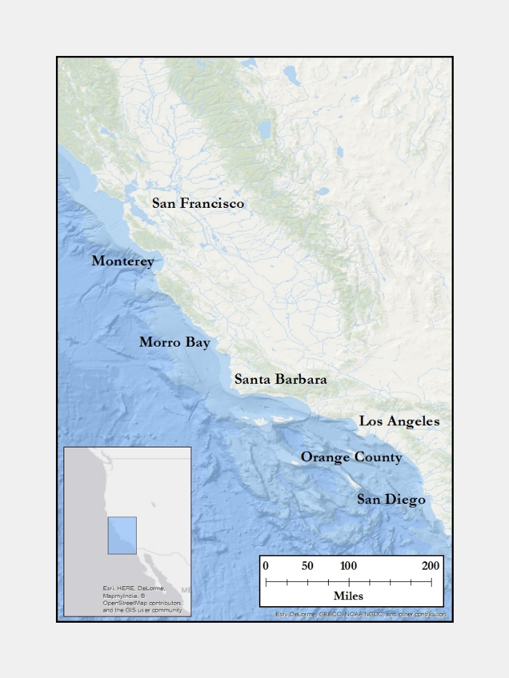

***2.2 Project Partners & Objectives***

This project addressed and contributed to NASA’s Oceans application area by analyzing changes in sea surface temperature (SST) and chlorophyll-a (chl-a) levels through the use of remote sensing technology. The findings can improve understanding of the trends and patterns of SSTs and chlorophyll-a from 2003 to 2016, and can be used to compare with grunion run data along the California coast. The trends in SSTs and chlorophyll-a concentrations will help determine how the grunion are responding and migrating.

Collaborating with the Grunion Greeters Project under Dr. Karen Martin, this project hopes to expand its partner’s capacity to predict spawning sites and create management plans to conserve the species from further anthropogenic harm.

To date, the Grunion Greeters have been utilizing *in situ* datasets provided by citizen scientists, but have not yet harnessed the capabilities of remote sensing technology and analysis afforded by Earth observations data. The time series maps of SST and chlorophyll-a conditions generated by this project will provide a new perspective to its partner, the Grunion Greeters. This product will save time and resources for the project, allowing them to more coherently assess current management approaches, where citizen scientists should focus their *in situ* data collection, where future spawns may occur, and how to direct future management practices.

# 3. Methodology

***3.1 Data Acquisition***

The Ocean Color SMI (Standard Mapped Image) Level-3 Product from 2003 to2016 was obtained from the Moderate Resolution Imaging Spectroradiometer (MODIS) aboard the Aqua satellite for the chlorophyll-a time series analysis. The product has a resolution of 1 kilometer and is an 8-day composite. The satellite uses 36 spectral bands with a specific array of wavelengths used for each one. For ocean color data, we focused on bands 8-16 for the project. This band range includes data for chlorophyll-a concentrations, an indicator of where phytoplankton and therefore zooplankton, the main food source of grunion, are concentrated. The data were acquired from Open-source Project for a Network Data Access Protocol (OPeNDAP), a simple data access tool to download the data as a NetCDF and process it in MATLAB.

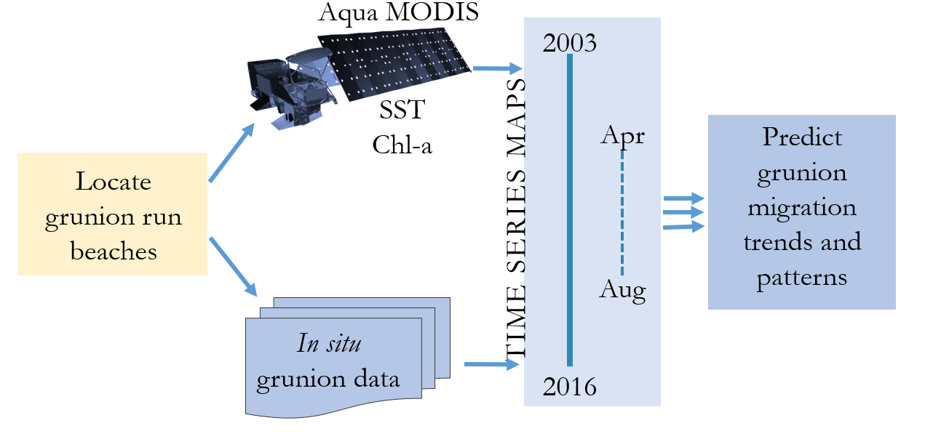

*Figure 2*. Illustration of the combination of *in situ* and satellite data to create a time series to then hypothesize the grunion migration patterns.

Remote sensing imagery, Multi-scale Ultra-high Resolution Sea Surface Temperature (MUR SST), (GHRSST, Global Foundation Sea Surface Temperature Analysis (v4.1) Level 4), data were utilized for the sea surface temperature time series map. MUR data combines six data sources to reduce cloud cover and produce images at a high resolution of 1 km. The six sources include the instruments MODIS, Advanced Very High Resolution Radiometer (AVHRR), Advanced Microwave Scanning Radiometer – Earth Observing System (AMSR-E), Advanced Microwave Scanning Radiometer 2 (AMSR2), Windsat, and *in situ* data from buoys and ships. The MUR data were obtained through OPeNDAP and downloaded as netCDF files via MATLAB using coordinates of our six coastal location boxes. The dates included April 1, 2003 through August 31, 2016.

Six shapefiles were defined within ArcMap and QGIS along the California coast to narrow down our study area and to pull coordinates for the satellite data. The boundaries of the boxes were chosen in order to encapsulate both a specific beach and major coastal area for the grunion as well as one of the air temperature stations from NOAA’S National Climatic Data Center (NCDC). These boxes of various sizes extended from San Francisco Bay in the north to San Diego in the south. We used them to subset our satellite imagery data, and then examined and compared NCDC air temperature data to the MODIS sea surface temperature data to look for any variation. Air temperature data were gathered from NOAA’s National Centers for Environmental Information (NCEI). The maximum and minimum air temperatures were analyzed for each location along the California coast.

The El Niño Southern Oscillation (ENSO) and Pacific Decadal Oscillation (PDO) indices for the time period of 2003 to 2016 were acquired from NOAA’s National Centers for Environmental Information and the National Centers for Environmental Prediction (NCEP). These indices were chosen to compare with our temperature and chlorophyll-a concentration data in order to afford some insight into longer-scale patterns which may have influenced the grunion. These indices go back to the 1850’s, making it easier to look for long-term trends in the Pacific Ocean along the coast of California. Additionally, both the ENSO and PDO phenomena are known to have a marked effect on the abundance of a multitude of species in the Pacific.

The grunion data were provided by the Grunion Greeters Project in spreadsheets for four different beaches – San Francisco Bay/Dillon Beach, Malibu, Cabrillo, and Pacific Beach, San Diego. The magnitude of grunion runs was recorded using the Walker Scale, with values of 0 to 5, with 0 representing no grunion present during an expected run and 5 the highest potential for a run, with thousands of fish on the beach. Grunion Greeter volunteers collect these data. Although these citizen scientists undergo training before collecting data, the nature of the Walker Scale means that the boundaries between values are not obvious, and two different observers may differ in their assessments of the same grunion run. Therefore, the data set has subjectivity present. The date range for the grunion data is from 2002 to 2017; however, reports were not received consistently for every beach and there are some years when the data are sparse as no volunteers were present to record data.

***3.2 Data Processing***

The program MATLAB was used for the JPL MUR (Multiscale Ultra-high Resolution MEaSUREs (Making Earth Science Data Records for Use in Research Environments)) dataset as well as the Ocean Color chlorophyll-a dataset. The data for JPL MUR were downloaded as a NetCDF using the OPeNDAP server via MATLAB. The data were subset for both geographic extent and temporal extent (April - August of each year). The chlorophyll-a dataset was downloaded by year for our study period months from the National Oceanic and Atmospheric Administration’s (NOAA) tool called Easier Access to Scientific Data (ERDDAP). ERDDAP is a data access form to simply pull data from Aqua MODIS in our coordinate range.

MATLAB was used to subset the *in situ* data from NCDC into specific categories such as maximum, minimum, and average air temperature, coordinates of stations, station names and the date the data were collected. This was done for all *in situ* data including our air temperature data from NCEI. This program was also utilized to subset the MUR SST and Aqua MODIS chlorophyll-a concentrations to create matrices to hold our date range of April-August of 2003 to 2016 in our six designated locations along the coast. After subsetting the data for each location, monthly means were calculated for the entire study period. The climatologies of each month of each location throughout the time period were also calculated. The climatology was subtracted from the corresponding monthly mean of each location to determine these anomalies. MATLAB was also used to create images of the April monthly mean sea surface temperatures and mean chlorophyll-a concentrations of the years 2003, 2010, and 2016 to visually see how the coastal areas were changing through the time period. April was chosen to display these images since it is the peak time of the grunion spawning season and during this time the spring bloom of chlorophyll is fairly abundant near the coast of California.

NASA’s SeaDAS software was used to generate a visual image of an April 2016 SST anomaly for 2002-2017 April climatology. An ocean color, Aqua MODIS Chlorophyll Concentration, OCl Algorithm level 3 BIN, global image for April monthly climatology and another image of April monthly chlorophyll concentration was manually downloaded into SeaDAS. Each file was interpolated for the area of latitude of 90 to -90 and longitude 180 to -180. The files were collocated to subtract the April 2016 monthly composite from the April 2002-2017 climatology. This process generated the monthly anomaly for April 2016. The image was clipped to the area of our study area, the coast of California.

***3.3 Data Analysis***

To compare multiple parameters at once, the minimum *in situ* daily temperature (NOAA’S NCEI), grunion Walker Value data, mean SST (MUR) and chlorophyll-a concentration (Aqua MODIS) for our four beaches, San Francisco Bay/Dillon, Malibu, Cabrillo and Pacific Beach during the months April-August and the years 2004-2016 were plotted altogether in Excel. This time series begins in 2004 or 2005, since data collection from the Grunion Greeters was not active prior to this year. Each bar in the figure represents the Walker Value for one months for April-August. Minimum mean air temperature, SST and Chl-a variables were plotted as lines (Figure 3). These parameters were plotted to look for a relationship of grunion numbers during the runs, temperature of the air and water, as well as the chlorophyll-a concentration for the four beaches along the coast. The beaches chosen represent a small glimpse of how many grunion are present at these different latitudes.

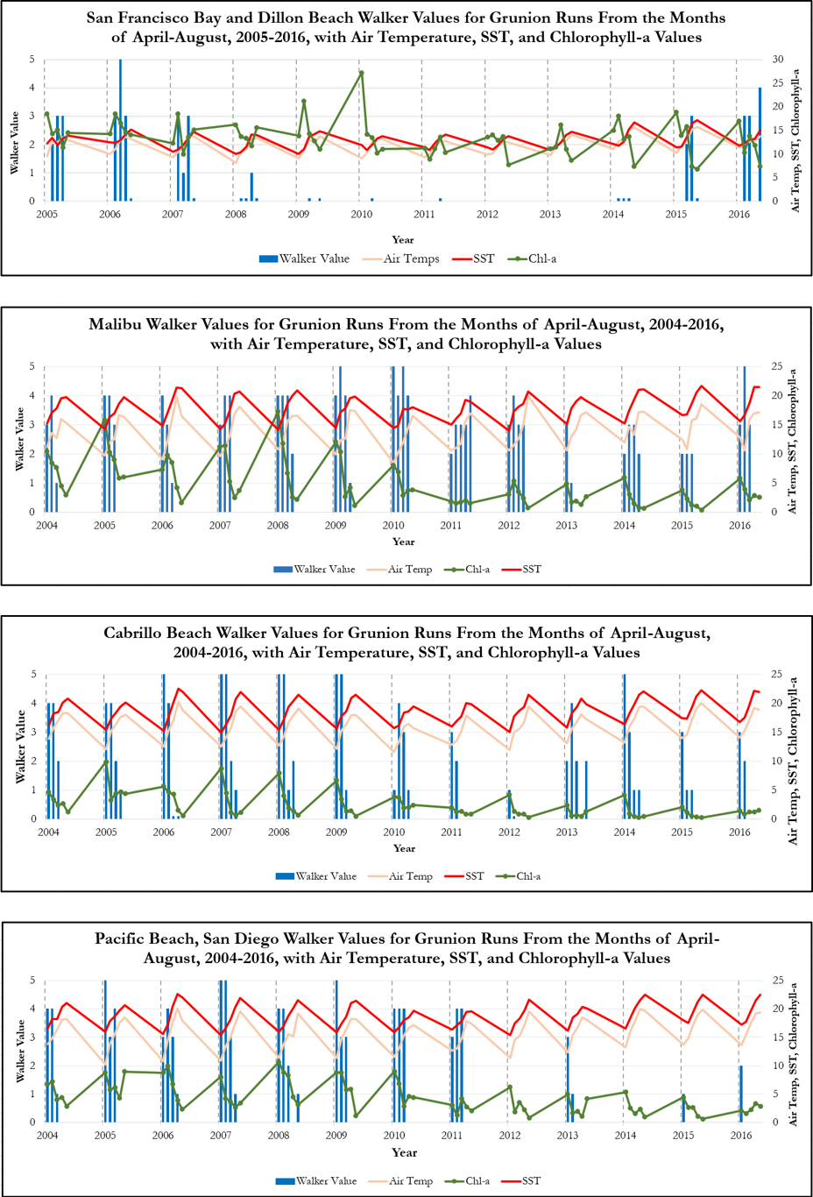A time series anomaly index calculated from MUR SST data and Aqua MODIS chlorophyll-a data of our six major study area boxes near the California coast were created to compare the magnitude of increases and decreases of the variables over time (Figure 4). These indices are plotted as bars, each bar represents a month April – August for 14 years starting at 2002 and ending at 2016. The bars are shown red when there is an increase and blue when there is a decrease, making it easier to see the variation of SST and chlorophyll-a concentration over the months and years. Along with the satellite data, mean minimum *in situ* air temperature from NOAA’S NCEI was plotted as a dotted line to determine any shifts or changes in the air temperature versus the sea surface temperature. The ENSO and PDO indices from NOAA’s NCEP were included to allow southern California’s SST and chlorophyll-a trends to be compared to climatic oscillations occurring on a greater timescale in the larger picture of the Pacific Ocean.

*Figure 3.* *In situ* grunion data from the Grunion Greeters Project and station air temperature plotted with SST data from MUR (°C) and Chlorophyll-a (mg/m3) concentrations from MODIS for April-August, 2004-2016.

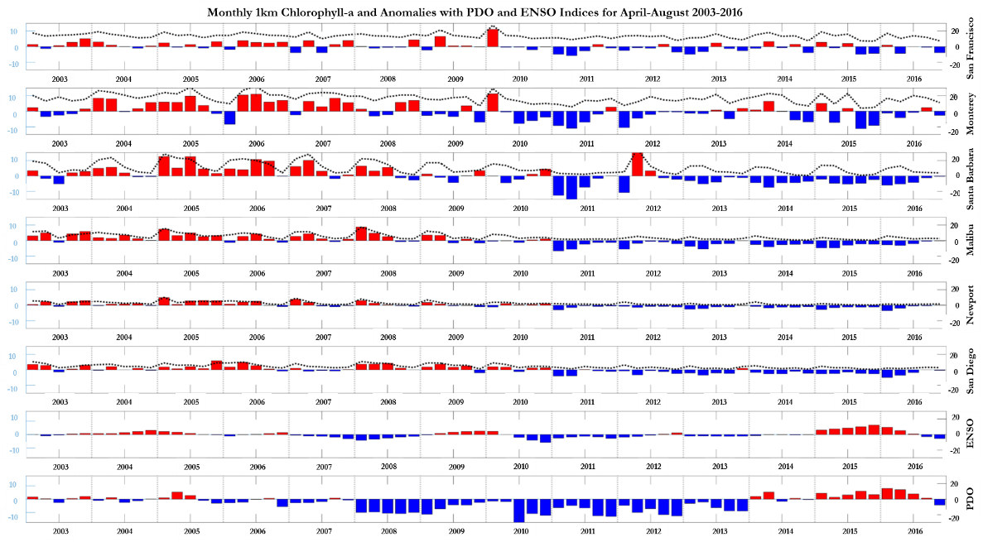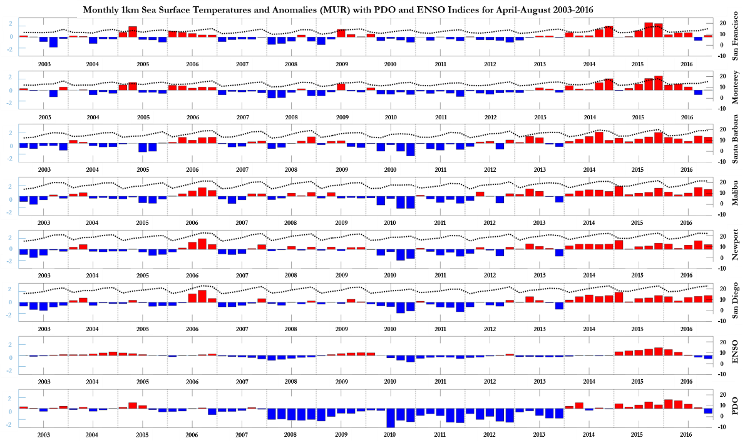

*Figure 4*. Sea surface temperature and chlorophyll-a concentration anomaly indices calculated from satellite data and represented as bars for each month. *In situ* air temperature plotted as a dotted line for comparison to the SST. ENSO and PDO indices compared with chlorophyll-a and SST satellite values and anomalies for the time period.

The four beaches with the most consistent and greatest amount of grunion runs throughout the years 2004-2016 were available for *in situ* data. At least two runs occurred per month (in line with the full and new moons). The highest Walker value for each month for each beach was taken to represent the entire month, as any lower runs were considered to be noise and not representative of the full potential of a spawn for the location at a certain time. Air temperature stations near the designated beaches were selected from the NCDC database to compare to the satellite sea surface temperature data. Grunion data from these four beaches situated up and down the coast were plotted with the subset chlorophyll-a, sea surface temperature, and air temperature data in Excel. R-squared values were calculated using linear regression for each location’s fields (SST, chlorophyll-a, air temperature) individually against the Walker values to see how well these fields could explain grunion run strength.

# 4. Results & Discussion

***4.1 Analysis of Results***

The plots of remotely sensed sea surface temperature and *in situ* air temperature closely mirror each other, validating the satellite imagery temperature recordings. The SSTs are higher and do not drop as low as the air temperatures due to the high heat capacity of water and due to the fact that the mean minimum temperatures were plotted. Chlorophyll-a concentration trends appear to be inversely related to the temperature data; as the chlorophyll-a concentrations increased, sea surface temperature decreased. Cold SSTs and high chlorophyll-a levels indicate the presence of upwelling. As winds from the north blow south, Ekman transport causes surface waters near the coast to move west (away from the coast). Colder, nutrient-dense water upwells from the deeps to replace the warmer surface waters that have been pushed west. These conditions were seen when grunion were more likely to be present and in a larger abundance. When looking at the beaches on a latitudinal gradient, chlorophyll-a concentrations are relatively high in the San Francisco Bay/Dillon Beach area due to that area’s anthropogenic activities, with the overall concentration of chlorophyll-a decreasing towards the south. Grunion data for the four beaches were plotted individually to give a general idea of how grunion run activity varies by latitude (Figure 4). Grunion runs are always highest in magnitude during the first few months of the spawning season, similar to the trend of chlorophyll-a concentrations each year. It should be noted that there are only zeroes or no data taken (NAN) for San Francisco Bay/Dillon Beach during the years of 2009 to 2014.

The SST anomalies match the PDO and especially the ENSO indices much closer than the chlorophyll-a anomalies, which was expected based on what is known about these two climatic phenomena. Additionally, SST monthly values for the six regions contain more similarities in their overall trends and trajectories than the chlorophyll-a monthly values for the six regions. While all six regions’ sea surface temperatures follow the same annual trends the areas to the south are always warmer. However, for chlorophyll-a concentration, patterns are less regular and are far higher in the north.

Uncertainties naturally arise due to the relative shortness of the timescale of our study; 2003-2016 is a little over a decade and large-scale migration patterns are harder to detect with this limitation. Additionally, not all of the available grunion data from Grunion Greeters were incorporated into our analysis due to time restrictions. The data also contained holes and inconsistencies as citizen scientists were not active during all years of the study at all the beaches. Working with more grunion data could expand, refute, or solidify some of our results.

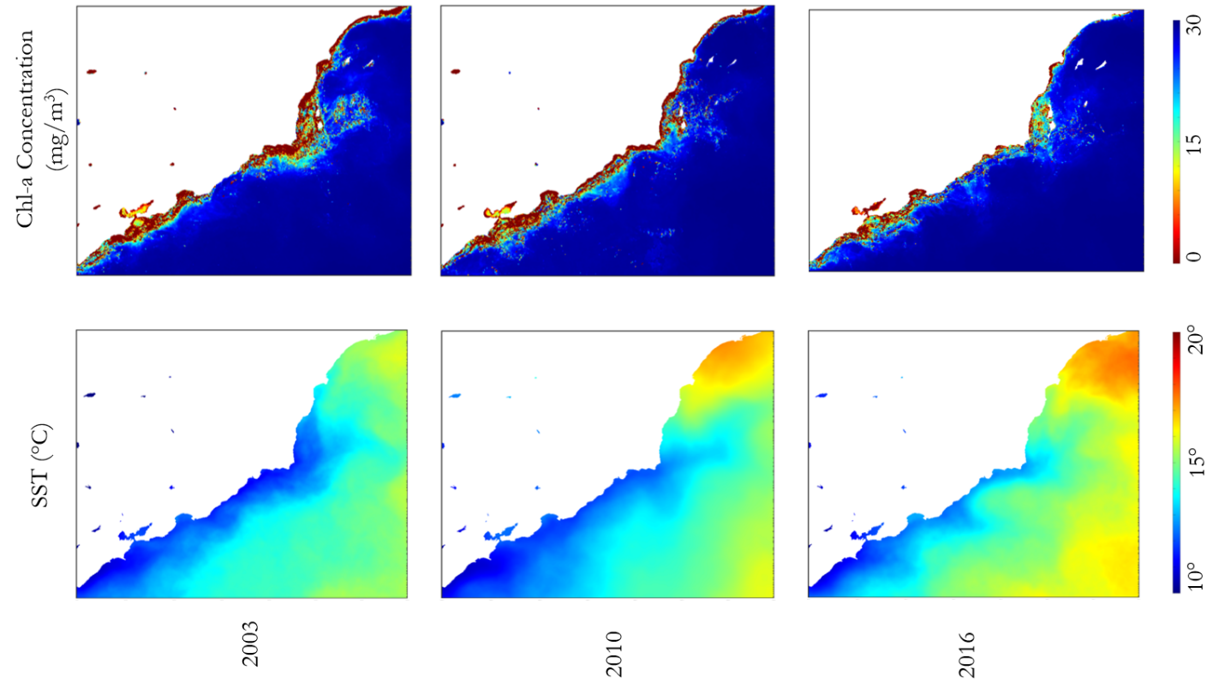

*Figure 5*. SST and chl-a images from MUR and Aqua MODIS respectively for the month of April in the years 2003, 2010, and 2016.

***4.2 Future Work***

Outside of its spawning habits, most of the life history of the California grunion is still unknown and unstudied. There is great potential for future work on this unique, endemic species and what roles it fills in the pelagic ocean, as well as room for expansion in research on what factors affect the magnitude and location of grunion runs. Such research could conduct comparisons of harmful algal blooms caused by species such as *pseudo-nitzschia* to the movement of grunion populations in the ocean. The domoic acid produced by the algae may have a notable effect on grunion as it does other marine species. Harmful algal blooms can be analyzed using satellite data. Additionally, ocean currents and wind speed and direction could be compared to grunion movements along the coast, as they are subject to changes in these physical oceanic factors.

Another potential area of future work would be to expand the scope of study to the entire California coast and to include all months of the year. Delineating latitudinal bins or county-wide study regions in combination with grunion run presence may be helpful in revealing large-scale patterns occurring in both grunion runs and CA’s coastal ocean and atmospheric conditions.

Additionally, The ‘Blob’ index is another variable to compare to grunion numbers includes. This was a large warm area in the Pacific Ocean between approximately 2013-2016. This phenomena had not been seen before in earth’s climate history and caused many species to migrate north near cooler waters. Correlating other species’ migration patterns due to this warm patch could help figure out where the grunion moved during this time period.

A small lag may be present when comparing grunion movement with sea surface termpature and chlorophyll-a concentrations. It would be helpful to extend the data period to cover the entire year, instead of the months April-August. Lag correlations would be simpler to spot as the parameters would not be cut off for the early spring and fall and winter months.

Furthermore, the upwelling index can be examined or calculated by finding the difference in off-shore sea surface temperature compared to on-shore sea surface temperature. This parameter found along the coast of California in combination with other fields can help decipher correlations with grunion numbers. The stronger the upwelling, the more cold, chlorophyll-rich water is pushed upwards, helping the ecosystem to flourish. This index could be examined to see how it lines up with patterns of grunion presence and absence along the coast.

Finally, some suggestions for the future of the Grunion Greeters Project include standardizing the collection and storage of citizen science data so that it can be easily transferred and analyzed between beaches and years, and data management is cleaner and more efficient overall. Adding other factors to the collection of *in situ* measurements such as air temperature, water temperature, etc., could also be useful in validating remote sensing data. Having a standardized dataset of in-situ grunion run data would open the potential to more robust analysis and even a near real-time grunion index.

# 5. Conclusions

This project successfully created the time series of sea surface temperature and chlorophyll-a concentration from NASA’s Earth observing satellites for the coast of California during the months of the grunion spawning period, April - August. The project also created an anomaly time series during the same time period of both variables for an easy comparison of variations for each year. The MUR SST and chlorophyll-a data, when processed through MATLAB, created fairly smooth and continuous images to make it simple to see where temperature and chlorophyll-a are increasing and decreasing along California’s coast over the years. When compared, these parameters and *in situ* grunion data show potential for future research and conclusions on how the grunion move along the coast of California. The MATLAB script created and the time series generated by this project will help our partner make predictions on future grunion migration patterns.

# 6. Acknowledgments

The Southern California Oceans team would like to thank the mentors and partners who provided their time and support to make this project possible:

**Advisor**

Benjamin Holt (NASA Jet Propulsion Laboratory, California Institute of Technology)

**Partner**

Dr. Karen Martin (Pepperdine University, Grunion Greeters Project)

Any opinions, findings, and conclusions or recommendations expressed in this material are those of the author(s) and do not necessarily reflect the views of the National Aeronautics and Space Administration.

This material is based upon work supported by NASA through contract NNL11AA00B and cooperative agreement NNX14AB60A.

# 7. Glossary

**AMSR-E** – Advanced Microwave Scanning Radiometer aboard NASA’s Aqua satellite

**Aqua** – A satellite which collects information about earth’s water cycle, crossing the equator in the afternoon (EOS PM)

**AVHRR** – Advanced Very High Resolution Radiometer sensing system

**Chlorophyll-a (chl-a)** – Pigment necessary for photosynthesis, contained in the reaction center of chloroplasts

**Coastal/shoreline armament/armoring** – Human reinforcement of the shoreline using jetties, seawalls, offshore breakers, and sandbags; intended to reduce coastal erosion and protect development, it actually increases erosion on a decadal timescale

**El Niño Southern Oscillation (ENSO)** – Irregular periodicity of SST fluctuations in the equatorial Pacific, which affect the climate and many processes in the surrounding regions

**GHRSST** – Group for High Resolution Sea Surface Temperature

**Milt** – Semen of a male fish

**MODIS** – Moderate Resolution Imaging Spectroradiometer, instrument aboard the Aqua and Terra satellites

**MUR SST** – Multi-scale Ultra-high Resolution Sea Surface Temperature, conglomerated from the Group for High Resolution Sea Surface Temperature (GHRSST), which includes the sensor AMSR-E from the Aqua platform, MODIS from both Terra and Aqua, NOAA-18 from AVHRR-3, and Coriolis from WindSat

**Earth observations (EO)** – Satellites and sensors that collect information about the Earth’s physical, chemical, and biological systems over space and time

**NCEI**– National Centers for Environmental Information

**NOAA** – National Oceanic and Atmospheric Administration

**Pacific Decadal Oscillation** – A cycle of SST and climate variability which occurs on a longer time scale than ENSO, but still within the Pacific Ocean

**SST** – Sea Surface Temperature

**Terra** – A satellite which collects information on interactions between earth’s atmosphere, oceans, lands, and radiant energy, crossing the equator in the morning (EOS AM)

**Walker Scale** – Scale developed to measure the strength of a grunion run, with values from 0 to 5

# 8. References

Global Historical Climatology Network - Daily (GHCN-Daily), Version 3. NOAA National Climatic Data Center. http://doi.org/10.7289/V5D21VHZ [6/27/2017].

Martin, K. (2015). Biodiversity: California Grunion. *Urban Coast, 5*(1), 150-156.

Martin, K., Bailey, K., Moravek C., & Carlson, K., (2011). Taking the Plunge: California Grunion Embryos Emerge Rapidly with Environmentally Cued Hatching. *Integrative & Comparative Biology, 51*(1): 26-37.

Martin, K., Hieb, K.A., & Roberts, D.A., (2013). A Southern California icon surfs north: Local ecotype of California grunion, *Leuresthes tenuis* (Atherinopsidae), revealed by multiple approaches during temporary habitat expansion into San Francisco Bay. *Copeia, 2013*(4), 729-739.

Martin, K. L. M., Moravek, C. L., Martin, A.D., & Martin, R.D. (2011). Community based monitoring

improves management of essential fish habitat for beach spawning California Grunion. In A. Bayed (ed.) *Sandy beaches and coastal zone management – Proceedings of the Fifth International Symposium on Sand Beaches, 19th-23rd October 2009, Rabat, Morocco*. Rabat, Morocco: Travaux de l’Institut Scientifique, 6, 65-72.

Martin, K., Speer-Blank, R.., Pommerening, J., Flannery, K., & Carpenter, K. (2006). Does beach grooming

harm grunion eggs. *Shore & Beach*, *74*(1), 17-22.

Martin, K., Staines, A., Studer, M., Stivers, C., Moravek, C., Johnson, P., & Flannery, J. (2007). Grunion

Greeters in California: Beach spawning fish, coastal stewardship, beach management, and ecotourism. In *Proceedings of the 5th International Coastal & Marine Tourism Congress: Balancing Marine Tourism, Development, and Sustainability, 1,* 73-86.

Ocean Biology Processing Group. (2015). MODIS-Aqua Level 3 Mapped Chlorophyll Data Version 2014. NASA Ocean Biology DAAC. doi: 10.5067/AQUA/MODIS/L3M/CHL/2014.

NOAA National Centers for Environmental Prediction (NCEP), EP Extended Reconstructed Sea Surface Temperature version 4 (ERSST.v4): Part II. Parametric and structural uncertainty estimations. *Journal of Climate*, *28*, 931–951. doi:10.1175/JCLI-D-14-00007.1

Ocean Biology Processing Group. (2015). MODIS Aqua Level 3 SST Thermal IR Daily 4km Daytime

v2014.0. NASA Physical Oceanography DAAC. doi://10.5067/MODSA-1D4D4

Walker, C. (2011). Grunion Run. *Alaska Airlines Magazine*, 163-168. Retrieved from http//grunion.org/content/GrunionArticleAlaskaAirlinesMagazineMarch2011.pdf