**NASA DEVELOP National Program**



NASA Goddard Space Flight Center

*Spring 2017*

New York Ecological Forecasting

Utilizing NASA Earth Observations to Map Eastern Hemlock for Hemlock Woolly Adelgid Management in Adirondack Park and Tug Hill State Forest, New York

**Technical Report**

Final Draft –March 30, 2017

Madeline Ruid (Project Lead)

Sara Lubkin

Sean McCartney

Rachel Soobitsky

Ariel Walcutt

Amy McNally, University of Maryland Earth System Science Interdisciplinary Center, NASA Goddard Space Flight Center (Science Advisor)

# 1. Abstract

The hemlock woolly adelgid (HWA), *Adelges tsugae* Annand, is an invasive species first identified in Richmond, Virginia in 1951. The pest has spread rapidly and has devastated eastern hemlock, *Tsuga canadensis* (L.) Carrière, populations from Georgia to Maine. Eastern hemlock is a keystone species in East Coast forests, as it is slow growing, long-lived, shade tolerant, and provides habitat for a variety of wildlife. Thus far, hemlock populations in the Adirondack Mountains and Tug Hill region of New York have been spared from infestation because the HWA cannot survive temperatures lower than -30°C to -35°C (-22°F to -31°F). However, warming winter temperatures are placing these stands at risk. The Adirondack Park Invasive Plant Program (APIPP) is leading early detection and rapid response efforts to manage future infestations and preserve the hemlock stands within the region. DEVELOP worked with APIPP to map existing eastern hemlock stands in Adirondack Park using the spectral angle mapper classification and Airborne Visible InfraRed Imaging Spectrometer (AVIRIS) imagery. Ancillary datasets, such as HWA presence data, were used within the Maximum Entropy species distribution model to predict habitat suitability in this region of upstate New York, to forecast the risk of infestation in 2035. APIPP will use the present-day eastern hemlock stand maps and HWA risk models to better allocate resources for monitoring and management of this invasive species.

**Keywords**

AVIRIS, Landsat, MaxEnt, hemlock wooly adelgid, *Adelges tsugae,* invasive species, Adirondack Park

# 2. Introduction

* 1. ***Background Information***

Since the 1800s, invasive species brought into the United States through the global shipping trade have devastated forests and cost the government and homeowners billions of dollars in damage each year (Aukema, 2011; Lovett, 2016). There are currently more than 60 invasive species that pose a risk to forests, with the most severe infestations located in the Northeast and Upper Midwest (Aukema, 2010). While policies are in place to slow the introduction of non-native species, the pervasive use of solid wood packaging has increased the amount of newly introduced non-native forest pests to 12 new species per decade (Julian, 2016).

One of the most damaging invasive species is the hemlock woolly adelgid (HWA), *Adelges tsugae* Annand. The insect was first collected from hemlock in the eastern United States in 1951 from Richmond, Virginia (Cheah et al., 2004). HWA reproduces at a rate of two generations per year, causing decline and mortality of individual eastern hemlock trees within four to ten years of infestation (Hanavan, 2015). As of 2013, the HWA has decimated populations of eastern hemlock, *Tsuga canadensis*, in 414 counties in 20 states (U.S. Forest Service, 2013). It is the most destructive pest within the sap feeder guild, and annual costs associated with HWA damage total hundreds of millions of dollars (Aukema et al., 2011) (Table 1).

**Table 1:** Annual costs in U.S. millions of dollars. Adapted from Aukema et al, 2011.

|  |  |  |  |  |  |
| --- | --- | --- | --- | --- | --- |
| **Damage Scale** | **Federal Government Expenditures** | **Local Government Expenditures** | **Household Expenditures** | **Residential Property Value Loss** | **Forest Landowner Timber Loss** |
| HWA | 4.3 | 66 | 44 | 100 | 1.1 |
| All Sap Feeders | 1.4 | 170 | 130 | 260 | 4.2 |
| All Forest Pests | 216 | 2,040 | 1,500 | 1,500 | 152 |

The loss of ecosystem services due to eastern hemlock decline is also significant. Eastern hemlock is a long-lived species that either grows in pure stands or comprises at least 70% of the area within mixed-forest stands (Case, 2017). Thus, hemlock is a ‘foundation species’ that plays a unique and important role in soil chemistry, microclimate, and ecosystem dynamics, as well as providing valuable habitat for a variety of plants and animals (Kong, 2008; Albani, 2010). In the northeastern United States, eastern hemlock provides the most effective winter cover for white-tailed deer populations and provide crucial habitat for native brook trout (Reay, 2010). In the event of widespread eastern hemlock mortality, early-successional tree species like black birch and striped maple become prevalent. When forest composition changes, forest ecosystem functions, species distributions, and watershed functionality also change. Black birch and maple do not provide the necessary habitat for northeastern native species (Kong, 2008); therefore, hemlock decline changes the ecology of northern hardwood forest habitats.

Currently, hemlock populations in the Adirondack Mountains and Tug Hill region of New York have been spared because the HWA cannot survive temperatures lower than -30°C to -35°C (-22°F to -31°F) (Cheah et al., 2004). However, warming winter temperatures are putting these stands at risk (Rozenzweig et al., 2011). If detected early enough, chemical applications can slow or eradicate HWA infestations to preserve the eastern hemlock stands and their ecosystem services (Hanavan, 2015). These interventions can be costly and are not applicable at large scales (Hanavan, 2015). Therefore, a top priority for environmental organizations in New York is to develop early detection and rapid response efforts to manage future infestations and preserve the hemlock stands within the region.

The study area covers 45,000 km2of the Adirondack and Tug Hill region of New York State (Figure 1). Average annual temperatures range from 3°C to 8°C (37°F to 46°F). The region encompasses the rainiest and snowiest portions of the state, with average annual precipitation of 127 cm and average maximum snowfall of 445 in in both the Adirondacks and Tug Hill Plateau (Rozenzweig, 2011). The study period extended from January 2016 to January 2017, with a future forecast for the year 2035.

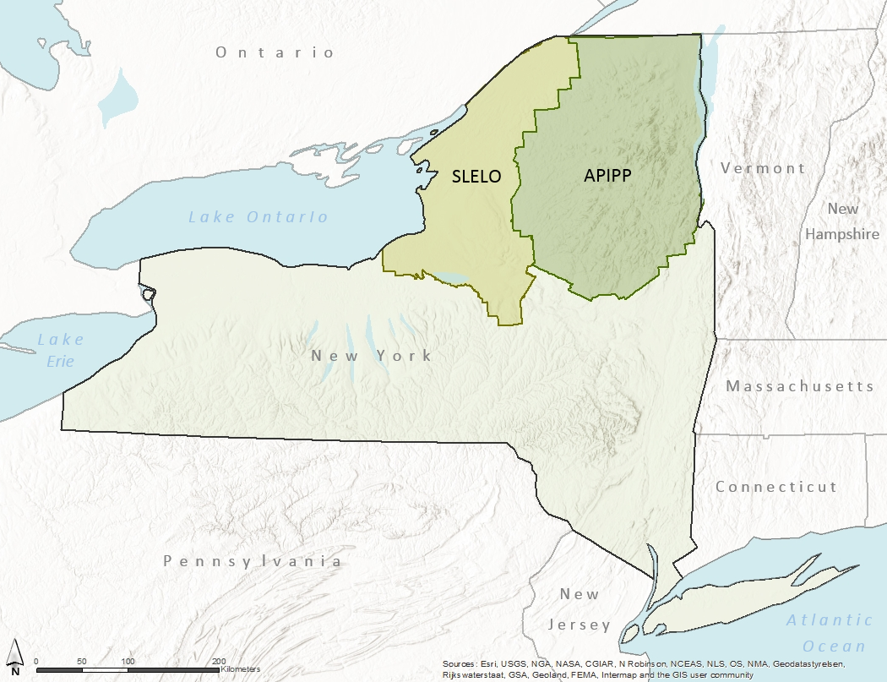

**Figure 1.** Study area map that highlights the project’s focus in the Adirondack Park Invasive Plant Program (APIPP) and St. Lawrence-Eastern Lake Ontario (SLELO) regions for invasive species management.

* 1. ***Project Partners & Objectives***

Two primary objectives guided this project. The first was the mapping of existing ranges of eastern hemlock in Adirondack Park and Tug Hill State Park utilizing Earth observation imagery from 2009 and 2016. The second was the forecasting of the susceptibility of the mapped hemlock to potential HWA infestation based on climate models for 2035. The end-user for this project was the Adirondack Park Invasive Plant Program (APIPP). The program is a partnership founded by the Adirondack Chapter of The Nature Conservancy, New York State Department of Environmental Conservation, New York State Department of Transportation, and New York State Adirondack Park Agency. APIPP manages the Adirondack Partnership for Regional Invasive Species Management (PRISM) in the study area. It is one of eight PRISMs in New York State and is tasked with protecting the Adirondack region from the negative impacts of invasive species. As part of this mission, APIPP seeks to protect hemlock stands from the invasive HWA.

APIPP works closely with the St. Lawrence-Eastern Lake Ontario (SLELO) PRISM. SLELO manages the forests to the west of Adirondack Park, including Tug Hill State Forest (22,000 km2), which also contains stands of hemlock. Given the total area of concern, maps of detailed hemlock stand locations are necessary to narrow the areas to be monitored and potentially treated for HWA infestation. Knowing the current distribution of hemlock will help APIPP and SLELO prioritize ground survey efforts and increase the potential for successful pest management. Forecast risk maps will allow APIPP to target field campaigns for HWA in Adirondack Park in the future.

Four collaborating partners provided additional advising and resources for this project: Adirondack Research LLC, Cornell University’s New York Invasive Species Research Institute (NYISRI), Tug Hill Commission, and the U.S. Forest Service (USFS).

The project addressed NASA’s Ecological Forecasting National Application Area within the Applied Sciences Program. NASA Earth observations from Landsat 8 Operational Land Imager (OLI) and Airborne Visible/InfraRed Imaging Spectrometer (AVIRIS) were used to create a map of existing eastern hemlock stands. Ancillary datasets and the NASA Earth Exchange Downscaled Climate Model (NEX-DCP30) were used in a species distribution model to map the risk of HWA infestation in 2035.

# 3. Methodology

***3.1 Data Acquisition***

*3.1.1 Earth Observations*

We utilized multiple Earth observation data sets for this project, including: AVIRIS, Landsat 8 Operational Land Imager (OLI), and Sentinel-2 Multispectral Instrument (MSI). AVIRIS is an optical sensor that includes 224 continuous spectral bands with wavelengths ranging from 400 to 2500 nanometers. The AVIRIS instrument is flown on several aircraft platforms, at about 20 km above sea level (NASA JPL, 2017). We obtained 21 AVIRIS hyperspectral reflectance files for the study area from NASA via the file transfer protocol site (ftp://popo.jpl.nasa.gov/pub/). The images were collected over three days in 2009 (July 10th, July 15th, July 28th); this was the only AVRIS imagery available. Since hemlock is a slow-growing, long-lived species, and our study area is a constitutionally protected “Forever Wild” area, we determined that imagery from 2009 are appropriate for the identification of present-day hemlock locations. We chose the least cloudy date of July 15th and narrowed our analysis to three scenes that overlapped with hemlock presence data from the New York National Heritage Program (NYNHP) (Figure 4, Appendix).

We downloaded Landsat 8 OLI Level-1 surface reflectance scenes with less than 20 percent cloud cover from the United States Geological Survey (USGS) EarthExplorer data portal. Four scenes were needed for full coverage of the study area (Figure 5 and Table 3, Appendix). For each scene, we chose the least cloudy tile for the leaf-off season (September 2016 – November 2016), so that pixels with evergreen vegetation could be easily identified. We also downloaded Sentinel-2 Level 1C top-of-atmosphere reflectance tiles for the study area and study period from the USGS EarthExplorer data portal. We downloaded eleven 100 km by 100 km scenes acquired by the Sentinel-2 satellite on June 10, 2016 for our analysis. We chose this day because of a lack of clouds.

*3.1.2 Ancillary Datasets*

We incorporated a variety of ancillary datasets throughout our project, including: Shuttle Radar Topography Mission (SRTM), tree species presence and absence data, HWA location data, Hydrological data and maps based on Shuttle Elevation Derivatives at multiple Scales (HydroSHEDS), primary road network data, cropland data layer, January average minimum temperature, and NEX-DCP30 climate model data. The spatial extent of all ancillary datasets matched our eastern U.S. study area for future climate prediction (Figure 6, Appendix).

We obtained SRTM digital elevation model (DEM) Version 3 from Google Earth Engine at a resolution of 1/3 arc seconds. We extracted slope and aspect information from the DEM file on ArcMap. The NYNHP provided point shapefiles depicting conifer presence and absence data. Relevant attributes include presence and percent cover of hemlock, white cedar, balsam fir, and spruce trees in the upper canopy. The NYNHP also provided polygon shapefiles showing known locations of hemlock rich habitat. This habitat included hardwood swamp, northern hemlock forest, and hemlock-rich peat swamp. In these habitats, hemlock accounts for the majority of trees. We downloaded point shapefiles depicting confirmed presence of the HWA from 2001 to 2017 and confirmed absence from 2015 to 2017 from the New York iMapInvasives and Biodiversity Information Serving Our Nation (BISON) datasets. We acquired river data as line shapefiles from HydroSHEDS database and 2016 TIGER primary road data from the United States Census Bureau. We downloaded a 30 m cropland data layer from the United States Department of Agriculture Statistics Service CropScape portal. We downloaded the January average minimum temperature dataset from 1981-2010 as an 800 m resolution raster image from the PRISM Climate Group. Lastly, we obtained the average January minimum temperature for 2035 from NEX-DCP30, an ensemble dataset comprised of 33 models with845.86 m resolution. It was selected for the moderate emissions scenario RCP4.5 where radiative forcing is 4.5 W/m2 greater in 2100 relative to 1750.

***3.2 Data Processing***

We projected all imagery and ancillary spatial data in the WGS_1984_UTM_Zone_18N coordinate system.

*3.2.1 Atmospheric Correction*

For the AVIRIS imagery, we used the Fast Line-of-Sight Atmospheric Analysis of Hypercubes (FLAASH) Atmospheric Correction Module in ENVI to convert radiance data to reflectance and correct for atmospheric scattering. We selected the U.S. Standard atmospheric model and the rural aerosol mode with spectral polishing turned off. We saved the corrected files in ENVI (.dat) and tiff formats. We decided not to mosaic the AVIRIS scenes together to preserve spectral accuracy in the overlapping portions of the scenes and to reduce processing time.

For all Landsat scenes, TerrSet’s LANDSAT module served the function of converting radiance data to reflectance values and performing atmospheric correction using the Cos(t) model. We selected this reflectance correction type because it accounts for atmospheric gas absorption and scattering in addition to uniform haze effects. We did not mosaic the Landsat scenes together, as they were collected in different months.

*3.2.2 Masking*

In order to speed processing and improve accuracy, we created a mask within the Landsat images of areas not likely to be hemlock trees. We first masked deciduous trees using imagery taken after leaf off when only coniferous trees would be green. We used ENVI’s NDVI function to calculate the Normalized Difference Vegetation Index (NDVI), a measure of greenness. Each image was sliced to ranges differentiating coniferous and non-coniferous cover types (Table 3, Appendix). These ranges were then used to create a mask, with coniferous vegetation given a value of 1, and all non-conifer pixels given a value of 0. We clipped the cropland data layer for the Continental United States to the boundary of New York. We then reclassified the imagery, giving non-agriculture categories a value of 1 and all agriculture classes a value of 0. To create the final mask, we multiplied the Landsat NDVI mask with the CDL Agriculture mask using the raster calculator in ESRI ArcMap.The final mask allowed us to eliminate all areas that were not potential eastern hemlock habitat.

Since the AVIRIS scenes were not mosaicked, we used ArcMap’s extract by mask function to clip the mask to the extent of each AVIRIS scene using the previously generated tiff file. We used the raster to polygon function to convert the extracted imagery into shapefiles and then used “select by attribute” to import only pixels with grid codes equal to 0 (the areas we wanted to mask) into a shapefile. We imported this shapefile into ENVI as a region of interest (ROI) with all records used as a single ROI and used it to build an ENVI mask (Build Mask) for the corresponding scene.

*3.2.3 Band Reduction*

Because AVIRIS data has high spectral and spatial resolution, processing data was time consuming. To decrease processing time, we chose to reduce the number of bands from 240 to 22. Bands chosen included 443.3662; 491.9066; 560.0477;667.5610; 704.7756; 743.8685; 782.8781; 841.2361; 860.6471; 870.3448; 938.0827; 947.7387; 1101.5260; 1196.9659; 1263.3459; 1373.0300; 1452.7820; 1612.2400; 1917.1479; 1927.1980; 2187.6890; and 2227.6260. We chose these bands because they best corresponded with Sentinel-2 bands and with the peaks and troughs of published hemlock spectral signatures (Pontius, 2005).

*3.2.4 Training Data*

We imported the conifer point and polygon shapefiles into ArcMap and clipped the files to the extent of each AVRIS scene. We extracted points representing the presence of *Tsuga* (Hemlock), *Abies* (Fir), *Picea* (Spruce) and *Pinus* (Pine) to individual shapefiles. We used the ArcMap edit function to remove points located on clouds, roads, or on edges. We followed the same procedure for points representing the absence of *Tsuga.* Because the habitat polygons included streams and clouds, we subdivided each habitat polygon into multiple smaller polygons omitting pixels with water or clouds. For each scene, we created a cloud point shapefile in ArcMap and added points to areas with clouds using the edit function. We imported all shapefiles into ENVI as ROI’s for the corresponding AVIRIS scene. All records for each shape file were saved to a single ROI.

*3.2.5 Ancillary Datasets*

We processed the remaining data sets, including roads, rivers, present and future temperature, elevation, slope, aspect and HWA presence in preparation for the MaxEnt species distribution model. We resampled each layer to the spatial resolution of the NEX-DCP 30 future temperature data (845.86 meters per pixel). We used the DISTANCE module in TerrSet and the road and hydrology data sets to create raster layers of distance to roads and distance to rivers. We converted the NEX-DCP30 future temperature data from a NetCDF file to a tiff using Python GDAL extension. We then converted temperature from degrees Kelvin to degrees Celsius using ArcMap’s raster calculator.

***3.3 Data Analysis***

We classified each reduced band AVIRIS scene using ENVI’s spectral angle mapper. We selected all 22 bands for classification. We applied the NDVI and agriculture masks, and the individual tree and cloud ROIs were imported as training data. The maximum angle was set to 0.04 to ensure confidence in our results. All other settings were left at their default value. We performed a second classification for several scenes using the habitat polygon training data as well as the *tsuga* absence points and cloud points*.* We set the maximum angle at .025 for *Tsuga* habitat, .03 for *tsuga* absence and .04 for clouds.

In order to forecast the risk of HWA infestation, we utilized the Maximum Entropy (MaxEnt) species distribution model in TerrSet to assess the habitat suitability for HWA in our study area for 2035. This machine learning algorithm is a widely-used method for estimating the population distribution of a particular series. We incorporated our ancillary datasets as the environmental variables for this model, with the HWA presence locations as the input training data file. We used the NEX-DCP30 2035 data as the future projection layer. We left all MaxEnt options at their default settings.

**4. Results & Discussion**

***4.1 Analysis of Results***

We initially classified the AVIRIS scenes using the tree point files (*Tsuga, Abies, Picea, Pinus*) as training data for ENVI’s spectral angle mapper. However, we quickly realized that many pixels included numerous training points representing multiple tree types. ENVI classified these pixels as the first training data type used, resulting in overclassification and decreased confidence in our results. As an alternative, we used the hemlock habitat shapefile as training data. However, using hemlock habitat training data limited our analysis to the AVIRIS scenes that overlapped with hemlock habitat data from the New York National Heritage Program (NYNHP) (Figure 4, Appendix).

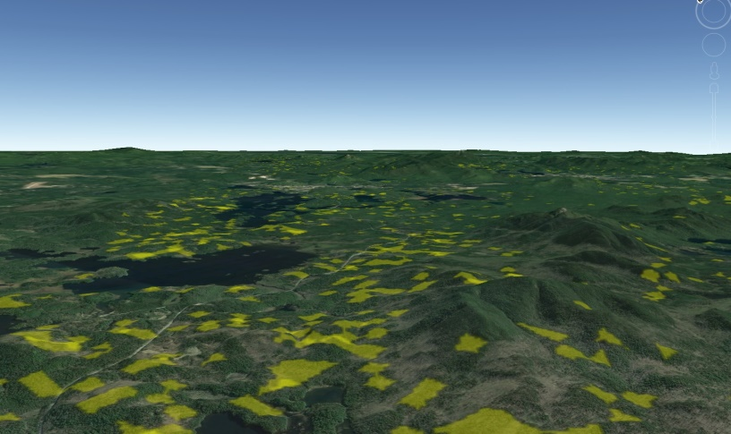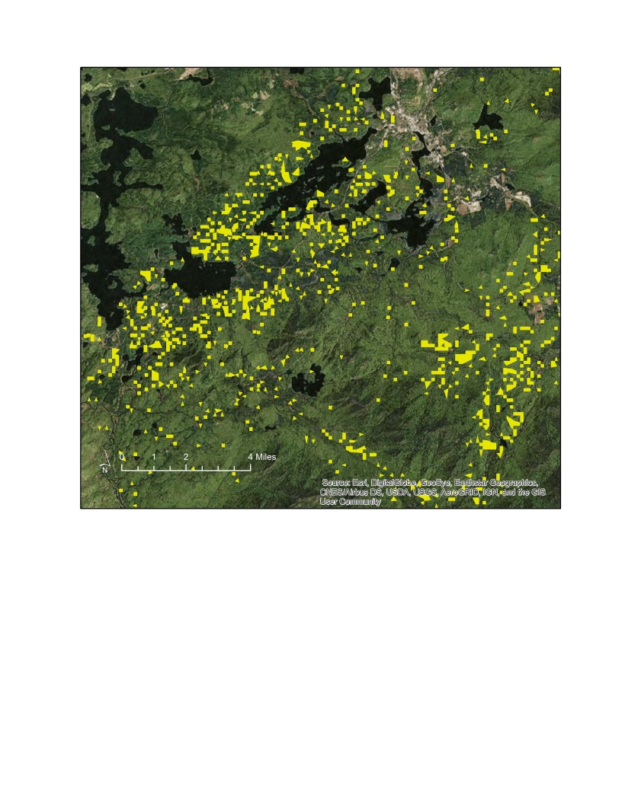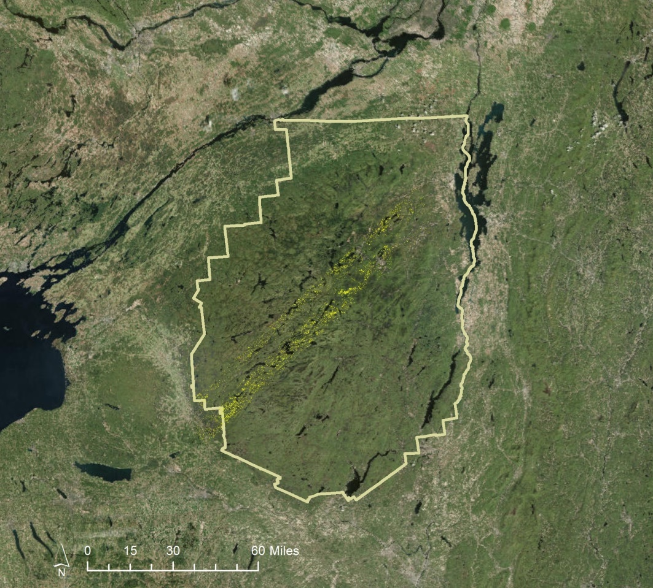

**Hemlock Stands**

**Adirondack Park**

**AVIRIS Coverage**

**Figure 2**: The three AVIRIS scenes used within our analysis, overlaid on the Adirondack Park boundary. The hemlock classification results are shown.

The resulting classification (Figure 2) showed areas most likely to contain hemlock trees. These areas appeared to be located near bodies of water and on slopes primarily in the southwestern portion of the park. This is consistent with hemlock habitat and APIPP reports of hemlock distribution in the park (personal communication). Our small maximum angle of .025 for hemlock habitats gives us high confidence that all areas chosen are spectrally very similar to our training data. However, we cannot have full confidence in our classification without ground validation. More accurate *in situ* data and field validation of our preliminary maps will allow a robust accuracy assessment and further refinement of the classification.

A second limitation was the large size of AVIRIS datasets. Loading and processing the large datasets was time consuming and not feasible in a ten-week term. We reduced the number of bands from 224 to 22 in order to reduce the processing time, but the band reduction may have affected the accuracy of our classification.

Data size limitations also hindered the processing of Sentinel-2 datasets. Google Earth Engine’s Code Editor is a cloud-based geospatial processing platform that hosts data archives encompassing the entirety of entire Earth observation catalogs. We used the Javascript and Python-supported interface to import Sentinel-2 data, mosaic tiles, and clip by the final NDVI and agriculture mask. However, exporting the processed Sentinel-2 images to Google Earth Engine’s graphic user interface (GUI) exceeded the maximum number of pixels allowed. Due to the limited time of this project, we could not complete the classification in Google Earth Engine.

We used TerrSet’s SENTINEL module to atmospherically correct selective bands using the cos(t) model. While stacking bands together succeeded, mosaicking the corrected bands in ENVI proved to be unsuccessful due to processing speed.

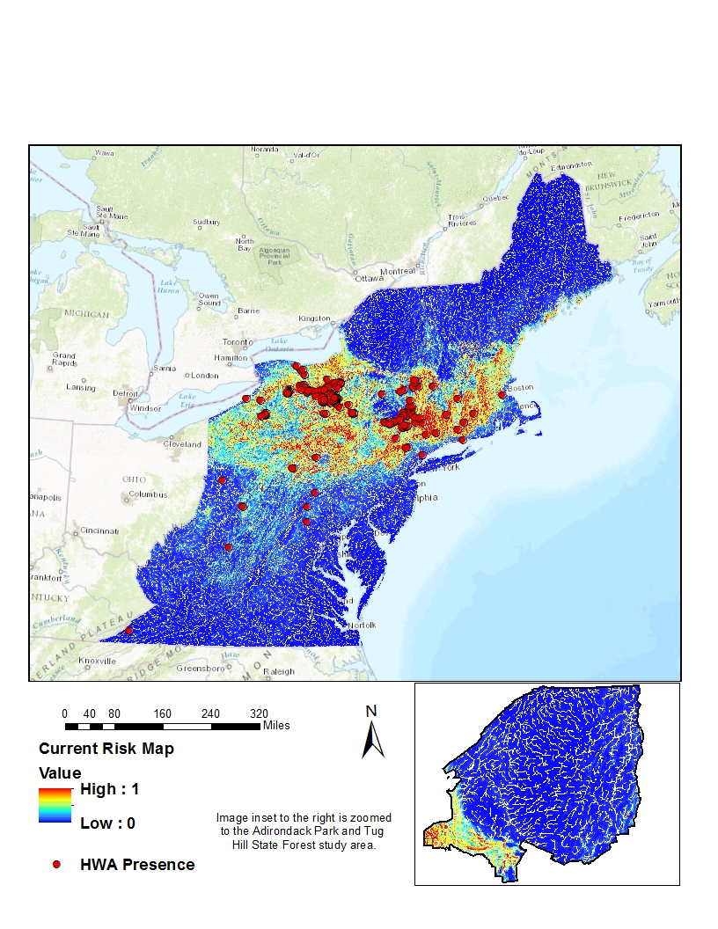

**Figure 3**: MaxEnt model results for current risk map of HWA infestation. HWA presence data used within the model are displayed.

Figure 3 is the risk map for current HWA infestation produced using the MaxEnt model in TerrSet. The model predicts a high chance of HWA infestation from mid-Pennsylvania to Massachusetts and Connecticut. In addition, the model indicates a low chance of infestation for the southern states and northern states. When we used this model to forecast infestation risk to 2035, the result appeared identical to the current risk in Figure 3. When we performed a raster calculation subtracting the forecasted map from the current map, no pixels were displayed, indicating that no difference was detected. We believe this is due to the spatial extent of presence data provided to the model. The presence data was too clustered within our climate prediction study area to accurately predict areas of future infestation.

**Table 2**: Estimate of relative contributions of the environmental variables to the MaxEnt model.

|  |  |  |
| --- | --- | --- |
| **Variable** | **Percent contribution** | **Permutation importance** |
| current climate dataset | 65.5 | 71.4 |
| slope | 15.5 | 12.2 |
| digital elevation model | 7.9 | 10 |
| distance to roads | 4.9 | 0.2 |
| aspect | 2.9 | 2.9 |
| distance to rivers | 1.9 | 1.6 |
| cropland data layer | 1.5 | 1.7 |

In order to predict future infestation areas, MaxEnt utilized a number of environmental variables associated with the HWA presence data to find suitable habitat conditions. Table 2 lists the relative contribution of each environmental variable as a contribution to the whole model. The current climate dataset paired with the HWA presence data had the largest influence on the results indicating that temperature plays a major role in HWA distribution. The second largest contributor to the model was slope, emphasizing the importance of derivatives of elevation. The placement of temperature and slope as the two highest contributors to HWA distribution is consistent with known HWA and eastern hemlock habitat. Eastern hemlocks are preferentially found on slopes, and temperature has been the limiting factor in HWA distribution. It was surprising to note that distance to rivers provided only a 1.9% contribution to the habitat model. Eastern hemlock habitat is normally found on steep slopes near rivers and streams. The fact that the model found that distance to rivers has a small role in the HWA habitat may be evidence that the HWA presence data is too clustered to give us completely accurate results.

***4.2 Future Work***

Using AVIRIS data to map hemlock is an economical and practical way to determine hemlock locations in large, mountainous areas like Adirondack Park where field mapping is not feasible. Field validation and additional *in situ* data are needed to provide an accuracy assessment and further refine the classification. Future AVIRIS flyovers could provide expanded coverage of the park and allow additional mapping.

In the future, our team would suggest choosing a smaller area of interest for Sentinel-2 in order to minimize data processing obstacles. Google Earth Engine, with its full archive of Sentinel-2 data and accelerated processing, has the best potential for completing a supervised classification of the data. As with AVIRIS classification, additional *in situ* data representing pure hemlock stands would improve classification accuracy. Our project partners noted the possibility of incorporating this type of data collection in their upcoming field season.

# 5. Conclusions

Using AVIRIS data to map hemlocks is feasible. While we had sufficient amounts of training data, the amount of mixed-pixel species and clustering of presence data obscured some of our results. A more distributed high-quality dataset would result in more accurate results. Field validation and additional *in situ* data are needed to provide an accuracy assessment and further refine the classification. On-going mapping efforts will allow APPIP and SLELO PRISM to monitor hemlock in Adirondack Park and the Tug Hill Region and work to prevent infestation by the hemlock wooly adelgid. A qualitative assessment of the classified hemlock revealed a higher density of hemlock in the southwest portion of Adirondack Park, which aligned with known locations provided by our partners.

# 6. Acknowledgments

The New York Ecological Forecasting team would like to thank the mentors and partners who helped make this project possible:

Mentors/Advisors

* Dr. Amy McNally, University of Maryland Earth System Science Interdisciplinary Center, NASA Goddard Space Flight Center
* Dr. John Bolten, NASA Goddard Space Flight Center

Partners

* Brendan Quirion, Adirondack Park Invasive Plant Program (APIPP)
* Zachary Simek, Adirondack Park Invasive Plant Program (APIPP)
* Dr. Ezra Schwartzberg, Adirondack Research LLC
* Dr. Mark Whitmore, New York Invasive Species Research Institute at Cornell University
* Rob Williams, Saint Lawrence-Eastern Lake Ontario Partnership for Regional Invasive Species Management (SLELO PRISM)
* Megan Pistolese, Saint Lawrence-Eastern Lake Ontario Partnership for Regional Invasive Species Management (SLELO PRISM)
* Katie Malinowski, Tug Hill Commission
* Ryan Hanavan, U.S. Forest Service (USFS)

Any opinions, findings, and conclusions or recommendations expressed in this material are those of the author(s) and do not necessarily reflect the views of the National Aeronautics and Space Administration.

This material is based upon work supported by NASA through contract NNL16AA05C and cooperative agreement NNX14AB60A.

# 7. Glossary

**APIPP** – Adirondack Park Invasive Plant Program; The end-user of this project

**AVIRIS** – Airborne Visible/InfraRed Imaging Spectrometer. Creates hyperspectral data that contains 224 continuous spectral bands with wavelengths from 400 to 2500 nanometers

**BISON** – Biodiversity Information Serving Our Nation

**DEM** – Digital Elevation Model

**HWA** – hemlock woolly adelgid

**HydroSHEDS** –

**MODIS** – MODerate resolution Imaging Spectroradiometer

**MSI** – MultiSpectral Instrument

**NYNHP** – New York National Heritage Program

**NYISRI** – New York Invasive Species Research Institute

**OLI** – Operational Land Imager

**PRISM** – Adirondack Partnership for Regional Invasive Species Management

**ROI** – region of interest

**NDVI** – Normalized Difference Vegetation Index

**NEX-DCP30** – NASA Earth Exchange- Downscaled Climate Projection 30

**SLELO** – St. Lawrence-Eastern Lake Ontario PRISM

**SRTM** – Shuttle Radar Topography Mission

**USFS** – U.S. Forest Service

**USGS** – United States Geological Survey

# 8. References

Albani, M., Moorcroft, P., Ellison, A., Orgwig, D., & Foster, D. (2010). Predicting the impact of hemlock woolly adelgid on carbon dynamics of eastern United States forests. *Canadian Journal of Forest Research*, *40*, 119–133. https://doi.org/10.1139/X09-167

Aukema, J., McCullough, D., Von Holle, B., Liebhold, A., Britton, K., & Frankel, S. (2010). Historical Accumulation of Nonindigenous Forest Pests in the Continental United States. *BioScience*, *60*(11), 886–897. https://doi.org/10.1525/bio.2010.60.11.5

Aukema, J., Leung, B., Kovacs, K., Chivers, C., & Britton, K., et al. (2011). Economic Impacts of Non-Native Forest Insects in the Continental United States. *PLoS One*, *6*(9), e24587. https://doi.org/ 10.1371/journal.pone.0024587

Case, B., Buckley, H., Barker-Plotkin, A., Orwig, D., & Ellison, A. (2017). When a foundation crumbles: forecasting forest community dynamics following the decline of the foundation species Tsuga Canadensis. Manuscript submitted for publication*.* https://doi.org/10.1101/099333

Cheah, Carole, et al (2004). Biological control of hemlock woolly adelgid. *United States Department of Agriculture, Forest Service, Forest Health Technology Enterprise Team*. Retrieved from https://www.researchgate.net/ profile/Carole_Cheah/publication/235323687_Biological_Control_of_Hemlock_Woolly_Adelgid/links/54217b650cf203f155c6d740/Biological-Control-of-Hemlock-Woolly-Adelgid.pdf

European Space Agency. (2015). Sentinel-2 Data [Data set]. Geoscience Australia. https://doi.org/10.4225/25/566A407CD2E2B

Hanavan, R. P., Pontius, J., & Hallett, R. (2015). A 10-Year Assessment of Hemlock Decline in the Catskill Mountain Region of New York State Using Hyperspectral Remote Sensing Techniques. *Journal of Economic Entomology*, *108*(1), 339–349. https://doi.org/10.1093/jee/tou015

Kong, N., Fei, S., Rieske-Kinney, L., & Obrichy, J. (2008). Mapping Hemlock Forest in Harlan County, Kentucky. In *Proceedings of the 6th Southern Forestry and Natural Resources GIS Conference,(Eds. P. Bettinger, K. Merry, S. Fei, J. Drake, N. Nibbelink, J. Hepinstall), Athens* (pp. 107–117). Retrieved from http://www.soforgis.net/2008/presentations/107_Kong.pdf

List of Counties and States with Known Hemlock Woolly Adelgid Infestations. (2013, May). US Forest Service. Retrieved from https://www.na.fs.fed.us/fhp/hwa/infestations/infestations.shtm

Lovett, G. M., Weiss, M., Liebhold, A., Holmes, T., Leung, B., Lambert, K., … Campbell, F. (2016). Nonnative forest insects and pathogens in the United States: Impacts and policy options. *Ecological Applications*, *0*(0), 1–19. Retrieved from https://www.srs.fs.usda.gov/pubs/ja/2016/ ja_2016_holmes_001.pdf

Lundeen, Sarah. (2017). AVIRIS- Airborne Visible/InfraRed Imaging Spectrometer. *NASA Jet Propulsion Laboratory, California Institude of Technology*. Retrieved from https://aviris.jpl.nasa.gov/

NASA Jet Propulsion Laboratory (2016). Airborne Visible/Infrared Imaging Spectrometer (AVIRIS) Data. [Data set]. USA: National Aeronautics and Space Administration. doi: 10.5067/R92TRY26ZN2Q.

Pontius, J., Hallett, R., & Martin, M. (2005). Using AVIRIS to assess hemlock abundance and early decline in the Catskills, New York. *Remote Sensing of Environment, 97*, 163–173.

Rozenzweig, C., Solecki, W., DeGaetano, A. (2011) *Responding to Climate Change in New York State: The ClimAID Integrated Assessment for Effective Climate Change Adaptation in New York State*. New York State Energy Research and Development Authority. Retrieved from https://www.nyserda.ny.gov/ About/Publications/Research-and-Development-Technical-Reports/Environmental-Research-and-Development-Technical-Reports/Response-to-Climate-Change-in-New-York

Reay, R. (2010). Management of Eastern Hemlock for Deer Wintering Areas. In *Proceedings: symposium on sustainable management of hemlock ecosystems in eastern North America* (pp. 144–147). U.S. Department of Agriculture, Forest Service, Northeastern Research Station. Retrieved from https://www.nrs.fs.fed.us/pubs/gtr/gtr_ne267/gtr_ne267_144.pdf

Spector, J. (2016, May 10). How to Stop Invasive Pests from Killing Millions of America’s Trees. *CityLab*. Retrieved from http://www.citylab.com/work/2016/05/how-to-stop-invasive-pests-from-killing-millions-of-american-trees/481944/

The Adirondack Park. (2017). Adirondack Regional Tourism Council. Retrieved from http://visitadirondacks.com/about/adirondack-park

U.S. Geological Survey Earth Resources Observation and Science Center. (2016). Provisional Landsat OLI Surface Reflectance [Data set]. U.S. Geological Survey. https://doi.org/10.5066/F78S4MZJ

Walsh, K. (n.d.). Climate of the Adirondacks. Retrieved from http://traveltips.usatoday.com/climate-adirondacks-105097.html

# 9. Appendices

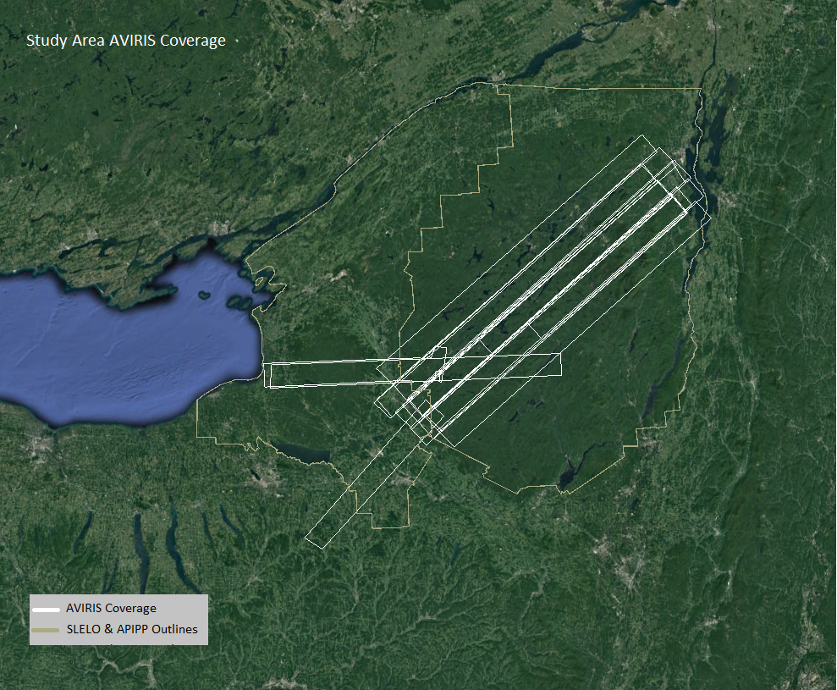

**Figure 4.** Overlay of available AVIRIS scenes from 2009 (white) within study area boundary (yellow) in Google Earth.

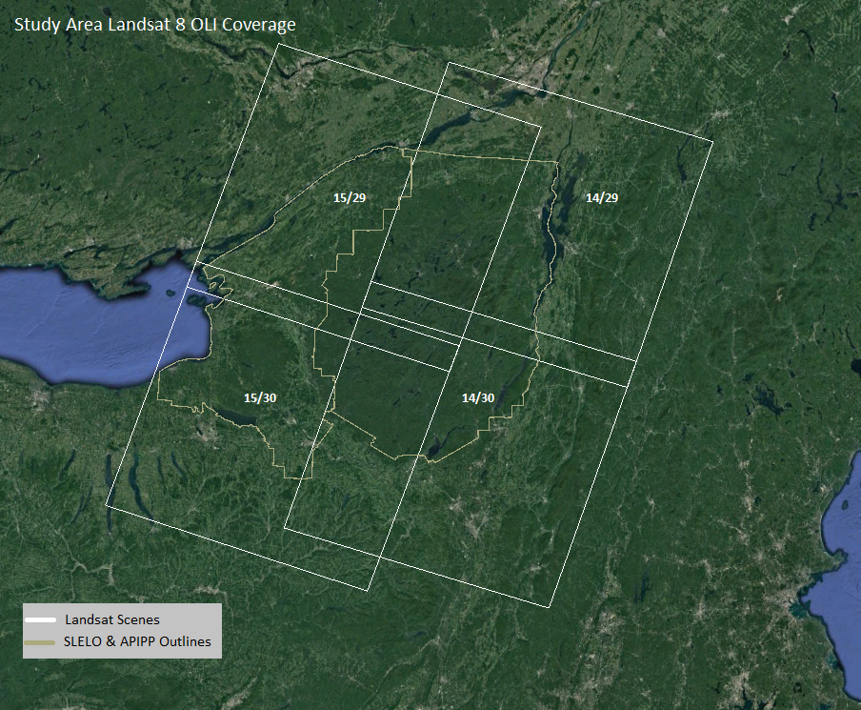

**Figure 5.** Overlay of Landsat 8 scenes (white) that provide full coverage of study area.

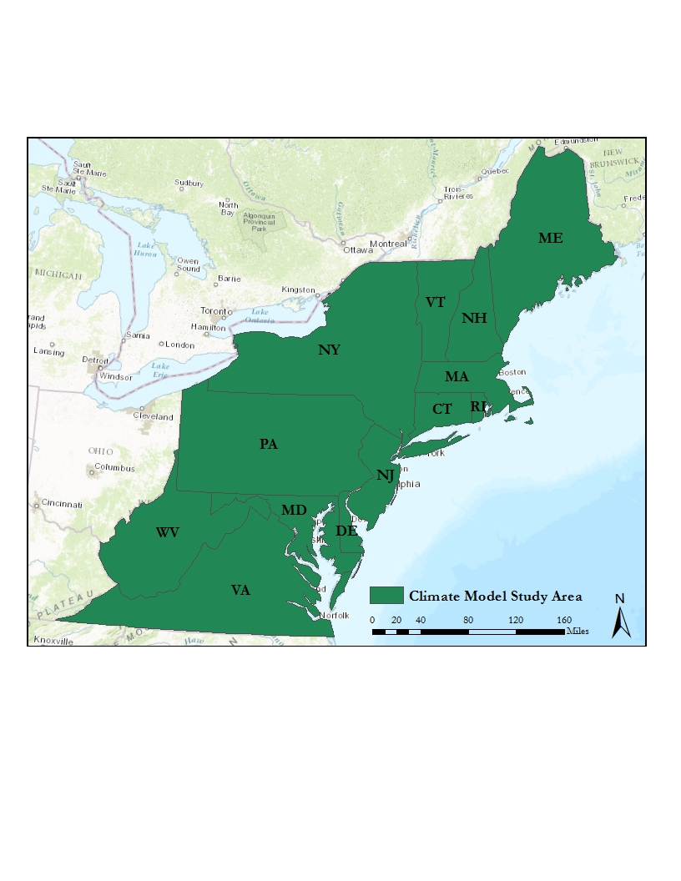

**Figure 6.** Study area for forecasting risk of HWA infestation within a climate prediction model.

**Table 3:** The Landsat 8 scenes included in the study area, the corresponding dates used for analysis, and the final NDVI values used to create the mask for potential coniferous species.

|  |  |  |
| --- | --- | --- |
| **Path/Row** | **Date Used** | **NDVI Range for Coniferous Species** |
| 15/29 | November 16, 2016 | .30-.52 |
| 14/29 | September 13, 2016 | .35-.6396 |
| 15/30 | November 16, 2016 | .30-.59 |
| 14/30 | September 14, 2016 | .35-.6395 |