**NASA DEVELOP National Program**



Fort Collins, Colorado (USGS-CSU)

*Summer 2015*

Colorado Agriculture

Reconstructing Forest Harvest History in Northern Colorado and Southern Wyoming Using the Landsat Time Series

**Technical Report** 

Final Draft – August 7, 2015

Brian Woodward (Project Lead)

Stephanie Krail

Eric Rounds

Christina Welch

Dr. Paul Evangelista, Natural Resources Ecology Lab, CSU (Science Advisor)

Tony Vorster, BANR (Mentor)

Previous Contributors:

Ryan Anderson, Natural Resources Ecology Lab, CSU (Mentor)

Peter Gibbons

Andrea Harbin

Aaron Sidder

# I. Abstract

Timber harvests are a crucial part of northern Colorado and southern Wyoming’s local economy. The future health of the forests and ecological diversity are contingent upon appropriately managing the present forest resources. However, incomplete records of past harvests expose disparities concerning the accurate location, timing, and extent of the forest harvests. This project was designed to provide natural resource managers with a reliable map of the forest harvest history in an effort to facilitate the most educated decision making process. At the request of the three project partners, Ben Delatour Scout Ranch (BDSR), Bioenergy Alliance Network of the Rockies (BANR), and Colorado State Forest Service (CSFS), 27 years of Landsat data were spectrally linked to create a continuous map delineating forest harvest history, wildfires, and mountain pine beetle kill. By accessing the Landsat archives, this project utilized 1986-2011 imagery from Landsat 1-3, Multispectral Scanner (MSS) and Landsat 4-5, Thematic Mapper (TM). The collected scenes were preprocessed using LandsatLinkr to acquire consistent images atmospherically corrected for surface reflectance, masked for cloud cover, and stacked in a Tasseled Cap (Tcap) composite. The generated Brightness, Greenness, and Wetness bands (Tcap 1, 2, and 3) were run through the Landsat-based Detection of Trends in Disturbance and Recovery (LandTrendr) model to produce a visual representation of all magnitudes of disturbances within the designated area. By prioritizing timber harvest as a key disturbance, LandTrendr accurately delineated an annual forest harvest history in northern Colorado and southern Wyoming.

**Keywords**

Remote Sensing, Forest Harvest History, Forest Management, Land Cover Change, LandTrendr, LandsatLinkr, Colorado, Agriculture

# II. Introduction

Across northern Colorado and southern Wyoming, ongoing timber harvests effectively reduce the risk of wildfires and ensure the health of the forests while bolstering the local economy. Because forest harvest records are scattered and incomplete, there is a need for an accurate map delineating the yearly forest harvest history. Creating a more comprehensive record of forest disturbances will provide the necessary materials for more effective forest management.

As a part of the Agricultural category of the DEVELOP National Application Area, this project investigated forest harvest history in an effort to better inform land managers on the timing and extent of previous forest harvests. Beyond this project, the LandTrendr software will continue to offer new and improved ways of identifying, delineating, and analyzing land cover change in a multitude of agricultural and ecological contexts.

During the first term of this project, the team used the LandTrendr model to delineate forest harvest history within the boundaries of the Ben Delatour Scout Ranch (BDSR) and Colorado State Forest (CSF) from 1987-2011. The methods provided the foundation for the second term of the project, in which the team’s main objective was to refine the initial results and create more accurate and conclusive maps for the project partners. Specifically, the goal was to extend the study area and time series from the first term.

Figure 1: Project study area, which includes the Colorado State Forest (CSF), Arapaho-Roosevelt National Forest, Medicine Bow-Routt National Forest, and Ben Delatour Scout Ranch (BDSR)

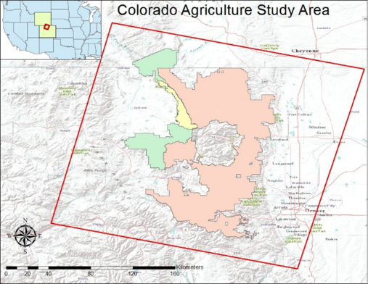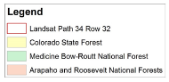

While the study area was successfully expanded to include all publicly managed forest areas within Landsat path 34, row 32, the Colorado Agriculture II team had complications extending the time series with the data from Landsat 1-3, 7, and 8.

Creating an accurate and complete forest harvest history for northern Colorado and southern Wyoming benefits numerous local organizations. This project has been working closely with the project partners, the Ben Delatour Scout Ranch (BDSR), the Bioenergy Alliance Network of the Rockies (BANR), and the Colorado State Forest Service (CSFS), to ensure that the results will assist them in various future projects. The BDSR is managed by a volunteer committee operating on a restricted budget. This budget does not include field measurements or mapping expenses. Using the final products to supplement BDSR’s current records will provide the organization with a more complete harvest history while still operating within their budget. Our second partner, BANR, is an organization that is funded through a United States Department of Agriculture grant. BANR researches the feasibility of converting beetle-killed pine trees into biofuel to support the regional sustainable energy industry. Since harvest history is an important variable in the amount of biomass available at a location on a site, the final products will be used to validate the accuracy of the BANR’s biomass estimates. The Colorado State Forest Service (CSFS), the third project partner, will use the final maps from this project to prioritize future harvests and thinning operations.

# III. Methodology

*Figure 2: Workflow depicting the project methodology*

***Run Model***

**Use LandsatLinkr to process MSS/TM data**

**Select data using EarthExplorer**

**Landsat 4-8 for July & August**

**Create study area mask**

**Deliver final maps to partners**

**Derive:**

**Cloudmask**

**3 Band TCAP**

**6 Band LEDAPS**

**Statistically validate outputs**

**Run LandTrendr Evaluation mode**

**Evaluate outputs, remove unsatisfactory images**

**Run LandTrendr Segmentation mode**

**4 Indices:**

**Normalized Burn Ratio (NBR)**

**Brightness**

**Greenness**

**Wetness**

***Analysis***

**Preprocessing**

During the Summer 2015 NASA DEVELOP term, the Fort Collins Agriculture II team evaluated forest harvest history in northern Colorado and southern Wyoming with imagery from the Landsat time series (Landsat 4 and 5). The project utilized LandsatLinkr (LLR), a processing software designed by Justin Braaten at Oregon State University, and the Landsat-based Detection of Trends in Disturbance and Recovery (LandTrendr, v. 3.0) algorithm, created by the Kennedy Lab in the College of Forestry at Oregon State University (Braaten 2015) (Kennedy et al. 2010).

**Data Acquisition**

Landsat imagery for path 34, row 32 from the years 1975-2011 was downloaded utilizing a 50% cloud threshold to identify the clearest images. For each year that imagery was available, 1-3 images in the peak growing season between July and August were selected for analysis. Landsat 1-3 (MSS), 7 (ETM+), and 8 (OLI) data were acquired from the USGS Earth Explorer interface.

After identifying acceptable scenes using the Earth Explorer interface, Landsat 4 and 5 high level Landsat products were downloaded using the ESPA (USGS Earth Resources Observation and Science Center Science Processing Architecture) ordering interface, which is an on-demand science data processing service offered by the USGS.

Products acquired from the ESPA included raw imagery (Level 1 product), surface reflectance data, and a cloud mask. The cloud mask created by the USGS ESPA removes snow, water, and shadow for each scene. Each image was projected in the Albers Equal-Area Conic Projection (written as “Albers Projection” from here on) for use in the LandTrendr package.

**Data Processing**

Preprocessing Landsat data for use in LandTrendr is a critical part of the workflow. To successfully run LandTrendr, it is imperative to standardize the input data. All images require consistent extents, projections, and resolution; inconsistencies in any of these areas will trigger errors.

*LandsatLinkr (LLR) Package*

To maintain preprocessing consistency, the project utilized the LLR utility to prepare the data for LandTrendr (Braaten 2015). LLR is a software created and distributed by the Laboratory for Applications of Remote Sensing in Ecology at Oregon State University in the Department of Forest Ecosystems and Society. LLR is an automated image processing utility written in R (R Core Team 2014) and distributed as an R package. This utility allows for batch preprocessing of large volumes of data that spanned the entire duration of the Landsat mission. LLR was used to calibrate Land Ecosystem Disturbance Adaptive Processing System (LEDAPS) image stacks, tasseled cap raster stacks, and cloud masks for the entire TM time series (Braaten 2015).

The publicly available version of the LandTrendr algorithm requires three file types as inputs for TM/ETM data, which are derived from LLR. For input into LandTrendr, all file outputs require a specific naming convention provided by the LandTrendr Users Guide (Kennedy et al. 2013). The first is the Thematic Mapper (TM) tasseled cap transformation, which is a 3-band image stack consisting of a brightness, greenness, and wetness band (Crist and Cicone 1984). The second LLR output is a 6-band LEDAPS raster stack. LEDAPS imagery is a consistent and reliable surface reflectance product that highlights forest change, including long-term land cover, water resources, and vegetation studies (Masek et al. 2006). Finally, binary cloud and shadow masks were created through LLR.

*LandTrendr Algorithm*

LandTrendr is an advanced environmental modeling algorithm that allows researchers to map and identify environmental disturbances in a dynamic way. Instead of providing landscape-level trends in change, LandTrendr enables detection of change at the pixel-level and provides information on the magnitude, duration, and initial onset of the change. Forest disturbances may be slow-moving, like the mountain pine beetle epidemic, or fast, like a forest fire. Specific to this project, timber harvests happen quickly and change the surface reflectance characteristics of the forest. LandTrendr enables detection of the different types of change forests undergo and enables understanding of the temporal nature of these changes on the pixel level (Kennedy et al. 2013).

LandTrendr requires all input files to be in ENVI \*.bsq format with accompanied header (or \*.hdr) files. Input files must also have the same projection and datum. Since LandTrendr is most reliably tested using the Albers Projection, files were formatted as such during preprocessing (Kennedy et al. 2013). The project also utilized a study area mask, which is detailed in the LandTrendr User’s Guide, and was provided by the Kennedy Lab (Kennedy et al. 2015).

Experience with the IDL (Interactive Data Language) programming language was critical for running and troubleshooting in LandTrendr. Many of the errors generated by the LandTrendr model stem from files produced in preprocessing. LandTrendr error messages can be cryptic, but functionally serve to alert the user to errors in their data, which may include inconsistencies in extent, projection, or cell size. LLR standardized input data, which reduced the number of errors immensely.

After the model ran successfully with data from Landsat 4 and 5, Landsat 1-3 MSS and Landsat 8 OLI data was integrated into the LandTrendr analysis in an attempt to extend the time series. A 43 year array of tasseled cap composite images was generated to create a full time series. Since LandTrendr was designed to work exclusively with TM/ETM+ data, a modified code was obtained in an effort to utilize the full tasseled cap time series. Although, the LandTrendr runs were successful, the outputs were not as robust as the TM results; thus, the time period was not be extended beyond 1986-2011 at this time.

**Data Analysis and Refinement**

LandTrendr identified trends in land surface changes over time. Changes from year to year were detected and characterized in both spectral data and imagery. The spatial and temporal details found in the data revealed dynamic environmental change. LandTrendr data was inspected manually and changes were documented using image analysis techniques. The final data interpretations were based on outputs from LandTrendr.

*GIS Analysis*

LandTrendr generates a “greatest disturbance output”, which contains essential data for the delineation of forest harvest and other types of major disturbances. Although there are eight different bands contained within the greatest disturbance output, only two are of primary importance for this project: the magnitude of percent forest cover loss and the year of onset. In order to refine the results, both rasters were converted to a tiff and reclassified to display disturbances over 50%. The resulting reclassified file was then multiplied by the year of onset using the “raster calculator” in ArcMap to create an output, which contained only disturbances greater than 50% based on the year they were first detected in the imagery.

*Validation and Attribution*

As an initial validation process, 1,500 randomly selected points within the CSF were visually inspected using a combination of ArcMap, and Google Earth (GE) to verify how the chosen conditions delineated disturbances in LandTrendr. The magnitude, or band two of the greatest disturbance output, was reclassified to display all disturbances greater than 10% on a magnitude forest cover loss scale. In the absence of a forest/non-forest mask, this reclassification process eliminated sites with very low magnitude disturbances from the validation process. The magnitude band was then converted to a polygon in Arcmap using the “raster to polygon” tool and C:\Users\skrail\Downloads\FullExtent_Magnitude.tif1,500 points were randomly selected within those polygons. Individual point data for the magnitude, year of duration, and elevation were extracted from the greatest disturbance raster and input into a spreadsheet. Within Arcmap, the random points shapefile and the magnitude of disturbance raster were overlaid on a high-resolution imagery basemap from SPOT to help identify the impetus of recent disturbances. Concurrently, the 1,500 random points were converted to a .kml file using the “layer to kml” tool in ArcMap. The resulting .kml file was then opened in Google Earth and used in conjunction with available historical imagery from NAIP to analyze disturbances. Finally, each of the 1,500 points were validated by visually verifying each point as either harvested or unharvested. Using the greatest disturbance raster, the Colorado Agriculture II team estimated the percentage that each pixel was harvested; every pertinent detail, misclassification, or disturbance type were carefully documented.

Figure 3: A greatest disturbance output created with using the NBR index for all publically managed forests within the full extent of path 34, row 32

The results from the initial validation process were transferred to a spreadsheet for statistical analysis. To remove any superfluous data, all points located above treeline, which begins at ~3,300 meters in Colorado, were removed to reduce the margin of error (Jacobs 1987). Any points not located within a forested area were also removed from the data set. Once only relevant points remain, the data was categorized by it being NBR or Wetness derived, whether LandTrendr predicted the point to be harvested or unharvested, and how it was observed during the validation process. The categories were Predicted Harvest Observed Harvest, Predicted Harvest Observed Non-Harvest, Predicted Non-Harvest Observed Harvest, and Predicted Non-Harvest Observed Non-Harvest for both NBR and Wetness. Each category was analyzed for disturbance magnitude frequency. The resulting values were normalized and used to create a histogram for NBR disturbance magnitude frequency (Figure 6) and Wetness disturbance magnitude frequency (Figure 7). By tabulating the number of points within each of the categories depicting predicted and observed, confusion matrices were C:\Users\skrail\Downloads\CSF_Harvested_Areas_8_3_2015.tifcreated to test the accuracy of the NBR and Wetness indices using our delineation methods, depicted in Figure 8 and Figure 9. Metrics, such as the accuracy, sensitivity, and specificity, were derived from the confusion matrices using known formulas. The highlighted cells of Figure 8 and 9 compare the success of the NBR index to the Wetness index. Lastly, the minimum, 1st quartile, median, 3rd quartile, and maximum were generated to create a box and whisker plot for each category of data within the NBR and Wetness indices, which can be found in the appendix.

# IV. Results and Discussion

**Analysis of Results**

C:\Users\skrail\Downloads\BDSR_NBR_GreatestMagnitude_With_YearsOnset.tifThe results from this project focus on different displays of disturbances within the study area. To best meet the needs of the project partners, the Colorado Agriculture II team constructed a variety of maps ranging from minimally processed outputs to very specific results. Figure 3 depicts a greatest disturbance output for all publically managed forests within the full extent of path 34, row 32. Narrowing our scope to the boundaries of the CSF, Figure 4 displays harvested plots that are delineated and categorized by year. BDSR was the focus of Figure 5 where all disturbances were classified on a magnitude of percent canopy cover loss scale. Figure 3 and 5 were created with the NBR index and Figure 4 utilized both NBR and Wetness indices. The BDSR, CSFS, and BANR received comprehensive maps and output files to enable further application of the project’s research.

Figure 4: Harvested plots delineated and categorized by year throughout the Colorado State Forest (CSF). The output was derived from a combination of NBR and Wetness indices.

Figure 5: All NBR specific disturbances with Ben Delatour Scout Ranch (BDSR) categorized on a magnitude of percent canopy cover loss scale

Validation analyzed how well the chosen criteria delineated disturbances in LandTrendr, which proved useful for

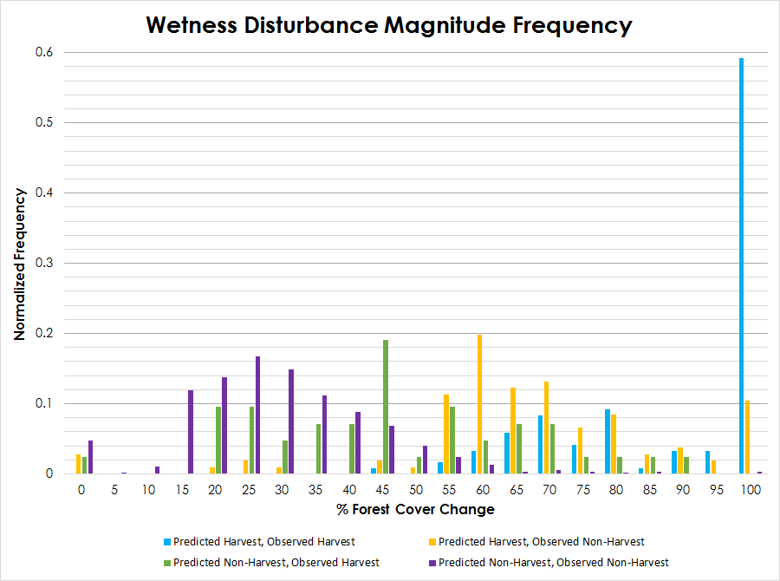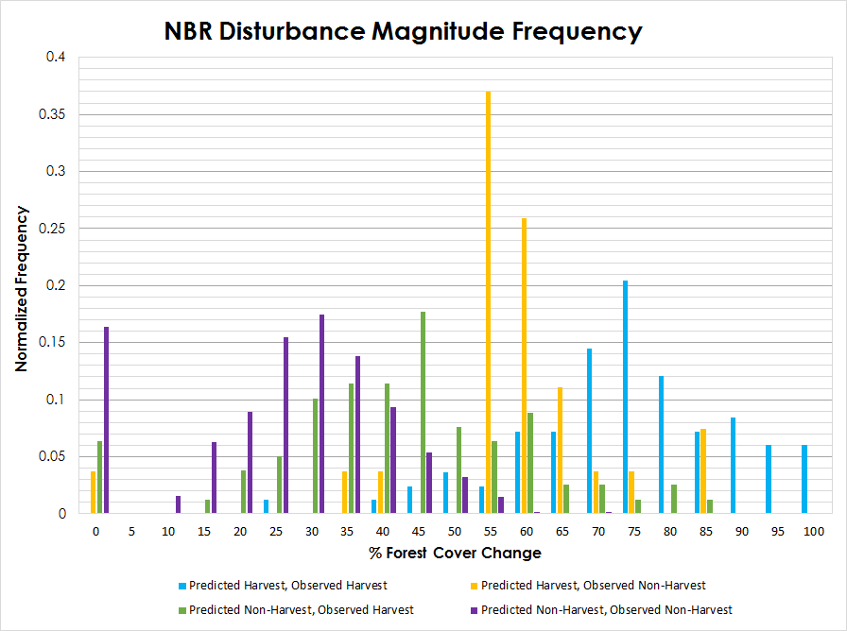

Figure 6: Frequency of NBR disturbance magnitudes on a percent forest cover change scale. Each category is depicted by a different color.

Figure 7: Frequency of Wetness disturbance magnitudes on a percent forest cover change scale. Each category is depicted by a different color.

deciding the ideal threshold of disturbances and the best index for creating the final maps. The NBR Disturbance Magnitude Frequency histogram (Figure 6) indicates a high frequency of misidentified points at 45, 50, and 55% canopy cover change. Increasing the threshold for the NBR index to a 60% forest cover change would eliminate these confounding points of disturbance from our maps, thus creating more accurate representations of harvest. The Wetness Disturbance Magnitude Frequency histogram (Figure 7) shows higher frequencies of misidentified points at 45 and 60% canopy cover change, which also indicates that the ideal threshold for the Wetness index would be 60% canopy cover change. While raising the threshold to 60% removes the vast majority of beetle kill as a disturbance, it also eliminates part of the forest harvest.

The confusion matrix compares the predicted versus observed parameters of the harvested and unharvested points within the 1,500 validation point data set. Accuracy, sensitivity, and specificity are the three statistics derived from the confusion matrix.  The confusion matrices, found in Figure 8 and 9, state that the accuracy of NBR is higher than Wetness. While this information is reflected in Figure 3 and 5, which used the NBR index for increased accuracy, Figure 4 accounts for both the NBR and Wetness indices to capture a larger harvested area.

|  |  |  |  |  |  |  |
| --- | --- | --- | --- | --- | --- | --- |
| **NBR Confusion Matrix** | | | | | | |
|  | **Observed** | | | **Metrics** | | |
| **Predicted** |  | **Harvest** | **Non-Harvest** | **Accuracy** | 0.9217 | 92.17% |
| **Harvest** | 83 | 27 | **Sensitivity** | 0.5123 | 51.23% |
| **Non-Harvest** | 79 | 1165 | **Specificity** | 0.9773 | 97.73% |

*Figure 8: NBR confusion matrix and metrics calculated from the frequency of NBR disturbance magnitudes*

|  |  |  |  |  |  |  |
| --- | --- | --- | --- | --- | --- | --- |
| **Wetness Confusion Matrix** | | | | | | |
|  | **Observed** | | | **Metrics** | | |
| **Predicted** |  | **Harvest** | **Non-Harvest** | **Accuracy** | 0.8907 | 89.07% |
| **Harvest** | 120 | 106 | **Sensitivity** | 0.7407 | 74.07% |
| **Non-Harvest** | 42 | 1086 | **Specificity** | 0.9111 | 91.11% |

*Figure 9: Wetness confusion matrix and metrics calculated from the frequency of Wetness disturbance magnitudes*

**Discussion**

Attempts in term 1 to manually preprocess data resulted in inconsistencies that became difficult to track and account for in LandTrendr. Instead, the project utilized LandsatLinkr (Braaten 2015) to preprocess and standardize our input data for use in LandTrendr. Using LLR for the preprocessing of preliminary data for LandTrendr allowed for a more seamless, universal scheme, dramatically decreasing processing time and errors.

A main objective of this project was to expand the time series to incorporate Landsat 1-5, 7, and 8. While LandTrendr was successful in running with all of the sensors including imagery from 1975-2014, the program was not originally designed for this information, thus the outputs were not as robust as when just using the TM data. Imagery from Landsat 7 was not used in the final analysis due to the scan line error. Final results were based on Landsat 4 and 5, ranging from 1986-2011.

The processes and algorithms utilized within this project can be adapted for continued research in a variety of directions. A possible focus for additional work is expanding the study area and extending the time series to include more NASA satellites and sensors. Since only points within the CSF were visually verified, additional validation could occur within the entire scene of path 34, row 32. Other potential projects could consider delineating low magnitude disturbances, such as forest thinning, as well as classifying insect damage within affected areas.

# V. Conclusions

# By inputting imagery from the Landsat time series into the LandTrendr model, the Colorado Agriculture II team accurately mapped extent and timing of past timber harvests within the CSF, Arapaho-Roosevelt National Forest, Medicine Bow-Routt National Forest, and BDSR. The derived timber harvest locations were verified by analyzing a series of randomly generated points within the produced maps using high resolution satellite imagery. Upon completion of the final maps, additional timber harvests that were previously unaccounted for or unmapped to their full extent were identified.

The LandTrendr algorithm has the potential to further investigate and clarify the land cover change history of the forested regions within northern Colorado and southern Wyoming. Continued research and development of the algorithm’s code will undoubtedly produce more in depth, accurate records of these areas leading to better management and overall health of the forests.

# VI. Acknowledgements

This project was made possible through support and mentorship of select individuals and organizations. We extend a kind thanks to the following:

* Dr. Paul Evangelista, Colorado State University (CSU), Natural Resource Ecology Laboratory (NREL)
* Tony Vorster, CSU, NREL, Bioenergy Alliance Network of the Rockies (BANR)
* Bob Sturtevant, Ben Delatour Scout Ranch (BDSR)
* Ryan Anderson, CSU, NREL
* Nick Young, CSU, NREL
* John Twitchell, Colorado State Forest (CSF)
* Justin Braaten, Oregon State University (OSU), Laboratory for Applications of Remote Sensing in Ecology (LARSE)
* Robert Kennedy, OSU, LARSE

This material is based upon work supported by NASA through contract NNL11AA00B and cooperative agreement NNX14AB60A.

# VII. References

Braaten, Justin. “LandsatLinkr 0.1.4 User Guide.” LandsatLinkr. Oregon State University, 4 Mar. 2015. Web. 24 March 2015.

Crist, E. P., and R. C. Cicone. 1984. A Physically-Based Transformation of Thematic Mapper Data---The TM Tasseled Cap. *IEEE Transactions on Geoscience and Remote Sensing* GE-22: 256–263.

Jacobs, Randy, Robert Ormes M. “Guide to the Colorado Mountains.” Johnson Books. June 1987. Web. 30 July 2015.

Kennedy, Robert E., Justin Braaten, Zhiqiang Yang, Peder Nelson, and Maureen Duane. “LandTrendr Users Guide, Version 0.1." *GitHub.* Oregon State University, 29 July 2013. Web. 25 Mar. 2015.

Kennedy, R. E., Z. Yang, and W. B. Cohen. 2010. Detecting trends in forest disturbance and recovery using yearly Landsat time series: 1. LandTrendr - Temporal segmentation algorithms. *Remote Sensing of Environment* 114:2897–2910.

Masek, Jeffery. “LEDAPS.” Landsat Ecosystem Disturbance Adaptive Processing System. National Aeronautics and Aerospace Administration, 28 Feb. 2011. Web. 25 Mar. 2015.

Masek, Jeffery G., Eric F. Vermote, Nazmi E. Saleous, Robert Wolfe, Forrest G. Hall, Karl F. Huemmrich, Feng Gao, Jonathan Kutler, and Teng-Kui Lim. “A Landsat Surface Reflectance Dataset for North America. 1990-2000. “IEEE Geoscience and Remote Sensing Letters 3.1 (2006): 68-71. IEEE, 1 Jan. 2006. Web. 25 Mar. 2015

R Core Team. 2014. R: A language and environment for statistical computing. R Foundation for Statistical Computing, Vienna, Austria. URL [http://www.R-project.org/](http://www.r-project.org/).

Sohngen, B., & Mendelsohn, R. 1998. Valuing the impact of large-scale ecological change in a market: The effect of climate change on US timber. *American Economic Review*, 686-710.

# VIII. Content Innovation

**Glossary**

**BSQ extension** - known as an ArcView Image File (Band Sequential); LandTrendr works better when all input files are in the bsq format

* **Accompanied .hdr extension** - contains valuable information for identifying, displaying, and georeferencing the image; the hdr extension must be present to open the bsq file

**Cloud Mask** - utilizes several cloud detection tests to indicate whether or not a pixel is obstructed by clouds

**Confusion matrix -** contains information about actual and predicted values used by a classification model

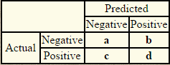

* **Accuracy** - is the proportion of the total number of predictions that were correct



* **Sensitivity** - is the proportion of positive cases that were correctly identified, as calculated using the equation



* **Specificity**- is the proportion of negatives cases that were incorrectly classified as positive



**ESPA (USGS Earth Resources Observation and Science Center Science Processing Architecture)** - an interface to search and order satellite imagery

**Greatest disturbance** - LandTrendr output depicting land cover change that has the highest percent cover loss in comparison to other disturbances

* **Year of Onset** - When the disturbance began to take place
* **Magnitude** - Intensity of disturbance
* **Duration** - How long disturbance took place

**LandsatLinkr** - A new automated system for processing large volumes of Landsat imagery to align their format in compliance of LandTrendr’s specifications (see http://landsatlinkr.weebly.com/)

**LandTrendr** - Landsat-based Detection of Trends in Disturbance and Recovery; Algorithm to automatically stack imagery from different years and identify various land cover change (see http://landtrendr.forestry.oregonstate.edu/)

**Land Ecosystem Disturbance Adaptive Processing System (LEDAPS)** - a NASA project to delineate and map forest disturbance, regrowth, and conversion

**Layer to KML** - ArcMap tool to convert a GIS map to a format compatible with Google Earth

**Normalized Burn Ratio (NBR)** - an equation to calculate changes in vegetation cover

**Raster Calculator** - ArcMap tool that allows for Map Algebra calculations to be performed on raster pixel values

**Reclassification** - ArcMap tool that changes the values in a raster

**Surface reflectance** - the amount of incoming solar radiation that is not absorbed by the Earth’s surface

**Tasseled cap Transformation** - the conversion of readings into composite values consisting of the brightness, greenness, and wetness bands

**Map Viewer**

<https://drive.google.com/open?id=0B8PO2Jez27CMbUNPc29MdVdqelk>

# IX. Appendices

**NBR Distribution Magnitude Frequency**

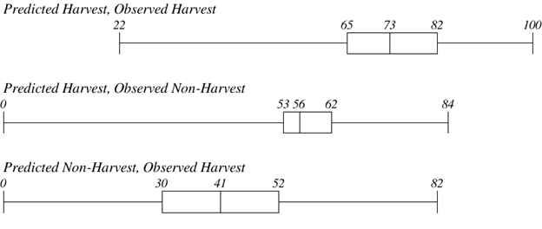

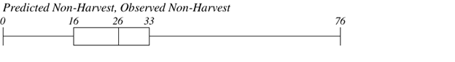



*Figure 10: Diagrams portraying the range, distribution, and frequency of magnitudes observed within each category of NBR data*

**Wetness Distribution Magnitude Frequency**

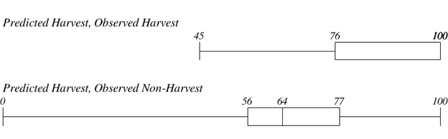

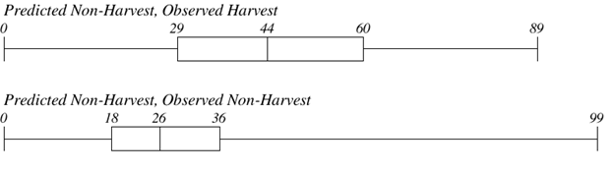

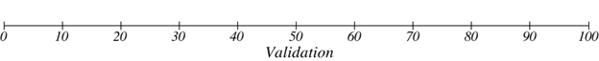

*Figure 11: Diagrams portraying the range, distribution, and frequency of magnitudes observed within each category of Wetness data*