Peru & Bolivia Climate
Estimating Soil Organic Carbon using Earth Observations to Inform Irrecoverable Carbon Reserve Management in Peru and Bolivia


Technical Report
Final – March 30th, 2023

Aarti Arora (Project Lead)
Aaron Carr
Arina Fuqua
Haydee Portillo

Advisors:
Sean McCartney, Science Systems and Applications, Inc., NASA Goddard Space Flight Center (Science Advisor)
K. Arthur Endsley, The University of Montana (Science Advisor)

Fellow:
Carli Merrick (Maryland - Goddard)

1. Abstract
Irrecoverable carbon (IC) reserves contain large stores of the element, are at risk of being released due to human activity and consequentially contribute to global warming upon eviction. The Amazon, which covers about 0.5% of Earth's surface, contains the largest and highest-density reserves of IC. Conservation International (CI) works with local communities to establish and expand protected areas to prevent the loss of these reserves. This project's research strived to help CI better understand soil organic carbon (SOC) stocks and supplement their ability to monitor SOC changes in South America through a remote sensing lens. Earth observations utilized included the Soil Moisture Active Passive Level 4 Carbon Net Ecosystem Exchange (SMAP L4C) product and Level-2A true color imagery from Sentinel-2 MultiSpectral Instrument (MSI). SOC distribution maps and trend analyses were generated for Peru and Bolivia between 2016 and 2022. SMAP L4C SOC estimates were then compared to SoilGrids, CI’s current SOC data source. Additionally, a methodology for monitoring SOC utilizing SMAP will allow CI to monitor future changes. The project determined that trends of significantly decreasing SOC generally occurred within the extent of the Andes Mountains while most area outside had increased. Overall, SOC increased across the entire study period for each plant functional type and average SOC over all plant functional types. SMAP agrees with SoilGrids in the eastern portion of the study area and within the Bolivian Amazon but disagrees along the Andes range and in northeastern Peru.

Key Terms
Soil Moisture Active Passive (SMAP), Sentinel-2 MSI, Soil Organic Carbon, Irrecoverable Carbon, SMAP Level 4 Carbon (L4C) Product, Climate change

2. Introduction
2.1 Background Information
IC refers to carbon stored in the Earth system that, if released to the atmosphere, could not be replaced by 2050. IC has three criteria: its ability to be managed by humans, its vulnerability to anthropogenic or natural climate change, and its recoverability within a certain time-period. Biomass and soils are two terrestrial carbon pools that respond differently to changes in land use and climate and take different amounts of time to recover and sequester carbon (Goldstein et al., 2020).

Soil organic matter, which includes both living and decaying plant, animal, bacterial, and fungal material, is where carbon is stored within soils (Stockmann et al., 2013). Soils are an important terrestrial pool of carbon and store over three times as much as is found in the atmosphere (Ontl & Schulte, 2012; Grace et al., 2012). Scientists measure soil organic matter by measuring its carbon component or its SOC, and around 58% of soil organic matter is carbon (Post et al., 2001). Soils contain more than 200 times as much carbon as yearly fossil fuel emissions, so small changes in the SOC stock could vastly increase or decrease atmospheric carbon dioxide levels (Paustian et al., 2016; Stockmann et al., 2013). Land-use changes, such as converting forested lands to croplands, have depleted soil carbon stocks and contributed to historic and contemporary greenhouse gas emissions (Powlson et al., 2014).

The Amazon basin is important for both carbon conservation and biodiversity. Its tropical forests and peatlands are globally the largest and highest-density reserves of IC (31.5 Gigatons; Noon et al., 2022). The Amazon covers about 0.5% of the Earth’s surface yet has the highest species density on the planet. The species within the basin are highly endemic, meaning they evolved within their landscapes and are not found elsewhere around the world. Species loss impacts the wider ecosystem; the Amazon provides many ecosystem functions globally such as carbon sequestration and water recycling (Guayasamin et al., 2021; Vergara et al., 2022). Biodiversity loss could therefore impact the ability of the Amazon’s soils and forests to sequester carbon.

This project focused on Peru and Bolivia (Figure 1) for January 1, 2016, through November 8, 2022. In Bolivia, CI works in consultation with more than 800 stakeholders from 3 Indigenous groups, which resulted in the creation of a 1.5-million-hectare municipal protected area. The organization’s continued work in Bolivia has resulted in a mosaic of Indigenous and protected lands that hold 187 Megatons (Mt) of IC and 20 endangered or threatened species. Peru does protect between 1000 and 2000 Mt IC through protected areas, national parks, community reserves, and community lands but has lost 1.3% of this stock since 2010 (Goldstein et al., 2021).

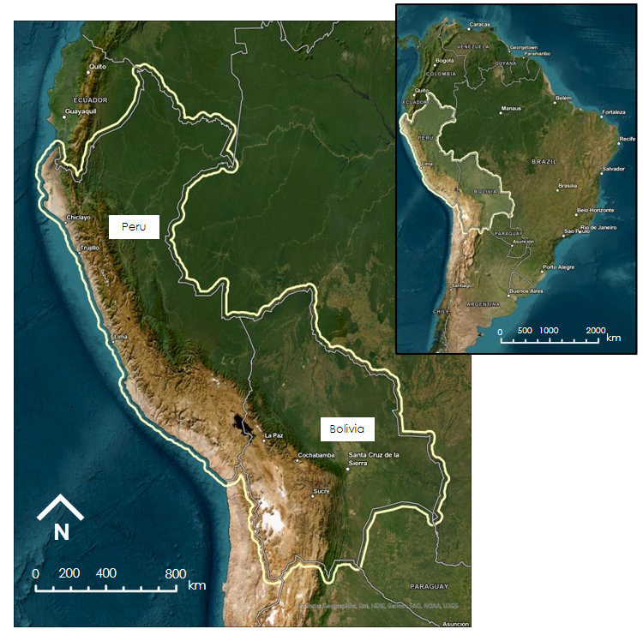
Figure 1. Overall study area for the project with the countries labeled (left) and inset map of South America with the study area highlighted (right).

2.2 Project Partners & Objectives
The Peru & Bolivia Climate DEVELOP team partnered with CI, a non-profit organization that works on global conservation efforts. The organization co-manages carbon reserves within South America through collaboration with a variety of partners and decision makers such as Indigenous groups and local, state, and federal governments. Additionally, CI advises policy advocating for biodiversity and conservation globally. In Amazonia, CI works on establishing and expanding protected areas to prevent the loss of IC in both above-ground vegetation and soils. Recently, the organization is working on global efforts to manage lands rich in IC. CI hopes to prevent the release of billions of tons of carbon into the atmosphere from human activities and mitigate biodiversity loss.

NASA Earth observations can enhance CI’s capacity to better estimate SOC stock and supplement their ability to timely monitor changes in SOC. The organization currently uses SoilGrids to estimate SOC, however this is a modeled product and does not produce changes in SOC over time. The main objectives of this project were to create SOC distribution and trend maps; compare SMAP SOC estimates (a physically based model-enhanced product) to SoilGrids SOC estimates (a static interpolation product); and finally, to produce a methodology for monitoring SOC utilizing SMAP. CI will benefit from this project by furthering their understanding of how to access SMAP L4C, how it compares to SoilGrids, and its applications to SOC monitoring.

3. Methodology
3.1 Data Acquisition
We acquired the SMAP L4C product from the National Snow and Ice Data Center using the Application for Extracting and Exploring Analysis Ready Samples (AppEEARS). SMAP L4C is a modeled product that produces a daily global carbon budget at a depth range of 0–5 centimeters and compressed resolution of 9-kilometers (Kimball et al., 2022). The products were ordered in the network common data format filetype in annual bundles. AppEEARS did not have data for SMAP L4C after November 8, 2022. We also accessed the open-source Python code package pyl4c for visualizing and analyzing SMAP L4C which was provided by Dr. Arthur Endsley of the University of Montana’s Numerical Terradynamic Simulation Group (Endsley and Schwher, 2023). The SMAP L4C product utilizes inputs from the SMAP Level 4 product's surface to root zone soil moisture geophysical data (SMAP L4SM), Moderate Resolution Imaging Spectroradiometer (MODIS) and Visible Infrared Imaging Radiometer Suite, and the Global Modeling and Assimilation Office Goddard Earth Observing System-5 Forward Processing System. SMAP L4C provides soil carbon data in the Equal-Area Scalable Earth (EASE) Grid 2.0 projected coordinate system (EPSG:6933). The pyl4c package also includes a sub-module for resampling SMAP L4C into its native and higher 1-km resolution.

We acquired shapefiles of the study area, one for Bolivia and one for Peru, from the United Nations Office for the Coordination of Humanitarian Affairs (GeoBolivia, 2021; Instituto Geográfico Nacional, 2020). These were buffered 25-km beyond their borders using Python 3.10.9 for use in all future analyses. AppEEARS allows shapefiles to be uploaded for spatial subsetting but simplifies complex shapes. Therefore, the buffer ensured that the entirety of each country was captured.

Dr. Endsley supplied a copy of the global MODIS Land Cover Type Level 3 Product (MCD12Q1) at a majority resampled resolution of 1-km. MCD12Q1 classifies land by plant functional type (PFT), from which SMAP L4C generates over PFTs 1 through 8 (Friedl and Sulla-Menashe, 2019). An additional landform classification data layer was accessed from the United States Geological Survey’s (USGS) Global Mountain Explorer 2.0 for classification of mountain presence in the SMAP L4C spatial trend analysis (Karagulle et al., 2017). The landform classifications are modeled from slope, local relief, and profile parameters. The USGS preserved the only 4 mountain-specific classifications from the 16 original landform classifications: scattered low mountains, scattered high mountains, low mountains, and high mountains.

The SoilGrids inventory is a globally modeled spatial collection of soil properties fitted using over 240,000 observations from the International Soil Reference and Information Centre’s World Soil Information Service database (Poggio et al., 2021). Global map layers of SOC and bulk density aggregated to 1,000-meters were accessed through the International Soil Reference and Information Centre’s Web Distributed Authoring and Versioning service. These data were exported from the 0–5-cm depth range and compared to SMAP L4C.

We generated true color composites for the period between January 1, 2019, and December 31, 2022, to provide CI with reference imagery of their sites of interest for use in informing management decisions on the ground. CI shared two specific areas: Ampiyacu-Yaguas Lower Putumayo and Northern Bolivian Amazon. We adapted JavaScript code from our Science Advisor at NASA GSFC, Sean McCartney, to acquire true color imagery from the Sentinel-2 MSI Level-2A Surface Reflectance product through the Google Earth Engine Data Catalog. The Level-2A products consist of remotely sensed optical imagery at 10-m spatial resolution (European Space Agency, n.d.).

Table 1. Overview of Earth observation data sources used in this project
Satellite(s) and Sensors | Processing Levels | Purpose | Spatial Resolution | Image Dates | Source
Aqua and Terra Moderate Resolution Imaging Spectroradiometer (MODIS) | Level-3 | Land-cover classification | 1-km | 2000 | LP DAAC
Soil Moisture Active Passive Radiometer (SMAP): radiometer (passive) | Level-4C | Daily estimates of net ecosystem carbon exchange | 9-km | January 1, 2016 – November 8, 2022 | National Snow and Ice Data Center
Copernicus Sentinel-2 Multispectral Instrument (MSI) | Level-2A (Surface Reflectance) | True color maps of project sites in Peru and Bolivia | 10-m | January 1, 2019 – December 31, 2022 | European Space Agency via Google Earth Engine

3.2 Data Processing
3.2.1 SoilGrids Unit Conversion
The SoilGrids products (SOC and bulk density) were projected into the EASE-Grid 2.0 projection using the bilinear interpolation resampling technique in ArcGIS Pro 2.9 which is consistent with previous comparisons to SMAP L4C (Endsley et al., 2020). Utilizing the ‘Raster Calculator,’ we converted the SoilGrids products into units consistent with SMAP L4C. SoilGrids SOC is in units of decigrams of carbon per kilogram of soil. To convert to grams of carbon per square meter of soil, we multiplied SOC with bulk density and assumed the SoilGrids’ measured depth was 5-cm.

3.2.2 True Color Imagery
We collected true color imagery from the Sentinel-2 MSI Level-2A (COPERNICUS/S2_SR) image collection and clipped to the extent of two areas of interest: one in northeastern Peru (approximately 693 km²) and the other in northern Bolivia (approximately 1,705 km²). We specified a date range of January 1, 2019, to December 31, 2022, and filtered the collection to a cloud pixel percentage of 5% or less. We selected bands 2, 3, and 4 which correspond to the blue, green, and red bands respectively. We computed the median value of each band with the median reducer function to produce true color composites. The visualization parameters were defined with a minimum of 0 and a maximum of 3000 to stretch the data and improve image contrast. We exported the images in GeoTIFF format and imported them into ArcGIS Pro to be mosaiced.

3.3 Data Analysis
To analyze changes in SOC over time, both interannually and over the study period, we utilized a correlated-seasonal Mann-Kendall test. A Mann-Kendall test analyzes timeseries for unidirectional or monotonic trends. The test is non-parametric, and therefore the underlying data is not normally distributed (Hussain et al., 2019). However, the traditional Mann-Kendall test assumes that the data tested are not serially correlated and that seasonality does not affect the data (Hirsch and Slack, 1984). Serial or autocorrelation occurs when data are dependent on previous values. In this case, the value of SOC today is dependent on the value of SOC yesterday. To test for serial correlation, we used the Durbin-Watson test statistic, which tests for serial correlation on the residuals of an ordinary least squares regression (Chatterjee and Simonoff, 2013). The Durbin-Watson statistic ranges from 0–4, with values close to 2 indicating little to no serial correlation, and values less than 1 indicating positive serial correlation (Chen, 2016; Bhattacharyya, 2020).

Histograms of the daily SOC data suggest the data are not normally distributed (Figure B1). The Durbin-Watson statistic for each PFT and the overall mean SOC for each country range from 0.58 to 1.49 indicating positive serial correlation. Seasonal trends are also visible within the yearly time series of the data. For these reasons, we chose to run a series of correlated-seasonal Mann-Kendall tests over the study period for each PFT and for the mean SOC.

As seasonality was apparent in SMAP L4C, we used the Seasonal Mann-Kendall test to also analyze the spatial trends of daily average SOC in Peru and Bolivia. This was completed using the ‘Generate Trend’ function in ArcGIS Pro with a daily seasonal period. Cells of significant increasing and decreasing SOC were isolated by using the Mann-Kendall Score (S) and probability-value (p-value) output bands as masks. S values above 0 indicate increasing change, while values below indicate decreasing change. These outputs were compared against the presence of mountainous terrain in Peru and Bolivia, including the Andes Mountains, using the Karagulle et al. (2017) landform classification product.

The SMAP L4C and SoilGrids datasets were then compared by calculation of the root mean square error (RMSE). RMSE has previously been used to evaluate the overall agreement of two spatial datasets; for example, the USGS has employed this statistic to summarize the accuracy between the 3D Elevation Program, the National Elevation Dataset, and ground-based measurements (Skinner, 2011; Gesch et al., 2014). RMSE between SMAP L4C and SoilGrids was calculated with equation 1:

$RMSE = \sqrt{\frac{\sum_{i=1}^{n}{{\left(SMAP L4C - SoilGrids\right)}^{2}}}{n}}$ (Equation 1)

4. Results & Discussion
4.1 Analysis of Results
4.1.1 Mann-Kendall Analysis
An initial look at the SMAP L4C data suggests that the spatial distribution of SOC is geographically divided by the mountainous and desert regions of Peru and Bolivia (Figure A1). SOC visually appears to increase from 2016 through 2021; we statistically analyze this apparent trend later. Approximately 99.4% of SMAP L4C measurements are below 5,000 g C m⁻² (grams of Carbon per square meter; Figure A2). The median and mean SOC values between 2016 and 2021 were 1,484 and 1,758 g C m⁻², respectively.

Except for PFT 3 in Peru, which is entirely empty across each year, all the PFT time series and the overall mean have a significant increasing trend. The S-score for each Mann-Kendall test is a large positive number, indicating an increasing trend (Meals et al., 2011). The p-values are low, between 0.004 and 0.0006, suggesting these trends are significant. The results for the time series Mann-Kendall analysis are within Table 2. The observed increase in SOC over the study period may reflect the short study period; Dr. Endsley suggested that the trend may either be genuine or the result of the SMAP model equilibrating. This same test over shorter periods, such as for mean SOC between 2016–2017, did not find any trend because seasonal fluctuations dominate interannually, making it difficult to distinguish an overall trend.

Table 2
Results of Durbin-Watson Statistic to test serial correlation, seasonal correlated Mann-Kendall test, for January 1, 2016, through November 8, 2022

Country | Variable | Durbin-Watson Statistic | Trend | P-Value | S-score
Bolivia | PFT 1 | 0.5920 | Increasing | 0.0048 | 180.0
Bolivia | PFT 2 | 0.8846 | Increasing | 0.0048 | 180.0
Bolivia | PFT 3 | 1.1312 | Increasing | 0.0048 | 180.0
Bolivia | PFT 4 | 1.4062 | Increasing | 0.0048 | 180.0
Bolivia | PFT 5 | 1.0731 | Increasing | 0.0062 | 172.0
Bolivia | PFT 6 | 1.4939 | Increasing | 0.0062 | 172.0
Bolivia | PFT 7 | 0.9086 | Increasing | 0.0048 | 180.0
Bolivia | PFT 8 | 1.0591 | Increasing | 0.0048 | 180.0
Bolivia | Mean | 1.2035 | Increasing | 0.0048 | 180.0
Peru | PFT 1 | 1.0369 | Increasing | 0.0048 | 180.0
Peru | PFT 2 | 0.8573 | Increasing | 0.0048 | 180.0
Peru | PFT 3 | Empty slice | Empty | Empty | Empty
Peru | PFT 4 | 1.3892 | Increasing | 0.0048 | 180.0
Peru | PFT 5 | 0.7561 | Increasing | 0.0097 | 152.0
Peru | PFT 6 | 0.5870 | Increasing | 0.0063 | 170.0
Peru | PFT 7 | 0.9196 | Increasing | 0.0109 | 156.0
Peru | PFT 8 | 1.0057 | Increasing | 0.0048 | 180.0
Peru | Mean | 1.2161 | Increasing | 0.0048 | 180.0

The spatial Mann-Kendall performed in ArcGIS Pro identified cells of significant (p-value < 0.05) SOC change in the 0–5-cm soil depth between 2016 and 2021 (Figure 2). Significant SOC increases account for 89% of the study area experiencing SOC change (Table B1). However, 21.5% of mountainous regions are significantly decreasing compared to just 1.68% of non-mountainous regions. The ratio of significant increasing change to significant decreasing change between mountainous and non-mountainous regions is 3.67 and 58.5, respectively. Therefore, non-mountainous regions are experiencing significant SOC increases over a much larger proportion than mountainous regions. However, both mountainous and non-mountainous regions contain more areas with significantly increasing SOC than decreasing. These summarizations consider the study area as a single merge of Peru and Bolivia. The overlap along the two countries’ shared borders due to the 25-km buffer is noted in Table B1.

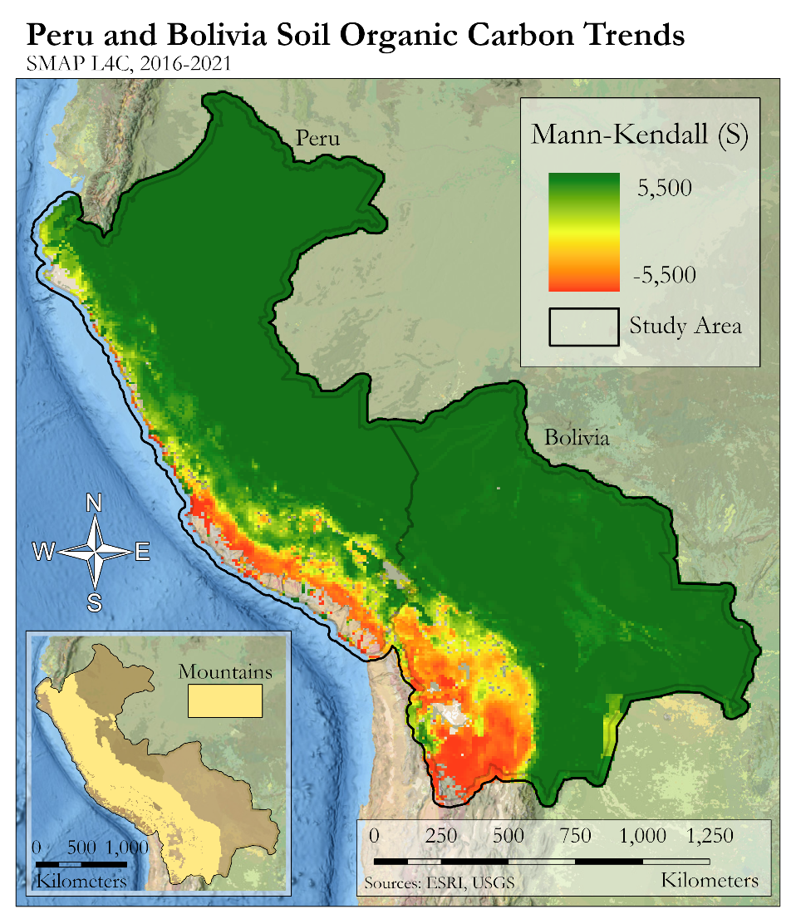
Figure 2. Significant changes in soil organic carbon per SMAP L4C across Peru and Bolivia from 2016–2021. Positive values indicate increasing SOC while negative values suggest the opposite.

Bolivia SOC is significantly decreasing over an area nearly twice as large as that decreasing in Peru. The tendency for SOC decreases to follow mountainous regions is strongest in Bolivia’s southwestern corner in the Altiplano. This is particularly true of the area surrounding Bolivia’s salt flats and lakes, such as Salar de Uyuni, Coipasa Lake, and Lake Poopó. The Altiplano is one of the most extensive plateaus on Earth at an elevation of nearly 4,000-m above sea level (Bull et al., 2018). Its southern end receives much less rainfall than its northern half. The Atacama Desert, one of the driest in the world, parallels the Altiplano Plateau and the Andes Mountains; the latter two, in addition to the western edge of the Amazon basin, generally agree with the spatial extent of decreasing SOC trends in both countries.

The southern border between Bolivia and Paraguay contains an isolated grouping of relatively low magnitude increasing SOC according to SMAP L4C (Figure B2). This area is outside the Andes and within the Gran Chaco region. The anomaly overlaps Médanos del Chaco National Park’s west end while straddling the Bolivia and Paraguay border. Its full extent into Paraguay is undetermined due to the limitations of the study area. Médanos del Chaco National Park contains portions of the Yrenda Aquifer System, which is important to the Chaco region’s water reserves, and is also home to unique fauna that are endemic to the region (UNESCO World Heritage Convention, 2022). It was also submitted for inclusion in the United Nations Educational, Scientific and Cultural Organization’s Tentative Lists as a potential nomination for the World Heritage List. We have noted this area because other non-mountainous regions of Bolivia and Peru manifest a stronger increasing trend in SOC; regardless, Médanos del Chaco National Park is indeed experiencing an increasing trend. The anomaly also tends to exhibit high SOC values around 2,500 g C m⁻² while the area immediately outside tends to fall below approximately 2,000 g C m⁻². Additionally, the anomaly does not appear to be influenced by the underlying land cover classifications because the dominating PFT (4; deciduous broadleaf trees) is homogenously distributed both within and outside the area (i.e., the anomaly is not contained by a grouping of a particular PFT). This differs from the slightly higher grouping of S values just north of the feature, which mimic the distribution of PFTs 5, 6, and 8 (shrub, grass, and broadleaf croplands, respectively). This area has strong agricultural activity and is centered by the city of Santa Cruz de la Sierra. The anomaly is not manifested in the SoilGrids dataset, and it does not appear to relate to PFT classification; for these reasons, the anomaly is likely due to a trend in climatological drivers of the SMAP L4C model which are not incorporated into the SoilGrids product.

4.1.2 Comparison between SMAP outputs and SoilGrids
We performed RMSE for each cell and the entire study area overall; for both these analyses, we averaged SMAP values from January 1, 2021, through December 31, 2021, and from January 1, 2016, through December 31, 2021. In the SMAP 2021 vs SoilGrids comparison between cells, the values of RMSE range between 0.0004 and 90.8, with low values indicating areas of high agreement and high values indicating areas of low agreement. Areas of high disagreement are along the eastern edge of the Andes and into the northeast Peruvian Amazon. The western edge of the Andes and the Bolivian Amazon have high disagreement (Figure 3). The comparison of SMAP for 2016–2021 versus SoilGrids for individual cells had a similar pattern for agreement and disagreement (Figure C1). The values of RMSE range from 0.001 and 91.7. SMAP generally has higher values along the coast and in the Bolivian Amazon while SoilGrids has higher values in the Peruvian Amazon and along the Andes. Additionally, the extent of the anomaly mentioned in section 4.1.1 appears to follow the grouped pattern of high RMSE in southeastern Bolivia.

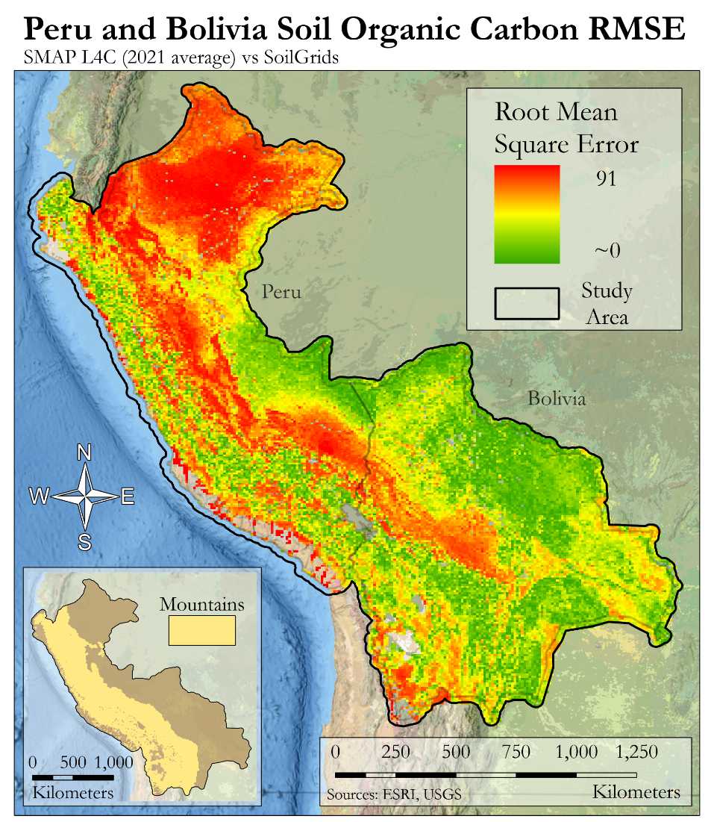
Figure 3. Root mean square error or SMAP L4C mean soil organic carbon averaged from January 1, 2021, through December 31, 2021, to SoilGrids

The values for the RMSE analysis for the entire study area altogether are in Table 3. SoilGrids agrees slightly more with SMAP from 2021 than the average of 2016–2021, but the differences are small. Initially, we calculated RMSE without standardization, and the value for the second column is in units of g C per m². RMSE has no standard interpretation, but values closer to zero indicate higher agreement. Interpretation of RMSE in this case is difficult: the data ranges are large so it’s unclear whether the RMSE represents absolutely high or low agreement. To make our RMSE values comparable to other analyses or future work with SOC with different scales, we standardized RMSE by dividing by the mean. In both cases, the 2021 RMSE values are lower than the 2016–2021 values.

Table 3
Results of Root Mean Square Error for SoilGrids vs SMAP L4C for the entire study area

Time | RMSE | RMSE (standardized by mean)
2021 | 1850.679 | 1.021
2016–2021 | 1880.071 | 1.074

4.1.3 True Color Map of Area of Interest
Figure 4 shows the composite true color imagery superimposed over the study area. Appendix D (Figures D1 and D2) show the true color imagery for each study area separately. The imagery of northeastern Peru, the Ampiyacu-Yaguas Lower Putumayo, has high amounts of vegetation and captures two rivers. The imagery of the Northern Bolivian Amazon shows significant development in the northern portion. For the area in northeastern Peru, there is high disagreement between SMAP L4C and SoilGrids (see Figure 3, Figure C1, Figure C2). However, the Northern Bolivian Amazon study area contains high agreement between the two datasets. Both areas of interest also have relatively lower amounts of SOC as compared to the western edges of each country (see Figure A1) and are experiencing significant increases in SOC (see Figure 2, Figure B2).

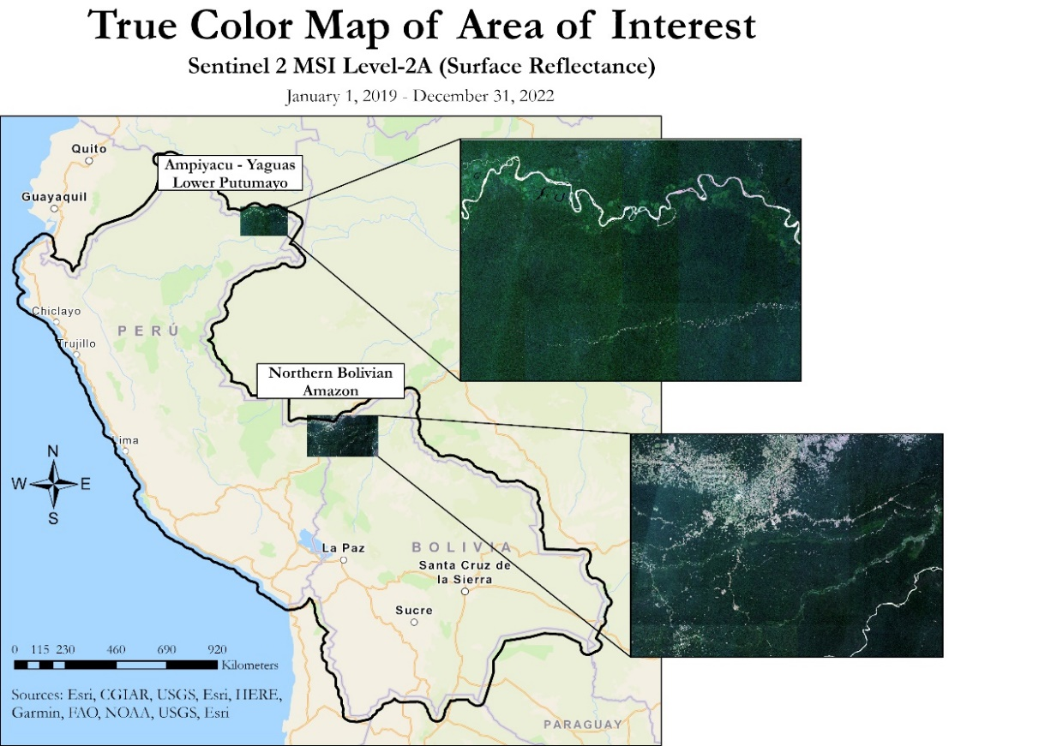
Figure 4. Composite true color map of area of interest as reference image from January 1, 2019, through December 31, 2022.

4.1.4 Downscaling Takeaways
An additional step we hoped to achieve was to fully downscale SMAP L4C prior to analysis. The SMAP L4C data is originally calculated at a 1-km resolution and then spatially averaged to 9-km due to storage constraints. The SOC values averaged by 1-km PFT classification are preserved within the 9-km cells and can be resampled to the MCD12Q1 land cover. This land cover data, along with the Resample sub-module from pyl4c, can be used to return the annual granules to their former spatial resolution. While we did manage to downscale our data using this method, we did not have time to rerun our analyses.

We initially attempted to downscale the data in ArcGIS Pro but encountered a misalignment issue. The MODIS land cover product and SMAP L4C were converted to point features and spatially joined. Both datasets were projected into EASE GRID 2.0, but MCD12Q1 did not align correctly with SMAP L4C. Therefore, SMAP L4C attributes were joined to MCD12Q1 cells outside of their true 9-km extent by a 4.5-km offset (Figure E1). Linear artifacts formed where SMAP L4C points fell on the border of two adjacent MCD12Q1 rows. This issue was due to error of the fixed origin of MCD12Q1’s affine transformation. We corrected this when downscaling in Python by adding and subtracting 4,500-m from the X and Y coordinate corners, respectively.

4.2 Future Work
Additional work can identify the potential causes for changes in SOC during the study period. The overall increase in SOC, if the trend is genuine, may have multiple causes. Dr. Endsley suggested additional work could look at potential trend drivers because it may be difficult to separate climate trends within the data from the L4C model equilibrating. Future work could also look at SMAP L4SM in the afternoon and plot trends of soil moisture and soil temperature against SOC trends from SMAP L4C. Known climate trends may be visible within these datasets and explain some of the visible changes. For example, colder temperatures suppress SOC decay. La Niña is associated with cooler temperatures from June to August over much of the project’s study area and cool and wet weather in northwestern Peru from December through February (Zhao et al., 2017; Lindsey, 2016). NOAA reported cooler Oceanic Niño Index anomalies associated with La Niña in parts of 2016, 2017–2018, and 2020–2023, and future analysis could look at whether this, or other climate drivers, impact SOC concentrations in this region (Climate Prediction Center).

One uncertainty is that land cover has likely changed in the study area, but the underlying MODIS land cover product is from the year 2000. Downscaling SMAP L4C with a more recent land cover product can help identify whether changes in land cover are driving either spatial or temporal changes in SOC. Future work should also consider the time difference between the SMAP L4C and SoilGrids data. SMAP L4C represents a snapshot of recent conditions, while SoilGrids utilizes observations from approximately 60-years (Poggio et al., 2021). Additionally, SMAP L4C and SoilGrids comparisons should consider a more accurate method of unionizing the two. Our comparison assumed a SoilGrids depth of 5-cm while SMAP L4C retained its 0-5-cm range, so disagreement was expected.

Future analyses can look at SOC changes over time and in areas larger than one cell through an optimized hot spot analysis; this may identify groupings of significant SOC change for additional study. These statistical relationships could also signify trends between certain land processes and SOC concentrations. For example, SOC tends to decrease on the coast-side of the Andes mountains which may be facilitated by physical erosion due to large slope. Additionally, the spatial extent of significantly decreasing SOC trends is similar to that of the Andes mountains, Altiplano Plateau, and the Atacama Desert. Due to the limitations of the project term, we were unable to identify or create a shapefile for these borders, but high aridity in these regions is likely associated with decreasing SOC concentrations. Therefore, a decrease in the Mann-Kendall score of a particular region over time may be a signal for uplift or desertification.

Additional work can inform current and future IC management. A comparison between SOC concentrations of protected and unprotected lands with the same PFTs, latitudes, and climatic regimes could illuminate the impacts management practices have on IC. There is also a potential case study between the Piura peninsula in Northern Peru and the western corner extent of the study area near the Atacama Desert. Although the two areas are very arid, Piura exhibited increasing trends in SOC compared to the dominantly decreasing trends in the south. Finally, future analyses could measure the average mean residence time of SOC within protected area and attempt to connect residence time with the recoverability of that carbon; for example, the loss of SOC in areas with lower residence times suggests that carbon could be recoverable while loss of SOC in areas with longer residence times suggests that carbon may not be recoverable on a relevant timescale.

5. Conclusions
Overall, SOC increased over the entire time period for both countries, for the overall SOC mean and for each PFT. However, this trend may be due to model equilibration. The generation of SMAP L4C is also limited to outdated land classifications. PFTs have likely changed since 2000 but the land cover map within SMAP L4C is not dynamic. Areas of significant SOC decreases generally follow the spatial extent of the Andes Mountains, and nearly all areas outside are experiencing significant increases in SOC. The pattern of overall SOC concentrations is generally opposite that of the spatial patterns of increase and decrease: the areas of highest SOC are within the Andes and along the western portion of both countries while the interiors tend to have lower concentrations.

An anomaly detected near Médanos del Chaco National Park exhibited contrastingly lower magnitudes of significant SOC increase and relatively larger amounts of SOC when compared to other non-mountainous regions. However, this anomaly did not appear dependent on land classification which suggests a localized change in soil temperature and/or surface and root-zone moisture which are climatic drivers in SMAP L4C. SoilGrids did not manifest the anomaly or this sensitivity to the drivers, which should be considered when choosing between the two SOC data sources. For example, SMAP L4C may be more sensitive to areas with static land and dynamic climate conditions. With these analyses and the overall methodology for tracking SOC changes over time, CI can identify if their smaller areas of interest are within areas of overall increasing or decreasing SOC and what management strategies are applicable to those regions.

6. Acknowledgments
The Peru and Bolivia Climate team would like to express our appreciation and thanks to Monica Noon, Erika Munshi, and Patrick Roehrdanz from Conservation International, their Science Advisor Sean McCarney, and our fellow Carli Merrick for their guidance throughout this project. Additionally, we would like to thank Dr. Arthur Endsley from the University of Montana for his scientific guidance in using SMAP L4C.

Maps throughout this work were created using ArcGIS® software by Esri. ArcGIS® and ArcMap™ are the intellectual property of Esri and are used herein under license. All rights reserved.

This material contains modified Copernicus Sentinel data (2019-2022), processed by ESA.

Any opinions, findings, and conclusions or recommendations expressed in this material are those of the author(s) and do not necessarily reflect the views of the National Aeronautics and Space Administration.

This material is based upon work supported by NASA through contract NNL16AA05C.

7. Glossary
AppEEARS – Application for Extracting and Exploring Analysis Ready Samples
Conservation International – non-profit organization working on co-managing irrecoverable carbon reserves
Durbin-Watson – a measure of serial correlation on the residuals from regression analysis
Earth observations – Satellites and sensors that collect information about the Earth’s physical, chemical, and biological systems over space and time
GEE – Google Earth Engine
GeoTIFF – Geographic tagged Image File Format
Irrecoverable carbon – vast stores of carbon in nature that are vulnerable and if released due to human activity, could not be restored
La Niña – the opposite of an El Niño: trade winds strengthen and stronger upwelling along eastern Pacific which can impact temperature and precipitation patterns globally
Mann-Kendall test – a statistical test, which does not assume the underlying data falls within a normal or specified distribution (nonparametric), which measures whether an increasing or decreasing trend (monotonic) is consistent
MODIS – Moderate Resolution Imaging Spectroradiometer
PFT – Plant Functional Type
RMSE – root mean square error
Shapefile – a file format to store geographic vector data
SMAP L4C – Soil Moisture Active Passive Level-4 Carbon
SOC – Soil organic carbon

8. References
Bhattacharyya, R. (2020). Chapter 63: Trade Liberalization, Infrastructure Development, and FDI in India and China. In Khosrow-Pour,M., Clarke, S., Jennez, M.E., Anttiroiko, A., Kamel, S., Lee, I., Kisielnicki, J., Gupta, A., van Slyke, C., Wang, J., & Weerakkody, V. (Eds). Foreign Direct Investments: Concepts, Methodologies, Tools, and Applications. IFI Global, Hershey, Pennsylvania.

Bull, A.T., Andrews, B.A., Dorador, C. (2018). Introducing the Atacama Desert. Antonie van Leeuwenhoek, Vol.(111), 1269–1272. https://doi.org/10.1007/s10482-018-1100-2

Chatterjee, S. & Simonoff, J.S. (2013). Handbook of Regression Analysis. Wiley, Hoboken, New Jersey.

Chen, Y. (2016). Spatial Autocorrelation Approaches to Testing Residuals from Least Squares Regression. PLoS One, 11(1). 10.1371/journal.pone.0146865

Climate Prediction Center. (n.d.). Cold & Warm Episodes by Season. https://origin.cpc.ncep.noaa.gov/products/analysis_monitoring/ensostuff/ONI_v5.php

Endsley, K.A., Reichle, J.S., & Watts, J.D. (2020). Satellite monitoring of global surface soil organic carbon dynamics using the SMAP Level 4 Carbon production. Journal of Geophysical Research: Biosciences, 125(12). https://doi.org/10.1029/2020JG006100

Endsley, K.A., and Schwher, K., (2023). arthur-e/pyl4c: Latest and greatest (v0.14.1) Zenodo. https://doi.org/10.5281/zenodo.7626785

European Space Agency. (n.d.). Sentinel-2 Mission Guide. Sentinel Online.
https://sentinel.esa.int/web/sentinel/missions/sentinel-2/overview

Friedl, M., Sulla-Menashe, D. (2019). MCD12Q1 MODIS/Terra+Aqua Land Cover Type Yearly L3 Global 500m SIN Grid V006 [Data set]. NASA EOSDIS Land Processes DAAC. Accessed 2023-02-16 from https://doi.org/10.5067/MODIS/MCD12Q1.006

GeoBolivia: la Infraestructura de Datos Espaciales del Estado Plurinacional de Bolivia. (2021). Bolivia (Plurinational State of) - Subnational Administrative Boundaries [Data File]. Retrieved from https://data.humdata.org/dataset/cod-ab-bol.
Gesch, D.B., Oimoen, M.J., & Evans, G.A. (2014). Accuracy assessment of the U.S. Geological Survey National Elevation Dataset, and comparison with other large-area elevation datasets—SRTM and ASTER: U.S. Geological Survey Open-File Report 2014–1008, 10 p., http://dx.doi.org/10.3133/ofr20141008.

Goldstein, A., Noon, M., Ledezma, J.C., Roehrdanz, P., Raghav, S., McGreevey, M., Stone, C., Shrestha S., Kroner, R.G., Hole, D. & Turner, W. (2021). Irrecoverable Carbon: The Places We Must Protect to Avert the Climate Catastrophe. Conservation International. https://www.conservation.org/docs/default-source/publication-pdfs/irrecoverable-carbon-report.pdf?sfvrsn=16207fea_2

Goldstein, A., Turner, W. R., Spwan, S. A., Anderston-Teixiera, K.J., Cook-Patton, S., Fargione, J., Gibbs, H.K., Griscom, B., Hweson, J.H., Howard, J.F., Ledezma, J.C., Page, S., Koh, L.P., Rockström, J., Sanderman, J., & Hole, D.G. (2020). Protecting irrecoverable carbon in Earth’s ecosystems. Nature Climate Change, 10, 287–95. https://doi.org/10.1038/s41558-020-0738-8

Grace, P.R., Antle, J., Aggarwall P.K., Ogle, S., Paustian, K. & Basso, B. (2012). Soil carbon sequestration and associated economic costs for farming systems of the Indo-Gangetic Plan: A meta-analysis. Agriculture, Ecosystems and Environment, 146, 137-146. https://doi.org/10.1016/j.agee.2011.10.019

Guayasamin, J.M., Ribas, C.C., Carnaval, A.C., Carrillo, J.D., Hoorn, C., Lohmann, L.G., Riff, D., Ulloa Ulloa, C., & Albert, J.S. (2021). Chapter 2: Evolution of Amazonian Biodiversity. In Nobre, C., Encalada, A., Anderson, E., Roca Alcazar F.H., Bustamante M., Mena, C., Peña-Claros, M., Poveda, G., Rodriguez, J.P., Saleska, S., Trumbore, S., Val, A.L., Villa Nova, L., Abramovay, R., Alencar, A., Rodríguez Alzza, C., Armenteras, D., Artaxo, P., Athayde, … Zapata- Ríos, G. (Eds). Amazon Assessment Report 2021. United Nations Sustainable Development Solutions Network, New York, USA. https://doi.org/10.55161/CZWN4679.

Hirsch, R.M., & Slack, J.R. (1984). A Nonparametric Trend Test for Seasonal Data with Serial Dependence. Water Resources Research, 20(6): 727-732. https://doi.org/10.1029/WR020i006p00727

Hussain et al., (2019). pyMannKendall: a python package for non parametric Mann Kendall family of trend tests. Journal of Open Source Software, 4(39), 1556, https://doi.org/10.21105/joss.01556

Instituto Geográfico Nacional – IGN. (2020). Peru - Subnational Administrative Boundaries [Data File]. Retrieved from https://data.humdata.org/dataset/cod-ab-per.
Karagulle, D., C. Frye, R. Sayre, S. Breyer, P. Aniello, R. Vaughan, and D. Wright. (2017). Modeling global Hammond landform regions from 250-m elevation data. Transactions in GIS. https://doi.org/10.1111/tgis.12265

Kimball, J. S., Endsley, K.A., Jones, L.A., & Reichle, R. 2022. SMAP L4 Global Daily 9 km EASE-Grid Carbon Net Ecosystem Exchange, Version 7 [Soil Organic Carbon]. Boulder, Colorado USA. NASA National Snow and Ice Data Center Distributed Active Archive Center. https://doi.org/10.5067/3K9F0S1Q5J2U. [February 14, 2023].

Lindsey, Rebecca. (2016). Global Impacts of El Niño and La Niña. National Oceanographic and Atmospheric Association Climate.gov. https://www.climate.gov/news-features/featured-images/global-impacts-el-ni%C3%B1o-and-la-ni%C3%B1a

Meals, D.W., Spooner, J., Dressing, S.A., & Harcum, J.B. (2011). Statistical analysis for monotonic trends, Tech Notes 6. Tetra Tech for the U.S. Environmental Protection Agency. https://www.epa.gov/sites/default/files/2016-05/documents/tech_notes_6_dec2013_trend.pdf

Noon, M.L., Goldstein, A., Ledezma, J.C., Roehrdanz, P.R., Cook-Patton, S.C., Spawn-Lee, S.A., Wright, T.M., Gonzalez-Roglich, M., Hole, D.G., Rockström, J., & Turner, W.R. (2022). Nature Sustainability, 5, 37-46. https://doi.org/10.1038/s41893-021-00803-6

Ontl, T.A. & Schulte, L.A. (2012). Soil Carbon Storage. Nature Education Knowledge, 3(10):35. https://www.nature.com/scitable/knowledge/library/soil-carbon-storage-84223790/

Paustian, K., Lehmann, J., Ogle, S., Reay, D., Roberston, G.P., & Smith, P. (2016). Climate-smart soils. Nature, 532, 49-57. https://doi.org/10.1038/nature17174

Poggio, L., de Sousa, L.M., Batjes, N.H., Heuvelink, G.B.M., Kempen, B., Ribeiro, El, & Rossiter, D. (2021). SoilGrids 2.0: producing soil information for the globe with quantified spatial uncertainty. Soil, 7, 217-240. https://doi.org/10.5194/soil-7-217-2021

Post, W.M., Izaurralde, R.C., Mann, L.K., & Bliss, N. (2001). Monitoring and Verifying Changes of Soil Organic Carbon in Soil. Climatic Change, 51, 73-99. https://doi.org/10.1023/A:1017514802028

Powlson, D.S., Stirling, C.M., Jat, M.L., Gerard, B.G., Palm, C.A., Sanchez, P.A., & Cassman, K.G. (2014). Limited potential of no-till agriculture for climate change mitigation. Nature Climate Change, 4, 678-683. https://doi.org/10.1038/nclimate2292

Skinner, K.D. (2011). Evaluation of LiDAR-acquired bathymetric and topographic data accuracy in various hydrogeomorphic settings in the Deadwood and South Fork Boise Rivers, West-Central Idaho, 2007: U.S. Geological Survey Scientific Investigations Report 2011–5051, 30 p.

Stockmann, U., Adams, M.A., Crawford, J.W., Field, D.J., Henakaarchchi, N., Jenkins, M., Minasny, B., Mcratney, A.B., de Remy de Courcelles, V., Singh, K., Wheeler, I., Abbott, L., Angers, D.A., Baldock, J., Bird, M., Brookes, P.C., Chenu, C., Jastrow, J.D., ... Zimmerman, M. (2013). The knowns, known unknowns and unknowns of sequestration of soil organic carbon. Agriculture, Ecosystems and Environment, 163, 80-99. https://doi.org/10.1016/j.agee.2012.10.001

UNESCO World Heritage Convention. (2022). Médanos del Chaco National Park. https://whc.unesco.org/en/tentativelists/6611/

Vergara, A., Arias, M., Gachet, B., Naranjo, L.G., Roman, L., Surkin, J., Tamayo, V., Bueno, P., Gagen, M., Perreira, M., Granzio, T., Mena, V., Mongylardi, C., Oliveira, E., Perez, J., Petrone, S., Rivadeneira, M.I., Rubio, H., Shanbol, N., ... Yunda, R. (2022). Living Amazon Report 2022. https://files.worldwildlife.org/wwfcmsprod/files/Publication/file/1w8fz5mktn_lar__ingles_23_dic_2022.pdf?_ga=2.258742537.2013233585.1680714089-2003308000.1680714088

Zhao, Y., Ding, Y., Hou X., Li F.Y., Han, W., & Yun, X. (2017) Effects of temperature and grazing on soil organic carbon storage in grasslands along the Eurasian steppe eastern transect. PLoS ONE 12(10). https://doi.org/10.1371/journal.pone.0186980

9. Appendices

Appendix A – SOC Distribution
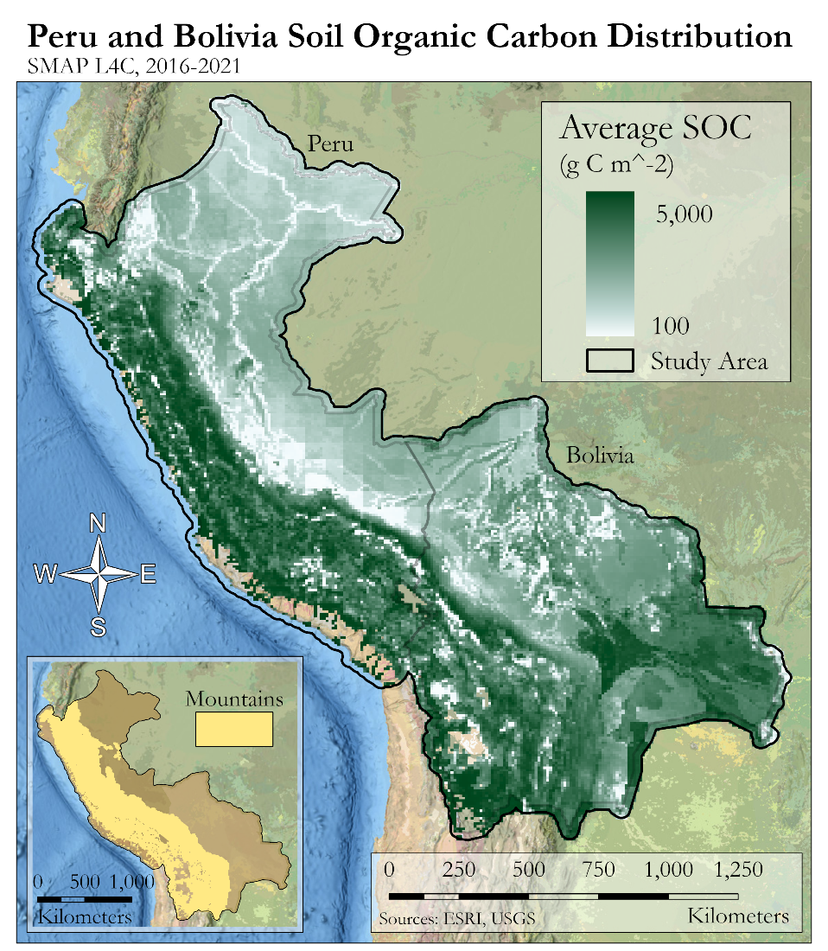
Figure A1. Soil organic carbon distribution averaged 2016–2021 from daily SMAP L4C over the study area (NOTE: a histogram equalize stretch was utilized to increase contrast).

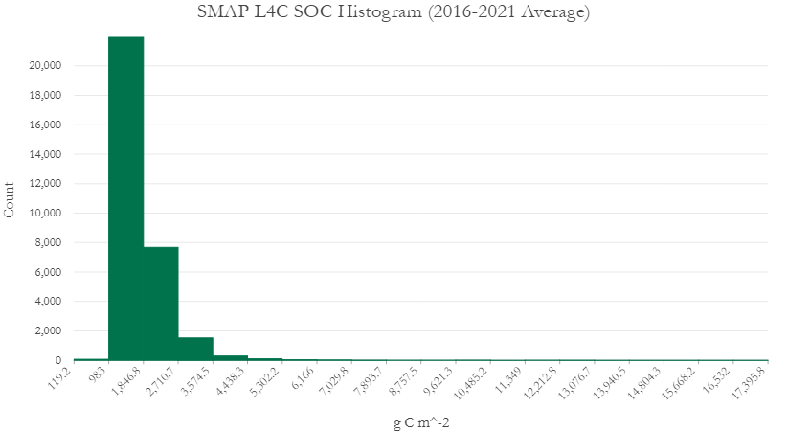

Figure A2. Histogram of 9km SMAP L4C soil organic carbon averaged 2016-2021.

Appendix B – Mann-Kendall
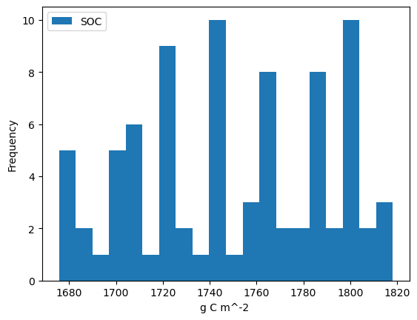
Figure B1. Histogram of mean SOC in g C/m² for Peru from January 1, 2016, through November 8, 2022, averaged monthly to check if it visually falls along a normal distribution.

Table B1. Spatial Mann-Kendall areal statistics (*NOTE overlap between the two country study areas)
Attribute ($km^{2}$) | Peru & Bolivia | Peru* | Bolivia*
Area Sig Inc SOC | 2,290,208.26 | 1,294,003.37 | 1,049,029.63
Area Sig Dec SOC | 270,615.24 | 96,155.64 | 179,328.24
Area Sig Inc SOC (Mountainous) | 905,485.896 | - | -
Area Sig Inc SOC (Non-Mountainous) | 1,384,722.36 | - | -
Area Sig Dec SOC (Mountainous) | 247,002.336 | - | -
Area Sig Dec SOC (Non-Mountainous) | 23,612.904 | - | -
Portion Mountainous Experiencing Sig Change that is Inc | 78.57% | - | -
Portion Mountainous Experiencing Sig Change that is Dec | 21.43% | - | -
Portion Non-Mountainous Experiencing Sig Change that is Inc | 98.32% | - | -
Portion Non-Mountainous Experiencing Sig Change that is Dec | 1.68% | - | -

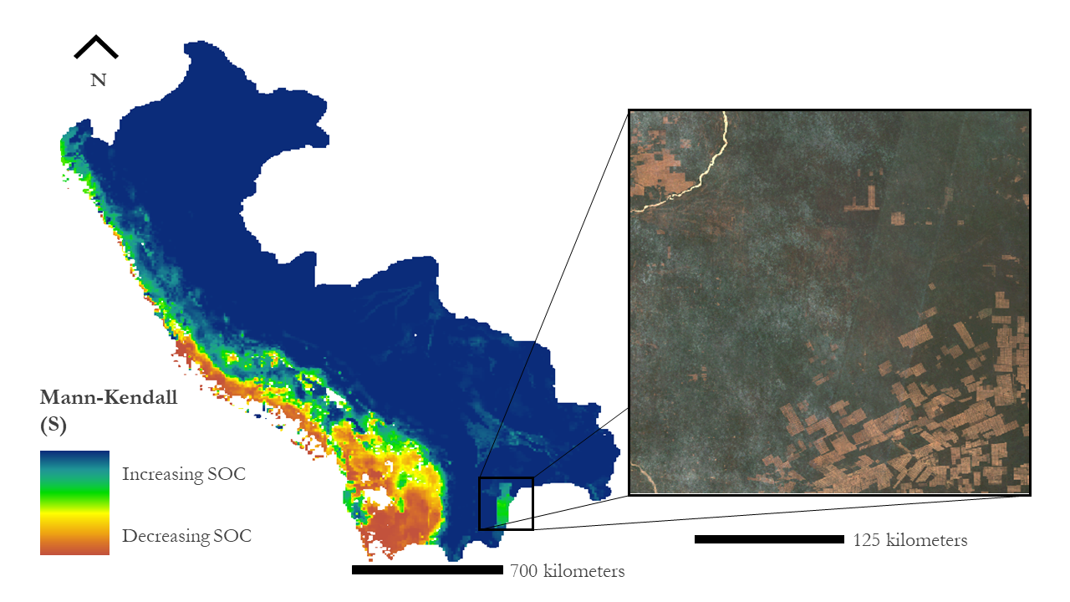
Figure B2. Anomaly found in south-eastern Bolivia with Sentinel-2 true color reference.

Appendix C – SoilGrids Comparison
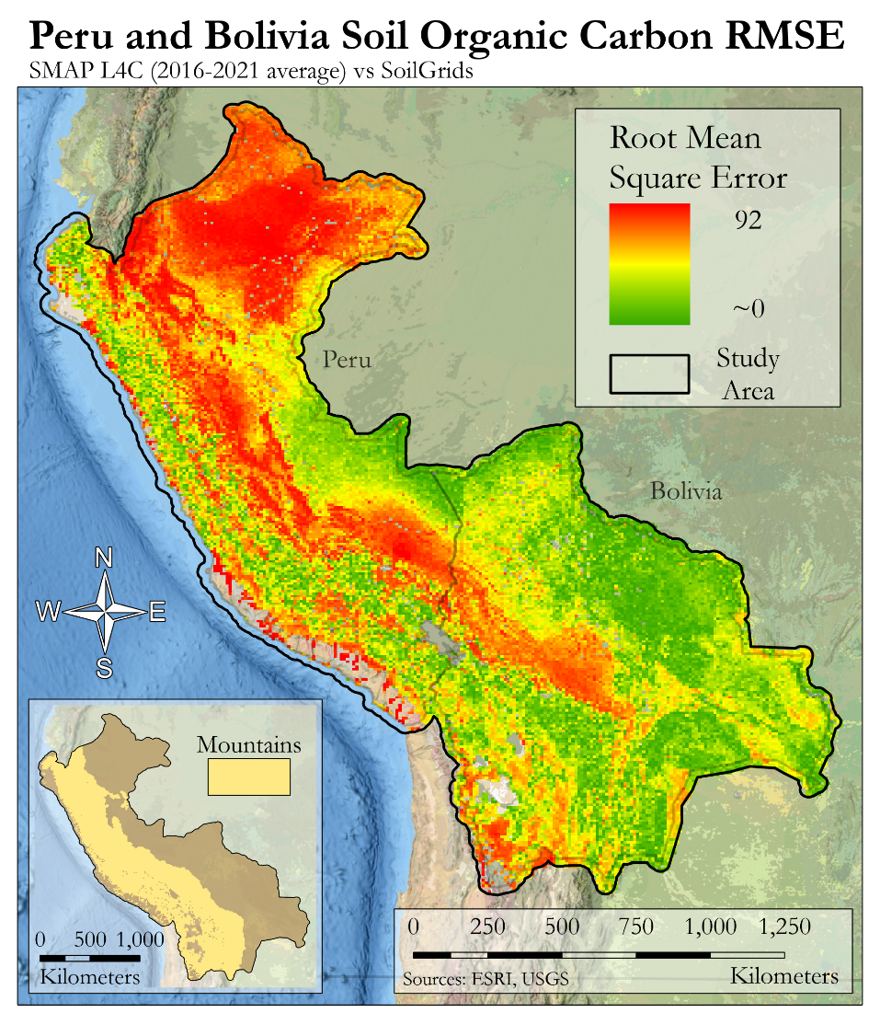
Figure C1. Root mean square error or SMAP L4C mean soil organic carbon averaged from January 1, 2016, through December 31, 2021, to SoilGrids
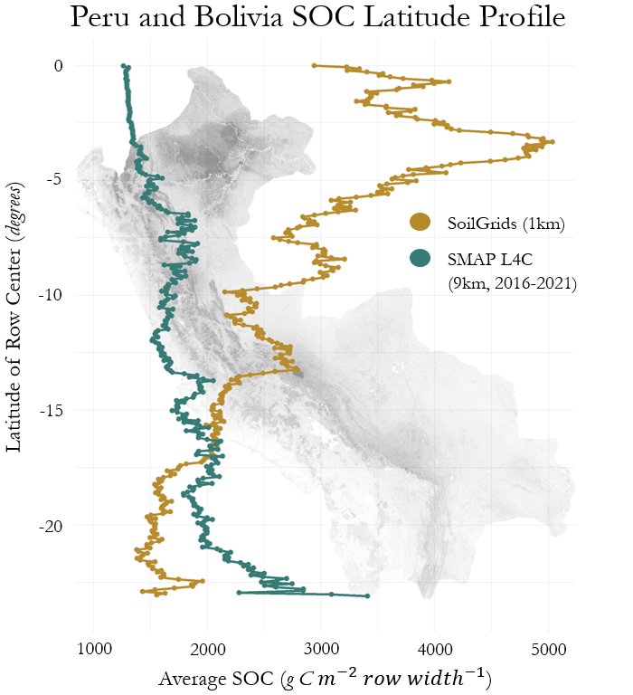

Figure C2. Profile of SoilGrids (1km) and SMAP L4C (9km, 2016-2021 average) soil organic carbon averaged by latitude (row)

Appendix D – True Color Imagery

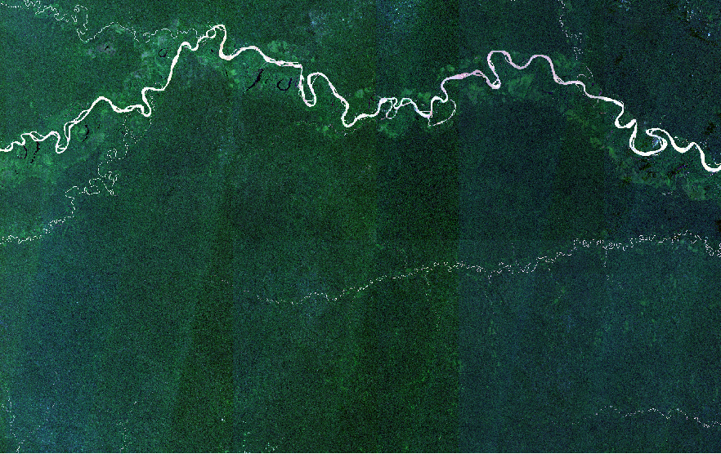
Figure D1. True color map of area of interest in Peru as reference image from January 1, 2019, through December 31, 2022.
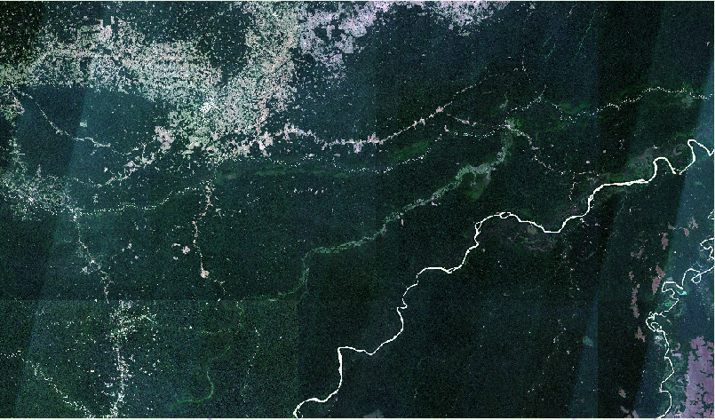
Figure D2. True color map of area of interest in Bolivia as reference image from January 1, 2019, through December 31, 2022.

Appendix E – Downscaling

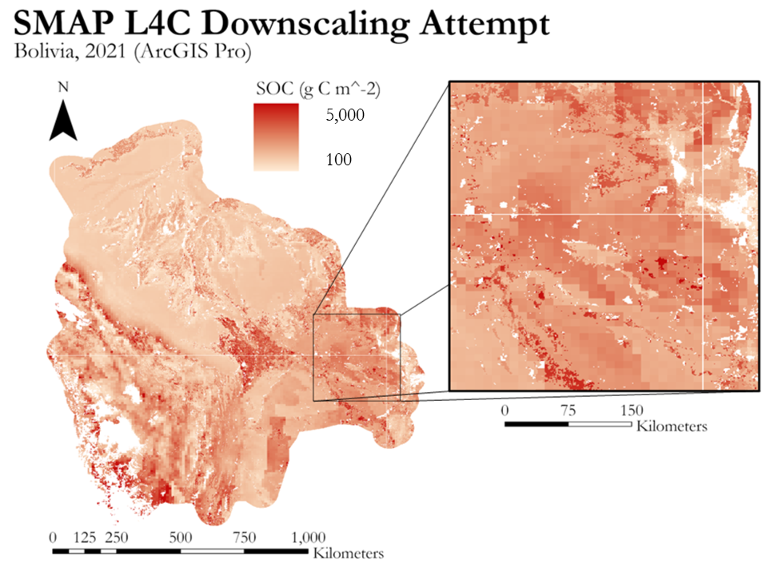

Figure E1. Attempts to downscale 9km SMAP L4C with use of 1km MCD12Q1 in ArcGIS Pro produced linear null artifacts due to offset issues between native projections.

