Gila Water Resources II

Using Earth Observations to Identify Wildfire Impacts on Hydrologic Functions and Recovery in the Gila National Forest

  
**Technical Report**

Final Draft – April 2nd, 2020

Alia Giolitti (Project Lead)

Carli Merrick

Madeline Allen

Sarah Hafer

Dr. Sebastian Martinuzzi, University of Wisconsin-Madison (Science Advisor)

Dr. John Bolten, NASA Goddard Space Flight Center (Science Advisor)

Previous Contributors:

Terra Edenhart-Pepe

Abigail Barenblitt

Ariege Besson

**1. Abstract**

Wildfires have the potential to cause devastating and long-lasting impacts on ecological systems. In the Gila National Forest (Gila NF), wildfire events have occurred with increasing frequency and severity over recent years. These disturbances such as the historic Whitewater-Baldy Complex Fire (2012) and Silver Fire (2013) have raised concerns over post-fire soil erosion, flooding, debris flows, and vegetation recovery. Understanding the connection between burn events and ecological functions is crucial for developing effective land management practices within the Gila NF that ensure the conservation of the watershed. Our Gila Water Resources II team worked in partnership with the US Department of Agriculture (USDA) US Forest Service’s (USFS) Gila National Forest and Region 3. This project was designed to provide insight into the influence of wildfires on increased flooding events and to determine if restoration efforts in the Gila NF are having a beneficial and noticeable impact on recovery. The goals of this project included generating data-supported end products to inform land management decisions, including the prioritization of specific regions and time scales for post-fire restoration efforts. To understand recovery trends and hydrologic impact in the Gila NF between 2000 and 2020, this project used NASA Eath observations (EO) and ancillary data, including, but not limited to, Landsat 5 Thematic Mapper (TM), Landsat 7 Enhanced Thematic Mapper Plus (ETM+), Landsat 8 Operational Land Imager (OLI), USGS stream gauge data, and data provided by USDA USFS’s Gila National Forest and Region 3.

**Keywords**

hydrology, watershed, post-fire recovery, wildfire, vegetation, Landsat, Normalized Burn Ratio (NBR), New Mexico

**2. Introduction**

***2.1 Background Information***

Wildfires are common phenomena that can vastly impact and transform both abiotic and biotic factors such as water flow, land cover, biological makeup, and erosion across a wide variety of ecosystems, particularly semi-arid grasslands, shrublands, and forest. These habitat types are especially prone to fires and in some cases even rely on wildfires to maintain biodiversity and ecological health (Hutto, 2008). However, in recent years there have been increasing instances of severe burn events that have the potential to impact community recovery (Odion et al., 2014). In the past few decades, the Gila National Forest (Gila NF) watershed in Southern New Mexico has experienced a heightened frequency of severe wildfires that have caused noticeable changes in the ecological structure, land cover, and hydrologic functions (Wine & Cadol, 2016; Wine, Cadol, & Makhnin, 2018). The Whitewater-Baldy Complex Fire in 2012 was the largest fire ever recorded in New Mexico and burned 274,784 acres. The Silver Fire in 2013, burned 138,698 acres, including nearly 800 acres of private property. These fires had profound impacts on the Gila watershed (Gila National Forest, 2012; Gila National Forest, 2013) and have prompted community concern over associated impacts within the national forest and downstream including flooding, erosion, debris flows, water quality, stream discharge, and vegetation recovery. Vegetation regrowth after burn events varies depending on the severity, frequency, and burn area (Ireland & Petropoulos, 2015; Odion et al., 2014). The mixed conifer forests, ponderosa pine forests, and varying shrublands of Gila NF are well adapted to mixed-severity fire regimes, and, therefore, have a high threshold for fire disturbances. However, in recent years there has been concern from land managers about increasingly severe wildfire events that may disrupt historic regeneration patterns (Bright et al., 2019; Meng et al., 2015; Odion et al., 2014).

In an effort to stimulate post-fire succession and recovery, the US Forest Service at Gila National Forest (USFS Gila National Forest) has begun applying treatments after particularly severe fires including the Bear Fire 2006, the Whitewater-Baldy Complex Fire 2012, and the Silver Fire 2013. Treatment applications include aerial seeding of selected areas with a mixture of quick-growing, primary succession species including barley (*Hordeum vulgare*), mountain brome (*Bromus marginatus*), and Arizona fescue (*Festuca arizonica*). Additional treatments include the application of a mixture of seed and straw mulch. These treatment areas were selected on a basis of burn severity, contiguous land cover, the threat to life and property downstream of the burned areas, areas upstream of habitat that houses threatened or endangered aquatic species, and areas upstream of historic mines. The objective of this restoration is not only to supplement post-wildfire vegetative recovery of forested areas, but also to encourage re-stabilization of riparian areas, which are important for regulating stream flow, erosion, and water quality (Bunn,Davies, & Mosisch, 1999; Keesstra et al., 2012; Kobziar & McBride 2006). The focus of treatment in areas that could have a cumulatively destructive effect downstream of burn events, including erratic stream flow and decreased water quality, stem from USFS Gila National Forest observations of a potential relationship between wildfires and flash floods, with increased flooding and debris flows occurring downstream within the years following severe fires. The USFS Gila National Forest Burned Area Emergency Response (BAER) Team that examined the immediate impact of the Whitewater-Baldy Complex fire predicted that post-fire flows from a 25-year precipitation event could increase 2 to 4 times in many of the drainage regions impacted by these fires (Gila National Forest, 2012). This observation by the USFS Gila National Forest is supported through other recent studies that have documented and successfully modeled relationships between wildfires and post-fire flooding (Hallema et al., 2018; Wine & Cadol, 2016).

Land managers respond to wildfire-related environmental disruption by employing restoration practices like seeding and mulching. However, informed restoration efforts require an understanding of the interrelated processes acting on the landscape (Aqua Terra Consultants, 2019.; Potyondy & Geier, 2010). Managing the future risk of harmful watershed system impacts necessitates the characterization of landscape changes at spatial and temporal scales that capture fire effects (Kennedy, Yang, Cohen, et al., 2012). Previous studies demonstrate that satellite data from NASA Earth observations (EO) and other sources have a large potential for helping land managers understand the impacts of wildfires. Our project utilized NASA EO and various ancillary data to understand how wildfires in the Gila NF affect watershed hydrological functions and vegetative community regrowth. The study area for this project included all of the Hydrologic Unit (HUC) 12 level watersheds intersecting with the Gila NF (*Figure 1*).

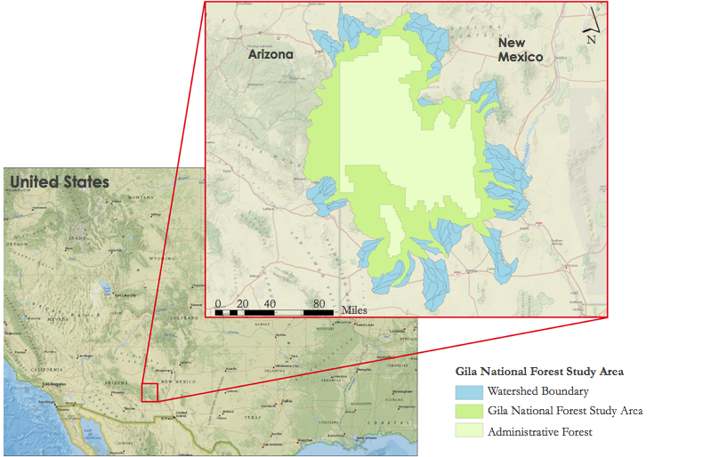

*Figure 1.* Map showing Gila National Forest Watershed boundaries.

***2.2 Project Partners & Objectives***

Our partners in the Gila Water Resources II project were the USFS Gila National Forest and USFS Region 3. The USFS Gila National Forest has actively managed and monitored regional disturbances with practices that include survey, inventory, and observation of environmental correlations; however, condition assessments and management decision practices currently rely on local knowledge, ground surveys, and some *in situ* restoration monitoring and data collection. Our partners seek to employ resource-effective actions related to ecosystem restoration and management following burn events and to formulate a body of knowledge concerning potential patterns related to increasing occurrences of wildfires.

This project investigated the impacts of wildfire disturbances on hydrologic functions and vegetation recovery in the Gila NF. This ensured structured and informative end products that will enable our partners at USFS Gila National Forest and USFS Region 3 to have an improved understanding of wildfire impacts within the Gila NF watershed and make effective management decisions. The team identified severe fires that occurred in the Gila NF from 2000 to 2018 (*Figure 2*). A few of these severe fires were the subject of restorative actions by USFS Gila National Forest. We compared post-fire recovery in treatment plots for two of those fires, the Silver Fire 2013 and the Bear Fire 2006, against control areas. This analysis was undertaken to help our partners determine if the current post-wildfire treatment methodology is a beneficial use of time and funding.

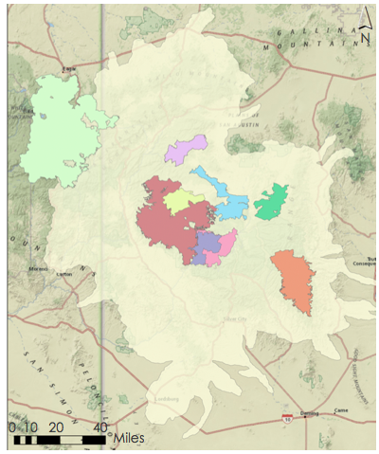



**Gila National Forest Study Fires**



Gila National Forest Study Area

DryLake Complex Fire 2003

Boiler Fire 2003

Bull Fire 2005

Bear Fire 2006

Miller Fire 2011



 Silver Fire 2013

Wallow Fire 2011

 Buzzard Fire 2018

Whitewater Baldy Complex Fire 2012

*Figure 2.* The study area for this project, including the boundaries of individual fires over the past 20 years that burned over 50,000 acres of land respectively.

Additionally, we investigated the relationship between wildfire events, heightened streamflow, and precipitation from 2000 to 2019. This analysis provided our partners with a broader understanding of the relationship between wildfires and the resulting flooding they have observed, which may help to mitigate and predict future stream flows post-fire.

***2.3 Previous Term: Gila Water Resources I***

The preliminary term for Gila Water Resources laid the foundation for understanding the impacts of interrelated disturbances on watershed recovery dynamics. The purpose of this project was to generate data-supported knowledge to inform land management decisions and planning, including the prioritization of specific regions for restoration efforts. They determined that Normalized Burn Ratio (NBR) is a useful metric for recovery within a watershed, due to the consistency between their results and pre-established values of burn severity levels. Their results established a pathway for further exploration of recovery at the watershed level. Furthermore, their project demonstrated that United States Geological Survey (USGS) gauge streamflow data could be analyzed and used in the future as an additional metric for watershed recovery. The previous term established the proficiency of NBR as a metric for vegetative community recovery and executed a preliminary analysis for vegetative community recovery for the Whitewater-Baldy Complex and Silver Fires. However, the previous term did not find a significant difference in percent recovery in regions with different burn severities and land cover types. An in-depth statistical analysis was out of the scope for this project; however, it was noted that recovery for forested areas was higher than alternative land covers.

**3. Methodology**

***3.1 Data Acquisition***

We received legacy data from Term I of the Gila Water Resources project including USGS HUC 12 Watershed Boundaries and USGS National Landcover Database (NLCD) (Table A2). Additionally, our team acquired data including Burn Severity, Riparian Vegetation, and Post-Fire Treatment Areas from USFS Gila National Forest and USFS Region 3. The Post-Fire Treatment Area data were only available for three fires: the Bear Fire 2006, the Whitewater-Baldy Complex Fire 2012, and the Silver Fire 2013 (Table A2). We also acquired a 1/3 arc-second resolution Digital Elevation Model for our study area from USGS National Elevation Dataset (Table A2).

To examine trends in vegetation recovery, we employed a combination of ancillary data and NASA EO including Landsat 5 Thematic Mapper (TM), Landsat 7 Enhanced Thematic Mapper Plus (ETM+) and Landsat 8 Operational Land Imager (OLI) atmospherically corrected surface reflectance Near Infrared (NIR) and Short-wave Infrared 2 (SWIR 2) band data from 2000 through 2019 (Table A1). These data were obtained via Climate Engine, a platform that utilizes Google Earth Engine (GEE) to process climate and satellite data. Landsat data were obtained for treatment and control plots (described in more detail in section 3.2) for Bear Fire (2006) and Silver Fire (2013). To do this, shapefiles containing the plot area polygons were imported into Google Earth Engine through the Asset Manager on the Google Code Playground as table assets. The table asset was then made public and the ID was copied into Climate Engine, thus importing the polygon area information, and enabling us to obtain Landsat time-series data for specific plots. For each plot, the NIR and SWIR 2 band data at a 30-meter resolution were exported as comma-separated values (CSV) files for a custom date range of 2000-01-01 to 2019-12-31, and named according to the following format: [Fire Name]_[Treatment or Control]_[Plot ID]_[Band Name]_[Year Range] for example, Silver_Treat_FID00_NIR_2000-2019.

One of our first steps for the hydrological analyses was to acquire additional USGS Stream Gauge Data to accompany the data from the gauges chosen last term, which provided important data on streamflow in the study area. Our team obtained 20 years of data from two stream gauges inside of and downstream from the Gila NF. These specific gauges were strategically selected based on their position relative to severe wildfires that burned between 2000 and 2018. All gauges chosen for this study can be seen in *Figure B1*.

For the selected watershed area, precipitation data were retrieved from two sources: Parameter-elevation Regressions on Independent Slopes Model (PRISM) and Global Precipitation Measurement – Integrated Multi-satellitE Retrievals for GPM (GPM-IMERG). GPM-IMERG was chosen as the source of precipitation data for this project however, a comparison of the two datasets was conducted during this term and can be found in Appendix C. GPM-IMERG is a NASA Level three product that provides precipitation data that are estimated based on satellite data collected from the Global Precipitation Measurement satellite for the entire globe combined with measurements from the Tropical Rainfall Measuring Mission (TRMM) satellite and modeled precipitation data as well. We obtained the GPM-IMERG precipitation data via Google Earth Engine. The team wrote a script that imports the watershed polygon and the “GPM: Global Precipitation Measurement (GPM) v6” Image Collection and selects the “precipitationCal” band data, which is calibrated snapshot precipitation data reported at a half-hourly timescale with the units mm/hr. Then, we set up a loop to obtain daily data, from 2000-07-01 (one month after GPM-IMERG data began) to 2019-12-31. Within the loop, the image collection is filtered by the specified date range, clipped to the area of the watershed, summed temporally per day, and averaged spatially across the watershed area. Finally, we created lists of the dates and the daily precipitation sums and exported them to Google Drive.

***3.2 Data Processing***

For the vegetation recovery analysis, control plots were selected within the perimeters of the Bear Fire (2006) and the Silver Fire (2013) as a standard upon which to compare the effectiveness of varying treatment strategies by USFS Gila National Forest. For the identification of these control areas, we calculated average burn severity and average elevation for each treatment plot, using Zonal Statistics in ArcMap 10.7.1. In addition to these variables, we also identified the most prevalent landcover type based on a singular majority for each respective plot. To isolate control areas, we created a Weighted Overlay that factored in the level of burn severity, land cover type, and elevation. Weighted Overlay is a method to suggest the suitability of locations for particular uses based on defined parameters, in this case, to identify comparable control areas based on the characteristics of the treatment plots selected by USFS Gila National Forest. The resulting control plots were used to compare post-wildfire vegetation regrowth and recovery (*Figure 3)*.

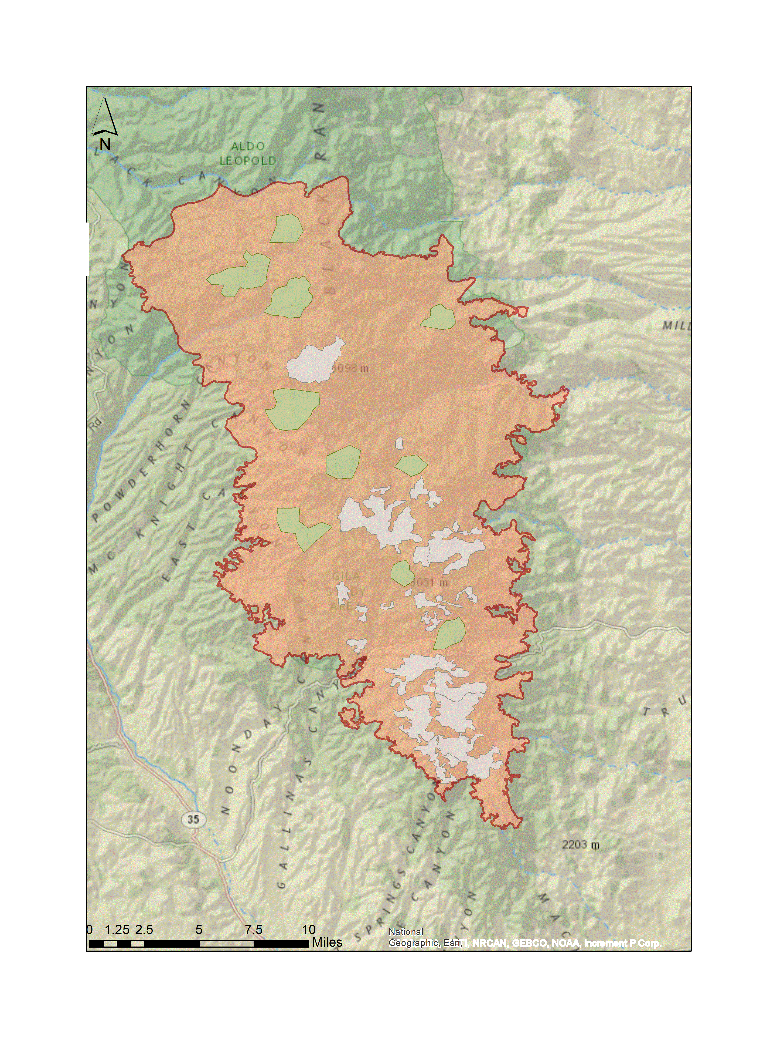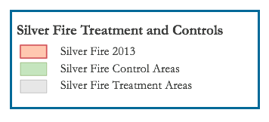

*Figure 3*. Map of 10 control plots and 28 treatment plots for the Silver Fire.

NBR, a vegetation health metric, was chosen as the primary index for examining vegetative regrowth because past studies suggest that it is ideal for assessing post-fire recovery. NBR is more sensitive to disturbance events than Normalized Difference Vegetative Index (NDVI) and is less prone to saturation when considering post-fire vegetation recovery (Bright et al., 2019; Kennedy, Yang, Gorelick, et al., 2018). Additionally, Soulard et al. (2016) found that current disturbance products are inadequate for identifying burn events and studying their effects in areas such as mountain meadows, where the composition of the vegetation is either mixed or largely characterized by herbaceous vegetation. NBR was calculated in RStudio 1.2.5033-1 using the Landsat near infrared (NIR) and shortwave infrared (SWIR2) band data (Equation 1):

$\text{NBR=}\frac{\text{NIR-SWIR2}}{\text{NIR+SWIR2}}$ (1)

In addition to identifying trends in vegetation recovery, the team examined the influence of wildfires on the hydrology of streams and rivers in the Gila NF. For the methods and results of our hydrological analyses, we focused largely on the Gila River Near Redrock stream gauge and its corresponding sub-watershed. *(Figure B1).* To begin the hydrological analyses, we calculated flow duration curves, which allowed us to examine how frequently the stream of interest had varying levels of discharge, specifically as it related to the 2002 to 2006 period where 20% of the given watershed was burned. In order to examine long-term change, the team identified three time frames of before (1971 to 2001), during (2002 to 2006), and after (2007 to 2019) this burn period. To calculate flow duration, we acquired daily stream gauge data for the given time periods and ordered them from largest to smallest and assigned a rank, M, where the largest value is assigned M=1. A corresponding probability (P) was then calculated for each stream gauge datum, P=100*[M/(n+1)], where n is equal to the number of data points P was calculated for. We plotted the discharge on the y-axis against its corresponding P on the x-axis for all 3 time periods, which were plotted on the same graph for comparison.

A key aspect of this term's methodology was the inclusion of precipitation data in the hydrological analysis. This addition is essential for understanding if changes in stream dynamics can be partially attributed to the impact of wildfires in the Gila NF. To include precipitation data in this study it was necessary to determine the extent of the watershed that drained into the individual stream gauges of interest. To do this, we conducted a watershed delineation in ArcMap using stream gauge point vector files and a USGS digital elevation model (DEM) of the study region (Parmenter & Melcher, 2012). The individual DEM raster files were mosaiced into a continuous raster file before beginning the tutorial. In summary, the watershed delineation process included the following steps: (1) producing a “filled” or “depressionless” flow direction raster via identifying sinks and filling them; (2) creating a flow accumulation raster to delineate major streams, and then identifying the point of the high accumulation flow closest to the stream gauge of interest; (3) delineating a watershed-based on the identified point and the “depressionless” flow direction raster. This delineated watershed area was used while obtaining precipitation data. The lists of the dates and the daily precipitation sums from GPM-IMERG were converted into CSV format and merged in R. We then converted the precipitation data from values of mm/half-hour to mm/hour in R before further analyses were conducted.

Last term, the Hydrostats package in R was used to perform a streamflow separation analysis which isolated the baseflow from the total streamflow for daily USGS stream discharge data. This term, we used this data to calculate surface flow by subtracting the baseflow from the total streamflow. We then examined how total streamflow (Q), baseflow (bf), and surface flow (sf) changed on a daily, monthly, and annual scale for our stream gauge over the course of the past twenty years while controlling for precipitation by dividing these three variables by the processed GPM-IMERG precipitation data for the corresponding watershed (Equation 2).

$\text{sf=}\text{Q-bf}$ (2)

Finally, we knew that a key concern within Gila National Forest was the occurrence of flash flood events following wildfires, and the resulting implications on stream restoration projects. To examine this problem further, we decided to evaluate the "flashiness" of the stream - how quickly the river's flow increases and decreases during a storm. One way to calculate it is with the Richards-Baker Flashiness Index calculation, where ${\text{q}}_{\text{i}}$ is the daily discharge on the ith day (Equation 3).

$\text{R-B Index=}\frac{\sum_{\text{i=1}}^{\text{n}}{\text{|}{\text{q}}_{\text{i}}\text{-}{\text{q}}_{\text{i-1}}\text{|}}}{\sum_{\text{i=1}}^{\text{n}}{{\text{q}}_{\text{i}}}}$ (3)

This calculation gives an output of one flashiness index value and can be assessed on differing time scales for variant periods. We calculated the flashiness index on a daily, monthly, annual, and 5-year scale for one of our delineated watersheds: Gila River near Redrock New Mexico. To evaluate the relationship between wildfire prevalence and changes in flashiness, we evaluated percent watershed burned on an annual scale for the Gila River Near Redrock sub-watershed to compare to the annual flashiness index values. We identified the percentage burned using Arcmap 10.7.1. First, we located every fire that overlapped with the sub-watershed from 2000 to 2018 using the Intersect tool. We then determined the area of intersection and the subsequent percentage of area overlap for each fire. With this information, the fires were grouped by year and we were able to determine the overall percentage of sub-watershed that burned annually. Additionally, based on a 2018 study by Wine & Cadol, we decided to also find a rolling sum of percent watershed burned in five-year increments. This study showed that the hydrological effects of a wildfire may not be seen unless at least 1/5th (20%) of the watershed has been burned within five years.

***3.3 Data Analysis***

To analyze the efficacy of the USFS Gila National Forest’s restoration treatments in contributing to post-fire vegetation recovery, NBR was plotted over time. For each treatment and control plot, a time series graph was created showing the raw NBR data from 2000 through 2019. A smoothed line was calculated using the Local Regression (Loess) method and added to this graph, making the trends in vegetation health more apparent. Additionally, a dashed line showing the date of the respective fire was included to more easily relate changes in NBR to fire disturbance. Then, for each fire, separate graphs were made for each landcover type including the average smoothed NBR curve for the treatment and the control plots. These graphs allowed us to compare trends in vegetation recovery for areas with the same landcover type that received restorative treatments against areas that didn’t for each fire.

For our analysis of the accumulated hydrological data, we plotted several graphs displaying flow duration curves, runoff coefficient, and flashiness index values as they relate to periods of elevated percent watershed burned. A flow duration curve displays the likelihood of specific stream discharge values. Three curves were plotted to compare trends in stream discharge before, during, and after, a five-year period (2002 to 2006) where 21% of the watershed was burned.

To show the trends in stream discharge while controlling for precipitation, we plotted the runoff coefficient Q/P and sf/P over the twenty-year period from 2000 to 2019. We highlighted the same period of intense fire activity that was used for the flow duration curves. Finally, we plotted the annual percent watershed burned and annual flashiness index values on the same graph to examine the relationship between wildfire prevalence in the watershed and changes in stream dynamics.

**4. Results & Discussion**

***4.1 Analysis of Results: Vegetation Recovery***

To assess the difference in vegetation recovery for individual treatment and control plots in the Bear and Silver fires, that occurred in 2006 and 2013 respectively, the team used an NBR time series. These time series show an abrupt decrease in NBR for treatment and control areas immediately following both fires (*Figure 4; Figure 5; Figure B2)*.

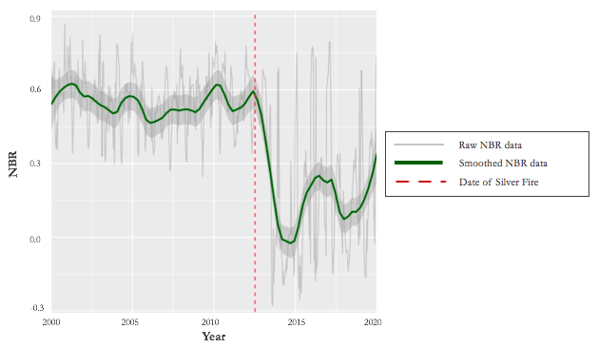*Figure 4*. Time series of average NBR values over 2000 to 2019 for a single treatment plot for the Silver Fire (2013).

Our results for the vegetation recovery analyses were displayed based on landcover type because variant landcover types have differing spectral identities and respond differently to burn events. The Silver Fire time series curves representative of each treatment type follows similar trends, although there are visible pre-fire differences in NBR between the control and treatment plots. These discrepancies suggest potential irregularities between treatment and control plots, such as inconsistent vegetation densities or the presence of alternative landcover types within the plots (*Figure 5*). Areas that were subject to treatment appear to recover at a similar rate to the corresponding control plots. This is especially visible for control plots and areas that were seeded and mulched, where the most prevalent land cover type was mixed conifer. However, further analyses are needed to determine whether there is a statistical difference in recovery patterns.

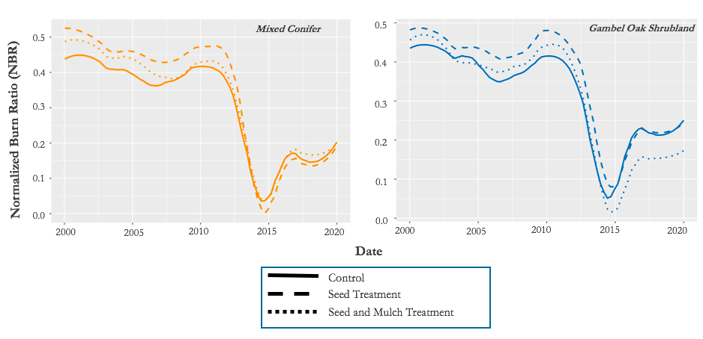

*Figure 5*. Vegetation recovery for **Silver Fire (2013**): Average NBR from 2000-2020 shown according to majority land cover type and treatment type. **Left:** Mixed Conifer plots (6 control, 14 seeded, and 7 seeded and mulched). **Right:** Gambel Oak Shrubland (2 control, 2 seeded, and 1 seeded and mulched).

Our results for vegetation recovery analysis of the Bear Fire also suggest a similar recovery rate between treatment and control areas (*Figure B2)*. The graphs displaying change in NBR for plots where the majority land cover type is mixed conifer and aspen, montane subalpine grassland, and ponderosa pine show a notable difference in NBR pre-fire. However, the graph displaying change in NBR for spruce-fir shows a very similar pre-fire fit for both control and treatment areas. However, the graph depicting spruce-fir shows that vegetation in the areas selected for post-fire treatment were less impacted by the fire than areas left to recover without inference, which makes an overall recovery comparison difficult. Additionally, there is limited evidence for a long-term continuous recovery trend after Bear Fire because the 2012 Whitewater-Baldy Complex Fire overlapped most of the previous areas burned.

***4.1 Analysis of Results: Hydrological Impacts***

Further analysis was done to examine discharge and cumulative frequency. From the flow duration curve, we can see the probability of how high stream discharge may be, and how this behavior of the stream has changed with time *(Figure 6).* We examined 30-years prior to and 12-years after the period from 2002 to 2006, in which 21% of the drainage area to the Gila River near Redrock stream gauge was burned (*Figure 10*). There is a downward shift in the graph over time suggesting that stream discharge has generally decreased; however, it should be noted that there is variation in the time frames not accounted for by each curve.

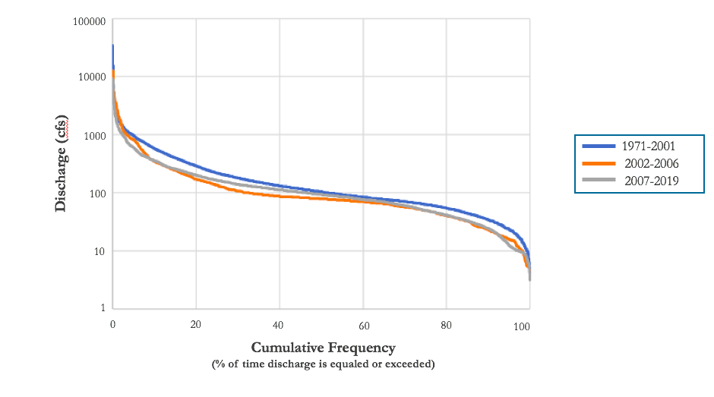

*Figure 6.* Flow duration curve for discharge at Gila Near Redrock stream gauge.

One way that the team examined stream characteristics while controlling for precipitation was by calculating the runoff coefficient, which is the total streamflow divided by precipitation (Q/P) (*Figure 7*). This value is higher when more water is flowing into the stream, which may be a result of lower infiltration rates and higher runoff rates – both of which are characteristics commonly observed following severe wildfires. Q/P tends to be less than 1 since discharge values do not usually exceed precipitation amounts; however, the graph shows the three highest peaks to have anomalously high monthly Q/P values (Nov 2006, Nov 2010, Feb 2016), with each over 1. This is a result of heavy rain during the respective, previous month and very little rain in each month in question. The relationship between surface flow and precipitation shows how the amount of water flowing over the surface of the landscape has changed over time due to variables other than precipitation (*Figure 7*). In both graphs, 2002 to 2006 the time period in which 21% of the watershed burned, is highlighted in red. In the graph display sf/P, the maximum values may increase following this time period, as can be seen by the increasingly high peaks; however, further analyses are needed to determine whether trends observed in these graphs are statistically significant.

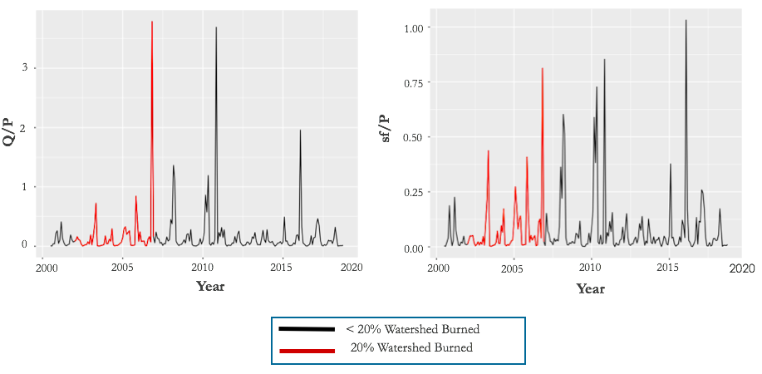

*Figure 7.* Total streamflow (Q) divided by precipitation (P) and surface flow (sf) divided by precipitation (P) over a twenty-year period.

Periods of severe wildfire events in the Gila NF may result in heightened stream flashiness. Here we see a one- to two- year lag between years in which particularly large amounts of the watershed burned, and the flashiness of the stream increased (*Figure 8*)*.* The peak values for percent watershed burned and the corresponding years where the Richards-Baker flashiness index exceeded 0.3 are highlighted in Table A3*.* These findings suggest that wildfires could be impacting the characteristics of this stream and how it floods. Further analyses are necessary to factor in precipitation, as well as to look at discrete events pre- and post-fire, in order to more clearly determine whether this increase in flashiness is a result of wildfire impact on the watershed or precipitation anomalies.

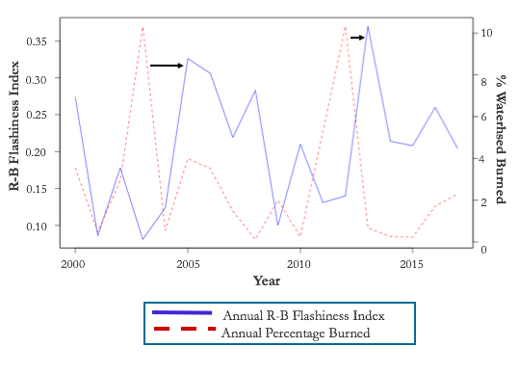

*Figure 8.* Annual percent watershed burned compared to annual Richards-Baker Flashiness Index value.

***4.2 Future Work***

The results of this study provided insightful analyses that can be used to help inform future environmental management decisions by USFS Gila National Forest; however, continued exploration is required for a complete assessment of wildfire impacts on the watersheds within Gila NF. Future research for this project should apply the vegetation recovery methodology to Whitewater-Baldy Complex Fire and other treated fires. Moreover, the hydrological analysis methodology should be applied to the other stream gauges in our study region. Event-based analyses need to be performed to confirm the lag between percent watershed burned and increased flashiness of a stream. Also, additional variables should be included in the hydrological analysis, such as snowmelt and soil moisture. Future studies should also attempt to address climatic variability and how the frequency and severity of burn events and precipitation events may be altered. Hydrology in semi-arid regions does not behave the same as the hydrology elsewhere and any future term studying water resources in the Gila National Forest should approach their analyses with this perspective.

**5. Conclusions**

This project was focused on addressing two major concerns: the effectiveness of vegetation restoration efforts and the impact of burn events on the hydrology of the watershed. Methodologies were established to remotely identify control areas as a basis of comparison for the effectiveness of post-fire restoration actions, and then monitor vegetation recovery over time through the use of NASA Earth observations. Preliminary findings show that areas that were targeted for post-wildfire vegetation restoration by USFS Gila National Forest have similar recovery patterns to untreated areas with comparable burn severity and land cover types. These results and methodology can be used by USFS Gila National Forest to inform vegetation restoration decisions.

Methodologies were also established for comparing the flashiness of a stream to the area burned within a watershed and examining changes in stream dynamics over time. The results show that the annual flashiness of a stream increases one to two years after a high percentage of the watershed burns, suggesting wildfires may be impacting the way in which streams respond to significant precipitation events. Further flashiness analyses are needed to account for other factors such as precipitation anomalies, but these preliminary results may help inform decision-making for stream reconstruction efforts.

**6. Acknowledgments**

* Dr. John Bolten, NASA Goddard Space Flight Center
* Dr. Sebastian Martinuzzi, University of Wisconsin-Madison
* Dr. Ibrahim Mohammed, Goddard Space Flight Center
* Dr. Jessica Erlingis Lamers, Goddard Space Flight Center
* Dr. Raha Hakimdavar, USDA, US Forest Service
* Darcy Gray, SSAI/NASA DEVELOP, Goddard Space Flight Center
* Carolyn Koury, USDA, US Forest Service, Gila National Forest
* Mike Natharius, USDA, US Forest Service, Gila National Forest
* Nessa Natharius, USDA, US Forest Service, Gila National Forest
* Jack Triepke, USDA, US Forest Service, Region 3
* Bart Matthews, USDA, US Forest Service, Region 3
* Anna Jaramillo, USDA, US Forest Service, Region 3

Any opinions, findings, and conclusions or recommendations expressed in this material are those of the author(s) and do not necessarily reflect the views of the National Aeronautics and Space Administration.

This material is based upon work supported by NASA through contract NNL16AA05C

**7. Glossary**

**Disturbance –** A temporary change in environmental conditions that creates a drastic change to a region or ecosystem

**Earth observations** – Satellites and sensors that collect information about the Earth’s physical, chemical, and biological systems over space and time

**HUC 12 Watershed** – A 6th level, local sub-watershed level that captures tributary systems

**Loess Method –** a non-parametirc method for smoothing multiple regressions in a time series

**MODIS** – MODerate resolution Imaging Spectroradiometer

**NBR –** Normalized Burn Ratio; A formula using near infrared and shortwave-infrared wavelengths to estimate burn severity

**NDVI –** Normalized Difference Vegetation Index; A formula using near infrared and red wavelengths to estimate vegetation

**PRISM –** Parameter-elevation Regressions on Independent Slopes Model; An analytical tool created by Oregon State University that uses point data, a digital elevation model, and other spatial data sets to generate gridded estimates of monthly, yearly, and event-based climatic parameters, such as precipitation, temperature, snowfall, degree days, and dew point. (NRCS National Water and Climate Center, n.d.)

**Riparian –** Habitats directly adjacent to rivers and streams; generally, act as a buffer between streams, rivers, and land.

**Shapefile –** A simple method of storing geometric location or geographic features as a point, line, or polygon

**Watershed –** A land area that channels precipitation to surface water systems and eventually to outflow points, such as the ocean

**8. References**

Aqua Terra Consultants. (2019). Watershed modeling to evaluate potential impacts of climate and land use change on the hydrology and water quality of major U.S. drainage basins.

Bright, B. C., Hudak, A. T., Kennedy, R. E., Braaten, J. D., & Khalyani, A. H. (2019). Examining post-fire

vegetation recovery with Landsat time series analysis in three western North American forest types. *Fire Ecology*, *15*(1), 8. <https://doi.org/10.1186/s42408-018-0021-9>

Bunn, S. E., Davies, P. M., & Mosisch, T. D. (1999). Ecosystem measures of river health and their response to riparian and catchment degradation. *Freshwater Biology*, *41*(2), 333-345. <https://doi.org/10.1046/j.1365-2427.1999.00434.x>

Daly, C., Halbleib, M., Smith, J. I., Gibson, W. P., Doggett, M. K., Taylor, G. H., Curtis, J., & Pasteris, P. P. (2008). Physiographically sensitive mapping of climatological temperature and precipitation across the conterminous United States. *International Journal of Climatology*, *28*(15), 2031-2064. <https://doi.org/10.1002/joc.1688>

Daly, C., Slater, M. E., Roberti, J. A., Laseter, S. H., & Swift, L. W. (2017). High-resolution precipitation mapping in a mountainous watershed: Ground truth for evaluating uncertainty in a national precipitation dataset. *International Journal of Climatology*, *37*, 124-137. <https://doi.org/10.1002/joc.4986>

Gila National Forest. (2012). *Whitewater Baldy Complex Burned Area Emergency Response (BAER) Team executive summary*. United States Forest Service: Silver City, New Mexico. Retrieved from:<https://www.fs.usda.gov/Internet/FSE_DOCUMENTS/stelprdb5375619.pdf>

Gila National Forest. (2013). *Silver Fire Burned Area Emergency Response (BAER) Team executive summary*. United States Forest Service: Silver City, New Mexico. Retrieved from: <https://www.fs.usda.gov/detail/gila/landmanagement/resourcemanagement/?cid=stelprdb5374811>

Hallema, D. W., Sun, G., Caldwell, P. V., Norman, S. P., Cohen, E. C., Liu, Y., Bladon, K. D., & McNulty, S. G. (2018). Burned forests impact water supplies. *Nature Communications*, *9*(1), 1307. <https://doi.org/10.1038/s41467-018-03735-6>

Huffman, G.J., E.F. Stocker, D.T. Bolvin, E.J. Nelkin, Jackson Tan (2019), GPM IMERG Final Precipitation L3 Half Hourly 0.1 degree x 0.1 degree V06, Greenbelt, MD, Goddard Earth Sciences Data and Information Services Center (GES DISC), [https://doi.org/](https://doi.org/10.1016/j.apgeog.2014.11.016)[10.5067/GPM/IMERG/3B-HH/06](https://doi.org/10.5067/GPM/IMERG/3B-HH/06)

Hutto, R. L. (2008). The ecological importance of severe wildfires: Some Like It Hot. *Ecological Applications*, *18*(8), 1827-1834. [https://doi.org/10.1890/08-0895.1](https://doi.org/10.1890/08-0895.1 )

Ireland, G., & Petropoulos, G. P. (2015). Exploring the relationships between post-fire vegetation regeneration dynamics, topography and burn severity: A case study from the Montane Cordillera Ecozones of Western Canada. *Applied Geography*, *56*, 232-248. [https://doi.org/10.1016/j.apgeog.2014.11.01](https://doi.org/10.1016/j.apgeog.2014.11.016)

Keesstra, S. D., Kondrlova, E., Czajka, A., Seeger, M., & Maroulis, J. (2012). Assessing riparian zone impacts on water and sediment movement: A new approach. *Netherlands Journal of Geosciences - Geologie En Mijnbouw*, *91*(1–2), 245-255. <https://doi.org/10.1017/S0016774600001633>

Kennedy, R. E., Yang, Z., Cohen, W. B., Pfaff, E., Braaten, J., & Nelson, P. (2012). Spatial and temporal

patterns of forest disturbance and regrowth within the area of the Northwest Forest Plan. *Remote Sensing of Environment*, *122*, 117-133. <https://doi.org/10.1016/j.rse.2011.09.024>

Kennedy, R.E., Yang, Z., Gorelick, N., Braaten, J., Cavalcante, L., Cohen, W.B., & Healey, S. (2018). Implementation of the LandTrendr Algorithm on Google Earth Engine. *Remote Sensing.* *10*, 691. <https://doi.org/10.3390/rs10050691>

Kobziar, L. N., & McBride, J. R. (2006). Wildfire burn patterns and riparian vegetation response along two northern Sierra Nevada streams. *Forest Ecology and Management*, *222*(1–3), 254-265. <https://doi.org/10.1016/j.foreco.2005.10.024>

Meng, R., Dennison, P. E., Huang, C., Moritz, M. A., & D’Antonio, C. (2015). Effects of fire severity and post-fire climate on short-term vegetation recovery of mixed-conifer and red fir forests in the Sierra Nevada Mountains of California. *Remote Sensing of Environment*, *171*, 311–325. <https://doi.org/10.1016/j.rse.2015.10.024>

NRCS National Water and Climate Center(n.d.). *Climate Products—PRISM*. Retrieved March 31, 2020, from <https://www.wcc.nrcs.usda.gov/climate/prism.html>

Odion, D. C., Hanson, C. T., Arsenault, A., Baker, W. L., DellaSala, D. A., Hutto, R. L., Klenner, W., Moritz, M. A., Sherriff, R. L., Veblen, T. T., & Williams, M. A. (2014). Examining historical and current mixed-severity fire regimes in ponderosa pine and mixed-conifer forests of Western North America. *PLoS ONE*, *9*(2), e87852. <https://doi.org/10.1371/journal.pone.0087852>

Parmenter, W. B., & Melcher, J. (2012). *Watershed and Drainage Delineation by Pour Point in ArcMap 10*. 16.

Potyondy, J. P., & Geier, T. W. (2010). *Watershed condition classification technical guide*. United States Forest Service. Retrieved from: <https://www.fs.fed.us/biology/resources/pubs/watershed/maps/watershed_classification_guide2011FS978.pdf>

Rodell, M., Peters-Lidard, C., Erlingis, J., Li, B., Kumar, S., Famiglietti, J., Wei Liu, P., & Emery, C., (n.d.). The Western Land Data Assimilation. Retrieved from: <https://appliedsciences.nasa.gov/system/files/sites/default/files/Rodell%20-%20WWAO%20The%20Western%20Land%20Data%20Assimilation%20System.pdf>

Soulard, C.E., Albano, C. M., Villarreal, M. L., & Walker, J. J. (2016). Continuous 1985–2012 Landsat monitoring to assess fire effects on meadows in Yosemite National Park, California. *Remote Sensing, 8*, 371. <https://doi.org/10.3390/rs8050371>

U.S. Geological Survey Earth Resources Observation and Science Center. (2012). Landsat 4-5 TM Level-2 Surface Reflectance (SR) Science Product [Data set]. U.S. Geological Survey. https://doi.org/10.5066/F7KD1VZ9

U.S. Geological Survey Earth Resources Observation and Science Center. (2019). Landsat 7 ETM+ Level-2 Surface Reflectance (SR) Science Product [Data set]. U.S. Geological Survey. https:// https://doi.org/10.5066/F7Q52MNK

U.S. Geological Survey. (2013). USGS 13 arc-second n34w109 1 x 1 degree: U.S. Geological Survey.

U.S. Geological Survey Earth Resources Observation and Science Center. (2019). Landsat 8 OLI Level-2 Surface Reflectance (SR) Science Product [Data set]. U.S. Geological Survey. <https://doi.org/10.5066/f78s4mzj>

U.S. Geological Survey National Center for Earth Resources Observation and Science and the USDA Forest Service Geospatial Technology and Application Center. (2019) MTBS Burn Area Boundary [Data set]. Monitoring Trends in Burn Severity

Wine, M. L., & Cadol, D. (2016). Hydrologic effects of large southwestern USA wildfires significantly increase regional water supply: fact or fiction? *Environmental Research Letters*, *11*(8). [https://doi.org/10.1088/1748-9326/11/8/085006](https://doi.org/10.1088/1748-9326/11/8/085006  )

Wine, M. L., Cadol, D., & Makhnin, O. (2018). In ecoregions across western USA streamflow increases during post-wildfire recovery. *Environmental Research Letters*, *13*(1). <https://doi.org/10.1088/1748-9326/aa9c5a>

**9. Appendices**

**Appendix A**

Table A1

*Earth Observation Platforms and Data*

|  |  |  |  |  |
| --- | --- | --- | --- | --- |
| **Earth Observation Data** | | | |  |
| **Platform & Sensor** | **Spectral Resolution** | **Parameters** | **Acquisition Location** | **Level** |
| **Landsat 5 TM** | 30 m | Spectral vegetation  indices | Google Earth Engine Image Collection ID: LANDSAT/LT05/C01/T1_SR | 1 & 2 |
| **Landsat 7 ETM+** | 30 m | Spectral vegetation  indices | Google Earth Engine Image Collection ID: LANDSAT/LE07/C01/T1_SR | 1 & 2 |
| **Landsat 8 OLI** | 30 m | Spectral vegetation  indices | Google Earth Engine Image Collection ID: LANDSAT/LC08/C01/T1_SR | 1 & 2 |
| **GPM_IMERG** | 10 km | Precipitation | Google Earth Engine Image Collection ID: NASA/GPM_L3/IMERG_V06 | 3 |

Table A2

*Ancillary data acquired and used in this project*

|  |  |  |  |
| --- | --- | --- | --- |
| **Ancillary Data** | | | |
| **Parameter** | **Spatial Resolution** | **Provider** | **Source** |
| Fire Perimeters | Vector Data | USDA USFS FIRESTAT | USDA USFS |
| Burn Severity (MTBS) | Vector Data | Monitoring Trends in Burn Severity (MTBS) | USDA USFS |
| Watershed Boundaries | Vector Data | United States Geological Survey | United States Geological Survey |
| Land Cover | 30 m | United States Geological Survey | National Land Cover Database |
| Elevation | 30 arc seconds | United States Geological Survey | National Elevation Dataset |
| Streamflow | N/a | USGS National Water Information System | USGS Gauges |
| Post-Fire Treatment Areas | Vector Data | USDA USFS Region 3 and Gila National Forest | USDA USFS Region 3 and Gila National Forest |

Table A3

*Annual percent watershed burned compared to annual Richards-Baker Flashiness Index value*

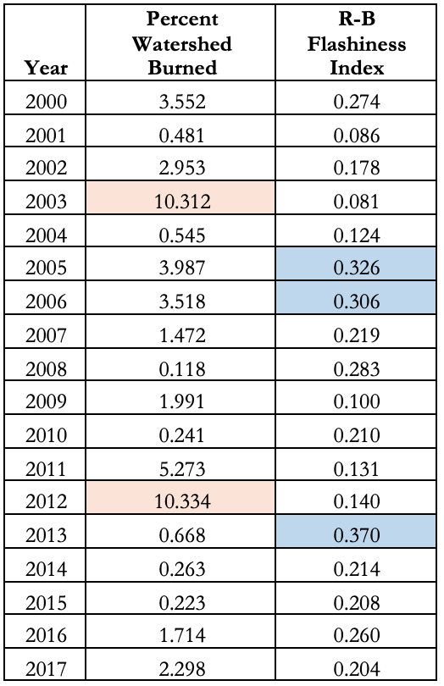

**Appendix B**

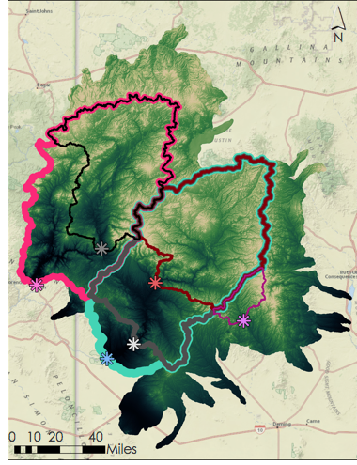

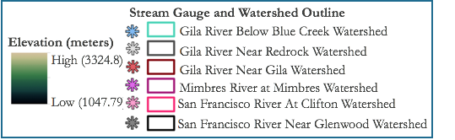

*Figure B1.* Delineated *s*ub-watershedsassociated with stream gauges within and downstream of the Gila National Forest

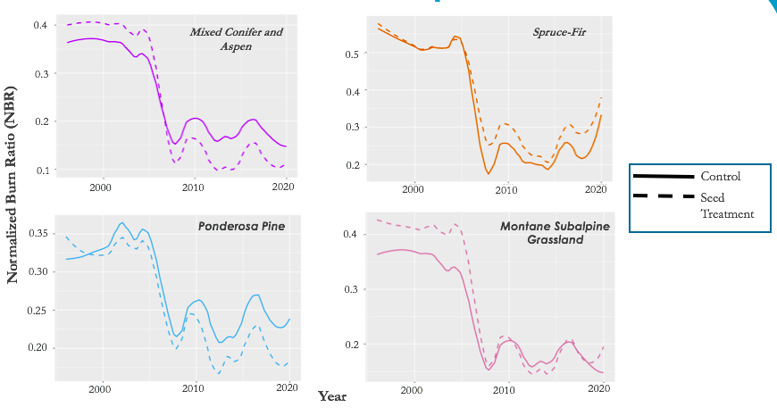

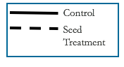

*Figure B2.* Vegetation recovery for **Bear fire (2006**): Average NBR from 2000-2020 shown according to majority land cover type and treatment type. **Top Left**: Mixed Conifer plots (3 control plots; 2 seeded plots), **Top Right:** Spruce-Fir plots (2 control plots; 2 seeded plots), **Bottom Left:** Ponderosa Pine plots (1 control plot; 3 seeded plots), **Bottom Right**: Montane Subalpine Grassland plots (4 control plots; 4 seeded plots)

**Appendix C**

**Supplementary Information**

***C1. Western Land Data Assimilation System (WLDAS)***

One of the original objectives of this study was to utilize the Western Land Data Assimilation System (WLDAS) model. This model was developed at NASA and would be a great use of NASA products for a project in partnership with the US Forest Service. WLDAS is a model that incorporates elevation, soil layers, land cover, and precipitation data to produce climatological outputs (Rodell et al., n.d.) and an attempt was made to use the precipitation data from the model in the hydrological analysis of the project. The model was run for our study region only and outputted as individual NetCDF files for each day for the 20-year study period.

It was originally thought that this would be sufficient for obtaining precipitation data for our region. A Python script was written that successfully looped through the directory of NetCDF files from WLDAS, extracted the precipitation data, and output daily precipitation averaged over the whole study area into a CSV file; however, the team decided that smaller subwatershed areas needed to be determined and used for analysis. Watershed delineation was performed using our chosen stream gauges, discussed in more detail in section 3.2. We attempted to write scripts in Python to clip all (~40,000) NetCDF files to the smaller subwatershed shapefiles, but it ultimately became a task that was outside the scope for this term. The team then explored alternate precipitation datasets to use for the study.

During this term, a newer version of WLDAS was in development at NASA Goddard Space Flight Center, which included the Leaf Area Index (LAI) output from the Moderate Resolution Imaging Spectroradiometer (MODIS) satellite instrument as an input for the model. LAI characterizes plant canopies and is essentially leaf area divided by ground area. When LAI decreases it is showing a loss of vegetation, and therefore, by including LAI into the WLDAS model, it is possible that the fires in the Gila NF would be detected. This would be a giant step forward in using modeled data in this region to study the long-term hydrological response to wildfire, and the implementation of WLDAS into this study could be considered as the sole focus for a future term.

***C2. Comparison of GPM-IMERG and PRISM Precipitation Datasets***

In an exploration of possible precipitation datasets to use in this study, PRISM and GPM-IMERG data were obtained. PRISM is a model that was produced by Oregon State University (OSU) and uses elevation, spatial, and climatic datasets to model climatic outputs on a 4km spatial scale (Daly et al., 2008; Daly et al., 2017). According to the partners for this project, PRISM is the precipitation dataset most commonly used by the US Forest Service. PRISM precipitation data were obtained in a similar way as described for the Landsat band data in section 3.1: A shapefile of the delineated watershed polygon was imported on Google Earth Engine as a table asset, the table asset was made public, and that asset ID was used to import the polygon boundary into Climate Engine. Then, native time series 4km resolution PRISM data were selected for the same custom date range (2000-01-01 to 2019-12-31) and exported as a Comma Separated Values (CSV) file. Because GPM-IMERG is the dataset chosen for analysis in this study, the acquisition of the data is described in section 3.1.

The two precipitation datasets were successfully converted to CSV format and the outputs were compared on various timescales. As noted in section 3.1, before comparing values, the GPM-IMERG data were converted from values of mm/half-hour to mm/hour.To compare the data on multiple timescales, both daily precipitation datasets were summed monthly and annually in R.

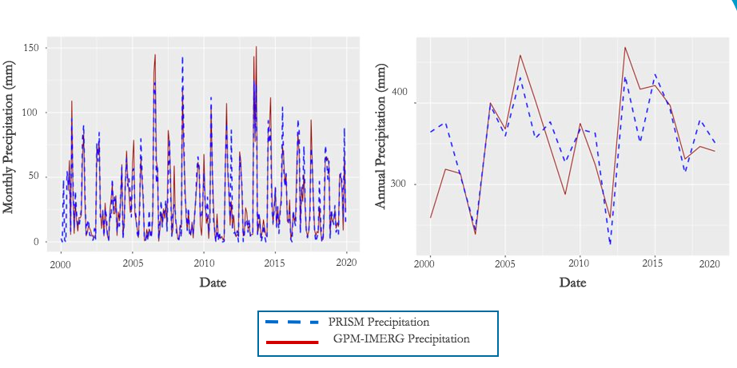

*Figure C2.1.* PRISM and GPM-IMERG precipitation data comparison on a monthly and annual time scale.

Table C2.1

*Fifteen lowest monthly summed precipitation values for PRISM and GPM-IMERG datasets*

|  |  |  |  |
| --- | --- | --- | --- |
| PRISM | | GPM - IMERG | |
| Date | Monthly Summed Precipitation (mm) | Date | Monthly Summed Precipitation (mm) |
| Feb 2000 | 0 | Nov 2010 | 0.21 |
| May 2000 | 0 | Nov 2006 | 0.48 |
| Mar 2011 | 0 | Nov 2005 | 0.85 |
| Apr 2011 | 0 | May 2003 | 0.97 |
| May 2011 | 0 | May 2011 | 1.39 |
| Jan 2014 | 0 | Apr 2008 | 1.59 |
| May 2014 | 0 | May 2018 | 1.75 |
| Mar 2016 | 0 | Dec 2005 | 1.82 |
| Nov 2017 | 0 | Feb 2016 | 1.93 |
| May 2018 | 0 | Apr 2018 | 2.08 |
| Jun 2012 | 0.03 | Mar 2008 | 2.09 |
| Nov 2010 | 0.15 | May 2010 | 2.59 |
| Oct 2012 | 0.26 | Mar 2011 | 2.66 |
| Jun 2011 | 0.48 | Feb 2006 | 2.74 |
| Apr 2018 | 0.60 | Apr 2009 | 3.02 |

This comparison was done to provide the project partners with more information on available datasets for additional research going forward. Overall, the datasets do not appear to be vastly different, though further statistical analyses are required for a more concrete comparison. One interesting difference between datasets can be observed in the monthly summed data, especially when ordered by least values first, as shown in Table C2.1: several months of PRISM precipitation data have zero precipitation recorded, whereas all months of GPM-IMERG data have at least some precipitation recorded. This may be an interesting comparison to continue in a future study and could be useful for researchers in the US Forest Service.