Eastern Washington Disasters
Integrating NASA Earth Observations to Analyze Spatiotemporal Distributions of Lightning-Caused Wildfires in Eastern Washington


Technical Report
Final Draft – April 2rd, 2020

Ani Matevosian (Project Lead)
Amelia Zaino
Amy Kennedy
Evan Bradish

Dr. Juan Torres-Pérez, Bay Area Environmental Research Institute, NASA Ames Research Center
Dr. Kenton Ross, NASA Langley Research Center
Dr. Christopher J. Schultz, Short-term Prediction Research and Transition Center, NASA Marshall Space Flight Center
Dr. Chris Hain, Short-term Prediction Research and Transition Center, NASA Marshall Space Flight Center
Dr. Vincent Ambrosia, NASA Ames Research Center
John Dilger, Spatial Informatics Group

1. Abstract
According to the Washington Department of Natural Resources, roughly 36% of large fires in the state since 2010 were caused by lightning. General trends also show a greater increase in the number of lightning-ignited fires over the last three decades. The NASA DEVELOP Eastern Washington Disasters team partnered with The Nature Conservancy’s Washington Chapter to analyze the relationship between lightning strikes and wildfire events in Eastern Washington, with an emphasis on Kittitas and Yakima Counties. Using the International Space Station Lightning Imaging Sensor, the Landsat 5 Thematic Mapper and Landsat 8 Operational Land Imager vegetation moisture index, and Washington Department of Natural Resources historical fire data, the team generated a lightning-caused fire vulnerability index for 2001-2019. Climatology maps of lightning, wildfire, and vegetation moisture of the study area, along with an Esri ArcGIS StoryMap, further communicated project findings. The project results demonstrated that spatiotemporal patterns of lightning-ignited wildfires in Eastern Washington can be useful to inform land management practices and better predict areas that may be more vulnerable to these events.

Keywords:
fire regime, land cover, Lightning Imaging Sensor, lightning-ignited wildfires, forest ecology, wildfire ecology, fuel moisture

2. Introduction
  - Background Information
Eastern Washington is on the leeward side of the Cascade Range in Washington State. Warm, damp air from the Pacific Ocean loses its moisture as it travels over the mountain peaks, resulting in relatively drier conditions on the eastern side of the mountain range (Western Regional Climate Center, 2002). Wildfires occur naturally in this area, with lightning igniting up to 60% of wildfires on public lands in western mountainous states like Washington (Rorig & Ferguson, 2002). These fires play a key role in resetting and regenerating ecosystems. Many native plants of the region have adapted to fire, including the lodgepole pine (Pinus contorta) and Douglas fir (Pseudotsuga menziesii) (Busby, 2019).

Historically, Native American tribes utilized prescribed burns to clear land for hunting and promote the growth of berry-producing shrubs. Prescribed fires can help reduce the catastrophic damage of wildfires by safely reducing the density of vegetation that builds up over time in the absence of natural fires. Prescribed fire has the ability to decrease fire severity while protecting communities from unplanned fires in the future (Kolden, 2019). The Nature Conservancy, along with public and private partners, currently carries out prescribed burns to reduce the risk of large fires and promote forest health (Lasbo, 2018).

Eastern Washington’s economy in the past century has been closely tied to its landscape and natural resources. Forests on the slopes of the Cascade Mountains provided timber for sawmills across the region for most of the 20th century. In the early 1990s, environmental regulations to protect forest habitat and endangered species such as the spotted owl (Strix occidentalis) forced the timber industry into a decline (Prengaman, 2016). This, combined with historic fire suppression initiatives and restrictions on prescribed burning in the late 20th century (Thompson, 2018), has led to dense underbrush growth which can exacerbate wildfire severity (Washington State Department of Natural Resources, 2018). As the economy of the region changed, development patterns changed as well. Between 1976 and 2006, the population increased by 66 percent in Eastern Washington as wildlands became increasingly urbanized and residential structures were built on forested land. Though urban development in this area is not particularly dense, the fragmentation of wildlands can make it difficult and costly to fight wildfires (Gray et al., 2013); this is especially problematic for areas with built-up fuels and dense underbrush, as fires in these areas have the potential for becoming large and destructive.

While fires have always been integral to ecosystem health in the region, three notable fires caused by lightning strikes have burned over 95,000 acres (Burned Area Response Team, 2015-2018). These case studies burned through the Okanogan-Wenatchee National Forest, requiring the US Forest Service’s Burned Area Response team to request nearly $300,000 in funding for post-fire emergency treatments (Burned Area Response Team, 2015-2018). The 2015 Black Canyon Fire, caused by a lightning strike, ignited on August 14 and burned 32,735 acres (Burned Area Response Team, 2015). Forest management agencies predicted that fine sediment and debris flows following the fire would have long-term effects on the Methow River watershed fish populations, including the steelhead trout (Oncorhynchus mykiss) and Chinook salmon (Oncorhynchus tshawytscha) (Burned Area Emergency Response, 2015). The 2017 Jolly Mountain Fire was ignited by a lightning strike on August 11, which burned a total of 36,817 acres over three months (Burned Area Emergency Response, 2017). The resulting smoke affected the health of nearby residents in the city of Yakima (Oliver, 2017). Air quality in the city was rated as hazardous as late as September 4, and residents were warned by health officials that if wildfire seasons continue to worsen, the Yakima Valley could see an increase in unhealthy air days (McCauley, 2019).

Recently, in 2018, conditions in July across the region were hotter and drier than normal, which fueled a larger series of fires (U.S. Bureau of Land Management & U.S. Forest Service, 2019). The Crescent Mountain Fire, the largest of this series, began with a lightning strike on July 29, and spread across 52,610 acres, forcing evacuations in nearby communities. This fire burned 33% of the Twisp River watershed, raising concerns about subsequent debris flows and potential damage to human life and property (Burned Area Emergency Response, 2018).

There are many factors to consider when evaluating fire ignition from lightning strikes, such as fuel, soil and atmospheric moisture conditions, and precipitation. While these conditions contribute to the likelihood of fire ignition, fire researchers recognize the paramount significance of dry lightning events (Rorig & Ferguson, 2002). Lightning-caused fires also pose a particular difficulty regarding detection and containment. Often, lightning-ignited fires occur far from developed areas, meaning they take time to detect, allowing them to grow and burn more area. Suppression tactics are also given priority to fires in close proximity to populated areas, so even if a wildfire is detected in a remote area, it may not be addressed if there are more pressing fires (Kasischke et al., 2010; Narayanaraj & Wimberly, 2012). In addition, lightning-ignited fires in remote areas tend to grow larger because of the lack of roads that break up fuel continuity (Narayanaraj & Wimberly, 2012). Although lightning-ignited fires are natural, literature shows that years of fire suppression and global warming have created an environment of dense fuels and dry land that is more prone to fire ignition. With this in mind, this study explores the conditions that enable these fires to ignite and grow large in this region.

The project partner, The Nature Conservancy Washington Chapter (TNC-W), has a field office in Cle Elum, in Kittitas County. Therefore, the study area for this project was Eastern Washington with a focus on Kittitas and Yakima Counties (Figure 1). The study period was January 2001 through December 2019 due to data availability; although fires are concentrated during drier months, the team looked at all months during these years to account for conditions preceding the fire season that affect the severity and likelihood of ignition.

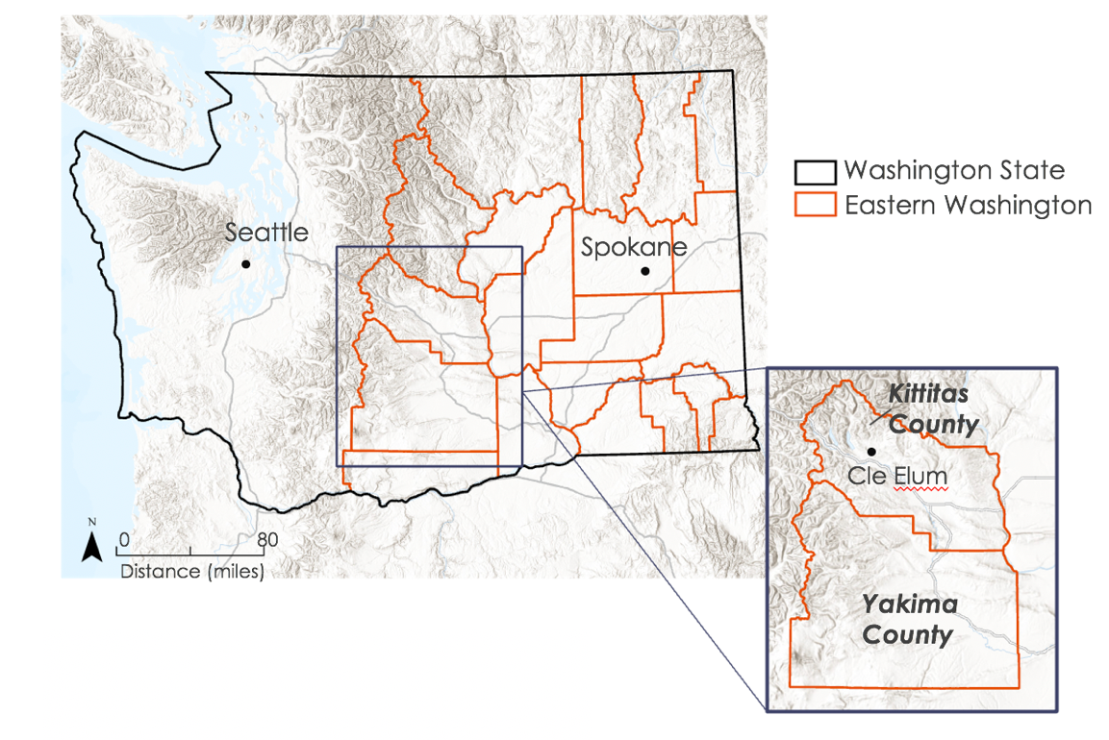
Figure 1. Washington State and the study area of Eastern Washington with an inset of Kittitas and Yakima Counties. Background map sources: ESRI, Airbus DS, USGS, NGA, NASA, CGIAR, N Robinson, NCEAS, NLS, OS, NMA, Geodatastyrelsen, Rijkswaterstaat, GSA, Geoland, FEMA, Intermap and the GIS user community
  - Project Partners & Objectives
TNC-W manages millions of acres of land across Washington with the mission to restore, protect, and manage forests and water resources in the state. Washington State is conducting a multi-agency effort to restore forest health, which includes removing underbrush and conducting controlled burns to help mitigate wildfire damage. The TNC-W is actively engaged with residents and landowners across the region, educating and involving the community in restoration efforts. This project aimed to assess the spatiotemporal patterns of lightning-ignited wildfires in Eastern Washington, with case studies in Kittitas and Yakima Counties, the region of interest for our partner. A final composite climatology map generated from lightning, fire, and vegetation moisture evaluated the fire risk of the region and helped illustrate vulnerable areas for the partner. These end products may be useful for the partner to share and pique the public’s interest in the possible growing frequency and threat of lightning-ignited wildfires. Science communication material in the form of an ArcGIS Online StoryMap will aid the partner in efforts to educate the community on lightning-ignited wildfires in their region.

3. Methodology
3.1 Data Acquisition
3.1.1 Fire Data Acquisition
Washington Department of Natural Resources (DNR) vector data (Table 1) were acquired for large fire perimeters from 1985 to 2019 through the Washington DNR GIS Open Data Portal. The Washington DNR large fire data were validated for accuracy using the Terra and Aqua Moderate Resolution Imaging Spectroradiometer (MODIS) combined MCD64A1 Version 6 Burned Area data product. The MODIS data product for the State of Washington was acquired using Google Earth Engine. The team created a dataset for this time period using the image collection function. The ‘BurnDate’ attribute within the image collection was selected, which denotes the Julian day of the corresponding year that a fire was first detected and assigns the entire pixel the same value. The image collection was reduced on the max Julian value to retain all detected fires over the study period and was then clipped to the Washington state boundary. The team then exported the data into Google Drive in TIF file format and later downloaded it to a local server.

3.1.2 Lightning Data Acquisition
The team acquired the International Space Station (ISS) Lightning Imaging Sensor (LIS) lightning flash data from the Global Hydrology Resource Center (GHRC) Distributed Active Archive Center (DAAC), using the Hydro 2.0 Data Search Tool found on NASA EarthData (Table 1). The Level 2 Non-Quality Controlled LIS on ISS Science Dataset included lightning flash times, radiant energy, and longitudinal and latitudinal coordinates in Network Common Data Form (netCDF-4) format. The team bulk downloaded the LIS data URLs for the period of March 1, 2017, to December 31, 2019, as these were the years of data available for this study area’s latitude. The team downloaded this LIS data from the website linked in the GHRC DAAC Python Recipe using the GNU operating systems tool Wget in Windows command prompt.

3.1.3 Vegetation Moisture Content Data Acquisition
For a high-resolution analysis and visualization of vegetation moisture in the study area, the team downloaded imagery from the Landsat 5 Thematic Mapper (TM) and the Landsat 8 Operational Land Imager (OLI) (see Table 1). The team acquired the data at a resolution of 30 square meter pixels via Google Earth Engine. The spatial extent of the data was clipped to the study area of Eastern Washington, east of the Cascade crest.
Table 1
Earth observations data used in this project, organized by their platform and sensor.
Platform & Sensor | Parameter | Use
Aqua MODIS | Active Fire Product | MODIS derived fire products were used to identify fire events from 2001-2019.
Terra MODIS | Active Fire Product | MODIS derived fire products were used to identify fire events from 2001-2019.
ISS LIS | Total lightning flashes | ISS LIS climatology data was utilized to identify lightning strikes throughout Eastern Washington throughout the study period of 2017-2019.
Landsat 5 TM | Vegetation Moisture Content | Landsat 5 TM data products were used to calculate a normalized difference moisture index for the years 2001-2011.
Landsat 8 OLI | Vegetation Moisture Content | Landsat 8 OLI data products were used to calculate a normalized difference moisture index for the years 2013-2019.

3.2 Data Processing
3.2.1 Fire Data Processing
The team imported the GeoTIFF MODIS image collection file for the years 2001 to 2019 and the Washington DNR Large Fire dataset for the years 1985 to 2019 into ArcGIS Pro 2.4. The MODIS GeoTIFF data were visually compared to the Washington DNR large fires vector polygons to verify accuracy. The Washington DNR large fire vector polygons covered a greater extent than the MODIS burned area and showed a greater level of accuracy, therefore the team ultimately used the Washington DNR vector perimeters to populate the fire fishnet climatology.

The team chose to use a fishnet to be able to process and analyze three different types of data in a standard way across the study region; these hexagonal fishnet cells could capture point data, such as lightning strikes, with polygon data, like burn area or vegetation moisture. To begin, a fishnet grid was created using the "Generate Tessellation" tool in the Data Management toolbox of ArcGIS Pro. The shapes selected for the Tessellation were transverse hexagons 25 km-squared in size for each cell. This cell size of 25 square km cells was chosen in order to capture a significant number of lightning strikes while maintaining a fine enough resolution to accurately capture vegetation moisture. The transverse hexagonal grid was then clipped to an Eastern Washington county boundaries file to better preserve the shape of the study area. Each cell was given a unique "CELL_ID" to make future joining possible. The Washington DNR large fires vector data were joined to the hexagonal grid fishnet retaining all attributes within the intersect tool. Within the newly created intersect layer attribute table, a new field labeled ‘Burned Area’ was created. The team then used the ‘Burned Area’ field and the calculate geometry function to calculate the burned area within each fishnet cell. A new field was created in the attribute table of the original fishnet table called ‘Cell Area’ expressed in square kilometers, which was populated using the calculate geometry function in the attribute table. The Fishnet table and the Intersect table were then joined based on the ‘Cell ID’ fields, renamed ‘Fishnet_Fire_Intersect’ and the output table was exported to the geodatabase. In the newly joined and exported table with fields ‘Burn Area’ and ‘Cell Area,’ a new field was created called ‘Percent Burned’ that was populated by the percentage of the cell that was burned by dividing the burned area by the total area of each cell.

This new field shows the percentage of area within each fishnet cell that has been burned between 1985 and 2019. This table was then exported for further data manipulation within Microsoft Excel. Within Microsoft Excel, a new column was populated with rank value for each ‘Percent Burned’ record in the table. The ‘Percent Burned’ values were ranked by reclassifying percent burned values 0-0.25, 0.25-.5, .5-.75, and .75-1 as 0, 1, 2, 3 and named ‘Fire_Rank’. The table was saved as a CSV file and imported back into ArcGIS Pro where it was joined with the ‘Fishnet_Fire_Intersect’ table using the ‘CELL_ID’ as the common field. The final fire climatology was symbolized using the ‘Fire_Rank’ column.

3.2.2. Lightning Data Processing
The team downloaded the Wget tool to bulk download all files of non-quality controlled LIS data from March 1, 2017, to December 31, 2019, as netCDF-4 files. The team then followed the GHRC DAAC “data recipe” titled “ISS LIS Lightning Flash Location Quickview using Python 2.7 and GIS” and the Python script acquired from the GHRC GitLab. The script converted the NetCDF-4 files to a CSV file with the latitude and longitude coordinates of detected lightning flashes for the years 2017-2019 as shown in Figure 2 (Weigel, 2018). The team added an exception to the “for loop” code that enabled the code to continue the loop even after encountering files with missing latitude and longitude values and to log those files.

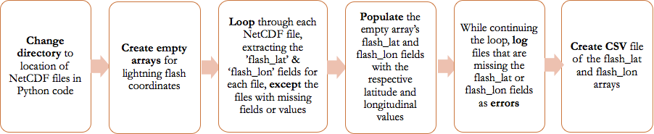
Figure 2. This flowchart shows the process by which the Python GHRC DAAC GitHub code converted NetCDF files to a CSV of the compiled lightning strike coordinates for 2017-2019.
The team then imported this CSV file into ArcGIS Pro and displayed the lightning as vector point data by their latitude and longitude coordinates. The team followed the fishnet methodology (see Section 3.2.1) for the lightning using the original hexagonal fishnet template. The lightning layer was intersected with the fishnet grid, then lightning points were added for each cell and output in a new field of the attribute table. The team queried out zero values for the sum of lightning “counts” per cell and grouped the data by Jenks Natural Breaks into three classes, which were then ranked 1-3. These values were rejoined with the zero values and the new list of values was ranked on a 0-3 scale, where a rank of 0 was the lowest lightning count in a cell (0) and a rank of 3 was the highest range of lightning count in a cell (4-7). The newly ranked cells were rejoined to the fishnet by their ‘CELL_ID’ and symbolized based on their rank value.

3.2.3 Vegetation Moisture Data Processing
Using the Google Earth Engine Javascript API, the team acquired Landsat 5 TM and Landsat 8 OLI imagery. The images were a composite of those captured during the fire season (May-October) of each year for the study period, 2001-2019. To create the image composite, the mean value was calculated for all the images captured during the fire season per year, resulting in 18 images. 2004 and 2012 were excluded due to errors in image acquisition. The team then calculated a Normalized Difference Moisture Index (NDMI) for each image, calculated as shown in Equation 1, where NIR is the near-infrared band, and SWIR is the short-wave infrared band. On Landsat 5 TM, those bands are Band 4 and Band 5 respectively. On Landsat 8 OLI, those bands are Band 5 and Band 6.
$\text{NDMI} \text{=} \text{(NIR -SWI}\text{R) / (NIR+SWIR)}$ (1)
After exporting the NDMI images, they were divided into the following groups and averaged: 2001-2006, 2007-2011, 2013-2017, and 2017-2019. The group of 2017-2019 images corresponds to the available lightning data. Resulting values were then ranked from 0 - 3, with 0 as the wettest vegetation, and 3 as the driest vegetation. Then, results were summarized by generating zonal statistics to display the majority of each rank within the cells of the fishnet grid (see Section 3.2.1). Vegetation moisture climatologies can be found in Appendix A.

3.2.4 Composite Climatology Map
The team used the processed fire, lightning, and vegetation moisture fishnet data layers to create a final composite climatology vulnerability index with these three factors equally weighted. This was achieved by adding the “RANK” fields for all the hexagonal cells of the three fishnet grid inputs and reclassifying them into 4 classes. Following a similar method as the other climatologies, the team queried out the zero values, divided the data into ranks of 1-3 by Jenks Natural Breaks, rejoined the zeros to yield 4 classes ranked from 0-3. The team then symbolized the cells having the highest vulnerability index value of 3 corresponding to the most vulnerable areas—those that experience frequent fires, incidences of lightning, and low vegetation moisture.

3.3 Data Analysis
The team used the fishnet methodology to analyze the spatiotemporal relationship between the three factors: fire, lightning, and vegetation moisture for the region. The team input these layers into the fishnet, calculated the parameters as described in the previous sections, added their ranks, then yielded a fishnet with each cell representing a rank from 0-3, where 0 is less vulnerable and 3 is most vulnerable. The resulting Composite Vulnerability Climatology displayed the sum of the individual ranks of the cells. Since each of the three-factor layers were ranked from 0-3, the composite fishnet sums ranged from 0-9. The team reclassified these values by Jenks Natural Breaks to range from 0-3 as shown in Table 2. The team also displayed the sum of the ranks in a chart by county (Appendix B, Figures B1 & B2), and qualitatively analyzed the spatial pattern of vulnerability by the clustering of cells of various ranks in the final composite climatology.

Sum of Ranks of Cells | Final Rank
$≤$1.0 | 0
$≤$3.0 | 1
$≤$5.0 | 2
$≤$9.0 | 3

Table 2
Table showing reclassification of the sum of the individual climatology ranks to the final rank for the Composite Vulnerability Climatology.

4. Results & Discussion
The results of this project include individual climatologies for the factor layers of burn area, lightning exposure, and vegetation moisture as shown below (Figures 4, 5, & 6). The layers are displayed by their ranks of 0-3, where a rank of 3 corresponds to higher vulnerability to lightning-ignited fire. Figure 7 shows all three factors combined, re-ranked as shown in Table 2, to generate a Composite Vulnerability Index. This final climatology shows that high index red cells were concentrated in the northwest region of the study area, specifically Okanogan County, as well as a vertical section roughly 100km east, but parallel, to the Cascade Range.
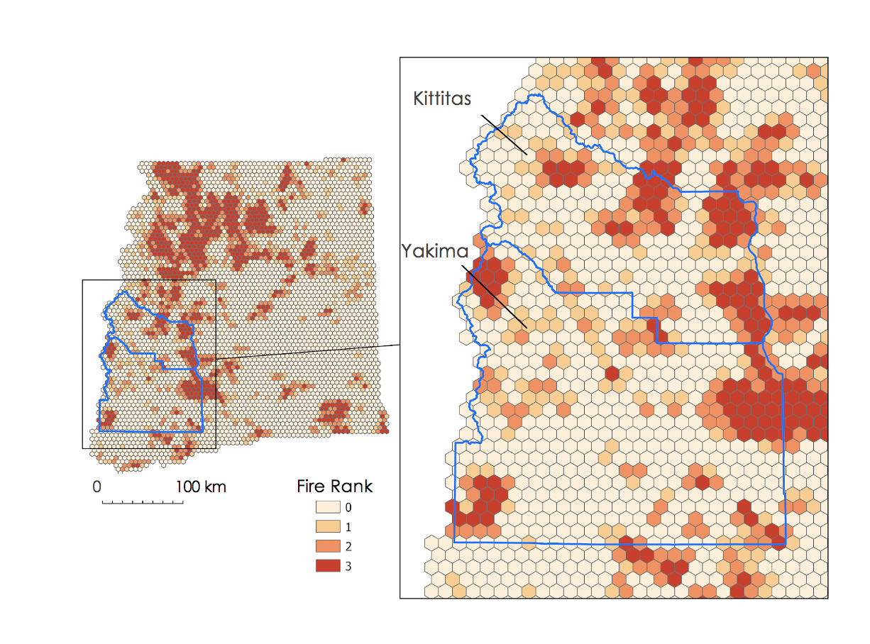
Figure 4. Fire Vulnerability Index Fishnet: 1985-2019. This individual fire climatology is shown above, where cells represent their percent burn rank. High ranks correspond to more percent burned within the cell, thus a higher vulnerability.

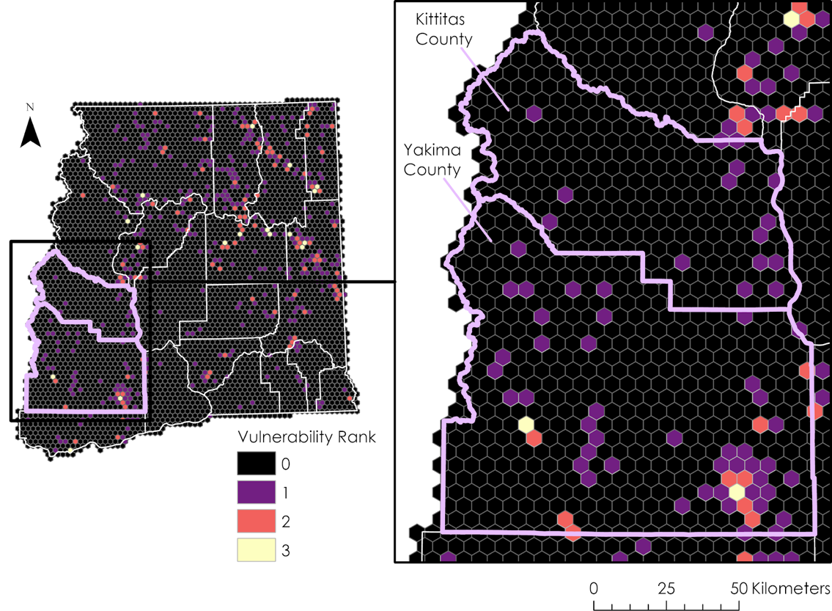

Figure 5. Lightning Vulnerability Index Fishnet: 2017-2019. The individual lightning climatology is shown above, where fishnet cells represent a vulnerability rank for lightning strikes. The rank is based on the count of lightning events captured by the LIS. High ranks correspond to high lightning counts, and thus a higher vulnerability for lightning-ignited fires.
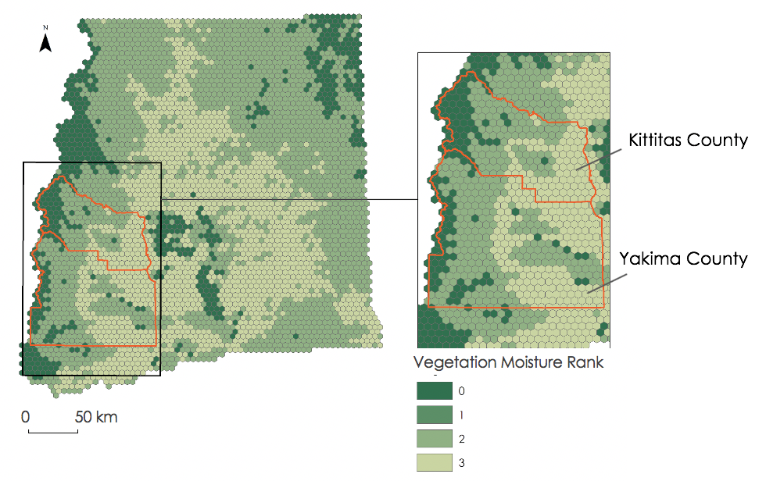
Figure 6. Vegetation Moisture Index Fishnet: 2017-2019. The individual vegetation moisture climatology is shown above, where higher ranked cells correspond to drier vegetation, while lower-ranked cells are more moist. To evaluate changes in vegetation moisture over time, imagery from the following time periods: 2001-2006, 2007-2011, and 2013-2017 is available. Refer to Appendix A, Figures A1-A3 to view these climatologies.

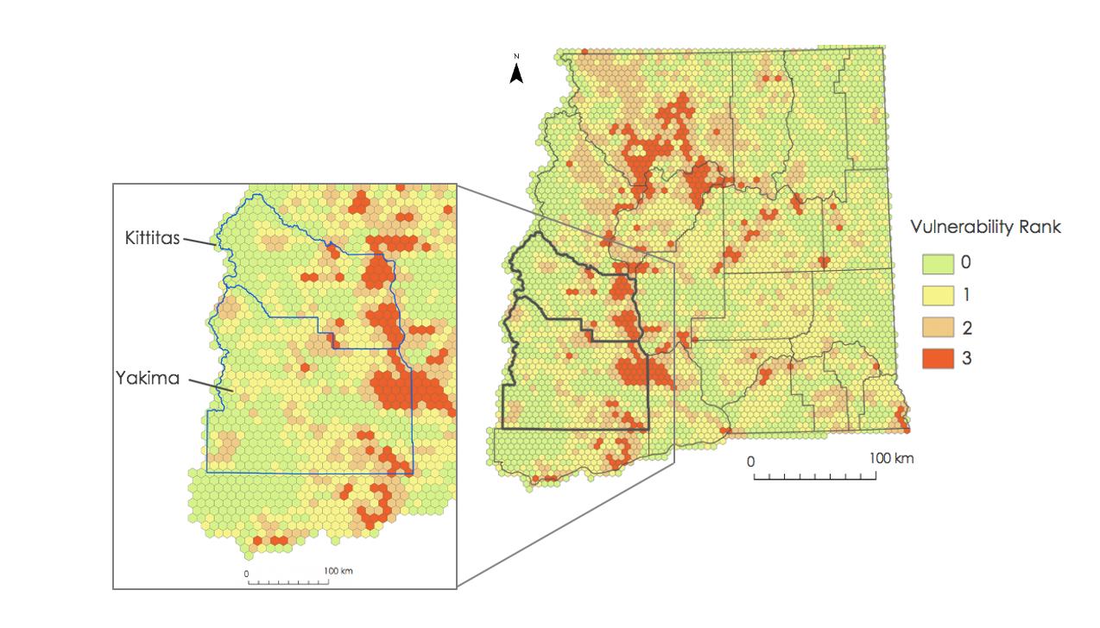
Figure 7. The Composite Vulnerability Index. This final climatology displays the final vulnerability assessment, created by combining Figures 4-6. Vulnerability is shown to vary across the study area, but the northwest portion as well as parallel to the Cascade Crest (located on the western edge of the study area) shows a high concentration of red, high index cells (value of 3). Areas of interest include Kittitas and Yakima Counties, where the eastern corners also show relatively high vulnerability.

4.1 Analysis of Results
The Composite Vulnerability Index (Figure 7) showed that vulnerability varies across the region, but that there is a clustered pattern. High index cells were concentrated in the northwest corner of the study area, specifically in Okanogan County. These cells continue through Douglas, Kittitas, Yakima, Chelan, and Benton Counties (see Appendix B, Figures B1 & B2). In Figure 7, the eastern corners of Yakima and Kittitas Counties also exhibited high concentrations of red, high index cells, corresponding to higher vulnerabilities as compared to the surrounding region. Also, the climatology showed that approximately 100 km east of the Cascades there was a clustering of high index cells that fall N-S parallel to the Cascades, and along the Columbia River (Figure 7; Appendix B, Figures B1 & B3). The final climatology also showed a high vulnerability in the northern corner of Yakima and Benton Counties, near the location of a decommissioned nuclear power plant, the Hanford Reservation (see Appendix B, Figure B4). Moreover, the high index cells tended to be located close to roads (see Appendix B, Figure B4). These high vulnerability cells represent areas that have largely been burned, have had more exposure to lightning strikes, and are composed of drier vegetation.

The team’s method of dividing the data by Jenks Natural Breaks and ranking could have been a source of uncertainty. It is also important to note that each factor was weighted equally in this fishnet methodology, which may yield some error. Fuel moisture, for example, may be more influential in the likelihood of ignition as compared to an area that has historically been burned by fire. Furthermore, there were limitations in the temporal scale of the data; due to availability and confidence in the data, the team used lightning data for 2017-2019, vegetation moisture data for 2017-2019, and fire data for 2001-2019. Lastly, the team intended to use the Visible Infrared Imaging Radiometer Suite (VIIRS) Active Fire Product as well as supplement lightning data from the Tropical Rainfall Measuring Mission (TRMM) satellite. However, both were not available for our study area.
4.2 Future Work
Ideas for future work include incorporating data from different satellites, sensors, and time periods as well as exploring different variables that could be factored into the vulnerability index. As mentioned previously in the background section, wildfires cause issues with health and air quality, even from many miles away. Future projects related to or continuing this work could study how smoke from wildfires impacts the air quality of nearby communities. It is also important to note that while soil moisture, historically burned areas, and lightning strikes are all indicators of fire risk, there are a wealth of other factors that influence the likelihood of fire ignition which could be included in an analysis, such as ladder fuels or the topography of a region. It could also be worth integrating demographic data and the proximity of wildfires to populations in future studies. This could assist in gaining a better understanding of the vulnerability of communities to the adverse effects of fires. Finally, it would be worth incorporating different lightning sensors, both to verify data from the LIS and to supplement with previous years’ data. Extending the study period would benefit the reliability of the study in finding longer-term patterns of soil moisture, historically burned areas, and lightning strikes in the study area.

5. Conclusions
The Composite Vulnerability Index climatology reveals that the northwest region of our study area, notably Okanogan County, and the eastern portion of Kittitas and Yakima Counties are more vulnerable to a lightning-ignited wildfire as compared to the surrounding region. Okanogan County experienced a large wildfire caused by lightning in 2015, providing some validation of this composite vulnerability index. The climatology also illustrated a clustered pattern of highly vulnerable cells along the Columbia River, parallel to the Cascades, and into the northern portion of Benton County. Determining these vulnerable areas may encourage further planning and attention to the issue, as well as generally raise awareness of lightning as an ignition source in this region. Also, a qualitative analysis of the individual fire and vegetation moisture climatologies suggests a relationship between the two variables; cells previously burned by fires overlapped with cells composed of drier vegetation. This information may supplement the existing fire research conducted by the partner.

The project results introduced the use of lightning data to the partner, allowing them to examine trends in lightning-caused wildfires across Eastern Washington. The team’s application of Earth observation data, including ISS LIS lightning flash locations and Landsat derived vegetation moisture data, analyzed via a fishnet imparts the partner with a useful methodology for future, similar projects. The individual climatology maps generated by the team provide the partner with a visualization of spatiotemporal trends of significant factors involved in lightning-ignited wildfires. The fire burn percent climatology map provides the partner with a view of areas historically burned by fires during the years of 2001-2019, a useful result given their interest in fires over time. Similarly, a climatology of lightning exposure identifies regions within Eastern Washington that have experienced more lightning events over the past 3 years. The vegetation moisture climatology shows the central region of the study area to be drier than its surroundings. These factor climatologies display spatial patterns of layers that can be applied by the partner to various geographical, agricultural, or forest management projects.

Citizens of Eastern Washington are familiar with the wildfire-caused smoke, especially from those ignited by lightning. Given that the partner’s current outreach is focused more on human-caused fires rather than lightning-caused, the team-generated StoryMap will be a useful tool to highlight lightning as an ignition source in this region and educate the community about how vulnerable their region is to these events. In addition to the results of this project, a succeeding DEVELOP project term will incorporate wildfire data to provide the partner with research on the changing air quality of this region.

6. Acknowledgments
The DEVELOP Eastern Washington Disasters team would like to thank their partner Brian Straniti at The Nature Conservancy, Washington Chapter for his collaboration throughout the project. The team would also like to recognize the support of their science advisors, Dr. Juan Torres-Pérez and Dr. Kenton Ross. They further acknowledge the guidance and informative discussions with Dr. Christopher Schultz and Dr. Chris Hain of NASA SPoRT, Dr. Vincent Ambrosia of NASA Ames, and John Dilger of Spatial Informatics Group. The team also thanks Christine Evans and Essence Raphael for providing assistance from their experience completing the Hindu-Kush Himalayan Disasters project. Lastly, the team would like to thank their Fellows, Gina Cova and Zachary Bengtsson, for their incredible guidance and consistent support throughout the term.

Any opinions, findings, and conclusions or recommendations expressed in this material are those of the author(s) and do not necessarily reflect the views of the National Aeronautics and Space Administration.

This material is based upon work supported by NASA through contract NNL16AA05C.

7. Glossary
Earth observations – Satellites and sensors that collect information about the Earth’s physical, chemical, and biological systems over space and time
Generate Tessellation – Generates a tessellated grid of regular polygon features to cover a given extent. The tessellation can be of triangles, squares, diamonds, hexagons, or transverse hexagons
Fire Regime – The overall pattern of wildfires in an area over a long period of time, includes frequency and intensity of fires
Fragmentation – The division of wild tracts of land by roads or development
GHRC DAAC – Global Hydrology Resource Center Data Active Archive Center
ISS LIS – International Space Station Lightning Imaging Sensor
Julian day – Dating system where each day has a numerical value between 1 and 365 (values are between 1 and 366 for leap years)
LP DAAC – Land Processes Distributed Active Archive Center
MODIS – Moderate resolution Imaging Spectroradiometer
Prescribed Burning – Controlled fires to burn underbrush in a forest, used as a method of fire suppression; rejuvenates forests, reduces dense vegetation and underbrush
TNC-W – The Nature Conservancy, Washington Chapter
VI – Vegetation Index

8. References
Blakeslee, R. (2019). Non-Quality Controlled Lightning Imaging Sensor (LIS) on International Space Station (ISS) Science Data [Dataset]. NASA EOSDIS Global Hydrology Resource Center Distribute Active Archive Center. Retrieved from https://ghrc.nsstc.nasa.gov/pub/lis/iss/. doi: http://dx.doi.org/10.5067/LIS/ISSLIS/DATA107

Burned Area Emergency Response. (2018). Burned Area Emergency Response (BAER) Information Brief - Crescent Mountain Fire 2500-8 Summary. Central Washington Fire Recovery. http://www.centralwashingtonfirerecovery.info/2018/wp-content/uploads/2018/10/Crescent-Mountain-2500-8-Summary-Briefing.pdf
Burned Area Emergency Response. (2017). Burned Area Emergency Response (BAER) Information Brief – Jolly Mountain Fire 2500-8 Summary. Central Washington Fire Recovery.
http://centralwashingtonfirerecovery.info/2017/wp-content/uploads/2017/11/Jolly-Mountain-2500-8-Summary-Briefing.pdf
Burned Area Emergency Response. (2015). Burned Area Emergency Response (BAER) Information Brief – Black Canyon Fire FS-2500-8 Summary. Central Washington Fire Recovery.
http://centralwashingtonfirerecovery.info/2015/wp-content/uploads/2015/10/BlackCanyon2500-8SummaryFinal.pdf
Busby, S. U. (2019). Forest structure, composition, and regeneration after high-severity and rapidly repeated wildfires in the Central Cascade Range (Paper 5127) [Masters thesis, Portland State University]. PDX Scholar. 10.15760/etd.7006
Giglio, L., Boschetti, L., Roy, D. P., Humber, M. L., & Justice, C. O. (2018). The Collection 6 MODIS burned area mapping algorithm and product. Remote Sensing of Environment, 217, 72-85.

Giglio, L., Boschetti, L., Roy, D., Hoffmann, A. A., & Humber, M. (2016). Collection 6 MODIS Burned Area Product User’s Guide Version 1.0. NASA EOSDIS Land Processes DAAC: Sioux Falls, SD, USA.

Gray, A., Azuma, D., Lettman, G., Thompson, J., & McKay, N. (2013). Changes in Land Use and Housing on Resource Lands in Washington State, 1976-2006. United States Department of Agriculture - Forest Service. https://www.fs.fed.us/pnw/pubs/pnw_gtr881.pdf
Kasischke, E. S., Verbyla, D. L., Rupp, T. S., McGuire, A. D., Murphy, K. A., Jandt, R., Barnes, J. L., Hoy, E. E., Duffy, P. A., Calef, M., & Turetsky, M. R. (2010). Alaska’s changing fire regime--implications for the vulnerability of its boreal forests. Canadian Journal of Forest Research, 40(7), 1313-1324. https://doi.org/10.1139/X10-098
Kolden, C. (2019). We’re Not Doing Enough Prescribed Fire in the Western United States to Mitigate Wildfire Risk. Fire, 2(2), 30. https://doi.org/10.3390/fire2020030

Lasbo, Nikolaj (2018, October 12). How We’re Returning Fire to the Landscape. The Nature Conservancy Washington. Retrieved March 17, 2020 from https://www.washingtonnature.org/fieldnotes/trex-roslyn-ridge-prescribed-fire-forests.
McCauley, T. (2019). Wildfire smoke impacting air quality across the Yakima Valley. Yakima Herald.
https://kimatv.com/news/local/wildfire-smoke-impacting-air-quality-across-the-yakima-valley

Narayanaraj, G. & Wimberly, M. (2012). Influences of forest roads on the spatial patterns of human- and lightning-caused wildfire ignitions. Applied Geography, 32(2), 878-888. https://doi.org/10.1016/j.apgeog.2011.09.004

Oliver, M. J. (2017, September 2). Jolly Mountain Fire threatens 3,800 homes, unhealthy levels of smoke hit Yakima. Yakima Herald.
https://www.yakimaherald.com/news/local/jolly-mountain-fire-threatens-homes-unhealthy-levels-of-smoke-hit/article_18b774b2-8ff9-11e7-b9a3-37d1ebacbc8d.html

Prengaman, K. (2016, November 16). Future full of doubt for Central Washington timber industry. Yakima Herald. https://www.yakimaherald.com/news/local/future-full-of-doubt-for-central-washington-timber-industry/article_28f74f22-ac93-11e6-a2ee-67aef0626395.html

Rorig, M. L. & Ferguson, S. A. (2002). The 2000 fire season: Lightning-caused fires. Journal of Applied Meteorology, 41, 786-791. https://doi.org/10.1175/1520-450(2002)041%3C0786:TFSLCF%3E2.0.CO;2

Roy, D. P., Boschetti, L., Justice, C. O., & Ju, J. (2008). The collection 5 MODIS burned area product—Global evaluation by comparison with the MODIS active fire product. Remote sensing of Environment, 112(9), 3690-3707.

Thompson, L. (2018, December 23). State agency wants to increase prescribed burns for healthier forests. Yakima Herald. https://www.yakimaherald.com/news/local/state-agency-wants-to-increase-prescribed-burns-for-healthier-forests/article_9bad3474-073a-11e9-8abf-db01e71ab3fb.html

U.S. Bureau of Land Management & USDA Forest Service - Region 6. (2019). 2018 Pacific Northwest Wildland Fire Season. https://www.fs.usda.gov/Internet/FSE_DOCUMENTS/fseprd611322.pdf

U.S. Census Bureau, Geography Division. (2019). 2019 TIGER/LineⓇ Shapefiles: Landmarks [Dataset]. Retrieved from https://www.census.gov/cgi bin/geo/shapefiles/index.php?year=2019&layergroup=Landmarks

U.S. Census Bureau, Geography Division. (2019). 2019 TIGER/LineⓇ Shapefiles: Roads [Dataset]. Retrieved from https://www.census.gov/geographies/mapping-files/time-series/geo/tiger-line-file.html

U.S. Geological Survey Earth Resources Observation and Science Center. (2012). Landsat TM Level-2 Surface Reflectance (SR) Science Product. U.S. Geological Survey. https://doi.org/10.5066/f7kd1vz9

U.S. Geological Survey Earth Resources Observations and Science Center. (2018). Landsat OLI Level-1 Surface Reflectance (SR). Science Product. U.S. Geological Survey. https://doi.org/10.5066/F71835S6

Washington Department of Natural Resources. WA County Boundaries [Feature Layer]. “Washington Department of Natural Resources GIS Open Data.” n.d. Accessed http://data-wadnr.opendata.arcgis.com/datasets/wa-county-boundaries/geoservice?geometry=-131.980%2C44.623%2C-109.655%2C49.839

Washington Department of Natural Resources. Washington Large Fires 1973-2018 [Dataset]. Scale of 1:1,906,144. “Washington Geospatial Open Data Portal.” 1973-2019. Accessed on February 10, 2020, from http://geo.wa.gov/datasets/wadnr::washington-large-fires-1973-2018

Washington State Department of Ecology. (2007). WAECY – River Miles [Dataset]. Retrieved from http://geo.wa.gov/datasets/waecy::waecy-river-miles

Washington State Department of Natural Resources. (2018). 20-Year Forest Health Strategic Plan - Eastern Washington. https://www.dnr.wa.gov/ForestHealthPlan

Weigel, Amanda (2018, February 2). ISS LIS Lightning Flash Heat Map and Flash Location CSV File. (Python 2.7). https://gitlab.com/NASA-GHRC-DAAC/data-recipes/-/blob/master/ISS_LIS_FlashLoc_Quickview.py
Western Regional Climate Center. (2002, January 16). Climate of Washington. https://wrcc.dri.edu/narratives/WASHINGTON.htm

9. Appendices
Appendix A

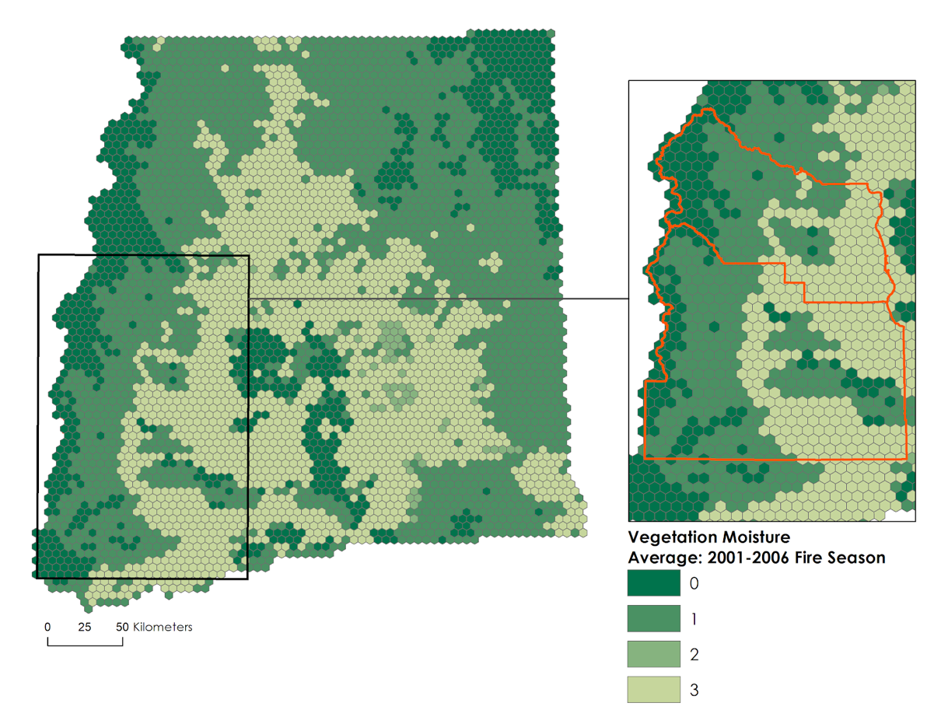
Yakima County
Kittitas County
Figure A1. A Vegetation Moisture Index climatology for the years of May-October 2001-2006 is shown above.

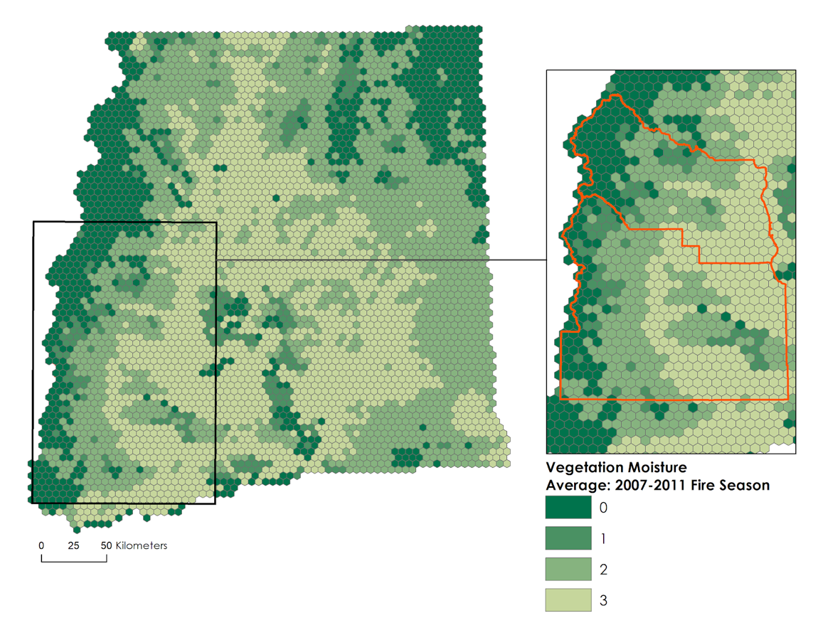
Yakima County
Kittitas County
Figure A2. A Vegetation Moisture Index climatology for 2007 - 2011 (May to October) is shown above.

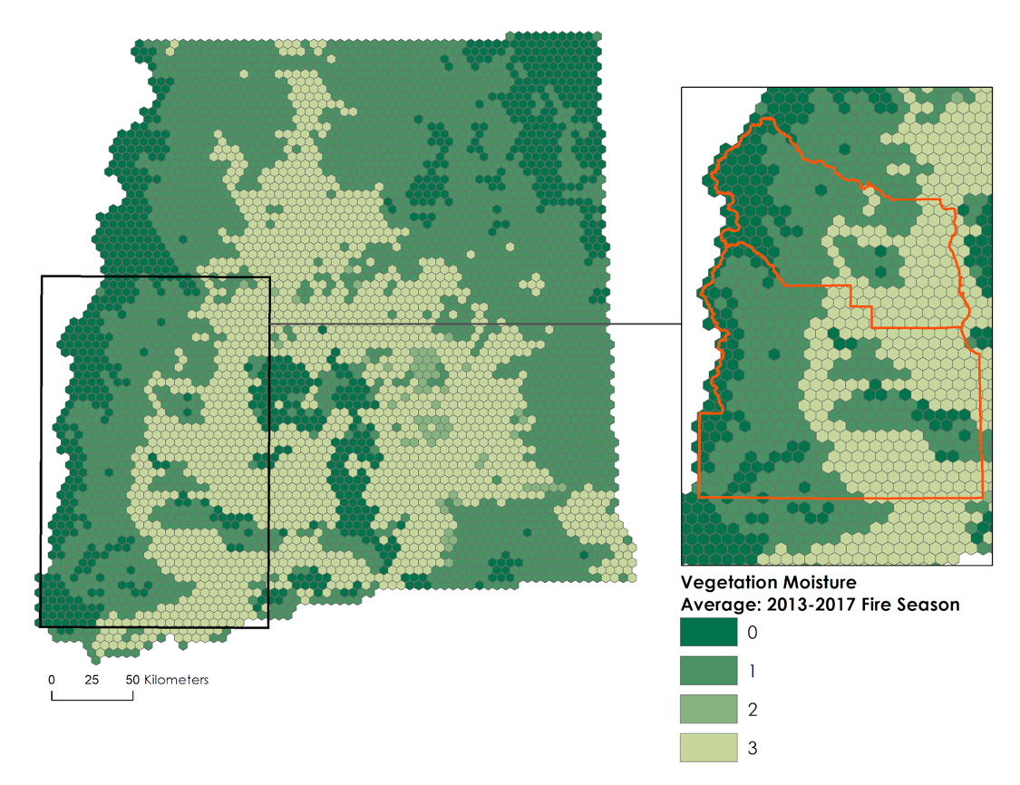
Yakima County
Kittitas County
Figure A3. Vegetation Moisture Index climatology for 2013 - 2017 (May to October) is shown above.
*Note: 2004 and 2012 were eliminated due to errors in the initial acquired Landsat imagery.

Appendix B

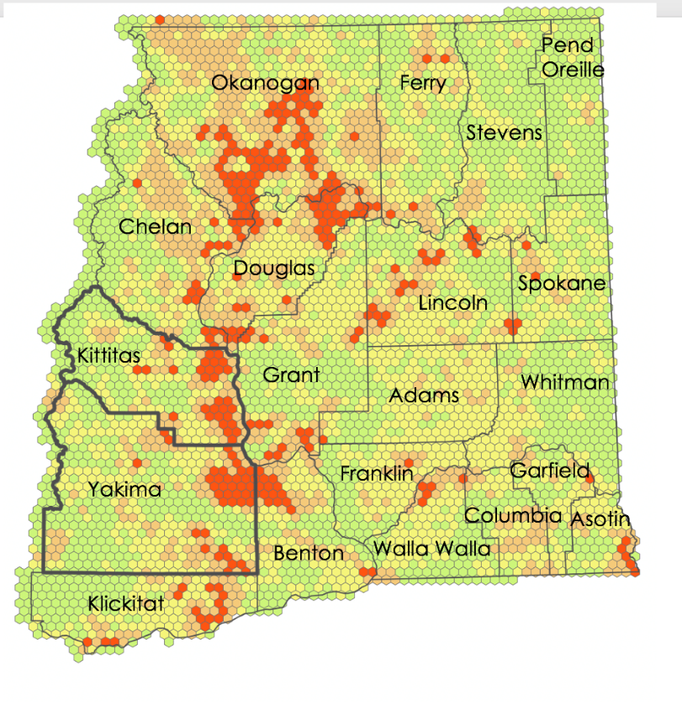
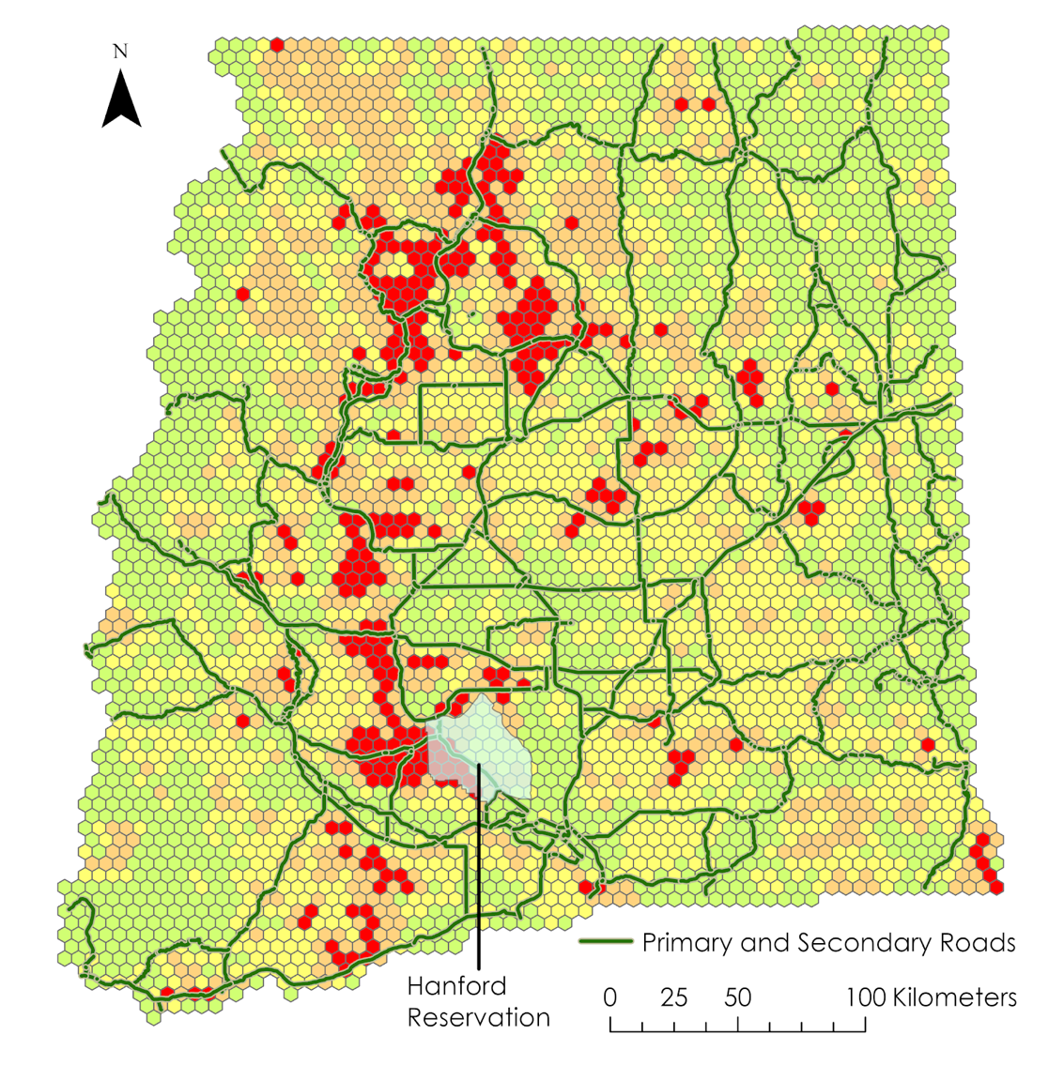

Figure B1. Composite Vulnerability Index with county labels. This climatology map displays county boundaries, to better understand vulnerabilities in the context of the Eastern Washington region.

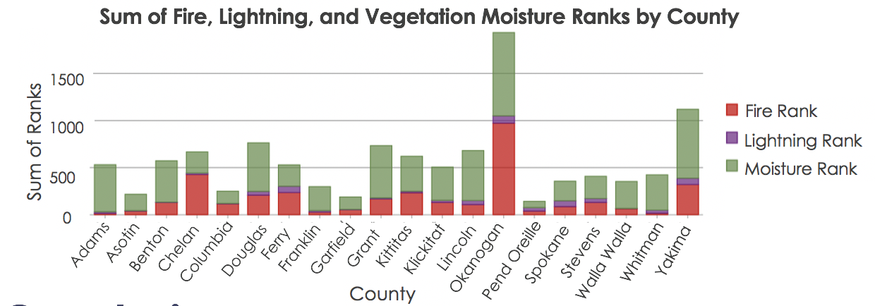

Figure B2. Sum of the individual factor ranks by County. Okanogan and Yakima County show higher counts, corresponding to higher vulnerabilities.

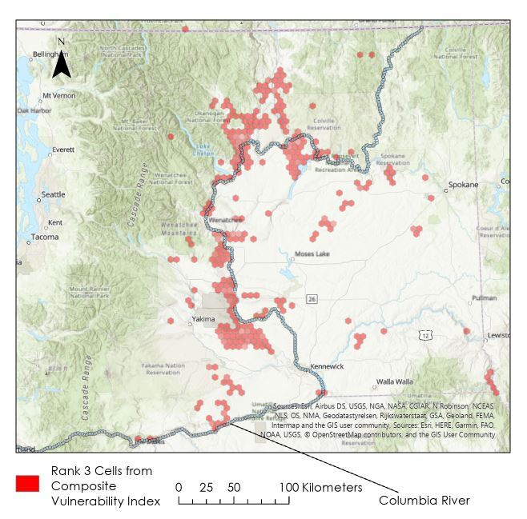

Figure B3. Rank Three Vulnerability Cells from Composite Climatology with Columbia River
Above, the highest ranked vulnerability cells from the composite climatology are shown along with the Columbia River. The image shows a pattern of high risk cells clustered in areas along the path of the river. Transparency of cells was increased to allow the basemap and river to be seen.

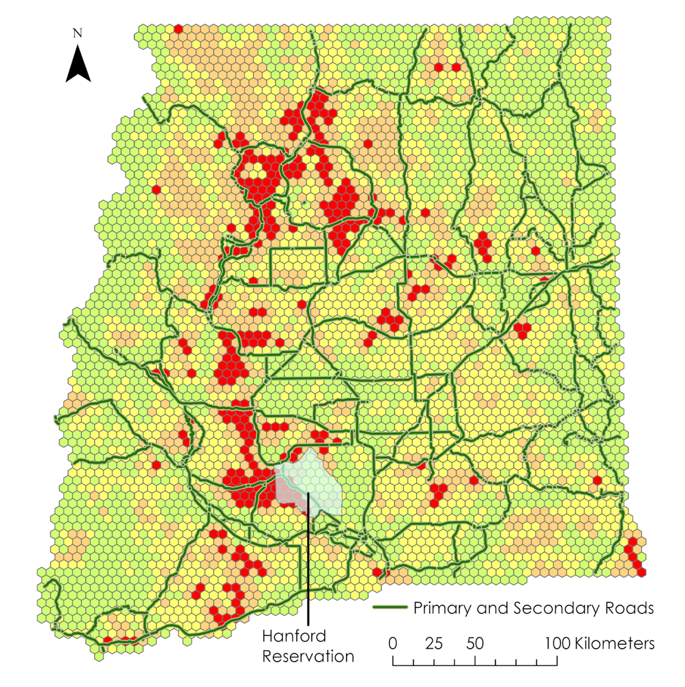

Figure B4. Composite Vulnerability Index with roads and Hanford Reservation landmark. This climatology map displays primary and secondary roads, as well as the Hanford Reservation, showing a pattern of high-risk areas for lightning-ignited wildfires falling near major roads. The Hanford Reservation is a large landmark that partially overlaps with high-risk areas, and so the team included it as a potential area of interest.

