**NASA DEVELOP National Program**

 Wise County Clerk of Court's Office

**Summer 2016**

**Short Title: Southeast U.S. Agriculture**

**Subtitle:** Incorporating NASA Earth Observations into the USDA Southeast Regional Climate Hub Lately Identified Geospecific Heightened Threat System (SERCH LIGHTS) to Assist Farmers in Making Informed Decisions on Water and Crop Management

**VPS Title:** Truth in the Soil: Using SMAP to Monitor Drought in Southeast US

**Project Team & Partners**

**Project Team:**

Yaping Xu (Project Lead), ypxu2011@gmail.com

Yousra Benchekroun

Kimberly Berry

Grant Bloomer

**Advisors & Mentors:**

Dr. Kenton Ross (NASA DEVELOP National Program)

Dr. DeWayne Cecil (Global Science & Technology [GST] National Centers for Environmental Information [NCEI])

Bob VanGundy (The University of Virginia’s College at Wise)

Michael Bender (NASA DEVELOP National Program)

**Partner Organizations:**

|  |  |  |  |
| --- | --- | --- | --- |
| **Organization** | **POC (Name, Position/Title)** | **Partner Type** | **Boundary Org?** |
| USDA Southeast Regional Climate Hub (SERCH) | Jennifer Moore Myers (Program Coordinator) and John Cobb (IT Specialist) | End-User | Yes |

**Project Details**

**Applied Sciences National Applications Addressed:** Agriculture, Climate, Water Resources

**Study Area:** Southeastern United States (AL, AR, FL, GA, KY, LA, MS, NC, SC, TN, VA)

**Study Period:** April 2015 – May 2016

**Earth Observations & Parameters:**

Soil Moisture Active Passive (SMAP), L-Band Radiometer – Soil Moisture

**Ancillary Datasets Utilized:**

* North American Land Data Assimilation System (NLDAS) - Soil moisture data will be incorporated into the SERCH LIGHTS tool to increase the relevance of the tool for water management purposes and better drought prediction.
* Soil Climate Analysis Network (SCAN) - Soil Moisture

**Software Utilized:**

* Python 2.7 – Programming language & image manipulation
* ArcGIS- Raster manipulation/analysis, image enhancement, and map creation

**Project Overview**

**80-100 Word Objectives Overview:**

The United States Department of Agriculture (USDA) Southeast Regional Climate Hub (SERCH) is currently driven by NOAA’s Climate Prediction Center, and does not currently use NASA Earth observations for their Lately Identified Geospecific Heightened Threat System (LIGHTS) tool. The objective of this project is to integrate the North American Land Data Assimilation System (NLDAS) and Soil Moisture Passive Aggressive (SMAP) data into SERCH LIGHTS by focusing on the NASA Earth observations and methodology. While the current tool provides appropriate data for meteorological droughts, NLDAS and SMAP deal with agricultural droughts. Incorporating both of these NASA Earth observations into SERCH LIGHTS will increase the accuracy and range of the tool, and thereby increase the end-user’s water management capabilities.

**Abstract:**

Regional climate variability in the southeastern United States is a concern for agricultural and forestry management. Droughts are an important consequence of this variability, affecting both the agricultural and forestry sectors’ ability to manage their water resources. The United States Department of Agriculture (USDA) Southeast Regional Climate Hub (SERCH) has thus developed a tool called Lately Identified Geospecific Heightened Threat System (LIGHTS) in order to provide information for its users that would increase water management efficiency. It identifies and alerts users to changes in drought, temperature, and precipitation patterns. However, LIGHTS lacks soil moisture information, which also affects drought patterns. This project therefore aims to update the current drought monitoring system by incorporating Soil Moisture Active Passive (SMAP) level 3 data as a support layer, by retrieving Standardized Soil Moisture Index (SSI) as a measure and by using Python as the programming language. Ground truth soil moisture data from Soil Climate Analysis Network (SCAN) were collected for validation. As a result, this integration of SMAP data into SERCH LIGHTS will increase the end-user’s water management capabilities in response to drought conditions.

**Keywords:**

Remote Sensing, SMAP, NLDAS, Drought, Soil Moisture, Standardized Soil Moisture Index, Python

**Community Concerns:**

* Regional climate variability in the southeast United States is a concern for agricultural and forestry management. This variability causes droughts, heat stress, and flooding events while also changing pest phenology.
* Drought induced water-stress directly affects the agricultural and forestry sectors’ ability to manage their water resources by decreasing water supply.
* While SERCH LIGHTS allows users to address water management more efficiently, it lacks information regarding soil moisture, which also affects drought patterns.

**Current Management Practices & Policies**:

The SERCH LIGHTS system is currently driven by NOAA’s Climate Prediction Center’s Monthly Drought Outlook, Monthly Temperature and Precipitation Outlook, and Risk of Seasonal Climate Extremes in the US, which is also related to the El Nino Southern Oscillation (ENSO). Subscribers, who are typically in the sectors of forestry or agriculture, receive a notification when their location is predicted to experience changing conditions related to drought. This system allows users to address drought and water management issues efficiently and directly. The USDA SERCH does not currently use NASA Earth observations for their LIGHTS tool. They are aware of NASA Earth observations and its ability to be incorporated into this tool but are unaware of the methodology on how to do so.

**Decision Support Tools & Benefits:**

|  |  |  |  |
| --- | --- | --- | --- |
| **End-Product** | **Earth Observations Used** | **Benefit & Impact** | **Software**  **Release** |
| SERCH LIGHTS Update | SMAP | The updates to this tool will provide the end-users with the most accurate, relevant information about drought conditions in their region | 3 |

**Project VPS/Booklet Imagery**

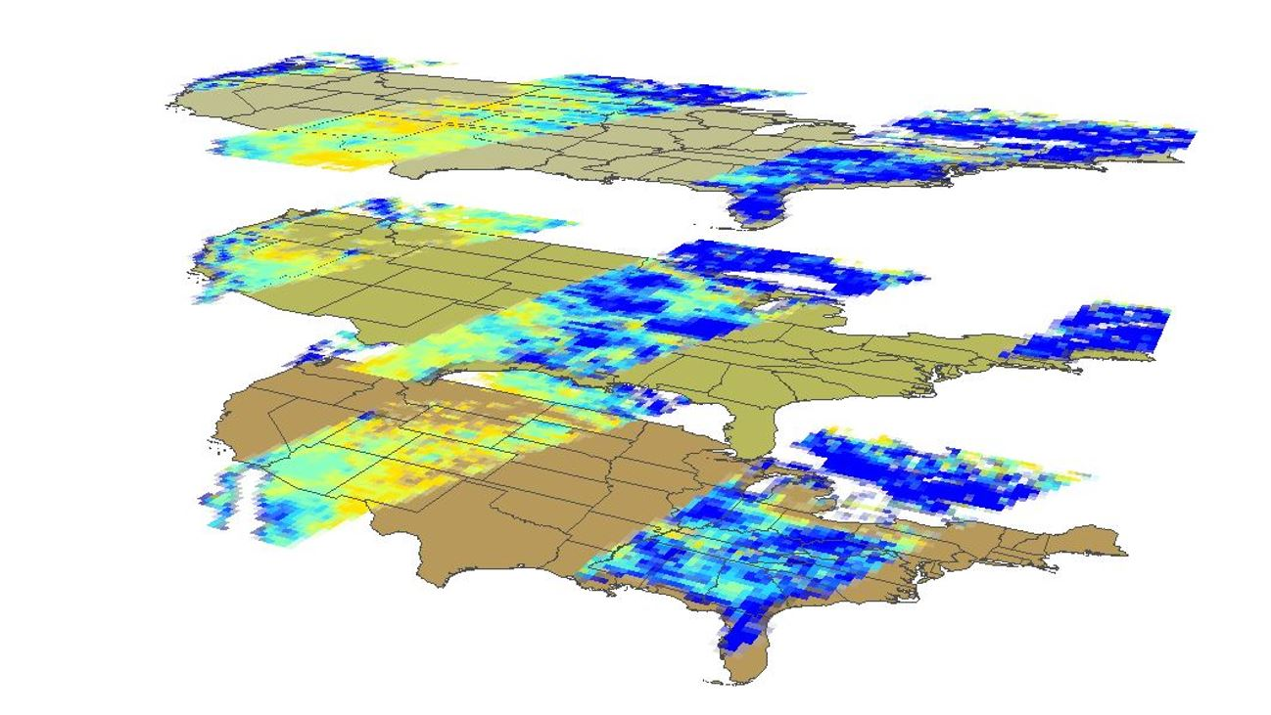

**Caption:** Standardized Soil Moisture Index layers of three day data. The Standardized Soil Moisture Index is a Z-score of SMAP data compared to NLDAS historic statistics. Image Credit: Southeast Agriculture Team.

**Image:** 2016Sum_WC_SoutheastUSAg_VPSImage.JPEG