**NASA DEVELOP National Program**



USGS at Colorado State University

*Summer 2015*

Ethiopia Ecological Forecasting

Longer sub-title (ex. Synthetic Aperture Radar Data Decision Support for Atlantic Blue Fin Tuna Population Assessment and Management in the Gulf of Mexico)

 **Technical Report**

Rough Draft – June 25, 2015

Stephen Chignell

Chandra Fowler

Kelly Hopping

Darin Schulte

Paul Evangelista, Natural Resource Ecology Lab, Colorado State University (Science Advisor)

# I. Abstract

[Placeholder - do not put anything here until the final draft submission. The abstract in the project summary is where the working draft of the abstract should “live”]

**Keywords**

Landsat, MODIS, LandTrendr, fire, time series, change detection, Ethiopia, Bale Mountains

# II. Introduction

***Background Information***

Ethiopian pastoralists have a long history of managing high-elevation shrublands with intentional burning, but these fires may lead to unintended consequences, such as reduced habitat for the endangered Mountain Nyala.

***Project Objectives***

We quantified fire distribution in Ericaceuos shrublands of the Bale-Arsi massif, Ethiopia, mapping burned areas over 42 years (1973-2015) using Landsat Multispectral Scanner, Thematic Mapper, Enhanced Thematic Mapper, and Operational Land Imager data, as well as the Moderate Resolution Imaging Spectroradiometer Burned Area product. Our findings improve the understanding of past fire extent, which will inform future conservation efforts by The Murulle Foundation and its partners in Ethiopia.

***Study Period and Area***

The study period for this project was January 1973 – June 2015. The study area was located in south-central Ethiopia, and comprised the Bale-Arsi massif, Sanetti Plateau, and surrounding lowlands (WRS1 Landsat Scene Path 180, Row 55; WRS2 Landsat Scene Paths 167 and 168, Row 55.

***National Application Addressed***

This project addresses the NASA national application area of ecological forecasting and will provide tools to decision makers in Ethiopia and our partner association the Murulle Foundation. These tools and compiled data sets contribute to the global knowledge implementing legislation balancing the health of the diverse ecosystems of the Bale Mountains and healthy economic growth for the area.

**Project Partners**

The Murulle Foundation

# III. Methodology

Using the USGS Earth Explorer portal (<http://earthexplorer.usgs.gov>), we downloaded level 1 terrain-corrected Multispectral Scanner (MSS) imagery from Landsat satellites 1, 3, and 5. Through the USGS Bulk Surface Reflectance Interface (<http://espa.cr.usgs.gov/ordering/new>), we downloaded level 1 terrain-corrected, top of atmosphere and surface reflectance climate data records for Thematic Mapper (TM) imagery from Landsat 5, Enhanced Thematic Mapper (ETM+) imagery from Landsat 7, and Operational Land Imager (OLI) imagery from Landsat 8. The USGS Bulk Surface Reflectance Interface also calculated the following spectral indices for all Landsat TM, ETM+, and OTI data: NDVI, NDMI, NBR, NBR2, SAVI, MSAVI, and EVI. We used all available scenes in January through March from WRS1 path 180, row 55 and for WRS2 paths 167 and 168, row 55. In total, this yielded XX scenes from 25 years, spanning from 1973-2015. We also downloaded 30-m2 resolution digital elevation model data from the Shuttle Radar Topography Mission (SRTM) through the USGS Earth Explorer portal (<http://earthexplorer.usgs.gov>).

Moderate Resolution Imaging Spectroradiometer (MODIS) Burned Area Product data from March 2000 to March 2015 was downloaded using the University of Maryland's MODIS Fire Science Team ftp server (<ftp://ba1.geog.umd.edu/>). This data was captured by NASA's Aqua and Terra Satellites and the MODIS Burned Area Product algorithm was applied, detecting fire scars by taking time series data and locating occurrences of rapid changes in daily surface reflectance. The data from this product was manipulated in ArcMap to show both yearly and monthly occurrences of wildfire in our study area.

We mosaicked twenty 1-degree tiles of SRTM elevation data to make a digital elevation map for our study area. For this we used R code (R Development Core Team, 2014) provided by Justin Braaten at the Laboratory for Applications of Remote Sensing in Ecology at Oregon State University. To process the Landsat imagery, we used the R LandsatLinkr package (Braaten et al. 2015). Within LandsatLinkr we projected all data to North America Albers Equal-Area Conic since LandsatLinkr has not yet been developed to work with projections outside of North America. For MSS imagery, LandsatLinkr decompresses, stacks, resamples, reprojects, and georegisters the scenes. It then converts the data to top-of-atmosphere radiance and surface reflectance, which it then pairs with a DEM to create a cloud mask. TM and ETM+ data downloaded from the USGS Bulk Surface Reflectance Interface already includes atmospheric corrections and cloud masks derived from LEDAPS, so for scenes from these sensors LandsatLinkr only decompresses, stacks, resamples, and reprojects the data. Then LandsatLinkr calculates tasseled cap indices for all scenes, calibrates MSS to TM scenes, and then produces annual, cloud-free composites based on mean pixel values for all overlapping, cloud-free areas within a year.

Although the LandsatLinkr program documentation recommends using as many images as possible from within a phenological season each year, we were concerned that compositing later dates after which burning had occurred with earlier dates from the same year, before fires started, would cause the composited spectral values in burned areas to be diluted relative to if we used only a single image after the fires had occurred. However, if we prioritized capturing all fires from within the January-March dry season and only selected the very latest dates from this period each year, this would prevent LandsatLinkr from finding cloud-free pixels across several dates in order to create a single cloud-free image for each year. Therefore, to balance this tradeoff between diluting the spectral signature of burned areas and losing information to clouds, we decided to use the scene from the latest date from January to March with few to no clouds each year. When there were moderate levels of clouds at later dates, we paired them with earlier, cloud-free dates (not sure if we will do this???).

Although LandTrendr is able to incorporate Landsat 8 imagery, LandsatLinkr does not currently support processing of OLI data. We therefore manually prepared the OLI surface reflectance product for use in LandTrendr by applying the tasseled cap transformation coefficients derived by Baig et al. (2014), and reclassifying the FMask cloudmask to a binary map. We then projected all of these layer to North America Albers Equal Area Conic. We clipped the MODIS Burned Area product to the extent of our study area and created polygons for fires that occurred there within each year.

LandTrendr was designed to work with continuous time series of Landsat data, but for our study area in Ethiopia, we had temporal data gaps in years with no imagery, as well as spatial data gaps from 2004-2009 and 2012-2013 when the only scenes collected were from Landsat 7 ETM+ when the scan line corrector was broken. We were concerned that these missing data could impede our ability to detect burned areas, particularly if regeneration after a fire occurred during a data gap period, thus preventing LandTrendr from capturing a change in the trajectory of the reflectance of that through time, which would in turn prevent us from classifying those areas as highly disturbed, or burned pixels.

To address this potential problem with data gaps in the Landsat record, we paired our analyses of Landsat imagery with data from the Enhanced Vegetation Index (EVI) and Burned Area products from the Moderate Resolution Imaging Spectroradiometer (MODIS) sensor on the Aqua and Terra satellites. However, the MODIS data is also at a much coarser spatial resolution than the 30 m2 Landsat data (EVI: 250 m2; Burned Area: 500 m2), so we were also interested in whether these products would be able to capture smaller fires picked up by the Landsat imagery.

First, to generate a conservative and independent dataset with which to validate the LandTrendr disturbances identified as burned areas, we generated random points within each MODIS burned area polygon in January-March, 2000-2015. These were compared against the Landsat burn areas to calculate user’s, producer’s, and overall accuracies (Table X (error matrix)).

Second, we used the random points (include specific #) generated for the validation to assess trajectories of vegetation change in burned areas. The Oak Ridge National Laboratory Distributed Active Archive Center for Biogeochemical Dynamics Global MODIS Subset Tool (<http://daac.ornl.gov/MODIS/modis.shtml>) provides standard MODIS products for any location and time period in the historical record (2000 – 2015). We acquired the MOD13Q1 (Terra) and MYD13Q1 (Aqua) vegetation indices values for each of the burn points; while this product includes both NDVI and EVI data, we chose to focus on EVI because of its ability to avoid oversaturation due to dense rainforest canopy like that found in the Bale Mountains.

The continuous record from MODIS to assess the timescale of vegetation recovery after fires in order to determine whether our 2-3 year data gaps in the Landsat record would allow enough vegetation to regenerate that we would be unable to detect the initial fire using LandTrendr. (We assumed that the 5- and 7-year Landsat data gaps in the early 1980s and 1990s, respectively, would be too long.)

Rough Draft of Flow Chart (ppt file is saved in Box under Tech Paper)

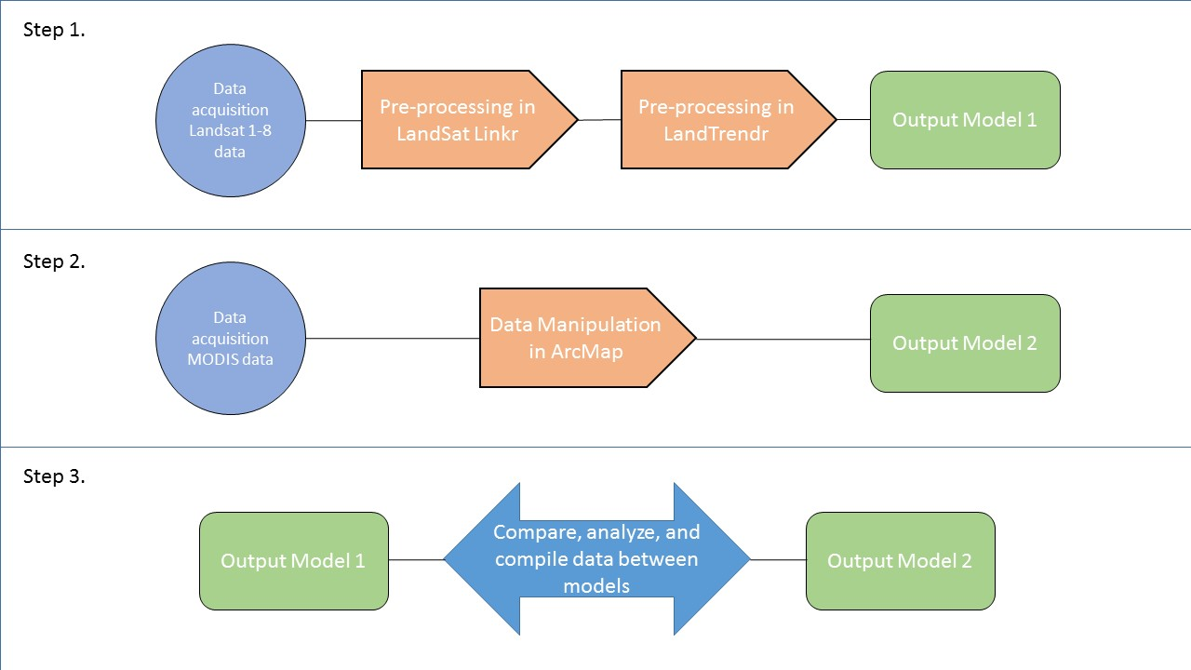

# IV. Results & Discussion

Coming Soon!

Insert images, graphs, maps, charts, etc. here. Choose the most important results to highlight here. No word cap, but two to six pages is a good range.

Things to discuss:

* Analysis of Results: What can you tell from your graphs, images, etc? What does this mean for your project?
* Errors & Uncertainty: What factors could you not account for, what things didn’t work out like you expected they would, etc.
* Future Work: If this project was to be selected for another term, what would be the focus? What other areas would be of interest?

# V. Conclusions

Coming Soon!

Final conclusions. Word count: 200-600 (~a page).

# VI. Acknowledgments

Insert here. Keep to a concise paragraph or bullets of names. End with the following sentence.

This material is based upon work supported by NASA through contract NNL11AA00B and cooperative agreement NNX14AB60A.

# VII. References

Insert references here. Only include articles/content cited in the body of text above. It’s great if you read many other articles, but they should not all be listed here unless they are being cited in this report.

Use whatever style you want - here are some options:

<http://www.dovepress.com/author_guidelines.php?folder_id=208>

<http://en.wikipedia.org/wiki/Citation>

<http://www.agu.org/pubs/pdf/AuthorRefSheet.pdf>

<http://linguistics.byu.edu/faculty/henrichsenl/apa/apa01.html>

Braaten, J.D., Cohen, W.B., & Yang, Z. (2015). LandsatLinkr: Tools to spectrally link Landsat data. R package version 0.1.13.http://landsatlinkr.weebly.com/

R Core Team. (2014). *R: A Language and Environment for Statistical Computing*. Vienna, Austria: R Foundation for Statistical Computing. Retrieved from http://www.R-project.org/

# VIII. Content Innovation

In preparation for DEVELOP’s coming microjournal, please select two content innovation features to support your paper. For each item, please list the name of the feature, and include the tool itself if possible (eg. glossary terms and definitions). If the tool does not work in Microsoft Word (eg. Interactive MATLAB Figure Viewer), please list the file name and upload the related file to the microjournal folder on the DEVELOP Exchange. If you choose to use Inline Supplementary Material, please also include where the material should appear in the text.

**Some options include:**

AudioSlides

Database Linking Tool

Data Profile

Executable Papers

Featured Author Videos

Featured Multimedia for this Article (video and podcast options)

Glossary Viewer

Inline Supplementary Material (figures, tables, computer code)

Interactive Map Viewer

Interactive MATLAB Figure Viewer

Interactive Plot Viewer

Nomenclature Viewer

# IV. Appendices

Insert here