**NASA DEVELOP National Program**



NASA Marshall Space Flight Center

*Fall 2015*

Lake Victoria Water Resources

Spatio-Temporal Analysis of Lake Victoria Water Hyacinth and Algal Blooms Using NASA Earth Observations for Improved Water Management

 **Technical Report**

Final Draft – November 19, 2015

Jeanné le Roux (Project Lead)

Daryl Ann Winstead

Christina Fischer

Sara Amirazodi

Austin Vacek

Dr. Jeffrey Luvall, NASA at National Space Science and Technology Center (Science Advisor)

Dr. Robert Griffin, University of Alabama in Huntsville (Science Advisor)

# I. Abstract

Lake Victoria, with a surface area of 68,800 km2, is the largest lake in Africa. The lake is surrounded by Kenya, Tanzania, and Uganda and is home to more than 30 million people, making it one of the most densely populated rural areas in the world. These people rely on the lake for all aspects of their lives, including fishing, agriculture, and industrial applications. However, the increasing population has negatively impacted water quality through agricultural and industrial run-off and sewage. Furthermore, the invasive water hyacinth (*Eichhornia crassipes*) is blocking fishing access and providing breeding grounds for disease carrying mosquitoes and snails. Ongoing efforts between SERVIR Africa and the Regional Centre for Mapping of Resources for Development (RCMRD) have been assessing and monitoring water quality parameters such as chlorophyll concentration, temperature, and turbidity for Lake Victoria using the Moderate Resolution Imaging Spectrometer (MODIS) sensor on the Aqua satellite. This project seeks to include the use of Landsats 5,7,8 and Earth Observing-1 (EO-1) to assess surface reflectance, chlorophyll-a, and water hyacinth presence. The study will focus on the Winam Gulf region of Lake Victoria in Kenya, since this area experiences abundant water hyacinth activity and has been identified by RCMRD as an area of focus. The data collected will be used to create a preliminary algorithm to detect water hyacinth. This algorithm will then be applied on imagery ranging from August 2000 to October 2015 to provide a historical context of the range of water Hyacinth in the Winam Gulf.

**Keywords**

Lake Victoria, Water Quality, Water Resources, Invasive Species, Remote Sensing

# II. Introduction

With a surface area of 68, 800 km2 in a catchment area of 194, 200 km2, Lake Victoria is the largest of Africa’s great lakes. The lake is shared by Kenya, Uganda, and Tanzania, and serves as the main reservoir of the Nile River. The drainage basin area is shared by Kenya, Uganda, Tanzania, Rwanda, and Burundi (Odada et al. 2006).

Millions of people depend directly on the lake for survival, utilizing it as a source of drinking water and food. Commercial fishing on the lake is also a vital part of the economy, as it provides a source of income for individuals and families (Kayombo and Jorgensen 2006). Consequently, the water quality in Lake Victoria has rapidly degraded during the past century due to rising human activity. Sewage, industrial, and agricultural runoff have resulted in disturbances in the chemical balance of the lake. Excess nutrients in the water have caused eutrophication, a process which feeds rapid plant and algae growth while subsequently depleting the available oxygen in the water. Chemical runoff from herbicides and pesticides not only pose a threat to human health, but the deoxygenated water resulting from nutrient dumping activities also spells trouble for species living in the lake (Kolding et al. 2008).

Once a thriving biodiversity hotspot, Lake Victoria has experienced a rapid decline in endemic fish species since the introduction of the invasive Nile Perch in the early 1960’s (Nkalubo et al. 2014). The introduction of *Eichhornia crassipes*, or water hyacinth, has also had adverse impacts on the region by blocking boating access to the important fishery the lake provides and by providing a breeding ground for disease carrying insects and snails (Kayombo and Jorgensen 2006). Schistosomiasis, also known as “snail fever,” is a parasitic disease carried by freshwater snails which thrive on water hyacinth. Swimming, bathing, fishing and even domestic chores such as laundry and herding livestock in affected waters can put people at risk of contracting the disease. Furthermore, nutrient runoffs from increasing populations, agriculture, and industry in the region are also major contributors to hyacinth blooms (Kiage and Obuoyo 2011).

This study focused on the Winam Gulf, in the Kenyan portion of the lake, as noted in Figure 1. The gulf’s isolated geography, shallow waters, and close proximity to some of the most densely populated areas in Africa have made it a target for water pollution, resulting in massive algal blooms and water hyacinth outbreaks.

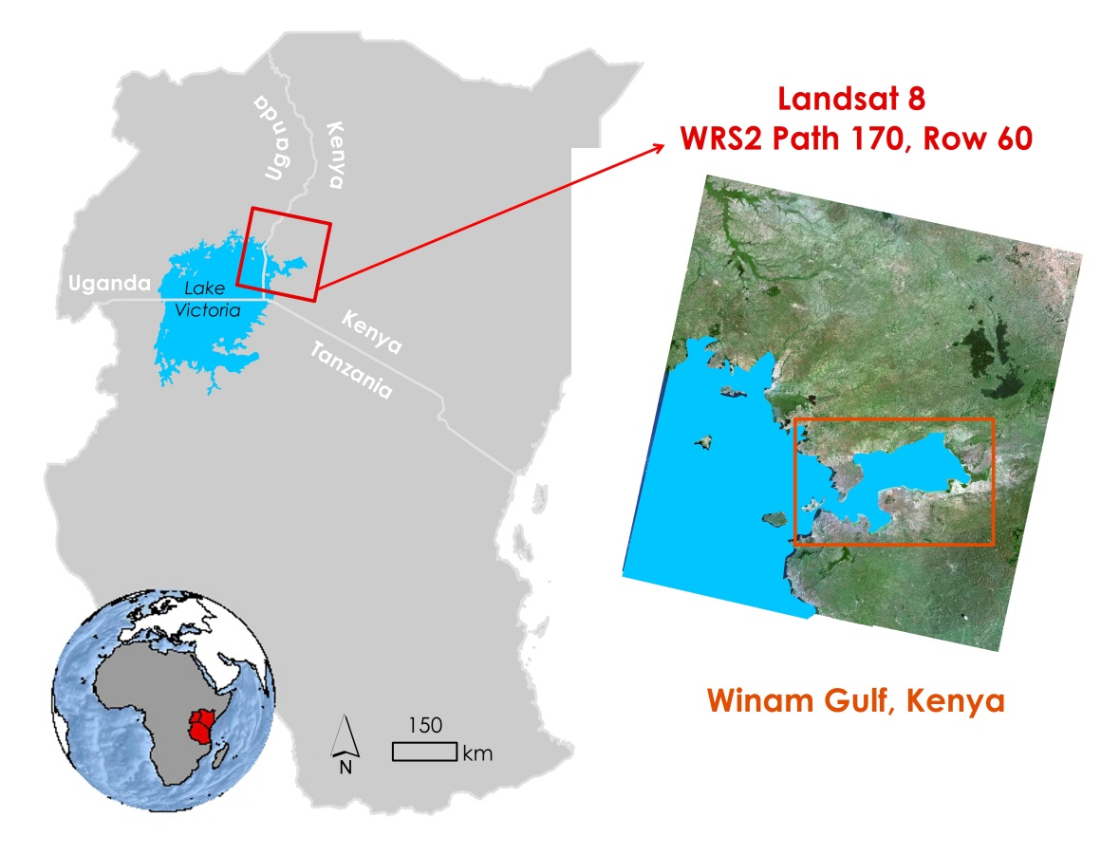

Figure 1: Project Study Area, Winam Gulf of Lake Victoria in Kenya

Despite the challenges that come with managing such a large body of water, several organizations have been making an effort to improve water quality, control invasive species, and facilitate collaboration on these issues among the nations which thrive off of Lake Victoria. SERVIR -The Regional Visualization and Monitoring System is a joint venture between NASA and the U.S. Agency for International Development (USAID), providing satellite-based Earth monitoring, imaging, and predictive models to help improve environmental decision-making among developing nations with hubs in Africa, the Hindu-Kush region of the Himalayas, and the lower Mekong River Basin in Southeast Asia. SERVIR – East Africa, located in Kenya, has been collaborating with the Regional Centre for Mapping of Resources for Development (RCMRD) to monitor certain water quality parameters, as well as hyacinth extent, in Lake Victoria via satellite remote sensing techniques. Current efforts include mapping chlorophyll concentration, water surface temperature, and turbidity for Lake Victoria using the Moderate Resolution Imaging Spectrometer (MODIS) sensor on the Aqua satellite. In addition, preliminary efforts have been made to map the extent of the water hyacinth in the Winam Gulf using Landsat imagery.

This project aimed to complement RCMRD and SERVIR’s efforts to gain a better understanding of the invasive water hyacinth. This was done by developing a water hyacinth detection algorithm using Landsat imagery to help determine areas in need of mitigation and to prioritize study efforts. A Time Series Map of Aquatic Vegetation, spanning from August 2000 to October 2015, was also developed to provide a historical context of water hyacinth extent and algal blooms in the Gulf. Collaboration with members from the SERVIR Coordination Office, the SERVIR East Africa Team, and RCMRD was facilitated to reach this goal.

This project addressed NASA’s national water resources application area by researching water quality and water hyacinth within the Winam Gulf in Lake Victoria. Monitoring the historical water quality of the lake achieved a better understanding of the degradation of the water quality and the growth of the water hyacinth.

# III. Methodology

**Data Acquisition** The Landsat Surface Reflectance High Level GeoTIFF data product for Landsat 5 Thematic Mapper (TM), Landsat 7 Enhanced Thematic Mapper Plus (ETM+), and Landsat 8 Operational Land Imager (OLI) were downloaded for WRS-2 path 170, row 60 from the United States Geological Survey (USGS) Earth Explorer website. Landsat 5 TM and Landsat 7 ETM+ imagery from this data product have had a MODIS atmospheric correction applied, in addition to a 6S radiative transfer model to generate top of atmosphere reflectance (TOA), surface reflectance, brightness temperature, and masks for clouds, cloud shadows, adjacent clouds, land, and water (USGS). Landsat 8 images from this data product were atmospherically corrected and converted to surface reflectance using the newly developed L8SR algorithm (USGS). Scenes from 2008 to October 2015 were downloaded for data processing. Exact dates are listed in Appendix A. Images with minimal cloud cover throughout the scene were selected to use.

The Surface Reflectance High Level data product was only available for Landsat imagery taken during and after 2008. Imagery chosen for analysis pre-dating 2008 was downloaded as Level 1 GeoTIFF’s from the USGS GLOVIS website. These scenes were converted to surface reflectance using the “surface_reflectance” function in the landsat module provided in the DEVELOP National Program Python Package (dnppy).

High resolution WorldView imagery was obtained for November 29, 2013. This imagery was used to test the accuracy of the methodology.

**Data Processing**

Two different methods were tested to extract the location of water hyacinth and surface algal blooms in the Winam Gulf.

The first method, from here on referred to as the NDWI method, used the Normalized Difference Water Index (NDWI) to distinguish water features from non-water features in the Gulf. First, an NDWI was performed using the following general equation:

$$\text{NDWI} \text{=}\frac{\text{(green} \text{-} \text{NIR)}}{\text{(green} \text{+} \text{NIR)}}$$

where, *green* = surface reflectance green band

and, *NIR* = surface reflectance near infrared band

Areas with a NDWI of 0.1 or less were extracted and converted to a shapefile representing non-water features. As a rule of thumb, the literature suggests to use the threshold of 0 to determine between water and non-water features when using a water index, however, this threshold was increased to 0.1 in order to extract additional algae (Xu 2006).

The Normalized Difference Vegetation Index (NDVI) looks at the contrast between red absorption and near infrared (NIR) reflectance to highlight features of vegetation health (Hute et al. 2002). A NDVI was performed over the study area using the following general equation:

$$\text{NDVI} \text{=}\frac{\text{(NIR} \text{-} \text{red)}}{\text{(NIR} \text{+} \text{red)}}$$

where, *NIR* = surface reflectance near infrared band

and, *red* = surface reflectance red band

The NDVI file was then clipped down to the “non-water features” shapefile for focus. Areas with an NDVI of min - 0.82 were classified as algae, while areas with an NDVI of 0.82 or greater were classified as water hyacinth/macrophytes. A threshold of 0.82 was chosen based on the results from a study conducted by Cho et al. 2008.

The second approach, from here on referred to as the MNDWI method, utilized the Modified Normalized Difference Water Index (MNDWI) to distinguish between water and non-water features in the study area. First, a MNDWI was calculated using the following general equation:

$$\text{MNDWI} \text{=}\frac{\text{(green} \text{-} \text{SWIR)}}{\text{(green} \text{+} \text{SWIR)}}$$

where, *green* = surface reflectance green band

and, *SWIR* = surface reflectance short wave infrared band

Areas with an MNDWI of 0 or less were converted to a shapefile representing non-water features. The NDVI file was then clipped to this shapefile to show variations in vegetation density and health. Since the MNDWI method only extracted the densest vegetative features, the NDVI was not further reclassified and represented only water hyacinth/macrophytes.

Model Builder in ArcMap was used to generate a model to automate both methodologies. Models were used on low cloud cover Landsat images dating from August 2000 to October 2015 and grouped together into map packages for each year. A table summarizing the dates of all Landsat scenes processed can be found in Appendix A. The data in the map packages shows how vegetation on the surface of the Winam Gulf has moved and changed over time.

**Data Analysis**

RCMRD provided a spreadsheet of *in situ* observations noting coordinate point locations of water hyacinth and algal bloom presence. Unfortunately, these *in situ* observations did not match the date of any available Landsat images over the study area, and therefore could not be used for validation. Due to the floating nature of water hyacinth, mats can move around by the force of wind and tides, and can shift positions over the course of a single storm (Barrett 1980). For these reasons it is imperative to have ground truth data collected as close as possible temporally to the Landsat imagery when used for validation purposes.

Project partner Africa Flores provided access to a high resolution WorldView image over the study area that was taken at 8:15 A.M. on November 29, 2013, only 19 minutes after a Landsat 8 pass over the same area. WorldView, a commercial satellite, has a very fine spatial resolution of half a meter allowing for easy visual distinction between macrophytes, algae, and water. This WorldView image was used as a substitute for *in situ* presence and absence points.

The model outputs from the NDWI method on November 29, 2013 were separated into three shapefiles: one representing the extent of water, one representing the extent of algae, and another representing the extent of water hyacinth/macrophytes. 100 points were randomly generated for each shapefile using the “Create Random Points” tool in ArcMap, resulting in a total sample of 300 points. These points represented predicted absence and presence points, respectively. Each point was examined in comparison to the high resolution image and marked as a true positive prediction, false positive prediction, true negative prediction, or false negative prediction. The true classification for each point was recorded as well. Due to the differences in spatial resolution between Landsat and WorldView, any point located within 30 m (the extent of one Landsat pixel) of water hyacinth or algae was classified as such. These results were recorded in a confusion matrix table, and accuracy statistics calculated.

The model outputs from the MNDWI method on November 29, 2013 were separated into two shapefiles. One shapefile represented the extent of water, serving as the area of predicted absence. The other shapefile represented the extent of water hyacinth/macrophytes, serving as the area of predicted presence. 100 points were randomly generated for each shapefile, resulting in a total sample of 200 points. Each point was examined and marked as a true positive point, false positive point, true negative point, or false negative point. Once again, any point falling within a 30 m distance of water hyacinth was classified as such. The true classification of each point was also recorded. These results were entered into a confusion matrix table, and accuracy statistics calculated.

# IV. Results & Discussion

**Data Analysis Results**

The NDWI method proved to have an overall accuracy of 62%. Confusion matrix results are summarized in Table 1.

Table 1: Confusion matrix for the NDWI model showing predicted hyacinth and algae presence versus actual presence. Blue highlighted boxes indicate true positives, and red highlighted boxes indicate true negatives.

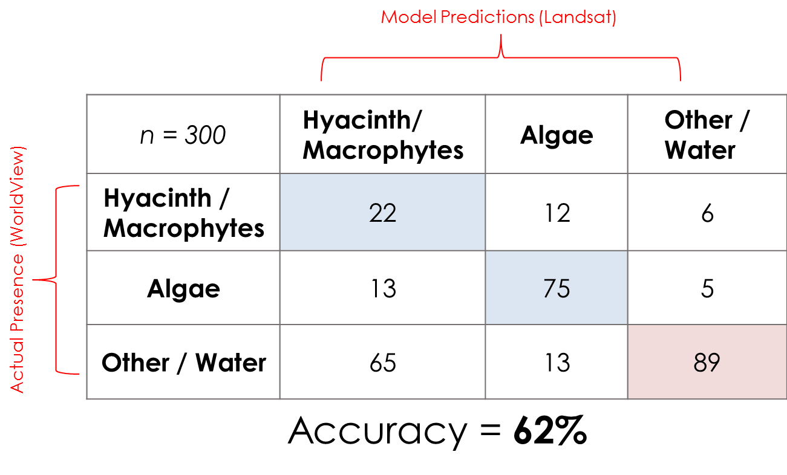

Of the 100 predicted hyacinth presence points, only 22 were predicted correctly. 13 predicted hyacinth points were actually algae, whereas 61 points were actually land and only 4 were water. The high number of misclassified pixels on land is primarily due to the level of detail in the water shapefile used to represent the study area. The water shapefile was generated using Landsat imagery, and several small islands and marginal areas along the coast were included as part of water. Vegetation on islands and areas on the coast have very similar NDVI readings when compared to water hyacinth, and were therefore be included in the classification. 12.5% of the time water hyacinth was confused for algae, or vice versa. This suggests that the NDVI threshold used to distinguish between algae and water hyacinth (NDVI = 0.82) performed relatively well, however, this threshold cannot be depended on as an absolute cutoff point to differentiate between algae and macrophytes as there will always be some overlap. Overall, this can serve as a baseline method for determining the location of both algal blooms and water hyacinth; however, some misclassifications can be expected (Figure 2).

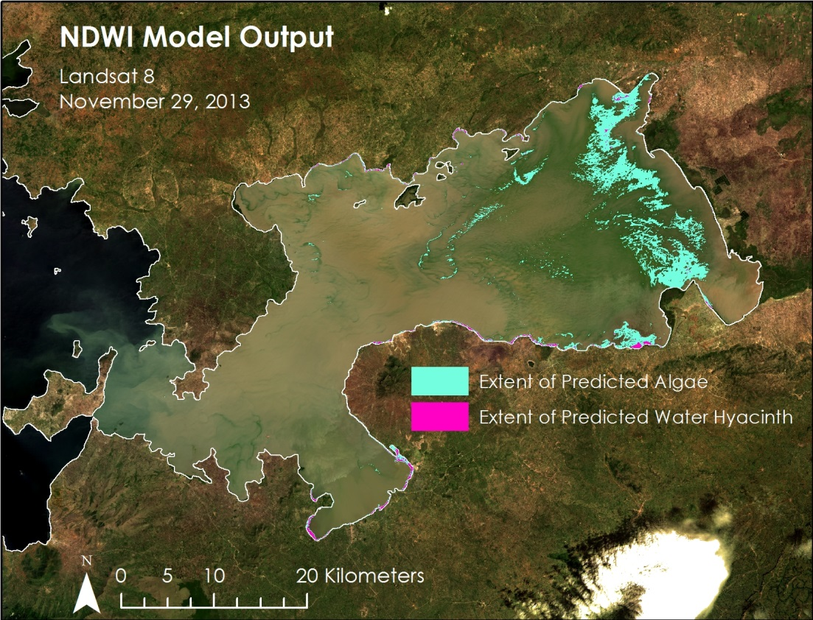

Figure 2: NDWI method predicted extent of algae and water hyacinth/macrophytes over a true color composite Landsat image.

The MNDWI method had an overall accuracy of 87%. Confusion matrix results are summarized in Table 2.

Table 2 : Confusion matrix for the MNDWI model showing predicted hyacinth presence versus actual presence. The blue highlighted box indicates true positives, while the red highlighted box indicates true negatives.

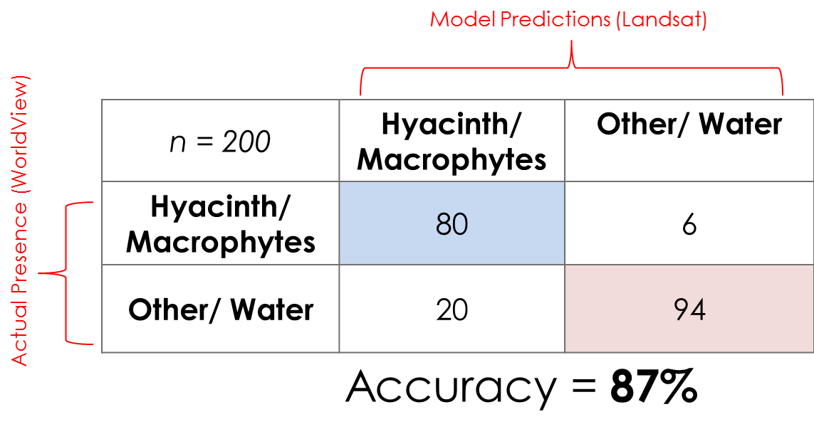

Of the 100 predicted water hyacinth points, 80 were true positives and 20 were false positives. Of the false positives, 5 were actually land while 15 were water. All 15 of these water points were within 30 m of land, suggesting that the NDVI of the Landsat pixels where these points fell were influenced by the presence of land. If a more accurate shapefile were used, and it was assumed that these land errors were eliminated, this method’s accuracy could increase up to 96%. Of the 6 false negatives, all 6 were actually water hyacinth, revealing that small areas of water hyacinth were not fully captured by this method. This method is very promising for detecting the presence and extent of water hyacinth and other dense vegetative growth on the surface of the Winam Gulf. This method is not recommended for detecting algal blooms, as the MNDWI threshold did not extract many algae, if any (Figure 3).

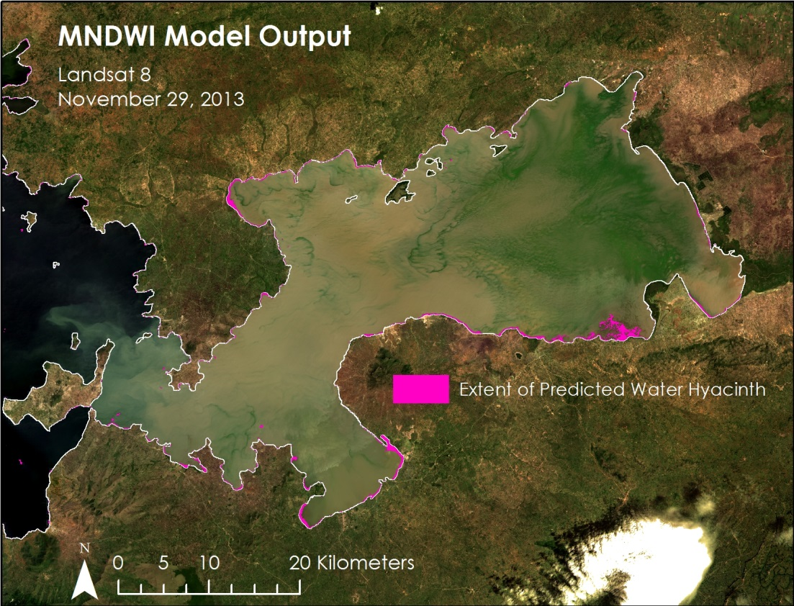

Figure 3: MNDWI model predicted extent of water hyacinth over a true color composite Landsat image.

**Errors & Uncertainty**

During the selected study period, a limited number of Landsat images could be implemented due to cloud cover over the Winam Gulf. Any cloud cover over water could result in misclassification errors, and additional methods will need to be developed to mask out clouds over affected images.

As mentioned previously, a more detailed study area shapefile depicting total water cover would greatly reduce misclassification errors for both methods. Small islands and several areas along the coast were included in the shapefile used for this analysis. Fluctuating water levels of Lake Victoria further complicate attaining an accurate water shapefile.

Water hyacinth is difficult to distinguish from other macrophyte species via Landsat imagery alone. While these methods were developed with the intention of extracting water hyacinth, other native floating aquatic species such as nile cabbage and papyrus may also be detected.

Furthermore, the high resolution WorldView image used for validation only covered 29% of the total study area. Despite this, the WorldView image provided ample data for validation as it covered the majority of the extent of predicted water hyacinth.

**Future Work**

Future work within the scope of this project will include addressing the errors and uncertainties mentioned. More imagery can be included in future analyses if a method is developed to deal with cloud cover. A more detailed study area shapefile derived from higher resolution data should be developed to improve accuracy. A more effective method for distinguishing between algae and other vegetation growth should also be an area of future focus.

As this project is proposed to last 3 terms, future work outside of the scope of this project will include research into additional water quality parameters, differentiation between water hyacinth and other vegetation, and multi-instrumental analysis for continuous monitoring.

# V. Conclusions

The extent of aquatic vegetation over the Winam Gulf was derived using two methods, NDWI and MNDWI, which were both useful, in different aspects. The NWDI method pulled out both algae and macrophytes that were present on the surface of the lake water. However, the MNDWI method was more beneficial to the study due to the model pulling out surface vegetation only. In addition, the MNDWI method achieved a higher accuracy in the confusion matrix than the NDWI method.

# VI. Acknowledgments

The Lake Victoria Water Resources team would like to thank the mentors and partners who provided their time and support to make this project possible:

Mentors/Advisors

● Dr. Jeffrey Luvall, NASA at NSSTC

● Dr. Robert Griffin, the University of Alabama in Huntsville

● Africa Flores, NASA-SERVIR Eastern and Southern Africa

Partners

● James Wanjohi Nyaga, NASA-SERVIR Eastern and Southern Africa

● Dr. Robinson Mugo, RCMRD

Other

● Leigh Sinclair, NASA DEVELOP

● Timothy Klug, the University of Alabama in Huntsville

Any opinions, findings, and conclusions or recommendations expressed in this material are those of the author(s) and do not necessarily reflect the views of the National Aeronautics and Space Administration.

This material is based upon work supported by NASA through contract NNL11AA00B and cooperative agreement NNX14AB60A.

# VII. References

Barrett S. C. H. (1980) Sexual Reproduction in Eichhornia crassispes (Water Hyacinth). I. Fertility of Clones from Diverse Regions. *Journal of Applied Ecology*, Vol. 17, No. 1, 101 – 112. Web.

Cho et al. (2008) Test of Multi-spectral Vegetation Index for Floating and Canopy-forming Submerged Vegetation. *International Journal of Environmental Research and Public Health*, Vol. 5, No. 5, 477-83. Web.

Hute et al. (2002) Overview of the radiometric and biophysical performance of the MODIS vegetation indices. *Remote Sensing of the Environment,* Vol. 83, 195 – 213. Web.

Kayombo S. and Jorgensen S. E. “Lake Victoria: experience and lessons learned brief” *International Lake Environment Committee, Lake Basin Management Initiative.* February 27, 2006, Kusatu, Japan. Web.

Kiage, Lawrence M., and Joyce Obuoyo (2011) “The Potential Link Between El Nino and Water Hyacinth Blooms in Winam Gulf of Lake Victoria, East Africa: Evidence from Satellite Imagery.” *Water Resources Management,* Vol. 25 , No.14, 3931–45. Web.

Kolding et al. (2008) “Are the Lake Victoria fisheries threatened by exploitation or eutrophication? Towards an ecosystem-based approach to management.” *The ecosystem approach to fisheries*, 309 – 350. Print.

Nkalubo, Winnie, Chapman, and Fredrick Muyodi (2014) Feeding Ecology of the Intensively Fished Nile Perch, Lates Niloticus, in Lake Victoria, Uganda. *Aquatic Ecosystem Health & Management,* Vol.17, No.1, 62–69. Web.

Odada, E., Daniel O. Olago, and W. Ochola. “Environment for Development: An ecosystems assessment of lake Victoria basin environmental and socio-economic status, trends and human vulnerabilities” *United Nations Environment Programme (UNEP) and Pan African START Secretariat (PASS).* 2006, Nairobi, Kenya. Web.

“Landsat Surface Reflectance High Level Data Products” *USGS*. USGS, 5 October 2015. Web.

Xu (2006) Modification of Normalized Difference Water Index (NDWI) to Enhance Open Water Features in Remotely Sensed Imagery. *International Journal of Remote Sensing.* Vol. 27, No. 14, 3025 – 33. Web.

# VIII. Content Innovation

VPS

File Name: 2015Fall_MSFC_LakeVictoriaWaterResources_VPS

Interactive Map

File Name: 2015Fall_MSFC_LakeVictoriaWaterResources_InteractiveMap

AudioSlides

File Name: 2015Fall_MSFC_LakeVictoriaWaterResources_AudioSlides

# IV. Appendices

Appendix A.

Table 4: Scene ID's and dates of Landsat imagery processed and included in final map packages.

|  |  |  |  |  |  |  |
| --- | --- | --- | --- | --- | --- | --- |
| **2000** | **Landsat Scene** | **Date** |  | **2008** | **Landsat Scene** | **Date** |
|  | LE71700602000066 | 6-Mar |  |  | LE71700602008008 | 8-Jan |
|  | LE71700602000098 | 7-Apr |  |  | LE71700602008248 | 4-Sep |
|  | LE71700602000338 | 3-Dec |  |  | LT51700602008272 | 28-Sep |
| **2001** | **Landsat Scene** | **Date** |  | **2009** | **Landsat Scene** | **Date** |
|  | LE71700602001036 | 5-Feb |  |  | LE71700602009042 | 11-Feb |
|  | LE71700602001100 | 10-Apr |  |  | LT51700602009162 | 11-Jun |
|  | LE71700602001132 | 12-May |  |  | LT51700602009178 | 27-Jun |
|  | LE71700602001228 | 16-Aug |  |  | LT51700602009194 | 13-Jul |
| **2002** | **Landsat Scene** | **Date** |  | **2010** | **Landsat Scene** | **Date** |
|  | LE71700602002039 | 8-Feb |  |  | LE71700602010029 | 29-Jan |
|  | LE71700602002087 | 28-Mar |  |  | LE71700602010141 | 21-May |
|  | LE71700602002247 | 4-Sep |  |  | LE71700602010349 | 15-Dec |
|  | LE71700602002279 | 6-Oct |  |  | LT51700602010357 | 23-Dec |
|  | LE71700602002343 | 9-Dec |  | **2011** | **Landsat Scene** | **Date** |
| **2003** | **Landsat Scene** | **Date** |  |  | LE71700602011304 | 31-Oct |
|  | LE71700602003074 | 15-Mar |  |  | LT51700602011184 | 3-Jul |
|  | LE71700602003138 | 18-May |  |  | LT51700602011200 | 19-Jul |
|  | LE71700602003330 | 26-Nov |  |  | LT51700602011232 | 20-Aug |
|  | LE71700602003362 | 28-Dec |  |  | LT51700602011264 | 21-Sep |
| **2004** | **Landsat Scene** | **Date** |  |  | LT51700602011296 | 23-Oct |
|  | LE71700602004045 | 14-Feb |  | **2012** | **Landsat Scene** | **Date** |
|  | LE71700602004077 | 17-Mar |  |  | LE71700602012003 | 3-Jan |
|  | LE71700602004109 | 18-Apr |  |  | LE71700602012035 | 4-Feb |
|  | LE71700602004141 | 20-May |  |  | LE71700602012275 | 1-Oct |
|  | LE71700602004157 | 5-Jun |  |  | LE71700602012291 | 17-Oct |
|  | LE71700602004237 | 24-Aug |  | **2013** | **Landsat Scene** | **Date** |
|  | LE71700602004285 | 11-Oct |  |  | LC81700602013109 | 19-Apr |
|  | LE71700602004317 | 12-Nov |  |  | LC81700602013125 | 5-May |
|  | LE71700602004333 | 28-Nov |  |  | LC81700602013141 | 21-May |
|  | LE71700602004349 | 14-Dec |  |  | LE71700602013005 | 5-Jan |
| **2005** | **Landsat Scene** | **Date** |  |  | LE71700602013021 | 21-Jan |
|  | LE71700602005015 | 15-Jan |  |  | LE71700602013133 | 13-May |
|  | LE71700602005047 | 16-Feb |  | **2014** | **Landsat Scene** | **Date** |
|  | LE71700602005111 | 21-Apr |  |  | LC81700602014016 | 16-Jan |
|  | LE71700602005191 | 10-Jul |  |  | LC81700602014080 | 21-Mar |
|  | LE71700602005303 | 30-Oct |  |  | LE71700602014328 | 24-Nov |
|  | LE71700602005351 | 17-Dec |  | **2015** | **Landsat Scene** | **Date** |
| **2006** | **Landsat Scene** | **Date** |  |  | LC81700602015003 | 3-Jan |
|  | LE71700602006002 | 18-Jan |  |  | LC81700602015035 | 4-Feb |
|  | LE71700602006018 | 3-Feb |  |  | LC81700602015131 | 11-May |
|  | LE71700602006034 | 11-Jun |  |  | LC81700602015195 | 14-Jul |
|  | LE71700602006162 | 17-Oct |  |  | LC81700602015275 | 2-Oct |
|  | LE71700602006290 | 2-Nov |  |  | LE71700602015027 | 27-Jan |
|  | LE71700602006306 | 4-Dec |  |  | LE71700602015059 | 28-Feb |
|  | LE71700602006338 | 2-Jan |  |  | LE71700602015075 | 16-Mar |
| **2007** | **Landsat Scene** | **Date** |  |  | LE71700602015187 | 6-Jul |
|  | LE71700602007005 | 5-Jan |  |  |  |  |
|  | LE71700602007053 | 22-Feb |  |  |  |  |
|  | LE71700602007197 | 16-Jul |  |  |  |  |
|  | LE71700602007277 | 4-Oct |  |  |  |  |
|  | LE71700602007357 | 23-Dec |  |  |  |  |