**NASA DEVELOP National Program**



NASA Marshall Space Flight Center

*Fall 2015*

North Mexico Ecological Forecasting

Using NASA Earth Observations to Monitor and Manage Ocelot Habitat Loss in North Mexico

 **Technical Report**

Final Draft – November 19, 2015

Ryan Schick (Project Lead)

Padraic Conner

Maggi Klug

Leigh Sinclair

Dr. Jeffrey Luvall, NASA at the National Space Science Technology Center (Science Advisor)

Dr. Robert Griffin, University of Alabama in Huntsville (Science Advisor)

Previous Contributors:

Daryl Ann Winstead

Kaushik Narasimhan

Christina Fischer

Amberle Keith

# I. Abstract

Ocelots (*Leopardus pardalis*) are medium sized wild cats that have a distribution reaching from Argentina to the southwestern portion of the United States. Although the ocelot is one of the most abundant wild cats throughout most of its range, the population in the United States is less than 100 and is protected under the Endangered Species Act. This ocelot population is separated from the main population by the United States-Mexico border and is facing a loss of habitat due to anthropogenic disturbance. Because of this separation, the U.S. population is now showing signs of inbreeding, which causes health issues and decreases the chance of survival. The U.S. Fish and Wildlife Service, along with other partners, are preparing to translocate ocelots from Mexico to the United States to bolster the gene pool of the U.S. population.  This project aided in this goal by using remotely sensed data to delineate suitable habitat areas and examine where ocelots are most likely to be found in northeastern Mexico. Landsat 5 and 8 were used to create supervised land cover classifications for 1996, 2004, and 2014 to assess temporal changes. Surface reflectance imagery from Terra and Aqua, as well as Suomi NNP, were used to derive a Normalized Difference Vegetation Index (NDVI) to verify land cover classifications. SRTM-v2 data was used to create digital elevation models. The land cover and elevation data, along with presence data and environmental variables, were analyzed by the Princeton Maximum Entropy model and the “Fuzzy Logic” tool to identify suitable ocelot habitat.

**Keywords**

Ocelot, Remote Sensing, Conservation, Mexico, Population, Ecological Forecasting

# II. Introduction

Ocelots (*Leopardus pardalis*) are a medium sized wild cat. They have a range that stretches from Argentina up to the southern tip of eastern Texas. The United States population of ocelots is currently listed as endangered as there is reported to be less than 100 remaining. The primary causes of the decline in ocelot populations are habitat loss and fragmentation (Harveson, et al. 2004). This fragmentation is mainly due to anthropogenic causes, such as increased urbanization, road-kill, and involvement in the illegal fur trade. Furthermore, ocelot populations in the United States are isolated from ocelot populations in Mexico, which has led to inbreeding.  Inbreeding can cause a depressive effect, reducing survival and fertility of offspring due to the accumulation of deleterious recessive genes (Charlesworth and Willis 2009). Introduction of individuals from a healthy population into an inbred population has been shown to be effective at removing detrimental variation and restoring neutral genetic variation. This results in an increase in fitness within the population (Bouzat et al. 2009). Efforts are being made by the U.S. Fish and Wildlife Service in conjunction with partners to translocate ocelots from Mexico in order to increase the genetic diversity of the United States population.

**Project Objectives**

The objectives of this project were to create Habitat Probability Maps, a Habitat Percent Cover Graph, Future Habitat Probability Maps, and Road Risk Maps. The Habitat Percent Cover Graph assessed the past, present, and future extent of the ocelot habitat in Northeastern Mexico, and the Habitat Probability Map showed areas most likely to be inhabited by ocelot populations. The Future Habitat Probability Maps estimated habitat growth or loss, and the Road Risk Maps identified areas of road that intersect probable ocelot habitat. These end products helped project partners with conservation efforts. The project objectives address the ecological forecasting section of NASA’s Applied Science application areas.

**Study Area**

The study area (Figure 1) was in northeastern Mexico, Landsat path and rows 26/42, 26/43, 26/44, 27/42, 27/43, and 27/44. This area consists of dense woody vegetation, low tropical forest, and ebony-grassland communities (Haines, et al. 2005).

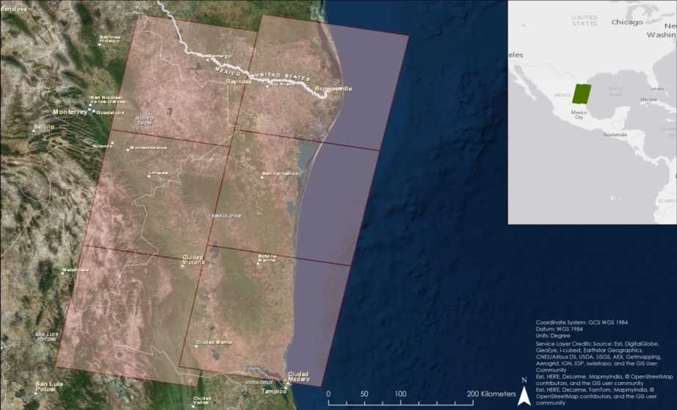

Figure 1: Study Area

**Study Period**

The study period for this project focused on the years 1996, 2004, and 2014. These years were selected to show how urbanization and agricultural areas have grown and/or changed. Data was downloaded during the dry season of the study area. This is so cloud cover would be at a minimum and so the data would show the least amount of vegetation available that would be suitable for an ocelot. Using this data minimized classification errors between growing agriculture and dense vegetation.

**Project Partners**  
Partners for this project were Mr. Ken Kaemmerer and Dr. Josh Gaspard from the Pittsburgh Zoo & Pittsburgh Plate Glass Aquarium, Dr. Michael Tewes from the Caesar Kleberg Wildlife Research Institute at Texas A&M University-Kingsville, Ms. Nanette Bragin from the Denver Zoo, Mr. Mitch Sternberg from the South Texas Refuge Complex, Dr. John Young Jr. from the Texas Department of Transportation, Dr. Arturo Caso and Dr. Arturo Flores-Martinez from the Secretaría de Medio Ambiente y Recusos Naturales (SEMARNAT), and Dr. Tyler Campbell from the East Wildlife Foundation.

Currently, remote sensing is not being utilized by any of the project partners to monitor the decrease of the ocelot habitat. Research on the cat typically consists of using radio collars and traps to track their movement. Other management practices that the partners are using include the occasional collection of aerial imagery, translocating up to four ocelots from Mexico to south Texas each year, restoring native vegetation in the area that is preferred by the ocelots, and planning wildlife crossing structures. These field techniques can be time consuming and costly for researchers. The use of remote sensing is a relatively quick and cost-effective way to collect data that can be useful to the project partners.

# III. Methodology

**Data Acquisition**

Landsat 5 Thematic Mapper (TM) and Landsat 8 Operational Land Imager (OLI) Level 1 data were downloaded from the United States Geological Survey (USGS) EarthExplorer website for December through April in 1996, 2004, and 2014. The resolution of the data were 30m. These data will be used to create land cover classifications.

Digital Elevation Model (DEM) data were downloaded from the USGS Global Visualization Viewer website using Shuttle Radar Topography Mission Version 2 (SRTM-V2) void-filled 90m resolution.

Suomi NPP Visible Infrared Imaging Radiometer Suite (VIIRS) reflectance data were acquired from NASA Land Web. The data were used to derive the Normalized Difference Vegetation Index (NDVI).

Bioclim climatic variables were downloaded from the Worldclim website. Future climate predictions were also downloaded from this site for 2050 and 2070.

**Data Processing**

The “Composite Bands” tool in ArcMap 10.3 was used to create a composite image from the Landsat bands. Near-infrared, red, and green, bands 4, 3, 2 and 5, 4, 3 for Landsat 5 and 8, respectively, were used to create a false infrared image. The composite images were then mosaicked together using the “Mosaic to New Raster” tool to create an image of the entire study area for land cover classification.

After the images were mosaicked together, training samples were collected to create signature files. At least 100 training samples were collected for each of the 7 classes used (Water, Sand, Urban, Grassland/Field/Growing Ag, Fallow/Bare Soil, Scrubland, and Forest). These samples were merged into each respective class and then the signature file was saved. Signature files were created for 1996, 2004, and 2014 to create a land cover classification for each of those years to show change in land cover over the study period.

To generate NDVI using Suomi NPP VIIRS data, near infrared and red bands, bands M7 and M4, respectively, were georeferenced using ENVI Classic. The data were then exported as geoTIFFs for use in the “Raster Calculator” tool in ArcMap 10.3.  The following equation was used: $$NDVI=\frac{NIR - RED}{NIR + RED}$$

 

To calculate distance to stream, the “Fill” tool in ArcMap 10.3 was first used to fill in sinks. Then, flow direction and flow accumulation were calculated. All cells with drainage area of greater than 25km2 were classified as streams. This equals a flow accumulation cell value of 27,778 or greater. Finally, the “Euclidean Distance” tool in ArcMap 10.3 was used to show distance to stream. Slope was calculated by using the “Slope” tool in ArcMap 10.3. Suitable ocelot habitat was pulled out of land classifications by using the “Reclassify” tool to only show areas that are woodland and scrub. To show the distance to suitable ocelot habitat, the “Euclidean Distance” tool was used.

***Habitat Probability Map***

The Princeton University Maximum Entropy Distribution Model (MaxEnt) was used to determine areas most likely to contain ocelots. Distance to streams, elevation, slope, land cover classification, and 19 bioclimatic variables (Table1) were used in the model. All variables were set to have the same projection, extent, and resolution by using the “Extract by Mask” tool in ArcMap 10.3. They were then converted to .asc files for use in MaxEnt. Of the 52 presence locations, we withheld 25% as test data using subsampling method. The test data was randomized for each replicate. Ten replicates were used with maximum iterations set for 1,000. The final output shows a map of a scale from 0 to 1, with values closer to 1 as areas most likely to contain ocelots. This methodology was used for each year in the study period.

Table 1: BioClim Data

|  |  |
| --- | --- |
| Variable title | Variable |
| BIO1 | Annual Mean Temperature |
| BIO2 | Mean Diurnal Range (Mean of monthly (max temp - min temp)) |
| BIO3 | Isothermality (BIO2/ BIO7) (* 100) |
| BIO4 | Temperature Seasonality (standard deviation of weekly mean temp *100) |
| BIO5 | Max Temperature of Warmest Month |
| BIO6 | Min Temperature of Coldest Month |
| BIO7 | Temperature Annual Range (BIO5-BIO6) |
| BIO8 | Mean Temperature of Wettest Quarter |
| BIO9 | Mean Temperature of Driest Quarter |
| BIO10 | Mean Temperature of Warmest Quarter |
| BIO11 | Mean Temperature of Coldest Quarter |
| BIO12 | Annual Precipitation |
| BIO13 | Precipitation of Wettest Month |
| BIO14 | Precipitation of Driest Month |
| BIO15 | Precipitation Seasonality (Coefficient of Variation) |
| BIO16 | Precipitation of Wettest Quarter |
| BIO17 | Precipitation of Driest Quarter |
| BIO18 | Precipitation of Warmest Quarter |
| BIO19 | Precipitation of Coldest Quarter |

The Fuzzy Logic Model in ArcMap 10.3 was also used to determine areas most likely to contain ocelots. Distance to streams, slope, and distance to suitable habitat were used in this model. All variables have the same projection of WGS 1984 UTM 14 N and resolution of 30m. Once variables were projected and in the correct resolution, they were rescaled from 0 to 1 by using the “Fuzzy Membership” tool in ArcMap 10.3 (Table 2). Once all fuzzy memberships were assigned, the “Fuzzy Overlay” was used using the “AND” operation to only show areas where all of these variables meet. The final output shows a map scaled from 0 to 1, with values closer to 1 as areas most likely to contain ocelots. This methodology was done for each year in the study period.

Table 2: Fuzzy Membership values for each variable

|  |  |  |  |
| --- | --- | --- | --- |
| Variable | Membership | Midpoint | Hedge |
| Distance to Stream | Small | 1,430.4433595 | 1 |
| Slope | Small | 9.4751705 | 5 |
| Distance to Suitable Habitat | Small | 45 | 3 (1996)  3 (2004)  2 (2014) |

***Road Risk Map***

The Road Risk Map was created by using the “Intersect” tool in ArcMap 10.3. This tool took values 0.5 or greater from the Habitat Probability Map created by the MaxEnt and intersected it with a road network shapefile.

***Future Projections Map***

The Future Projections Map was created by using the MaxEnt model. These projections used the NASA GISS-E2-R climate prediction model. The representative concentration pathway (RCP) 2.6 and RCP 8.5 models were used. RCP 2.6 represents a model in which global greenhouse gas emissions peak between 2010 and 2020. RCP 8.5 represents a model in which global greenhouse emissions continue to rise through the 21st century.

**Data Analysis**

For both the MaxEnt and Fuzzy Logic model final outputs, values of 0.5 or greater were determined to be areas most likely to contain ocelots. To only show these values, the “Reclassify” tool was used. The area of each Habitat Probability Map was calculated and put in a graph to show how the area of habitat probability has changed from 1996 to 2070.

# IV. Results & Discussion

***Habitat Probability Map***

The variables that consistently contributed the most to the model across all years were bio19, bio13, bio11, bio3, and bio4 (Table 1 and Appendix B), with bio19 being the top contributor each year. These 5 variables contributed more than 50% of the predictive power of the model. All models except for 2014 had an Area Under the Curve (AUC) greater than 0.9 (Appendix B). The 2014 model had an AUC of 0.883 (Appendix B).

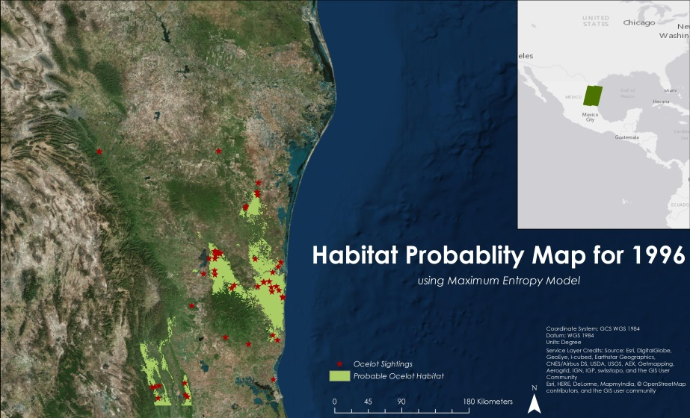

Figure 2: Habitat Probability Map for 1996 using MaxEnt

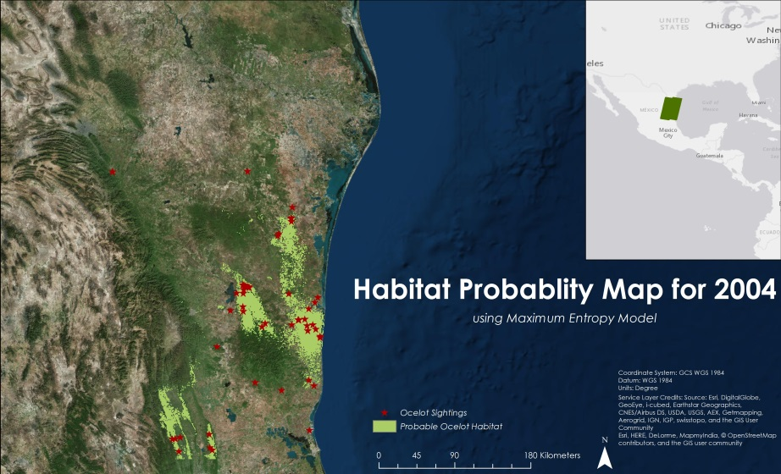

Figure 3: Habitat Probability Map for 2004 using MaxEnt

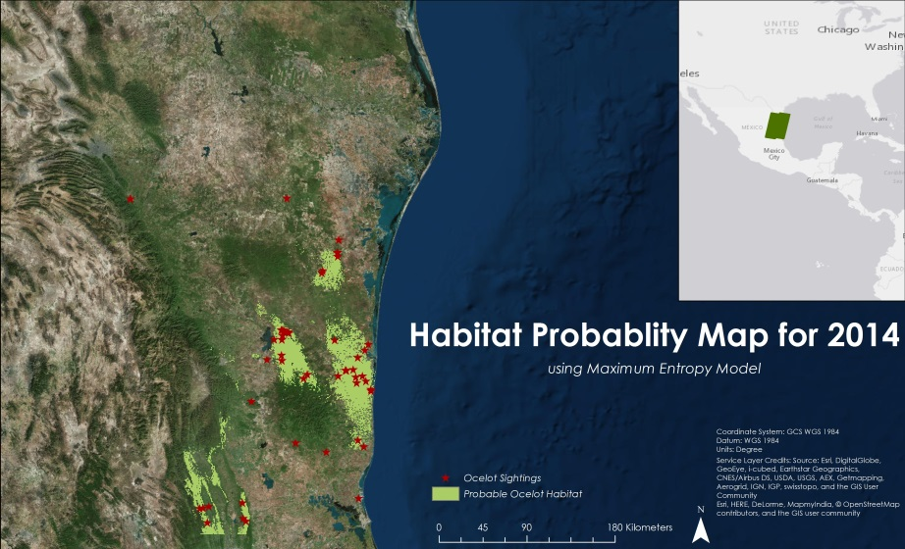

Figure 4: Habitat Probability Map for 2014 using MaxEnt

An Error Matrix was calculated with 1996 (Table 3) and 2014 (Table 5) having accuracy greater than 80%. The 2004 model had an accuracy of 68% (Table 4).

Table 3: Error Matrix results of MaxEnt Habitat Probability Map for 1996

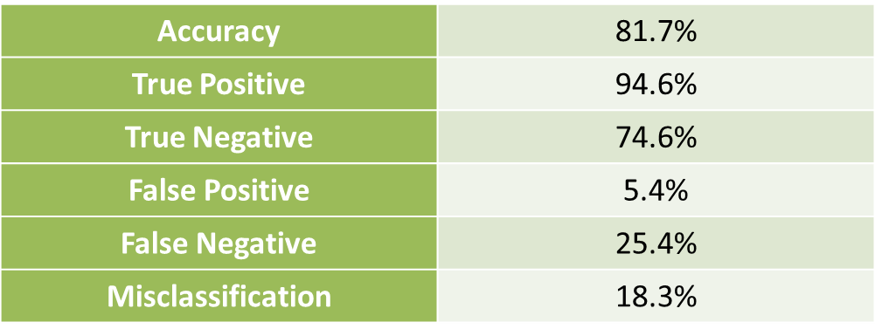

Table 4: Error Matrix results of MaxEnt Habitat Probability Map for 2004

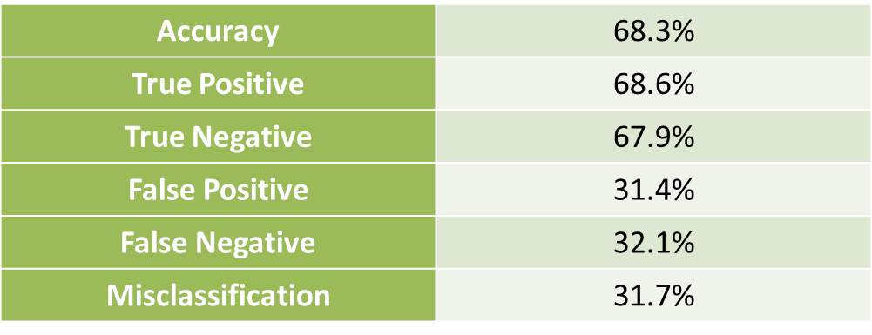

Table 5: Error Matrix results of MaxEnt Habitat Probability Map for 2014

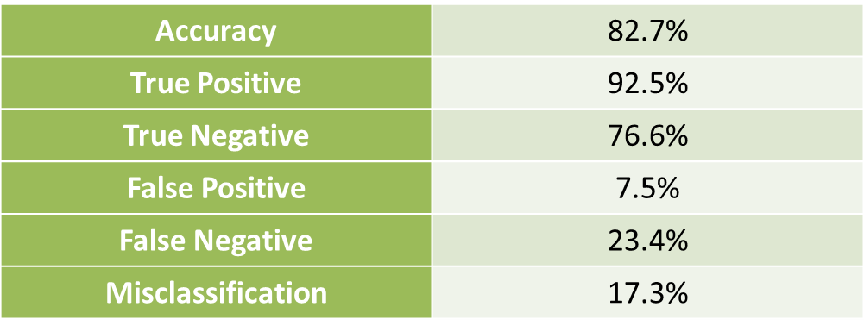

The Habitat Probability Map created by the Fuzzy Logic Model showed suitable habitat throughout northeast Mexico, covering about 60% of the study area (Appendix A). An Error Matrix was performed on each map showing 1996 and 2004 to be over 60% accurate, while 2014 was about 55% accurate (Appendix A).

***Road Risk Map***

The Road Risk Maps (Appendix A) showed an overall decrease in road risk through the study period (Figure 5, 6, and 7). Between the years 1996 and 2004 there was a decrease in 49.1km of road risk, and an 8.9km road risk decrease between 2004 and 2014. Overall, there was a road risk decrease of 58km from 1996 to 2014. There are less roads intersecting ocelot habitat because there was a net decrease in suitable habitat for the study period.



Figure 5: Total length of risk of road mortality in 1996



Figure 6: Total length of risk of road mortality in 2004



Figure 7: Total length of risk of road mortality in 2014

***Future Projections Map***

The Future Projection maps showed great variability, which is to be expected. The RCP 8.5 model showed greater amounts of habitat remaining for ocelots than did the RCP 2.6 model for both 2050 and 2070. Using the 8.5 RCP model, future predictions for 2050 showed an increase in habitat while predictions for 2070 showed a decrease. This appears to be attributable to more precipitation and higher winter temperatures in the study area if greenhouse gases increase throughout the century.

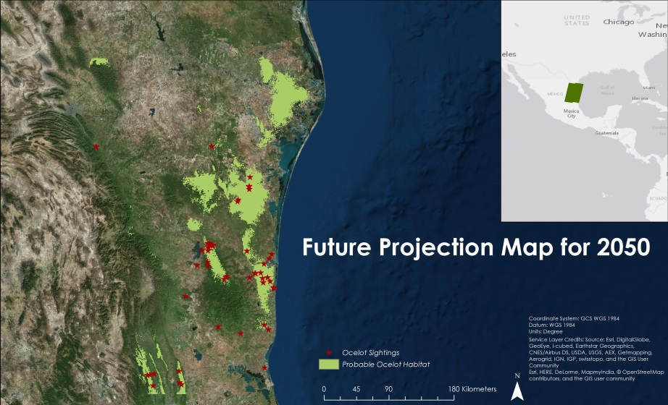

Figure 8: Future Projection Map for 2050 using MaxEnt RCP 8.5

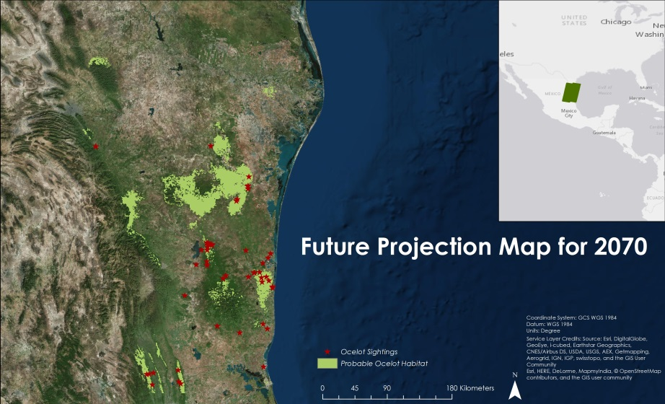

Figure 9: Future Projection Map for 2070 using MaxEnt RCP 8.5

***Habitat Percent Graph***

The MaxEnt results showed that habitat decreased between 1996 and 2014 by over 173 km2 (Figure 10). The ocelot suitable habitat increased dramatically from 2014 to 2050. However, between 2050 and 2070 there was predicted to be a decrease.

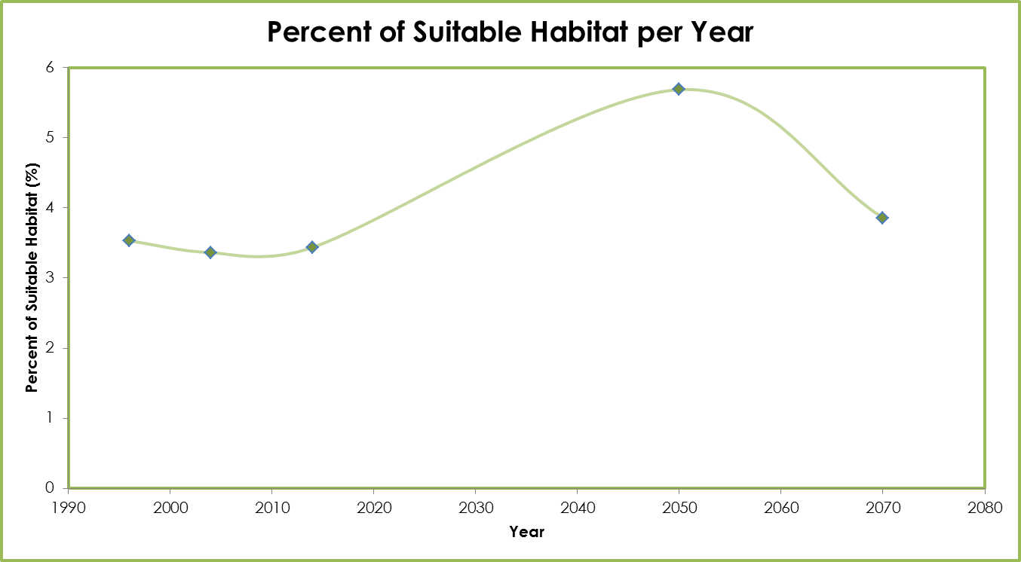

Figure 10: Percent of suitable ocelot habitat per year over the study area from MaxEnt model

The Fuzzy Logic Model results showed that habitat decreased from 1996 to 2004, but increased from 2004 to 2014 with an overall maximum area of suitable habitat in 2014 (Figure 11).

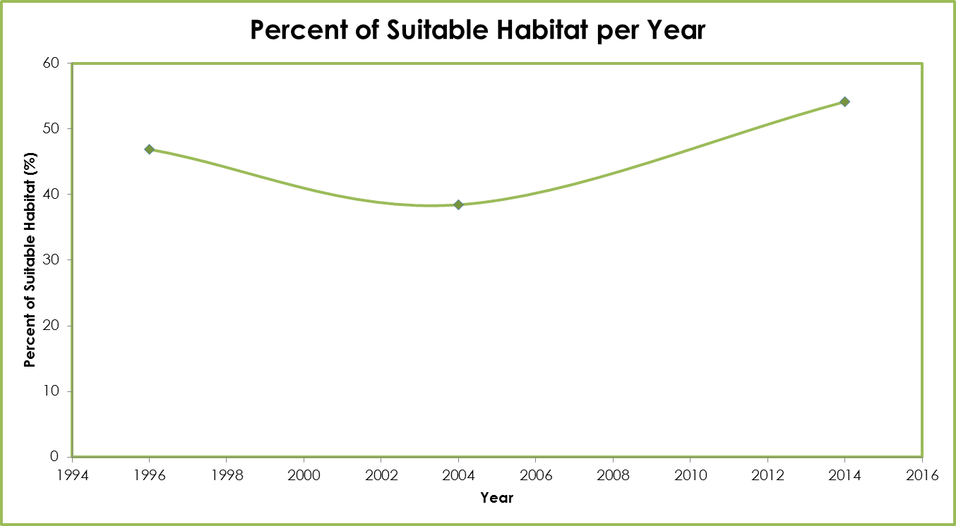

Figure 11: Percent of suitable ocelot habitat per year over the study area from Fuzzy Logic model

**Errors and Uncertainty**

The 2004 Landsat 5 data had random pixels of bad data, which caused some small repeating dashes of erroneous data. Landsat 8 data acquired for 2014 had cloud cover over path/row 27/43 and 27/44, which obscured some of the data and led to potential error in the land cover classification. Landsat 5 data from 1996 for paths 26 and 27 were taken a month apart, in March and April, respectively. Because of this, vegetation in the April images was greener than in the March images, potentially leading to errors.

Habitat projections for 2050 and 2070 did not account for land cover change and urban growth, which would alter the results.

# V. Conclusions

Both the Fuzzy Logic and MaxEnt model showed a decrease in habitat for 1996 to 2004 and a slight increase between 2004 and 2014. The MaxEnt model showed a net decrease of 170 km² between 1996 and 2014.

The MaxEnt model outputs proved to be more accurate than the Fuzzy Logic outputs. The accuracy of the years 1996, 2004, and 2014 for MaxEnt were 81.7%, 68.3%, and 82.7%, while the accuracy for Fuzzy Logic was 62.5%, 65.4%, and 54.8%.

Future projections based on climatic data showed that there is expected to be a net increase of 78,000km² in ocelot habitat up to the year 2070. This is mainly because the precipitation and temperatures for the study area are predicted to rise and, therefore, increase vegetation.

This study shows that ocelot habitat in Mexico has decreased in the past 20 years. With the data from Fuzzy and MaxEnt models, the U.S. Fish and Wildlife service along with project partners are better able to find ocelots. This way they can translocate them to safer areas near other ocelot populations in order to boost the gene pool.

# VI. Acknowledgments

The North Mexico Ecological Forecasting team would like to acknowledge their advisors for their guidance and their project partners also for their guidance, data, and support for this project:

Science Advisors:

* Dr. Jeffrey Luvall, NASA at the National Space Science and Technology Center
* Dr. Robert Griffin, the University of Alabama in Huntsville

Project Partners:

* Pittsburgh Zoo & PPG Aquarium
* Caesar Kleberg Wildlife Research Institute at Texas A&M University-Kingsville
* The Denver Zoo
* South Texas Refuge Complex
* Texas Department of Transportation
* Secretaría de Medio Ambiente y Recusos Naturales (SEMARNAT)
* East Wildlife Foundation

Any opinions, findings, and conclusions or recommendations expressed in this material are those of the author(s) and do not necessarily reflect the views of the National Aeronautics and Space Administration.

This material is based upon work supported by NASA through contract NNL11AA00B and cooperative agreement NNX14AB60A.

# VII. References

Bouzat, J. L., Johnson, J. A., Toepfer, J. E., Simpson, S. A., Esker, T. L., & Westemeier, R. L. (2009). Beyond the beneficial effects of translocations as an effective tool for the genetic restoration of isolated populations. Conservation Genetics, 10(1), 191-201.

Charlesworth, D., & Willis, J. H. (2009). The genetics of inbreeding depression. *Nature Reviews Genetics*, *10*(11), 783-796.

Haines, A. M., M. E. Tewes, L . L. Laack, W. E. Grant, and J. Young. 2005. Evaluating recovery strategies for an ocelot (Leopardus pardalis) population in the United States. Biological Conservation 126:512-522.

Harveson, P.M., M.E. Tewes, G.l. Anderson and L.L. Laack. 2004. Habitat use by ocelots in south Texas: implications for restoration. Wildlife Society Bulletin 32(3): 948-954.

# VIII. Content Innovation

VPS

File Name: 2015Fall_MSFC_NorthMexicoEcologicalForecasting_VPS

Interactive Map

File Name: 2015Fall_MSFC_NorthMexicoEcologicalForecasting_InteractiveMapViewer

AudioSlides

File Name: 2015Fall_MSFC_NorthMexicoEcologicalForecasting_AudioSlides

# IV. Appendices

**Appendix A**

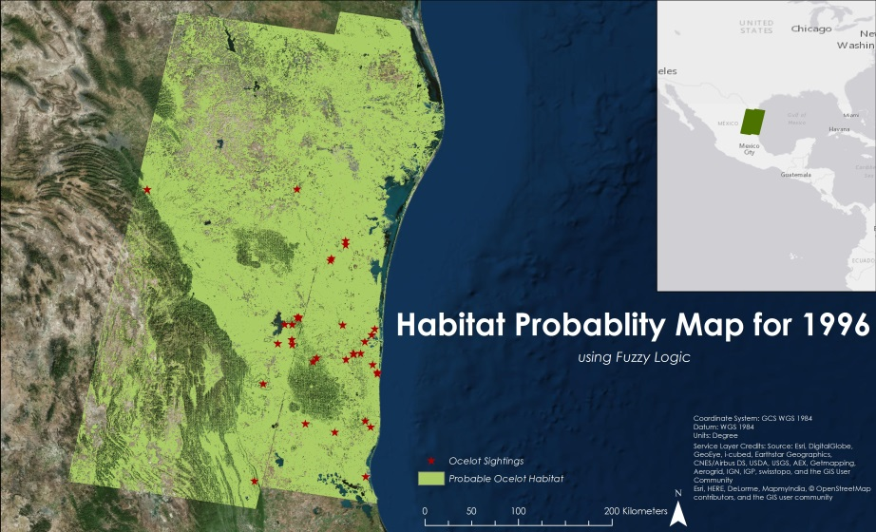

Figure 12: Habitat Probability Map for 1996 using Fuzzy Logic Model

Table 6: Error Matrix results of Fuzzy Logic Model Habitat Probability Map for 1996

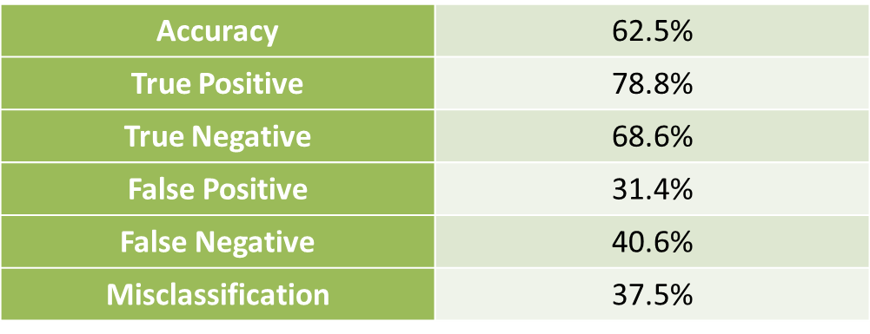

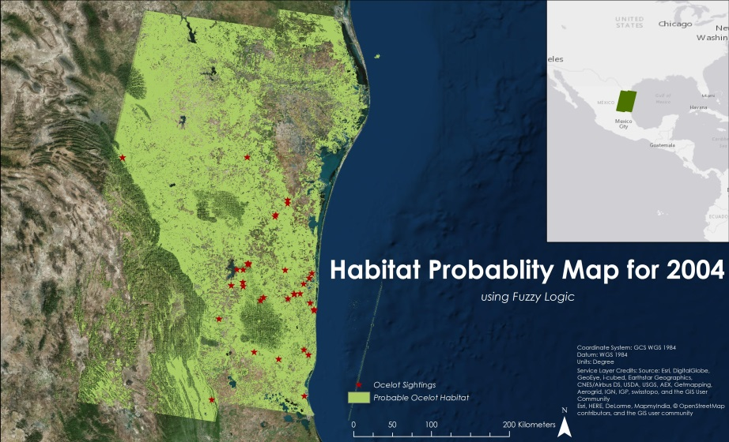

Figure 13: Habitat Probability Map for 2004 using Fuzzy Logic Model

Table 7: Error Matrix results of Fuzzy Logic Model Habitat Probability Map for 2004

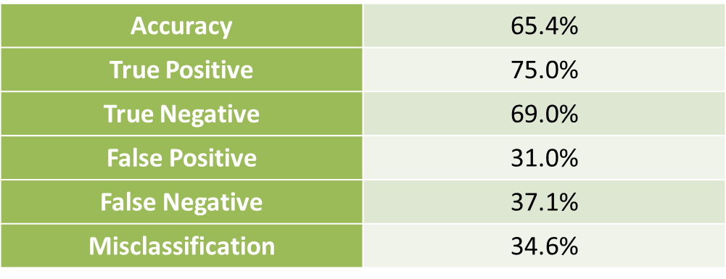

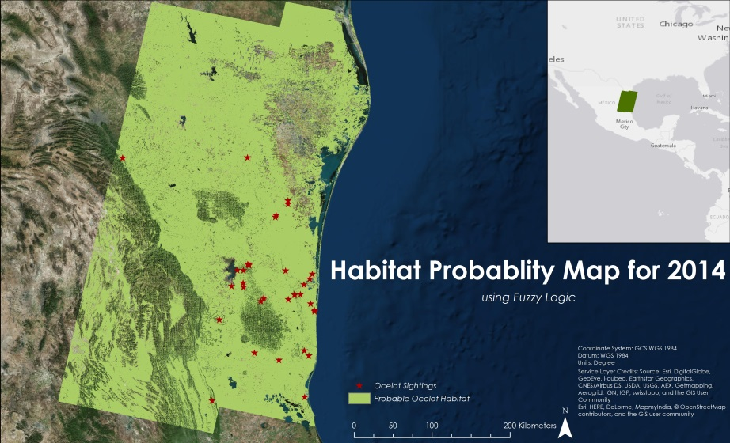

Figure 14: Habitat Probability Map for 2014 using Fuzzy Logic Model

Table 8: Error Matrix results of Fuzzy Logic Model Habitat Probability Map for 2014

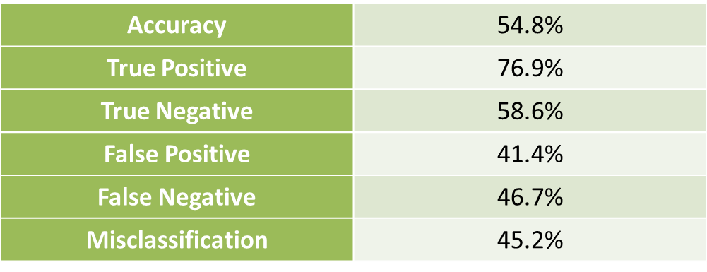

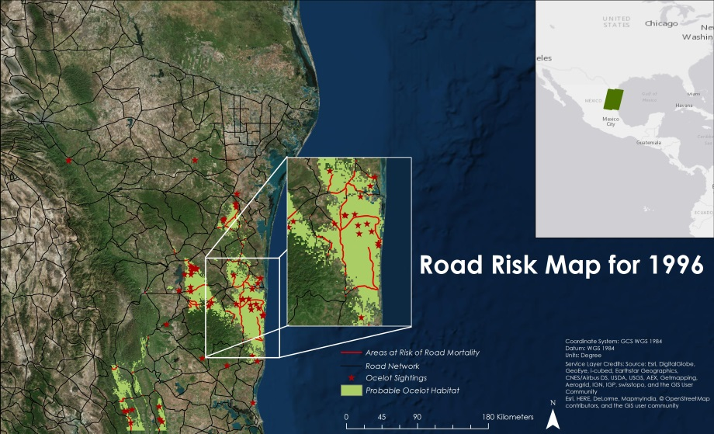

Figure 15: Areas at risk of road mortalities for 1996

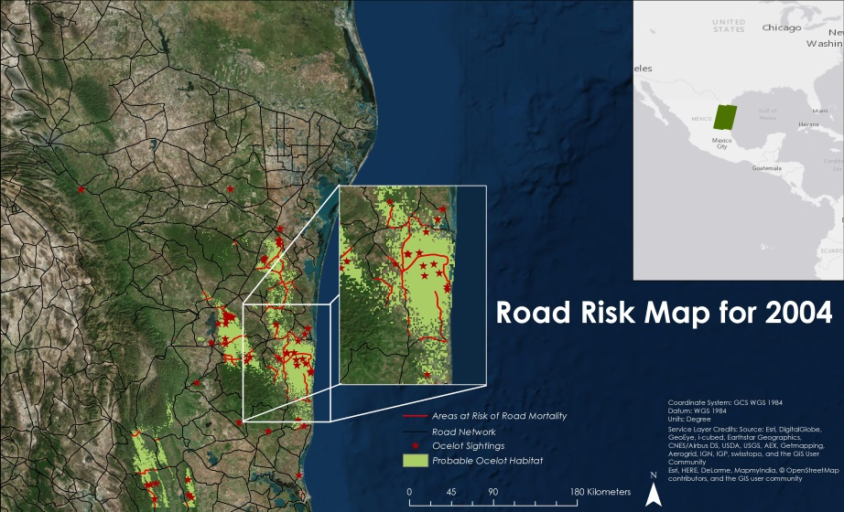

Figure 16: Areas at risk of road mortalities for 2004

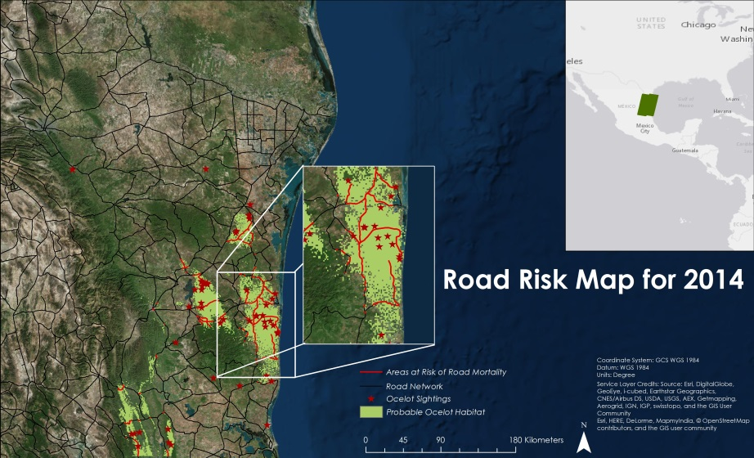

Figure 17: Areas at risk of road mortalities for 2014

Table 9: Percent of suitable ocelot habitat throughout the study area using the MaxEnt model

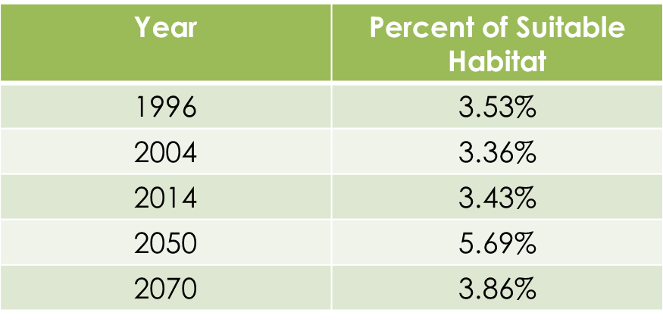

Table 10: Percent of suitable ocelot habitat throughout the study area using the Fuzzy Logic Model

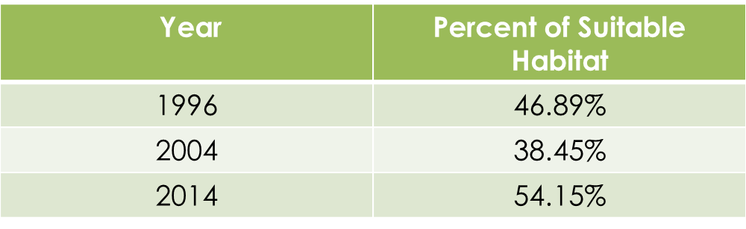

**Appendix B**

Table 11: Percent contribution and permutation importance of variables for the MaxEnt model for the year 2004

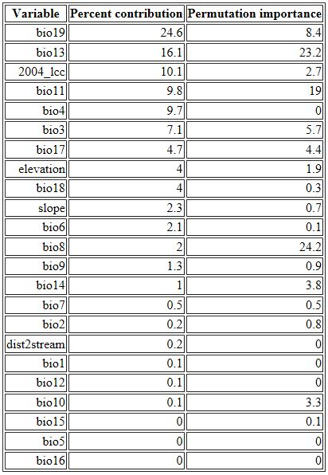

Table 12: Percent contribution and permutation importance of variables for MaxEnt model for the year 2014

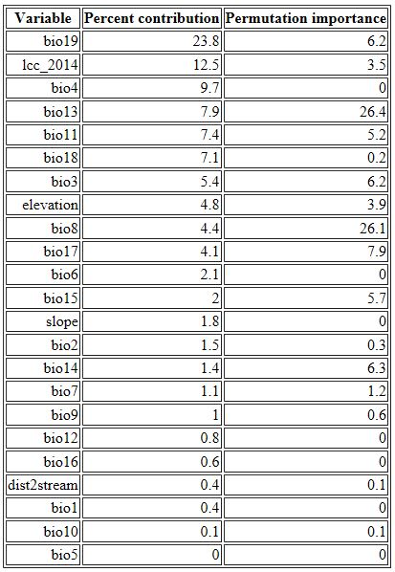

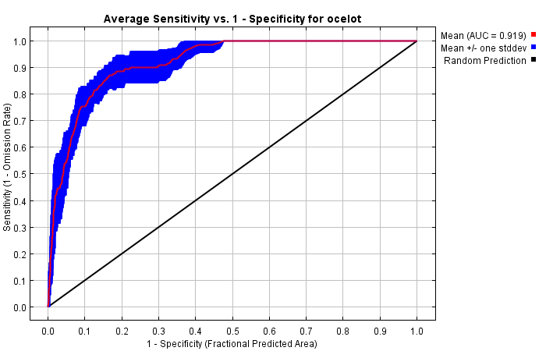

Figure 18: Area under the curve graph for MaxEnt model for 1996

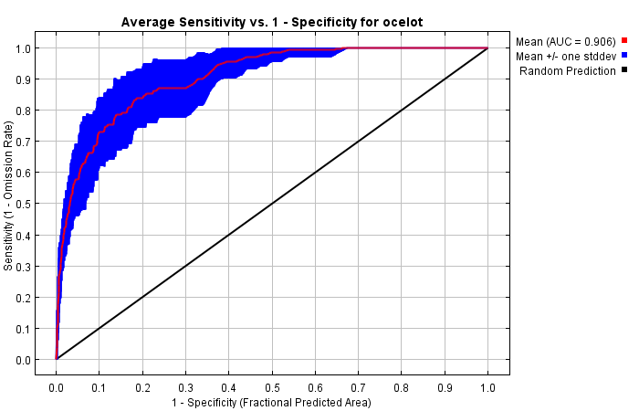

Figure 19: Area under the curve graph for MaxEnt model for 2004

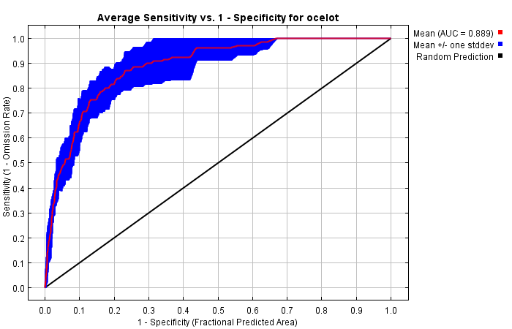

Figure 20: Area under the curve for MaxEnt model for 2014