**NASA DEVELOP National Program**



University of Georgia

*Spring 2016*

Atlanta Water Resources

Identifying Key Urban Areas to Reduce Stormwater Runoff in Metropolitan Atlanta

 **Technical Report**

Rough Draft – Feb 18, 2016

Christopher Cameron (Project Lead)

Beatriz Avila

Veronica Fay

Jason Reynolds

Alex Smith

Jacob Spaulding

Wenjing Xu

Dr. Rosanna Rivero, University of Georgia (Science Advisor)

Dr. Marguerite Madden (Science Advisor)

# I. Abstract

[Placeholder - do not put anything here until the final draft submission. The abstract in the project summary is where the working draft of the abstract should “live”]

**Keywords**

LUCIS, SWAT, Green Infrastructure, Reforestation, Landsat 8, ASTER

# II. Introduction

**Background**

Growing populations and rapid development within major cities, such as Atlanta, Georgia, raise questions about local water quality due to the negative environmental impacts associated with increased runoff and impervious surface cover. Additionally, the difficulty of municipal water management in these large, urban landscapes poses a challenge for city officials who work to identify what infrastructure is needed to support local demands for water and assist runoff management efforts. As cities like Atlanta continue to grow, these issues will influence regional demand for water, require additional infrastructure, and cost residents even more in utilities to support municipal water management projects.

An increasing concern within the city of Atlanta is the overall health of the Chattahoochee River watershed and its incoming water quality (Figure 2). Rivers are especially sensitive to runoff inputs and pollution in urban landscapes because of impervious surfaces, such as parking lots and streets. These impervious surfaces produce a large volume of surface runoff, increasing the risk of contaminants flowing into local waterways. This is a primary concern for the city of Atlanta since surface water provides almost all of drinking water and non-point source pollution is an issue within the Chattahoochee River watershed (Georgia Institute of Technology, 2014).

The development of green infrastructure has proven to be a resourceful and cost-effective tool to address water quality and runoff management issues in city landscapes (Tzoulas et. al., 2007). Green infrastructure refers to a network of open space, forests, wildlife habitat, parks and other natural areas within urban and suburban areas, which help sustain clean air, water, and other natural resources (McMahon, 2000). These green spaces also have a large benefit in enriching the quality of life for local residents by providing recreational use and aesthetic beauty (McMahon, 2000). Green infrastructure has been shown to benefit watershed health by decreasing the effects of pollution into waterways (Livesly et. al., 2011). Specifically, urban forests were found to decrease stormwater runoff by allowing water to infiltrate and the soil to absorb particles and contaminants before entering the surface water.

In conjunction with The Nature Conservancy’s on-going work, this project looks at the potential for areas within the Atlanta metropolitan region to support green infrastructure development via reforestation efforts. Previous DEVELOP projects, such as the Miami-Dade Ecological Forecasting Team, used land cover suitability models to analyze potential areas for green infrastructure development. By promoting green infrastructure with conservation and strategic reforestation, the goal of this project is to help reduce nutrient-laden overland flow and sediment inputs into the regional watersheds.

**Project Objectives**

The goal of this project is to assist The Nature Conservancy in identifying locations within metropolitan Atlanta to focus reforestation of degraded areas and forested land protection efforts, which will reduce sediment and nutrient-laden stormwater runoff in the Chattahoochee River watershed. This was accomplished by integrating 2015 Landsat 8 Operational Land Imager (OLI) imagery and Terra Advanced Spaceborne Thermal Emission and Reflection Radiometer (ASTER) elevation data into the Land Use Conflict Identification Strategy (LUCIS) model and the Soil and Water Assessment Tool (SWAT) to produce a comprehensive examination of current land use and watershed characteristics within the greater Atlanta region.

**Study Area and Period**

The study area for this project was the Metropolitan North Georgia Water Planning District (MNGWPD) which is comprised of the following 15 counties: Bartow, Cherokee, Clayton, Cobb, Coweta, Dekalb, Douglas, Fayette, Forsyth, Fulton, Gwinnett, Hall, Henry, Paulding, and Rockdale (Figure 1). This area contains what is also referred to as the greater Atlanta region, with a population of over 5.2 million people, and is the ninth largest city in America, according to the 2010 US Census (US. Census Bureau, 2010). The MNGWPD intersects 9 regional watersheds including the Chattahoochee, Ocmulgee, Oconee, Flint, Etowah, Tallapoosa, Coosawattee, and Oostanaula rivers (Figure 2). This project examined datasets from 2001 to 2015 to obtain sufficient criteria relating to land cover changes, climate, and urban development for the LUCIS and SWAT models.

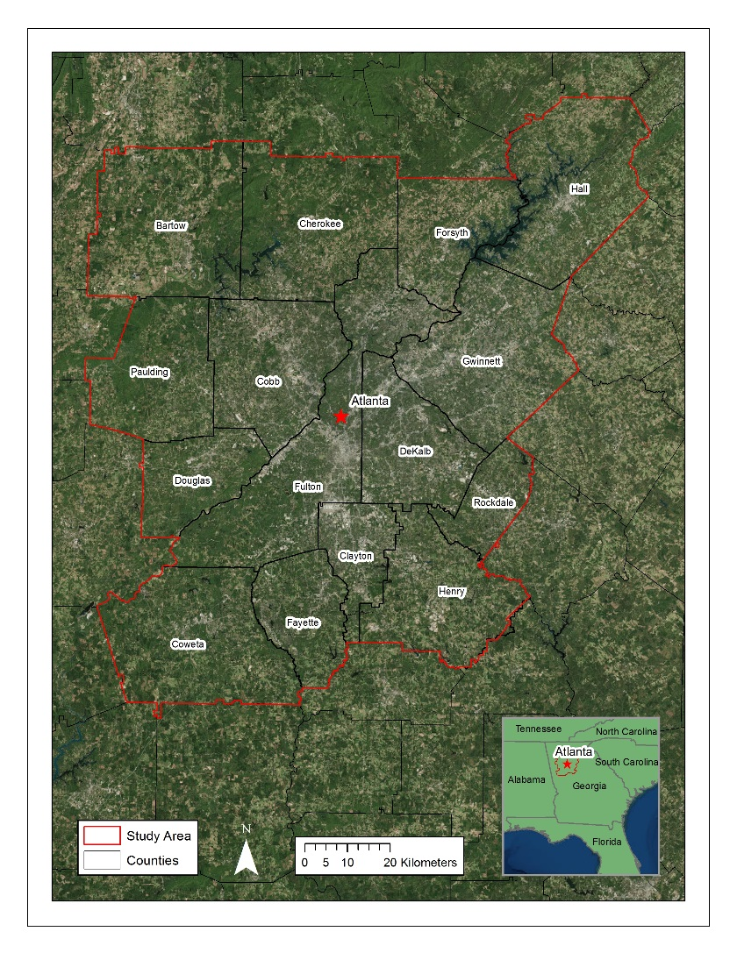

Figure 1: Study area map.

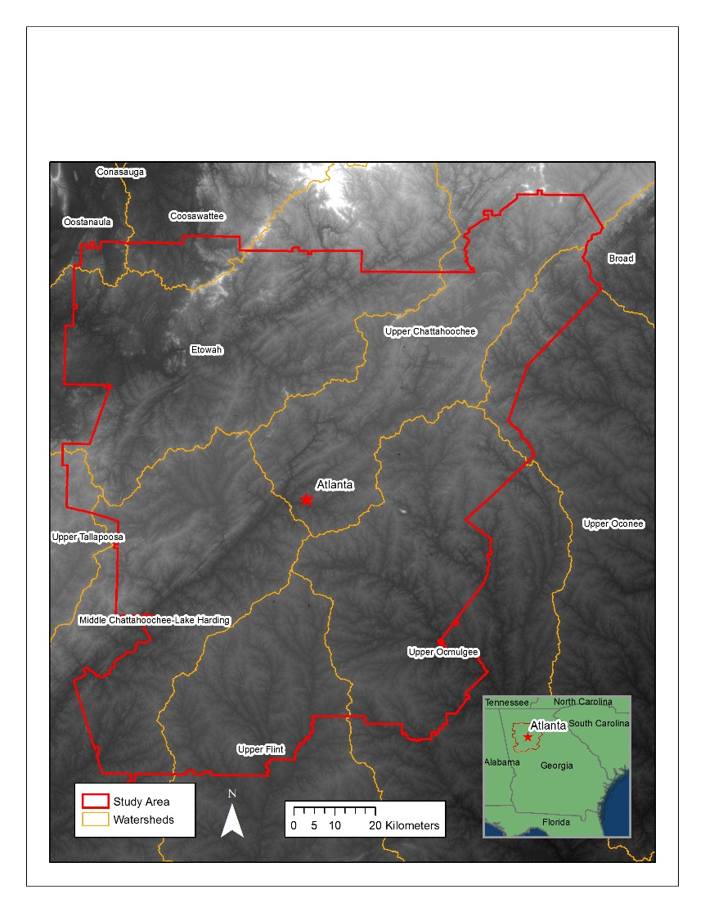

Figure 2: Major watersheds within the Atlanta Water Resources project study area.

**National Applications Addressed**

This study addressed the NASA Applied Sciences Water Resources National Application Area by incorporating both Landsat 8 OLI and Terra ASTER data into watershed-scale characterizations of land cover and water quality across the MNGWPD. This was accomplished using the SWAT and LUCIS models to identify areas associated with high stormwater runoff potential. Additionally, this study addressed the Ecological Forecasting Application Area by using the LUCIS model to identify potential reforestation and conservation zones within the MNGWPD to assist The Nature Conservancy’s efforts in local conservation activities.

**Project Partners**

Project partners at The Nature Conservancy have been engaged in on-going work with local policy makers to promote reforestation and green infrastructure efforts in the Atlanta region as a means to reduce the flow of nutrient and sediment-laden runoff into local rivers. Currently, their work is focused on 3 primary goals: (1) implementing equitably distributed reforestation projects that increase tree cover to strategically capture and filter stormwater in areas that provide benefits to local biodiversity and increase community resilience, (2) influencing local planning approaches so that they benefit conservation and socio-economic development, and (3) encouraging productive public dialogue and engagement in conservation in cities with an emphasis on underserved communities so that people become more aware of how their actions can have a positive impact on green spaces and local watersheds, as well as fosters support for participation in conservation actions. This work is part of a broader, nation-wide initiative to promote conservation practices in large cities.

The Nature Conservancy will use the results of this project to inform their work in Atlanta by identifying conservation targets based on a spatially-weighted analysis incorporating multiple factors. This project will be used as a means for The Nature Conservancy to identify critical, geographic relationships concerning the future expansion of green infrastructure and stormwater management in Atlanta. They will also use the results of this work as means to continue reforestation discussions with local policy makers and organizations such as Trees Atlanta and the Atlanta Regional Commission.

# III. Methodology

**Data Acquisition**

Landsat 8 OLI provided 2015 imagery for current land use classification to use in both the SWAT and LUCIS models. Additionally, Terra ASTER 10 m and 30 m resolution Digital Elevation Models (DEMs) provided the elevation data used in these models. Both of these datasets were obtained through the United States Geologic Survey (USGS) EarthExplorer data download platform. Landsat OLI coverage for the MNGWPD corresponded to two scenes in path-rows 19-36 and 19-37. A total of 6 ASTER DEMs were downloaded to provide complete elevation data for the MNGWPD.

Ancillary datasets used in the LUCIS and SWAT models were primarily provided by The Nature Conservancy. These included water bodies, rivers, urban developments, water quality, soils, and land cover datasets. All data provided by The Nature Conservancy was fit to the project study region(Appendix A).

**Data Processing**

Landsat OLI imagery was mosaicked and atmospherically corrected in ENVI 5.3 using its Quick Atmospheric Correction (QuAC) algorithm. The resulting image was then used for a supervised 2015 land cover classification following discussions of an appropriate classification scheme with The Nature Conservancy. The ASTER DEMS were also mosaicked to produce one, continuous data layer for the MNGWPD.

All non-raster ancillary data were rasterized for later use in the LUCIS model. This process included generating intermediate data layers, such as distance rasters, for spatial analysis. These raster data layers were created individually based on ranking criteria and objectives defined within the LUCIS model. Throughout the processing stage, datasets were organized and divided based on the goals and objectives defined in the LUCIS criteria matrix (Appendix B).

**Data Analysis**

A supervised land cover classification of the 2015 Landsat imagery was performed in ENVI. The resulting land cover map provided the most recent land use patterns for the MNGWPD. This data was incorporated into both the LUCIS and SWAT model methodologies as a current land cover data layer. Classification was first done to identify 6 broad classes: urban, forest, agriculture, open water, wetlands, and bare land. These land cover classes were then divided into respective subgroups for each LUCIS objective.

The primary method used in this project included the LUCIS model. All ancillary and project-generated datasets were utilized in LUCIS based on goals and objectives corresponding to 3 primary land use types: urban, agriculture, and conservation. These three categories correspond to the major land use allocations reflecting conflicting interests in the study area. Each of the three LUCIS land use categories had an independent set of goals and objectives relating to water quality and reforestation (Appendix B). These goals and objectives were used to develop suitability criteria for each land use group and, ultimately, a suitability data layer. The resulting suitability data layers were weighted based on input from The Nature Conservancy to produce a series of maps illustrating potential conflict or multiple land use zones for reforestation interests.

The SWAT model was used in this project to assess the impact of different land management practices as well as quantify the hydrological processes of the MNGWPD watersheds. The 10 m ASTER DEMs, gridded soil survey (gSSURGO) data, 2015 Landsat 8-based land cover classification, and climate data from the Climate Forecast System Reanalysis (CFSR) for 2001-2014 were used satisfy the data inputs for the SWAT model.

The SWAT output was calibrated using USGS stream-gage discharge data following the Calibration and Uncertainty Programs (SWAT-CUP) methodology.

# IV. Results & Discussion

Coming soon!

# V. Conclusions

Coming soon!

# VI. Acknowledgments

Our team would like to thank our science advisors, Drs. Rosanna Rivero and Marguerite Madden at UGA. Additionally, we would like to thank our partners at The Nature Conservancy, Sara Gottlieb and Myriam Dormer, for their involvement with the project and communication throughout the term.

Any opinions, findings, and conclusions or recommendations expressed in this material are those of the author(s) and do not necessarily reflect the views of the National Aeronautics and Space Administration.

This material is based upon work supported by NASA through contract NNL11AA00B and cooperative agreement NNX14AB60A.

# VII. References

Georgia Institute of Technology, Assessing Urban Tree Canopy In The City Of Atlanta; A Baseline Canopy Study. Atlanta: Georgia Institute of Technology, 2014.

Livesley, S.J., McPherson, G.M., and Calfapietra, C. (2016). The Urban Forest and Ecosystem Services: Impacts on Urban Water, Heat, and Pollution Cycles at the Tree, Street, and City Scale. Journal of Environmental Quality, 45.

McMahon, E.T. (2000). Green Infrastructure. Planning Commissioners Journal, 37.

Tzoulas, K., Korpela, K., Venn, S., Yli-Pelkonen, V., Kaźmierczak, A., Niemela, J., & James, P. (2007). Promoting ecosystem and human health in urban areas using Green Infrastructure: A literature review. Landscape and urban planning, 81.

# VIII. Content Innovation

2 required; 3 for microjournal consideration

# IV. Appendices

Appendix A: Ancillary Data

|  |  |
| --- | --- |
| **Dataset** | **Source** |
| LandPro2009 | Atlanta Regional Commission |
| LandPro2010 | Atlanta Regional Commission |
| Protected Areas of Georgia | Conservation Biology Institute |
| City of Atlanta Streams | Atlanta Regional Commission |
| City of Atlanta Watersheds | Atlanta Regional Commission |
| Lakes, Ponds, Reservoirs, and Swamps Atlanta Region | Atlanta Regional Commission |
| SE Aquatic Connectivity Assessment Project | The Nature Conservancy |
| National Hydrography Dataset Plus V2.1 | US EPA |
| Water Quality in Georgia | GA EPD |
| Gridded Soil Survey (gSSURGO) | USDA |
| Developments of Regional Impact | Atlanta Regional Commission |
| Toxic Release Inventory | US EPA |
| SLEUTH Projected Urban Growth | NC State University and USGS |

Appendix B: LUCIS Criteria Matrix

*Urban*

|  |  |  |  |  |  |
| --- | --- | --- | --- | --- | --- |
| **Goal** | **Objective/Criteria** | **Weight** | **Method** | **Data** | **Source** |
| Minimize Untreated Stormwater Flow into Chattahoochee from Impervious Surface | Identify location of stormwater retention ponds and outfalls (into the river) |  | Calculate retention pond density and outfall density | NPDES; point file of any additional Waste Treatment plant not listed on the NPDES; Stormwater overflows; Retention Ponds; Watershed Boundaries (HUC) | EPA; ARC; USGS |
| Identify Location of Brownfields, Abandoned Construction sites and open bare land |  | Suitability ranking of parcels as potential construction/future expansion sites. Higher weights will be assigned to large, open areas. | Landsat 8-based supervised land cover classification, 2015 | Atlanta Water Resources Team Spring 2016 |
| Identify areas or locations of greater preference or suitability for construction (property zone values) |  | Weighted overlay of the associated subcriteria. | Property zone values; Floodplain zones; Streams |  |

*Agriculture*

|  |  |  |  |  |  |
| --- | --- | --- | --- | --- | --- |
| **Goal** | **Objective/Criteria** | **Weight** | **Method** | **Data** | **Source** |
| Identify agricultural lands with a high potential to impact local water quality and stormwater runoff | Identify regions that are in close proximity to streams/waterways |  | Distance analysis to measure proximity between agricultural land and waterways. Reclassification according to ranking system. | Streams; ASTER DEM | NASA |
| Identify regions with high topographic gradient |  | Slope analysis of elevation data | ASTER DEM | NASA |
| Identify areas with soils with lower permeability |  | Ranking of mapped soil series based on hydrologic soil group | Gridded Soil Survey (gSSURGO) | USDA |

*Conservation*

|  |  |  |  |  |  |
| --- | --- | --- | --- | --- | --- |
| **Goal** | **Objective/Criteria** | **Weight** | **Method** | **Data** | **Source** |
| Protect existing green infrastructure and identify opportunities to increase/expand green spaces through reforestation in metro Atlanta | Identify existing protected areas/green spaces |  | Rank existing protected areas (of all ownership types) based on GAP ranking score (1-4): 1= most strictly protected and managed, 4= no current protection or management plan in place | Protected Areas of Georgia, 2012 | The Conservation Biology Institute |
| Analyze existing proportions of local vegetation and forests (including proportions, size) |  | Extract forest/vegetation patches from 2015 land cover classification and perform focal statistics on patches | Landsat 8-based supervised land cover classification, 2015 | Atlanta Water Resources Team Spring 2016 |
| Identify associated land cover types for potential reforestation areas |  | Perform majority focal statistics on land cover classes other than forest | Landsat 8-based supervised land cover classification, 2015 | Atlanta Water Resources Team Spring 2016 |
| Prioritize reforestation targets based on: Adjacent land cover change type, proximity to water/river, public vs private ownership, population density of surrounding area, topography, protection status |  | Weighted overlay of the associated subcriteria. | Landsat 8 classification, 2015; 2001 NLCD; Streams; Water bodies of the Atlanta Region; NHD flowlines; Developments of Regional Impact; ASTER DEM; Protected Areas - Georgia, October 2012 | Atlanta Water Resources Team Spring 2016; USGS; Atlanta Regional Commission; US EPA; NASA; The Conservation Biology Institute |