**NASA DEVELOP National Program**

Wise County Clerk of Court’s Office and NASA Langley Research Center

**Fall 2015**

**Short Title: Virginia Water Resources II**

**Subtitle:** Utilizing NASA Earth Observations to Identify Algal Hotspots in the Chesapeake Bay

**VPS Title:** Remote Sensing of Algal Hotspots in the Chesapeake Bay

**Project Team & Partners**

**Project Team:**

Arika Egan (Project Lead), arikaegan@gmail.com

Zachary Tate

Jakub Blach

Jessica Jozwik

Tyler Rhodes

**Advisors & Mentors:**

Dr. Kenton Ross (NASA DEVELOP National Program)

Dr. Bob Vangundy (University of Virginia at Wise)

Dr. DeWayne Cecil (Global Science and Technology Inc.)

Melanie Salyer (NASA DEVELOP Wise)

**Past or Other Contributors:**

Cassandra Morgan

Sara Lubkin

**Partner Organizations:**

Virginia Institute of Marine Science (VIMS) (End-User), POC: Dr. Kim Reece; Boundary Organization

Virginia Department of Environmental Quality (DEQ) (End-User), POC: Anne Schlegal and, Dr. Tish Robertson

Old Dominion University (ODU) - Department of Biological Sciences (Collaborator), POC: Dr. Todd Egerton

Virginia Governor’s Office Deputy Secretary of Natural Resources for the Chesapeake Bay (Collaborator), POC: Russ Baxter

**Project Details**

**Applied Sciences National Application Addressed:** Water Resources

**Study Area:** Virginia (VA) - Lower James River, Lower York River, Elizabeth River, Mobjack Bay,

Chesapeake Bay

**Study Period:** May 2011 - October 2015

**Earth Observations & Parameters:**

Aqua, MODIS – Daily Chlorophyll-*a*

Landsat 8, OLI – Land cover

**Ancillary Datasets Utilized:**

* Virginia Institute of Marine Science – *in-situ* water sample data
* Old Dominion University – *in-situ* water sample data
* National Oceanic and Atmospheric Administration (NOAA) – CoastWatch MODIS Chlorophyll-*a* product

**Models Utilized:**

* Lim, J & Choi, M (2015) - Multiple regression models of spectral reflectance and water quality parameters
* Song et. al. (2011) Retrieval of total suspended matter (TSM) and chlorophyll-*a* (Chl-*a*) concentration from remote-sensing data for drinking water resources

**Software Utilized:**

ArcGIS - Raster manipulation/analysis, image enhancement & mapping of Landsat data

R - Statistical analysis, calculation and testing of chlorophyll estimation formula

**Project Overview**

**Objectives Overview:**

The purpose of this project was to create a Python tool that allows users to determine potential locations of harmful algal blooms (HABs) in the Chesapeake Bay and its estuaries. The tool integrates Landsat 8 and Aqua MODIS data and applies an algorithm, calibrated using historical *in-situ* data collected by the Virginia Institute of Marine Science and Landsat 8 satellite, to create maps highlighting hotspots of algal blooms. With this tool, our partners will be able to detect, test, and respond to HABs quickly and efficiently. They can accurately monitor the timing, magnitude, duration, and frequency of specific HABs locations.

**Abstract:**

Harmful Algal Blooms (HABs) in the Chesapeake Bay Watershed have an increasingly negative effect on the ecosystems in which they grow. They deprive their ecosystem of oxygen, produce harmful toxins, and mechanically damage other organisms. This disrupts the natural water chemistry and causes large-scale fish mortality events. Scientists from the Virginia Institute of Marine Science (VIMS) and Old Dominion University (ODU) monitor HABs and their effect on the water quality; however, the Chesapeake and its estuaries are geographically too large for the groups to continuously monitor HABs. This limits the group’s ability to monitor up-to-date locations of HABs and the water quality associated with them. To remedy this, surface reflectance data from Landsat 8 obtained from the USGS Earth Explorer, data from the Aqua MODIS Chlorophyll imagery collected from NOAA CoastWatch, and *in-situ* data from VIMS and ODU were combined and correlated to create an algorithm that produces a map of algal hotspots in the Chesapeake Bay area. Data were collected from May 2011 through October 2015. This algorithm will allow scientists at VIMS and ODU to identify the location of algal hotspots using current Landsat 8 data, as well as give them the ability to assess the timing, magnitude, duration, and frequency of HABs in the Chesapeake Bay Watershed.

**Community Concerns:**

* HABs degrade water quality by:
  + Reducing sunlight exposure to other organisms
  + Depleting oxygen supply to other organisms
  + Producing toxins that harm water life and humans
* HABs threaten:
  + Fishing industries, as toxins cause illness and death in fish.
  + Tourism industries, as beaches are closed due to unhealthy, smelly water. Murky water becomes unattractive to tourists.
  + Prolonged ecological health, as each bloom produces more toxins and depletes oxygen and sunlight.

**Current Management Practices & Policies**:

Currently, an HAB task force (comprised of the Virginia Institute of Marine Science, the Marine Resources Commission, the Department of Environmental Quality, Old Dominion University, the Virginia Department of Health, and several auxiliary agencies) is responsible for the detection, research, and response to HABs in the Chesapeake Bay area. This task force has 20 fixed testing stations throughout the Chesapeake Bay. Water quality parameters, genetic molecular analysis, and HAB/phytoplankton identification tests are conducted monthly from May through November. Additionally, a 24 hour HAB Hotline has been established and community members are asked to report suspicious colors, smells, or fish kills in their areas. When HABs are detected or reported, the response team collects samples that are analyzed at different institutions depending on the nature of the report. The VA Health Department then determines future actions based on guidelines set by the Clean Water Act and State of Virginia Water Quality Standards. This current method requires many resources, relies heavily on community engagement, and requires ample time to identify, collect, and process samples.

**Decision Support Tools & Benefits:**

|  |  |  |
| --- | --- | --- |
| **End-Product** | **Earth Observations Used** | **Benefit & Impact** |
| Chesapeake Bay Chlorophyll Hotspot Identifier | Landsat 8 OLI/TIRS | Allows partners to identify areas with high chlorophyll content, allowing them to determine potential sampling sites. |

**Project Imagery**

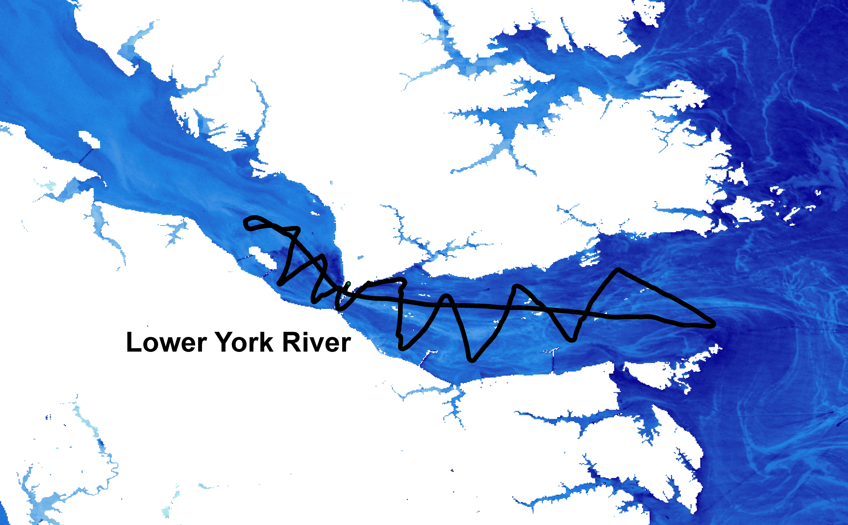

**Caption:** August 17th – Virginia Institute of Marine Science dataflow path on York River, overlaid on Band 1 of Landsat 8, with land and cloud pixels removed. Image Credit: Wise County Clerk of Court’s Office Team.

**Image:** DataFlowonRiver.jpg

**Software Release Requirements**

Category IV

**Software Title:** Chesapeake Bay Chlorophyll Hotspot Identifier

**Software Abbreviation:** CBCHI

**Technical Point of Contact:** Arika Egan, [arikaegan@gmail.com](mailto:arikaegan@gmail.com), Wise County.

**Brief Description of the Software:**

The CBCHI allows users to identify chlorophyll concentrations in the Chesapeake Bay area using Landsat 8 as input. Its output will provide a map whose legend identifies chlorophyll concentrations in the Landsat 8 data.

**Type of Code:** *Source Code and Executable Code*

**Will the software include any embedded computer databases?** No

**Does the software use or call any open software or libraries?** Python module “os”

**List the software or libraries used, under what license they were obtained, and the URL for the license in the table below:**

|  |  |  |
| --- | --- | --- |
| **Name** | **License** | **License URL** |
| ArcPy | Group License through ArcGIS | http://www.esri.com/software/arcgis |
| Python module “os” | Open source license | https://www.python.org/ |

**Full Software Description and Plan**

**Introduction/Objective:**

The Chesapeake Bay Area is host to excessive blooms of algae that damage the ecosystem. The Virginia Institute of Marine Science conducts surveys to identify these blooms in order to mitigate their effect on the environment. However, the geographic size of the Chesapeake Bay area is too large to conduct continuous data surveys. We created a tool that uses satellite data to provide a map of the Chesapeake Bay area, highlighting harmful algal blooms. This will allow scientists at VIMS to quickly identify the locations of the harmful algae blooms so they know where they should conduct surveys to understand the causes of the blooms.

**Applications and Scope:**

This program can be used with new and incoming data from the Landsat 8 satellite to determine algal hotspots in the Chesapeake Bay area. The results it produces will highlight areas where high sampling becomes a necessity and/or priority.

**Capabilities:**

Every ecosystem is different, so a program or algorithm that identifies HABs in one region may not work for another. A specific algorithm for the Chesapeake Bay does not currently exist. Our algorithm uses satellite data containing real color and chlorophyll data to identify areas with high algal concentration, or algal hotspots, in the Chesapeake Bay. This algorithm is the first of its kind for the Chesapeake Bay area. It will provide a map of algae concentrations, which will allow researchers to assign priority levels to various locations.

**Interfaces:**

The code will prompt the user to input the directory containing the raw Landsat 8 data. The code will then use the images in the directory to create a final raster image containing the chlorophyll concentrations. This image will be saved in the original directory, and can be opened in ArcGIS.

**Assumptions, limitations, & Errors:**

This tool will work only for the Chesapeake Bay area. Since it was created using data from only the York River, it’s possible that it will only work for the York River. However, it should be able to work for the rivers of the Chesapeake Bay. To be more robust

**Testing:**

The tool was created using *in situ* data from the Virginia Institute of Marine Science. Predictions the tool made were tested against the *in situ* data.