**NASA DEVELOP National Program**



NASA Ames Research Center

*Summer 2016*

San Francisco Bay Area Health and Air Quality

Using Aircraft *In Situ* Observations for Methane Monitoring and Hotspot Detection over the San Francisco Bay Area

 **Technical Report**

Final Draft –August 11, 2016

Maya Midzik (Project Lead)

Garima Raheja

Joseph Abbate

Dr. Abhinav Guha, Bay Area Air Quality Management District (Mentor)

Dr. Phil Martien, Bay Area Air Quality Management District (Mentor)

Dr. Laura Iraci, NASA Ames Research Center (Mentor)

Dr. Josette Marrero, NASA Postdoctoral Program (Mentor)

Mr. Warren Gore, NASA Ames Research Center (Mentor)

Dr. Emma Yates, Bay Area Environmental Research Institute (Mentor)

Dr. Juan Torres-Pérez, Bay Area Environmental Research Institute (Science Advisor)

# 1. Abstract

Methane (CH4 ) is a potent greenhouse gas. According to the Environmental Protection Agency (EPA), one ton of methane emissions can absorb almost twenty five times as much energy as one ton of carbon dioxide emissions over a one hundred year timescale. A majority of methane emissions can be attributed to anthropogenic sources, including livestock farms, landfills, and wastewater treatment plants. The Bay Area Air Quality Management District (BAAQMD) regulates these and other stationary sources of air pollution in the nine counties surrounding San Francisco Bay, an urban area with a diverse array of landforms and emissions sources. BAAQMD traditionally estimates emissions using a bottom-up approach, combining emissions factor and activity data to estimate source emissions per sector. However, recent literature suggests that these bottom-up approaches are underestimating CH4 emissions by nearly 50% in many regions of California (Fairley, Fischer 2015). Therefore, there is interest in characterizing the ground-level distribution of methane within the urban region of the San Francisco Bay Area for the purposes of comparing the top-down measurements with the bottom-up spatial emissions inventories utilized by BAAQMD, and also for better understanding emissions sources that are not already accounted for in the BAAQMD emissions inventory. Though Earth-observing satellites can effectively monitor mid-to-upper tropospheric CH4 on a global scale, current instrumentation is limited in its capacity to accurately measure near-surface CH4 on a local scale. This project used sub-Planetary Boundary Layer (PBL) *in situ* airborne CH4 measurements from the NASA Alpha Jet Atmospheric eXperiment (AJAX) to create a comprehensive spatially-resolved CH4 enhancement map over the San Francisco Bay Area. Backward trajectory analyses on wind plumes near locations of four “hotspots” (two over Petaluma, one over Mountain View, and one over San Pablo Bay) were conducted using historical wind direction data from the National Digital Forecast Database (NDFD). The backward trajectory approach was used to identify the emissions sources already present in the current BAAQMD emissions inventory that are associated with high CH4 enhancements, and therefore pinpoint specific sites for further investigation by the upcoming BAAQMD Mobile Greenhouse Gas Measurement Van, AJAX flights, targeted satellite missions, and other top-down greenhouse gas measurement methods. Finally, dense AJAX measurements over the Mountain View area were used to create three time-series analyses which demonstrated consistent seasonal variation in background methane concentrations, with ambient methane concentrations rising drastically between the winter months of November to February, and dropping in the summer months of May to August. These results give a synoptic view of historical methane concentrations over the Bay Area, as well as local emissions case studies, which can help BAAQMD better focus future research and regulation.

**Keywords**

Emissions inventory, bottom-up estimate, top-down measurement, remote sensing

# 2. Introduction

***2.1. Background Information***

CH4 is a potent greenhouse gas with a radiative forcing second only to CO2  (IPCC, 2013). The concentration of CH4 in the atmosphere has been rising dramatically, with current tropospheric concentrations almost 2.5 times those of pre-1750 levels (Blasing, 2016). Natural processes within ecosystems can emit CH4; however, the rapid increase in atmospheric CH4 has been attributed primarily to anthropogenic sources such as landfills, livestock farms, and natural gas production systems (Miller, 2013).

Regional inventories of CH4 emissions are estimated using a “bottom-up” method, which combines data on local source sectors with information on emissions factor per source sector (Guha, personal communication, June 28, 2016). Information on locations and extents of sources is collected from various databases, including the USDA National Agricultural Statistics Service Cattle Inventory and the US Department of Transportation Office of Highway Policy Information Traffic Volume Trends. The emissions estimates per unit factors rely on a combination of biogeochemical models.

Recent studies have shown that regional emissions inventories may be largely underestimating true CH4 emissions (Miller et al., 2013). In particular, a study of the San Francisco Bay Area used the Bay Area Air Quality Management District (BAAQMD) carbon monoxide (CO) emissions inventory and the slope of ambient local CH4 to CO to demonstrate that “top-down estimates of CH4 emissions… correspond to reasonably a constant factor of 1.5-2.0 (at 95% confidence) times larger than the BAAQMD CH4 emissions inventory” (Fairley, Fischer 2015). However, this study was conducted using gas chromatography instrumentation, which is primarily used for measurement of volatile organic compounds (VOCs) and has low sensitivity for CH4  (Guha, personal communication, June 28, 2016). There is significant interest in accurately validating both the top-down and bottom-up emissions estimates using top-down CH4 measurements, which can be provided by airborne and satellite observations.

However, most greenhouse gas measuring satellites seek to monitor global aggregate CH4 levels. For this purpose, these sensors are sensitive to the CH4 in the upper troposphere and lower stratosphere, which contain approximately 75% of the CH4  within a column (CH4 is a “well-mixed” gas in the atmosphere). These satellites are not sensitive to CH4 below the planetary boundary layer (PBL), the layer of the Earth’s atmosphere closest to the surface, which contains and traps the CH4 emitted by ground-level sources. Targeted greenhouse gas monitoring satellites such as GOSAT (Greenhouse Gases Observing Satellite) can provide total column measurements of CH4, but there have been no GOSAT measurements over the Bay Area since 2011.

Airborne observations are an incredibly valuable source of top-down greenhouse gas measurements for well-mixed gases, since airplanes are able to fly and record data below the PBL. The NASA Alpha Jet Atmospheric eXperiment (AJAX) uses an airplane to fly to targeted locations in and around California, and measures greenhouse gas concentrations at various altitudes.

The data from the AJAX flights can be used for understanding the behavior of methane within the San Francisco Bay Area from 2011 to 2016.

***2.2. Project Partners & Objectives:***

The Bay Area Air Quality Management District (BAAQMD) regulates air pollution within nine counties surrounding the San Francisco Bay in Northern California: Alameda, Contra Costa, Marin, Napa, San Francisco, San Mateo, Santa Clara, Solano, and Sonoma (Fischer, 2015). These counties contain a wide range of land uses including high-density urban metropolises, dairy farms, waste disposal sites, refineries, and homes and businesses. BAAQMD compiles emissions inventories for criteria air pollutants, climate forcing pollutants, and toxic air contaminants. As part of the 2016 Clean Air Plan/Regional Climate Protection Strategy, BAAQMD is creating a Bay Area Greenhouse Gas Monitoring Network. This network includes four stationary monitoring stations (in Bodega Bay, San Martin, Patterson Pass, and Bethel Island), as well as a mobile greenhouse gas measurement van that will begin collecting measurements in the fall of 2016 (Guha, personal communication, June 28, 2016).

The NASA Alpha Jet Atmospheric eXperiment (AJAX) is a demilitarized aircraft shared between the H211 Corporation and the NASA Ames Research Center (ARC) through a Space Act Agreement (Hamil et. al., 2015). It is outfitted with a Meteorological Measurement System (MMS), and a cavity ring-down spectrometer, which measures atmospheric concentrations of greenhouse gasses including CH4, CO2, and water vapor. The Alpha Jet Atmospheric Experiment (AJAX) is located at the NASA Ames Research Center, and conducts flights associated with campaigns to support NASA Orbiting Carbon Observatory (OCO-2), validate the Emission Database for Global Atmospheric Research (EDGAR) emissions inventory over the San Joaquin Valley, and validate GOSAT measurements. Although these campaigns are not primarily focused on Bay Area emissions, takeoff and landing sections of flights out of ARC can provide valuable data over the nine-county BAAQMD jurisdiction.

By applying AJAX observations to understanding local CH4 enhancements, this project addresses NASA’s Applied Sciences National Application Area of health and air quality by helping the Bay Area community better understand the distribution of source-specific CH4 emissions. Additionally, this study explores the potential benefits of utilizing NASA airborne instrumentation to aid BAAQMD in understanding and regulating regional air quality.

# 3. Methodology

***3.1 Data Acquisition***

Airborne *in situ* CH4 (ppmv), CO2 (ppmv), and H2O (%v) measurements (with geolocation and time stamps) from 162 AJAX flights between 2011 and 2016 were obtained for this project (Iraci, personal communication, June 29, 2016 ). All chemical species were measured using a cavity ring-down spectrometer (CRDS, Picarro, Inc., Model G 2301-m, (CO2  at 1603 nm, and CH4and H2O at 1651 nm). Flights after Flight #99 (on July 17, 2013) also recorded *in situ* meteorological measurements (MMS) of static pressure, static temperature, and wind in three dimensions.

Gridded historical forecasts of wind direction for the Pacific Southwest region (NDFD WMO Heading Reference: YBQZ) from the National Digital Forecast Database (NDFD) maintained by NOAA as part of the NWS Digital Services Program were downloaded through the NOAA National Operational Model Archive & Distribution System (NOMADS).

Hourly *in situ* ground-based CH4 (ppmv) measurements from BAAQMD monitoring stations were obtained from Dr. Abhinav Guha, Senior Air Quality Engineer at BAAQMD. The temporal ranges of the data for each sensor were as follows: October 2015 to June 2016 (Bodega Bay), February 2016 to June 2016 (Bethel Island, Patterson Pass, and San Martin).

Shapefiles for regional spatial emissions inventory estimates with locations of emission sources and estimate emissions from each source were obtained from BAAQMD Planning and Climate Protection Division.

***3.2 Data Processing***

A Python algorithm was developed to detect the height of the PBL for each flight, indicated by rapid changes in meteorological factors. For Flight #99 and later, the algorithm used MMS data from the flight. First, the time at which the flight first left the Bay Area jurisdiction (defined as a rectangular box, 37.0 N to 38.5 N and -121 W to -123.2 W) and entered the jurisdiction on its landing approach were found. The “entry” and “exit” sections were continuous and occurred over a short time span; these can be treated as snapshots of vertical profiles over a consistent area and near-instantaneous time span. Within the “entry” and “exit” sections, the altitude of the PBL was calculated as the mean of the height with the minimum temperature, minimum pressure, and minimum wind speed. After the PBL altitude was calculated for the “entry” and “exit” of each flight, the minimum of the two calculated PBL altitudes was accepted as the calculated PBL altitude for the entire flight. All data above this calculated altitude in this flight were removed. This process was repeated for each flight, and all data below in-flight-PBL are compiled. The calculated altitudes of the PBL ranged from 400 to 1330. For Flight #98 and before, 400 m (the lowest calculated PBL from the flights that had associated MMS data, and therefore the most conservative estimate for PBL height) was uniformly defined as the height of the PBL each flight.

Gridded historical forecasts for wind direction from NDFD were converted into verbose point shapefiles using the tkdegrib program provided by NOAA. The decoded data were input into ArcGIS as wind vector barbs for spatial analysis.

***3.3 Data Analysis***

*3.3.1 Comprehensive Hotspot Mapping*

CH4 concentrations were normalized for each flight to quantify the enhancement of a methane concentration above its daily background (and remove bias from days with high background CH4). All flights had highly right-skewed CH4 distributions, and a few number of points with very high CH4 concentrations. Cumulatively, 86.21% points were within one z-scored of the mean. Areas with CH4 z-scores above 2.0 were considered “hotspots” and plotted as varying degrees of the color red to indicate CH4, enhancements. All points below z-scores of 2 were plotted as varying degrees of the color red to generate a spatially-resolved visual tool for inspecting and understanding horizontal distribution of CH4.

*3.3.2 Backward Trajectory Modeling*

CH4 “hotspots” were identified as areas with local CH4 concentrations with z-scores of two to fourteen. Gridded historical wind forecasts for the date, location, and hour of the AJAX overpass on the hotspot were plotted on top of the hotspot CH4 concentration data, and the maps were visually inspected, with possible local emissions sources noted. Four such “hotspots” were analyzed (two over Petaluma, and one each over Mountain View and San Pablo Bay).

*3.3.3 Time-Series Analysis*

As all AJAX flights depart from and return to the NASA Ames Research Center, there is a high density of methane observations recorded in this surrounding area. AJAX flights were subset for 0.05 degrees surrounding ARC. Data ascertained to be below the PBL for the flight were processed in R to create time series over three locations (Mountain View, Patterson Pass, and San Martin).

# 4. Results & Discussion

Fig. 1: CH4 Enhancement Map Over San Francisco Bay Area

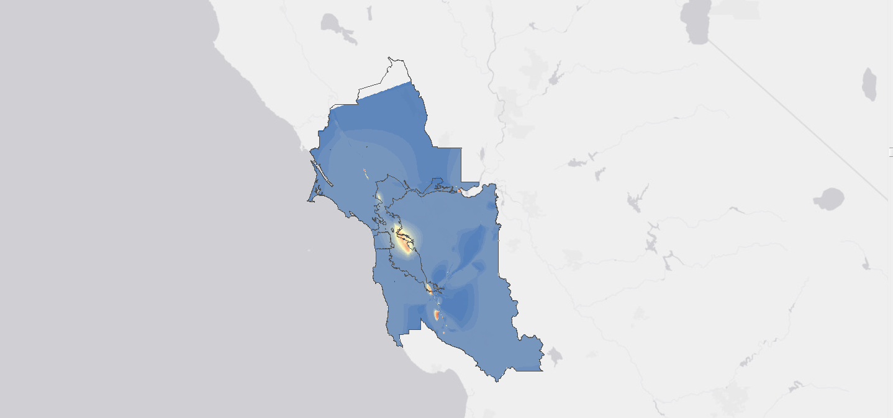

High: 8.15 (z-score)

Low: 0.91 (z-score)

Fig.2: Hotspot A over Petaluma, CA

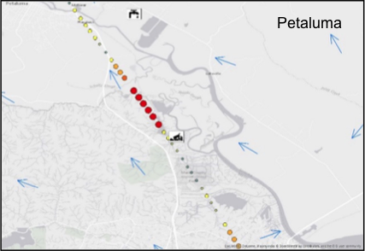

Fig.3: Hotspot B over Petaluma, CA

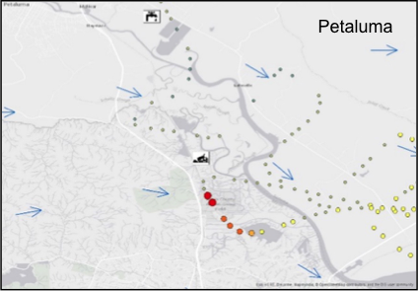

Fig.4: Hotspot over San Pablo Bay, CA

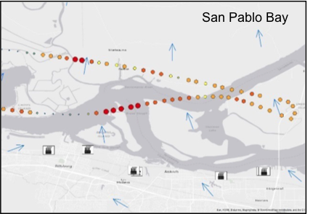

Fig.5: Hotspot over Mountain View, CA

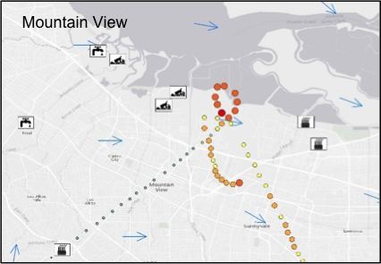

***4.1 Analysis of Results***

The final normalized CH4 enhancement map (Fig. 2), created using all AJAX flights from 2011-2016, covered 95% of the area within the BAAQMD regulatory jurisdiction. This map identifies the area over Oakland as an area of consistently elevated CH4 levels (this high CH4 enhancement area occurs over a number of refineries, as indicated by the BAAQMD emissions inventory). This map also helps identify four smaller “hotspot” regions (two over Petaluma, and one each over Mountain View and San Pablo Bay), which are areas with exceptionally high CH4 enhancements for very small sections of the flight.

In the case of Petaluma (Fig. 2 and 3), the hotspot occurs north of the landfill when the wind is blowing northwards, and the hotspot occurs to the south when the wind is blowing southwards. In San Pablo Bay (Fig. 4), the hotspots occur downwind from the refineries in the area. These basic analyses provide indicators to the usefulness of AJAX monitoring in detecting sources that create exceptionally high CH4 levels. In the Mountain View hotspot (Fig. 5), there is a hotspot over NASA-ARC, which is downwind of two landfills, but there is also a string of hotspots south of NASA-ARC with no obvious source upwind. Hotspots such as this one—hotspots without obvious emissions sources directly upwind—can be valuable areas of investigation for the BAAQMD Mobile Greenhouse Gas Monitoring Van.

However, AJAX flight density varies over the San Francisco Bay Area—there are denser data in the southern region, and sparser data in the northern region—creating uncertainty in the map (Fig. 2). Although this map represents estimated areas of significantly enhanced methane measurements, it does not necessarily cover all possible methane hotspots for the area due to limitations in flight density below the PBL.

Time series analysis of methane levels over the NASA Ames Research Center (Appendix, Fig 18) revealed significant seasonal variation in the gas, with yearly highs of methane occurring between November and February, and yearly lows occurring from May to August. BAAQMD measurements over the San Martin monitoring site for 2015-16 were shown to be consistent with AJAX observations; however, measurements over Patterson Pass were inconsistent with AJAX measurements over the same region, indicating that further work is needed in utilizing AJAX as a consistent sensor over time.

***4.2 Future Work***

# This project outlines potential points of interest for future research and collaboration. AJAX data can continue to be integrated to derive a synoptic view of CH4 over the San Francisco Bay Area, and to create a more localized view of what sources are enhancing the CH4 levels. Further investigation of “hotspots” can pinpoint areas of interest for the BAAQMD Mobile GHG Monitoring Van. In addition, this project represents the beginning of a number of collaborations between AJAX and BAAQMD, including a brief validation campaign planned for the fall of 2016. Furthermore, future AJAX flights coordinated with BAAQMD Mobile Monitoring data collection will be vital in understanding the spatial and vertical distribution of CH4 concentrations over the diverse landforms of the San Francisco Bay Area.

# 5. Conclusions

Aggregate data from AJAX, traditionally a targeted measuring system, were utilized to develop a pseudo-monitoring system for understanding overall Bay Area CH4 enhancements. These data were also used to detect “hotspots” caused by Bay Area emissions sources, in response to the need for CH4 measurement comparisons between top-down and bottom-up approaches. To address this discrepancy, meteorological factors were used to determine the height of the PBL at the time and date of each AJAX flight. AJAX data below the PBL were used to develop comprehensive maps of estimated CH4 concentrations and local CH4 relative enhancements over the Bay Area. Hotspots were found over Mountain View, Petaluma, and San Pablo Bay. These hotspots were investigated by integrating historical wind direction forecasts, and the nearest emissions sources were noted. In the case of Mountain View, no known sources of emissions were found downwind of the hotspot—this hotspot thus indicates points of interest for examination by the BAAQMD Mobile GHG Monitoring Van or by other top-down methods. The high density of data collected over NASA-ARC was used to create a time series of the CH4 concentrations in Mountain View, and demonstrated regular seasonal fluctuations in CH4 concentrations; the highest CH4 concentrations occurred in the winter months between November and February, and the lowest CH4 concentrations occurred in the summer months between May and August. These seasonal trends can also be seen in the nascent BAAQMD sensor network, and thus indicate that AJAX is a valuable source of corroboration for the BAAQMD Greenhouse Gas Monitoring Network. Areas of high uncertainty and areas with high deviations from the bottom-up emissions inventory estimate were identified for future investigation by top-down methods. Supplementing airborne observations with ground-based measurements will help develop a better understanding of the spatial distribution of CH4 over the San Francisco Bay Area, and will assist scientists and policymakers in creating more effective strategies for reducing CH4 emissions.

# 6. Acknowledgments

* Partners
  + Dr. Abhinav Guha, Senior Air Quality Engineer, Bay Area Air Quality Management District
  + Dr. Phil Martien, Air Quality Engineering Manager, Bay Area Air Quality Management District
* Alpha Jet Atmospheric Experiment (AJAX)
  + Dr. Laura Iraci, NASA Ames Research Center
  + Dr. Josette Marrero, NASA Postdoctoral Program
  + Mr. Warren Gore, NASA Ames Research Center
  + Dr. Emma Yates, Bay Area Environmental Research Institute
* Mentors / Advisors
  + Ms. Chippie Kislik, DEVELOP Center Lead at NASA Ames Research Center
  + Ms. Vickie Ly, DEVELOP Assistant Center Lead at NASA Ames Research Center
  + Dr. Juan Torres-Pérez, Bay Area Environmental Research Institute

Any opinions, findings, and conclusions or recommendations expressed in this material are those of the author(s) and do not necessarily reflect the views of the National Aeronautics and Space Administration.

This material is based upon work supported by NASA through contract NNL11AA00B and cooperative agreement NNX14AB60A.

# 7. References

Blasing, T. (2016, April). Recent greenhouse gas concentrations. Retrieved June 29, 2016, from <http://cdiac.ornl.gov/pns/current_ghg.html>

Etheridge, D. M., Steele, L. P., Francey, R. J., & Langenfelds, R. L. (1998). Atmospheric methane between 1000 A.D. and present: Evidence of anthropogenic emissions and climatic variability. *Journal of Geophysical Research: Atmospheres J. Geophys. Res.,* *103*(D13), 15979-15993. doi:10.1029/98jd00923

Fairley, D., & Fischer, M. L. (2015). Top-down methane emissions estimates for the San Francisco Bay Area from 1990 to 2012. *Atmospheric Environment,* *107*, 1-32. doi:10.1016/j.atmosenv.2015.01.065

Fischer, M. L., & Jeong, S. (2015). *Evaluating the Bay Area Methane Emission Inventory* [Scholarly project]. Retrieved June 29, 2016.

Guha, A. (n.d.). *GHG Inventory and Measurements Background* [Scholarly project]. Retrieved June 29, 2016.

Hamill, P., Iraci, L. T., Yates, E. L., Gore, W., Bui, T. P., Tanaka, T., & Loewenstein, M. (2016). A new instrumented airborne platform for atmospheric research. *Bulletin of the American Meteorological Society*,*97*(3), 397-404.

Karion, A., Sweeney, C., Pétron, G., Frost, G., Michael Hardesty, R., Kofler, J., ... & Brewer, A. (2013). Methane emissions estimate from airborne measurements over a western United States natural gas field. *Geophysical Research Letters*, *40*(16), 4393-4397.

Miller, S. M., Wofsy, S. C., Michalak, A. M., Kort, E. A., Andrews, A. E., Biraud, S. C., ... & Miller, B. R. (2013). Anthropogenic emissions of methane in the United States. *Proceedings of the National Academy of Sciences*, *110*(50), 20018-20022.

Peischl, J., Ryerson, T. B., Holloway, J. S., Trainer, M., Andrews, A. E., Atlas, E. L., ... & Goldstein, A. H. (2012). Airborne observations of methane emissions from rice cultivation in the Sacramento Valley of California. *Journal of Geophysical Research: Atmospheres*, *117*(D24).

Stocker, T. F., Qin, D., Plattner, G. K., Tignor, M., Allen, S. K., Boschung, J., ... & Midgley, B. M. (2013). IPCC, 2013: climate change 2013: the physical science basis. Contribution of working group I to the fifth assessment report of the intergovernmental panel on climate change.

Stull, Rolald B. (1988). *An Introduction to Boundary Layer Meteorology*. Kluwer Academic Publishers. p. 200.

**8. Content Innovation**

**Content Innovation #1**

http://earthzine.org/2016/08/11/the-steaks-are-high-methane-on-the-rise/

**Content Innovation #2**

Inline Supplementary Material (*see Appendix below*)

**Content Innovation #3**

Glossary (*see: Appendix, Fig. 20)*

# 9. Appendix

Fig. 6: Law Dome Antarctica (Average of 3 Ice Cores), DED8-2 FIRN, and Archived Air Samples from Cape Grim (Etheridge et al., 1998)

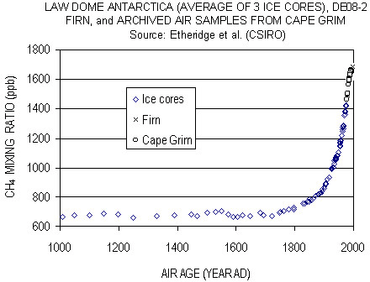

Fig.7: BAAQMD Estimated Emissions Inventory (Fairley and Fischer, 2015)

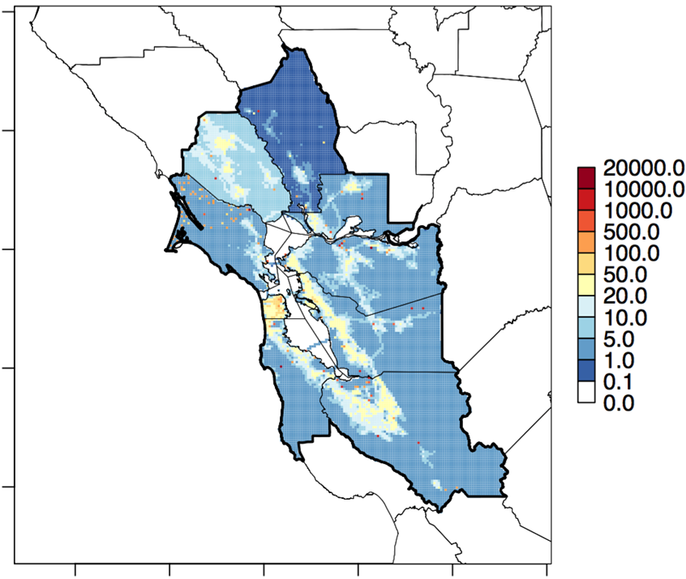

Fig.8: Locations of BAAQMD CH4 Sensors

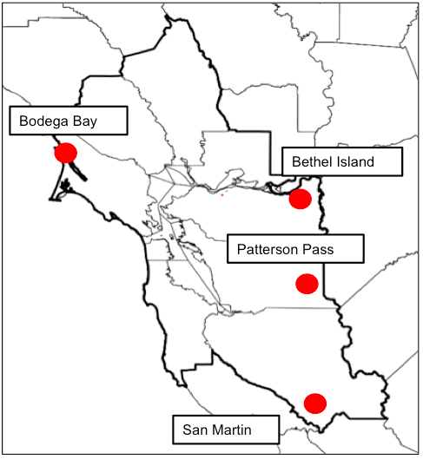

Fig.9: Diagram of Satellite Reaches and Planetary Boundary Layer Interactions

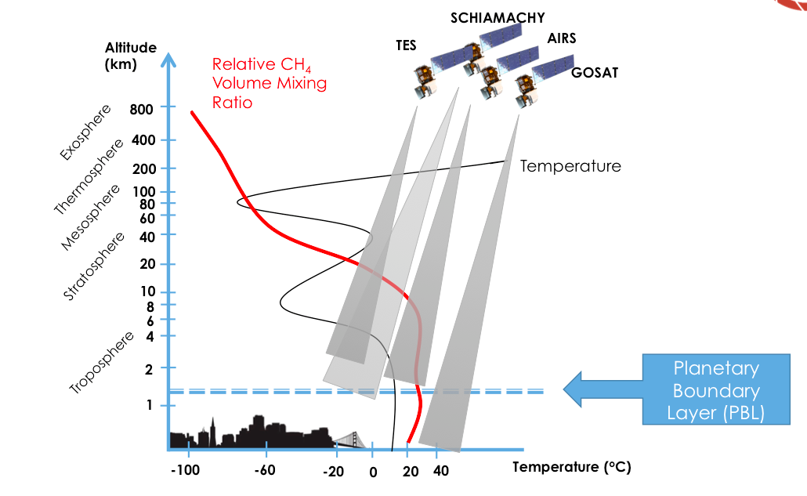

Fig.10: AJAX Photos and Instrumentation Diagram

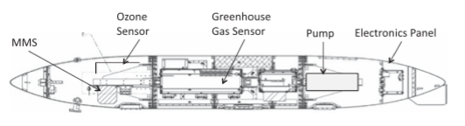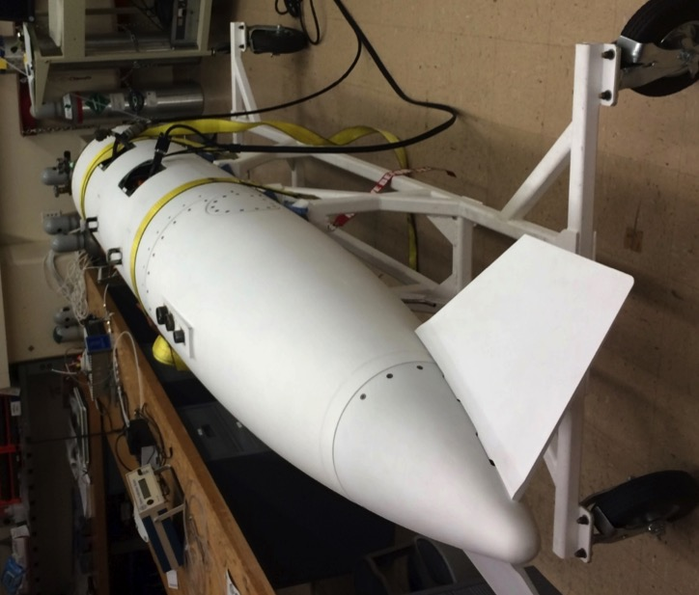

Hamill et al., 2016

Photograph courtesy of Warren Gore

Fig.11: Map of All AJAX Flight Paths

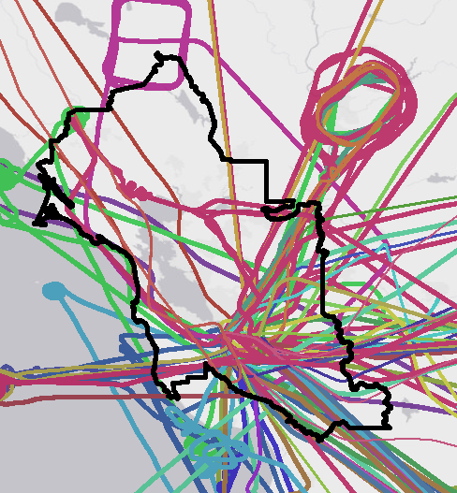

Fig.12: Diagram of Variation in PBL with Time of Day (Erica McGrath-Spangler and Andrea Molod, GMAO)

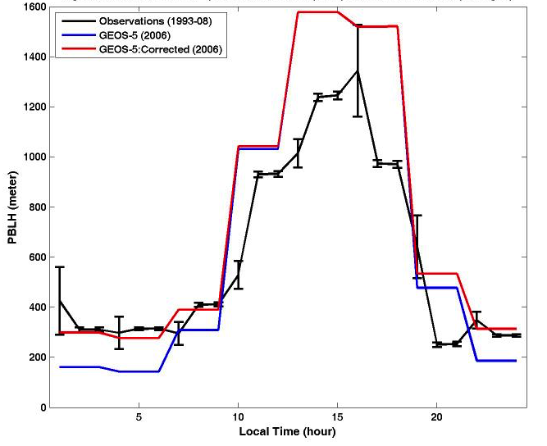

Fig.13: Diagram of Vertical Variation in Meteorological Factors (Stull, 1988)

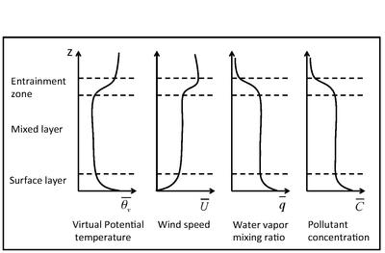

**ALTITUDE**

Fig.14: Graphs of PBL Detectio Using Python Algortihm for Flight 164

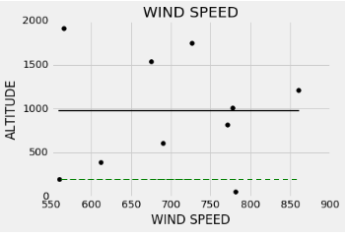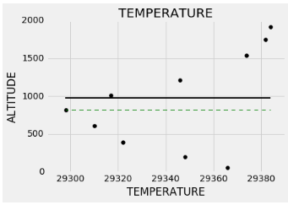

Fig.15: CH4 Concentration Map Over San Francisco Bay Area

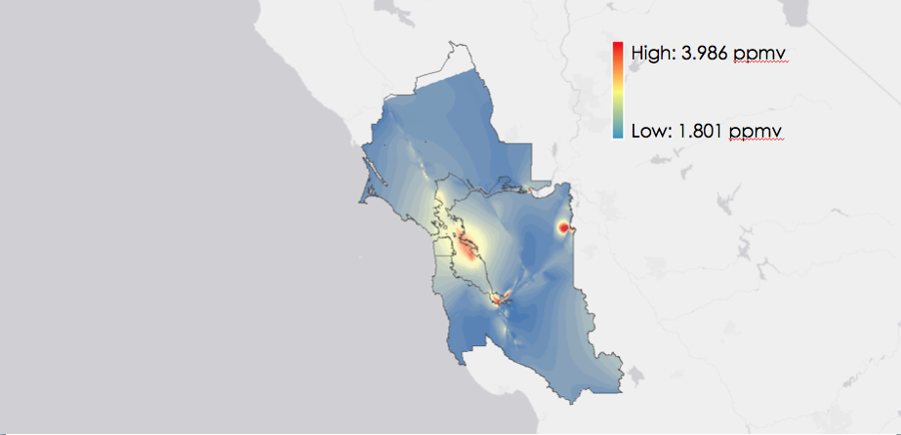

Fig.16: Map of AJAX Flights over NASA-ARC

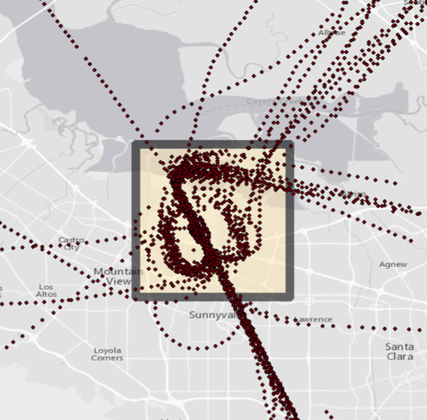

Fig.17: Time Series over NASA-ARC

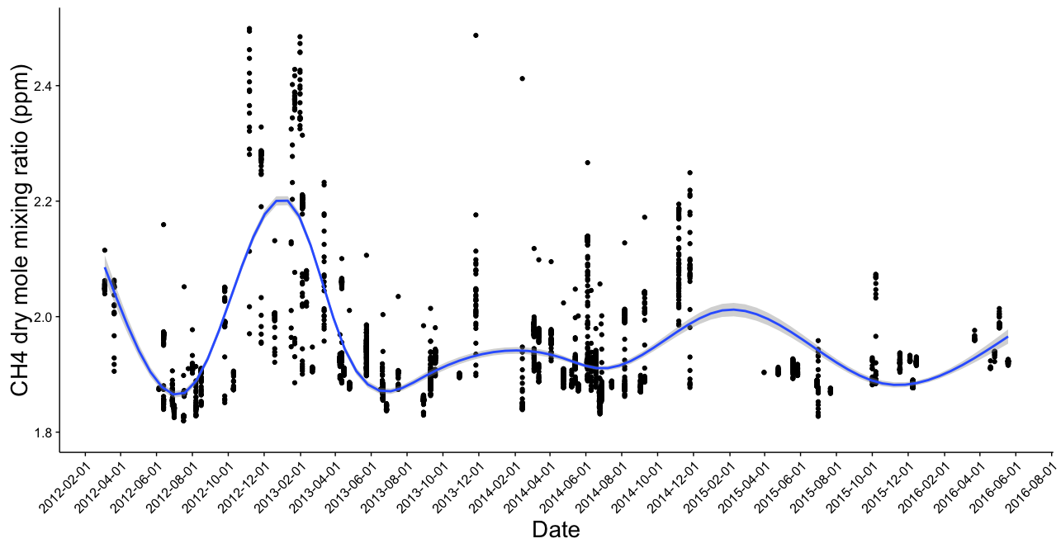

Fig.18: Time Series over Patterson Pass

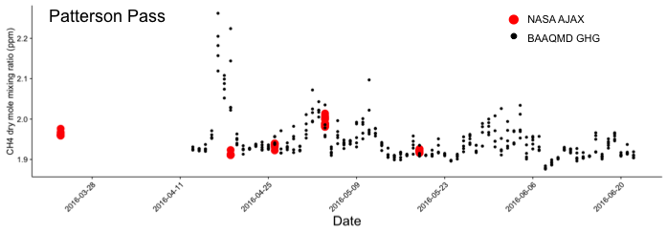

Fig.19: Time Series over San Martin

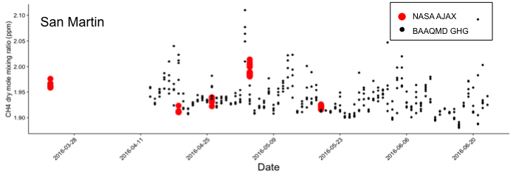

Fig.20: Glossary

**Alpha Jet Atmospheric eXperiment (AJAX) –** A projectlocated at the NASA Ames Research Center that conducts flights associated with campaigns to support NASA Orbiting Carbon Observatory (OCO-2), validate the Emission Database for Global Atmospheric Research (EDGAR) emissions inventory over the San Joaquin Valley, and validate GOSAT (Greenhouse Gases Observing Satellite) measurements.

**Bay Area Air Quality Management District (BAAQMD) –** Regional agency thatregulates air pollution within nine counties surrounding the San Francisco Bay in Northern California: Alameda, Contra Costa, Marin, Napa, San Francisco, San Mateo, Santa Clara, Solano, and Sonoma.

**Bottom-up Approach –** Refers to a method of air quality monitoring, combining local source sector totals and estimated emissions per unit factors (Guha, personal communication, June 28, 2016).

**Emissions Inventory** – A regional documentation of source-specific criteria air pollutants, climate forcing pollutants, and toxic air contaminants.

**Picarro Cavity Ring-Down Spectrometer (CRDS) –** An instrument used by the AJAX team that implements three specific near-infrared absorption spectrums to measure atmospheric concentrations of methane, carbon dioxide, and water vapor.

**Planetary Boundary Layer (PBL) –** Highly variable in its altitude, this atmospheric layer contains local greenhouse gas enhancements, distinguishable from other well-mixed and transboundary gases more abundant at higher atmospheric levels.

**Top-down Approach –** Refers to a method of air quality monitoring primarily through satellite imagery and aircraft-based measurements.