**NASA DEVELOP National Program**



NASA Langley Research Center

*Summer 2015*

Texas Water Resources

Utilizing NASA Earth Observations to Monitor Drought Severity in Texas for Wildfire Mitigation Support

 **Technical Report**

Final Draft – July 29, 2015

Megan Buzanowicz (Project Lead)

Laura Lykens

Zacary Richards

Jeff Close (USAF)

Dr. Kenton Ross, NASA DEVELOP National Program (Science Advisor)

Dr. Venkat Lakshmi, University of South Carolina (Science Advisor)

I. ABSTRACT

The 2011 wildfire season was one of the most destructive wildfire seasons in Texas history. The combination of a wet 2010 growing season, which allowed vegetation to prosper, followed by an extremely dry year in 2011 provided the worst case scenario for wildfires. The purpose of this project was to expand upon a drought severity index (DSI) created during the summer 2013 Great Plains Agriculture project. A risk map of potential wildfire areas that contain dry fuels was also created; specifically, how dry the fuels are. To accomplish this, data that measure specific factors contributing to drought conditions and dry vegetation were acquired, including land surface temperature and the Normalized Difference Vegetation Index (NDVI) from the Moderate Resolution Imaging Spectrometer (MODIS) instrument onboard the Aqua and Terra satellites, precipitation from the Multi-Sensor Precipitation Estimate (MPE), and soil moisture from the North American Land Data Assimilation System (NLDAS). Data for these four factors were compiled through ArcGIS in order to assemble a risk map. The accuracy of the DSI was correlated to live fuel moisture data supplied by the Texas Forest Service (TFS). Methods and results produced for determining drought conditions were presented to the TFS for future use throughout the state; the benefit of which was a high-resolution drought index that can be easily constructed with little cost to the end-user.

**Keywords:**

Texas, Drought, Wildfires, Drought Severity Index, Remote Sensing, MODIS

# II. INTRODUCTION

## ***Background Information***

The most recent multi-year drought in Texas began in October 2010, with dry conditions throughout the fall and winter seasons (Nielson-Gammon, 2012). However, March 2011 delivered the greatest blow to the state with widespread extreme drought conditions ailing the majority of its counties. Receiving less than 16 inches in rainfall that year, or 51% of the average annual precipitation for the 1981 to 2010 period, aquifers and lakes plunged to their lowest levels since the historic drought of the 1950s (Nielson-Gammon, 2012). The U.S. Drought Monitor, utilizing a six-month Standard Precipitation Index (SPI), placed 92.4% of the state’s counties in severe drought conditions or worse.

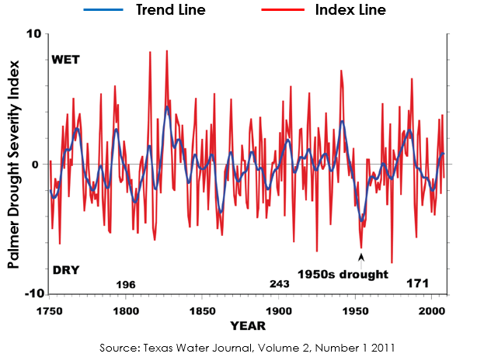

By early November of 2011, 1,000 of Texas’ 4,700 public water systems had imposed voluntary or mandatory water restrictions, twenty-three of which believed they were within 180 days of running out of water completely (Rubenstein, 2012). Texas AgriLife Extension Service estimated the agricultural losses for the year at 5.2 billion dollars (Fannin, 2012). Moreover, the Texas Forest Service (TFS) reported 23,835 wildfires from November 2010 through September 2011, scorching 3.8 million acres (Combs, 2012). According to the Texas Water Journal, these “mega-droughts” are infrequent in nature, but are a natural occurrence in the southwest region. The study of tree rings, for example, makes it possible to measure drought conditions as far back as 1750. Using the Palmer Drought Severity Index (PDSI), the Texas Water Resources Institute (TWRI) created a chart that displays these occurrences by tracking the overall trend (Fig. 1). However, the Texas Water Development Board (TWDB) emphasized that if nothing is done to address and prepare for these multi-year droughts, the state groundwater supplies will fall 30% costing Texas businesses and workers nearly 116 billion dollars and 1.1 million in job losses from 2010 to 2060 (TWDB, 2011).

Figure 1: Texas Water Journal, Volume 2, Number 1, 2011

## ***Project Objective***

The objective of the project at DEVELOP Langley was to assist the TFS in preparing for future wildfires by expanding upon a drought severity index (DSI) created during the summer 2013 Great Plains Agriculture project. This will allow the TFS to identify what geographical locations within the state of Texas are the most prone to wildfire disasters and where water resources may be concentrated in order to fight them efficiently. The accuracy of the DSI was correlated with the measurements of live fuel moisture content (FMC) obtained from the National Fuel Moisture Database.

The causal factors of wildfires are nearly impossible to pre-emptively determine as many of the ignition sources tend to be people who accidently or deliberately set fires. However, the contributing factors to wildfires may very well give an indication of what areas are more prone to ignition and sustaining the fires than others. The Food and Agriculture Organization lists these factors as drought conditions, fire weather conditions, available fuel, landscape homogeneity, various vegetative conditions, land management practices, and governing policies (Williams et al., 2012). While the summer 2015 Texas Disasters DEVELOP team at NASA’s John C. Stennis Space Center analyzed landscape homogeneity and vegetation species vulnerable to ignitions, the scope of our project encompassed drought conditions and available fuel based on those conditions. Ignition potential is greatly related to the moisture content of vegetation which, in turn, is closely linked to the components of the Universal Triangle: soil moisture, temperature and vegetation (Wu, 2012). While other indices are heavily reliant on temperature and precipitation readings, such as the widely used PDSI and the Standard Precipitation Index (SPI), soil moisture in the root zone is a more critical component of vegetative stress than the actual amounts of precipitation (Wang, 2000). Therefore, this project aimed at integrating temperature, soil moisture, vegetation and, precipitation into a DSI.

Figure 2: Environmental Protection Agency – Western Ecology Division

## ***Study Area***

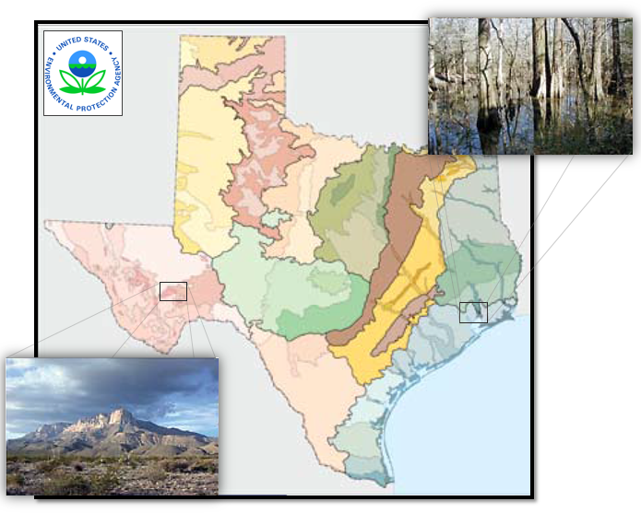The area being studied for this project was the state of Texas, which encompasses 268,820 square miles. The ecological regions within this territory are vast, and their unique environments should be given equal consideration when planning for disasters at the scale assigned to this project (Fig. 2). From the Chihuahuan Deserts in the west, to the Gulf Coastal Plains and Cross Timbers in the east, the factors contributing to drought will affect each of these regions differently.

## ***Study Period***

The periods of study ranged from May 2010 through September 2011 and May 2014 through June 2015. These periods were selected because of the extreme drought conditions that began in the state in 2010, and brought about widespread wildfires to various regions the following year as the vegetation became stressed and the fuel load increased dramatically. The latter years were included in this study as they offer the most current timeline available for research.

## ***National Application(s) Addressed***

This project addressed the NASA Applied Sciences national application area of Water Resources, due to the scarcity of water available to the state during multi-year drought conditions and the necessity of the resource when suppressing wildfires. This project supports the goal of the Water Resources Program, which entails the application of NASA satellite data to improve the decision-making tools of partners who manage water resources. With more information regarding the spatial coverage of drought conditions, the TFS can better allocate this resource to mitigate the spread of wildfires when they occur. This project expands the range of end users to those who may not be familiar with or have access to remote sensing technology but will have the ability to disseminate information to city and state government officials, non-profit organizations, and other organizations with a vested interest in water resource.

## ***Project Partners***

The project partner was the Texas A&M Forest Service. Currently, the service uses products such as the Landscape Fire and Resource Management Planning Tools (LANDFIRE) and the National Predictive Services Unit which applies the Palmer Drought Severity Index as well as the Keetch-Byram Drought Index to classify drought severity. The TFS employs the LANDFIRE program to support fire planning, analysis, budgeting and evaluate fire planning alternatives. This project supplied the TFS with a DSI that incorporates soil moisture and vegetation data, two factors lacking in many drought severity indices (Wang, 2000) thus allowing the TFS to continue to monitor drought conditions across the state at greater and more reliable accuracy.

Moreover, the Wildfire Risk Interactive Map currently accessible to the public through the TFS website incorporates fire intensity scale, LANDSAT data, percentage of vegetation cover, residential areas, and fire behavior potential. These layers are historical readings that pinpoint areas prone to wildfires and categorize a resident’s risk based on their proximity to that area. However, the TFS desired a product that could acquire data as close as possible to the present in order to verify locations reaching critical thresholds of live FMC.

# III. METHODOLOGY

## ***Data Acquisition***

Eight-day Aqua MODIS Land Surface Temperature data (LST) MYD11A2 and 16-day Terra MODIS Normalized Difference Vegetation Index (NDVI) MOD13Q1 was extracted from NASA’s Earth Observing System Data and Information System (EOSDIS) for the study period using a python script shared by the Texas Disasters Summer 2015 team at the John C. Stennis Space Center (SSC) which we modified. MODIS was given preference by the team as it is capable of operating with 36 spectral bands that capture 250, 500 and 1000 m resolutions. This is the highest number of spectral bands of any global coverage moderate resolution imager (Justice et al., 2002). With Terra descending by late morning and Aqua ascending in the early afternoon, the latter was selected to provide LST readings due to the greater impact of higher temperatures later in the day on vegetation and soil moisture (Savtchenko, 2004). Each day during the study period were extracted in a batch using *wget*, *a* free utility tool for non-interactive downloading from the Web, through a script written in Python 2.7.

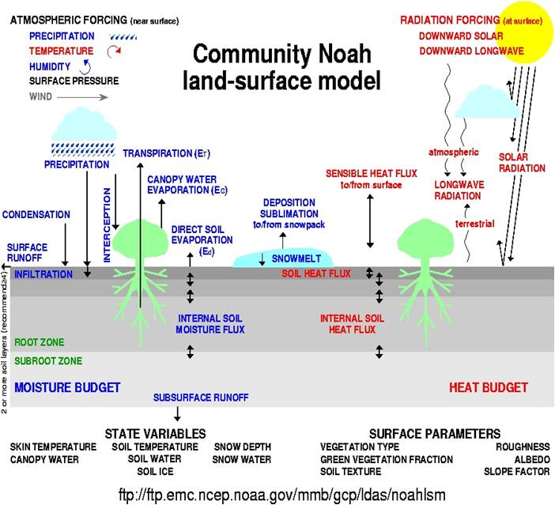Data from NASA’s recently launched Soil Moisture Active Passive (SMAP) satellite were unavailable to use during this term. To conduct soil moisture calculations, the Texas Water Resources team relied on the North American Land Data Assimilation System (NLDAS-2) as a model for securing soil moisture values. NLDAS-2 was chosen because of its frequent use by the Climate Prediction Center (CPC) for their seasonal drought outlooks and monthly briefings. Moreover, several authors of the US Drought Monitor (USDM) have referenced the NLDAS-2 soil moisture and total runoff percentiles in past analyses. The NLDAS-2 may incorporate one of four different land surface models (LSMs), whose purpose is to accurately reproduce observed water and energy fluxes (Xia, 2012). All four of these models include direct evaporation from bare soil, transpiration from vegetation, evaporation of interception, and snow sublimation. However, the processing of the models vary in vegetation phenology, canopy resistance parameters, and their root profiles. For the intentions of this project, the Noah 2.8 model was chosen as it offers four layers and the most layers of the four models, with a spatial thickness of 10 cm in forested and non-forested regions that encompasses the root zone (Fig. 3). In consideration of the recently launched Soil Moisture Active Passive (SMAP) satellite, the depth of the study using NLDAS-2 was limited to 10 cm in depth in order to match SMAP’s capabilities to the greatest degree possible. Therefore, NLDAS-2 NOAH0125 Version 2 monthly archived files for the study period were downloaded from The Goddard Earth Sciences Data Information Services Center (GESDISC). Unfortunately, the NLDAS-2 offers the coarsest spatial resolution at 13.75 km2.

Figure 3: A description of the variables and parameters of the NLDAS-2 Noah model courtesy of NOAA

Daily Multisensor Precipitation Estimator (MPE) data were collected from the National Oceanic and Atmospheric Administration (NOAA) National Weather Service (NWS) Advanced Hydrologic Prediction Service (AHPS). The MPE is an interactive software tool within the Advanced Weather Interactive Processing System that integrates rain gauge and satellite rainfall estimates with radar-only estimates and creates high-resolution gridded rainfall products at 4 km2 (Fulton, 2005).

TFS recommended turning to the National Fuel Moisture Database for acquiring FMC readings from various stations located throughout Texas that are concentrated on species of vegetation that are common to the state. Ideally, sampling a fast-burning grass species and a slow-burning tree species would add credibility to the study, however Mike Dunivan, a fire analyst with the TFS, revealed that the FMC measurements for the grass species were discontinued due to inaccuracies. Moreover, the available tree species for selection were narrowed down to two in particular whose values were prevalent on several stations and fell within our study periods: *Pinus taeda* (Loblolly Pine) and *Juniperus pinchotii* (Redberry Juniper). These two coniferous species and their close relatives are considered to be the cause of “crown fires”, or fires that jump from the canopy of one tree to another.

## ***Data Processing***

The precipitation data were downloaded as point shapefiles and were converted to rasters through the “Point to Raster” tool in Arcmap and mosaicked to a full raster of Texas in ArcGIS using a code constructed in Model Builder. The eight-day Aqua MODIS Land Surface Temperature data (LST) MYD11A2 and 16-day Terra MODIS Normalized Difference Vegetation Index (NDVI) MOD13Q1were downloaded as multiple swath tiles for each day. Those tiles were mosaicked to form one raster with the Model Builder function in ArcMap and then followed by sub-setting the raster to our study area.

ArcGIS Model Builder and Raster Calculator were used to calculate a 30 day sum for the precipitation datasets. The summed outputs were compiled and normalized to adhere to the scales of both the MODIS NDVI data and Land Surface Temperature data. To obtain their correct values, MODIS MOD13Q1 NDVI data was multiplied by a factor of 0.0001 to obtain scaled NDVI values and MODIS MYD11A2 LST was multiplied by a factor of 0.02. Once the necessary variables were normalized, they were organized to adhere to the DSI equation.

## ***Data Analysis***

The Scaled Drought Condition Index (SDCI) model provides the foundation for the DSI. This particular model was chosen due its optimal performance as a remote sensing-based drought index for both arid and humid regions in the study undertaken by Rhee, Im & Carbone (2010). The applicability of the model to our project encompasses both the semi-arid regions of Western Texas as well as the humid climate in the East. The SDCI is calculated using equation 1 as suggested by Rhee et al. (2010):

DSI $=(\frac{1}{4}$) scaled LST + $(\frac{1}{2}$) scaled *TRMM* + $(\frac{1}{4}$) scaled *VI*

Equation 1: DSI including land surface temperature, precipitation, and vegetation proposed by Rhee et al. 2010

However, this equation was modified to reflect the alternate satellites used to acquire similar data. For instance, the Vegetation Index (*VI*) listed in the equation above was replaced with the Normalized Difference Vegetation Index (NDVI) because of its higher correlation coefficients within arid regions (Rhee et al., 2010). Due to its higher spatial resolution, MPE data was given preference over the Tropical Rainforest Monthly Mission (*TRMM*).

The ArcGIS raster calculator tool was applied to measure the DSI by employing the following modified equation (Watkins, Lessel, Perillo, Ross; 2013):

*DSI $=(\frac{1}{4}$*) scaled LST + $(\frac{1}{2}$) scaled *MPE* + $(\frac{1}{4}$) scaled *NDVI*

Equation 2: In the equation above, LST represents the land surface temperature, MPE is the precipitation value, while the NDVI equates to the Normalized Difference Vegetation Index.

*LST*: (LSTmax – LST)/(LSTmax – LSTmin)

*MPE*: (MPE – MPEmin)/(MPEmax - MPEmin)

*NDVI*: (NDVI - NDVImin)/(NDVImax – NDVImin)

*Equation 3: A python script written by the Summer 2013 Great Plains Agriculture DEVELOP term, for the purpose of assessing drought in the Great Plains region, was implemented in order to scale land surface temperature, precipitation, and vegetation.* *The three inputs were scaled through the execution of the formulas above.*

scaled *NDVI + scaled LST* + scaled *MPE* + scaled *NLDAS*

*Equation 4: In addition to the calculations performed by the Great Plains Study, soil moisture data was included in the DSI equation as well. Therefore, the formula was once again modified to incorporate a LST, NDVI, MPE and Soil Moisture data batch, each with equal weight in the formula.*

*NLDAS-2:* (NLDAS – NLDASmin)/(NLDASmax – NLDASmin)

*Equation 5: The NLDAS-2 was scaled in a similar manner to the other three inputs in Equation 3.*

Each variable was measured in different units, therefore, equations were used to normalize each variable to a zero to one scale in order to adhere to the DSI equation which is the sum of the scaled variables (Equation xxxx).

In addition, the modified DSI was given three different weight values in order to test its correlation with the FMC data using a scatter plot graph created in Microsoft Excel 2013.

*Weight 1*: ($\frac{3}{10}$) scaled NLDAS + ($\frac{3}{10}$) scaled NDVI + ($\frac{3}{10}$) scaled MPE + ($\frac{1}{10}$) scaled LST

*Weight 1 was configured to reflect the importance of moisture over temperature. It is common knowledge that despite high temperatures, moisture may still be prevalent depending on the other three factors.*

*Weight 2: $(\frac{1}{4})$* scaled NLDAS + $(\frac{1}{4})$ scaled NDVI + $\left(\frac{1}{4}\right)$ scaled MPE + $(\frac{1}{4})$ scaled LST

*Weight 2* distributed equal importance in the equation to all variables in order to verify whether or not land surface temperature played as much of a vital role in measuring drought severity as the other three factors.

*Weight 3*: ($\frac{2}{5}$) scaled NLDAS + ($\frac{3}{10}$) scaled NDVI + ($\frac{1}{4}$) scaled MPE + ($\frac{1}{10}$) scaled LST

*Weight 3 was also tested as it placed soil moisture as the heavily determining factor for drought conditions above others. This was conducted in conjunction with the theory by Lingli Wang (2008) that the exchange of moisture and heat within the top meter of the soil surface and the atmosphere is key in determining drought severity (pg. 16).*

# IV. RESULTS & DISCUSSION

## ***Analysis of Results***

## 

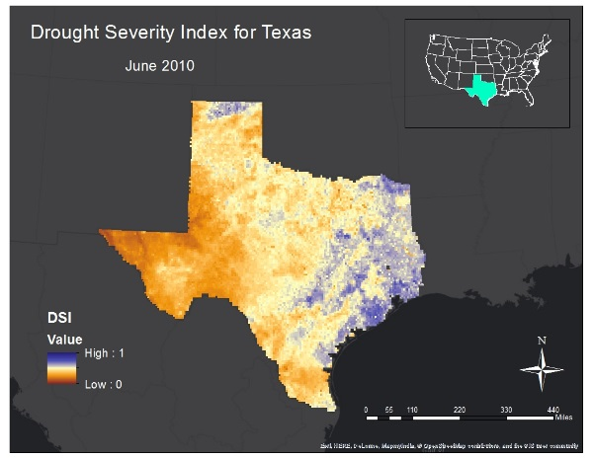 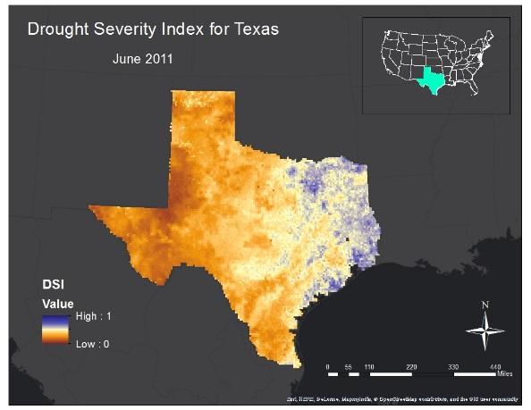

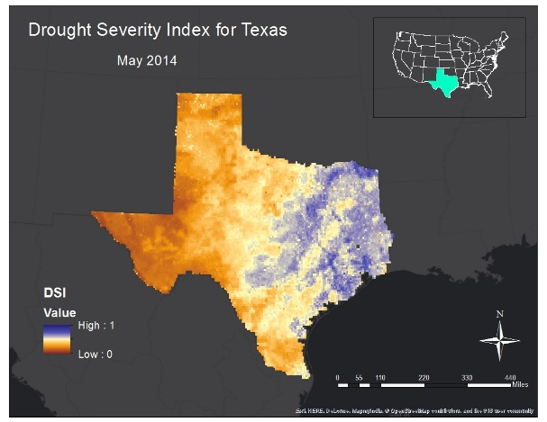 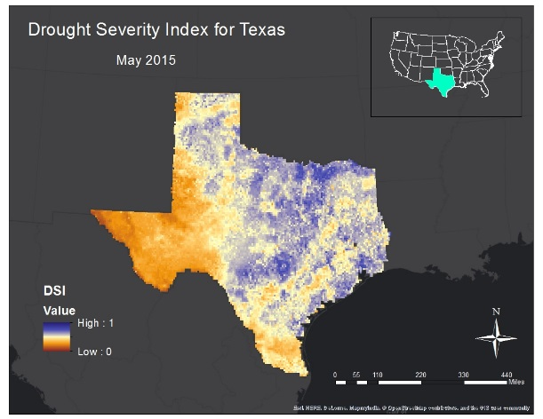

## Figure 4: In Appendix A, the summer months for each year in the study period reflect the change in the impact of drought conditions on various regions throughout the state. In the images above, the DSI reflects the increase in drought conditions within the state from June 2010 to June 2011. From May 2014 to May 2015 however, the western and northern regions were greatly alleviated of their dry spell after the rainstorms that occurred during May of 2015. In consideration of these results, it is clear that the DSI mirrors the environmental circumstances affecting Texas historically.

## 

## Table 1: The six classifications, ranging in numerical values from zero to one, identify areas low in value and dry, as well as areas high in value and wet. Blue areas reflect adequate to slightly lacking moisture levels while the pale yellow to brown colors indicate areas of concern and potential wildfire risk. This classification scheme was adopted from Rhee, et al (2010).

Scatter plots and correlation coefficient *r2*  figures were calculated with three different weight values and applied to Redberry Juniper and Loblolly Pine FMC measurements (Appendix B). After applying Weight 1, the resulting *r2* values from Redberry Juniper were quite high from 2010-2011 at 73%, however, the latter years of 2014-2015 were quite low at 0.04%. Similarly, the Loblolly Pine results contain values averaging 3% in the earlier period and 44% in the latter years. Weight 2 had the worst r2 values, with some of those values remaining unchanged while others drastically weakened. Finally, the last two charts were calculated using Weight 3, which was determined to have the most significant relationship of the three weights used as it correlated to the FMC with much higher *r2* values in 2014-2015 for Redberry Juniper and 2010-2011 for Loblolly Pine. However, the opposing years decreased slightly by a few percentage points. We believe the reason for these differentiations are due to the weight emphasis placed on vegetation and soil moisture. Greater soil moisture weight, in particular, seems to improve the *r* values to a certain degree. There was a trend identified, however, between the different weight values. The spring season months were found to have a greater correlation with live fuel moisture data compared to the summer, fall and winter months. This could be because Spring is the start of some species’ blooming season where moisture is of importance.

Unfortunately, the reasons for the lack of correlations in portions of the graph could be numerous. The downward trend line of the Loblolly Pine could be an indication of the health of the forest. Stressed pine species that have been infested with the blue stain fungus carried by the Mountain Pine Beetle, for example, can penetrate the phloem and xylem of the trees thereby disrupting transpiration processes until the their deaths years later (Wulder, 2006). Therefore, even in wet conditions, it is possible that the trees involved in this study were incapable of absorbing adequate moisture. These speculations are plausible and more information would be needed to pinpoint the disruptions in the relationship between drought severity and live fuel moisture content. However, the previously mentioned seasonal trend is a great factor derived from this project that can be further analyzed to help the Texas Forest Service use our project as a specialized index.

## ***Errors & Uncertainty***

Aqua/Terra MODIS functions at a 250 m2 – 1 km2 spatial resolution, a much less coarse visual display than the 13.75 km2 resolution of the NLDAS. This discrepancy may cause local scale accuracy errors in the final product. Past studies have criticized the MPE for underestimating precipitation values (Westcott, Knapp, Hilberg, 2007). Moreover, MPE sensors, which rely on Next-Generation Radar (NEXRAD) data, are susceptible to the typical errors common to weather radar. These errors include large radar scans that result in average precipitation levels in a 16 km2 area, bright banding, low topped convection, and the accuracy of the reflectivity-rainfall algorithm (NOAA NWS, 2013).

Since fuel moisture content measurements were taken from merely two coniferous species, Redberry Juniper and Loblolly Pine, the *r2* values between the DSI and the FMC could alter drastically for grassland species. Such species would include Buffalo and Johnson grass, which can stimulate fast-burning, “crawling” fires on the land surface (citation). Including grasses in a study of this nature would be beneficial in determining the correlation between the FMC and the DSI. Additionally, the water requirements for vegetation during the cooler seasons could be significantly less than in the warmer seasons, particularly with Juniper species which tend to be drought-hardy (Sandoval). With this in mind, high soil moisture levels during temperate winter conditions may not directly reflect in the moisture absorbed by the tree.

The summer months in 2010 do not correlate particularly well in comparison to the summer months in 2011 due to the abundant amount of cloud cover in the former year. Estimations used to fill in the null values may have led to inaccuracies reflected in the scatter plot graphs.

Easily the greatest concern is the applicability of the SDCI model in the DSI equation to the ecological regions existing within Texas. The SDCI values were developed for use within four separate states – two states for arid environments and two states for humid environments, according to the article published by Rhee et al. (2010). Despite their close proximity to the area of study, Arizona, New Mexico, and the Carolinas, these environments may not accurately resonate with the coefficients that are needed for the unique regions in Texas.

## ***Future Work***

According to the European Spread project, vulnerabilities to wildfire disasters are equally as important as the ignition potential when developing a fire risk map (Chuvieco et al., 2009). Therefore, future studies should include the proximity of easily ignitable vegetation to residential and urban areas where populations are threatened should a wildfire occur. The DSI can be used in this regard to specific areas with high urban populations located in areas with ignitable vegetation.

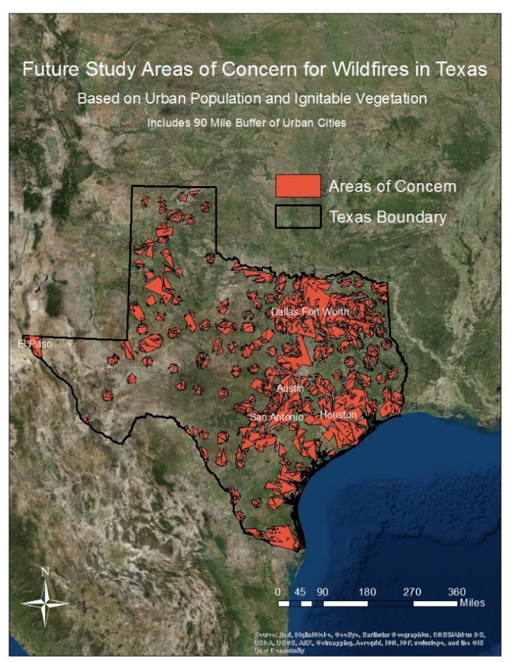

Figure 4: A map showing possible future study areas of concern in red. These are based on ignitable vegetation in a 90 mile proximity to major urban areas.

Furthermore, forthcoming DEVELOP teams who become responsible for the continuation of this project, will have access to NASA’s first Earth-observing satellite designed to obtain soil moisture data. In light of this, the Soil Moisture Active Passive (SMAP) could very well replace the NLDAS component of the DSI. Unfortunately, due to an investigation into a likely electrical malfunction, SMAP could be limited to passive microwave capabilities, and may be unable to calibrate its readings via radar mechanisms(citation). SMAP scientists are unsure whether or not the data collected will be affected by this malfunction.

# V. CONCLUSIONS

As one of the major agricultural hubs of the United States, Texas’ commercial production of livestock, wheat, corn and hay were devastated by the drought over the last five years. While water demands are expected to decrease for irrigation purposes due to the implementation of drip systems over the next forty-five years, municipality demand would increase by 73.5%, while manufacturing needs are predicted to rise by 121% (Combs, 2012). With this forecast in mind, it should be evident that water resources will continue to be an essential component in the economic future of the state. Despite the recent rains in May of 2015, the history of drought in Texas insist that we learn from the past in order to prepare for a similar event in the years to come. The Drought Severity Index can help in that regard by identifying areas of concern and allowing decision makers to allocate resources where they are needed most.

Despite inconsistencies in the correlation graphs between the DSI and the FMC, this study has laid the foundation for forthcoming work that involves a focus on the importance of soil moisture in dry conditions and how SMAP may play a role in determining prospective trends in wildfire risk. Although there were some inconsistent correlations with Live Fuel Moisture data, the Texas Water Resources team identified a trend within some of the correlations. The spring season months were found to be of a higher correlation compared to the other seasons of the year. This discovery within the DSI should be researched more in depth as it can be a starting point to help further this index’s credibility.

The trend of higher correlations in the spring season is of importance from this project and could potentially be investigated more thoroughly. The DSI could also be correlated with the Soil Climate Analysis Network (SCAN) developed by the Natural Resources Conservation Service (NRCS). Collecting remote station data from SCAN for precipitation, soil moisture and soil temperature, and comparing these values with those obtained for the DSI, could very well contribute to the DSI’s legitimacy as a tool for future applications. It should also be noted that there are multiple weights that could be given for each of the four variables included in the DSI, and the Texas Water Resource team invites researchers and scientists alike to continue to experiment with these weights in their own work.

“*Unless you try to do something beyond what you have already mastered, you will never grow.”*

* *Ralph Waldo Emerson*

# VI. ACKNOWLEDGMENTS

The Texas Water Resources team would like to thank the following contributors for taking the time to lend their expertise towards this project:

Dr. Kenton Ross (NASA DEVELOP, National Science Advisor)

Curt Stripling (Texas Forest Service, Geospatial System Coordinator)

Tom Spencer (Texas Forest Service, Department Head of Predictive Services)

Emily Adams (NASA DEVELOP LaRC Center Lead)

Lance Watkins (NASA DEVELOP National Program, Geoinformatics/Center Lead)

Grant Mercer (University of Nevada – Las Vegas)

Rocky Garcia (City University of New York)

Jeff Ely (NASA DEVELOP Geoinformatics Fellow)

Tiffani Miller (NASA DEVELOP, Project Coordinator Senior Fellow)

This material is based upon work supported by NASA through contract NNL11AA00B and cooperative agreement NNX14AB60A.

# VII. REFERENCES

Chuvieco, Emilio, Inmaculada Aguado, Marta Yebra, Héctor Nieto, Javier Salas, M. Pilar Martín, Lara Vilar, Javier Martínez, Susana Martín, Paloma Ibarra, Juan De La Riva, Jaime Baeza, Francisco Rodríguez, Juan R. Molina, Miguel A. Herrera, and Ricardo Zamora. "Development of a Framework for Fire Risk Assessment Using Remote Sensing and Geographic Information System Technologies." *Ecological Modelling* 221.1 (2010): 46-58. *Elsevier*. Web. 24 June 2015.

Cleaveland, Malcolm K., Todd H. Votteler, Daniel K. Stahle, Richard C. Casteel, and Jay L. Banner. "Extended Chronology of Drought in South Central, Southeastern, and West Texas." *Texas Water Journal* 2.1 (2011): 54-96. Dec. 2011. Web. 8 July 2015. <https://journals.tdl.org/twj/index.php/twj/article/view/2049/5840>.

Combs, Susan. "The Impact of the 2011 Drought and Beyond." *The Impact of the 2011 Texas Drought and Beyond*. Texas Comptroller of Public Accounts, 06 Feb. 2012. Web. 09 June 2015. <http://comptroller.texas.gov/specialrpt/drought/>.

Fannin, Blair. "Texas Agricultural Droght Losses Reach Record $5.2 Billion." *AgriLife Today*. Texas AgriLife Extension Office, 17 Aug. 2011. Web. 24 June 2015. <http://today.agrilife.org/2011/08/17/texas-agricultural-drought-losses-reach-record-5-2-billion/>.

# Fulton, Richard. "Multisensor Precipitation Estimator (MPE) Workshop." *National Weather Service Training Center* (n.d.): n. pag. 14 Dec. 2005. Web. 10 June 2015. <http://www.nws.noaa.gov/oh/hrl/papers/wsr88d/MPE_workshop_NWSTC_lecture2_121305.pdf>.

Griffith, Glenn, Sandy Bryce, James Omernik, and Anne Rogers. "Ecoregions of Texas." *Western Ecology Division*. Environmental Protection Agency, 27 Dec. 2007. Web. 10 June 2015. <ftp://ftp.epa.gov/wed/ecoregions/tx/TXeco_Jan08_v8_Cmprsd.pdf>.

Justice, C.O, J.R.G Townshend, E.F Vermote, E. Masuoka, R.E Wolfe, N. Saleous, D.P Roy, and J.T Morisette. "An Overview of MODIS Land Data Processing and Product Status." *Remote Sensing of Environment* 83.1-2 (2002): 3-15. Web. 23 June 2015.

Nielson-Gammon, John W. "The 2011 Texas Drought." *Texas Water Journal* 3.1 (2012): 59-95. 01 Nov. 2012. Web. 9 June 2015.

NWS Internet Services Team. "Quality of Data." *AHPS Precipitation Analysis*. National Weather Service, 25 June 2014. Web. 10 June 2015. <http://water.weather.gov/precip/about.php>.

"Ralph Waldo Emerson." BrainyQuote.com. Xplore Inc, 2015. 14 July 2015. http://www.brainyquote.com/quotes/quotes/r/ralphwaldo121506.html

Rhee, Jinyoung, Jungho Im, and Gregory J. Carbone. "Monitoring Agricultural Drought for Arid and Humid Regions Using Multi-sensor Remote Sensing Data." *Remote Sensing of Environment* 114.12 (2010): 2875-887. *Elsevier*. Web. 10 June 2015.

Rodell, Matthew. "NLDAS-2 Model Data Description/Information." *LDAS | Land Data Assimilation Systems*. National Aeronautics and Space Administration, 29 May 2015. Web. 23 June 2015. <http://ldas.gsfc.nasa.gov/nldas/NLDAS2model.php>.

Rubenstien, Carlos. Texas Commission on Environmental Quality, testimony before a joint hearing of the Senate Natural Resources and Agriculture and Rural Affairs committees, Austin, Texas, November 2, 2011.

Sandoval, Stephani. "Common Conifers in New Mexico Landscapes." *New Mexico StateUniversity Cooperative Extension Service* (n.d.): n. pag. Web. 14 July 2015. <http://aces.nmsu.edu/ces/forestry/documents/treeid.pdf>.

Savtchenko, A., D. Ouzounov, S. Ahmad, J. Acker, G. Leptoukh, J. Koziana, and D. Nickless. "Terra and Aqua MODIS Products Available from NASA GES DAAC." *Advances in Space Research* 34 (2004): 710-14. *Science Direct*. Web. 23 June 2015.

Wang, Lingli. *Remote Sensing Techniques for Soil Moisture and Agricultural Drought Monitoring*. Diss. George Mason U, 2008. Ann Arbor: Proquest Information and Learning, 2008. *Literature Online [ProQuest]*. Web. 9 June 2015.

*Water for Texas: Summary of the 2011 Regional Water Plans*. Austin, Tex. (P.O. Box 13087, Austin 78711): Texas Dept. of Water Resources, 1984. Texa Water Development Board, 20 Jan. 2011. Web. 24 June 2015. <http://www.twdb.texas.gov/waterplanning/rwp/regions/doc/2011RWPLegislativeSummary

Watkins, Lance, Jerrod Lessel, Alxandra Perillo, and Kenton Ross. *Great Plains Agriculture: Monitoring Rangeand Loss Due to Changing Precipitation Regimes for Enhanced Range Management in the Great Plains*. Tech. Langley: NASA DEVELOP Ntional Program, 2013. Web. 15 June 2015.

Westcott, Nancy E., H. Vernon Knapp, and Steven D. Hilberg. "Comparison of Gage and Multi-sensor Precipitation Estimates over a Range of Spatial and Temporal Scales in the Midwestern United States." *Journal of Hydrology* 351.1-2 (2008): 1-12. *Science Direct*. Web. 10 June 2015.

Williams, Jerry, Dorothy Albright, Anja Hoffmann, Andrey Eritsov, Peter Moore, Jose De Morais, Mchael Leonard, Jesus San Miguel-Ayanz, Gavriil Xanthopoulos, and Pieter Van Lierop. "Findings and Implications from a Coarse-Scale Global Assessment of Recent Selected Mega-Fires." *Fire Management* (2012): n. pag. 27 Mar. 2012. Web. 24 June 2015. <http://www.fao.org/forestry/32063-0613ebe395f6ff02fdecd13b7749f39ea.pdf>.

Wu, Di. "Assessing Drought in Agricultural Area of Central U.S. with the MODIS Sensor." (2012): n. pag. *Inernational Symposium on Synergistic Approaches to Foodand Water Security*. George Mason University, 17 Oct. 2012. Web. 24 June 2015. <http://wamis.cos.gmu.edu/ISSAFWS/ppt/session2_1_Wu.pdf>.

Wulder, M., White, J., Bentz, B., Alvarez, M., & Coops, N. (2006, February 3). Estimating the probability of mountain pine beetle red-attack damage. Retrieved April 23, 2015, from http://www.sciencedirect.com/science/article/pii/S0034425705004220

Xia, Youlong, Kenneth Mitchell, Michael Ek, Brian Cosgrove, Justin Sheffield, Lifeng Luo, Charles Alonge, Helin Wei, Jesse Meng, Ben Livneh, Qingyun Duan, and Dag Lohmann. "Continental-scale Water and Energy Flux Analysis and Validation for North American Land Data Assimilation System Project Phase 2 (NLDAS-2): 2. Validation of Model-simulated Streamflow." *J. Geophys. Res. Journal of Geophysical Research* 117.D3 (2012): n. pag. *Journal of Geophysical Research*. Web. 22 June 2015.

# **VIII. Content Innovation**

Interactive Map Viewer

Virtual Poster Session

# **IX. Appendix**

## ***Appendix A***

**May 2010 – October 2011**

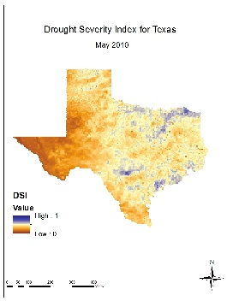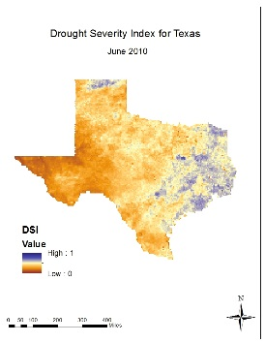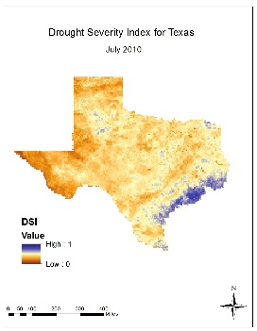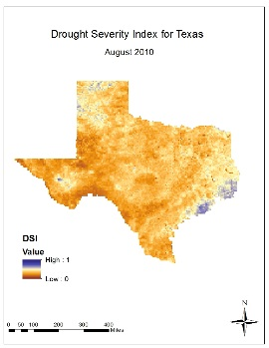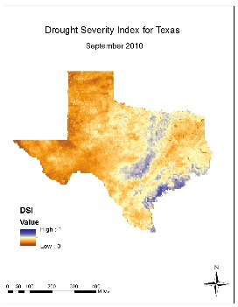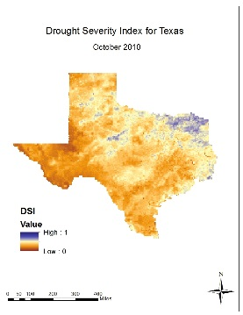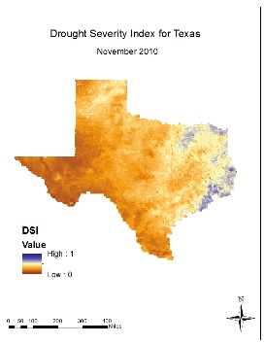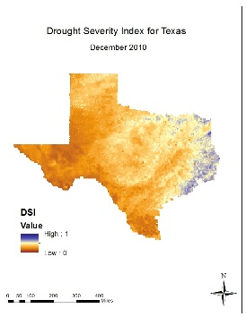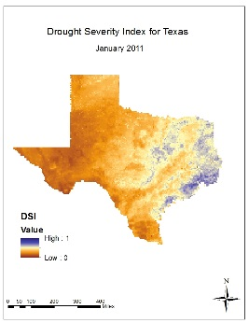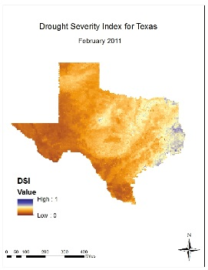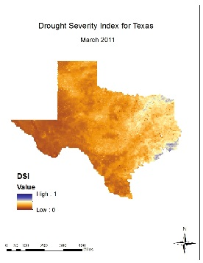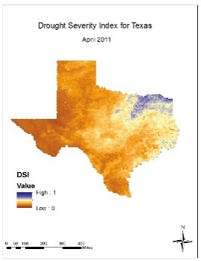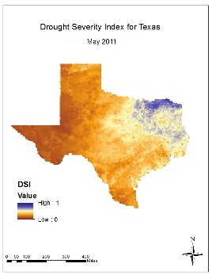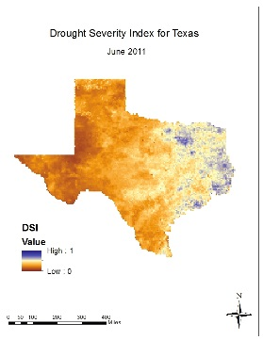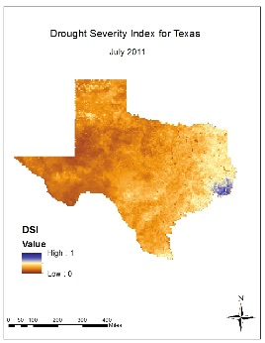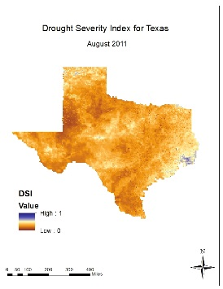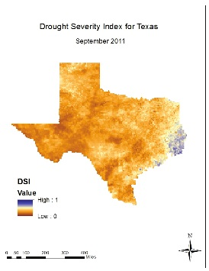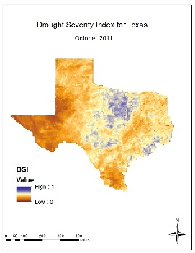

**May 2014 – June 2015**

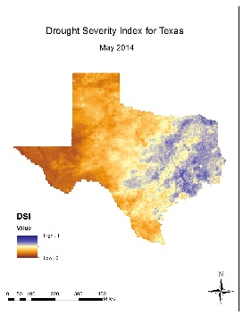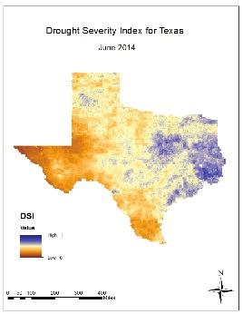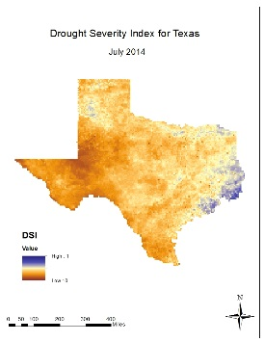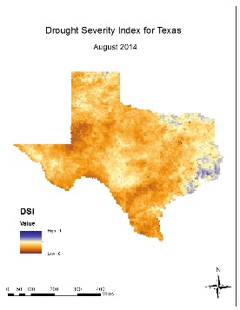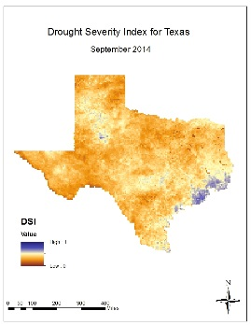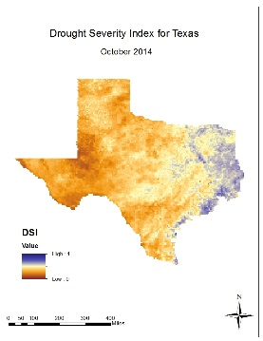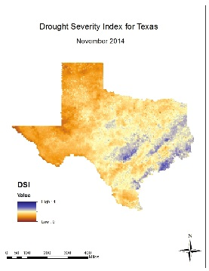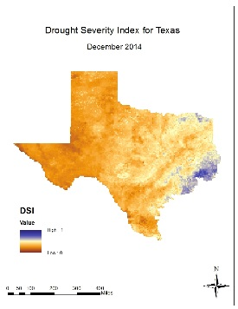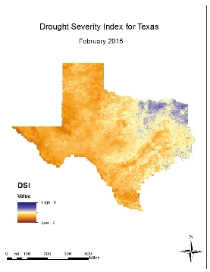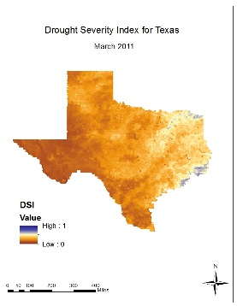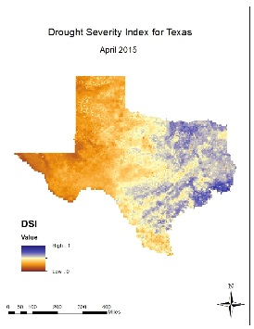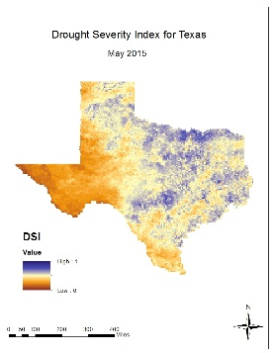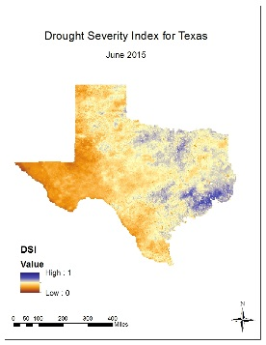

## ***Appendix B***

**Weight 1: 30% NLDAS + 30% NDVI + 30% MPE + 30% LST**

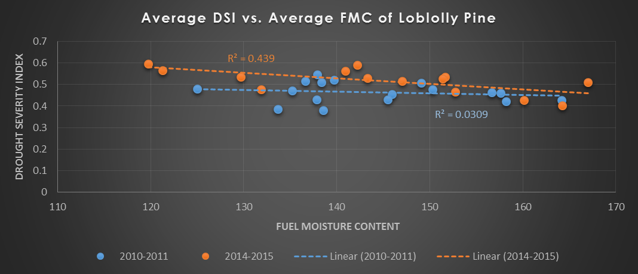

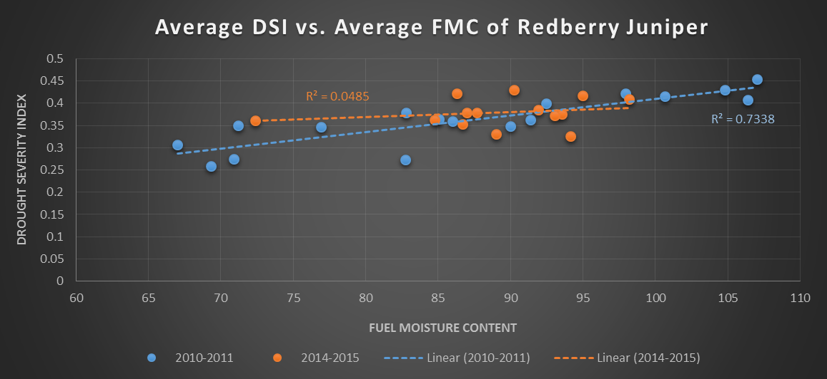

**Weight 2: 25% NLDAS + 25% NDVI + 25% MPE + 25% LST**

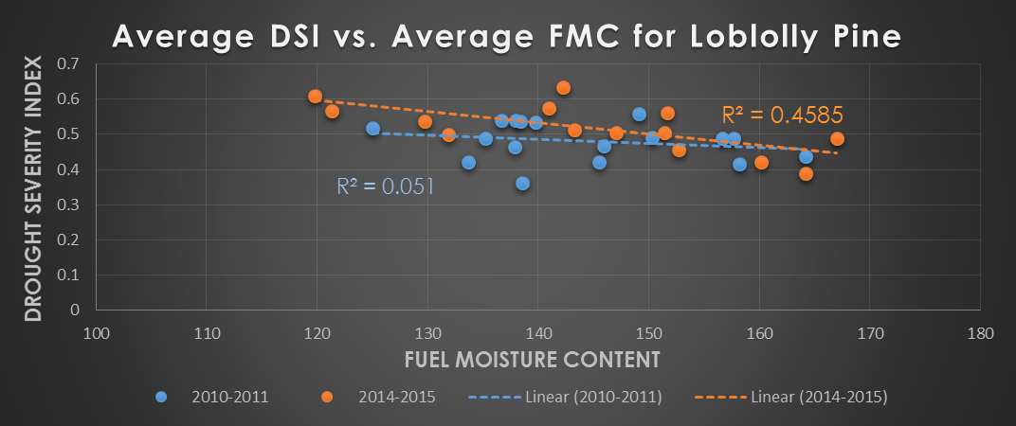

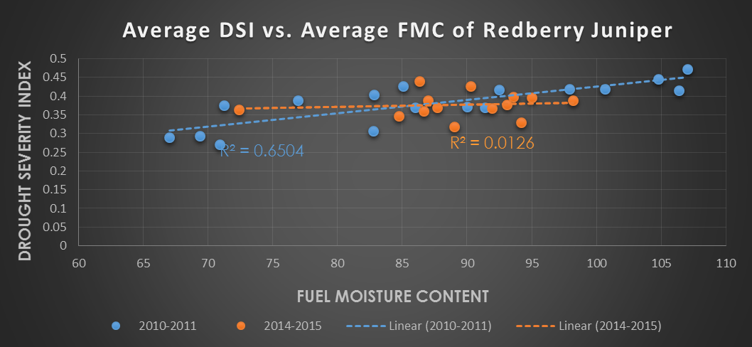

**Weight 3: 40% NLDAS + 30% NDVI + 20% MPE + 10% LST**

