**Node:** Node Name (EX. Virginia – Langley)

**Title:** What is the title of your StoryMap, Use Title Case (EX. Environmental Stressors Impacting Northern Forest Sugarbush)

**Point of Contact (POC):** Name, email (do not use your ssai email)

**\***For the outline you will include each section/tab header that will go in the StoryMap. Under that section you will include a description of what content will go there. If you have an image or map you can include it on this document.

**\*NOTE:** The transcript will be submitted separately. This should be all text that you plan to include in the StoryMap.

**Example:**

Opening

* Title: Environmental Stressors Impacting Northern Forest Sugarbush
* Team Names below the title: John Smith, Thomas Oliver, Erin Rogers, Jane Williams
* Picture of the study area will be in the background

Introduction

* Image of maple trees.

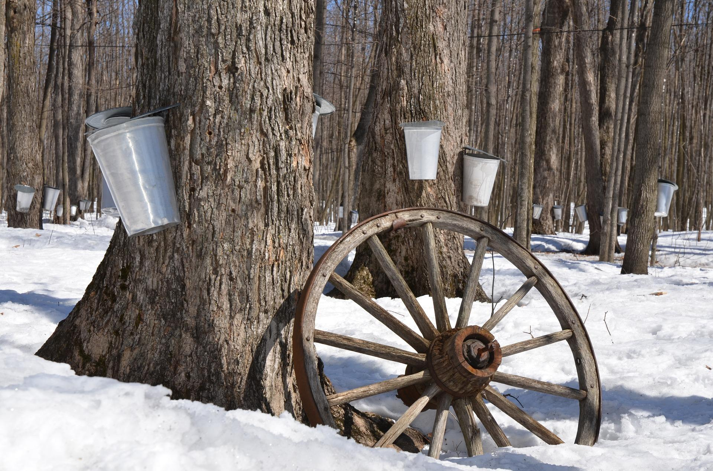

* Image credit: Diapicard
* Background of the project
* Community concerns