New York Ecological Forecasting II
Comparing the Efficiency of Space-Based Imagery to AVIRIS Airborne Data for the Identification of Hemlock Forests to Mitigate Invasive Species Expansion


Technical Report
Final Draft – August 8th, 2019

Rya Inman (Project Lead)
Abigail Barenblitt
Ryan Hammock
Niharika ‘Chitra’ Kokkirala

Dr. Ezra Schwartzberg, Adirondack Research, LLC (Science Advisor)
Dr. Jennifer Pontius, University of Vermont (Science Advisor)

Previous Contributors:
Dr. Sara Lubkin
Sean McCartney
Madeline Ruid
Rachel Soobitsky
Ariel Walcutt

1. Abstract
Hemlock woolly adelgid (HWA; Adelges tsugae) is an invasive species that threatens eastern hemlock (Tsuga canadensis) in US forests. Eastern hemlock has a greater capacity to store carbon, regulate stream temperatures, and provide habitat for wildlife compared to sympatric tree species. The New York Ecological Forecasting II team partnered with the New York State Department of Environmental Conservation’s Partnership for Regional Invasive Species Management, Adirondack Park Invasive Plant Program (APIPP) and Partnership for Regional Invasive Species Management, Saint Lawrence – Eastern Lake Ontario (SLELO PRISM), Adirondack Research, Cornell University, and the University of Vermont to support their hemlock conservation efforts. APIPP and SLELO currently lack detailed location data on hemlock stands. We created four hemlock distribution maps modeled using a random forest (RF) classifier in Google Earth Engine (GEE), each using data from either Landsat 8 Operational Land Imager (OLI) or Sentinel-2 Multispectral Imager (MSI), as well as variables closely linked to hemlock habitat (e.g. elevation, aspect, distance to nearest stream, soil moisture, soil acidity, land cover type). Ground-surveyed hemlock presence points allowed the team to train and validate these models and compare the accuracy of previous Airborne Visible/Infrared Imaging Spectrometer (AVIRIS) models to satellite-based models. Our team then used ancillary datasets, including HWA presence data and temperature projections, to predict hemlock mortality in New York through 2049. These maps aim to improve APIPP’s and SLELO’s current hemlock inventories and HWA early detection efforts. Hemlock distribution maps created from OLI and MSI provide more efficient, repeatable models of hemlock distribution than those created with AVIRIS data alone. Our forecasting model also supports predictions that HWA spread will result in decreased hemlock populations across New York State through 2049.

Keywords
remote sensing, Landsat 8, Sentinel-2, species distribution, eastern hemlock (Tsuga canadensis), hemlock woolly adelgid (Adelges tsugae)

2. Introduction

  - Background Information
The hemlock woolly adelgid (Adelges tsugae) – hereafter HWA – is an invasive species that is decimating eastern hemlock (Tsuga canadensis) tree populations across the eastern United States. HWA has spread rapidly throughout the Northeast since its unintentional introduction to the region in the 1980s (Pontius, Hallett, & Martin, 2005). HWA feeds on stored starch and disrupts the nutrient flow to the branches and needles of hemlock, ultimately leading to hemlock mortality in 4 to 6 years after initial contact (McClure, 1991). The loss of this keystone species could result in changes to their ecosystem services and US forest composition.

Previous studies of HWA have demonstrated the declining abundance of hemlock-associated species, such as black-throated green warbler, blackburnian warbler, and hermit thrush as hemlock populations decline (Tingley, Orwig, Field, & Motzkin, 2002). As a late-successional species, hemlock retains lower branches, creating complex vertical structures throughout the height of the tree (DeGraaf, Yamasaki, Leak, & Lanier, 1992). Consequently, their dense canopies provide shady, cool shelter and protection for many species (Pontius, Hallett, & Martin, 2005). The loss of hemlock as a dominant forest species impacts carbon storage within forested ecosystems. These long-lived trees have the potential to store larger quantities of carbon through biomass, leaf litter, and soil for long periods of time compared to other species found in the same ecosystems (Finzi, Breemen, & Canham, 1998). Projections of hemlock loss over a 150-year period indicate that as hemlock is lost, total carbon storage in forests decreases (Krebs, 2014). Hemlock also helps regulate thermal and hydrologic regimes within forests. Streams co-located with hemlock stands tend to be cooler in summer and warmer in winter, leading to higher species richness in these streams and more stable habitats for aquatic species such as brook trout (Snyder, Young, Ross, & Smith, 2005).

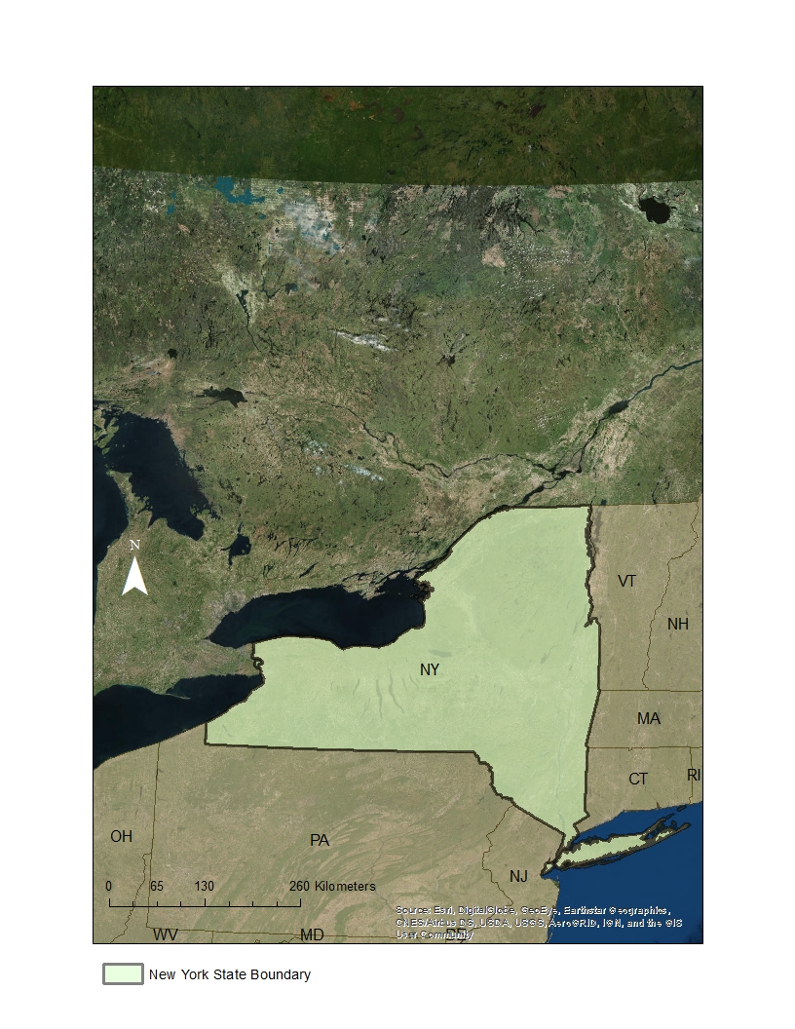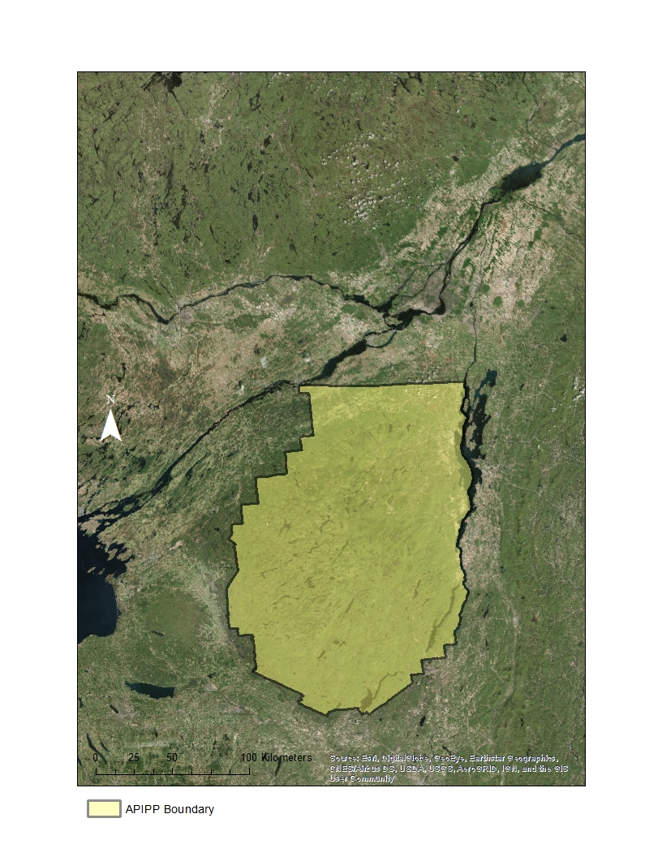
Figure 1. This is a map of the study area, including New York State (left) and an inset of the Adirondack Park region (APIPP jurisdiction) (right).
A previous DEVELOP project conducted in spring 2017 used Airborne Visible/Infrared Imaging Spectrometer (AVIRIS) imagery from a 2009 flight and ancillary datasets to create a hemlock stand distribution map and a habitat suitability and infestation risk map for HWA. The temporal scope of the study ranged from January 2016 to January 2017 but included remote sensing data from as early as 2009 (AVIRIS), as well as scenes collected from 2016 (Landsat 8 Operational Land Imager [OLI], Sentinel-2 Multispectral Imager [MSI]) in their analyses (Ruid, Lubkin, McCartney, Soobitsky, & Walcutt, 2017). To forecast the spread of HWA through 2035, the previous team used the TerrSet Maximum Entropy (MaxEnt) species distribution model. The original study area from spring 2017 covered 45,000 km² of the Adirondack and Tug Hill regions of upstate New York (NY) (Figure 1).

This study expanded upon the 2017 project to examine the efficacy of using satellite data to create a similar hemlock distribution map, as satellite sensors are continuously transmitting new data that are more cost-effective for end-users than AVIRIS data. While AVIRIS can provide highly detailed spectral data, AVIRIS flights must be commissioned for each study region and time period. The present study examined the entirety of New York State (Figure 1) from January 2016 to January 2019. Our team investigated the potential of three satellites for this study: Landsat 8 OLI, Sentinel-2 MSI, and Terra Advanced Spaceborne Thermal Emission and Reflection Radiometer (ASTER). Each of these satellites provide free, moderate spatial and temporal resolution data that could prove effective for creating a distribution model for a species of interest. There is a high potential for using remote sensing to detect the spectral signature of coniferous species (Stenberg, Mõttus, & Rautiainen, 2008). Additionally, previous work has shown that satellites can create hemlock distribution maps that are at least 72% accurate (Kong, Fei, Rieske, & Obrycki, 2008). Forest managers are interested in not only accessing better tools for locating hemlock stands but also understanding how HWA will affect the overall distribution of hemlock in the long term. Therefore, this study also projected the impact of HWA on hemlock distribution in New York State through 2049. We chose to forecast our model 30 years in the future to allow for at least five cycles of hemlock die-off.

  - Project Partners & Objectives
The two primary end users are the New York State Department of Environmental Conservation, Partnership for Regional Invasive Species Management, Saint Lawrence – Eastern Lake Ontario (SLELO) and the Adirondack Park Invasive Plant Program (APIPP). APIPP and SLELO are two of eight Partners for Regional Invasive Species Management (PRISMs) in New York State. The central objective of this project was to map eastern hemlock distribution across New York State in order to create a guide for local partners to prioritize hemlock-rich areas in their efforts to detect and mitigate HWA infestation. The partners currently use on-the-ground observations to survey hemlock. However, hemlock grows in patches dispersed across a large landscape making ground observations particularly difficult without an accurate guiding map. The partners are interested in using NASA Earth observations (EO) to create more accurate, cost-effective hemlock distribution maps, with the goal of achieving a model that is 80% accurate. The partners will benefit from a repeatable methodology that will allow them to expand upon the current findings through additional ground survey points. Having a statewide distribution model to inform their on-the-ground efforts will help them focus their efforts more effectively. In addition, forecasting the effect of HWA on hemlock distribution through 2049 should aid the project partners in anticipating future shifts in tree species composition.

3. Methodology

3.1 Data Acquisition
All data acquisition, processing, and analyses were performed within the Google Earth Engine (GEE) JavaScript Application Programming Interface (API). We chose to process all data using GEE as this is a freely available and powerful resource for processing GIS and remote sensing data. This makes our tool available to users without the purchase of specialized software. This project acquired multiple EO datasets, including Landsat 8 OLI, Sentinel-2 MultiSpectral Instrument (MSI), and Terra ASTER (Table 1). In our model, we included a number of parameters that may predict hemlock presence according to previous literature (Table 2) (Kong, Fei, Rieske, & Obrycki, 2008). We used the NASA Shuttle Radar Topography Mission (SRTM) Digital Elevation Model (DEM) in GEE to derive elevation and aspect and Soil Moisture Active Passive (SMAP) to derive soil moisture. Hydrography data from the New York State GIS Program Office provided the information needed for determining the distance to the nearest stream. We used the National Cooperative Soil Survey SSURGO database to acquire soil information. To incorporate climate into the model, our team used the average annual minimum and maximum temperature estimates from NASA Earth Earth Exchange (NEX) Downscaled Climate Projections. We constrained each of these parameters based on information from the US Forest Service descriptions of hemlock habitat requirements (Carey, 1993). The constraints on our parameters included elevations of 730 m or below, north and northwest facing aspects, soil moisture profiles of 50% or greater (moist soils), soil acidity with a pH of 6.5 or lower (acidic soils), and areas with a landcover type indicating forested regions. We created a distance to stream band using the hydrography data by calculating the Euclidean distance to stream vector data and creating a raster file in ArcMap. This information was later included as a band in our final model to demonstrate the negative correlation between hemlock presence and distance to stream (Carey, 1993).

Table 1
List of satellite observations acquired
Platform | Sensor | Level | Google Earth Engine ImageCollection IDs
Landsat 8 | Operational Land Imager (OLI) | Tier 1 | LANDSAT/LC08/C01/T1_SR
Sentinel-2 | MultiSpectral Instrument (MSI) | 1C | COPERNICUS/S2
Terra | Advanced Spaceborne Thermal Emission and Reflection Radiometer (ASTER) | L1T | ASTER/AST_L1T_003
Space Shuttle Endeavour | Shuttle Radar Topography Mission (SRTM) | V3 | USGS/SRTMGL1_003
SMAP | Soil Moisture Active Passive  (SMAP) | 3 | NASA_USDA/HSL/SMAP_soil_moisture

Table 2
Ancillary datasets incorporated into random forest model along with satellite data
Parameter | Resolution | Provider | Source | Constraints
Elevation | 30 m | NASA Jet Propulsion Lab | SRTM DEM | 0-730 m
Aspect | 30 m | NASA Jet Propulsion Lab | SRTM DEM | North/ Northwest
Distance to Nearest Stream | 30 m | New York State GIS Program Office | NY State Hydrography | N/A
Soil Moisture Profile | 0.25 arc degrees | Hydrological Science Laboratory (HSL) at NASA Goddard Space Flight Center | SMAP | >=50%
Soil Acidity | 30 m | Natural Resources Conservation Service  Soils, US Department of Agriculture | SSURGO | =<6.5
NLCD | 30 m | US Geological Survey | National Land Cover Database | 41 - Deciduous Forest, 42 - Evergreen Forest, 43 - Mixed Forest
Past, Present and Future Temperature Data | 25 arc seconds | NASA | NEX-DCP30 Downscaled Climate Projections | >20 °C

3.2 Data Processing
Our team obtained pre-processed satellite imagery through GEE. GEE provides access to a continuously updated database of satellite imagery, including NASA EO products from Landsat 8 OLI and Terra ASTER and ESA Copernicus Sentinel-2 MSI. Specifically, we used GEE to access Landsat 8 OLI atmospherically corrected surface reflectance (SR; “USGS Landsat 8 Surface Reflectance Tier 1”), Sentinel-2 MSI top-of-atmosphere (TOA) reflectance (“Sentinel-2 MSI: MultiSpectral Instrument, Level-1C”), and Terra ASTER at-sensor radiance (“ASTER L1T Radiance”) datasets. Before beginning data analysis, we chose to exclude Terra ASTER from our study. This was due not only to a lack of coverage across our New York State study region, but also the unavailability of data during the leaf-off period, which was instrumental to identifying evergreen vegetation. We chose to use Sentinel-2 TOA reflectance data because it was processed and available for four years, 2015-2019, and had less cloudy images, as opposed to Sentinel-2 SR. In contrast, we chose to use Landsat 8 SR data because it provided images for four years with atmospherically corrected images with less than 10% cloud cover. To forecast the effects of HWA spread on eastern hemlock, we first projected HWA spread to 2049 and subsequently determined the area of hemlock stands that would remain alive and unaffected. To do so, we used the same satellite imagery and ancillary datasets as in the distribution model plus NASA NEX-DCP30 climate data loaded into the model through GEE.

In order to maximize our training and validation data, we combined field survey points collected within the Adirondacks by our partners at Adirondack Research and APIPP with previously collected field survey points across New York State from the New York Natural Heritage Program (NYNHP). In order to align the attributes of each dataset for consistent processing in GEE, we reclassified the NYNHP percent hemlock canopy cover attribute to match the classes from the Adirondack Research dataset: 90-100% canopy cover translated to ‘Pure Hemlock,’ 50-89% translated to ‘Hemlock Dominant,’ 10-49% translated to ‘Hemlock Subdominant,’ and 0-9% translated to the ‘No Hemlock’ class.

3.3 Data Analysis
To create new distribution maps from the present study period (January 2016 to January 2019), our team used a random forest (RF) classification model in GEE. An RF model is a supervised machine learning algorithm, specifically a multiple regression tree model, which draws a bootstrap sample Z of size N from the provided training data, using random subsets of the data to construct each tree (Dunckel et al., 2015). Our team trained the RF model using 80% of the field data (APIPP: 80 points, NY: 268 points) provided by our project partners. We retained 20% of the field data (APIPP: 21 points, NY: 68 points) to be used for validating the final output of our model. We chose a split of 80:20 for our data, as this falls within the range of commonly used ratios in supervised machine learning applications (Kong et al., 2008; Clark et al., 2011), and we wanted to ensure adequate training with the limited number of points we had available.

In GEE, the RF classifier is applied to a single image from which the model classifies each individual pixel into classes as provided from the training data. Our single ‘image’ consisted of a stack of multiple data sources, including the Landsat 8 OLI or Sentinel-2 MSI mosaic and Euclidean distance to streams layer. Specific bands from this image are selected in order to instruct the model on which bands to analyze for the spectral signature of each feature class. In our model, the selected bands were the blue, green, red, near infrared, and appended ‘distance to streams’ bands (Landsat 8 OLI model: ‘B2’, ‘B3’, ‘B4’, ‘B5’, ‘ST’, respectively; Sentinel-2 MSI model: ‘B2’, ‘B3’, ‘B4’, ‘B8’, ‘ST’). This narrows the amount of data analyzed in the RF model to only the most important bands for identifying eastern hemlock spectrally.

After running the random forest model, the classified output raster is then masked according to the remaining hemlock habitat parameters. To isolate only evergreen vegetation, we masked leaf-off satellite imagery for areas with NDVI greater than 0 during that period, which would indicate areas of vegetation during the winter months. Additionally, we applied a mask for only Deciduous, Evergreen, and Mixed Forest classes in the NLCD layer. We restricted the SRTM elevation layer to mask out elevations above 731 m. We also masked out the SRTM aspect layer for only north and northwest aspects. For soil moisture, we masked the SMAP layer for soil moisture profile greater than or equal to 50%. We also masked the USDA SSURGO layer to include only soil acidity levels less than or equal to pH 6.5.

To validate the results from the spring 2017 term, our team used GEE to determine where data points collected in the field intersected with a predicted area of hemlock. We created a buffer with a radius of 10 m around each point and used a spatial join to isolate points that intersected with areas where hemlock was predicted to be present based on the model created in 2017. Field data points containing any degree of hemlock presence (“Pure Hemlock,” “Hemlock Dominant,” and “Hemlock Sub Dominant”) that coincided with predicted hemlock area from the AVIRIS-based map were counted positively toward the accuracy of the model. Field data points that contained no hemlock but coincided with predicted hemlock areas were counted negatively against model accuracy.

To validate the results of the 2019 satellite-based hemlock distribution models, we used two accuracy assessment techniques. We performed the same method as for AVIRIS, described in the paragraph above. We also ran a resubstitution accuracy assessment on the classification output in GEE for the 2019 satellite-based models. This consisted of substituting the 80% of our field data that we used to train the model back in to assess the extent that these points accurately corresponded to the output of the classification at their coincident pixel on the distribution map. This allowed us to assess how well the model output fit the original training data before conducting our accuracy assessment.

To forecast the impact of HWA on the distribution of hemlock into 2049, we chose two methods of forecasting. We refer to the first method as the overlay method. For this first method, we used the linear rate of expansion of HWA without consideration for other environmental factors to create a buffer that displayed the spread of HWA in New York State through 2049. We then used NASA NEX-DCP30 downscaled climate data to mask out areas that would be colder than -20°C, a temperature at which many HWA individuals cannot survive (Costa, Trotter, Montgomery, & Fortney 2008). While verbal communication with our project partners indicate that HWA may survive at temperature thresholds above -26°C, we chose the -20°C threshold based on previous literature. Finally, we used the output of our hemlock distribution model to mask out regions that would not support HWA populations.

We refer to the second method as the random forest method. For this second forecasting method, we took the present day distribution model of hemlock presence and added present day temperature projections to train a separate random forest classification algorithm. The random forest classification algorithm input consisted of the original New York State hemlock distribution model, past and present temperature projections using the NASA NEX-DCP30 downscaled climate data, and HWA presence points provided by iMAP invasives and USGS BISON. This input data helped train the random forest classification algorithm under present day conditions. The output from the random forest classification model was then paired with future NEX-DCP30 temperature projections through the year 2049 and parameters that originated from the original hemlock distribution model.

4. Results & Discussion

4.1 Analysis of Results
Within the study region used for the AVIRIS model, 21 of the 58 points intersected with predicted areas of hemlock (Table 3). Of the 58 points, 31 were correctly classified as hemlock present or absent according to the model results. This model is 53% accurate. We cannot establish a direct comparison of the accuracy of this model to the accuracy of the satellite-based models due to differences in initial model construction. The 2017 AVIRIS model does not incorporate any habitat parameters nor the 2018 surveyed forest plot data, making it difficult to draw conclusions from direct comparisons of the accuracy assessments conducted for each model. While the 2017 AVIRIS model was trained on a limited number of ground-truthed points, it was not trained on the same 268 points the satellite-based models were trained on, which could greatly improve the model.

Table 3
Results of accuracy assessment performed for 2017 AVIRIS model
Model | Total Points | Number of Matched Points | Accuracy
AVIRIS | 58 | 31 | 53%

The models derived from Landsat 8 and Sentinel-2 yielded distribution maps of hemlock in the three dominance classes included in the original training data (Figures 2 & 3). Based on the resubstitution error matrix, the Landsat 8 model created for both the APIPP and New York State regions had a training accuracy of 92%. The Sentinel-2 model created for the APIPP region had a training accuracy of 81%. Due to the storage size of the Sentinel-2 model, we were unable to calculate the training accuracy of this model when run across the entire New York State region due to GEE limitations. Therefore, we feel more confident about the results derived from Landsat 8 data. For the Landsat 8 model created for the APIPP region, 67% of the validation points were accurately classed for hemlock presence or absence (Table 4). However, only 52% of the validation points were accurately classed for hemlock dominance. When we extrapolated this model out to New York State, 52% of the validation points were accurately classed from hemlock presence or absence and 29% of the points were accurately classed for hemlock presence when divided into the three classes.

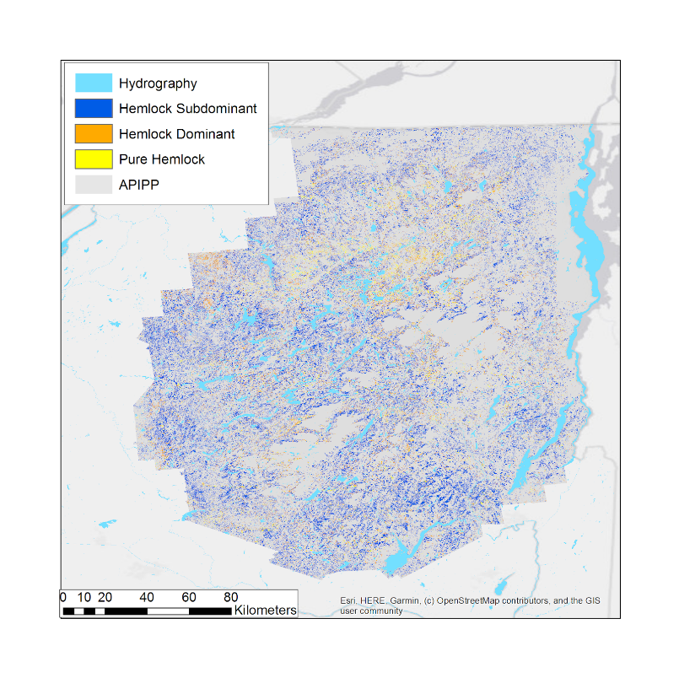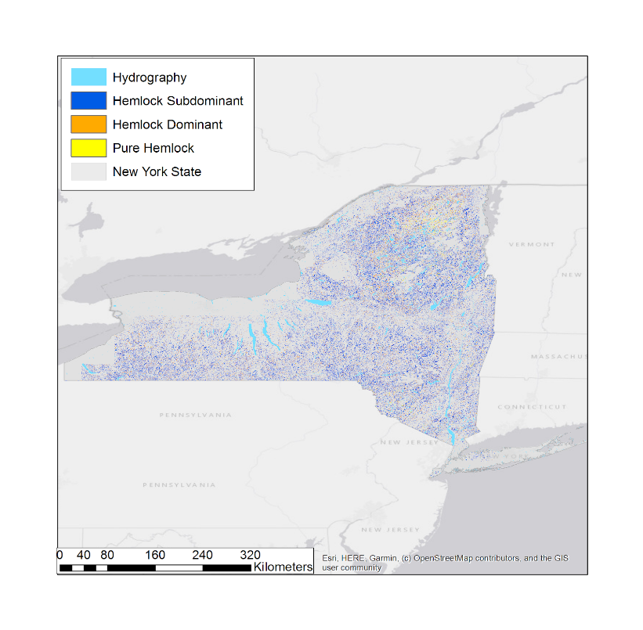
Figure 2. This is a map of the final hemlock distribution map predicted using Landsat 8 OLI data for the Adirondack Park region (APIPP jurisdiction) (left) and New York State (right). Full scale maps can be found in Appendix A (A1& A2 respectively). See Appendix A for full size images.

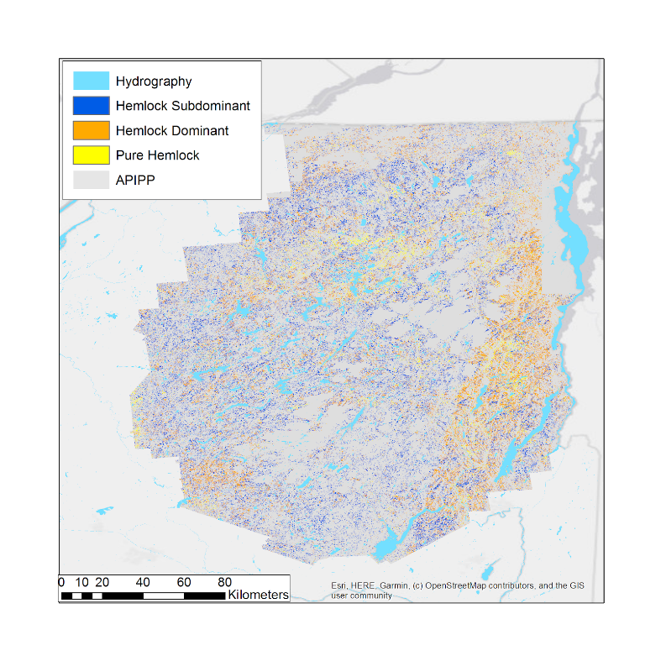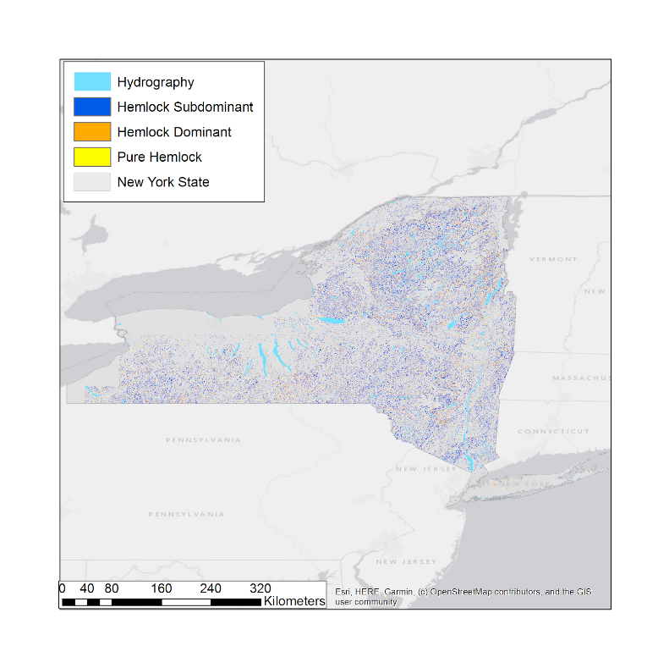
Figure 3. This is a map of the final hemlock distribution map predicted using Sentinel-2 MSI data for the Adirondack Park region (APIPP jurisdiction) (left) and New York State (right). Full scale maps can be found in Appendix A (A3& A4 respectively). See Appendix A for full size images.

From the Sentinel-2 model created for the APIPP region, 57% of the validation points were accurately classed for hemlock presence or absence and 43% of the points were accurately classed for hemlock dominance. When we extrapolated this model out to New York State, 50% of the validation points were accurately classed for hemlock presence or absence and 28% of the points were accurately classed for hemlock dominance (Table 4). In addition to the varying degree of accuracy between the Landsat 8 and Sentinel-2 model, we also noticed that the Sentinel-2 model classified a larger ratio of total hemlock stands as hemlock dominant stands compared to the Landsat 8 model. We believe that the difference in accuracy and dominance classification may be attributed to cloudier images retrieved from Sentinel-2 during our study period. Neither of these models achieved our partner’s goal of an 80% accurate model, which is likely due to a limited amount of training data. A power analysis would be necessary to determine the requisite number of points to achieve this level of accuracy.

Table 4
Results of accuracy assessment performed for 2019 Landsat 8 and Sentinel-2 models
Model | Number of Matched Points | Accuracy of Hemlock Dominance Predictions | Hemlock Presence/ Absence Accuracy
Landsat 8 APIPP | 14 | 52% | 67%
Landsat 8  New York State | 36 | 29% | 52%
Sentinel-2 APIPP | 12 | 43% | 57%
Sentinel-2  New York State | 34 | 28% | 50%

Finally, the results of our forecasting model were comparable between both methods of forecasting. Both the Random Forest model and the raster overlay methods yielded results demonstrating the spread of HWA, and therefore the decline of hemlock through much of New York State through 2049. However, both models clearly indicated that hemlock stands would likely remain intact in the northern regions of New York State, particularly in the vast majority of the APIPP region. These forecasting results indicate that while warming temperatures will likely lead to the decline of hemlock due to HWA, higher elevations within the Adirondacks region will likely allow hemlock to remain a dominant feature within these forests.

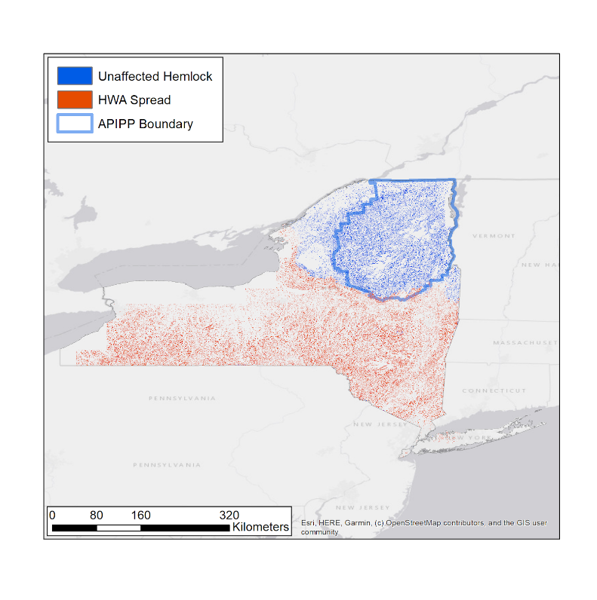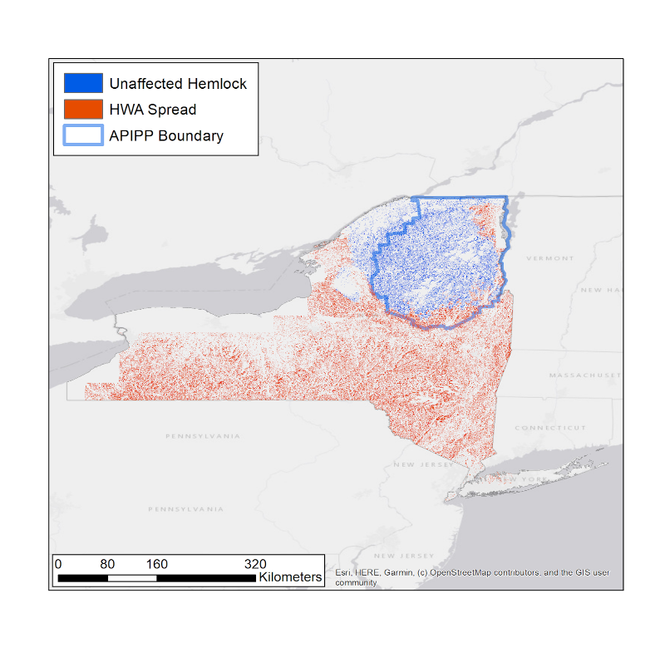
Figure 4. The forecasting model of hemlock distribution in 2049 after the effects of HWA spread based on the overlay methodology (left) and based on the random forest methodology (right). See Appendix A for full size images.

4.2 Future Work
The models created in this project are capable of adaptation to incorporate datasets acquired after this term, including higher-resolution remote sensing datasets as they emerge. NASA EOs that hold great potential for future application to this study include ICESat-2 LiDAR data, which can be especially useful once the satellite has completed an adequate number of orbits to thoroughly record data across New York State. At this point in time, ICESat-2 does not have adequate coverage across New York State to provide a complete picture of canopy structure.

Furthermore, a greater quantity and geographic distribution of field data of eastern hemlock presence and absence should help train the classification with a greater degree of accuracy. Not only would more field data better train the model, but they would provide a more statistically robust accuracy assessment. There is potential for retrieving additional points through the US Forest Service’s Forest Inventory and Analysis (FIA). FIA data can be obtained via an official Materials Transfer Agreement (MTA) process; however, this is a lengthy process that could not be completed within the length of this term. Within our project time period we were also unable to provide a power analysis of how many ground-truthed points would yield a more accurate model. Determining the number of points required to achieve a model with the desired accuracy of 80% is critical to helping our partners understand how much more ground-surveying is required. We hope that future work on this project will be able to provide this assessment.

Additional data may also help clarify differences between the Landsat 8 and Sentinel-2 derived maps. While the Landsat 8 model was more accurate based on our analyses, our project partners indicated that the region of hemlock dominant stands displayed in our Sentinel-2 model matches with distribution maps created by other government agencies. We were unable to account for this difference during this term. However, this would be an important feature to understand in the future.

For our forecasting component, our partners expressed interest in examining the effect of HWA on stream resilience. While we were unable to examine this relationship over the course of this term, this could be an important component for future forecasting analyses. Additionally, examining the impact of HWA on hemlock distribution at different temperature thresholds could provide our partners with better information about hemlock die-off in different scenarios.

Finally, the accuracy of the AVIRIS model was not directly comparable to the accuracy of the satellite-based models. The AVIRIS model created in 2017 did not include as much training data or habitat parameters in the model construction. We believe that including both of these aspects in the AVIRIS model would yield a more accurate model that is easily comparable to our satellite-based models.

5. Conclusions

Satellite-based models, such as the one we created, can be continuously updated and improved upon. We have created a model that can be continuously expanded with additional ground-truthing data and habitat parameters of interest. This demonstrates the feasibility of using satellite-based imagery to create publicly accessible habitat distribution models available to land managers and conservation organizations. Overall, Landsat 8 provided a more accurate basis for our model, whereas the feasibility of applying Sentinel-2 during our period of study was diminished due to cloudier imagery. While we also believe that the AVIRIS model would be improved by incorporating additional training data and habitat parameters into the model construction, satellite-based models use publicly available satellite data, which provides the basis for a cost-effective solution for determining hemlock distribution with a higher temporal resolution and spatial domain. The model we created is applicable across not only New York State, but also across the eastern United States given substantial training data within regions of interest. Finally, our forecasting model shows that hemlock in the Adirondack Mountains will remain unaffected by HWA due to colder temperatures at higher elevations. However, critical die-off levels for HWA are still disputed and we still recommend proactive management against HWA. While hemlock conservation efforts are critical for New York State, these results offer some hope to the Adirondack region and indicate that this region will have a lengthier period of time to enact HWA management practices.

6. Acknowledgments
- Victor Lenske, NASA DEVELOP, Science Systems and Applications, Inc.
- Dr. John Bolten, NASA Goddard Space Flight Center
- Dr. Ezra Schwartzberg, Director/Entomologist, Adirondack Research, LLC
- Brendan Quirion, Adirondack Park Invasive Plant Program
- Zachary Simek, Adirondack Park Invasive Plant Program
- Dr. David Lagomasino, University of Maryland, NASA Goddard Space Flight Center
- Dr. Paul Montesano, Science Systems and Applications, Inc.
- Dr. Sara Lubkin, NASA DEVELOP
- Sean McCartney, NASA DEVELOP
- Madeline Ruid, NASA DEVELOP
- Rachel Soobitsky, NASA DEVELOP
- Ariel Walcutt, NASA DEVELOP

This material contains modified Copernicus Sentinel data from 2017-2019, processed by ESA.

Any opinions, findings, and conclusions or recommendations expressed in this material are those of the author(s) and do not necessarily reflect the views of the National Aeronautics and Space Administration.

This material is based upon work supported by NASA through contract NNL16AA05C.

7. Glossary
API – Application Programming Interface: system that allows interaction with the functions of a program without accessing the source code
APIPP – Adirondack Park Invasive Plant Program
Aspect – Compass direction that a slope faces
ASTER – Advanced Spaceborne Thermal Emission and Reflection Radiometer
AVIRIS – Airborne Visible/Infrared Imaging Spectrometer
BISON – Biodiversity Information Serving Our Nation: USGS mapping information system that contains species occurrence data sets that are spatially and temporally distributed collected by researchers and citizen scientists.
Bootstrap – A resampling method that that repeatedly draws large numbers of small samples from the original sample with replacement
DEM – Digital elevation model
EO – Earth observations: Satellites and sensors that collect information about the Earth’s physical, chemical, and biological systems over space and time
ESA – European Space Agency
GEE – Google Earth Engine
HWA – Hemlock Woolly Adelgid
Late Successional Species – A plant species that will remain unchanged in terms of species composition within an undisturbed site
MSI – MultiSpectral Instrument
NDVI – Normalized Difference Vegetation Index; a metric for vegetation productivity
NLCD – National Land Cover Database
OLI – Operational Land Imager
Power Analysis – A statistical hypothesis test that allows one to determine the sample size required to detect an effect with a certain level of confidence
PRISM – Partners for Regional Invasive Species Management
Random Forest Model – A supervised machine learning algorithm
SMAP – Soil Moisture Active Passive
SRTM – Shuttle Radar Topography Mission
SR – Surface Reflectance
SSURGO – Soil Survey Geographic Database
Sympatric – Species with overlapping distributions within a region or ecosystem
TOA – Top of Atmosphere

USGS – United States Geological Survey

8. References
Carey, J. (1993). Tsuga canadensis. In: Fire Effects Information System, [Online]. U.S. Department of Agriculture, Forest Service, Rocky Mountain Research Station, Fire Sciences Laboratory. Retrieved from: https://www.fs.fed.us/database/feis/plants/tree/tsucan/all.html.

Clark, J. T., Fei, S., Liang, L., & Rieske, L.K. (2011). Mapping eastern hemlock: Comparing classification techniques to evaluate susceptibility of a fragmented and valued resource to an exotic invader, the hemlock wooly adelgid. Forest Ecology and Management, 266, 216-222. doi:10.1016/j.foreco.2011.11.030

Costa, S., Trotter, R., Montgomery, M. & Fortney, M. (2008). Low temperature in the Hemlock Woolly Adelgid system. Forest Service, Forest Health Technology Enterprise Team, 47-52. Paper presented at the Fourth Symposium on hemlock woolly adelgid in the eastern United States, Morgantown, WV: U.S. Retrieved from https://www.nrs.fs.fed.us/pubs/35156

DeGraaf, R. M., Yamasaki, M., Leak, W. B., & Lanier, J. W. (1992). New England wildlife: Management of forested habitats. General Technical Report NE 144, 92-97. Radnor, PA: US Department of Agriculture, Forest Service, Northeastern Forest Experiment Station. Retrieved from https://www.fs.fed.us/ ne/newtown_square/publications/technical_reports/ pdfs/scanned/ne_gtr144c.pdf

Dunckel, K., Weiskittel, A., Fiske, G., Sader, S. A., Latty, E., & Arnett, A. (2015). Linking remote sensing and various site factors for predicting the spatial distribution of eastern hemlock occurrence and relative basal area in Maine, USA. Forest Ecology and Management, 358, 180-191. doi:10.1016/j.foreco.2015.09.012

EROS CENTER. (2000). USGS ASTER L1T Radiance. Google Earth Engine, accessed July 2019. doi://10.5067/ASTER/AST_L1T.003

EROS CENTER. (2013). USGS Landsat 8 Surface Reflectance Tier 1. Google Earth Engine, accessed July 2019. doi://10.5066/F71835S6

European Union Copernicus (2015). Sentinel-2 MSI: MultiSpectral Instrument, Level-1C. Google Earth Engine, accessed July 2019.

Finzi, A. C., Breemen, N. V., & Canham, C. D. (1998). Canopy tree-soil interactions within temperate forests: Species effects on soil carbon and nitrogen. Ecological Applications, 8(2), 440-446. doi:10.1890/1051-0761(1998)008[0440:CTSIWT]2.0.CO;2

Kong, N., Fei, S., Rieske, L., & Obrycki, J. (2008). Mapping hemlock forests in Harlan County, Kentucky. Paper presented at the 6th Southern Forestry and Natural Resources GIS Conference, 107-117, Athens, GA: U.S. Retrieved from https://www.researchgate.net/publication/228418558_MAPPING_HEMLOCK_FORESTS_IN_HARLAN_COUNTY_KENTUCKY

Krebs, J. J. (2014). Modeling the effects of the hemlock woolly adelgid on carbon storage in northern New England forests (Master’s thesis). Retrieved from the University of Vermont ScholarWorks @ UVM Database at https://scholarworks.uvm.edu/cgi/viewcontent.cgi?article=1306&context=graddis

McClure, M. (1991). Density-dependent feedback and population cycles in Adelges tsugae (Homoptera: Adelgidae) on Tsuga canadensis. Environmental Entomology 20(1), 258-264. doi:10.1093/ee/20.1.258

NASA Jet Propulsion Laboratory. (2014). SRTM Digital Elevation Data Version 4. Google Earth Engine, accessed July 2019. doi://10.1029/2005RG000183

Pontius, J., Hallett, R., & Martin, M. (2005). Assessing hemlock decline using visible and near-infrared spectroscopy: Indices comparison and algorithm development. Applied Spectroscopy. https://doi.org/10.1366/0003702054280595

Ruid, M., Lubkin, S., McCartney, S., Soobitsky, R., & Walcutt, A. (2017). New York ecological forecasting: Utilizing NASA Earth observations to map eastern hemlock for hemlock woolly adelgid management in Adirondack Park and Tug Hill State Forest, New York (Technical report for the NASA DEVELOP National Program). Retrieved from http://www.devpedia.developexchange.com/dp/index.php?title=New_York_ Ecological_Forecasting_GSFC_Spring_2017

Snyder, C. D., Young, J. A., Ross, R. M., & Smith, D. R. (2005). Long-term effects of hemlock forest decline on headwater stream communities (Forest Health Technology Enterprise Team Report FHTET-2005-01, pp. 42-55). Paper presented at the Third Symposium on Hemlock Woolly Adelgid, Morgantown, WV. Retrieved from http://citeseerx.ist.psu.edu/viewdoc/download?doi=10.1.1.365.5482&rep= rep1&type=pdf

Stenberg, P., Mõttus, M., & Rautiainen, M. (2008). Modeling the Spectral Signature of Forests: Application of remote sensing models to coniferous canopies. Advances in Land Remote Sensing, 147-171. doi: 10.1007/978-1-4020-6450-0_6

Tingley, M. W., Orwig, D. A., Field, R., & Motzkin, G. (2002). Avian response to removal of a forest dominant: Consequences of hemlock woolly adelgid infestations. Journal of Biogeography, 29(10-11), 1505-1516. doi:10.1046/j.1365-2699.2002.00789.x

9. Appendices
Appendix A

Figure A1: Hemlock distribution map for APIPP region using Landsat 8 OLI

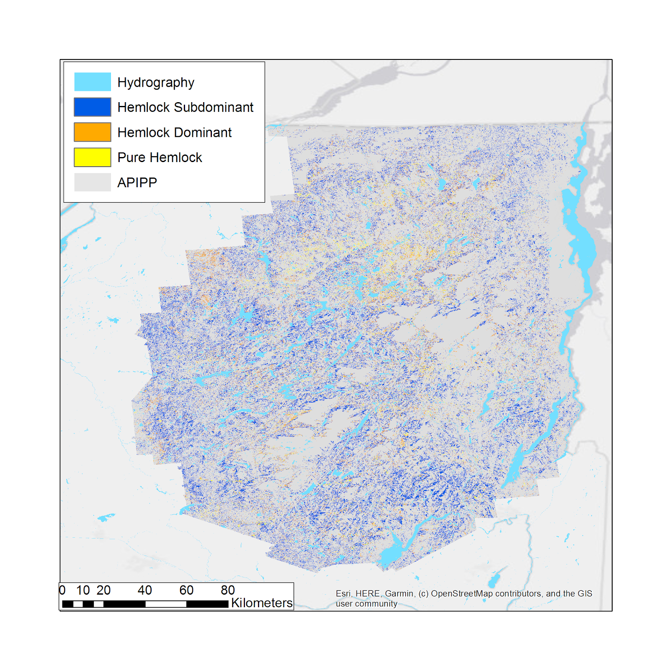

Figure A2: Hemlock distribution map for New York State region Landsat 8 OLI
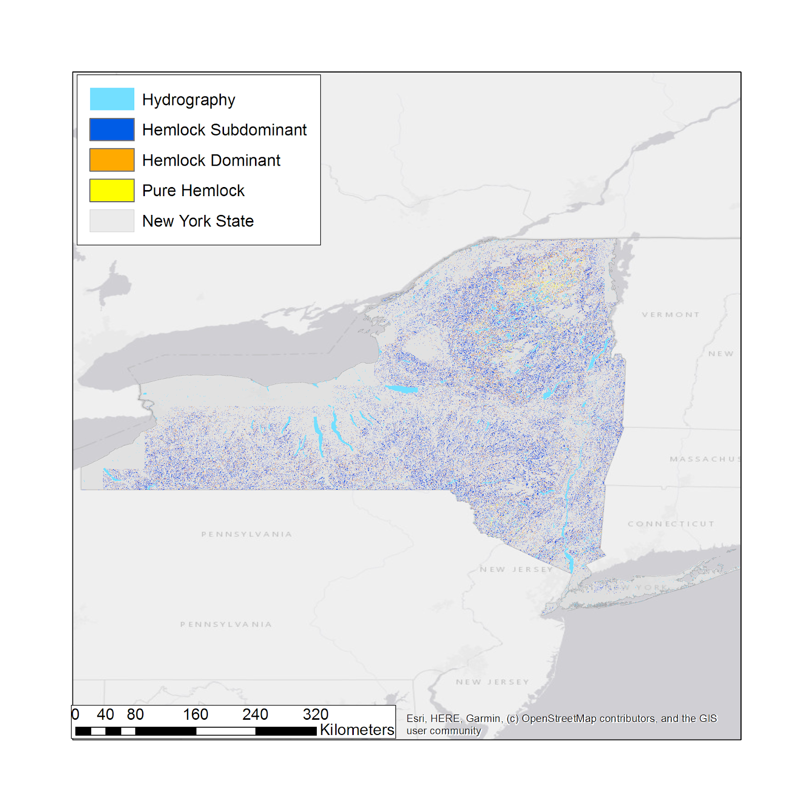

Figure A3: Hemlock distribution map for APIPP region using Sentinel-2 MSI
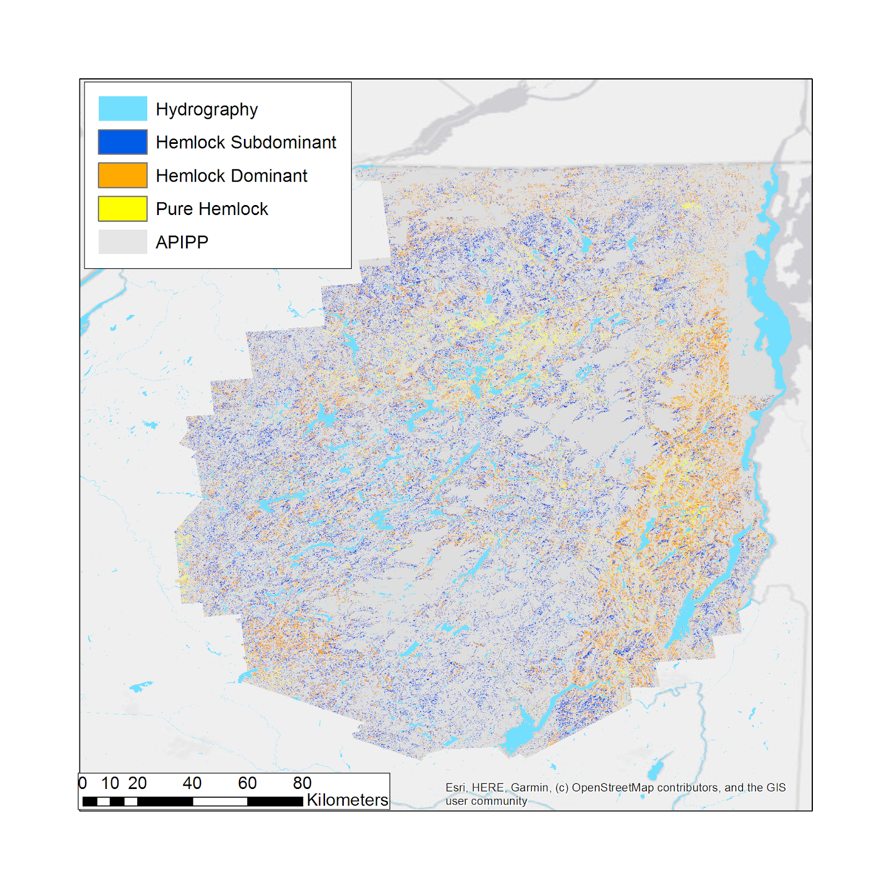

Figure A4: Hemlock distribution map for New York State region using Sentinel-2 MSI
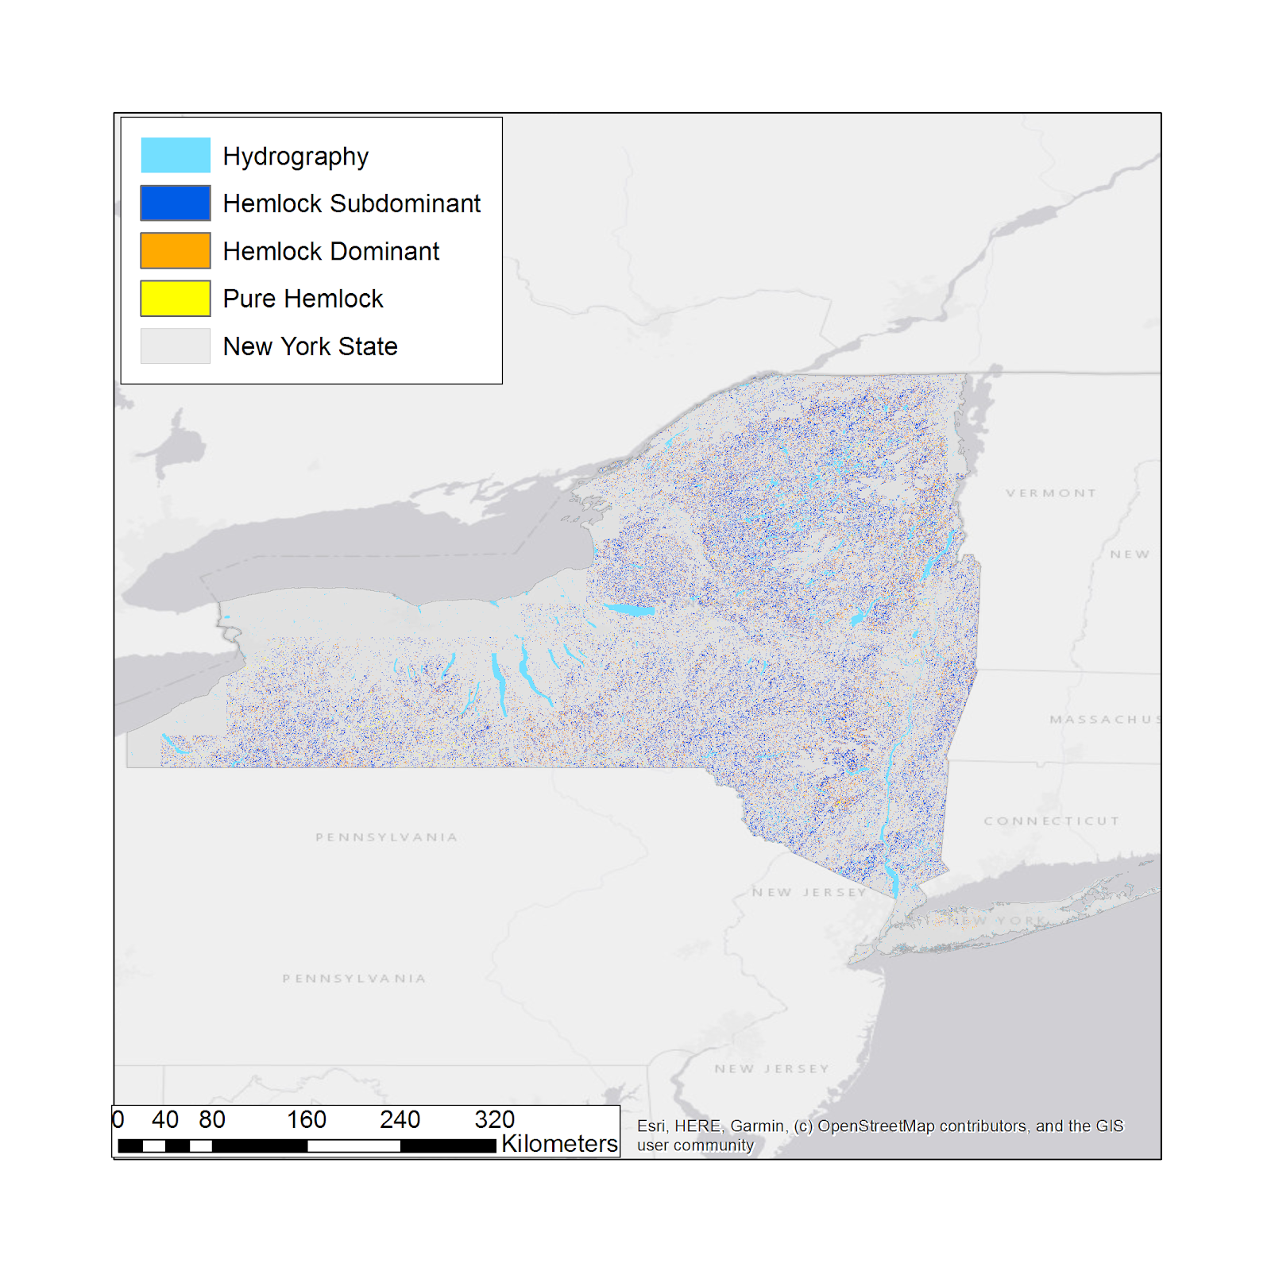

Figure A5: Forecast model of hemlock distribution in 2049 after the effects of HWA spread based on the overlay methodology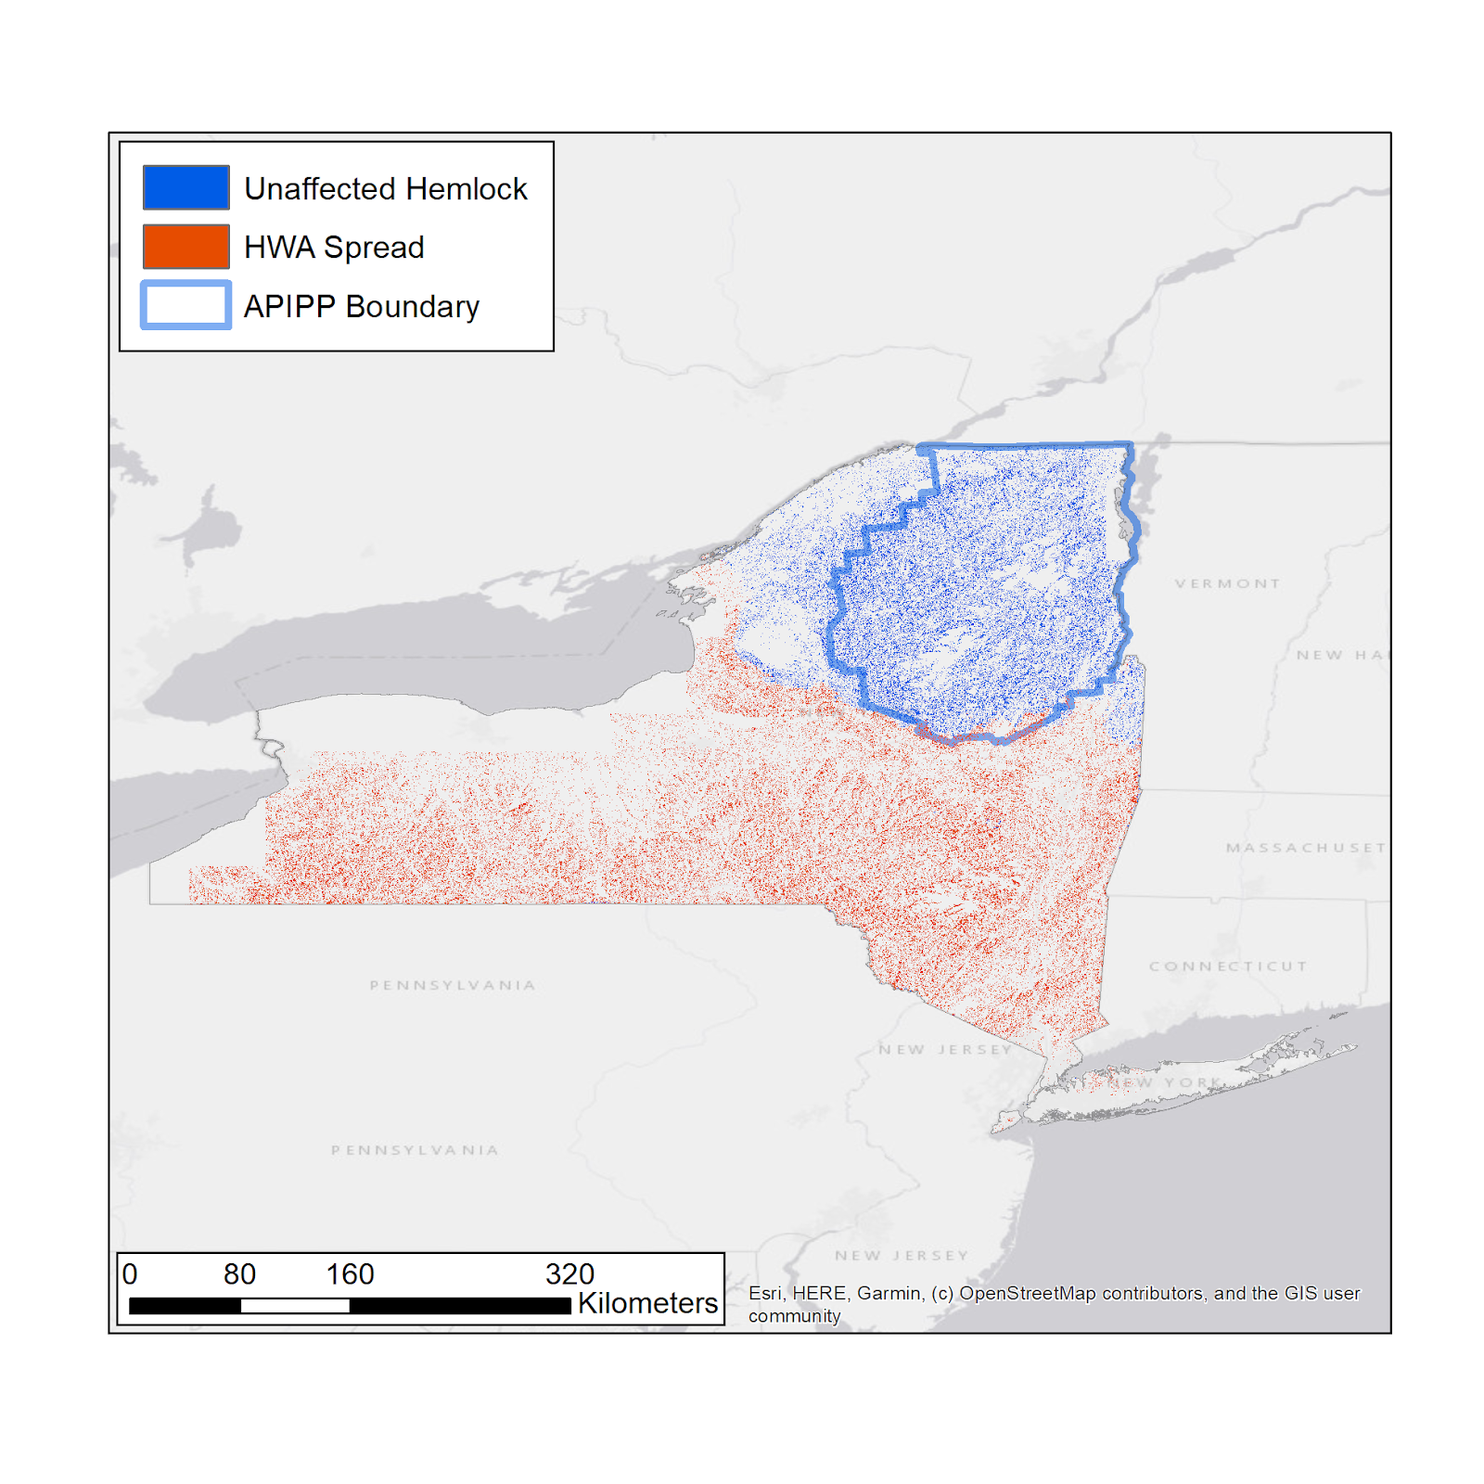

Figure A6: Forecast model of hemlock distribution in 2049 after the effects of HWA spread based on the random forest methodology
