Mobile Urban Development

Evaluating Urban Heat Islands and Flooding to Enhance Green Infrastructure Initiatives in Coastal Communities in Mobile County, Alabama

**Technical Report**

Final Draft – August 8th, 2019

Lydia Stanley (Project Lead)

Arman Bajracharya

Kelly Dunn

Filoteo Gomez-Martinez

Joseph Spruce, Science Systems & Applications, Inc. (Science Advisor)

Dr. Kenton Ross, NASA Langley Research Center (Science Advisor)

# 1. Abstract

This project utilized satellite Earth observations to assess locations in Mobile County, Alabama, that are vulnerable to the urban heat island effect (UHI) and flood impacts. Our partner, Groundwork Mobile County (GWMC), and other local entities need information on UHIs and flooding risk to develop mitigation strategies for reducing such threats. To locate communities with UHI impacts between 2005 and 2019, our team used Landsat 5 Thematic Mapper (TM), Landsat 8 Thermal Infrared Sensor (TIRS) and Terra Moderate Resolution Imaging Spectroradiometer (MODIS) to evaluate land surface temperature. Low elevation areas susceptible to flooding were distinguished using Shuttle Radar Topography Mission (SRTM) data. The team assessed flash flood vulnerability with Sentinel-1 C-band Synthetic Aperture Radar (C-SAR) and LiDAR elevation data. Lastly, the team processed data from Landsat 5 TM and Landsat 8 Operational Land Imager (OLI) to compute the Normalized Difference Vegetation Index (NDVI) and compared that with Sentinel-2 Multispectral Instrument (MSI) data to evaluate impervious surface area and thus, the increase in urban development over time. A Social Vulnerability Index (SoVI) was produced for Mobile County based on a five-point scale, comparing demographic characteristics with UHIs and flood potential. To compute social vulnerability maps, the team retrieved data from the Agency of Toxic Substances and Disease Registry (ATSDR) dataset. Of the 114 census tracts, 11 tracts showed high risk for both flooding and extreme urban heat. Our project provided GWMC with end products that help in planning mitigation strategies for reducing flood risks and UHI effects.

**Keywords:**

remote sensing, NDVI, Sentinel-1 C-SAR, land surface temperature (LST), Landsat 8, flood vulnerability

# 2. Introduction

## 2.1    Background Information

Mobile County is located in the southwestern corner of Alabama and neighbors the Gulf of Mexico. Mobile has mild-subtropical weather with hot and humid summer months and an average of 66 inches of annual precipitation (Neel-Schaffer & Hydro Engineering Solutions, 2017). Mobile County has a population of about 413,000 and within the State of Alabama is ranked 38 out of 67 counties in terms of poor health and 41 out of 67 counties in terms of “quality of life” (U.S Census Bureau, n.d.). Due to its proximity to the Gulf of Mexico and low elevation, Mobile County is susceptible to floods from tropical storms and hurricane activity (Turnipseed, Van Wilson, Stoker, & Tyler, 2007). This has been illustrated by past events such as Hurricane Katrina, on August 29, 2005, when Mobile Bay area surged 11 feet (3.35 m) (NASA Earth Observatory, 2005).

The first element of this project focused on Urban Heat Islands (UHI), which is a phenomenon that describes the temperature difference between rural and urban areas that are caused by land use/land cover (LULC) change. To visualize urbanization densities and how it affects LULC, the team referred to Mundhe & Jaybhaye (2014) methodologies. Mundhe & Jaybhaye (2014) utilized Landsat 5 Thematic Mapper (TM) data, and ERDAS IMAGINE software to reclassify and categorize satellite imagery into seven different classes. In urban areas, there are different levels of development in which impervious surfaces cover the land. These impervious surfaces are made of impenetrable materials, like asphalt, that absorb and emit heat while inhibiting rain from filtering back into the soil to replenish groundwater (Mohajerani, Bakaric, & Jeffrey-Bailey, 2017). To analyze Land Surface Temperature (LST) and the effects of UHI the Mobile Urban Development NASA DEVELOP team used NASA Earth observations from Landsat 5 TM, Landsat 8 Thermal Infrared Sensor (TIRS) and Terra Moderate Resolution Imaging Spectroradiometer (MODIS). TIRS bands from Landsat sensors contribute to the study of UHI to calculate LST variation from a city to non-urban spaces (Sobrino, Oltra-Carrió, Sória, Bianchi & Paganini, 2012). Similarly, other researchers have used the TIRS bands to analyze the effect of green infrastructure on UHI within Lyon, France (Renard, Alonso, Fitts, Hadiiosif, & Comby, 2019). The team utilized data from April 2005 to April 2019 in the study area.

The UHI effect creates “hotspots” within urban areas creating an environment in which the community is at risk. A heat-related illness study conducted during the summer of 2012 by the Alabama Department of Public Health concluded that 67 cases of heat-related illness occurred in Mobile County. Mitigation of UHI effect can occur through different measures, one of which is green space infrastructure plans (Gunawardena, Wells, & Kershaw, 2017). Green spaces within urbanized areas are plots of vegetation (e.g., recreational parks, forests, and nature trails) that produce microclimates – due to variations in vegetation and the promotion of evapotranspiration, therefore resulting in a “cool island” effect (Hamada & Ohta, 2010).

To incorporate a socioeconomic and demographic risk evaluation the team created a social vulnerability index, which was inspired by a previous study on the City of Toronto (Armenakis, Du, Natesan, Persad, & Zhang, 2017). The previous study utilized census data to establish and analyze social vulnerability in response to flooding. This team incorporated the use of Digital Elevation Modeling (DEM) and overlaid flood potential on a map of the study area to create this element. The team utilized the LiDAR Data Exchange File (LAS) in flood research because of its high resolution, with a vertical accuracy of 15 centimeters. The LAS dataset enables the production of highly accurate flood models as it captures subtle topographical variation (Toda, Yokingco, Paringit, & Lasco, 2017).

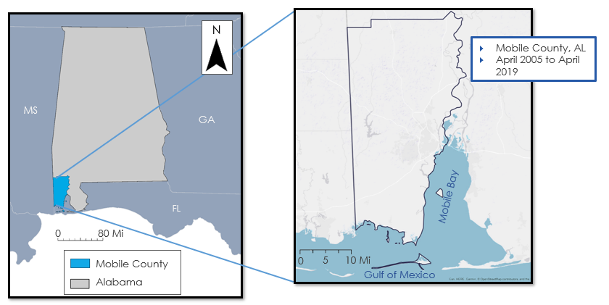

*Figure 1.* Study Area of Mobile County within Alabama (right) including neighborhoods of concern for GWMC (left).

## 2.2   Project Partners & Objectives

Groundwork Mobile County (GWMC), a trust of Groundwork USA, is geared towards promoting environmental sustainability efforts with the help of community-based partnerships. GWMC focuses on revitalizing brownfield sites into green spaces and encouraging programs for youth to improve and develop new skills in preparation for the professional world. GWMC’s interest in this project lied primarily in the impact of UHI effect in the following areas: Prichard, Africatown, and neighborhoods within the City of Mobile. Flood vulnerability and overall socioeconomic vulnerability are important to visualize in Mobile because the partner’s study areas fall within the potential flooding parameters. The project partner can use the maps and techniques from this study to continue monitoring areas at high risk and to train youth in GIS and remote sensing technologies.

## 2.3 Project Objectives:

The project objective was to produce risk maps that illustrate Mobile County’s vulnerability to flash flooding and UHI effects. These risk maps identified census tracts with high impervious surface areas prone to increased runoff during flash flood events, UHI susceptibility, and vulnerability. Another objective was to demonstrate the potential of GIS and remote sensing techniques and capabilities. These techniques can help support planning within GWMC’s concerned study areas and methodologies can allow for different study periods and parameters to be applied.

# 3. Methodology

## 3.1 Data Acquisition

### 3.1.1 Urban Heat Maps

The team retrieved Landsat 5 TM and Landsat 8 TIRS Analysis Ready Data (ARD) for the tiles horizontal 21 and 22, and vertical 15 and 16 from 2005, 2015 and 2019 (Table A1). The images contained less than 10 percent of the cloud cover per scene. The data were acquired from the US Geological Survey (USGS) EarthExplorer data portal for World Reference System (WRS). The study was intended to examine temperature trends primarily during the summer months. This resulted in limited availability of images with low cloud coverage. Despite the fluctuations across the dataset, the spatial distribution of the hot spots had a consistent result throughout the timeframe of the study. The Landsat-derived heat maps were compared to the 8-day composite of Terra MODIS Level-3 MOD11A2 data, with a spatial resolution of 1000 m. The team downloaded MODIS data from the Land Processes Distributed Active Archive Center (LP DAAC) through USGS.

### 3.1.2 Flood Extent Analysis

To examine flooding in the study area, the team used three different products. To start, the team acquired Shuttle Radar Topography Mission (SRTM) data from USGS EarthExplorer, which is a Level-1 product released in 2014. The SRTM data has a resolution of 1-arc second. The team used Sentinel-1A C-band Synthetic Aperture Radar (C-SAR) data that were downloaded from the Copernicus Open Access Hub. The C-SAR data selected was Interferometric Wide Swath (IW) mode of Ground Range Detected (GRD) data with a 5 by 20 m spatial resolution. The team used C-SAR data from August 3, 2018, following the flash flood event on August 2, 2018, and selected June 11, 2019, for the non-flood image. Lastly, LiDAR data from 2016 were obtained from the USGS site as LAS tiles(Table A2)*.*

### 3.1.3 Socioeconomic and Demographic Risk Evaluation

The team conducted the risk evaluation using 2012 to 2016 American Community Survey (ACS) 5-year estimate data at the census tract level. The team used the database created by the Agency for Toxic Substances and Disease Registry (ATSDR) Geospatial Research, Analysis and Services Program (GRASP), to access shapefiles with demographic data associated with the population per census tract. In order to properly visualize census tract data, after pre-processing the team used the NAD 1983 HARN State Plane Alabama West FIPS 0102 (meter) coordinate system. The team also incorporated processed data from Urban Heat Maps and Flood Extent Analysis to calculate aggregated social vulnerability index.

### 3.1.4 Impervious Surface Evaluation

The team obtained USGS National Land Cover Database (NLCD) data for 2001, 2006, 2011 and 2016 to evaluate the change in impervious surface cover. The NLCD classifies land cover into 20 categories that differentiate the types of urban development and vegetation. Furthermore, Landsat 5 TM Level-2 data for 2005, and Landsat 8 Operational Land Imager (OLI) Level-2 imagery for 2018 from paths 21 and 39 were downloaded from USGS EarthExplorer (Table A3). These images were used to calculate the Normalized Difference Vegetation Index (NDVI). Additionally, the team downloaded Sentinel-2 Multispectral Instrument (MSI) Level-2 data: T16RCU, T16RCV, T16RDU and T16RDV from the Copernicus Open Access Hub. The team processed MSI data to create NDVI in order to compare to the NDVI imagery obtained from Landsat 5 TM and Landsat 8 OLI. All the images downloaded contain less than 10 percent of cloud cover per scene.

**3.2 Data Processing**

### 3.2.1 Urban Heat Maps

The team analyzed the spatial distribution of UHI in Mobile County from 2005 through 2019 to highlight the regions of severe heat as well as determine mean LST per census tract. The team utilized ARD data for the thermal bands. The ARD data were derived from Landsat 5 TM and Landsat 8 TIRS. The team used the raster calculator in QGIS 3.4.8 to convert the temperature values from Kelvin to degrees Fahrenheit. The resulting raster showed the distribution of heat throughout the study area. Then, the mean temperature was calculated per census tract using the Zonal Statistics tool in ArcMap 10.5. The Zonal Statistics tool retrieves raster data within the boundaries of another shapefile to calculate statistical estimates per polygon.

### 3.2.2 Flood Extent Analysis

As mentioned above, the team used SRTM, Sentinel-1 C-SAR and LiDAR data in the flood visualizations. The following paragraphs have descriptions of processing of each dataset in their respective order (*Figure B1*)*.* First, the team mosaicked the four SRTM images and assigned elevation thresholds of 1, 2 and 3 meters in order to identify low-lying areas prone to flooding. The 3-meter threshold was based on the 2005 Hurricane Katrina storm surge, which reached up 11 feet (3.35 meters). Furthermore, the team calculated the percentage of low-lying areas per census tract. The team assigned regions under 3-meter elevation value of 1 and regions above the 3-meter threshold value of 0. The team omitted 0-meter elevation regions, as water cover was already prevalent. Then, the mean for each census tract was calculated using Zonal Statistics such that the resultant value was the percentage of low-lying areas excluding water cover. The percentages were then overlaid with the aggregated social vulnerability index.

Second, the C-SAR data were processed using the Sentinel Application Platform (SNAP). The SAR images were clipped to the area of interest (North Lat: 31.171, West Long: -88.4254, South Lat: 30.589, & East Long -87.625). Since the C-SAR Level 1 data are not analysis ready the processing included five-steps: apply-orbit-file, thermal noise removal, calibration, speckle filter, and terrain correction through graph builder. The apply-orbit-file was used to georeference the data as the Global Navigation Satellite System records the Sentinel-1 SAR data. Thermal noise removal eliminates the backscatter intensity of the receiver. Calibrationconverts the digital number (DN) to the physical unit (radar backscatter) to sigma naught.Then, speckle filter smooth’s the image andreduces the inherent ‘salt and pepper-like’ texture. Terrain correctionwas then applied to correct the topographical variations of an image and the tilt of the satellite sensor and to re-project the scene to the desired geographical projection. The team used preprocessing steps based on SAR-preprocessing documentation developed by Thomas Weiß (2018).

After preprocessing, the C-SAR images in order to identify water cover for each image, binarization was applied based on the inland permanent water bodies. This binarization also helped create the histogram for the filtered backscatter coefficient. The low values of the backscatter correspond to the water, and high values correspond to the non-water class. Then, the team selected VV polarization due to its suitability to flood mapping purposes (Stroppiana et al., 2019). Then, we applied a horizontal stretch to approximately 0.025 of the Sigma0_VV for the two images flood and no flood. Based on the histogram of flood and not flood data. Then, the team performed manual digitization over permanent inland water bodies to obtain threshold Sigma0_VV that would be used to identify water in flooded regions for each image. Based on the 90% percentile on each image within the study area, such that any pixel with Sigma0_VV below the threshold was interpreted as water. In this way, the thresholds for the no-flood image and the flood image were identified to be 0.0115 and 0.0213 respectively *(Figure B2)*. Hence, the thresholds were used to create the binarized raster for each image using the following conditional statements:

For the no flood image:

*If (Sigma0_VV< 0.015) and (Sigma0_VV > 0) then 1 else NaN*

For the flash flood image:

*If (Sigma0_VV< 0.020) and (Sigma0_VV > 0) then 1 else NaN*

Then, from the two output images of no-flood and flood, an RGB composite image was created to visualize flood differences. In the red band, no flood images were selected and in the green and blue bands flood image was selected. Lastly, the LiDAR data were processed in Esri ArcMap 10.5. In order to process the Laser or LAS files, the 3-D Analyst tool was necessary. The team converted the point cloud data for the region surrounding the City of Mobile to Triangular Irregular Networks (TIN), which show the regions of low elevations that could be impacted from flash floods and storm surges from tropical storms. LiDAR data are widely used in flooding research because of vertical accuracy of 15 centimeters with one meter of spatial resolution, which produces highly accurate flood models as it captures subtle topographical variation (Toda et al., 2017).

### 3.2.3 Socioeconomic and Demographic Risk Evaluation

The socioeconomic and demographic risk evaluation illustrates the vulnerability based on demographic variables, the severity of UHI effect, and the presence of low-lying areas identified per census tract. The team selected 10 variables with the highest relevance to flood and heat vulnerability from the 2012-2016 American Community Survey (ACS) 5-year Estimates data, which are based on shapefiles, acquired from the ATSDR. These variables were classified into 3 categories sorted by vulnerability as listed in *Figure B3*. The team standardized the raw data into a 5-point index using Equations 1 and 2 below in order to allow seamless comparison among variables across different scales, such as income versus unemployment rate. The standardized quantity was then multiplied by vulnerability number (low vulnerability = 1, medium vulnerability = 2, high vulnerability = 3) to calculate a weighted value. After calculating the weighted sum for each census tract, Equation 3converted the values into the social vulnerability index ranging from 0 to 5. The vulnerability index was appended to shapefiles of census tracts from the 2010 census.

*For factors directly proportional to risk: $\text{Standardized Value = (}\frac{\text{Census Tract Value - Minimum}}{\text{Range}}\text{) × 5}$*    (1)

*For factors inversely proportional to risk: $\text{Standardized Value = 5 - (}\frac{\text{Census Tract Value - Minimum}}{\text{Range}}\text{) ×5}$*     (2)

$\text{Social }\text{Vulnerability Index = }\frac{\text{Sum of Weighted Value per Census Tract}}{\text{Maximum among all Census Tracts}} \text{× 5}$ (3)

The team created aggregated vulnerability index by incorporating the percentage of land under 3-meter elevation and mean LST per census tract. The raw values for each of these parameters were converted to a 5-point scale usingEquation 4 and used to calculate the final aggregated social vulnerability index using Equation 5(*Figure B4*), where SoVI is Social Vulnerability Index, LSTs is Standardized Land Surface Temperature, and Fs is Percentage of Land under 3-meter elevation.

This methodology was performed using ArcGIS Pro software.

$\text{Standardized Value=} \text{(}\frac{\text{Census Tract Value - Minimum}}{\text{Range}}\text{)} \text{× 5}$ (4)

Aggregated SoVI = 0.4 * SoVI + 0.3 * LSTs + 0.3 * Fs (5)

### 3.2.4 Impervious Surface Evaluation

In order to emphasize the coverage of impervious surface throughout the study area, the team analyzed the changes in land use through the study period as well as the differences in vegetation cover. The team re-classified the NLCD data to reduce the number of classes from 20 to 6 (*Figure B5*). The new classes include open water, developed open space, low intensity developed, medium intensity developed, high intensity developed and vegetation/barren land. The team clipped the NLCD imagery to the Mobile County boundary and acquired total acreage per class for 2001, 2006, 2011 and 2016 (Table A4) then narrowed further to 5 classes. Deciduous forests, evergreen forest, mixed forest, shrub, herbaceous, hay/pasture, cultivated crops, woody, and emergent herbaceous wetlands were grouped into one vegetation class and water was omitted to further calculate urbanization densities. In the impervious surface evaluation, there were 4 different types of urbanized density and 1 vegetation class. ERDAS IMAGINE software was used to reclassify data using the reclassify tool and assigned values to condense the classes down. The processed land cover change imagery from 2001 to 2016 was visualized through zonal statistics in ArcPro to show which census bureau tracts had high impervious surface areas. Acreage was calculated for all recorded dates and then used to calculate vegetation loss and urban growth. With this acreage data, an analysis of land change over time was mapped between 2001 and 2016. This development over 15 years was visualized through the use of Weighted Sum in ArcMap 10.5 for a before and after. This process showed vegetation and barren land change into urban areas to analyze urban sprawl potential.

In addition to the NLCD data, NDVI was used to show vegetation density within the study area *Figure B6.* NDVI utilizes the near-infrared and red band to determine vegetation greenness. The values ranged from -1 to +1, with greater numbers indicating high levels of greenness, which is representative of dense vegetation. The team used Level 2 imagery from Landsat 5 TM and Landsat 8 OLI from 2005 and 2018 respectively to obtain the NDVI raster. Level 2 imagery were pre-processed to surface reflectance and were ready to be used for NDVI calculation upon download. The team calculated NDVI values using the red (R) band and near-infrared (NIR) band as per Equation 6. The R band and NIR band for Landsat 5 TM are bands 3 and 4, respectively, and bands 4 and 5 for Landsat 8 OLI, respectively. In addition, NDVI raster calculated from Sentinel 2 MSI data from 2019 was used for comparison using bands 4 and 8 as R and NIR respectively.

$\text{NDVI = }\frac{\text{NIR - R}}{\text{NIR +R}}$         (6)

## 3.3 Data Analysis

### 3.3.1 Urban Heat Maps

The team used a common legend ranging from 70°F to 95°F based on the minimum and the maximum temperatures across the dataset as shown in *Figure 2*. The minimum temperature was assigned as dark blue (cooler) and the maximum temperature was assigned dark red (hotter) under a continuous color ramp. This provided a seamless comparison between different images. The LST measurements were spatially compared to the Terra MODIS data (*Figure B7)*.

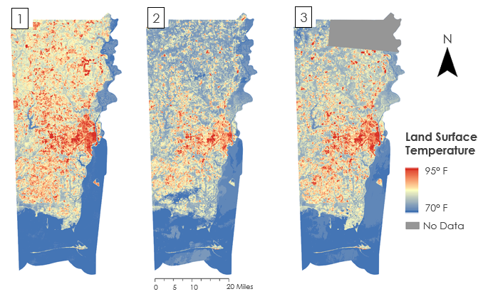

*Figure 2.* LST variations across Mobile County. Maps 1, 2 and 3 from April 9, 2005, April 21, 2015, and April 16, 2019, respectively based on Landsat 5 TM and Landsat 8 TIRS.

### 3.3.2 Flood Extent Analysis

The SRTM data allowed the team to visualize thresholds in Mobile County based on 1, 2 and 3-meter elevation. The 3-meter threshold was based on the 2005 Hurricane Katrina when the storm surge reached up to 3.35 meters in Mobile County.  Based on these thresholds, several low-lying areas were identified. The major regions of concern were the Mobile downtown, Bayou La Batre, and Dauphin Island. These visualization parameters were checked against the National Oceanic and Atmospheric Administration (NOAA) Sea Level Rise Viewer for accuracy.

The SAR data allowed the team to identify subtle changes from the flash flood that occurred in downtown Mobile on August 2, 2018. The increase in water body extent was identified in the low-lying areas of downtown Mobile, and other locations mentioned above. While SAR data is suitable to study flood events, the temporal resolution heavily influenced flood data availability (Notti et al., 2018) for this and other issues flash floods are challenging to map. Flash flood is the result of high intensity of rain and is highly localized, causing a rapid rise of water within hours, this makes it difficult to map. Similarly, a flash flood is attributed to the morphology of a place, which can be affected by human activities such as high percentage of impermeable surfaces, roads, and poor drainage infrastructure (Hakdaoui, Emran, Pradhan, Lee, & Fils, 2019). Lastly, the LiDAR data were converted to Triangular Irregular Networks (TIN) to create the 3-D visualizations of two locations of Mobile downtown the Convention Center and the Alabama Cruise Terminal as examples.

### 3.3.3 Socioeconomic and Demographic Risk Evaluation

To evaluate socioeconomic and demographic vulnerability, data from ATSDR were processed into weighted sums. The vulnerability factors were scaled based on the minimum and maximum values for all census tracts to facilitate consistency among the variables. This provided the relative statistics of risk for given demographic factors on a scale of 0 to 5, where 0 related to low risk, and 5 related to higher risk. The team applied the multiplication factors to retrieve the resultant sum. The weighted sum ranged from 16.22 to 48.47, which was then converted into a 5-point scale for convenience. The team compared the final index to ATSDR Social Vulnerability Index (SoVI) 2016 data for accuracy. The weighted sums were combined with census tract data to identify areas of high vulnerability. Census tracts of high vulnerability often occurred in clusters within two cities: the City of Prichard and the City of Mobile (Table A5).

### 3.3.4 Impervious Surface Evaluation

NLCD classifications for 2001, 2006, 2011, and 2016 were reclassified and compared by acreage. Vegetation was grouped together and urbanized density was classified into four different types (open, low, medium, high). United States Census Bureau tract boundaries were overlaid on the new impervious surface layer and calculated based on urban density within a tract area using zonal statistics. Census tracts with a rating of 4 represented high urbanization and 0 represented low to no urbanization. The team calculated the acreage of LULC for 2001 and 2016 with a map outlining areas of vegetation and barren land that became development on the outskirts of the City of Mobile; indicating that urban sprawl was occurring in areas outside of urbanization. Areas with increased densities of impervious surfaces could have linkage to UHI and flood vulnerability according to weighted census tract data and the aggregated social vulnerability map.

# 4. Results & Discussion

## 4.1 Analysis of Results

### 4.1.1 Urban Heat Maps

According to surface temperatures, the UHI effect is most prominent in downtown Mobile. UHIs have increased energy demands as well as thermal stress and risk of heat-related illness and morbidity. *Figure 3* below reveals, which census tracts have, the highest recorded mean land surface temperatures. The LST recorded on April 21, 2015, revealed that areas with high vegetation or agriculture land area had the lowest LST, at 70.5 °F (21.4 °C), and urbanized city limits had the highest LST at 93.9 °F (34.4 °C). This is concerning considering the census tracts with the highest and lowest readings are neighboring bodies of water. Water has a high specific heat capacity, which helps mitigate heat, but the ratio of impervious surface is dense enough to inhibit any positive effects of the cooling processes.

One way to mitigate these UHI-prone areas is by revitalization with green infrastructure, which can reduce heat absorption through an increase in albedo. Some cities have installed green roofs or green infrastructure in high-density areas to break up the concentration of large impervious surface areas and these efforts have proven to be successful. The implementation of green spaces introduces areas of vegetation into urban areas and increases vegetation reflectance/albedo while decreasing CO2, runoff and storm water volume through increased infiltration, evaporation, and evapotranspiration. Evapotranspiration is a significant factor of green spaces as it introduces the “cool island effect” into urban areas and creates a microclimate that combats high surface temperatures.

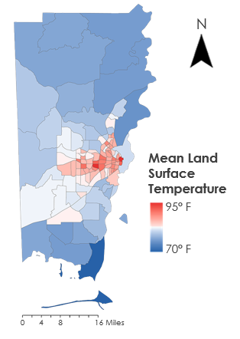

*Figure 3.* LST in Mobile county concentrated within census tracts based on Landsat 5 TM and Landsat 8 TIRS

Utilizing only one date per year for LST resulted in an inaccurate output due to limited sample size. Using summer and winter month averages over the years would provide a better understanding of how temperatures fluctuate and how the affected census tracts above are responding to temperatures in the winter versus summer. Multiple sources of temperature data could have provided better insight as well, but in the interest of time, that amount of data was not analyzed.

### 4.1.2 Flood Extent Analysis

The SRTM DEM data allowed for an overlay of up to 3-meter flood based on land surface contours, therefore presenting low-lying area with high risk to flood events (*Figure 4*). These data were overlaid on an aggregated social vulnerability to reveal that approximately 3 high-risk census tracts could be affected by flash flooding. Uncertainties lie with certain aspects of the flood extent analysis because there is a lack of data availability for recent floods and flash floods that have occurred in Mobile County. The delay between the flash flood and the time of acquisition for Sentinel-1A and 1B based on their 6-day cycle compromised the analysis of the flash flood conditions. The visualizations in this project only represent a potential for flood in areas based on its land elevation and the no-flood vs. flash flood SAR imagery (*Figure B8*),but cannot provide insight from previous flood events. Any increase in water volumes was primarily observed in riverbanks and lakes (*Figure B9*). Moreover, the 3D LiDAR imagery highlighted the vulnerable images at the Mobile Convention Center and the Alabama Cruise Terminal (*Figure B10*).

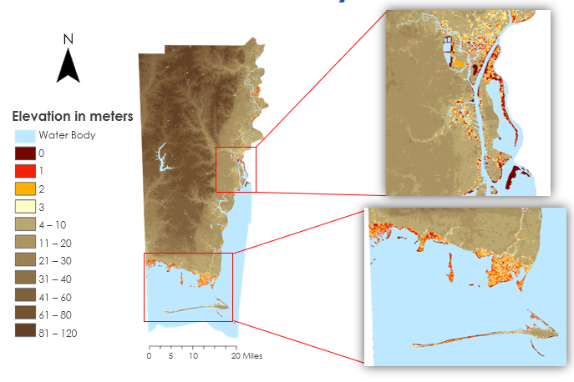

*Figure 4.* Low-lying areas across Mobile County with the insets show the regions with the majority of high-risk areas at the City of Mobile (top-right), Bayou La Batre and Dauphin Island (bottom-right)

### 4.1.3 Socioeconomic and Demographic Risk Evaluation

The SoVI for Mobile County created a basis for risk potential variables to use for comparison. Social vulnerability refers to the groups of people that lack the resources to alleviate, remedy, or recover from the effects of high-risk situations. For this project, the high-risk situations mentioned involved UHI and flooding. Since this project analyzed human resilience to the meteorological phenomenon, it was important to highlight areas at the highest risk if urban heat or flooding were to happen. The SoVI illustrated 11 census tracts with the highest vulnerability based on demographic variables (*Figure B11*). Of all risk variables analyzed, all shared the City of Mobile and the City of Prichard as the highest vulnerability to high-risk events as seen in *Figure 5*.

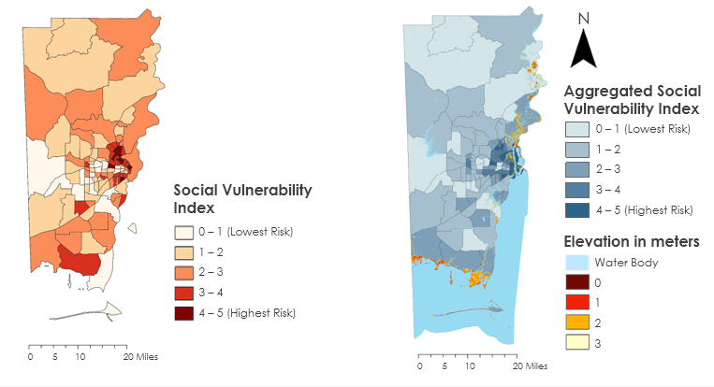

*Figure 5.* Social vulnerability index map (left) based on demographic statistics, and aggregated social vulnerability index (right), which further includes standardized LST and flood vulnerability.

Areas of error and uncertainty arise from the period the data was derived. Data to create the social vulnerability index came from US Census Bureau 2010 data, but a more recent US Census Bureau data or population information from the county itself may have provided more concrete data of Mobile’s current state. There were also certain demographics left out due to lack of information, for example, the homeless population.

### 4.1.4 Impervious Surface Evaluation

Impervious surface data is the linking variable between UHIs and flood vulnerability. Since impervious surfaces are also non-penetrable material, flow volumes are increased with heavy precipitation. This is because impervious surfaces will not filter water through it and to the soil to aid filtration rates in groundwater systems.  In *Figure 6*, vegetation and barren land classes were previously separated and now grouped. This is because barren land accounts for a smaller percentage of total land-use. Agriculture was also grouped in despite being anthropogenically modified or developed because it did not factor into the criteria of development that resulted in the creation of impervious surfaces. By doing this, the impervious surfaces were easily visualized and the progression of development was pinpointed.

The northern end of the City of Mobile has been developing out of the high-density areas of the city and into more rural areas, leading to urban sprawl. Urban sprawl is a phenomenon in which urban areas begins to expand and spread in an uncontrolled way. Land use change was further analyzed through acreage change. The largest segments of land classification affected were vegetation, barren land, and open/low development. This is because areas of vegetation and barren land were either cleared or developed into open and low-density development areas between 2001 and 2016.

Moreover, a total of 10,166.6 acres of vegetation and barren land were lost to development, which overall gained 10,770.7 acres of land (*Figure B12)*.  The 600 acres of developmental change could stem from the removal of water parcels during the data evaluation process, therefore skewing estimations along the coast of Mobile County. This will pose as an uncertainty.

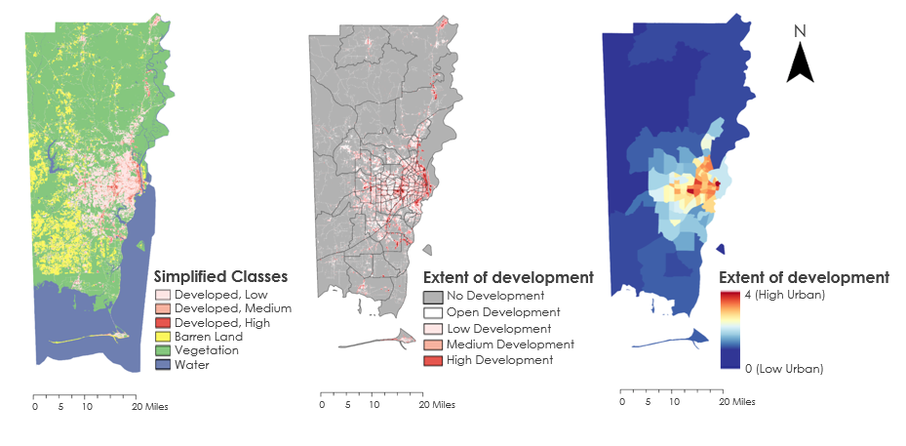

*Figure 6.* The process of evaluating data from NLCD to census tract concentration.

## 4.2 Future Work

This project addressed UHI and flood risk by overlaying these variables with socioeconomic demographic information gathered in 2010. However, the results of this project are general perspectives and trends that were analyzed using the mentioned variables. The team identified broad areas of demographic characteristics and variability of the risk.  Therefore, future work should look at those variables separately for the examination and quantification of changes in vegetation cover, impervious surfaces and the relationship between UHI and population. This project focused on specific areas of high vulnerability like the City of Prichard and the City of Mobile. UHI analysis would require LST data that were composited of multiple dates rather than a single date derived from 3 separate years.  The team’s suggestion is to analyze the monthly LST averages from a multi-year span. The team’s analysis of flood potential in Mobile county was limited due to data availability and elevations below a threshold. Due to the temporal resolutions of Sentinel-1 A and B, different radar data including Advanced Land Observing Satellite (ALOS) Phased Array type L-band Synthetic Aperture Radar (PALSAR) could be useful to map flood extent. For the SoVI calculation, an evaluation of the 2020 US Census Bureau data would present more accurate results versus the 2010 US Census Bureau data used. Moreover, several groups of people were excluded from the vulnerability analysis and the number of homeless people in Mobile County is missing from the evaluation, as census data does not record such information. These variables will provide a more accurate understanding of the study area and high-risk communities. When evaluating areas that are socially vulnerable and have had changes in LULC over a 15-year time span, these factors would improve greatly with a ground-truth process for data accuracy purposes.

# 5. Conclusions

The team concluded that the highest surface temperatures were observed within the City of Mobile in the downtown area and the City of Prichard. The project provided insight into the technical feasibility of using NASA (e.g., Landsat and MODIS) and ESA (e.g., Sentinel-1) satellite data for assessing flooding and UHI impacts for Mobile County, Alabama. The project also utilized LiDAR altimetry data and NLCD data for assessing flood and vegetation change, respectively. In comparison to the urban spaces, the areas of dense vegetation had lower LST; a difference of 13 degrees Fahrenheit was identified between the two land cover types. This difference in LST alludes to vegetation having a higher reflectance and albedo effect compared to impervious surfaces, which absorb and retain heat. Through the previously mentioned Earth observations, the highest vulnerability was observed in areas of high development, impervious surface area, and UHIs.

In terms of impervious surface evaluation, 10,166.6 acres were converted from barren land and vegetation to urban from 2001 to 2016 when analyzing LULC in Mobile County. This change in acreage accounts for 1 percent of Mobile County’s total land use but occurs as clusters on the outskirts of the City of Mobile.

The potential of flooding does not pose a high threat to the county in upland areas of dense vegetation. Flood risk was identified based on elevation data for 3 low-lying locations; these areas of concern are the Mobile basin area, Bayou La Batre, and Dauphin Island. Despite the uncertainty in using non-optimally timed data collections for the August 3, 2018 flood event, flood potential was observed along the coastal extent of Mobile County using Sentinel-1 data. To reduce impacts on the environment for residents at risk without having to relocate them, the implementation of green spaces and green infrastructure is an effective mitigation strategy for both flooding and UHI effects.

Based on the aggregated social vulnerability index, 11 census tracts were identified as socially vulnerable in addition to being at risk to the effects of UHI and flooding. The City of Prichard and downtown Mobile were identified as areas of high impervious surfaces. Through the use of relevant methodology and satellite data, mitigation efforts proposed by GWMC can be used to help the identified areas promote better risk management practices. In order to continue work and education of the project from the project partner’s end, a story map was built based on the end products and is user-friendly (*Figure B.13*)

# 6. Acknowledgments

The Mobile Urban Development Team would like to thank the following people:

* Joseph Spruce, Science Advisor, Science Systems and Applications, Inc.
* Dr. Kenton Ross, Science Advisor, NASA Langley Research Center
* Bernard H. Eichold II, M.D., Dr. P.H., Mentor, Mobile County Health Department
* Madison Murphy, Center Lead, NASA DEVELOP Alabama – Mobile & Marshall Nodes
* Danielle Quick, Impact Analysis Senior Fellow, NASA Langley Research Center
* Larissa Graham, Project Lead, Groundwork Mobile County
* Eldon Blancher, PhD, BCES, Groundwork Mobile County
* Ray Richardson, City of Mobile Groundwork Mobile County

This material contains modified Copernicus Sentinel data 2019, processed by ESA.

Any opinions, findings, and conclusions or recommendations expressed in this material are those of the author(s) and do not necessarily reflect the views of the National Aeronautics and Space Administration.

This material is based upon work supported by NASA through contract NNL16AA05C.

# 7. Glossary

**C-SAR** – C-band Synthetic Aperture Radar

**DEM** – Digital Elevation Model

**DN** –Digital Number

**Earth observations** – Satellites and sensors that collect information about the Earth’s physical, chemical, and biological systems over space and time from a distance

**Evapotranspiration** – Part of the water cycle; water is transferred from the ground through plants and back into the atmosphere

**GWMC** – Groundwork Mobile County

**Hot spots** – Areas that are prone to high amounts of heat

**Impervious surfaces** – Non-porous surfaces in urbanized or developed areas (e.g., concrete, asphalt) that does not filter liquid

**OLI** –Operational Land Imager

**TIRS** –Thermal Infrared Sensor

**TM** –Thematic Mapper

**LAS** – LiDAR Data Exchange File

**LiDAR** – Light Detection and Ranging

**LST** – Land Surface Temperature

**LULC** – Land Use Land Change

**MODIS** – MODerate Resolution Imaging Spectroradiometer

**NLCD** –National Land Cover Database

**NDVI** – Normalized Difference Vegetation Index; monitoring changes in vegetation through measurement of the near-infrared difference

**Resiliency** – The ability to recover a community relatively quickly in the aftermath from a natural phenomena

**RGB** – Red Green Blue

**SRTM** – Shuttle Radar Topography Mission

**Social Vulnerability Index (SoVI)** – A classification system of the population’s potential risk to negative effects

**SWMP** – Storm Water Management Plan

**UHI** – Urban heat island; Urban areas that are significantly higher in temperature than neighboring rural areas

**USGS** –United States Geological Survey

**Urban Sprawl** – The unrestricted growth and uncontrollable spread of a developing area

**Vulnerability** – The exposure to harm or risk

# 8. References

Armenakis, C., Du, E. X., Natesan, S., Persad, R. A., & Zhang, Y. (2017). Flood risk assessment in urban areas based on spatial analytics and social factors. *Geosciences*, *7*(4), 123. <https://doi.org/10.3390/geosciences7040123>

Gunawardena, K. R., Wells, M. J., & Kershaw, T. (2017). Utilising green and bluespace to mitigate urban heat island intensity. *Science of The Total Environment, 584-585*, 1040-1055.<https://doi.org/10.1016/j.scitotenv.2017.01.158>

Hakdaoui, S., Emran, A., Pradhan, B., Lee, C., & Fils, S. C. N. (2019). A collaborative change detection approach on multi-sensor spatial imagery for desert wetland monitoring after a flash flood in southern Morocco. *Remote Sensing*, *11*(9), 1042. <https://doi.org/10.3390/rs11091042>

Hamada, S., & Ohta, T. (2010). Seasonal variations in the cooling effect of urban green areas on surrounding urban areas. *Urban Forestry & Urban Greening, 9*(1), 15-24.<https://doi.org/10.1016/j.ufug.2009.10.002>

Hulley, G., & Hook, S. (2018). *VIIRS/NPP Land Surface Temperature and Emissivity Daily L3 Global 1km SIN Grid Day V001*. NASA EOSDIS Land Processes DAAC. Accessed 12 June 2019 <https://doi.org/10.5067/VIIRS/VNP21A1D.001>

Mohajerani, A., Bakaric, J., & Jeffrey-Bailey, T. (2017). The urban heat island effect, its causes, and mitigation, with reference to the thermal properties of asphalt concrete. *Journal of Environmental Management*, *197*, 522-538.<https://doi.org/10.1016/j.jenvman.2017.03.095>

Mundhe, N., & Jaybhaye, R. G. (2014). Impact of urbanization on land use/land covers change using Geo-spatial techniques. *International Journal of Geomatics and Geosciences*, *5.* 50-60*.* https://www.researchgate.net/publication/281320790_Impact_of_urbanization_on_land_useland_covers_change_using_Geo-spatial_techniques

NASA Earth Observatory. (2005, September 3). Hurricane damage in Mobile, AL. Retrieved June 21, 2019, from<https://earthobservatory.nasa.gov/images/5822/hurricane-damage-in-mobile-al>

Neel-Schaffer & Hydro Engineering Solutions. (2017).Section 1: Program administration. *Storm Water Management Program (SWMP) Plan*. Mobile, Alabama. Retrieved June 14, 2019, from<http://www.stormwatermobile.org/news.php?id=215>

Notti, D., Giordan, D., Caló, F., Pepe, A., Zucca, F., & Galve, J. P. (2018). Potential and limitations of open satellites data for flood mapping, *Remote Sensing*, *10*(11), 1673. <https://doi.org/10.3390/rs10111673>

Renard, F., Alonso, L., Fitts, Y., Hadiiosif, A., & Comby, J. (2019). Evaluation of the effect of urban redevelopment on surface urban heat islands, *Remote Sensing,* *11*(3), 299. <https://doi.org/10.3390/rs11030299>

Sobrino, J. A., Oltra-Carrió, R., Sória, G., Bianchi, R., & Paganini, M. (2012). Impact of spatial resolution and satellite overpass time on evaluation of the surface urban heat island effects. *Remote Sensing of Environment*, *117*, 50-56. <https://doi.org/10.1016/j.rse.2011.04.042>

Stroppiana, D., Boschetti, M., Azar, R., Barbieri, M., Collivignarelli, F., Gatti, L.,…Holecz, F. (2019). In-season early mapping of rice area and flooding dynamics from optical and SAR satellite data. *European Journal of Remote Sensing*, *52*(1). <https://doi.org/10.1080/22797254.2019.1581583>

Toda, L. L., Yokingco, J. C. E., Paringit, E. C., & Lasco, R. D. (2017). A LiDAR-based flood modelling approach for mapping rice cultivation areas in Apalit, Pampanga. *Applied Geography, 80*, 34-47. <http://dx.doi.org/10.1016/j.apgeog.2016.12.020>

Turnipseed, D. P., Van Wilson Jr., K., Stoker, J., & Tyler, D. (2007). Mapping Hurricane Katrina peak storm surge in Alabama, Mississippi, and Louisiana. In *Proceedings of the 37th Annual Mississippi Water Resources Conference.* Jackson, MS: Water Resources Research Institute, Mississippi State University. Retrieved from https://www.researchgate.net/publication/242113857_Mapping_ Hurricane_Katrina_Peak_Storm_Surge_in_Alabama_Mississippi_and_Louisiana

United States Census Bureau. (n.d.). *QuickFacts: Mobile County, Alabama*. Retrieved June 21, 2019, from<https://www.census.gov/quickfacts/mobilecountyalabama>

# US Geological Survey Earth Resources Observation and Science Center Archive. (2013). Landsat 8 OLI/TIRS Level-2 Data Products Surface Reflectance, accessed 12 June 2019. <https://doi.org/10.5066/f78s4mzj>

US Geological Survey Earth Resources Observation and Science Center Archive. (2012). Landsat 5 TM Level-2 Data Products Surface Reflectance, accessed 12 June 2019. <https://doi.org/10.5066/f7kd1vz9>

US Geological Survey Earth Resources Observation and Science Center Archive. U.S Landsat Analysis Ready Data (ARD) Level-2 Data Product, accessed 12 June 2019. https://[doi.org/10.5066/f7319](https://doi.org/10.5066/F7319TSJ)tsj

US Geological Survey Earth Resources Observation and Science Center Archive. (ND). [US LiDAR Dataset] *The National Map Viewer*. Retrieved from https://viewer.nationalmap.gov/basic/

US Geological Survey Earth Resources Observation and Science Center Archive. Digital Elevation. Shuttle Radar Topography Mission (SRTM) Non-Void Filled, accessed 12 June 2019. doi: /10.5066/F7K072R7

Wan, Z., Hook, S., Hulley, G. (2015). *MOD11A1 MODIS/Terra Land Surface Temperature/Emissivity Daily L3 Global 1km SIN Grid V006*. NASA EOSDIS Land Processes DAAC, accessed 12 June 2019. doi: 10.5067/MODIS/MOD11A1.006

Weiß, T. (2018). Sar-pre-processing Documentation*.* Retrieved from https://‌buildmedia.readthedocs.org‌/media/pdf/‌‌‌multiply-sar-pre-processing/‌get_to_version_0.4/‌multiply-sar-pre-processing.pdf

# 9. Appendices

**Appendix A.** Data tables

Table A1

*List of Analysis Ready Data for Urban Heat Maps*

|  |  |  |  |
| --- | --- | --- | --- |
| **Acquisition Date** | **Sensors** | **Horizontal** | **Vertical** |
| April 9, 2005 | LT05_20050409 | 21 | 16 |
| LT05-20050409 | 21 | 15 |
| LT05-20050409 | 22 | 16 |
| LT05-20050409 | 22 | 15 |
| April 21, 2015 | LC08_CU_20150421 | 21 | 16 |
| LC08_CU_20150421 | 21 | 15 |
| LC08_CU_20150421 | 22 | 16 |
| LC08_CU_20150421 | 22 | 15 |
| April 16, 2019 | LC08_CU_20190416 | 21 | 16 |
| LC08_CU_20190416 | 21 | 15 |
| LC08_CU_20190416 | 22 | 16 |
| LC08_CU_20190416 | 22 | 15 |

Table A2

*List of SRTM, Radar and LiDAR data acquisition for flood extent analysis*

|  |  |
| --- | --- |
| **SRTM data** | |
| Sep 23rd, 2014. | SRTMIN31W088V3 |
| Sep 23rd, 2014. | SRTMIN31W089V3 |
| Sep 23rd, 2014. | SRTMIN30W089V3 |
| Sep 23rd, 2014. | SRTMIN30W088V3 |

|  |  |  |
| --- | --- | --- |
| **Sentinel-1A C-SAR band (Synthetic Aperture Radar) data** | | |
| **Flash flood** | August 3, 2018 | S1A_IW_GRDH_1SDV_20180803T235410_20180808T235435_023089_0281D5_9CE9.SAFE |
| **No- flood** | June 11, 2019 | S1A_IW_GRDH_1SDV_20190611T235413_20190611T235438_027639_031E97_1331.SAFE |

|  |  |
| --- | --- |
| **LiDAR Data** | |
| USGS_LPC_AL_MobileCo_2014_1788252A_LAS | 2016 |
| USGS_LPC_AL_MobileCo_2014_1788258A_LAS | 2016 |
| USGS_LPC_AL_MobileCo_2014_1794252A_LAS | 2016 |
| USGS_LPC_AL_MobileCo_2014_1794258A_LAS | 2016 |

Table A3

*List of imagery obtained for Impervious Surface Analysis*

|  |  |  |
| --- | --- | --- |
| **Sensors/Date** | **File name** | **Path/Row or Fields** |
| Landsat 5 TM August 17, 2015 | LT05_L1TP_021039_20000817_T1 | 21/39 |
| Landsat 8 OLI April 28, 2018 | LC08_L1TP_021039_20180429_T1 | 21/39 |
| Sentinel-2 MSI /  May 13, 2019 | S2B_MSIL2A_20190513T162839_N0212_R083_T16RCU_‌20190513T221002 | T16RCU |
| S2B_MSIL2A_20190513T162839_N0212_R083_T16RCV_‌20190513T221002 | T16RCV |
| S2B_MSIL2A_20190513T162839_N0212_R083_T16RDU_‌20190513T221002 | T16RDU |
| S2B_MSIL2A_20190513T162839_N0212_R083_T16RDV_‌20190513T221002 | T16RD |

Table A4

*Acreage data for land cover type from 2001 to 2016*

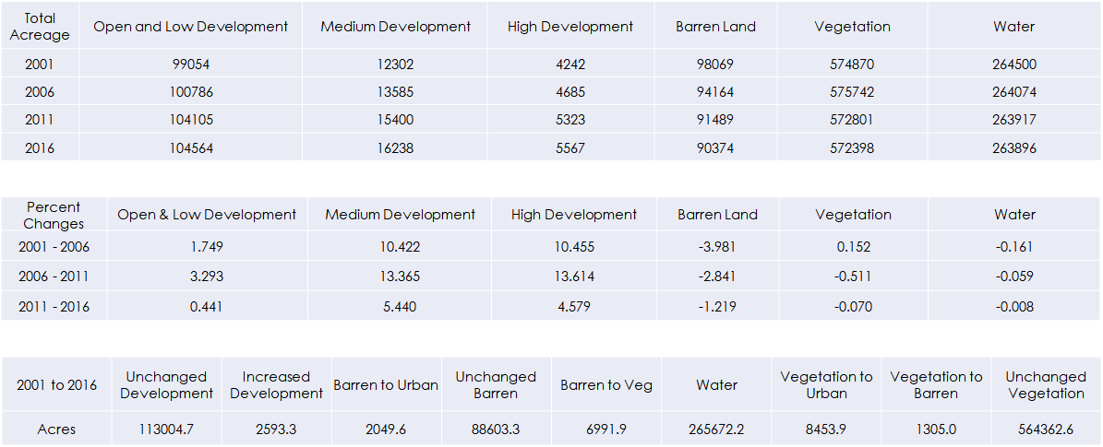

Table A5

*Census Tracts with Aggregated Social Vulnerability Index over 4 (out of 5)*

|  |  |  |  |
| --- | --- | --- | --- |
| Census Tract | **Location** | **Boundaries (Clockwise)** | **Aggregated SoVI** |
| 2 | City of Mobile | Beauregard St., N Conception St., St. Anthony St., S Water St., Church St., S Claiborne St., Canal St. N, S Broad St. | 5 |
| 15.02 | City of Mobile | Arlington St., I-10, Michigan Ave. | 4.86 |
| 15.01 | City of Mobile | Duval St., Michigan Ave., I-10, E Cardinal Dr., W Cardinal Dr., Raven Dr. | 4.83 |
| 4.02 | City of Mobile |  | 4.80 |
| 75 | City of Prichard | Dunlap Cir., Dr. Martin Luther King Jr. Dr., Rebel Rd. | 4.55 |
| 11 | City of Mobile |  | 4.43 |
| 27 | City of Mobile | Spring Hill Ave., N Florida St., Dauphin St., I65, Moffett Rd. | 4.43 |
| 40 | City of Prichard | W. Station St., Percy Ave., St. Stephens Rd., I-65 | 4.22 |
| 6 | City of Mobile | Toulmans Spring Branch, Three Mile Creek, St. Stephens Rd., S Wilson Ave. | 4.22 |
| 7.01 | City of Mobile | Barrets Ln., Jones Ave., St. Stephens Rd., Pleasant Ave., Donald St., Gibson St., Leslie Ave., Oonnor St., Summerville St. | 4.11 |
| 12 | City of Mobile | Mobile River, Spanish River, Baker St., S. Broad St., Virginia St., I-10, Canal St., S Claibourne, Church St., S Water St. | 4.09 |

**Appendix B.** Methodology and Analysis

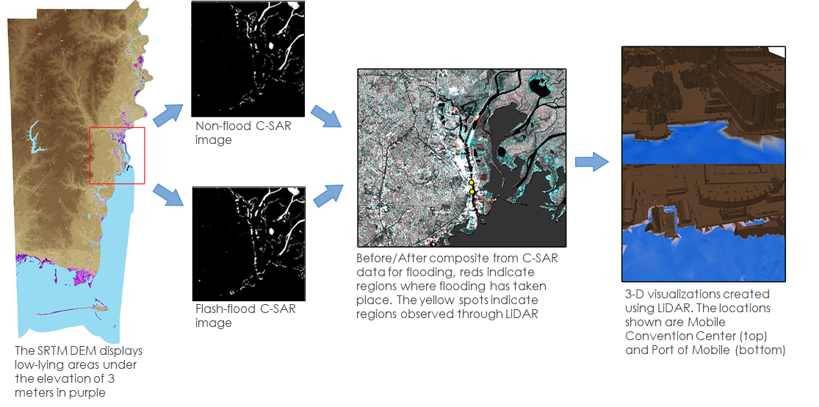

*Figure B1*. Illustration of data processing for the Flood extent analysis. The raw data used are obtained from SRTM, Sentinel 1 C-SAR and USGS LiDAR

|  |  |
| --- | --- |
| Water bodies no flood on June 11, 2019 | Water bodies with the flash flood on August 3, 2018 |
|  |  |

*Figure B2****.***Water polygon statistics with no flood image (left) and flash flood image (right)

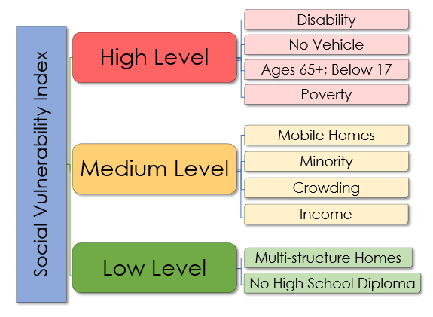

*Figure B3.* Social Vulnerability Index break-down based on Census Bureau 2010 data

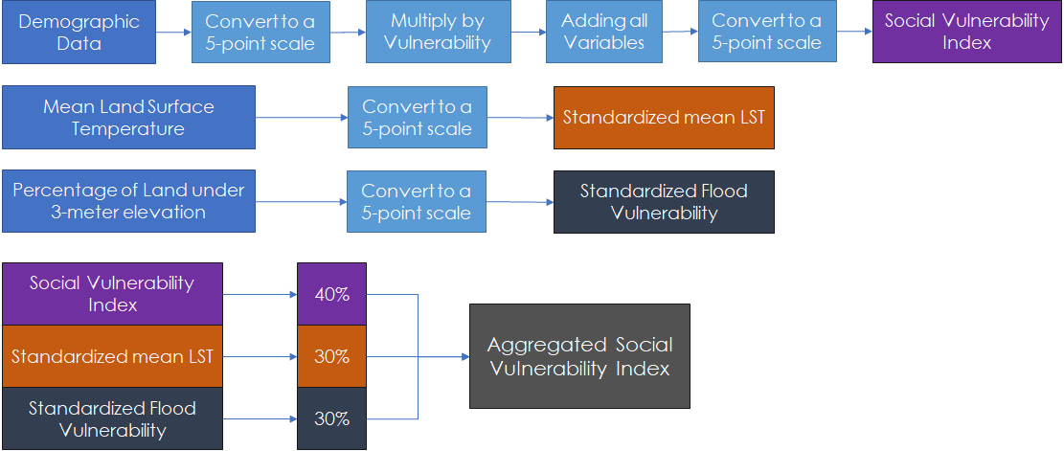

*Figure B4****.*** Flow chart of the methodology for the aggregated social vulnerability index.

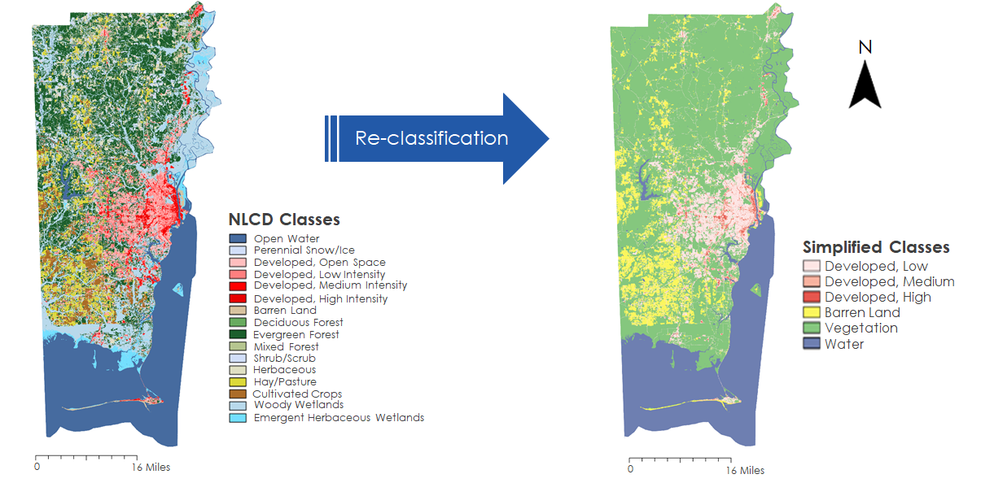

*Figure B5.* Reclassification process from NLCD to 6 classes.

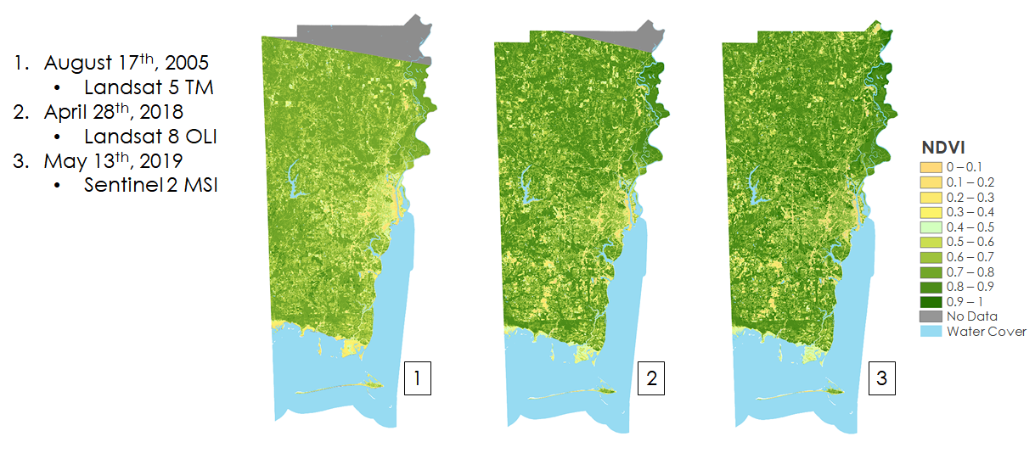

*Figure B6.* NDVI classification from 2005-2019 for validation of impervious surface evaluation

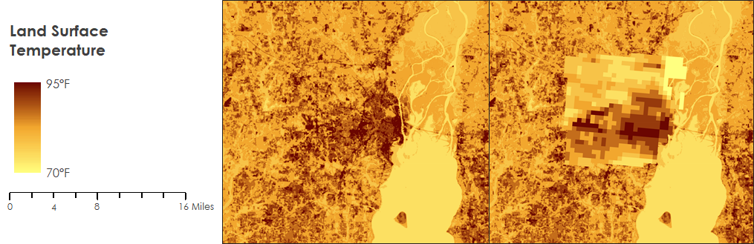

*Figure B7*. Spatial Comparison between LST from Landsat 8 TIRS Imagery and Terra MODIS

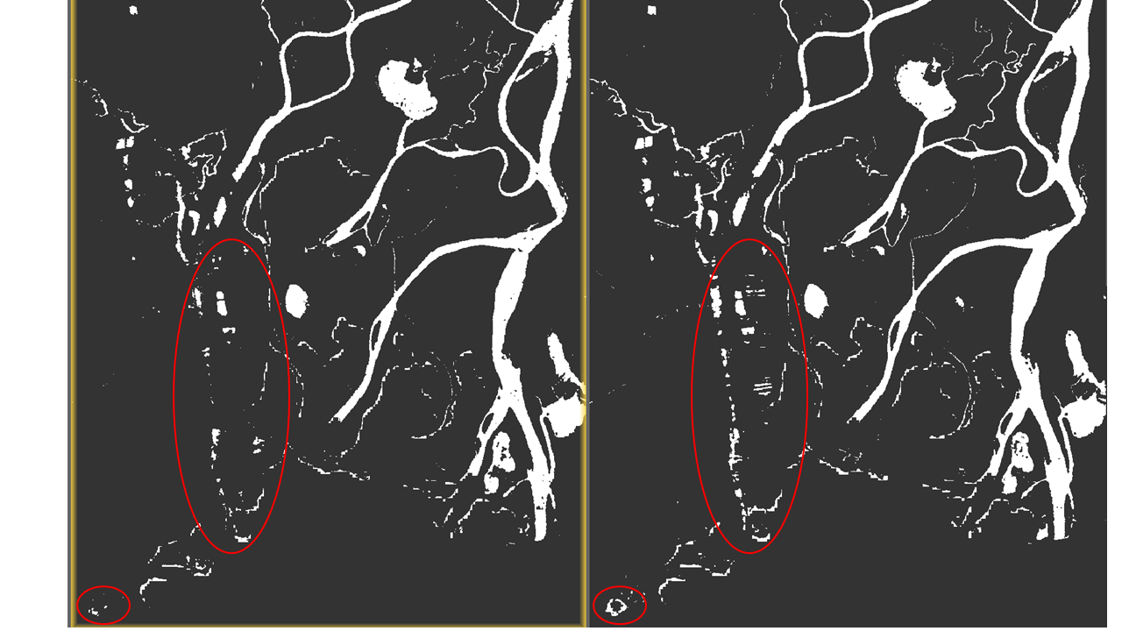

*Figure B8*. Flood imagery in the downtown City of Mobile. No-flood (left) and flash flood (right).

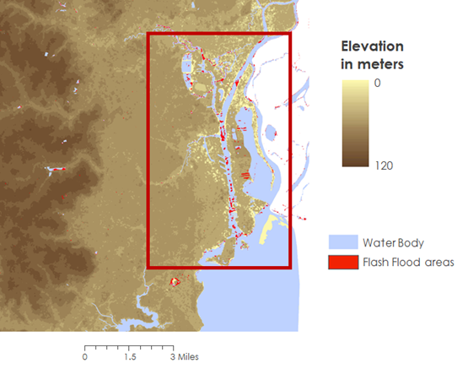

*Figure B9.* The case study site of downtown City of Mobile’s riverbank flood. The flash flood regions were determined from Sentinel 1 C-SAR imagery.

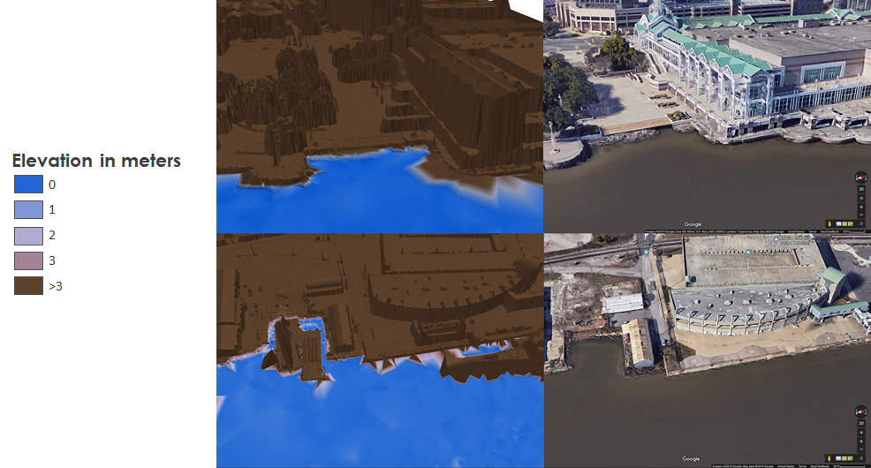

*Figure B10*. LiDAR 3D imagery of Mobile Convention Center (top) and Port of Mobile (bottom)

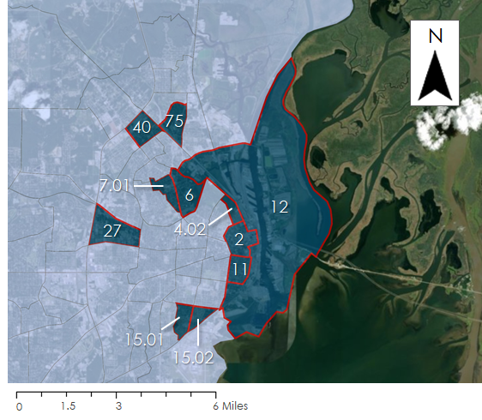

*Figure B11.* Labeled census tracts with aggregated social vulnerability greater than 4 (out of 5)

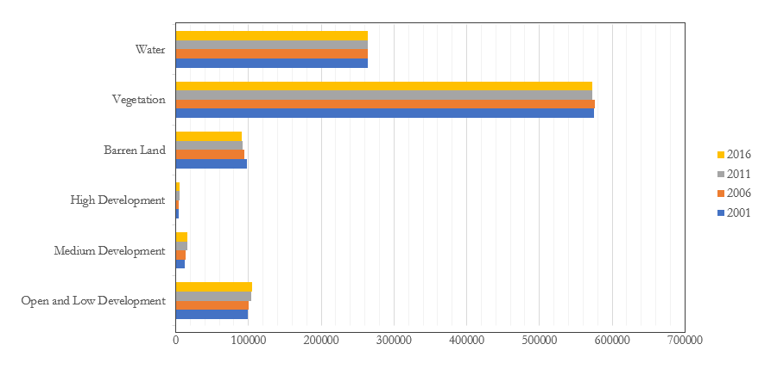

*Figure B12.* Land use change by the acre from 2001 to 2016

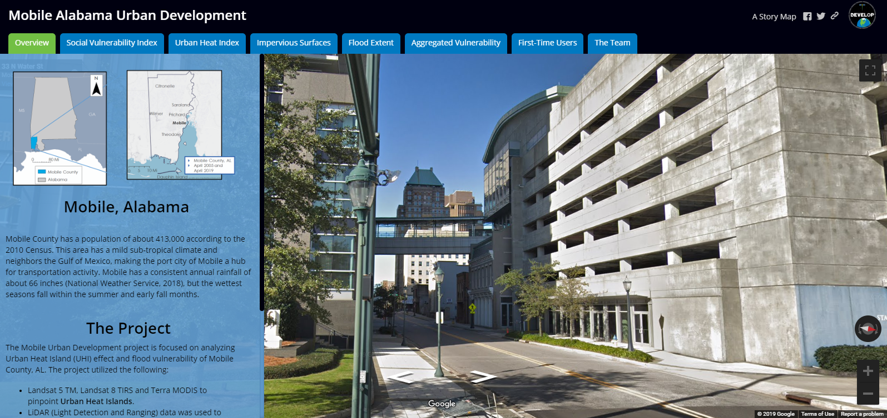

*Figure B13.* Story map of end products for community education efforts. (https://arcg.is/1aiLnm)