Texas Water Resources

Analyzing Drought-related Impacts on Urban Tree Inventory Conditions and Recovery in Texas

 **Technical Report**

Final Draft – April 4th, 2019

Anna Stamatogiannakis (Project Lead)

Millie Smith

Nick Roberts

Sally Ross

Dr. Jessica Matthews, North Carolina Institute for Climate Studies, North Carolina State University (Science Advisor)

Joe Spruce, Science Systems & Applications, Inc. (Science Advisor)

# 1. Abstract

In 2011, Texas experienced a severe drought that caused substantial economic and environmental losses. The Texas A&M Forest Service (TFS) estimated that 300 million trees succumbed to the severe drought conditions, with urban areas, in particular, losing about 5.6 million shade trees. For these estimations, the TFS uses resource-intensive *in situ* data collection methods. Studies have shown that ground-based inventories of the Urban Tree Canopy (UTC) can be augmented with remote sensing data. To explore this, the TFS Sustainable Forestry Department and the US Forest Service Southern Research Station partnered with NASA DEVELOP. For this project, our team aimed to assess pre- and post-drought canopy mortality in Austin and Houston. We implemented an unsupervised classification technique on National Agriculture Imagery Program (NAIP) high-resolution aerial imagery to determine the extent of the UTC. Then, using the Normalized Difference Vegetation Index (NDVI) derived from Landsat 5 Thematic Mapper (TM), Landsat 7 Enhanced Thematic Mapper Plus (ETM+), and Landsat 8 Operational Land Imager (OLI) data, we analyzed the relationship between NDVI anomalies and canopy mortality. Additionally, we utilized the Standardized Precipitation-Evapotranspiration Index (SPEI) derived from the National Oceanic and Atmospheric Administration’s nClimGrid dataset to give a broader context of climatic variables surrounding canopy loss. Ultimately, our results will be used by the TFS to identify areas that are likely to experience higher instances of UTC mortality and to monitor trends in recovery.

**Keywords**

Normalized Difference Vegetation Index (NDVI), remote sensing, Landsat, urban tree mortality, drought, urban trees, unsupervised classification

# 2. Introduction

* 1. ***Background Information***

A prolonged, multi-month drought of unprecedented intensity occurred in Texas during 2011, causing extensive damage to vegetation in many areas of the state. October 2010 through September 2011 was Texas’s driest 12-month period on record (Nielsen-Gammon, 2011). Many locations throughout the state measured less than 25 percent of their normal 12-month precipitation, with the driest conditions found in the southern, western, and central regions. This scarcity of precipitation occurred alongside record high temperatures in the summer of 2011. The average temperature from June to August of 2011 was 30.4˚C, which was 2.9˚C above the long-term average (Hoerling et al., 2013). As a result of the heat and extreme drought, the state experienced record agricultural losses, damage to infrastructure, and devastating wildfires (Combs, 2012). In addition, drought-related mortality affected a wide diversity of tree species and habitats. An estimated 6.2 percent of live trees across the state perished, which is almost nine times greater than normal annual mortality (Moore et al., 2015). In particular, according to estimates by the Texas A&M Forest Service, about 5.6 million urban trees died as a result of the 2011 drought.

Urban trees provide immeasurable ecosystem services such as improving air, soil, and water quality, reducing carbon emissions, and increasing biodiversity. They are also linked to improved quality of life in the urban environment through increased thermal comfort, air quality, aesthetic appearance, and noise abatement (Nowak et al., 2010). Due to the 2011 drought, the estimated loss of the services provided by urban trees is about $280 million per year, and the estimated cost of removal of dead trees is $560 million (Texas A&M Forest Service, 2015). Drought-induced tree mortality poses not only an economic burden to the public, but also a possible safety concern in the form of falling limbs or branches, or increased susceptibility to fire. Therefore, assessing the response of urban trees to drought and detecting trends in mortality and recovery is critical for urban forest management. In addition to more traditional *in situ* data collection methods, urban forest management can be augmented by remotely sensed data (Lambert, Drenou, Denux, Balent, & Cheret, 2013; Lawley, Lewis, Clarke, & Ostendorf, 2016; Moore et al., 2015).

The study area encompassed the cities of Austin and Houston (*Figure 1*), and the study period was from 2010 to 2016. Austin is the capital of Texas, with a population of approximately 930,000 and an urban tree density of 173 trees per acre (Nowak et al., 2016). Houston, the largest city in the state, has a population of 2.4 million with an urban tree density of 83 trees per acre (Nowak et al., 2017). Both cities experience high land development and have subtropical climates. While only 2.5 percent of Texas land mass is considered urban, nearly 85 percent of Texans live in urbanized areas. With such a large portion of Texas residents living in urban environments, urban environmental stewardship has grown increasingly important (Nowak et al., 2010).

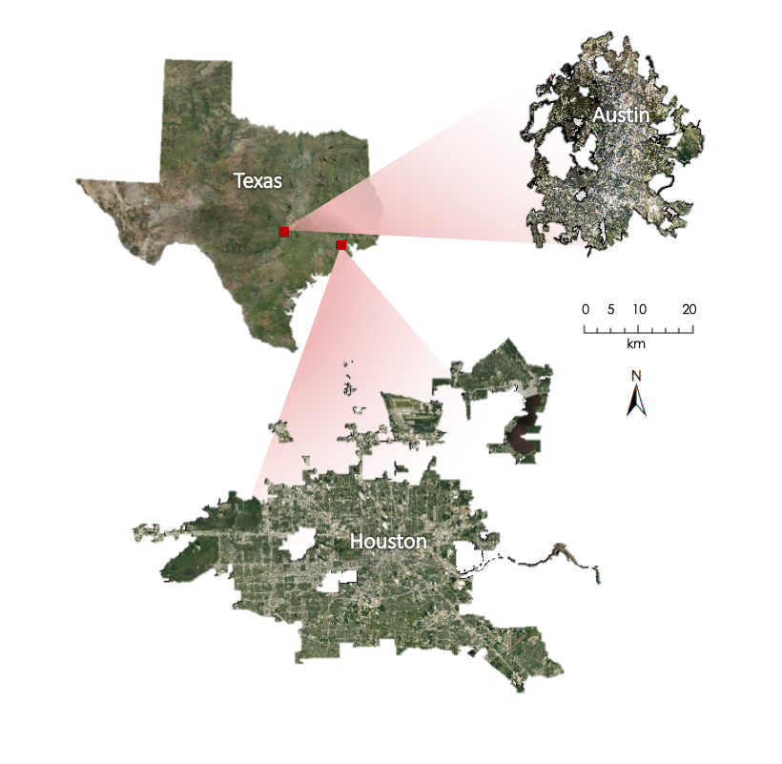

Figure 1. Map of study area spanning the cities of Austin, TX, and Houston, TX

* 1. ***Project Partners & Objectives***

The end user of this project was the Texas A&M Forest Service (TFS) Sustainable Forestry Department. The TFS wanted a product that could incorporate remotely sensed data with field-based data to detect trends in tree mortality and recovery following the 2011 Texas drought. This product would expand the monitoring efforts of the TFS, which currently consist of costly and time-consuming field-based data collection. The project collaborator for this project was the United States Forest Service (USFS) Southern Research Station’s Eastern Forest Environmental Threat Assessment Center (EFETAC), which is interested in analyzing impacts to urban tree inventories following extreme weather events using aerial imagery, satellite remote sensing, and *in situ* information.

Currently, TFS utilizes data from the Urban Forest Inventory and Analysis (FIA) program, which includes measurements of tree size, tree and sapling health/condition, general stand and site characteristics, and other estimates of tree health. TFS expressed interest in incorporating remotely sensed data to create a reproducible methodology for estimating drought-related tree mortality. In response, our research project was initiated to address three main goals: 1) employ NASA Earth observations to monitor drought impacts, 2) analyze the response of Urban Tree Cover (UTC) to drought in Austin and Houston using unsupervised classification methods, and 3) to investigate the relationship between Normalized Difference Vegetation Index (NDVI) anomalies and canopy mortality. We also created a public-facing story map that discusses our project’s key results and other background information on the 2011 drought’s impacts on Texas forests. Our end products are intended to inform resource managers of areas requiring further assessment and to generally aid in urban forest management.

# 3. Methodology

***3.1 Data Acquisition***

Our team extracted the following imagery from Google Earth Engine (GEE): Tier 1 Landsat 5 Thematic Mapper (TM) Surface Reflectance imagery from the years 1986 to 2011, Tier 1 Landsat 7 Enhanced Thematic Mapper Plus (ETM+) Surface Reflectance imagery for 2012, Tier 1 Landsat 8 Operational Land Imager (OLI) Surface Reflectance imagery for 2013 to 2016. All Landsat images are Level 2 processed satellite products. Tables 1 below provides more details about these products.

Our team also used the US Geographic Survey (USGS) EarthExplorer portal to acquire all National Agriculture Imagery Program (NAIP) imagery from 2010 and 2012 which covered the geographic extent of Houston and Austin, determined by shapefiles of each city provided by our partners at the TFS. 97 Digital Orthophoto Quarter Quad (DOQQ) images in GeoTIFF format were downloaded for each year to cover Houston and 54 DOQQ images were downloaded for each year to cover Austin, for a total of 302 NAIP images. Tables 2 and 3 below provide more details about the resolution and collection period for the NAIP imagery utilized.

In addition to Landsat imagery acquired through GEE, our team also used the USGS EarthExplorer portal to acquire high-quality Landsat 5 TM and Landsat 7 ETM+ data corresponding to each NAIP collection period in 2010 and 2012. The individual Landsat scenes chosen were selected on a basis of image quality (e.g., estimated percent cloud coverage) and temporal proximity to the dates of NAIP imagery collection for more direct comparison between Landsat imagery and NAIP imagery. More details on the image collection dates for each source can be found below in Table 3.

Table 1

NASA Earth observations utilized in data analysis

|  |  |  |  |
| --- | --- | --- | --- |
| **Earth observation Product** | **Spatial Resolution** | **Temporal Resolution** | **Years Active** |
| Tier 1 Landsat 5 TM Surface Reflectance | 30 meters | 16 days | 1984 to 2013* |
| Tier 1 Landsat 7 ETM+ Surface Reflectance | 30 meters | 16 days | 1999 to Present** |
| Tier 1 Landsat 8 OLI Surface Reflectance | 30 meters | 16 days | 2013 to Present** |

*\*Useable Landsat 5 data available for the study area extends between 1984 to 2011*

*\*\*For this project, present=April 2019*

Table 2

Aerial imagery products utilized in data analysis

|  |  |  |  |
| --- | --- | --- | --- |
| **Aerial Imagery Product** | **Spatial Resolution** | **Temporal Resolution** | **Years Active** |
| NAIP | 1 meter | 2 years* | 2003 to Present** |

*\*NAIP availability varies, but for Texas, NAIP imagery is available in 2010, 2012, 2014, and 2016*

*\*\*Imagery from 2016 is the most recent available NAIP data*

Table 3

*Collection dates for single Landsat scenes and NAIP imagery*

|  |  |  |
| --- | --- | --- |
| **Product** | **City** | **Collection Date** |
| Tier 1 Landsat 5 TM Surface Reflectance | Austin, TX | May 2010 |
| Tier 1 Landsat 5 TM Surface Reflectance | Houston, TX | May 2010 |
| Tier 1 Landsat 7 ETM+ Surface Reflectance | Austin, TX | June 2012 |
| Tier 1 Landsat 7 ETM+ Surface Reflectance | Houston, TX | May 2012* |
| NAIP Pre-Drought | Austin, TX | May 2010 |
| NAIP Pre-Drought | Houston, TX | May 2010 |
| NAIP Post-Drought | Austin, TX | June 2012 |
| NAIP Post-Drought | Houston, TX | June 2012 |

*\*Landsat 7 imagery from May 2012 was selected due to the lack of availability of high-quality imagery for June 2012*

***3.2 Data Processing***

*3.2.1 Tree Cover Isolation*

In order to create a tree canopy mortality map, our team first isolated areas of tree cover for each city in 2010. To do this, we used the geospatial processing software ESRI ArcMap 10.6 and its analytic tools to mosaic the NAIP imagery acquired for each city to raster layer, resulting in overall NAIP imagery layers for both cities in 2010. Our team used these NAIP imagery layers to derive an NDVI layer for each city (Equation 1). Using the raster calculator tool, we then separated the red (R), green (G), blue (B), and near-infrared (NIR) bands from the NAIP imagery layers for each city. We also used the focal statistics tool to calculate the range for the G and NIR bands for each city using a 7 by 7 cell window. We then used the raster calculator to take the average of these range calculations. This was used as a “texture” layer, which helped visually separate areas such as grass which have similar NDVI values to tree canopy but much less variation (Behee, 2012). We then used the NDVI layer, all four bands (R, G, B, and NIR), and the “texture” layer as inputs into the Iso Cluster unsupervised classification tool with an output of 25 classes. Each of these classes was manually assessed by our team in order to determine which classes contained tree cover and which did not. We reclassified classes composed of tree cover to a value of 1 and classes composed of things other than tree cover to a value of 0. For a visual representation of the tree cover isolation process, see Figure A1 in Appendix A.

$\text{NDVI=}\frac{\text{NIR-R}}{\text{NIR+R}}$ (1)

*3.2.2 Tree Mortality Classification*

Our team used the 2010 NAIP derived tree cover map as a masking layer for the overall NAIP imagery for each city in both years. We chose to apply the tree cover classification from 2010 also to 2012 in order to save time. We also hypothesized that the generally healthy canopy conditions in 2010 would make it easier for a classification algorithm to identify tree canopy given the larger contrast between tree cover and non-tree cover in 2010. We then separated all four bands from the masked NAIP imagery layers for each year and each city. Additionally, our team used the masked NAIP imagery to recalculate the NDVI layer and the “texture” layer. We used these layers as inputs into the second round of Iso Cluster unsupervised classification with an output of 15 classes. Our team manually assessed the composition of each of the 15 classes, making note of whether the tree cover in each class seemed to be living or dead based on the color (*Figure 2*). If the canopy was green and had a high NDVI value, the canopy was assessed to be living. If the canopy was brown and had a comparatively poor NDVI value, the canopy was assessed to be dead. We then reclassified the living canopy classes to have a value of 0 and the dead canopy classes to have a value of 100. The maps we produced by this process are our four binary “tree mortality” maps, showing the presence of canopy mortality in each city in the years 2010 and 2012, shown in Figures 5 through 8.

(a) 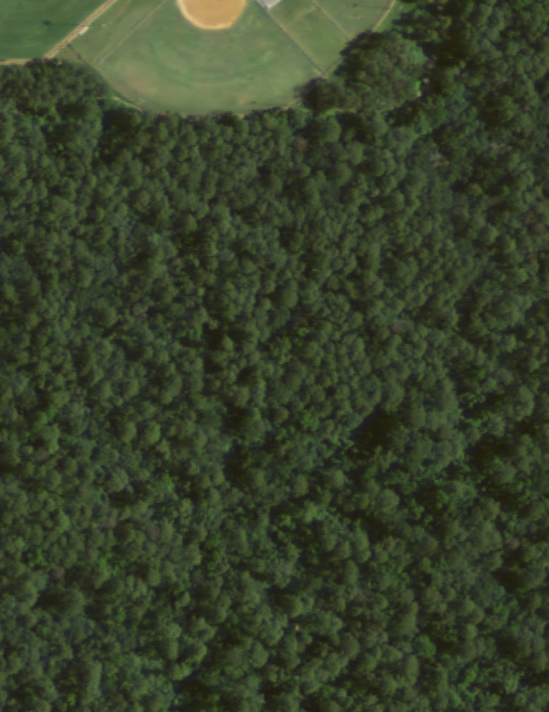 (b) 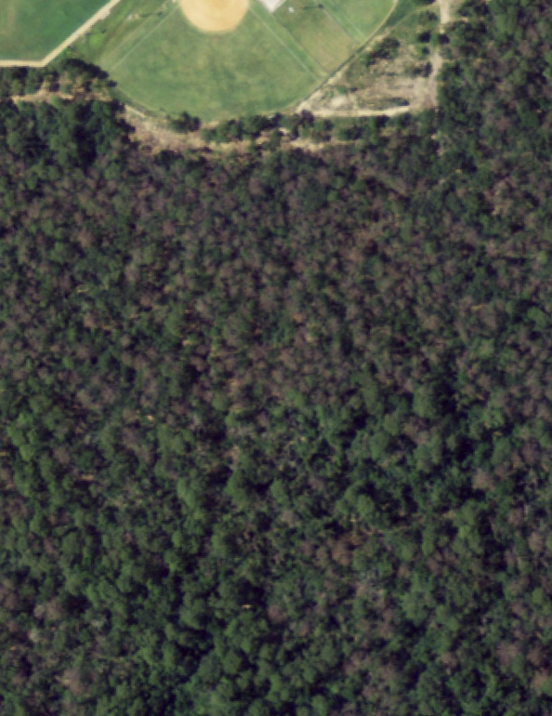

*Figure 2*. Comparison of urban tree canopy over Houston in 2010 (a) and 2012 (b)

In order to have a tree mortality product at a lower resolution for comparison against Landsat imagery, our team then used the aggregate tool in ArcGIS with the “mean” option and a cell factor of 30, meaning that the output raster layer would have a resolution of 30-meters and would display the mean value of our reclassified tree mortality layer. This gives us the percent composition of each 30-meter cell made up of dead canopy. In order to not count areas of very low tree density which would overestimate tree cover and incorporate non-tree areas, we created a “tree density” layer by reclassifying the 1-meter tree mortality map to have a uniform value of 1. Our team then used the aggregate tool with the “sum” option and a cell factor of 30, meaning the output raster layer would show how many 1-meter cells assessed to be trees would fit into each 30-meter resolution cell. We then used the extract by attributes tool to select only the cells within our created tree density layer which contained over 450 “tree” pixels or was composed of over 50 percent tree cover. Our team then used this “high-density tree cover” layer to mask the “percent canopy mortality” layer, creating a “high-density tree mortality” raster layer for Austin and Houston in 2010 and 2012. For a visual representation of the tree cover isolation process, see Figure A1 in Appendix A.

*3.2.3 Landsat NDVI Anomaly Calculation*

Our team chose to evaluate the utility of NDVI anomalies and NDVI normalized anomalies in the prediction of percent canopy mortality due to our hypothesis that as vegetative conditions grew worse, there would be both an increase in negative NDVI anomalies and an increase in tree mortality, meaning the two would have an identifiable relationship. In order to calculate the NDVI anomalies for Austin and Houston, we first used GEE to calculate the NDVI historical norms. We used all images from Landsat 5 TM, Landsat 7 ETM+, and Landsat 8 OLI in the calculation of the 30-year historical norm from 1986 to 2016. We chose this period of time because the standard time span of climatological historical norms is 30 years and we wanted to include Landsat 8 OLI in the calculation of NDVI norms. Our team first filtered the Landsat imagery collection to the bounds of Austin, determined by the partner provided shapefile of city boundaries, and clipped the image collection to these bounds. We then used common Landsat quality processing algorithms in GEE to remove areas flagged by each Landsat sensor as clouds, then applied a function meant to make Landsat 8 OLI images more directly comparable to Landsat 5 TM and Landsat 7 ETM+ images (Roy et al., 2016). We then calculated the NDVI values for each image in the collection. Our team then calculated the maximum NDVI values for each month of each year (i.e. we calculated a value for January 1986, January 1987, January 1988, and so on for every year and every month). We chose to use the maximum NDVI values for each month because any lingering issues with cloud cover would be reduced by taking the maximum NDVI value from each month, given that issues with cloud cover would lower the NDVI value for a given area. Our team then computed the mean NDVI maximum for each month (i.e. a single NDVI norm value for each month). This process was then repeated for the city of Houston, yielding 30-year NDVI historical norms for each city.

Our team also used GEE to calculate the NDVI anomalies. For the NDVI anomalies in 2010, we used the high-quality single Landsat 5 TM scenes acquired for each city to calculate NDVI values for 2010. We then subtracted the monthly norm associated with the collection date of the Landsat 5 TM scenes from the NDVI values derived from the single Landsat 5 TM scenes to yield NDVI anomalies for 2010 in each city. We replicated this process using Landsat 7 ETM+ scenes to yield NDVI anomalies for 2012 in each city (Equation 2).

$\text{NDVI Anomaly= Current NDVI-NDVI Norm}$ (2)

To calculate normalized NDVI values, we took the calculated NDVI anomaly values for each year and divided them by the monthly NDVI norms used to calculate the anomalies (Equation 3).

$\text{Normalized NDVI Anomaly=} \frac{\text{NDVI Anomaly}}{\text{NDVI Norm}}$ (3)

***3.3 Data Analysis***

*3.3.1 Tree Cover Layer Validation*

Our team assessed the accuracy of our 2010 NAIP derived 1-meter tree cover classification by using the Create Accuracy Assessment Points tool in ArcMap with “equalized stratified random” selected as the sampling strategy and a sample size of 100. Given that our tree cover classification has only 2 classes, tree and not a tree, this generated 50 points in each class. We manually assessed the composition of each point to see if the classification was accurate. This resulted in an 82 percent accuracy for Austin in 2010 and an 88 percent accuracy in Houston in 2010.

*3.3.2 Model Creation and Evaluation*

We used R to create a series of four logistic regression models using Landsat-derived vegetation indices and NAIP-derived canopy mortality to predict percent canopy mortality at the 30 m resolution. We chose to use logistic regression because logistic regression is capped at 0 and 1 in terms of predicted values, which aligns well with the plausible prediction range of 0-100 percent. Selecting logistic regression avoids predicting illogical scenarios (<0% and >100% tree mortality) with our model. The four evaluated models included choices of NDVI vs. normalized NDVI anomaly model inputs and random vs. stratified sampling methods to select training data.

In order to formulate a relationship between NDVI anomalies and percent mortality, we first had to ensure that the values of each raster lined up exactly for accurate extraction of point pairs. To do this, we first used the raster function from the raster library in R to load in the raster layers with NDVI anomaly values and percent canopy mortality that matched in terms of collection year and city (i.e. NDVI anomalies for Austin 2010 and percent canopy mortality for Austin 2010). We then used the crop function from the raster library to match extents of each raster layer exactly. Our team then converted each raster layer into a numeric vector and loaded these vectors into a data frame. We bound the data frames into a single data frame containing all data from both years and both cities. Our team eliminated observations with null or missing values from the overall data frame. We repeated this process for the creation of the two models using normalized NDVI anomalies instead of simple NDVI anomalies.

Our team experimented with two sampling methods for selecting data used to train the model: simple random sampling and stratified random sampling. In the two models utilizing simple random sampling, we used the sample function to randomly select 70 percent of all of the observations in the combined data frame to use as training samples for model creation. The remaining 30 percent of observations were used as test data to evaluate the created model. In the two models utilizing stratified random sampling, we first grouped the data in ten percent intervals of canopy mortality (i.e. each observation with greater than or equal to 0 percent mortality but less than 10 percent canopy mortality is grouped together, etc.). We then identified the number of observations comprising 70 percent of the smallest grouping. This was how many observations we used for training from each of the 10 groupings. The remainder of the data was used as test data.

To implement the logistic models, our team used the logitMod function. Our models used one of the two vegetation indexes combined with one of the two sampling methods to predict percent canopy mortality, as shown in Table 4. We evaluated the performance of each model by recording the model’s Akaike information criterion (AIC), as well as the area under the Receiver Operating Curve (AUROC). Our team also plotted the predicted percent canopy mortality against the observed canopy mortality and evaluated the plot visually. Ideally, this plot would show a perfect correlation and would produce a 45-degree linear trendline, meaning all predicted values perfectly match their observed value. The AIC and AUROC were used to comparatively evaluate models derived from the same sampling method, given that AIC and AUROC values cannot be used for comparison between models using different training data. The grouping and trend evaluation of the predicted versus observed plot evaluation was used to compare models of different sampling methods. We found that the logistic regression model using stratified random sampling of training data and NDVI anomalies to predict percent canopy mortality performed the best, as shown in Table 4. The resulting plot of training data from this model with the overlaid model is shown in *Figure 3*, and the plot of predicted versus observed values for training data is shown in *Figure 4.*

Table 4

*The four logistic models examined along with evaluation criteria*

|  |  |  |  |  |
| --- | --- | --- | --- | --- |
| **Sampling Method** | **Vegetation Index** | **AIC\*** | **AUROC\*\*** | **Plot Evaluation** |
| Simple Random | NDVI Anomalies | 287662 | 0.5284 | Loose grouping, flat trendline |
| Stratified Random | NDVI Anomalies | 25932 | 0.9799 | Loose grouping, slightly positive trendline |
| Simple Random | Normalized NDVI Anomalies | 301932 | 0.4932 | Very loose grouping, flat trendline |
| Stratified Random | Normalized NDVI Anomalies | 26122 | 0.9795 | Loose grouping, slightly positive trendline |

*\*The model with the lowest AIC is considered best among the choices*

*\*\*A higher AUROC value denotes a better-suited model*

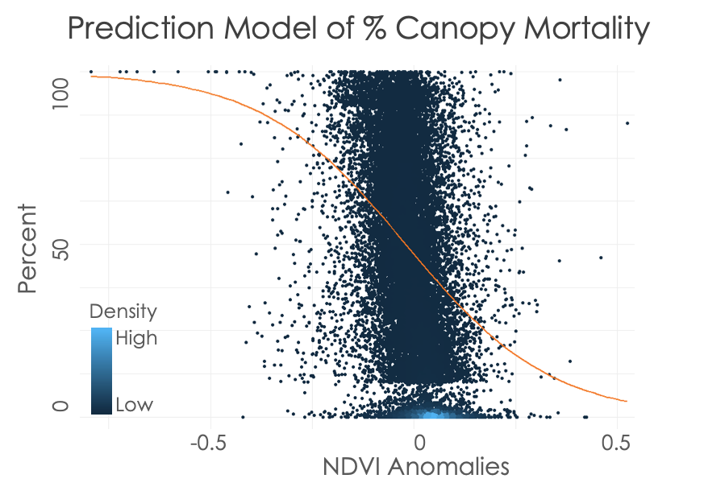

*Figure 3*. Plot of the logistic model created with stratified random sampling using NDVI anomalies to predict percent canopy mortality

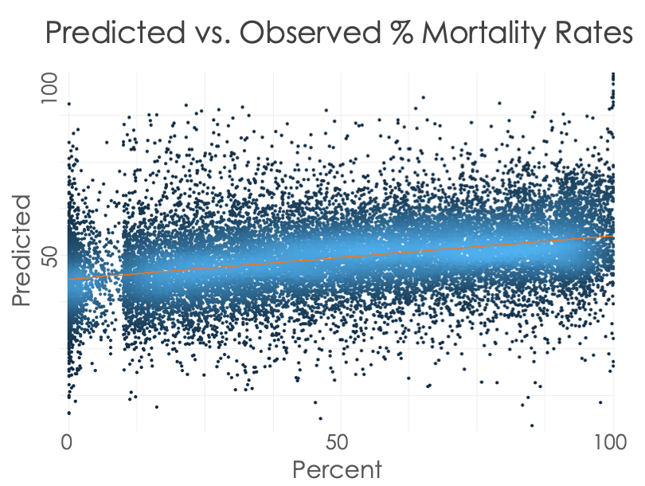

*Figure 4*. Plot of predicted vs. observed percent mortality with predicted percent canopy mortality on the y-axis and observed canopy mortality on the x-axis

# 4. Results & Discussion

***4.1 Analysis of Results***

We found that in Austin, overall canopy mortality increased from about 1.75 percent in 2010 to about 19.64 percent in 2012. Similarly, in Houston, canopy mortality increased from approximately 1.99 percent in 2010 to 19.56 percent in 2012. This dramatic increase is evidence of the devastating effects of the drought and can be seen in figures 5 through 8 below.

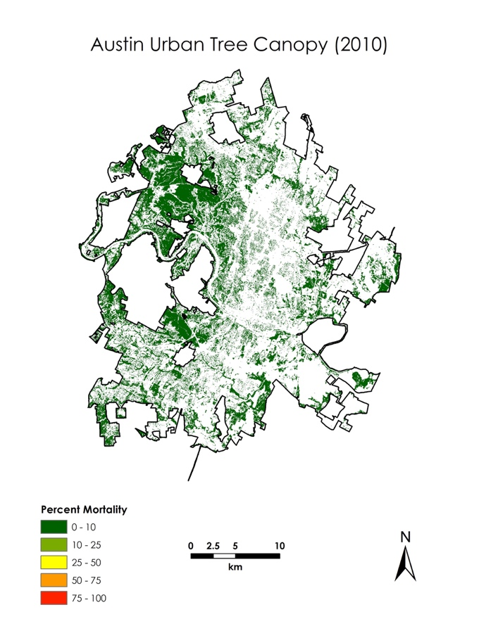 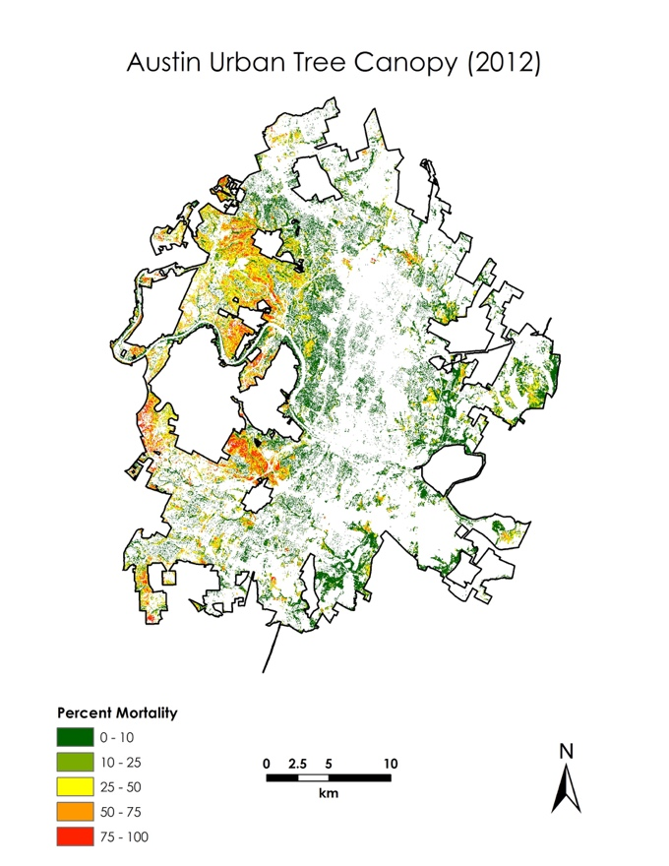

*Figure 6*. 30 m NAIP-Derived Percent Mortality of the Austin Urban Tree Canopy in 2012

*Figure 5*. 30 m NAIP-Derived Percent Mortality of the Austin Urban Tree Canopy in 2010

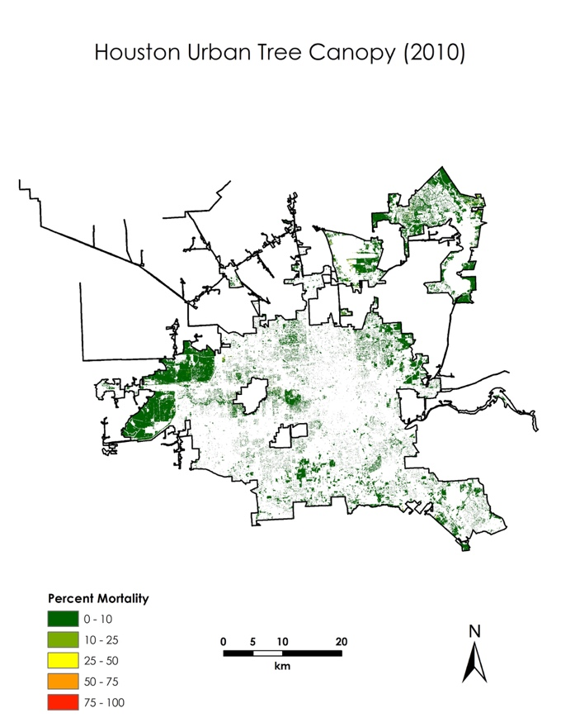 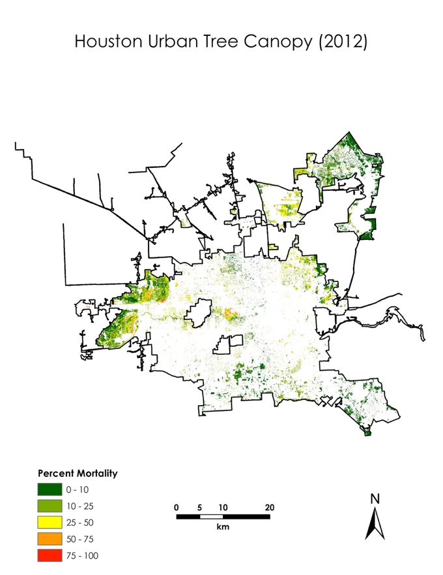

*Figure 8*. 30 m NAIP-Derived Percent Mortality of the Houston Urban Tree Canopy in 2012

*Figure 7*. 30 m NAIP-Derived Percent Mortality of the Houston Urban Tree Canopy in 2010

There are several limitations associated with our work. In our analysis, we referred to “live canopy” and “dead canopy”. We equated live canopy to trees that have a visible green crown, and dead canopy to trees with an uncharacteristically brown crown. However, it cannot be assumed that a tree is dead because the crown is brown – a physical observation is necessary to validate whether or not a tree is dead. Given the lack of available *in situ* data for our time period of interest, we could not directly validate our assessment of tree mortality. We did validate our assessment of the tree canopy itself, but this validation was limited. We only looked at 100 randomly sampled points throughout Houston and Austin to verify if our “tree” vs. “not a tree” determination was valid. Finally, we assumed that the tree canopy in Austin and Houston stayed constant from 2010 to 2012.

In terms of our model, it tends to predict within the range of 40 to 50 percent canopy mortality, which leads to overestimation in areas that are actually healthy, and underestimation in areas of severe canopy mortality. As shown in *Figure 9* below, the model-derived percent canopy mortality map for Austin in 2012 generates large swaths of areas in the 25 to 50 percent mortality range. Additionally, Landsat 7 scan line errors are evident in the map below. To match the post-drought NAIP collection period (June 2012), we were limited to using Landsat 7 NDVI data, which was the only Landsat satellite in operation at the time. Thus, our model had a more limited selection of input data, which could affect accuracy. Additionally, since NAIP data was collected in the summer (May 2010 and June 2012), our model is most optimally applicable to summer months, when peak greenness is observed. Finally, NDVI can change from many factors other than droughts, such as pests/disease, wildfires, or urban development, to name a few.

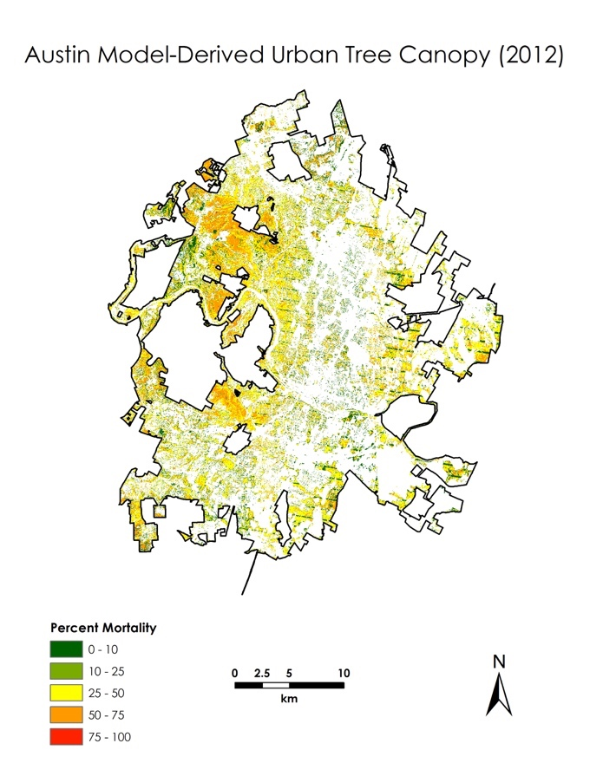

*Figure 9.* 30 m Model-Derived Percent Mortality of the Austin Urban Tree Canopy in 2012

Despite these limitations of the model, we attempted to forecast UTC mortality in 2016. The *figure 10* below shows the results of this derivation. As we assumed, this derivation overpredicted mortality, given that 2016 was not a drought year in Texas. However, when comparing this result to base imagery for Austin in 2016, it becomes clear that high mortality areas in this map (in the 75 to 100 percent category) are actually areas where urban development has occurred since 2012, indicating an updated tree cover map is necessary.

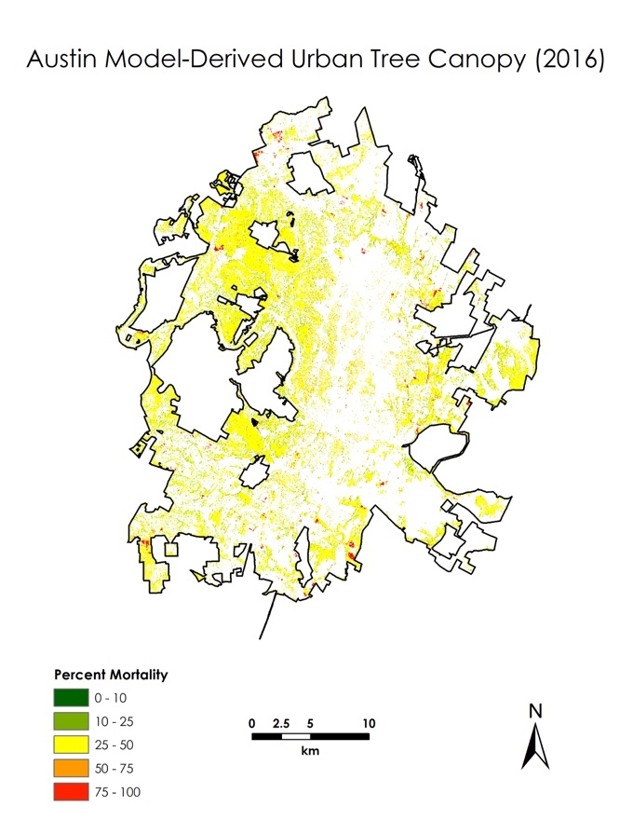

*Figure 10*. 30 m Model-Derived Percent Mortality of the Austin Urban Tree Canopy in 2016

***4.2 Future Work***

Future teams could employ several tactics to improve the accuracy of this analysis and build upon the results of this project. Perhaps most importantly, our classification of canopy mortality could be refined and more robustly validated with high quality *in situ* data. Urban FIA data was not available to the team during this study, but it could be included as a method of ground-truthing. Light Detection and Ranging (LiDAR) is another data source that could provide a more accurate classification of the UTC. In our assessment of canopy mortality, other factors should be considered, namely: urbanization, storm hazards, fire, and disease and pests. Our project entirely focused on drought, but future work could focus on how these other factors simultaneously impact vegetation in urban environments.

While our project only explored the relationship between NDVI anomalies and canopy mortality, future teams could test other vegetation indices or climate indices (such as the Standardized Precipitation-Evapotranspiration Index (SPEI)). Additionally, satellite imagery with a higher spatial resolution could be used for NDVI calculations, such as the Sentinel-2 MultiSpectral Instrument (MSI). Also, Sentinel-2 has additional red edge spectral bands that collect data that could be useful for improving the detection of vegetation health issues, such as tree mortality. Since we were looking at impacts of the 2011 drought, Sentinel’s data collection began too late for addressing needs of our project, but this satellite could be useful for looking at tree recovery trends, or for looking at urban tree impacts from more recent extreme weather events.

# 5. Conclusions

Ultimately, we found that the drought had similar negative impacts on urban tree cover in both Austin and Houston. We hoped to analyze the recovery of urban tree cover after the drought using our model, but given the significant overestimation of mortality, we could not make sound conclusions on post-drought recovery. However, our model was useful in identifying areas of urban tree cover change that were not related to drought – for example, the sections of the 2016 model-derived map that are predicted to have new high canopy mortality are areas where urban development occurred after 2012.

While our work did not find a particularly strong relationship between NDVI anomalies and canopy mortality, we have passed on our methodology and model to our partners, who can modify the model and further explore relationships between urban tree cover change and additional cofactors. Additionally, the story map created provides useful information on the project, including the context to the 2011 drought, and gives an online interface for members of the public to get more information about the drought impacts to Texas urban forests. Our project demonstrated the potential of NAIP aerial imagery and Landsat remote sensing for aiding urban forestry. The project provided the TFS with tools, data, and know-how for potentially moving the application forward, especially if *in situ* data is used to further refine and validate the products derived from remote sensing. In doing so, the TFS could possibly supplement future inventories of urban health conditions with data from satellite imagery.

# 6. Acknowledgments

This project was made possible through the support and mentorship of select individuals and organizations. We extend thanks to the following:

* Dr. Jessica Matthews, North Carolina Institute for Climate Studies, North Carolina State University
* Joe Spruce, Science Systems & Applications, Inc.
* Andrew Shannon, NASA DEVELOP NCEI Node Center Lead

Any opinions, findings, and conclusions or recommendations expressed in this material are those of the author(s) and do not necessarily reflect the views of the National Aeronautics and Space Administration.

This material is based upon work supported by NASA through contract NNL16AA05C.

# 7. Glossary

**Earth observations** – satellites and sensors that collect information about the Earth’s physical, chemical, and biological systems over space and time

**Google Earth Engine (GEE)** – a cloud-based geospatial processing platform

**Landsat** - a series of Earth-observing satellite missions jointly managed by NASA and the U.S. Geological Survey

**Light Detection and Ranging (LiDAR)** – a remote sensing method that uses light in the form of a pulsed laser to measure ranges (variable distances) to the Earth

**National Agriculture Imagery Program (NAIP)** – acquires 1-meter resolution aerial imagery of the continental US during the agricultural growing season

**Normalized Difference Vegetation Index (NDVI)** – an index which is calculated from near-infrared light reflection (which vegetation strongly reflects) and red light (which vegetation absorbs)

**Sentinel** – a family of satellite missions developed by the European Space Agency that includes the Sentinel-2 system that collects data at a comparable spatial and spectral resolution to Landsat 8 data

**Standardized Precipitation-Evapotranspiration Index (SPEI)** – a multiscalar drought index based on climatic data that can be used for determining the onset, duration, and magnitude of drought conditions  
**Urban Forest Inventory and Analysis (FIA) Program** – a comprehensive field-based and annually updated inventory of all forest ownerships for each of the 50 states

**Urban Tree Canopy (UTC)** – refers to the layer of tree leaves, branches, and stems that provide tree coverage of the ground when viewed from above

# 8. References

Behee, C. (2012). Vegetation modeling with NAIP color IR imagery. In Washington GIS Conference. Tacoma, WA. Retrieved from: <http://www.waurisa.com/conferences/2012/presentations/11%20Chris%20Behee%20Vegetation%20Modeling%20with%20NAIP%20Color%20IR%20Imagery.pdf>

Combs, S. (2012). *The impact of the 2011 drought and beyond* (Texas Comptroller of Public Accounts Publication No. 96-1704). Austin, TX: Data Services Division. Retrieved from <http://tiggernut.com/ClimateChange/96-1704-Drought.pdf>

Hoerling, M., Kumar, A., Dole, R., Nielsen-Gammon, J. W., Eischeid, J., Perlwitz, J., ... Chen, M. (2013). Anatomy of an extreme event. *Journal of Climate, 26*, 2811-2832. <https://doi.org/10.1175/JCLI-D-12-00270.1>

Lambert, J., Drenou, C., Denux, J. P., Balent, G., & Cheret, V. (2013). Monitoring forest decline through remote sensing time series analysis. *GIScience & Remote Sensing, 50*(4), 437-457. <https://doi.org/10.1080/15481603.2013.820070>

Lawley, V., Lewis, M., Clarke, K., & Ostendorf, B. (2016). Site-based and remote sensing methods for monitoring indicators of vegetation condition: An Australian review. *Ecological Indicators, 60*, 1273-1283. <https://doi.org/10.1016/j.ecolind.2015.03.021>

Moore, G. W., Edgar, C. B., Vogel, J. G., Washington‐Allen, R. A., March, R. G., & Zehnder, R. (2015). Tree mortality from an exceptional drought spanning mesic to semiarid ecoregions. *Ecological Applications, 26(*2), 602-611. <https://doi.org/10.1890/15-0330>

Nowak, D., Stein, S., Randler, P., Greenfield, E., Comas, S., Carr, M., & Alig, R. (2010). *Sustaining America’s urban trees and forests* (USDA Forest Service General Technical Report NRS-62). Newtown Square, PA: USDA Forest Service Northern Research Station. Retrieved from [https://www.fs.fed.us/openspace/fote/reports/nrs-62_sustaining_americas_urban.pdf](%20https://www.fs.fed.us/openspace/fote/reports/nrs-62_sustaining_americas_urban.pdf)

Nowak, D., Bodine, A., Hoehn III, R., Edgar, C., Hartel, D., Lister, T., & Brandeis, T., (2016). *Austin’s Urban Forest, 2014* (Resource Bulletin NRS-100). Newtown Square, PA: U.S. Department of Agriculture, Forest Service, Northern Research Station. Retrieved from <https://www.fs.fed.us/nrs/pubs/rb/rb_nrs100.pdf>

Nowak, D., Bodine, A., Hoehn III, R., Edgar, C., Riley, G., Hartel, D., … Lister, T. (2017). *Houston’s Urban Forest, 2015*. (Resource BulletinSRS–211) Asheville, NC: U.S. Department of Agriculture, Forest Service, Southern Research Station. Retrieved from <https://www.srs.fs.usda.gov/pubs/rb/rb_srs211.pdf>

Nielsen-Gammon, J. (2011). The 2011 Texas drought: A briefing packet for the Texas Legislature. College Station, TX: Office of the State Climatologist, Texas A&M University. Retrieved from [https://oaktrust.library.tamu.edu/handle/1969.1/158245](%20https://oaktrust.library.tamu.edu/handle/1969.1/158245)

Roy, D., Kovalskyy, V., Zhang, H., Vermote, E., Yan, L., Kumar, S., & Egorov, A. (2016). Characterization of Landsat-7 to Landsat-8 reflective wavelength and normalized difference vegetation index continuity. *Remote Sensing of Environment, 185*, 57-70. <https://doi.org/10.1016/j.rse.2015.12.024>

United States Department of Agriculture Farm Service Agency. (2003). National Agriculture Imagery Program 2010/2012 imagery. Farm Service Agency, accessed February 27, 2019. Retrieved from: <https://earthexplorer.usgs.gov/>

US Geological Survey Earth Resources Observation and Science Center. (2018). Landsat 8 OLI/TIRS Level-2 Data Products – Surface Reflectance. [Image collection]. US Geological Survey. <https://doi.org/10.5066/F78S4MZJ>

US Geological Survey Earth Resources Observation and Science Center (2018). Landsat 7 ETM+ Level-2 Data Products – Surface Reflectance [Image collection]. US Geological Survey. <https://doi.org/10.5066/F7Q52MNK>

US Geological Survey Earth Resources Observation and Science Center (2018). Landsat 4-5 TM Level-2 Data Products – Surface Reflectance [Image collection]. US Geological Survey. <https://doi.org/10.5066/F7KD1VZ9>

# 9. Appendices

Appendix A. Methodology Flowchart

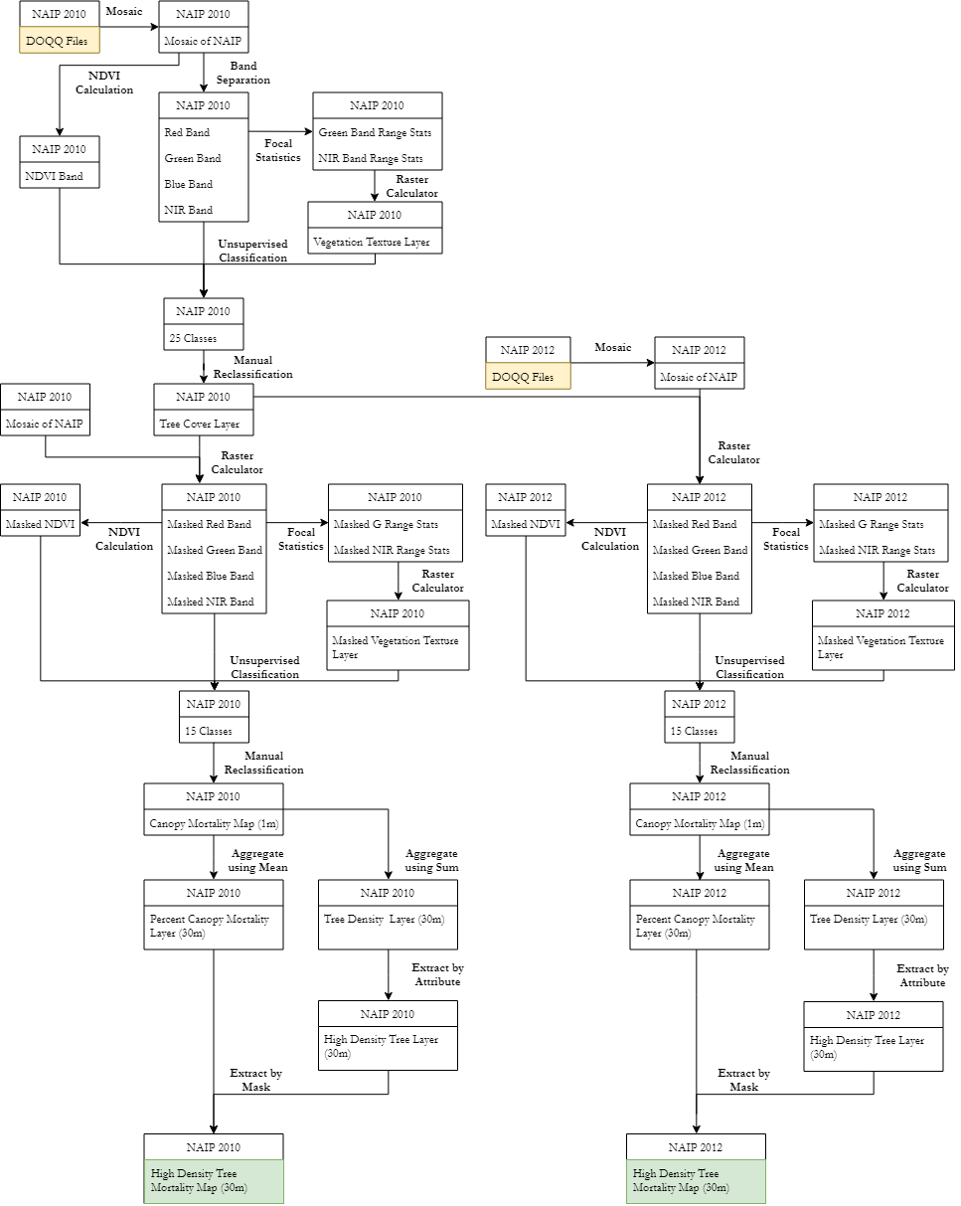

*Figure A1*. Flowchart of the methodology for the classification of the UTC and determination of percent mortality