NASA DEVELOP National Program

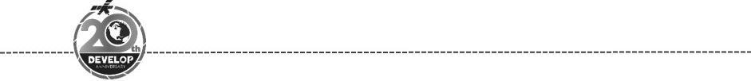
Massachusetts – Boston
Spring 2018

Plum Island Estuary Water Resources
Utilizing NASA Earth Observations to Assess Marine Sediment Fluxes and Determine Marsh Vulnerability in the Plum Island Estuary


Technical Report
March 29th, 2018

Zachary Bengtsson (Project Lead)
Bogumila Backiel
Sydney Neugebauer
Ruizhe Guo
Kimberly Johnson

Cedric Fichot, Boston University (Science Advisor)
Sergio Fagherazzi, Boston University (Science Advisor)

1. Abstract
Salt marshes provide valuable ecosystem services, including protection from coastal storms, erosion control, carbon sequestration, improved water quality, and ecological diversity. Plum Island Estuary (PIE), the largest salt marsh in the northeast United States, is a two thousand year-old ecosystem located thirty-five miles north of Boston, Massachusetts. As sea level rises, the structure and health of this marshland ecosystem depends on sediment availability. Current research in the estuary, performed by the United States Geological Survey (USGS) and the Woods Hole Marine Biological Laboratory (MBL), uses point-measurements of sediment fluxes. However, these isolated data points can be misleading when attempting to understand system-wide changes. Landsat 8 Operational Land Imager (OLI) and Sentinel-2 MultiSpectral Instrument (MSI) imagery from 2013 to 2017 were compared to in situ data measurements. An algorithm was generated to calculate total suspended sediment concentration and distribution in the estuary. In dynamic ecosystems like salt marshes, utilizing remote sensing to quantify and visualize sediment supply assists end users in generating current and future vulnerability assessments of PIE to sea level rise.

Keywords
Salt marsh, Plum Island Estuary, ecosystem services, suspended sediment concentration (SSC), remote sensing reflectance (Rrs), sea level rise, Landsat 8 OLI, Sentinel-2 MSI

2. Introduction
  - Background Information
Salt marshes, such as the Plum Island Estuary, are coastal grassland ecosystems that are regularly flooded by seawater. Marshes provide many ecosystem services to human communities, including water quality improvement, protection from storms, carbon sequestration, erosion control, and recreation opportunities (Barbier et al., 2011). Coastal ecosystems, like salt marshes, are in jeopardy due to sea level rise (SLR), which is projected to rise 60 cm to one meter globally by 2100 (Nicholls & Cazenave, 2010).

The Northeast United States is a hotspot for SLR; from 1950 to 2009, SLR was 3 to 4 times greater in this region than the global average (Sallenger et al., 2012). Sea level rise is exaggerated on the Atlantic coast due to subsidence of land and water circulation changes in the Atlantic Ocean (Krasting et al., 2016). Models predict that sea level will rise even further in the Atlantic coast with an increase in global temperatures caused by carbon emissions contributing to ice melt (Yin et al., 2009; Krasting et al., 2016). Rising sea levels will cause severe flooding and long-term erosion in salt marshes, but vertical migration of the marsh can mitigate these effects (FitzGerald et al., 2008).

A sufficient supply of sediment is required for salt marshes to expand vertically. When hydrological flow reduction occurs in a marsh ecosystem, it is easier for sediment to settle. This sediment is trapped by aboveground plant biomass, which provides more substrate for plants to grow. This plant growth increases sediment capture, thus generating a positive feedback loop in which flow reduction, sedimentation, and plant growth work together to maintain marsh structure and build vertically. This process relies heavily on adequate sediment supply (Wang & Temmerman, 2013). Many plant species are threatened by the increasing salinity and more frequent flooding that accompanies SLR, jeopardizing the delicate balance that is crucial to marsh persistence (Janousek et al., 2013).

There is debate concerning the ability of marshes to adapt to changing coastal conditions. Kirwan et al. (2016) stated that studies have overestimated marsh loss to SLR because of their failure to include lateral migration and sediment accretion rates. However, response to this publication has cautioned researchers not to divert focus from SLR as a threat to marsh ecosystems, as long term analysis and evaluation of the geochronological record is necessary to fully understand the potential impact of rising sea level (Parkinson et al., 2017). To resolve this debate, it has been suggested that future research include point measurements in dynamic locations of the marsh and incorporate anthropogenic and climate variability factors which are influencing vertical migration, erosion, and the creation of ponds (Kirwan et al., 2016). Recent research completed in Plum Island Estuary suggests that while the marsh may have enough sediment supply to maintain vertical elevation, the overall marsh area may be threatened by SLR (Hopkinson et al., N.d.).

The study area of this research project is focused on the Plum Island Estuary (PIE), and is the largest estuary in the Northeast United States. The estuary is located 56 kilometers north of Boston, Massachusetts, in the Gulf of Maine (Figure 1). The Ipswich, Rowley, and Parker rivers drain into the estuary, with a combined watershed area of 585 square kilometers. The Parker River National Wildlife Refuge protects 4,700 acres of the area. A limited number of homes and structures exist in and around the protected area, but development is strictly controlled on local, state, and federal levels. Salt marshes within the estuary are dominated by saltmeadow cordgrass (Spartina patens) and smooth cordgrass (Spartina alterniflora). Islands and tidal creeks are also present in the estuary. The Plum Island Estuary Long Term Ecological Research Network (PIE LTER) is responsible for environmental monitoring and research data collection in the area. The study period of our project spans from April 2013 to December 2017.

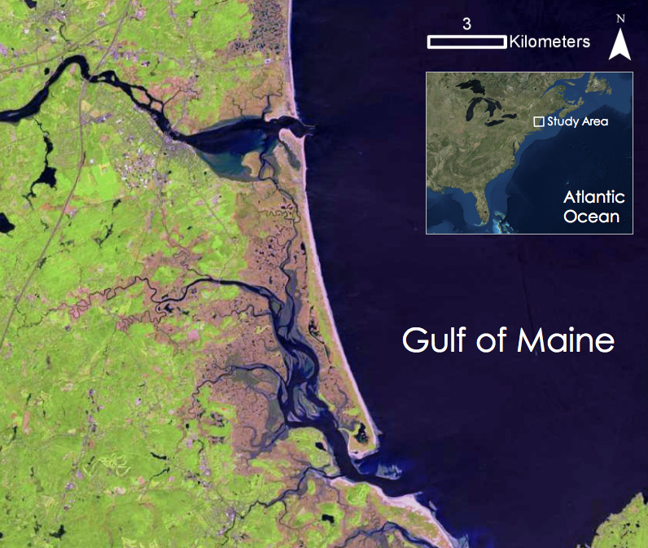

Figure 1. The PIE study area located in coastal Northeast Massachusetts. Shown are the Ipswich, Merrimack, Rowley, and Parker Rivers. (Source: Landsat 8 OLI from May 24, 2015).

  - Project Partners & Objectives
The objective of this NASA DEVELOP study was to visualize and quantify the sediment dynamics of the PIE. The project partners in this study are Dr. Neil Ganju from the United States Geological Survey (USGS) Woods Hole Coastal and Marine Science Center, Nancy Pau from the United States Fish and Wildlife Service (USFWS), and Dr. Anne Giblin, from the Plum Island Ecosystems Long Term Ecological Research Network (PIE LTER). This project will increase the repertoire of tools our partners have to assess vulnerability of the estuary. Conserving salt marshes is necessary to retain the ecosystem services they provide, which are important to the surrounding community in various ways. This project aimed to develop an accurate methodology that uses Earth observations to estimate suspended sediment concentration of the water in the estuary. Using this methodology, we visualized and measured sediment levels throughout the estuary, including measurements of the SSC values along a transect in the estuary’s main channel, and ultimately created a time series of suspended sediment concentration in the water column. The information gathered via the methodology developed in this project can be used to help explain the formation of ponds in the marsh, determine the vulnerability of freshwater habitats, and allocate resources appropriately for marsh restoration and conservation.

3. Methodology
3.1 Data Acquisition
The team downloaded five years of aerial images from two satellites’ sensors (Table 1). We downloaded all data as level 1 (Level-1 GeoTIFF Data Product for Landsat 8 and L1C Tile in JPEG2000 format for Sentinel-2), with no atmospheric correction. Out of the 113 available Landsat images since 2013, 52 did not have cloud cover (46%). These images began in April 2013 and ended in October 2017. Each year had 8 to 11 months of images available, with 2014 having the greatest number. Of the 89 available Sentinel-2 images, 42 were free of significant cloud cover, ranging from December 2015 to December 2017. Of the 94 total cloudless images, we ultimately analyzed 28 images due to multiple factors, including access to atmospheric conditions at the time the image was taken and probable interference of aerosols unseen by visual inspection used for initial image selection.

Table 1
Satellites, data information, and download sources of data obtained for the Plum Island Estuary
Data | Source | Years | Resolution
Landsat 8 OLI | USGS Global Visualization Viewer (GloVis) | 2013-2017 | 30m
Sentinel-2 MSI | USGS Global Visualization Viewer (GloVis) | 2016-2017 | 10-20m

3.2 Data Processing
The team used ACOLITE to perform atmospheric corrections, to extract the remote sensing reflectances (Rrs), and to produce quasi-true color images of each scene (Figure 2). In remote sensing of ocean color, about 90% of the signal is due to the influence from the atmosphere, while around 10% is due to the reflectance of the water body (Siegel et. al., 2000). For this reason, we opted to perform customized atmospheric corrections rather than use level 2 data. Using data from PIE LTER, we manually adjusted the Rayleigh corrections to correspond with atmospheric pressure taken in the area at the date and time of imagery generation.

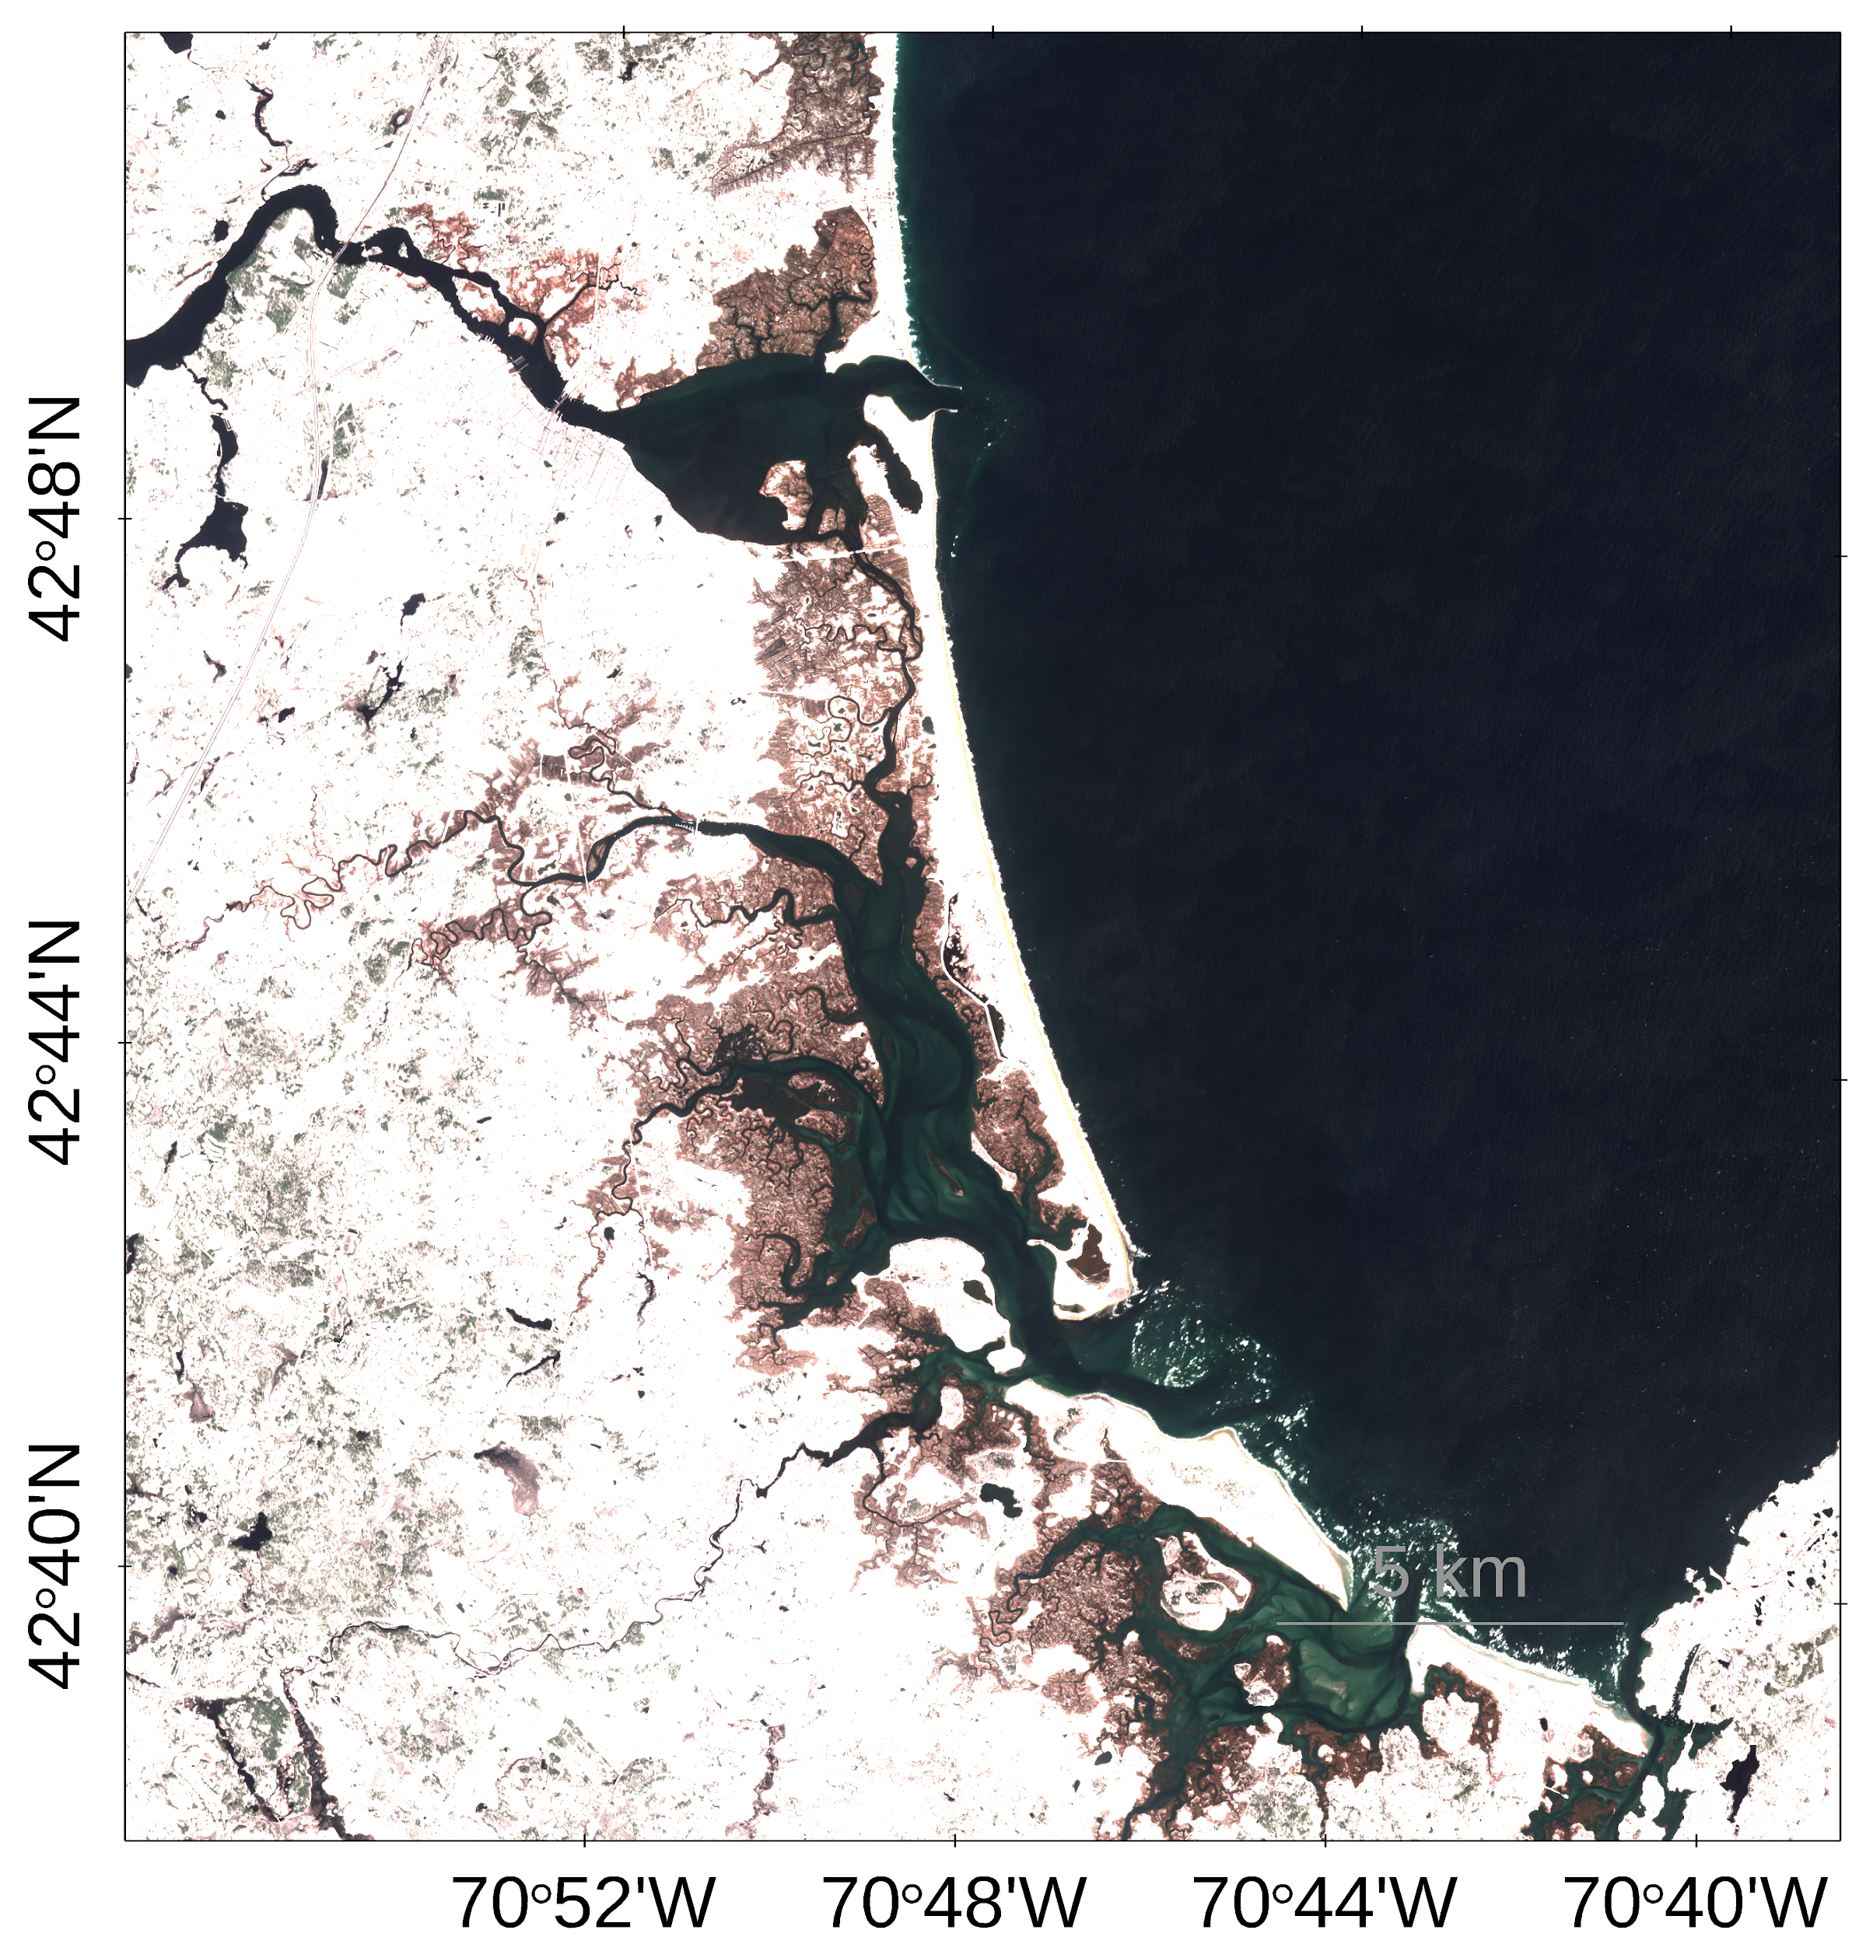
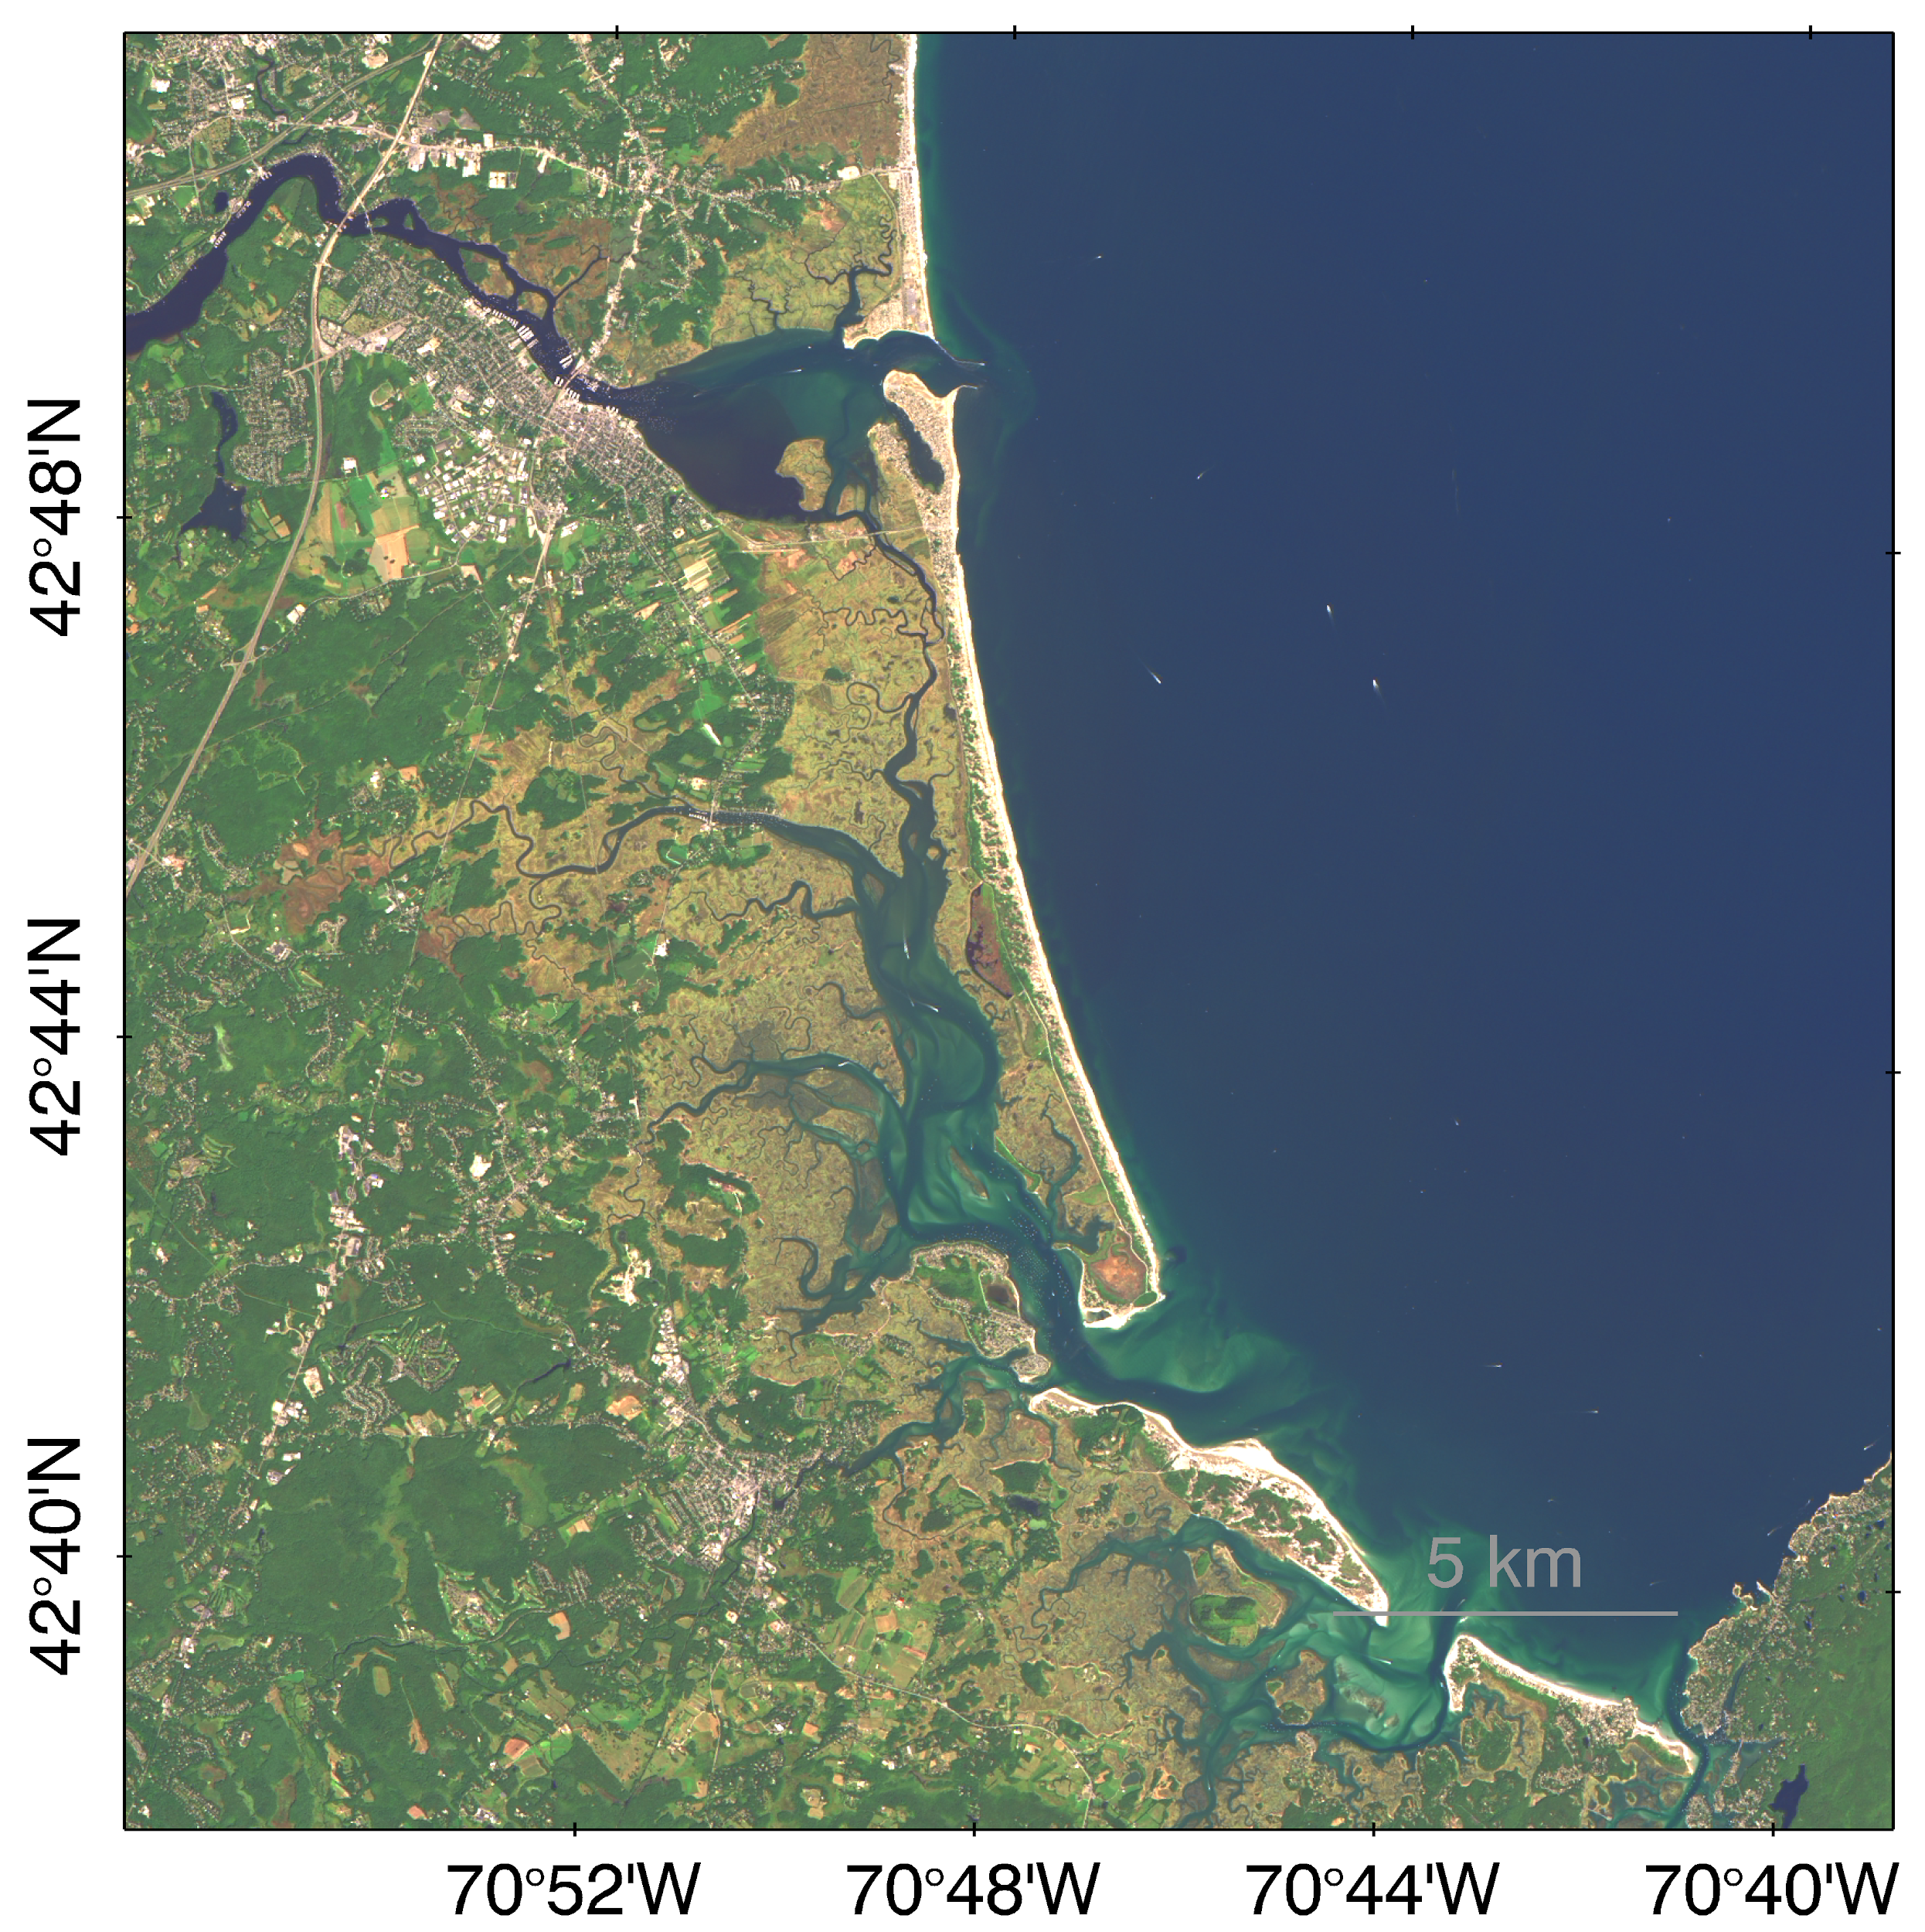

Figure 2. Quasi-true color images of study area generated using ACOLITE (Source: Landsat 8 OLI from August 25, 2014 and Sentinel-2 MSI from April 5, 2016).

Subsequently, we needed to choose the most appropriate aerosol corrections for the PIE. According to the black pixel assumption, in open ocean water, water leaving radiance in the near-infrared (NIR) is negligible and is thus assumed to be zero (Siegel et. al., 2000). Because of this assumption, it can also be inferred that any signal in the NIR results from the radiative properties of aerosols in the atmosphere, which allows for the correction of these contributions (Vanhellemont & Ruddick, 2015). However, when looking at more turbid waters, this assumption is no longer valid. Turbid waters are filled with particles that significantly increase the backscattering of the incident radiant flux so that backscattering by in-water constituents in the NIR is no longer negligible. In these cases, the signal in the NIR band is the result of both aerosols in the atmosphere and backscattering by in-water constituents. To address this issue, it is common to use short-wave infrared aerosol corrections, corresponding to band 6 (1609 nm) and band 7 (2201 nm) on Landsat 8, which performs well when analyzing extremely turbid waters (Vanhellemont & Ruddick, 2015). Although the study area is turbid, it is unclear whether or not it can be considered “extremely” turbid.

The team tested three atmospheric correction methods to determine which was most accurate: short-wave infrared (SWIR) correction, Red/NIR correction, and NIR/SWIR correction. Based on the results of these comparisons, we used the NIR/SWIR correction setting in ACOLITE. The gains used for Landsat 8 are pre-set in ACOLITE, which is specified for moderately turbid waters (Pahlevan et. al., 2017). However, there are no built-in gains in ACOLITE for Sentinel-2. SeaDAS is not currently capable of correcting imagery using gains for Sentinel-2, but a future update is predicted in which gains may be applied for this sensor.

In addition to these corrections, we tested and compared three different algorithms in ACOLITE for turbidity, all generated by Dogliotti et al. (2015): a general algorithm for turbid waters, an algorithm calibrated for the red portion of the visible spectrum, and an algorithm calibrated for the NIR portion of the spectrum. For estimating SSC, we used the algorithm generated by Nechad et al. (2010) for 865 nm on Landsat 8 and Sentinel-2. After completing these tests, the science advisors determined that it would be best to create an original empirical algorithm for this specific area using in situ SSC measurements, as none of these algorithms were well suited to the study area. However, running these algorithms indicated another challenge to overcome: shallow areas close to the shore or in narrow parts of the channel often appeared as very turbid, while deeper parts of the channel appeared less turbid, indicating that the algorithms were primarily showing topography rather than true turbidity or SSC. In order to correct for the effects of bottom reflectance, we interpolated point bathymetry data from 2010 to create a mask for areas in the estuary with a depth shallower than 3 meters. When creating the mask, the original bathymetry collected by LiDAR needed to be interpolated, as the resolution was 20m, which differs from the resolution of our satellite imagery. By applying this mask, very shallow areas were excluded from the study area, and the effects of topography were reduced.

3.3 Data Analysis
Based on the available in situ data and software, we opted to generate an empirical algorithm to estimate SSC from Rrs. We developed an empirical algorithm in R based on 13 in situ data points, 6 from PIE and 7 from nearby open ocean (New Inlet and South Stellwagen Bank in Massachusetts). During this process, we tested combinations of several Rrs wavelengths and various band ratios from each sensor with both linear and non-linear methods. The adjusted R-squared and root-mean-squared error (RMSE) were used to evaluate the different algorithms. A higher adjusted R-squared and lower RMSE indicated a better fitting model and algorithm. The final algorithm is a polynomial, and is based on Rrs at a wavelength of 655 nm for Landsat 8 and 664 nm for Sentinel-2. After applying these algorithms to all Rrs data in Matlab, final SSC maps were produced.

We created maps using ESRI ArcGIS Pro by projecting the estimated SSC (Figure 3). The SSC raster generated using Matlab was masked at depths shallower than 3 meters from a bathymetry file. A digital elevation model (DEM) with a spatial resolution of 1 meter was converted into a polygon, and masked at sea level and above, to represent the channels. A transect through the main channel was created in ESRI ArcGIS Pro using the bathymetry file. We drew a polyline in the deepest part of channel according to bathymetry data to avoid the effects of topography. The transect starts from the top of the estuary and continues 20 km into the Atlantic Ocean. We obtained coordinates from the transect line and exported the SSC value for each point along the transect, and then plotted SSC and elevation over transect distance using transect data in Matlab to create SSC plots.

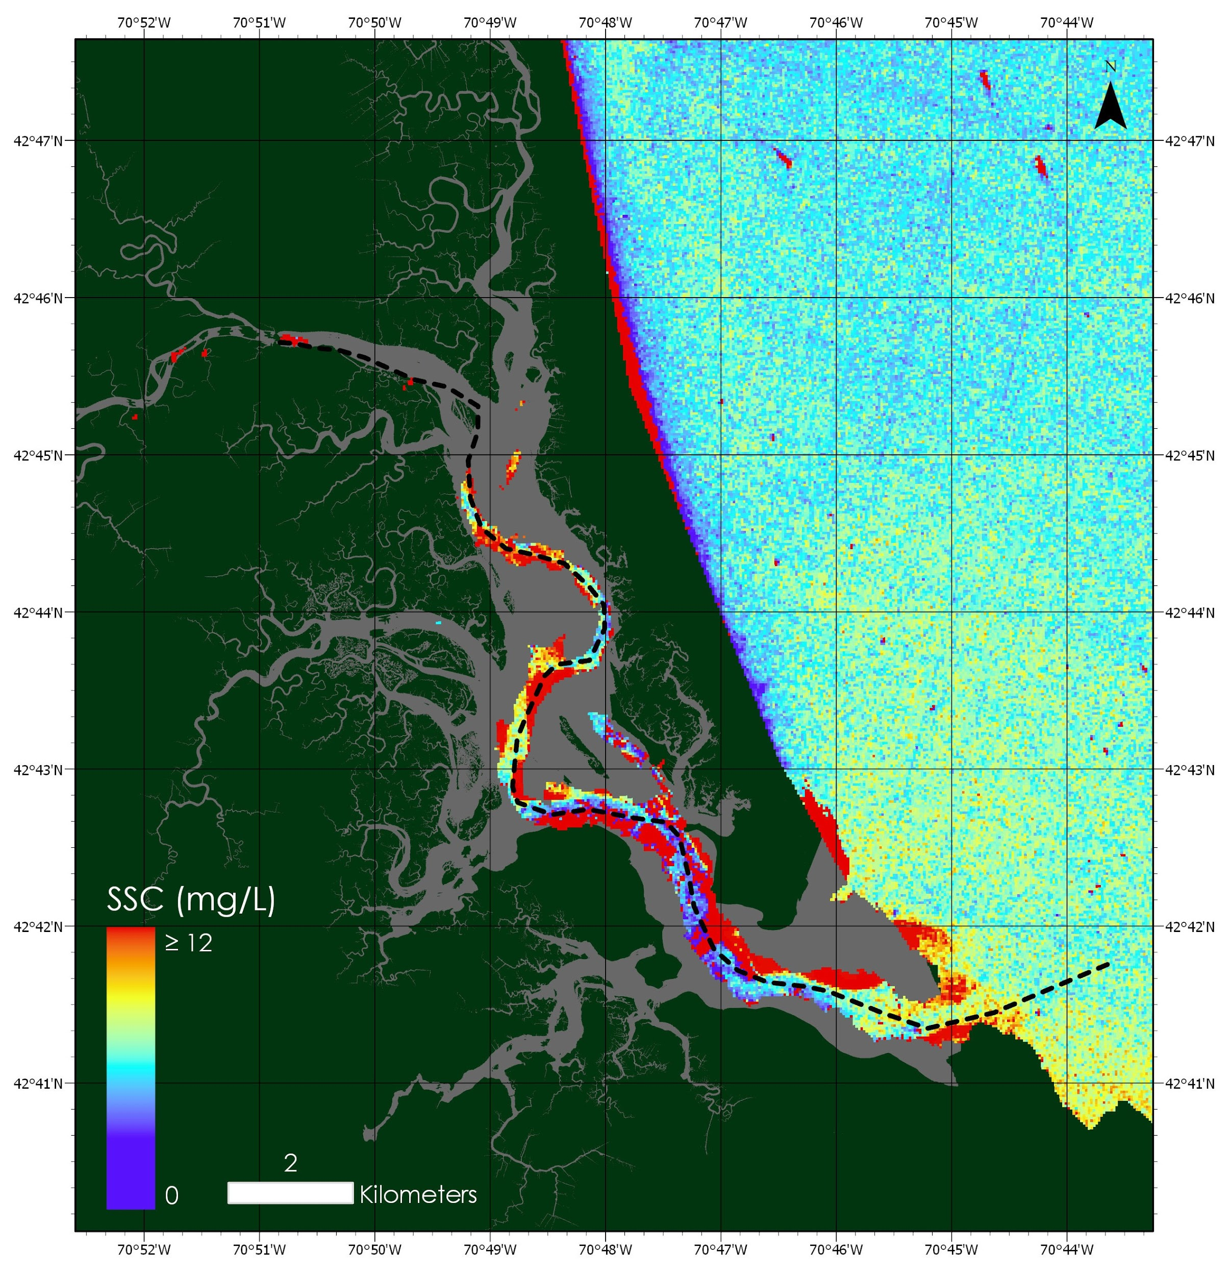

Figure 3. Map of SSC generated with ACOLITE, Matlab, and projected with ESRI ArcGIS Pro, using the SSC algorithm generated by our team (Source: Landsat 8 OLI from August 25, 2014).

4. Results & Discussion
4.1 Analysis of Results
To determine the likely source of suspended sediment, we evaluated SSC maps and graphs generated for each date of available imagery. SSC maps displayed many areas of high SSC, which are indicated by red areas (Figure 5). The graphs showed several extreme peaks which we believe are not accurate SSC measurements. This error could be a result of both the inaccuracy of the bathymetry data or the failure of atmospheric correction in parts of the imagery. To eliminate the effect of these outliers, we omitted all SSC values above 30 mg/L, as well as all values along the transect between 7-8 km and 8.5-9.5 km. On all of the transect data graphs, there were peaks in these portions of the graph, suggesting that this area of the transect was actually quite shallow and the values likely represented bottom reflectance. There is no significant difference between the results of Landsat 8 and Sentinel-2, and no clear seasonal patterns emerged. We attempted comparison of images over time, but did not find any outstanding patterns of SSC distribution. Variation in the quality of results and gaps in time affected temporal assessment. SSC plots often displayed what appears to be a decreasing trend in SSC along the transect (Figure 4 and 6).

We plotted water depth at certain points to help determine whether the SSC values were affected by topography. High tide images appear to yield lower SSC, while the opposite is true for low tide images. We determined water depth from bathymetry data (Figure A1) and predicted daily tidal level data (obtained from NOAA). We displayed elevation alongside SSC to aid in the delineation of true SSC versus bottom reflectance. Due to the effects environmental conditions may have on Rrs, we also elected to include wind, tidal, and weather data (from PIE LTER and NOAA) to help interpret these results.

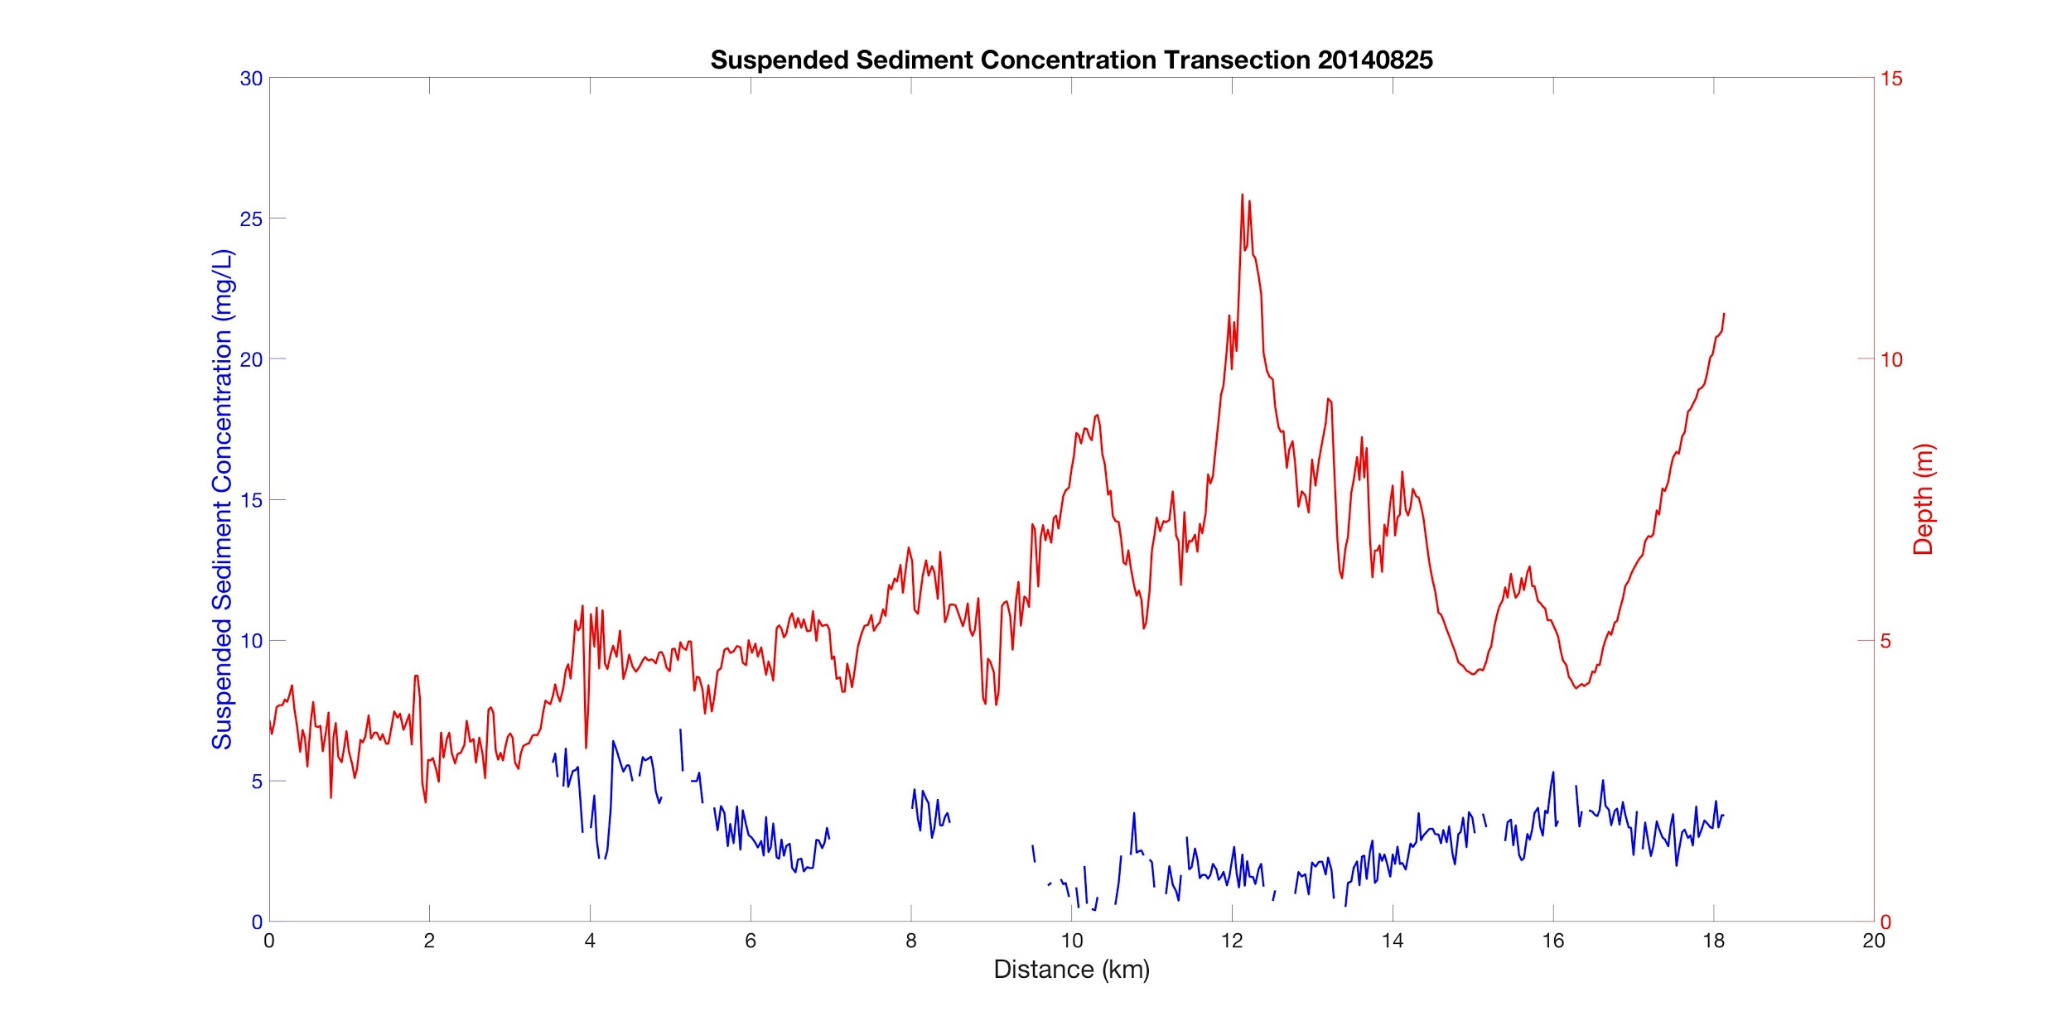
Figure 4. Suspended sediment concentration and water depth along a 20 km transect in the Plum Island Estuary (Source: Landsat 8 OLI from August 25, 2014).

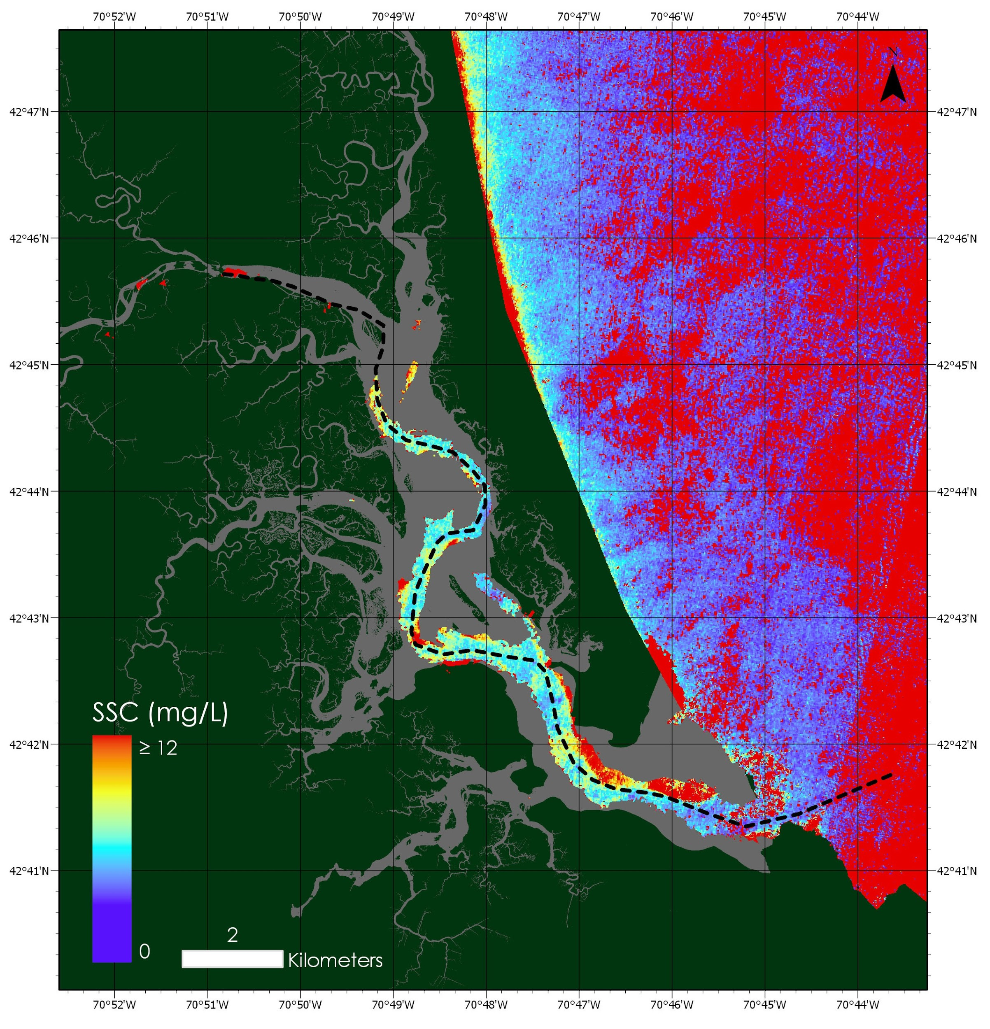
Figure 5. Map of SSC generated with ACOLITE, Matlab, and projected with ESRI ArcGIS Pro, using the SSC algorithm generated by our team (Source: Sentinel-2 MSI from April 5, 2016).

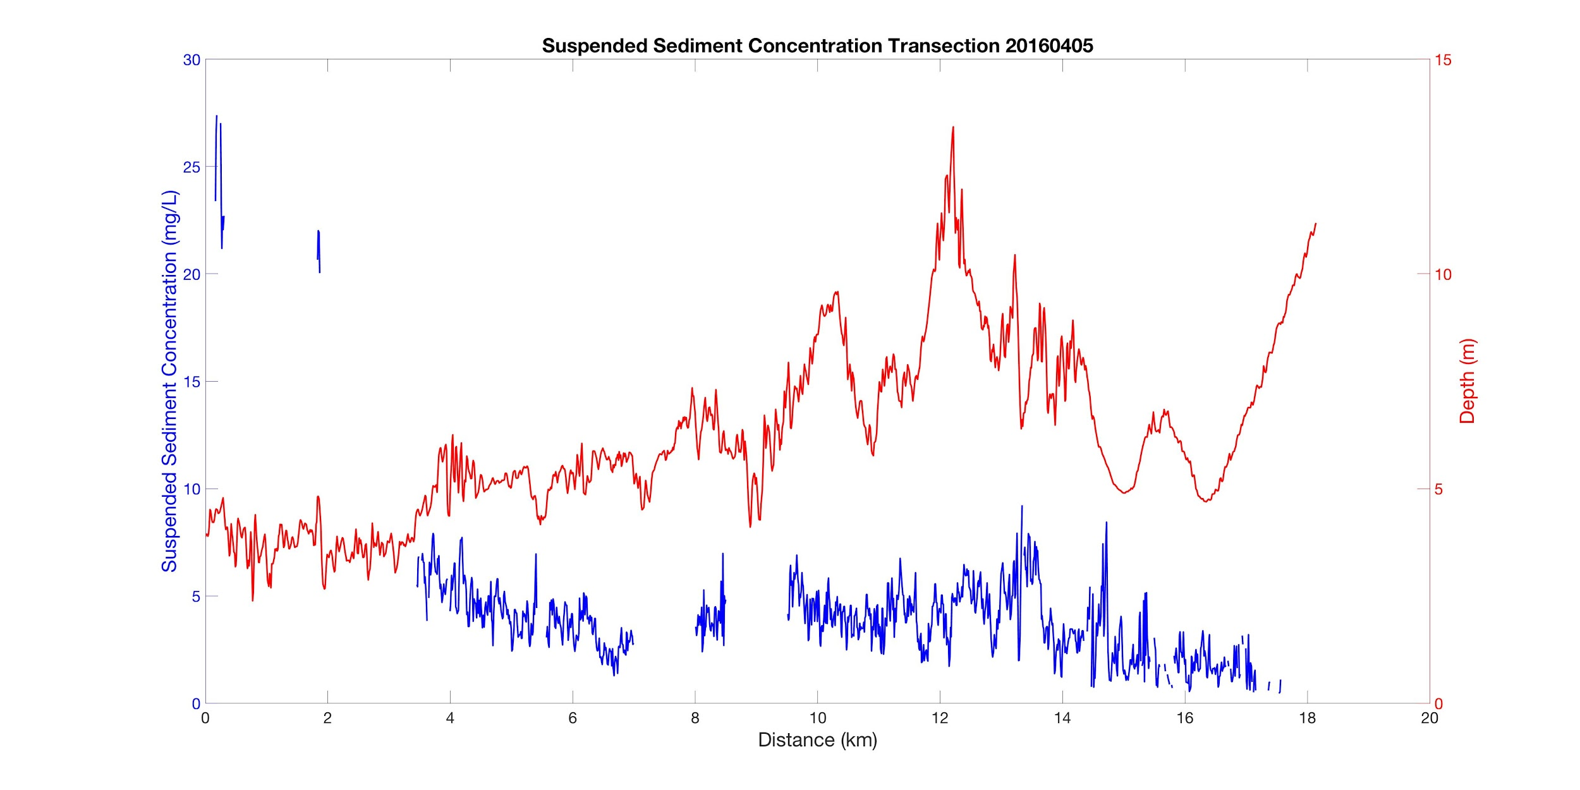
Figure 6. Suspended sediment concentration and water depth along a 20 km transect in the Plum Island Estuary (Source: Sentinel-2 MSI from April 5, 2016).

4.2 Errors and Uncertainties
Limitations in the current versions of ACOLITE and SeaDAS prevented our team from adjusting the gains when completing the atmospheric correction of Sentinel-2 imagery, which may have caused errors when converting the raw data into radiance. Our algorithm for calculating suspended sediment lacks accuracy in these optically complex waters, since the algorithm is empirical and based off of only a small number of in situ data points. We used a pared-down number of satellite images (28 in total between Landsat 8 OLI and Sentinel-2 MSI) because a large number of images had to be eliminated due to cloud cover and aerosol interference. Additionally, peaks in the transect data and areas of our maps with consistently high SSC values may still be showing the effects of bottom reflectance, which could be corrected by using more recent bathymetry data.

4.3 Future Work
Future work in this area could incorporate additional Earth observations, including the most recent images from Landsat 8 and Sentinel-2, as well as some Landsat 7 imagery and Sentinel-3 imagery as it becomes available. This will provide an extended time series which provides a better understanding of the pattern of SSC distribution in the estuary. Updated bathymetry data to create more detailed masks that include tidal levels could help control for the effects of bottom reflectance and topography in the SSC measurements. A larger number of in situ data points would be beneficial in producing a more accurate empirical algorithm in this area. Future field measurements will, ideally, correspond with the collection times of the remote sensing data. Alternatively, future studies could explore other classes of algorithms, such as a semi-analytical approach or the use of look-up tables. Further validation assessments and statistical analyses would help determine the accuracy and utility of the algorithm. Finally, additional landscape features could be included in the future, such as the mouth of the Merrimack River, in order to better determine sediment availability, which will assist our partners in understanding the sediment dynamics of the estuary.

5. Conclusions
This project made advances in exploring the methodologies involved in modeling SSC in estuaries. In general, we observed that SSC decreases along the transect, from the top of the estuary to the ocean. However, this statement is purely observational, and statistical testing was not completed to validate this observation. This gradient, from high SSC from within the estuary to low SSC in the ocean, may indicate that the greatest source of sediment to PIE is the Parker River, rather than the Merrimack River.

Higher levels of SSC appear when the tidal level is low and vice versa, with higher tidal level corresponding to lower SSC. It is difficult to determine whether this is because low tidal levels lead to more exposure of the bottom (and thus increased bottom reflectance), or if the high SSC is correct. Certain areas within the main channel of the estuary appear to be particularly susceptible to bottom reflectance. These areas likely have a topographical feature that increases the incidence of bottom reflectance and displayed consistently high (over 30 mg/L) SSC. We attempted to control for these areas via masking and eliminating outliers from transect analysis, but more refined work must be done to eliminate the persistent issue of bottom reflectance.

Effective and specialized atmospheric correction is paramount to accurate analysis of Rrs. We expected the higher spatial resolution of Sentinel-2 MSI (10-20m versus 30m in Landsat 8 OLI) to yield clearer and more consistent SSC calculations. However, the use of gains for atmospheric correction of Sentinel-2 MSI imagery is not yet established in the software we used for data processing. More consistent and usable results, with less backscattering interference from aerosols, were obtained from Landsat 8 OLI due to the application of gains in ACOLITE.

The factors limiting SSC analysis within salt marshes originate from the dynamic nature of the system. Evolving topography, bathymetry, and changing tidal level created a number of variables that must be controlled. Another challenge to obtaining “true” Rrs is the adaptation of atmospheric correction processes for each sensor used. Further work done in PIE will need to emphasize a continued integration of these variables into analysis to accurately estimate SSC from Rrs while taking environmental conditions into account. Nevertheless, we expect that accurate Rrs measurements are feasible with careful and comprehensive atmospheric correction. Likewise, accurate SSC estimations are achievable for deep areas in the channel that are less strongly influenced by bottom reflectance.

6. Acknowledgments
We wish to thank the following individuals for their contributions to our project:
Dr. Neil Ganju, United States Geological Survey, Woods Hole Coastal and Marine Science Center
Dr. Anne Giblin, Long Term Ecological Research Network, Plum Island Ecosystems LTER
Nancy Pau, United States Fish and Wildlife Service, Parker River National Wildlife Refuge

This material contains modified Copernicus Sentinel data (2015-2017), processed by ESA.

Any opinions, findings, and conclusions or recommendations expressed in this material are those of the author(s) and do not necessarily reflect the views of the National Aeronautics and Space Administration.

This material is based upon work supported by NASA through contract NNL16AA05C and cooperative agreement NNX14AB60A.

7. Glossary
Salt marsh – Coastal ecosystem consisting of grasses that is flooded by saltwater
Plum Island Estuary (PIE) – An ecosystem in northeast Massachusetts containing salt marshes, islands and tidal flats
Ecosystem services – Benefits to all living organisms arising from functions in ecosystems
Suspended sediment concentration (SSC) – The ratio of the mass of dry sediment in a water-sediment mixture to the mass of the water-sediment mixture
Remote sensing reflectance (Rrs) – Apparent optical property that is the ratio of water leaving irradiance to total incident solar radiation on a flat surface; also known as ocean (or water) color
Sea level rise – Increase in ocean water levels due to climate change induced ice melt
Landsat 8 Operational Land Imager (OLI) – One of the two instruments aboard Landsat 8, which includes all previous Landsat bands with the addition of two additional spectral bands: a deep blue visible channel (band 1) specifically designed for water resources and coastal zone investigation, and a shortwave infrared channel (band 9) for the detection of cirrus clouds
Sentinel-2 Multi-Spectral Instrument (MSI) – A multi-spectral instrument with 13 spectral channels in the visible/near infrared (VNIR) and short wave infrared spectral range (SWIR)

8. References
Barbier, E. B., Hacker, S. D., Kennedy, C., Koch, E. W., Stier, A. C., & Silliman, B. R. (2011). The value of estuarine and coastal ecosystem services. Ecological Monographs, 81(2), 169-193.

Dogliotti, A. I., Ruddick, K. G., Nechad, B., Doxaran, D., & Knaeps, E. (2015). A single algorithm to retrieve turbidity from remotely-sensed data in all coastal and estuarine waters. Remote Sensing of Environment, 156, 157-168.

European Space Agency. (2013-2017). Sentinel-2 Data. Processed by ESA.

Fichot, C. (2017). In situ Suspended Sediment Concentration Collected from Plum Island Estuary and Nearby Open Ocean.

FitzGerald, D. M., Fenster, M. S., Argow, B. A., & Buynevich, I. V. (2008). Coastal impacts due to sea-level rise. Annual Review of Earth and Planetary Sciences, 36, 601-647.

Hopkinson, C.S., Morris, J.T., Fagherazzi, S., Wollheim, W., and Raymond, P. (n.d.). A budget of sediment sources that enable tidal marshes in the Plum Island Sound Estuary to maintain elevation relative to sea-level rise. Manuscript submitted for publication.

Janousek, Chris, C. Folger, & C. Mayo. Early life history responses of tidal wetland plants to sea-level rise and salinization in the Pacific Northwest. Proceedings from Coastal and Estuarine Research Federation, November 03 - 07, 2013, San Diego, CA.

Kirwan, M. L., Temmerman, S., Skeehan, E. E., Guntenspergen, G. R., & Fagherazzi, S. (2016). Overestimation of marsh vulnerability to sea level rise. Nature Climate Change, 6(3), 253.

Krasting, J. P., Dunne, J. P., Stouffer, R. J., & Hallberg, R. W. (2016). Enhanced Atlantic sea-level rise relative to the Pacific under high carbon emission rates. Nature Geoscience, 9(3), 210.

Nechad, B., Ruddick, K. G., & Park, Y. (2010). Calibration and validation of a generic multisensor algorithm for mapping of total suspended matter in turbid waters. Remote Sensing of Environment, 114(4), 854-866.

Nicholls, R. J. & Cazenave, A. (2010). Sea-level rise and its impact on coastal zones. Science, 328(5985), 1517-1520.

Parkinson, R.W., Craft, C., DeLaune, R.D., Donoghue, J.F., Kearney, M., Meeder, J.F., Morris, J., and Turner, R.E. (2017). Marsh vulnerability to sea-level rise. Nature Climate Change 7, 756(2017).

Sallenger Jr, A. H., Doran, K. S., & Howd, P. A. (2012). Hotspot of accelerated sea-level rise on the Atlantic coast of North America. Nature Climate Change, 2(12), 884.

Siegel, D. A., Wang, M., Maritorena, S., & Robinson, W. (2000). Atmospheric Correction of Satellite Ocean Color Imagery: The Black Pixel Assumption. Applied Optics, 39(21), 3582-3591.

US Geological Survey Earth Resources Observation and Science Center. (2013-2017). Provisional Landsat OLI Surface Reflectance [Data set]. US Geological Survey. https://dx.doi.org/10.5066/F78S4MZJ

Yin, J., Schlesinger, M. E., & Stouffer, R. J. (2009). Model projections of rapid sea-level rise on the northeast coast of the United States. Nature Geoscience, 2(4), 262.

Vanhellemont, Q., & Ruddick, K.. (2015). Advantages of high quality SWIR bands for ocean colour processing: Examples from Landsat-8. Remote Sensing of Environment, 161, 89-106.

Pahlevan, N., Schott, J. R., Franz, B. A., Zibordi, G., Markham, B., Bailey, S., ... & Strait, C. M. (2017). Landsat 8 remote sensing reflectance (Rrs) products: Evaluations, intercomparisons, and enhancements. Remote Sensing of Environment, 190, 289-301.

Wang, C., & Temmerman, S. (2013). Does bio-geomorphic feedback lead to abrupt shifts between alternative landscape states? An empirical study on intertidal flats and marshes. Journal of Geophysical Research: Earth Surface, 118(1), 229-240.

9. Appendix
Appendix A - Additional Model Results and Examples

Figure A1: Interpolated bathymetry for the estuary, generated using Matlab (Source: National Geophysical Data Center, NOAA).