**NASA DEVELOP National Program**



Virginia – Langley

*Fall 2017*

Pacific Southwest Cross-Cutting II

Improving Detection of Land Use Changes in Habitat Conservation Plan Areas Using NASA Earth Observations and a Landscape Anomaly Detection Tool

 **Technical Report**

Final Draft – November 16, 2017

Kimberly Johnson (Project Lead)

Jarell Perez

Michaela Britt

Justin Herbst

Emily Gotschalk

Zachery Stout

Dr. Kenton Ross, NASA Langley Research Center (Science Advisor)

Previous Contributors:

Sean Robison

Liz Dyer

Katie Thomas

# 1. Abstract

The US Fish and Wildlife Service (USFWS) monitors and approves the creation of Habitat Conservation Plan (HCP) areas under the Endangered Species Act (ESA). Habitat Conservation Plans allow economic development in areas that have threatened and endangered species with the agreement that the developer provides a necessary alternative habitat for the species that rely on areas being developed. Each HCP is unique and created in a partnership between the landowner or developer and the USFWS. The HCP is tailored to fit the needs of both the proposed development or land use and the species that will be affected. While regulations limit the activities and development in HCP areas, it is difficult for the USFWS to effectively monitor all the land that falls within HCPs. Partnering with the USFWS, a user-friendly interface was developed in the Google Earth Engine API to display remotely-sensed imagery obtained from Landsat 5 TM, Landsat 7 ETM+, Landsat 8 OLI, and Sentinel-2 MSI satellites. These data were used to remotely detect land use changes in the HCPs from 2000 to 2017. The user interface displays Relative Green Index, percent change in Relative Green Index, Normalized Burn Ratio (NBR), cropland data, and National Agriculture Imagery Program data to assist in land use change evaluation. This tool will be used by biologists and conservationists at the USFWS to detect land use change.

**Keywords**

Habitat Conservation Plan (HCP), land use change, United States Fish and Wildlife Service (USFWS), Graphical User Interface, Google Earth Engine API, Landsat, Sentinel, Relative Green (RG)

# 2. Introduction

* 1. ***Background Information***

The Endangered Species Act (ESA) was created in 1973 to protect endangered and threatened species and preserve their habitats. However, with an expanding number of endangered and threatened species listed, it has become increasingly important to reduce conflict between economic development and habitat and species conservation. Incidental Take Permits were created under a 1982 amendment to the ESA in Section 10a(1)(B). They allow the take and destruction of listed species and their habitat, granted that the disturbance is accompanied by a Habitat Conservation Plan (HCP) (UWFWS, 2013). Habitat Conservation Plans are created in a partnership between the US Fish and Wildlife Service (USFWS) and the landowner or developer of the property (USFWS & NOAA, 2016), and is unique and designed to fit the needs of both the development and the affected species. Habitat Conservation Plans must include (1) a proposed site assessment, which includes the listed species that will be affected, (2) a plan to minimize and mitigate those negative effects on listed species, and (3) funding available to implement those mitigations. After creation of the HCP, the landowner or developer must maintain the HCP and provide yearly status reports to the USFWS (USFWS & NOAA, 2016). In turn, biologists at the USFWS help monitor changes in the HCPs throughout their designated region. There are a limited number of biologists at the USFWS that supervise over 84 million acres of HCP areas. Currently, HCP monitoring has been limited to field work by USFWS biologists who each oversee multiple HCPs, which is costly and time-consuming. To reduce cost and increase efficiency, the USFWS wanted to assess the efficacy of remotely-sensed Earth observations to detect land use change within HCP areas, which is often a challenging aspect of the lifecycle of an HCP (Franklin, Regan, Hierl, Deutschman, Johnson, & Winchell, 2011). To address these concerns, our team developed a Landscape Anomaly Detection Tool with an easy-to-use interface that could detect land use change across large areas. This tool used NASA Earth observations and was created using JavaScript in the Google Earth Engine (GEE) API – a cloud-based computational platform that can perform analyses on Earth observations to examine land cover dynamics (Moore & Hansen, 2011).

Remote sensing is useful to scientists, such as biologists and resource managers, because it allows them to study landscape-scale areas without needing to physically travel to each site that interests them. Remotely-sensed imagery can be applied to many different analyses, such as land use, land cover, and vegetation changes (Green, Kempka, & Lackey, 1994; Lyon, Yuan, Lunetta, & Elvidge, 1998). Because vegetation indices are useful calculations in detecting temporal land use change (Lyon et al., 1998; Glenn, Huete, Nagler, & Nelson, 2008), this project mainly used the Normalized Difference Vegetation Index (NDVI), Relative Green (RG) Index, and the Percent Change in RG (ΔRG). Having the ability to supervise large regions remotely will allow the USFWS to more efficiently use funds and resources to send biologists into the field to collect data only when unexpected or particularly dramatic land use changes have occurred.

This study focused on the Pacific Southwest Region (Region 8) of the USFWS, which includes California, Nevada, and parts of Oregon, from January 2000 to the present day (Figure 1). The HCPs in Region 8 cover more than 84 million acres and include a wide range of habitat types, such as deserts, shrublands, savannahs, forests, and wetlands. There are 136 HCPs in this region that aid in the protection of some of the region’s 346 endangered or threatened species (USFWS, 2016).

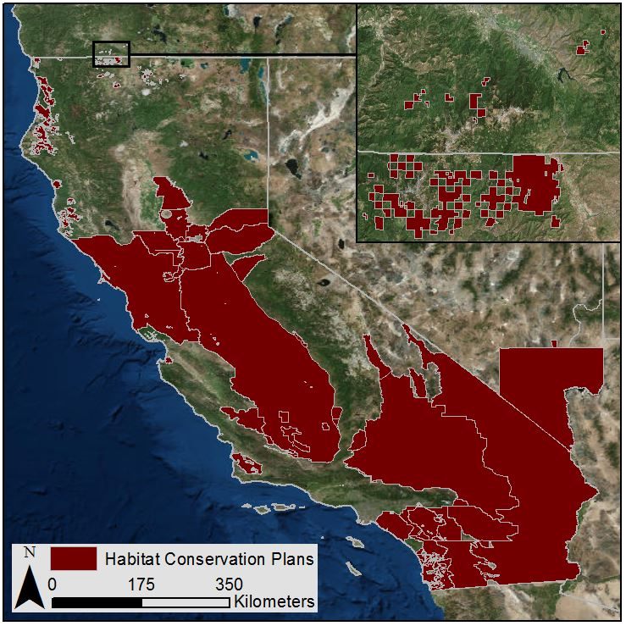

*Figure 1*. This image depicts the Habitat Conservation Plan areas in California, Nevada, and Oregon. The inset map depicts smaller HCPs in northern California and Oregon. The HCP areas were provided by the USFWS in Region. 8.

* 1. ***Project Partners & Objectives***

The Ecological Services Program in Region 8 of the USFWS was the primary project partner for this project. In addition, the USFWS National Wetland Inventory of the Midwest Region’s (Region 3: Illinois, Indiana, Iowa, Michigan, Minnesota, Missouri, Ohio, and Wisconsin) GIS expert has been included in discussions to determine future expansion of the tool into other geographic areas or study disciplines. The study area focused on the USFWS Region 8; however, the tool could be modified for future use in other areas of the US. This tool can be used to remotely detect land use change in HCPs, giving the USFWS the ability to pinpoint areas of interest for further investigation.

This study is considered a Cross-Cutting project, combining NASA’s Ecological Forecasting and Agriculture national application areas. Ecological Forecasting and Agriculture both utilize satellite data to provide more accurate information for natural resource monitoring. The USFWS had four project objectives focused around a user-friendly GEE tool: 1) to create a tool that allows the user to identify and select an area and time of interest; 2) to analyze the study area using NASA Earth observations and vegetation indices; 3) to add ancillary data to the tool that can be used to preliminarily explain why the land use change occurred for reasons other than development; and 4) to allow exports, enabling the user to export images from the tool to use for documentation in reports, presentations, and other materials useful to the USFWS.

# 3. Methodology

***3.1 Data Acquisition***

Google Earth Engine is a free, open-source, and cloud-based computational tool that contains a public data collection with access to satellite data from as early as the 1980s. This imagery is easily searchable and imported using a script within the API. This project used data from multiple satellites, including Landsat 5 Thematic Mapper (TM), Landsat 7 Enhanced Thematic Mapper Plus (ETM+), Landsat 8 Operational Land Imager (OLI), and Sentinel-2 Multispectral Instrument (MSI). The specific datasets used were USGS Landsat 5 Collection 1 Tier 1 TOA Reflectance (Orthorectified) with Fmask, USGS Landsat 7 Collection 1 Tier 1 TOA Reflectance (Orthorectified) with Fmask, USGS Landsat 8 Collection 1 Tier 1 TOA Reflectance (Orthorectified) with Fmask, and Sentinel-2 MultiSpectral Instrument (MSI), Level-1C.

We calculated one ancillary dataset, Normalized Burn Ratio (NBR), and imported two ancillary datasets through GEE: US Department of Agriculture (USDA) National Agriculture Statistics Service (NASS) Cropland Data Layers and National Agriculture Imagery Program (NAIP) imagery. The NASS data layer is produced annually and can be used to determine if the land use change detected was caused by a change in crop type rather than a change caused by another anthropogenic activity. The NAIP imagery is collected on longer cycles, such as a five-year cycle beginning in 2003 or a three-year cycle in 2009. Although NAIP imagery is available too intermittently for analysis, it does provide a higher spatial resolution at 1 m ground sample distance compared to the 30 m resolution of the Landsat satellites or the 10 m resolution of Sentinel-2.

The imagery used for analysis was dependent on the time frame of interest, as selected by the user, and the preselected baseline years of January 2000 to December 2010 that utilizes Landsat 5 imagery data. Landsat 5 TM, Landsat 7 ETM+, Landsat 8 OLI and Sentinel-2 MSI data collections were merged in GEE and were utilized when available for the time and area of interest. The USFWS provided the HCP shapefiles for Region 8 for identifying study areas of interest. These were integrated into the GEE script through a Google Fusion Table, which allows the program to call whichever HCP the user would like displayed.

***3.2 Data Processing***

The data used for analysis and ancillary datasets included imagery from the Landsat 5 TM, Landsat 7 ETM+, Landsat 8 OLI, and Sentinel-2 MSI data collections available in GEE. These collections were merged to create one large collection that spanned from 1984 to 2017. Creating a merged collection allows for easy comparison across all of the image collections and between the merged collection and other ancillary data products. In the creation of this tool, NDVI, RG, and Percent ΔRG were used as primary data products, while NBR was used as an ancillary product. These products were incorporated into the Landscape Anomaly Detection Tool as buttons that generate maps when selected in conjunction with a time and area of interest.

Our team used NDVI to remotely measure vegetation changes with a high degree of accuracy. An NDVI is the normalized ratio of the red and near infrared (NIR) wavelengths in a remotely-sensed image. It measures how much vegetation is in an area (Newnham, Verbesselt, Grant, & Anderson, 2011) by detecting the presence or absence of vegetation (Glenn et al., 2008). It is also able to produce meaningful results of vegetation across seasonal and inter-annual changes (Huete, Didan, Miura, Rodriquez, Gao, & Ferreira, 2002). Healthy plants during the growing season absorb a high amount of visible light and reflect a high amount of NIR. Normalized Difference Vegetation Index values can be quantified using Equation 1, creating a vegetation index between -1 and 1. A negative NDVI indicates there is little to no vegetation in the area, while a positive value is indicative of healthy growth. A negative NDVI value can also be indicative of events that impact vegetation, such as drought or fire.

$\text{NDVI} \text{=} \frac{{\text{ρ}}_{\text{NIR}}\text{-} {\text{ρ}}_{\text{Red}}}{{\text{ρ}}_{\text{NIR}}\text{+} {\text{ρ}}_{\text{Red}}}$ (1)

Relative Green was the primary vegetation index used for this project because it uses baseline and current NDVI values at each pixel in an image to analyze vegetation across different landscapes, giving a more accurate representation across the study area (Newnham et al., 2011). To calculate the Relative Green (RG) index, we found the minimum and maximum NDVI values of each individual pixel during the month of interest in each of the baseline years from 2000 to 2010. RG gives a more accurate representation of the study area. The landscape is highly variable across California, Nevada, and Oregon, including dense redwood forests and desert. Relative Green normalizes each pixel making the RG specific to a small area, likely including the same cover type, and thus yielding more relevant results. RG can more easily identify land cover changes in diverse vegetation areas creating a more accurate portrayal of the area of interest than NDVI (Newnham et al., 2011). Equation 2 shows how RG is calculated by comparing the historic maximum and minimum NDVI values with the current NDVI value for each pixel. Relative Green values that are positive, from 0 to 1, indicate current vegetation is more similar to historic maximums while lower values, from 0 to -1, indicate that current vegetation is more similar to historic minimums.

${\text{RG}}_{\text{i,j}} \text{=} \frac{{\text{NDVI}}_{\text{i,j} }\text{-} {\text{NDVI}}_{\text{min,j}}}{{\text{NDVI}}_{\text{max,j} }\text{-} {\text{NDVI}}_{\text{min,j}}}$ (2)

While this study focused on RG, it was crucial to identify changing land use and a change in Relative Green over time (ΔRG). The percent ΔRG portrays where the vegetation cover has changed from one year to the next (Equation 3). A positive percent change is indicative of vegetation growth while a negative percent change is indicative of vegetation loss since the previous year. There are many reasons why vegetation could experience gains or losses in a particular area, including drought, flooding, and fire.

$\text{Percent ΔRG =} \frac{{\text{RG}}_{\text{current}} \text{-} {\text{RG}}_{\text{previous}}}{{\text{RG}}_{\text{current}}}$ (3)

The Normalized Burn Ratio (NBR) was developed by the US Forest Service and is used to identify areas where it is likely that fires have occurred. The NBR uses NIR and Shortwave Infrared (SWIR) reflectance to identify areas that exhibit changes in reflectance of both NIR and SWIR (Equation 4). Prior to a fire, an area with vegetation will have a high NIR and a low SWIR reflectance, and after a fire the SWIR is higher than the NIR (Key & Benson, 2006). Normalized Burn Ratio gives the user the ability to identify and compare areas where land cover change has occurred as a result of a fire rather than another natural or anthropogenic cause.

$\text{NBR} \text{=} \frac{\text{NIR} \text{-} \text{SWIR}}{\text{NIR} \text{+} \text{SWIR}}$ (4)

***3.3 Data Analysis***

The team approached the tool on a functional basis. The main goal was to allow the user to specify their area of interest, dates of interest, calculations of interest, and ability to export results. The tool is divided into five sections. The first section allows the user to select an HCP of interest from a drop-down menu, and then it zooms to the selected location. The geometry of the HCPs were imported from a Google Fusion Table, which allowed the script to efficiently call the more than one hundred features. Not only did it increase efficiency, it also served as an array for which the code could populate the drop-down menu that displays the selected HCP on the map. The second section allows the user to input the month and year of interest, which defines the time period for each calculation applied to the merged Landsat and Sentinel data collection. This allows the RG and percent ΔRG to be calculated for the month of interest if and when the user chooses to run those calculations. When the RG button is clicked, a chart of mean NDVI for each day of the year of interest is calculated for the selected HCP. The third section allows the user to overlay ancillary datasets in an attempt to explain any unexpected results from the RG and percent ΔRG results. This gives the user a better understanding of any land use changes occurring in the selected HCP. The ancillary datasets include NBR, cropland, and NAIP. Finally, the user has the ability to export the results from GEE as a GeoTIFF, allowing the user to incorporate the outputs in written reports and presentations as needed. The baseline years have been hardcoded to 2000 to 2010, so there is no option to change these years in the user interface, but they could be updated in the JavaScript code.

# 4. Results & Discussion

***4.1 Analysis of Results***

Earth observations can be used to detect land use changes (Green et al., 1994; Lyon et al., 1998); in particular, Landsat imagery is useful in monitoring vegetation changes (Hansen & Loveland, 2012). The tool uses Landsat and Sentinel imagery to detect land use change and preliminarily explore the potential causes of it. Below are two case studies of how biologists at the USFWS could use this Landscape Anomaly Detection Tool to identify land use changes and their possible causes.

The first case study is focused on the Bakersfield Regional Habitat Conservation Plan Area as the area of interest, and a time of interest from 2015 to 2016 (Figures 2 & 3a-d). The user can satisfy the analysis objective for the identified area by calculating the RG from one year to the next and examining recent land use changes that have occurred in the HCP. In the case study, the identical points that are symbolized in blue on the maps allow the user to quickly identify that there has been vegetation loss at that specific location from October 2015 to October 2016 (Figures 3a-b). More generally, there has been a spatial increase in vegetation loss across the entire image. After observing this change in RG, the user can attempt to address the explanation objective by overlaying ancillary datasets, such as the cropland data. The Bakersfield Regional Habitat Conservation Plan Area is characterized by extensive agriculture. The agriculture is immediately apparent in the RG results due to the rectangular shape of many areas (Figures 3a-b). From 2015 to 2016, there is a large change at the point of interest, as the RG results display a sharp change from yellow to red indicative of vegetation more representative of the historic minimums from 2000-2010 (Figures 3a-b). There are several possible causes of the change in vegetation, though the mostly likely cause in this area is a change in crop type. Looking at the USDA Cropland Data for 2015 and 2016, a potential cause for the change in RG becomes apparent as the cropland changed from cotton to fallow land (Figures 3c-d).

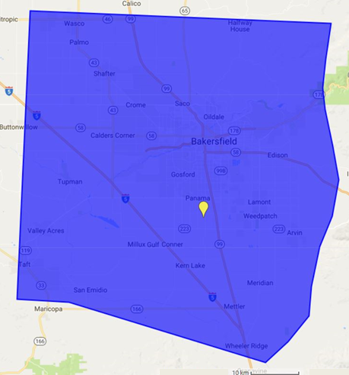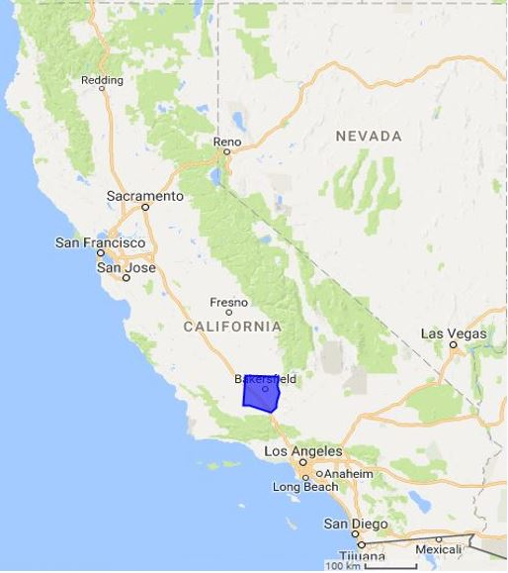

*Figure 2.* The Bakersfield Regional Habitat Conservation Plan Area outline and the location selected for analysis with the Landscape Anomaly Detection Tool for the first case study.

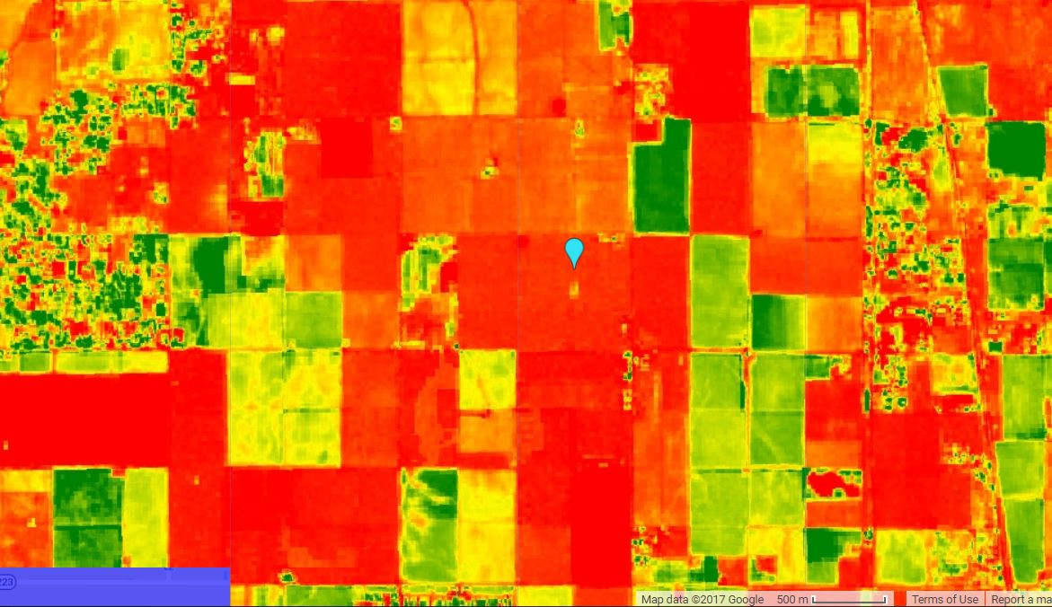

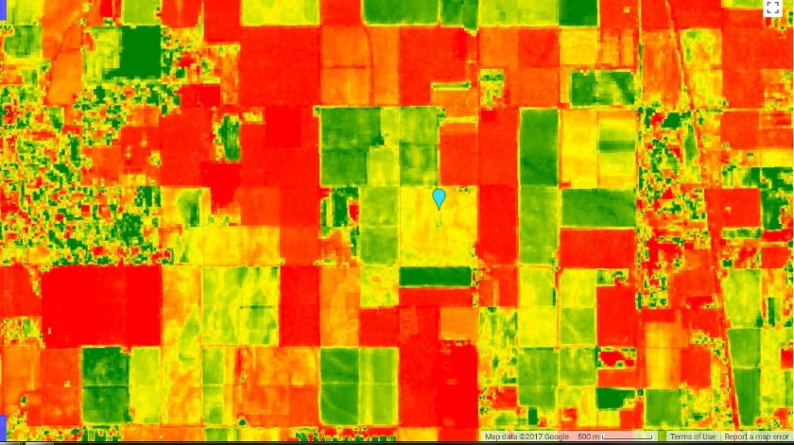

**Relative Green**

-1 (Vegetation Loss)

0 (No Change)

1 (Vegetation Gain)

*3b.* October 2016 Relative Green

*3a.* October 2015 Relative Green

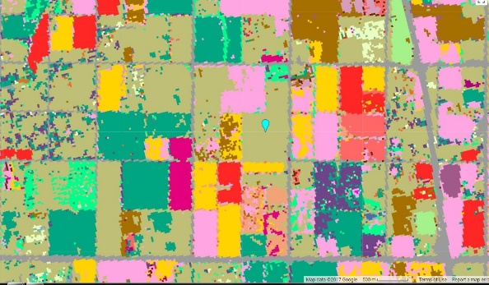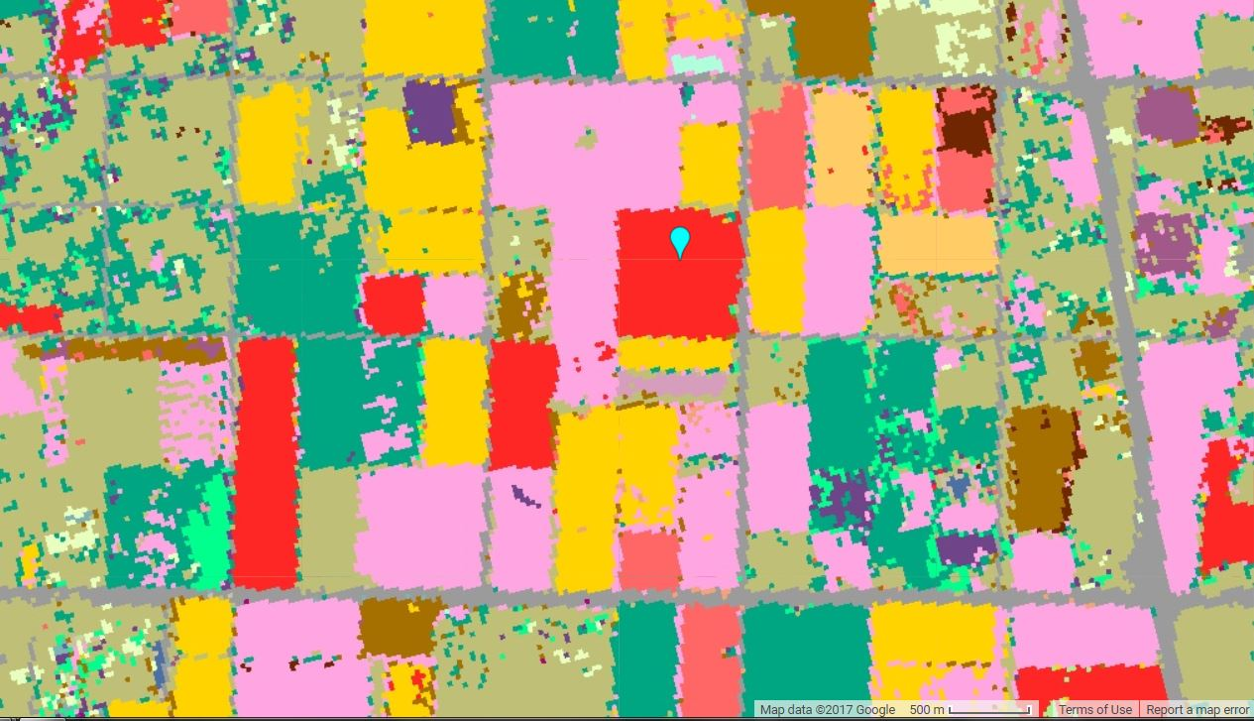

*3d.* October 2016 USDA Cropland

*3c.* October 2015 USDA Cropland

*Figures 3a-d.* Imagery from October 2015 and 2016 in the Bakersfield HCP. *3a-b* show RG while *3c-d* show USDA Cropland Data. In *3a-b* the RG changes abruptly over a relatively large area. The crop type changed from cotton (red) in 2015 to fallow land (olive green) in 2016, which appeared in a negative change in the Relative Green.

The Landscape Anomaly Detection Tool can also identify land use changes that may have occurred as a result of fire. For a second case study, the Desert Renewable Energy HCP, which encompasses a large portion of southern California, was selected (Figure 4). A fire, called the Johnson Fire, occurred in this HCP in October 2016. The RG in the area of the fire indicates vegetation loss, but it does not stand out because it is situated in an area that has a lot of vegetation loss (Figure 5a). By adding and examining the October 2016 (Figure 5b) and October 2015 (Figure 5c) ancillary NBR data sets, the user can see that a fire occurred in that area, which may have contributed to the vegetation loss in the RG results. The fire likely was a moderate-intensity fire, as the red is pale and not bright (Figure 5b). In Figure 5c, there is a bright red area to the east of the Johnson fire area that could be indicative of a high intensity fire, though a fire at this location is unknown to the authors at this time.

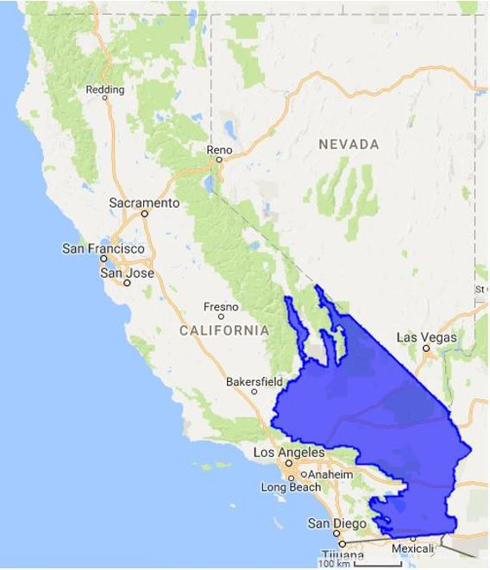

*Figure 4.* The Desert Renewable Habitat Conservation Plan area that encompasses a vast amount of southern California.

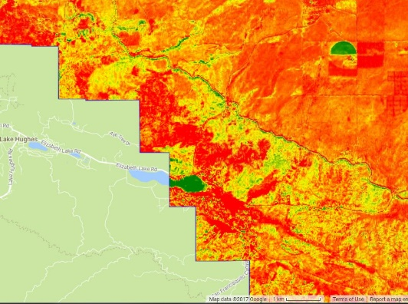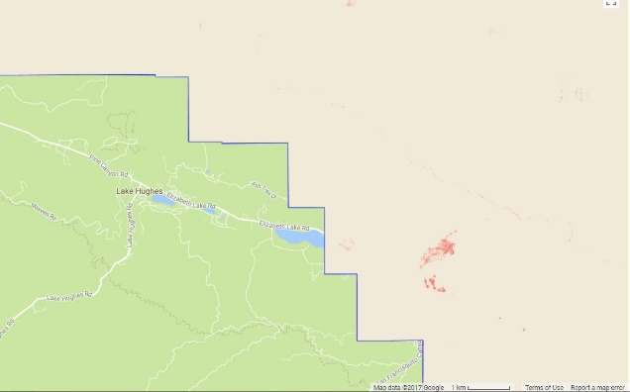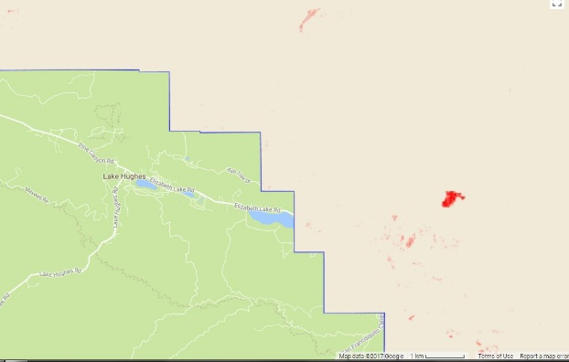

5c.  
2015 NBR

5a.  
2016 RG

5b.  
2016 NBR

*Figures 5a-c.* The Johnson Fire in Kern County California in October 2016. *Figure 5a* shows the RG at the time and that there is an evident red area where the fire occurred. *Figure 5b*. The NBR for the same area shows a distinct red area in the same area where the fire occurred. *Figure 5c.* The same area in 2015 does not show a fire however it does indicate a high likelihood that another fire occurred directly adjacent to the area in 2015.

Analyses from the two case studies reveal the usefulness of the Landscape Anomaly Detection Tool and confirm the feasibility of using GEE to create an open-source, cloud-based computational tool for the USFWS. The case studies also make it clear that the examination of ancillary datasets allows for preliminary explanation of the detected land use changes that occur within HCPs in the Pacific Southwest Region.

***4.2 Future Work***

In the future, this project could be greatly expanded by the USFWS to encompass more data and extend to other applications. The tool could be geographically expanded to include all the HCPs and other protected areas in the US by adding polygons to the Google Fusion Table and updating the code in GEE. Other organizations that monitor large areas, whether for protecting species and habitats or otherwise, could also use this tool to track land use changes. The tool could be adapted for use across a variety of environments and landscapes to assist the USFWS across the country. When expanding the tool for use in other areas, different vegetation indices may be more useful than others. For example, in a heavily forested area that is relatively uniform in vegetation type, NDVI would work similarly to RG, negating the necessity of calculating RG to normalize the type of vegetation (Newnham et al., 2011). This tool could also be useful for other initiatives, such as determining areas that should be granted protection status. The workflow we have followed can serve as a model for a framework in which a script can be written and structured in GEE. Moving forward, the script could be set up to include more recent data as it becomes available from Landsat 8 OLI and Sentinel-2 MSI, along with new ancillary datasets, such as precipitation, flooding, and climate data, which could be valuable in drought-prone areas like the Pacific Southwest. Another focus for the future could be transitioning the tool into Google App Engine, which would make the tool look more polished and allow the partners to host the tool on their own website, increasing customization, flexibility, and visibility.

# 5. Conclusions

This study demonstrated the efficacy of GEE and remotely-sensed Earth observations for the USFWS to remotely detect recent land use changes in HCPs. The RG results can preliminarily identify areas that have undergone vegetation change, and the ancillary datasets allow for the preliminary determination of possible causes of vegetation changes. The user interface within GEE allows users with limited GIS and remote sensing experience to effectively identify areas where land use change has occurred due to natural and anthropogenic causes. The Landscape Anomaly Detection Tool successfully calculates and displays RG, Percent ΔRG, and NBR. The tool also displays USDA Cropland Data and NAIP Imagery. The Landscape Anomaly Detection Tool will enable biologists at the USFWS to more effectively detect land use changes in HCPs, allowing them to more efficiently focus their resources and field visits.

# 6. Acknowledgments

Dr. Kenton Ross, NASA DEVELOP National Science Advisor

Pat Lineback, Regional GIS Coordinator; USFWS Pacific Southwest Region

Dan Cox, Regional Habitat Conservation Coordinator; USFWS Pacific Southwest Region

Brian Huberty, Regional NWI and Remote Sensing Coordinator; USFWS Midwest Region

Any opinions, findings, and conclusions or recommendations expressed in this material are those of the author(s) and do not necessarily reflect the views of the National Aeronautics and Space Administration.

This material is based upon work supported by NASA through contract NNL16AA05C and cooperative agreement NNX14AB60A.

This material contains modified Copernicus Sentinel data (2015-Present), processed by ESA.

# 7. Glossary

**Endangered Species Act (ESA)** – The Endangered Species Act was signed into effect in 1973 by Richard Nixon and aims to protect species that are designated as threatened or endangered. The USFWS and National Marine Fisheries Service oversees the ESA.

**Enhanced Thematic Mapper Plus (ETM+)** – The ETM+ is a multispectral sensor on the Landsat 7 satellite that collects images of Earth.

**Google Earth Engine (GEE) API** – Google Earth Engine is a platform capable of processing satellite imagery and other Earth observation data on the cloud.

**Ground Sample Distance (GSD)** – Ground Sample Distance is the distance between the centers of pixels measured on the ground in a digital photo taken from space.  
**Habitat Conservation Plan (HCP)** – An HCP is a necessary document that is part of a developer’s application for an Incidental Take Permit and describes the steps the developer will take to minimize impacts on threatened and endangered species. This document, which the developer creates with guidance from the USFWS, also states how the conservation plan will be funded.  
**Incidental Take Permit** – An incidental take permit legalizes otherwise illegal activities that directly or indirectly impact threatened or endangered species, such as killing or removal of habitat.

**National Agricultural Statistics Service (NASS)** – The NASS is the statistical branch of the USDA with regional offices across the country that report on agricultural production.  
**NBR (Normalized Burn Ratio)** – NBR is a vegetation index similar to NDVI that is used to determine the likelihood that a fire occurred in an area.  
**NDVI (Normalized Difference Vegetation Index)** – NDVI is a vegetation index that uses the red and near-infrared bands from a remotely sensed image to determine the amount of vegetation in an area.  
**NIR (Near Infrared)** – NIR is located on the shorter wavelength end of the infrared region of the electromagnetic spectrum, ranging from 0.75-0.90 µm in Band 4 of Landsat 5, 0.77-0.90 µm in Band 4 of Landsat 7, and 0.851-0.879 µm in Band 5 of Landsat 8.  
**Operational Land Imager (OLI)** – The OLI is a sensor on the Landsat 8 satellite that collects images of Earth and has a 16-day cycle, measuring visible, near-infrared, and shortwave infrared regions of the electromagnetic spectrum.  
**Relative Green (RG)** – Relative Green is a measure of how green the vegetation of an area has been historically. Every pixel is normalized to its own minimum and maximum values, which prevents desert vegetation from being compared with forest vegetation, for example.

**Multi-spectral Instrument (MSI)** – The MSI, a sensor on the Sentinel-2 satellite, measures radiation in the visible, near-infrared, and shortwave infrared regions of the electromagnetic spectrum (2015-present).  
**SWIR (Shortwave Infrared)** – SWIR is radiation with wavelengths longer than NIR in the infrared region of the electromagnetic spectrum, ranging from 1.55-1.75 µm in Band 5 of Landsat 5, 1.55-1.75 µm in Band 5 of Landsat 7, and 1.566-1.651 µm in Band 6 of Landsat 8.  
**Thematic Mapper (TM)** – The TM is a sensor on the Landsat 5 satellite that collects images of Earth and measures mid-range infrared regions of the electromagnetic spectrum.  
**Threatened and endangered species** – Endangered species are defined as “any species which is in danger of extinction throughout all or a significant portion of its range” according to the ESA, while threatened species are defined as species that are in danger of becoming endangered throughout all or a significant portion of its range.

**US Department of Agriculture (USDA)** – The USDA is the federal organization in charge of creating and enforcing laws relating to farming, crops, and food in the United States.  
**United States Fish and Wildlife Service (USFWS)** – The USFWS is a federal organization that, alongside the National Marine Fisheries Service, is responsible for enforcing the ESA. The organization is in charge of the terrestrial and freshwater organisms and habitats.

# 8. References

European Space Agency. Sentinel-2 Data. https://doi.org/10.4225/25/566a407cd2e2b

Franklin, J., Regan, H., Hierl, L., Deutschman, D., Johnson, B., & Winchell, C. (2011). Planning, implementing, and monitoring multiple-species habitat conservation plans. *American Journal of Botany,* *98*(3), 559-571. doi:10.3732/ajb.1000292.

Glenn, E. P., Huete, A. R., Nagler, P. L., & Nelson, S. G. (2008) Relationship between remotely-sensed vegetation indices, canopy attributes and plant physiological processes: What vegetation indices can and cannot tell us about the landscape. *Sensors*, *8*, 2136-2160.

Green, K., Kempka, D., & Lackey, L. (1994). Using remote sensing to detect and monitor land-cover and land-use change. *Photogrammetric Engineering & Remoting Sensing*, *60*(3), 331–337.

Hansen, Matthew C. & Loveland, Thomas R. (2012) A review of large area monitoring of land cover change using Landsat data. *Remote Sensing of Environment*, 122, 66-74.

Huete, A., Didan, K., Miura, T., Rodriquez, E. P., Gao, X., & Ferreira, L. G. (2002). Overview of the radiometric and biophysical performance of the MODIS vegetation indices. *Remote Sensing of Environment, 83*, 195-213.

Key, Carl & Benson, Nathan. (2005) Landscape Assessment (LA): Sampling and Analysis Methods. US Forest Service Gen Tech. Rep RMRS-GTR-164-CD.

Lyon, J. G., Yuan, D., Lunetta, R. S., & Elvidge, C. D. (1998). A change detection experiment using vegetation indices. *Photogrammetric Engineering and Remote Sensing*, *64*(2), 143–150.

Moore, R.T. & Hansen, M.C. (2011) Google Earth Engine: a new cloud-computing platform for global-scale earth observation data and analysis. *American Geophysical Union*, Fall Meeting 2011.

Newnham, G.J., Verbesselt, J., Grant, I.F., Anderson, S.A.J. (2011). Relative Greenness Index for assessing curing of grassland fuel. *Remote Sensing of Environment, 115*(6), 1456-1463. doi:10.1016/j.rse.2011.02.005.

U.S. Department of Agriculture, National Agricultural Statistics Service. (2016). Cropland data layer. Retrieved from https://www.nass.usda.gov/Research_and_Science/Cropland/Release/index.php (2017).

US Fish & Wildlife Service. (2013). Endangered Species Act | Section 10. Retrieved from https://www.fws.gov/endangered/laws-policies/section-10.html

US Fish & Wildlife Service. (2016). About the Pacific Southwest Regional Office. Retrieved from <https://www.fws.gov/cno/about_us.html>

US Fish & Wildlife Service & National Oceanic & Atmospheric Administration. (2016). Habitat Conservation Planning and Incidental Take Permit Processing Handbook. Retrieved from<https://www.fws.gov/endangered/esa-library/pdf/HCP_Handbook.pdf>

U.S. Geological Survey Earth Resources Observation and Science Center. (2012). Provisional Landsat ETM+ Surface Reflectance. US Geological Survey. https://doi.org/10.5066/f7q52mnk

U.S. Geological Survey Earth Resources Observation and Science Center. (2012). Provisional Landsat TM Surface Reflectance. US Geological Survey. https://doi.org/10.5066/f7kd1vz9

U.S. Geological Survey Earth Resources Observation and Science Center. (2014). Provisional Landsat OLI Surface Reflectance. US Geological Survey. https://doi.org/10.5066/f78s4mzj