NASA DEVELOP National Program
National Centers for Environmental Information - Asheville
Fall 2015

Missouri River Climate
Understanding runoff in the Missouri River Basin using NASA and NOAA satellite observations for improved river system management and decision support


Technical Report
Final Draft – November 19, 2015

Emily Sturdivant (Project Lead)
Nancy Barnhardt
Alec Courtright
Sam Swanson

L. DeWayne Cecil, GST (Science Advisor)

I. Abstract
The Missouri River‘s highly variable discharge directly affects livelihoods in six states. Water management decisions by the U.S. Army Corps of Engineers rely on accurate forecasting of river flows. These decisions impact local residents, businesses, and ecosystems. Environmental variables such as soil moisture, snowpack, and soil temperature have a poorly-quantified influence on river runoff. In particular, the Northern Plains Region of the Basin is not adequately covered by ground monitoring stations, resulting in a data-poor region and an incomplete understanding of the driver variables of run-off. This project used earth observations from NASA and NOAA and in situ datasets to improve the understanding of water availability and runoff. It analyzed soil moisture, snowpack, and soil temperature datasets for the period from 1979 to 2015. Data analysis resulted in climatologies and mapped the 35-year monthly averages for each variable. Results indicate increasing trends in snow water equivalent and soil moisture in the Upper Basin Plains focus region over the 35-year period. There were consistent east-west differences in timing of soil freeze and thaw. These results will aid the USACE team in their informed water management and communication with basin residents.

Keywords
Missouri River Basin, Runoff, Water Management, Soil moisture, Soil temperature, Snow Water Equivalent, Microwave Remote Sensing

II. Introduction
In 2011, an unprecedented rain-on-snow event following one of the largest snow years in recorded history led to massive floods in the Missouri River Basin (MRB). To prevent the Basin’s dams from being overtopped and possible dam failure, the United States Army Corps of Engineers (USACE) was forced to release up to 160,000 cubic feet per second (cfs) from basin dams - the largest amount since record-keeping began in 1898 [USGAO 2014]. Subsequent flooding and damage along the Missouri River from Montana to Missouri affected farms, homes, businesses, industries, public infrastructure, and transportation networks, costing the agency approximately $1 billion [USGAO 2014]. The U.S. Government Accountability Office concluded that although USACE officials could not have predicted such an event, further research should be conducted to better understand the environmental factors that drive run-off in the MRB.

The Missouri River Basin Water Management Division (MRBWMD) currently uses a monthly runoff forecast to anticipate Basin conditions at six dam and reservoir locations. At the beginning of each calendar year, USACE forecasts expected monthly runoff. They then revise the forecast for each 3-week period. The 3-week outlook more precisely estimates water supply across the region and informs management of reservoir inflows, releases, storage levels, and hydropower generation. Present forecasts incorporate basin conditions (i.e. soil moisture and snowpack) from meteorological stations and volunteer data collection, historical trends, and climate estimations [USACE, 2006]. However, the upper Missouri River Basin is a data poor region with sparsely located ground stations to detect terrestrial water conditions and few volunteers to collect in situ data. For example, although mountain snowpack runoff is well-measured, there is little available information on snow water equivalents and surface water storage in the Northern Plains region [Grode, 2015].

The influence of such environmental variables as soil temperature, soil moisture, and snowpack on the river system is poorly quantified. In particular, coverage of the Northern Plains region by on-the-ground monitoring sites is sparse, resulting in incomplete understanding of the historical trends, seasonality, and current conditions of the many hydrological inputs to a highly variable river system [Grode, 2015]. This study aimed to expand the knowledge base of these data-sparse areas by incorporating remotely sensed data into Basin forecasting. Improved detection of these variables through NASA and NOAA Earth Observations will enhance decision-making processes concerning basin flood control, navigation, irrigation, recreation, water quality, water supply, fish and wildlife, and hydropower generation.

Project Objectives
The project used remotely sensed, reanalysis, and in situ data from the previous 35 years to improve the understanding of water supply and runoff in the Missouri River Basin. With a focus on the Northern Plains region of the basin, it 1) detected historic and present soil temperature, soil moisture, and snow water equivalent through a combination of NASA and NOAA Earth Observations and in situ data; 2) documented the normal and anomalous conditions for the Northern Plains region; and 3) performed exploratory analyses of the association between these driver variables and stream discharge.

Study Period
The project studied the 35 years between September 1979 and November 2015. Snow water equivalent data from 2013-2015 was not available due to processing issues.


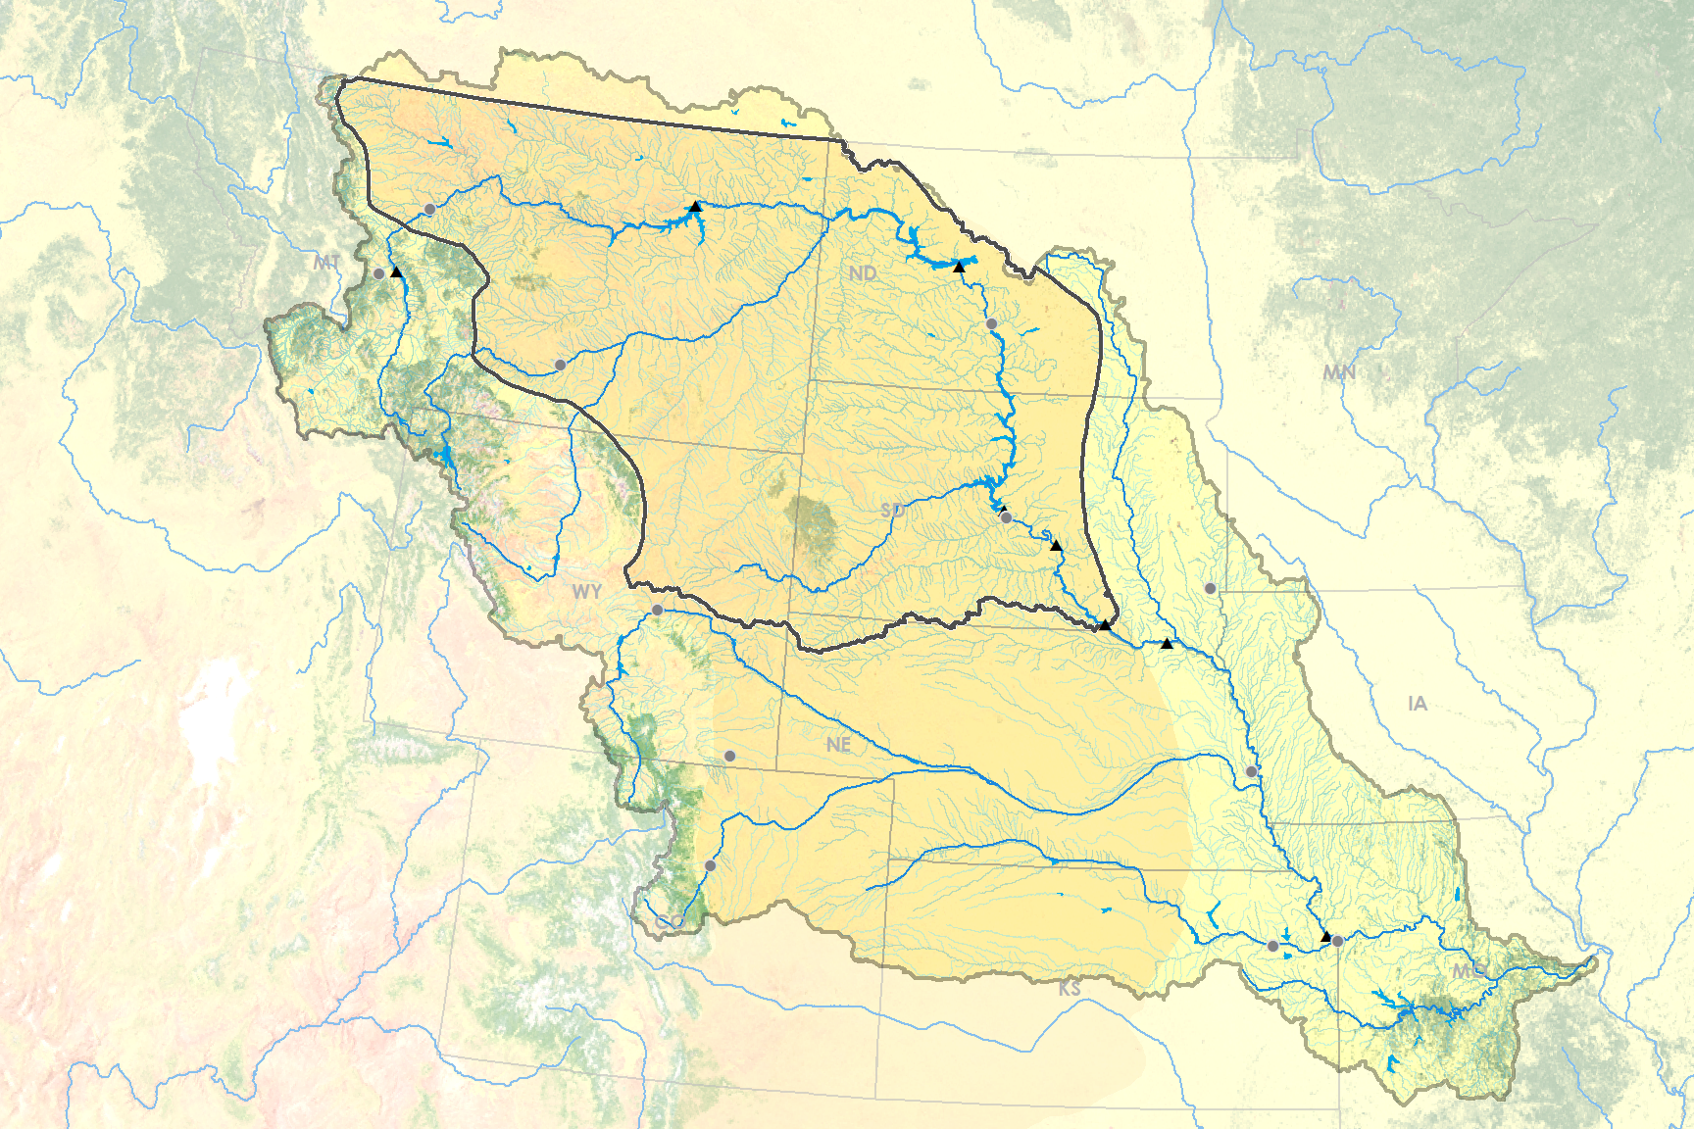
Study Area
Great Falls
Helena
Casper
Bismarck
Pierre
Sioux Falls
Denver
Omaha
Kansas City
Topeka
Billings
Fort Peck
Garrison
Oahe
Big Bend
Fort Randall
Canyon Ferry
Gavins Point
Upper Basin Plains Focus Region
Northern Great Plains
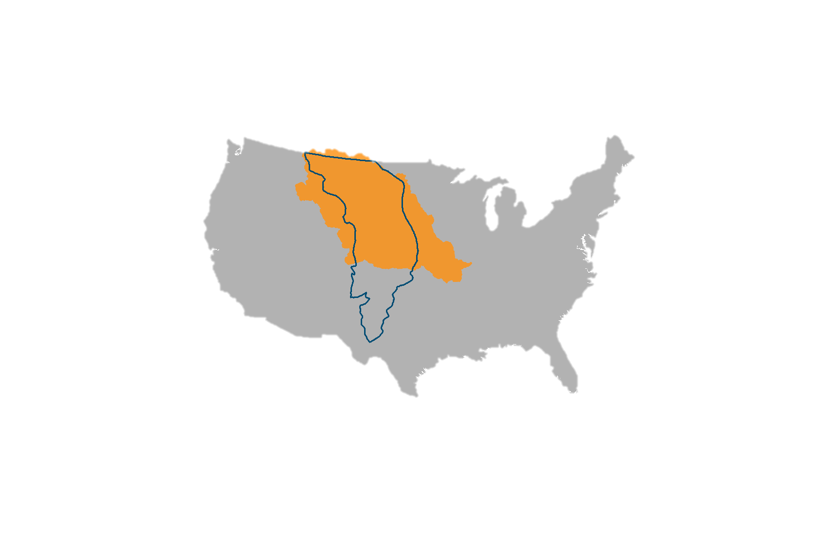
Figure 1. Missouri River Basin. The Missouri River flows from the mountains of eastern Montana through the Great Plains of the Dakotas and into the Mississippi. The confluence between the upper basin and the Northern Plains, outlined in dark gray, were examined as the focus region. It is regulated by six major dams operated by the USACE. Source: Missouri River Climate team.

The Missouri River Basin covers 529,300 square miles and contains the largest reservoir system (by storage) in the United States [“The Missouri River Story”, 2010]. The three uppermost reservoirs on the Missouri River, Fort Peck, Garrison, and Oahe, contain nearly 90 percent of the system’s 71.4 million acre-feet (MAF) of storage [USACE, 2006]. This study focused on the upper Missouri River Basin, as the three reservoirs mentioned above are crucial to the mainstem reservoir system and USACE. The upper basin stretches from western Montana to Sioux City, Iowa - spanning large portions of Montana, North Dakota, South Dakota, and Wyoming. Within the upper Missouri River Basin, west of the Rocky Mountains, lies the Northern Plains region, a sparsely populated prairie-land where heavy snowpack and rapid melt in 2011 played a major role in that year’s historic floods [USGAO, 2014]. Despite its importance when forecasting runoff potential in the MRB, the Northern Plains region is poorly understood due to a lack of in situ stations measuring snowpack, soil moisture, and soil temperature.

NASA Application Areas
The project addressed NASA’s Applied Science Application Areas of Climate, Water Resources, and Agriculture. Although the project did not analyze climate directly, the variables analyzed are considered climate proxies. The dynamics among soil moisture, soil temperature, and snow water equivalent will help USACE to effectively manage water resources throughout the Basin, especially in years of extreme drought or flood. These water resources are crucial to agriculture in the region.

Project Partners
The project sought to achieve a relevant and informational product for end-users by involving Kevin Grode, P.E., of the USACE MRBWMD, Dennis Todey, PhD, a State Climatologist and Associate Professor at South Dakota State University, and Doug Kluck, the NOAA Regional Climate Services Director for the Central Region. Kevin Grode leads the Reservoir Regulation Team of the MRBWMD, a team of hydraulic engineers and computer specialists who conduct studies and produce short- and long-term forecasts pertaining to the regulation of the Missouri River Mainstem Reservoir System. Of the predictive variables used by the Reservoir Regulation Team to update forecasts, soil moisture, soil temperature, and snow water equivalent remain largely un-quantified, especially in the Northern Plains region [Grode, 2015]. The MRBWMD will use the results to improve their decision-making processes.

Dr. Dennis Todey and Doug Kluck help to disseminate information to the public. Dr. Todey is an expert on current climate conditions and outlooks across the Northern Plains and Midwest. Mr. Kluck works closely with the Regional Climate Centers, state climatologists, and federal and state governments, among others, to develop climate data stewardship, build climate change capacity, and assess climate services needs by sector. To this end, Mr. Kluck and Dr. Todey are interested in a product that can assist with forecasting runoff in the Missouri River Basin, especially long-term forecasts in light of trends associated with climate change. An improved understanding of trends in these variables and their effect on runoff will aid in their communications with basin organizations and residents.

III. Methodology
The stated objectives were achieved through acquisition, processing, and analysis methodologies customized to each variable and the relevant available datasets. Remotely sensed (Table 1) and in situ (Table 2) data sources were used. All datasets were aggregated to monthly summary statistics for standardized comparisons with other datasets. In addition to the data described below, shapefiles of watershed boundaries and the river network from USGS were used for context and to restrict analysis to hydrologically-relevant areas.

Table 1. Remotely sensed data sources are displayed by hydrological variable. Of the available datasets, these were selected to optimize length of time, spatial resolution, and inter-dataset consistency.
Variable | Data product | Platform | Product level | Resolution | Obs. frequency | Time period | Source
Snow water equivalent | GlobSnow SWE | SMMR, SSM/I, AMSR-E, ground-based | Weekly SWE (L3B) | 25km | Daily, Weekly | 1979-2012 | ESA GlobSnow Consortium
Soil moisture | NLDAS | NOAA GOES | Soil moisture content | 1/8 degree | Monthly | 1979-pres. | NASA GES-DISC
Soil temp. | NLDAS | NOAA GOES | Soil temp. | 1/8 degree | Monthly | 1979-pres. | NASA GES-DISC

Table 2. In-situ data sources were used for comparison with remote data sources.
Variable | Data product | Platform | Distribution of stations | Obs. frequency | Time period | Source
Discharge | USGS water | stream gauge stations | 23 gauges in focus region | Daily (average) | 1979-present | USGS
Soil moisture | SCAN | ground stations | 7 sites in focus region | Daily | Varies by station | NOAA NRCS
Stream gauge locations | HCDN | low-impact stream gauges data set | 23 gauges in focus region | N/A | 1974-2009 | USGS

Snow Water Equivalent
The GlobSnow consortium derives an estimate of snow water equivalent (SWE) from satellite observations and ground station data. SWE is the amount of water, in inches, resulting from melting a column in the snowpack. It incorporates measurements from NASA Earth observations’ SSM/I, SMMR, and AMSR-E sensors and from the ECMWF weather stations. The GlobSnow data product includes both daily and weekly estimates at 25km grid spacing, from 1979 to 2012, which are publicly accessible at www.globsnow.info/swe/ [Luojus et al., 2010]. It improves upon SWE calculations derived from SSM/I and is especially accurate over medium elevation flat plains with seasonal snow cover, which accurately describes the Northern Plains region [Vuyovich et al., 2014]. Although data is available in daily measurements, certain days and locations are missing because of the satellite overpass. The daily SWE estimates are derived from the SWE on a given day and the previous 6 days, so that a daily value is summarized by a week-long period.

- The complete series of weekly data was downloaded in NetCDF format and converted to GeoTIFF using R. The pixels contained within the Missouri River Basin were extracted to conduct time series analyses for each pixel.
- R software was used to calculate maximum monthly SWE for each pixel. Because snowfall accumulates with consecutive storms, maximum SWE is one measurement to summarize an amount of snow in a given period. This way, each month from 1979 to 2012 is summarized by its maximum SWE. Thirty-three year climatologies were created from the averages of these maximums – or, on average, the maximum SWE for October, November, December, etc., using ArcMap.
- Anomalous years were calculated by averaging maximum SWE over years – or, on average, the maximum SWE for that year, and how different it was from, on average, the maximum SWE over all 33 years. These yearly anomalies from normal were shown graphically (see Results).
- Finally, trends in snow water equivalents were analyzed using R statistical packages. A linear model was created for every pixel that plotted the change in SWE over time. The resulting coefficient for each pixel describes its trend, which could be mapped using ArcGIS techniques to give a 33-year overview of the basin.

Soil moisture
Two datasets were used to analyze soil moisture: North American Land Data Assimilation System 2 (NLDAS) modeled soil moisture content and the Soil Climate Analysis Network (SCAN) in situ data (Tables 1 and 2). NLDAS produces near real time data on a 0.125° grid over central North America. It is produced using NOAA Geostationary Operational Environmental Satellite (GOES) data and ground station data [Xia, 2012]. NLDAS is supported by the NOAA Climate Program Office's Modeling, Analysis, Predictions, and Projections program [“LDAS”]. The project used soil moisture content data from the Noah model in NetCDF format.

SCAN in situ stations from the National Resource Conservation Service (NRCS) produce near real-time daily measurements of soil moisture and are available in CSV format. Data records from some sites begin in the 1990s and others in the 2000s, depending on the date of installation.

The soil moisture analysis followed the following steps:
- Monthly NLDAS data was downloaded in NetCDF and converted to CSV format using R.
- Both NLDAS and SCAN data were aggregated to monthly average per year and then graphed to visually confirm the usefulness of the NLDAS dataset.
- The average soil moisture content (kg/m²) value in the focus region for each month in the 35-year period was calculated in R and displayed as a table in Excel.
- In R, the 35-year average value for each month was calculated for each pixel.
- The monthly climatologies were displayed as maps in ArcMap.
- Anomaly graphs were made in Excel to show how unusual each year was from the average soil moisture content that was calculated.

Soil Temperature
Soil temperature data was also acquired from the NLDAS-2 product with all the same parameters described for soil moisture. The project used monthly soil temperature data from 1979 through 2015.
- The entire monthly dataset was downloaded and converted from NetCDF to CSV in R.
- Monthly soil temperature for each point in the MRB was classified into a binary indication of freeze/thaw state (1 below freezing or 0 for above freezing) in R.
- The median freeze/thaw state of each pixel over the 35-year period was calculated. The median value was used to represent the long-term normals because freeze/thaw state is a binary metric.
- The 35-year median for each month from October to May was displayed in maps - creating a monthly climatology of frozen soil.
- The spatial patterns informed the creation of 35-year mean soil temperature maps for November and March.
- The single pixels encompassing Billings, MT and Bismarck, ND were selected as representative of conditions in the west and east, respectively. The average monthly soil temperatures indicated the first month and last month of below freezing soil temperatures as well as the duration of below freezing monthly soil temperatures. Two tables and a histogram were created to compare frozen ground durations in the western and eastern plains of the upper MRB.

Streamflow
In situ measurements of stream discharge were used to assess the relationship with the driver variables and to explore the possibility of modeling the impact of driver variables on discharge. The USGS provides daily, average discharge from 1979 to the present from a well-populated network of stream gauge stations across the nation. The USGS Hydro-Climatic Data Network (HCDN) is a more selective list within this network, updated in 2009, which only includes waterways without major anthropogenic disturbance, “to provide a streamflow dataset suitable for analyzing hydrologic variations and trends in a climatic context” (Lins 2012).

The following methodology processed the streamflow data:
- Daily discharge from 1979 - 2015 for each USGS stream gauge in the Missouri River Basin were obtained as a text file from USGS Surface-Water Daily Data. The HCDN-2009 list was downloaded as an Excel file from the USGS HCDN site.
- Both datasets were imported into R and days with missing observations removed.
- Common stations between the HCDN-2009 dataset and the USGS Surface-Water network were merged in R, producing a dataset from 1979-2015 of streamflow gauges within the MRB that “reflect prevailing meteorological conditions” (Lins 2012).
- The resulting station data was aggregated to total monthly discharge in million acre-feet (MAF).

The following methodology performed a multiple regression analysis on the four variables:
- The MRB HCDN sites were isolated to the 12 sites on unique tributaries within the upper basin plains focus region in ArcMap using a river network shapefile.
- The total monthly discharge values at all 12 sites were aggregated to the mean monthly discharge per site for the focus region, resulting in a dataset of one discharge value in million acre feet (MAF) per month per year, identical to the datasets produced from the three driver variables.
- Values of all four variables were standardized to Z-scores. Z-scores, or standardized scores, express observations in terms of the standard deviation of each observation from the mean of all observations. Their use permits relative comparison of the coefficient results.
- Two multiple linear regressions were performed in R, using discharge as the dependent variable and SWE, soil moisture, and soil temperature as the three independent variables. One regression was run for all observations from the melt season and one for all observations from the growing season. ‘Melt season’ refers to February through April and ‘growing season’ refers to May through September, as agreed upon by the project partners based on their expert knowledge of the hydrology and agriculture of the region. SWE was not included in the analysis of the growing season because snow is rarely present.
- For each regression analysis, a matrix of Pearson correlation coefficients was first produced to assess the separate relationships between each of the variables. Then, the multiple regression analysis was performed and analyzed with a table of coefficients and their significance and an Analysis of Variance.

IV. Results & Discussion
Snow Water Equivalent
Climatologies, or normals over 33 years, were created to show average maximum snow water equivalents for every month. These normals can be used to compare past years to current ones. Figure 2 shows the average maximum SWE for February.
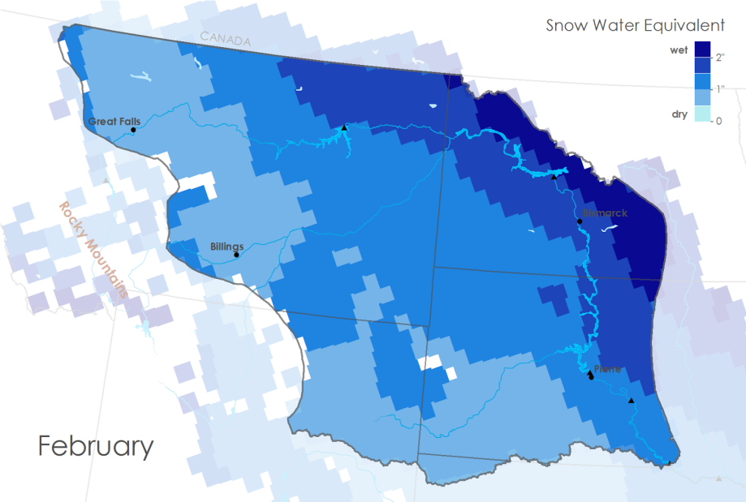
Figure 2. Climatology showing normal conditions for February in the Northern Plains Region. On average, maximum snow water equivalent (SWE) reaches 2 inches in the northeast, and does not rise above 1 inch in the southwest.

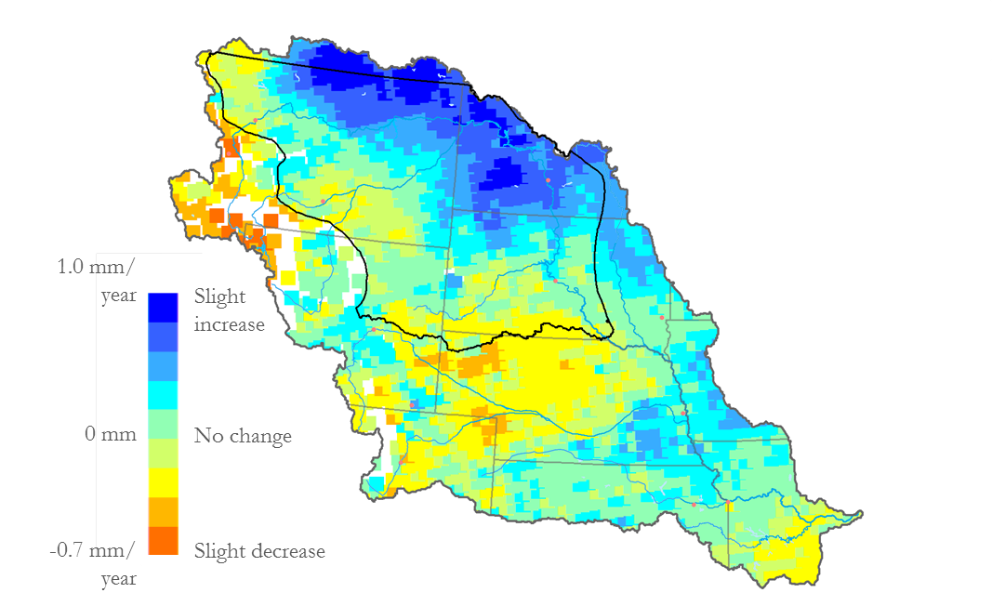
A linear model assessed trends in SWE for every pixel since 1979. Figure 3 shows a trend map showing average change in maximum SWE per year. These results are consistent with IPCC projections that precipitation in high-latitude areas will increase due to global warming [IPCC, 2007].

Slight
increase

No change

Slight decrease

1.0 mm/year

0 mm/year

-0.7 mm/year

Figure 3. Trend map showing average change in maximum snow water equivalent (SWE) per year. The northeastern part of the upper Great Plains saw an increase in as much as 1 mm of average maximum SWE per year in the last three decades.

A histogram was used to chart anomalous years against a 33-year average, to show deviations from normal by year. A slightly increasing trend in yearly anomalies coincides with the above map. Water years 1983 and 1998 saw less than average SWE. (A water year, according to the USGS, is identified as the latter year when describing two years spanning October 1st – September 30th.) The 2016 water year shows similar indications of El Niño trends, leading us to expect less than average snowpack in our focus area as well. The years 1986, 1997, and 2011 all saw snowpack levels of two standard deviations or higher above normal. Such levels can lead to significant flooding, 2011 being particularly infamous in the MRB.

Water Years
2 Standard
Deviations
1 Standard
Deviation
1998
1983
(in)
1.2

1.0

0.8

0.6

0.4

0.2

0

-0.2

-0.4

-0.6

-0.8

-1.0

Figure 4. Average maximum deviations from normal by year in the Northern Plains Region. Snowpack in 2011 was 2 standard deviations above normal. 1983 and 1998 are highlighted for their strong El Niño trends.

Soil Moisture
A visual confirmation of the usefulness of the NLDAS dataset was done with SCAN in situ sites in the Northern Plains Region of the basin. The conclusion of this validation was that the two datasets were very similar and the satellite data can be used for data collection. Figure 5 shows the average soil moisture content in February from 1979-2015. Figure 6 shows the annual deviation from normal of the soil moisture content averaged across the pixels in the upper basin plains focus region.

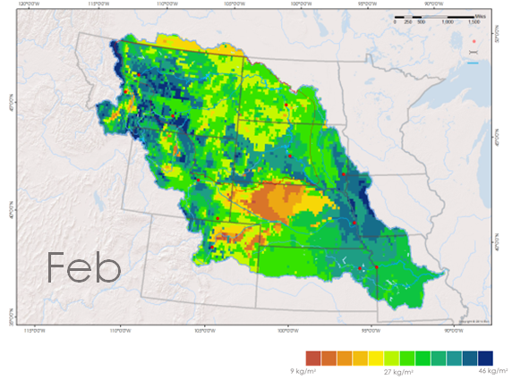
 9kg/m² 27kg/m² 46kg/m²
Figure 5. Average soil moisture content for February from 1979-2015 in the Missouri River Basin. February has the highest average soil moisture content of all of the months during the year.

1998
1983
1 Standard
Deviation
2 Standard
Deviations
1998
1983
Figure 6. Yearly average soil moisture content across the upper basin plains region deviations from normal by year. Strong El Niño years are shown in red.

Soil Temperature
Monthly climatologies of frozen or unfrozen soil from October to May (water years) were produced using average soil temperatures over the past 35 years (Figure 7). Two soil temperature maps comparing the 35-year average temperatures of November and March were created (Figure 8).

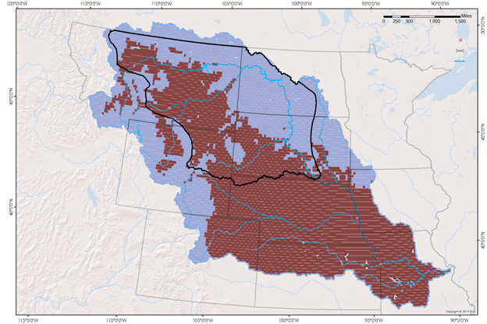
Frozen
Not Frozen
March
Figure 7. Monthly climatology shows frozen and unfrozen soil in March which highlights how, within the focus region (outlined in black), the western plains thaw earlier in the year than the northeastern portion of the basin.


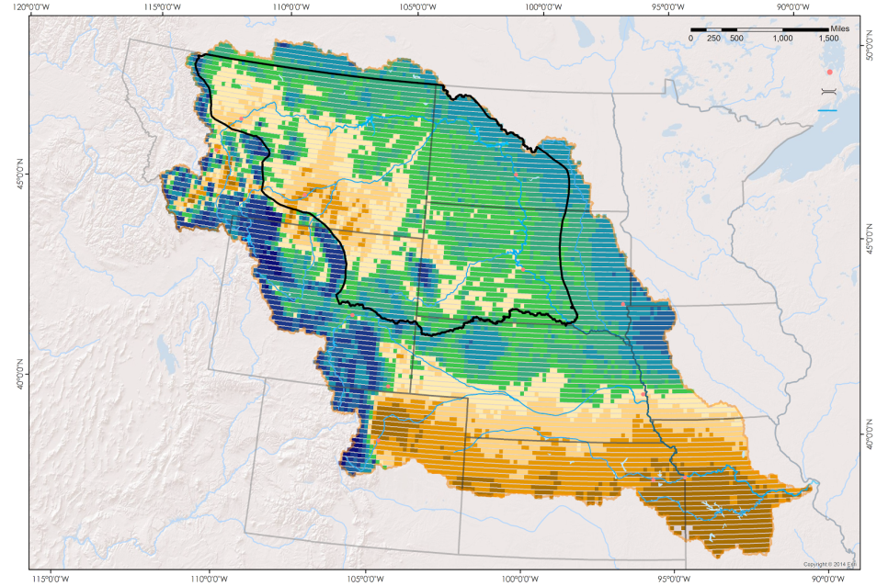
March

3 °C - 5 °C
0 °C
-14 °C - -9 °C

Figure 8. Soil temperatures in March across the basin and averaged over the past 35 years. This map gives a deeper look into the soil temperature differences between the western and eastern portions of the northern plains and upper basin area.

Two tables comparing first and last months of below freezing soil temperatures as well as the duration of below freezing soil temperatures per water year for Billings, MT and Bismarck, ND were generated with a chart for visual comparison of the duration of freeze in the East and the West (Figure 9). Within the upper basin plains region, there is an east-west difference in seasonal soil freeze and thaw over the 35-year study period. The northeastern plains in the upper MRB (east of Montana and the Black Hills of South Dakota) experience cooler soil temperatures than the western plains (from eastern Montana to the Rocky Mountain Range) in November. During March, a majority of the western plains’ soils have already thawed while the northeastern plains remain frozen.
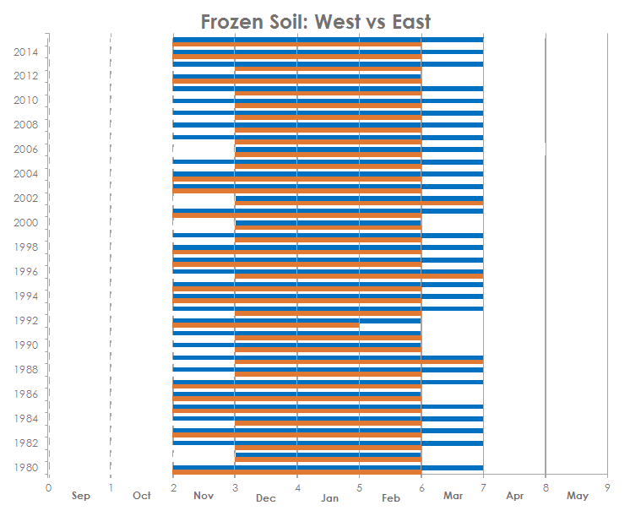
Billings, MT
Bismarck, ND
Figure 9. Graphical representation of the difference in first, last, and duration of freezing months between the western upper plains (Billings, MT) and the eastern upper plains (Bismarck, ND). Bismarck consistently has longer durations of frozen soil.

Streamflow
During the melt season (February - April), the driver variables exhibit stronger correlations with each other than with discharge. This is to be expected because the variables are closely interrelated in the environment. However, SWE and discharge have a positive correlation of 0.33 during spring melt. SMC and SWE have a strong positive correlation of 0.74. Soil temperature has a strong negative correlation with both SWE (-0.67) and SMC (-0.84) during the melt season.

During the growing season (May - September), SMC and soil temperature are less correlated with each other than during the melt season. Discharge has a strong positive correlation of 0.64 with SMC and a negative correlation of -0.36 with soil temperature (ST). As mentioned above, SWE and discharge have a negligible correlation during the growing season and SWE is not included in further growing season analysis.

Table 3. Pearson correlation coefficients indicate the correlation between discharge, snow water equivalent (SWE), soil moisture content (SMC), and soil temperature (ST) during the melt season (February through April).
FEB-APR | Discharge | SWE | SMC | ST
Discharge | 1
SWE | 0.33 | 1
SMC | 0.17 | 0.74 | 1
ST | 0.10 | -0.67 | -0.84 | 1

Table 4. Pearson correlation coefficients indicate the correlation between discharge, snow water equivalent (SWE), soil moisture content (SMC), and soil temperature (ST) during the growing season (May through September).
MAY-SEP | Discharge | SWE | SMC | ST
Discharge | 1
SWE | 0.01 | 1
SMC | 0.64 | 0.17 | 1
ST | -0.36 | -0.33 | -0.38 | 1

During the melt season, the linear model that uses all three variables to predict discharge was created from the coefficients of the variables, noted in Z-scores. All coefficients were statistically significant (p<0.05). The model is:
Discharge = -0.69 + 0.76*SWE + 0.82*SM + 2.2*ST
Adjusted R² = 0.36 (df=3, p<0.01)

During the growing season, the linear model that predicts discharge was created from the coefficients of soil moisture and soil temperature values, observed in Z-scores. The coefficient of soil moisture is statistically significant (p<0.05), but the coefficient of soil temperature is not (p>0.1). The model is:
Discharge = 1.18 + 0.9*SM - 0.31*ST
Adjusted R² = 0.4 (df=2, p<0.01)

The model for the melt season shows a positive relationship between the three variables and discharge. Soil temperature, in particular, shows the largest influence on discharge in the melt season. This suggests the utility of soil temperature as a proxy for seasonal timing of runoff. In contrast, the model for the growing season shows the greatest influence from soil moisture and soil temperature has an inverse relationship with discharge.

A complex environment such as the MRB is poorly explained by only three variables. However, these models suggest the relationship between selected variables and discharge, a relationship that should be explored further.

V. Conclusions
The above results yield conclusions that will be used by USACE in understanding river runoff in the MRB. The majority of the MRB experienced a flat or increasing trend in snow accumulation from 1979 to 2015. Soil moisture content shows an increasing trend over the study period. These trends are both also consistent with the increased precipitation predicted by the IPCC. There is evidence of interannual trends in these two variables that would be interesting to explore further.

Within the upper basin plains region, the east exhibits colder soil and longer duration of frozen ground than the west. Frozen soil in the northeastern plains affects the amount and rate of runoff within the upper basin. Snowmelts in this region before or during March will experience little soil infiltration and higher runoff.

There should be ongoing exploration of the relationships between hydrological variables and discharge. A similar technique can be employed with the following refinements. Means of refining the model should include: adding precipitation and other relevant hydrological variables, downscaling the regional averages from the upper basin to smaller drainage areas, and logically exploring a lag in the time series.

The 2016 water year is predicted to be the strongest El Niño in recorded history. If 1983 and 1998, previous years with strong El Niño weather patterns, are any indication, 2016 can expect below average SWE and average soil moisture. However, only two years are not enough to draw definite conclusions concerning El Niño and the MRB in the present.

VI. Acknowledgments
The project authors wish to acknowledge the enthusiasm, support, and science provided by the following people:
- Rocky Bilotta
- Anthony Arguez
- Ethan Shepherd
- Jesse Bell
- Carrie Vuyovich
- Kevin Stamm
- Jessica Sutton
- Emma Baghel
- Deke Arndt
- James Adams
- Ned Gardiner

Any opinions, findings, and conclusions or recommendations expressed in this material are those of the author(s) and do not necessarily reflect the views of the National Aeronautics and Space Administration.

This material is based upon work supported by NASA through contract NNL11AA00B and cooperative agreement NNX14AB60A.

VII. References
Bilotta, Rocky, Jesse E. Bell, Ethan Shepherd, and Anthony Arguez. "Calculation and Evaluation of an Air-Freezing Index for the 1981–2010 Climate Normals Period in the Coterminous United States."American Meteorological Society. NOAA NCEI, Jan. 2015. Web. 21 Sept. 2015.
"Great Plains." The Columbia Electronic Encyclopedia. Infoplease, 2012. Web. 02 Oct. 2015.
Grode, K. (2015), personal communication.
"The Missouri River Story". Columbia Environmental Research Center. U.S. Geological Survey. Retrieved 2010-04-10.
IPCC, 2007: Climate Change 2007: Synthesis Report. Contribution of Working Groups I, II and III to the Fourth Assessment Report of the Intergovernmental Panel on Climate Change [Core Writing Team, Pachauri, R.K and Reisinger, A. (eds.)]. IPCC, Geneva, Switzerland, 104 pp.
"LDAS | Land Data Assimilation Systems - NLDAS Concept/Goals." LDAS | Land Data Assimilation Systems - NLDAS Concept/Goals. NASA, 15 Oct. 2015. Web. 19 Nov. 2015.
"Temperature - Precipitation - Sunshine - Snowfall." Map of Sioux City. U.S. Climate Data, 2015. Web. 02 Oct. 2015.
U.S. Army Corps of Engineers (2006), Missouri River Mainstem Reservoir System Master Water Control Manual, Reservoir Control Center, Northwestern Division - Missouri River Basin, Omaha, NE, <http://www.nwd-mr.usace.army.mil/rcc/reports/mmanual/MasterManual.pdf>.
U.S. Government Accounting Office (2014), MISSOURI RIVER FLOOD AND DROUGHT: Experts Agree the Corps Took Appropriate Action, Given the Circumstances, but Should Examine New Forecasting Techniques, GAO-14-741: Published: Sep 12, 2014. Publicly Released: Sep 12, 2014.
Vuyovich, C. M., J. M. Jacobs, and S. F. Daly (2014), Comparison of passive microwave and modeled estimates of total watershed SWE in the continental United States, Water Resour. Res., 50, 9088–9102, doi:10.1002/2013WR014734.
Xia et al "Continental-scale Water and Energy Flux Analysis and Validation for the North American Land Data Assimilation System Project Phase 2 (NLDAS-2): 1. Intercomparison and Application of Model Products - Xia - 2012 - Journal of Geophysical Research: Atmospheres - Wiley Online Library." AGU Publications, 3 Feb. 2012. Web. 24 Sept. 2015.

VIII. Content Innovation
Glossary Viewer
Each of the following words will have an associated text bubble that appears when hovering to provide an explanation of the term.
cfs - cubic feet per second. A common measurement of stream flow, and the units by which our USGS data was first given.
acre-feet - the amount of water required to cover one acre of land in water 1 foot deep. USGS data was converted from cubic feet per second to million acre-feet to summarize discharge in 1 month.
snow water equivalent - the amount of water, in millimeters or inches, standing after an amount of snow is melted down, in our case theoretically. Because snowpack varies in density, snow water equivalents are used a measure of potential water in snow that will contribute to runoff during spring thaw.
average maximum snow water equivalent - because snow accumulates with consecutive snowstorms throughout the winter, maximum snow water equivalent is one way of measuring snowpack over a time period. Our study found maximum SWE at every pixel during every month for the 33-year study period. To summarize months and years, average maximum SWE was calculated - or, on average, the maximum SWE found over that period of time at that pixel.
kg/m² - the measurement of water by weight in a space of soil used to summarize soil moisture content. Soil moisture content is an averaged over the first meter of soil depth.
MRB - Missouri River Basin, covering 529,300 square miles and containing the largest reservoir system (by storage) in the United States
Study area - see MRB
Focus area - within our study area, our focus was the overlap of the Upper Missouri River Basin above Fort Randall and the Great Plains. Referred to as the upper Great Plains Region or the Northern Plains, lack of ground stations in this region led it to be the focus of our study.
Water year - in accordance with the USGS, a water year describes the months by which surface-water supply is gained and lost, from October 1st to September 30th. For example, the winter from 1979-1980 is part of the water year 1980.

Featured Multimedia
The following section will include links to featured videos with explanations of the floods of 2011 and other additional information.

Missouri River Climate VPS video (to be published after term if it cannot be embedded)
This link/embedded video will be at the end of the technical paper abstract.

Climate cast video explaining 2011 floods:
This link will be placed in intro during discussion of 2011 flooding events.
https://www.climate.gov/news-features/videos/missouri-river-flooding-2011-responding-climate-extreme

Department of Defense – U.S. Army Corps of Engineers footage assessing 2011 floods
This link will be placed in intro during discussion of 2011 flooding events while discussing the U.S. Army Corps of Engineers efforts to combat flooding damage.
https://www.youtube.com/watch?v=QSo3Ka49TTU

Animated illustration
The monthly climatologies will be presented in an individual animated gif of each variable that portrays the changing seasonal patterns.

IV. Appendices
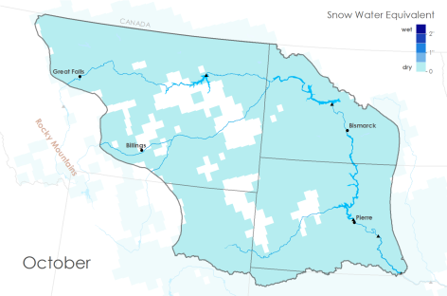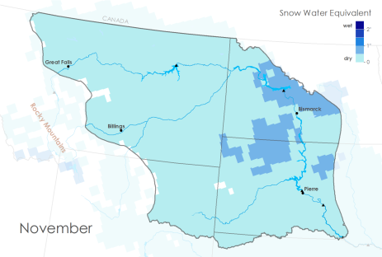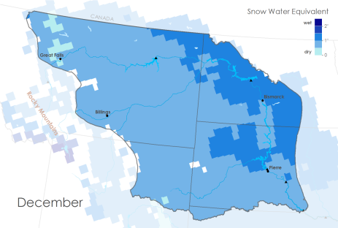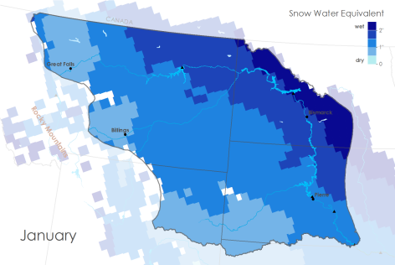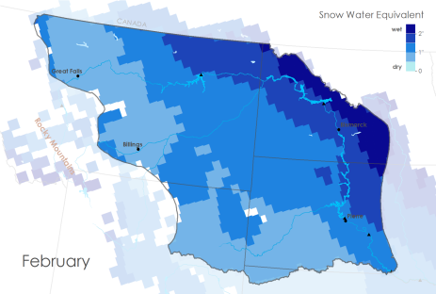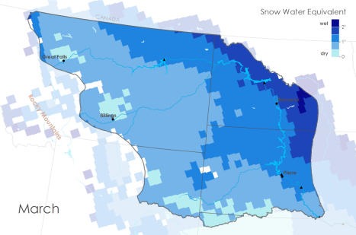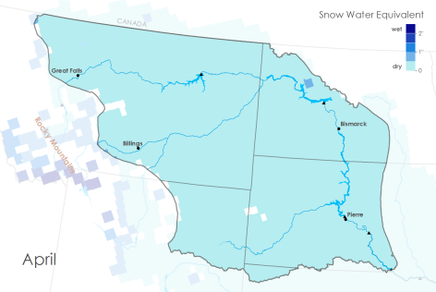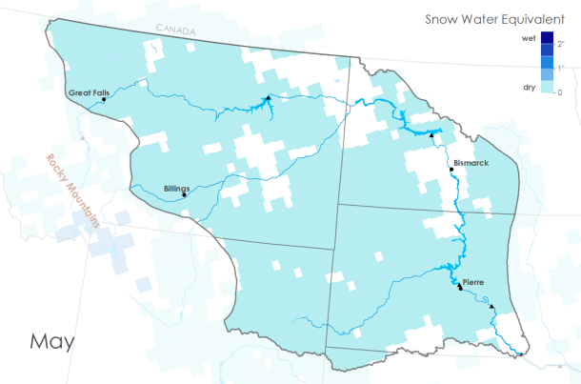
Figure 10. Climatologies of average maximum snow water equivalent, for every month in the upper Great Plains. Snow accumulates throughout the year, and completes its melt in April.

Table 5. Table showing maximum SWE by year and month. Color scheme correlates to above climatologies. One inch equals 25.4 mm.
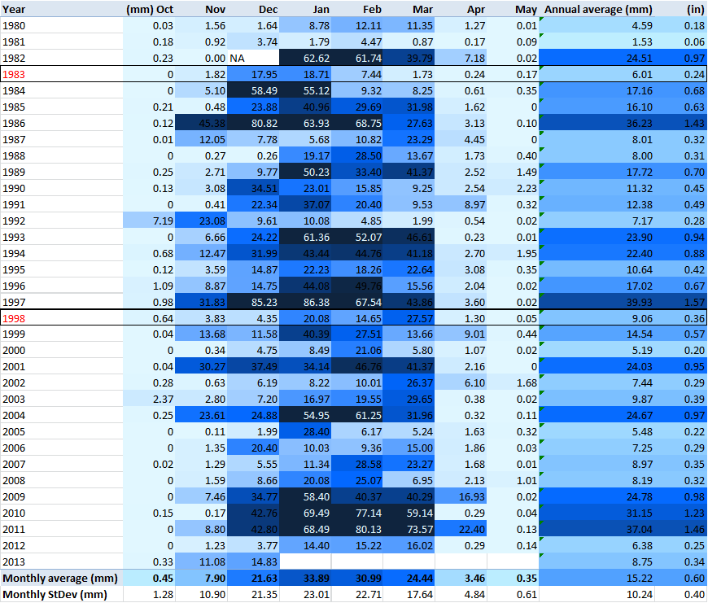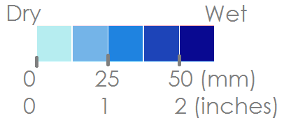
Nov
Jul

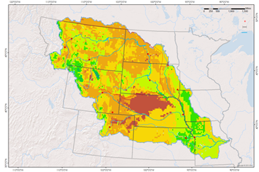
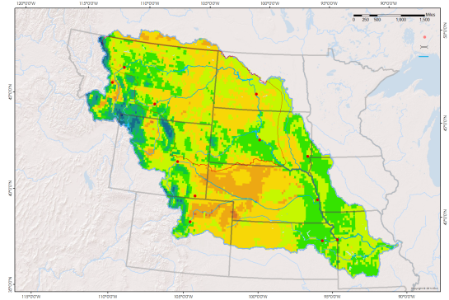
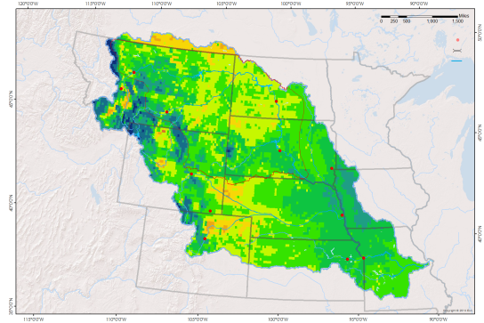
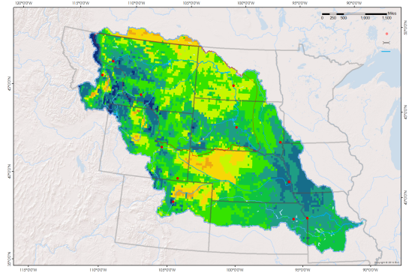
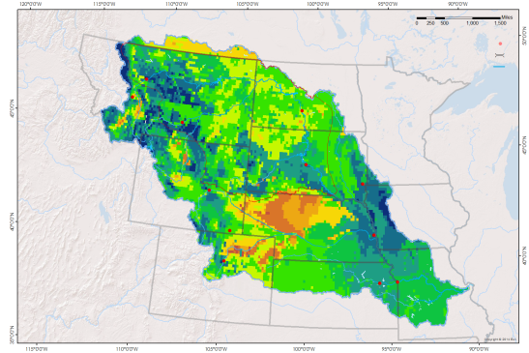
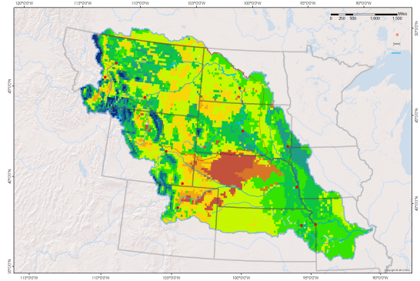
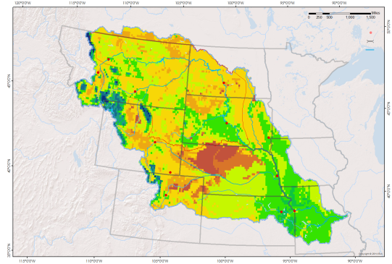
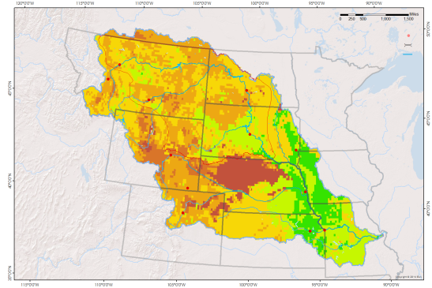
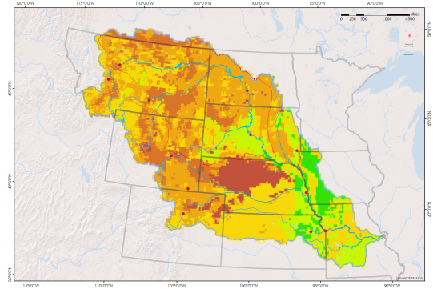
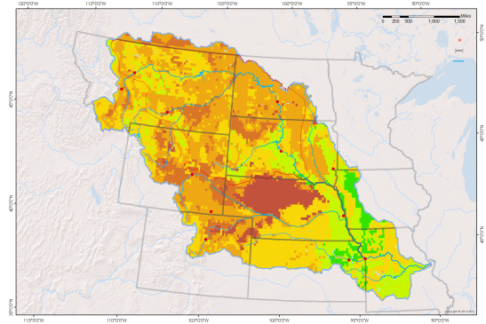
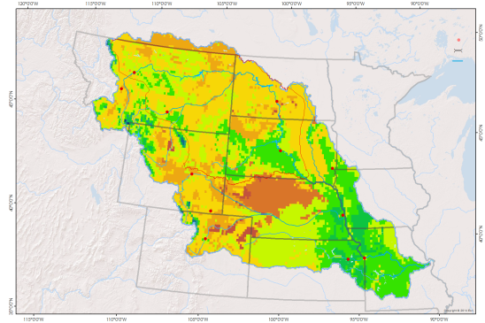
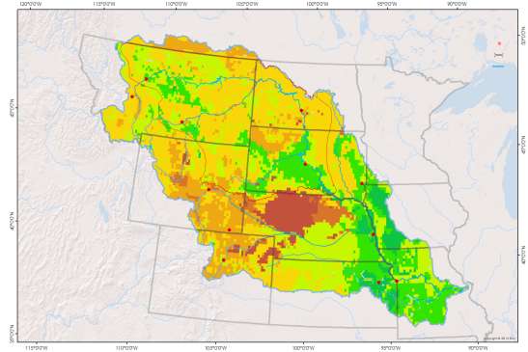
Oct
Dec
Jan
Feb
Mar
Apr
Aug
Sep
Jun
May
Jul
Nov

9kg/m² 27kg/m² 46kg/m²
Figure 11. These maps are monthly climatologies of soil moisture content each month over the 35 year study period.

Table 6. This table shows the yearly and monthly average soil moisture content of our focus region. It also includes the average soil moisture content for each month of each year. The highlighted years indicate strong El Niño years.

9kg/m² 27kg/m² 46kg/m²

Soil Temperature
Monthly Climatologies indicating areas with frozen and unfrozen soil based on average monthly temperatures over the past 35 years (September 1979-August 2015).
Figure 12.
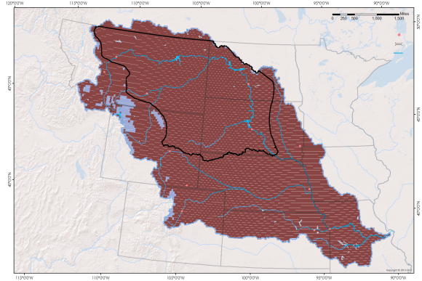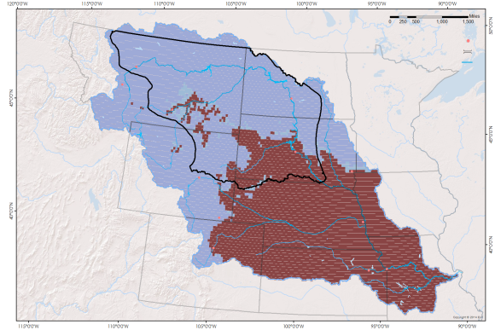
October
November
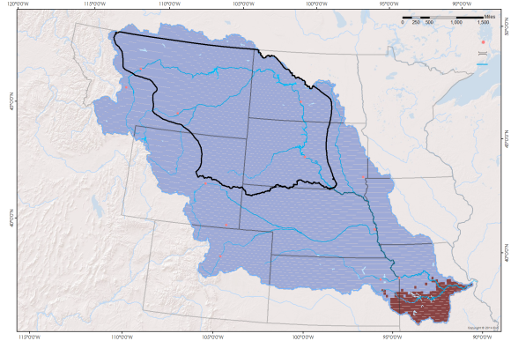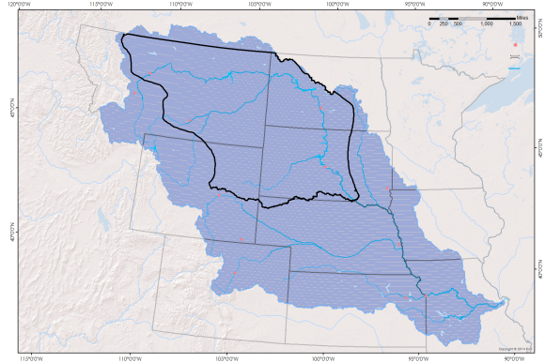
May
April
February
March
December
January
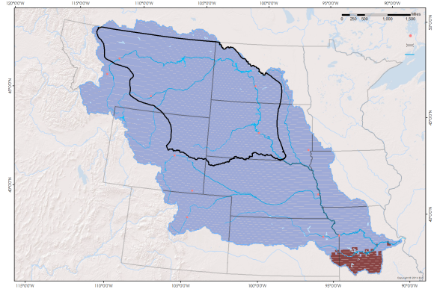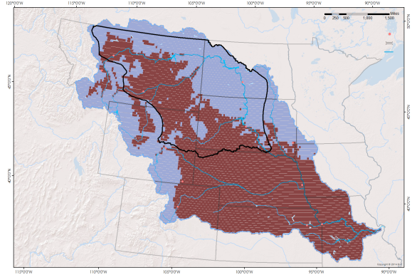
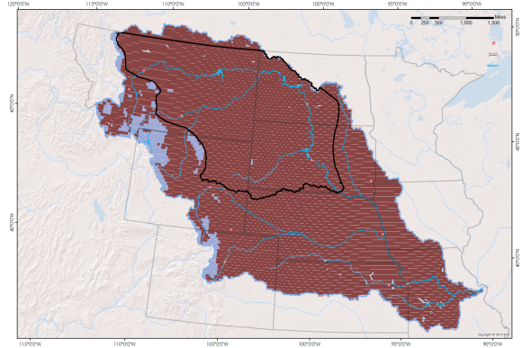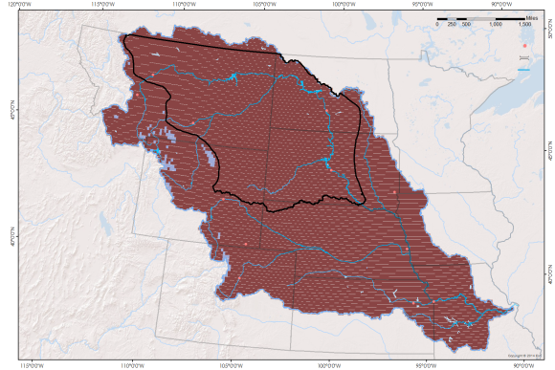
Frozen
Not Frozen

November and March Soil temperature maps averaged over the past 35 years (September 1979-August 2015). The focus region of the study is outlined in black and comes from a composite area of the upper MRB and the Great Plains Region. Green to blue colors represent below freezing soil temperatures and tan to brown colors represent above freezing soil temperatures.

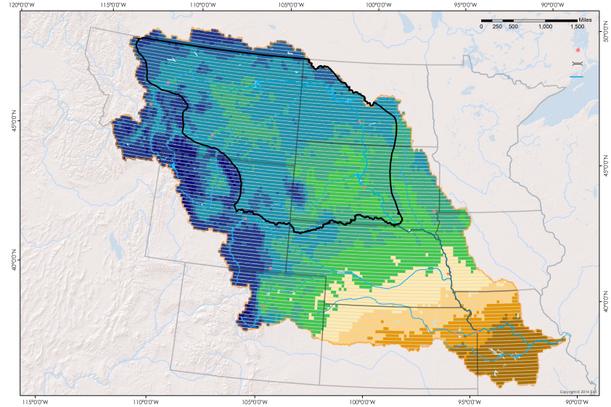
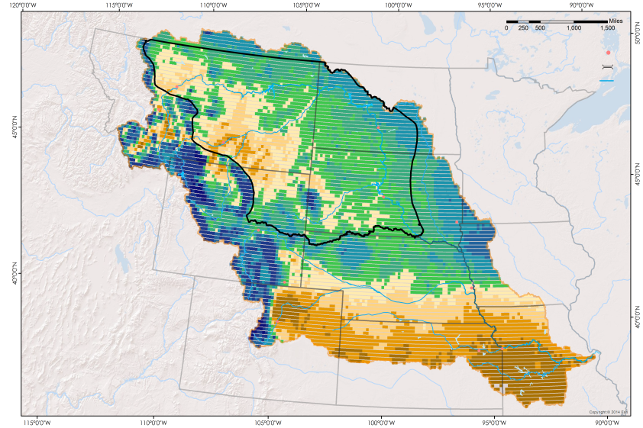
Figure 13
March
November
3 °C - 5 °C
0 °C
-14 °C - -9 °C

Tables 7 and 8. Eastern point (Bismarck, ND) and western point (Billings, MT) soil temperature within focus area, northern plains and upper MRB. The tables indicate first months, last months and duration of months with average soil temperatures below freezing. The darker the color the longer the duration of frozen months – for first and last months the darker colors signify earlier or later in the water year respectively.

Table 7
Bismarck, ND

Table 8
Billings, MT

