Jane Doe Total: $177.83

SAMPLE TRAVEL REIMBURSEMENT

Copies can be submitted to speed the reimbursement process; however, no reimbursement will be finalized until original receipts are received by the NPO office.

Jan 24, 2013

Airfare: $116.39

Taxi: $11.10

Food: $50.34 (If this amount is in excess of the per diem, only the per diem will be reimbursed.)

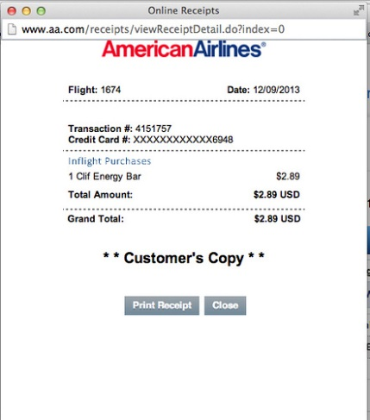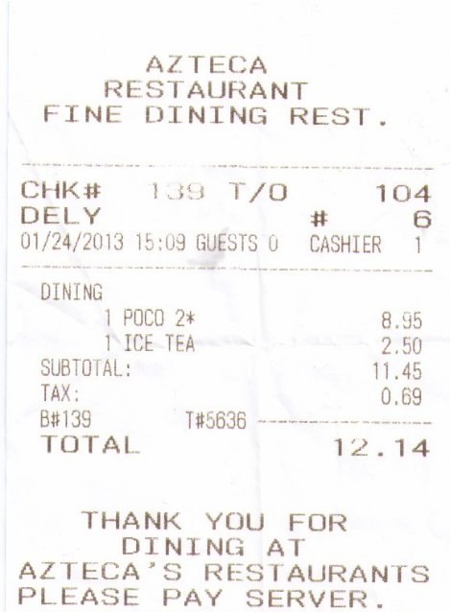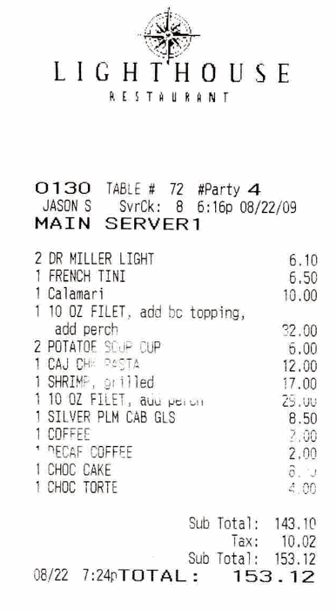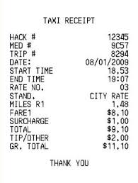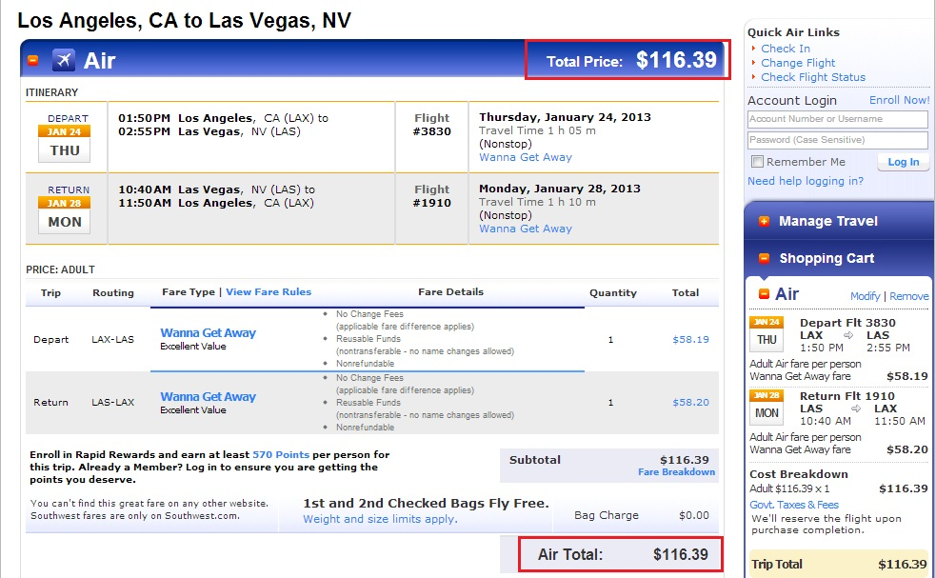

Tape each receipt securely to the page. Do not use the back.

**1/24/13**

1/24/13

1/24/13

$33 + $2.31(tax) = $35.31

If an itemized bill is not possible, ask for copies of the bill for each person. On your copy, List your portion.

------------------------------------------------------------------ ------------------------------------------------------------------

Alcohol is not reimbursable   
------------------------------------------------------------------------------------------------------------------------------------

-----------------------------------------------------------------

-----------------------------------------------------------------

------------------------------------------------------------------

------------------------------------------------------------------------------------------------------------------------------------