**NASA DEVELOP National Program**



NASA Marshall Space Flight Center

*Spring 2017*

Mississippi River Basin Disasters II

Automated Mapping of Flood Events in the Mississippi River Basin Utilizing NASA Earth Observations

 **Technical Report**

Final Draft – March 30, 2017

Mercedes Bartkovich (Project Lead)

Helen Baldwin-Zook

Dashiell Cruz

Nicholas McVey

Dr. Jeffrey Luvall, NASA Marshall Space Flight Center (Science Advisor)

Dr. Robert Griffin, University of Alabama in Huntsville (Science Advisor)

Dr. Andrew Molthan, NASA SPoRT (Science Advisor)

Leigh Sinclair, University of Alabama in Huntsville, Information Technology and Systems Center (Mentor)

Previous Contributors:

Olivia Callaway

Chris Ploetz

# 1. Abstract

The Mississippi River Basin is the fourth largest drainage basin in the world, and is susceptible to multi-level flood events caused by heavy precipitation, snow melt, and changes in water table levels. Conducting flood analysis during periods of disaster is a challenging endeavor for NASA’s Short-term Prediction Research and Transition Center (SPoRT), Federal Emergency Management Agency (FEMA), and the U.S. Geological Survey’s Hazards Data Distribution Systems (USGS HDDS) due to heavily-involved research and lack of manpower. During this project, an automated script was generated that performs high-level flood analysis to relieve the workload for end-users. The script incorporated Landsat 8 Operational Land Imager (OLI) tiles and utilized computer-learning techniques to generate accurate water extent maps. The script referenced the Moderate Resolution Imaging Spectroradiometer (MODIS) land-water mask to isolate areas of flood induced waters. These areas were overlaid onto the National Land Cover Database’s (NLCD) land cover data, the Oak Ridge National Laboratory’s LandScan data, and Homeland Infrastructure Foundation-Level Data (HIFLD) to determine the classification of areas impacted and the population density affected by flooding. The automated algorithm was tested on multiple flood events within the Mississippi River Basin, and focused on the September 2016 flood event that occurred in Upper Mississippi River Basin. This script allows end-users to create their own flood probability and impact maps for disaster mitigation and recovery efforts.

**Keywords**

Mississippi River Basin, disaster relief, Landsat 8 OLI, NDWI, flood impact, flood probability, automated, Python

# 2. Introduction

* 1. ***Background Information***

The Mississippi River Basin is the world’s fourth largest drainage basin, draining 41% of the contiguous U.S. to the Gulf of Mexico (U.S. Army Corps of Engineers, n.d.). The millions of residents within the Mississippi River Basin area, which includes portions of 31 states, undergo social and economic damage each time a flood event occurs within the Basin (Kusky, 2013). Since 2010, flooding has incurred more than $34 billion in damages within the basin (Gerencer, 2015) and has continuously been an issue for farmers within the Midwest region (Garber, 2008). In a recent flood event in September 2016, over 10,000 people were evacuated from flood areas in Iowa and Wisconsin (Blau, 2016), and an estimated tens of thousands of acres of crops were lost as a result of flooded farmland (Eller, 2016; Towne, 2016). This project addresses the needs of communities in the basin by providing more precise data and maps to disaster response and relief organizations.

This term builds upon the project’s previous work which developed a flood algorithm using Landsat 8 Operational Land Imager (OLI) data to identify flooded areas within the Mississippi River Basin. Previously, the project focused on a January 2016 flood event that occurred in parts of Louisiana and Mississippi along the Mississippi River. Landsat 8 OLI recorded data soon after the flood peak, on September 26, 2016, providing extremely clear images of the flood extent. The Federal Emergency Management Agency (FEMA) and United States Geological Survey Hazards Data Distribution Systems (USGS HDDS) have expressed interest in an analysis of this September 2016 Upper Mississippi River Basin flood that occurred in Cedar Rapids, Iowa.

* 1. ***Project Partners & Objectives***

The objective of this term’s project was to create a Python script providing the user with the ability to conduct flood analysis of any given area and date across the United States. This project partnered with FEMA, USGS HDDS, and the NASA Short-term Prediction Research and Transition Center (SPoRT). FEMA is the primary disaster relief organization in the United States; their mission is to “support…citizens and first responders to ensure that as a nation we work together to build, sustain, and improve…capability to prepare for, protect against, respond to, recover from and mitigate all hazards” (FEMA, 2016). The USGS HDDS provides a multitude of data on various natural hazards and ecosystems to scientists worldwide. NASA SPoRT is a NASA project designed to distribute unique observations and data acquisitions to enhance understanding of various weather events.

The project partners expressed a need for an automated, easy to operate script for flood analysis due to shrinking budgets and lack of manpower to conduct such extensive studies. This project utilized the flood algorithm created in a previous project to create the Python script to conduct automatic analysis on a continental scale. The script will allow users to input path-row-tile combinations across the United States for any desired date and create user specific flood analysis of a given area in the continental United States. The automated script will be tested on the Upper Mississippi River Basin flood event that reached its peak on September 23, 2016, and will then be used to analyze multiple flood events throughout the entire Mississippi River Basin (Figure 1). NASA SPoRT will use the script created this term to generate rapid analysis maps of various flood events and provide these maps to FEMA and the USGS HDDS who will process the maps created by the automated script further by extracting various forms of population data and infrastructure data to more accurately assess damage and recovery efforts.

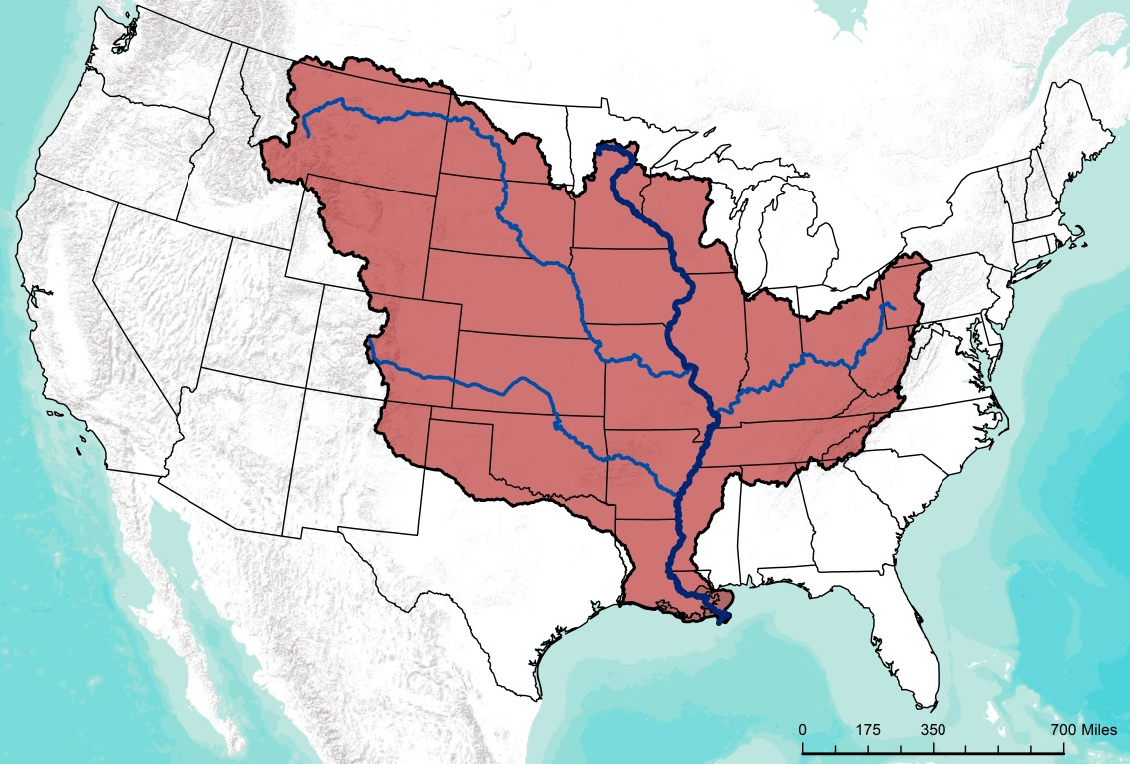

Mississippi River

Mississippi River Major Drainages

Mississippi River Basin



**Study Area**

Figure 1. Project study area. The Mississippi River Basin.

# 3. Methodology

***3.1 Data Acquisition***

This project primarily utilized Landsat 8 OLI multispectral imagery of flood events at 30m resolution. These images were acquired manually using USGS’s Earth Explorer and Global Visualization Viewer (GLOVIS) and saved to the workspace defined by the user prior to flood analysis. In the previous term, McFeeters’ NDWI was determined to identify flood water more accurately than other indices. In order to produce this NDWI, a band that represents reflected green light and a band that represents near infrared radiation are necessary. This index maximizes these differences in reflectance between land and water because water has a high reflectance in the green wavelengths and a low reflectance in the near infrared wavelengths, while vegetation and soil have high reflectance in the near infrared (McFeeters, 1996). In the case of Landsat 8, band 3 records visible green light from 0.53 µm to 0.59 µm wavelengths, and band 5 records near infrared radiation from 0.85 µm to 0.88 µm wavelengths (USGSa, 2016). Band 9, the Landsat 8 cloud mask product, removed unusable data. Preliminary work was done with WorldView-2 images obtained from the Digital Globe website to assess the feasibility of modifying the flood identification algorithm and script to incorporate use of this higher spatial and temporal data.

At the start of each flood event analysis, the script set local variables, retrieved relevant imagery from the workspace with the Python glob.glob function, and imported Arcpy, including 3D Analyst and Spatial Analyst extensions (Figure 2). Local variables included a water mask, as well as agriculture, population, and infrastructure data. The Global Water Mask was obtained from the University of Maryland and NASA’s Global Land Cover Facility website, and provided a complete map of surface water at 250m spatial resolution. National Land Cover Database (NLCD) 2011 data were obtained from the Multi-Resolution Land Characteristics consortium (MRLC) website. The 2011 NLCD dataset categorizes different types of land cover into 16 classes at a 30m spatial resolution and provided valuable information regarding flood impact on agriculture. Homeland Infrastructure Foundation-Level Data (HIFLD) were acquired from the Homeland Infrastructure Foundation-Level Data website. The HIFLD were used to map flood impact on infrastructure. LandScan 2014 data were downloaded from the Oak Ridge National Laboratory (ORNL) and were used to analyze flood impact on local populations.

Figure 2. Algorithm used to create the data acquisition and processing sections of the Flood Probability Python script.

***3.2 Data Processing***

After data acquisition, manually downloaded Landsat images were processed resulting in an NDWI (Figure 2). In order to conduct analysis on a flooded area larger than a single Landsat 8 tile at one time, the individual tiles had to be combined into a single tile for each band. These bands were mosaicked together according to band type using a “for” function loop and “Mosaic to New Raster” tool from the Arcpy package. Once mosaicked, the cloud mask (band 9) was extracted from the mosaicked bands 3 and 5. To ensure an accurate value for reflectance during processing, bands 3, visible green, and 5, near infrared, were converted from Digital Numbers (DN) to top of atmosphere (TOA) reflectance. While surface reflectance would have produced even more accurate results, the turn-around time required for a Landsat surface reflectance product is three to five days (USGS, 2016b). The team decided that even a short lag would reduce the benefits of the script to the project partners and proceeded with TOA reflectance.

DN is the actual amount of radiance measured by the satellite, whereas reflectance is a property of the object being observed and represents the ratio of light reaching and being reflected from the target. TOA refers to the value of this reflectance at the top of the atmosphere, as opposed to at the earth’s surface. This conversion was necessary as DN does not account for changes in the radiance measured. For example, annual changes in the angle of the sun’s rays as they strike the earth will change the measured radiation depending on the time of year, while the same target object will have the same ratio of light reaching and being reflected from itself at all times (USGS, 2016c; Ray, 2002). The TOA reflectance is calculated from the DN values of the radiance image using Equation 1:

*ρλ'* = *MρQcal* + *Aρ* (1)

where *ρλ'* is TOA planetary reflectance, *Mρ* is band-specific multiplicative rescaling factor from the metadata, *Qcal* is quantized and calibrated DN values, and *Aρ* is band-specific additive rescaling factor from the metadata (USGS, 2016c).

Once the TOA conversion was complete, invalid image areas were eliminated by using the Raster Calculator through the Arcpy module to remove negative values. This step ensured the proper execution of a Normalized Difference Water Index. Normalized Difference Water Index (NDWI) was calculated using Equation 2:

|  |  |
| --- | --- |
| *NDWI =* | *Green - NIR* |
| *Green + NIR* |

(2)

where Green is visible green light and NIR is near-infrared radiation. NDWI helps distinguish water from non-water by using the green and NIR bands to produce an image where negative values are typically non-water features and positive values are typically open water areas (USGS, 2016d). NDWI outputs tend to appear cleaner with less noise, and are not as influenced by seasonality (e.g. growing seasons) as other spectral signatures (Gao, 1996).

***3.3 Data Analysis***

During the data analysis stage, flood-induced water and impacted agriculture, population and infrastructure were identified in the processed Landsat 8 images (Figure 3). The script distinguished land and water within the study area by applying a maximum likelihood classification to the NDWI using the NDWI signature file created for the Arkansas, Louisiana, and Mississippi area during the December 2015-January 2016 flood event during the previous term. This signature file was a collection of samples of what water and land should look like in an NDWI output. These served as a baseline to distinguish water from land. These samples were then incorporated into the computer learning classification process.

Figure 3. Algorithm used to create the data analysis section of the Flood Probability Python script.

Once the classification was complete, the Global Land Cover Facility water extent map was used as a water mask to remove non-flood waters from the NDWI signature, resulting in only flood induced water (Figure 4). After the Flood Extent Map was created, the LandScan, HIFLD, and NLCD 2011 data were clipped to the study area, and data that intersected with the flood waters were extracted to create a Flood Impact Map (Figure 5). This impact map provided information about the effect of the flood on population, infrastructure, and agriculture.

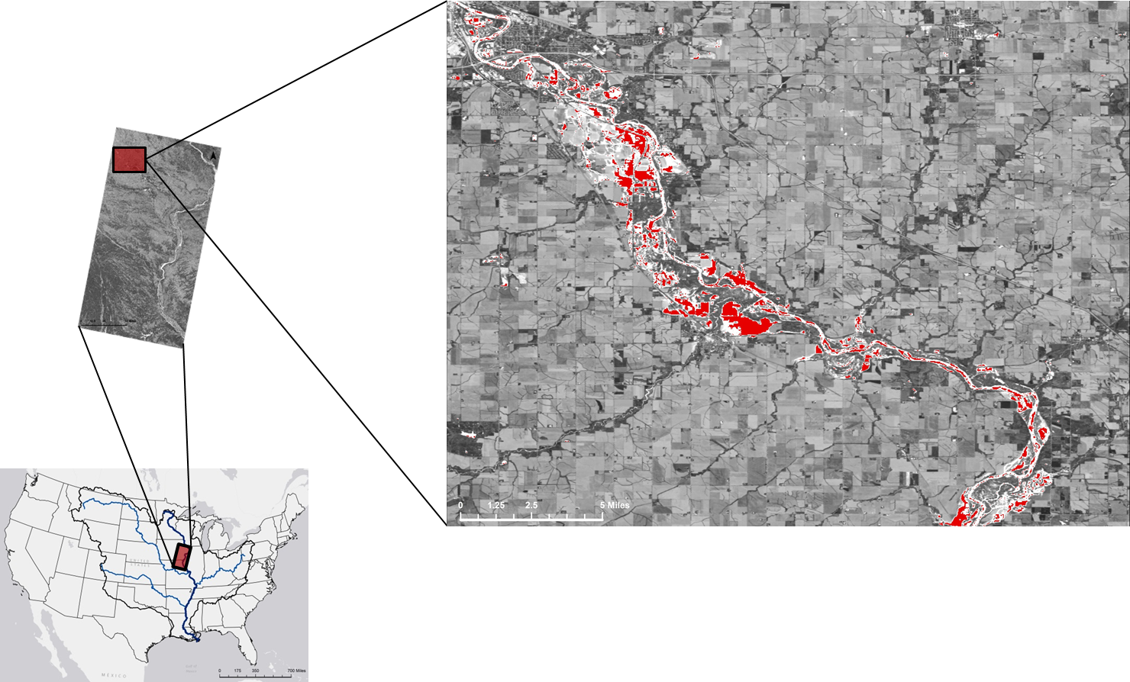



**Water Classification**

Figure 4. Flood Extent Map of the zoomed-in northwest corner of the Iowa flood event, identifying areas of flood inducted water.

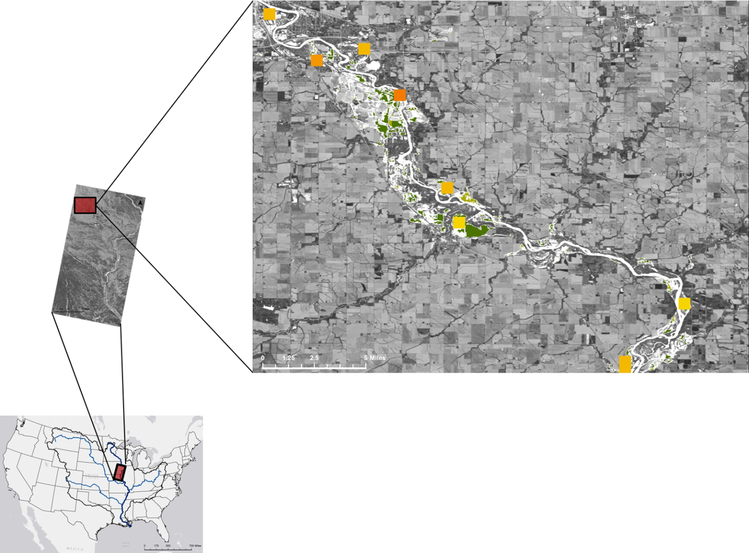



Pasture/Hay

Cultivated Crops

**NLCD Agriculture**



Other

Child Care Facilities

Colleges/Universities

Corporate Offices

Grade Schools

Hospitals

Mobile Home Parks

Assisted Living Facilities

Urgent Care Facilities

**HIFLD Infrastructure Data**



**Landscan Population Data**

Figure 5. Flood Impact Map of the zoomed-in northwest corner of the Iowa flood event, identifying impacted areas of population, agriculture and infrastructure.

The automated algorithm was tested on multiple flood events that occurred between September 2013 and March 2016 throughout the Mississippi River Basin, in addition to the flood event focused on in the previous project. At FEMA’s request, data was specifically extracted from an Iowa flood event that took place in September 2016.

# 4. Results & Discussion

The algorithm was automated using a python script. This script produced both a flood extent map that identified flood water and a flood impact map that singled out areas that were impacted by the flood event. The script was used to analyze 11 different flood events that occurred between August 2013 and March 2017, as seen in Table 1 and Figure 6, to test its ability to identify flood water and flood impact on a variety of landscapes and physiographic regions.

Table 1. List of flood events that were analyzed using the automated Python script.

|  |  |  |
| --- | --- | --- |
| **Location** | **Flood Date** | **Image Date** |
| Reno Co., Kansas | 8/4/2013 | 8/6/2013 |
| Boulder, Colorado | 9/15/2013 | 9/17/2013 |
| Claremore, Oklahoma | 5/23/2015 | 5/26/2015 |
| St. Louis, Missouri | 12/28/2015 | 12/31/2015 |
| Mississippi/Louisiana | 3/11/2016 | 3/13/2016 |
| Fremont Co., Wyoming | 5/11/2016 | 5/13/2016 |
| St. Paul, Minnesota | 6/23/2016 | 7/10/2016 |
| Fayette Co.,West Virginia | 6/23/2016 | 6/30/2016 |
| Indiana/Ohio | 8/28/2016 | 8/30/2016 |
| Cedar Rapids, Iowa | 9/26/2016 | 9/27/2016 |
| Waynesburg, Pennsylvania | 3/1/2017 | 3/4/2017 |

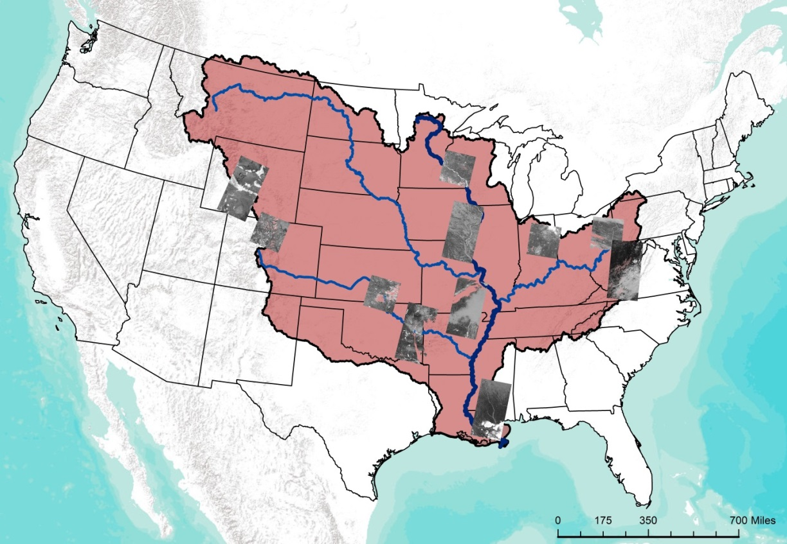

Mississippi River

Mississippi River Major Drainages

Mississippi River Basin



**NDWI of Areas Analyzed**

**Key Features**

Figure 6. Map of flood events that were analyzed using the automated Python script.

For each of these flood events, both a flood extent map and flood impact map were created to analyze the effect (Appendices A-J). In addition, these flood events fell within five of the six physiographic regions within the Mississippi River Basin, providing confidence in the script’s and the signature file’s ability to analyze flood events throughout the basin.

***4.1 Analysis of Results***

The 11 flood events impacted nearly 20,000 people, over 74,000 acres of agriculture (i.e. 16%), and five large infrastructures. The flood that occurred in Mississippi and Louisiana during March 2016 had the greatest numerical population impact of the 11 events, affecting almost 8,000 people, while the Missouri flood event had the largest agricultural impact, effecting over 55,000 acres of agriculture in the area (Table 2). Abnormally, according to our analysis, the flood event in Minnesota had minimal impact on the population or agriculture. This lack of results could to be due to the delay in available Landsat 8 OLI imagery, which was not available until 14 days after the peak of the flood event. On the contrary, news articles that covered the Minnesota flood stated that there was at least $32 million in damages and 53% of farmland was flooded (Davies, 2014).

Table 2. Impact Analysis of each flood event that was tested.

|  |  |  |  |  |
| --- | --- | --- | --- | --- |
|  | Flood Impact | | | |
| Flood Event | No. People | Percent of Ag. | Acres of Ag. | Infrastructure |
| Reno Co., KS | 63 | 0.09% | 321.14 | 0 |
| Boulder, CO | 6128 | 3.77% | 1,741.57 | Grade School and Nursing Home/Assisted Living Facility |
| Claremore, OK | 219 | 1.73% | 6,719.43 | 0 |
| St. Louis, MO | 648 | 3.18% | 55,258.14 | 0 |
| MS/LA | 7857 | 5.24% | 4,427.21 | College/University |
| Fremont Co., WY | 225 | 0.02% | 29.36 | 0 |
| St. Paul, MN | 0 | 0.00% | 8.22 | 0 |
| Fayette Co.,WV | 52 | 0.01% | 19.35 | Child Care Facility |
| IN/OH | 925 | 0.07% | 424.77 | 0 |
| Cedar Rapids, IA | 953 | 0.77% | 4737 | 0 |
| Waynesburg, PA | 2447 | 0.57% | 630.93 | Child Care Facility |

***4.2 Future Work***

The project partners expressed an interest in a self-contained downloading process within our code. Acknowledging that data acquisition is one of the most challenging components to data analysis, the self-contained process would eliminate the need for an external site to be accessed that can confuse or complicate the analysis to be conducted. The team developed a working version of this code, but it had several issues and only operated correctly about half of the time. The team continued to search for a solution to make this feature fully operational, and has come to the conclusion that 64-bit background processing on the 10.4 version of ArcMap would be sufficient to add this feature, but it is untested.

The team has also considered incorporating an input section that would allow the user to select the geographic region that the user is interested in studying. The team would have this selection incorporate premade signature files to be used in the maximum likelihood classification process. This would ensure the accuracy of all analysis being conducted regardless of variance in reflectance values due to region diversity across the United States.

The masking itself is being done through utilization of the cloud bands provided by the USGS from the Landsat 8 data download and a water mask generated from MODIS. The utilization of these two features were satisfactory for a basic analysis but to move into more detailed analysis there are some issues with each that need to be addressed. The 250m mask poses a problem when areas of prevailing water are too small to be detected by MODIS. This leads to our product erroneously classifying these waters as flood-induced instead of as prevailing water bodies. The incorporation of a 30m water mask, such as the NLCD open water classification, would be very beneficial to eliminating false detection. For clouds, the team simply deleted all data covered by the clouds making analysis impossible on cloudy days. Finding better methods to mask clouds and shadows, as well as mapping prevailing water in the United States, would improve the overall accuracy of our product.

Another variable that would improve the usefulness of our product is to incorporate more robust infrastructure or population data, for example a building footprint shapefile. This would allow for residential houses that are affected by flooding to be identified instead of only identifying major infrastructure like hospitals and schools.

Worldview data is extremely high resolution and available much more frequently, on a 3-day return interval. The incorporation of this data, or the more assessable high resolution Sentinel-2 MSI data, with the team’s process for flood mapping could provide even more accurate flood analysis data to the project partners. This would also afford more opportunities to avoid cloud covered days and get the best available picture of the flood event.

# 5. Conclusions

This project automated the flood probability algorithm created by Mississippi River Basin Disasters I. The resulting Python script was used to analyze 11 flood events from August 2013 to March 2017, including events that occurred in five of the six physiographic regions within the Mississippi River Basin. For each event, the script produced a Flood Extent map and Flood Impact map. In addition, the team quantified impacts on agriculture, population and infrastructure during each flood event based on the Flood Impact maps. The script, Flood Extent maps and Flood Impact maps created during the term will provide our project partners with valuable information about flood events that can be used to inform their decision-making processes.

# 6. Acknowledgments

The Mississippi River Disaster team would like to thank the mentors and partners who dedicated their time and assistance to this project. Without any of them, this project would not have been possible.

Mentors/Science Advisors:

* Dr. Jeffrey Luvall (NASA Marshall Space Flight Center)
* Dr. Robert Griffin (University of Alabama in Huntsville)
* Dr. Andrew Molthan (NASA SPoRT)
* Leigh Sinclair (University of Alabama in Huntsville/Information Technology and Systems Center)

Partners:

* Dr. Andrew Molthan (NASA SPoRT)
* Brenda Jones (USGS HDDS)
* Glen Russell (FEMA)

Others:

* Maggi Klug (DEVELOP Center Lead at NASA Marshall Space Flight Center)

Any opinions, findings, and conclusions or recommendations expressed in this material are those of the author(s) and do not necessarily reflect the views of the National Aeronautics and Space Administration.

This material is based upon work supported by NASA through contract NNL16AA05C and cooperative agreement NNX14AB60A.

# 7. Glossary

**MODIS** – Moderate resolution Imaging Spectroradiometer: a key instrument on the TERA and AQUA satellites that orbit the Earth on a 1 to 2 day cycle collecting data from 36 spectral bands or wavelengths.

**HDDS** –Hazard Data Distrubution System (USGS): an event-based interface that provides a single point-of-entry for access to remotely sensed imagery and other geospatial datasets as they become available.

**FEMA** –Federal Emergency Management Agency

**SPoRT** –Short-term Prediction Research and Transition Center (NASA)

**OLI** – Operational Land Imager (Landsat 8): an instrument that collects high resolution data in the visible, near infrared, and short wave infrared portions of the energy spectrum.

**NLCD** – National Land Cover Database

**HIFLD** – Homeland Infrastructure Foundation-Level Data

**DN** – Digital Number: amount of radiance measured by the satellite

# 8. References

Blau, M. (2016). Iowa flooding: Thousands evacuate Cedar Rapids. Retrieved February 08, 2017, from http://www.cnn.com/2016/09/27/us/iowa-wisconsin-flooding/

Eller, D. (2016). Iowa flooding sucker-punches harvest. Retrieved February 08, 2017, from http://www.desmoinesregister.com/story/money/agriculture/2016/09/27/flooding-sucker-punches-iowa-harvest/91135314/

Davies, R. (2014). Cost of June 2014 Minnesota Floods. Retrieved March 09, 2017, from http://floodlist.com/america/usa/cost-minnesota-floods-june-2014

Federal Emergency Management Agency (2016). About the Agency. Retrieved February 14, 2017, from https://www.fema.gov/about-agency/

Garber, K. (2008). Midwest Floods Ruin Crops. Retrieved February 08, 2017, from http://www.usnews.com/news/national/articles/2008/06/18/midwest-floods-ruin-crops/

Gerencer, T. (2015). U.S. Floods Cost $34 Billion. Retrieved February 08, 2017, from http://moneynation.com/u-s- floods-cost- 34-billion/

Gao, Bo-cai. (1996). NDWI-A Normalized Difference Water Index for Remote Sensing of Vegetation Liquid Water from Space. Remote Sensing of Environment. 58:257-266.

Kusky, T.M. (2013). A Brief History of Flooding and Flood Control Measures Along the Mississippi River Basin, in Boulter, S., Palutikof, J., Karoly, D.J., and Guitart, D. (Eds.), *Natural Disasters and Adaptation to Climate Change* (31-41). Cambridge: Cambridge University Press.

McFeeters, S.K.(1996). The use of the Normalized Difference Water Index (NDWI) in the delineation of open water features. Retrieved March 30, 2017, from http://eclass.uth.gr/eclass/modules/document/file.php/MHXC174/Mc_Feeters_NDWI_01431169608948714.pdf

Ray, Terrill W. (2002). Radiance vs. Reflectance. Retrieved February 14, 2017, from http://www.harrisgeospatial.com/Company/PressRoom/TabId/190/ArtMID/786/ArticleID/3377/3377.aspx/

Towne, J. (2016). Harvest on Hold as Farmers Wait for Fields to Dry. Retrieved February 08, 2017, from http://whotv.com/2016/09/27/harvest-on-hold-as-farmers-wait-for-fields-to-dry/

US Army Corps of Engineers. The Mississippi Drainage Basin. Retrieved February 08, 2017, from http://www.mvn.usace.army.mil/Missions/Mississippi-River-Flood-Control/Mississippi-River-Tributaries/Mississippi-Drainage-Basin/ Retrieved 9 February 2017

USGS (2016a). What are the band designations for the Landsat satellites? Retrieved March 30, 2017, from https://landsat.usgs.gov/what-are-band-designations-landsat-satellites

USGS (2016b). Provisional Landsat 8 Surface Reflectance Data Available. Retrieved March 23, 2017, from https://landsat.usgs.gov/provisional-landsat-8-surface-reflectance-data-available

USGS (2016c). Using the USGS Landsat 8 Product. Retrieved February 14, 2017, from https://landsat.usgs.gov/using-usgs-landsat-8-product/

USGS (2016d). Normalized Difference Water Index. Retrieved February 14, 2017, from https://deltas.usgs.gov/fm/data/data_ndwi.aspx





Pasture/Hay

Cultivated Crops

**NLCD Agriculture**



0

0 - 5

5 – 25

25 – 50

50 – 100

100 – 500

500 – 2,500

2,500 – 5,000

5,000 – 180,000

**Landscan Population**

# 9. Appendices

**Appendix A.**

Flood Extent Map and Flood Impact Map of the Reno Co., Kansas flood event which peaked on August 4, 2013 and impacted 63 people, 321.1 acres of agriculture, and 0 infrastructures.

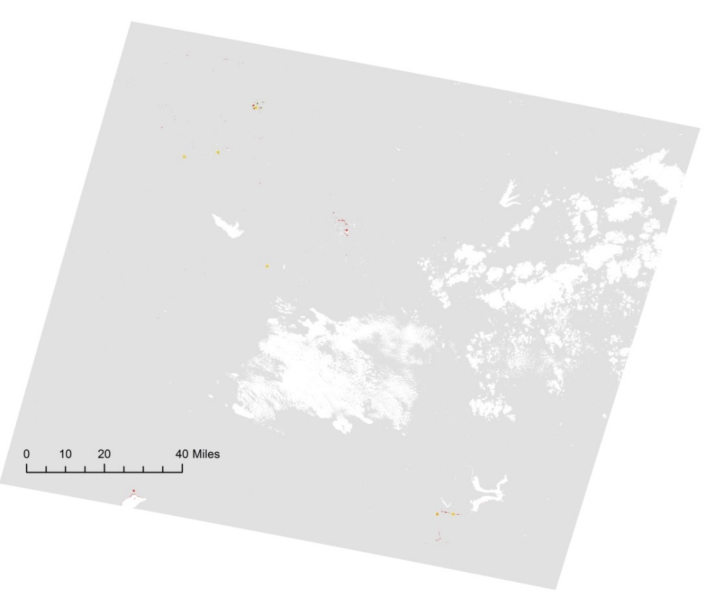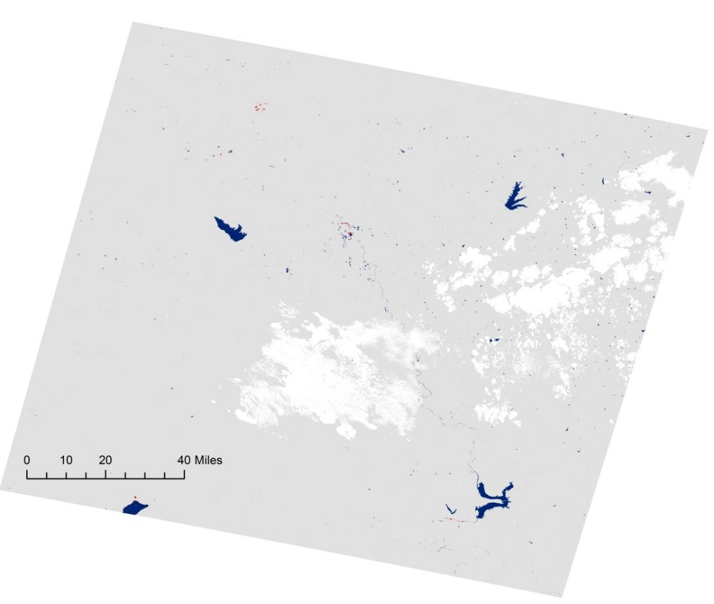



0

0 - 5

5 – 25

25 – 50

50 – 100

100 – 500

500 – 2,500

2,500 – 5,000

5,000 – 180,0000

0 - 5

5 – 25

25 – 50

50 – 100

100 – 500

500 – 2,500

2,500 – 5,000

5,000 – 180,000

**Landscan Population**Flood Water



Pasture/Hay

Cultivated CropsPasture/Hay

Cultivated Crops

**NLCD AgricultureNLCD Agriculture Data**



Flood Induced Water

Water Mask

**Water Classification**

**Appendix B.**

Flood Extent Map and Flood Impact Map of the Boulder, Colorado flood event which peaked on September 15, 2013, and impacted 6,128 people, 1,741.6 acres of agriculture, 1 grade school and one nursing home/assisted living facility.

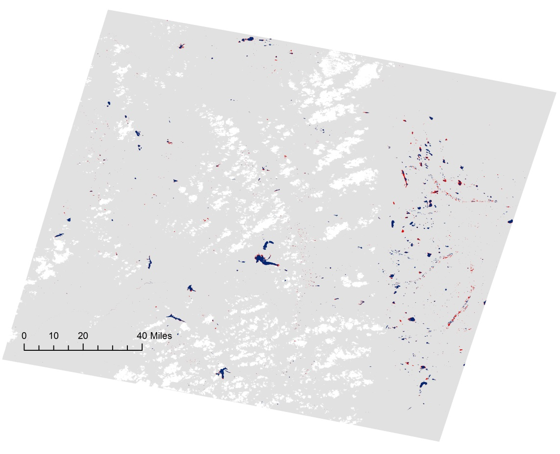

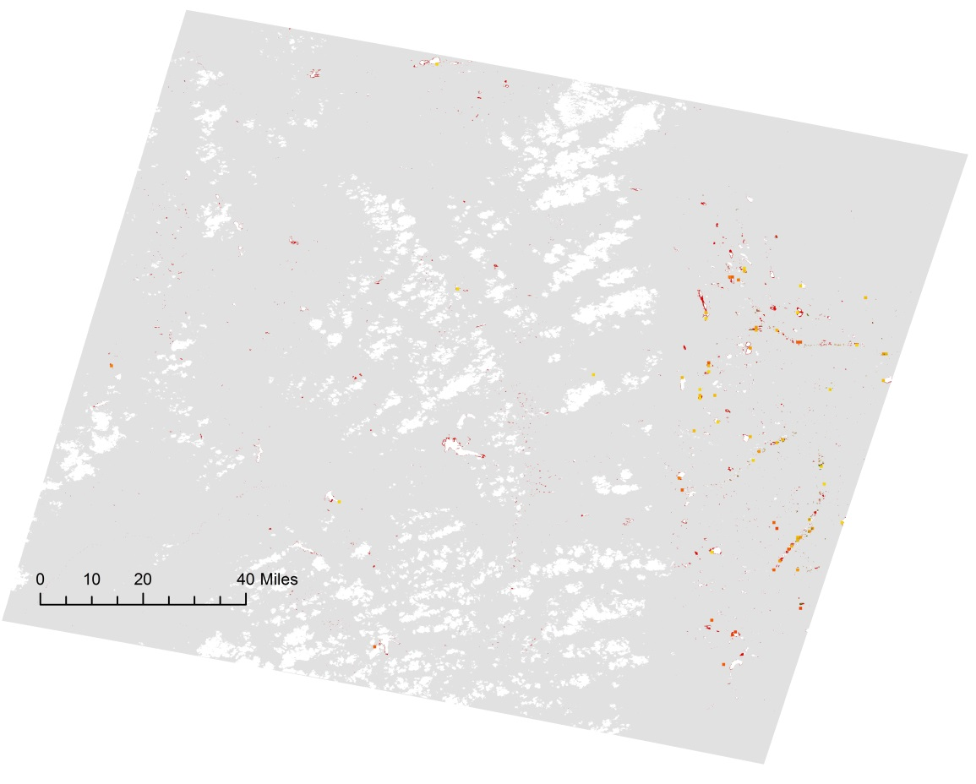



Flood Induced Water

Water Mask

**Water Classification**



Other

Child Care Facilities

Colleges/Universities

Corporate Offices

Grade Schools

Hospitals

Mobile Home Parks

Assisted Living Facilities

Urgent Care Facilities

**HIFLD Infrastructure Data**



Pasture/Hay

Cultivated Crops

**NLCD Agriculture**



0

0 - 5

5 – 25

25 – 50

50 – 100

100 – 500

500 – 2,500

2,500 – 5,000

5,000 – 180,000

**Landscan Population**

**Appendix C.**

Flood Extent Map and Flood Impact Map of the Claremore, Oklahoma flood event which peaked on May 23, 2015, and impacted 219 people, 6,719.4 acres of agriculture, and 0 infrastructures.

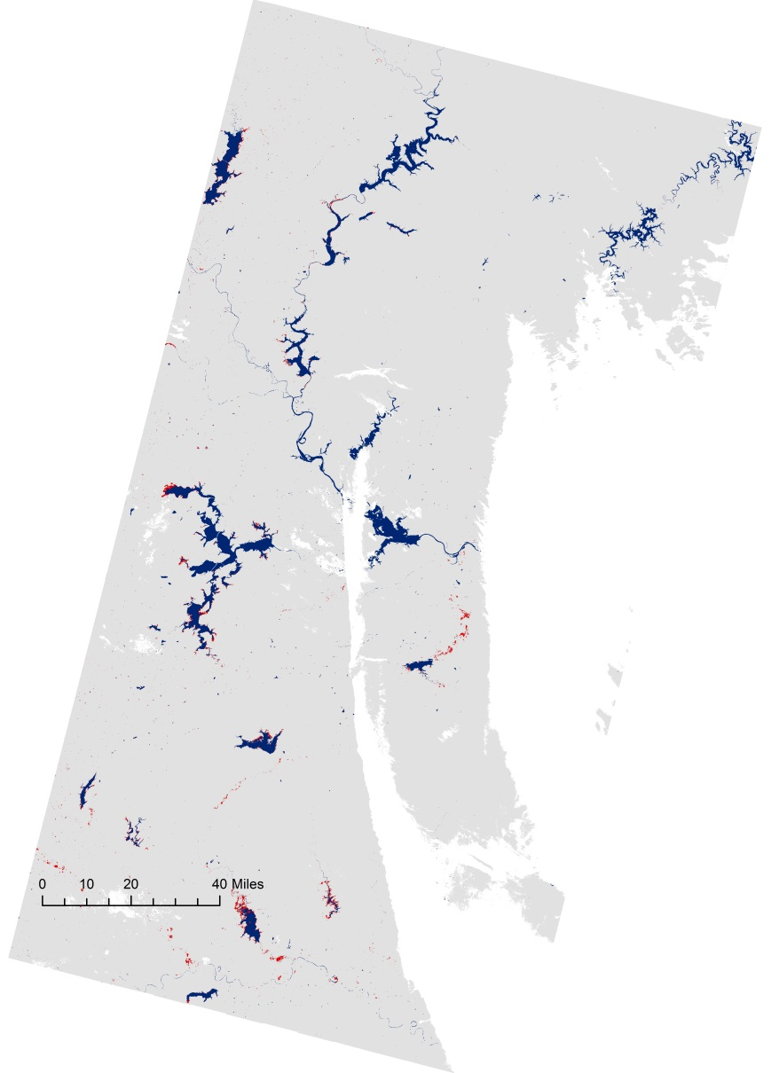



Flood Induced Water

Water Mask

**Water Classification**

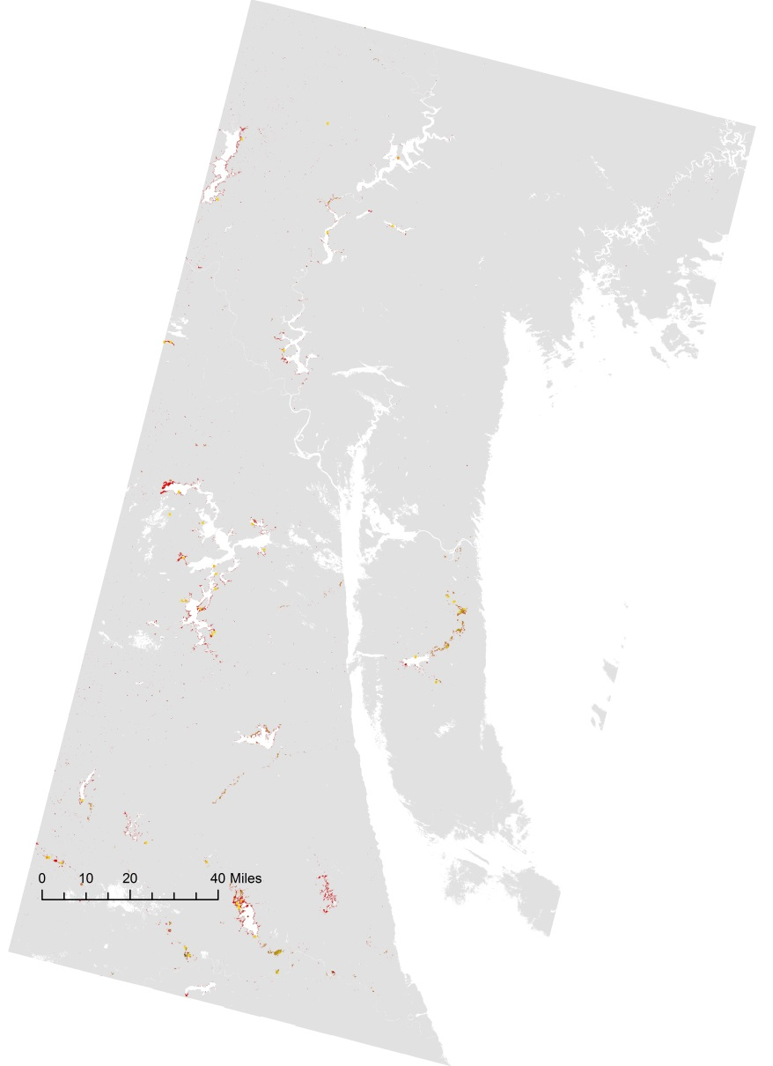

  
**Appendix D.**



Pasture/Hay

Cultivated Crops

**NLCD Agriculture**



0

0 - 5

5 – 25

25 – 50

50 – 100

100 – 500

500 – 2,500

2,500 – 5,000

5,000 – 180,000

**Landscan Population**

Flood Extent Map and Flood Impact Map of the St. Louis, Missouri flood event which peaked on December 28, 2015, and impacted 648 people, 55,258.1 acres of agriculture, and 0 infrastructures.

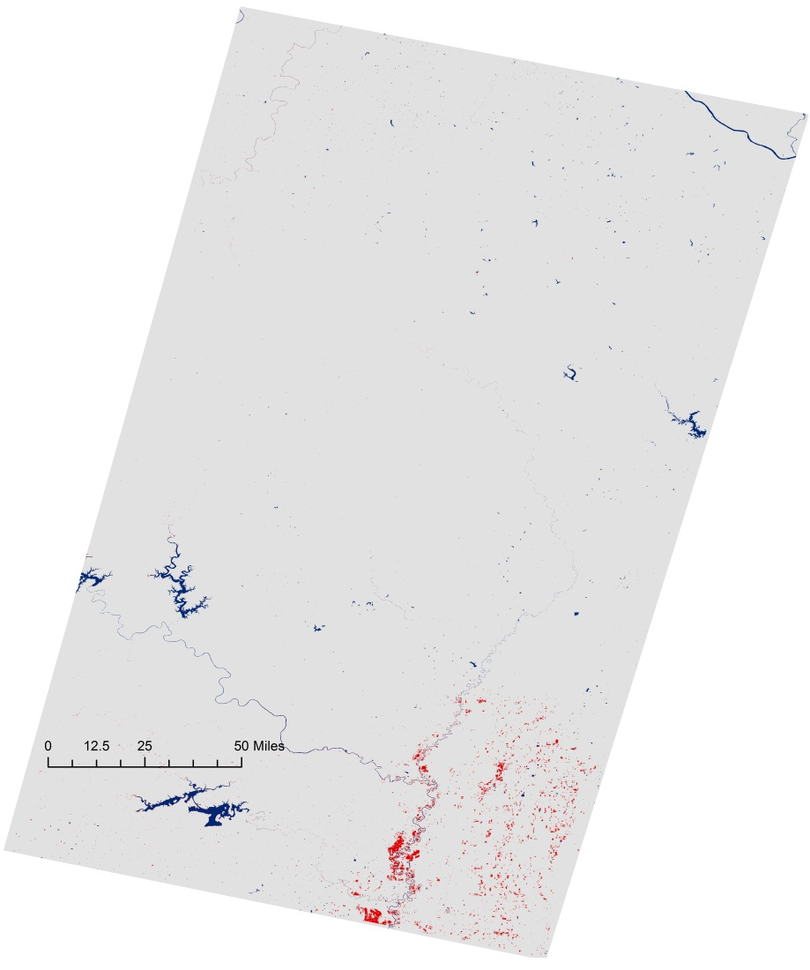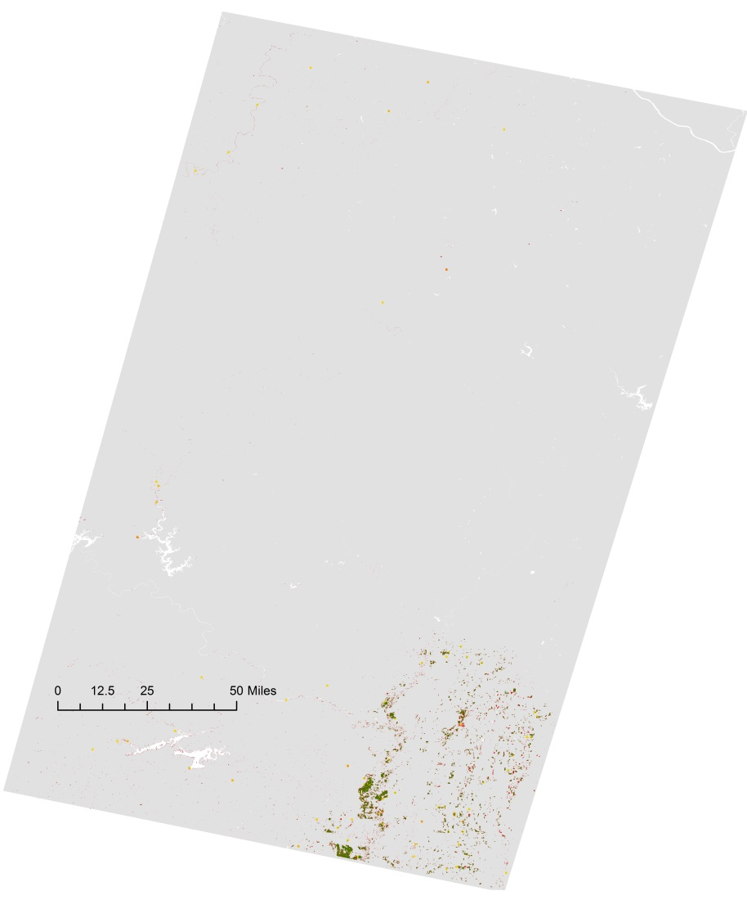



Flood Induced Water

Water Mask

**Water Classification**



Pasture/Hay

Cultivated Crops

**NLCD Agriculture**



0

0 - 5

5 – 25

25 – 50

50 – 100

100 – 500

500 – 2,500

2,500 – 5,000

5,000 – 180,000

**Landscan Population**

**Appendix E.**

Flood Extent Map and Flood Impact Map of the Mississippi/Louisiana which peaked on March 11, 2016, and impacted 7,857 people, 4,427.2 acres of agriculture, and 1 college/university.

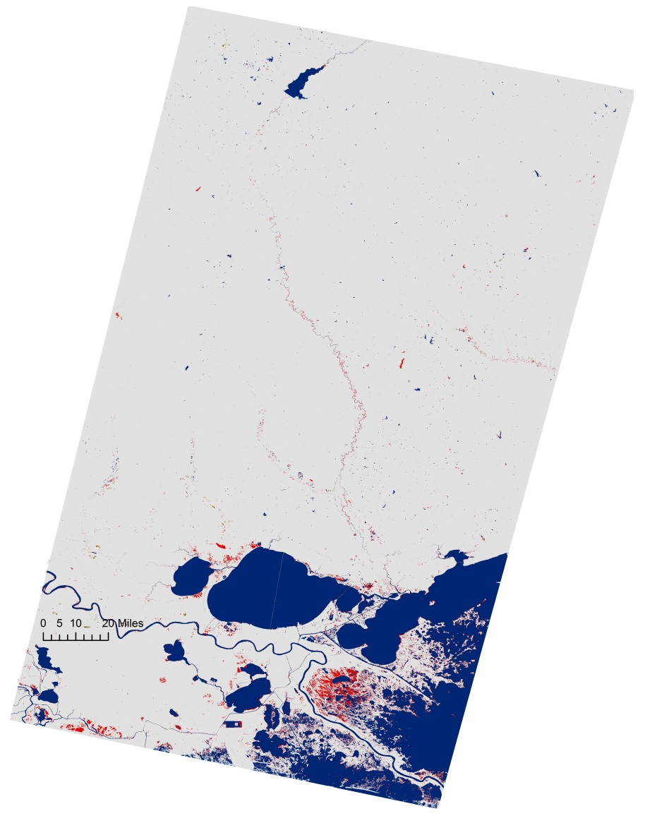

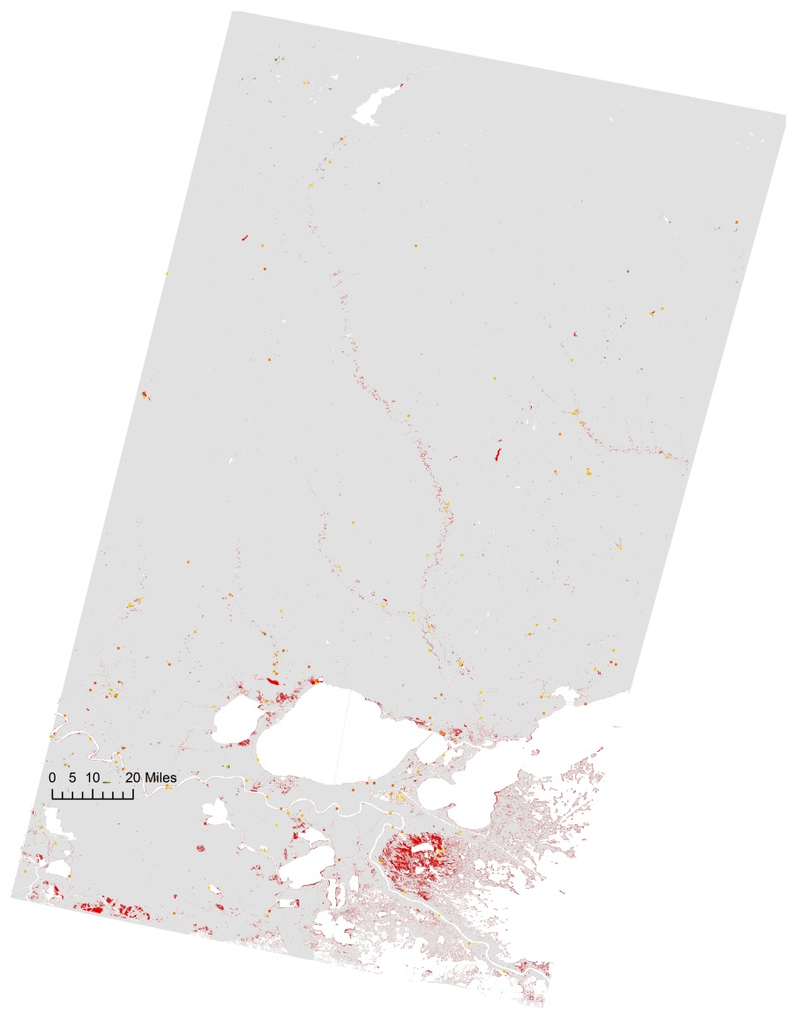



Flood Induced Water

Water Mask

**Water Classification**



Other

Child Care Facilities

Colleges/Universities

Corporate Offices

Grade Schools

Hospitals

Mobile Home Parks

Assisted Living Facilities

Urgent Care Facilities

**HIFLD Infrastructure Data**



0

0 - 5

5 – 25

25 – 50

50 – 100

100 – 500

500 – 2,500

2,500 – 5,000

5,000 – 180,000

**Landscan Population**



Pasture/Hay

Cultivated Crops

**NLCD Agriculture**

**Appendix F.**

Flood Extent Map and Flood Impact Map of the Fremont Co., Wyoming flood event which peaked on May 11, 2016, and impacted 225 people, 29.4 acres of agriculture, and 0 infrastructures.

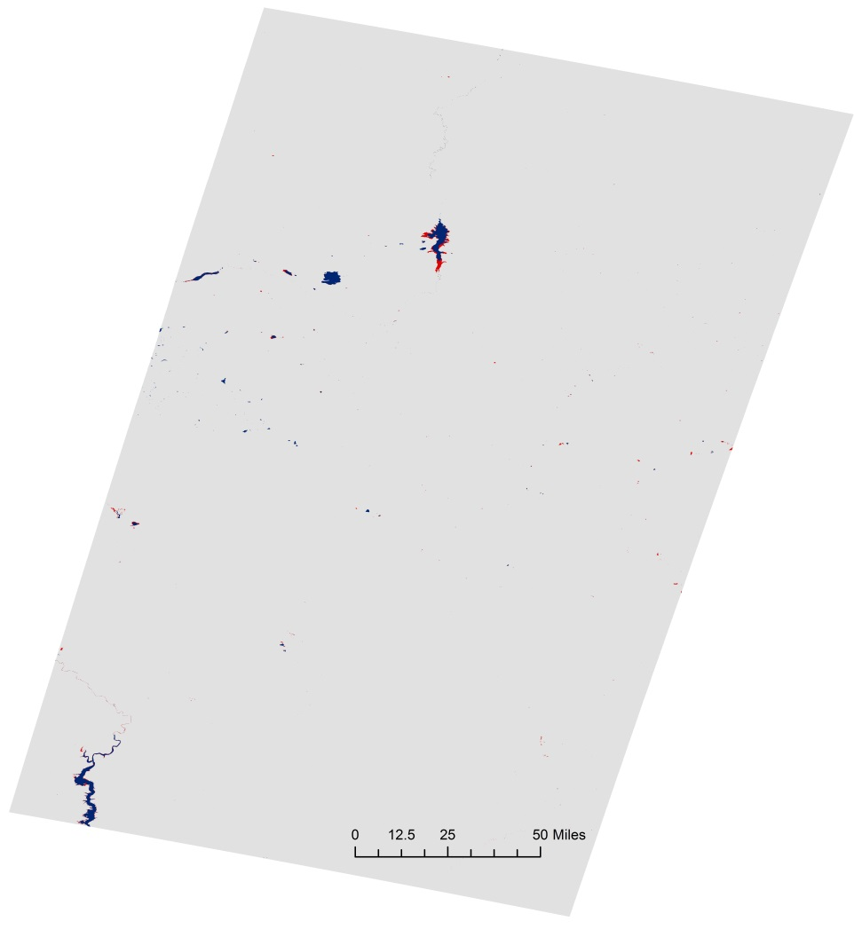

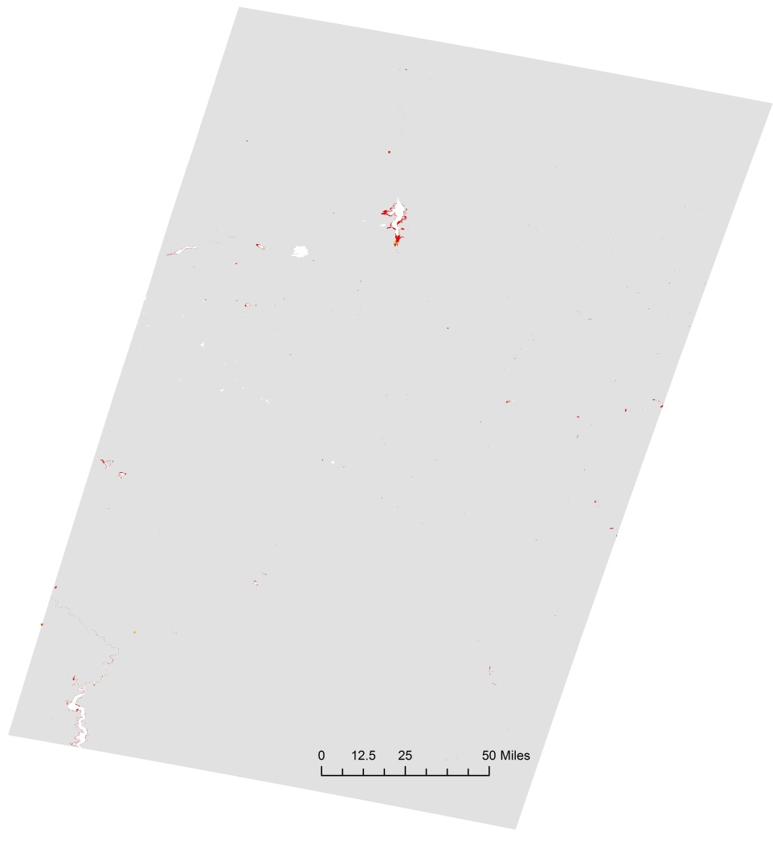



Flood Induced Water

Water Mask

**Water Classification**



Pasture/Hay

Cultivated Crops

**NLCD Agriculture**



0

0 - 5

5 – 25

25 – 50

50 – 100

100 – 500

500 – 2,500

2,500 – 5,000

5,000 – 180,000

**Landscan Population**

**Appendix F.**

Flood Extent Map and Flood Impact Map of the St. Paul, Minnesota flood event which peaked on June 23, 2016, and impacted 0 people, 8.2 acres of agriculture, and 0 infrastructures.

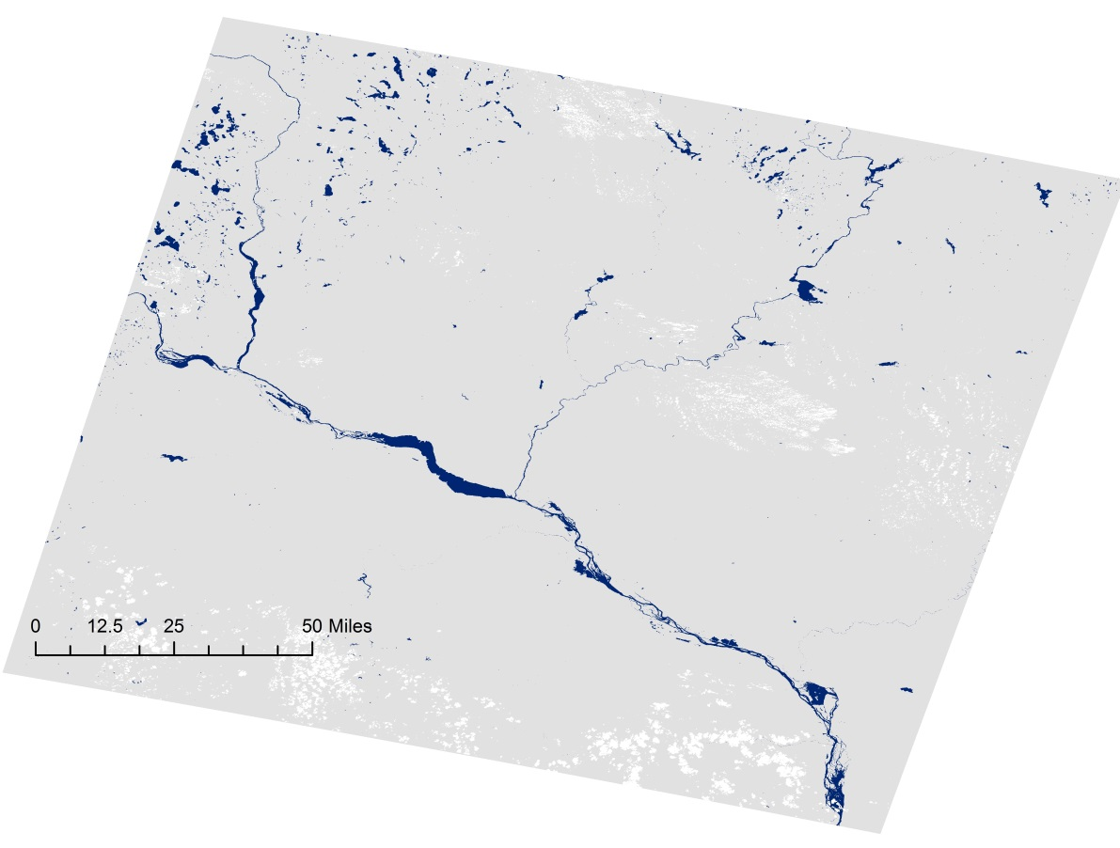

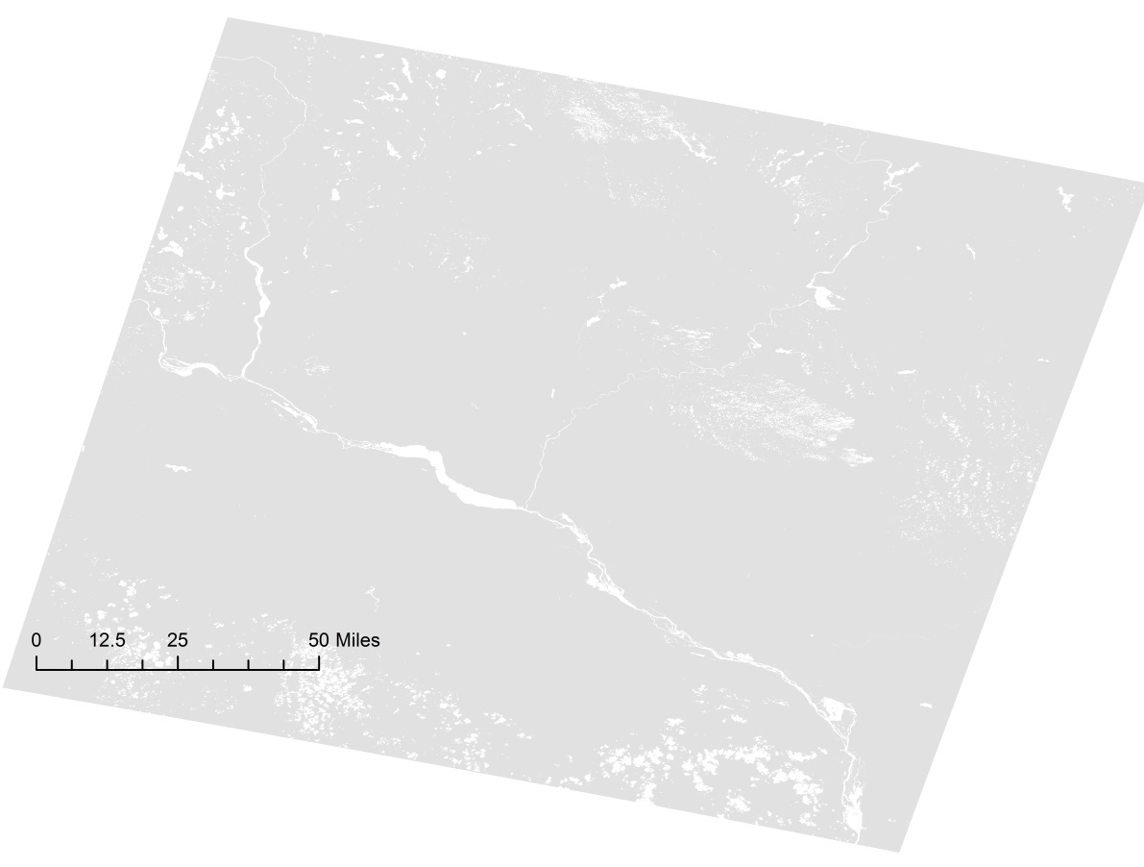



Flood Induced Water

Water Mask

**Water Classification**



Pasture/Hay

Cultivated Crops

**NLCD Agriculture**



0

0 - 5

5 – 25

25 – 50

50 – 100

100 – 500

500 – 2,500

2,500 – 5,000

5,000 – 180,000

**Landscan Population**

**Appendix G.**

Flood Extent Map and Flood Impact Map of the Fayette Co., West Virginia flood event which peaked on June 23, 2016, and impacted 52 people, 19.5 acres of agriculture, and 1 child care facility.

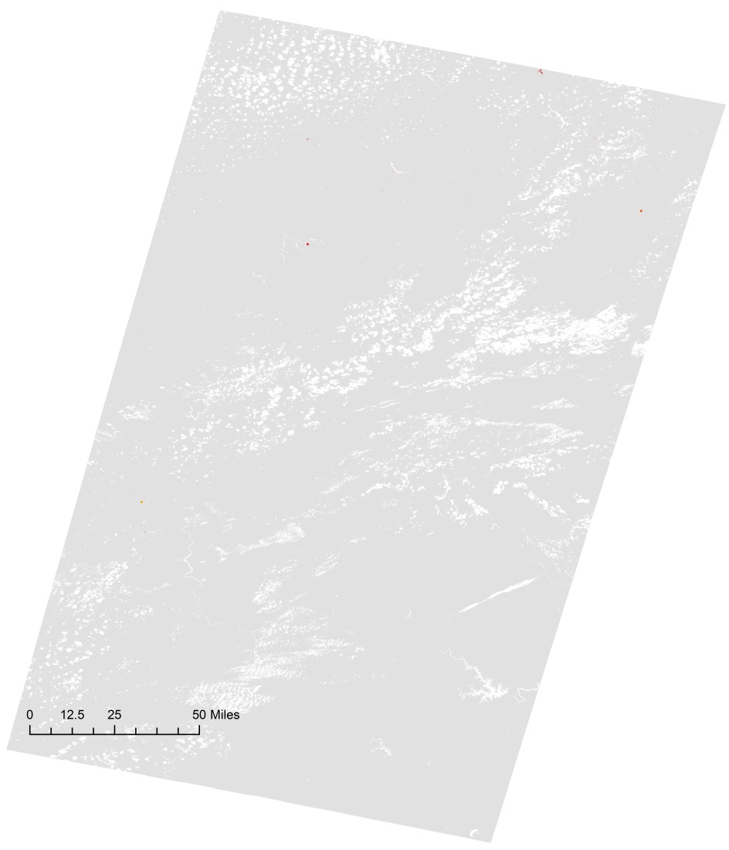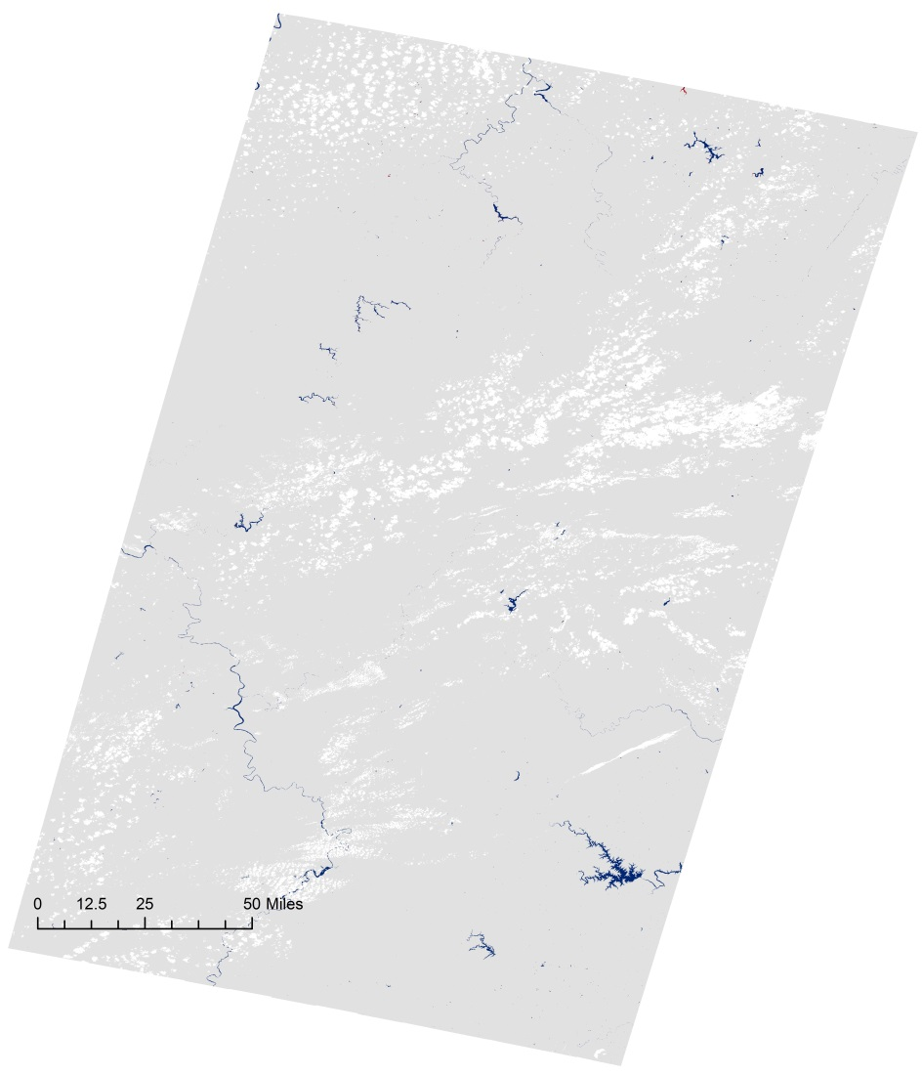



Pasture/Hay

Cultivated Crops

**NLCD Agriculture**



Flood Induced Water

Water Mask

**Water Classification**



Other

Child Care Facilities

Colleges/Universities

Corporate Offices

Grade Schools

Hospitals

Mobile Home Parks

Assisted Living Facilities

Urgent Care Facilities

**HIFLD Infrastructure Data**



0

0 - 5

5 – 25

25 – 50

50 – 100

100 – 500

500 – 2,500

2,500 – 5,000

5,000 – 180,000

**Landscan Population**

**Appendix H.**

Flood Extent Map and Flood Impact Map of the Indiana/Ohio flood event which peaked on August 28, 2016, and impacted 925 people, 424.8 acres of agriculture, and 0 infrastructures.

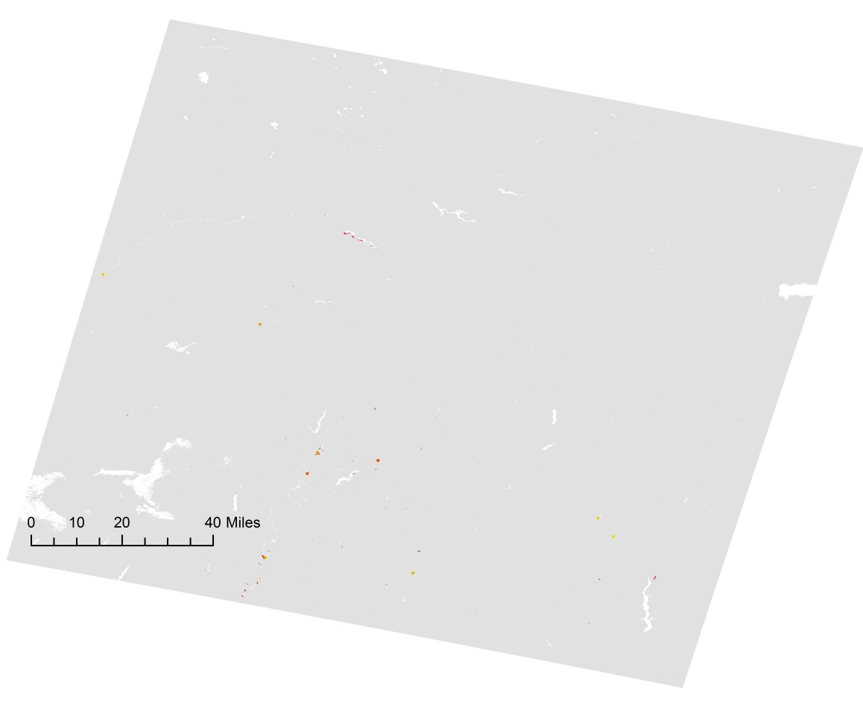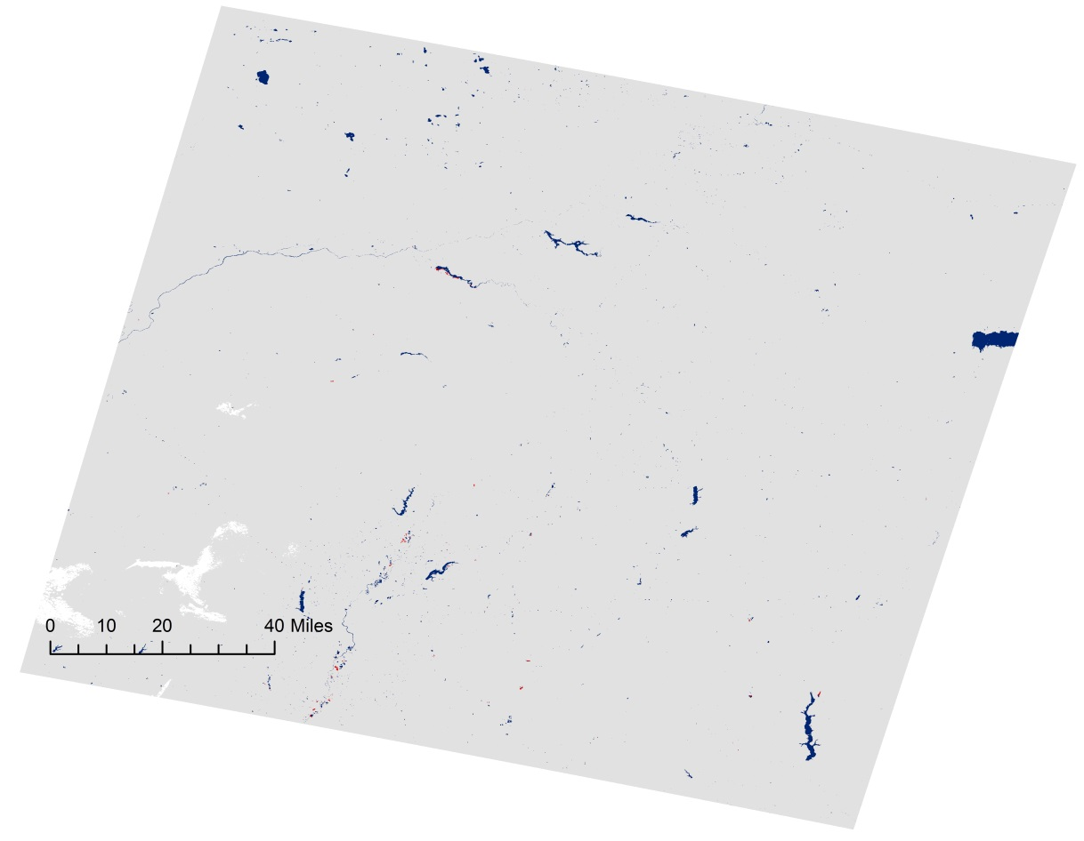



Flood Induced Water

Water Mask

**Water Classification**



Pasture/Hay

Cultivated Crops

**NLCD Agriculture**



0

0 - 5

5 – 25

25 – 50

50 – 100

100 – 500

500 – 2,500

2,500 – 5,000

5,000 – 180,000

**Landscan Population**

**Appendix I.**

Flood Extent Map and Flood Impact Map of the Cedar Rapids, Iowa which peaked on September 26, 2016, and impacted 953 people, 4,737 acres of agriculture, and 0 infrastructures.

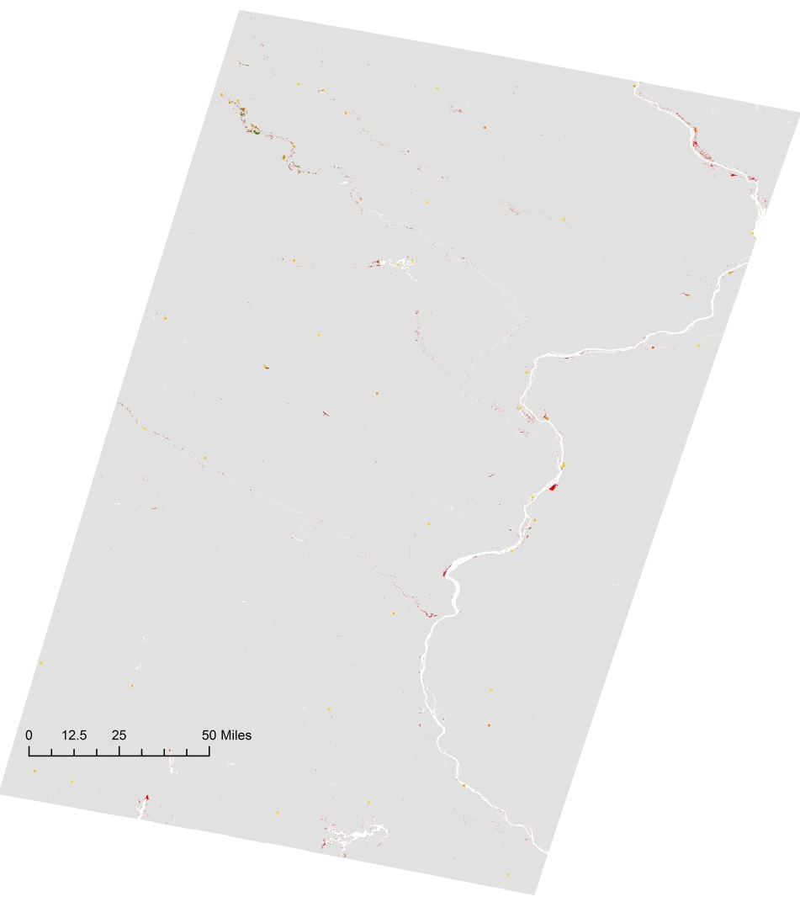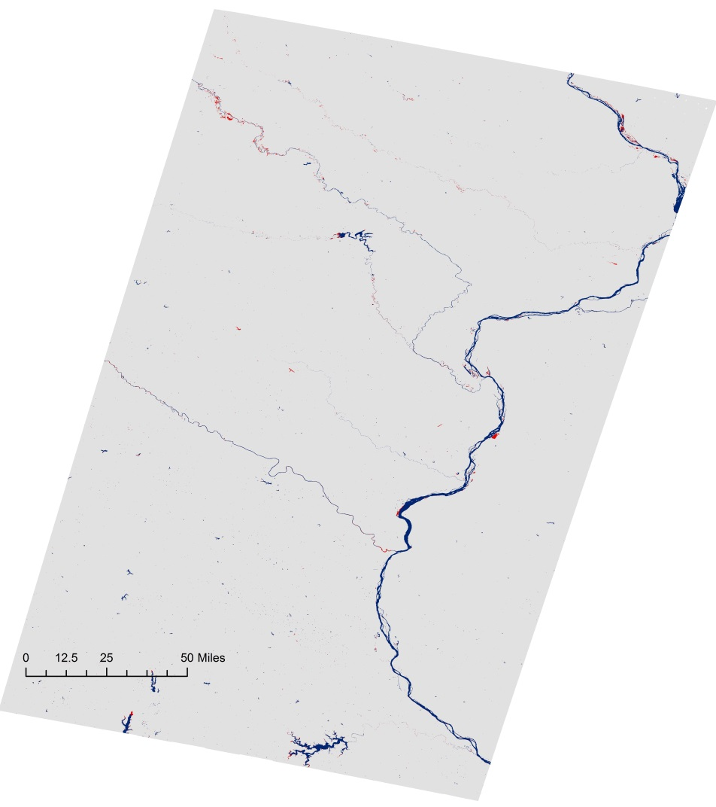



Flood Induced Water

Water Mask

**Water Classification**



Pasture/Hay

Cultivated Crops

**NLCD Agriculture**



0

0 - 5

5 – 25

25 – 50

50 – 100

100 – 500

500 – 2,500

2,500 – 5,000

5,000 – 180,000

**Landscan Population**

**Appendix J.**

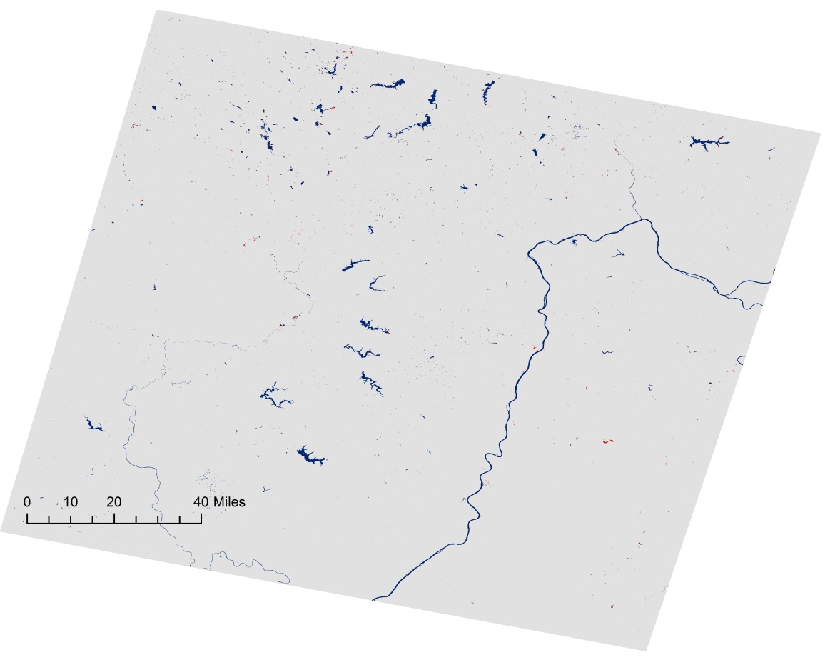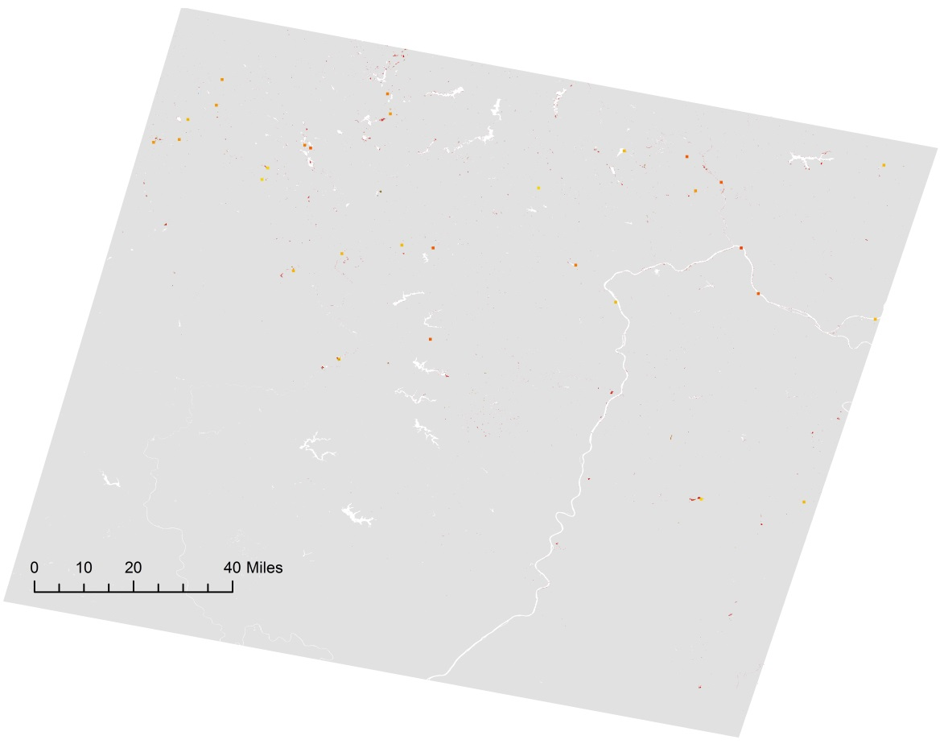Flood Extent Map and Flood Impact Map of the Waynesburg, Pennsylvania which peaked on March 1, 2017, and impacted 2,447 people, 630.9 acres of agriculture, and 1 child care facility.



Flood Induced Water

Water Mask

**Water Classification**



Other

Child Care Facilities

Colleges/Universities

Corporate Offices

Grade Schools

Hospitals

Mobile Home Parks

Assisted Living Facilities

Urgent Care Facilities

**HIFLD Infrastructure Data**



Pasture/Hay

Cultivated Crops

**NLCD Agriculture**



0

0 - 5

5 – 25

25 – 50

50 – 100

100 – 500

500 – 2,500

2,500 – 5,000

5,000 – 180,000

**Landscan Population**